Participant Instructions for Adobe Connect

At least one day before the meeting

Install the Adobe Connect app. To get the app go to:
http://www.adobe.com/go/Connectsetup (Windows)
http://www.adobe.com/go/ConnectSetupMac (Mac)

Connecting to the meeting – 1, 2, 3

- The Adobe Connect meeting link is on the eAgenda.  Click the meeting link.  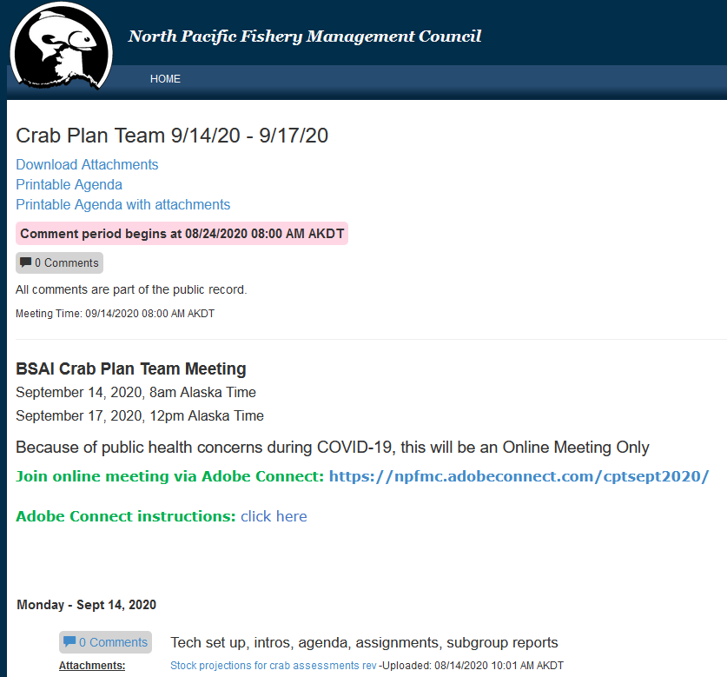 | - On the next screen,  enter your name (first and last please) in the space provided.  Click Enter Room  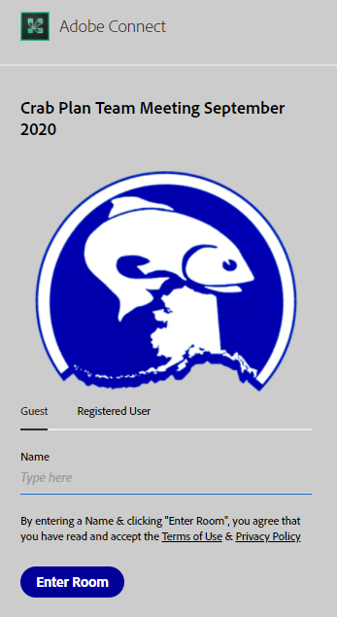
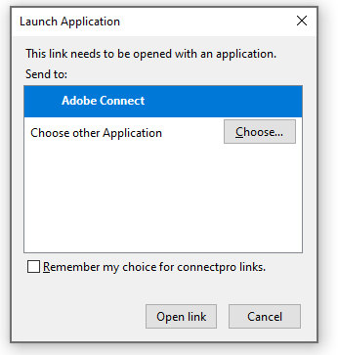  - If you see this dialog box, you have the app installed.  Click “Open link” in the pop up dialog box | If this is all you get, you need to install the Adobe Connect app, click the link in your browser to install.  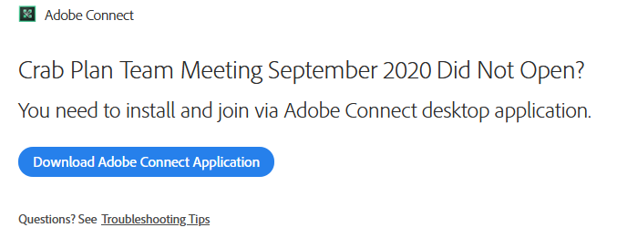

Connect Audio
IMPORTANT – Active participants (e.g., members of the committee) must use phone and do not have the option of connecting their computer microphone to speak
Listen-only participants can listen via phone or computer speakers

Enter your phone# (including area code)  after a delay of several seconds, you will get an automatic call to connect to the meeting  When prompted, press “1” on your phone to connect to the meeting audio  After a delay of up to 40 seconds, you will hear that you have been muted, which means you are successfully connected to the meeting  The host will unmute you. | 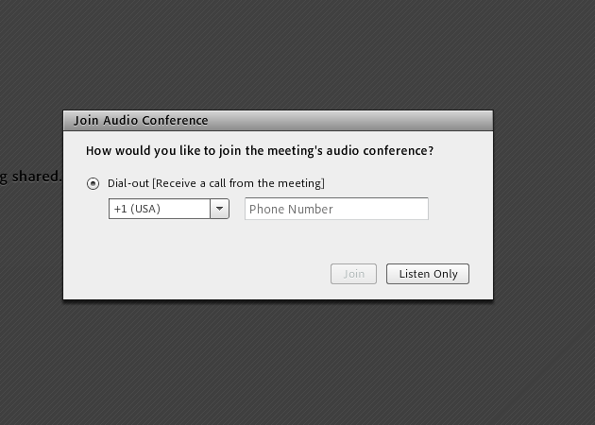

Within the Meeting

Where am I? …  You will see your name on the “Attendees” pod.  You will enter as a Participant  You will see some attendees listed as Hosts and some as Presenters | 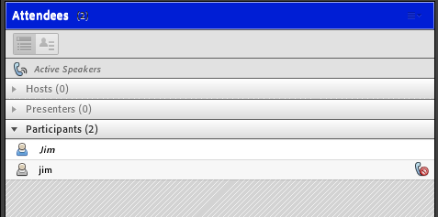

Plan Team members and other active participants

Audio
- The Host will grant you control of your audio after welcome.
- Please stay muted unless you need to talk to the group.
- Please mute your phone from the phone (not within Adobe Connect)
- Please silence your computer audio – the meeting audio sometimes comes through the app and can create echo/feedback

Video

Select Start My Webcam on the top menu | 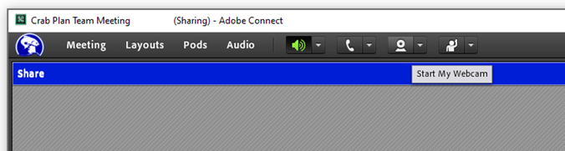

To present …

When prompted by the Host or Co-Chairs  Select the DROP DOWN ARROW next to “Share your screen” within the main share window  Select “Share Document”  Select the document (your presentation) to share with the audience.  Check that your audio is on (no slash through phone icon).  The Host or Co-Chairs will alert you when…  - Attendees are having problems with audio/visual  - Someone needs to ask a question during the presentation | 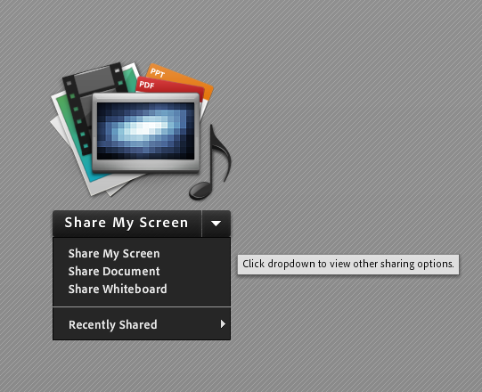
*WARNING: Share My Screen (not Share Document) means whatever email pops up is seen by the entire audience.

