**Appendix A. Description of the Norton Sound Red King Crab Model**

**a. Model description.**

The model is an extension of the length-based model developed by Zheng et al. (1998) for Norton Sound red king crab. The model has 8 male length classes with model parameters estimated by the maximum likelihood method. The model estimates abundances of crab with CL ≥64 mm and with 10-mm length intervals (8 length classes, ≥134mm) because few crab measuring less than 64 mm CL were caught during surveys or fisheries and there were relatively small sample sizes for trawl and winter pot surveys. The model treats newshell and oldshell male crab separately but assumes they have the same molting probability and natural mortality.



**Length proportion**

Pot Survey

1980-2012:

Standardized

CPUE

**Length proportion**

Com retained & discards

Com Fishery

Jun – Sept

Assume: July 01

Molting, Growth

**Tag recovery**

Recruitment

Natural mortality

7 months

July 01

Pre-fishery Population

**Feb 01: SAFE**

**Assessment**

**Abundance**

Catch selectivity

Com & Sub Fishery

Nov – May

Assume: Feb 01

July 01

Post-fishery Population

Catch & Survey selectivity

Survey selectivity

**Length proportion**

Com retained:

2015 -

Natural mortality

5 months

Feb 01

Post-fishery Population

Survey selectivity

Population

During fishery

**Abundance & Length proportion**

Trawl survey

Norton Sound Red King Crab Modeling Scheme

Timeline of calendar events and crab modeling events:

* **Model year starts February 1st to January 31st of the following year.**
* **All winter fishery harvest occurs on February 1st**
* **Molting and recruitment occur on July 1st**
* **Initial Population Date: February 1st 1976**

*Initial pre-fishery summer crab abundance on February 1st 1976*

Abundance of the initial pre-fishery population was assumed to consist of newshell crab to reduce the number of parameters, and estimated as

|  |  |
| --- | --- |
|  | (1) |

where, length proportion of the first year (*pl*) was calculated as

|  |  |
| --- | --- |
|  | (2) |

for model estimated parameters *al*.

*Crab abundance on July 1st*

Summer (01 July) crab abundance of new and oldshells consists of survivors of winter commercial and subsistence crab fisheries and natural mortality from 01Feb to 01July:

|  |  |
| --- | --- |
|  | (3) |

where

*Ns,l,t* , *Os,l,t* : summer abundances of newshell and oldshell crab in length class *l* in year *t* ,

*Nw,l,t*, *Ow,l,t* : winter abundances of newshell and oldshell crab in length class *l* in year *t*,

*Cw,t*, *Cp,t* : total winter commercial and subsistence catches in year *t*,

*Pw,n,l,t*, *Pw,o,l,t* : Proportion of newshell and oldshell length class *l* crab in year *t*, harvested by winter commercial fishery,

*Pp,n,l,t* , *Pp,o,l,t* : Proportion of newshell and oldshell length class *l* crab in year *t*, harvested by winter subsistence fishery,

*Dw,n,l,t*, *Dw,o,l,t*: Discard mortality of newshell and oldshell length class *l* crab in winter commercial fishery in year *t* ,

*Dp,n,l,t*, *Dp,o,l,t* : Discard mortality of newshell and oldshell length class *l* crab in winter subsistence fishery in year *t*,

*Ml* : instantaneous natural mortality in length class *l,*

0.42 : proportion of the year from Feb 1 to July 1 is 5 months.

Length proportion compositions of winter commercial catch (*Pw,n,l,t*, *Pw,o,l,t*) in year *t* were estimated as:

|  |  |
| --- | --- |
|  | (4) |

where

*Plg,l* : the proportion of legal males in length class *l* ,

*Sw,l*: Selectivity of winter fishery pot.

Subsistence fishery does not have a size limit; however, crab of size smaller than length class 3 are generally not retained. Hence, we assumed proportion of length composition *l* = 1 and 2 as 0, and estimated length compositions (*l* ≥ 3) as follows

|  |  |
| --- | --- |
|  | (5) |

*Crab abundance on Feb 1st*

Newshell Crab: Abundance of newshell crab of year *t* and length-class *l* (*Nw,l,t* ) year-t consist of: (1) new and oldshell crab that survived the summer commercial fishery and molted, and (2) recruitment (*Rl,t*) .

|  |  |
| --- | --- |
|  | (6) |

Oldshell Crab: Abundance of oldshell crabs of year *t* and length-class *l* (*Ow,l,t* ) consists of the non-molting portion of survivors from the summer fishery:

|  |  |
| --- | --- |
|  | (7) |

where

*Gl’, l* : a growth matrix representing the expected proportion of crabs growing from length class *l’* to length class *l*

*Cs,t* : total summer catch in year *t*

*Ps,n,l,t-1* , *Ps,o,l,t-1* : proportion of summer catch for newshell and oldshell crabs of length class *l* in year *t-1*,

*Dl,t-1*: summer discard mortality of length class *l* in year *t-1*,

*ml* : molting probability of length class *l*,

*yc* : the time in year from July 1 to the mid-point of the summer fishery,

0.58: Proportion of the year from July 1st to Feb 1st is 7 months is 0.58 year,

*Rl,t-1*: recruitment into length class *l* in year *t-1*.

*Discards*

Discards are crabs that were caught by fisheries but were not retained, which consists of summer commercial, winter commercial and winter subsistence.

Summer and winter commercial discards

In summer (*Dl,t*) and winter (*Dw,n,l,t* , *Dw,o,l,t*) commercial fisheries, sublegal males (<4.75 inch CW and <5.0 inch CW since 2005) are discarded. Those discarded crabs are subject to handling mortality. The number of discards was not directly observed, and thus was estimated from the model as: Observed Catch x (estimated abundance of crab that are not caught by commercial pot)/(estimated abundance of crab that are caught by commercial pot)

Model discard mortality in length-class *l* in year *t* from the summer and winter commercial pot fisheries is given by

|  |  |
| --- | --- |
|  | (8) |
|  | (9) |
|  | (10) |

where

*hms*: summer commercial handling mortality rate assumed to be 0.2,

*hmw*: winter commercial handling mortality rate assumed to be 0.2,

*Ss,l*: Selectivity of the summer commercial fishery,

*Sw,l*: Selectivity of the winter commercial fishery,

*Sr,l*: Retention selectivity of the summer commercial fishery,

Winter subsistence Discards

Discards (unretained) of winter subsistence fishery is reported in a permit survey (*Cd,t*), though its size composition is unknown. We assumed that subsistence fishers discarded all crabs of length classes 1 -2.

|  |  |
| --- | --- |
|  | (11) |
|  | (12) |

*Cd,t*: Winter subsistence discards catch,

*Recruitment*

Recruitment of year *t*, *Rt*, is a stochastic process around the geometric mean, *R0*:

|  |  |
| --- | --- |
|  | (13) |

*Rt* of the last year was assumed to be an average of previous 5 years: *Rt* = (*Rt-1* + *Rt-2* + *Rt-3* + *Rt-4* + *Rt-5* )/5.

*Rt* was assumed to be newshell crab of immature (< 94mm) length classes 1 to *r*:

|  |  |
| --- | --- |
|  | (14) |

where *r* takes multinomial distribution, same as the equation (2)

*Molting Probability*

Molting probability for length class *l*, *ml*, was estimated as an inverse logistic function of length-class mid carapace length (*L*) and parameters (*α*, *β*) where *β* corresponds to *L50*.

|  |  |
| --- | --- |
|  | (15) |

*Trawl net, summer commercial pot,*

Trawl and summer commercial pot selectivity was assumed to be a logistic function of mid-length-class, constrained to be 0.999 at the largest length-class (*Lmax*):

|  |  |
| --- | --- |
|  | (16) |

*Winter pot selectivity*

Winter pot selectivity was assumed to be a dome-shaped with inverse logistic function of length-class mid carapace length (*L*) and parameters (*α*, *β*) where *β* corresponds to *L50*.

|  |  |
| --- | --- |
|  | (17) |

Selectivity of the length classes *Sw,s*  (S= *l*1, *l*2) were individually estimated.

*Growth transition matrix*

The growth matrix *Gl’, l* (the expected proportion of crab molting from length class *l’* to length class *l* ) was

assumed to be normally distributed:

|  |  |
| --- | --- |
|  | (18) |

Where



Observation model

*Summer trawl survey abundance*

Modeled trawl survey abundance of year *t* (*Bst,t*) is July 1st abundance subtracted by summer commercial fishery harvest occurring from July 1st to the mid-point of summer trawl survey, multiplied by natural mortality occurring between the mid-point of commercial fishery date and trawl survey date, and multiplied by trawl survey selectivity. For the first year (1976) trawl survey, the commercial fishery did not occur.

|  |  |
| --- | --- |
|  | (19) |

where

*yst* : the time in year from July 1 to the mid-point of the summer trawl survey,

*yc*: the time in year from July 1 to the mid-point for the catch before the survey, (*yst* > *yc*: Trawl survey starts after opening of commercial fisheries),

*Pc,t* : the proportion of summer commercial crab harvested before the mid-point of trawl survey date.

*Sst,l*: Selectivity of the trawl survey.

Winter pot survey CPUE

Winter pot survey cpue (*fwt*) was calculated with catchability coefficient *q* and exploitable abundance:

|  |  |
| --- | --- |
|  | (20) |

Summer commercial CPUE

Summer commercial fishing CPUE (*ft*) was calculated as a product of catchability coefficient *q* and mean exploitable abundance minus one half of summer catch, At:

|  |  |
| --- | --- |
|  | (21) |

Because the fishing fleet and pot limit configuration changed in 1993, *q1* is for fishing efforts before 1993, *q2* is from 1994 to present.

Where *At* is exploitable legal abundance in year *t*, estimated as

|  |  |
| --- | --- |
|  | (22) |

*Summer pot survey abundance* (Removed from likelihood components)

Abundance of *t-*th year pot survey was estimated as

|  |  |
| --- | --- |
|  | (23) |

Where

*yp* : the time in year from July 1 to the mid-point of the summer pot survey.

Length composition

*Summer commercial catch*

Length compositions of the summer commercial catch for new and old shell crabs *Ps,n,l,t*and *Ps,o,l,t*, were modeled based on the summer population, selectivity, and legal abundance:

|  |  |
| --- | --- |
| (Alternative model) | (24) |

*Summer commercial fishery discards (1977-1995)*

Length/shell compositions of observer discards were modeled as

|  |  |
| --- | --- |
|  | (25) |

*Summer commercial fishery total catch (2012-present)*

Length/shell compositions of observer discards were modeled as

|  |  |
| --- | --- |
|  | (26) |

*Summer trawl survey*

Proportions of newshell and oldshell crab, *Pst,n,l,t* and *Pst,o,l,t* were given by

|  |  |
| --- | --- |
|  | (27) |

*Winter pot survey*

Winter pot survey length compositions for newshell and oldshell crab, *Psw,n,l,t*and *Psw,o,l,t* (*l* ≥ 1) were calculated as

|  |  |
| --- | --- |
|  | (28) |

*Spring Pot survey 2012-2015*

Winter pot survey length compositions for newshell and oldshell crab, *Psw,n,l,t*and *Psw,o,l,t* (*l* ≥ 1) were assumed to be supper crab population caught by winter pot survey gears

|  |  |
| --- | --- |
|  | (29) |

*Estimates of tag recovery*

The proportion of released tagged length class *l’* crab recovered after *t-th* year with length class of *l* by a fishery of *s-th* selectivity (*Sl*) was assumed to be proportional to the growth matrix, catch selectivity, and molting probability (*ml*) as

|  |  |
| --- | --- |
|  | (30) |

where *X* is a molting probability adjusted growth matrix with each component consisting of

|  |  |
| --- | --- |
|  | (31) |

**c. Likelihood components.**

Under assumptions that measurement errors of annual total survey abundances and summer commercial fishing efforts follow lognormal distributions and each type of length composition has a multinomial error structure (Fournier and Archibald 1982; Methot 1989), the log-likelihood function is

|  |  |
| --- | --- |
|  | (32) |

1where

*i*: length/shell compositions of :

1 triennial summer trawl survey,

2 annual winter pot survey,

3 summer commercial fishery retained catch,

4 observer discards or total catch during the summer fishery

5 spring pot survey.

*Ki,t*: the effective sample size of length/shell compositions for data set *i* in year *t,*

*Pi,l,t* : observed and estimated length compositions for data set *i*, length class *l*, and year *t.*

*κ* : a constant equal to 0.0001,

*CV* : coefficient of variation for the survey abundance,

*Bi,k,t*: observed and estimated annual total abundances for data set *i* and year *t,*

*ft* : observed and estimated summer fishing CPUE,

*w2t*: extra variance factor,

*SDR* : Standard deviation of recruitment = 0.5,

*Kl’,t*: sample size of length class *l’* released and recovered after *t-th* in year,

*Pl’,l,t,s* : observed and estimated proportion of tagged crab released at length *l’* and recaptured at

length *l*, after *t-th* year by commercial fishy pot selectivity *s*,

*W*: weighting for the tagging survey likelihood

It is generally believed that total annual commercial crab catches in Alaska are fairly accurately reported. Thus, total annual catch was assumed known.

**b. Software used**: AD Model Builder (Fournier et al. 2012).

**d. Parameter estimation framework:**

1. Parameters Estimated Independently

The following parameters were estimated independently: natural mortality (*M* =0.18), proportions of legal males by length group.

Natural mortality was based on an assumed maximum age, *tmax*, and the 1% rule (Zheng 2005):

,

where *p* is the proportion of animals that reach the maximum age and is assumed to be 0.01 for the 1% rule (Shepherd and Breen 1992, Clarke et al. 2003). The maximum age of 25, which was used to estimate *M* for U.S. federal overfishing limits for red king crab stocks results in an estimated *M* of 0.18. Among the 199 recovered crabs from the tagging returns during 1991-2007 in Norton Sound, the longest time at liberty was 6 years and 4 months from a crab tagged at 85 mm CL. The crab was below the mature size and was likely less than 6 years old when tagged. Therefore, the maximum age from tagging data is about 12, which does not support the maximum age of 25 chosen by the CPT.

Proportions of legal males (CW > 4.75 inches) by length group were estimated from the ADF&G trawl data 1996-2011 (Table 11).

1. Parameters Estimated Conditionally

Estimated parameters are listed in Table 10. Selectivity and molting probabilities based on these estimated parameters are summarized in Tables 11.

A likelihood approach was used to estimate parameters

**e. Definition of model outputs.**

1. Estimate of mature male biomass (MMB) is on **February 1st** and is consisting of the biomass of male crab in length classes 4 to 8



*wml*: mean weight of each length class (Table 11).

1. Projected legal male biomass for winter and summer fishery OFL was calculated as

 Baseline model

 Alternative model

1. Recruitment: the number of males in length classes 1, 2, and 3.

**f. OFL**

The Norton Sound red king crab fishery consists of two distinct fisheries: winter and summer. The two fisheries are discontinuous with 5 months between the two fisheries during which natural mortalities occur. To incorporate this fishery, the CPT in 2016 recommended the following formula:

|  |  |
| --- | --- |
|  | (1) |

And

|  |  |
| --- | --- |
|  | (2) |

Where *p* is a specific proportion of winter crab harvest to total (winter + summer) harvest

At given fishery mortality (FOFL), Winter harvest is a fishing mortality

|  |  |
| --- | --- |
|  | (3) |

|  |  |
| --- | --- |
|  | (4) |

where Bs is a summer crab biomass after winter fishery and x (0 ≤ x ≤1) is a fraction that satisfies equation (2)

Since Bs  is a summer crab biomass after winter fishery and 5 months of natural morality ()

|  |  |
| --- | --- |
|  | (5) |

Substituting *0.42M* to *m*, summer harvest is

|  |  |
| --- | --- |
|  | (6) |

Thus, OFL is

|  |  |
| --- | --- |
|  | (7) |

Combining (2) and (7),

|  |  |
| --- | --- |
|  | (8) |

Solving (8) for x

|  |  |
| --- | --- |
|  | (9) |

Combining (7) and (9), and substituting back,

revised retained OFL is



Further combining (3) and (9), Winter fishery harvest rate (Fw) i

|  |  |
| --- | --- |
|  | (10) |

Summer fishery harvest rate (Fs) is

|  |  |
| --- | --- |
|  | (11) |

# Appendix B

# Norton Sound Red King Crab CPUE Standardization

**Note: This is an update of model by G. Bishop (SAFE 2013).**

## Methods

### Data Source & Cleaning

Commercial fishery harvest data were obtained from ADF&G fish ticket database, which included: Landing Date, Fish Ticket Number, Vessel Number, Permit Fishery ID, Statistical Area(s) fished, Effort, and Number and Pounds of Crab harvested (Table A2-1,2,3, Figure A2-1). Fish ticket database may have multiple entries of identical Fish Ticket Number, Vessel Number, Permit Fishery ID, and Statistical Area. In those cases, at least one Effort data are missing or zero with the Number and Pounds of Crab harvested. These entries indicate that crab were either retained from the commercial fishery (i.e., not sold), or dead loss.

Following data cleaning and combining methods were conducted.

1. Sum crab number and efforts by Fish Ticket Number, Vessel Number, Permit Fishery ID, Statistical Area.
2. Remove data of missing or zero Efforts, Number of Crab, Pounds of Crab (Those are considered as true missing data).
3. Calculate CPUE as Number of Crab/Effort.

### Data Censoring

During 1977-92 period, vessels of 1 year of operation and/or 1 delivery per year harvested 20-90% of crab (Table A2-5, Figure A2-2). For instance, all vessels did only 1 delivery in 1989, and in 1988 64% of crab were harvested by 1 vessel that did only 1 delivery. On the other hand, during the 1993-2017 period of post super-exclusive fishery status, the majority of commercial crab fishery and harvest was done by vessels with more than 5 years of operations and more than 5 deliveries per year. For 1977 – 1992, censoring was made for vessels of more than 2 years of operations. Increasing deliveries to more than one would result in no estimates for some years. For 1993 – 2018, censoring was made for vessels of more than 5 years of operations and 5 deliveries per year.

### Analyses

A GLM was constructed as



Where YR: Year, PD: Fishery periods (1977-1992, 1993-2004,2005-2018), VSL: Vessel, MSA: Statistical Area, WOY: Week of Year, and PF: Permit vs open fishery (Table 1). All variables were treated as categorical. Inclusion of interaction terms was not considered because they were absent (SAFE 2013).

For selection of the best model, forward and backward stepwise selection was conducted. (R step function)

**fit <- glm(L.CPUE.NO ~ factor(YR) + factor(VSL) + factor(WOY) + factor(MSA) + factor(PF) + factor(PD),,data=NSdata.C)**

**step <- step(fit, direction='both', trace = 10)**

**best.glm<-glm(formula(step), data=NSdata.C)**

Table B-1. List of variables in the fish ticket database. Variables in bold face were used for generalized linear modeling.

| **Variable** | **Description** | |
| --- | --- | --- |
| **YR** | | Year of commercial fishery |
| **VSL** | | Unique vessel identification number |
| Fish Ticket Number | | Unique delivery to a processor by a vessel |
| **PF** | | Unique Permit Fishery categories |
| **PD** | | Fishery period: 1977-1992, 1993-2004,2005-2018 |
| Statistical Area | | Unique fishery area. |
| **MOA** | | Modified statistical area, combining each statistical area into 4 larger areas: Inner, Mid, Outer, Outer North |
| Fishing Beginning Date | | Date of pots set |
| Landing Date | | Date of crab landed to processor |
| **WOY** | | Week of Landing Date **(calculated)** |
| Effort | | The number of pot lift |
| Crab Numbers | | Total number of crabs harvested from pots |
| Crab Pounds | | Total pounds of crab harvested from pots |
| **ln(CPUE)** | | ln(Crab Numbers/Effort) **(calculated)** |

Table B-2. Permit fisheries, descriptions, and years with deliveries for Norton Sound summer commercial red king crab harvest data.

|  |  |  |  |
| --- | --- | --- | --- |
| **Permit fishery** | **Type** | **Description** | **Years** |
| K09Q | Open access | KING CRAB , POT GEAR VESSEL UNDER 60', BERING SEA | 1994–2002 |
| K09Z | Open access | KING CRAB , POT GEAR VESSEL UNDER 60', NORTON SOUND | 1992–2017 |
| K09ZE | CDQ | KING CRAB , POT GEAR VESSEL UNDER 60', NORTON SOUND CDQ, NSEDC | 2000–2017 |
| K09ZF | CDQ | KING CRAB , POT GEAR VESSEL UNDER 60', NORTON SOUND CDQ, YDFDA | 2002–2004 |
| K91Q | Open access | KING CRAB , POT GEAR VESSEL 60' OR OVER, BERING SEA | 1978–1989 |
| K91Z | Open access | KING CRAB , POT GEAR VESSEL 60' OR OVER, NORTON SOUND | 1982–1994 |

Table B-3. Modified statistical area definitions used for analysis of Norton Sound summer commercial red king crab harvest data.

|  |  |
| --- | --- |
| **Modified statistical area** | **Statistical areas included** |
| Inner | 616331, 616401, 626331, 626401, 626402 |
| Mid | 636330, 636401, 636402, 646301, 646330, 646401, 646402 |
| Outer | 656300, 656330, 656401, 656402, 666230, 666300, 666330, 666401 |
| Outer North | 666402, 666431, 676300, 676330 ,676400, 676430, 676501, 686330 |

Table B-4. Final generalized linear model formulae and AIC selected for Norton Sound summer commercial red king crab fishery. The dependent variable is ln(CPUE) in numbers.

|  |  |  |  |  |  |
| --- | --- | --- | --- | --- | --- |
| Var | Df | Deviance | Resid DF | Resid Dev | AIC |
| YR | 41 | 1312.43 | 6274 | 5082.7 |  |
| VSL | 90 | 574.57 | 6143 | 3770.3 |  |
| WOY | 15 | 82.89 | 6129 | 3195.7 |  |
| MSA | 3 | 65.83 | 6125 | 3047.0 |  |
| PF | 6 | 20.14 | 6119 | 3026.9 | 13547 |
| +PD+MOY | 3 |  |  |  | 13547.67 |
|  |  |  |  |  |  |

Table B-5. Standardized (censored/full data), and scaled arithmetic observed CPUE indices.

|  |  |  |
| --- | --- | --- |
| Year | Censored | |
| **CPUE** | **SE** |
| 1977 | 3.29 | 0.68 |
| 1978 | 4.68 | 0.65 |
| 1979 | 2.87 | 0.64 |
| 1980 | 3.07 | 0.65 |
| 1981 | 0.86 | 0.64 |
| 1982 | 0.20 | 0.62 |
| 1983 | 0.90 | 0.65 |
| 1984 | 1.59 | 0.65 |
| 1985 | 0.50 | 0.66 |
| 1986 | 1.74 | 0.70 |
| 1987 | 0.61 | 0.64 |
| 1988 | 2.36 | 0.86 |
| 1989 | 1.21 | 0.61 |
| 1990 | 1.08 | 0.68 |
| 1991 |  |  |
| 1992 | 0.17 | 0.60 |
| 1993 | 0.90 | 0.35 |
| 1994 | 0.81 | 0.34 |
| 1995 | 0.42 | 0.34 |
| 1996 | 0.51 | 0.34 |
| 1997 | 0.84 | 0.35 |
| 1998 | 0.79 | 0.36 |
| 1999 | 0.92 | 0.36 |
| 2000 | 1.24 | 0.34 |
| 2001 | 0.64 | 0.34 |
| 2002 | 1.23 | 0.34 |
| 2003 | 0.85 | 0.34 |
| 2004 | 1.27 | 0.34 |
| 2005 | 1.19 | 0.34 |
| 2006 | 1.31 | 0.34 |
| 2007 | 1.02 | 0.34 |
| 2008 | 1.32 | 0.34 |
| 2009 | 0.84 | 0.34 |
| 2010 | 1.22 | 0.34 |
| 2011 | 1.58 | 0.34 |
| 2012 | 1.29 | 0.34 |
| 2013 | 0.67 | 0.33 |
| 2014 | 1.12 | 0.34 |
| 2015 | 1.45 | 0.34 |
| 2016 | 1.27 | 0.34 |
| 2017 | 1.10 | 0.34 |
| 2018 | 0.64 | 0.34 |

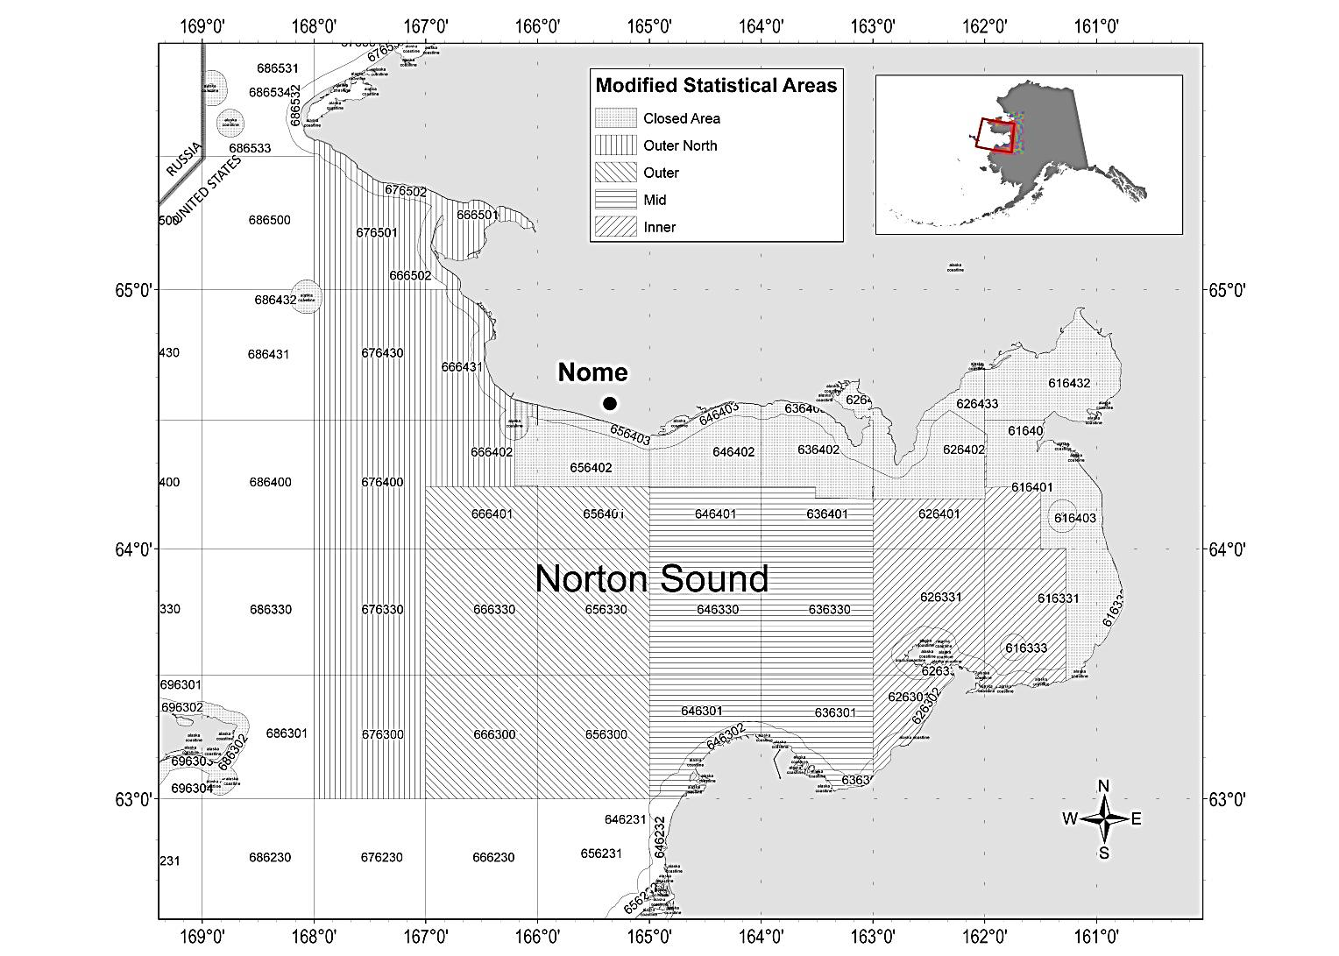

Figure A2-1. Closed area and statistical area boundaries used for reporting commercial harvest information for red king crab in Registration Area Q, Northern District, Norton Sound Section and boundaries of the new *Modified Statistical Areas* used in this analysis.

# Appendix C

# Norton Sound Red King Crab Summer Commercial Fishery Discard Estimation

Formal methodologies have not been established for estimating Red King Crab discards by Norton Sounds Summer commercial fishery from observer data. Here, I describe a few methods and discuss pros and cons of each method.

Data source and description of survey protocols

Norton Sound Summer Commercial fishery observer survey started in 2009 as a potential feasibility project, and formal data collection started since 2012. The observer survey in Norton Sound is voluntary. Due to small boat size, the boat that can take a fishery observer is limited. Fishery observer often work as a crew member. During the fishery, an observe inspect every pots. All lengths/shell condition/sex of red king crab in the pots were measured, and the fisherman sorts out discards that are noted. **Observed discarded crab are deemed accurate.** However, it is uncertain whether fishing behaviors of the volunteer fishermen are the same as other unobserved fishermen. Observed fishermen tend to have large boat and catcher and sellers. Here are possible concerns:

1. The observed fishermen may go to better fishing grounds with more legal crab and less sub-legals: **higher legal retain CPUE and lower discards CPUE than unobserved (lower discards proportion)**
2. The observed fishermen may not mind sorting out crab and may choose areas: **higher legal retain CPUE and higher discards CPUE than unobserved (higher discards proportion)**
3. The observed fishermen may keep more legal crab that are not accepted by NSEDC: **lower discard CPUE than unobserved (lower discard proportion)**

### Data Source & Cleaning

From 2012 to 2018, crab catches of 3-4 volunteer crab fishing vessels were observed. Annual observed pots ranged 69 to 199 and total observed crab ranging from 2200 to 5300 (Table 1). All observed data were combined.

### Estimation Methods

Two methods were considered: CPUE and Proportion methods. CPUE method expands observed CPUE (Observed number of crab)/(observed pots) to all fisheries pot lifts, whereas proportional method expands observed proportion of discards to retained: (observed number of discards)/(observed number of retained) to all fisheries retained catch.

CPUE has two methods: LNR and Subtraction. LNR simply expands CPUE of discards, whereas Subtraction expands CPUE of total catch and subtract total retained catch.

LNR method

LNR method simply expands CPUE of discards to total pot lifts



Where Nobs, sub  and Nobs, ld  are observed number of sublegal and legal crab discarded, and Pobs is the number of pot-lifts by the observed fishermen during the observed period.



Where PFT.total, is total number of pot lifts of all fishermen recorded in fish tickets.

Observer bias corrected LNR method adds correction to CPUE of the observed fishermen by multiplying the CPUE ratio between observed fishermen (CPUEFT.obs) and unobserved fishermen (CPUEFT.unobs) derived from fish tickets.

 



Where NFT.obs and NFT.unobs are total number of crab delivered (thorough out season) by observed and unobserved fishermen, and PFT.obs  and PFT.unobs total number of pot lifts by observed and unobserved fishermen.

  

  

Subtraction method

Subtraction method expands total catch CPUE and subtracts total retained catch



Where Nobs is a total number of crab caught by the observed fishermen during the observed period.



Where NFT.total is the total number of retained crab during the season.

Bias corrected Subtraction method is simply bias corrected total catch minus retained catch



Finally, the proportion method that expands ratio of discards to retained.



Where Nobs.lr is observed number of retained legal crab by observed fishermen during the observed periods.

In an assessment model, total number of crab discarded by summer commercial fishery is modeled as



where NF.R and NF.D are model estimated number of crab retained and discarded, which is essentially the same ss proportional method.

### Results

While general annual discard trends were similar among the 3 methods, the number of discards differed (Table 2). Overall, the Subtraction method estimated the highest and the Proportional method estimated the lowest. Bias correction method (LNR2, Sub2) reduced discard estimates during 2013-2017 (Table 3).

**Discussion**

The CPUE method assumes that observed CPUE would represent total CPUE or that there is no difference in **CPUE** between observed and unobserved fishermen. Difference between LNR and Subtraction method is that LNR method assumes that **observed discards are accurate** whereas subtraction method assumes that **observed discards are biased but observed total catches are accurate.** On the other hand, the proportional method assumes that observed discard proportions would represent total proportion or that **every fisherman has a similar crab composition**.

In Norton Sound observer survey, discarded crab are more likely accurate because separation of retained vs discards are often done in cooperation with the fishermen. However, fishermen and timing of observation are limited to convenience of volunteer fishermen who have larger boats (so that observer can be on board) and are also high catchers. They would be more efficient in catching legal crab with fewer discards than those with small boats. They would also take observers when they expect higher catch.

In fact, season total retained legal crab CPUE by observed fishermen were generally higher than other unobserved fishermen (Table 2). Furthermore, their CPUE was generally higher during the periods when observers were on board. Observed fishermen appeared to go different fishing area from those of all fishermen (Table 4). Those suggest that subtraction method would probably overestimate discards. Direction of bias for LNR and proportional methods are difficult to evaluate. If the observed fishermen tend to better avoid catching sublegal crab (e.g., lower sublegal proportion), the proportional method would underestimate discard catch. But, as they have higher catch CPUE, their discard catch CPUE could still be higher than those of unobserved fishermen. Then, discard catch estimate by LNR method could overestimate as well as underestimate.

Table 1. Observed pot lifts, catch, and total pot lifts and catch from 2012 to 2018

|  |  |  |  |  |  |  |  |  |
| --- | --- | --- | --- | --- | --- | --- | --- | --- |
|  | Observer Survey | | | | |  | Fish Tickets | |
| Year | Pot lifts  Pobs | Sublegal  Nobs.sub | Legal retained  Nobs.lr | Legal discards  Nobs.ld | Female |  | pot lifts  PFT.total | Retained  NFT.total |
| 2012 | 78 | 898 | 1055 | 177 | 152 |  | 10041 | 161113 |
| 2013 | 199 | 2775 | 2166 | 258 | 123 |  | 15058 | 130603 |
| 2014 | 147 | 1504 | 1838 | 341 | 104 |  | 10127 | 129656 |
| 2015 | 69 | 969 | 1676 | 577 | 224 |  | 8356 | 144224 |
| 2016 | 67 | 264 | 1700 | 169 | 878 |  | 8,009 | 138997 |
| 2017 | 110 | 432 | 2174 | 122 | 373 |  | 9440 | 135322 |
| 2018 | 78 | 547 | 1096 | 10 | 574 |  | 8797 | 89613 |
| 2019 | 28 | 123 | 142 | 1 | 89 |  | 5436 | 24913 |

Table 2. Retained Crab CPUE between observed (CPUE.ob) during the observer survey, and season total CPUE between observed and unobserved fishermen derived from fish ticket data.

|  |  |  |  |
| --- | --- | --- | --- |
| Year | CPUEobs | CPUEFT.obs | CPUEFT.unobs |
| 2012 | 13.53 | 16.05 | 16.57 |
| 2013 | 10.88 | 8.67 | 7.47 |
| 2014 | 12.50 | 12.80 | 11.87 |
| 2015 | 24.29 | 17.26 | 15.62 |
| 2016 | 25.37 | 17.36 | 15.30 |
| 2017 | 19.76 | 14.33 | 13.33 |
| 2018 | 14.05 | 10.19 | 10.09 |
| 2019 | 5.07 | 4.58 | 4.56 |

Table 3. The number of discarded crab estimated by 5 methods and model.

|  |  |  |  |  |  |  |
| --- | --- | --- | --- | --- | --- | --- |
| Year | LNR | LNR2 | Sub | Sub2 | Prop | Model |
| 2012 | 138386 | 150043 | 113084 | 136182 | 164167 | 94564 |
| 2013 | 229502 | 173750 | 262797 | 167229 | 182880 | 120486 |
| 2014 | 127104 | 104697 | 124070 | 79340 | 130150 | 147066 |
| 2015 | 187223 | 135910 | 245965 | 139023 | 133037 | 88430 |
| 2016 | 51760 | 32965 | 115976 | 23394 | 35403 | 50228 |
| 2017 | 47543 | 34870 | 98790 | 36384 | 34484 | 46441 |
| 2018 | 62820 | 60714 | 96816 | 90566 | 45542 | 45848 |
| 2019 | 24074 | 23362 | 26729 | 24203 | 21755 | 28887 |

Table 4. Average legal crab proportion caught by 2012-2018 trawl survey and Summer commercial harvest proportion in major fishing stat area

|  |  |  |
| --- | --- | --- |
|  | Catch proportion | |
| STAT Area | All fishermen | Observed  Fishermen |
| 666401 | 15% | 7% |
| 656401 | 21% | 18% |
| 646401 | 19% | 46% |
| 636401 | 33% | 19% |
| 626401 | 15% | 2% |

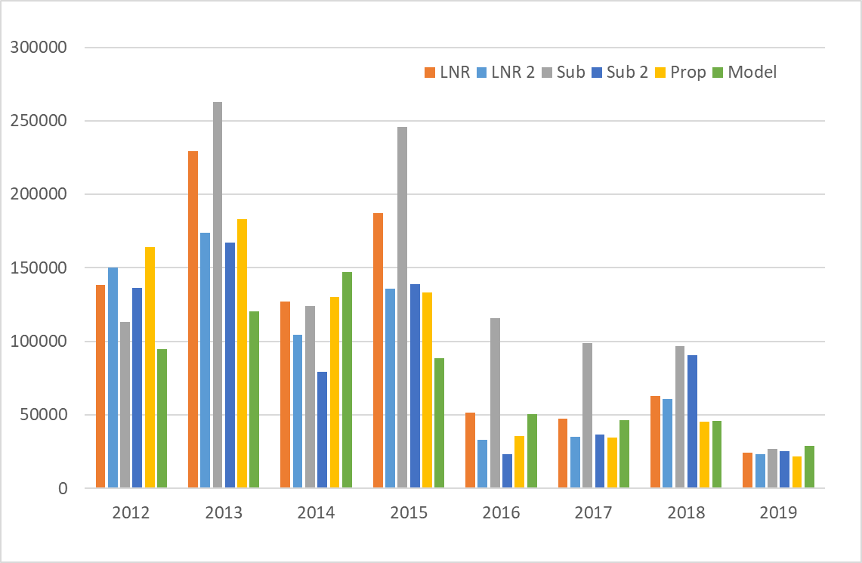

Figure 1. The number of discarded crab estimated by 3 methods.

# Appendix D

# VAST model estimation of Norton Sound Red King Crab abundance and distribution.

Here I present several VAST model results of Norton Sound Red King Crab abundance and distribution.

**Dataset:**

Trawl survey data of all years (NOAA: 1976-1991, ADFG: 1996-2020, NOAA NBS: 2010-2018) were combined as follows:



……



In the above Latitude and Longitude are trawl coordinate, Totalmale is the number of male NSRKC (> 63mm) caught in the trawl.

**Model setting:**

Model settings were suggested by James Thorson during the VAST modeling workshop.

settings = make_settings( n_x=50, Region="Other",purpose="index2",bias.correct=FALSE,

FieldConfig=c("Omega1"=1, "Epsilon1"=1, "Omega2"=0, "Epsilon2"=0), Version="VAST_v9_2_0", use_anisotropy=TRUE)

fit = fit_model( "settings"=settings, "Lat_i"=data[,'Latitude'],

"Lon_i"=data[,'Longitude'], "t_i"=data[,'Year'],

"c_i"=rep(0,nrow(data)), "b_i"=data[,'Totalmale'],

"a_i"=data[,'Swept_NM2'], "v_i"=data[,'Agent'],

"observations_LL"=cbind("Lat"=data[,'Latitude'],"Lon"=data[,'Longitude']),

getsd=TRUE, newtonsteps=1, grid_dim_km=c(5,5),

maximum_distance_from_sample=50,

knot_method="samples")

The model was ran in two data configurations: 1. All trawl survey data, 2. Trawl survey data limited to current ADFG survey stations.

### Results

1. All data

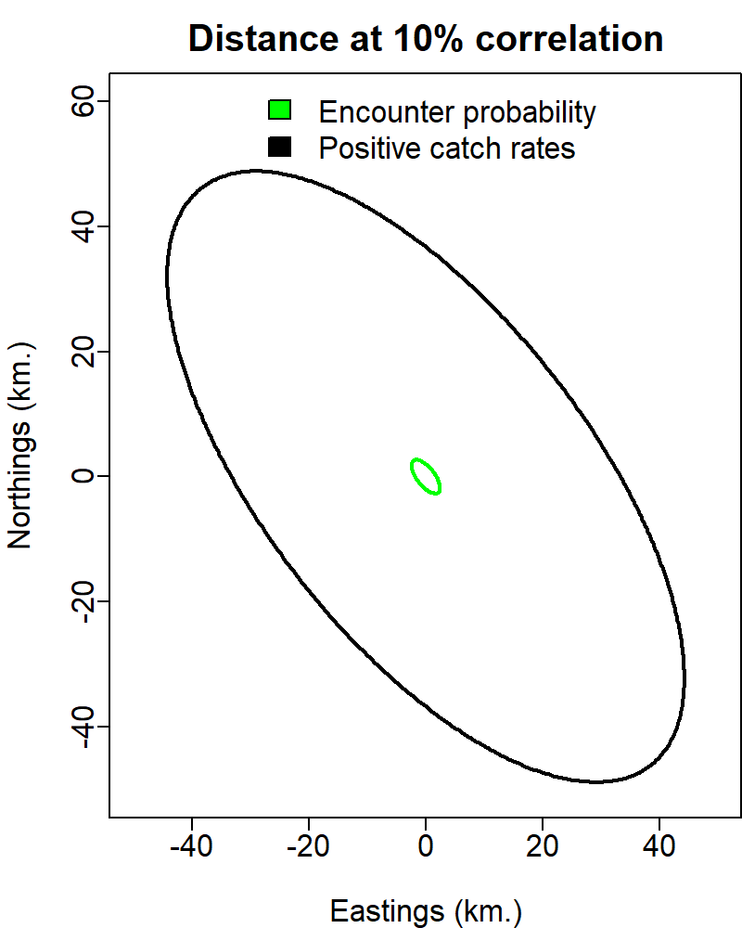 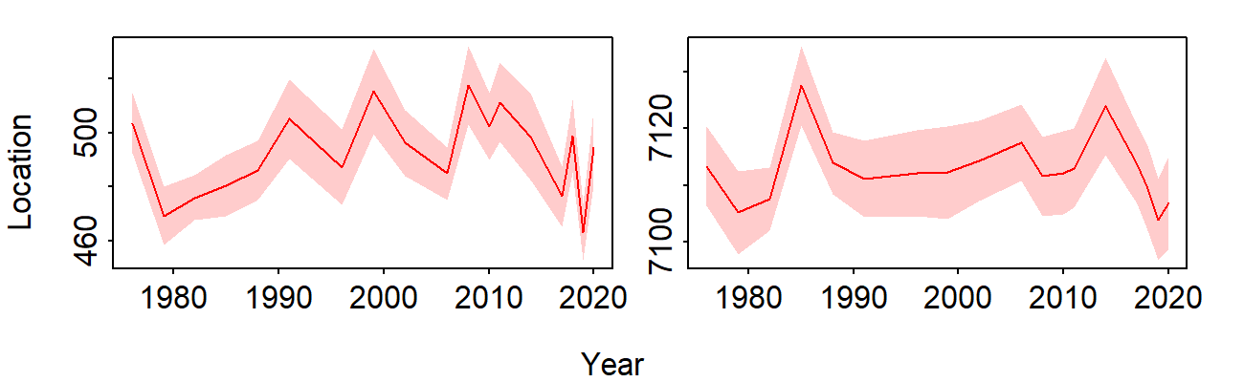 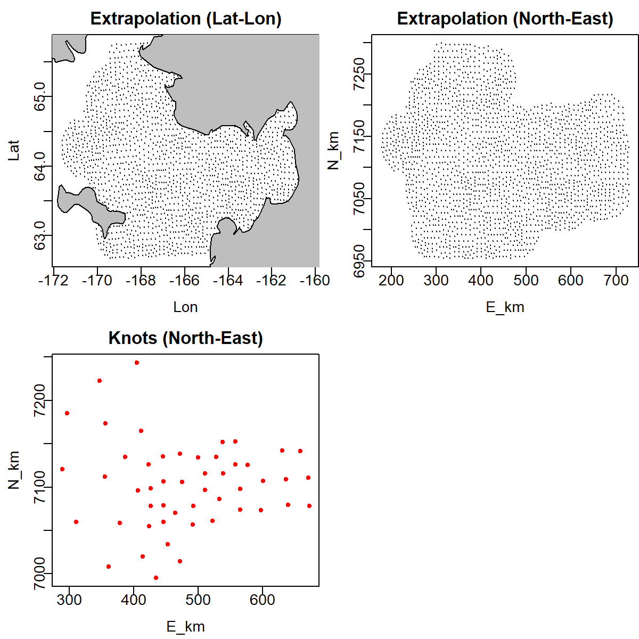

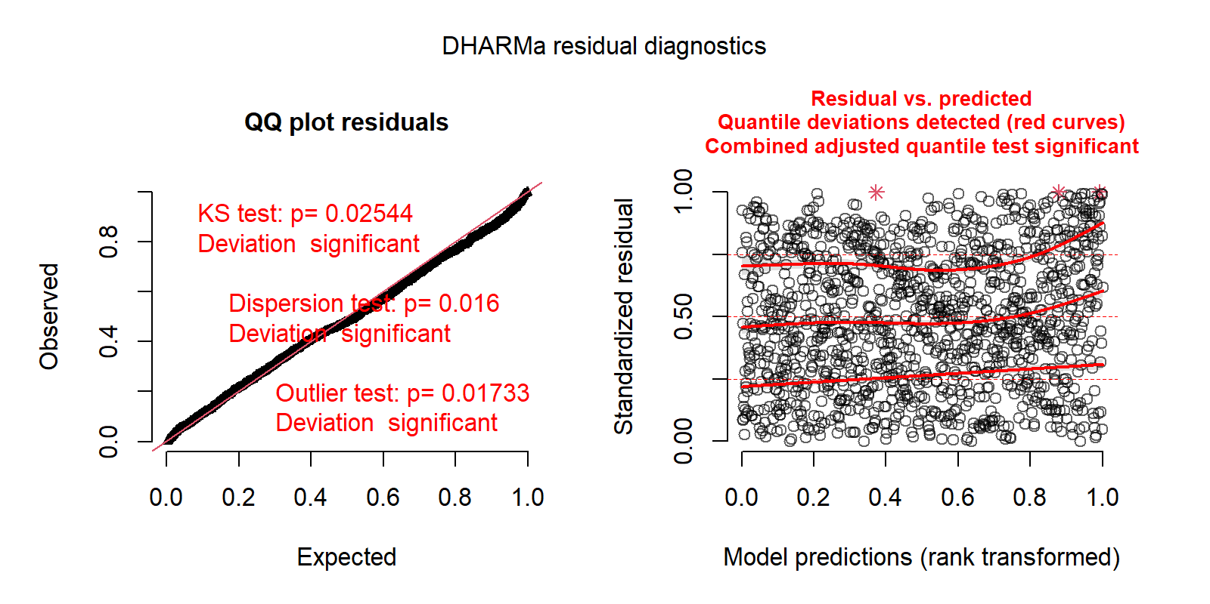

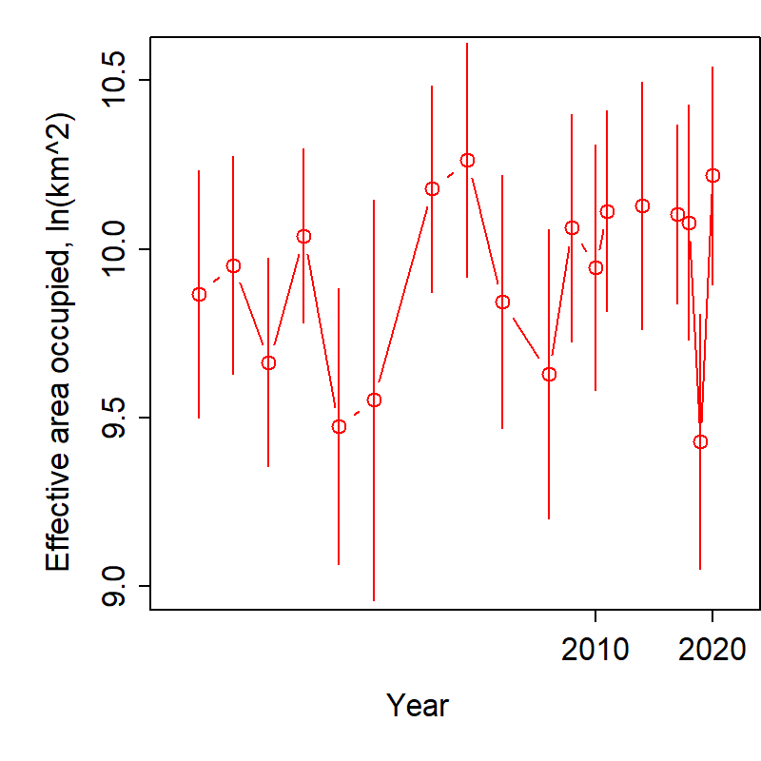 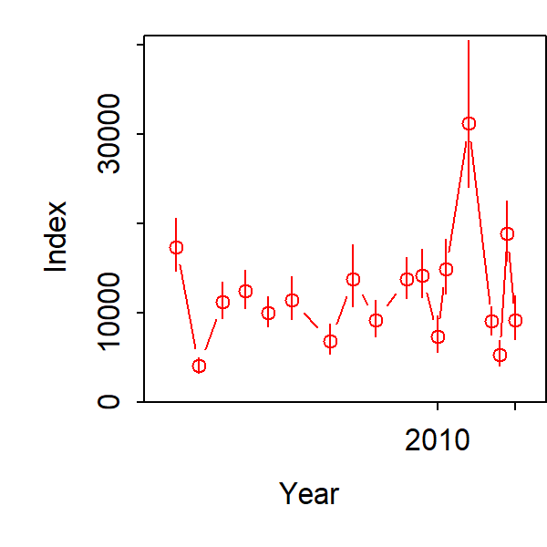

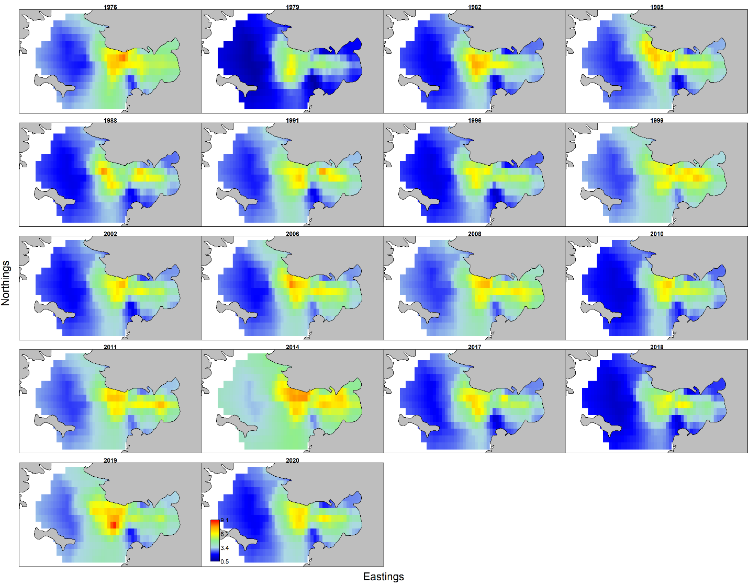

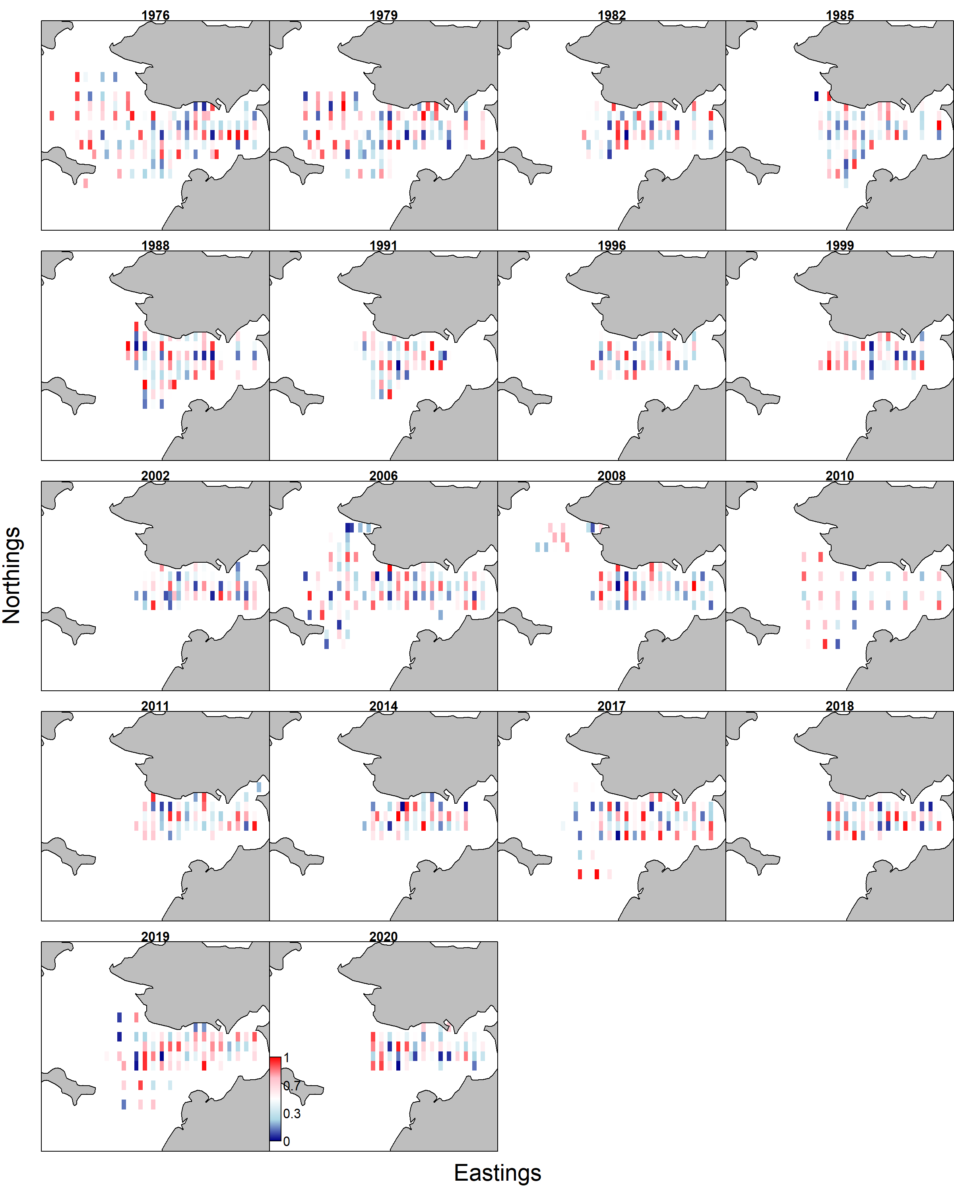

1. Limited data

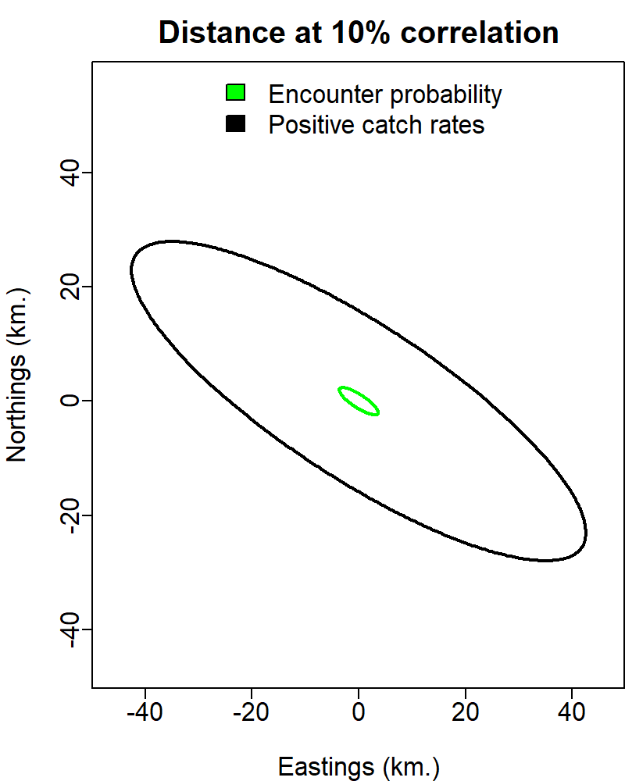 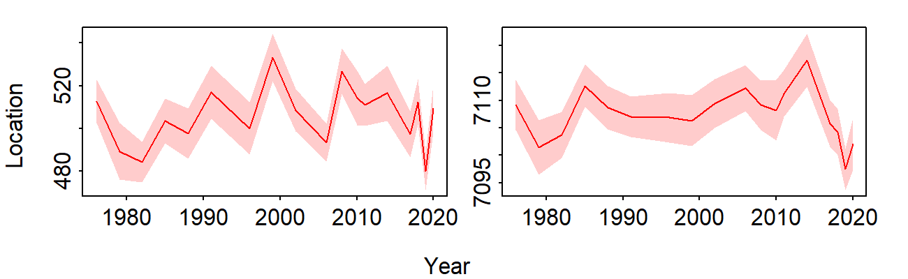

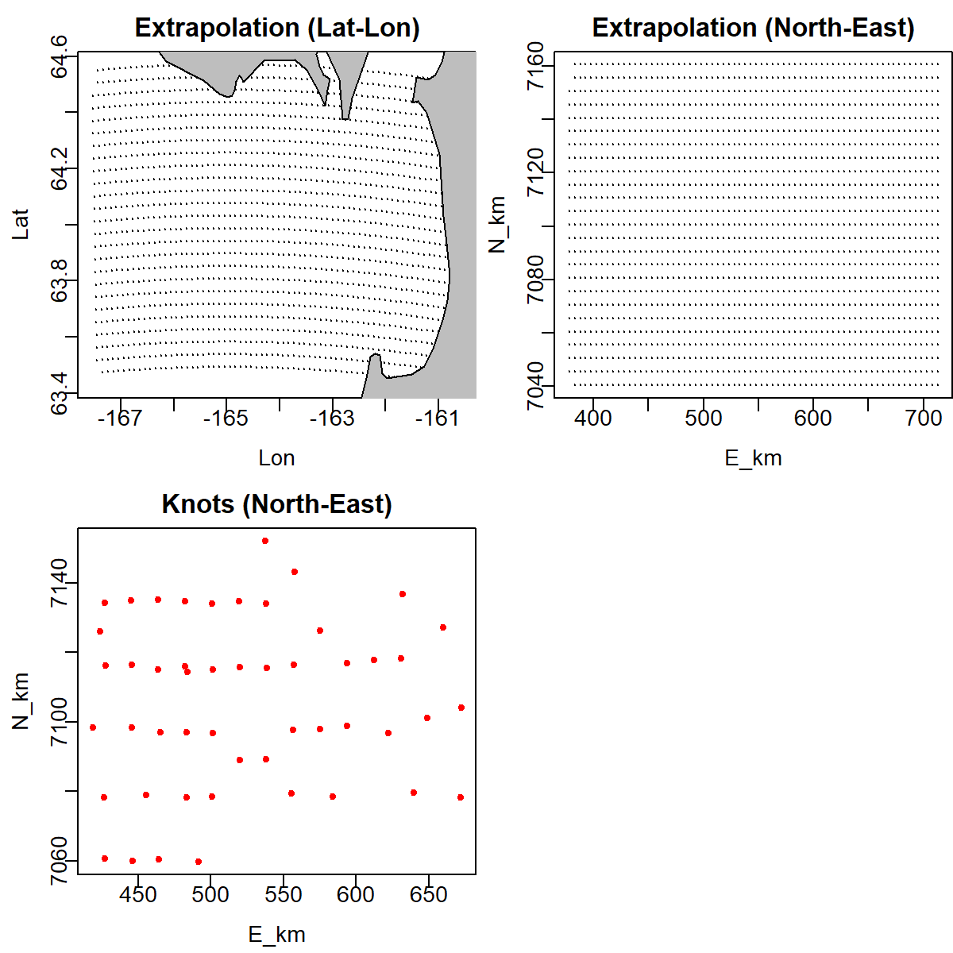

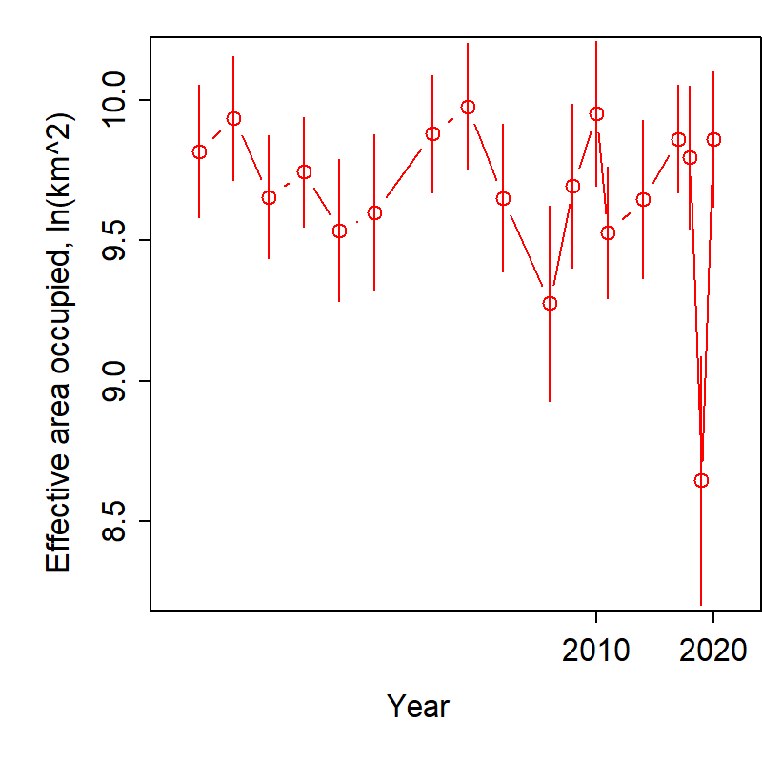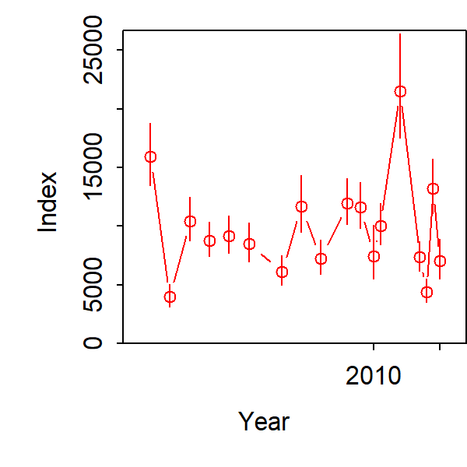

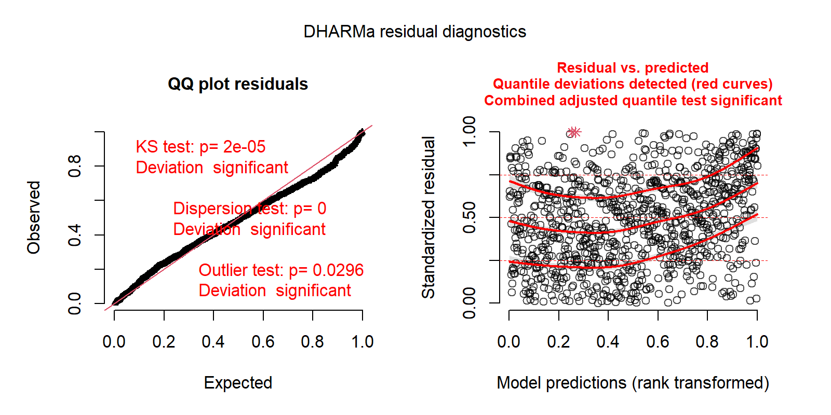

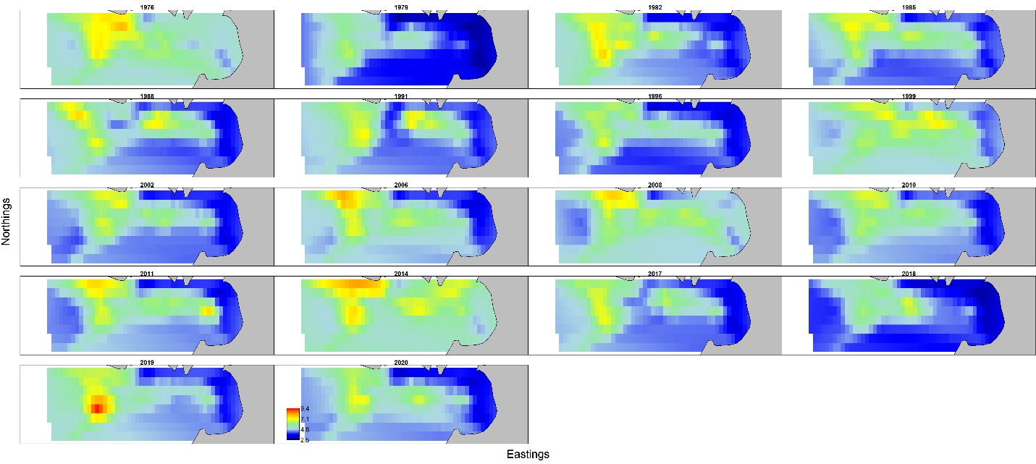

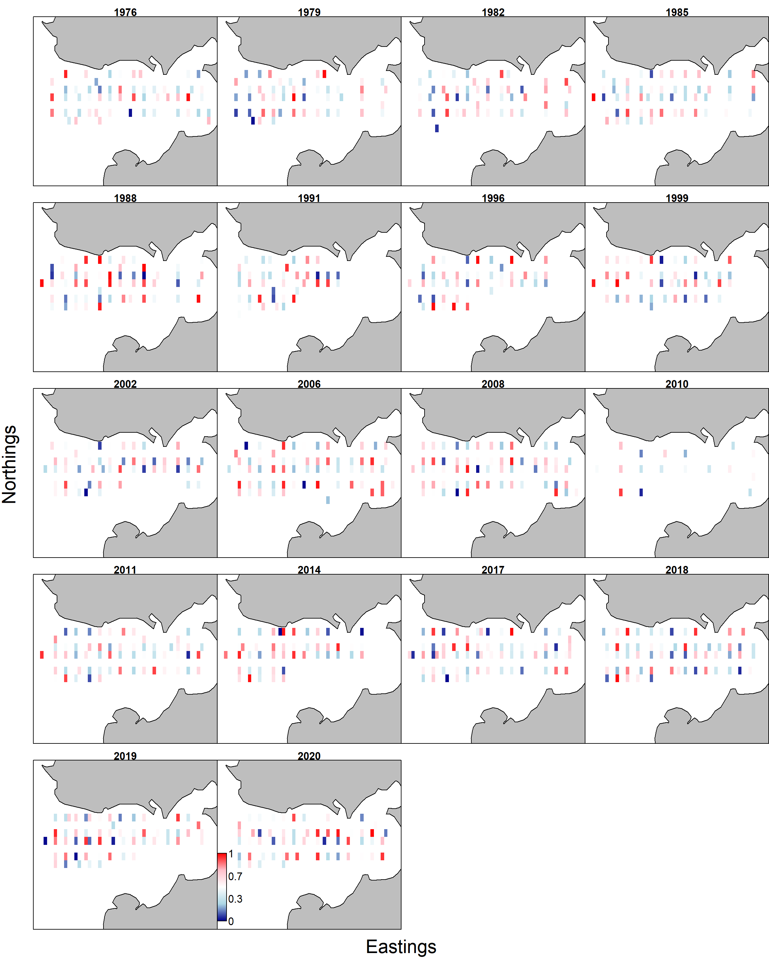

Comparison of abundance among survey (dots and line: NOAA: red, ADFG: black, 95CI), VAST estimate of all data (red) and ADFG survey stations (blue).

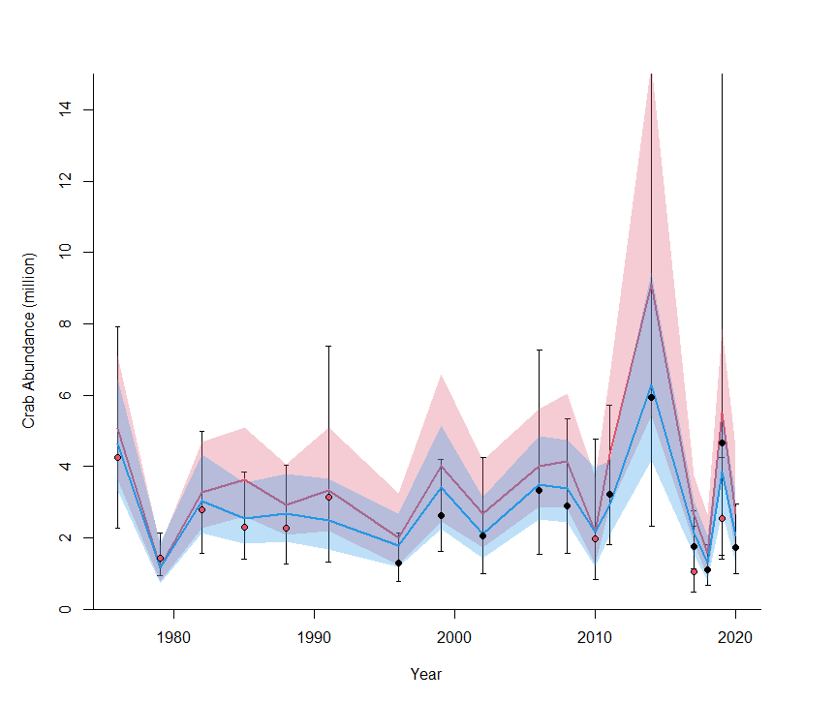

VAST model output of entire Q3 region by NBS survey only

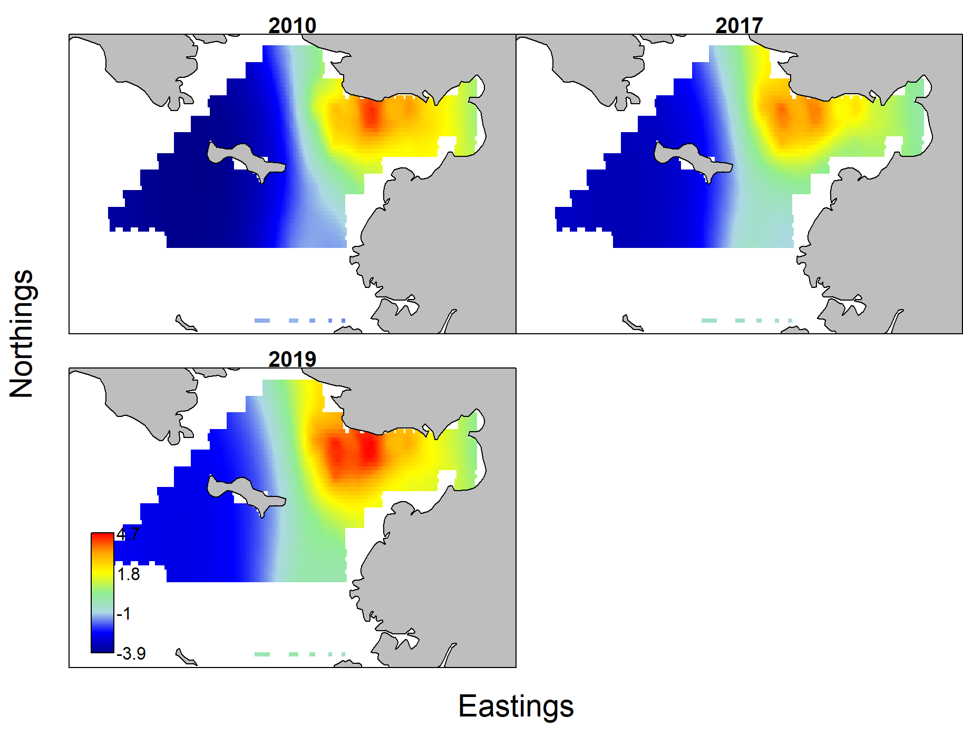

Discussion

Estimates of abundance were generally similar among survey and VAST. Model estimated CI ranges were smaller than survey CI, and abundance using all data set was larger than those with limited data, which is expected. VAST estimated of NSRKC distribution differ among years and survey dataset. Running and fitting NSRKC trawl data with VAST appeared to be difficult, probably because of lack of consistent data.

# Appendix E

# Comparison of NSRKC Assessment model and GMACS.

Here I present GMACS model results of Norton Sound Red King Crab.

### Results

1. Likelihood

#Likelihoods_by_type (raw and weighted)

Catch data : -243.0128 -243.0128

Index data : -17.4632 -17.4632

Size data : 2191.2923 2191.2923

Stock recruitment : 49.1075 49.1075

Tagging data : -27183.9978 -27183.9978

Penalties : 8.1202

Priors : 89.5863

Initial size-structure : 4.2178

Total : 2081.8482

#Likelihoods_by_type_and_fleet

Catches

Raw likelihood: -82.1415 -47.1010 -113.7703

Emphasis : 1.0000 1.0000 1.0000

Net likelihood: -82.1415 -47.1010 -113.7703

Index

Raw likelihood: -0.8482 -4.1091 -10.2921 -2.2137

Emphasis : 1.0000 1.0000 1.0000 1.0000

Net likelihood: -0.8482 -4.1091 -10.2921 -2.2137

Size-composition

Raw likelihood: 67.0324 630.1601 647.3172 86.7070 203.3226 477.7301 79.0228

Emphasis : 1.0000 1.0000 1.0000 1.0000 1.0000 1.0000 1.0000

Net likelihood: 67.0324 630.1601 647.3172 86.7070 203.3226 477.7301 79.0228

Recruitment penalities

Penalities : 49.1075 0.0000 0.0000

Because likelihood structures and weights differ between GMACS and assessment model, comparison of likelihood values in inappropriate.

1. Model estimates

|  |  |  |  |  |  |  |  |  |
| --- | --- | --- | --- | --- | --- | --- | --- | --- |
|  | NSRKC size classes | | | | | | | |
| M | 1 | 2 | 3 | 4 | 5 | 6 | 7 | 8 |
| GMACS | 0.18 | 0.18 | 0.18 | 0.18 | 0.18 | 0.18 | 0.19 | 0.19 |
| Assessment | 0.18 | 0.18 | 0.18 | 0.18 | 0.18 | 0.18 | 0.58 | 0.58 |
| Summer Com Selectivity | | | | | | | | |
| GMACS | 0.13 | 0.22 | 0.37 | 0.54 | 0.72 | 0.85 | 0.95 | 1.00 |
| Assessment | 0.12 | 0.33 | 0.64 | 0.86 | 0.96 | 0.99 | 1.00 | 1.00 |
| Summer Com Retention | | | | | | | | |
| GMACS | 0.00 | 0.00 | 0.00 | 0.08 | 0.89 | 1.00 | 1.00 | 1.00 |
| Assessment | 0.00 | 0.00 | 0.00 | 0.07 | 0.88 | 1.00 | 1.00 | 1.00 |
| Winter Com Selectivity | | | | | | | | |
| GMACS | 0.10 | 0.29 | 1.00 | 1.00 | 0.99 | 0.96 | 0.81 | 0.45 |
| Assessment | 0.07 | 0.51 | 0.85 | 1.00 | 0.80 | 0.57 | 0.31 | 0.13 |
| Winter Com Retention | |  |  |  |  |  |  |  |
| GMACS | 0.00 | 0.00 | 0.00 | 0.91 | 1.00 | 1.00 | 1.00 | 1.00 |
| Assessment | 0.00 | 0.00 | 0.00 | 0.07 | 0.79 | 0.99 | 1.00 | 1.00 |
| Molting probability | |  |  |  |  |  |  |  |
| GMACS | 0.94 | 0.91 | 0.87 | 0.81 | 0.72 | 0.62 | 0.51 | 0.40 |
| Assessment | 0.98 | 0.96 | 0.92 | 0.86 | 0.76 | 0.61 | 0.45 | 0.30 |

1. Growth transition matrix

|  |  |  |  |  |  |  |  |  |
| --- | --- | --- | --- | --- | --- | --- | --- | --- |
| GMACS | |  |  |  |  |  |  |  |
| Pre-molt \ Post-molt | | 2 | 3 | 4 | 5 | 6 | 7 | 8 |
| 1 | 0.00 | 1.00 | 0.00 | 0.00 | 0.00 | 0.00 | 0.00 | 0.00 |
| 2 | 0 | 0.00 | 1.00 | 0.00 | 0.00 | 0.00 | 0.00 | 0.00 |
| 3 | 0 | 0 | 0.02 | 0.98 | 0.00 | 0.00 | 0.00 | 0.00 |
| 4 | 0 | 0 | 0 | 0.08 | 0.92 | 0.00 | 0.00 | 0.00 |
| 5 | 0 | 0 | 0 | 0 | 0.26 | 0.74 | 0.00 | 0.00 |
| 6 | 0 | 0 | 0 | 0 | 0 | 0.55 | 0.45 | 0.00 |
| 7 | 0 | 0 | 0 | 0 | 0 | 0 | 0.81 | 0.19 |
| 8 | 0 | 0 | 0 | 0 | 0 | 0 | 0 | 1.00 |
| Assessment |  |  |  |  |  |  |  |  |
| Pre-molt \ Post-molt | |  |  |  |  |  |  |  |
|  | 0.02 | 0.10 | 0.79 | 0.09 | 0.00 | 0.00 | 0.00 | 0.00 |
|  | 0 | 0.04 | 0.24 | 0.69 | 0.03 | 0.00 | 0.00 | 0.00 |
|  | 0 | 0 | 0.08 | 0.43 | 0.48 | 0.01 | 0.00 | 0.00 |
|  | 0 | 0 | 0 | 0.16 | 0.58 | 0.26 | 0.00 | 0.00 |
|  | 0 | 0 | 0 | 0 | 0.29 | 0.60 | 0.10 | 0.00 |
|  | 0 | 0 | 0 | 0 | 0 | 0.50 | 0.48 | 0.03 |
|  | 0 | 0 | 0 | 0 | 0 | 0 | 0.72 | 0.28 |
|  | 0 | 0 | 0 | 0 | 0 | 0 | 0 | 1.00 |

MMB

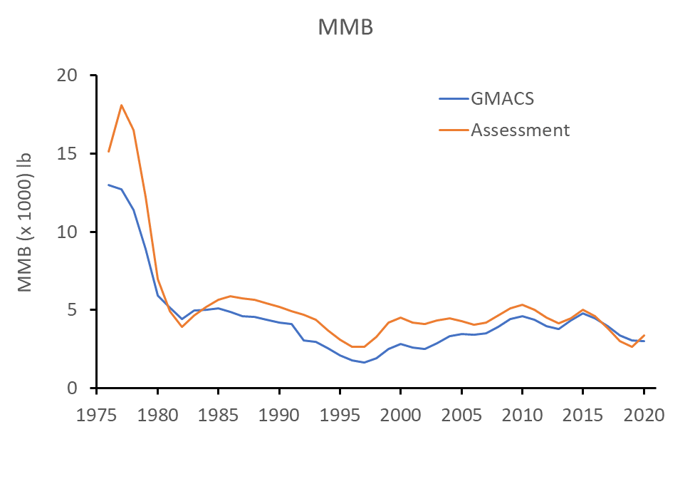

Comparison with assessment model GMACS estimates:

1. Nearly equal M across all size classes.
2. More gradual summer commercial post size selectivity.
3. More flattened dome shape Winter commercial pot size selectivity
4. Slightly higher molting probability of larger sized crab
5. Equal growth increments across all size classes.
6. Lower MMB.

Further analyses are needed to examine the source of differences.