**Norton Sound Red King Crab Stock Assessment for the fishing year 2021**

Toshihide Hamazaki1 and Jie Zheng 2

Alaska Department of Fish and Game Commercial Fisheries Division

1333 Raspberry Rd., Anchorage, AK 99518-1565

Phone: 907-267-2158

Email: [Toshihide.Hamazaki@alaska.gov](mailto:Toshihide.Hamazaki@alaska.gov)

2P.O. Box 115526, Juneau, AK 99811-5526

Phone : 907-465-6102

Email : [Jie.Zheng@alaska.gov](mailto:Jie.Zheng@alaska.gov)

# Executive Summary

1. Stock. Red king crab, *Paralithodes camtschaticus*, in Norton Sound, Alaska.
2. Catches. This stock supports three important fisheries: summer commercial, winter commercial, and winter subsistence fisheries. Of those, the summer commercial fishery accounts for 85% of total harvest. The summer commercial fishery started in 1977. Catch peaked in the late 1970s with retained catch of over 2.9 million pounds. Since 1994, the Norton Sound Crab fishery operated as super exclusive. For the 2020 fishery season, Norton Sound Red King Crab harvest consisted of **confidential number of** crab (**confidential** lb.) by winter commercial, 548 crab (1,096 lb) by winter subsistence, and 0 crab (0 lb) by summer commercial, totaling **confidential number of** crab (**confidential** lb). Total harvests were below ABC of 0.22 million lb. This harvest decline was due to NSEDC decided not to purchase crab.
3. Stock Biomass. The Norton Sound Red King Crab stock has been monitored by triennial surveys since 1976 by NOAA (1976-1991), NOAA NBS (2010, 2017, 2019), and ADF&G (1996-2020), with survey abundance ranged from 1.41 million to 5.9 million crab (> 63mm). In 2020, abundance by trawl survey by ADF&G was 1.717 million crab with survey CV of 0.27.
4. Recruitment. Model estimated recruitment was weak during the late 1970s and high during the early 1980s, with a slightly downward trend from 1983 to 1993. Estimated recruitment has been highly variable but on an increasing trend in recent years.
5. Management performance.

*Status and catch specifications (million lb.)*

|  |  |  |  |  |  |  |  |
| --- | --- | --- | --- | --- | --- | --- | --- |
| **Year** | **MSST** | **Biomass (MMB)** | **GHL** | **Retained**  **Commercial**  **Catch** | **Total**  **Retained**  **Catch** | **Retained**  **OFL** | **Retained**  **ABC** |
| 2017 | 2.31A | 5.14 | 0.50 | 0.49 | 0.50 | 0.67A | 0.54 |
| 2018 | 2.41B | 4.08 | 0.30 | 0.31 | 0.34 | 0.43B | 0.35 |
| 2019 | 2.24C | 3.12 | 0.15 | 0.08 | 0.08 | 0.24C | 0.19 |
| 2020 | 2.28D | 3.67 | 0.17 | Conf. | Conf. | 0.29D | 0.22 |
| 2021 | 2.24E | 4.83 | TBD | TBD | TBD | 0.59E | TBD |

*Status and catch specifications (1000t)*

|  |  |  |  |  |  |  |  |
| --- | --- | --- | --- | --- | --- | --- | --- |
| **Year** | **MSST** | **Biomass**  **(MMB)** | **GHL** | **Retained**  **Commercial**  **Catch** | **Total**  **Retained**  **Catch** | **Retained**  **OFL** | **Retained**  **ABC** |
| 2017 | 1.05A | 2.33 | 0.23 | 0.22 | 0.24 | 0.30A | 0.24 |
| 2018 | 1.09B | 1.85 | 0.13 | 0.14 | 0.15 | 0.20B | 0.16 |
| 2019 | 1.03C | 1.41 | 0.07 | 0.04 | 0.04 | 0.11C | 0.09 |
| 2020 | 1.04D | 1.66 | 0.08 | Conf. | Conf. | 0.13D | 0.10 |
| 2021 | 1.02E | 2.19 | TBD | TBD | TBD | TBD | TBD |

Notes:

MSST was calculated as BMSY/2

A-Calculated from the assessment reviewed by the Crab Plan Team in May 2017

B-Calculated from the assessment reviewed by the Crab Plan Team in May 2018

C-Calculated from the assessment reviewed by the Crab Plan Team in Jan 2019

D-Calculated from the assessment reviewed by the Crab Plan Team in Jan 2020

E-Calculated from the assessment reviewed by the Crab Plan Team in Jan 2021

Conversion to Metric ton: 1 Metric ton (t) = 2.2046×1000 lb

*Biomass in millions of pounds*

|  |  |  |  |  |  |  |  |  |  |
| --- | --- | --- | --- | --- | --- | --- | --- | --- | --- |
| **Year** | **Tier** | **BMSY** | **Current MMB** | **B/BMSY (MMB)** | **FOFL** | **Years to define**  **BMSY** | **M** | **1-Buffer** | **Retained ABC** |
| 2017 | 4a | 4.62 | 5.14 | 1.1 | 0.18 | 1980-2017 | 0.18 | 0.8 | 0.54 |
| 2018 | 4b | 4.82 | 4.08 | 0.9 | 0.15 | 1980-2018 | 0.18 | 0.8 | 0.35 |
| 2019 | 4b | 4.57 | 3.12 | 0.7 | 0.12 | 1980-2019 | 0.18 | 0.8 | 0.19 |
| 2020 | 4b | 4.56 | 3.66 | 0.8 | 0.14 | 1980-2020 | 0.18 | 0.75 | 0.22 |
| 2021 | 4a | 4.47 | 4.83 | 1.1 | 0.18 | 1980-2021 | 0.18 | TBD | TBD |

*Biomass in 1000t*

|  |  |  |  |  |  |  |  |  |  |
| --- | --- | --- | --- | --- | --- | --- | --- | --- | --- |
| **Year** | **Tier** | **BMSY** | **Current MMB** | **B/BMSY (MMB)** | **FOFL** | **Years to define**  **BMSY** | **M** | **1-Buffer** | **Retained ABC** |
| 2017 | 4a | 2.10 | 2.33 | 1.1 | 0.18 | 1980-2017 | 0.18 | 0.8 | 0.24 |
| 2018 | 4b | 2.07 | 1.85 | 0.9 | 0.15 | 1980-2018 | 0.18 | 0.8 | 0.16 |
| 2019 | 4b | 2.06 | 1.41 | 0.7 | 0.12 | 1980-2019 | 0.18 | 0.8 | 0.09 |
| 2020 | 4b | 2.07 | 1.66 | 0.8 | 0.14 | 1980-2020 | 0.18 | 0.75 | 0.10 |
| 2021 | 4b | 2.02 | 2.19 | 1.1 | 0.18 | 1980-2021 | 0.18 | TBD | TBD |

1. Probability Density Function of the OFL, OFL profile, and mcmc estimates.

1. The basis for the ABC recommendation

For Tier 4 stocks, the default maximum ABC is based on P*=49% that is essentially identical to the OFL. Accounting for uncertainties in assessment and model results, the SSC chose to use 90% OFL (10% Buffer) for the Norton Sound red king crab stock from 2011 to 2014. In 2015, the buffer was increased to 20% (ABC = 80% OFL). In 2020, the buffer was increased to 25% (ABC = 75% OFL) over concern for low CPUE of 2018-2019.

1. A summary of the results of any rebuilding analysis

N/A

1. ***Summary of Major Changes in 2020***
2. Changes to the management of the fishery**:**

None

1. Changes to the input data
   1. Data update:
      1. Winter subsistence harvest. Winter and summer commercial crab fishery did not catch crab.
      2. Trawl surveys: abundance, length-shell compositions:

ADFG 2021

1. Changes to the assessment methodology:

None

1. Changes to the assessment results.
2. ***Response to SSC and CPT Comments***

Crab Plan Team – January 14-17, 2020

* Discards add more details

Appendix C. We expanded descriptions of discards estimation method proposed by CPT.

* Explore potential differences of between handling mortality in the summer and winter

Authors’ reply: Handling mortality for summer and winter fishery (20%) was determined arbitrary since inception of the NSRKC assessment model and not verified by field or laboratory experiments. Authors appreciate CPT’s guidance regarding how this is explored in Norton Sound. As for impacts on abundance and biomass estimates, we ran model with several handling mortality scenarios (e.g. handling mortality changed 0%, 50%, 80%) and found little impacts on abundance and biomass estimates (results not presented here).

* Consider the impact of ghost fishing of lost pots from the winter fishery

Authors’ reply: This is an interesting topic; however, few data are available on NSRKC. The impact of ghost fishing is studied by recovering lost gear and determine the number of crabs caught (e.g. Stevens et al 2000) or deliberately “loose” and follow gear over time (Bullimore et al. 2001). There is also study by Long et al. (2014) utilizing 17 years of acoustic tags and tracking by boat and divers observing the tagged crab killed in ghost fishing gears. Those studies; however, appeared to be conducted in waters where it is safe to dive, locate and retrieve “lost” gears. In contrast, in Norton Sound winter fishing are conducted through ice and lost pots are often caused by changes of ice conditions (e.g. ice break) by storm, currents, or temperature increase.

Authors appreciate CPT’s guidance regarding how this issue can be explored in Norton Sound.

Bullimore, B. A., P.B. Newman, M. J. Kaiser, S. E. Gilbert, and K. M. Lock. 2001. A study of catch in a fleet of “ghost-fishing” post. Fishery Bulletin 99. 247-253.

Long, W.C., P.A. Cummisky, and J.E. Munk. 2014. Effects of ghost fishing on the population of red king crab (*Paralithodes camtschatcus*) in Womens Bay, Kodiak Island, Alaska. Fishery Bulletin 112, 101-111

Stevens, B.G., I. Vinning, B. Byersdorfer, and W. Donaldson. 2000. Ghost fishing by Tannar crab (*Chionpcetes baird*) pots off Kodiak, Alaska: pot density and crach per trap as determined from sidescan sonar and pot recovery data. Fishery Bulletin. 98, 389-399.

SSC – January 14-17, 2020

* Provide additional information and clarification on the data-weighting approach for size composition date in this assessment. Specifically, provide a justification for the arbitrary minimum sample sizes (10 or 20) applied to all but tag size-composition data, report the harmonic mean implied sample size (the average is a biased estimate for the multinomial), and provide standardized (Pearson) residuals in the residual plot including a legend showing the scale of the reported residuals.

Authors’ reply: the arbitrary minimum sample sizes (10 or 20) were evaluated, recommended, and adopted by CPT and SSC (SAFE 2012). The sample sizes were arbitrary selected by examining model fit between abundance (trawl survey) data and model. Increasing input sample size generally resulted in decline of model fit from trawl survey biomass data. Input sample sizes were reduced until the model fit to trawl survey biomass data was deemed reasonably acceptable. Weighting factor (0.5) of tag size-composition data were also determined in a similar manner. Alternative sample size setting, such as Francis’ weighting was tried (SAFE 2020); however, the attempt did not work well because of too few (8) size classes. Harmonic mean of implied sample size is reported in Figure 14, and standardized Pearson residual plots are reported in Figures 16-20.

* Explore widening the area used for the NOAA trawl survey biomass estimate and explore the effect on estimated catchability. The current catchability estimate is less than one and this may be related to the fact that crab are found outside of the standard area. In addition, please explore whether crab catches are also included from outside the assumed survey area.

Authors’ reply:

Estimates of abundance and distribution by VAST model are provided here.

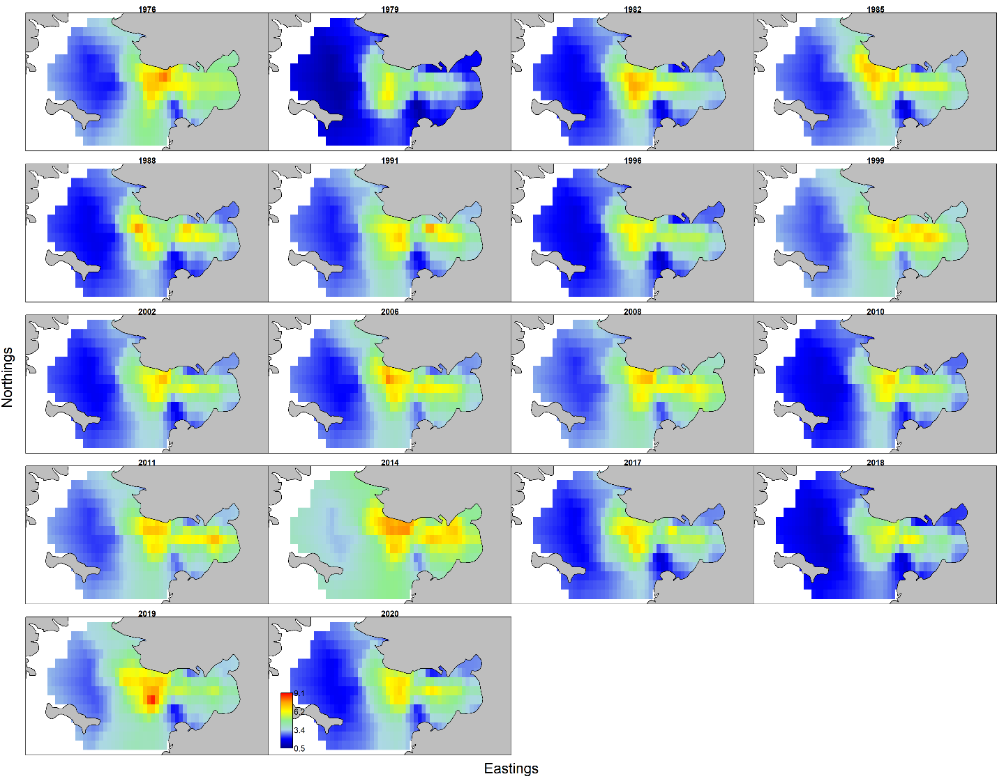

Except for 1978, more than 95% of crab have been harvested in fishery statistical area that are within the assumed survey area.



Figure: Proportion of Norton Sound Red King Crab harvested within the standard trawl survey area. Statistical area deemed within trawl survey area are 616331, 616401, 626331, 626401, 626402, 636330, 636401, 636402, 646330, 646401, 646402, 656300, 656330, 656401, 656402, 666300, 666330, 666401, 666402, 676300, and 676330. Note that boundaries of trawl survey quadrat and statistical area do not match perfectly. Not all standard trawl survey quadrats were surveyed every survey period.

* Report on time series of the proportion of barren females in the SAFE and address their utility to indicate reproductive concerns for the stock. Specifically, consider caveats to the interpretation of this proportion, address whether this proportion has changed over time, and compare these proportions to other managed red king crab stocks.

Authors’ reply:

The proportion of barren females in trawl surveys were reported in table 3, where the proportion was calculated as: the number of mature females with clean pleopods divided by the total number mature females captured. Note that data ADFG trawl surveys 1999 and 2002 includes both mature and immature because database did not contain the information, even though operational plan indicated that female maturity would be identified. BBRKC proportions may be inflated by likely including some immature females, especially during the early period.



While both NOAA and ADFG separate immature and mature females, it is unknown whether criteria are the same between the two agencies. It is also unknown whether the criteria have been consistent across years.

As for utility of the data in assessment model, hypothetically we can expect how the portion of barren females would affect future population as follows:



Where, *Nm,y+x* is the number male crab in y+x years, *pb,y* is the proportion of barren egg females, *Fy* is an average fecundity,*Nf,m,y* is the number of mature females, and *f* is a stock-recruit function.

The equation suggest that the proportion of barren mature females would be informative about predicting future populations, given that (1) the number of female is known, (2) stock-recruitment functional form is known, (3) female fecundity is known, and (4) the number of years to reach maturity is known. Thus far, this information, unfortunately, is unavailable for NSRKC stocks. To accomplish this following steps need to be accomplished: (1) estimate trawl survey abundance of female NSRKC, (2) construct female population dynamics model that estimate annual female abundance, (3) investigate methods that can estimate annual proportion of barren females, (4) investigate the number of years taking for maturity (i.e. x), and (5) investigate appropriate functional form that predict male crab abundance. After the above issues are investigated through field, laboratory, and simulation research, authors believe that potential effects of barren female proportion on future male recruitment, abundance, and biomass can be evaluated

In the meantime, limited historical data suggest that high barren mature female proportion observed in 2019 was not observed in 2020, and occurrence of this high barren female proportion appears to be episodic. Further, contrary to expectation that high barren female proportion would negatively impact future population, NSRKC abundance and MMB were stable or slightly increased from late-1990 to mid-2010s after high proportion of barren females observed in 1996-2005 (Figs 4, 5).

CPT – September 14-17, 2020

* For January 2021, the priority is to run the following models:
  + Model 19.0. Based on the model naming convention, this model should remain as 19.0 and include new data for 2020. For this base model, the estimated growth from the model should be compared to the estimated growth from tagging data outside of the model.
  + Model 20.0. The GMACS model. Detailed comparisons between this GMACS model and model 19.0 are needed. For example, GMACS could be run by taking the parameter estimates from model 19.0 as known inputs to evaluate differences due to model structure. Following this, some of the GMACS parameters could be estimated.

* Improve data weighting, especially effective sample sizes for length composition data.

Author reply:

Given that Francis’ weighting method did not work well, we appreciate any suggestions for data weighting and objective criteria for assessing improvements,

* Update VAST estimates.

Author reply:

Author appreciate an opportunity given to participate in VAST training workshop. However, running VAST model continues to be very difficult.

R-code previously worked in August 2020 now failed to run after Windows System updated. Reinstalling R VAST packages give errors

install_github("james-thorson/VAST")

Error in utils::download.file(url, path, method = method, quiet = quiet, :

download from 'https://api.github.com/repos/james-thorson/VAST/tarball/HEAD' failed

install.github("james-thorson/FishStatsUtils")

Error in install.github("james-thorson/FishStatsUtils") : ould not find function "install.github"

Even though the package was installed, the package failed to compile VAST via TMB

make: *** [C:/PROGRA~1/R/R-40~1.3/etc/x64/Makeconf:229: VAST_v9_4_0.o] Error 1

Error in TMB::compile(paste0(Version, ".cpp")) : Compilation failed

This is a recurring issue. Unfortunately, posting “issues” in GitHub did not resolve the issues. Authors appreciate further assistance.

* Report detailed data on female egg conditions and clutch fullness data. The percentages of barren mature females in Table 3 are helpful, but it is difficult to separate immature and mature females for some years, and the percentages may not be reliable. A table could be constructed that summarizes clutch fullness and percentages of barren mature females by year and length group. If information is not available to separate immature and mature females for a given year, footnotes of the table should show this lack of information.

Author reply:

Following is the percentage of barren females of mature crab by size class.

|  |  |  |  |  |  |  |  |  |  |  |
| --- | --- | --- | --- | --- | --- | --- | --- | --- | --- | --- |
|  |  | Length size classes | | | | | | | | |
| Year | Agent | 54 | 64 | 74 | 84 | 94 | 104 | 114 | 124 | 134 |
| 1976 | NOAA | 0 | 3.8 | 1.3 | 2.4 | 0 | 0 | 0 | 0 | 0 |
| 1979 | NOAA | 0 | 100 | 0 | 0 | 0 | 0 | 0 | 0 | 0 |
| 1982 | NOAA | 0 | 0 | 0 | 0 | 0 | 0 | 0 | 0 | 0 |
| 1985 | NOAA | 0 | 0 | 0 | 0 | 0 | 0 | 0 | 0 | 0 |
| 1988 | NOAA | 0 | 5.9 | 0 | 0 | 0 | 0 | 0 | 0 | 0 |
| 1991 | NOAA | 0 | 0 | 0 | 0 | 0 | 0 | 0 | 0 | 0 |
| 1996 | ADFG | 0 | 61.1 | 32.1 | 0 | 0 | 0 | 0 | 0 | 0 |
| 1999 | ADFG | 0 | 25 | 0 | 5.6 | 0 | 0 | 0 | 0 | 0 |
| 2002 | ADFG | 0 | 11.8 | 5.5 | 2.9 | 0 | 0 | 0 | 0 | 0 |
| 2006 | ADFG | 0 | 10 | 2.6 | 0 | 0 | 0 | 50 | 0 | 0 |
| 2008 | ADFG | 0 | 16.7 | 3.7 | 0 | 0 | 0 | 0 | 0 | 0 |
| 2010 | NOAA | 0 | 0 | 0 | 0 | 0 | 0 | 0 | 0 | 0 |
| 2011 | ADFG | 0 | 28.6 | 4.2 | 7.1 | 0 | 0 | 0 | 0 | 0 |
| 2014 | ADFG | 0 | 0 | 0 | 0 | 0 | 0 | 0 | 0 | 0 |
| 2017 | ADFG | 0 | 44.4 | 33.3 | 0 | 0 | 33.3 | 0 | 0 | 0 |
| 2017 | NOAA | 0 | 0 | 0 | 0 | 0 | 0 | 0 | 0 | 0 |
| 2018 | ADFG | 0 | 100 | 0 | 16.7 | 50 | 0 | 0 | 0 | 0 |
| 2019 | ADFG | 100 | 54.2 | 42.9 | 16.7 | 0 | 0 | 0 | 0 | 0 |
| 2019 | NOAA | 0 | 50 | 11.1 | 0 | 0 | 0 | 0 | 0 | 0 |
| 2020 | ADFG | 0 | 20 | 5.3 | 0 | 0 | 0 | 0 | 0 | 0 |

* Report the annual lost pot data, such as total number of lost pots each year and the proportion of pots lost in each fishery each year.

Author replay:

Following the number of pots lost in winter fisheries by fishery by year. Less than 10 pots per year are lost during summer subsistence fisheries,

|  |  |  |  |  |
| --- | --- | --- | --- | --- |
|  | Commercial | | Subsistence | |
| Year | # of pots lost | # of fishermen fished | # of pots lost | # of households fished |
| 2005–06 | ND | 1 | 50 | 67 |
| 2006–07 | ND | 8 | 132 | 116 |
| 2007–08 | ND | 9 | 6 | 108 |
| 2008–09 | ND | 7 | 8 | 70 |
| 2009–10 | 30 | 10 | 23 | 85 |
| 2010–11 | 3 | 5 | 8 | 95 |
| 2011–12 | 64 | 35 | 19 | 138 |
| 2012–13 | 23 | 26 | 4 | 104 |
| 2013–14 | 105 | 21 | 16 | 75 |
| 2014–15 | 104 | 44 | 16 | 107 |
| 2015–16 | 38 | 25 | 20 | 64 |
| 2016–17 | 201 | 43 | 11 | 109 |
| 2017–18 | 179 | 28 | 33 | 82 |
| 2018–19 | 32 | 6 | 59 | 60 |
| 2019–20 | 3 | conf | 33 | 50 |

Number of pots owned by each fisherman/household is unknown. The maximum pots permitted is 20 pots per fisherman since 2007 (Jim Menard ADFG). Winter commercial fish-ticket data indicate that on average 9 pot pulls per fish ticket returned, which indicates that commercial winter fisherman owns or uses 9 pots per fishing. Assuming that each fisherman owns 9 pots winter commercial fishermen would lose about 35% (6%- 71%) of their pots per year.

Potential impacts of lost pots on crab population is largely depends upon catchability of the lost pots. On average, winter commercial fishermen catch 4.5 legal retained male crabs per pot pull soaked for 3 day, indicating that a typical winter pot catches 1.5 (0.6 – 2.7) crabs per day. Applying to this catchability and assuming that lost pots keep catching crabs during the entire winter season (120 days), (i.e. 180 (72-324) crab/pot/season), total number of crab caught by lost commercial crab pots would be 230- 65,000 per year or 1% - 39% of total crab harvested per year. This estimate does not include sublegal, female, and legal (< 5.0 inch CW) crab that are also caught but not reported, as well as crabs caught by lost winter subsistence pots. Furthermore, the lost pots can continue catching crab year-round and multiple years. Those suggest that potential effects of lost winter commercial and subsistence pots on the NSRKC population could be far great than estimated here. Simultaneously, if lost pots are disintegrated quickly under the ice their potential impacts on the population could be negligible.

SSC – October 14-17, 2020

* bring forward OFL and ABC recommendations based on total catch rather than retained catch only.

Authors reply;

NSRKC summer (and winter) observer discards survey was started ***not to estimate total discards***, but to obtain some insights about characteristics of discards. The survey is entirely voluntary and opportunistic solely by cooperation of fishermen who allow a surveyor on board. While total discards can be calculated with various methods (Appendix C), none of the estimates are statistically sound or defensible. Those estimates are most likely biased with unknown degree.

Per request by of SSC, we calculated retained (OFL.r), unretained times handling mortality (0.2) (OFL.nr), and total OFL (OFL.t) based on 5 *ad hoc* estimates of discards (Appendix C).

|  |  |  |  |  |  |  |
| --- | --- | --- | --- | --- | --- | --- |
| Model | 19.0 | 19.0a | 19.0b | 19.0c | 19.0d | 19.0e |
| Method |  | LNR | LNR2 | Sub | Sub2 | Prop |
| Likelihood Total | 324.5 | 325.9 | 325.8 | 329.0 | 327.2 | 325.5 |
| Discards likelihood |  | 1.30 | 1.27 | 3.61 | 2.58 | 1.01 |
| OFLr | 0.593 | 0.589 | 0.589 | 0.592 | 0.591 | 0.587 |
| OFLnr | 0.039 | 0.039 | 0.039 | 0.041 | 0.039 | 0.039 |
| OFL.t | 0.632 | 0.628 | 0.628 | 0.633 | 0.630 | 0.626 |

However, because none of discards estimates are statistically sound and defensible, authors question validity of total OFL by any estimation methods.

For practical application of total OFL, stability of observer survey needs to be considered. As the survey is started as an *ad hoc*, the observer survey lacks any stable and dedicated funding and staff. Survey may not occur in the future, due to lack of volunteer fishermen, shortages of staff or funding. Thus, based on *ad hoc* nature of the program, ***authors do not recommend* setting total OFL for NSRKC stock.**

* bring forward a GMACS model (20.0) in the upcoming assessment, including a detailed comparison with the base model (19.0)

Author reply:

We were able to closely match population dynamics of GMACS with those of the assessment model 19.0 by entering assessment model estimated parameters (See Appendix E). However, the matches are not close enough to be considered that both models are producing identical population dynamics.

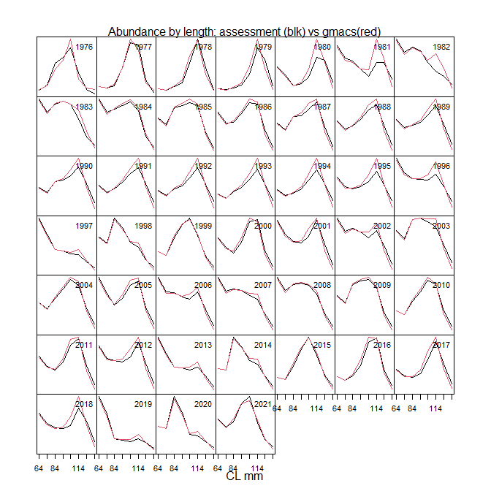

Figure: Male abundance by size class by year between assessment model (black) and gmacs (red)

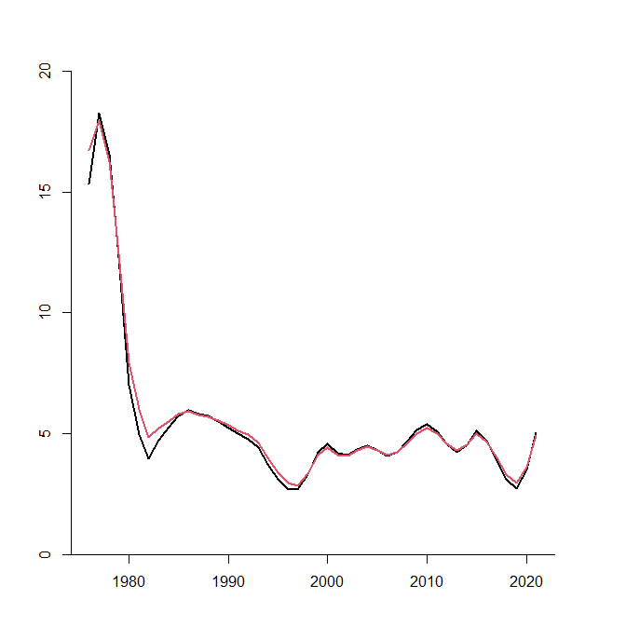

Figure: MMB (million lb) time series between assessment model (black) and gmacs (red)

* Further develop the VAST modeling approach and that they bring forward more complete diagnostics, including spatial residuals. Bring forward a model run in the upcoming assessment that uses the VAST estimates rather than standard survey estimates.

Author reply:

Running VAST model continues to be very difficult (See reply to CPT). Per request by SSC, model 19.0 was run with VAST estimates. Note that VAST estimates of NSRKC abundance are generally higher than the trawl survey because VAST estimates crab in areas where survey was not conducted. Consequently, as VAST coverage increased model estimated MMB, BMSY, and thus OFL increased. OFL was increased from 0.59 million lb of model 19.0 to 1.03 million lb for all data area and 0.75 million lb for ADFG area. Note that this VAST estimate did not cover entire Q3 NSRKC management area west of 167 where bycatch of NSRKC by ground fishery occur. If the VAST estimates were to be expanded to entire Q3, its abundance and thus MMB and OFL would be increased further.



Figure: MMB projection and BMSY of model 19.0 with trawl data (black), VAST of all trawl survey data (red), and VAST of data limited to ADFG survey area (green).

* include additional measures of reproductive success such as a time series of average clutch fullness.

Author reply:

Average clutch fullness was included in the table 3.

* The retrospective analysis should peel off more than 4 years to evaluate performance over a longer time period (~10 years) to better assess the magnitude and possible causes of the apparent positive bias in biomass estimates.

Author reply:

Model 19.0 includes data and likelihood components with shorter time series data that estimated retention probability. To conduct 10 years retrospective analysis retention probability was fixed with estimate from the 2020 data (Figure 22). By doing so, however, the model is not the same as the model 19.0. This also assumes that changes in estimates of retention probabilities have little or no influence on model projection.

As for possible causes of the positive bias, it is most likely due to high trawl survey abundance in 2014 and high proportion of sublegal crab following years. Historical SAFE model MMB time series and projection adopted by CPT-SSC shifted to overestimate after the 2014 trawl survey.



Figure: MMB timeseries and projection of NSRKC SAFE approved model from 2008 to 2021. Vertical red line shows 2014 trawl survey year.

* In the February 2020 SAFE, the author requested help with earlier SSC recommendations to incorporate LK/TK in the management process. In response, the SSC suggested that this could be a test case for efforts by the LK/TK Taskforce. In June the SSC acknowledged the challenges to this effort posed by the COVID pandemic and encouraged relationship building in an effort to work towards a more comprehensive, coordinated LK/TK and climate change-oriented outreach and community engagement effort beginning in 2021.

Author reply:

We appreciate LK/TK Taskforce for helping NSRKC management process. The LK/TK co-chairs informed the authors

“the Taskforce will not conduct original research (i.e., interviews, participant observation, focus groups, etc.) to collect data that answers the key management questions related to spatial patterns, size distribution, changes in spatial distribution, etc, ….., The LKTK Taskforce is able to give guidance and best practices for social science and Indigenous methods for doing LKTK research. I cannot speak to whether you are the appropriate person to do this work, because it will require a particular methodological and analytical skill set, and because assessment authors do have flexibility in putting together their documents. I think you have the ability to put together a contributing team for the assessment and maybe there's opportunity there.”

Further, authors were informed that

“The NPFMC Taskforce on Traditional Knowledge did identify Norton Sound King Crab as a critical issue… However, …, the Taskforce chose not to take this issue on in a case study approach. They decided it was premature to do so because they have not yet agreed upon best research practices, or how Council staff, in the future should engage these types of topics on behalf of the Council once the Taskforce is disbanded.”

To meet SSC’s requests following needs to be accomplished.

A team of TK/LK researchers who have expertise in planning and conducting the research needs to be identified.

A proposed research plan needs to be written and reviewed by the Taskforce.

The most importantly, funding source need to be identified and secured.

At this moment, none of the above has been done.

* The CPT, SSC and public comments have pointed out the lack of maturity data as well as potential trends in size at maturity. Specifically, the SSC suggested a meta-analysis across red king crab stocks that occur at different temperatures.

Author reply:

Although author contacted several scientists via literature search, authors were unable to get responses, and thus was unable to locate any Russian or Norwegian scientists who have and are willing to share data regarding red king crab size at maturity and ocean bottom temperatures where red king crab habits. Author requests SSC’s expertise locating those scientists and data. Note that the size at maturity of Barents Sea red king crab is similar to that of Bristol Bay red king crab (~104mm CL )(Rafter *et al.*, 1996) and female size at maturity is about 108mm CL (Hajelset et al 2009), even though bottom temperature of Barents Sea is comparable to Norton Sound (~ 4.0C) (Boitsov *et al.* 2012).

* The SSC agrees with additional recommendations in the CPT minutes, including a review of the growth matrix to determine if growth is overestimated in the model, which may explain some of the observed discrepancies between estimates of MMB and mature males caught in the survey.

Author reply:

We estimated model increments in default model 19.0 (linear) and for individual length class (19.1). Both models appeared to be overestimating growth increments than observed.

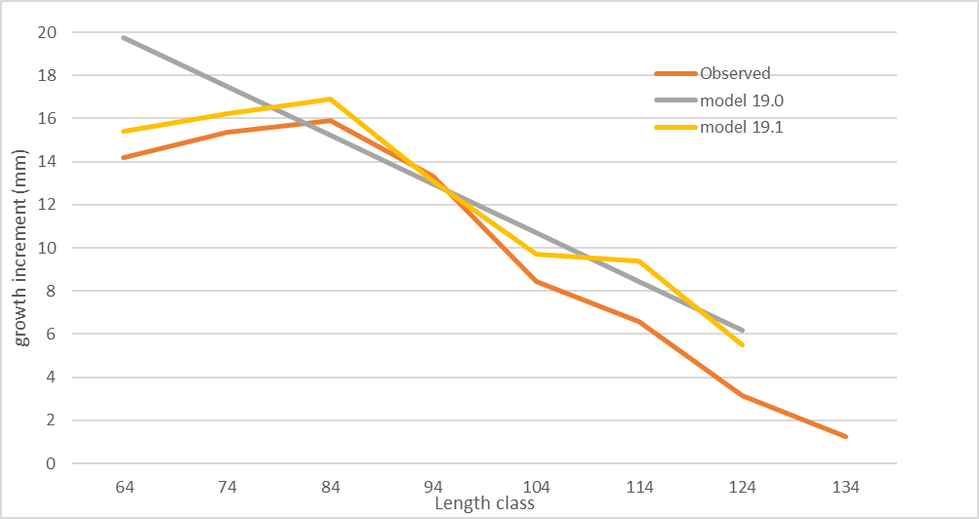

Model fit to tag recovery size distribution data are better for 19.1 (likelihood 67.7) than model 19.0 (likelihood 82.7). Visual inspection of model fits to tag recover data also showed that 19.1 had better fit than 19.0, though the difference appeared to be small.

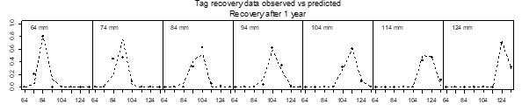

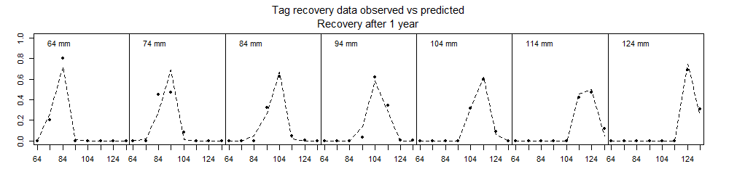

Figure: tag recovery fit between model 19.0 (above) and 19.1 (below)

However, MMB trends were similar between the two, which suggests that correcting growth does not appear to explain the observed discrepancies between estimates of MMB and mature males caught in the survey.



Figure: MMB projection between model 19.0 (black) and model 19.1 (red). Vertical dash lines show BMSY.

* The SSC adds one new recommendation with the goal of eventually including females in the assessment model, which is currently a male-only model. Specifically, we would like to see an inventory of available data on females, including a list of any surveys and studies that have sampled females, the type of data collected, sample sizes, the length of available time series, etc.

Author reply:

|  |  |  |
| --- | --- | --- |
| Survey type | Sample number | Data collected |
| Spring Pot survey | 2012: **101**, 2013: **248**  2014: **554**. 2015: **42** | CL length,  clutch fullness,  egg development,  egg color |
| Fall pot survey | 2013: **300**, 2014: **105** | CL length,  clutch fullness,  egg development,  egg color |
| Summer Trawl pot survey | 1976: **181**, 1979: **43**  1982: **269**, 1985: **151**  1988: **219**, 1991: **105**  1996: **168**, 1999: **81**  2002: **168**, 2006: **194**  2008: **163** | CL length,  clutch fullness,  egg development,  egg color |
| Summer Com Observer | 2012: **237**, 2013:**122**  2014: **104**, 2015: **224**  2016: **878**, 2017: **373**  2018: **579**, 2019: **89** | CL length,  clutch fullness,  egg development,  egg color |
| Winter Pot | 1983: **238**, 1984: **78**  1985: **14,** 1986: **6**  1987: **9**, 1989: **9**  1990: **18**, 1991: **8**  1993: **1**, 1995: **10**  1996: **26**, 1997: **60**  1998: **38**, 1999: **15**  2000: **22**, 2001: **1**  2002: **4**, 2003: **22**  2004: **9**, 2005: **20**  2006: **25**, 2007: **15**  2008: **102**, 2009: **29**  2010: **4**, 2011: **5**  2012: **7** | CL length,  clutch fullness, |

Here is a table of known historical survey, sample size, and type of data collected. Note that raw data may not be available in some of historical surveys. Other data may also exist.

1. ***Introduction***
   * + 1. Species: red king crab (*Paralithodes camtschaticus*) in Norton Sound, Alaska.
       2. General Distribution: Norton Sound red king crab is one of the northernmost red king crab populations that can support a commercial fishery (Powell et al. 1983). It is distributed throughout Norton Sound with a westward limit of 167-168o W. longitude, depths less than 30 m, and summer bottom temperatures above 4oC. The Norton Sound red king crab management area consists of two units: Norton Sound Section (Q3) and Kotzebue Section (Q4) (Menard et al. 2011). The Norton Sound Section (Q3) consists of all waters in Registration Area Q north of the latitude of Cape Romanzof, east of the International Dateline, and south of 66°N latitude (Figure 1). The Kotzebue Section (Q4) lies immediately north of the Norton Sound Section and includes Kotzebue Sound. Commercial fisheries have not occurred regularly in the Kotzebue Section. This report deals with the Norton Sound Section of the Norton Sound red king crab management area.
       3. Evidence of stock structure: Thus far, no studies have investigated possible stock separation within the putative Norton Sound red king crab stock.
       4. Life history characteristics relevant to management: One of the unique life-history traits of Norton Sound red king crab is that they spend their entire lives in shallow water since Norton Sound is generally less than 40 m in depth. Distribution and migration patterns of Norton Sound red king crab have not been well studied. Based on the 1976-2006 trawl surveys, red king crab in Norton Sound are found in areas with a mean depth range of 19 ± 6 (SD) m and bottom temperatures of 7.4 ± 2.5 (SD) oC during summer. Norton Sound red king crab are consistently abundant offshore of Nome.

Norton Sound red king crab migrate between deeper offshore and inshore shallow waters. Timing of the inshore mating migration is unknown, but is assumed to be during late fall to winter (Powell et al. 1983). Offshore migration occurs in late May - July (Jenefer Bell, ADF&G, personal communication). The results from a study funded by North Pacific Research Board (NPRB) during 2012-2014 suggest that older/large crab (> 104mm CL) stay offshore in winter, based on findings that large crab are not found nearshore during spring offshore migration periods (Jenefer Bell, ADF&G, personal communication). Molt timing is unknown but likely occurs in late August – September, based on increase catches of newly-molted crab late in the fishing season (August- September) (Joyce Soong, ADF&G personal communication) and evaluation of molting hormone profiles in the hemolymph (Jenefer Bell, ADF&G, personal communication). Recent observations also indicate that mating may be biennial (Robert Foy, NOAA, personal communication). Trawl surveys show that crab distribution is dynamic with recent surveys showing high abundance on the southeast side of Norton Sound, offshore of Stebbins and Saint Michael.

* + - 1. Brief management history: Norton Sound red king crab fisheries consist of commercial and subsistence fisheries. The commercial red king crab fishery started in 1977 and occurs in summer (June – August) and winter (December – May). The majority of red king crab harvest occurs offshore during the summer commercial fishery, whereas the winter commercial and subsistence fisheries occur nearshore through ice.

Summer Commercial Fishery

A large-vessel summer commercial crab fishery started in 1977 in the Norton Sound Section (Table 1) and continued from 1977 through 1990. No summer commercial fishery occurred in 1991 because there were no staff to manage the fishery. In March 1993, the Alaska Board of Fisheries (BOF) limited participation in the fishery to small boats. Then on June 27, 1994, a super-exclusive designation went into effect for the fishery. This designation stated that a vessel registered for the Norton Sound crab fishery may not be used to take king crabs in any other registration areas during that registration year. A vessel moratorium was put into place before the 1996 season. This was intended to precede a license limitation program. In 1998, Community Development Quota (CDQ) groups were allocated a portion of the summer harvest; however, no CDQ harvest occurred until the 2000 season. On January 1, 2000 the North Pacific License Limitation Program (LLP) went into effect for the Norton Sound crab fishery. The program dictates that a vessel which exceeds 32 feet in length overall must hold a valid crab license issued under the LLP by the National Marine Fisheries Service. Changes in regulations and the location of buyers resulted in eastward movement of the harvest distribution in Norton Sound in mid-1990s. In Norton Sound, a legal crab is defined as ≥ 4-3/4 inch carapace width (CW, Menard et al. 2011), which is approximately equivalent to ≥ 104 mm carapace length mm CL. Since 2005, commercial buyers (Norton Sound Economic Development Corporation) started accepting only legal crab of ≥ 5 inch CW. This may have increased discards; however, because discards have not been monitored until 2012, impact of this change on discards is unknown. This issue was also examined in assessment model selection, which showed no difference in estimates of selectivity functions before and after 2005 (NPFMC 2016).

Portions of Norton Sound area are closed to commercial fishing for red king crab. Since the beginning of the commercial fisheries in 1977, waters approximately 5-10 miles offshore of southern Seward Peninsula from Port Clarence to St. Michael have been closed to protect crab nursery grounds during the summer commercial crab fishery (Figure 2). The spatial extent of closed waters has varied historically. In 2020 Board of Fisheries closed Norton Sound area east of 167 degrees W. longitude for commercial summer crab fisheries.

CDQ Fishery

The Norton Sound and Lower Yukon CDQ groups divide the CDQ allocation. Only fishers designated by the Norton Sound and Lower Yukon CDQ groups are allowed to participate in this portion of the king crab fishery. Fishers are required to have a CDQ fishing permit from the Commercial Fisheries Entry Commission (CFEC) and register their vessel with the Alaska Department of Fish and Game (ADF&G) before begin fishing. Fishers operate under the authority of each CDQ group. CDQ harvest share is 7.5% of total projected harvest, which can be prosecuted in both summer and winter fisheries season.

Winter Commercial Fishery

The winter commercial crab fishery is a small fishery using hand lines and pots through the nearshore ice. On average 10 permit holders harvested 2,500 crab during 1978-2009. From 2007 to 2015 the winter commercial catch increased from 3,000 crab to over 40,000 (Table 2). In 2015 winter commercial catch reached 20% of total crab catch. The BOF responded in May 2015 by amending regulations to allocate 8% of the total commercial guideline harvest level (GHL) to the winter commercial fishery, which became in effect since the 2017 season. The winter red king crab commercial fishing season was also set from January 15 to April 30, unless changed by an emergency order. The new regulation became in effect since the 2016 season.

Subsistence Fishery

While the winter subsistence fishery has a long history, harvest information is available only since the 1977/78 season. The majority of the subsistence crab fishery harvest occurs using hand lines and pots through nearshore ice. Average annual winter subsistence harvest was 5,400 crab (1977-2010). Subsistence harvesters need to obtain a permit before fishing and record daily effort and catch. There are no size or sex specific harvest limits; however, the majority of retained catches are males of near legal size.

Summer subsistence crab fishery harvest has been monitored since 2004 with an average harvest of 712 crab per year. Since this harvest is very small, the summer subsistence fishery was not included in the assessment model. **Harvest of both commercial and subsistence winter fisheries is influenced largely by availability of stable ice condition. Low harvest can occur due to poor ice condition, regardless of crab abundance.**

* + - 1. Brief description of the annual ADF&G harvest strategy

Since 1997 Norton Sound red king crab has been managed based on a guideline harvest level (GHL). From 1999 to 2011 the GHL for the summer commercial fishery was determined by a prediction model and the model estimated predicted biomass: (1) 0% harvest rate of legal crab when estimated legal biomass < 1.5 million lb; (2) ≤ 5% of legal male abundance when the estimated legal biomass falls within the range 1.5-2.5 million lb; and (3) ≤ 10% of legal male when estimated legal biomass >2.5 million lb.

In 2012 a revised GHL for the summer commercial fishery was implemented: (1) 0% harvest rate of legal crab when estimated legal biomass < 1.25 million lb; (2) ≤ 7% of legal male abundance when the estimated legal biomass falls within the range 1.25-2.0 million lb; (3) ≤ 13% of legal male abundance when the estimated legal biomass falls within the range 2.0-3.0 million lb; and (3) ≤ 15% of legal male biomass when estimated legal biomass >3.0 million lb.

In 2015 the Alaska Board of Fisheries passed the following regulations regarding the winter commercial fisheries:

* 1. Revised GHL to include summer and winter commercial fisheries.
  2. Set guideline harvest level for the winter commercial fishery (GHLw) at 8% of the total GHL
  3. Dates of the winter red king crab commercial fishing season are from January 15 to April 30.

OFL and ABC of Norton Sound red king crab is **retained crab** only, primarily because of **the lack of estimates of unretained crab (i.e. discards) from summer and winter commercial fisheries**. Voluntary opportunistic summer commercial crab fishery observer survey was started since 2012, in which an observer was invited to a boat to sample and records discards. Although total discards can be calculated from those samples using various estimation methods (Appendix C), representativeness of the surveys and thus accuracy of total discards estimates remains unknown. **Thus far, neither CPT nor SSC recommended an discards estimation methods appropriate for NSRKC.**

|  |  |
| --- | --- |
| Year | Notable historical management changes |
| 1976 | The abundance survey started |
| 1977 | **Large vessel commercial fisheries began (Legal size ≥ 5 inch CW)** |
| 1978 | **Legal size changes to ≥ 4.75 inch CW** |
| 1991 | Fishery closed due to staff constraints |
| 1994 | Super exclusive designation went into effect. The end of large vessel commercial fishery operation. |
| 1998 | Community Development Quota (CDQ) allocation went into effect |
| 1999 | Guideline Harvest Level (GHL) went into effect |
| 2000 | North Pacific License Limitation Program (LLP) went into effect. |
| 2002 | Change in closed water boundaries (Figure 2) |
| 2005 | **Commercially accepted legal crab size changed from ≥ 5 inch CW** |
| 2006 | The Statistical area Q3 section expanded (Figure 1) |
| 2008 | Start date of the open access fishery changed from July 1 to after June 15 by emergency order.  **Pot configuration requirement: at least 4 escape rings (> 4.5 inch diameter) per pot located within one mesh of the bottom of the pot, or at least ½ of the vertical surface of a square pot or sloping side-wall surface of a conical or pyramid pot with mesh size > 6.5 inches.** |
| 2012 | The Board of Fisheries adopted a revised GHL for summer fishery. |
| 2016 | Winter GHL for commercial fisheries was established and modified winter fishing season dates were implemented. |
| 2020 | BOF closed summer commercial fishery E of 164 Latitude. |

* + - 1. Summary of the history of the *B*MSY.

NSRKC is a Tier 4 crab stock. Direct estimation of the *B*MSY is not possible. The *B*MSY proxy is calculated as mean model estimated mature male biomass (MMB) from 1980 to present. Choice of this period was based on a hypothesized shift in stock productivity a due to a climatic regime shift indexed by the Pacific Decadal Oscillation (PDO) in 1976-77.

1. ***Data***
2. Summary of new information:

Winter commercial and subsistence fisheries:

The winter commercial fishery catch in 2020 was *confidential* crab (*confidential* lb.). Subsistence retained crab catch was 813 and unretained was 265 crab or 33 % of total catch (Table 2).

Summer commercial fishery:

The summer commercial fishery opened on 6/25/2020 and closed on 9/03/2020. Total of 0 crab (0 lb.) were harvested (Table 1). This has been the lowest harvest since 2000.

Total retained harvest for the 2020 season was *confidential* crab (*confidential* lb) and did not exceed the 2020 ABC of 0.22 million lb.

Observer total and discard, or commercial retained crab surveys were conducted. No tagged crab recovery was reported.

Estimated summer trawl Norton Sound red king crab abundance survey by ADFG (7/31-8/14, 2020) (> 63 mm) was 1.72 million (CV 27%) (Table 3).

1. Available survey, catch, and tagging data
2. 

|  |  |  |  |
| --- | --- | --- | --- |
|  | Years | Data Types | Tables |
| Summer trawl survey | 76,79,82,85,88,91,96, 99, 02,06,08,10,11,14,17-20 | Abundance | 3 |
| Length-shell comp | 6 |
| Winter pot survey | 81-87, 89-91,93,95-00,02-12 | Length-shell comp | 7 |
| Summer commercial fishery | 77-90,92-19 | Retained catch | 1 |
| Standardized CPUE, | 1 |
| Length-shell comp | 4 |
| Summer Com total catch | 12-19 | Length-shell comp | 9 |
| Summer Com Discards | 87-90,92,94, 12-19 | Length-shell comp | 8 |
| Winter subsistence fishery | 76-20 | Total & Retained catch | 2 |
| Winter commercial fishery | 78-20 | Retained catch | 2 |
|  | 15-18 | Retained Length-Shell | 5 |
| Tag recovery | 80-19 | Recovered tagged crab | 10 |

Data available but not used for assessment

|  |  |  |  |
| --- | --- | --- | --- |
| Data | Years | Data Types | Reason for not used |
| Summer pot survey | 80-82,85 | Abundance | Uncertainties on how estimates were made. |
| Length proportion |
| Summer preseason survey | 95 | Length proportion | Just one year of data |
| Summer subsistence fishery | 2005-2013 | retained catch | Too few catches compared to commercial |
| Winter Pot survey | 87, 89-91,93,95-00,02-12 | CPUE | CPUE data Not reliable due to ice conditions |
| Preseason Spring pot survey | 2011-15 | CPUE,  Length proportion | Years of data too short |
| Postseason Fall pot survey | 2013-15 | CPUE,  Length proportion | Years of data too short |

Catches in other fisheries

In Norton Sound, the directed Pacific Cod pot fishery was issued in 2018 under the CDQ permit. In 2018 and 2019 fishery seasons, a total of 8 and 13 kg (mortality applied) of NSRKC were taken from the groundfish fisheries (CPT 2020). However, all of bycatch occurred in the west of 168.0 longitude where none of NSRKC survey has been conducted.

|  |  |  |
| --- | --- | --- |
|  | Fishery | Data availability |
| Other crab fisheries | Does not exist | NA |
| Groundfish pot | Pacific Cod | Y |
| Groundfish trawl | Does not exist | NA |
| Scallop fishery | Does not exist | NA |

1. Other miscellaneous data:

Satellite tag migration tracking (NOAA 2016, ADFG 2020)

Spring offshore migration distance and direction (2012-2015)

Monthly blood hormone level (indication of molting timing) (2014-2015)

Data aggregated:

Proportions of legal size crab, estimated from trawl survey and observer data. (Table 13)

Data estimated outside the model:

Summer commercial catch standardized CPUE (Table 1, Appendix B)

1. ***Analytic Approach***
2. **History of the modeling approach.**

The Norton Sound red king crab stock was assessed using a length-based synthesis model (Zheng et al. 1998). Since adoption of the model, a major challenge is how to deal with low proportions of large male crab in the trawl survey and commercial fishery catch data; specifically the model projects higher abundance-proportions of large size class (> 123mm CL) of crab than observed. This problem was further exasperated when natural mortality *M* was set to 0.18 from previous *M* = 0.3 in 2011 (NPFMC 2011). This issue has been resolved by assuming (3-4 times) higher *M* for the large crab (i.e., *M* = 0.18 for length classes ≤ 123mm, and higher M for > 123mm) (NPFMC 2012, 2013, 2014, 2015, 2016, 2017, 2018). Alternative assumptions have been explored, such as changing molting probability (i.e., crab matured quicker or delayed maturation), higher natural mortality, and dorm shaped selectivity (i.e., large crab are not caught, or moved out of fishery/survey grounds). However, those alternative assumptions did not produce better model fits. Model estimated length specific molting probability was similar to inverse logistic curve, and did not improve model fit (NPFMC 2016). Constant *M* across all length classes resulted in higher *M* (0.3-0.45) (NPFMC 2013, 2017). Dome shaped selectivity (i.e., assume large crab were not caught/not surveyed/moved out of survey and fishing area) increased MMB twice higher than other models. A model with gradual increase of *M* across length classes resulted in *M* increase staring at size 94mm. However, this did not improve overall model fit and was rejected for model consideration (NPFMC 2018). With addition of total catch length data in summer and retention length data in winter commercial fisheries, the 2019 model specification examined estimation of retention curve for both summer and winter fishery, and evaluation of OFL under Tier 3 formula.

Historical Model configuration progression:

2011 (NPFMC 2011)

1). *M* =0.18.

2). *M* of the last length class = 0.288.

3). Include summer commercial discards mortality = 0.2.

4). Weight of fishing effort = 20.

5). The maximum effective sample size for commercial catch and winter surveys = 100.

2012 (NPFMC 2012)

1. *M* of the last length class = 3.6×*M*.
2. The maximum effective sample size for commercial catch and winter surveys = 50.
3. Weight of fishing effort = 50.

2013 (NPFMC 2013)

* 1. Standardize commercial catch cpue and replace likelihood of commercial catch efforts to standardized commercial catch cpue with weight = 1.0.
  2. Eliminate summer pot survey data from likelihood.
  3. Estimate survey *q* of 1976-1991 NMFS survey with maximum of 1.0.
  4. The maximum effective sample size for commercial catch and winter surveys = 20.

2014 (NPFMC 2014)

1. Modify functional form of selectivity and molting probability to improve parameter estimates (2 parameter logistic to 1 parameter logistic).
2. Include additional variance for the standardized cpue.
3. Include winter pot survey cpue (But was removed from the final model due to lack of fit).
4. Estimate growth transition matrix from tagged recovery data.

2015 (NPFMC 2015)

1. Winter pot survey selectivity is an inverse logistic, estimating selectivity of the smallest length group independently.
2. Reduce Weight of tag-recovery: W = 0.5.
3. Model parsimony: one trawl survey selectivity and one commercial pot selectivity.

2016 (NPFMC 2016)

1. Length range extended from 74mm – 124mm above to 64mm – 134mm above.
2. Estimate multiplier for the largest (> 123mm) length classes.

2017 (NPFMC 2017)

1. Change molting probability function from 1 to 2 parameter logistic. Assume molting probability not reaching 1 for the smallest length class.

2018 No model change requests

2019 (NPFMC 2019)

1. Fit total catch length composition and estimate retention probability for summer and winter commercial fishery.
2. Include winter commercial retained length data.

2020 No model change.

1. **Model Description**
2. Description of overall modeling approach:

The model is a male-only size structured model that combines multiple sources of survey, catch, and mark-recovery data using a maximum likelihood approach to estimate abundance, recruitment, catchability of the commercial pot gear, and parameters for selectivity and molting probabilities (See Appendix A for full model description).

Unlike other crab assessment models, NSRKC modeling year starts from February 1st to January 31st of the following year. This schedule was selected because Norton Sound winter crab fisheries can start when Norton Sound ice becomes thick enough to operate fishery safely, which can be as earliest as mid-late January.

b-f. See Appendix A.

1. Critical assumptions of the model:
2. Male crab mature at CL length 94mm.

Size at maturity of NSRKC (CL 94 mm) was determined by adjusting that of BBRKC (CL 120mm) reflect the slower growth and smaller size of NSRKC.

1. Molting occurs in the fall after the summer fishery.
2. Instantaneous natural mortality *M* is 0.18 for all length classes, except for the last two length groups (>123mm).
3. Trawl survey selectivity is a logistic function with 1.0 for length classes 7-8. Selectivity is constant over time.
4. Winter pot survey selectivity is a dome shaped function: Reverse logistic function of 1.0 for length class CL 84mm, and model estimate for CL < 84mm length classes. Selectivity is constant over time.

This assumption is based on the fact that a low proportion of large crab are caught in the nearshore area where winter surveys occur. Causes of this pattern may be that (1) fewer large crab migrate into nearshore waters in winter or (2) large crab are fished out by winter fisheries where the survey occurs (i.e., local depletion). Recent studies suggest that the first explanation is more likely than the second (Jenefer Bell, ADF&G, personal communication).

1. Summer commercial fisheries selectivity is an asymptotic logistic function of 1.0 at the length class CL 134mm. While the fishery changed greatly between the periods (1977-1992 and 1993-present) in terms of fishing vessel composition and pot configuration, the selectivity of each period was assumed to be identical. Model fits of separating and combining the two periods were examined in 2015 and showed no difference between the two models (NPFMC 2015). For model parsimony, the two were combined.
2. Summer trawl survey selectivity is an asymptotic logistic function of 1.0 at the length of CL 134mm. While the survey changed greatly between NOAA (1976-1991) and ADF&G (1996-present) in terms of survey vessel and trawl net structure, selectivity of both periods was assumed to be identical. Model fits separating and combining the two surveys were examined in 2015. No differences between the two models were observed (NPFMC 2015) and for model parsimony the two were combined.
3. Winter commercial and subsistence fishery selectivity and length-shell conditions are the same as those of the winter pot survey. All winter commercial and subsistence harvests occur February 1st.

Winter commercial king crab pots can be any dimension (5AAC 34.925(d)). No length composition data exist for crab harvested in the winter commercial and subsistence fisheries. However, because commercial fishers are also subsistence fishers, it is reasonable to assume that the commercial fishers used crab pots that they use for subsistence harvest, and hence both fisheries have the same selectivity.

1. Growth increments are a function of length, constant over time and estimated from tag recovery data.
2. Molting probability is an inverse logistic function of length for males.
3. A summer fishing season for the directed fishery is short. All summer commercial harvests occur at the day when 50% of harvest occurred.
4. Discards handling mortality rate for all fisheries is 20%.

No empirical estimates are available.

1. Annual retained catch is measured without error.
2. Retained catch of crab are estimated by retained probability function.

Since 2005, buyers announced that only legal crab with ≥ 5 inch CW are acceptable for purchase. Since samples are taken at a commercial dock, it was anticipated that this change would lower the proportion of legal crab. However, the model was not sensitive to this change (NPFMC 2013, 2017).

1. Length compositions have a multinomial error structure and abundance has a log-normal error structure.
2. Changes of assumptions since last assessment:

None.

1. **Model Selection and Evaluation**
2. Description of alternative model configurations.

For 2021 preliminary assessment, we used the base model adopted for the 2020 assessment (Model 19.0). We do not propose alternative models this time. Instead, we present results by GMACS.

1. Evaluation of negative log-likelihood values.

|  |  |
| --- | --- |
|  | **Jan 2021** |
| Model |  |
| Additional Parameters |  |
| Total | 324.49 |
| TSA | 11.10 |
| St.CPUE | -24.23 |
| TLP | 122.13 |
| WLP | 38.50 |
| CLP | 49.20 |
| OBS | 24.54 |
| REC | 2.73 |
| WN | 17.79 |
| TAG | 82.69 |
| BMSY(mil.lb) | 4.52 |
| MMB 2021 (mil.lb) | 5.05 |
| Legal crab Catchable (mil.lb) | 3.96 |
| OFL(mil.lb) | 0.59 |
| M | 0.18/0.59 |

TSA: Trawl Survey Abundance

St. CPUE: Summer commercial catch standardized CPUE

TLP: Trawl survey length composition:

WLP: Winter pot survey length composition

CLP: Summer commercial retention catch length composition

REC: Recruitment deviation

OBS: Summer commercial catch observer discards (Baseline) or total catch (Alternative models) length composition

TAG: Tagging recovery data composition

WN: Winter Commercial length-shell composition

1. **Results** 
   1. List of effective sample sizes and weighting factors (Figure 15)

“Implied” effective sample sizes were calculated as



Where and are observed and estimated length compositions in year *y* and length group *l*, respectively. Estimated effective sample sizes vary greatly over time.

Maximum sample sizes for length proportions:

|  |  |
| --- | --- |
| Survey data | Sample size |
| Summer commercial, winter pot,  and summer observer | minimum of 0.1 × actual sample size or 10 |
| Summer trawl and pot survey | minimum of 0.5 × actual sample size or 20 |
| Tag recovery | 0.5× actual sample size |

The above sample sizes were arbitrary selected by examining model fit between abundance (trawl survey) data and model. Increasing input sample size generally resulted in decline of model fit totrawl survey abundance.

Weighting factor:

Recruitment SD: 0.5.

2. Tables of estimates.

1. Model parameter estimates (Tables 11, 12, 13).
2. Abundance and biomass time series (Table 14).
3. Recruitment time series (Table 14).
4. Time series of catch/biomass (Tables 15).

3. Graphs of estimates.

a. Molting probability and trawl/pot selectivity (Figure 3).

b. Estimated male abundances (recruits, legal, and total) (Figure 4).

c. Estimated mature male biomass (Figure 5).

e. Time series of catch and estimated harvest rate (Figure 6).

4. Evaluation of the fit to the data.

a. Fits to observed and model predicted catches.

Not applicable. Catch is assumed to be measured without error.

b. Model fits to survey numbers.

* 1. Time series of trawl survey (Figure 7).
  2. Time series of standardized cpue for the summer commercial fishery (Figure 8).

c. Model fits to catch and survey proportions by length (Figures 9-13).

d. Marginal distribution for the fits to the composition data.

1. Plots of implied versus input effective sample sizes and time-series of implied effective sample size (Figure 14).
2. Plots of bubble and Pearson residuals (Figure 15- 20)

f. RMSEs of trawl survey and standardized CPUE. QQ plots and histograms of residuals of trawl survey and standardized CPUE (Figure 21).

1. Retrospective analyses (Figure 22).

Retrospective analyses were limited to past 5 years because winter commercial length data that were used to estimate retention curve were limited to 5 years of data.

|  |  |  |
| --- | --- | --- |
| Year | Predicted MMB (x1000) | Hindcast  MMB |
| 2021 | 4.830 |  |
| 2020 | 3.389 | 3.722 |
| 2019 | 2.656 | 3.060 |
| 2018 | 3.030 | 3.950 |
| 2017 | 3.831 | 5.649 |
| 2016 | 4.604 | 4.086 |

Revised Mohn’s rho 0.257

Hurtado-Ferro et al. (2015), provided guideline of Mohn’s rho exceeding the range of (-0.15 to 0.2) for longer life-history and (-0.22 to 0.30) for shorter lived species, should cause for concern.

1. Uncertainty and sensitivity analyses.
2. ***Calculation of the OFL***

1. Specification of the Tier level and stock status.

The Norton Sound red king crab stock is placed in Tier 4. It is not possible to estimate the spawner-recruit relationship, but some abundance and harvest estimates are available to build a computer simulation model that captures the essential population dynamics. Tier 4 stocks are assumed to have reliable estimates of current survey biomass and instantaneous *M*; however, the estimates for the Norton Sound red king crab stock are uncertain.

Tire 4 level and the OFL are determined by the *FMSY* proxy, *BMSY* proxy, and estimated legal male abundance and biomass:

|  |  |  |
| --- | --- | --- |
| Level | Criteria | *FOFL* |
| a |  |  |
| b |  |  |
| c |  |  |

where *B* is a mature male biomass (MMB), *BMSY* proxy is average mature male biomass over a specified time period, *M* = 0.18, *γ* = 1, *α* = 0.1, and *β* = 0.25.

For Norton Sound red king crab, MMB is defined as the biomass of males > 94 mm CL on February 01(Appendix A)**.**  *BMSY* proxy is

*BMSY* proxy = average model estimated MMB from 1980-2021.

**Estimated *BMSY* proxy is: 4.526 million lb or 2.053 k ton.**

Predicted mature male biomass in 2021 on February 01

**Mature male biomass: 5.046 (SE 0.70) million lb. or 2.29 (SE 0.31) k ton**

Since projected MMB is above *BMSY* proxy,

**Norton Sound red king crab stock status is Tier 4a,**

Where *FOFL* is calculated by



***FOFL* of 0.18 for all length classes.**

* 1. Calculation of OFL.

OFL was calculated for retained (*OFLr*), un-retained (*OFLur*), and total (*OFLT*) for legal sized crab, *Legal_B*, by applying *FOFL*.

*Legal_B* is a biomass of legal crab subject to fisheries and is calculated as: projected abundance by length crab (*Nw,l* + *Ow,l*)× fishery selectivity by length class (*Ss,l*) × proportion of legal crab per length class (*Plgl,l*) × average lb per length class (*wml*).



Sublegal (unretained crab) is defined as winter sublegal crab catchable to fishery



The Norton Sound red king crab fishery consists of two distinct fisheries: winter and summer. The two fisheries are discontinuous with 5 months between the two fisheries during which natural mortalities occur. To incorporate this fishery, the CPT in 2016 recommended the following formula:





And 

Where *p* is a specific proportion of winter crab harvest to total (winter + summer) harvest.

Solving *x* of the above, a revised retained OFL is



Accounting for difference in length specific natural mortality



Unretained OFL (*OFLur*) is a sub-legal crab biomass catchable to the summer commercial pot fishery calculated as: projected legal abundance (Feb 1st) × commercial pot selectivity × proportion of sub-legal crab per length class × average lb per length class × handling mortality (*hm* =0.2)



The total male OFL can be calculated as



**However, because non-retained crabs are not evaluated, NSRKC OFL is limited to retained crab: *OFLr*.**

For calculation of the OFLr 2021, we specified *p* = 0.16.

Projected legal male biomass catchable to fishery (Feb 01) in 2021 is: **3.962 million lb or 1.80 k ton**

Retained OFL of Norton Sound Red King Crab for 2021 fishery is

**OFLr = 0.59 million lb. or 0.27 k ton**

1. ***Calculation of the ABC***

1. Specification of the probability distribution of the OFL.

Probability distribution of the OFL was derived using ADMB’s 1 million MCMC.

ABC is calculated as (1-ABC buffer)∙OFL

In 2015 ABC buffer of Norton Sound Red King Crab was set to 20%, which was increased to 25% in 2020.

Applying 25% buffer, Norton Sound Red King Crab retained ABC for 2021 fishery is

**ABC = 0.474** **million lb. or 0.215 k ton**

1. ***Rebuilding Analyses***

Not applicable

1. ***Data Gaps and Research Priorities***

The major data gap of Norton Sound red king crab is its overall biology, including natural mortality, size at maturity, spatial and temporal distribution and abundance, molting frequency and growth, as well as female abundance, fecundity, size at maturity, mating timing, spatial-temporal distribution and abundance. Specifically, the model assumes size dependent natural mortality (i.e. high natural mortality of > 123mm).

Further missing is analyses of LK/TK and socio-economic impacts of NSRKC fisheries that could be highly significant in determination of management matrix such as ABC buffer.

**Acknowledgments**

We thank all CPT members for all review of the assessment model and suggestions for improvements and diagnoses.

**References**

Fournier, D., and C.P. Archibald. 1982. A general theory for analyzing catch at age data. Can. J. Fish. Aquat. Sci. 39:1195-1207.

Fournier, D.A., H.J. Skaug, J. Ancheta, J. Ianelli, A. Magnusson, M.N. Maunder, A. Nielsen, and J. Sibert. 2012. AD Model Builder: using automatic differentiation for statistical inference of highly parameterized complex nonlinear models. Optim. Methods Softw. 27:233-249.

Menard, J., J. Soong, and S. Kent 2011. 2009 Annual Management Report Norton Sound, Port Clarence, and Kotzebue. Fishery Management Report No. 11-46.

Methot, R.D. 1989. Synthetic estimates of historical abundance and mortality for northern anchovy. Amer. Fish. Soc. Sym. 6:66-82.

Mohn, R. 1999. The retrospective problem in sequential population analysis: An investigation using cod fishery and simulated data. ICES Journal of Marine Science, 56:473-488.

NPFMC 2011. Stock assessment and fishery evaluation report for the King and Tanner crab

fisheries of the Bering Sea and Aleutian Islands regions. 2011 Crab SAFE. North Pacific Fishery Management Council, Anchorage, AK, USA.

NPFMC 2012. Stock assessment and fishery evaluation report for the King and Tanner crab

fisheries of the Bering Sea and Aleutian Islands regions. 2012 Crab SAFE. North Pacific Fishery Management Council, Anchorage, AK, USA.

NPFMC 2013. Stock assessment and fishery evaluation report for the King and Tanner crab

fisheries of the Bering Sea and Aleutian Islands regions. 2013 Crab SAFE. North Pacific Fishery Management Council, Anchorage, AK, USA.

NPFMC 2014. Stock assessment and fishery evaluation report for the King and Tanner crab

fisheries of the Bering Sea and Aleutian Islands regions. 2014 Crab SAFE. North Pacific Fishery Management Council, Anchorage, AK, USA.

NPFMC 2015. Stock assessment and fishery evaluation report for the King and Tanner crab

fisheries of the Bering Sea and Aleutian Islands regions. 2015 Crab SAFE. North Pacific Fishery Management Council, Anchorage, AK, USA.

NPFMC 2016. Stock assessment and fishery evaluation report for the King and Tanner crab

fisheries of the Bering Sea and Aleutian Islands regions. 2016 Crab SAFE. North Pacific Fishery Management Council, Anchorage, AK, USA.

NPFMC 2017. Stock assessment and fishery evaluation report for the King and Tanner crab

fisheries of the Bering Sea and Aleutian Islands regions. 2017 Crab SAFE. North Pacific Fishery Management Council, Anchorage, AK, USA.

NPFMC 2018. Stock assessment and fishery evaluation report for the King and Tanner crab

fisheries of the Bering Sea and Aleutian Islands regions. 2018 Crab SAFE. North Pacific Fishery Management Council, Anchorage, AK, USA.

Powell, G.C., R. Peterson, and L. Schwarz. 1983. The red king crab, *Paralithodes camtschatica* (Tilesius), in Norton Sound, Alaska: History of biological research and resource utilization through 1982. Alaska Dept. Fish and Game, Inf. Leafl. 222. 103 pp.

Zheng, J., G.H. Kruse, and L. Fair. 1998. Use of multiple data sets to assess red king crab, *Paralithodes camtschaticus*, in Norton Sound, Alaska: A length-based stock synthesis approach. Pages 591-612 *In* Fishery Stock Assessment Models, edited by F. Funk, T.J. Quinn II, J. Heifetz, J.N. Ianelli, J.E. Powers, J.F. Schweigert, P.J. Sullivan, and C.-I. Zhang, Alaska Sea Grant College Program Report No. AK-SG-98-01, University of Alaska Fairbanks.

Table 1. Historical summer commercial red king crab fishery economic performance, Norton Sound Section, eastern Bering Sea. Bold type shows data that are used for the assessment model.

|  |  |  |  |  |  |  |  |  |  |  |  |  |  |  |  |  |
| --- | --- | --- | --- | --- | --- | --- | --- | --- | --- | --- | --- | --- | --- | --- | --- | --- |
|  | Guideline | Commercial | |  |  |  |  |  |  |  |  |  |  |  |  | **Mid-day from July 1** |
|  | Harvest | Harvest (lb) a, b | |  |  |  |  |  |  |  |  |  |  |  |  |
|  | Level | Open |  | **Number** | Total Number (Open Access)  CDQ) | | |  | Total Pots | | **ST CPUE** | | Season Length | | |
| **Year** | (lb) b | Access | CDQ | **Harvest (lb)** | Vessels | Permits | Landings |  | Registered | Pulls | **CPUE** | **SD** | Days | Dates | |
| **1977** | c | 517.787 |  | **195,877** | 7 | 7 | 13 |  |  | 5,457 | **3.29** | **0.68** | 60 | c | | **0.049** |
| **1978** | 3,000.000 | 2,091.961 |  | **660,829** | 8 | 8 | 54 |  |  | 10,817 | **4.68** | **0.65** | 60 | 6/07-8/15 | | **0.142** |
| **1979** | 3,000.000 | 2,931.672 |  | **970,962** | 34 | 34 | 76 |  |  | 34,773 | **2.87** | **0.64** | 16 | 7/15-7/31 | | **0.088** |
| **1980** | 1,000.000 | 1,186.596 |  | **329,778** | 9 | 9 | 50 |  |  | 11,199 | **3.07** | **0.65** | 16 | 7/15-7/31 | | **0.066** |
| **1981** | 2,500.000 | 1,379.014 |  | **376,313** | 36 | 36 | 108 |  |  | 33,745 | **0.86** | **0.64** | 38 | 7/15-8/22 | | **0.096** |
| **1982** | 500.000 | 228.921 |  | **63,949** | 11 | 11 | 33 |  |  | 11,230 | **0.2** | **0.62** | 23 | 8/09-9/01 | | **0.151** |
| **1983** | 300.000 | 368.032 |  | **132,205** | 23 | 23 | 26 |  | 3,583 | 11,195 | **0.9** | **0.65** | 3.8 | 8/01-8/05 | | **0.096** |
| **\1984** | 400.000 | 387.427 |  | **139,759** | 8 | 8 | 21 |  | 1,245 | 9,706 | **1.59** | **0.65** | 13.6 | 8/01-8/15 | | **0.110** |
| **1985** | 450.000 | 427.011 |  | **146,669** | 6 | 6 | 72 |  | 1,116 | 13,209 | **0.5** | **0.66** | 21.7 | 8/01-8/23 | | **0.118** |
| **1986** | 420.000 | 479.463 |  | **162,438** | 3 | 3 |  |  | 578 | 4,284 | **1.74** | **0.7** | 13 | 8/01-8/25 | | **0.153** |
| **1987** | 400.000 | 327.121 |  | **103,338** | 9 | 9 |  |  | 1,430 | 10,258 | **0.61** | **0.64** | 11 | 8/01-8/12 | | **0.107** |
| **1988** | 200.000 | 236.688 |  | **76,148** | 2 | 2 |  |  | 360 | 2,350 | **2.36** | **0.86** | 9.9 | 8/01-8/11 | | **0.110** |
| **1989** | 200.000 | 246.487 |  | **79,116** | 10 | 10 |  |  | 2,555 | 5,149 | **1.21** | **0.61** | 3 | 8/01-8/04 | | **0.096** |
| **1990** | 200.000 | 192.831 |  | **59,132** | 4 | 4 |  |  | 1,388 | 3,172 | **1.08** | **0.68** | 4 | 8/01-8/05 | | **0.099** |
| **1991** | 340.000 |  |  | **0** | No Summer Fishery | | |  |  |  |  |  |  |  | |  |
| **1992** | 340.000 | 74.029 |  | **24,902** | 27 | 27 |  |  | 2,635 | 5,746 | **0.17** | **0.6** | 2 | 8/01-8/03 | | **0.093** |
| **1993** | 340.000 | 335.790 |  | **115,913** | 14 | 20 | 208 |  | 560 | 7,063 | **0.9** | **0.35** | 52 | 7/01-8/28 | | **0.093** |
| **1994** | 340.000 | 327.858 |  | **108,824** | 34 | 52 | 407 |  | 1,360 | 11,729 | **0.81** | **0.34** | 31 | 7/01-7/31 | | **0.044** |
| **1995** | 340.000 | 322.676 |  | **105,967** | 48 | 81 | 665 |  | 1,900 | 18,782 | **0.42** | **0.34** | 67 | 7/01-9/05 | | **0.093** |
| **1996** | 340.000 | 224.231 |  | **74,752** | 41 | 50 | 264 |  | 1,640 | 10,453 | **0.51** | **0.34** | 57 | 7/01-9/03 | | **0.101** |
| **1997** | 80.000 | 92.988 |  | **32,606** | 13 | 15 | 100 |  | 520 | 2,982 | **0.84** | **0.35** | 44 | 7/01-8/13 | | **0.074** |
| **1998** | 80.000 | 29.684 | 0.00 | **10,661** | 8 | 11 | 50 |  | 360 | 1,639 | **0.79** | **0.36** | 65 | 7/01-9/03 | | **0.110** |
| **1999** | 80.000 | 23.553 | 0.00 | **8,734** | 10 | 9 | 53 |  | 360 | 1,630 | **0.92** | **0.36** | 66 | 7/01-9/04 | | **0.104** |
| **2000** | 336.000 | 297.654 | 14.87 | **111,728** | 15 | 22 | 201 |  | 560 | 6,345 | **1.24** | **0.34** | 91 | 7/01- 9/29 | | **0.126** |
| **2001** | 303.000 | 288.199 | 0 | **98,321** | 30 | 37 | 319 |  | 1,200 | 11,918 | **0.64** | **0.34** | 97 | 7/01- 9/09 | | **0.104** |
| **2002** | 248.000 | 244.376 | 15.226 | **86,666** | 32 | 49 | 201 |  | 1,120 | 6,491 | **1.23** | **0.34** | 77 | 6/15-9/03 | | **0.060** |
| **2003** | 253.000 | 253.284 | 13.923 | **93,638** | 25 | 43 | 236 |  | 960 | 8,494 | **0.85** | **0.34** | 68 | 6/15-8/24 | | **0.058** |
| **2004** | 326.500 | 314.472 | 26.274 | **120,289** | 26 | 39 | 227 |  | 1,120 | 8,066 | **1.27** | **0.34** | 51 | 6/15-8/08 | | **0.033** |
| **2005** | 370.000 | 370.744 | 30.06 | **138,926** | 31 | 42 | 255 |  | 1,320 | 8,867 | **1.19** | **0.34** | 73 | 6/15-8/27 | | **0.058** |
| **2006** | 454.000 | 419.191 | 32.557 | **150,358** | 28 | 40 | 249 |  | 1,120 | 8,867 | **1.31** | **0.34** | 68 | 6/15-8/22 | | **0.052** |
| **2007** | 315.000 | 289.264 | 23.611 | **110,344** | 38 | 30 | 251 |  | 1,200 | 9,118 | **1.02** | **0.34** | 52 | 6/15-8/17 | | **0.036** |
| **2008** | 412.000 | 364.235 | 30.9 | **143,337** | 23 | 30 | 248 |  | 920 | 8,721 | **1.32** | **0.34** | 73 | 6/23-9/03 | | **0.079** |
| **2009** | 375.000 | 369.462 | 28.125 | **143,485** | 22 | 27 | 359 |  | 920 | 11,934 | **0.84** | **0.34** | 98 | 6/15-9/20 | | **0.090** |
| **2010** | 400.000 | 387.304 | 30 | **149,822** | 23 | 32 | 286 |  | 1,040 | 9,698 | **1.22** | **0.34** | 58 | 6/28-8/24 | | **0.074** |
| **2011** | 358.000 | 373.990 | 26.851 | **141,626** | 24 | 25 | 173 |  | 1,040 | 6,808 | **1.58** | **0.34** | 33 | 6/28-7/30 | | **0.038** |
| **2012** | 465.450 | 441.080 | 34.91 | **161,113** | 40 | 29 | 312 |  | 1,200 | 10,041 | **1.29** | **0.34** | 72 | 6/29-9/08 | | **0.093** |
| **2013** | 495.600 | 373.278 | 18.585 | **130,603** | 37 | 33 | 460 |  | 1,420 | 15,058 | **0.67** | **0.33** | 74 | 7/3-9/14 | | **0.110** |
| **2014** | 382.800 | 360.860 | 28.148 | **129,657** | 52 | 33 | 309 |  | 1,560 | 10,127 | **1.12** | **0.34** | 52 | 6/25-8/15 | | **0.052** |
| **2015** | 394.600 | 371.520 | 29.595 | **144,255** | 42 | 36 | 251 |  | 1,480 | 8,356 | **1.45** | **0.34** | 26 | 6/29-7/24 | | **0.033** |
| **2016** | 517.200 | 416.576 | 3,583 | **138,997** | 36 | 37 | 220 |  | 1,520 | 8,009 | **1.27** | **0.34** | 25 | 6/27-7/21 | | **0.025** |
| **2017** | 496,800 | 411,736 | 0 | **135,322** | 36 | 36 | 270 |  | 1,640 | 9,401 | **1.1** | **0.34** | 30 | 6/26-7/25 | | **0.027** |
| **2018** | 319,400 | 298,396 | 0 | **89,613** | 34 | 34 | 256 |  | 1,400 | 8,797 | **0.64** | **0.34** | 35 | 6/24-7/29 | | **0.030** |
| **2019** | 150,600 | 73,784 | 1,239 | **24,506** | 24 | 26 | 146 |  | 1,096 | 5,438 | **0.26** | **0.34** | 62 | 6/25-9/03 | | **0.068** |
| **2020** | 170,000 | 0 | 0 | **0** | 0 | 0 | 0 |  | 0 | 0 | **0** | **0** | 0 | 6/25-9/03 | | **0** |

a Deadloss included in total. b Millions of pounds. c Information not available.

Table 2. Historical winter commercial and subsistence red king crab fisheries, Norton Sound Section, eastern Bering Sea. Bold typed data are used for the assessment model.

|  |  |  |  |  |  |  |  |  |  |  |  |
| --- | --- | --- | --- | --- | --- | --- | --- | --- | --- | --- | --- |
|  |  | | Commercial | | Subsistence | | | | | | |
| **Model Year** | Yeara | # of  Fishers | | # of Crab Harvested | | Winterb | Permits | | | Total Crab | |
| Issued | Returned | Fished | Caughtc | Retainedd |
| **1978** | 1978 | 37 | | **9,625** | | 1977/78 | 290 | 206 | 149 | **NA** | **12,506** |
| **1979** | 1979 | 1f | | **221f** | | 1978/79 | 48 | 43 | 38 | **NA** | **224** |
| **1980** | 1980 | 1f | | **22f** | | 1979/80 | 22 | 14 | 9 | **NA** | **213** |
| **1981** | 1981 | 0 | | **0** | | 1980/81 | 51 | 39 | 23 | **NA** | **360** |
| **1982** | 1982 | 1f | | **17f** | | 1981/82 | 101 | 76 | 54 | **NA** | **1,288** |
| **1983** | 1983 | 5 | | **549** | | 1982/83 | 172 | 106 | 85 | **NA** | **10,432** |
| **1984** | 1984 | 8 | | **856** | | 1983/84 | 222 | 183 | 143 | **15,923** | **11,220** |
| **1985** | 1985 | 9 | | **1,168** | | 1984/85 | 203 | 166 | 132 | **10,757** | **8,377** |
| **1986** | 1985/86 | 5 | | **2,168** | | 1985/86 | 136 | 133 | 107 | **10,751** | **7,052** |
| **1987** | 1986/87 | 7 | | **1,040** | | 1986/87 | 138 | 134 | 98 | **7,406** | **5,772** |
| **1988** | 1987/88 | 10 | | **425** | | 1987/88 | 71 | 58 | 40 | **3,573** | **2,724** |
| **1989** | 1988/89 | 5 | | **403** | | 1988/89 | 139 | 115 | 94 | **7,945** | **6,126** |
| **1990** | 1989/90 | 13 | | **3,626** | | 1989/90 | 136 | 118 | 107 | **16,635** | **12,152** |
| **1991** | 1990/91 | 11 | | **3,800** | | 1990/91 | 119 | 104 | 79 | **9,295** | **7,366** |
| **1992** | 1991/92 | 13 | | **7,478** | | 1991/92 | 158 | 105 | 105 | **15,051** | **11,736** |
| **1993** | 1992/93 | 8 | | **1,788** | | 1992/93 | 88 | 79 | 37 | **1,193** | **1,097** |
| **1994** | 1993/94 | 25 | | **5,753** | | 1993/94 | 118 | 95 | 71 | **4,894** | **4,113** |
| **1995** | 1994/95 | 42 | | **7,538** | | 1994/95 | 166 | 131 | 97 | **7,777** | **5,426** |
| **1996** | 1995/96 | 9 | | **1,778** | | 1995/96 | 84 | 44 | 35 | **2,936** | **1,679** |
| **1997** | 1996/97 | 2f | | **83f** | | 1996/97 | 38 | 22 | 13 | **1,617** | **745** |
| **1998** | 1997/98 | 5 | | **984** | | 1997/98 | 94 | 73 | 64 | **20,327** | **8,622** |
| **1999** | 1998/99 | 5 | | **2,714** | | 1998/99 | 95 | 80 | 71 | **10,651** | **7,533** |
| **2000** | 1999/00 | 10 | | **3,045** | | 1999/00 | 98 | 64 | 52 | **9,816** | **5,723** |
| **2001** | 2000/01 | 3 | | **1,098** | | 2000/01 | 50 | 27 | 12 | **366** | **256** |
| **2002** | 2001/02 | 11 | | **2,591** | | 2001/02 | 114 | 61 | 45 | **5,119** | **2,177** |
| **2003** | 2002/03 | 13 | | **6,853** | | 2002/03 | 107 | 70 | 61 | **9,052** | **4,140** |
| **2004** | 2003/04 | 2f | | **522** f | | 2003/04g | 96 | 77 | 41 | **1,775** | **1,181** |
| **2005** | 2004/05 | 4 | | **2,091** | | 2004/05 | 170 | 98 | 58 | **6,484** | **3,973** |
| **2006** | 2005/06 | 1f | | **75f** | | 2005/06 | 98 | 97 | 67 | **2,083** | **1,239** |
| **2007** | 2006/07 | 8 | | **3,313** | | 2006/07 | 129 | 127 | 116 | **21,444** | **10,690** |
| **2008** | 2007/08 | 9 | | **5,796** | | 2007/08 | 139 | 137 | 108 | **18,621** | **9,485** |
| **2009** | 2008/09 | 7 | | **4,951** | | 2008/09 | 105 | 105 | 70 | **6,971** | **4,752** |
| **2010** | 2009/10 | 10 | | **4,834** | | 2009/10 | 125 | 123 | 85 | **9,004** | **7,044** |
| **2011** | 2010/11 | 5 | | **3,365** | | 2010/11 | 148 | 148 | 95 | **9,183** | **6,640** |
| **2012** | 2011/12 | 35 | | **9,157** | | 2011/12 | 204 | 204 | 138 | **11,341** | **7,311** |
| **2013** | 2012/13 | 26 | | **22,639** | | 2012/13 | 149 | 148 | 104 | **21,524** | **7,622** |
| **2014** | 2013/14 | 21 | | **14,986** | | 2013/14 | 103 | 103 | 75 | **5,421** | **3,252** |
| **2015** | 2014/15 | 44 | | **41,062** | | 2014/15 | 155 | 153 | 107 | **9,840** | **7,651** |
| **2016** | 2015/16 | 25 | | **29,792** | | 2015/16 | 139 | 97 | 64 | **6,468** | **5,340** |
| **2017** | 2017 | 43 | | **26,008** | | 2017 | 163 | 163 | 109 | **7,185** | **6,039** |
| **2018** | 2018 | 28 | | **9,180** | | 2018 | 123 | 120 | 82 | **5,767** | **4,424** |
| **2019** | 2019 | 6 | | **1,050** | | 2019 | 101 | 101 | 60 | **2,080** | **1,545** |
| **2020** | 2020 | conf | | **conf** | | 2020 | 79 | 79 | 50 | **813** | **548** |

a Prior to 1985 the winter commercial fishery occurred from January 1 - April 30. As of March 1985, fishing may occur from November 15 - May 15.

b The winter subsistence fishery occurs during months of two calendar years (as early as December, through May).

c The number of crab actually caught; some may have been returned.

d The number of crab retained is the number of crab caught and kept.

f Confidentiality was waived by the fishers.

h Prior to 2005, permits were only given out of the Nome ADF&G office. Starting with the 2004-5 season, permits were given out in Elim, Golovin, Shaktoolik, and White Mountain.

Table 3. Summary of triennial trawl survey Norton Sound male red king crab abundance estimates (CL ≥ 64mm) . Trawl survey abundance estimate is based on 10×10 nm2 grid, except for 2010 and 2017 (20×20 nm2). Bold typed data are used for the assessment model.

|  |  |  |  |  |  |  |  |  |
| --- | --- | --- | --- | --- | --- | --- | --- | --- |
|  |  |  |  | Abundance  ≥64 mm | | Female | | |
| Year | Dates | Survey  Agency | Survey  method |  | CV | N | % barren | % clutch full |
| 1976 | 9/02 – 9/25 | NMFS | Trawl | **4301.8** | **0.31** | 181 | 1.9 | 66.7 |
| 1979 | 7/26 - 8/05 | NMFS | Trawl | **1457.4** | **0.22** | 42 | 25.0 | 79.9 |
| 1980 | 7/04 - 7/14 | ADFG | Pots | 2092.3 | N/A |  |  |  |
| 1981 | 6/28 - 7/14 | ADFG | Pots | 2153.4 | N/A |  |  |  |
| 1982 | 7/06 - 7/20 | ADFG | Pots | 1140.5 | N/A |  |  |  |
| 1982 | 9/05 - 9/11 | NMFS | Trawl | **3548.9** | **0.25** | 269 | 0 | 84.3 |
| 1985 | 7/01 - 7/14 | ADFG | Pots | 2320.4 | 0.083 |  |  |  |
| 1985 | 9/16 -10/01 | NMFS | Trawl | **2424.9** | **0.26** | 151 | 0 | 87.5 |
| 1988 | 8/16 - 8/30 | NMFS | Trawl | **2702.3** | **0.29** | 219 | 1.0 | 80.7 |
| 1991 | 8/22- 8/30 | NMFS | Trawl | **3132.5** | **0.43** | 105 | 0 | 69.3 |
| 1996 | 8/07 - 8/18 | ADFG | Trawl | **1283.0** | **0.25** | 168 | 0 | 71.9 |
| 1999 | 7/28 - 8/07 | ADFG | Trawl | **2608.0** | **0.24** | 81 | 30.7 | 80.4 |
| 2002 | 7/27 - 8/06 | ADFG | Trawl | **2056.0** | **0.36** | 168 | 4.6 | 76.8 |
| 2006 | 7/25 - 8/08 | ADFG | Trawl | **3336.0** | **0.39** | 194 | 3.6 | 67.3 |
| 2008 | 7/24 - 8/11 | ADFG | Trawl | **2894.2** | **0.31** | 28 | 5.0 | 56.1 |
| 2010a | 7/27 - 8/09 | NMFS | Trawl | **1980.1** | **0.44** | 116 | 0 | 70.2 |
| 2011 | 7/18 - 8/15 | ADFG | Trawl | **3209.3** | **0.29** | 135 | 9.8 | 67.2 |
| 2014 | 7/18 - 7/30 | ADFG | Trawl | **5934.6** | **0.47** | 60 | 0 | 60.4 |
| 2017 | 7/28 - 8/08 | ADFG | Trawl | **1762.1** | **0.22** | 43 | 21.4 | 71.6 |
| 2017 | 8/18 - 8/29 | NMFS | Trawl | **1035.8** | **0.40** | 58 | 0 | 80.0 |
| 2018 | 7/22 - 7/29 | ADFG | Trawl | **1108.9** | **0.25** | 424 | 21.1 | 76.3 |
| 2019 | 7/17-7/29 | ADFG | Trawl | **4660.8** | **0.60** | 386 | 48.6 | 50.6 |
| 2019 | 8/04-8/07 | NMFS | Trawl | **2532.4** | **0.26** | 94 | 17.6 | 47.9 |
| 2020 | 7/31-8/14 | ADFG | Trawl | **1716.5** | **0.27** | 186 | 6.4 | 67.5 |

Abundance of NMFS survey (1976-1991) was estimated by NMFS, multiplying the mean CPUE (# NRKC/NM2) across all hauls (including re-tows) to a standard survey area (7600NM2).

In contrast, abundance of ADFG (1996-2019) and NMFS (2010,2017) survey were estimated by ADFG by multiplying CPUE (# NRKC/NM2) of each station to an area represented by the station (~100NM2) and summing across all surveyed station (ADFG: 4700 – 5200NM2. NOAA 5841 NM2).

Clutch fullness index of both NOAA and ADFG were converted as follows

|  |  |  |  |  |  |
| --- | --- | --- | --- | --- | --- |
| NOAA  code | NOAA  Fullness | Assigned  % | ADFG  code | ADFG  Fullness | Assigned  % |
| 2 | 0-1/8 | 6.25 | 3 | 1-29% | 15 |
| 3 | 1/8-1/4 | 18.75 | 4 | 30-59% | 45 |
| 4 | 1/4 – 1/2 | 27.5 | 5 | 60-89% | 75 |
| 5 | 1/2 – 3/4 | 62.5 | 6 | 90-100% | 95 |
| 6 | 3/4 – 1 | 87.5 |  |  |  |
| 7 | >1 | 100 |  |  |  |

Table 4. Summer commercial retained catch length-shell compositions.

|  |  |  |  |  |  |  |  |  |  |  |  |  |  |  |  |  |  |
| --- | --- | --- | --- | --- | --- | --- | --- | --- | --- | --- | --- | --- | --- | --- | --- | --- | --- |
|  |  |  |  | New Shell | | | | |  |  |  | Old Shell | | | | | |
| Year | Sample | 64-73 | 74-83 | 84-93 | 94-103 | 104-113 | 114-123 | 124-133 | 134+ | 64-73 | 74-83 | 84-93 | 94-103 | 104-113 | 114-123 | 124-133 | 134+ |
| 1977 | 1549 | 0 | 0 | 0 | 0.00 | 0.42 | 0.34 | 0.08 | 0.05 | 0 | 0 | 0 | 0.00 | 0.06 | 0.04 | 0.01 | 0.00 |
| 1978 | 389 | 0 | 0 | 0 | 0.01 | 0.19 | 0.47 | 0.26 | 0.04 | 0 | 0 | 0 | 0.00 | 0.01 | 0.01 | 0.01 | 0.00 |
| 1979 | 1660 | 0 | 0 | 0 | 0.03 | 0.23 | 0.38 | 0.26 | 0.07 | 0 | 0 | 0 | 0.00 | 0.03 | 0.00 | 0.00 | 0.01 |
| 1980 | 1068 | 0 | 0 | 0 | 0.00 | 0.10 | 0.31 | 0.37 | 0.18 | 0 | 0 | 0 | 0.00 | 0.00 | 0.01 | 0.02 | 0.01 |
| 1981 | 1784 | 0 | 0 | 0 | 0.00 | 0.07 | 0.15 | 0.28 | 0.23 | 0 | 0 | 0 | 0.00 | 0.00 | 0.05 | 0.12 | 0.09 |
| 1982 | 1093 | 0 | 0 | 0 | 0.04 | 0.19 | 0.16 | 0.22 | 0.29 | 0 | 0 | 0 | 0.00 | 0.01 | 0.02 | 0.03 | 0.03 |
| 1983 | 802 | 0 | 0 | 0 | 0.04 | 0.41 | 0.36 | 0.06 | 0.03 | 0 | 0 | 0 | 0.00 | 0.04 | 0.01 | 0.02 | 0.02 |
| 1984 | 963 | 0 | 0 | 0 | 0.10 | 0.42 | 0.28 | 0.06 | 0.01 | 0 | 0 | 0 | 0.01 | 0.07 | 0.05 | 0.01 | 0.00 |
| 1985 | 2691 | 0 | 0 | 0.00 | 0.06 | 0.31 | 0.37 | 0.15 | 0.02 | 0 | 0 | 0 | 0.00 | 0.03 | 0.03 | 0.01 | 0.00 |
| 1986 | 1138 | 0 | 0 | 0 | 0.03 | 0.36 | 0.39 | 0.12 | 0.02 | 0 | 0 | 0 | 0.00 | 0.02 | 0.04 | 0.02 | 0.00 |
| 1987 | 1985 | 0 | 0 | 0 | 0.02 | 0.18 | 0.29 | 0.27 | 0.11 | 0 | 0 | 0 | 0.00 | 0.03 | 0.06 | 0.03 | 0.01 |
| 1988 | 1522 | 0 | 0.00 | 0 | 0.02 | 0.20 | 0.30 | 0.18 | 0.04 | 0 | 0 | 0 | 0.01 | 0.06 | 0.10 | 0.07 | 0.02 |
| 1989 | 2595 | 0 | 0 | 0 | 0.01 | 0.16 | 0.32 | 0.17 | 0.05 | 0 | 0 | 0 | 0.00 | 0.06 | 0.12 | 0.09 | 0.02 |
| 1990 | 1289 | 0 | 0 | 0 | 0.01 | 0.14 | 0.35 | 0.26 | 0.07 | 0 | 0 | 0 | 0.00 | 0.04 | 0.07 | 0.05 | 0.01 |
| 1991 |  |  |  |  |  |  |  |  |  |  |  |  |  |  |  |  |  |
| 1992 | 2566 | 0 | 0 | 0 | 0.02 | 0.20 | 0.27 | 0.14 | 0.09 | 0 | 0 | 0 | 0.00 | 0.08 | 0.13 | 0.06 | 0.02 |
| 1993 | 17804 | 0 | 0 | 0 | 0.01 | 0.23 | 0.39 | 0.23 | 0.03 | 0 | 0 | 0 | 0.00 | 0.02 | 0.04 | 0.03 | 0.01 |
| 1994 | 404 | 0 | 0 | 0 | 0.02 | 0.09 | 0.08 | 0.07 | 0.02 | 0 | 0 | 0 | 0.02 | 0.19 | 0.25 | 0.20 | 0.05 |
| 1995 | 1167 | 0 | 0 | 0 | 0.04 | 0.26 | 0.29 | 0.15 | 0.05 | 0 | 0 | 0 | 0.01 | 0.05 | 0.07 | 0.06 | 0.01 |
| 1996 | 787 | 0 | 0 | 0 | 0.03 | 0.22 | 0.24 | 0.09 | 0.05 | 0 | 0 | 0 | 0.01 | 0.12 | 0.14 | 0.08 | 0.02 |
| 1997 | 1198 | 0 | 0 | 0 | 0.03 | 0.37 | 0.34 | 0.10 | 0.03 | 0 | 0 | 0 | 0.00 | 0.06 | 0.04 | 0.03 | 0.01 |
| 1998 | 1055 | 0 | 0 | 0 | 0.03 | 0.23 | 0.24 | 0.08 | 0.03 | 0 | 0 | 0 | 0.02 | 0.11 | 0.14 | 0.08 | 0.03 |
| 1999 | 562 | 0 | 0 | 0 | 0.06 | 0.29 | 0.24 | 0.18 | 0.09 | 0 | 0 | 0 | 0.00 | 0.02 | 0.05 | 0.04 | 0.00 |
| 2000 | 17213 | 0 | 0 | 0 | 0.02 | 0.30 | 0.39 | 0.11 | 0.02 | 0 | 0 | 0 | 0.00 | 0.05 | 0.07 | 0.04 | 0.01 |
| 2001 | 20030 | 0 | 0 | 0 | 0.02 | 0.22 | 0.37 | 0.21 | 0.07 | 0 | 0 | 0 | 0.00 | 0.02 | 0.05 | 0.02 | 0.01 |
| 2002 | 5219 | 0 | 0 | 0 | 0.04 | 0.23 | 0.28 | 0.25 | 0.07 | 0 | 0 | 0 | 0.00 | 0.03 | 0.04 | 0.03 | 0.01 |
| 2003 | 5226 | 0 | 0 | 0 | 0.02 | 0.37 | 0.32 | 0.12 | 0.03 | 0 | 0 | 0 | 0.00 | 0.02 | 0.05 | 0.05 | 0.01 |
| 2004 | 9606 | 0 | 0 | 0 | 0.01 | 0.38 | 0.39 | 0.11 | 0.03 | 0 | 0 | 0 | 0.00 | 0.03 | 0.03 | 0.01 | 0.01 |
| 2005 | 5360 | 0 | 0 | 0 | 0.00 | 0.25 | 0.47 | 0.16 | 0.02 | 0 | 0 | 0 | 0.00 | 0.02 | 0.05 | 0.02 | 0.01 |
| 2006 | 6707 | 0 | 0 | 0 | 0.00 | 0.18 | 0.35 | 0.17 | 0.02 | 0 | 0 | 0 | 0.00 | 0.05 | 0.14 | 0.07 | 0.01 |
| 2007 | 6125 | 0 | 0 | 0 | 0.01 | 0.36 | 0.34 | 0.14 | 0.03 | 0 | 0 | 0 | 0.00 | 0.02 | 0.06 | 0.03 | 0.01 |
| 2008 | 5766 | 0 | 0 | 0 | 0.00 | 0.35 | 0.35 | 0.06 | 0.01 | 0 | 0 | 0 | 0.00 | 0.09 | 0.09 | 0.04 | 0.01 |
| 2009 | 6026 | 0 | 0 | 0 | 0.01 | 0.34 | 0.33 | 0.11 | 0.02 | 0 | 0 | 0 | 0.00 | 0.08 | 0.08 | 0.02 | 0.01 |
| 2010 | 5902 | 0 | 0 | 0 | 0.01 | 0.39 | 0.36 | 0.10 | 0.01 | 0 | 0 | 0 | 0.00 | 0.05 | 0.05 | 0.02 | 0.00 |
| 2011 | 2552 | 0 | 0 | 0 | 0.00 | 0.32 | 0.40 | 0.12 | 0.02 | 0 | 0 | 0 | 0.00 | 0.06 | 0.06 | 0.02 | 0.00 |
| 2012 | 5056 | 0 | 0 | 0 | 0.00 | 0.24 | 0.46 | 0.18 | 0.02 | 0 | 0 | 0 | 0.00 | 0.03 | 0.04 | 0.02 | 0.00 |
| 2013 | 6072 | 0 | 0 | 0 | 0.00 | 0.24 | 0.37 | 0.24 | 0.06 | 0 | 0 | 0 | 0.00 | 0.01 | 0.04 | 0.02 | 0.00 |
| 2014 | 4682 | 0 | 0 | 0 | 0.01 | 0.28 | 0.24 | 0.18 | 0.07 | 0 | 0 | 0 | 0.00 | 0.04 | 0.09 | 0.07 | 0.02 |
| 2015 | 4173 | 0 | 0 | 0 | 0.01 | 0.48 | 0.28 | 0.10 | 0.03 | 0 | 0 | 0 | 0.00 | 0.02 | 0.03 | 0.03 | 0.01 |
| 2016 | 1543 | 0 | 0 | 0 | 0.00 | 0.25 | 0.47 | 0.16 | 0.03 | 0 | 0 | 0 | 0.00 | 0.02 | 0.02 | 0.03 | 0.01 |
| 2017 | 3412 | 0 | 0 | 0 | 0.00 | 0.18 | 0.39 | 0.21 | 0.03 | 0 | 0 | 0 | 0.01 | 0.03 | 0.12 | 0.05 | 0.01 |
| 2018 | 2609 | 0 | 0 | 0 | 0.00 | 0.11 | 0.32 | 0.32 | 0.08 | 0 | 0 | 0 | 0 | 0.01 | 0.08 | 0.08 | 0.02 |
| 2019 | 1136 | 0 | 0 | 0 | 0.01 | 0.32 | 0.23 | 0.13 | 0.03 | 0 | 0 | 0 | 0 | 0.02 | 0.10 | 0.14 | 0.03 |

Table 5. Winter commercial catch length-shell compositions.

|  |  |  |  |  |  |  |  |  |  |  |  |  |  |  |  |  |  |
| --- | --- | --- | --- | --- | --- | --- | --- | --- | --- | --- | --- | --- | --- | --- | --- | --- | --- |
|  |  |  |  | New Shell | | | | |  |  |  | Old Shell | | | | | |
| Year | Sample | 64-73 | 74-83 | 84-93 | 94-103 | 104-113 | 114-123 | 124-133 | 134+ | 64-73 | 74-83 | 84-93 | 94-103 | 104-113 | 114-123 | 124-133 | 134+ |
| 2015 | 576 | 0 | 0 | 0 | 0.07 | 0.50 | 024 | 0.06 | 0.01 | 0 | 0 | 0 | 0.01 | 0.04 | 0.03 | 0.03 | 0.01 |
| 2016 | 1016 | 0 | 0 | 0 | 0.03 | 0.45 | 0.31 | 0.03 | 0.00 | 0 | 0 | 0 | 0.01 | 0.09 | 0.04 | 0.02 | 0.01 |
| 2017 | 540 | 0 | 0 | 0 | 0.00 | 0.20 | 0.30 | 0.13 | 0.02 | 0 | 0 | 0 | 0.00 | 0.08 | 0.19 | 0.06 | 0.02 |
| 2018 | 401 | 0 | 0 | 0 | 0.00 | 0.11 | 0.25 | 0.27 | 0.05 | 0 | 0 | 0 | 0 | 0.04 | 0.16 | 0.10 | 0.02 |

Table 6. Summer Trawl Survey length-shell compositions.

|  |  |  |  |  |  |  |  |  |  |  |  |  |  |  |  |  |  |  |
| --- | --- | --- | --- | --- | --- | --- | --- | --- | --- | --- | --- | --- | --- | --- | --- | --- | --- | --- |
|  |  |  | New Shell | | | | | | | | Old Shell | | | | | | | |
| Year | Survey | Sample | 64-73 | 74-83 | 84-93 | 94-103 | 104-113 | 114-123 | 124-133 | 134+ | 64-73 | 74-83 | 84-93 | 94-103 | 104-113 | 114-123 | 124-133 | 134+ |
| 1976 | NMFS | 1326 | 0.01 | 0.02 | 0.10 | 0.19 | 0.34 | 0.18 | 0.02 | 0.00 | 0.00 | 0.00 | 0.01 | 0.02 | 0.03 | 0.04 | 0.01 | 0.01 |
| 1979 | NMFS | 220 | 0.01 | 0.01 | 0.00 | 0.02 | 0.05 | 0.05 | 0.03 | 0.01 | 0.01 | 0.00 | 0.01 | 0.04 | 0.14 | 0.40 | 0.19 | 0.03 |
| 1982 | NMFS | 327 | 0.22 | 0.07 | 0.16 | 0.23 | 0.17 | 0.03 | 0.00 | 0.00 | 0.00 | 0.00 | 0.01 | 0.02 | 0.03 | 0.02 | 0.02 | 0.03 |
| 1985 | NMFS | 350 | 0.11 | 0.11 | 0.19 | 0.17 | 0.16 | 0.06 | 0.01 | 0.00 | 0.00 | 0.00 | 0.00 | 0.02 | 0.05 | 0.08 | 0.05 | 0.01 |
| 1988 | NMFS | 366 | 0.16 | 0.19 | 0.12 | 0.13 | 0.11 | 0.06 | 0.03 | 0.00 | 0.00 | 0.00 | 0.01 | 0.01 | 0.03 | 0.07 | 0.05 | 0.03 |
| 1991 | NMFS | 340 | 0.18 | 0.08 | 0.02 | 0.03 | 0.06 | 0.03 | 0.01 | 0.01 | 0.03 | 0.06 | 0.02 | 0.08 | 0.16 | 0.14 | 0.09 | 0.02 |
| 1996 | ADFG | 269 | 0.29 | 0.21 | 0.13 | 0.09 | 0.05 | 0.00 | 0.00 | 0.01 | 0.00 | 0.00 | 0.03 | 0.03 | 0.04 | 0.04 | 0.04 | 0.03 |
| 1999 | ADFG | 283 | 0.03 | 0.01 | 0.10 | 0.29 | 0.26 | 0.13 | 0.03 | 0.01 | 0.00 | 0.00 | 0.00 | 0.03 | 0.05 | 0.04 | 0.02 | 0.00 |
| 2002 | ADFG | 244 | 0.09 | 0.12 | 0.14 | 0.11 | 0.02 | 0.03 | 0.02 | 0.01 | 0.01 | 0.03 | 0.07 | 0.10 | 0.09 | 0.09 | 0.05 | 0.02 |
| 2006 | ADFG | 373 | 0.18 | 0.26 | 0.21 | 0.11 | 0.06 | 0.04 | 0.02 | 0.00 | 0.00 | 0.00 | 0.00 | 0.02 | 0.04 | 0.04 | 0.01 | 0.00 |
| 2008 | ADFG | 275 | 0.12 | 0.15 | 0.21 | 0.11 | 0.10 | 0.03 | 0.02 | 0.01 | 0.00 | 0.01 | 0.04 | 0.06 | 0.08 | 0.01 | 0.04 | 0.00 |
| 2010 | NMFS | 69 | 0.01 | 0.04 | 0.06 | 0.17 | 0.06 | 0.03 | 0.00 | 0.00 | 0.00 | 0.03 | 0.09 | 0.20 | 0.19 | 0.07 | 0.03 | 0.01 |
| 2011 | ADFG | 315 | 0.13 | 0.11 | 0.09 | 0.11 | 0.18 | 0.14 | 0.03 | 0.01 | 0.00 | 0.00 | 0.01 | 0.02 | 0.09 | 0.04 | 0.03 | 0.00 |
| 2014 | ADFG | 387 | 0.08 | 0.15 | 0.24 | 0.18 | 0.09 | 0.02 | 0.01 | 0.01 | 0.00 | 0.00 | 0.03 | 0.10 | 0.05 | 0.04 | 0.01 | 0.00 |
| 2017 | ADFG | 116 | 0.14 | 0.12 | 0.05 | 0.09 | 0.10 | 0.04 | 0.00 | 0.00 | 0.01 | 0.02 | 0.02 | 0.02 | 0.07 | 0.18 | 0.04 | 0.00 |
| 2017 | NMFS | 58 | 0.09 | 0.10 | 0.14 | 0.05 | 0.05 | 0.05 | 0.05 | 0.03 | 0.03 | 0.00 | 0.03 | 0.05 | 0.03 | 0.19 | 0.05 | 0.03 |
| 2018 | ADFG | 73 | 0.37 | 0.10 | 0.11 | 0.03 | 0.01 | 0.03 | 0.04 | 0.01 | 0 | 0.07 | 0.01 | 0.04 | 0.03 | 0.03 | 0.10 | 0.03 |
| 2019 | ADFG | 307 | 0.55 | 0.30 | 0.03 | 0 | 0.00 | 0.00 | 0.00 | 0 | 0.00 | 0.00 | 0.01 | 0.02 | 0.01 | 0.02 | 0.03 | 0.01 |
| 2019 | NMFS | 135 | 0.36 | 0.30 | 0.08 | 0.04 | 0.01 | 0 | 0.01 | 0.01 | 0.04 | 0.01 | 0.04 | 0.02 | 0.01 | 0.01 | 0.04 | 0.01 |
| 2020 | ADFG | 111 | 0.13 | 0.22 | 0.30 | 0.06 | 0.05 | 0.01 | 0 | 0 | 0.03 | 0.08 | 0.05 | 0.02 | 0.02 | 0.02 | 0 | 0.01 |

Table 7. Winter pot survey length-shell compositions.

|  |  |  |  |  |  |  |  |  |  |  |  |  |  |  |  |  |  |  |  |  |
| --- | --- | --- | --- | --- | --- | --- | --- | --- | --- | --- | --- | --- | --- | --- | --- | --- | --- | --- | --- | --- |
|  |  |  | New Shell | | | | | | | | | | Old Shell | | | | | | | |
| Year | CPUE | Sample | 64-73 | 74-83 | 84-93 | 94-103 | | 104-113 | | 114-123 | 124-133 | 134+ | 64-73 | 74-83 | 84-93 | 94-103 | 104-113 | 114-123 | 124-133 | 134+ |
| 1981/82 | NA | 719 | 0.00 | 0.10 | 0.23 | 0.21 | | 0.07 | | 0.02 | 0.02 | 0.00 | 0.00 | 0.05 | 0.11 | 0.11 | 0.04 | 0.02 | 0.02 | 0.00 |
| 1982/83 | 24.2 | 2583 | 0.03 | 0.08 | 0.28 | 0.28 | | 0.21 | | 0.07 | 0.01 | 0.00 | 0.00 | 0.00 | 0.00 | 0.00 | 0.02 | 0.01 | 0.01 | 0.01 |
| 1983/84 | 24.0 | 1677 | 0.01 | 0.16 | 0.26 | 0.23 | | 0.15 | | 0.06 | 0.01 | 0.00 | 0.00 | 0.00 | 0.00 | 0.02 | 0.06 | 0.03 | 0.01 | 0.01 |
| 1984/85 | 24.5 | 789 | 0.02 | 0.09 | 0.25 | 0.35 | | 0.16 | | 0.06 | 0.01 | 0.00 | 0.00 | 0.00 | 0.00 | 0.01 | 0.03 | 0.02 | 0.00 | 0.00 |
| 1985/86 | 19.2 | 594 | 0.04 | 0.12 | 0.17 | 0.24 | | 0.19 | | 0.08 | 0.01 | 0.00 | 0.00 | 0.00 | 0.00 | 0.01 | 0.06 | 0.04 | 0.01 | 0.00 |
| 1986/87 | 5.8 | 144 | 0.00 | 0.06 | 0.15 | 0.19 | | 0.07 | | 0.04 | 0.00 | 0.00 | 0.00 | 0.00 | 0.01 | 0.04 | 0.30 | 0.11 | 0.03 | 0.00 |
| 1987/88 |  |  |  |  |  | |  | |  | | | | | | | | | | |
| 1988/89 | 13.0 | 500 | 0.02 | 0.13 | 0.15 | 0.13 | | 0.19 | | 0.17 | 0.03 | 0.00 | 0.00 | 0.00 | 0.00 | 0.00 | 0.05 | 0.08 | 0.03 | 0.00 |
| 1989/90 | 21.0 | 2076 | 0.00 | 0.05 | 0.21 | 0.26 | | 0.18 | | 0.12 | 0.06 | 0.01 | 0.00 | 0.00 | 0.00 | 0.00 | 0.03 | 0.06 | 0.02 | 0.00 |
| 1990/91 | 22.9 | 1283 | 0.00 | 0.01 | 0.09 | 0.29 | | 0.27 | | 0.10 | 0.01 | 0.00 | 0.00 | 0.00 | 0.00 | 0.00 | 0.03 | 0.12 | 0.07 | 0.02 |
| 1992/93 | 5.5 | 181 | 0.00 | 0.01 | 0.03 | 0.06 | | 0.13 | | 0.12 | 0.03 | 0.00 | 0.00 | 0.00 | 0.00 | 0.02 | 0.19 | 0.27 | 0.10 | 0.05 |
| 1993/94 |  |  |  |  |  | |  | |  | | | | | | | | | | |
| 1994/95 | 6.2 | 858 | 0.01 | 0.06 | 0.08 | 0.10 | | 0.26 | | 0.23 | 0.07 | 0.01 | 0.00 | 0.00 | 0.00 | 0.00 | 0.03 | 0.07 | 0.06 | 0.02 |
| 1995/96 | 9.9 | 1580 | 0.06 | 0.14 | 0.20 | 0.19 | | 0.11 | | 0.07 | 0.03 | 0.00 | 0.00 | 0.00 | 0.00 | 0.01 | 0.06 | 0.07 | 0.03 | 0.01 |
| 1996/97 | 2.9 | 398 | 0.07 | 0.21 | 0.22 | 0.11 | | 0.15 | | 0.11 | 0.05 | 0.01 | 0.00 | 0.00 | 0.00 | 0.00 | 0.02 | 0.03 | 0.01 | 0.01 |
| 1997/98 | 10.9 | 881 | 0.00 | 0.14 | 0.41 | 0.27 | | 0.05 | | 0.02 | 0.00 | 0.00 | 0.00 | 0.00 | 0.01 | 0.02 | 0.03 | 0.02 | 0.02 | 0.01 |
| 1998/99 | 10.7 | 1307 | 0.00 | 0.02 | 0.12 | 0.36 | | 0.36 | | 0.08 | 0.01 | 0.00 | 0.00 | 0.00 | 0.00 | 0.01 | 0.02 | 0.01 | 0.01 | 0.00 |
| 1999/00 | 6.2 | 575 | 0.02 | 0.09 | 0.10 | 0.16 | | 0.33 | | 0.18 | 0.03 | 0.00 | 0.00 | 0.00 | 0.00 | 0.00 | 0.05 | 0.02 | 0.01 | 0.00 |
| 2000/01 | 3.1 | 44 |  |  |  | |  | |  | | | | | | | | | | |
| 2001/02 | 13.0 | 828 | 0.05 | 0.29 | 0.26 | 0.17 | | 0.06 | | 0.06 | 0.04 | 0.01 | 0.01 | 0.00 | 0.01 | 0.01 | 0.00 | 0.01 | 0.00 | 0.00 |
| 2002/03 | 9.6 | 824 | 0.02 | 0.10 | 0.22 | 0.28 | | 0.18 | | 0.06 | 0.02 | 0.00 | 0.00 | 0.01 | 0.01 | 0.02 | 0.02 | 0.03 | 0.02 | 0.01 |
| 2003/04 | 3.7 | 296 | 0.00 | 0.02 | 0.16 | 0.26 | | 0.32 | | 0.14 | 0.01 | 0.00 | 0.00 | 0.00 | 0.01 | 0.02 | 0.02 | 0.01 | 0.02 | 0.01 |
| 2004/05 | 4.4 | 405 | 0.00 | 0.07 | 0.14 | 0.18 | | 0.22 | | 0.19 | 0.07 | 0.00 | 0.00 | 0.00 | 0.00 | 0.00 | 0.04 | 0.06 | 0.01 | 0.00 |
| 2005/06 | 6.0 | 512 | 0.00 | 0.14 | 0.23 | 0.21 | | 0.16 | | 0.05 | 0.02 | 0.00 | 0.00 | 0.01 | 0.01 | 0.02 | 0.04 | 0.07 | 0.03 | 0.01 |
| 2006/07 | 7.3 | 159 | 0.07 | 0.14 | 0.19 | 0.35 | | 0.13 | | 0.04 | 0.00 | 0.00 | 0.00 | 0.00 | 0.01 | 0.01 | 0.02 | 0.04 | 0.00 | 0.00 |
| 2007/08 | 25.0 | 3552 | 0.01 | 0.14 | 0.25 | 0.17 | | 0.14 | | 0.07 | 0.01 | 0.00 | 0.01 | 0.04 | 0.07 | 0.03 | 0.03 | 0.01 | 0.01 | 0.00 |
| 2008/09 | 21.9 | 525 | 0.00 | 0.07 | 0.13 | 0.35 | | 0.20 | | 0.08 | 0.01 | 0.00 | 0.00 | 0.00 | 0.00 | 0.00 | 0.04 | 0.10 | 0.00 | 0.00 |
| 2009/10 | 25.3 | 578 | 0.01 | 0.05 | 0.13 | 0.21 | | 0.24 | | 0.11 | 0.02 | 0.00 | 0.00 | 0.00 | 0.01 | 0.06 | 0.10 | 0.05 | 0.01 | 0.00 |
| 2010/11 | 22.1 | 596 | 0.02 | 0.08 | 0.13 | 0.20 | | 0.17 | | 0.13 | 0.05 | 0.00 | 0.00 | 0.00 | 0.01 | 0.03 | 0.11 | 0.05 | 0.01 | 0.00 |
| 2011/12 | 29.4 | 675 | 0.03 | 0.11 | 0.23 | 0.19 | | 0.12 | | 0.13 | 0.04 | 0.00 | 0.00 | 0.00 | 0.00 | 0.01 | 0.05 | 0.05 | 0.03 | 0.00 |

Table 8. Summer commercial 1987-1994 observer discards length-shell compositions.

|  |  |  |  |  |  |  |  |  |  |  |  |  |  |  |  |  |  |
| --- | --- | --- | --- | --- | --- | --- | --- | --- | --- | --- | --- | --- | --- | --- | --- | --- | --- |
|  |  | New Shell | | | | | | | | Old Shell | | | | | | | |
| Year | Sample | 64-73 | 74-83 | 84-93 | 94-103 | 104-113 | 114-123 | 124-133 | 134+ | 64-73 | 74-83 | 84-93 | 94-103 | 104-113 | 114-123 | 124-133 | 134+ |
| 1987 | 1146 | 0.06 | 0.19 | 0.32 | 0.33 | 0.03 | 0.00 | 0.00 | 0.00 | 0.00 | 0.00 | 0.02 | 0.04 | 0.00 | 0.00 | 0.00 | 0.00 |
| 1988 | 722 | 0.01 | 0.04 | 0.15 | 0.48 | 0.14 | 0.00 | 0.00 | 0.00 | 0.00 | 0.01 | 0.03 | 0.10 | 0.04 | 0.00 | 0.00 | 0.00 |
| 1989 | 1000 | 0.07 | 0.19 | 0.24 | 0.22 | 0.03 | 0.00 | 0.00 | 0.00 | 0.02 | 0.03 | 0.07 | 0.11 | 0.03 | 0.00 | 0.00 | 0.00 |
| 1990 | 507 | 0.08 | 0.23 | 0.27 | 0.27 | 0.04 | 0.00 | 0.00 | 0.00 | 0.02 | 0.02 | 0.02 | 0.05 | 0.01 | 0.00 | 0.00 | 0.00 |
| 1992 | 580 | 0.11 | 0.17 | 0.30 | 0.29 | 0.03 | 0.00 | 0.00 | 0.00 | 0.01 | 0.02 | 0.02 | 0.04 | 0.01 | 0.00 | 0.00 | 0.00 |
| 1994 | 850 | 0.07 | 0.06 | 0.11 | 0.15 | 0.02 | 0.00 | 0.00 | 0.00 | 0.07 | 0.07 | 0.15 | 0.24 | 0.05 | 0.00 | 0.00 | 0.00 |

Table 9. Summer commercial observer total catch length-shell compositions.

|  |  |  |  |  |  |  |  |  |  |  |  |  |  |  |  |  |  |
| --- | --- | --- | --- | --- | --- | --- | --- | --- | --- | --- | --- | --- | --- | --- | --- | --- | --- |
|  |  | New Shell | | | | | | | | Old Shell | | | | | | | |
| Year | Sample | 64-73 | 74-83 | 84-93 | 94-103 | 104-113 | 114-123 | 124-133 | 134+ | 64-73 | 74-83 | 84-93 | 94-103 | 104-113 | 114-123 | 124-133 | 134+ |
| 2012 | 3055 | 0.10 | 0.05 | 0.08 | 0.15 | 0.15 | 0.17 | 0.06 | 0.01 | 0.00 | 0.00 | 0.00 | 0.03 | 0.08 | 0.09 | 0.03 | 0.00 |
| 2013 | 4762 | 0.19 | 0.16 | 0.09 | 0.10 | 0.16 | 0.16 | 0.09 | 0.01 | 0.00 | 0.00 | 0.00 | 0.00 | 0.01 | 0.02 | 0.01 | 0.00 |
| 2014 | 3506 | 0.02 | 0.05 | 0.13 | 0.22 | 0.22 | 0.12 | 0.08 | 0.03 | 0.00 | 0.00 | 0.00 | 0.02 | 0.03 | 0.03 | 0.02 | 0.01 |
| 2015 | 1671 | 0.01 | 0.04 | 0.09 | 0.23 | 0.37 | 0.14 | 0.05 | 0.01 | 0.00 | 0.00 | 0.00 | 0.01 | 0.02 | 0.02 | 0.01 | 0.00 |
| 2016 | 2114 | 0.01 | 0.01 | 0.03 | 0.12 | 0.29 | 0.36 | 0.08 | 0.02 | 0.00 | 0.00 | 0.00 | 0.01 | 0.03 | 0.03 | 0.02 | 0.00 |
| 2017 | 2748 | 0.02 | 0.03 | 0.03 | 0.06 | 0.19 | 0.33 | 0.18 | 0.02 | 0.00 | 0.00 | 0.00 | 0.00 | 0.02 | 0.07 | 0.03 | 0.01 |
| 2018 | 1628 | 0.03 | 0.06 | 0.12 | 0.11 | 0.09 | 0.17 | 0.18 | 0.04 | 0.00 | 0.00 | 0.01 | 0.01 | 0.15 | 0.07 | 0.08 | 0.02 |
| 2019 | 236 | 0.13 | 0.06 | 0.06 | 0.13 | 0.08 | 0.05 | 0.01 | 0.01 | 0 | 0 | 0.00 | 0.04 | 0.11 | 0.14 | 0.14 | 0.05 |

Table 10. The number of tagged data released and recovered after 1 year (Y1) – 3 year (Y3) during 1980-1992 and 1993-2019 periods.

|  |  |  |  |  |  |  |  |  |  |  |  |  |  |  |
| --- | --- | --- | --- | --- | --- | --- | --- | --- | --- | --- | --- | --- | --- | --- |
| Release  Length  Class | Recap  Length  Class | 1980-1992 | | |  |  |  |  | 1993-2019 | | |  |  |  |
| Y1 | Y2 | Y3 | Y4 | Y5 |  |  | Y1 | Y2 | Y3 | Y4 | Y5 | Y6 |
| 64 – 73 | 64 – 73 |  |  |  |  |  |  |  |  |  |  |  |  |  |
| 64 – 73 | 74 - 83 | 1 |  |  |  |  |  |  |  |  |  |  |  |  |
| 64 – 73 | 84 - 93 | 1 | 1 |  |  |  |  |  | 3 |  |  |  |  |  |
| 64 – 73 | 94 - 103 |  |  |  |  |  |  |  |  | 5 |  |  |  |  |
| 64 – 73 | 104 – 113 |  |  |  | 1 |  |  |  |  | 4 | 11 | 3 | 1 | 1 |
| 64 – 73 | 114 – 123 |  |  |  | 1 |  |  |  |  |  | 11 | 5 | 1 |  |
| 64 – 73 | 124 – 133 |  |  |  |  |  |  |  |  |  |  | 1 |  | 1 |
| 64 – 73 | 134+ |  |  |  |  |  |  |  |  |  |  |  | 2 |  |
| 74 - 83 | 74 - 83 |  |  |  |  |  |  |  |  |  |  |  |  |  |
| 74 - 83 | 84 - 93 |  |  |  |  |  |  |  | 21 |  |  |  |  |  |
| 74 - 83 | 94 - 103 |  |  |  |  |  |  |  | 22 | 12 |  |  |  |  |
| 74 - 83 | 104 – 113 |  | 2 |  |  |  |  |  | 4 | 94 | 19 | 4 | 1 |  |
| 74 - 83 | 114 – 123 |  |  | 2 |  | 2 |  |  |  | 5 | 46 | 17 | 2 | 1 |
| 74 - 83 | 124 – 133 |  |  |  |  |  |  |  |  |  | 6 | 11 | 3 | 2 |
| 74 - 83 | 134+ |  |  |  |  |  |  |  |  |  |  | 1 |  |  |
| 84 - 93 | 84 - 93 |  |  |  |  |  |  |  |  |  |  |  |  |  |
| 84 - 93 | 94 - 103 | 5 |  |  |  |  |  |  | 42 | 5 | 2 |  |  |  |
| 84 - 93 | 104 – 113 | 10 | 2 |  | 1 |  |  |  | 81 | 34 | 14 | 1 |  |  |
| 84 - 93 | 114 – 123 |  | 1 | 1 | 1 |  |  |  | 7 | 69 | 27 | 9 | 3 |  |
| 84 - 93 | 124 – 133 |  |  |  | 1 | 1 |  |  | 1 | 3 | 9 | 12 | 4 |  |
| 84 - 93 | 134+ |  |  |  |  |  |  |  |  |  |  | 2 | 1 |  |
| 94 - 103 | 94 - 103 | 3 | 1 | 1 |  |  |  |  | 7 | 2 |  |  |  |  |
| 94 - 103 | 104 – 113 | 31 | 1 | 3 |  |  |  |  | 165 | 33 | 2 |  |  |  |
| 94 - 103 | 114 – 123 | 26 |  | 1 | 1 |  |  |  | 82 | 38 | 32 | 3 |  |  |
| 94 - 103 | 124 – 133 | 2 |  |  |  |  |  |  |  | 19 | 13 | 5 | 1 |  |
| 94 - 103 | 134+ |  |  |  |  | 1 |  |  | 1 |  |  | 1 | 1 | 1 |
| 104 – 113 | 104 – 113 | 16 |  |  |  |  |  |  | 59 | 7 |  |  |  |  |
| 104 – 113 | 114 – 123 | 34 | 13 |  |  |  |  |  | 109 | 64 | 9 | 3 | 1 |  |
| 104 – 113 | 124 – 133 | 7 | 6 | 3 | 1 |  |  |  | 15 | 18 | 18 | 9 | 1 |  |
| 104 – 113 | 134+ |  |  |  | 1 |  |  |  |  |  | 4 | 1 | 1 | 1 |
| 114 – 123 | 114 – 123 | 16 | 2 |  |  |  |  |  | 72 | 9 |  |  |  |  |
| 114 – 123 | 124 – 133 | 26 | 9 | 1 |  |  |  |  | 72 | 38 | 10 | 1 | 1 |  |
| 114 – 123 | 134+ | 5 | 1 |  | 1 |  |  |  | 19 | 6 | 3 | 4 |  |  |
| 124 – 133 | 124 – 133 | 15 |  |  |  |  |  |  | 41 | 9 | 1 |  |  |  |
| 124 – 133 | 134+ | 10 | 4 | 2 |  |  |  |  | 15 | 12 | 7 | 1 |  |  |
| 134+ | 134+ | 15 | 6 | 1 |  |  |  |  | 11 | 2 |  |  |  |  |

Table 11. Summary of initial input parameter values and bounds for a length-based population model of Norton Sound red king crab. Parameters with “log_” indicate log scaled parameters.

|  |  |  |  |  |  |
| --- | --- | --- | --- | --- | --- |
| Parameter | Parameter description | Est | sd | Lower | Upper |
| log_q1,2 | Commercial fishery catchability (1977-92, 1993-2019) | -6.762 | 0.112 | -20.5 | 20 |
| log_N76 | Initial abundance | 9.117 | 0.109 | 2.0 | 15.0 |
| R0 | Mean Recruit | 6.457 | 0.082 | 2.0 | 12.0 |
| log_σR2 | Recruit standard deviation |  |  | -40.0 | 40.0 |
| a1-7 | Intimal length proportion |  |  | 0 | 10.0 |
| r1 | Proportion of length class 1 for recruit |  |  | 0 | 10.0 |
| log_*α* | Inverse logistic molting parameter | -2.707 | 0.090 | -5.0 | -1.0 |
| log_*β* | Inverse logistic molting parameter | 4.833 | 0.015 | 1.0 | 5.5 |
| log_*φ*st1 | Logistic trawl selectivity parameter | -5.000 | 0.040 | -5.0 | 1.0 |
| log_*φwa* | Inverse logistic winter pot selectivity parameter | -2.378 | 0.402 | -5.0 | 1.0 |
| log_*φwb* | Inverse logistic winter pot selectivity parameter | 4.766 | 0.067 | 0.0 | 6.0 |
| Sw1,2 | Winter pot selectivity of length class 1,2 | 0.059 | 0.033 | 0.1 | 1.0 |
|  |  | 0.433 | 0.149 |  |  |
| log_*φ1* | Logistic commercial catch selectivity parameter | -2.065 | 0.052 | -5.0 | 1.0 |
| log_acr | Logistic summer commercial retention selectivity parameter | -0.790 | 0.129 | -5.0 | 1.0 |
| log_bcr | Logistic summer commercial retention selectivity parameter | 4.646 | 0.008 | 0.0 | 6.0 |
| log_awr | Logistic winter commercial retention selectivity parameter | -0.991 | 0.510 | -5.0 | 1.0 |
| log_bwr | Logistic winter commercial retention selectivity parameter | 4.658 | 0.035 | 0.0 | 6.0 |
| *w2t* | Additional variance for standard CPUE | 0.000 | 0.000 | 0.0 | 6.0 |
| ms | Natural mortality multipliers | 3.260 | 0.254 | 0.5 | 5.0 |
| q | Survey q for NMFS trawl 1976-91 | 0.709 | 0.114 | 0.1 | 1.0 |
| q | Survey q for NMFS NBS trawl 2010,17,19 | 0.843 | 0.185 | 0.1 | 1.0 |
| *σ* | Growth transition sigma | 3.846 | 0.185 | 0.0 | 30.0 |
| *β1* | Growth transition mean | 12.064 | 0.705 | 0.0 | 20.0 |
| *β2* | Growth transition increment | 7.744 | 0.173 | 0.0 | 20.0 |

Table 12. Estimated molting probability incorporated transition matrix.

|  |  |  |  |  |  |  |  |  |
| --- | --- | --- | --- | --- | --- | --- | --- | --- |
| Pre-molt  Length  Class | Post-molt Length Class | | | | | |  |  |
| 64-73 | 74-83 | 84-93 | 94-103 | 104-113 | 114-123 | 124-133 | 134+ |
| 64 - 73 | 0.02 | 0.10 | 0.79 | 0.09 | 0.00 | 0.00 | 0.00 | 0.00 |
| 74 - 83 |  | 0.04 | 0.24 | 0.69 | 0.03 | 0.00 | 0.00 | 0.00 |
| 84 - 93 |  |  | 0.08 | 0.43 | 0.48 | 0.01 | 0.00 | 0.00 |
| 94 - 103 |  |  |  | 0.16 | 0.58 | 0.26 | 0.00 | 0.00 |
| 104 - 113 |  |  |  |  | 0.29 | 0.60 | 0.10 | 0.00 |
| 114 - 123 |  |  |  |  |  | 0.50 | 0.48 | 0.03 |
| 124 - 133 |  |  |  |  |  |  | 0.72 | 0.28 |
| 134+ |  |  |  |  |  |  |  | 1.00 |

Table 13. Estimated selectivity, mortality, molting probabilities, and proportions of legal crab by length class (mm CL) for Norton Sound male red king crab.

|  |  |  |  |  |  |  |  |  |  |
| --- | --- | --- | --- | --- | --- | --- | --- | --- | --- |
|  |  |  |  |  |  | Selectivity | | |  |
| Length  Class | Legal  Proportion | Summer  Com  Retention | Winter  Com  Retention | Mean  weight (lb) | Natural mortality (*M*) | Trawl | Winter  Pot | Summer Fishery | Molting  Probability |
| 64 - 73 | 0.00 | 0.00 | 0.00 | 0.49 | 0.18 | 1.00 | 0.07 | 0.12 | 0.98 |
| 74 - 83 | 0.00 | 0.00 | 0.00 | 0.87 | 0.18 | 1.00 | 0.51 | 0.33 | 0.96 |
| 84 - 93 | 0.00 | 0.00 | 0.00 | 1.14 | 0.18 | 1.00 | 0.85 | 0.64 | 0.92 |
| 94 - 103 | 0.29 | 0.07 | 0.07 | 1.80 | 0.18 | 1.00 | 1.00 | 0.86 | 0.86 |
| 104 - 113 | 0.93 | 0.88 | 0.76 | 2.36 | 0.18 | 1.00 | 0.80 | 0.96 | 0.76 |
| 114 - 123 | 1.00 | 1.00 | 0.99 | 3.03 | 0.18 | 1.00 | 0.57 | 0.99 | 0.61 |
| 124 - 133 | 1.00 | 1.00 | 1.00 | 3.79 | 0.59 | 1.00 | 0.31 | 1.00 | 0.45 |
| 134+ | 1.00 | 1.00 | 1.00 | 4.43 | 0.59 | 1.00 | 0.13 | 1.00 | 0.30 |

Table 14. Annual abundance estimates (million crab) and mature male biomass (Feb 01) (MMB, million lb) for Norton Sound red king crab estimated by a length-based analysis.

|  |  |  |  |  |  |  |
| --- | --- | --- | --- | --- | --- | --- |
|  | Abundance | | | Legal (≥ 104mm) | | MMB |
| Year | Recruits  (<94mm) | Total | Mature  (≥ 94mm) | Abundance | Biomass | Biomass |
| 1976 | 2.63 | 9.11 | 6.48 | 4.75 | 12.17 | 15.36 |
| 1977 | 1.08 | 7.99 | 6.91 | 5.83 | 16.24 | 18.27 |
| 1978 | 0.77 | 6.42 | 5.65 | 5.19 | 15.73 | 16.60 |
| 1979 | 0.56 | 4.50 | 3.95 | 3.68 | 11.78 | 12.28 |
| 1980 | 1.11 | 3.33 | 2.22 | 2.05 | 6.70 | 7.03 |
| 1981 | 1.60 | 3.25 | 1.65 | 1.39 | 4.51 | 4.98 |
| 1982 | 1.70 | 3.21 | 1.51 | 1.11 | 3.26 | 3.98 |
| 1983 | 1.67 | 3.51 | 1.84 | 1.38 | 3.88 | 4.73 |
| 1984 | 1.72 | 3.77 | 2.04 | 1.58 | 4.42 | 5.28 |
| 1985 | 1.39 | 3.59 | 2.20 | 1.72 | 4.88 | 5.75 |
| 1986 | 1.35 | 3.58 | 2.23 | 1.81 | 5.21 | 5.98 |
| 1987 | 1.16 | 3.28 | 2.13 | 1.75 | 5.12 | 5.82 |
| 1988 | 1.07 | 3.13 | 2.06 | 1.72 | 5.10 | 5.73 |
| 1989 | 1.11 | 3.06 | 1.95 | 1.64 | 4.93 | 5.50 |
| 1990 | 0.92 | 2.78 | 1.86 | 1.55 | 4.67 | 5.25 |
| 1991 | 0.83 | 2.58 | 1.76 | 1.48 | 4.48 | 4.99 |
| 1992 | 0.73 | 2.38 | 1.65 | 1.41 | 4.31 | 4.76 |
| 1993 | 0.59 | 2.10 | 1.52 | 1.30 | 4.01 | 4.41 |
| 1994 | 0.56 | 1.84 | 1.28 | 1.11 | 3.41 | 3.74 |
| 1995 | 0.66 | 1.73 | 1.07 | 0.92 | 2.83 | 3.12 |
| 1996 | 0.86 | 1.81 | 0.96 | 0.78 | 2.37 | 2.69 |
| 1997 | 1.53 | 2.52 | 0.99 | 0.77 | 2.27 | 2.67 |
| 1998 | 1.30 | 2.61 | 1.30 | 0.93 | 2.62 | 3.30 |
| 1999 | 0.76 | 2.42 | 1.66 | 1.27 | 3.54 | 4.25 |
| 2000 | 0.82 | 2.49 | 1.67 | 1.41 | 4.08 | 4.56 |
| 2001 | 1.18 | 2.67 | 1.49 | 1.26 | 3.79 | 4.21 |
| 2002 | 1.36 | 2.86 | 1.50 | 1.20 | 3.57 | 4.12 |
| 2003 | 1.11 | 2.75 | 1.63 | 1.27 | 3.69 | 4.35 |
| 2004 | 0.84 | 2.53 | 1.69 | 1.36 | 3.91 | 4.52 |
| 2005 | 1.14 | 2.71 | 1.57 | 1.31 | 3.85 | 4.33 |
| 2006 | 1.46 | 2.96 | 1.50 | 1.20 | 3.56 | 4.09 |
| 2007 | 1.62 | 3.23 | 1.61 | 1.23 | 3.53 | 4.22 |
| 2008 | 1.65 | 3.47 | 1.82 | 1.38 | 3.90 | 4.70 |
| 2009 | 1.30 | 3.29 | 1.99 | 1.54 | 4.32 | 5.15 |
| 2010 | 0.86 | 2.89 | 2.03 | 1.64 | 4.68 | 5.40 |
| 2011 | 0.93 | 2.76 | 1.83 | 1.56 | 4.58 | 5.09 |
| 2012 | 1.18 | 2.80 | 1.62 | 1.36 | 4.11 | 4.58 |
| 2013 | 1.98 | 3.52 | 1.54 | 1.23 | 3.66 | 4.23 |
| 2014 | 1.38 | 3.15 | 1.76 | 1.29 | 3.67 | 4.53 |
| 2015 | 0.66 | 2.64 | 1.98 | 1.55 | 4.31 | 5.11 |
| 2016 | 0.47 | 2.16 | 1.70 | 1.46 | 4.24 | 4.69 |
| 2017 | 0.53 | 1.87 | 1.34 | 1.19 | 3.62 | 3.90 |
| 2018 | 0.72 | 1.77 | 1.06 | 0.91 | 2.83 | 3.10 |
| 2019 | 2.12 | 3.09 | 0.97 | 0.78 | 2.39 | 2.73 |
| 2020 | 1.69 | 3.10 | 1.41 | 0.94 | 2.66 | 3.51 |
| 2021 | 1.18 | 3.21 | 2.03 | 1.49 | 3.96 | 5.05 |

Table 15. Summary of catch and estimated discards (million lb) for Norton Sound red king crab. Assumed average crab weight is 2.0 lb for winter subsistence catch and 1.0 lb for Winter subsistence discards. Summer and winter commercial discards were estimated from the model.

|  |  |  |  |  |  |  |  |
| --- | --- | --- | --- | --- | --- | --- | --- |
| Year | Summer  Com | Winter  Com | Winter  Sub | Modeled Discards  Summer | Discards Winter  Sub | Modeled Discards Winter Com | Total |
| 1977 | 0.52 | 0.000 | 0.000 | 0.022 | 0 | 0.000 | 0.542 |
| 1978 | 2.09 | 0.024 | 0.025 | 0.040 | 0.008 | 0.001 | 2.188 |
| 1979 | 2.93 | 0.001 | 0.000 | 0.050 | 0 | 0.000 | 2.981 |
| 1980 | 1.19 | 0.000 | 0.000 | 0.024 | 0 | 0.000 | 1.214 |
| 1981 | 1.38 | 0.000 | 0.001 | 0.068 | 0 | 0.000 | 1.449 |
| 1982 | 0.23 | 0.000 | 0.003 | 0.020 | 0.001 | 0.000 | 0.254 |
| 1983 | 0.37 | 0.001 | 0.021 | 0.037 | 0.006 | 0.000 | 0.435 |
| 1984 | 0.39 | 0.002 | 0.022 | 0.034 | 0.005 | 0.000 | 0.453 |
| 1985 | 0.43 | 0.003 | 0.017 | 0.032 | 0.002 | 0.000 | 0.484 |
| 1986 | 0.48 | 0.005 | 0.014 | 0.029 | 0.004 | 0.001 | 0.533 |
| 1987 | 0.33 | 0.003 | 0.012 | 0.018 | 0.002 | 0.000 | 0.365 |
| 1988 | 0.24 | 0.001 | 0.005 | 0.012 | 0.001 | 0.000 | 0.259 |
| 1989 | 0.25 | 0.000 | 0.012 | 0.012 | 0.002 | 0.000 | 0.276 |
| 1990 | 0.19 | 0.010 | 0.024 | 0.009 | 0.004 | 0.001 | 0.238 |
| 1991 | 0 | 0.010 | 0.015 | 0.000 | 0.002 | 0.001 | 0.028 |
| 1992 | 0.07 | 0.021 | 0.023 | 0.003 | 0.003 | 0.002 | 0.122 |
| 1993 | 0.33 | 0.005 | 0.002 | 0.015 | 0 | 0.000 | 0.352 |
| 1994 | 0.32 | 0.017 | 0.008 | 0.013 | 0.001 | 0.001 | 0.36 |
| 1995 | 0.32 | 0.022 | 0.011 | 0.015 | 0.002 | 0.002 | 0.372 |
| 1996 | 0.22 | 0.005 | 0.003 | 0.015 | 0.001 | 0.001 | 0.245 |
| 1997 | 0.09 | 0.000 | 0.001 | 0.009 | 0.001 | 0.000 | 0.101 |
| 1998 | 0.03 | 0.002 | 0.017 | 0.004 | 0.012 | 0.001 | 0.066 |
| 1999 | 0.02 | 0.007 | 0.015 | 0.002 | 0.003 | 0.001 | 0.048 |
| 2000 | 0.3 | 0.008 | 0.011 | 0.015 | 0.004 | 0.001 | 0.339 |
| 2001 | 0.28 | 0.003 | 0.001 | 0.015 | 0 | 0.000 | 0.299 |
| 2002 | 0.25 | 0.007 | 0.004 | 0.019 | 0.003 | 0.001 | 0.284 |
| 2003 | 0.26 | 0.017 | 0.008 | 0.022 | 0.005 | 0.002 | 0.314 |
| 2004 | 0.34 | 0.001 | 0.002 | 0.022 | 0.001 | 0.000 | 0.366 |
| 2005 | 0.4 | 0.006 | 0.008 | 0.022 | 0.003 | 0.001 | 0.44 |
| 2006 | 0.45 | 0.000 | 0.002 | 0.033 | 0.001 | 0.000 | 0.486 |
| 2007 | 0.31 | 0.008 | 0.021 | 0.030 | 0.011 | 0.001 | 0.381 |
| 2008 | 0.39 | 0.015 | 0.019 | 0.038 | 0.009 | 0.002 | 0.473 |
| 2009 | 0.4 | 0.012 | 0.010 | 0.034 | 0.002 | 0.002 | 0.46 |
| 2010 | 0.42 | 0.012 | 0.014 | 0.026 | 0.002 | 0.001 | 0.475 |
| 2011 | 0.4 | 0.009 | 0.013 | 0.019 | 0.003 | 0.001 | 0.445 |
| 2012 | 0.47 | 0.025 | 0.015 | 0.026 | 0.004 | 0.002 | 0.542 |
| 2013 | 0.35 | 0.061 | 0.015 | 0.031 | 0.014 | 0.009 | 0.48 |
| 2014 | 0.39 | 0.035 | 0.007 | 0.042 | 0.002 | 0.007 | 0.483 |
| 2015 | 0.40 | 0.099 | 0.019 | 0.028 | 0.005 | 0.010 | 0.561 |
| 2016 | 0.42 | 0.080 | 0.011 | 0.016 | 0.001 | 0.004 | 0.532 |
| 2017 | 0.41 | 0.078 | 0.012 | 0.013 | 0.001 | 0.004 | 0.518 |
| 2018 | 0.30 | 0.029 | 0.008 | 0.012 | 0.001 | 0.002 | 0.352 |
| 2019 | 0.08 | 0.032 | 0.003 | 0.006 | 0.001 | 0.001 | 0.123 |
| 2020 | 0 | Conf. | 0.001 | 0.000 | 0.000 | 0.000 | Conf. |

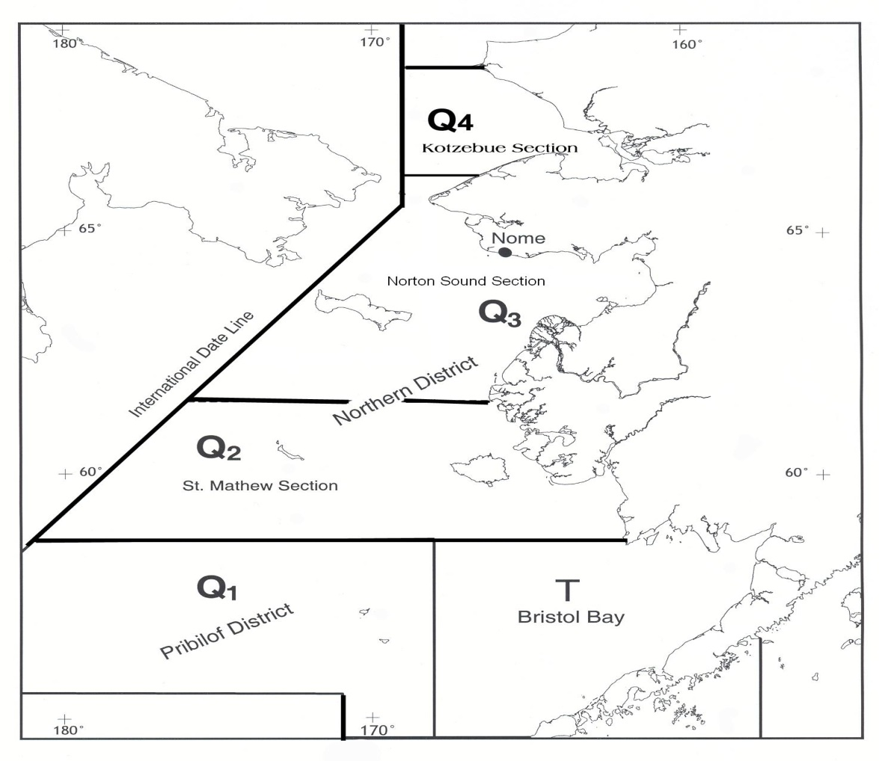

Figure 1. King crab fishing districts and sections of Statistical Area Q.

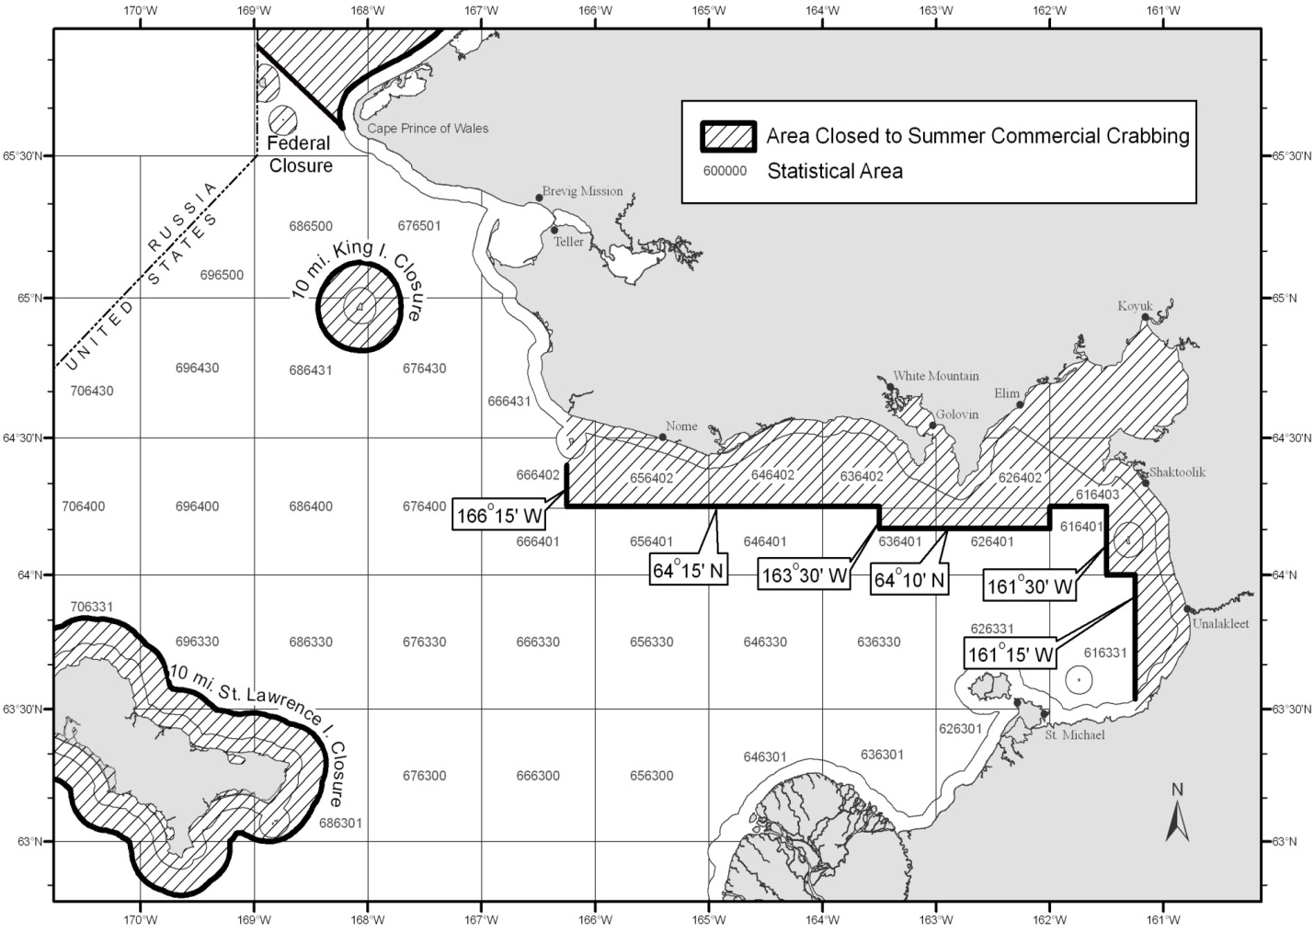

Figure 2. Closed water regulations in effect for the Norton Sound commercial crab fishery. Line around the coastline delineates the 3-mil3 state waters zone.

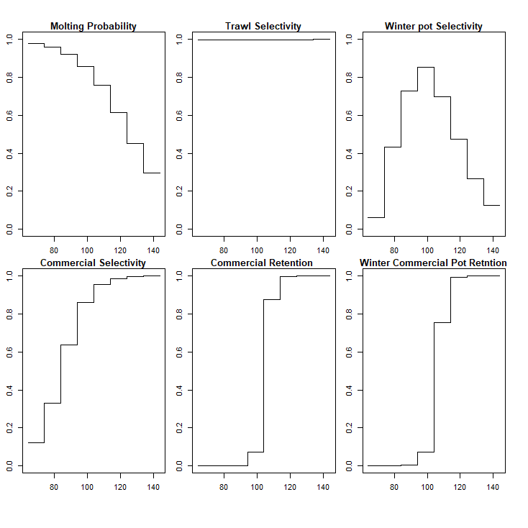

Figure 3. Model estimated annual molting probability, and selectivity for trawl survey, winter pot survey, summer commercial fishery, and summer and winter commercial retention. X-axis is carapace length (mm).

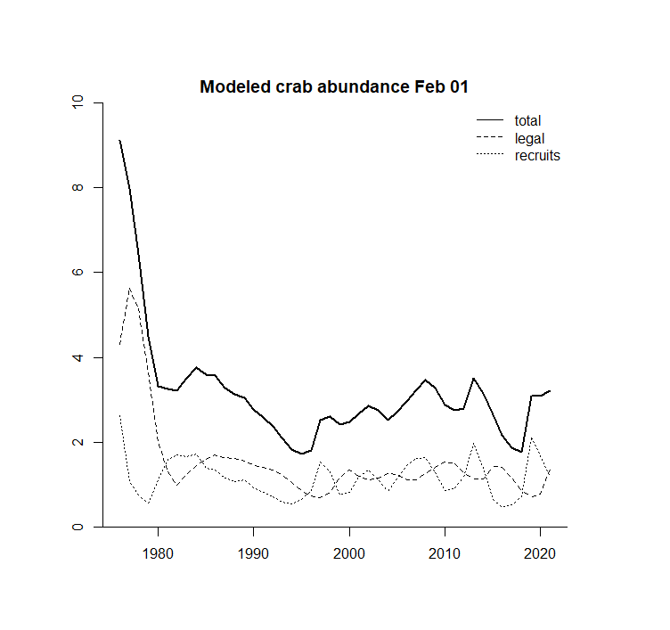

Figure 4. Model estimated abundances of total, legal (CL>104mm) and recruit (CL 64-94nn) males during1976-2019.

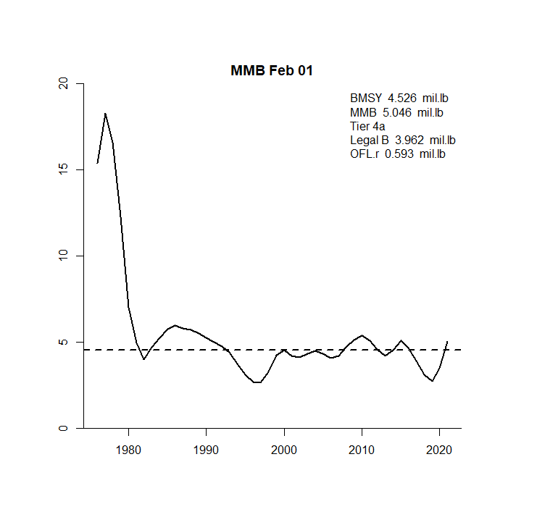

Figure 5. Estimated MMB during 1976-2021. Dash line shows Bmsy (Average MMB of 1980-2020).

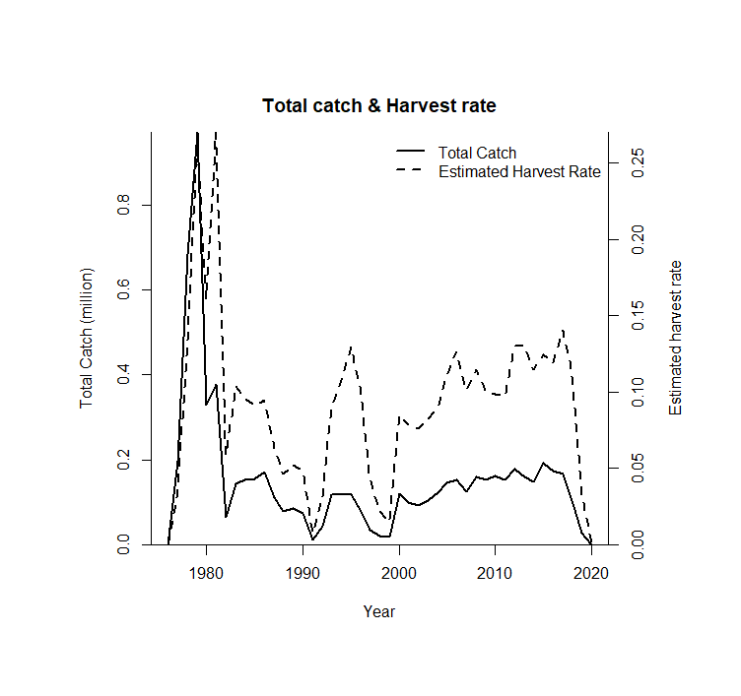

Figure 6. Commercial catch and estimated harvest rates of legal males over time.

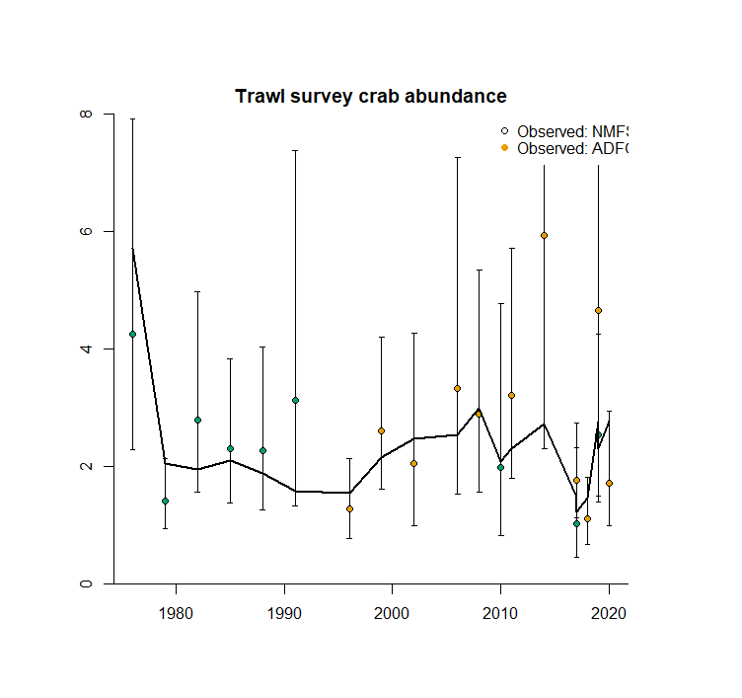

Figure 7. Observed (open circle) (White: NMFS, Red ADF&G) and model estimated (line) trawl survey male abundances with 95% lognormal Confidence Intervals (crab ≥ 64 mm CL). Shaded area indicate 95%CI lognormal CI of the model estimate.

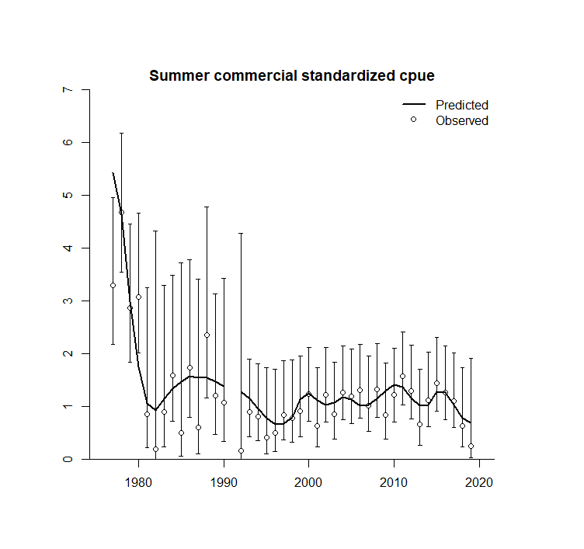

Figure 8. Observed (open circle) with 95% lognormal Confidence Intervals and model estimated (lines) standardized CPUE.

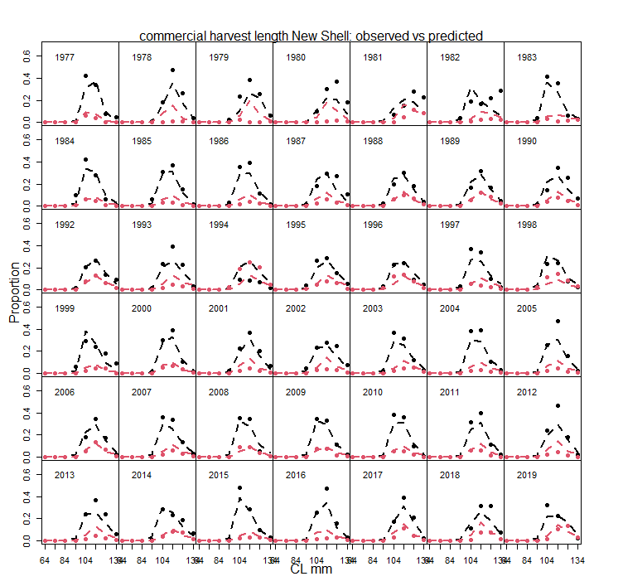

Figure 9. Predicted (line) vs. observed (dots: black New Shell, red Old Shell) length class proportions for the summer commercial harvest 1977-2019.

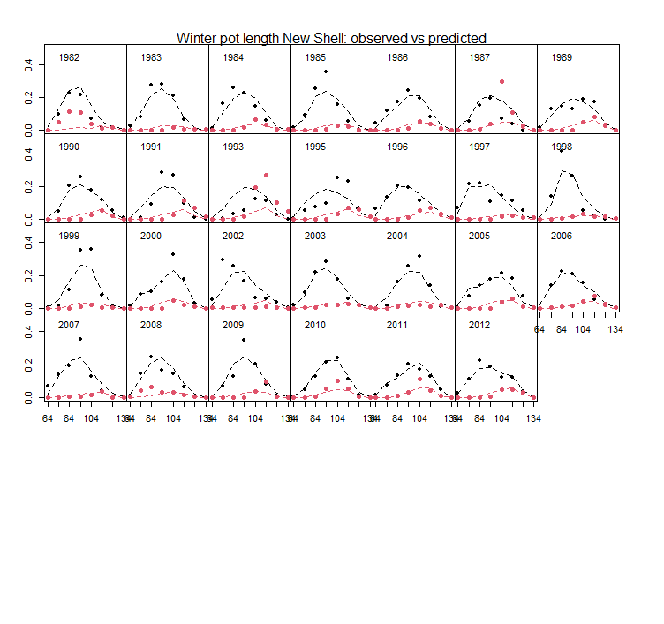Figure 10. Predicted (line) vs. observed (dots: black New Shell, red Old Shell) length class proportions for summer trawl survey 1976 – 2020

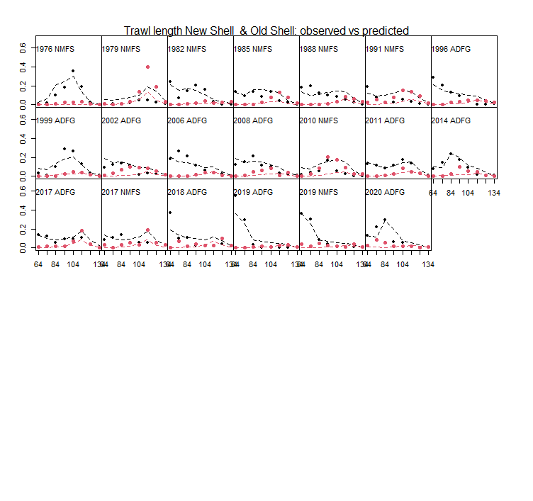

Figure 11. Predicted (line) vs. observed (dots: black New Shell, red Old Shell) length class proportions for winter pot survey 1982 – 2012

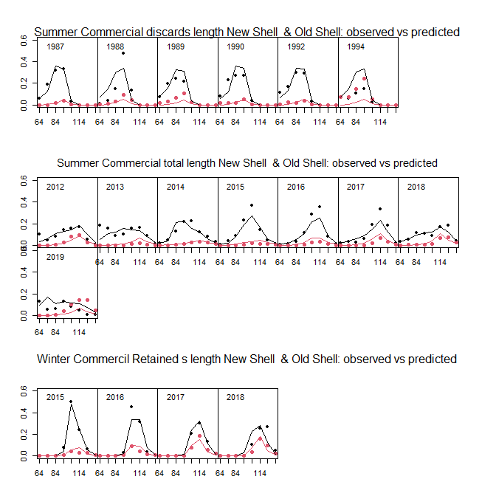

Figure 12. Predicted (line) vs. observed (dots: black New Shell, red Old Shell) length class proportions for summer commercial total and discards and winter commercial retained fishery 2015-2019

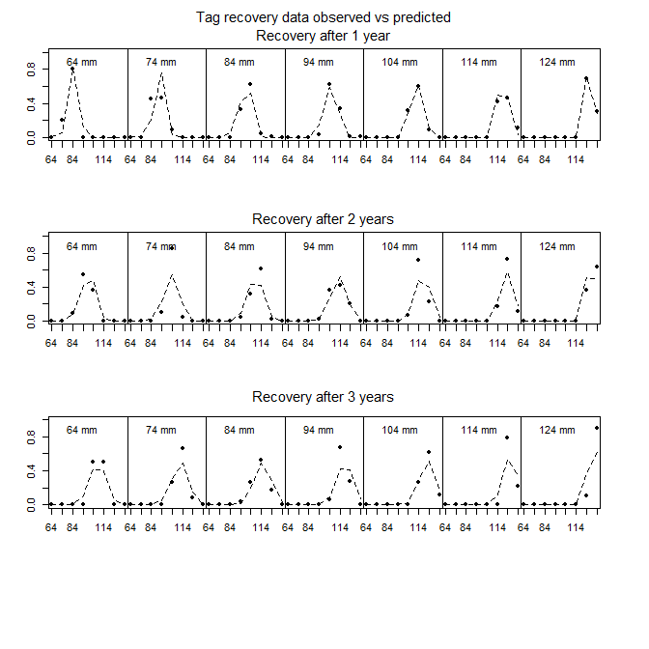

Figure 13. Predicted (line) vs. observed (dots: black New Shell, red Old Shell) length class proportions tag recovery data.

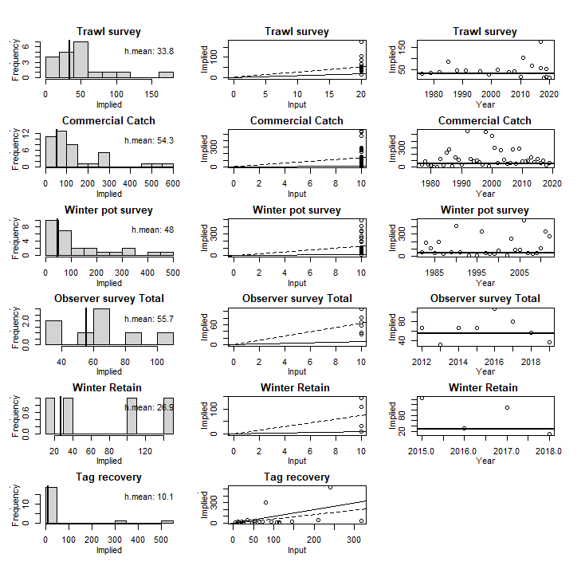

Figure 14. Input vs. model implied effective sample size. Figures in the first column show implied effective sample size (x-axis) vs. frequency (y-axis). Vertical solid line is the harmonic mean of implied sample size. Figures in the second column show input sample sizes (x-axis) vs. implied effective sample sizes (y-axis). Dashed line indicates the linear regression slope, and solid line is 1:1 line. Figures in the third column show years (x-axis) vs. implied effective sample sizes (y-axis). Horizontal solid line is the harmonic mean of implied sample size.

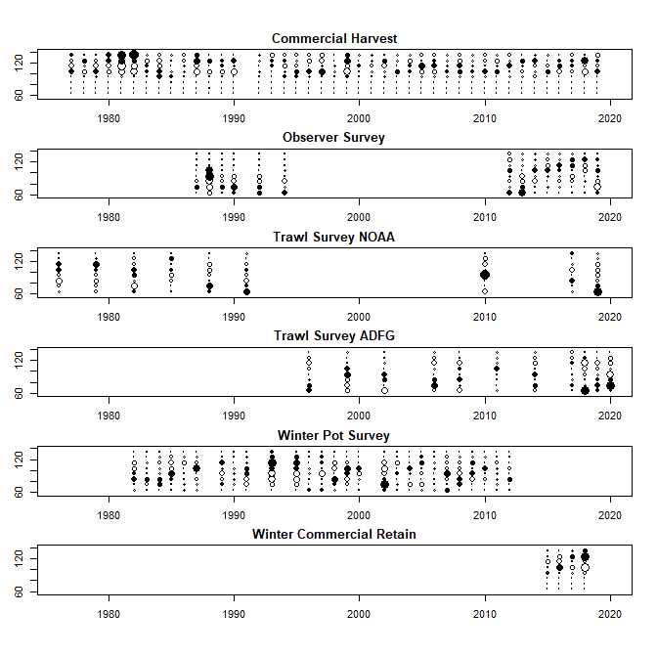

Figure 15. Bubble plots of predicted and observed length proportions.  
Black circle indicates model estimates lower than observed, white circle indicates model estimates higher than observed. Size of circle indicates degree of deviance (larger circle = larger deviance).

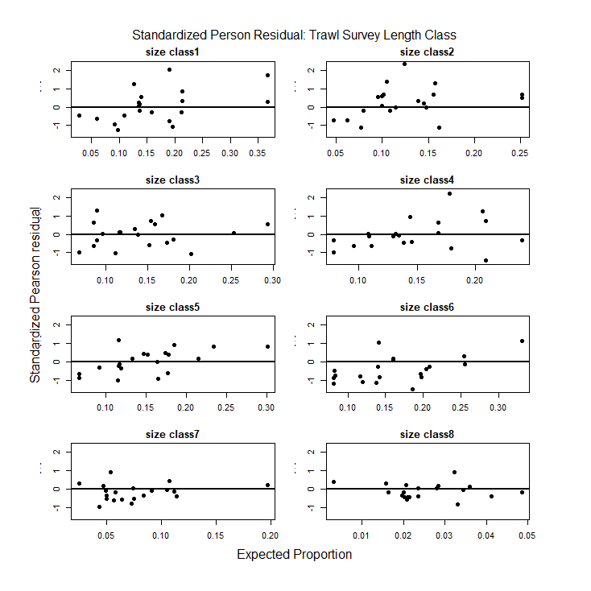

Figure 16. Standardized Pearson residual plot of Trawl survey length size classes 1-8.

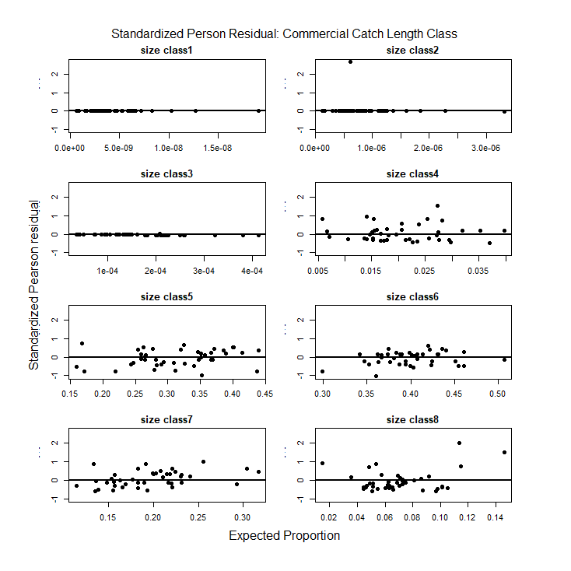

Figure 17. Standardized Pearson residual plot of Summer commercial retained length size classes 1-8.

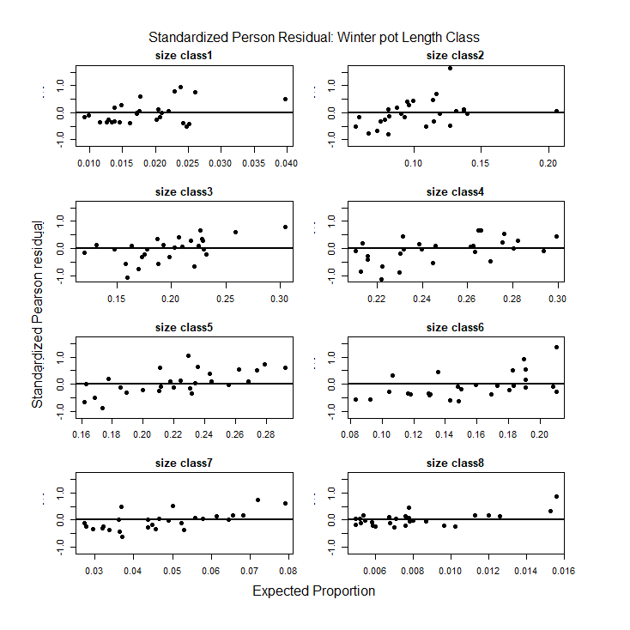

Figure 18. Standardized Pearson residual plot of Winter pot survey length size classes 1-8.

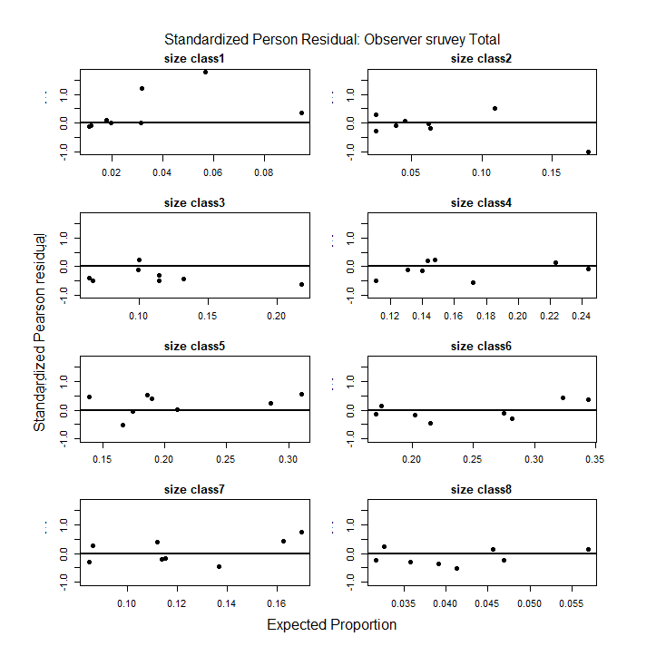

Figure 19. Standardized Pearson residual plot of Summer commercial observer total catch length size classes 1-8.

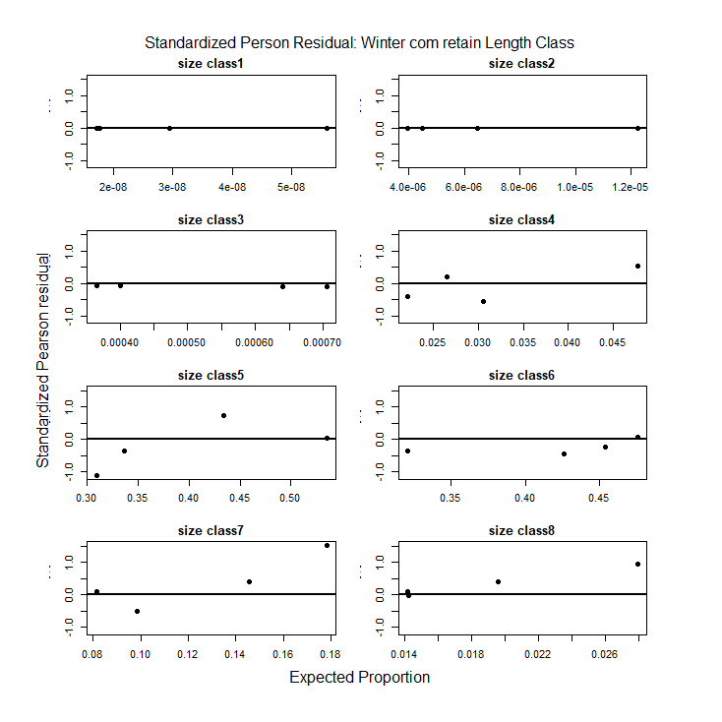

Figure 20. Standardized Pearson residual plot of Winter commercial retained length size classes 1-8.

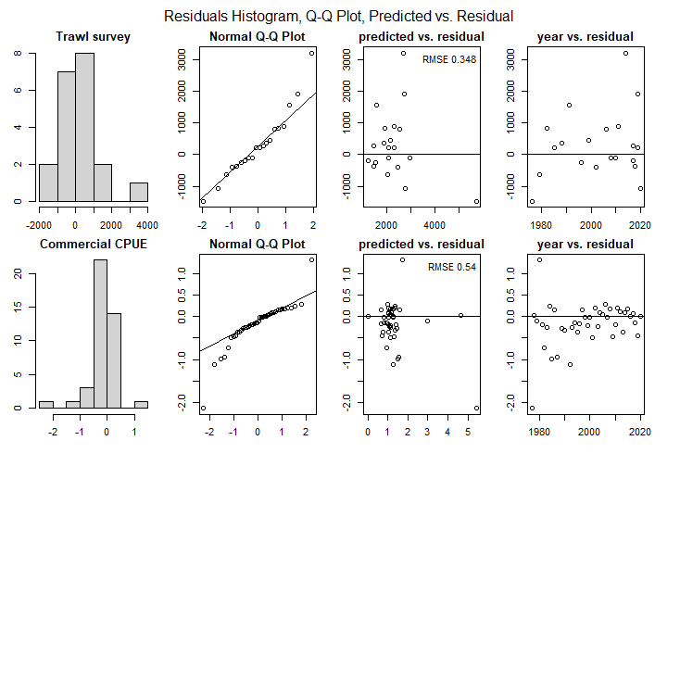

Figure 21. QQ Plot of Trawl survey and Commercial CPUE



Figure 22. Retrospective Analyses of Norton Sound Red King Crab MMB from 2016 to 2021. Solid black line: 2021 assessment model results.

# Appendix A. Description of the Norton Sound Red King Crab Model

**a. Model description.**

The model is an extension of the length-based model developed by Zheng et al. (1998) for Norton Sound red king crab. The model has 8 male length classes with model parameters estimated by the maximum likelihood method. The model estimates abundances of crab with CL ≥64 mm and with 10-mm length intervals (8 length classes, ≥134mm) because few crab measuring less than 64 mm CL were caught during surveys or fisheries and there were relatively small sample sizes for trawl and winter pot surveys. The model treats newshell and oldshell male crab separately but assumes they have the same molting probability and natural mortality.



**Length proportion**

Pot Survey

1980-2012:

Standardized

CPUE

**Length proportion**

Com retained & discards

Com Fishery

Jun – Sept

Assume: July 01

Molting, Growth

**Tag recovery**

Recruitment

Natural mortality

7 months

July 01

Pre-fishery Population

**Feb 01: SAFE**

**Assessment**

**Abundance**

Catch selectivity

Com & Sub Fishery

Nov – May

Assume: Feb 01

July 01

Post-fishery Population

Catch & Survey selectivity

Survey selectivity

**Length proportion**

Com retained:

2015 -

Natural mortality

5 months

Feb 01

Post-fishery Population

Survey selectivity

Population

During fishery

**Abundance & Length proportion**

Trawl survey

Norton Sound Red King Crab Modeling Scheme

Timeline of calendar events and crab modeling events:

* **Model year starts February 1st to January 31st of the following year.**
* **All winter fishery harvest occurs on February 1st**
* **Molting and recruitment occur on July 1st**
* **Initial Population Date: February 1st 1976**

*Initial pre-fishery summer crab abundance on February 1st 1976*

Abundance of the initial pre-fishery population was assumed to consist of newshell crab to reduce the number of parameters, and estimated as

|  |  |
| --- | --- |
|  | (1) |

where, length proportion of the first year (*pl*) was calculated as

|  |  |
| --- | --- |
|  | (2) |

for model estimated parameters *al*.

*Crab abundance on July 1st*

Summer (01 July) crab abundance of new and oldshells consists of survivors of winter commercial and subsistence crab fisheries and natural mortality from 01Feb to 01July:

|  |  |
| --- | --- |
|  | (3) |

where

*Ns,l,t* , *Os,l,t* : summer abundances of newshell and oldshell crab in length class *l* in year *t* ,

*Nw,l,t*, *Ow,l,t* : winter abundances of newshell and oldshell crab in length class *l* in year *t*,

*Cw,t*, *Cp,t* : total winter commercial and subsistence catches in year *t*,

*Pw,n,l,t*, *Pw,o,l,t* : Proportion of newshell and oldshell length class *l* crab in year *t*, harvested by winter commercial fishery,

*Pp,n,l,t* , *Pp,o,l,t* : Proportion of newshell and oldshell length class *l* crab in year *t*, harvested by winter subsistence fishery,

*Dw,n,l,t*, *Dw,o,l,t*: Discard mortality of newshell and oldshell length class *l* crab in winter commercial fishery in year *t* ,

*Dp,n,l,t*, *Dp,o,l,t* : Discard mortality of newshell and oldshell length class *l* crab in winter subsistence fishery in year *t*,

*Ml* : instantaneous natural mortality in length class *l,*

0.42 : proportion of the year from Feb 1 to July 1 is 5 months.

Length proportion compositions of winter commercial catch (*Pw,n,l,t*, *Pw,o,l,t*) in year *t* were estimated as:

|  |  |
| --- | --- |
|  | (4) |

where

*Plg,l* : the proportion of legal males in length class *l* ,

*Sw,l*: Selectivity of winter fishery pot.

Subsistence fishery does not have a size limit; however, crab of size smaller than length class 3 are generally not retained. Hence, we assumed proportion of length composition *l* = 1 and 2 as 0, and estimated length compositions (*l* ≥ 3) as follows

|  |  |
| --- | --- |
|  | (5) |

*Crab abundance on Feb 1st*

Newshell Crab: Abundance of newshell crab of year *t* and length-class *l* (*Nw,l,t* ) year-t consist of: (1) new and oldshell crab that survived the summer commercial fishery and molted, and (2) recruitment (*Rl,t*) .

|  |  |
| --- | --- |
|  | (6) |

Oldshell Crab: Abundance of oldshell crabs of year *t* and length-class *l* (*Ow,l,t* ) consists of the non-molting portion of survivors from the summer fishery:

|  |  |
| --- | --- |
|  | (7) |

where

*Gl’, l* : a growth matrix representing the expected proportion of crabs growing from length class *l’* to length class *l*

*Cs,t* : total summer catch in year *t*

*Ps,n,l,t-1* , *Ps,o,l,t-1* : proportion of summer catch for newshell and oldshell crabs of length class *l* in year *t-1*,

*Dl,t-1*: summer discard mortality of length class *l* in year *t-1*,

*ml* : molting probability of length class *l*,

*yc* : the time in year from July 1 to the mid-point of the summer fishery,

0.58: Proportion of the year from July 1st to Feb 1st is 7 months is 0.58 year,

*Rl,t-1*: recruitment into length class *l* in year *t-1*.

*Discards*

Discards are crabs that were caught by fisheries but were not retained, which consists of summer commercial, winter commercial and winter subsistence.

Summer and winter commercial discards

In summer (*Dl,t*) and winter (*Dw,n,l,t* , *Dw,o,l,t*) commercial fisheries, sublegal males (<4.75 inch CW and <5.0 inch CW since 2005) are discarded. Those discarded crabs are subject to handling mortality. The number of discards was not directly observed, and thus was estimated from the model as: Observed Catch x (estimated abundance of crab that are not caught by commercial pot)/(estimated abundance of crab that are caught by commercial pot)

Model discard mortality in length-class *l* in year *t* from the summer and winter commercial pot fisheries is given by

|  |  |
| --- | --- |
|  | (8) |
|  | (9) |
|  | (10) |

where

*hms*: summer commercial handling mortality rate assumed to be 0.2,

*hmw*: winter commercial handling mortality rate assumed to be 0.2,

*Ss,l*: Selectivity of the summer commercial fishery,

*Sw,l*: Selectivity of the winter commercial fishery,

*Sr,l*: Retention selectivity of the summer commercial fishery,

*Swr,l*: Retention selectivity of the winter commercial fishery,

Winter subsistence Discards

Discards (unretained) of winter subsistence fishery is reported in a permit survey (*Cd,t*), though its size composition is unknown. We assumed that subsistence fishers discarded all crabs of length classes 1 -2.

|  |  |
| --- | --- |
|  | (11) |
|  | (12) |

*Cd,t*: Winter subsistence discards catch,

*Recruitment*

Recruitment of year *t*, *Rt*, is a stochastic process around the geometric mean, *R0*:

|  |  |
| --- | --- |
|  | (13) |

*Rt* of the last year was assumed to be an average of previous 5 years: *Rt* = (*Rt-1* + *Rt-2* + *Rt-3* + *Rt-4* + *Rt-5* )/5.

*Rt* was assumed to be newshell crab of immature (< 94mm) length classes 1 to *r*:

|  |  |
| --- | --- |
|  | (14) |

where *r* takes multinomial distribution, same as the equation (2)

*Molting Probability*

Molting probability for length class *l*, *ml*, was estimated as an inverse logistic function of length-class mid carapace length (*L*) and parameters (*α*, *β*) where *β* corresponds to *L50*.

|  |  |
| --- | --- |
|  | (15) |

*Trawl net, summer commercial pot,*

Trawl and summer commercial pot selectivity was assumed to be a logistic function of mid-length-class, constrained to be 0.999 at the largest length-class (*Lmax*):

|  |  |
| --- | --- |
|  | (16) |

*Winter pot selectivity*

Winter pot selectivity was assumed to be a dome-shaped with inverse logistic function of length-class mid carapace length (*L*) and parameters (*α*, *β*) where *β* corresponds to *L50*.

|  |  |
| --- | --- |
|  | (17) |

Selectivity of the first 3 length classes *Sw,s*  (S= *l*1, *l*2, *l*3) were individually estimated.

*Growth transition matrix*

The growth matrix *Gl’, l* (the expected proportion of crab molting from length class *l’* to length class *l* ) was

assumed to be normally distributed:

|  |  |
| --- | --- |
|  | (18) |

Where



Observation model

*Summer trawl survey abundance*

Modeled trawl survey abundance of year *t* (*Bst,t*) is July 1st abundance subtracted by summer commercial fishery harvest occurring from July 1st to the mid-point of summer trawl survey, multiplied by natural mortality occurring between the mid-point of commercial fishery date and trawl survey date, and multiplied by trawl survey selectivity. For the first year (1976) trawl survey, the commercial fishery did not occur.

|  |  |
| --- | --- |
|  | (19) |

where

*yst* : the time in year from July 1 to the mid-point of the summer trawl survey,

*yc*: the time in year from July 1 to the mid-point for the catch before the survey, (*yst* > *yc*: Trawl survey starts after opening of commercial fisheries),

*Pc,t* : the proportion of summer commercial crab harvested before the mid-point of trawl survey date.

*Sst,l*: Selectivity of the trawl survey.

Winter pot survey CPUE (**depleted**)

Winter pot survey cpue (*fwt*) was calculated with catchability coefficient *q* and exploitable abundance:

|  |  |
| --- | --- |
|  | (20) |

Summer commercial CPUE

Summer commercial fishing CPUE (*ft*) was calculated as a product of catchability coefficient *q* and mean exploitable abundance minus one half of summer catch, At:

|  |  |
| --- | --- |
|  | (21) |

Because the fishing fleet and pot limit configuration changed in 1993, *q1* is for fishing efforts before 1993, *q2* is from 1994 to present.

Where *At* is exploitable legal abundance in year *t*, estimated as

|  |  |
| --- | --- |
|  | (22) |

*Summer pot survey abundance* (**depleted**)

Abundance of *t-*th year pot survey was estimated as

|  |  |
| --- | --- |
|  | (23) |

Where

*yp* : the time in year from July 1 to the mid-point of the summer pot survey.

Length composition

*Summer commercial retained catch*

Length compositions of the summer commercial catch for new and old shell crabs *Ps,n,l,t*and *Ps,o,l,t*, were modeled based on the summer population, selectivity, and legal abundance:

|  |  |
| --- | --- |
|  | (24) |

*Summer commercial fishery discards (1977-1995)*

Length/shell compositions of observer discards were modeled as

|  |  |
| --- | --- |
|  | (25) |

*Summer commercial fishery total catch (2012-present)*

Length/shell compositions of observer discards were modeled as

|  |  |
| --- | --- |
|  | (26) |

*Summer trawl survey*

Proportions of newshell and oldshell crab, *Pst,n,l,t* and *Pst,o,l,t* were given by

|  |  |
| --- | --- |
|  | (27) |

*Winter pot survey*

Winter pot survey length compositions for newshell and oldshell crab, *Psw,n,l,t*and *Psw,o,l,t* (*l* ≥ 1) were calculated as

|  |  |
| --- | --- |
|  | (28) |

*Winter commercial retained*

Winter commercial retained length compositions for newshell and oldshell crab, *Pcw,n,l,t*and *Pcw,o,l,t* (*l* ≥ 1) were calculated as

|  |  |
| --- | --- |
|  | (29) |

*Spring Pot survey 2012-2015 (****depleted****)*

Winter pot survey length compositions for newshell and oldshell crab, *Psw,n,l,t*and *Psw,o,l,t* (*l* ≥ 1) were assumed to be supper crab population caught by winter pot survey gears

|  |  |
| --- | --- |
|  | (30) |

*Estimates of tag recovery*

The proportion of released tagged length class *l’* crab recovered after *t-th* year with length class of *l* by a fishery of *s-th* selectivity (*Sl*) was assumed to be proportional to the growth matrix, catch selectivity, and molting probability (*ml*) as

|  |  |
| --- | --- |
|  | (31) |

where *X* is a molting probability adjusted growth matrix with each component consisting of

|  |  |
| --- | --- |
|  | (32) |

**c. Likelihood components.**

Under assumptions that measurement errors of annual total survey abundances and summer commercial fishing efforts follow lognormal distributions and each type of length composition has a multinomial error structure (Fournier and Archibald 1982; Methot 1989), the log-likelihood function is

|  |  |
| --- | --- |
|  | (32) |

1where

*i*: length/shell compositions of :

1 triennial summer trawl survey,

2 annual winter pot survey,

3 summer commercial fishery retained,

4 summer commercial observer discards or total catch,

5 winter commercial fishery retained.

*Ki,t*: the effective sample size of length/shell compositions for data set *i* in year *t,*

*Pi,l,t* : observed and estimated length compositions for data set *i*, length class *l*, and year *t.*

*κ* : a constant equal to 0.0001,

*CV* : coefficient of variation for the survey abundance,

*Bi,k,t*: observed and estimated annual total abundances for data set *i* and year *t,*

*ft* : observed and estimated summer fishing CPUE,

*w2t*: extra variance factor,

*SDR* : Standard deviation of recruitment = 0.5,

*Kl’,t*: sample size of length class *l’* released and recovered after *t-th* in year,

*Pl’,l,t,s* : observed and estimated proportion of tagged crab released at length *l’* and recaptured at

length *l*, after *t-th* year by commercial fishy pot selectivity *s*,

*W*: weighting for the tagging survey likelihood = 0.5

It is generally believed that total annual commercial crab catches in Alaska are fairly accurately reported. Thus, total annual catch was assumed known and accurate

**b. Software used**: AD Model Builder (Fournier et al. 2012).

**d. Out of model parameter estimation framework:**

1. Parameters Estimated Independently

*M*: Natural mortality

Natural mortality (*M* = 0.18) was based on an assumed maximum age, *tmax*, and the 1% rule (Zheng 2005):

,

where *p* is the proportion of animals that reach the maximum age and is assumed to be 0.01 for the 1% rule (Shepherd and Breen 1992, Clarke et al. 2003). The maximum age of 25, which was used to estimate *M* for U.S. federal overfishing limits for red king crab stocks results in an estimated *M* of 0.18. Among the 199 recovered crabs from the tagging returns during 1991-2007 in Norton Sound, the longest time at liberty was 6 years and 4 months from a crab tagged at 85 mm CL. The crab was below the mature size and was likely less than 6 years old when tagged. Therefore, the maximum age from tagging data is about 12, which does not support the maximum age of 25 chosen by the CPT.

Proportion of Legal sized crab

Proportions of legal males (CW > 4.75 inches) by length group were estimated from the ADF&G trawl data 1996-2019 (Table 11).

1. Parameters Estimated Conditionally

Estimated parameters are listed in Table 10. Selectivity and molting probabilities based on these estimated parameters are summarized in Tables 11.

A likelihood approach was used to estimate parameters

**e. Definition of model outputs.**

1. Mature male biomass (MMB) is on **February 1st** and is consisting of the biomass of male crab in length classes 4 to 8



*wml*: mean weight of each length class (Table 11).

1. Projected legal male biomass subject to winter and summer fishery OFL was calculated as winter biomass times summer commercial pot selectivity times proportion of legal crab. Though fishery size selectivity differ between winter and summer commercial, both fisheries were assumed to have the same selectivity because winter fishery is very small compared to summer fishery.



1. Recruitment: the number of males in length classes 1, 2, and 3.

**f. OFL**

The Norton Sound red king crab fishery consists of two distinct fisheries: winter and summer. The two fisheries are discontinuous with 5 months between the two fisheries during which natural mortalities occur. To incorporate this fishery, the CPT in 2016 recommended the following formula:

|  |  |
| --- | --- |
|  | (1) |

And

|  |  |
| --- | --- |
|  | (2) |

Where *p* is a specific proportion of winter crab harvest to total (winter + summer) harvest

At given fishery mortality (FOFL), Winter harvest is a fishing mortality

|  |  |
| --- | --- |
|  | (3) |

|  |  |
| --- | --- |
|  | (4) |

where Bs is a summer crab biomass after winter fishery and x (0 ≤ x ≤1) is a fraction that satisfies equation (2)

Since Bs  is a summer crab biomass after winter fishery and 5 months of natural morality ()

|  |  |
| --- | --- |
|  | (5) |

Substituting *0.42M* to *m*, summer harvest is

|  |  |
| --- | --- |
|  | (6) |

Thus, OFL is

|  |  |
| --- | --- |
|  | (7) |

Combining (2) and (7),

|  |  |
| --- | --- |
|  | (8) |

Solving (8) for x

|  |  |
| --- | --- |
|  | (9) |

Combining (7) and (9), and substituting back,

revised retained OFL is



Further combining (3) and (9), Winter fishery harvest rate (Fw) i

|  |  |
| --- | --- |
|  | (10) |

Summer fishery harvest rate (Fs) is

|  |  |
| --- | --- |
|  | (11) |

# Appendix B Norton Sound Red King Crab CPUE Standardization

**Note: This is an update of model by G. Bishop (SAFE 2013).**

**Methods**

**Data Source & Cleaning**

Commercial fishery harvest data were obtained from ADF&G fish ticket database, which included: Landing Date, Fish Ticket Number, Vessel Number, Permit Fishery ID, Statistical Area(s) fished, Effort, and Number and Pounds of Crab harvested (Table A2-1,2,3, Figure A2-1). Fish ticket database may have multiple entries of identical Fish Ticket Number, Vessel Number, Permit Fishery ID, and Statistical Area. In those cases, at least one Effort data are missing or zero with the Number and Pounds of Crab harvested. These entries indicate that crab were either retained from the commercial fishery (i.e., not sold), or dead loss.

Following data cleaning and combining methods were conducted.

1. Sum crab number and efforts by Fish Ticket Number, Vessel Number, Permit Fishery ID, Statistical Area.
2. Remove data of missing or zero Efforts, Number of Crab, Pounds of Crab (Those are considered as true missing data).
3. Calculate CPUE as Number of Crab/Effort.

**Data Censoring**

During 1977-92 period, vessels of 1 year of operation and/or 1 delivery per year harvested 20-90% of crab (Table A2-5, Figure A2-2). For instance, all vessels did only 1 delivery in 1989, and in 1988 64% of crab were harvested by 1 vessel that did only 1 delivery. On the other hand, during the 1993-2017 period of post super-exclusive fishery status, the majority of commercial crab fishery and harvest was done by vessels with more than 5 years of operations and more than 5 deliveries per year. For 1977 – 1992, censoring was made for vessels of more than 2 years of operations. Increasing deliveries to more than one would result in no estimates for some years. For 1993 – 2018, censoring was made for vessels of more than 5 years of operations and 5 deliveries per year.

**Analyses**

A GLM was constructed as



Where YR: Year, PD: Fishery periods (1977-1992, 1993-2004,2005-2018), VSL: Vessel, MSA: Statistical Area, WOY: Week of Year, and PF: Permit vs open fishery (Table 1). All variables were treated as categorical. Inclusion of interaction terms was not considered because they were absent (SAFE 2013).

For selection of the best model, forward and backward stepwise selection was conducted. (R step function)

**fit <- glm(L.CPUE.NO ~ factor(YR) + factor(VSL) + factor(WOY) + factor(MSA) + factor(PF) + factor(PD),,data=NSdata.C)**

**step <- step(fit, direction='both', trace = 10)**

**best.glm<-glm(formula(step), data=NSdata.C)**

Table B-1. List of variables in the fish ticket database. Variables in bold face were used for generalized linear modeling.

| **Variable** | **Description** | |
| --- | --- | --- |
| **YR** | | Year of commercial fishery |
| **VSL** | | Unique vessel identification number |
| Fish Ticket Number | | Unique delivery to a processor by a vessel |
| **PF** | | Unique Permit Fishery categories |
| **PD** | | Fishery period: 1977-1992, 1993-2004,2005-2018 |
| Statistical Area | | Unique fishery area. |
| **MOA** | | Modified statistical area, combining each statistical area into 4 larger areas: Inner, Mid, Outer, Outer North |
| Fishing Beginning Date | | Date of pots set |
| Landing Date | | Date of crab landed to processor |
| **WOY** | | Week of Landing Date **(calculated)** |
| Effort | | The number of pot lift |
| Crab Numbers | | Total number of crabs harvested from pots |
| Crab Pounds | | Total pounds of crab harvested from pots |
| **ln(CPUE)** | | ln(Crab Numbers/Effort) **(calculated)** |

Table B-2. Permit fisheries, descriptions, and years with deliveries for Norton Sound summer commercial red king crab harvest data.

|  |  |  |  |
| --- | --- | --- | --- |
| **Permit fishery** | **Type** | **Description** | **Years** |
| K09Q | Open access | KING CRAB , POT GEAR VESSEL UNDER 60', BERING SEA | 1994–2002 |
| K09Z | Open access | KING CRAB , POT GEAR VESSEL UNDER 60', NORTON SOUND | 1992–2017 |
| K09ZE | CDQ | KING CRAB , POT GEAR VESSEL UNDER 60', NORTON SOUND CDQ, NSEDC | 2000–2017 |
| K09ZF | CDQ | KING CRAB , POT GEAR VESSEL UNDER 60', NORTON SOUND CDQ, YDFDA | 2002–2004 |
| K91Q | Open access | KING CRAB , POT GEAR VESSEL 60' OR OVER, BERING SEA | 1978–1989 |
| K91Z | Open access | KING CRAB , POT GEAR VESSEL 60' OR OVER, NORTON SOUND | 1982–1994 |

Table B-3. Modified statistical area definitions used for analysis of Norton Sound summer commercial red king crab harvest data.

|  |  |
| --- | --- |
| **Modified statistical area** | **Statistical areas included** |
| Inner | 616331, 616401, 626331, 626401, 626402 |
| Mid | 636330, 636401, 636402, 646301, 646330, 646401, 646402 |
| Outer | 656300, 656330, 656401, 656402, 666230, 666300, 666330, 666401 |
| Outer North | 666402, 666431, 676300, 676330 ,676400, 676430, 676501, 686330 |

Table B-4. Final generalized linear model formulae and AIC selected for Norton Sound summer commercial red king crab fishery. The dependent variable is ln(CPUE) in numbers.

|  |  |  |  |  |  |
| --- | --- | --- | --- | --- | --- |
| Var | Df | Deviance | Resid DF | Resid Dev | AIC |
| YR | 41 | 1312.43 | 6274 | 5082.7 |  |
| VSL | 90 | 574.57 | 6143 | 3770.3 |  |
| WOY | 15 | 82.89 | 6129 | 3195.7 |  |
| MSA | 3 | 65.83 | 6125 | 3047.0 |  |
| PF | 6 | 20.14 | 6119 | 3026.9 | 13547 |
| +PD+MOY | 3 |  |  |  | 13547.67 |
|  |  |  |  |  |  |

Table B-5. Standardized (censored/full data), and scaled arithmetic observed CPUE indices.

|  |  |  |
| --- | --- | --- |
| Year | Censored | |
| **CPUE** | **SE** |
| 1977 | 3.29 | 0.68 |
| 1978 | 4.68 | 0.65 |
| 1979 | 2.87 | 0.64 |
| 1980 | 3.07 | 0.65 |
| 1981 | 0.86 | 0.64 |
| 1982 | 0.20 | 0.62 |
| 1983 | 0.90 | 0.65 |
| 1984 | 1.59 | 0.65 |
| 1985 | 0.50 | 0.66 |
| 1986 | 1.74 | 0.70 |
| 1987 | 0.61 | 0.64 |
| 1988 | 2.36 | 0.86 |
| 1989 | 1.21 | 0.61 |
| 1990 | 1.08 | 0.68 |
| 1991 |  |  |
| 1992 | 0.17 | 0.60 |
| 1993 | 0.90 | 0.35 |
| 1994 | 0.81 | 0.34 |
| 1995 | 0.42 | 0.34 |
| 1996 | 0.51 | 0.34 |
| 1997 | 0.84 | 0.35 |
| 1998 | 0.79 | 0.36 |
| 1999 | 0.92 | 0.36 |
| 2000 | 1.24 | 0.34 |
| 2001 | 0.64 | 0.34 |
| 2002 | 1.23 | 0.34 |
| 2003 | 0.85 | 0.34 |
| 2004 | 1.27 | 0.34 |
| 2005 | 1.19 | 0.34 |
| 2006 | 1.31 | 0.34 |
| 2007 | 1.02 | 0.34 |
| 2008 | 1.32 | 0.34 |
| 2009 | 0.84 | 0.34 |
| 2010 | 1.22 | 0.34 |
| 2011 | 1.58 | 0.34 |
| 2012 | 1.29 | 0.34 |
| 2013 | 0.67 | 0.33 |
| 2014 | 1.12 | 0.34 |
| 2015 | 1.45 | 0.34 |
| 2016 | 1.27 | 0.34 |
| 2017 | 1.10 | 0.34 |
| 2018 | 0.64 | 0.34 |

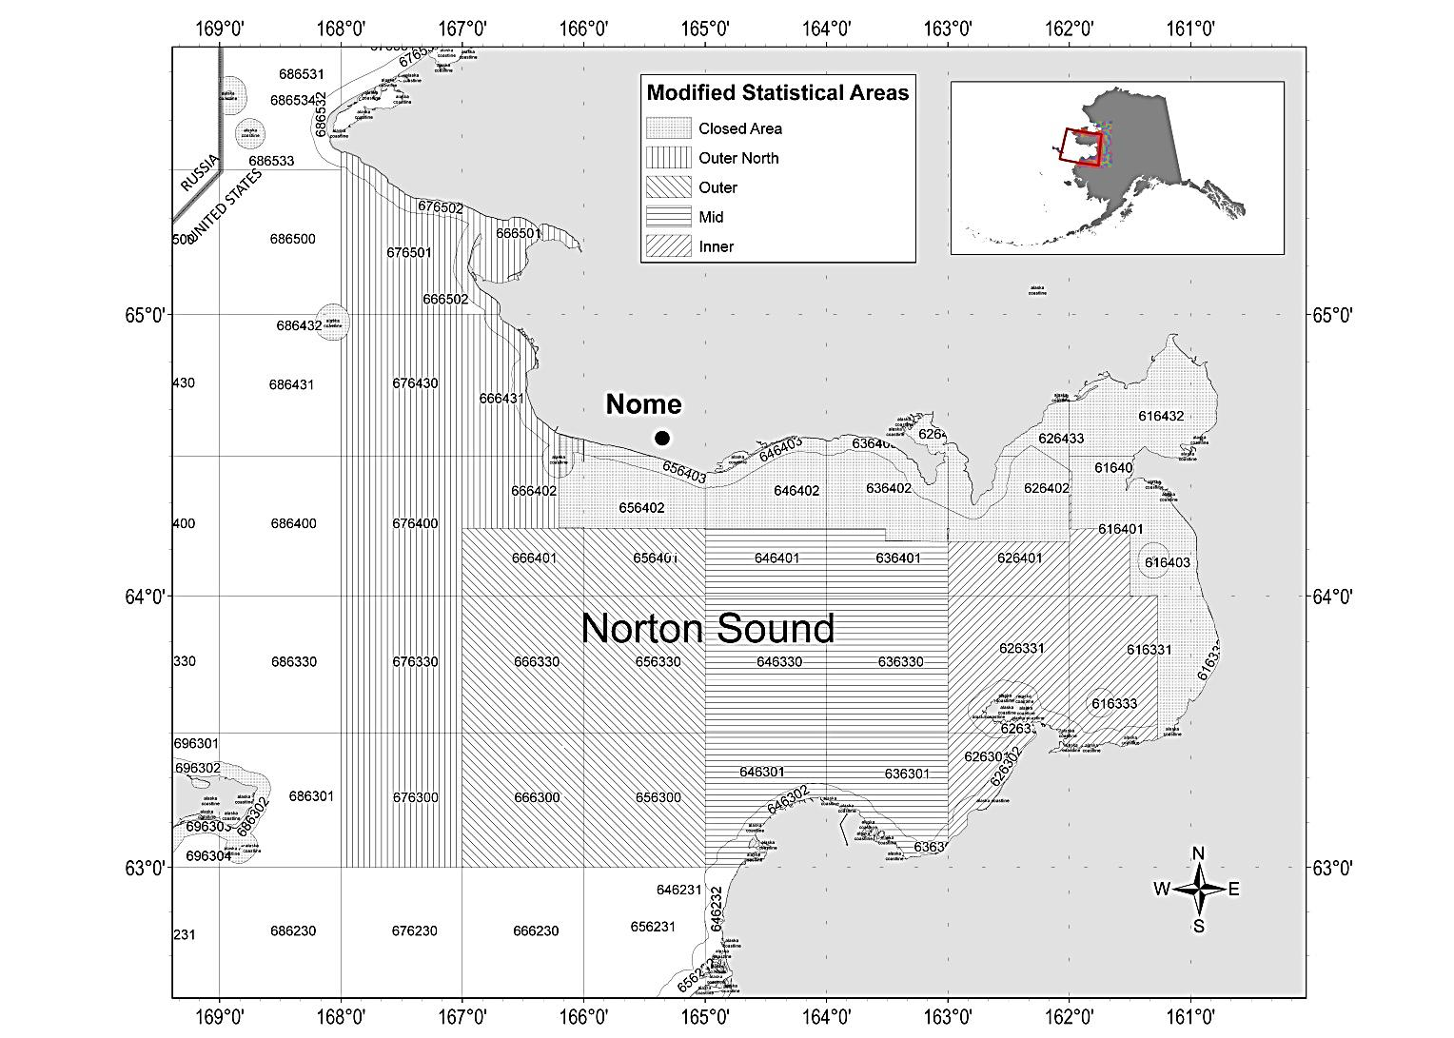

Figure A2-1. Closed area and statistical area boundaries used for reporting commercial harvest information for red king crab in Registration Area Q, Northern District, Norton Sound Section and boundaries of the new *Modified Statistical Areas* used in this analysis.

# Appendix C Norton Sound Red King Crab Summer Commercial Fishery Discard Estimation

Formal methodologies have not been established for estimating Red King Crab discards by Norton Sounds Summer commercial fishery from observer data. Here, I describe a few methods and discuss pros and cons of each method.

Data source and description of survey protocols

Norton Sound Summer Commercial fishery observer survey started in 2009 as a potential feasibility project, and formal data collection started since 2012. The observer survey in Norton Sound is voluntary. Due to small boat size, the boat that can take a fishery observer is limited. Fishery observer often work as a crew member. During the fishery, an observe inspect every pots. All lengths/shell condition/sex of red king crab in the pots were measured, and the fisherman sorts out discards that are noted. **Observed discarded crab are deemed accurate.** However, it is uncertain whether fishing behaviors of the volunteer fishermen are the same as other unobserved fishermen. Observed fishermen tend to have large boat and catcher and sellers. Here are possible concerns:

1. The observed fishermen may go to better fishing grounds with more legal crab and less sub-legals: **higher legal retain CPUE and lower discards CPUE than unobserved (lower discards proportion)**
2. The observed fishermen may not mind sorting out crab and may choose areas: **higher legal retain CPUE and higher discards CPUE than unobserved (higher discards proportion)**
3. The observed fishermen may keep more legal crab that are not accepted by NSEDC: **lower discard CPUE than unobserved (lower discard proportion)**

**Data Source & Cleaning**

From 2012 to 2018, crab catches of 3-4 volunteer crab fishing vessels were observed. Annual observed pots ranged 69 to 199 and total observed crab ranging from 2200 to 5300 (Table 1). All observed data were combined.

**Estimation Methods**

Two methods were considered: CPUE and Proportion methods. CPUE method expands observed CPUE (Observed number of crab)/(observed pots) to all fisheries pot lifts, whereas proportional method expands observed proportion of discards to retained: (observed number of discards)/(observed number of retained) to all fisheries retained catch.

CPUE has two methods: LNR and Subtraction. LNR simply expands CPUE of discards, whereas Subtraction expands CPUE of total catch and subtract total retained catch.

LNR method

LNR method simply expands CPUE of discards to total pot lifts



Where Nobs, sub  and Nobs, ld  are observed number of sublegal and legal crab discarded, and Pobs is the number of pot-lifts by the observed fishermen during the observed period.



Where PFT.total, is total number of pot lifts of all fishermen recorded in fish tickets.

Observer bias corrected LNR method adds correction to CPUE of the observed fishermen by multiplying the CPUE ratio between observed fishermen (CPUEFT.obs) and unobserved fishermen (CPUEFT.unobs) derived from fish tickets.

 



Where NFT.obs and NFT.unobs are total number of crab delivered (thorough out season) by observed and unobserved fishermen, and PFT.obs  and PFT.unobs total number of pot lifts by observed and unobserved fishermen.

  

  

Subtraction method

Subtraction method expands total catch CPUE and subtracts total retained catch



Where Nobs is a total number of crab caught by the observed fishermen during the observed period.



Where NFT.total is the total number of retained crab during the season.

Bias corrected Subtraction method is simply bias corrected total catch minus retained catch



Finally, the proportion method that expands ratio of discards to retained.



Where Nobs.lr is observed number of retained legal crab by observed fishermen during the observed periods.

In an assessment model, total number of crab discarded by summer commercial fishery is modeled as



where NF.R and NF.D are model estimated number of crab retained and discarded, which is essentially the same ss proportional method.

**Results**

While general annual discard trends were similar among the 3 methods, the number of discards differed (Table 2). Overall, the Subtraction method estimated the highest and the Proportional method estimated the lowest. Bias correction method (LNR2, Sub2) reduced discard estimates during 2013-2017 (Table 3).

**Discussion**

The CPUE method assumes that observed CPUE would represent total CPUE or that there is no difference in CPUE between observed and unobserved fishermen. Difference between LNR and Subtraction method is that LNR method assumes that observed discards are accurate whereas subtraction method assumes that observed discards are biased but observed total catches are accurate. On the other hand, the proportional method assumes that observed discard proportions would represent total proportion or that every fisherman has a similar crab composition.

In Norton Sound observer survey, discarded crab are more likely accurate because separation of retained vs discards are often done in cooperation with the fishermen. However, fishermen and timing of observation are limited to convenience of volunteer fishermen who have larger boats (so that observer can be on board) and are also high catchers. They would be more efficient in catching legal crab with fewer discards than those with small boats. They would also take observers when they expect higher catch.

In fact, season total retained legal crab CPUE by observed fishermen were generally higher than other unobserved fishermen (Table 2). Furthermore, their CPUE was generally higher during the periods when observers were on board. Observed fishermen appeared to go different fishing area from those of all fishermen (Table 4). Those suggest that subtraction method would probably overestimate discards. Direction of bias for LNR and proportional methods are difficult to evaluate. If the observed fishermen tend to better avoid catching sublegal crab (e.g., lower sublegal proportion), the proportional method would underestimate discard catch. But, as they have higher catch CPUE, their discard catch CPUE could still be higher than those of unobserved fishermen. Then, discard catch estimate by LNR method could overestimate as well as underestimate.

Table 1. Observed pot lifts, catch, and total pot lifts and catch from 2012 to 2018

|  |  |  |  |  |  |  |  |  |
| --- | --- | --- | --- | --- | --- | --- | --- | --- |
|  | Observer Survey | | | | |  | Fish Tickets | |
| Year | Pot lifts  Pobs | Sublegal  Nobs.sub | Legal retained  Nobs.lr | Legal discards  Nobs.ld | Female |  | pot lifts  PFT.total | Retained  NFT.total |
| 2012 | 78 | 898 | 1055 | 177 | 152 |  | 10041 | 161113 |
| 2013 | 199 | 2775 | 2166 | 258 | 123 |  | 15058 | 130603 |
| 2014 | 147 | 1504 | 1838 | 341 | 104 |  | 10127 | 129656 |
| 2015 | 69 | 969 | 1676 | 577 | 224 |  | 8356 | 144224 |
| 2016 | 67 | 264 | 1700 | 169 | 878 |  | 8,009 | 138997 |
| 2017 | 110 | 432 | 2174 | 122 | 373 |  | 9440 | 135322 |
| 2018 | 78 | 547 | 1096 | 10 | 574 |  | 8797 | 89613 |
| 2019 | 28 | 123 | 142 | 1 | 89 |  | 5436 | 24913 |

Table 2. Retained Crab CPUE between observed (CPUE.ob) during the observer survey, and season total CPUE between observed and unobserved fishermen derived from fish ticket data.

|  |  |  |  |
| --- | --- | --- | --- |
| Year | CPUEobs | CPUEFT.obs | CPUEFT.unobs |
| 2012 | 13.53 | 16.05 | 16.57 |
| 2013 | 10.88 | 8.67 | 7.47 |
| 2014 | 12.50 | 12.80 | 11.87 |
| 2015 | 24.29 | 17.26 | 15.62 |
| 2016 | 25.37 | 17.36 | 15.30 |
| 2017 | 19.76 | 14.33 | 13.33 |
| 2018 | 14.05 | 10.19 | 10.09 |
| 2019 | 5.07 | 4.58 | 4.56 |

Table 3. The number of discarded crab estimated by 5 methods and model.

|  |  |  |  |  |  |  |
| --- | --- | --- | --- | --- | --- | --- |
| Year | LNR | LNR2 | Sub | Sub2 | Prop | Model |
| 2012 | 138386 | 150043 | 113084 | 136182 | 164167 | 94564 |
| 2013 | 229502 | 173750 | 262797 | 167229 | 182880 | 120486 |
| 2014 | 127104 | 104697 | 124070 | 79340 | 130150 | 147066 |
| 2015 | 187223 | 135910 | 245965 | 139023 | 133037 | 88430 |
| 2016 | 51760 | 32965 | 115976 | 23394 | 35403 | 50228 |
| 2017 | 47543 | 34870 | 98790 | 36384 | 34484 | 46441 |
| 2018 | 62820 | 60714 | 96816 | 90566 | 45542 | 45848 |
| 2019 | 24074 | 23362 | 26729 | 24203 | 21755 | 28887 |

Table 4. Average legal crab proportion caught by 2012-2018 trawl survey and Summer commercial harvest proportion in major fishing stat area

|  |  |  |
| --- | --- | --- |
|  | Catch proportion | |
| STAT Area | All fishermen | Observed  Fishermen |
| 666401 | 15% | 7% |
| 656401 | 21% | 18% |
| 646401 | 19% | 46% |
| 636401 | 33% | 19% |
| 626401 | 15% | 2% |

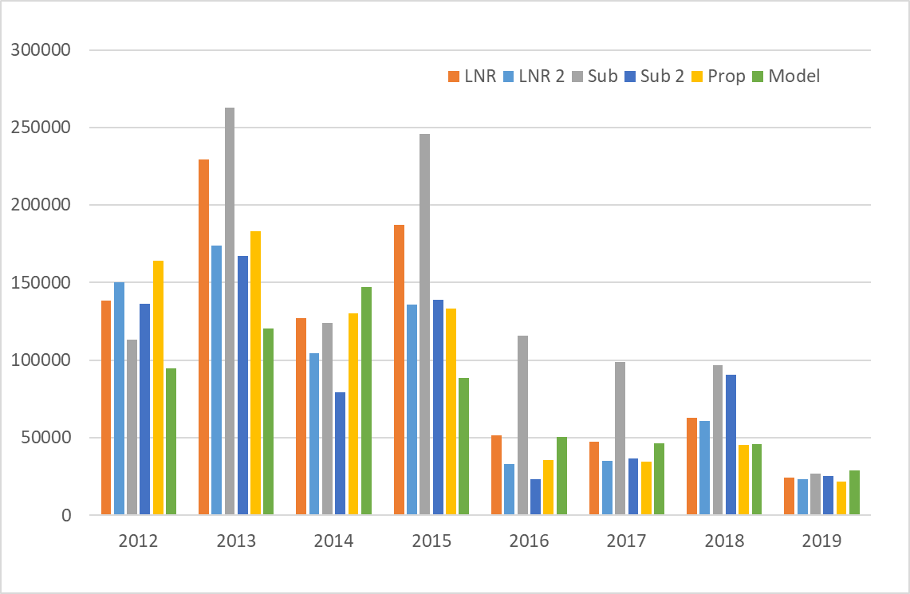

Figure 1. The number of discarded crab estimated by 3 methods.

# Appendix D VAST model estimation of Norton Sound Red King Crab abundance and distribution.

Here I present several VAST model results of Norton Sound Red King Crab abundance and distribution.

**Dataset:**

Trawl survey data of all years (NOAA: 1976-1991, ADFG: 1996-2020, NOAA NBS: 2010-2018) were combined as follows:



……



In the above Latitude and Longitude are trawl coordinate, Totalmale is the number of male NSRKC (> 63mm) caught in the trawl.

**Model setting:**

Model settings were suggested by James Thorson during the VAST modeling workshop.

settings = make_settings( n_x=50, Region="Other",purpose="index2",bias.correct=FALSE,

FieldConfig=c("Omega1"=1, "Epsilon1"=1, "Omega2"=0, "Epsilon2"=0), Version="VAST_v9_2_0", use_anisotropy=TRUE)

fit = fit_model( "settings"=settings, "Lat_i"=data[,'Latitude'],

"Lon_i"=data[,'Longitude'], "t_i"=data[,'Year'],

"c_i"=rep(0,nrow(data)), "b_i"=data[,'Totalmale'],

"a_i"=data[,'Swept_NM2'], "v_i"=data[,'Agent'],

"observations_LL"=cbind("Lat"=data[,'Latitude'],"Lon"=data[,'Longitude']),

getsd=TRUE, newtonsteps=1, grid_dim_km=c(5,5),

maximum_distance_from_sample=50,

knot_method="samples")

The model was ran in two data configurations: 1. All trawl survey data, 2. Trawl survey data limited to current ADFG survey stations.

**Results**

1. All data

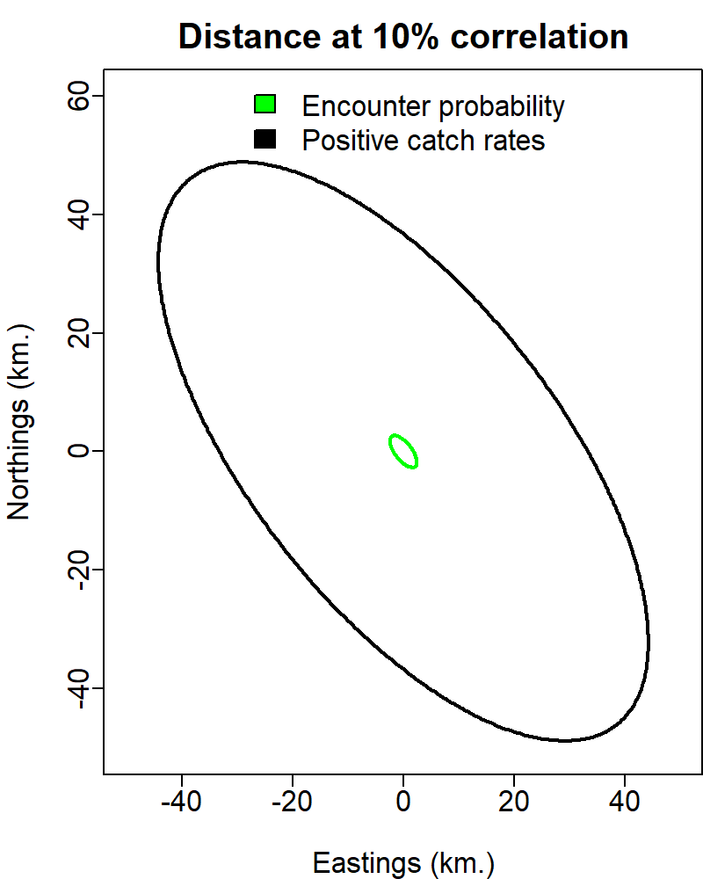 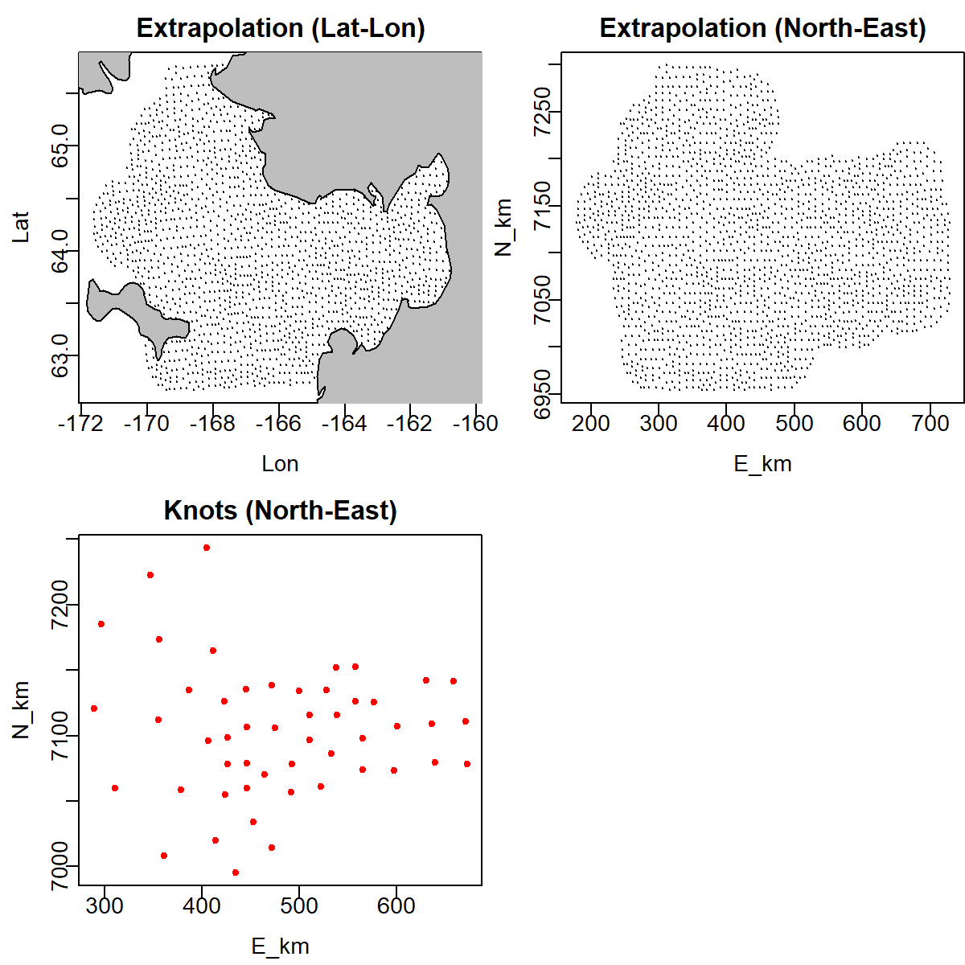

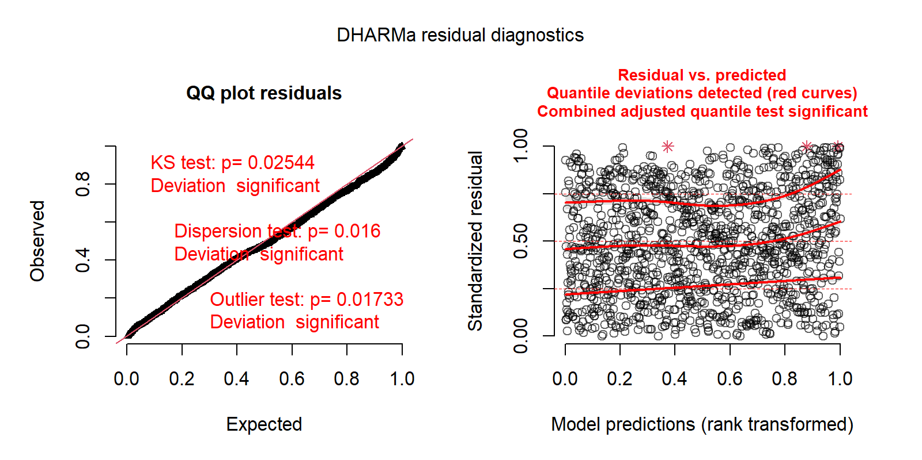

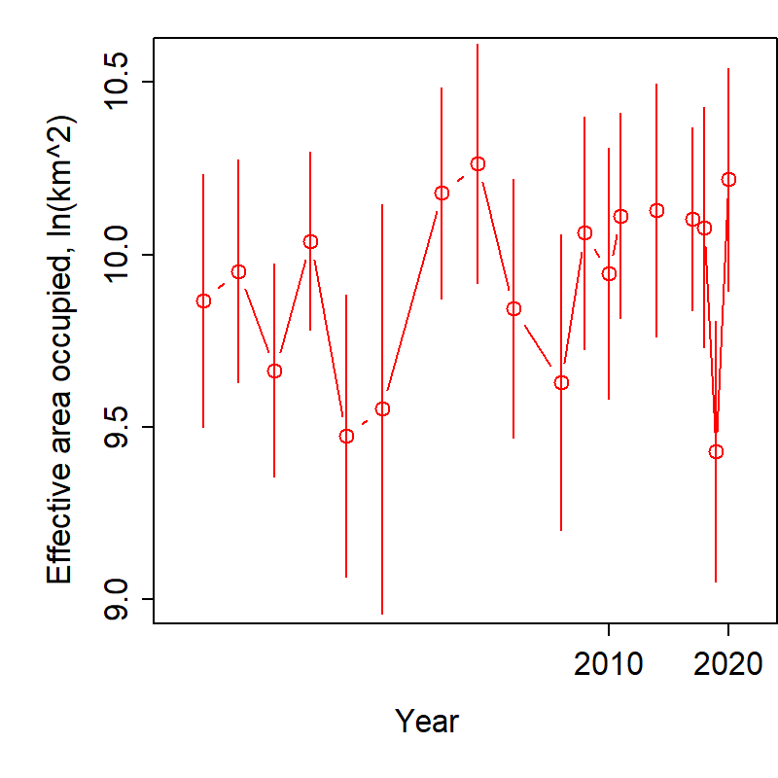 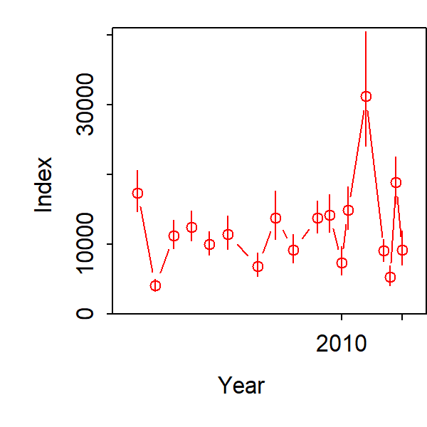

Abundance distribution



Spatial residual

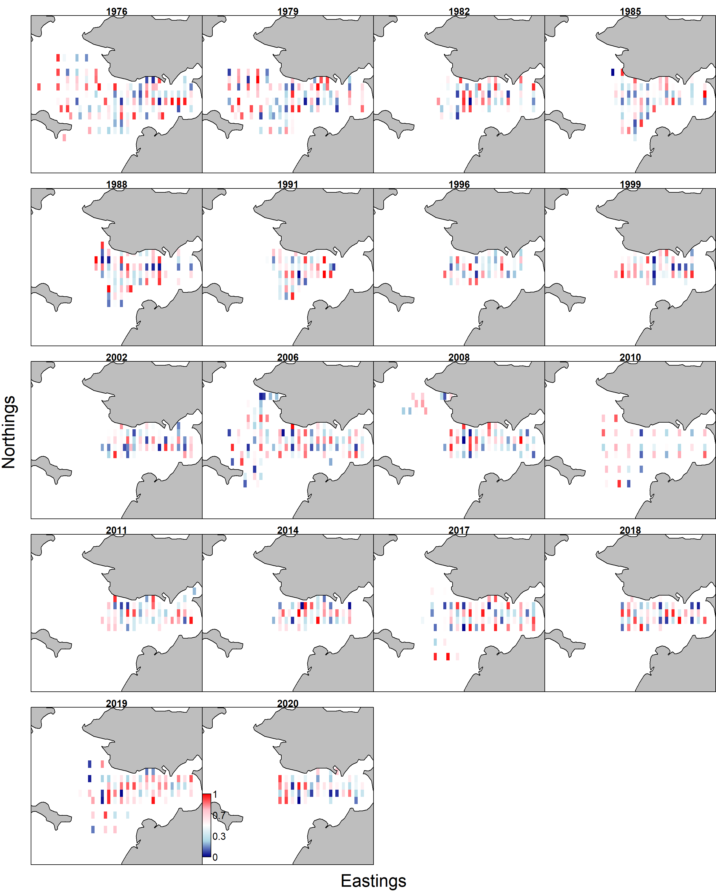

1. Limited data

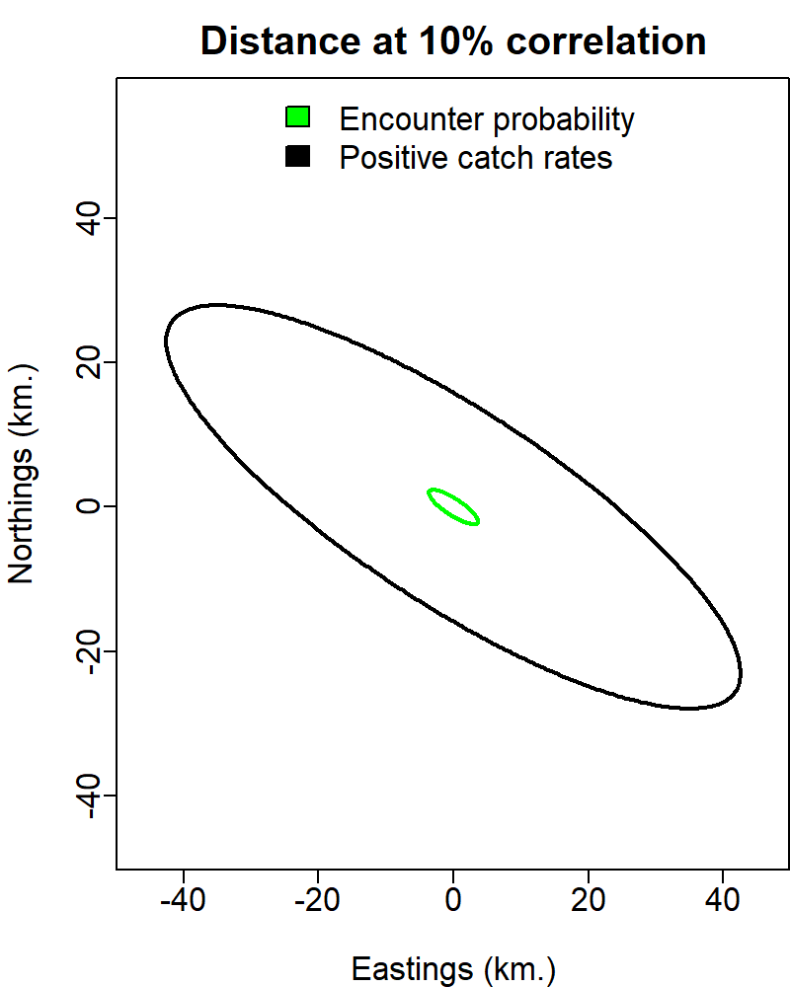

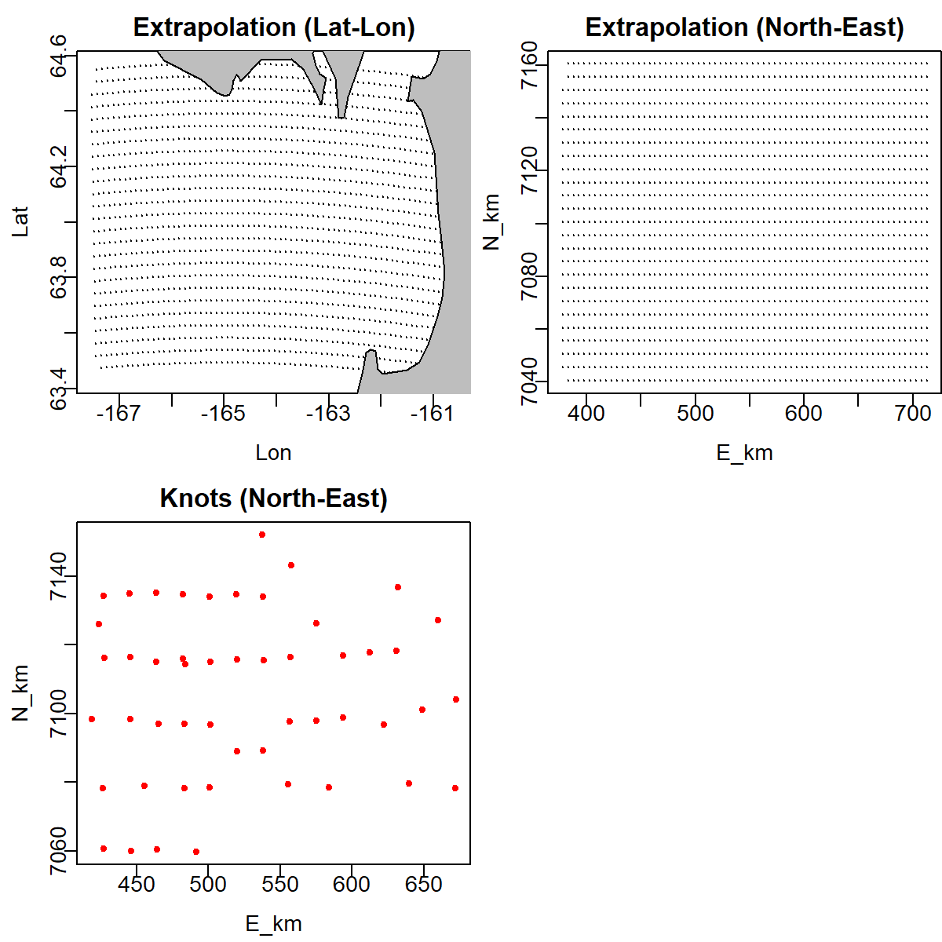

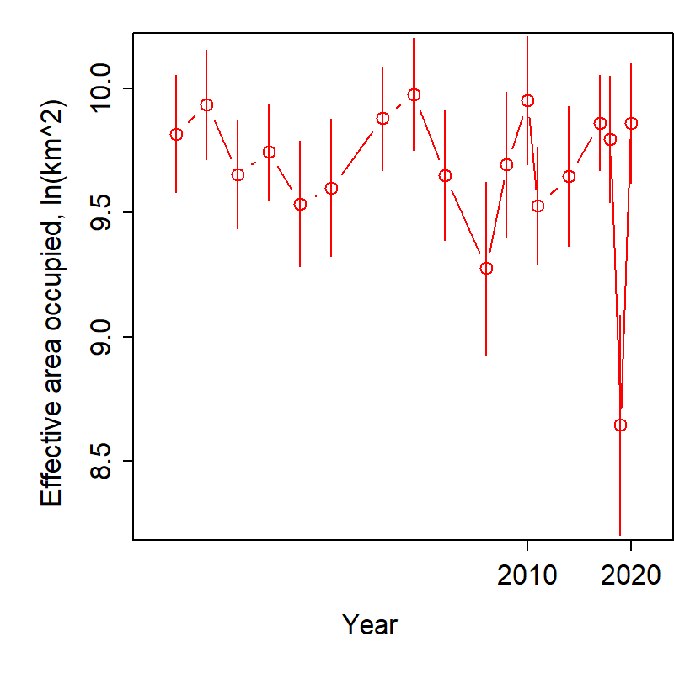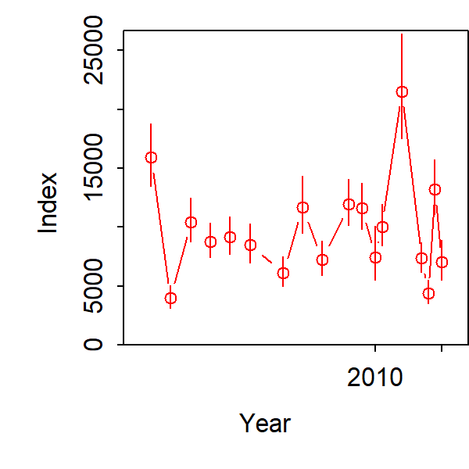

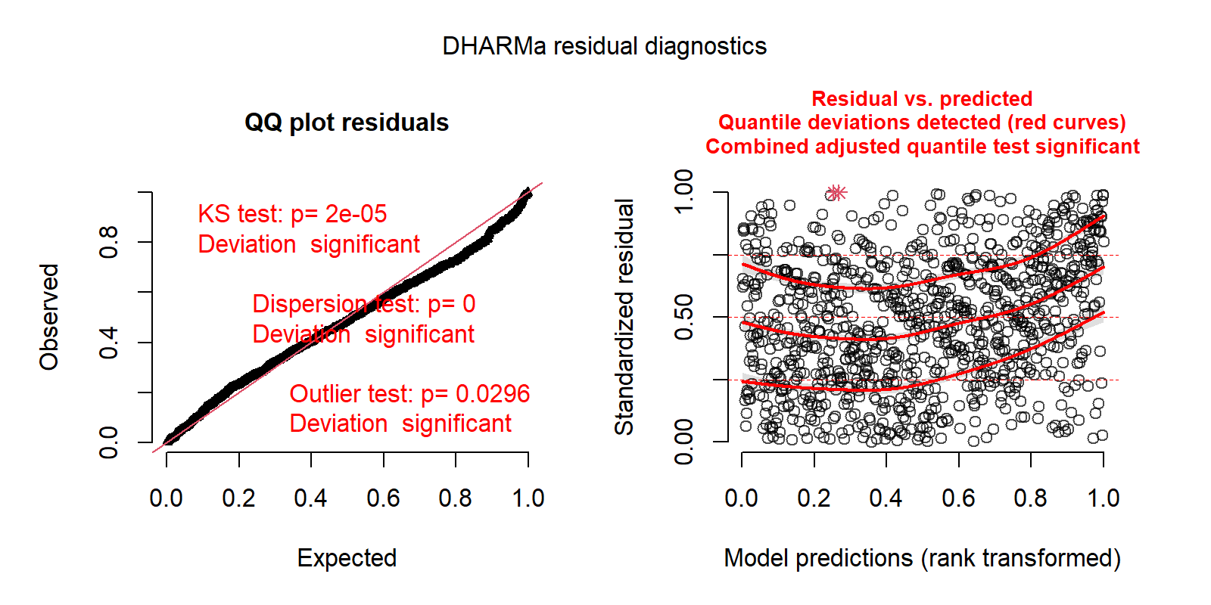

Abundance distribution

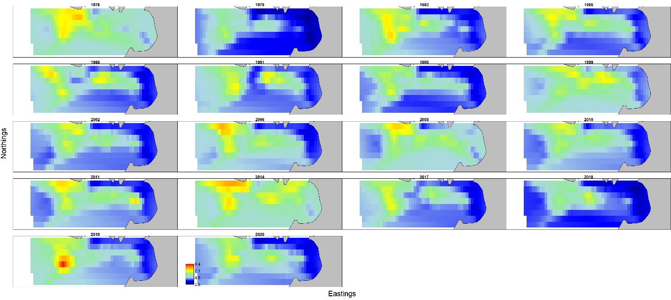

Spatial residuals

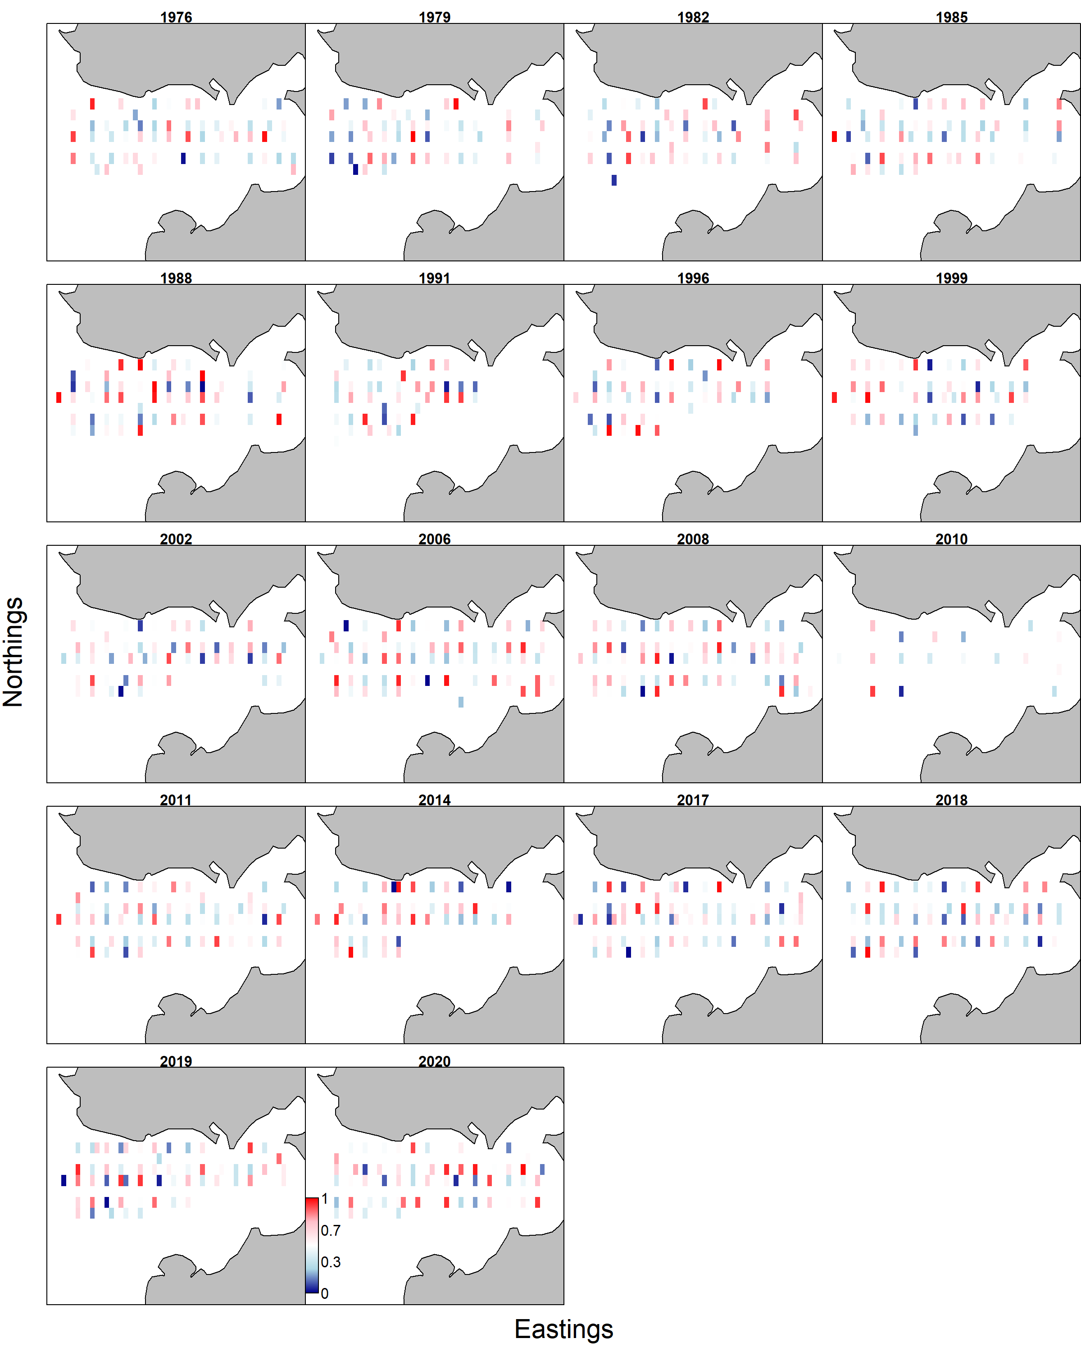

Comparison of abundance among survey (dots and line: NOAA: red, ADFG: black, 95CI), VAST estimate of all data (red) and ADFG survey stations (blue).

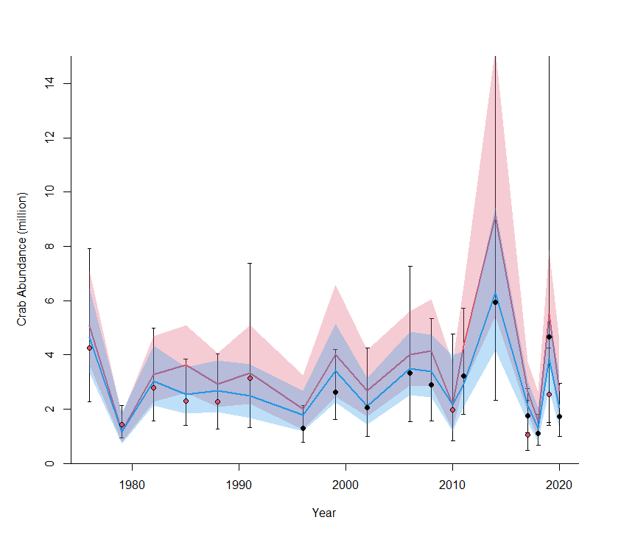

VAST model output of entire Q3 region by NBS survey only

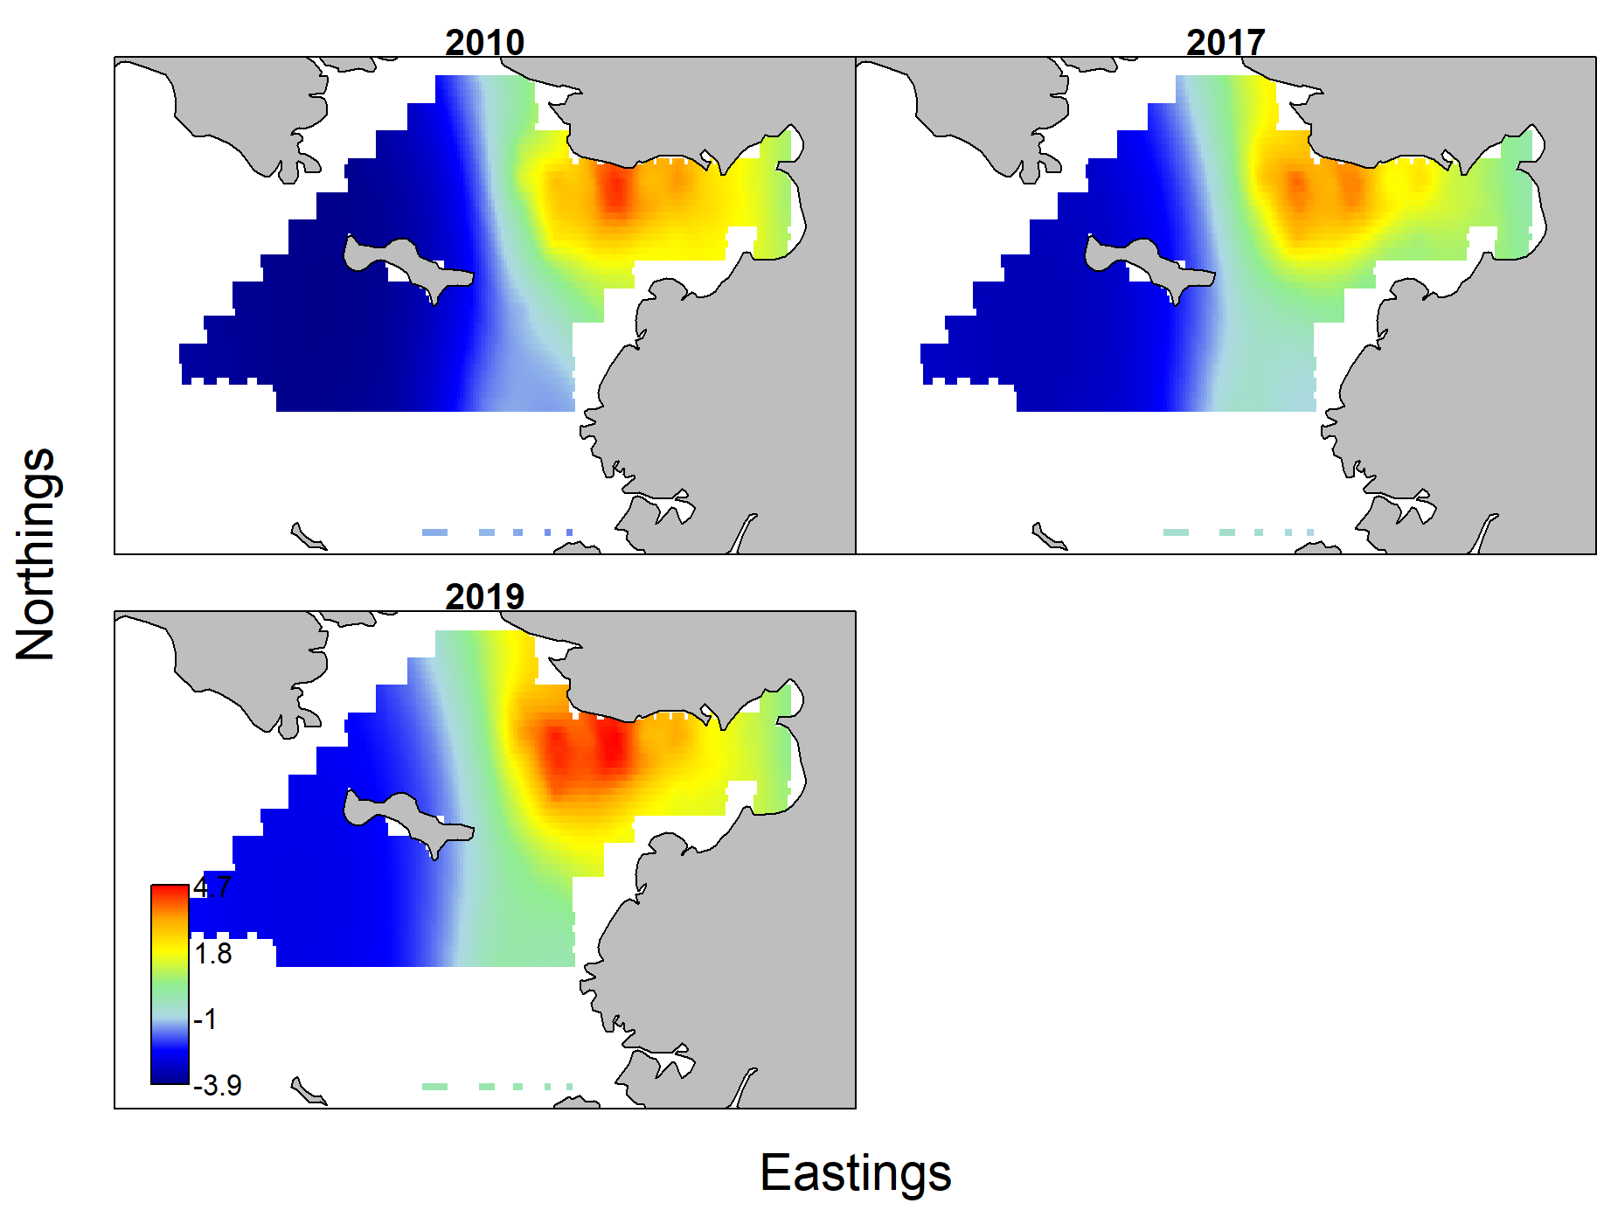

Discussion

Estimates of abundance were generally similar among survey and VAST. Model estimated CI ranges were smaller than survey CI, and abundance using all data set was larger than those with limited data, which is expected. VAST estimated of NSRKC distribution differ among years and survey dataset. Running and fitting NSRKC trawl data with VAST appeared to be difficult, probably because of lack of consistent data.

# Appendix E Comparison of NSRKC Assessment model and GMACS.

Here I present GMACS model results of Norton Sound Red King Crab.

Achievements from Sept 2020 to Jan 2021.

Run GMACS with assessment model results.

Issues remained:

1. Could not match initial model size composition
2. Could not match winter pot fishery selectivity
3. Could not match retention probability
4. Structural difference not resolved: assessment model remove catch directly (i.e. Catch is not modeled), whereas gmacs estimates catch (i.e., fishing mortality estimated).



Figure 1. Male abundance between assessment model (black) and gmacs (red)



Figure 2: MMB projection between assessment model (black) and gmacs (red)

# Appendix F Norton Sound red king crab data

Table 1. The number of mature females by year, length class, and clutch fullness from trawl survey. Note: definition of Clutch fullness differ between NOAA and ADFG

|  |  |  |  |  |  |  |  |  |  |
| --- | --- | --- | --- | --- | --- | --- | --- | --- | --- |
|  |  |  | Clutch fullness | | | | | | |
| Year | Agent | Length class | 1 | 2 | 3 | 4 | 5 | 6 | 7 |
| 1976 | NOAA | 54 | 0 | 0 | 0 | 0 | 1 | 0 | 0 |
| 1976 | NOAA | 64 | 1 | 1 | 0 | 7 | 4 | 11 | 2 |
| 1976 | NOAA | 74 | 1 | 0 | 5 | 17 | 16 | 36 | 4 |
| 1976 | NOAA | 84 | 1 | 1 | 0 | 6 | 13 | 18 | 3 |
| 1976 | NOAA | 94 | 0 | 0 | 1 | 0 | 1 | 4 | 0 |
| 1979 | NOAA | 64 | 3 | 0 | 0 | 0 | 0 | 0 | 0 |
| 1979 | NOAA | 74 | 0 | 0 | 0 | 0 | 0 | 2 | 0 |
| 1979 | NOAA | 84 | 0 | 0 | 1 | 0 | 0 | 5 | 0 |
| 1979 | NOAA | 94 | 0 | 0 | 0 | 0 | 0 | 1 | 0 |
| 1982 | NOAA | 54 | 0 | 0 | 0 | 0 | 0 | 1 | 0 |
| 1982 | NOAA | 64 | 0 | 1 | 0 | 1 | 0 | 15 | 0 |
| 1982 | NOAA | 74 | 0 | 0 | 0 | 1 | 0 | 38 | 0 |
| 1982 | NOAA | 84 | 0 | 0 | 0 | 1 | 1 | 25 | 0 |
| 1982 | NOAA | 94 | 0 | 0 | 0 | 0 | 0 | 4 | 0 |
| 1982 | NOAA | 104 | 0 | 0 | 0 | 0 | 0 | 1 | 0 |
| 1982 | NOAA | 114 | 0 | 0 | 0 | 0 | 0 | 1 | 0 |
| 1985 | NOAA | 64 | 0 | 0 | 0 | 0 | 0 | 6 | 0 |
| 1985 | NOAA | 74 | 0 | 0 | 0 | 0 | 0 | 18 | 0 |
| 1985 | NOAA | 84 | 0 | 0 | 0 | 0 | 0 | 14 | 0 |
| 1985 | NOAA | 94 | 0 | 0 | 0 | 0 | 0 | 9 | 0 |
| 1988 | NOAA | 54 | 0 | 0 | 0 | 1 | 0 | 0 | 0 |
| 1988 | NOAA | 64 | 1 | 0 | 0 | 2 | 4 | 10 | 0 |
| 1988 | NOAA | 74 | 0 | 1 | 1 | 0 | 5 | 37 | 0 |
| 1988 | NOAA | 84 | 0 | 0 | 1 | 0 | 1 | 29 | 0 |
| 1988 | NOAA | 94 | 0 | 0 | 0 | 0 | 0 | 4 | 0 |
| 1991 | NOAA | 74 | 0 | 0 | 1 | 1 | 0 | 2 | 0 |
| 1991 | NOAA | 84 | 0 | 0 | 2 | 1 | 3 | 7 | 0 |
| 1991 | NOAA | 94 | 0 | 0 | 0 | 0 | 0 | 5 | 0 |
| 1996 | ADFG | 64 | 11 | 0 | 0 | 1 | 5 | 1 | 0 |
| 1996 | ADFG | 74 | 9 | 0 | 1 | 6 | 8 | 4 | 0 |
| 1996 | ADFG | 84 | 0 | 0 | 1 | 1 | 8 | 4 | 0 |
| 1996 | ADFG | 94 | 0 | 0 | 0 | 0 | 3 | 1 | 0 |
| 1996 | ADFG | 104 | 0 | 0 | 0 | 0 | 0 | 1 | 0 |
| 1999 | ADFG | 64 | 1 | 0 | 0 | 0 | 3 | 0 | 0 |
| 1999 | ADFG | 74 | 0 | 0 | 1 | 0 | 10 | 1 | 0 |
| 1999 | ADFG | 84 | 1 | 0 | 0 | 0 | 9 | 8 | 0 |
| 1999 | ADFG | 94 | 0 | 0 | 0 | 0 | 4 | 4 | 0 |
| 1999 | ADFG | 104 | 0 | 0 | 0 | 0 | 0 | 1 | 0 |
| 2002 | ADFG | 64 | 2 | 0 | 0 | 4 | 7 | 4 | 0 |
| 2002 | ADFG | 74 | 3 | 0 | 1 | 9 | 26 | 16 | 0 |
| 2002 | ADFG | 84 | 1 | 0 | 1 | 4 | 14 | 15 | 0 |
| 2002 | ADFG | 94 | 0 | 0 | 0 | 2 | 4 | 7 | 0 |
| 2002 | ADFG | 104 | 0 | 0 | 0 | 1 | 1 | 5 | 0 |
| 2006 | ADFG | 64 | 1 | 0 | 1 | 5 | 3 | 0 | 0 |
| 2006 | ADFG | 74 | 1 | 0 | 3 | 9 | 23 | 3 | 0 |
| 2006 | ADFG | 84 | 0 | 0 | 0 | 3 | 15 | 4 | 0 |
| 2006 | ADFG | 94 | 0 | 0 | 0 | 1 | 4 | 1 | 0 |
| 2006 | ADFG | 104 | 0 | 0 | 0 | 0 | 2 | 0 | 0 |
| 2006 | ADFG | 114 | 1 | 0 | 0 | 0 | 1 | 0 | 0 |
| 2006 | ADFG | 124 | 0 | 0 | 0 | 0 | 2 | 0 | 0 |
| 2006 | ADFG | 134 | 0 | 0 | 0 | 0 | 1 | 0 | 0 |
| 2008 | ADFG | 54 | 0 | 0 | 0 | 1 | 0 | 0 | 0 |
| 2008 | ADFG | 64 | 2 | 0 | 7 | 2 | 1 | 0 | 0 |
| 2008 | ADFG | 74 | 0 | 1 | 1 | 10 | 12 | 3 | 0 |
| 2008 | ADFG | 84 | 0 | 0 | 1 | 7 | 5 | 3 | 0 |
| 2008 | ADFG | 94 | 0 | 0 | 0 | 1 | 0 | 0 | 0 |
| 2008 | ADFG | 114 | 0 | 0 | 0 | 1 | 2 | 0 | 0 |
| 2010 | NOAA | 64 | 0 | 0 | 0 | 1 | 0 | 0 | 0 |
| 2010 | NOAA | 74 | 0 | 0 | 0 | 6 | 0 | 1 | 0 |
| 2010 | NOAA | 84 | 0 | 0 | 0 | 1 | 0 | 4 | 0 |
| 2010 | NOAA | 94 | 0 | 0 | 0 | 3 | 0 | 1 | 0 |
| 2010 | NOAA | 104 | 0 | 0 | 0 | 0 | 0 | 2 | 0 |
| 2011 | ADFG | 64 | 4 | 0 | 0 | 6 | 4 | 0 | 0 |
| 2011 | ADFG | 74 | 1 | 0 | 1 | 10 | 9 | 3 | 0 |
| 2011 | ADFG | 84 | 1 | 0 | 0 | 0 | 8 | 5 | 0 |
| 2011 | ADFG | 94 | 0 | 0 | 1 | 1 | 4 | 2 | 0 |
| 2011 | ADFG | 104 | 0 | 0 | 0 | 0 | 1 | 0 | 0 |
| 2014 | ADFG | 64 | 0 | 0 | 0 | 2 | 1 | 0 | 0 |
| 2014 | ADFG | 74 | 0 | 0 | 0 | 14 | 8 | 3 | 0 |
| 2014 | ADFG | 84 | 0 | 0 | 1 | 2 | 5 | 0 | 0 |
| 2014 | ADFG | 94 | 0 | 0 | 0 | 0 | 1 | 0 | 0 |
| 2017 | ADFG | 64 | 4 | 0 | 1 | 1 | 2 | 1 | 0 |
| 2017 | ADFG | 74 | 1 | 0 | 1 | 0 | 1 | 0 | 0 |
| 2017 | ADFG | 84 | 0 | 0 | 0 | 1 | 2 | 3 | 0 |
| 2017 | ADFG | 94 | 0 | 0 | 1 | 0 | 4 | 2 | 0 |
| 2017 | ADFG | 104 | 1 | 0 | 0 | 0 | 0 | 2 | 0 |
| 2017 | NOAA | 64 | 0 | 0 | 0 | 1 | 0 | 0 | 0 |
| 2017 | NOAA | 74 | 0 | 0 | 0 | 1 | 0 | 1 | 0 |
| 2017 | NOAA | 84 | 0 | 0 | 0 | 0 | 0 | 1 | 0 |
| 2017 | NOAA | 94 | 0 | 0 | 0 | 0 | 0 | 2 | 0 |
| 2017 | NOAA | 104 | 0 | 0 | 0 | 0 | 0 | 3 | 0 |
| 2017 | NOAA | 114 | 0 | 0 | 0 | 1 | 0 | 0 | 0 |
| 2018 | ADFG | 64 | 1 | 0 | 0 | 0 | 0 | 0 | 0 |
| 2018 | ADFG | 74 | 0 | 0 | 0 | 1 | 4 | 3 | 0 |
| 2018 | ADFG | 84 | 1 | 0 | 0 | 1 | 4 | 0 | 0 |
| 2018 | ADFG | 94 | 1 | 1 | 0 | 0 | 1 | 1 | 0 |
| 2019 | ADFG | 54 | 3 | 0 | 0 | 0 | 0 | 0 | 0 |
| 2019 | ADFG | 64 | 31 | 1 | 8 | 11 | 7 | 1 | 0 |
| 2019 | ADFG | 74 | 18 | 0 | 5 | 10 | 7 | 2 | 0 |
| 2019 | ADFG | 84 | 1 | 0 | 0 | 2 | 2 | 1 | 0 |
| 2019 | ADFG | 94 | 0 | 0 | 0 | 0 | 1 | 0 | 0 |
| 2019 | NOAA | 64 | 2 | 0 | 1 | 1 | 0 | 0 | 0 |
| 2019 | NOAA | 74 | 1 | 0 | 0 | 8 | 0 | 0 | 0 |
| 2019 | NOAA | 84 | 0 | 1 | 0 | 2 | 0 | 0 | 0 |
| 2019 | NOAA | 104 | 0 | 0 | 0 | 1 | 0 | 0 | 0 |
| 2020 | ADFG | 54 | 0 | 0 | 1 | 0 | 0 | 0 | 0 |
| 2020 | ADFG | 64 | 5 | 0 | 4 | 3 | 12 | 1 | 0 |
| 2020 | ADFG | 74 | 2 | 3 | 15 | 16 | 30 | 29 | 0 |
| 2020 | ADFG | 84 | 0 | 0 | 1 | 6 | 12 | 12 | 0 |
| 2020 | ADFG | 94 | 0 | 0 | 0 | 0 | 0 | 4 | 0 |

Table 2: Criteria of maturity and clutch fullness used in ADFG and NOAA trawl surveys

|  |  |
| --- | --- |
| Maturity |  |
| ADFG (1996 - 2002) | Immature: < 72mm CL and no egg  Mature: ≥ 72mm CL or with egg |
| ADFG (2006 - 2020) | Immature: small abdominal flap  Mature: oval-shaped abdominal flap full covered |
| NOAA (1976 – 1991) | Immature: NA  Mature: NA |
| NOAA NBS (2010 – 2019) | Immature: NA  Mature: NA |
| Clutch size |  |
| ADFG (1996 – 2020) | 1: Barren clean plepod, 2: Barren matted plepod  3: 1- 29% full, 4: 30-59% full, 5: 60-89% full, 6: 90-100% full |
| NOAA (1976 – 2019) | 0: Immature, 1: Barren clean plepod, 2: 1- 12.5% full,  3: 12.5 - 25% full, 4: 26-50% full, 5: 51-75% full, 6: 76-100% full, 7: > 100% full, 9: No data |

**Appendix G**

Norton Sound red king crab 2020-2021 SAFE assessment model review by CPT (Jan & Sept 2020) and SSC (Feb & Oct 2020).

CPT: Jan 2020

**Norton Sound RKC - Final 2020 Assessment**

Toshihide Hamazaki presented the assessment Norton Sound red king crab based on the suite of models decided in September 2019 using updated data sets. The model selected in September was the base model developed in 2018. Key points of discussion included the treatment of discards, appropriateness of natural and discard mortalities, the utility of using shell condition within the model, documentation standards, and advice on buffers.

A range of methodologies for calculating discards was presented, but, given the relatively sparse documentation for the methods, the CPT was unable to effectively evaluate the various methodologies. The author suggested that the discards are less important to the assessment and management process than reliable survey data, a sentiment that was echoed by local managers. The CPT emphasized that federal guidelines require that OFLs be based on total removals, which requires an appropriate accounting for discard mortality. The CPT also stressed the need to be consistent in definitions of ‘discards’ and ‘total’ catches across stocks.

Historically, natural mortality was specified as 0.18yr-1 for all size classes except the largest size class. Models were presented in which a single value of natural mortality was used in response to questions of biological explanations for the major change in natural mortality-at-size implied by the assessment. Discard mortality has historically been set at 0.2 for both the summer and winter seasons. The possibility that mortality rates vary between winter and summer was raised given the harsh conditions encountered during winter. The utility of shell condition for Norton Sound red king crab was discussed given uncertainties around shell condition in other stocks. Difficulty in estimation of molting probabilities when shell condition was excluded in previous iterations of the assessment was listed as the reason for the continued inclusion of shell condition. Nevertheless, a model run without shell condition data (with perhaps a fixed molting probability) would address whether the estimates of high terminal M is being driven by inaccurate shell condition data.

The CPT recommended the use of the *status quo* model with a buffer between OFL and ABC increased to 25% to reflect very low recent catch per unit efforts and unusually large amounts of old shell crab in the fishery. A potential recruitment event is apparent in the length composition data, but is not expected to enter the fishery until 2-3 years. The CPT emphasized the need for appropriate documentation of methodology to facilitate discussion and the importance of appropriately plotted data and model output in this process.

The CPT recommends the following:

* The calculation of discards from the available data needs to be better documented to facilitate discussion by the CPT. In particular, all symbols in equations must be defined and clear descriptions of the differences among the various assumptions around methods of calculating discards should be provided.
* Comparisons of model estimates of discards to different potential calculations of discards should be presented in a figure.
* Develop a rationale for whether or not the bias correction should be applied to the discard data. Document the bias correction with enough depth to facilitate discussion by the CPT.
* Ensure that the definitions of ‘total’ catch and ‘discard’ catch are consistent with other assessments.
* Explore potential differences between handling mortality in the summer and winter.
* Consider the impact of ghost fishing of lost pots from the winter fishery.
* Figure 4 needs a representation of uncertainty for both the data and the model output. Any other figures missing representations of uncertainty should be revised.
* The dots on figures representing ‘projections’ (e.g. fig 4 & 5) were confusing, please join the line with the dots representing ‘projections’.
* Check equations 3, 6, and 7 for changes in the index ‘t’.
* Provide one main assessment document that includes tables and figures. Include all other information and analyses in a single appendix.
* Consider reducing the resolution of figures to control the size of documents.
* Ensure numbers in the front matter (e.g. MMB in the tables in which the OFLs are listed) are correct.
* Attempt to achieve 10-year peels for retrospective analyses. Consult published literature on how to assess the significance of the Mohn’s rho estimate.

**SSC: Feb 2020**

**Norton Sound Red King Crab**

The Norton Sound red king crab stock assessment was presented by Martin Dorn (NOAA-AFSC). Public testimony was provided by Adem Boeckmann (Norton Sound crab fisherman) and Scott Kent (Norton Sound Economic Development Corporation). Both expressed their concerns about the conservation of this stock. Low confidence in stock abundance estimates was noted, given the few crab caught in the NMFS and ADF&G trawl surveys and their relatively narrow spatial distribution. Mr. Boeckmann also presented data from Jenefer Bell (ADF&G) on clutch fullness from female crab caught during a tagging study, trawl surveys, and by fishery observers. According to the data tables and graphs presented, in 2019, approximately 50% of females had empty egg clutches, indicating reproductive failures associated with shortage of mature males. Changes in the spatial distribution of red king crab with stock increases (expansion) and decreases (contraction) were noted. In 2019, a sharp drop in fishery CPUE, associated with failure to find crab concentrations in adjacent areas, indicated low stock size. Based on these observations, Mr. Boeckmann did not feel that a fishery was advisable in 2020, whereas Mr. Kent supported an increase in the buffer between OFL and ABC from 20% to 25% as recommended by the CPT.

The Norton Sound red king crab stock assessment is a length-based model of male crab abundance involving data from four surveys: preseason summer pot, summer trawl, summer pot and winter pot. The stock assessment for 2020 was conducted with the following updated data: (1) commercial catch CPUE standardized over the full time period (1977-2019), rather than two separate time periods (1977-1993, 19942019); (2) recent winter and summer commercial fishery harvest, discards, and length compositions; size composition data were not collected for retained crab in the 2019 winter commercial fishery due to low harvest; (3) new tag recovery data from 14 crab for 2019; and (4) abundance estimates and associated data (e.g., length frequencies) from the 2019 ADF&G and NMFS trawl surveys. The SAFE provided supplementary information in four appendices: A – assessment model description, B – CPUE standardization, C – estimation of discards from the summer fishery, and D – plots (Q-Q plots, residuals, etc.) for base model 19.0 and alternatives 19.1-19.5. The base model and five alternatives were examined:

* Model 19.0: Base (Model 18.2b)
* Model 19.1: Model 19.0 + Tag recovery data just for 1 year
* Model 19.2: Model 19.0 + NOAA trawl survey q =1.0, estimate ADF&G survey q
* Model 19.3: Model 19.0 + Estimate survey q’s for both surveys
* Model 19.4: Model 19.0 + Estimate *M* equal for all lengths + dome-shape selectivity for trawl and summer commercial fishery (maximum selectivity 94-103 for trawl, 104-113 for commercial)
* Model 19.5: Model 19.0 + Estimate *M* equal for all lengths + dome-shape selectivity for trawl and summer commercial fishery (maximum selectivity 104-113 for trawl, 114-123 for commercial) **This assessment focused on the base model (Model 19.0) and the CPT continues to recommend adopting this model. The SSC agrees.** Using Model 19.0, the estimated 2020 mature male biomass (MMB) is 1,660 t, which is near the all-time low estimated in 1982. **Based on Model 19.0, stock biomass is above MSST so the stock is not overfished, and retained catch during 2019 did not exceed the OFL for this stock so overfishing is not occurring.** However, in the 2019 fishery, commercial harvests were well below the 2019 ABC. Poor fishery performance was attributed to: (1) late ice buildup preventing winter fisheries; (2) reduced participation in the summer commercial fishery; and (3) low CPUE. One optimistic sign is that the most recent (2019) recruitment estimate from length-based analysis is the largest on record since 1976 (Table 13), driven by increased catches of small individuals in 2018-19 trawl surveys. However, this year-class remains quite uncertain as it will be 2-3 years before these small crab grow enough to enter the fishery.

This stock has been managed under Tier 4.Tier 4 stocks are assumed to have reliable estimates of current survey biomass and instantaneous *M*. However, biomass estimates for Norton Sound red king crab are uncertain. As an example, in 2019 the abundance estimated by the ADF&G trawl survey was roughly double that estimated by the NMFS trawl survey. Both surveys encountered very high catches at individual stations but at different locations; in the case of the NMFS survey, the high-catch station was outside the standard ADF&G survey area. Also, a long-standing challenge for this assessment is a tendency for the model to project higher abundances of large-size males (>123 mm CL) than observed. Computationally, the issue was addressed by setting natural mortality *M* to be ~3-4 times higher for the largest size class relative to smaller size classes. It remains unclear whether such a sharp increase in *M* is real, owing to unknown causes, or whether there is another explanation, such as large crabs moving outside the survey area. Members of the public provided testimony that crab are not moving outside the survey area, based on wide-spread fishing effort and local knowledge shared by Mr. Boeckmann.

**MMB is estimated to be below the BMSY proxy, so this stock falls under Tier 4b. The resulting calculations provide a** **retained catch OFL of 0.287 million lb (0.13 thousand t) for 2020. The SSC endorses this OFL as recommended by the authors and CPT.**

**The CPT recommended increasing the buffer between OFL and ABC from 20% to 25% in 2020 on the basis of very low summer fishery CPUE and unusually large numbers of old-shell males in the fishery observed in 2019. However, the SSC is quite concerned about this stock and instead recommends a more conservative 30% buffer resulting in an ABC of 0.201 million lbs (0.09 thousand t) for 2020.**

**The SSC justifies a 30% buffer based on the following concerns:**

1. **Considerations of other stocks with similar levels of uncertainty**
2. **Concerns with model specification in part indicated by a positive retrospective pattern, whereby successive assessments indicate increasingly pessimistic estimates of stock size for the same years. The full magnitude of the retrospective bias is unknown given that peels of the data go back only a few years. The cause(s) of the pattern are unknown**
3. **Shortage of discard data and resultant inability to manage the stock based on total catch, which is the standard for federal fisheries**
4. **Unresolved issues associated with the apparent high *M* for the largest size class**
5. **Discrepancies in stock size estimates between ADF&G and NMFS surveys as well as concerns about the spatial distribution of crab relative to the survey footprint**
6. **Very low fishery CPUE and inability of the fishery to attain the ABC in 2019**
7. **Unusually large numbers of old-shell males in the fishery in 2018-2019**
8. **High proportions of barren females in survey and fishery observations indicating some reproductive failures in 2019**
9. **Below-average numbers of prerecruits (<94 mm CL) in 2015-2018 suggesting that belowaverage recruitment to the fishery will be experienced for several more years**
10. **High uncertainty in the magnitude of the most recent year class (prerecruits in 2019), preliminarily estimated to be large. However, these small crab are several years away from recruiting to the fishery as legal crab and they are challenged by unprecedented recent increases in Pacific cod, a crab predator, in Norton Sound.**

**The SSC appreciates the authors attempts to address the previous CPT and SSC recommendations and provides the following further guidance for additional work.** Many of these issues were topics of discussion at the CPT meeting. Among these, a leading concern is the continued use of retained catch OFLs and ABCs, rather than total catch OFLs and ABCs, which is the standard for federally managed fisheries. The SSC appreciates the authors’ attempt to generate preliminary discard estimates in Appendix C of the assessment. However, as pointed out by the CPT, a more complete description of alternative methods to calculate discards is needed to evaluate a potential way forward. The SSC also reminds the authors of the SSC’s suggestion from October 2019 in which the authors were encouraged to consider using dockside interviews as an approach to compare with analytical predictions of discards. The goal is to set OFLs and ABCs in terms of total removals (total fishing mortality). Accurate estimates of discards are even more important now, given low CPUE of legal males and the apparent very high abundance of sublegal crab. The SSC recommends that the assessment authors place top priority on working on this topic for next year’s assessment and supports the CPT’s recommendations in this regard.

**Some previous SSC comments were not resolved.** For example, the SSC suggested that a thorough examination of the spatial distribution of red king crab, in particular spatial differences in size composition, across the northern Bering Sea beyond Norton Sound would be helpful as it could provide insights into potential movement of large-size crab outside of the survey area. Also, the SSC had previously noted the number of crab caught per trawl appears to be very small in most cases with many zeros for both the ADF&G and NMFS surveys. In fact, in 2019, the NMFS trawl survey caught red king crab in only 10 of 16 stations and the ADF&G trawl survey caught king crab in only 27 of 52 stations. Based on such observations, the SSC had also earlier suggested that it might be useful to compare the ADF&G and NMFS surveys using appropriate methods for zero-inflated distributions, such as those offered in various R packages (e.g., pscl, gamlss, INLA, VAST, glmmfields). The authors responded that examination of the spatial distribution is a task more appropriate for NMFS and they also indicated lack of familiarity with the aforementioned packages for spatial modeling. The SSC suggests that treatment of survey data is critical to the Norton Sound red king crab stock assessment and encourages the assessment authors to pursue such spatial analyses through collaboration with experts in these techniques. The SSC highlights the portion of the NMFS survey that lies west of the ADF&G survey footprint, which contained crab not used in the abundance estimate, and suggests that methods directly estimating the spatial correlation structure among the data may provide a basis for estimating model-based indices that incorporate all available data and are robust to changes in survey footprint. These facts suggest that new field work may be needed to examine potential shifts in spatial distribution of the stock and raises questions whether a different survey design may be appropriate. Such concerns motivate the SSC’s recommendations to conduct spatial analyses.

Previously, the SSC encouraged bringing local and traditional knowledge into the assessment. The authors sought clarification from the SSC about how to do this. The SSC reiterates its February 2019 recommendation regarding local and traditional knowledge. As stated in the minutes from that meeting:

*Local and traditional knowledge: Both summer and winter fisheries for red king crab have been taking place in Norton Sound as well as in Kotzebue Sound for a long time and the SSC suggests that local commercial fishermen may have considerable knowledge about spatial patterns in size distributions, changes in spatial distribution, migratory behavior, and other aspects of red king crab dynamics in the region, as may local subsistence users of the resource, including elders. For instance, local users may possess valuable insights into the disposition of the “missing” large male crab. We strongly encourage the authors, through collaborations at the local level, to consider these sources of knowledge.*

Regarding the authors’ question about how to do this, the SSC notes that there are individuals with this expertise within NMFS and ADF&G who could help facilitate those collaborations, as well as several entities within the region including, but not limited to, NSEDC and Kawerak, Inc.

Previously, the SSC noted that new maturity studies are needed to improve the assessment as current estimates are based on a proxy method by applying the ratio of male to female size at maturity from the Bristol Bay red king crab stock to female size at maturity for Norton Sound. The SSC appreciates the addition of new chela and carapace size data from 97 males collected in 2019, and agrees that no obvious break-point is indicated by these data. Lacking new maturity data from Norton Sound red king crab, the SSC had previously suggested that the authors explore availability of Russian data on maturity. It is not clear whether the authors have been successful in locating Russian data for red king crab in the western Bering Sea. The SSC believes that maturity data are available from Norwegian and Russian scientists on the Barents Sea stock of red king crab. The SSC further suggested that a potential relationship between maturity and temperature across all stocks that have maturity data should be explored for potential predictive capability for Norton Sound. The SSC suggests that a meta-analysis of available size at maturity across red king crab stocks with respect to temperature may have the potential to demonstrate a temperature effect that could then be used to predict mean size of maturity for Norton Sound using local temperatures.

The SSC appreciates the evaluation of retrospective model performance but reminds the authors that retrospective analyses should be extended to peel more than 4 years; typical retrospective analyses are conducted over ~10 years. The SSC joins the CPT in continuing to recommend an attempt to conduct 10year peels for retrospective analyses. The SSC notes that, even with just four peels, there is a tendency for estimates of current-year biomass to become smaller each year with the addition of new data (Figure 18). Retrospective bias and its potential causes are important areas to explore more thoroughly.

The SSC supports the 13 bulleted CPT recommendations for the authors, as well as the CPT suggestion that a model run without shell condition data would address whether estimates of high terminal *M* is driven by inaccurate shell condition data. The SSC agrees that this an interesting possibility that should be considered.

Finally, the **SSC offers the following new recommendations**:

1. For future model comparisons, please plot time-series for all models, including the base model on a single plot for the figures presenting biomass and recruitment estimates.
2. Provide additional information and clarification on the data-weighting approach for sizecomposition date in this assessment. Specifically, provide a justification for the arbitrary minimum sample sizes (10 or 20) applied to all but tag size-composition data, report the harmonic meanimplied sample size (the average is a biased estimate for the multinomial), and provide standardized (Pearson) residuals in the residual plot including a legend showing the scale of the reported residuals.
3. Explore widening the area used for the NOAA trawl survey biomass estimate and explore the effect on estimated catchability. The current catchability estimate is less than one and this may be related to the fact that crab are found outside of the standard area. In addition, please explore whether crab catches are also included from outside the assumed survey area.
4. Report on time series of the proportion of barren females in the SAFE and address their utility to indicate reproductive concerns for the stock. Specifically, consider caveats to the interpretation of this proportion, address whether this proportion has changed over time, and compare these proportions to other managed red king crab stocks.

Under agenda item D7 Economic SAFE, the SSC requests the development of a quantitative baseline of annual community engagement and dependency for Norton Sound red king crab. There may be ways for the assessment authors to assist in this effort.

**CPT Sept 2020**

**Norton Sound Red King Crab - Proposed Model Runs for Jan 2021**

Hamachan Hamazaki (ADF&G) presented the model scenarios and preliminary results of the Norton

Sound red king crab (NSRKC) assessment to the CPT. The model is a male-only, size structured model that combines multiple sources of survey, catch, and mark-recovery data using a maximum likelihood approach to estimate abundance, recruitment, catchability of the commercial pot gear, and parameters for selectivity and molting probabilities from 1978 to 2020. A few years ago, the NSRKC crab year was changed to start from February 1 to January 31 of the following year to better match the summer and winter fisheries. The model was expanded from six to eight length groups in 2016. Hamachan did not propose new model scenarios for January 2021. Instead, he updated the base model (19.0) with new data for 2020 (model 20.0) and presented preliminary results of application of GMACS to this stock.

The winter fishery involves pots fished through the ice. The authors discussed the issue of lost pots, basically moved by shifting sea ice, and the unknown effect on additional unquantified crab mortality. While the area that shifting ice relocates pots to is important, the CPT suggested starting by documenting the quantity of pots lost per year, particularly compared to the total number of pots fished; up to 15 years of lost pot data may be available based on harvester interviews.

The new data for 2020 include the ADF&G trawl survey abundance and length compositions and a very small amount of subsistence catch and confidential winter commercial catch. The survey abundance was estimated to be 1.72 million crab for male crab >63 mm carapace length, much lower than the estimates for 2019, but higher than the survey abundance in 2018 (1.11 million crab). Male crab caught during the 2020 survey were mainly juveniles. The survey in 2020 tracked the growth progressions of juvenile crab from the 2019 survey, indicating the possibility of future increase of mature abundance. In 2020, NSEDC halted purchasing crab in the winter and summer commercial fisheries, and the Board of Fisheries also closed the summer commercial fishery in Norton Sound east of 164° W. long. There were no participants in the summer commercial fishery in the remainder of Norton Sound during 2020, and participation in the winter commercial fishery was also limited.

Mature male biomass and legal male abundance in 2021 are estimated by model 20.0 to be much larger than the 2019 values. However, there are some concerns regarding this increase. First, the model estimated survey abundance in 2020 is much higher than the observed survey abundance. Second, for male crab, four trawl surveys during 2018-2020 mainly caught juvenile crab, thus very low estimated survey mature male abundance. The CPT encouraged the authors to check the growth matrix to see whether growth was overestimated by the model. The retrospective results indicate that crab abundance was overestimated over time.

The results from the application of GMACS are very preliminary, and further work is needed before GMACS can be adopted as the preferred model for this stock. A CPT subgroup and Hamachan plan to meet in a month to check progress and provide feedback and suggestions on the GMACS modelling. Follow-up meetings of the subgroup may occur if needed before the January CPT meeting.

The CPT made the following recommendations:

* For January 2021, the priority is to run the following models:
  + Model 19.0. Based on the model naming convention, this model should remain as 19.0 and include new data for 2020. For this base model, the estimated growth from the model should be compared to the estimated growth from tagging data outside of the model.
  + Model 20.0. The GMACS model. Detailed comparisons between this GMACS model and model 19.0 are needed. For example, GMACS could be run by taking the parameter estimates from model 19.0 as known inputs to evaluate differences due to model structure. Following this, some of the GMACS parameters could be estimated.
* Improve data weighting, especially effective sample sizes for length composition data.
* Update VAST estimates.
* Report detailed data on female egg conditions and clutch fullness data. The percentages of barren mature females in Table 3 are helpful, but it is difficult to separate immature and mature females

for some years, and the percentages may not be reliable. A table could be constructed that summarizes clutch fullness and percentages of barren mature females by year and length group. If information is not available to separate immature and mature females for a given year, footnotes of the table should show this lack of information.

* Report the annual lost pot data, such as total number of lost pots each year and the proportion of pots lost in each fishery each year.

**SSC Oct 2020**

**Norton Sound Red King Crab proposed models**

The SSC received a brief summary on the preliminary NSRKC assessment from Katie Palof (ADF&G, CPT co-chair). The SSC appreciates the responsiveness of the assessment authors to numerous CPT and SSC recommendations regarding this stock. Written testimony was received from Louis Green, Jr. ( Seward Peninsula Subsistence Regional Advisory Council).

For the upcoming assessment, the authors propose to update the previously accepted base model (19.0) with new data for 2020, including 2020 ADF&G trawl survey abundances and length compositions and a very small amount of subsistence catch and (confidential) winter commercial catch. In addition, the authors plan to continue work on the GMACS model and input data issues.

The 2020 survey estimate of abundance was much lower than the 2019 estimate, but was higher than in 2018. The most recent surveys suggest that a large cohort of juvenile crab that was first observed in 2018 and 2019 will likely lead to increases in mature abundance in the near future. However, the SSC notes that the numbers of crab caught in the survey are quite low with many zero catches, resulting in wide survey confidence intervals.

**The SSC has a number of recommendations for the upcoming assessment cycle. The first four recommendations are listed in order of priority.**

First, the CPT and SSC in February recommended that the assessment authors place a high priority on incorporating discards into the estimate of total mortality for next year’s assessment in an effort to move towards a total catch OFL that includes discards, consistent with other crab stocks and with the MSA. Estimates of discards based on several different approaches were produced (Appendix C of SAFE) and the SSC requests that, if possible, the upcoming assessment bring forward OFL and ABC recommendations based on total catch rather than retained catch only.

Second, the authors have developed a GMACS version of the base model, but the CPT noted that a lot of issues remain to be worked out. The CPT recommended, and the SSC concurs, that the authors work with other experts to bring forward a GMACS model (20.0) in the upcoming assessment, including a detailed comparison with the base model (19.0).

Third, in response to previous requests, the authors explored the VAST modeling approach, combining early NOAA surveys (1977-1991), ADF&G surveys and recent NOAA NBS surveys to produce a consistent survey time series for the Q3 management area east of 164 °W. The VAST approach has the potential to address several of our previous concerns such as the large number of zero stations, crab extending beyond the standard survey area and a consistent area over which to estimate abundances. The VAST estimates tracked survey abundances well but are generally somewhat larger than the standard survey estimates due to the larger area included in the VAST model. As expected, the confidence intervals for the VAST estimates are generally smaller than those for the standard estimates. The model was not fully vetted and the authors indicated that fitting the model was “difficult.” The SSC requests that the authors further develop the VAST modeling approach and that they bring forward more complete diagnostics, including spatial residuals. The SSC also strongly encourages the authors to bring forward a model run in the upcoming assessment that uses the VAST estimates rather than standard survey estimates.

Fourth, this stock remains of concern due to recent declines in mature male biomass, declines in fishery CPUE and possible consequences for the reproductive capacity of the stock. In response to these concerns, the authors constructed a time series of the proportion of barren females. Consistent with public testimony, the observed proportion of barren females in the 2019 survey was the highest in the time series and was higher than has been observed anywhere in Alaska since the decline of red king crab stocks in the Gulf of Alaska 50 years ago. At that time, ADF&G trawl samples in Kaguyak Bay, Kodiak Island, found that 76% of mature females were barren when female:male sex ratios were highly skewed (72:1) in 1968. The authors noted some problems with the time series, including differences in how mature and immature females are classified in the NOAA and ADF&G surveys. The SSC concurs with the CPT recommendation to include this information in the upcoming assessment and, if possible, include additional measures of reproductive success such as a time series of average clutch fullness. The SSC notes that some training will be required to distinguish viable embryos from unfertilized (dead) eggs in the female’s clutch that have not yet sloughed off. The authors should also evaluate the reliability and consistency of these estimates over time, particularly for recent years. The status of reproductive measures will be helpful in evaluating potential risks to the stock to inform the size of any buffer.

In addition, the SSC highlights some recommendations from our previous meeting reports (plus one new one) and from the current CPT minutes that have not yet been addressed:

* The retrospective analysis should peel off more than 4 years to evaluate performance over a longer time period (~10 years) to better assess the magnitude and possible causes of the apparent positive bias in biomass estimates.
* In the February 2020 SAFE, the author requested help with earlier SSC recommendations to incorporate LK/TK in the management process. In response, the SSC suggested that this could be a test case for efforts by the LKTKS Taskforce. In June the SSC acknowledged the challenges to this effort posed by the COVID pandemic and encouraged relationship building in an effort to work towards a more comprehensive, coordinated LK/TK and climate change-oriented outreach and community engagement effort beginning in 2021.
* The CPT, SSC and public comments have pointed out the lack of maturity data as well as potential trends in size at maturity. Specifically, the SSC suggested a meta-analysis across red king crab stocks that occur at different temperatures. For a more detailed discussion, we refer the authors to our February 2020 minutes.
* The SSC agrees with additional recommendations in the CPT minutes, including a review of the growth matrix to determine if growth is overestimated in the model, which may explain some of the observed discrepancies between estimates of MMB and mature males caught in the survey.
* The SSC adds one new recommendation with the goal of eventually including females in the assessment model, which is currently a male-only model. Specifically, we would like to see an inventory of available data on females, including a list of any surveys and studies that have sampled females, the type of data collected, sample sizes, the length of available time series, etc.