Aleutian Islands Golden King Crab Model-Based Stock Assessment

May 2020 Crab SAFE DRAFT REPORT

M.S.M. Siddeek^{1,} J. Zheng¹, C. Siddon¹, B. Daly², M.J. Westphal³, and L. Hulbert¹
¹Alaska Department of Fish and Game, Division of Commercial Fisheries, P.O. Box 115526, Juneau, Alaska 99811
²Alaska Department of Fish and Game, Division of Commercial Fisheries, 351 Research Ct., Kodiak, Alaska 99615
³Alaska Department of Fish and Game, Division of Commercial Fisheries, PO Box 920587, Dutch Harbor, Alaska 99692.

Executive Summary

Stock
Golden king crab, Lithodes aequispinus, Aleutian Islands, east of 174° W longitude (EAG) and west of 174° W longitude (WAG).

Catches
The Aleutian Islands golden king crab (AIGKC) commercial fishery has been prosecuted every year since 1981/82. Retained catch peaked in 1986/87 at 2,686 t (5.922,425 lb) and 3,999 t (8,816,319 lb), respectively, for EAG and WAG, but the retained catch dropped sharply from 1989/90 to 1990/91. The fishery has been managed separately east (EAG) and west (WAG) of 174° W longitude since 1996/97, and Guideline Harvest Levels (GHLs) of 1,452 t (3,200,000 lb) for EAG and 1,225 t (2,700,000 lb) for WAG were introduced into management for the first time in 1996/97. The GHL was subsequently reduced to 1,361 t (3,000,000 lb) beginning in 1998/99 for EAG. The reduced GHLs remained at 1,361 t (3,000,000 lb) for EAG and 1,225t (2,700,000 lb) for WAG through 2007/08, but were increased to 1,429 t (3,150,000 lb) for EAG and 1,294 t (2,835,000 lb) for WAG beginning with the 2008/09 fishing season following an Alaska Board of Fisheries (BOF) decision. The management specification changed from GHL to TAC (Total Allowable Catch) with crab rationalization in 2005/06. The TACs were increased by another BOF decision to 1,501 t (3,310,000 lb) for EAG and 1,352 t (2,980,000 lb) for WAG beginning with the 2012/13 fishing season. The below par fishery performance in WAG in recent years lead to reduction in TAC to 1,014 t (2,235,000 lb), which reflected a 25% reduction in the TAC for WAG, while the TAC for EAG was kept at the same level 1,501 t (3,310,000 lb) for the 2015/16 through 2017/18 fishing seasons. With the improved fishery performance and stock status in 2017/18, the TACs were further increased to 1,134 t (2,500,000 lb) for WAG and 1,749 t (3,856,000lb) for EAG beginning with the 2018/19 fishing season. With the implementation of the state harvest strategy in 2019, the TACs were further increased to 1,302 t (2,870,000 lb) for WAG and 1,955 t (4,310,000 lb) for EAG. The EAG fishery achieved 100% of TAC while the WAG fishery is still continuing with 96% of TAC harvested for the 2019/20 fishing season at the time of this assessment.

Catches have been steady under the GHL/TAC and the fishery has harvested close to allowable levels since 1996/97. These TAC levels were set below the ABCs determined under Tier 5 criteria (considering 1991–1995 mean catch for the whole Aleutian Islands region, 3,145 t (6,933,822 lb), as the limit catch) under the most recent crab management plan. A new harvest strategy based on model estimated mature male abundance was accepted by the BOF in March 2019, specifying a 15% maximum harvest rate for EAG and 20% maximum harvest rate for WAG, and implemented during the 2019/20 fishery. In addition to the retained catch allotted as TAC, there was retained catch in a cost-recovery fishery towards a $300,000 goal in 2013/14 and 2014/15 to fund an on-board observer program, and towards a $500,000 goal in 2015/16 to 2019/20 in order to fund an on-board observer program and stock survey.

Catch per unit effort (CPUE, i.e., catch per pot lift) of retained legal males decreased from the 1980s into the mid-1990s, but increased after 1994/95, particularly with the initiation of the Crab Rationalization Program in 2005/06. Although CPUE for the two areas showed similar trends through 2010/11, during 2011/12–2014/15 CPUE trends have diverged (increasing for EAG and decreasing for WAG). Total retained catch in 2019/20 was 3,274 t (7,218,545 lb): 2,031 t (4,476,775 lb) from the EAG fishery (which included cost-recovery catch) and 1,244 t (2,741,770 lb) from the WAG fishery. Discarded (non-retained) catch occurs mainly during the directed fishery. Although low levels of discarded catch can occur during other crab fisheries, there have been no such fisheries prosecuted since 2004/05, except as surveys for red king crab conducted under an Alaska Department of Fish and Game (ADF&G) Commissioner’s Permit (and no AIGKC were caught during the cooperative red king crab survey performed by industry and ADF&G in the Adak area in September 2015; Hilsinger et al. 2016). Estimates of the bycatch mortality during crab fisheries decreased during 1995/96–2005/06, both in absolute value and relative to the retained catch weight and stabilized during 2005/06–2014/15. Total estimated bycatch mortality during crab fisheries in 2019/20 was 275 t (607,000 lb) for EAG and 116 t (256,000 lb) for WAG. Discarded catch also occurs during fixed-gear and trawl groundfish fisheries but is small relative to that during the directed fishery. Groundfish fisheries are a minor contributor to total fishery discard mortality, 23 t (52,000 lb) for EAG and 3 t (8,000 lb) for WAG in 2019/20. A cooperative golden king crab survey was performed by the Aleutian Islands King Crab Foundation (an industry group) and ADF&G in the EAG and WAG (for the first time) fisheries in August 2018, by vessels that were quota fishing. During the survey work, adjustments were made to a portion of the gear so escape mechanisms were no longer functional. However, for the purpose of catch accounting for 2019/20, it was assumed that bycatch mortality that occurred during the survey was accounted for by reported discards for the 2019/20 EAG fishery.

Stock biomass
Estimated mature male biomass (MMB) for EAG under all scenarios decreased from the 1980s to the 1990s, then increased during the 2000s and sharply increased since 2014. Estimated MMB for WAG decreased during the late 1980s and 1990s, increased during the 2000s, decreased for several years since 2009 and has increased since 2014. The low levels of MMB for EAG were observed in 1995–1997 and in 1990s for WAG. Stock trends reflected the fishery standardized CPUE trends in both regions.

Recruitment
The numbers of recruits to the model size groups under all scenarios have fluctuated in both EAG and WAG. For EAG, model recruitment was high in 2016 and 2017, highest in 2017; and lowest in 1986. The model recruitment for WAG was high during 1984 to 1986, highest in 1985, and lowest in 2011. A slightly increasing trend in recruitment was observed since 2011 in WAG.

Management performance
The model was accepted at the September 2016 CPT and October 2016 SSC meetings for OFL determination for the 2017/18 fishery cycle. In addition, the CPT in January 2017 and SSC in February 2017 recommended using the Tier 3 method to compute OFL and ABC. The assessment model was first used for setting OFL and ABC for the 2017/18 fishing season. This was followed since then. The CPT in May 2017 and SSC in June 2017 accepted the authors’ recommendation of using scenario 9 (i.e., model using the knife-edge maturity to determine MMB) for OFL and ABC calculation. During the May 2017 meeting, the CPT noted that a single OFL and ABC are defined for Aleutian Islands golden king crab (AIGKC). However, separate models are available by area. Hence, following previous assessments, OFLs and ABCs by area were summed to calculate OFL and ABC for the entire stock.

All models for EAG and WAG considered the last season fishery information (i.e., 2019/20 fishery, concluded in EAG and almost 96% of TAC achieved in WAG). We recommend two models form the common three models for EAG and WAG: model 20_1b (re-evaluation of observer CPUE indices after reducing the number of gear codes and consideration of different periods of recruitment estimates for mean number of recruits calculation for initializing the models for EAG and WAG); and model 20_2 (model 20_1b plus consideration of year and area interaction factor).

Model 20_1 is the base model (accepted model in 2019) with the knife edge male maturity at 111 mm CL, an M of 0.21yr⁻¹, and the addition of 2019/20 data. Models 20_1b and 20_2 are modifications from the base model.

Status and catch specifications (1000 t) of Aleutian Islands golden king crab
Year | MSST | Biomass (MMB) | TAC | Retained Catch | Total Catchª | OFL | ABC^{b}
2015/16 | N/A | N/A | 2.853 | 2.729 | 3.076 | 5.69 | 4.26
2016/17 | N/A | N/A | 2.515 | 2.593 | 2.947 | 5.69 | 4.26
2017/18 | 6.044 | 14.205 | 2.515 | 2.585 | 2.942 | 6.048 | 4.536
2018/19 | 5.880 | 17.848 | 2.883 | 2.965 | 3.355 | 5.514 | 4.136
2019/20^{c} | 6.047 | 14.760 | 3.257 | 3.275^{d} | 3.693^{d} | 5.249 | 3.937
2020/21e |  | 14.811 |  |  |  | 4.818 | 3.614
2020/21^{f} |  | 14.760 |  |  |  | 4.793 | 3.595
2020/21^{g} |  | 15.106 |  |  |  | 4.993 | 3.745

Status and catch specifications (million lb) of Aleutian Islands golden king crab
Year | MSST | Biomass (MMB) | TAC | Retained Catch | Total Catchª | OFL | ABC^{b}
2015/16 | N/A | N/A | 6.290 | 6.016 | 6.782 | 12.53 | 9.40
2016/17 | N/A | N/A | 5.545 | 5.716 | 6.497 | 12.53 | 9.40
2017/18 | 13.325 | 31.315 | 5.545 | 5.699 | 6.487 | 13.333 | 10.000
2018/19 | 12.964 | 39.348 | 6.356 | 6.536 | 7.396 | 12.157 | 9.118
2019/20^{c} | 13.331 | 32.540 | 7.180 | 7.219^{d} | 8.141^{d} | 11.572 | 8.679
2020/21e 32.652 10.623 7.967
2020/21^{f} 32.540 10.566 7.925
2020/21^{g} 33.303 11.008 8.256

- Total retained catch plus estimated bycatch mortality of discarded bycatch during crab fisheries and groundfish fisheries.
- 25% buffer was applied to total catch OFL to determine ABC.
- MMB and MSST estimates were determined by Model 20_1b with 2019/20 data.
- 100% TAC was achieved in EAG, but 96% TAC was achieved in WAG at the time of this assessment. The WAG fishery is continuing.
- Model 20_1, up to 2019/20 data.
- Model 20_1b, up to 2019/20 data.
g. Model 20_2, up to 2019/20 data.

Basis for the OFL
The length-based model developed for the Tier 3 analysis estimated mature male biomass (MMB) on February 15 each year for the period 1986 through 2020. The terminal year mature male biomass was projected by an additional year to determine OFL and ABC for the 2020/21 season. The Tier 3 approach uses a constant annual natural mortality (M), knife-edge maturity size of 111 mm carapace length, and the mean number of recruits for different time periods for OFL and ABC calculation. An M of 0.21 yr⁻¹ previously derived from the combined data (Siddeek et al. 2018) was used.
We provide the OFL and ABC estimates for EAG and WAG separately and combined (i.e., for the entire Aleutian Islands, AI) for six models, 20_1, 20_1b, 20_1c, 20_1d, 20_2, and 20_2b, for EAG; and three models, 20_1, 20_1b, and 20_2, for WAG in the following six tables. We treat scenario 20_1 as the base scenario for EAG and WAG.

EAG (Tier 3):
Biomass, total OFL, and ABC for the next fishing season in millions of pounds. Current MMB = MMB on 15 Feb. 2021.
Model | Tier | MMB_{35%} | Current MMB | MMB/  MMB_{35%} | F_{OFL} | Recruitment Years to define MMB_{35%} | F_{35%} | OFL | ABC  (P*=0.49) | ABC  (0.75*OFL)
EAG20_1 | 3a | 14.553 | 18.809 | 1.29 | 0.61 | 1987–2012 | 0.61 | 6.648 | 6.609 | 4.986
EAG20_1b | 3a | 14.935 | 18.674 | 1.25 | 0.61 | 1986–2017 | 0.61 | 6.583 | 6.544 | 4.937
EAG20_1c | 3a | 14.481 | 15.293 | 1.06 | 0.61 | 1986–2017 | 0.61 | 4.977 | 4.939 | 3.733
EAG20_1d | 3a | 14.724 | 17.173 | 1.17 | 0.61 | 1986–2017 | 0.61 | 5.850 | 5.826 | 4.387
EAG20_2 | 3a | 14.979 | 19.104 | 1.28 | 0.61 | 1986–2017 | 0.61 | 6.908 | 6.869 | 5.181
EAG20_2b | 3a | 14.579 | 16.177 | 1.11 | 0.61 | 1986–2017 | 0.61 | 5.478 | 5.438 | 4.109

Biomass in 1000 t; total OFL and ABC for the next fishing season in t.
Model | Tier | MMB_{35%} | Current MMB | MMB/  MMB_{35%} | F_{OFL} | Recruitment Years to Define MMB_{35%} | F_{35%} | OFL | ABC  (P*=0.49) | ABC  (0.75*OFL)
EAG20_1 | 3a | 6.601 | 8.532 | 1.29 | 0.61 | 1987–2012 | 0.61 | 3,015.592 | 2,997.858 | 2,261.694
EAG20_1b | 3a | 6.774 | 8.470 | 1.25 | 0.61 | 1986–2017 | 0.61 | 2,985.928 | 2,968.143 | 2,239.446
EAG20_1c | 3a | 6.568 | 6.937 | 1.06 | 0.61 | 1986–2017 | 0.61 | 2,260.998 | 2,504.178 | 1,695.748
EAG20_1d | 3a | 6.679 | 7.790 | 1.17 | 0.61 | 1986–2017 | 0.61 | 2,653.436 | 2,642.813 | 1,990.077
EAG20_2 | 3a | 6.794 | 8.665 | 1.28 | 0.61 | 1986–2017 | 0.61 | 3,133.485 | 3,115.767 | 2,350.114
EAG20_2b | 3a | 6.613 | 7.338 | 1.11 | 0.61 | 1986–2017 | 0.61 | 2,484.903 | 2,466.646 | 1,863.677

WAG (Tier 3):
Biomass, total OFL, and ABC for the next fishing season in millions of pounds. Current MMB = MMB on 15 Feb. 2021.
Model | Tier | MMB_{35%} | Current MMB | MMB/  MMB_{35%} | F_{OFL} | Recruitment Years to Define MMB_{35%} | F_{35%} | OFL | ABC  (P*=0.49) | ABC  (0.75*OFL)
WAG20_1 | 3a | 11.473 | 13.844 | 1.21 | 0.56 | 1987–2012 | 0.56 | 3.974 | 3.958 | 2.981
WAG20_1b | 3a | 11.725 | 13.867 | 1.18 | 0.56 | 1987–2018 | 0.56 | 3.983 | 3.968 | 2.988
WAG20_2 | 3a | 11.778 | 14.199 | 1.21 | 0.56 | 1987–2018 | 0.56 | 4.100 | 4.084 | 3.075

Biomass in 1000 t; total OFL and ABC for the next fishing season in t.
Model | Tier | MMB_{35%} | Current MMB | MMB / MMB_{35%} | F_{OFL} | Recruitment Years to Define MMB_{35%} | F_{35%} | OFL | ABC  (P*=0.49) | ABC  (0.75*OFL)
WAG20_1 | 3a | 5.204 | 6.279 | 1.21 | 0.56 | 1987–2012 | 0.56 | 1,802.747 | 1,795.486 | 1,352.060
WAG20_1b | 3a | 5.319 | 6.290 | 1.18 | 0.56 | 1987–2018 | 0.56 | 1,806.903 | 1,799.775 | 1,355.177
WAG20_2 | 3a | 5.343 | 6.441 | 1.21 | 0.56 | 1987–2018 | 0.56 | 1,859.828 | 1,852.480 | 1,394.871

Aleutian Islands (AI)
Total OFL and ABC for the next fishing season in millions of pounds.
Model | OFL | ABC | ABC
Model | OFL | (P*=0.49) | (0.75*OFL)
20_1 | 10.622 | 10.567 | 7.967
20_1b | 10.566 | 10.512 | 7.925
20_2 | 11.008 | 10.953 | 8.256
Aleutian Islands (AI)
Total OFL and ABC for the next fishing season in t.
Model | OFL | ABC | ABC
Model | OFL | (P*=0.49) | (0.75*OFL)
20_1 | 4,818.34 | 4,793.34 | 3,613.75
20_1b | 4,792.83 | 4,767.92 | 3,594.62
20_2 | 4,993.31 | 4,968.25 | 3,744.99

Probability density functions of the OFL
Assuming a lognormal distribution of total OFL, we determined the cumulative distributions of OFL and selected the median as the OFL.

Basis for the ABC recommendation
An x proportion buffer on the OFL; i.e., ABC = (1.0 - x) *OFL. The CPT recommended x = 0.25.

See also the section G on ABC.

A summary of the results of any rebuilding analysis:
Not applicable.

Summary of Major Changes

Changes (if any) to management of the fishery
- In 2019, a new state harvest strategy was implemented.

Changes to input data
- Commercial fisheries data were updated with values from the most recent observer and fish ticket data for 2019/20: retained catch for the directed fishery and discarded catch estimates for the directed fishery, non-directed crab fisheries, and groundfish fisheries. Thus, the time series of data used in the model are: retained catch (1981/82–2019/20), total catch (1990/91–2019/20), and groundfish bycatch (1989/90–2019/20) biomass and size compositions.
- Fish ticket retained CPUE were standardized by the generalized linear model (GLM) with the lognormal and negative binomial link functions for the 1985/86–1998/98 period.
- Observer pot sample legal size crab CPUE data were standardized by the GLM with the negative binomial link function with variable selection by R square criterion and CAIC (modified AIC), separately for 1995/96–2004/05 and 2005/06–2019/20 periods. A Year and Area interaction factor was considered in one model to estimate a set of CPUE indices. The habitat areas were determined from observer historical pot samples’ locations as fishing footprints (see Appendix B).

Changes to assessment methodology
None

Changes to assessment results
As expected, the addition of the 2019/20 data changed the OFL and ABC estimates, but changes in parameter or abundance estimates were not dramatic.

Response to January 2020 CPT comments

Comment# 1: The CPT reiterates the SSC request for a brief description of the cooperative survey in the assessment document, including the area sampled, size composition and a summary of results.

Response:
This is an evolving project to collect AIGKC data by active fishing vessels, following a designed two-stage sampling protocol. The data collection covers species, sex, count of crab by size, by pot, by string, and by vessel. Additional data such as depth of fishing, soak time, bait type, mesh size, and pot size are also collected. We use the number of legal-size male crabs at the vessel/string/pot level to estimate the CPUE by a hierarchical random effects model. A brief explanation of the method is provided in Appendix C.

We have completed the cooperative surveys for five fishing seasons (2015/16, 2016/17, 2017/18, 2018/19, and 2019/20) in the EAG region. We also extended the survey for the first time in the WAG region in 2018/19. The data series is short to obtain meaningful results. However, we used the EAG CPUE indices in some model scenarios in this analysis to get some feedback.

Comment# 2: Revised approach to select mean recruitment: The proposed approach sets mean recruitment to the average over the years for which the standard deviations of the recruitment estimates is 70% of the assumed standard deviation of inter-annual variability in recruitment. The choice of 70% is the lowest percentage at which a contiguous set of years would be selected. The CPT agrees with the general approach, and requests that the authors include the basis for the 70% in the next report.

Response:
The 70% value is an arbitrary choice satisfying the need to remove a few years from the tail end of the recruitment time series. Instead of using 70% of the fixed R_{sigma}, we used the 90th percentile cutoff level based on 1986 to 2020 recruit standard errors estimated by the base model 20_1 to exclude years with high recruit standard deviations. The 90th percentile choice is also an arbitrary level but uses the actual recruitment standard errors to obtain the cutoff level instead of R_{sigma}

Comment# 3: Revised approach for standardizing the fishery catch-rate data for 1995/96 – 2019/20. The CPT notes that basis for the specific blocks chosen for Year and Area interaction needs to be more clearly documented. The weight assigned to each block needs to be the total number of 1⁰x1⁰ cells ever fished. One potential problem with this approach is that there are blocks x years with no (or very few) data. The CPT made two suggestions:

a. Fit a model of the form $B_{i, j} = A_{i}+ C_{j}$ where $B_{i, j}$is the index of biomass for year i and block j, A_{i} is a year factor, and C_{j} is a block factor, and use this model to infer the biomass index for blocks x years with no (or very limited) data.

b. The variance of the total biomass index should be computed as:

$$Var \left(B_{i}\right)= \sum_{j}{{N_{ever, j}}^{2} var({CPUE}_{i, j})}$$
where $N_{ever, j}$is the total number of 1⁰x1⁰ cells ever fished in block j, and is the expected CPUE index for year i and block j.

Response:
We followed both suggestions. We used a GLM procedure to fit the year and area factors to available B_{i, j} indices and used the fitted model to fill the gap for missing year by block values. We also estimated the variance of the biomass index using the suggested formula (Appendix B).

Comment# 4: Analysis of the cooperative survey data. The use of a mixed-effects model is appropriate. However, the choice of covariates needs additional justification. For example, it was not clear that vessel * pot number should be treated as a fixed effect rather than pot number random within vessel. Similarly, a hierarchical structure for strings * block should be considered, such as string random within block, which is itself random. In general, the model for the analysis of the survey data should be more closely aligned with the design of the survey. One possible model would be:
Sumcatch ~ Year + (1|vessel/pot number) + ns(soakdays,ns=9) + ns(Depth,df=6) + (1|block/string).

Response:
We followed the hierarchical random effects model structure suggested by the CPT to analyze the cooperative survey data (Appendix C).

Comment# 5: The CPT recommended the following models for exploration for the May 2020 CPT meeting:
- Model 19.1b. As for model 19.1 but with revised periods of years for defining mean recruitment (EAG: 1985-2016; WAG: 1987-2016) and the fish ticket CPUE data standardized assuming a negative binomial distribution.
- Model 19.1c. As for model 19.1b except that the EAG 2015-2019 cooperative survey CPUE index is included in the assessment.
- Model 19.2. As for model 19.1b, except that the 1995/96 – 2018/19 CPUE data are standardized using year*area interactions.
- Model. 19.2b. As for model 19.2, except that the EAG 2015-2019 cooperative survey CPUE index is included in the assessment.

Response:
We considered all suggested models in this report (see Table T1).

Response to January 2020 SSC comments:

Comment# 1: The SSC reiterates for a description of the cooperative survey in the assessment document, including the area sampled and size compositions.

Response:
Please refer to our response to CPT comment#1.

Comment# 2: SSC supports exploration of treating pot as a random effect nested within vessel, or possibly string, and encourages alternative random effects model structures that align with assumptions of the cooperative survey design.

Response:
We followed the random effects approach to analyze the cooperative survey data because of two-stage sampling design structure. As per CPT suggestion#3, we used the pot within vessel and string within block structures in the random effects model analysis for this report. The exploration is continuing.

Comment# 3:
The SSC also reiterates the CPT request on the rationale for the 0.7 Sigma_R criterian for recruitments included in the estimation of reference points as this does not seem justified at this point.

Response:
The R_{sigma} value is user enforced, came from an arbitrary weight specified to the recruit likelihood. We made it non-subjective by setting the cutoff recruit deviation value at 90th percentile of the model estimated recruitment standard deviations for the whole time series. Recruitments with standard deviations less than the cutoff value are included for reference point estimation.

Comment# 4:
The SSC supports the CPT recommendation to explore the given set of models (CPT comments#5) for the May CPT meeting that explore new recruitment time series, different formulations of CPUE standardization, and the inclusion of cooperative survey CPUE.

Response:
We did in this report.

- Introduction
- Scientific name:
Golden king crab, Lithodes aequispinus J.E. Benedict, 1895.

- Distribution:
General distribution of golden king crab is summarized by NMFS (2004). Golden king crab, also called brown king crab, occur from the Japan Sea to the northern Bering Sea (ca. 61° N latitude), around the Aleutian Islands, generally in high-relief habitat such as inter-island passes, on various sea mounts, and as far south as northern British Columbia (Alice Arm) (Jewett et al. 1985). They are typically found on the continental slope at depths of 300–1,000 m on extremely rough bottom. They are frequently found on coral bottom.

The Aleutian Islands king crab stock boundary is defined by the boundaries of the Aleutian Islands king crab Registration Area O (Figure 1). In this chapter, “Aleutian Islands Area” means the area described by the current definition of Aleutian Islands king crab Registration Area O. Leon et al. (2017) define the boundaries of Aleutian Islands king crab Registration Area O:

The Aleutian Islands king crab management area’s eastern boundary is the longitude of Scotch Cap Light (164°44.72′W long), the northern boundary is a line from Cape Sarichef (54°36′N lat) to 171°W long, north to 55°30′N lat, and the western boundary the Maritime Boundary Agreement Line as described in the Maritime Boundary Agreement between the United States and the Union of Soviet Socialist Republics signed in Washington, June 1, 1990 (Figure 1-1 in Leon et al. 2017). Area O encompasses territorial waters of the state of Alaska (0–3 nautical miles) and waters of the Exclusive Economic Zone (3–200 nautical miles).

During 1984/85–1995/96, the Aleutian Islands king crab populations had been managed using the Adak and Dutch Harbor Registration Areas, which were divided at 171° W longitude (Figure 2), but from the 1996/97 season to present the fishery has been managed using a division at 174° W longitude (Figure 2). In March 1996 the Alaska Board of Fisheries (BOF) replaced the Adak and Dutch Harbor areas with the newly created Aleutian Islands Registration Area O and directed the Alaska Department of Fish and Game (ADF&G) to manage the golden king crab fishery in the areas east and west of 174°W longitude as two distinct stocks. That re-designation of management areas was intended to more accurately reflect golden king crab stock distribution, coherent with the longitudinal pattern in fishery production prior to 1996/97 (Figure 3). The longitudinal pattern in fishery production relative to 174° W longitude since 1996/97 is similar to that observed prior to the change in management area definition, although there have been some changes in the longitudinal pattern in fishery production within the areas east and west of 174° W longitude (Figure 4).

Commercial fishing for golden king crab in the Aleutian Islands Area typically occurs at depths of 100–275 fathoms (183–503 m). Pots sampled by at-sea fishery observers in 2013/14 were fished at an average depth of 176 fathoms (322 m; N=499) in the area east of 174° W longitude and 158 fathoms (289 m; N=1,223) for the area west of 174° W longitude (Gaeuman 2014).

- Evidence of stock structure:
Given the expansiveness of the Aleutian Islands Area and the existence of deep (>1,000 m) canyons between some islands, at least some weak structuring of the stock within the area would be expected. Data for making inferences on stock structure of golden king crab within the Aleutian Islands are largely limited to the geographic distribution of commercial fishery catch and effort. Catch data by statistical area from fish tickets and catch data by location from pots sampled by observers suggest that habitat for legal-sized males may be continuous throughout the waters adjacent to the islands in the Aleutian chain. However, regions of low fishery catch suggest that availability of suitable habitat, in which golden king crab are present at only low densities, may vary longitudinally. Catch has been low in the fishery in the area between 174° W longitude and 176° W longitude (the Adak Island area, Figures 3 and 4) in comparison to adjacent areas, a pattern that is consistent with low CPUE for golden king crab between 174° W longitude and 176° W longitude (Figure 5) during the 2002, 2004, 2006, 2010, and 2012 NMFS Aleutian Islands bottom trawl surveys (von Szalay et al. 2011). In addition to longitudinal variation in density, there is also a gap in fishery catch and effort between the Petrel Bank-Petrel Spur area and the Bowers Bank area; both of those areas, which are separated by Bowers Canyon, have reported effort and catch. Recoveries during commercial fisheries of golden king crab tagged during ADF&G surveys (Blau and Pengilly 1994; Blau et al. 1998; Watson and Gish 2002; Watson 2004, 2007) provided no evidence of substantial movements by crab in the size classes that were tagged (males and females ≥90-mm carapace length [CL]). Maximum straight-line distance between release and recovery location of 90 golden king crab released prior to the 1991/92 fishery and recovered through the 1992/93 fishery was 61.2 km (Blau and Pengilly 1994). Of the 4,567 recoveries reported through 12 April 2016 for the male and female golden king crab tagged and released between 170.5° W longitude and 171.5° W longitude during the 1991, 1997, 2000, 2003, and 2006 ADF&G Aleutian Island golden king pot surveys, none of the 3,807 with recovery locations specified by latitude and longitude were recovered west of 173° W longitude and only fifteen were recovered west of 172° W longitude (V. Vanek, ADF&G, Kodiak, pers. comm.). Similarly, of 139 recoveries in which only the statistical area of recovery was reported, none were recovered in statistical areas west of 173° W longitude and only one was in a statistical area west of 172° W longitude.

- Life history characteristics relevant to management:
There is a paucity of information on golden king crab life history characteristics due in part to the deep depth distribution (~200–1000 m) and the asynchronous nature of life history events (Otto and Cummiskey 1985; Somerton and Otto 1986). The reproductive cycle is thought to last approximately 24 months and at any one time, ovigerous females can be found carrying egg clutches in highly disparate developmental states (Otto and Cummiskey 1985). Females carry large, yolk-rich, eggs, which hatch into lecithotrophic (i.e., the larvae can develop successfully to juvenile crab without eating; Shirley and Zhou 1997) larvae that are negatively phototactic (Adams and Paul 1999). Molting and mating are also asynchronous and protracted (Otto and Cummiskey 1985; Shirley and Zhou 1997) with some indications of seasonality (Hiramoto 1985). Molt increment for large males (adults) in Southeast Alaska is 16.3 mm CL per molt (Koeneman and Buchanan 1985) and was estimated at 14.4 mm CL for legal males in the EAG (Watson et al. 2002). Annual molting probability of males decreases with increasing size, which results in a protracted inter-molt period and creates difficulty in determining annual molt probability (Watson et al. 2002). Male size-at-maturity varies among stocks (Webb 2014) and declines with increasing latitude from about 130 mm CL in the Aleutian Islands to 90 mm CL in Saint Matthew Island section (Somerton and Otto 1986). Along with a lack of annual survey data, limited stock-specific life history stock information prevents development of the standard length-based assessment model.

- Brief summary of management history:
A complete summary of the management history through 2015/16 is provided in Leon et al. (2017, pages 9–14). The first commercial landing of golden king crab in the Aleutian Islands was in 1975/76 but directed fishing did not occur until 1981/82.

The Aleutian Islands golden king crab fishery was restructured beginning in 1996/97 to replace the Adak and Dutch Harbor areas with the newly created Aleutian Islands Registration Area O and golden king crab in the areas east and west of 174° W longitude were managed separately as two stocks (ADF&G 2002). Hereafter, the east of 174° W longitude stock segment is referred to as EAG and the west of 174° W longitude stock segment is referred to as WAG. Table 1 provides the historical summary of number of vessels, GHL/TAC, harvest, effort, CPUE and average weight in the Aleutian Islands golden king crab fishery.

The fisheries in 1996/97–1997/98 were managed with 1,452 t (3,200,000 lb) for EAG and 1,225 t (2,700,000 lb) for WAG (Table 1). During 1998/99–2004/05 the fisheries were managed with 1,361 t (3,000,000 lb) for EAG and 1,225 t (2,700,000 lb) for WAG. During 2005/06–2007/08 the fisheries were managed with a total allowable catch (TAC) of 1,361 t (3,000,000 lb) for EAG and a TAC of 1,225 t (2,700,000 lb) for WAG. By state regulation (5 AAC 34.612), TAC for the Aleutian Islands golden king crab fishery during 2008/09–2011/12 was 1,429 t (3,150,000 lb) for EAG and 1,286 t (2,835,000 lb) for WAG. In March 2012 the BOF changed 5 AAC 34.612 so that the TAC beginning in 2012/13 would be 1,501 t (3,310,000 lb) for the EAG and 1,352 t (2,980,000 lb) for WAG. Additionally, the BOF added a provision to 5 AAC 34.612 that allows ADF&G to lower the TAC below the specified level if conservation concerns arise. The TAC for 2016/17 (and 2017/18) was reduced by 25% for WAG with 1,014 t (2,235,000 lb) while keeping the TAC for EAG at the same level as that in the previous season.

During 1996/97–2019/20 the annual retained catch during commercial fishing (including cost-recovery fishing that occurred during 2013/14–2019/20) has averaged 2% below the annual GHL/TACs. During 1996/97–2019/20, the retained catch has been as much as 13% below (1998/99) and as much as 6% above (2000/01) the GHL/TAC.

A summary of other relevant State of Alaska fishery regulations and management actions pertaining to the Aleutian Islands golden king crab fishery is provided below:

Beginning in 2005/06 the Aleutian Islands golden king crab fishery has been prosecuted under the Crab Rationalization Program. Accompanying the implementation of the Crab Rationalization program was implementation of a community development quota (CDQ) fishery for golden king crab in the eastern Aleutians (i.e., EAG) and the Adak Community Allocation (ACA) fishery for golden king crab in the western Aleutians (i.e., WAG; Hartill 2012). The CDQ fishery in the eastern Aleutians is allocated 10% of the golden king crab TAC for the area east of 174° W longitude and the ACA fishery in the western Aleutians is allocated 10% of the golden king crab TAC for the area west of 174° W longitude. The CDQ fishery and the ACA fishery are managed by ADF&G and prosecuted concurrently with the IFQ fishery.

Golden king crab may be commercially fished only with king crab pots (defined in regulation 5 AAC 34.050). Pots used to fish for golden king crab in the Aleutian Islands Area must be operated from a shellfish longline and, since 1996, must have at least four escape rings of five and one-half inches minimum inside diameter installed on the vertical plane or at least one-third of one vertical surface of the pot composed of not less than nine-inch stretched mesh webbing to permit escapement of undersized golden king crab (5 AAC 34.625 (b)). Prior to the regulation requiring an escape mechanism on pots, some participants in the Aleutian Islands golden king crab fishery voluntarily sewed escape rings (typically 139 mm or 5.5 inches) into their gear or, more rarely, included panels with escape mesh (Beers 1992). Regarding the gear used since the establishment of 5 AAC 34.625 (b) in 1996, Linda Kozak, a representative of the industry, reported in a 19 September 2008 email to the Crab Plan Team that, “… the golden king crab fleet has modified their gear to allow for small crab sorting,” and provided a written statement from Lance Nylander, of Dungeness Gear Works in Seattle, who “believes he makes all the gear for the golden king crab harvesting fleet,” saying that, “Since 1999, DGW has installed 9[-inch] escape web on the door of over 95% of Golden Crab pot orders we manufactured.” A study to estimate the contact-selection curve for male golden king crab that was conducted aboard one vessel commercial fishing for golden king crab during the 2012/13 season and showed that gear and fishing practices used by that vessel were highly effective in reducing bycatch of sublegal-sized males and females (Vanek et al. 2013). In March 2011 (effective for 2011/12), the BOF amended 5 AAC 34.625 (b) to relax the “biotwine” specification for pots used in the Aleutian Islands golden king crab fishery relative to the requirement in 5 AAC 39.145 that “(1) a sidewall ...of all shellfish and bottomfish pots must contain an opening equal to or exceeding 18 inches in length... The opening must be laced, sewn, or secured together by a single length of untreated, 100 percent cotton twine, no larger than 30 thread.” Regulation 5 AAC 34.625 (b)(1) allows the opening described in 5 AAC 39.145 (1) to be “laced, sewn, or secured together by a single length of untreated, 100 percent cotton twine, no larger than 60 [rather than 30] thread.”

Regulation (5 AAC 34.610 (b)) sets the commercial fishing season for golden king crab in the Aleutian Islands Area as 1 August through 30 April. That regulatory fishing season became effective in 2015/16 (the commercial fishing season was set in regulation as 15 August through 15 May during 2005/06–2014/15).

Current regulations (5 AAC 39.645 (d)(4)(A)) stipulate that onboard observers are required on catcher vessels during the time that at least 50% of the retained catch is captured in each of the three trimesters of the 9-month fishing season. Onboard observers are always required on catcher-processor vessels during the fishing season.

Additional management measures include only males of a minimum size may be retained by the commercial golden king crab fishery in the Aleutian Islands Area. By State regulation (5 AAC 34.620 (b)), the minimum legal-size limit is 6.0-inches (152.4 mm) carapace width (CW), including spines, which is at least one annual molt increment larger than the 50% maturity length of 120.8 mm CL for males estimated by Otto and Cummiskey (1985). A carapace length (CL) ≥136 mm is used to identify legal-size males when CW measurements are not available (Table 3-5 in NPFMC 2007b). Note the size limit for golden king crab has been 6-inches (152.4 mm) CW for the entire Aleutian Islands Area since the 1985/86 season. Prior to the 1985/86 season, the legal-size limit was 6.5-inches (165.1 mm) CW for at least one of the now-defunct Adak or Dutch Harbor Registration Areas.

We re-evaluated the male maturity size using 1991 pot survey measurements of carapace length and chela height in EAG and 1984 NMFS measurements in WAG (Siddeek et al. 2018). Bootstrap analysis of chela height and carapace length data provided the median 50% male maturity length estimates of 107.02 mm CL in EAG and 107.85 mm CL in WAG. We used a knife-edge 50% maturity length of 111.0 mm CL, which is the lower limit of the next upper size bin, for mature male biomass (MMB) estimation.

Daily catch and catch-per-unit effort (CPUE) are determined in-season to monitor fishery performance and progress towards the respective TACs. Figures 6 to 8 provide the 1985/86–2018/19 time series of catches, CPUE, and the geographic distribution of catch during the 2018/19 fishing season. Increases in CPUE were observed during the late 1990s through the early 2000s, and with the implementation of crab rationalization in 2005. This is likely due to changes in gear configurations in the late 1990s (crab fishermen, personal communication, 1 July 2008) and, after rationalization, to increased soak time (Siddeek et al. 2015), and decreased competition owing to the reduced number of vessels fishing. Decreased competition could allow crab vessels to target only the most productive fishing areas. Trends in fishery CPUE within the areas EAG and WAG generally paralleled each other during 1985/86–2010/11 but diverged during 2011/12–2019/20 (an increasing trend in EAG and a decreasing followed by increasing trends in WAG). Sharp increases in CPUE were observed since 2016 in WAG and 2017 in EAG.

- Brief description of the annual ADF&G harvest strategy:
In March 2019, the BOF accepted a revised harvest strategy (Daly et al. 2019). The annual TAC is set by state regulation, 5 AAC 34.612 (Harvest Levels for Golden King Crab in Registration Area O), as approved by the BOF in March 2019:

- In that portion of the Registration Area O east of 174° W. long., the total allowable catch level shall be established as follows:
- if MMA_{E} is less than 25 percent of MMA_{E,(1985-2017)}, the fishery will not open;
- if MMA_{E} is at least 25 percent but not greater than 100 percent of MMA_{E,(1985-2017)}, the number of legal male golden king crab available for harvest will be computed as (0.15)x(MMA_{E}/MMA_{E,(1985-2017)})x(MMA_{E}) or 25 percent of LMA_{E}, whichever is less; and
- if MMA_{E} is greater than 100 percent of MMA_{E,(1985-2017)}, the number of legal male golden king crab available for harvest will be computed as (0.15)x(MMA_{E}) or 25 percent of LMA_{E}, whichever is less.
- In that portion of the Registration Area O west of 174° W. long., the total allowable catch level shall be established as follows:
- if MMA_{W} is less than 25 percent of MMA_{W,(1985-2017)}, the fishery will not open
- if MMA_{W} is at least 25 percent but not greater than 100 percent of MMA_{W,(1985-2017)}, the number of legal male golden king crab available for harvest will be computed as (0.20)x(MMA_{W}/MMA_{W,(1985-2017)})x(MMA_{W}) or 25 percent of LMA_{W}, whichever is less; and
- if MMA_{W} is greater than 100 percent of MMA_{W,(1985-2017)}, the number of legal male golden king crab available for harvest will be computed as (0.20)x(MMA_{W}) or 25 percent of LMA_{W}, whichever is less.
- In implementing this harvest strategy, the department shall consider the reliability of estimates of golden king crab, the manageability of the fishery, and other factors the department determines necessary to be consistent with sustained yield principles and to use the best scientific information available and consider all sources of uncertainty as necessary to avoid overfishing.
- In this section,
- MMA_{E} means the abundance of male golden king crab in the portion of the Aleutian Islands Management Area O east of 174° W. long that are greater than or equal to 111 millimeters in carapace length estimated by the stock assessment model for the time prior to the start of the fishery;
- MMA_{E,(1985-2017)} means the mean value of the abundance of male golden king crab in the portion of the Aleutian Islands Management Area O east of 174° W. long that are greater than or equal to 111 millimeters in carapace length estimated by the stock assessment model for the time prior to the start of the fishery for the period 1985 – 2017;
- LMA_{E} means the abundance of male golden king crab in the portion of the Aleutian Islands Management Area O east of 174° W. long that are greater than or equal to 136 millimeters in carapace length estimated by the stock assessment model for the time prior to the start of the fishery;
- MMA_{W} means the abundance of male golden king crab in the portion of the Aleutian Islands Management Area O west of 174° W. long that are greater than or equal to 111 millimeters in carapace length estimated by the stock assessment model for the time prior to the start of the fishery;
- MMA_{W,(1985-2017)} means the mean value of the abundance of male golden king crab in the portion of the Aleutian Islands Management Area O west of 174° W. long that are greater than or equal to 111 millimeters in carapace length estimated by the stock assessment model for the time prior to the start of the fishery for the period 1985 – 2017;
- LMA_{W} means the abundance of male golden king crab in the portion of the Aleutian Islands Management Area O west of 174° W. long that are greater than or equal to 136 millimeters in carapace length estimated by the stock assessment model for the time prior to the start of the fishery.

In addition to the retained catch that is limited by the TAC established by ADF&G under 5 AAC 34.612, ADF&G also has authority to annually receive receipts of $500,000 through cost-recovery fishing on Aleutian Islands golden king crab. The retained catch from that cost-recovery fishing is not counted against attainment of the annually-established TAC.

- Summary of the history of the basis and estimates of MMB_{MSY} or proxy MMB_{MSY}:
We estimated the proxy MMB_{MSY} as MMB_{35%} using the Tier 3 estimation procedure, which is explained in a subsequent section.

- Data
- Summary of new information:
- Commercial fishery retained catch by size, estimated total catch by size, groundfish male discard catch by size, observer CPUE index, and commercial fishery CPUE index were updated to include 2019/20 information. The details are given in the graphic below.

Year | 81 | 82 | 83 | 84 | 85 | 86 | 87 | 88 | 89 | 90 | 91 | 92 | 93 | 94 | 95 | 96 | 97 | 98 | 99 | 00 | 01 | 02 | 03 | 04 | 05 | 06 | 07 | 08 | 09 | 10 | 11 | 12 | .. | .. | 17 | 18 | 19
Ret.C. & Size Comp.
Total C. & Size Comp.
Ground fish ByC. & Size Comp.
Observ. CPUE
Fishery CPUE
Tag release
Tag Recovery

2. Data presented as time series:
a. Total Catch:
Fish ticket data on retained catch weight, catch numbers, effort (pot lifts), CPUE, and average weight of retained catch for 1981/82–2019/20 (Table 1). Estimated total catch weight for 1990/91–2019/20 (Table 2a).

b. Bycatch and discards:
Retained catch, bycatch mortality (male and female of all sizes included) separated by the crab fishery and groundfish fishery, and total fishery mortality for 1981/82–2019/20 (Table 2). Crab fishery discards are available after observer sampling was established in 1988/89. Some observer data exist for the 1988/89–1989/90 seasons, but those data are not considered reliable. Table 2 provides crab fishery discards and groundfish fishery bycatch for 1991/92–2019/20 seasons.

- Catch-per-unit-effort:
- Pot fishery and observer nominal retained and total CPUE, pot fishery effort, observer sample size, and estimated observer CPUE index delineated by EAG and WAG for 1985/86–2019/20 (Table 3).

- Estimated commercial fishery CPUE index with coefficient of variation (Table 4 for EAG and Table 13 for WAG). The estimation methods, and CPUE fits are described in Appendix B.

- Catch-at-length:
Information on length compositions are available (Figures 9 to 11 for EAG; and 27 to 29 for WAG).

- Survey biomass estimates:
They are not available for the area because no systematic surveys, covering the entire fishing area, have occurred.

- Survey catch–at–length:
They are not available.

- Other time series data: None.

- Data which may be aggregated over time:
- Molt and size transition matrix: Tag release – recapture –time at liberty records from 1991, 1997, 2000, 2003, and 2006 male tag crab releases were aggregated by year at liberty to determine the molt increment and size transition matrix by the integrated model.
- Weight-at-length: Male length-weight relationship: $W=aL^{b}$ where a = 3.7255*10⁻⁴, b = 3.0896 (updated estimates).
- Natural mortality: Previously model estimated fixed natural mortality value, 0.21 yr⁻¹, was used in the assessment.

- Information on any data sources that were available, but were excluded from the assessment:
Data from triennial ADF&G pot surveys for Aleutian Islands golden king crab in a limited area in EAG (between 170° 21’ and 171° 33’ W longitude) that were performed during 1997 (Blau et al. 1998), 2000 (Watson and Gish 2002), 2003 (Watson 2004), and 2006 (Watson 2007) are available, but were not used in this assessment. However, the tag release and recapture data from these surveys were used.

Data from the cooperative pot surveys conducted during 2015 to 2019 are available but is limited in time span for full usage. The EAG survey covers the full time series but WAG survey started only in 2018. We incorporate the EAG data in a model scenario as a test run in this assessment.

- Analytic Approach
- History of modeling approaches for this stock:
A size structured assessment model based on only fisheries data was under development for several years for the EAG and WAG golden king crab stocks and accepted in 2016 for OFL and ABC setting for the 2017/18 season. The CPT in January 2017 and SSC in February 2017 recommended using the Tier 3 procedure to set the OFL and ABC. They also suggested using the maturity data to estimate the male mature biomass (MMB). We followed these suggestions in this report to estimate the model based OFL and ABC.

- Model Description:
- Description of overall modeling approach:
The underlying population dynamics model is male-only and length-based (Appendix A). This model combines commercial retained catch, total catch, groundfish fishery discarded catch, standardized observer legal size catch-per-unit-effort (CPUE) indices, fishery retained catch size composition, total catch size composition, and tag recaptures by release-recapture length to estimate stock assessment parameters. The tagging data were used to calculate the size transition matrix. To estimate the MMB, we used the knife-edge 50% maturity based on the chela height and carapace length data analysis. To include a long time series of CPUE indices for stock abundance contrast, we also considered the 1985/86–1998/99 legal size standardized CPUE indices as a separate likelihood component in all scenarios (see Table T1).

There were significant changes in fishing practice associated with changes in management regulations (e.g., constant TAC since 1996/97 and crab rationalization since 2005/06), pot configuration (escape web on the pot door increased to 9-inch since 1999), and improved observer recording in Aleutian Islands golden king crab fisheries since 1998. These changes prompted us to consider two sets of catchability and total selectivity parameters with only one set of retention parameters for the periods 1985/86–2004/05 and 2005/06–2019/20.

We fitted the observer and commercial fishery CPUE indices with estimated (by GLM) standard errors and an additional model estimated constant variance. The assessment model predicted total and retained CPUEs. However, we compared only the predicted retained CPUE with the observer legal size crab CPUE indices in the likelihood function because observer recordings of legal-size crabs are reliable.

The data series ranges used for the WAG are the same as those for EAG.

- Software:
AD Model Builder (Fournier et al. 2012).

c.–f. Details are given in Appendix A.

- Critical assumptions and consequences of assumption failures:
Because of the lack of an annual stock survey, we relied heavily on standardized CPUE indices (Appendix B) and catch and size composition information to determine the stock abundance trends in both regions. We assumed that the observer and fish ticket CPUE indices are linearly related to exploitable abundance. We kept M constant at 0.21 yr⁻¹. The M value was the combined estimates for EAG and WAG (Siddeek et al. 2018). We assumed directed pot fishery discard mortality at 0.20 yr⁻¹, overall groundfish fishery mortality at 0.65 yr⁻¹ (mean of groundfish pot fishery mortality [0.5 yr⁻¹] and groundfish trawl fishery mortality [0.8 yr⁻¹]), groundfish fishery selectivity at full selection for all length classes (selectivity = 1.0). Any discard of legal-size males in the directed pot fishery was not considered in this analysis. These fixed values invariably reduced the number of model parameters to be estimated and helped in convergence. We assumed different q’s (scaling parameter for standardized CPUE in the model, Equation A.13 in Appendix A) and logistic selectivity patterns (Equation A.9 in Appendix A) for different periods for the pot fishery.

- Changes to any of the above since the previous assessment:
None.

- Model code has been checked and validated.
The codes have been checked at various times by independent reviewers and the current codes are available with the first author.

- Model Selection and Evaluation

- Description of alternative model configurations:
We considered six models for EAG and three for WAG (Table T1). We presented OFL and ABC results for all models separately for EAG, WAG, and the entire AI in the executive summary tables. We considered model 20_1 as the base model. It considers:

- Initial abundance by the equilibrium condition considering the mean number of recruits for 1987–2012: The equilibrium abundance was determined for 1960, projected forward with only M and annual recruits until 1980, then retained catches removed during 1981–1984 and projected to obtain the initial abundance in 1985 (see Equations A.4 and A.5 in Appendix A).
- Observer CPUE indices for 1995/96–2019/20.
- Fishery CPUE indices for 1985/86–1998/99.
- Initial (Stage-1) weighting of effective sample sizes: number of vessel-days for retained and total catch size compositions, and number of fishing trips for groundfish discard size composition (the groundfish size composition was not used in the model fitting); and (Stage-2) iterative re-weighting of effective sample sizes by the Francis method.
- Two catchabilities and two sets of logistic total selectivities for the periods 1985/86–2004/05 and 2005/06–2019/20, and a single set of logistic retention curve parameters.
- Full selectivity (selectivity =1.0) for groundfish fishery bycatch.
- Knife-edge 50% maturity size of 111 mm CL.
- Stock dynamics M = 0.21 yr⁻¹, pot fishery handling mortality = 0.2 yr⁻¹, and mean groundfish bycatch handling mortality = 0.65 yr⁻¹.
- Size transition matrix using tagging data estimated by the normal probability function with the logistic molt probability sub-model. The tag-recaptures were treated as Bernoulli trials (i.e., Stage-1 weighting).
- The time period, 1987–2012, was used to determine the mean number of recruits for MMB_{35%} (a proxy for MMB_{MSY}) estimation under Tier 3.

The salient features and variations from the base scenario of all other scenarios are listed in Table T1. The list of fixed and estimable parameters is provided in Table A1 and detail weights with coefficient of variations (CVs) assigned to each type of data are listed in Table A2 of Appendix A.

Best estimates of parameter values for scenarios 20_1b and 20_2 were jittered to confirm model global convergence. The results indicated that global convergence was achieved for most runs (Appendix D).
Table T1. Features of all model scenarios: Initial condition was estimated in year 1960 by the equilibrium condition; two catchability and two sets of logistic total selectivity curves were used for the pre- and post-rationalization periods; a single retention curve was used for the whole period; a knife-edge minimum maturity size of 111 mm carapace length (CL) was used for MMB calculation; and a common M of 0.21 yr⁻¹ was used. The effective sample sizes for size compositions were estimated in two stages: Stage-1: number of vessel days/trips and Stage-2: Francis re-iteration method. Changes from scenario 20_1 specification are highlighted by the shaded text.

Model | CPUE Data Type | Time Period for Mean Number of Recruit Calculation
20_1 (accepted model in May 2019, implemented with up to 2019/20 data) | Observer data from 1995/96–2019/20 Fish ticket data from 1985/86–1998/99. Observer CPUE standardization by negative binomial and Fish ticket CPUE standardization by lognormal models | 1987–2012
20_1b | 20_1+ Fish ticket CPUE standardization by negative binomial | EAG:1986–2017; WAG:1987–2018
20_1c | 20_1b+ cooperative survey CPUE indices for 2015–2019. Cooperative survey CPUE standardization by random effects model | EAG:1986–2017
20_1d | 20_1b+ restrict cooperative survey CPUE indices to 2015–2018 | EAG:1986–2017
20_2 | 20_1b+ Year:Area interaction for observer CPUE standardization. | EAG:1986–2017; WAG:1987–2018
20_2b | 20_2+ cooperative survey CPUE indices for 2015–2019 | EAG:1986–2017

- Progression of results:
The OFL and ABC estimates are like those estimated by the 2019 model.

- Label the approved model from the previous year as model:
We used the notation 20_1 for the base model which came from the last year accepted assessment model, 19_1.

- Evidence of search for balance between realistic and simpler models:
Unlike annually surveyed stocks, Aleutian Islands golden king crab stock biomass is difficult to track, and several biological parameters are assumed based on knowledge from red king crab (e.g., handling mortality rate of 0.2 yr⁻¹) due to a lack of species/stock specific information. We fixed several model parameters after initially running the model with free parameters to reduce the number of parameters to be estimated (e.g., groundfish bycatch selectivity parameters were fixed). The six models also considered different configuration of parameters to select parsimonious models. The detailed results of the six models are provided in tables and figures.

- Convergence status and criteria:
ADMB default convergence criteria were used.

- Table of the sample sizes assumed for the size compositional data:
We estimated the initial input effective sample sizes (i.e., Stage-1) either as number of vessel-days for retained and total catch compositions and number of fishing trips for groundfish size composition (note: we did not use the groundfish size composition in the model fit) for all model scenarios. Then we estimated the Stage-2 effective sample sizes iteratively from Stage-1 input effective sample sizes using the Francis’ (2011, 2017) mean length-based method.

We provide the initial input sample sizes (Stage-1) and Stage-2 effective sample sizes for scenarios 20_1, 20_1b, and 20_2 in Tables 5 to 7 for EAG and Tables 14 to 16 for WAG.

- Provide the basis for data weighting, including whether the input effective sample sizes are tuned, and the survey CV adjusted:
Described previously (f).

- Do parameter estimates make sense and are they credible?
The estimated parameter values are within the bounds and various plots suggest that the parameter values are reasonable for a fixed M value for the golden king crab stocks.

- Model selection criteria:
We used several diagnostic criteria to select the appropriate models for our recommendation: CPUE fits, observed vs. predicted tag recapture numbers by time at large and release size, retained and total catch, and groundfish bycatch fits. Figures are provided for all model scenarios in the Results section.

- Residual analysis:
We illustrated residual fits by bubble plots for retained and total catch size composition predictions in various figures in the Results section.

- Model evaluation:
Only one model with several model scenarios is presented and the evaluations are presented in the Results section below.

- Results

- List of effective sample sizes and weighting factors:
The Stage-1 and Stage-2 effective sample sizes are listed for various scenarios in Tables 5 to 7 for EAG and Tables 14 to 16 for WAG. The weights, with the corresponding coefficient of variations specifications, for different data sets are provided in Table A2 for various models for both EAG and WAG. These weights (with the corresponding coefficient of variations) adequately fitted the length compositions and no further changes were examined.

We used weighting factors for catch biomass, recruitment deviation, pot fishery F, and groundfish fishery F. We set the retained catch biomass weight to an arbitrarily large value (500.0) because retained catches are more reliable than any other data sets. We scaled the total catch biomass weight in accordance with the observer annual sample sizes (number of pots) with a maximum of 250.0. The total catches were derived from observer nominal total CPUE and effort. In some years, observer sample sizes were low (Tables 3). We chose a small groundfish bycatch weight (0.2) based on the September 2015 CPT suggestion to lower its weight. We used the best fit criteria to choose the lower weight for the groundfish bycatch. Groundfish bycatch of Aleutian Islands golden king crab is very low (Table 2). We set the CPUE weights to 1.0 for all scenarios. We included a constant (model estimated) variance in addition to input CPUE variance for the CPUE fit. We used the Burnham et al. (1987) suggested formula for ln(CPUE) [and ln(MMB)] variance estimation (Equation A.14 of Appendix A). However, the estimated additional variance values were small for both observer and fish ticket CPUE indices for the two regions. Nevertheless, the CPUE index variances estimated from the negative binomial and lognormal GLMs were adequate to fit the model, as confirmed by the fit diagnostics (Fox and Weisberg 2011). Parameter estimates are provided in Tables 8 for EAG and 17 for WAG for all models. The numbers of estimable parameters are listed in Table A1 of Appendix A.

- Include tables showing differences in likelihood:
Tables 12 and 21 list the total and component negative log likelihood values for EAG and WAG, respectively.

- Tables of estimates:
- The parameter estimates with coefficient of variation for all models are summarized in Tables 8 and 17 for EAG and WAG, respectively. We have also provided the boundaries for parameter searches in those tables. All parameter estimates were within the bounds.

- All models considered molt probability parameters in addition to the linear growth increment and normally distributed growth variability parameters to determine the size transition matrix.

- The mature male and legal male abundance time series for all models are summarized in Tables 9 to 11 for EAG and Tables 18 to 20 for WAG.

- The recruitment estimates for those scenarios are summarized in Tables 9 to 11 for EAG and Tables 18 to 20 for WAG.

- The negative log-likelihood component values and total negative log-likelihood values for all models are summarized in Table 12 for EAG and Table 21 for WAG. Model 20_2 has the minimum total negative log likelihood for EAG whereas model 20_1 has the minimum for WAG. However, the total negative log likelihood values for the three selected models for WAG were not very different. We may conclude that the input observer CPUE indices with Year and Area interaction appears to have positively influenced the overall fit.

- Graphs of estimates:
- Selectivity:
Total selectivity and retention curves of the pre- and post-rationalization periods for all models are illustrated in Figure 12 for EAG and Figure 30 for WAG. Total selectivity for the pre-rationalization period was used in the tagging model. The groundfish bycatch selectivity appeared flat in the preliminary analysis, indicating that all size groups were vulnerable to the gear. This is also shown in the size compositions of groundfish bycatch (Figures 11 and 29 for EAG and WAG, respectively). Thus, we set the groundfish bycatch selectivity to 1.0 for all length-classes in the subsequent analysis.

- Mature male biomass:
The mature male biomass time series for six models are depicted in Figures 26 for EAG (for six models) and WAG (for three models). Mature male biomass tracked the CPUE trends well for all models for EAG and WAG. The biomass variance was estimated using the Burnham et al. (1987) suggested formula (Equation A.14 in Appendix A). We determined the mature male biomass values on 15 February each year and considered varying time series of recruits (see Table T1) for estimating mean number of recruits for the MMB_{35%} calculation under a Tier 3 approach.

- Fishing mortality:
The full selection pot fishery F over time is shown in Figures 25 for EAG (for six models) and WAG (for three models), respectively. The F peaked in late 1980s and early to mid-1990s and systematically declined in the EAG. Slight increases in F were observed from 2014 to 2016, followed by a decline in the EAG. On the other hand, the F in the WAG peaked in late 1980s, 1990s and early 2000s, declined in late 2000s, and slightly increased in 2013–2014 before declining.

- F vs. MMB:
We provide these plots for models 20_1b and 20_2 for EAG and WAG in Figure 43. The 2019 F was below the overfishing levels in both regions.

- Stock-Recruitment relationship: None.

- Recruitment:
The temporal changes in total number of recruits to the modeled population are illustrated in Figure 14 for EAG (for five models) and in Figure 32 for WAG (for three models). The recruitment distribution to the model size group (101–185 mm CL) is shown in Figures 15 and 33 for EAG and WAG, respectively for the respective number of models.

- Evaluation of the fit to the data:
- Fits to catches:
The fishery retained and total catch, and groundfish bycatch (observed vs. estimated) plots are illustrated in Figure 17 for EAG (for five models) and in Figure 35 for WAG (for three models). The 1981/82–1984//85 retained catch plots for respective number of models are depicted in Figures 18 and 36 for EAG and WAG, respectively. All predicted fits were very close to observed values, especially for retained catch and groundfish bycatch mortality. However, pre-1995 total catch data did not fit well.

- Survey data plot:
We provide some cooperative pot survey data plots in Appendix C.

- CPUE index data:
The model predicted CPUE vs. input CPUE indices for five models are shown in Figure 24 for EAG and for three models in Figure 42 for WAG. The CPUE variance was estimated using the Burnham et al. (1987) suggested formula (Equation A.14 in Appendix A). These figures compare the effects of different CPUE indices input to models.

- Tagging data:
The predicted vs. observed tag recaptures by length-class for years 1 to 6 post tagging are depicted in Figure 13 for EAG and Figure 31 for WAG. The predictions appear reasonable. Note that we used the EAG tagging information for size transition matrix estimation for both stocks (EAG and WAG). The size transition matrices estimated using EAG tagging data in the EAG and WAG models were similar.

- Molt probability:
The predicted molt probabilities vs. CL are depicted for five models in Figures 16 for EAG and for three models in Figure 34 for WAG. The fitted curves appear to be satisfactory.

- Fit to catch size compositions:
Retained, total, and groundfish discard length compositions are shown in Figures 9 to 11 for EAG and 27 to 29 for WAG. The retained and total catch size composition fits appear satisfactory. But, the fits to groundfish bycatch size compositions are bad. Note that we did not use the groundfish size composition in any of the model scenario fits.

We illustrate the standardized residual plots as bubble plots of size composition over time for retained catch (Figures 19 and 21 for EAG, and 37 and 39 for WAG) and for total catch (Figures 20 and 22 for EAG, and 38 and 40 for WAG) for two models (20_1b and 20_2). The retained catch bubble plots do not appear to exhibit major pronounced patterns among residuals for the selected scenarios.

- Marginal distributions for the fits to the composition data:
We did not provide this plot in this report.

- Plots of implied versus input effective sample sizes and time series of implied effective sample sizes:
We did not provide the plots or table values of implied vs. input effective sample sizes in this report. However, we provide the Stage-1 and the re-weighted Stage-2 effective sample sizes in Tables 5 to 7 for EAG and in Tables 14 to 16 for WAG, respectively for scenarios 20_1, 20_1b, and 20_2.

- Tables of RMSEs for the indices:
We did not provide this table in this report.

- Quantile-quantile (Q–Q) plots:
We did not provide these plots for model fits in this report.

- Retrospective and historical analysis:
The retrospective fits for scenarios 20_1, 20_1b, and 20_2 are shown in Figure 23 for EAG and in Figure 41 for WAG. The retrospective fits were prepared for the whole time series 1961 to 2019. The retrospective patterns did not show severe departure when five terminal years’ data were sequentially removed, especially for WAG, and hence the current formulation of the model appears stable. The modified Mohn rho values are also given in the figures.

Mohn rho (ρ) formula modified by Deroba (2014) is as follows:

$$Mohn ρ= \frac{\sum_{n=1}^{x}{\frac{\left[{\hat{MMB}}_{y=T-n,T-n}- {\hat{MMB}}_{y=T-n,T}\right]}{{\hat{MMB}}_{y=T-n,T}}}}{x}$$
where, ${\hat{MMB}}_{y=T-n,T-n}$ is the MMB estimated for year T-n (left subscript) using data up to T-n years (right subscript), T is the terminal year of the entire data, x is the total number of peels, most recent year’s data is “peeled off” recursively n times, where n =1, 2, 3. …x. We used five peels (x=5) and our T =2019.

The low values (<<1.0) of Mohn rho indicate no severe model misspecification, especially for WAG. A severe drop in modeled biomass from the initial MMB occurred when the fishery time series started in 1981.

- Uncertainty and sensitivity analysis:
The main task was to determine a plausible size transition matrix to project the population over time. In a previous study, we investigated the sensitivity of the model to determining the size transition matrix by using or not using a molt probability function (Siddeek et al. 2016a). The model fit is better when the molt probability model is included. Therefore, we included a molt probability sub-model for the size transition matrix calculation in all scenarios.

- Conduct ‘jitter analysis’:
We conducted jitter analysis on models 20_1b and 20_2 (Appendix D). The results indicated that global convergence was achieved for most runs.

- Calculation of the OFL

- Specification of the Tier level:
In the following section, we provide the Tier 3 method to determine OFL and ABC.

- List of parameter and stock size estimates (or best available proxies thereof) required by limit and target control rules specified in the fishery management plan:

The critical assumptions for MMB_{MSY} reference point estimation of Aleutian Islands golden king crab are:
- Natural mortality is constant.
- Growth transition matrix is fixed and estimated using tagging data with the molt probability sub-model.
- Total fishery selectivity and retention curves are length dependent and the 2005/06–2019/20 period selectivity estimates are used.
- Groundfish bycatch fishery selectivity is kept constant at 1.0 for all length groups.
- Model estimated recruits (in millions of crab) are averaged for different time periods depending on the chosen model.
- Model estimated groundfish bycatch mortality values are averaged for the period 2010/11 – 2019/20 (10 years).
- A knife-edge 50% maturity size of 111 mm CL is used for MMB estimation.

Method:
We simulated the population abundance starting from the model estimated terminal year stock size by length, model estimated parameter values, a fishing mortality value (F), and adding a constant number of annual recruits. Once the stock dynamics were stabilized (we used the 99th year estimates) for an F, we calculated the MMB/R for that F. We computed the relative MMB/R in percentage, ${\left(\frac{MMB}{R}\right)}_{x\%}$ (where x% = $\frac{\frac{{MMB}_{F}}{R}}{\frac{{MMB}_{0}}{R}} ×100$ and ${MMB}_{0}/R$ is the virgin MMB/R) for different F values.
F_{35%} is the F value that produces the MMB/R value equal to 35% of ${MMB}_{0}/R$.
MMB_{35%} is estimated using the following formula:
${MMB}_{35\%}={\left(\frac{MMB}{R}\right)}_{35}×\overline{R}$ , where $\overline{R}$ is the mean number of model estimated recruits for a selected period.

3. Specification of the OFL:
  - Provide the equations (from Amendment 24) on which the OFL is to be based:

$F_{OFL}$ is determined using Equation A.28 in Appendix A. The OFL is estimated by an iterative procedure accounting for intervening total removals (see Appendix A for the formulas).

  - Basis for projecting MMB to the time of mating:
We followed the NPFMC 2007a guideline.

  - Specification of F_{OFL}, OFL, and other applicable measures (if any) relevant to determining whether the stock is overfished or if overfishing is occurring:

See Management Performance table below. The OFL and ABC values for 2019/20 in the table below are the recommended values. The TACs for 2015/16-2016/17 in the table below do not include landings towards a cost-recovery fishery goal, but the catches towards cost-recovery fishing are included in the retained and total catch.

Status and catch specifications (1000 t) of Aleutian Islands golden king crab
Year | MSST | Biomass (MMB) | TAC | Retained Catch | Total Catchª | OFL | ABC^{b}
2015/16 | N/A | N/A | 2.853 | 2.729 | 3.076 | 5.69 | 4.26
2016/17 | N/A | N/A | 2.515 | 2.593 | 2.947 | 5.69 | 4.26
2017/18 | 6.044 | 14.205 | 2.515 | 2.585 | 2.942 | 6.048 | 4.536
2018/19 | 5.880 | 17.848 | 2.883 | 2.965 | 3.355 | 5.514 | 4.136
2019/20^{c} | 6.047 | 14.760 | 3.257 | 3.275^{d} | 3.693^{d} | 5.249 | 3.937
2020/21e |  | 14.811 |  |  |  | 4.818 | 3.614
2020/21^{f} |  | 14.760 |  |  |  | 4.793 | 3.595
2020/21^{g} |  | 15.106 |  |  |  | 4.993 | 3.745

Status and catch specifications (million lb) of Aleutian Islands golden king crab
Year | MSST | Biomass (MMB) | TAC | Retained Catch | Total Catchª | OFL | ABC^{b}
2015/16 | N/A | N/A | 6.290 | 6.016 | 6.782 | 12.53 | 9.40
2016/17 | N/A | N/A | 5.545 | 5.716 | 6.497 | 12.53 | 9.40
2017/18 | 13.325 | 31.315 | 5.545 | 5.699 | 6.487 | 13.333 | 10.000
2018/19 | 12.964 | 39.348 | 6.356 | 6.536 | 7.396 | 12.157 | 9.118
2019/20^{c} | 13.331 | 32.540 | 7.180 | 7.219^{d} | 8.141^{d} | 11.572 | 8.679
2020/21e 32.652 10.623 7.967
2020/21^{f} 32.540 10.566 7.925
2020/21^{g} 33.303 11.008 8.256

- Total retained catch plus estimated bycatch mortality of discarded bycatch during crab fisheries and groundfish fisheries.
- 25% buffer was applied to total catch OFL to determine ABC.
- MMB and MSST estimates were determined by Model 20_1b with 2019/20 data.
- 100% TAC was achieved in EAG, but 96% TAC was achieved in WAG at the time of this assessment. The WAG fishery is still continuing.
- Model 20_1, up to 2019/20 data.
- Model 20_1b, up to 2019/20 data.
g. Model 20_2, up to 2019/20 data.

4. Specification of the retained portion of the total catch OFL:
The retained catch portion of the total-catch OFL for EAG, WAG, and the entire Aleutian Islands (AI = EAG + WAG) stock were calculated for the three models (20_1, 20_1b, and 20_2):

Model 20_1:
EAG: 2,899 t (6.391 million lb)
WAG: 1,693 t (3.732 million lb)
AI: 4,592 t (10.123 million lb).

Model 20_1b:
EAG: 2,870 t (6.327 million lb)
WAG: 1,697 t (3.741 million lb)
AI: 4,567 t (10.068 million lb).

Model 20_2:
EAG: 3,011 t (6.638 million lb)
WAG: 1,748 t (3.853 million lb)
AI: 4,759 t (10.491 million lb).

- Calculation of ABC
We estimated the cumulative probability distribution of OFL assuming a log normal distribution of OFL. We calculated the OFL at the 0.5 probability and the maximum ABC at the 0.49 probability and considered an additional buffer by setting ABC =0.75*OFL
We provide the ABC estimates with the 25% buffer for EAG, WAG, and AI considering models 20_1, 20_1b, and 20_2:

Model 20_1:
EAG: ABC = 2,262 t (4.986 million lb)
WAG: ABC = 1,352 t (2.981 million lb)
AI: ABC = 3,614 t (7.967 million lb).

Model 20_1b:
EAG: ABC = 2,239 t (4.937 million lb)
WAG: ABC = 1,355 t (2.988 million lb)
AI: ABC = 3,594 t (7.925 million lb).

Model 20_2:
EAG: ABC = 2,350 t (5.181 million lb)
WAG: ABC = 1,395 t (3.075 million lb)
AI: ABC = 3.745 t (8.256 million lb).

- List of variables related to scientific uncertainty:
- Model relied largely on fisheries data.
- Observer and fisheries CPUE indices played a major role in the assessment model.
- Natural mortality, 0.21 yr⁻¹, was estimated in the previous model and not independently estimated here.
- The time period to compute the average number of recruits relative to the assumption that this represents “a time period determined to be representative of the production potential of the stock.”
- Fixed bycatch mortality rates were used in each fishery (crab fishery and the groundfish fishery) that discarded golden king crab.
- Discarded catch and bycatch mortality for each fishery that bycatch occurred during 1981/82–1989/90 were not available.

- List of additional uncertainties for alternative sigma-b.
We recommend a buffer of 25% to account for additional uncertainties.

- Author recommended ABC:
Authors recommend two ABC options based on 25% buffer on the OFL under scenarios 20_1b and 20_2.

- Rebuilding Analysis
Not applicable. This stock has not been declared overfished.

- Data Gaps and Research Priorities
- The recruit abundances were estimated from commercial catch sampling data. The implicit assumption in the analysis was that the estimated recruits come solely from the same exploited stock through growth and mortality. The current analysis did not consider the possibility that additional recruitment may occur through immigration from neighboring areas and possibly separate sub-stocks. The analysis also did not consider emigration from the study area, which would result in an assumption of increased M or a reduced estimate of recruits. Extensive tagging experiments or resource surveys are needed to investigate stock distributions.
- We estimated M in the model. However, an independent estimate of M is needed for comparison, which could be achieved with tagging experiments.
- An extensive tagging study will also provide independent estimates of molting probability and growth. We used the historical tagging data to determine the size transition matrix.
- An arbitrary 20% handling mortality rate on discarded males was used, which was obtained from the red king crab literature (Kruse et al. 2000; Siddeek 2002). An experimentally based independent estimate of handling mortality is needed for Aleutian Islands golden king crab.
- The Aleutian King Crab Research Foundation recently initiated crab survey programs in the Aleutian Islands. This program needs to be strengthened and continued for golden king crab research to address some of the data gaps and establish a fishery independent data source.
- We have been using the length-weight relationship established based on late 1990s data for golden king crab. It is unclear how the recent changes in environmental conditions in the Bering Sea will affect golden king crab growth and survival. The cooperative survey collected length weight data during 2018 were used in the current assessment; however more measurements are needed to increase the sample size to refine the length-weight model.
- We have recently included male maturity data in the model to determine a maturity curve for MMB estimation. The maturity data available to us were collected in 1984 and 1991. More data and more recent data are needed. The ADF&G observer sampling, dock side sampling, and independent survey programs collected male maturity data during the 2018/19 fishery. Preliminary analysis on these data was presented at the January 2020 CPT meeting. The CPT recommended to collect additional data on small size crab (sublegal) to evaluate the maturity fit. ADF&G and cooperative survey are continuing to collect additional data.
- Morphometric measurements provide morphometric maturity size. Ideally, an experimental study under natural environment condition is needed to collect male size at functional maturity data to determine functional maturity size.

- Acknowledgments
We thank ADF&G personnel in Kodiak, Dutch Harbor, and Juneau for preparing/providing various fisheries and biological data and plots for this assessment; We appreciate the technical and editorial help at various time from CPT and SSC members, and industry personnel.

- Literature Cited
Adams, C.F., and A.J. Paul. 1999. Phototaxis and geotaxis of light-adapted zoeae of the golden king crab Lithodes aequispinus (Anomura: Lithodidae) in the laboratory. Journal of Crustacean Biology. 19(1): 106-110.
ADF&G (Alaska Department of Fish and Game). 2002. Annual management report for the shellfish fisheries of the Westward Region, 2001. Alaska Department of Fish and Game, Division of Commercial Fisheries, Regional Information Report 4K02–54, Kodiak, Alaska.
Barnard, D.R., and R. Burt. 2004. Summary of the 2002 mandatory shellfish observer program database for the general and CDQ fisheries. Alaska Department of Fish and Game, Division of Commercial Fisheries, Regional Information Report 4K04–27, Kodiak, Alaska.
Barnard, D.R., R. Burt, and H. Moore. 2001. Summary of the 2000 mandatory shellfish observer program database for the open access fisheries. Alaska Department of Fish and Game, Division of Commercial Fisheries, Regional Information Report 4K01–39, Kodiak, Alaska.
Beers, D.E. 1992. Annual biological summary of the Westward Region shellfish observer database, 1991. Alaska Department of Fish and game, Division of Commercial Fisheries, Regional Information Report 4K92-33, Kodiak.
Blau, S.F., and D. Pengilly. 1994. Findings from the 1991 Aleutian Islands golden king crab survey in the Dutch Harbor and Adak management areas including analysis of recovered tagged crabs. Alaska Department of Fish and Game, Commercial Fisheries Management and Development Division, Regional Information Report 4K94-35, Kodiak.
Blau, S.F., L.J. Watson, and I. Vining. 1998. The 1997 Aleutian Islands golden king crab survey. Alaska Department of Fish and Game, Commercial Fisheries Management and Development Division, Regional Information Report 4K98-30, Kodiak.
Bowers, F.R., M. Schwenzfeier, S. Coleman, B.J. Failor-Rounds, K. Milani, K. Herring, M. Salmon, and M. Albert. 2008. Annual management report for the commercial and subsistence shellfish fisheries of the Aleutian Islands, Bering Sea, and the Westward Region’s shellfish observer program, 2006/07. Alaska Department of Fish and Game, Divisions of Sport Fish and Commercial Fisheries, Fishery Management Report No. 08-02, Anchorage, Alaska.
Bowers, F.R., M. Schwenzfeier, K. Herring, M. Salmon, J. Shaishnikoff, H. Fitch, J. Alas, and B. Baechler. 2011. Annual management report for the commercial and subsistence shellfish fisheries of the Aleutian Islands, Bering Sea, and the Westward Region’s shellfish observer program, 2009/10. Alaska Department of Fish and Game, Divisions of Sport Fish and Commercial Fisheries, Fishery Management Report No. 11-05, Anchorage, Alaska.
Bozdogan, H. 1987. Model selection and Akaike's Information Criterion (AIC): The general theory and its analytical extensions. Psychometrika, 52, 345-370.
Burnham, K.P., D.R. Anderson, G.C. White, C. Brownie, and K.H. Pollock. 1987. Design and analysis methods for fish survival experiments based on release-recapture. American Fisheries Society, Monograph 5, 437p.
Burnham, K.P. and D.R. Anderson. 2002. Model Selection and Multimodal Inference, A practical Information- Theoretic Approach. 2nd edition. Springer-Verlag, NY, 488p.
Daly, B., M.S.M. Siddeek, M. Stichert, S. Martell, and J. Zheng. 2019. Recommended harvest strategy for Aleutian Islands golden king crab. Alaska Department of Fish and Game, Fishery Manuscript Series No. 19-03, Anchorage.
Deroba, J.J. 2014. Evaluating the consequences of adjusting fish stock assessment estimates of biomass for retrospective patterns using Mohn’s rho. North American Journal of Fisheries Management 34:380-390.
Feenstra, J., A. Linnane, M. Haddon, and A. Punt. (unpublished, 2019). Impacts on CPUE from vessel fleet composition changes in an Australian lobster (Jasus edwardsii) fishery. New Zealand Journal of Marine and Freshwater Research.
Fournier, D.A., H.J. Skaug, J. Ancheta, J. Ianelli, A. Magnusson, M.N. Maunder, A. Nielsen, and J. Sibert. 2012. AD Model Builder: using automatic differentiation for statistical inference of highly parameterized complex nonlinear models. Optim. Methods Softw. 27:233-249.
Fox, J., and S. Weisberg. 2011. An R Companion to Applied Regression. Second edition. Sage Publications, Inc. 449 p.
Francis, R.I.C.C. 2011. Data weighting in statistical fisheries stock assessment models. Canadian Journal of. Fisheries and Aquatic Sciences 68: 1124–1138.
Francis, R.I.C.C. 2017. Revisiting data weighting in fisheries stock assessment models. Fisheries Research 192: 5-15.
Gaeuman, W.B. 2014. Summary of the 2013/2014 Mandatory Crab Observer Program Database for the Bering Sea/Aleutian Islands commercial crab fisheries. Alaska Department of Fish and Game, Fishery Data Series No. 14-49, Anchorage.
Gaeuman, W.B. 2011. Summary of the 2009/10 mandatory crab observer program database for the BSAI commercial crab fisheries. Fishery Data Series No. 11-04. Alaska Department of Fish and Game, Kodiak.
Hartill, T. 2012. Annual management report for the community development quota and Adak Community Allocation crab fisheries in the Bering Sea and Aleutian Islands, 2010/11. Pages 177–194 in Fitch, H., M. Schwenzfeier, B. Baechler, T. Hartill, M. Salmon, M. Deiman, E. Evans, E. Henry, L. Wald, J. Shaishnikoff, and K. Herring. Annual management report for the commercial and subsistence shellfish fisheries of the Aleutian Islands, Bering Sea and the Westward Region’s Shellfish Observer Program, 2010/11. Alaska Department of Fish and Game, Fishery Management Report No. 12-22, Anchorage.
Hilsinger, J., C. Siddon, and L. Hulbert. 2016. Cooperative red king crab survey in the Adak area, 2015. Anchorage., Alaska Department of Fish and Game, Fishery Data Series No. 16-18.
Hiramoto, K. 1985. Overview of the golden king crab, Lithodes aequispina, fishery and its fishery biology in the Pacific waters of Central Japan. Pages 297-315, In: Proceedings of the International King Crab Symposium. Alaska Sea Grant College Program, AK-SG-85-12, Fairbanks, Alaska.
Jewett, S.C., N.A. Sloan, and D.A. Somerton. 1985. Size at sexual maturity and fecundity of the fjord-dwelling golden king crab Lithodes aequispina Benedict from northern British Columbia. Journal of Crustacean Biology 5: 377–385.
Koeneman, T.M., and D.V. Buchanan. 1985. Growth of the golden king crab, Lithodes aequispina, in Southeast Alaskan waters. Pages 281-297, In: Proceedings of the International King Crab Symposium. Alaska Sea Grant College Program, AK-SG-85-12, Fairbanks, Alaska.
Kruse, G.H., L.C. Byrne, F.C. Funk, S.C. Matulich, and J. Zheng. 2000. Analysis of minimum size limit for the red king crab fishery in Bristol Bay, Alaska. N. Am. J. Fish. Manage. 20:307-319.
Leon, J. M., J. Shaishnikoff, E. Nichols, and M. Westphal. 2017. Annual management report for shellfish fisheries of the Bering Sea–Aleutian Islands management area, 2015/16. Alaska Department of Fish and Game, Fishery Management Report No. 17-10, Anchorage.
Maunder, M.N., and A.E. Punt. 2004. Standardizing catch and effort data: a review of recent approaches. Fisheries Research 70: 141-159.
Mohn, R. 1999. The retrospective problem in sequential population analysis: An investigation using cod fishery and simulated data. ICES Journal of Marine Science 56:473-488.
Moore, H., L.C. Byrne, and M.C. Schwenzfeier. 2000. Summary of the 1999 mandatory shellfish observer program database for the open access fisheries. Alaska Department of Fish and Game, Division of Commercial Fisheries, Regional Information Report 4K00–50, Kodiak, Alaska.
Morrison, R., R.K. Gish, and M. Ruccio. 1998. Annual management report for the shellfish fisheries of the Aleutian Islands. Pages 82–139 in ADF&G. Annual management report for the shellfish fisheries of the Westward Region. Alaska Department of Fish and Game, Division of Commercial Fisheries, Regional Information Report 4K98-39, Kodiak.
National Marine Fisheries Service (NMFS). 2004. Bering Sea Aleutian Islands Crab Fisheries Final Environmental Impact Statement. National Marine Fisheries Service, Alaska Region, Juneau, August 2004.
North Pacific Fishery Management Council (NPFMC). 2007a. Initial Review Draft: Environmental Assessment for proposed Amendment 24 to the Fishery Management Plan for Bering Sea and Aleutian Islands King and Tanner Crabs to Revise Overfishing Definitions. 17 January 2007. North Pacific Fishery Management Council, Anchorage.
North Pacific Fishery Management Council (NPFMC). 2007b. Public Review Draft: Environmental Assessment for proposed Amendment 24 to the Fishery Management Plan for Bering Sea and Aleutian Islands King and Tanner Crabs to Revise Overfishing Definitions. 14 November 2007. North Pacific Fishery Management Council, Anchorage.
Otto, R.S., and P.A. Cummiskey. 1985. Observations on the reproductive biology of golden king crab (Lithodes aequispina) in the Bering Sea and Aleutian Islands. Pages 123-135 In: Proceedings of the International King Crab Symposium. Alaska Sea Grant College Program, AK-SG-85-12, Fairbanks, Alaska.
R Core Team. 2018. R: A language and environment for statistical computing. R Foundation for Statistical Computing, Vienna, Austria. URL http://www.R-project.org/.
Shirley, T.C., and S. Zhou. 1997. Lecithotrophic development of the golden king crab Lithodes aequispinus (Anomura: Lithodidae). J. Crust. Biol. 17(2):207-216.
Siddeek, M.S.M. 2002. Review of biological reference points used in Bering Sea and Aleutian Islands (king and Tanner) crab management. Alaska Department of Fish and Game, Division of Commercial Fisheries, Regional Information Report 5J02-06, Juneau, Alaska.
Siddeek, M.S.M., D.R. Barnard, L.J. Watson, and R.K. Gish. 2005. A modified catch-length analysis model for golden king crab (Lithodes aequispinus) stock assessment in the eastern Aleutian Islands. Pages 783-805 in Fisheries assessment and management in data limited situations, Alaska Sea Grant College Program, AK-SG-05-02, Fairbanks, Alaska.
Siddeek, M.S.M., J. Zheng, and D. Pengilly. 2015. Aleutian Islands Golden King Crab (Lithodes aequispinus) Model-Based Stock Assessment in Fall 2015. Draft report submitted for the September 2015 Crab Plan Team Meeting. North Pacific Fishery Management Council, Anchorage, Alaska.
Siddeek, M.S.M., J. Zheng, A.E. Punt, and V. Vanek. 2016a. Estimation of size-transition matrices with and without moult probability for Alaska golden king crab using tag–recapture data. Fisheries Research 180:161-168.
Siddeek, M.S.M., J. Zheng, and D. Pengilly 2016b. Standardizing CPUE from the Aleutian Islands golden king crab observer data. In: T.J. Quinn II, J.L. Armstrong, M.R. Baker, J. Heifetz, and D. Witherell (eds.), Assessing and Managing Data-Limited Fish Stocks. Alaska Sea Grant, University of Alaska Fairbanks, Alaska, USA, pp. 97-116.
Siddeek, M.S.M., J. Zheng, C. Siddon, B. Daly, J. Runnebaum, and M.J. Westphal. 2018. Aleutian Islands Golden king crab model-based stock assessment in Spring 2018. CRAB2018SAFE chapter. North Pacific Fishery Management Council, Anchorage, Alaska.
Somerton, D.A., and R.S. Otto. 1986. Distribution and reproductive biology of the golden king crab, Lithodes aequispina, in the Eastern Bering Sea. Fishery Bulletin 81(3): 571-584.
Starr, P.J. 2012. Standardized CPUE analysis exploration: using the rock lobster voluntary logbook and observer catch sampling programmes. New Zealand Fisheries Assessment Report 2012/34, 75 p.
Vanek, V., D. Pengilly, and M.S.M. Siddeek. 2013. A study of commercial fishing gear selectivity during the 2012/13 Aleutian Islands golden king crab fishery east of 174° W longitude. Alaska Department of Fish and Game, Division of Sport Fish and Commercial Fisheries, Fishery Data Series No. 13-41.
Von Szalay, P.G., C.N. Roper, N.W. Raring, and M.H. Martin. 2011. Data report: 2010 Aleutian Islands bottom trawl survey. U.S. Dep. Commerce., NOAA Technical Memorandum NMFS-AFSC-215.
Watson, L.J. 2004. The 2003 triennial Aleutian Islands golden king crab survey and comparisons to the 1997 and 2000 surveys (revised October 17, 2005). Alaska Department of Fish and Game, Division of Commercial Fisheries, Regional Information Report 4K04-42, Kodiak. [Revised 10/17/2005].
Watson, L.J. 2007. The 2006 triennial Aleutian Islands golden king crab survey. Alaska Department of Fish and Game, Fishery Management Report No. 07-07, Anchorage.
Watson, L.J., and R.K. Gish. 2002. The 2000 Aleutian Islands golden king crab survey and recoveries of tagged crabs in the 1997–1999 and 2000–2002 fishing seasons. Alaska Department of Fish and Game, Division of Commercial Fisheries, Regional Information Report 4K02-6, Kodiak.
Watson, L.J., D. Pengilly, and S.F. Blau. 2002. Growth and molting of golden king crabs (Lithodes aequispinus) in the eastern Aleutian Islands, Alaska. Pages 169-187 in Crabs in cold water regions: biology, management, and economics, Alaska Sea Grant College Program, AK-SG-02-01, Fairbanks, Alaska.
Webb. J. 2014. Reproductive ecology of commercially important Lithodid crabs. Pages 285-314 in B.G. Stevens (ed.). King Crabs of the World: Biology and Fisheries Management. CRC Press, Taylor & Francis Group, New York.
Table 1. | Commercial fishery history for the Aleutian Islands golden king crab fishery 1981/82–2019/20: number of vessels, guideline harvest level (GHL; established in lb, converted to t) for 1996/97 – 2004/05, total allowable catch (TAC; established in lb, converted to t ) for 2005/06– 2019/20, weight of retained catch (harvest; t),number of retained crab, pot lifts, fishery catch-per-unit- effort (CPUE; retained crab per pot lift), and average weight (kg) of landed crab. The values are separated by EAG and WAG beginning in 1996/97.
Crab Fishing Season | Vessels |  | GHL/TAC |  | Harvestª |  | Crab^{b} |  | Pot Lifts |  | CPUE^{b} |  | Average Weight^{c}
1981/82 | 14–20 |  | – |  | 599 |  | 240,458 |  | 27,533 |  | 9 |  | 2.5^{d}
1982/83 | 99–148 |  | – |  | 4,169 |  | 1,737,109 |  | 179,472 |  | 10 |  | 2.4^{d}
1983/84 | 157–204 |  | – |  | 4,508 |  | 1,773,262 |  | 256,393 |  | 7 |  | 2.5^{d}
1984/85 | 38–51 |  | – |  | 2,132 |  | 971,274 |  | 88,821 |  | 11 |  | 2.2e
1985/86 | 53 |  | – |  | 5,776 |  | 2,816,313 |  | 236,601 |  | 12 |  | 2.1^{f}
1986/87 | 64 |  | – |  | 6,685 |  | 3,345,680 |  | 433,870 |  | 8 |  | 2.0^{f}
1987/88 | 66 |  | – |  | 4,199 |  | 2,177,229 |  | 307,130 |  | 7 |  | 1.9^{f}
1988/89 | 76 |  | – |  | 4,820 |  | 2,488,433 |  | 321,927 |  | 8 |  | 1.9^{f}
1989/90 | 68 |  | – |  | 5,453 |  | 2,902,913 |  | 357,803 |  | 8 |  | 1.9^{f}
1990/91 | 24 |  | – |  | 3,153 |  | 1,707,618 |  | 215,840 |  | 8 |  | 1.9^{f}
1991/92 | 20 |  | – |  | 3,494 |  | 1,847,398 |  | 234,857 |  | 8 |  | 1.9^{f}
1992/93 | 22 |  | – |  | 2,854 |  | 1,528,328 |  | 203,221 |  | 8 |  | 1.9^{f}
1993/94 | 21 |  | – |  | 2,518 |  | 1,397,530 |  | 234,654 |  | 6 |  | 1.8^{f}
1994/95 | 35 |  | – |  | 3,687 |  | 1,924,271 |  | 386,593 |  | 5 |  | 1.9^{f}
Crab Fishing Season | Vessels |  | GHL/TAC |  | Harvestª |  | Crab^{b} |  | Pot Lifts |  | CPUE^{b} |  | Average Weight^{c}
1995/96 | 28 |  | – |  | 3,157 |  | 1,582,333 |  | 293,021 |  | 5 |  | 2.0^{f}
 | EAG | WAG | EAG | WAG | EAG | WAG | EAG | WAG | EAG | WAG | EAG | WAG | EAG | WAG
1996/97 | 14 | 13 | 1,452 | 1,225 | 1,493 | 1,145 | 731,909 | 602,968 | 113,460 | 99,267 | 7 | 6 | 2.04^{f} | 1.91^{f}
1997/98 | 13 | 9 | 1,452 | 1,225 | 1,588 | 1,109 | 780,610 | 569,550 | 106,403 | 86,811 | 7 | 7 | 2.04^{f} | 1.95^{f}
1998/99 | 14 | 3 | 1,361 | 1,225 | 1,473 | 768 | 740,011 | 410,018 | 83,378 | 35,975 | 9 | 11 | 2.00^{f} | 1.86^{f}
1999/00 | 15 | 15 | 1,361 | 1,225 | 1,392 | 1,256 | 709,332 | 676,558 | 79,129 | 107,040 | 9 | 6 | 1.95^{f} | 1.86^{f}
2000/01 | 15 | 12 | 1,361 | 1,225 | 1,422 | 1,308 | 704,702 | 705,613 | 71,551 | 101,239 | 10 | 7 | 2.00^{f} | 1.86^{f}
2001/02 | 19 | 9 | 1,361 | 1,225 | 1,442 | 1,243 | 730,030 | 686,738 | 62,639 | 105,512 | 12 | 7 | 2.00^{f} | 1.81^{f}
2002/03 | 19 | 6 | 1,361 | 1,225 | 1,280 | 1,198 | 643,886 | 664,823 | 52,042 | 78,979 | 12 | 8 | 2.00^{f} | 1.81^{f}
2003/04 | 18 | 6 | 1,361 | 1,225 | 1,350 | 1,220 | 643,074 | 676,633 | 58,883 | 66,236 | 11 | 10 | 2.09^{f} | 1.81^{f}
2004/05 | 19 | 6 | 1,361 | 1,225 | 1,309 | 1,219 | 637,536 | 685,465 | 34,848 | 56,846 | 18 | 12 | 2.04^{f} | 1.77^{f}
2005/06 | 7 | 3 | 1,361 | 1,225 | 1,300 | 1,204 | 623,971 | 639,368 | 24,569 | 30,116 | 25 | 21 | 2.09^{f} | 1.91^{f}
2006/07 | 6 | 4 | 1,361 | 1,225 | 1,357 | 1,030 | 650,587 | 527,734 | 26,195 | 26,870 | 25 | 20 | 2.09^{f} | 1.95^{f}
2007/08 | 4 | 3 | 1,361 | 1,225 | 1,356 | 1,142 | 633,253 | 600,595 | 22,653 | 29,950 | 28 | 20 | 2.13^{f} | 1.91^{f}
2008/09 | 3 | 3 | 1,361 | 1,286 | 1,426 | 1,150 | 666,946 | 587,661 | 24,466 | 26,200 | 27 | 22 | 2.13^{f} | 1.95^{f}
2009/10 | 3 | 3 | 1,429 | 1,286 | 1,429 | 1,253 | 679,886 | 628,332 | 29,298 | 26,489 | 26 | 24 | 2.09^{f} | 2.00^{f}
2010/11 | 3 | 3 | 1,429 | 1,286 | 1,428 | 1,279 | 670,983 | 626,246 | 25,851 | 29,994 | 26 | 21 | 2.13^{f} | 2.04^{f}
Crab Fishing Season | Vessels |  | GHL/TAC |  | Harvestª |  | Crab^{b} |  | Pot Lifts |  | CPUE^{b} |  | Average Weight^{c}
 | EAG | WAG | EAG | WAG | EAG | WAG | EAG | WAG | EAG | WAG | EAG | WAG | EAG | WAG
2011/12 | 3 | 3 | 1,429 | 1,286 | 1,429 | 1,276 | 668,828 | 616,118 | 17,915 | 26,326 | 37 | 23 | 2.13^{f} | 2.09^{f}
2012/13 | 3 | 3 | 1,501 | 1,352 | 1,504 | 1,339 | 687,666 | 672,916 | 20,827 | 32,716 | 33 | 21 | 2.18^{f} | 2.00^{f}
2013/14 | 3 | 3 | 1,501 | 1,352 | 1,546 | 1,347 | 720,220 | 686,883 | 21,388 | 41,835 | 34 | 16 | 2.13^{f} | 1.95^{f}
2014/15 | 3 | 2 | 1,501 | 1,352 | 1,554 | 1,217 | 719,064 | 635,312 | 17,002 | 41,548 | 42 | 15 | 2.18^{f} | 1.91^{f}
2015/16 | 3 | 2 | 1,501 | 1,352 | 1,590 | 1,139 | 763,604 | 615,355 | 19,376 | 41,108 | 39 | 15 | 2.09^{f} | 1.85^{f}
2016/17 | 3 | 3 | 1,501 | 1,014 | 1,578 | 1,015 | 793,983 | 543,796 | 24,470 | 38,118 | 32 | 14 | 1.99^{f} | 1.87^{f}
2017/18 | 3 | 3 | 1,501 | 1,014 | 1,571 | 1,014 | 802,610 | 519,051 | 25,516 | 30,885 | 31 | 17 | 1.96^{f} | 1.95^{f}
2018/19 | 3 | 3 | 1,749 | 1,134 | 1,830 | 1,135 | 940,336 | 578,221 | 25,553 | 29,156 | 37 | 20 | 1.95^{f} | 1.96^{f}
2019/20 | 3 | 3 | 1,955 | 1,302 | 2,031 | 1,244 | 1,057,464 | 626,735 | 30,998 | 38,733 | 34 | 16 | 1.92^{f} | 1.98^{f}

Note:
- Includes deadloss.
- Number of crab per pot lift.
- Average weight of landed crab, including dead loss.
- Managed with 6.5" carapace width (CW) minimum size limit.
- Managed with 6.5" CW minimum size limit west of 171° W longitude and 6.0" minimum size limit east of 171° W longitude.
- Managed with 6.0" minimum size limit.
Catch and effort data include cost recovery fishery.

Table 2. Annual weight of total fishery mortality to Aleutian Islands golden king crab, 1981/82 – 2019/20, partitioned by source of mortality: retained catch, bycatch mortality during crab fisheries, and bycatch mortality during groundfish fisheries. For bycatch in the federal groundfish fisheries, historical data (1991–2008) are not available for areas east and west of 174W, and are listed for federal groundfish reporting areas 541, 542, and 543 combined. The 2009– present data are available by separate EAG and WAG fisheries and are listed as such. A mortality rate of 20% was applied for crab fisheries bycatch, and a mortality rate of 50% for groundfish pot fisheries and 80% for the trawl fisheries were applied.
 |  |  | Bycatch Mortality by Fishery Type (t)
 | Retained Catch (t) |  | Crab |  | Groundfish |  | Total Fishery Mortality (t)
Season | EAG | WAG | EAG | WAG | EAG | WAG | EAG | WAG | Entire AI
1981/82 | 490 | 95 |  |  |  |  |  |  | 585
1982/83 | 1,260 | 2,655 |  |  |  |  |  |  | 3,914
1983/84 | 1,554 | 2,991 |  |  |  |  |  |  | 4,545
1984/85 | 1,839 | 424 |  |  |  |  |  |  | 2,263
1985/86 | 2,677 | 1,996 |  |  |  |  |  |  | 4,673
1986/87 | 2,798 | 4,200 |  |  |  |  |  |  | 6,998
1987/88 | 1,882 | 2,496 |  |  |  |  |  |  | 4,379
1988/89 | 2,382 | 2,441 |  |  |  |  |  |  | 4,823
1989/90 | 2,738 | 3,028 |  |  |  |  |  |  | 5,766
1990/91 | 1,623 | 1,621 |  |  |  |  |  |  | 3,244
1991/92 | 2,035 | 1,397 | 515 | 344 | 0 |  |  |  | 4,291
1992/93 | 2,112 | 1,025 | 1,206 | 373 | 0 |  |  |  | 4,716
1993/94 | 1,439 | 686 | 383 | 258 | 4 |  |  |  | 2,770
1994/95 | 2,044 | 1,540 | 687 | 823 | 1 |  |  |  | 5,095
1995/96 | 2,259 | 1,203 | 725 | 530 | 2 |  |  |  | 4,719
1996/97 | 1,738 | 1,259 | 485 | 439 | 5 |  |  |  | 3,926
1997/98 | 1,588 | 1,083 | 441 | 343 | 1 |  |  |  | 3,455
1998/99 | 1,473 | 955 | 434 | 285 | 1 |  |  |  | 3,149
1999/00 | 1,392 | 1,222 | 313 | 385 | 3 |  |  |  | 3,316
2000/01 | 1,422 | 1,342 | 82 | 437 | 2 |  |  |  | 3,285
2001/02 | 1,442 | 1,243 | 74 | 387 | 0 |  |  |  | 3,146
2002/03 | 1,280 | 1,198 | 52 | 303 | 18 |  |  |  | 2,850
2003/04 | 1,350 | 1,220 | 53 | 148 | 20 |  |  |  | 2,792
2004/05 | 1,309 | 1,219 | 41 | 143 | 1 |  |  |  | 2,715
2005/06 | 1,300 | 1,204 | 22 | 73 | 2 |  |  |  | 2,601
2006/07 | 1,357 | 1,022 | 28 | 81 | 18 |  |  |  | 2,506
2007/08 | 1,356 | 1,142 | 24 | 114 | 59 |  |  |  | 2,695
2008/09 | 1,426 | 1,150 | 61 | 102 | 33 |  |  |  | 2,772
2009/10 | 1,429 | 1,253 | 111 | 108 | 18 | 5 | 1,558 | 1,366 | 2,923
2010/11 | 1,428 | 1,279 | 123 | 124 | 49 | 3 | 1,600 | 1,407 | 3,006
2011/12 | 1,429 | 1,276 | 106 | 117 | 25 | 4 | 1,560 | 1,398 | 2,957
2012/13 | 1,504 | 1,339 | 118 | 145 | 9 | 6 | 1,631 | 1,491 | 3,122
2013/14 | 1,546 | 1,347 | 113 | 174 | 5 | 7 | 1,665 | 1,528 | 3,192
2014/15 | 1,554 | 1,217 | 127 | 175 | 9 | 5 | 1,691 | 1,397 | 3,088
2015/16 | 1,590 | 1,139 | 165 | 157 | 23 | 2 | 1,778 | 1,298 | 3,076
2016/17 | 1,578 | 1,015 | 203 | 145 | 3 | 3 | 1,785 | 1,163 | 2,947
2017/18 | 1,571 | 1,014 | 219 | 126 | 10 | 2 | 1,801 | 1,142 | 2,942
2018/19 | 1,830 | 1,135 | 240 | 140 | 8 | 2 | 2,078 | 1,277 | 3,355
2019/20 | 2,031 | 1,244 | 275 | 116 | 23 | 3 | 2,239 | 1,363 | 3,693

Table 2a. Time series of estimated total male catch (weight of crabs on the deck without applying any handling mortality) for the EAG and WAG golden king crab stocks (1990/91–2019/20). The crab weights are for the size range ≥ 101mm CL and a length-weight formula was used to predict weight at the mid-point of each size bin. NA: no observer sampling to compute catch.
Year | Total Catch Biomass (t)  EAG | Total Catch Biomass (t)  WAG
1990/91 | 1,391 | 3,626
1991/92 | 5,813 | 2,537
1992/93 | 5,484 | 1,496
1993/94 | NA | 2,783
1994/95 | 1,950 | 4,872
1995/96 | 3,681 | 2,099
1996/97 | 2,037 | 1,740
1997/98 | 2,521 | 1,777
1998/99 | 2,762 | 1,070
1999/00 | 2,260 | 2,063
2000/01 | 2,537 | 2,197
2001/02 | 2,086 | 2,107
2002/03 | 1,796 | 1,865
2003/04 | 1,815 | 1,845
2004/05 | 1,621 | 1,859
2005/06 | 1,731 | 1,783
2006/07 | 1,631 | 1,546
2007/08 | 1,814 | 1,602
2008/09 | 1,811 | 1,726
2009/10 | 1,766 | 1,681
2010/11 | 1,750 | 1,592
2011/12 | 1,765 | 1,519
2012/13 | 1,943 | 1,825
2013/14 | 1,834 | 1,910
2014/15 | 1,962 | 1,586
2015/16 | 2,120 | 1,551
2016/17 | 2,224 | 1,544
2017/18 | 2,031 | 1,155
2018/19 | 2,639 | 1,507
2019/20 | 2,985 | 1,714
Table 3. Time series of nominal annual pot fishery retained, observer retained, and observer total catch-per-unit-effort (CPUE, number of crabs per pot lift), total pot fishing effort (number of pot lifts), observer sample size (number of sampled pots), and GLM estimated observer CPUE Index (for Model 20_1) for the EAG and WAG golden king crab stocks, 1985/86–2019/20. Observer retained CPUE includes retained and non-retained legal-size crabs.

Year | Pot Fishery Nominal Retained CPUE |  | Obs. Nominal Retained CPUE |  | Obs. Nominal Total CPUE |  | Pot Fishery Effort (no.pot lifts) |  |  | Obs. Sample Size (no.pot lifts) |  | Obs. CPUE Index
Year | EAG | WAG | EAG | WAG | EAG | WAG | EAG | WAG |  | EAG | WAG | EAG | WAG
1985/86 | 11.90 | 11.90 |  |  |  |  | 117,718 |  | 118,563
1986/87 | 8.42 | 7.32 |  |  |  |  | 155,240 |  | 277,780
1987/88 | 7.03 | 7.15 |  |  |  |  | 146,501 |  | 160,229
1988/89 | 7.52 | 7.93 |  |  |  |  | 155,518 |  | 166,409
1989/90 | 8.49 | 7.83 |  |  |  |  | 155,262 |  | 202,541
1990/91 | 8.90 | 7.00 | 6.84 | 8.34 | 13.00 | 26.67 | 106,281 |  | 108,533 | 138 | 340
1991/92 | 8.20 | 7.40 | 9.84 | 6.14 | 36.91 | 19.17 | 133,428 |  | 101,429 | 377 | 857
1992/93 | 8.40 | 5.90 | 10.44 | 4.26 | 38.52 | 16.83 | 133,778 |  | 69,443 | 199 | 690
1993/94 | 7.80 | 4.40 | 5.91 | 12.75 | 20.81 | 17.23 | 106,890 |  | 127,764 | 31 | 174
1994/95 | 5.90 | 4.10 | 4.66 | 6.62 | 12.91 | 19.23 | 191,455 |  | 195,138 | 127 | 1,270
1995/96 | 5.90 | 4.70 | 6.03 | 6.03 | 16.98 | 14.28 | 177,773 |  | 115,248 | 6,388 | 5,598 | 1.00 | 1.17
1996/97 | 6.50 | 6.10 | 6.02 | 5.90 | 13.81 | 13.54 | 113,460 |  | 99,267 | 8,360 | 7,194 | 0.94 | 0.98
1997/98 | 7.30 | 6.60 | 7.99 | 6.72 | 18.25 | 15.03 | 106,403 |  | 86,811 | 4,670 | 3,985 | 0.87 | 0.98
1998/99 | 8.90 | 11.40 | 9.82 | 9.43 | 25.77 | 23.09 | 83,378 |  | 35,975 | 3,616 | 1,876 | 1.00 | 1.09
1999/00 | 9.00 | 6.30 | 10.28 | 6.09 | 20.77 | 14.49 | 79,129 |  | 107,040 | 3,851 | 4,523 | 0.92 | 0.91
2000/01 | 9.90 | 7.00 | 10.40 | 6.46 | 25.39 | 16.64 | 71,551 |  | 101,239 | 5,043 | 4,740 | 0.82 | 0.84
2001/02 | 11.70 | 6.50 | 11.73 | 6.04 | 22.48 | 14.66 | 62,639 |  | 105,512 | 4,626 | 4,454 | 1.04 | 0.82
2002/03 | 12.40 | 8.40 | 12.70 | 7.47 | 22.59 | 17.37 | 52,042 |  | 78,979 | 3,980 | 2,509 | 1.10 | 0.91
2003/04 | 10.90 | 10.20 | 11.34 | 9.33 | 19.43 | 18.17 | 58,883 |  | 66,236 | 3,960 | 3,334 | 0.97 | 1.16
2004/05 | 18.30 | 12.10 | 18.34 | 11.14 | 28.48 | 22.45 | 34,848 |  | 56,846 | 2,206 | 2,619 | 1.44 | 1.24
2005/06 | 25.40 | 21.20 | 29.52 | 23.89 | 38.55 | 36.23 | 24,569 |  | 30,116 | 1,193 | 1,365 | 0.98 | 1.16
2006/07 | 24.80 | 19.60 | 25.13 | 23.93 | 33.39 | 33.47 | 26,195 |  | 26,870 | 1,098 | 1,183 | 0.80 | 1.10
2007/08 | 28.00 | 20.00 | 31.10 | 21.01 | 40.38 | 32.46 | 22,653 |  | 29,950 | 998 | 1,082 | 0.89 | 1.00
2008/09 | 27.30 | 22.40 | 29.97 | 24.50 | 38.23 | 38.16 | 24,466 |  | 26,200 | 613 | 979 | 0.88 | 1.15
2009/10 | 25.90 | 23.70 | 26.60 | 26.54 | 35.88 | 34.08 | 26,298 |  | 26,489 | 408 | 892 | 0.73 | 1.23
2010/11 | 26.00 | 20.90 | 26.40 | 22.43 | 37.10 | 29.05 | 25,851 |  | 29,994 | 436 | 867 | 0.76 | 1.10
2011/12 | 37.30 | 23.40 | 39.48 | 23.63 | 52.04 | 31.13 | 17,915 |  | 26,326 | 361 | 837 | 1.08 | 1.10
2012/13 | 33.02 | 20.57 | 37.82 | 22.88 | 47.57 | 30.76 | 20,827 |  | 32,716 | 438 | 1,109 | 1.04 | 1.07
2013/14 | 33.67 | 16.42 | 35.94 | 16.89 | 46.16 | 25.01 | 21,388 |  | 41,835 | 499 | 1,223 | 1.02 | 0.81
2014/15 | 42.29 | 15.29 | 47.01 | 15.25 | 60.00 | 22.67 | 17,002 |  | 41,548 | 376 | 1,137 | 1.34 | 0.73
2015/16 | 39.41 | 14.97 | 43.27 | 15.81 | 58.68 | 22.14 | 19,376 |  | 41,108 | 478 | 1,296 | 1.26 | 0.74
2016/17 | 32.45 | 14.29 | 36.89 | 16.65 | 52.82 | 24.41 | 24,470 |  | 38,118 | 617 | 1,060 | 1.05 | 0.86
2017/18 | 31.46 | 16.81 | 35.18 | 19.30 | 54.62 | 25.54 | 25,516 |  | 30,885 | 585 | 760 | 1.00 | 0.98
2018/19 | 36.80 | 19.83 | 41.57 | 22.90 | 62.97 | 30.61 | 25,553 |  | 29,156 | 475 | 688 | 1.25 | 1.18
2019/20 | 34.11 | 16.18 | 40.88 | 19.25 | 57.46 | 27.15 | 30,998 |  | 38,733 | 540 | 793 | 1.16 | 0.96

Table 4. Time series of negative binomial GLM estimated CPUE indices and coefficient of variation (CV) for the fish ticket based retained catch-per-pot lift for the EAG golden king crab stock. The GLM was fitted to the 1985/86 to 1998/99 time series of data.

Year | CPUE Index | CV
1985/86 | 1.63 | 0.05
1986/87 | 1.23 | 0.05
1987/88 | 0.96 | 0.05
1988/89 | 1.04 | 0.04
1989/90 | 1.08 | 0.03
1990/91 | 0.99 | 0.05
1991/92 | 0.90 | 0.04
1992/93 | 0.92 | 0.04
1993/94 | 0.91 | 0.05
1994/95 | 0.81 | 0.04
1995/96 | 0.78 | 0.04
1996/97 | 0.78 | 0.04
1997/98 | 1.05 | 0.05
1998/99 | 1.21 | 0.05

Table 5. The initial input number of vessel-days/trips and Stage-2 effective sample sizes iteratively estimated by the Francis method for retained, total, and groundfish discard catch size compositions of golden king crab for model 20_1 fit to EAG data. NA: not available.

Year | Initial Input Retained Vessel-Days Sample Size (no) | Stage-2 Retained Effective Sample Size (no) | Initial Input Total Vessel-Days Sample Size (no) | Stage-2 Total Effective Sample Size (no) | Initial Input Groundfish Trip Sample Size (no) | Stage-2 Groundfish Effective Sample Size (no)
1985/86 | 57 | 47
1986/87 | 11 | 9
1987/88 | 61 | 50
1988/89 | 352 | 288
1989/90 | 792 | 649 |  |  | 9 | 4
1990/91 | 163 | 134 | 22 | 13 | 13 | 6
1991/92 | 140 | 115 | 48 | 28 | NA | NA
1992/93 | 49 | 40 | 41 | 24 | 2 | 1
1993/94 | 340 | 279 | NA | NA | 2 | 1
1994/95 | 319 | 261 | 34 | 20 | 4 | 2
1995/96 | 879 | 720 | 1,117 | 654 | 5 | 2
1996/97 | 547 | 448 | 509 | 298 | 4 | 2
1997/98 | 538 | 441 | 711 | 416 | 8 | 4
1998/99 | 541 | 443 | 574 | 336 | 15 | 7
1999/00 | 463 | 379 | 607 | 355 | 14 | 7
2000/01 | 436 | 357 | 495 | 290 | 16 | 8
2001/02 | 488 | 400 | 510 | 298 | 13 | 6
2002/03 | 406 | 333 | 438 | 256 | 15 | 7
2003/04 | 405 | 332 | 416 | 243 | 17 | 8
2004/05 | 280 | 229 | 299 | 175 | 10 | 5
2005/06 | 266 | 218 | 232 | 136 | 12 | 6
2006/07 | 234 | 192 | 143 | 84 | 14 | 7
2007/08 | 199 | 163 | 134 | 78 | 17 | 8
2008/09 | 197 | 161 | 113 | 66 | 15 | 7
2009/10 | 170 | 139 | 95 | 56 | 16 | 8
2010/11 | 183 | 150 | 108 | 63 | 26 | 12
2011/12 | 160 | 131 | 107 | 63 | 13 | 6
2012/13 | 187 | 153 | 99 | 58 | 18 | 9
2013/14 | 193 | 158 | 122 | 71 | 17 | 8
2014/15 | 168 | 138 | 99 | 58 | 16 | 8
2015/16 | 190 | 156 | 125 | 73 | 10 | 5
2016/17 | 223 | 183 | 155 | 91 | 12 | 6
2017/18 | 213 | 175 | 133 | 78 | 12 | 6
2018/19 | 218 | 179 | 234 | 137 | 9 | 4
2019/20 | 208 | 170 | 230 | 135 | 8 | 4
Table 6. The initial input number of vessel-days/trips and Stage-2 effective sample sizes iteratively estimated by the Francis method for retained, total, and groundfish discard catch size compositions of golden king crab for model 20_1b fit to EAG data. NA: not available.

Year | Initial Input Retained Vessel-Days Sample Size (no) | Stage-2 Retained Effective Sample Size (no) | Initial Input Total Vessel-Days Sample Size (no) | Stage-2 Total Effective Sample Size (no) | Initial Input Groundfish Trip Sample Size (no) | Stage-2 Groundfish Effective Sample Size (no)
1985/86 | 57 | 47
1986/87 | 11 | 9
1987/88 | 61 | 50
1988/89 | 352 | 289
1989/90 | 792 | 650 |  |  | 9 | 4
1990/91 | 163 | 134 | 22 | 13 | 13 | 6
1991/92 | 140 | 115 | 48 | 28 | NA | NA
1992/93 | 49 | 40 | 41 | 24 | 2 | 1
1993/94 | 340 | 279 | NA | NA | 2 | 1
1994/95 | 319 | 262 | 34 | 20 | 4 | 2
1995/96 | 879 | 721 | 1,117 | 650 | 5 | 2
1996/97 | 547 | 449 | 509 | 296 | 4 | 2
1997/98 | 538 | 441 | 711 | 414 | 8 | 4
1998/99 | 541 | 444 | 574 | 334 | 15 | 7
1999/00 | 463 | 380 | 607 | 353 | 14 | 7
2000/01 | 436 | 358 | 495 | 288 | 16 | 8
2001/02 | 488 | 400 | 510 | 297 | 13 | 6
2002/03 | 406 | 333 | 438 | 255 | 15 | 7
2003/04 | 405 | 332 | 416 | 242 | 17 | 8
2004/05 | 280 | 230 | 299 | 174 | 10 | 5
2005/06 | 266 | 218 | 232 | 135 | 12 | 6
2006/07 | 234 | 192 | 143 | 83 | 14 | 7
2007/08 | 199 | 163 | 134 | 78 | 17 | 8
2008/09 | 197 | 162 | 113 | 66 | 15 | 7
2009/10 | 170 | 139 | 95 | 55 | 16 | 8
2010/11 | 183 | 150 | 108 | 63 | 26 | 12
2011/12 | 160 | 131 | 107 | 62 | 13 | 6
2012/13 | 187 | 153 | 99 | 58 | 18 | 9
2013/14 | 193 | 158 | 122 | 71 | 17 | 8
2014/15 | 168 | 138 | 99 | 58 | 16 | 8
2015/16 | 190 | 156 | 125 | 73 | 10 | 5
2016/17 | 223 | 183 | 155 | 90 | 12 | 6
2017/18 | 213 | 175 | 133 | 77 | 12 | 6
2018/19 | 218 | 179 | 234 | 136 | 9 | 4
2019/20 | 208 | 171 | 230 | 134 | 8 | 4
Table 7. The initial input number of vessel-days/trips and Stage-2 effective sample sizes iteratively estimated by the Francis method for retained, total, and groundfish discard catch size compositions of golden king crab for model 20_2 fit to EAG data. NA: not available.

Year | Initial Input Retained Vessel-Days Sample Size (no) | Stage-2 Retained Effective Sample Size (no) | Initial Input Total Vessel-Days Sample Size (no) | Stage-2 Total Effective Sample Size (no) | Initial Input Groundfish Trip Sample Size (no) | Stage-2 Groundfish Effective Sample Size (no)
1985/86 | 57 | 47
1986/87 | 11 | 9
1987/88 | 61 | 50
1988/89 | 352 | 289
1989/90 | 792 | 651 |  |  | 9 | 4
1990/91 | 163 | 134 | 22 | 13 | 13 | 6
1991/92 | 140 | 115 | 48 | 28 | NA | NA
1992/93 | 49 | 40 | 41 | 24 | 2 | 1
1993/94 | 340 | 279 | NA | NA | 2 | 1
1994/95 | 319 | 262 | 34 | 20 | 4 | 2
1995/96 | 879 | 723 | 1,117 | 659 | 5 | 2
1996/97 | 547 | 450 | 509 | 301 | 4 | 2
1997/98 | 538 | 442 | 711 | 420 | 8 | 4
1998/99 | 541 | 445 | 574 | 339 | 15 | 7
1999/00 | 463 | 381 | 607 | 358 | 14 | 7
2000/01 | 436 | 358 | 495 | 292 | 16 | 8
2001/02 | 488 | 401 | 510 | 301 | 13 | 6
2002/03 | 406 | 334 | 438 | 259 | 15 | 7
2003/04 | 405 | 333 | 416 | 246 | 17 | 8
2004/05 | 280 | 230 | 299 | 177 | 10 | 5
2005/06 | 266 | 219 | 232 | 137 | 12 | 6
2006/07 | 234 | 192 | 143 | 84 | 14 | 7
2007/08 | 199 | 164 | 134 | 79 | 17 | 8
2008/09 | 197 | 162 | 113 | 67 | 15 | 7
2009/10 | 170 | 140 | 95 | 56 | 16 | 8
2010/11 | 183 | 150 | 108 | 64 | 26 | 12
2011/12 | 160 | 132 | 107 | 63 | 13 | 6
2012/13 | 187 | 154 | 99 | 58 | 18 | 9
2013/14 | 193 | 159 | 122 | 72 | 17 | 8
2014/15 | 168 | 138 | 99 | 58 | 16 | 8
2015/16 | 190 | 156 | 125 | 74 | 10 | 5
2016/17 | 223 | 183 | 155 | 92 | 12 | 6
2017/18 | 213 | 175 | 133 | 79 | 12 | 6
2018/19 | 218 | 179 | 234 | 138 | 9 | 4
2019/20 | 208 | 171 | 230 | 136 | 8 | 4

Table 8. Parameter estimates and coefficient of variations (CV) with the 2019 MMB (MMB estimated on 15 Feb 2020) for models 20_1, 20_1b, and 20_2 for the golden king crab data from the EAG, 1985/86–2019/20. Recruitment and fishing mortality deviations and initial size frequency determination parameters were omitted from this list.
 | Model 20_1 |  | Model 20_1b |  | Model 20_2
Parameter | Estimate | CV | Estimate | CV | Estimate | CV | Limits
log_ω₁ ( growth incr. intercept) | 2.538 | 0.01 | 2.537 | 0.01 | 2.537 | 0.01 | 1.0, 4.5
ω₂ ( growth incr. slope) | -8.282 | 0.21 | -8.311 | 0.21 | -8.297 | 0.21 | -12.0-5.0
log_a (molt prob. slope) | -2.509 | 0.02 | -2.508 | 0.02 | -2.502 | 0.02 | -4.61-1.39
log_b (molt prob. L50) | 4.949 | 0.001 | 4.949 | 0.001 | 4.949 | 0.001 | 3.869,5.05
σ (growth variability std) | 3.678 | 0.03 | 3.677 | 0.03 | 3.678 | 0.03 | 0.1,12.0
log_total sel deltaθ, 1985–04 | 3.387 | 0.02 | 3.383 | 0.02 | 3.388 | 0.02 | 0.,4.4
log_ total sel deltaθ, 2005–19 | 2.951 | 0.02 | 2.951 | 0.02 | 2.938 | 0.02 | 0.,4.4
log_ ret. sel deltaθ, 1985–19 | 1.868 | 0.02 | 1.868 | 0.02 | 1.869 | 0.02 | 0.,4.4
log_tot sel θ₅₀, 1985–04 | 4.835 | 0.002 | 4.834 | 0.002 | 4.836 | 0.002 | 4.0,5.0
log_tot sel θ₅₀, 2005–19 | 4.922 | 0.002 | 4.922 | 0.002 | 4.919 | 0.002 | 4.0,5.0
log_ret. sel θ₅₀, 1985–19 | 4.915 | 0.0003 | 4.915 | 0.0003 | 4.915 | 0.0003 | 4.0,5.0
log_β_{r} (rec.distribution par.) | -1.079 | 0.17 | -1.080 | 0.17 | -1.076 | 0.17 | -12.0, 12.0
logq2 (catchability 1995–04) | -0.538 | 0.14 | -0.541 | 0.13 | -0.541 | 0.13 | -9.0, 2.25
logq3 (catchability 2005–19) | -0.711 | 0.17 | -0.712 | 0.17 | -0.752 | 0.15 | -9.0, 2.25
log_mean_rec (mean rec.) | 0.828 | 0.05 | 0.828 | 0.05 | 0.836 | 0.05 | 0.01, 5.0
log_mean_Fpot (Pot fishery F) | -0.940 | 0.07 | -0.943 | 0.07 | -0.963 | 0.07 | -15.0, -0.01
log_mean_Fground (GF byc. F) | -9.155 | 0.09 | -9.156 | 0.09 | -9.172 | 0.09 | -15.0, -1.6
$σ_{e}^{2}$ (observer CPUE additional var) | 0.055 | 0.36 | 0.055 | 0.36 | 0.045 | 0.37 | 0.0, 0.15
$σ_{e}^{2}$ (fishery CPUE additional var) | 0.039 | 0.43 | 0.033 | 0.44 | 0.033 | 0.44 | 0.0,1.0
2019 MMB | 9,765 | 0.22 | 9,762 | 0.22 | 10,099 | 0.21

Table 9. Annual abundance estimates of model recruits (millions of crabs), legal male biomass (t) with coefficient of variations (CV), and mature male biomass (t) with CV for model 20_1 for golden king crab in the EAG. Legal male biomass was estimated on July 1 (start of fishing year) of fishing year y. Mature male biomass for fishing year y was estimated on February 15 of year y+1, after the year y fishery total catch removal. Recruits estimates for 1961 to 2020 are restricted to 1985–2020. Equilibrium MMB_{eq} and MMB_{35%} are also listed.
Year | Recruits to the Model ( ≥ 101 mm CL) | Mature Male Biomass  ( ≥ 111 mm CL) | CV | Legal Size Male Biomass ( ≥ 136 mm CL) | CV
MMB_{eq} =22,632
MMB_{35%}=6,601
1985 | 1.68 | 9,486 | 0.04 | 9,723 | 0.06
1986 | 1.01 | 7,259 | 0.04 | 8,234 | 0.04
1987 | 4.25 | 6,645 | 0.05 | 6,430 | 0.04
1988 | 3.60 | 6,630 | 0.05 | 5,363 | 0.05
1989 | 2.02 | 5,771 | 0.06 | 4,793 | 0.07
1990 | 2.96 | 5,882 | 0.05 | 4,306 | 0.07
1991 | 3.49 | 5,966 | 0.04 | 4,586 | 0.06
1992 | 2.25 | 5,887 | 0.04 | 4,425 | 0.05
1993 | 2.15 | 6,044 | 0.03 | 4,452 | 0.05
1994 | 2.43 | 5,581 | 0.03 | 4,875 | 0.04
1995 | 2.30 | 5,001 | 0.04 | 4,435 | 0.04
1996 | 2.24 | 5,111 | 0.04 | 3,835 | 0.04
1997 | 3.00 | 5,363 | 0.05 | 3,969 | 0.04
1998 | 2.76 | 5,918 | 0.05 | 4,076 | 0.05
1999 | 2.86 | 6,571 | 0.05 | 4,501 | 0.05
2000 | 2.65 | 7,143 | 0.06 | 5,147 | 0.06
2001 | 2.00 | 7,456 | 0.06 | 5,746 | 0.06
2002 | 2.45 | 7,689 | 0.07 | 6,241 | 0.06
2003 | 2.12 | 7,882 | 0.07 | 6,540 | 0.07
2004 | 1.87 | 7,889 | 0.07 | 6,718 | 0.07
2005 | 2.76 | 7,902 | 0.07 | 6,830 | 0.07
2006 | 2.14 | 8,072 | 0.07 | 6,709 | 0.08
2007 | 2.06 | 8,055 | 0.07 | 6,798 | 0.08
2008 | 2.97 | 8,131 | 0.07 | 6,906 | 0.08
2009 | 1.93 | 8,314 | 0.06 | 6,837 | 0.08
2010 | 1.79 | 8,109 | 0.06 | 7,026 | 0.07
2011 | 2.09 | 7,817 | 0.06 | 7,063 | 0.06
2012 | 1.80 | 7,489 | 0.06 | 6,794 | 0.06
2013 | 1.55 | 6,963 | 0.06 | 6,465 | 0.06
2014 | 2.65 | 6,610 | 0.07 | 6,048 | 0.06
2015 | 3.24 | 6,783 | 0.08 | 5,534 | 0.07
2016 | 3.71 | 7,436 | 0.11 | 5,321 | 0.08
2017 | 4.97 | 8,770 | 0.14 | 5,670 | 0.11
2018 | 2.61 | 9,901 | 0.19 | 6,586 | 0.14
2019 | 2.25 | 9,765 | 0.22 | 7,893 | 0.18
2020 | 2.29
Table 10. Annual abundance estimates of model recruits (millions of crabs), legal male biomass (t) with coefficient of variations (CV), and mature male biomass (t) with CV for model 20_1b for golden king crab in the EAG. Legal male biomass was estimated on July 1 (start of fishing year) of fishing year y. Mature male biomass for fishing year y was estimated on February 15 of year y+1, after the year y fishery total catch removal. Recruits estimates for 1961 to 2020 are restricted to 1985–2020. Equilibrium MMB_{eq} and MMB_{35%} are also listed.
Year | Recruits to the Model ( ≥ 101 mm CL) | Mature Male Biomass  ( ≥ 111 mm CL) | CV | Legal Size Male Biomass ( ≥ 136 mm CL) | CV
MMB_{eq} =22,241
MMB_{35%}=6,774
1985 | 1.71 | 9,454 | 0.04 | 9,671 | 0.06
1986 | 1.02 | 7,248 | 0.04 | 8,189 | 0.04
1987 | 4.29 | 6,655 | 0.05 | 6,411 | 0.04
1988 | 3.63 | 6,672 | 0.05 | 5,363 | 0.05
1989 | 2.02 | 5,830 | 0.06 | 4,820 | 0.07
1990 | 2.91 | 5,926 | 0.05 | 4,359 | 0.07
1991 | 3.49 | 5,986 | 0.04 | 4,645 | 0.06
1992 | 2.25 | 5,903 | 0.04 | 4,459 | 0.05
1993 | 2.16 | 6,057 | 0.03 | 4,471 | 0.05
1994 | 2.43 | 5,592 | 0.04 | 4,889 | 0.04
1995 | 2.31 | 5,007 | 0.04 | 4,448 | 0.04
1996 | 2.24 | 5,117 | 0.04 | 3,844 | 0.04
1997 | 3.01 | 5,368 | 0.05 | 3,976 | 0.04
1998 | 2.76 | 5,923 | 0.05 | 4,082 | 0.05
1999 | 2.86 | 6,576 | 0.05 | 4,508 | 0.05
2000 | 2.65 | 7,149 | 0.06 | 5,154 | 0.06
2001 | 2.00 | 7,461 | 0.06 | 5,753 | 0.06
2002 | 2.45 | 7,693 | 0.07 | 6,248 | 0.06
2003 | 2.12 | 7,885 | 0.07 | 6,546 | 0.07
2004 | 1.87 | 7,891 | 0.07 | 6,723 | 0.07
2005 | 2.77 | 7,904 | 0.07 | 6,833 | 0.07
2006 | 2.14 | 8,074 | 0.07 | 6,712 | 0.08
2007 | 2.06 | 8,058 | 0.07 | 6,802 | 0.08
2008 | 2.97 | 8,134 | 0.07 | 6,911 | 0.08
2009 | 1.93 | 8,318 | 0.06 | 6,842 | 0.08
2010 | 1.79 | 8,112 | 0.06 | 7,031 | 0.07
2011 | 2.09 | 7,820 | 0.06 | 7,067 | 0.06
2012 | 1.80 | 7,493 | 0.06 | 6,798 | 0.06
2013 | 1.55 | 6,967 | 0.06 | 6,470 | 0.06
2014 | 2.65 | 6,613 | 0.07 | 6,053 | 0.06
2015 | 3.24 | 6,786 | 0.08 | 5,538 | 0.07
2016 | 3.71 | 7,437 | 0.11 | 5,326 | 0.08
2017 | 4.96 | 8,770 | 0.14 | 5,674 | 0.11
2018 | 2.61 | 9,899 | 0.19 | 6,589 | 0.14
2019 | 2.25 | 9,762 | 0.22 | 7,895 | 0.18
2020 | 2.29

Table 11. Annual abundance estimates of model recruits (millions of crabs), legal male biomass (t) with coefficient of variations (CV), and mature male biomass (t) with CV for model 20_2 for golden king crab in the EAG. Legal male biomass was estimated on July 1 (start of fishing year) of fishing year y. Mature male biomass for fishing year y was estimated on February 15 of year y+1, after the year y fishery total catch removal. Recruits estimates for 1961 to 2020 are restricted to 1985–2020. Equilibrium MMBeq and MMB_{35%} are also listed.
Year | Recruits to the Model ( ≥ 101 mm CL) | Mature Male Biomass  ( ≥ 111 mm CL) | CV | Legal Size Male Biomass ( ≥ 136 mm CL) | CV
MMB_{eq} =23,445
MMB_{35%}=6,794
1985 | 1.71 | 9,473 | 0.04 | 9,704 | 0.06
1986 | 1.02 | 7,262 | 0.04 | 8,208 | 0.04
1987 | 4.30 | 6,669 | 0.05 | 6,420 | 0.04
1988 | 3.62 | 6,685 | 0.05 | 5,370 | 0.05
1989 | 2.02 | 5,840 | 0.06 | 4,830 | 0.07
1990 | 2.90 | 5,936 | 0.05 | 4,365 | 0.07
1991 | 3.49 | 5,991 | 0.04 | 4,651 | 0.06
1992 | 2.22 | 5,899 | 0.04 | 4,463 | 0.05
1993 | 2.15 | 6,038 | 0.03 | 4,470 | 0.05
1994 | 2.44 | 5,566 | 0.04 | 4,875 | 0.04
1995 | 2.32 | 4,990 | 0.04 | 4,421 | 0.04
1996 | 2.26 | 5,114 | 0.04 | 3,819 | 0.04
1997 | 3.05 | 5,391 | 0.05 | 3,962 | 0.05
1998 | 2.83 | 5,985 | 0.05 | 4,087 | 0.05
1999 | 2.93 | 6,688 | 0.05 | 4,541 | 0.05
2000 | 2.72 | 7,314 | 0.06 | 5,229 | 0.06
2001 | 2.06 | 7,676 | 0.06 | 5,879 | 0.06
2002 | 2.52 | 7,951 | 0.06 | 6,423 | 0.06
2003 | 2.13 | 8,166 | 0.07 | 6,764 | 0.07
2004 | 1.87 | 8,160 | 0.07 | 6,977 | 0.07
2005 | 2.75 | 8,143 | 0.07 | 7,092 | 0.07
2006 | 2.16 | 8,281 | 0.07 | 6,948 | 0.08
2007 | 2.08 | 8,249 | 0.07 | 7,001 | 0.07
2008 | 2.98 | 8,313 | 0.07 | 7,085 | 0.07
2009 | 1.95 | 8,482 | 0.06 | 7,004 | 0.07
2010 | 1.81 | 8,267 | 0.06 | 7,181 | 0.07
2011 | 2.13 | 7,976 | 0.06 | 7,206 | 0.06
2012 | 1.82 | 7,658 | 0.06 | 6,932 | 0.06
2013 | 1.56 | 7,133 | 0.06 | 6,611 | 0.06
2014 | 2.68 | 6,777 | 0.07 | 6,201 | 0.06
2015 | 3.30 | 6,959 | 0.09 | 5,685 | 0.07
2016 | 3.82 | 7,648 | 0.11 | 5,473 | 0.09
2017 | 5.05 | 9,042 | 0.14 | 5,839 | 0.11
2018 | 2.66 | 10,217 | 0.18 | 6,804 | 0.13
2019 | 2.28 | 10,099 | 0.21 | 8,165 | 0.18
2020 | 2.31

Table 12. Negative log-likelihood values of the fits for models 20_1 (base, last year’s accepted model with additional 2019/20 data), 20_1b, and 20_2 (observer CPUE with Year an Area interaction factor) for golden king crab in the EAG. Likelihood components with zero entry in the entire rows are omitted. RetdcatchB= retained catch biomass.

Likelihood Component | Model 20_1 | Model 20_1b | Model 20_2
Number of free parameters | 149 | 149 | 149
Retlencomp | -1286.4300 | -1286.6600 | -1286.7800
Totallencomp | -1428.6400 | -1427.3300 | -1430.6100
Observer cpue | -0.5240 | -0.5376 | -2.4792
RetdcatchB | 7.7446 | 7.6845 | 7.9245
TotalcatchB | 23.3301 | 23.3858 | 23.4631
GdiscdcatchB | 0.0003 | 0.0003 | 0.0003
Rec_dev | 7.3036 | 7.3053 | 7.3886
Pot F_dev | 0.0126 | 0.0125 | 0.0128
Gbyc_F_dev | 0.0296 | 0.0296 | 0.0296
Tag | 2692.5200 | 2692.5100 | 2692.3100
Fishery cpue | -2.3673 | -3.5143 | -3.4738
RetcatchN | 0.0054 | 0.0055 | 0.0055
Total | 12.9831 | 12.8964 | 7.7967

Table 13. Time series of negative binomial GLM estimated CPUE indices and coefficient of variations (CV) for the fish ticket based retained catch-per-pot lift for the WAG golden king crab stock. The GLM was fitted to the 1985/86 to 1998/99 time series of data. GLM predictor variables were selected by R square criteria.

Year | CPUE Index | CV
1985/86 | 2.07 | 0.05
1986/87 | 1.59 | 0.04
1987/88 | 1.22 | 0.04
1988/89 | 1.41 | 0.03
1989/90 | 1.15 | 0.03
1990/91 | 0.87 | 0.03
1991/92 | 0.76 | 0.04
1992/93 | 0.61 | 0.04
1993/94 | 0.76 | 0.05
1994/95 | 0.83 | 0.04
1995/96 | 0.90 | 0.04
1996/97 | 0.84 | 0.03
1997/98 | 0.76 | 0.03
1998/99 | 1.06 | 0.03

Table 14. The initial input number of vessel-days/trips and Stage-2 effective sample sizes iteratively estimated by the Francis method for retained, total, and groundfish discard catch size compositions of golden king crab for model 20_1 model fit to WAG data. NA: not available.

Year | Initial Input Retained Vessel-Days Sample Size (no) | Stage-2 Retained Effective Sample Size (no) | Initial Input Total Vessel-Days Sample Size (no) | Stage-2 Total Effective Sample Size (no) | Initial Input Groundfish Trip Sample Size (no) | Stage-2 Groundfish Effective Sample Size (no)
1985/86 | 45 | 22
1986/87 | 23 | 11
1987/88 | 8 | 4
1988/89 | 286 | 139
1989/90 | 513 | 250 |  |  | 7 | 4
1990/91 | 205 | 100 | 190 | 99 | 6 | 4
1991/92 | 102 | 50 | 104 | 54 | 1 | 1
1992/93 | 76 | 37 | 94 | 49 | 3 | 2
1993/94 | 378 | 184 | 62 | 32 | NA | NA
1994/95 | 367 | 179 | 119 | 62 | 2 | 1
1995/96 | 705 | 344 | 907 | 474 | 5 | 3
1996/97 | 817 | 398 | 1061 | 554 | 8 | 5
1997/98 | 984 | 480 | 1116 | 583 | 6 | 4
1998/99 | 613 | 299 | 638 | 333 | 14 | 9
1999/00 | 915 | 446 | 1155 | 603 | 18 | 11
2000/01 | 1029 | 502 | 1205 | 629 | 11 | 7
2001/02 | 898 | 438 | 975 | 509 | 11 | 7
2002/03 | 628 | 306 | 675 | 352 | 16 | 10
2003/04 | 688 | 336 | 700 | 365 | 8 | 5
2004/05 | 449 | 219 | 488 | 255 | 9 | 6
2005/06 | 337 | 164 | 220 | 115 | 6 | 4
2006/07 | 337 | 164 | 321 | 168 | 14 | 9
2007/08 | 276 | 135 | 257 | 134 | 17 | 11
2008/09 | 318 | 155 | 258 | 135 | 19 | 12
2009/10 | 362 | 177 | 292 | 152 | 24 | 15
2010/11 | 328 | 160 | 222 | 116 | 13 | 8
2011/12 | 295 | 144 | 252 | 132 | 14 | 9
2012/13 | 288 | 140 | 241 | 126 | 18 | 11
2013/14 | 327 | 159 | 236 | 123 | 17 | 11
2014/15 | 305 | 149 | 219 | 114 | 18 | 11
2015/16 | 287 | 140 | 243 | 127 | 10 | 6
2016/17 | 392 | 191 | 253 | 132 | 12 | 8
2017/18 | 299 | 146 | 222 | 116 | 10 | 6
2018/19 | 328 | 160 | 318 | 166 | 5 | 3
2019/20 | 256 | 125 | 320 | 167 | 6 | 4
Table 15. The initial input number of vessel-days/trips and Stage-2 effective sample sizes iteratively estimated by the Francis method for retained, total, and groundfish discard catch size compositions of golden king crab for model 20_1b model fit to WAG data. NA: not available.
Year | Initial Input Retained Vessel-Days Sample Size (no) | Stage-2 Retained Effective Sample Size (no) | Initial Input Total Vessel-Days Sample Size (no) | Stage-2 Total Effective Sample Size (no) | Initial Input Groundfish Trip Sample Size (no) | Stage-2 Groundfish Effective Sample Size (no)
1985/86 | 45 | 22
1986/87 | 23 | 11
1987/88 | 8 | 4
1988/89 | 286 | 142
1989/90 | 513 | 255 |  |  | 7 | 4
1990/91 | 205 | 102 | 190 | 98 | 6 | 4
1991/92 | 102 | 51 | 104 | 54 | 1 | 1
1992/93 | 76 | 38 | 94 | 48 | 3 | 2
1993/94 | 378 | 188 | 62 | 32 | NA | NA
1994/95 | 367 | 182 | 119 | 61 | 2 | 1
1995/96 | 705 | 350 | 907 | 467 | 5 | 3
1996/97 | 817 | 405 | 1061 | 546 | 8 | 5
1997/98 | 984 | 488 | 1116 | 574 | 6 | 4
1998/99 | 613 | 304 | 638 | 328 | 14 | 9
1999/00 | 915 | 454 | 1155 | 595 | 18 | 11
2000/01 | 1029 | 511 | 1205 | 620 | 11 | 7
2001/02 | 898 | 446 | 975 | 502 | 11 | 7
2002/03 | 628 | 312 | 675 | 347 | 16 | 10
2003/04 | 688 | 341 | 700 | 360 | 8 | 5
2004/05 | 449 | 223 | 488 | 251 | 9 | 6
2005/06 | 337 | 167 | 220 | 113 | 6 | 4
2006/07 | 337 | 167 | 321 | 165 | 14 | 9
2007/08 | 276 | 137 | 257 | 132 | 17 | 11
2008/09 | 318 | 158 | 258 | 133 | 19 | 12
2009/10 | 362 | 180 | 292 | 150 | 24 | 15
2010/11 | 328 | 163 | 222 | 114 | 13 | 8
2011/12 | 295 | 146 | 252 | 130 | 14 | 9
2012/13 | 288 | 143 | 241 | 124 | 18 | 11
2013/14 | 327 | 162 | 236 | 121 | 17 | 11
2014/15 | 305 | 151 | 219 | 113 | 18 | 11
2015/16 | 287 | 142 | 243 | 125 | 10 | 6
2016/17 | 392 | 195 | 253 | 130 | 12 | 8
2017/18 | 299 | 148 | 222 | 114 | 10 | 6
2018/19 | 328 | 163 | 318 | 164 | 5 | 3
2019/20 | 256 | 127 | 320 | 165 | 6 | 4

Table 16. The initial input number of vessel-days/trips and Stage-2 effective sample sizes iteratively estimated by the Francis method for retained, total, and groundfish discard catch size compositions of golden king crab for model 20_2 model fit to WAG data. NA: not available.

Year | Initial Input Retained Vessel-Days Sample Size (no) | Stage-2 Retained Effective Sample Size (no) | Initial Input Total Vessel-Days Sample Size (no) | Stage-2 Total Effective Sample Size (no) | Initial Input Groundfish Trip Sample Size (no) | Stage-2 Groundfish Effective Sample Size (no)
1985/86 | 45 | 22
1986/87 | 23 | 11
1987/88 | 8 | 4
1988/89 | 286 | 142
1989/90 | 513 | 254 |  |  | 7 | 4
1990/91 | 205 | 102 | 190 | 99 | 6 | 4
1991/92 | 102 | 51 | 104 | 54 | 1 | 1
1992/93 | 76 | 38 | 94 | 49 | 3 | 2
1993/94 | 378 | 187 | 62 | 32 | NA | NA
1994/95 | 367 | 182 | 119 | 62 | 2 | 1
1995/96 | 705 | 349 | 907 | 475 | 5 | 3
1996/97 | 817 | 405 | 1061 | 555 | 8 | 5
1997/98 | 984 | 488 | 1116 | 584 | 6 | 4
1998/99 | 613 | 304 | 638 | 334 | 14 | 9
1999/00 | 915 | 453 | 1155 | 605 | 18 | 11
2000/01 | 1029 | 510 | 1205 | 631 | 11 | 7
2001/02 | 898 | 445 | 975 | 510 | 11 | 7
2002/03 | 628 | 311 | 675 | 353 | 16 | 10
2003/04 | 688 | 341 | 700 | 366 | 8 | 5
2004/05 | 449 | 223 | 488 | 255 | 9 | 6
2005/06 | 337 | 167 | 220 | 115 | 6 | 4
2006/07 | 337 | 167 | 321 | 168 | 14 | 9
2007/08 | 276 | 137 | 257 | 135 | 17 | 11
2008/09 | 318 | 158 | 258 | 135 | 19 | 12
2009/10 | 362 | 179 | 292 | 153 | 24 | 15
2010/11 | 328 | 163 | 222 | 116 | 13 | 8
2011/12 | 295 | 146 | 252 | 132 | 14 | 9
2012/13 | 288 | 143 | 241 | 126 | 18 | 11
2013/14 | 327 | 162 | 236 | 124 | 17 | 11
2014/15 | 305 | 151 | 219 | 115 | 18 | 11
2015/16 | 287 | 142 | 243 | 127 | 10 | 6
2016/17 | 392 | 194 | 253 | 132 | 12 | 8
2017/18 | 299 | 148 | 222 | 116 | 10 | 6
2018/19 | 328 | 163 | 318 | 166 | 5 | 3
2019/20 | 256 | 127 | 320 | 168 | 6 | 4

Table 17. Parameter estimates and coefficient of variations (CV) with the 2019 MMB (MMB estimated on 15 Feb 2020) for models 20_1, 20_1b, and 20_2 for the golden king crab data from the WAG, 1985/86–2019/20. Recruitment and fishing mortality deviations and initial size frequency determination parameters were omitted from this list.
 | Model 20_1 |  | Model 20_1b |  | Model 20_2
Parameter | Estimate | CV | Estimate | CV | Estimate | CV | Limits
log_ω₁ ( growth incr. intercept) | 2.537 | 0.01 | 2.537 | 0.01 | 2.537 | 0.01 | 1.0, 4.5
ω₂ ( growth incr. slope) | -7.699 | 0.22 | -7.733 | 0.22 | -7.717 | 0.22 | -12.0-5.0
log_a (molt prob. slope) | -2.625 | 0.03 | -2.626 | 0.03 | -2.626 | 0.03 | -4.61-1.39
log_b (molt prob. L50) | 4.947 | 0.001 | 4.947 | 0.001 | 4.947 | 0.001 | 3.869,5.05
σ (growth variability std) | 3.690 | 0.03 | 3.689 | 0.03 | 3.690 | 0.03 | 0.1,12.0
log_total sel deltaθ, 1985–04 | 3.411 | 0.01 | 3.408 | 0.01 | 3.410 | 0.01 | 0.,4.4
log_ total sel deltaθ, 2005–19 | 2.838 | 0.02 | 2.840 | 0.02 | 2.840 | 0.02 | 0.,4.4
log_ ret. sel deltaθ, 1985–19 | 1.793 | 0.02 | 1.793 | 0.02 | 1.793 | 0.02 | 0.,4.4
log_tot sel θ₅₀, 1985–04 | 4.868 | 0.002 | 4.868 | 0.002 | 4.868 | 0.002 | 4.0,5.0
log_tot sel θ₅₀, 2005–19 | 4.900 | 0.001 | 4.900 | 0.001 | 4.900 | 0.001 | 4.0,5.0
log_ret. sel θ₅₀, 1985–19 | 4.916 | 0.0002 | 4.916 | 0.0002 | 4.916 | 0.0002 | 4.0,5.0
log_β_{r} (rec.distribution par.) | -1.039 | 0.15 | -1.040 | 0.15 | -1.037 | 0.15 | -12.0, 12.0
logq2 (catchability 1995–04) | -0.046 | 1.41 | -0.036 | 1.93 | -0.037 | 1.85 | -9.0, 2.25
logq3 (catchability 2005–19) | -0.371 | 0.22 | -0.372 | 0.22 | -0.371 | 0.23 | -9.0, 2.25
log_mean_rec (mean rec.) | 0.719 | 0.06 | 0.721 | 0.05 | 0.722 | 0.05 | 0.01, 5.0
log_mean_Fpot (Pot fishery F) | -0.691 | 0.09 | -0.695 | 0.09 | -0.694 | 0.09 | -15.0, -0.01
log_mean_Fground (GF byc. F) | -8.292 | 0.10 | -8.294 | 0.10 | -8.296 | 0.10 | -15.0, -1.6
$σ_{e}^{2}$ (observer CPUE additional var) | 0.020 | 0.34 | 0.019 | 0.35 | 0.019 | 0.40 | 0.0, 0.15
$σ_{e}^{2}$ (fishery CPUE additional var) | 0.014 | 0.65 | 0.024 | 0.61 | 0.024 | 0.60 | 0.0,1.0
2019 MMB | 6,528 | 0.16 | 6,542 | 0.16 | 6,734 | 0.16

Table 18. Annual abundance estimates of model recruits (millions of crabs), legal male biomass (t) with coefficient of variations (CV), and mature male biomass (t) with CV for model 20_1 for golden king crab in the WAG. Legal male biomass was estimated on July 1 (start of fishing year) of fishing year y. Mature male biomass for fishing year y was estimated on February 15 of year y+1, after the year y fishery total catch removal. Recruits estimates for 1961 to 2020 are restricted to 1985–2020. Equilibrium MMB_{eq} and MMB_{35%} are also listed.
Year | Recruits to the Model ( ≥ 101 mm CL) | Mature Male Biomass  ( ≥ 111 mm CL) | CV | Legal Size Male Biomass ( ≥ 136 mm CL) | CV
MMB_{eq} =17,953
MMB_{35%}=5,204
1985 | 4.00 | 10,485 | 0.05 | 8,930 | 0.09
1986 | 3.57 | 8,072 | 0.05 | 8,414 | 0.07
1987 | 2.66 | 7,459 | 0.04 | 5,973 | 0.06
1988 | 1.76 | 6,376 | 0.04 | 5,631 | 0.04
1989 | 2.39 | 4,316 | 0.04 | 5,002 | 0.04
1990 | 1.92 | 3,956 | 0.05 | 3,130 | 0.05
1991 | 1.67 | 3,722 | 0.05 | 2,792 | 0.05
1992 | 2.10 | 3,895 | 0.04 | 2,692 | 0.05
1993 | 1.56 | 4,497 | 0.03 | 2,850 | 0.05
1994 | 1.97 | 3,808 | 0.03 | 3,469 | 0.03
1995 | 1.89 | 3,810 | 0.03 | 2,813 | 0.03
1996 | 1.71 | 3,821 | 0.04 | 2,762 | 0.03
1997 | 1.86 | 3,891 | 0.04 | 2,808 | 0.04
1998 | 1.90 | 4,214 | 0.03 | 2,888 | 0.04
1999 | 2.24 | 4,245 | 0.04 | 3,172 | 0.03
2000 | 2.50 | 4,394 | 0.04 | 3,114 | 0.04
2001 | 2.52 | 4,818 | 0.05 | 3,121 | 0.04
2002 | 2.44 | 5,345 | 0.05 | 3,446 | 0.05
2003 | 1.71 | 5,640 | 0.05 | 3,955 | 0.05
2004 | 2.23 | 5,715 | 0.06 | 4,421 | 0.05
2005 | 2.35 | 5,989 | 0.06 | 4,578 | 0.06
2006 | 2.47 | 6,531 | 0.05 | 4,720 | 0.06
2007 | 1.71 | 6,732 | 0.05 | 5,165 | 0.06
2008 | 1.51 | 6,563 | 0.05 | 5,483 | 0.05
2009 | 1.91 | 6,197 | 0.05 | 5,552 | 0.05
2010 | 1.59 | 5,916 | 0.05 | 5,205 | 0.05
2011 | 1.15 | 5,421 | 0.04 | 4,906 | 0.05
2012 | 1.84 | 4,823 | 0.05 | 4,564 | 0.05
2013 | 2.21 | 4,570 | 0.05 | 3,951 | 0.05
2014 | 1.69 | 4,639 | 0.06 | 3,469 | 0.06
2015 | 2.01 | 4,730 | 0.06 | 3,511 | 0.06
2016 | 2.14 | 5,101 | 0.07 | 3,635 | 0.07
2017 | 1.80 | 5,462 | 0.09 | 3,927 | 0.07
2018 | 3.28 | 5,897 | 0.12 | 4,313 | 0.09
2019 | 2.02 | 6,528 | 0.16 | 4,500 | 0.11
2020 | 2.05

Table 19. Annual abundance estimates of model recruits (millions of crabs), legal male biomass (t) with coefficient of variations (CV), and mature male biomass (t) with CV for model 20_1b for golden king crab in the WAG. Legal male biomass was estimated on July 1 (start of fishing year) of fishing year y. Mature male biomass for fishing year y was estimated on February 15 of year y+1, after the year y fishery total catch removal. Recruits estimates for 1961 to 2020 are restricted to 1985–2020. Equilibrium MMB_{eq} and MMB_{35%} are also listed.
Year | Recruits to the Model ( ≥ 101 mm CL) | Mature Male Biomass  ( ≥ 111 mm CL) | CV | Legal Size Male Biomass ( ≥ 136 mm CL) | CV
MMB_{eq} =18,343
MMB_{35%}=5,319
1985 | 4.05 | 10,471 | 0.05 | 9,006 | 0.10
1986 | 3.47 | 8,040 | 0.05 | 8,427 | 0.08
1987 | 2.68 | 7,387 | 0.04 | 5,960 | 0.06
1988 | 1.86 | 6,326 | 0.04 | 5,580 | 0.05
1989 | 2.52 | 4,339 | 0.04 | 4,936 | 0.04
1990 | 1.92 | 4,037 | 0.05 | 3,104 | 0.06
1991 | 1.64 | 3,808 | 0.05 | 2,836 | 0.05
1992 | 2.02 | 3,950 | 0.04 | 2,775 | 0.05
1993 | 1.59 | 4,521 | 0.03 | 2,928 | 0.05
1994 | 1.96 | 3,824 | 0.03 | 3,509 | 0.03
1995 | 1.89 | 3,817 | 0.04 | 2,830 | 0.03
1996 | 1.71 | 3,827 | 0.04 | 2,771 | 0.04
1997 | 1.86 | 3,892 | 0.04 | 2,814 | 0.04
1998 | 1.89 | 4,211 | 0.04 | 2,891 | 0.04
1999 | 2.24 | 4,238 | 0.04 | 3,172 | 0.04
2000 | 2.49 | 4,384 | 0.04 | 3,111 | 0.04
2001 | 2.52 | 4,805 | 0.05 | 3,114 | 0.04
2002 | 2.45 | 5,333 | 0.05 | 3,436 | 0.05
2003 | 1.71 | 5,631 | 0.05 | 3,943 | 0.05
2004 | 2.23 | 5,712 | 0.06 | 4,411 | 0.05
2005 | 2.35 | 5,988 | 0.06 | 4,572 | 0.06
2006 | 2.46 | 6,529 | 0.05 | 4,719 | 0.06
2007 | 1.71 | 6,731 | 0.05 | 5,165 | 0.06
2008 | 1.51 | 6,562 | 0.05 | 5,482 | 0.06
2009 | 1.91 | 6,197 | 0.05 | 5,551 | 0.05
2010 | 1.59 | 5,917 | 0.05 | 5,205 | 0.05
2011 | 1.15 | 5,423 | 0.04 | 4,907 | 0.05
2012 | 1.84 | 4,824 | 0.05 | 4,566 | 0.05
2013 | 2.21 | 4,574 | 0.05 | 3,952 | 0.05
2014 | 1.69 | 4,648 | 0.06 | 3,472 | 0.06
2015 | 2.01 | 4,742 | 0.06 | 3,517 | 0.06
2016 | 2.14 | 5,113 | 0.07 | 3,646 | 0.07
2017 | 1.81 | 5,475 | 0.09 | 3,940 | 0.07
2018 | 3.28 | 5,910 | 0.12 | 4,326 | 0.09
2019 | 2.02 | 6,542 | 0.16 | 4,513 | 0.11
2020 | 2.06

Table 20. Annual abundance estimates of model recruits (millions of crabs), legal male biomass (t) with coefficient of variations (CV), and mature male biomass (t) with CV for model 20_2 for golden king crab in the WAG. Legal male biomass was estimated on July 1 (start of fishing year) of fishing year y. Mature male biomass for fishing year y was estimated on February 15 of year y+1, after the year y fishery total catch removal. Recruits estimates for 1961 to 2020 are restricted to 1985–2020. Equilibrium MMB_{eq} and MMB_{35%} are also listed.
Year | Recruits to the Model ( ≥ 101 mm CL) | Mature Male Biomass  ( ≥ 111 mm CL) | CV | Legal Size Male Biomass ( ≥ 136 mm CL) | CV
MMB_{eq} =18,413
MMB_{35%}=5,343
1985 | 4.04 | 10,474 | 0.05 | 9,012 | 0.10
1986 | 3.47 | 8,041 | 0.05 | 8,432 | 0.08
1987 | 2.68 | 7,389 | 0.04 | 5,961 | 0.06
1988 | 1.86 | 6,328 | 0.04 | 5,582 | 0.05
1989 | 2.52 | 4,338 | 0.04 | 4,938 | 0.04
1990 | 1.91 | 4,035 | 0.05 | 3,105 | 0.05
1991 | 1.64 | 3,805 | 0.05 | 2,835 | 0.05
1992 | 2.01 | 3,943 | 0.04 | 2,772 | 0.05
1993 | 1.58 | 4,507 | 0.03 | 2,924 | 0.05
1994 | 1.97 | 3,809 | 0.03 | 3,500 | 0.03
1995 | 1.89 | 3,807 | 0.04 | 2,816 | 0.03
1996 | 1.70 | 3,817 | 0.04 | 2,760 | 0.04
1997 | 1.87 | 3,884 | 0.04 | 2,806 | 0.04
1998 | 1.90 | 4,210 | 0.03 | 2,882 | 0.04
1999 | 2.24 | 4,240 | 0.04 | 3,168 | 0.03
2000 | 2.49 | 4,384 | 0.04 | 3,111 | 0.04
2001 | 2.50 | 4,796 | 0.05 | 3,116 | 0.04
2002 | 2.42 | 5,307 | 0.05 | 3,433 | 0.05
2003 | 1.70 | 5,589 | 0.05 | 3,929 | 0.05
2004 | 2.26 | 5,667 | 0.06 | 4,379 | 0.05
2005 | 2.42 | 5,973 | 0.06 | 4,528 | 0.06
2006 | 2.51 | 6,566 | 0.05 | 4,682 | 0.06
2007 | 1.69 | 6,794 | 0.05 | 5,168 | 0.06
2008 | 1.46 | 6,612 | 0.05 | 5,531 | 0.05
2009 | 1.89 | 6,217 | 0.05 | 5,612 | 0.05
2010 | 1.57 | 5,912 | 0.04 | 5,243 | 0.05
2011 | 1.14 | 5,397 | 0.04 | 4,917 | 0.05
2012 | 1.86 | 4,792 | 0.05 | 4,551 | 0.05
2013 | 2.22 | 4,549 | 0.05 | 3,921 | 0.05
2014 | 1.72 | 4,638 | 0.06 | 3,442 | 0.06
2015 | 2.07 | 4,765 | 0.07 | 3,497 | 0.06
2016 | 2.18 | 5,177 | 0.07 | 3,647 | 0.07
2017 | 1.83 | 5,571 | 0.09 | 3,976 | 0.07
2018 | 3.39 | 6,050 | 0.12 | 4,400 | 0.09
2019 | 2.03 | 6,734 | 0.16 | 4,616 | 0.11
2020 | 2.06

Table 21. Negative log-likelihood values of the fits for models 20_1 (base, last year’s accepted model with additional 2019/20 data), 20_1b, and 20_2 (observer CPUE with Year an Area interaction factor) for golden king crab in the WAG. Likelihood components with zero entry in the entire rows are omitted. RetdcatchB= retained catch biomass.

Likelihood Component | Model 20_1 | Model 20_1b | Model 20_2
Number of free parameters | 149 | 149 | 149
Retlencomp | -1240.2800 | -1244.3900 | -1243.7800
Totallencomp | -1564.8500 | -1561.8900 | -1565.1200
Observer cpue | -13.0279 | -13.7535 | -11.6569
RetdcatchB | 5.1206 | 5.2357 | 5.3112
TotalcatchB | 45.6044 | 45.7246 | 45.7664
GdiscdcatchB | 0.0014 | 0.0015 | 0.0014
Rec_dev | 5.0374 | 4.9326 | 5.1016
Pot F_dev | 0.0264 | 0.0265 | 0.0266
Gbyc_F_dev | 0.0384 | 0.0385 | 0.0384
Tag | 2694.2000 | 2694.1900 | 2694.2400
Fishery cpue | -9.3432 | -5.6807 | -5.7031
RetcatchN | 0.0019 | 0.0019 | 0.0019
Total | -77.4698 | -75.5594 | -75.7768

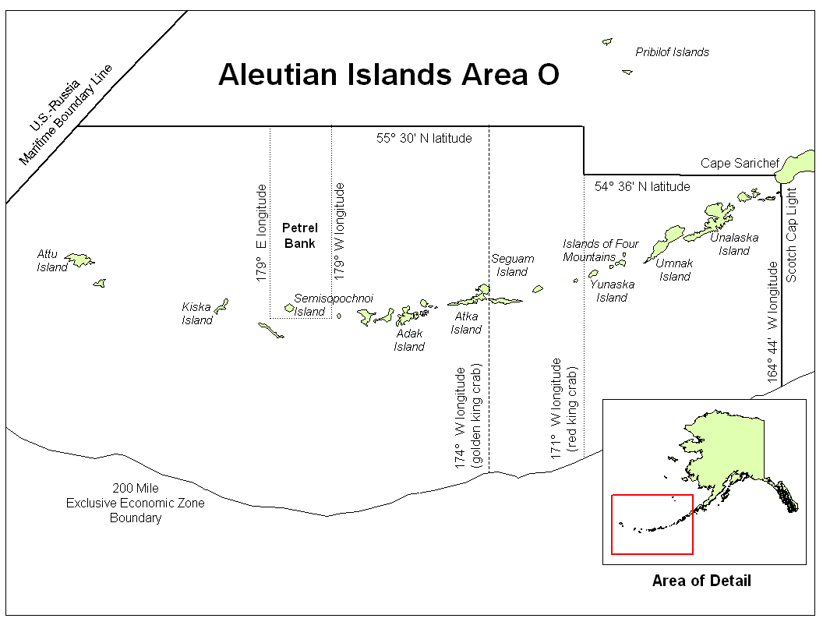

Figure 1. Aleutian Islands, Area O, red and golden king crab management area (from Leon et al. 2017).

Figure 2. Adak (Area R) and Dutch Harbor (Area O) king crab registration area and districts, 1984/85–1995/96 seasons (Leon et al. 2017).

Figure 3. Percent of total 1981/82–1995/96 golden king crab retained catch weight (harvest) from one-degree longitude intervals in the Aleutian Islands, with dotted line denoting the border at 171° W longitude used during the 1984/85–1995/96 seasons to divide fishery management between the Dutch Harbor Area (east of 171° W longitude) and the Adak Area (west of 171° W longitude) and solid line denoting the border at 174° W longitude used since the 1996/97 season to manage crab east and west of 174° W longitude (adapted from Figure 4-2 in Morrison et al. 1998).

Figure 4. Retained catch (t) of golden king crab within one-degree longitude intervals in the Aleutian Islands during the 2000/01 through 2019/20 commercial fishery seasons; solid line denotes the border at 174° W longitude that has been used since the 1996/97 season to manage Aleutian Island golden king crab as separate stocks east and west of 174° W longitude and dashed line denotes the border at 171° W longitude used during the 1984/85–1995/96 seasons to divide fishery management between the Dutch Harbor Area (east of 171° W longitude) and the Adak Area (west of 171° W longitude).

Figure 5. Average golden king crab CPUE (kg/nm2) for tows, number of tows, and average depth of tows from one-degree longitude intervals during the 2002, 2004, 2006, 2010, and 2012 NMFS Aleutian Islands bottom trawl surveys; preliminary summary of data obtained on 1 April 2013 from http://www.afsc.noaa.gov/RACE/groundfish/survey_data/default.htm.

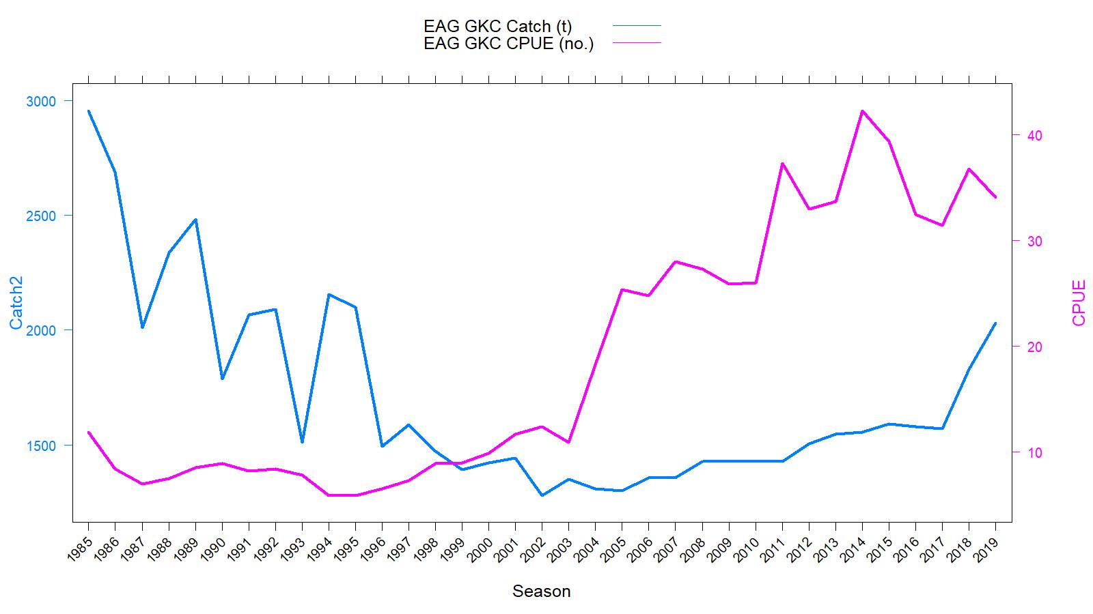
Figure 6. Historical commercial harvest (from fish tickets; metric tons) and catch-per-unit effort (CPUE, number of crabs per pot lift) of golden king crab in the EAG, 1985/86–2019/20 fisheries (note: 1985 refers to the 1985/86 fishing year).

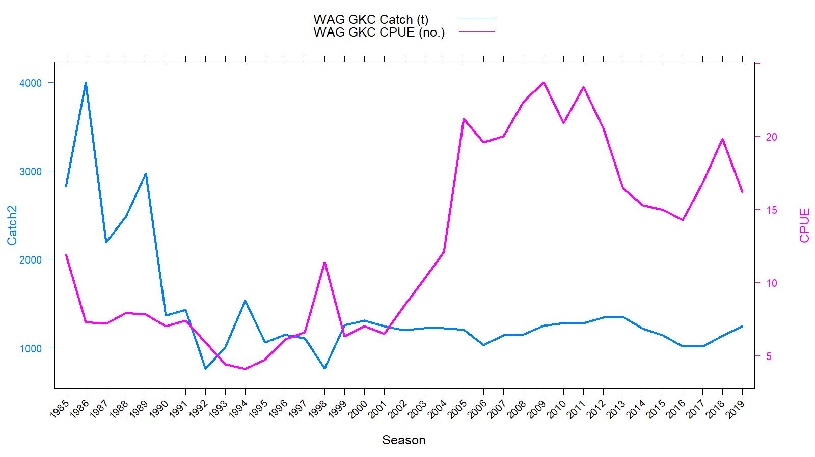
Figure 7. Historical commercial harvest (from fish tickets; metric tons) and catch-per-unit effort (CPUE, number of crabs per pot lift) of golden king crab in the WAG, 1985/86–2019/20 fisheries (note: 1985 refers to the 1985/86 fishing year).

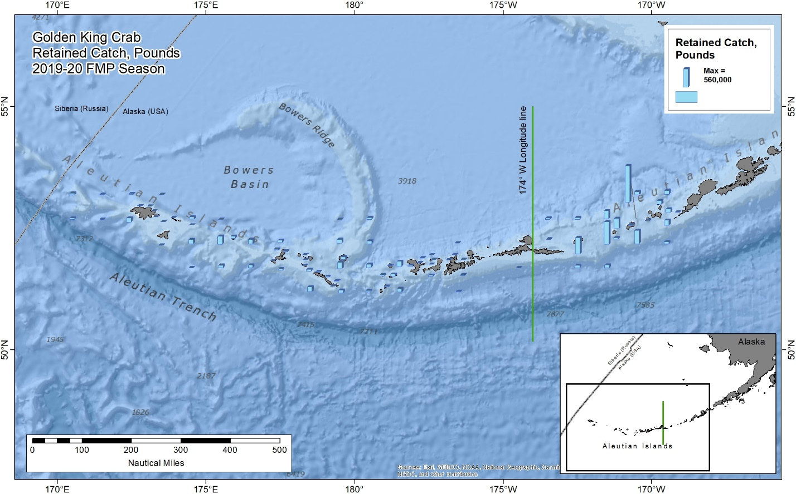

Figure 8. Catch distribution by statistical area.in 2019/20.

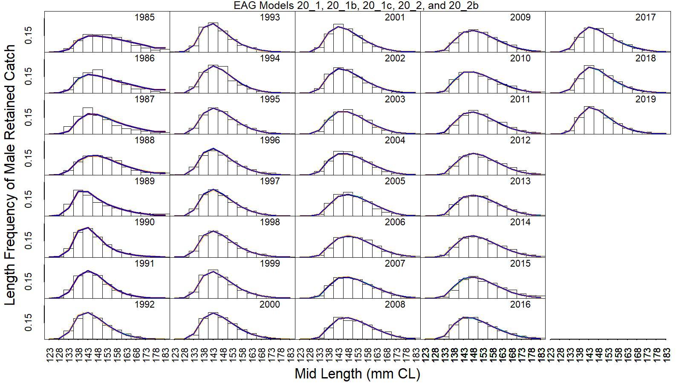
Figure 9. Predicted (line) vs. observed (bar) retained catch relative length frequency distributions under models 20_1 (orange line), 20_1b (black line), 20_1c (dark red line), 20_2 (green line), and 20_2b (blue line) for golden king crab in the EAG, 1985/86 to 2019/20. This color scheme is used in all other figures.

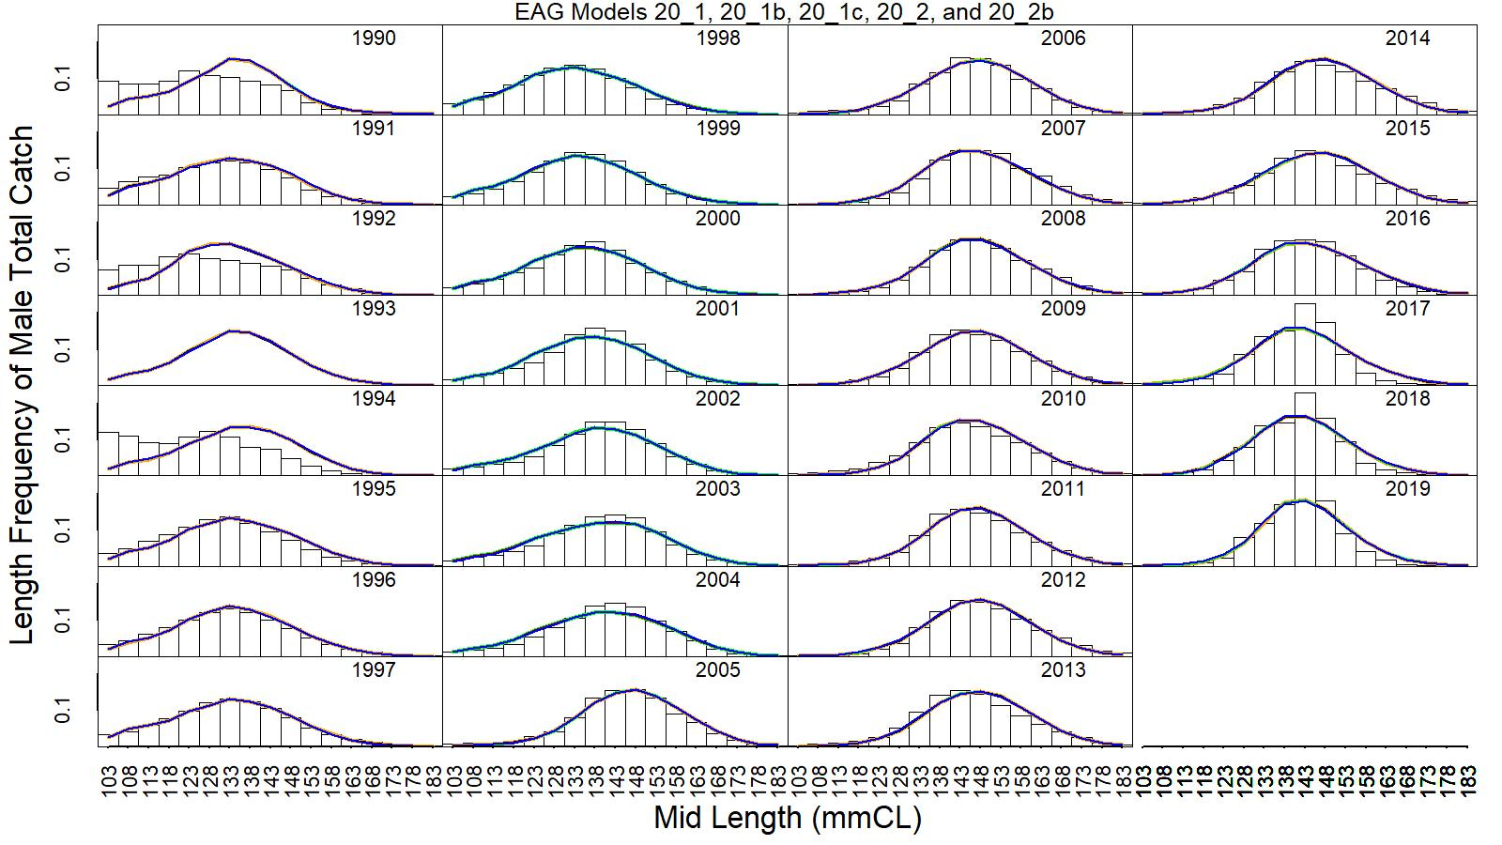
Figure 10. Predicted (line) vs. observed (bar) total catch relative length frequency distributions under models 20_1, 20_1b, 20_1c, 20_2, and 20_2b for golden king crab in the EAG, 1990/91 to 2019/20.

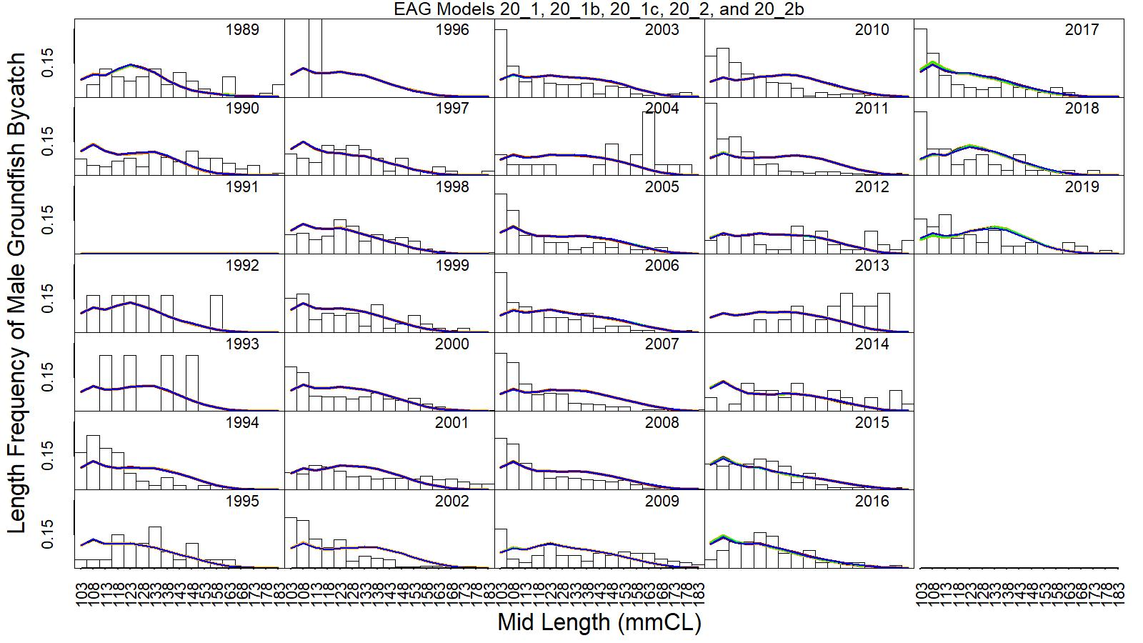
Figure 11. Predicted (line) vs. observed (bar) groundfish discarded bycatch relative length frequency distributions under models 20_1, 20_1b, 20_1c, 20_2, and 20_2b for golden king crab in the EAG, 19989/90 to 2019/20.

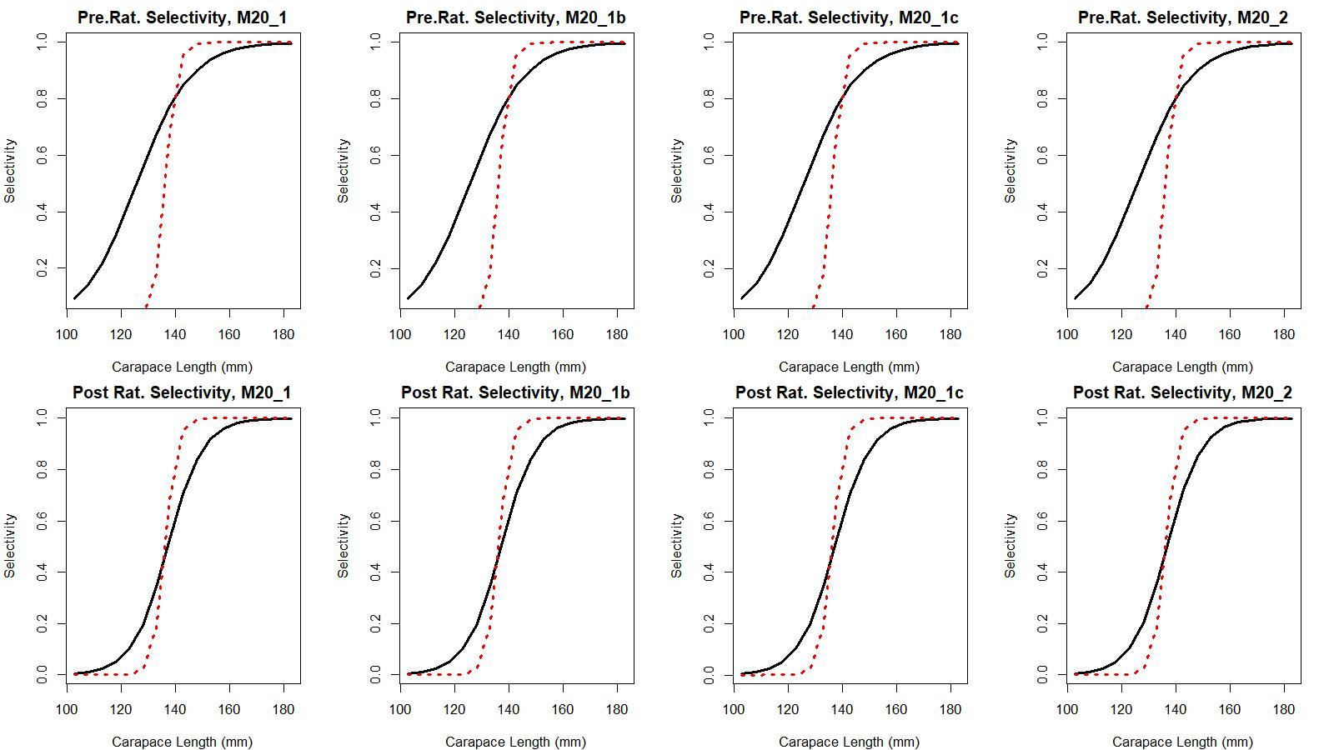
Figure 12. Estimated total (black solid line) and retained selectivity (red dotted line) for pre- and post- rationalization periods under models 20_1, 20_1b, 20_1c, and 20_2 fits to golden king crab data in the EAG.

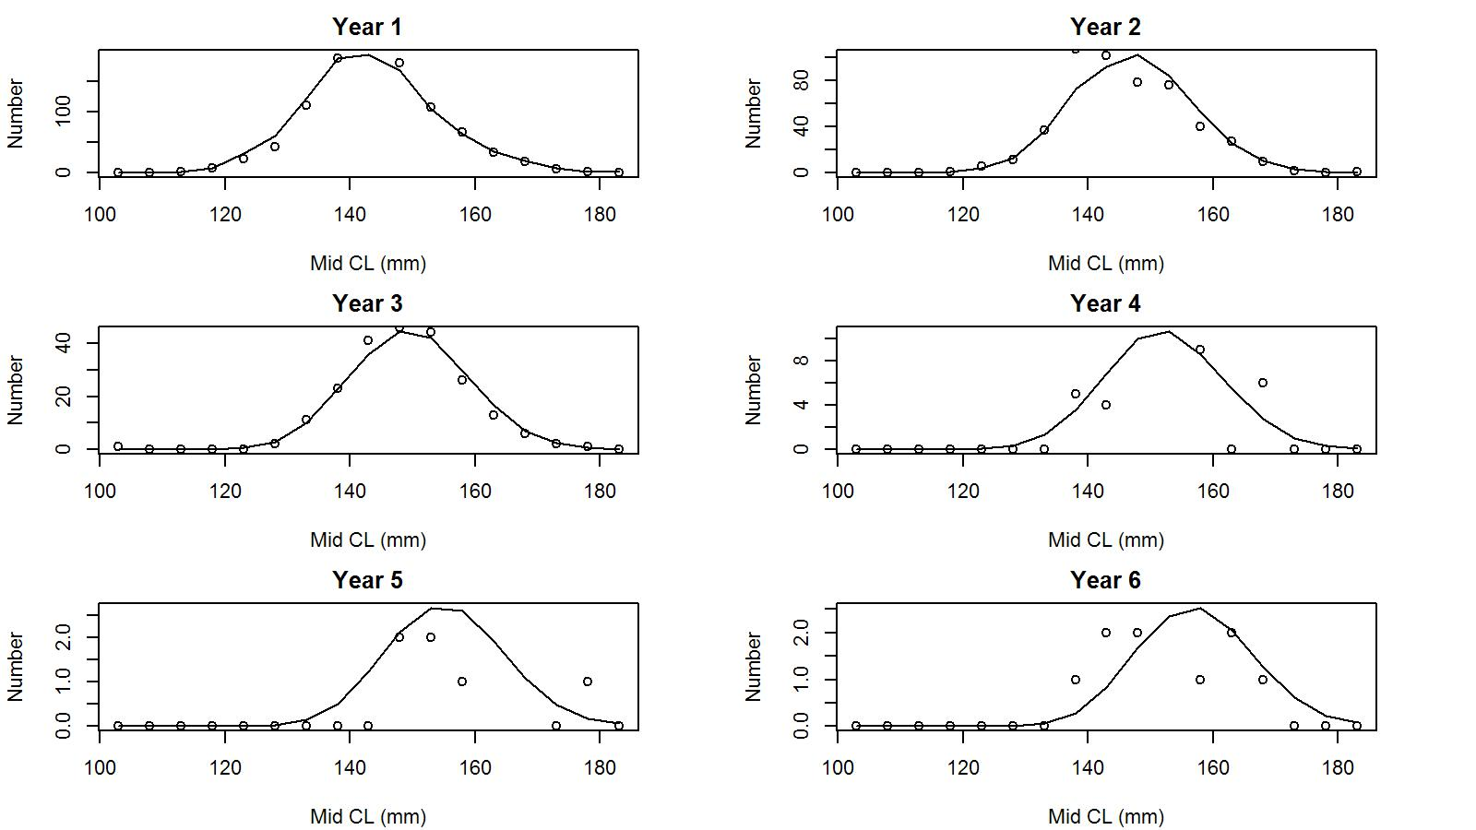
Figure 13. Observed (open circles) vs. predicted (solid line) tag recaptures by size bin for years 1 to 6 post tagging under model 20_1 for EAG golden king crab.

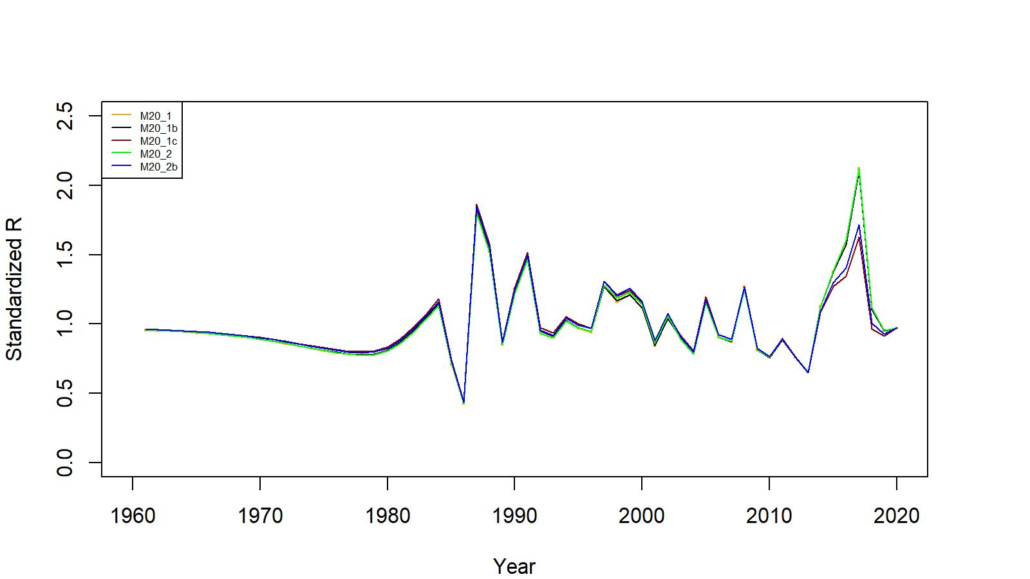

Figure 14. Estimated number of male recruits (crab size ≥ 101 mm CL) to the assessment model under models 20_1, 20_1b, 20_1c, 20_2, and 20_2b fits to EAG golden king crab data, 1961–2020. The numbers of recruits are standardized using (R-mean R)/mean R for comparing different scenarios’ results.

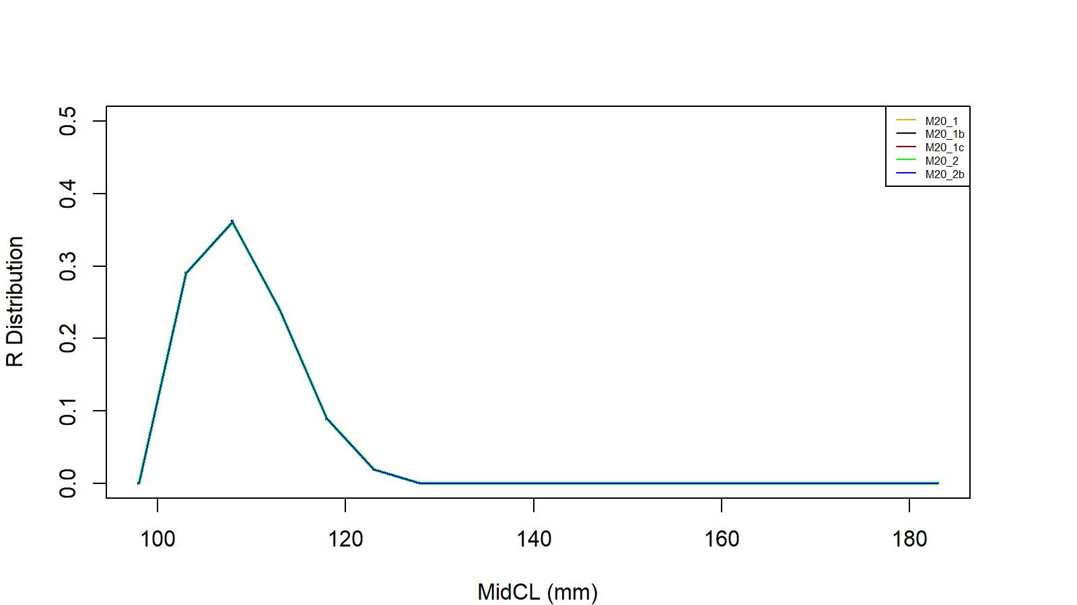
Figure 15. Recruit size distribution to the assessment model under models 20_1, 20_1b, 20_1c, 20_2, and 20_2b fits to EAG golden king crab data.

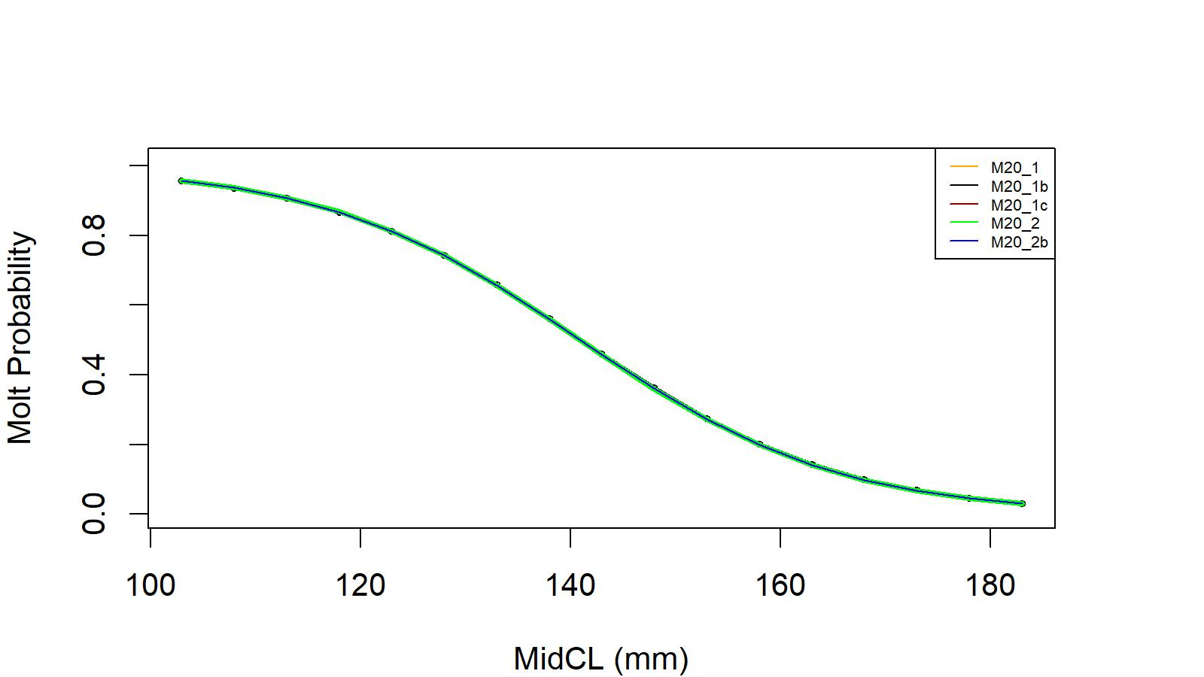
Figure 16. Estimated molt probability vs. carapace length of golden king crab for models 20_1, 20_1b, 20_1c, 20_2, and 20_2b fits to EAG golden king crab data.

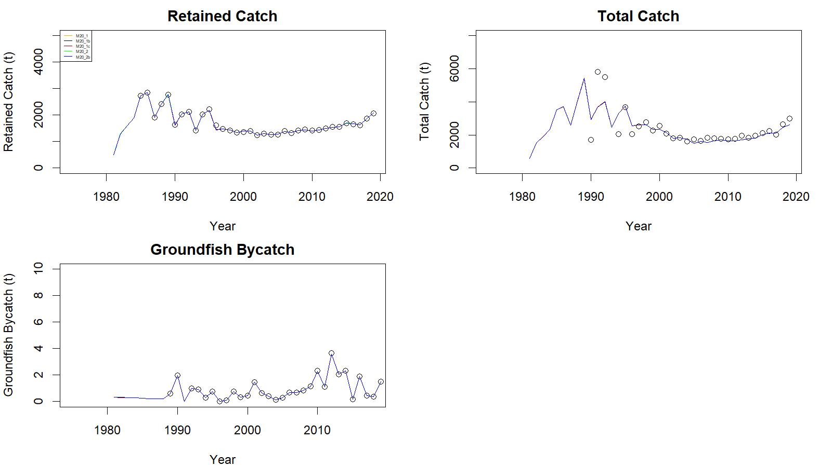
Figure 17. Observed (open circle) vs. predicted (solid line) retained catch (top left), total catch (top right in), and groundfish bycatch (bottom left) of golden king crab for models 20_1, 20_1b, 20_1c, 20_2, and 20_2b fits in EAG, 1981/82–2019/20.

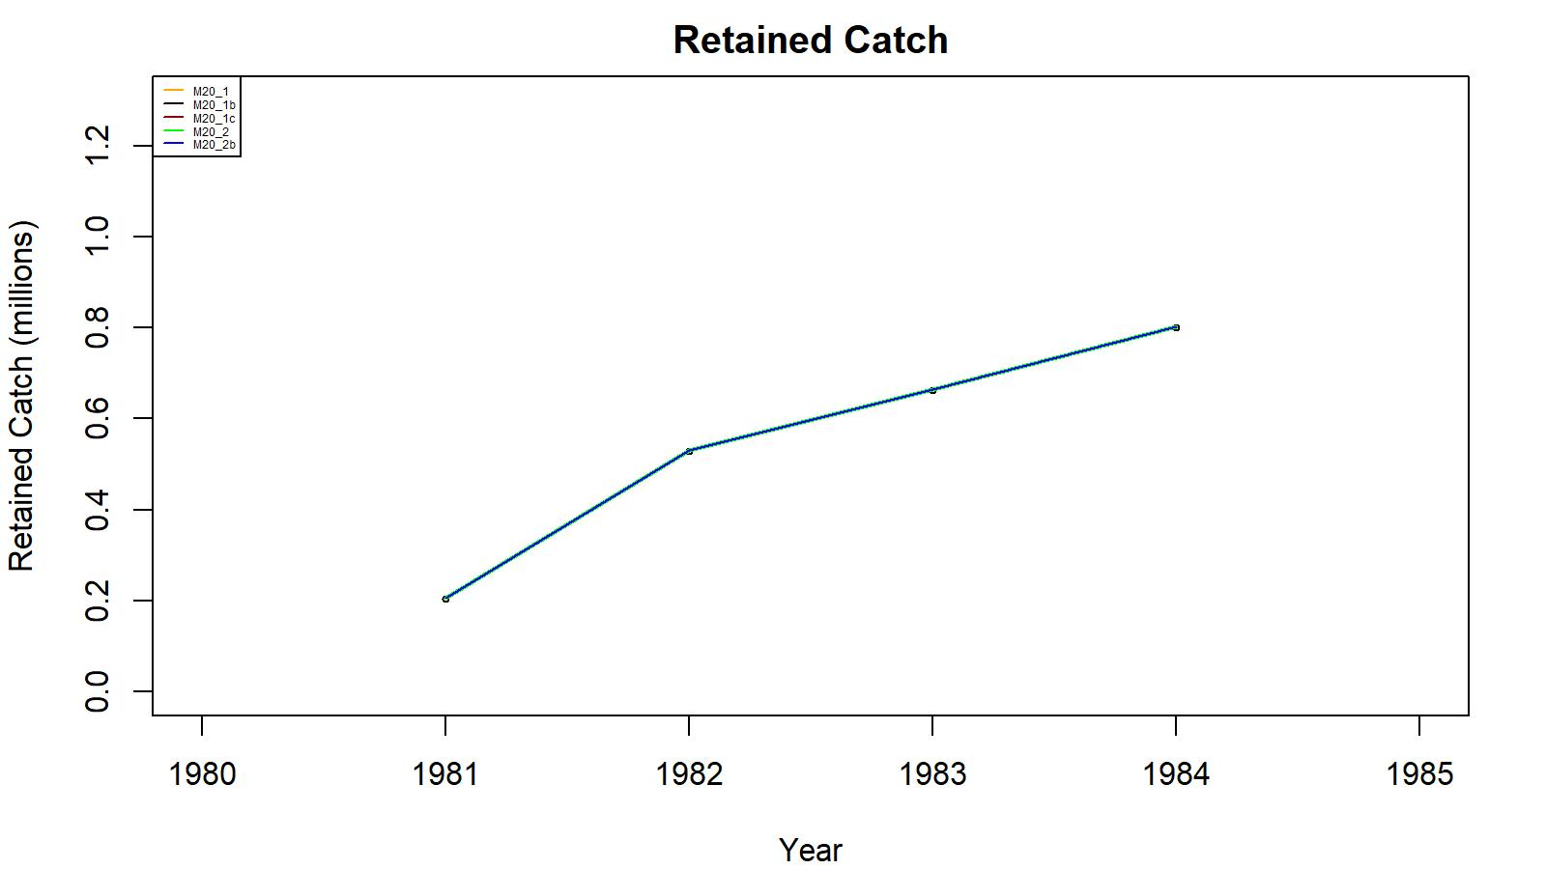
Figure 18. Observed (open circle) vs. predicted (solid line) retained catch of golden king crab for models 20_1, 20_1b, 20_1c, 20_2, and 20_2b for golden king crab fits in the EAG, 1981/82–1984/85. Note: Input retained catches to the model during pre-1985 fishery period were in number of crabs.

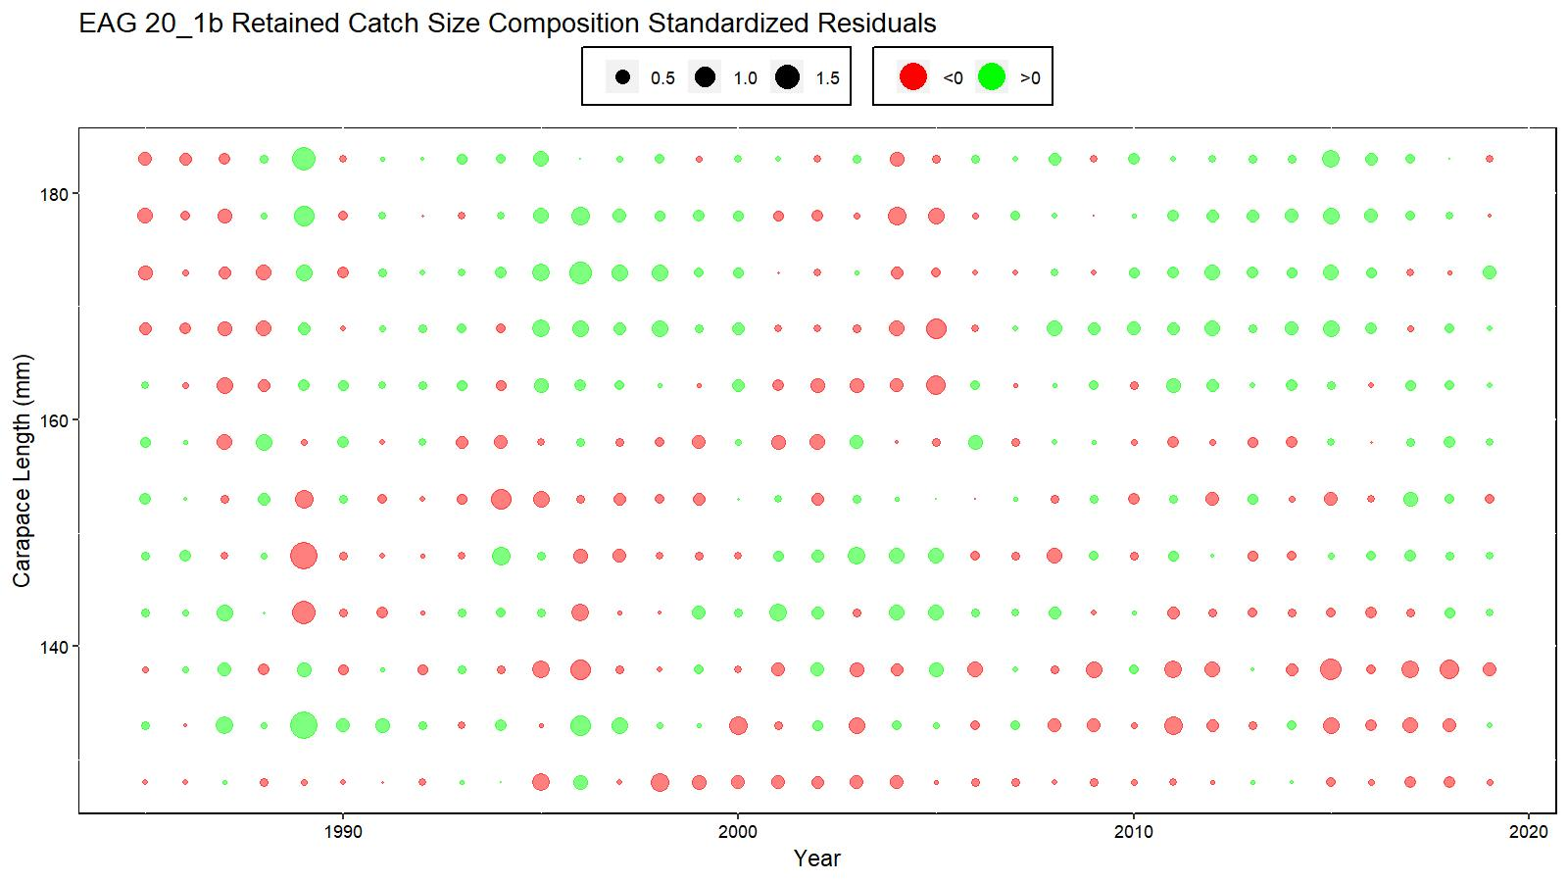
Figure 19. Bubble plot of standardized residuals of retained catch length composition for model 20_1b fit for EAG golden king crab, 1985/86–2019/20. Green circles are the positive and pink circles are the negative standardized residuals. The area of the circle is the relative magnitude of the residual.

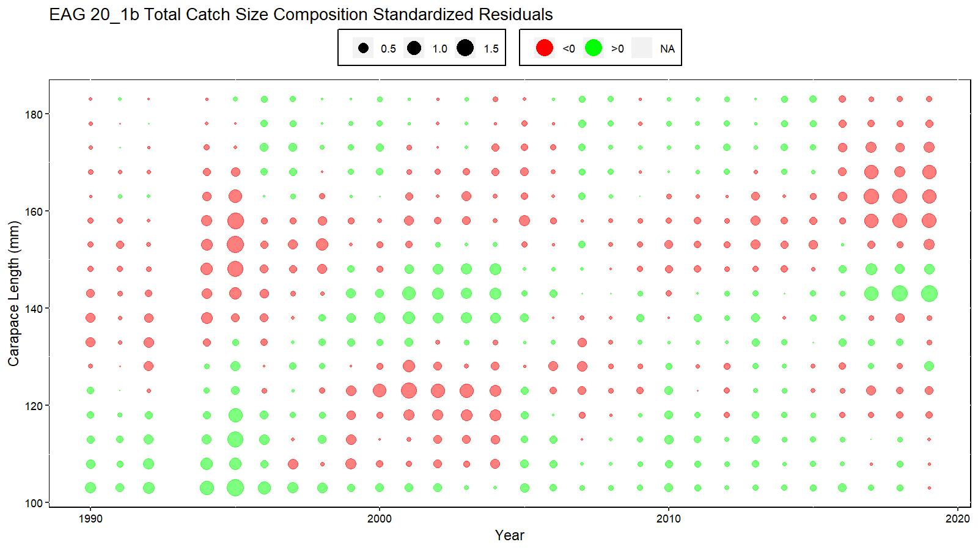
Figure 20. Bubble plot of standardized residuals of total catch length composition for model 20_1b fit for EAG golden king crab, 1990/91–2019/20. Green circles are the positive and pink circles are the negative standardized residuals. The area of the circle is the relative magnitude of the residual.

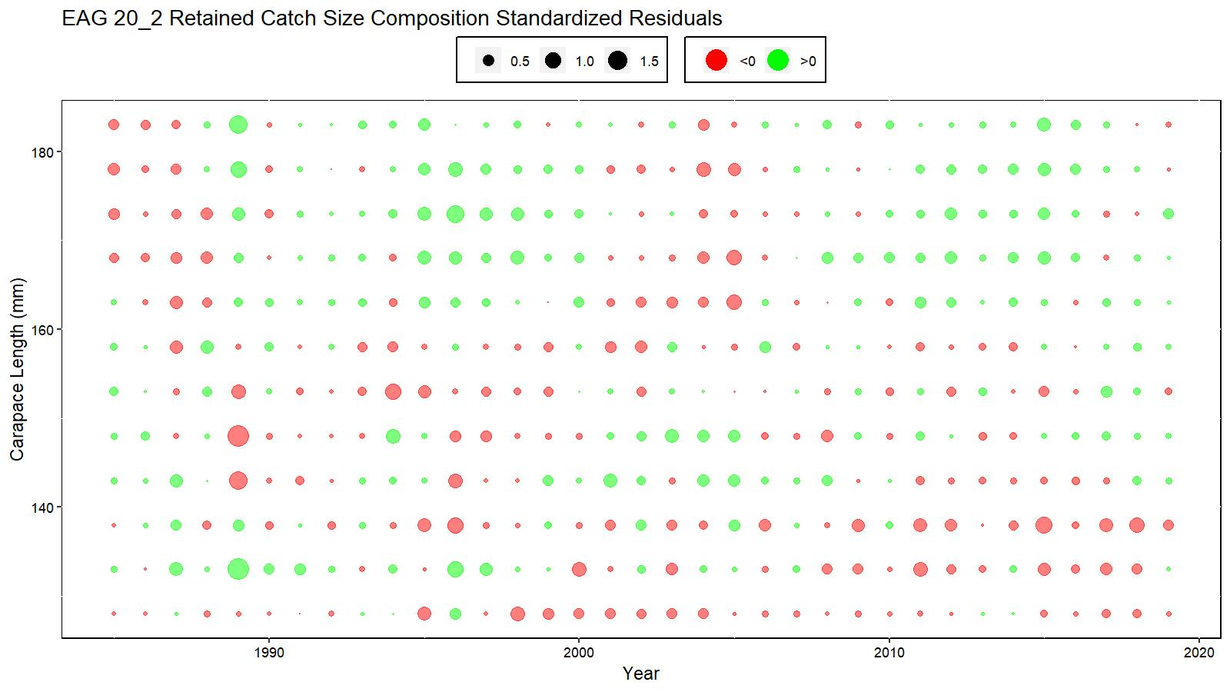
Figure 21. Bubble plot of standardized residuals of retained catch length composition for model 20_2 fit for EAG golden king crab, 1985/86–2019/20. Green circles are the positive and pink circles are the negative standardized residuals. The area of the circle is the relative magnitude of the residual.

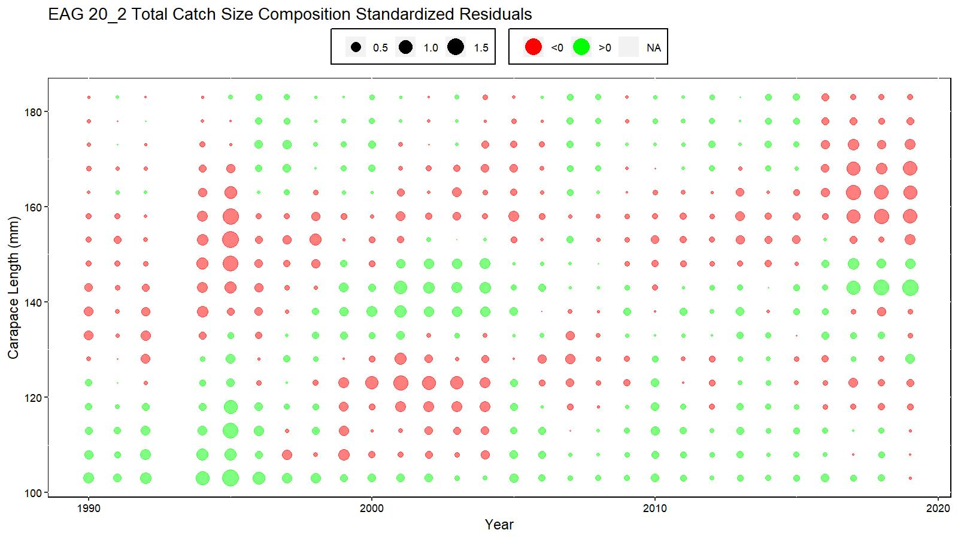
Figure 22. Bubble plot of standardized residuals of total catch length composition for model 20_2 fit for EAG golden king crab, 1990/91–2019/20. Green circles are the positive and pink circles are the negative standardized residuals. The area of the circle is the relative magnitude of the residual.

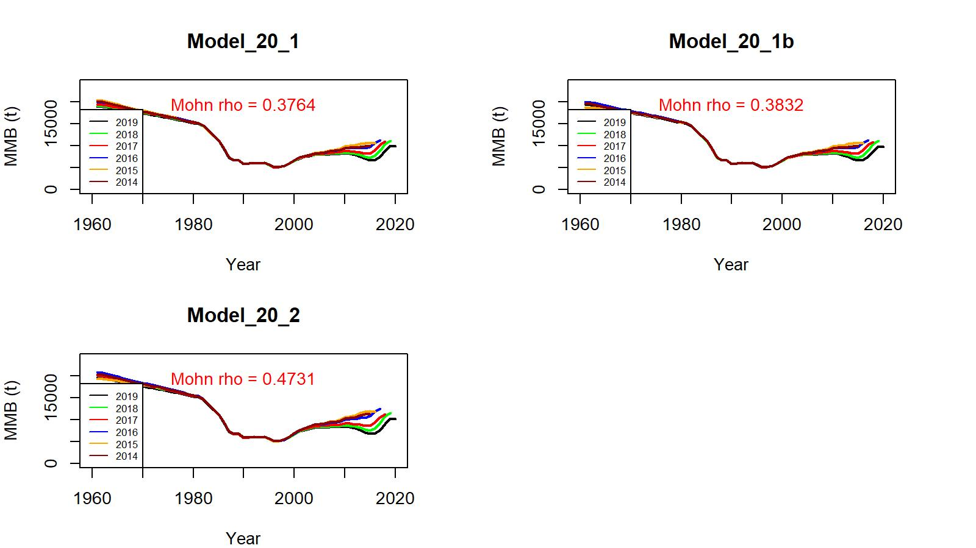
Figure 23. Retrospective fits of MMB by the model following removal of terminal year data under models 20_1, 20_1b and 20_2 for golden king crab in the EAG, 1960/61–2019/20.

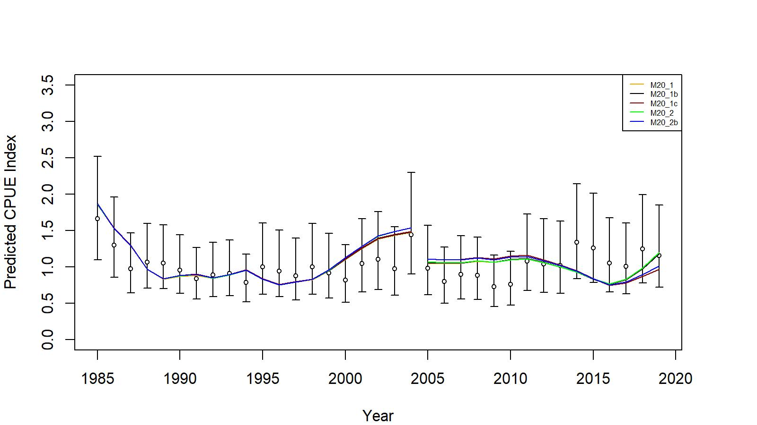
Figure 24. Comparison of input CPUE indices (open circles with +/- 2 SE for model 20_1) with predicted CPUE indices (colored solid lines) under models 20_1, 20_1b, 20_1c, 20_2, and 20_2b for EAG golden king crab data, 1985/86–2019/20. Model estimated additional standard error was added to each input standard error.
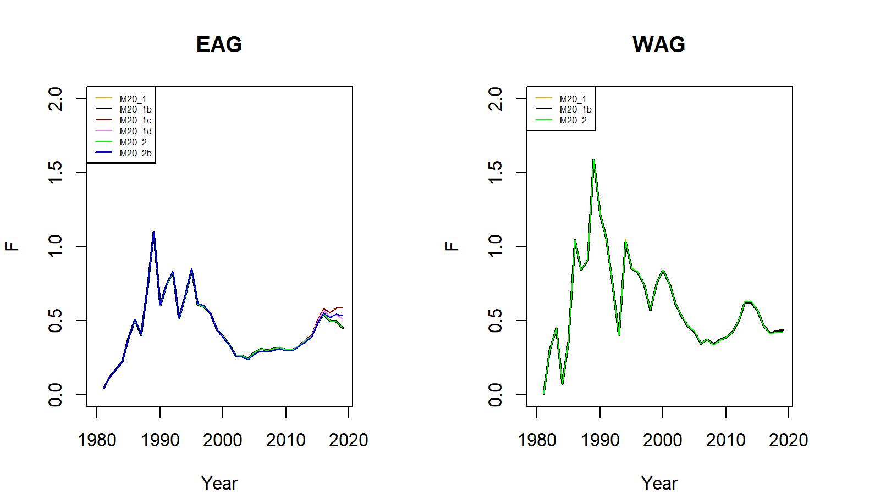

Figure 25. Trends in pot fishery full selection total fishing mortality of golden king crab for models 20_1, 20_1b, 20_1c, 20_2, and 20_2b fits in the EAG (left) and models 20_1, 20_1b, and 20_2 fits to WAG (right) data, 1981/82–2019/20.

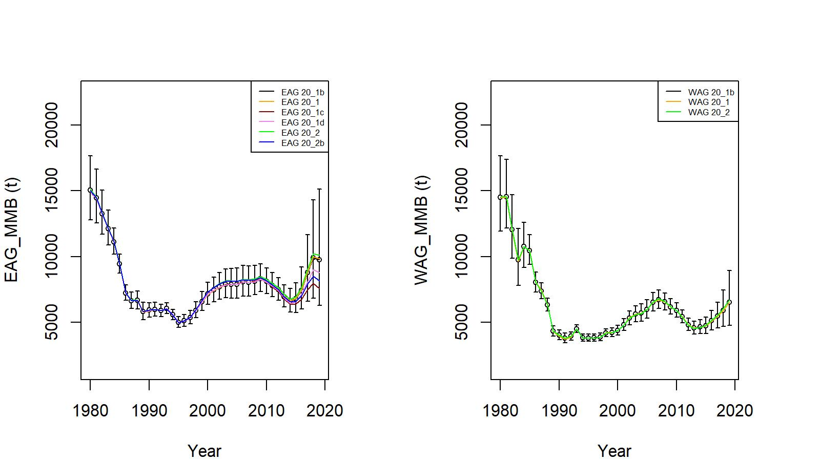
Figure 26. Trends in golden king crab mature male biomass for models 20_1, 20_1b, 20_1c, 20_1d, 20_2, and 20_2b fits to EAG (left) and models 20_1, 20_1b, and 20_2 fits to WAG (right) data, 1960/61–2019/20. Model 20_1b estimate has two standard error confidence limits.

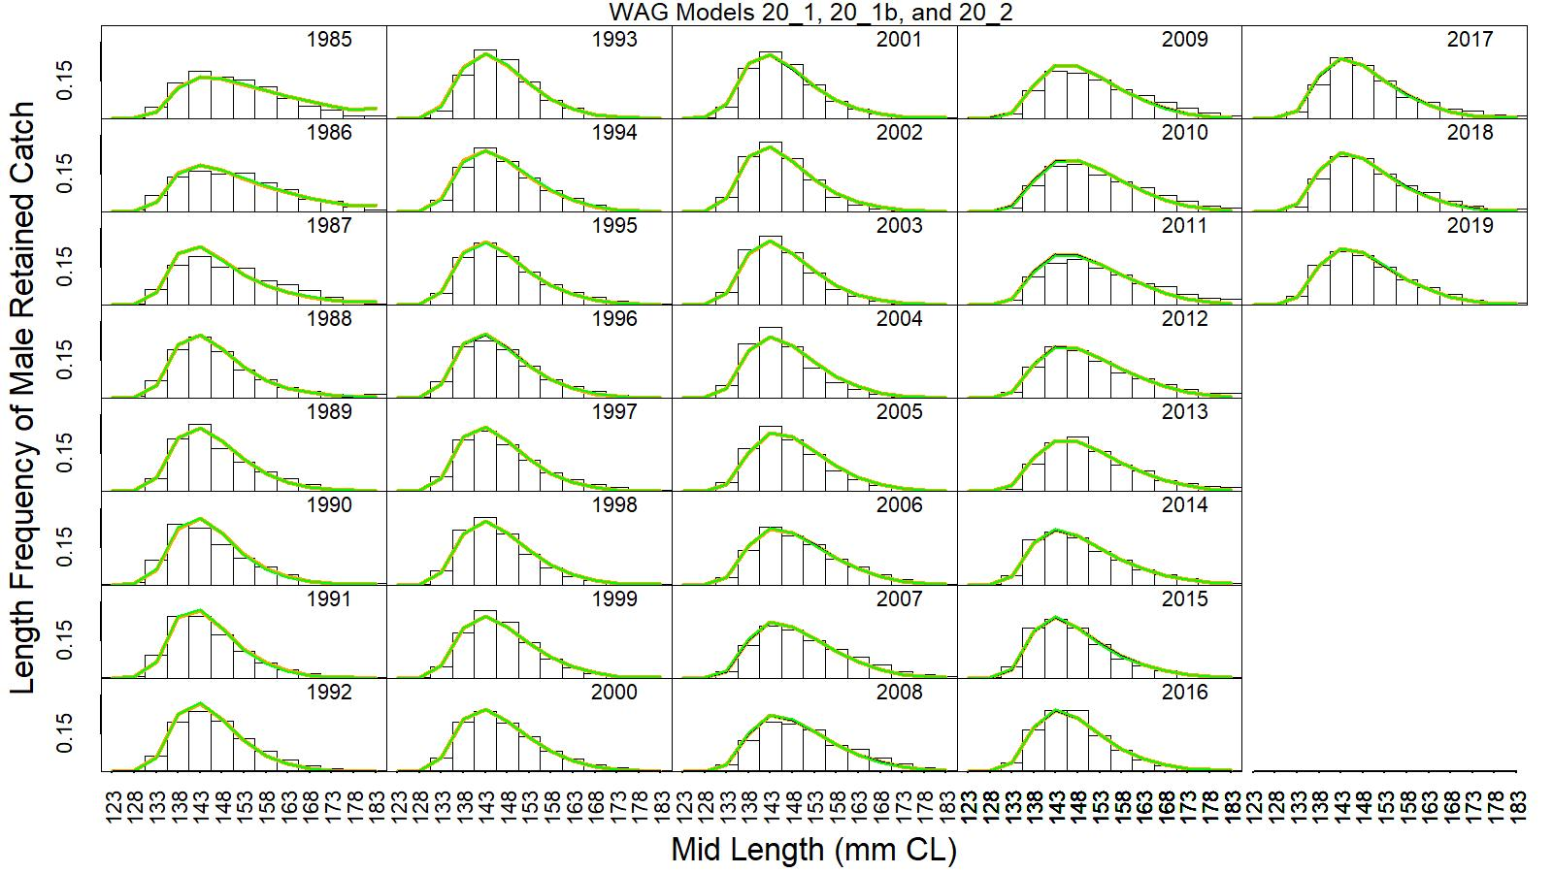
Figure 27. Predicted (line) vs. observed (bar) retained catch relative length frequency distributions under models 20_1, 20_1b, and 20_2 fits to golden king crab data in the WAG, 1985/86 to 2019/20.

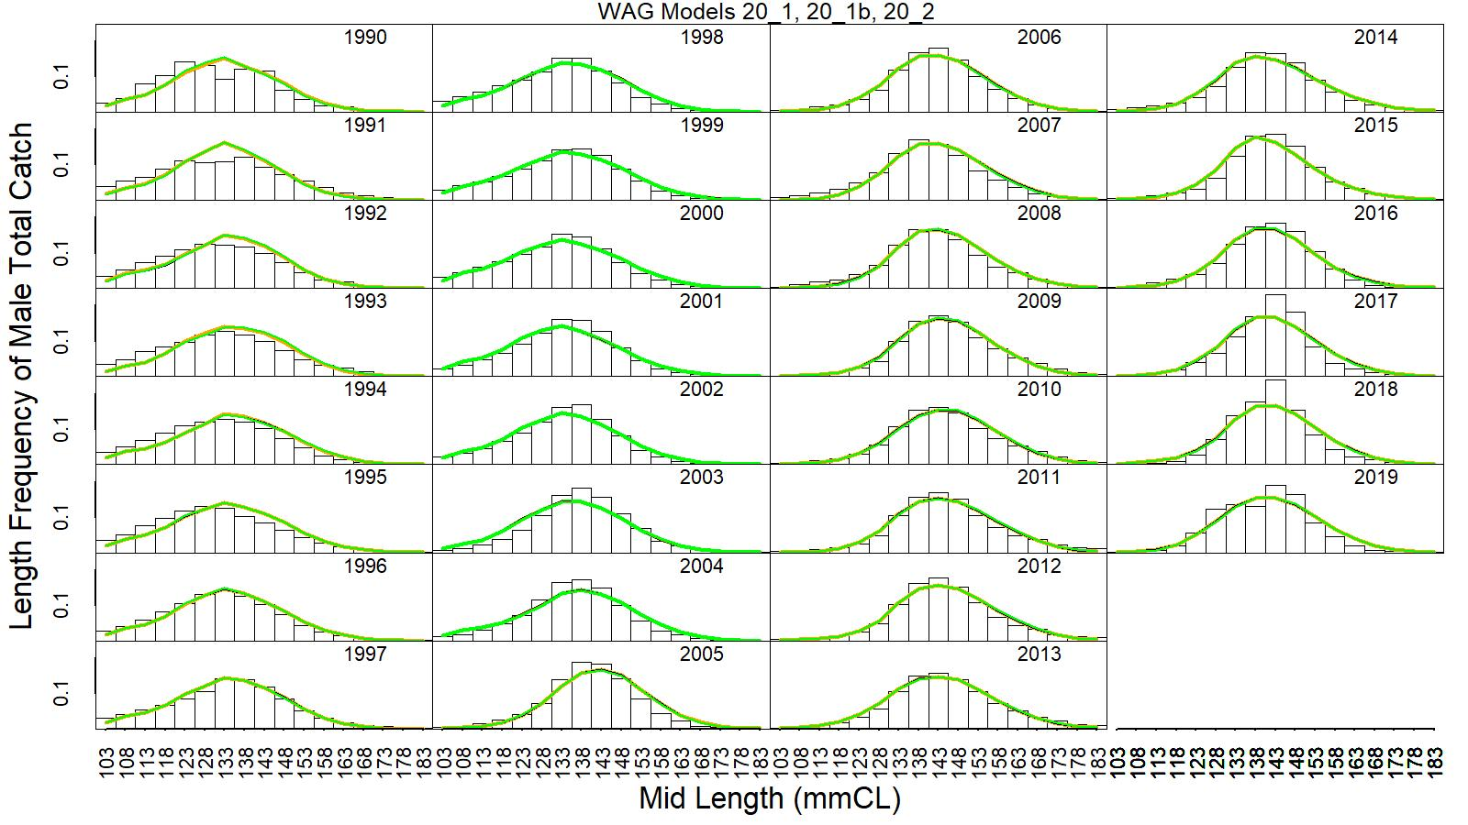
Figure 28. Predicted (line) vs. observed (bar) total catch relative length frequency distributions under models 20_1, 20_1b, and 20_2 fits to golden king crab data in the WAG, 1990/91 to 2019/20.

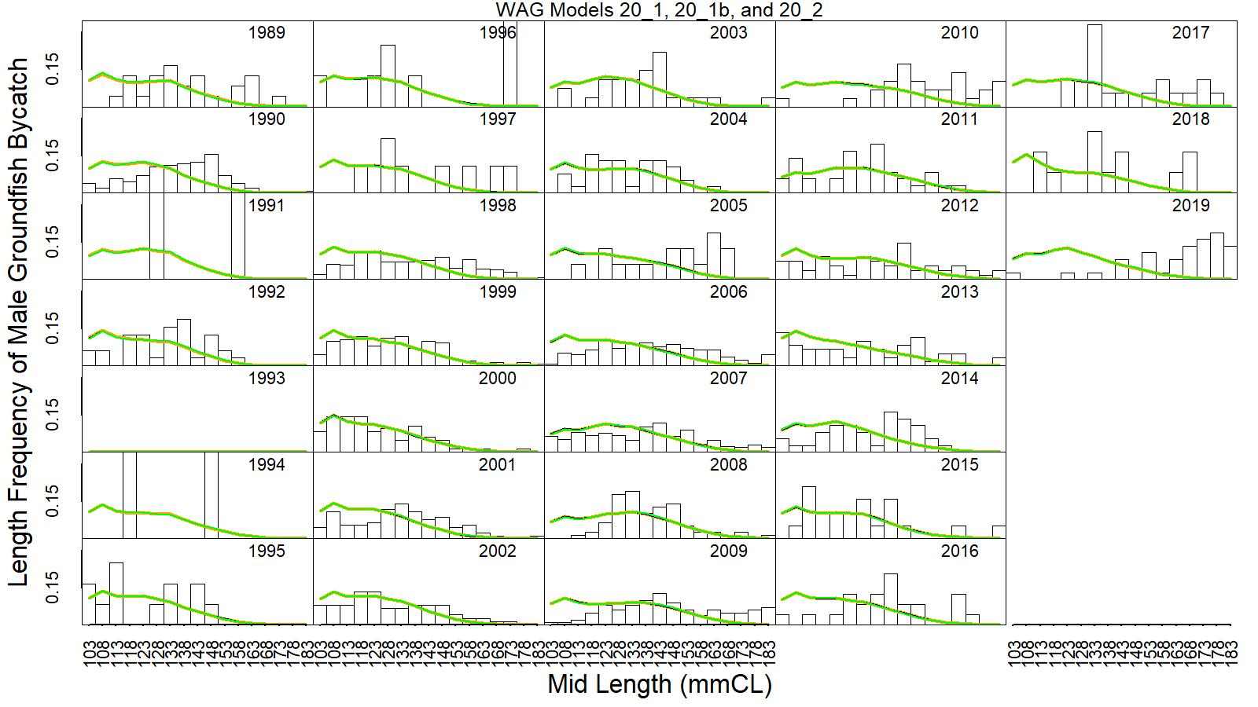
Figure 29. Predicted (line) vs. observed (bar) groundfish discarded bycatch relative length frequency distributions under models 20_1, 20_1b, and 20_2 fits to golden king crab data in the WAG, 1989/90 to 2019/20.

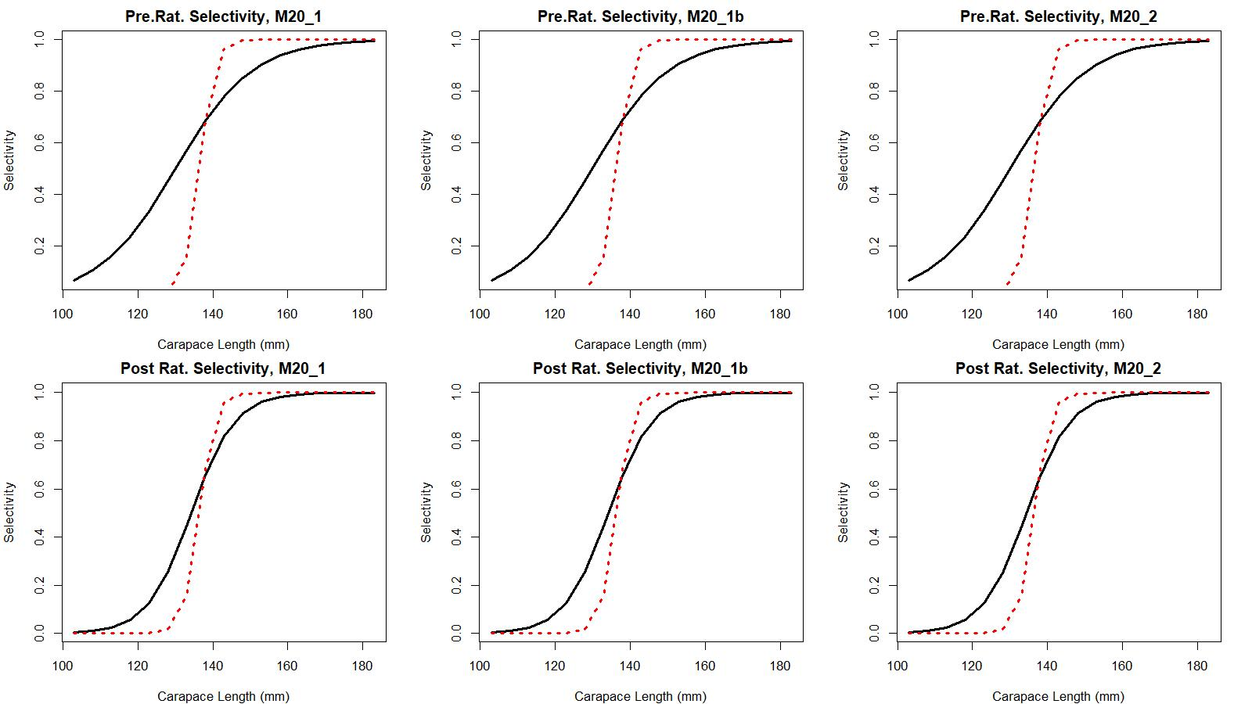

Figure 30. Estimated total (black solid line) and retained selectivity (red dotted line) for pre- and post- rationalization periods under models 20_1, 20_1b, and 20_2 fits to golden king crab data in the WAG.

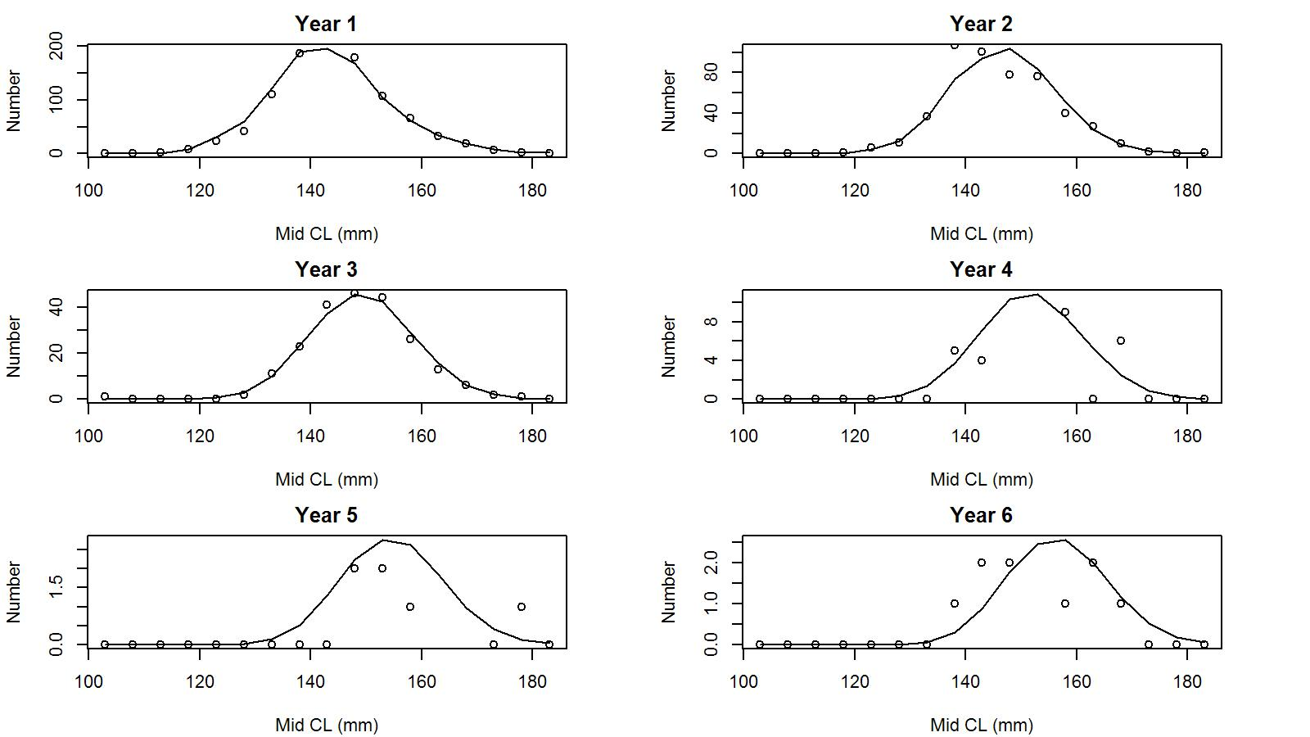

Figure 31. Observed (open circles) vs. predicted (solid line) tag recaptures by size bin for years 1 to 6 post tagging under model 20_1 fit to WAG golden king crab data.

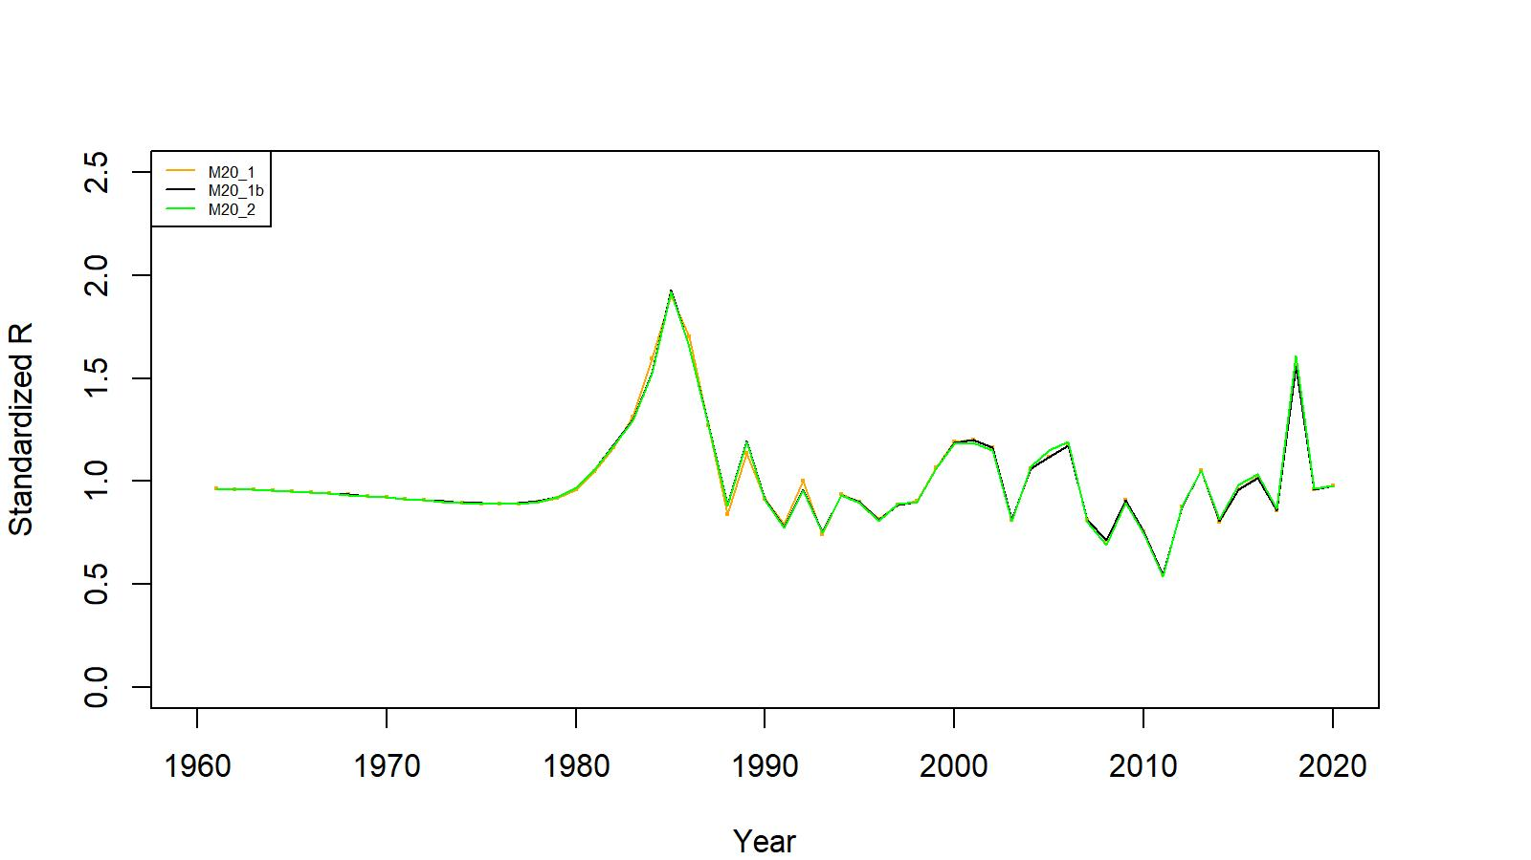
Figure 32. Estimated number of male recruits (crab size ≥ 101 mm CL) to the assessment model under models 20_1, 20_1b, and 20_2 fits to WAG golden king crab data, 1961–2020. The numbers of recruits are standardized using (R-mean R)/mean R for comparing different scenarios’ results.

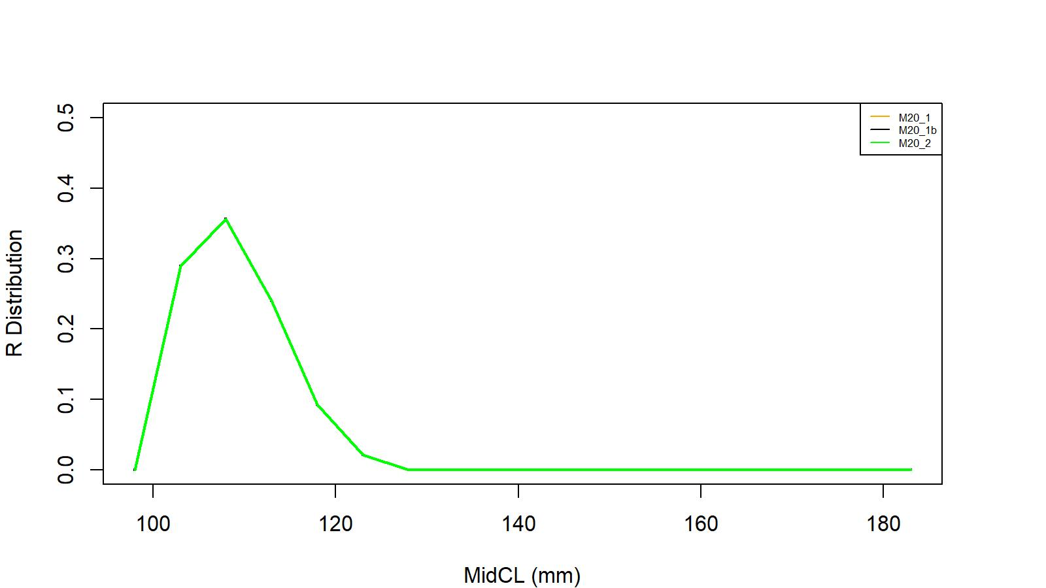
Figure 33. Recruit size distribution to the assessment model under models 20_1, 20_1b, and 20_2 fits to WAG golden king crab data.

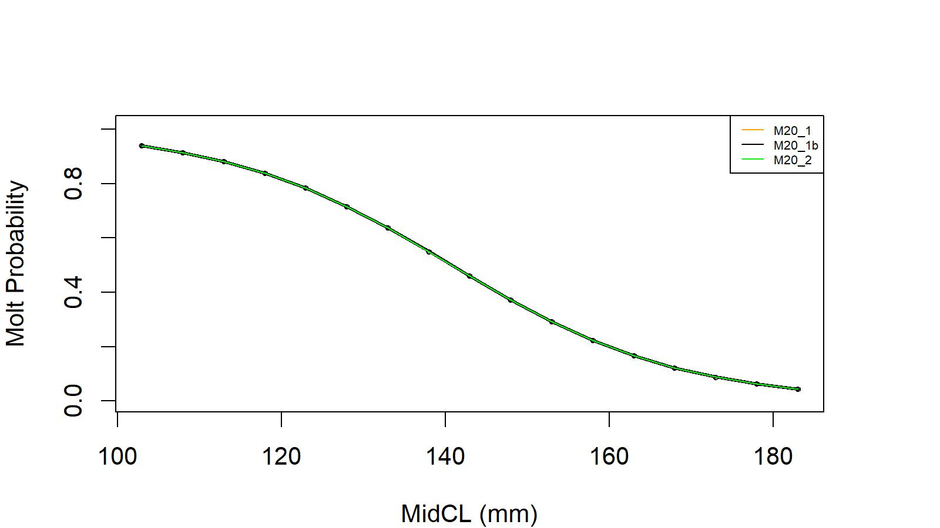
Figure 34. Estimated molt probability vs. carapace length of golden king crab for models 20_1, 20_1b, and 20_2 fits to WAG golden king crab data.

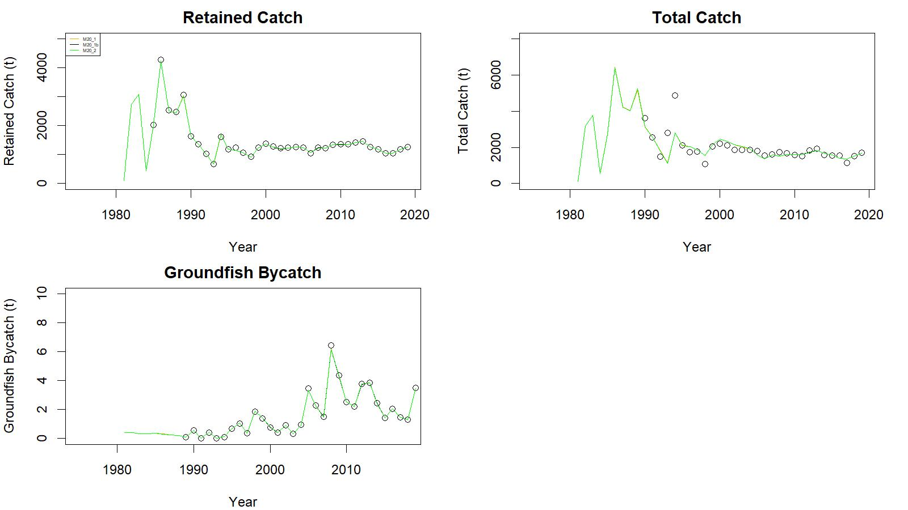
Figure 35. Observed (open circle) vs. predicted (solid line) retained catch (top left), total catch (top right in), and groundfish bycatch (bottom left) of golden king crab for models 20_1, 20_1b, and 20_2 fits to WAG data, 1981/82–2019/20.

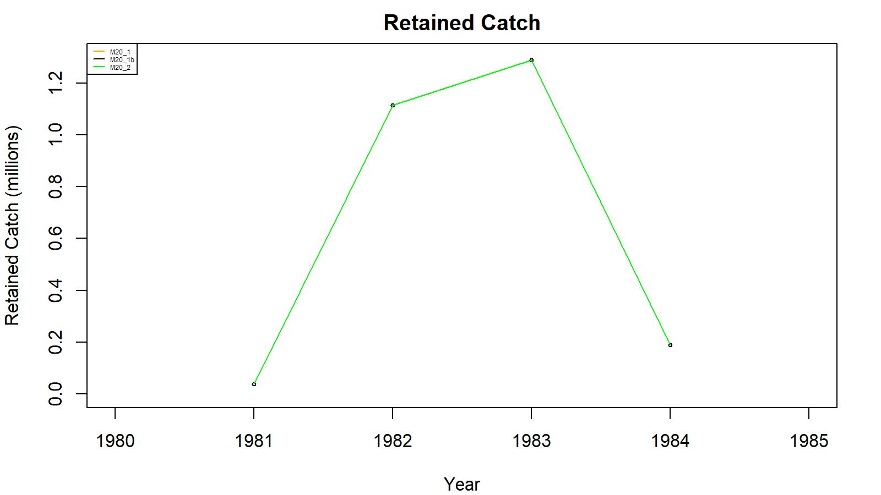
Figure 36. Observed (open circle) vs. predicted (solid line) retained catch of golden king crab for models 20_1, 20_1b, and 20_2 fits to WAG data, 1981/82–1984/85. Note: Input retained catches to the model during pre-1985 fishery period was in number of crabs.

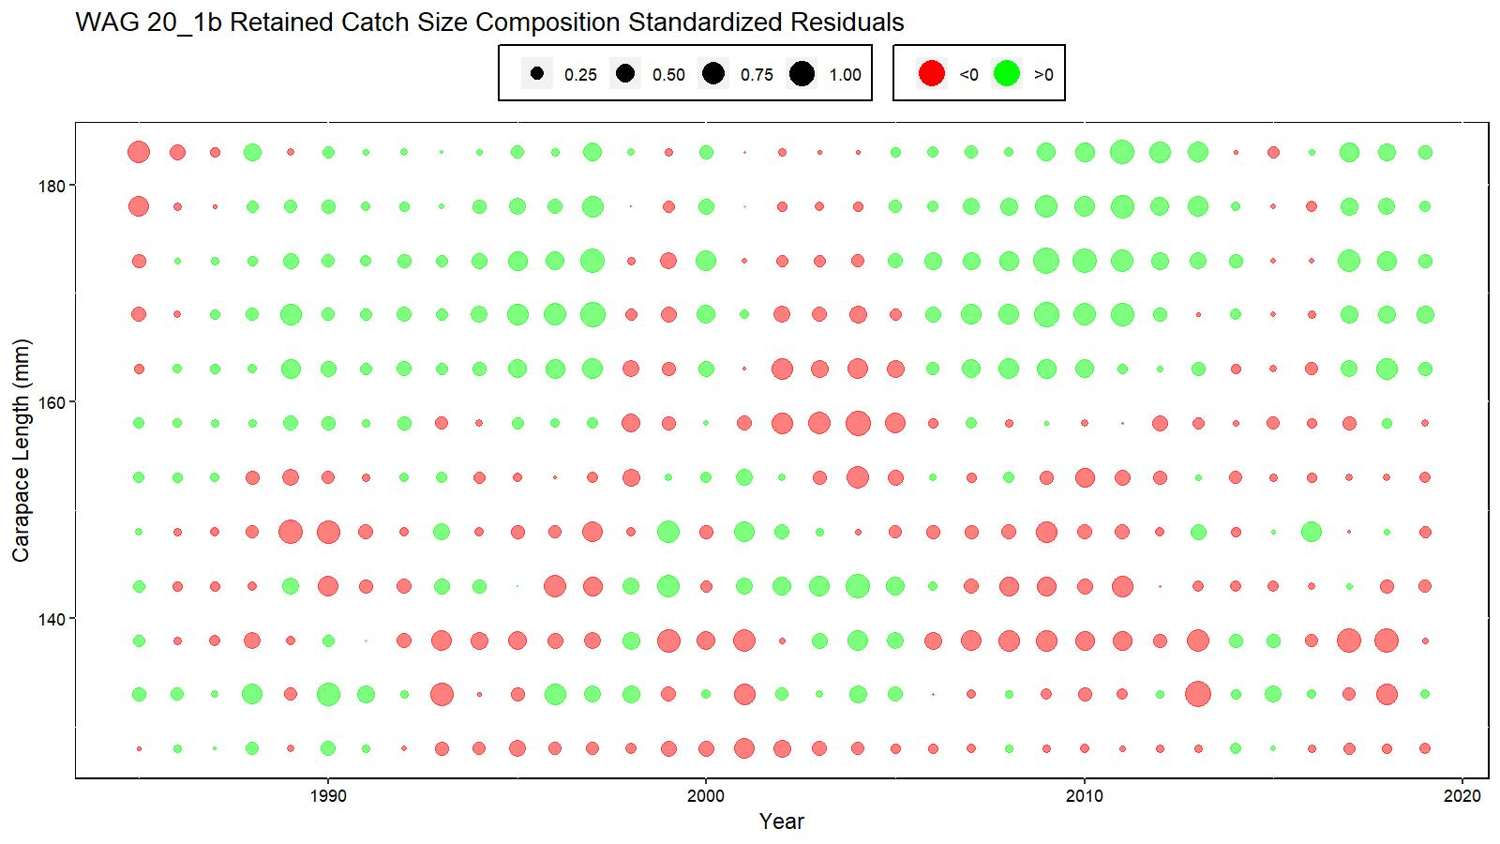
Figure 37. Bubble plot of standardized residuals of retained catch length composition for model 20_1b fit to WAG golden king crab data, 1985/86–2019/20. Green circles are the positive and pink circles are the negative standardized residuals. The area of the circle is the relative magnitude of the residual.

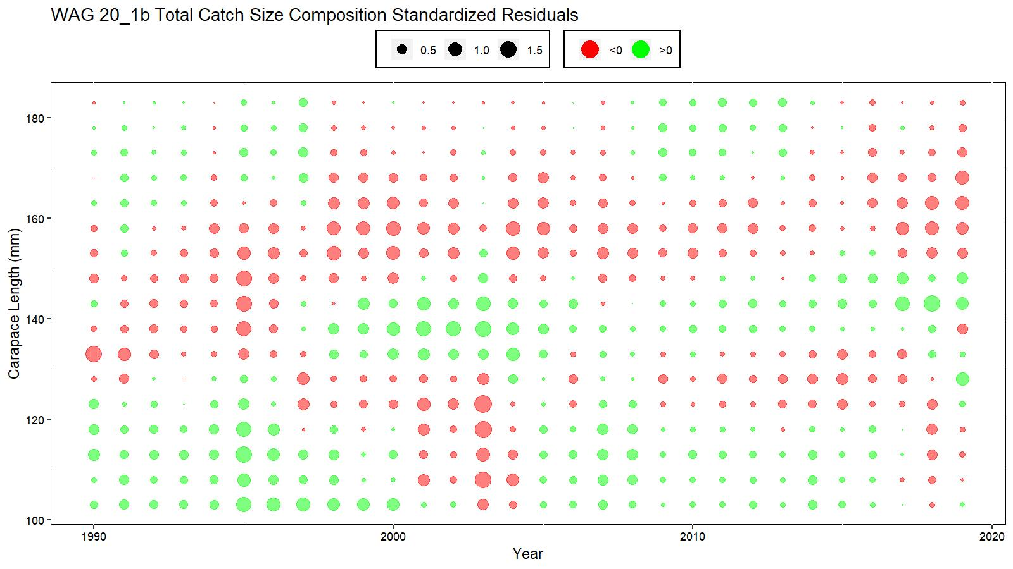
Figure 38. Bubble plot of standardized residuals of total catch length composition for model 20_1b fit to WAG golden king crab dat, 1990/91–2019/20. Green circles are the positive and pink circles are the negative standardized residuals. The area of the circle is the relative magnitude of the residual.

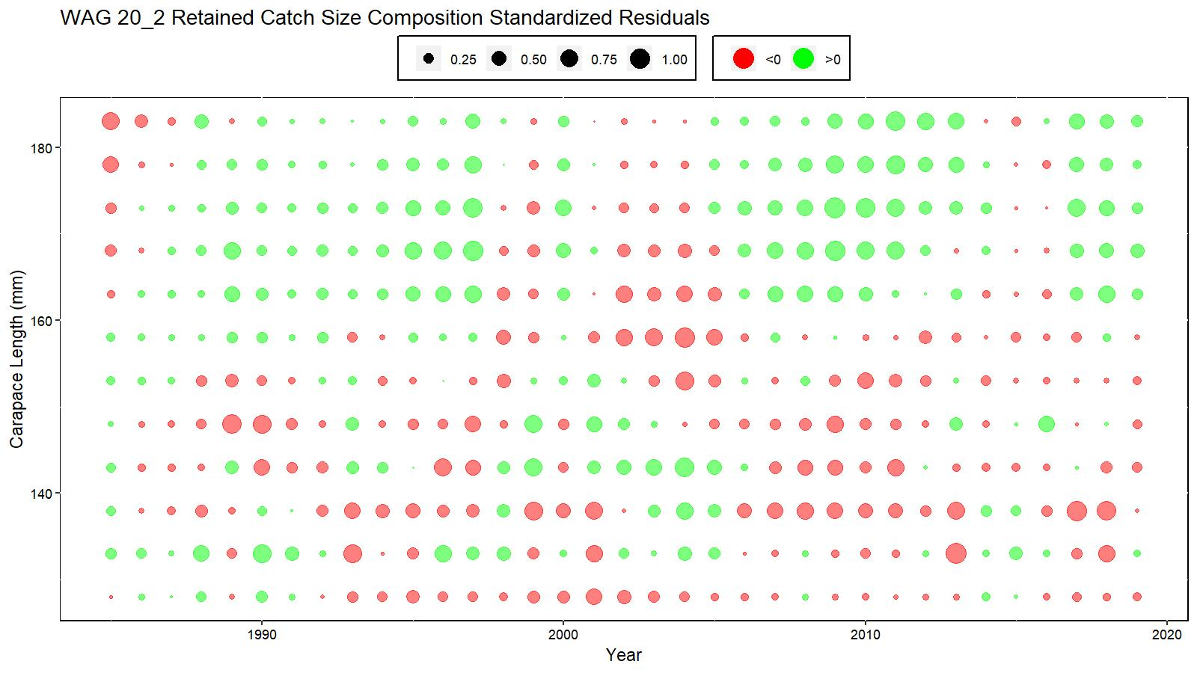
Figure 39. Bubble plot of standardized residuals of retained catch length composition for model 20_2 fit to WAG golden king crab data, 1985/86–2019/20. Green circles are the positive and pink circles are the negative standardized residuals. The area of the circle is the relative magnitude of the residual.

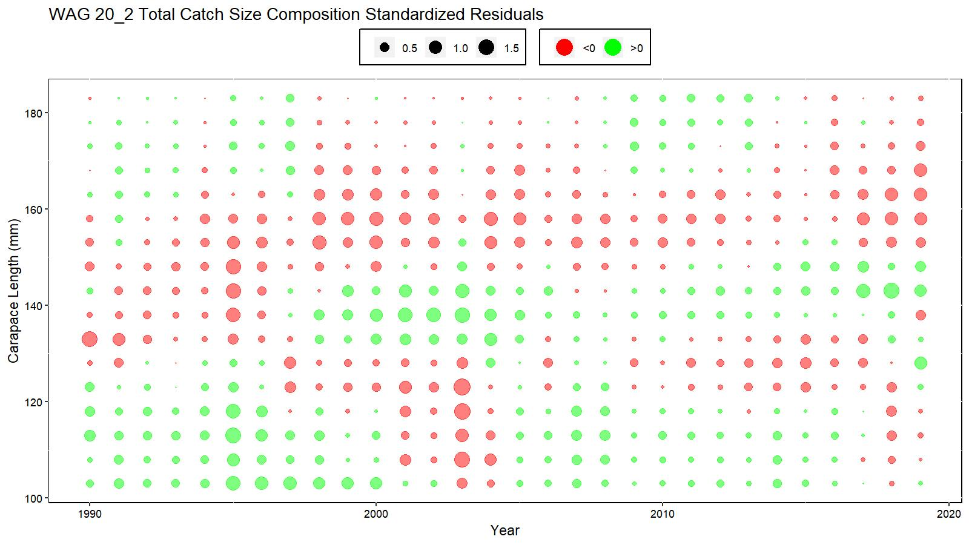
Figure 40. Bubble plot of standardized residuals of total catch length composition for model 20_2 fit to WAG golden king crab data, 1990/91–2019/20. Green circles are the positive and pink circles are the negative standardized residuals. The area of the circle is the relative magnitude of the residual.

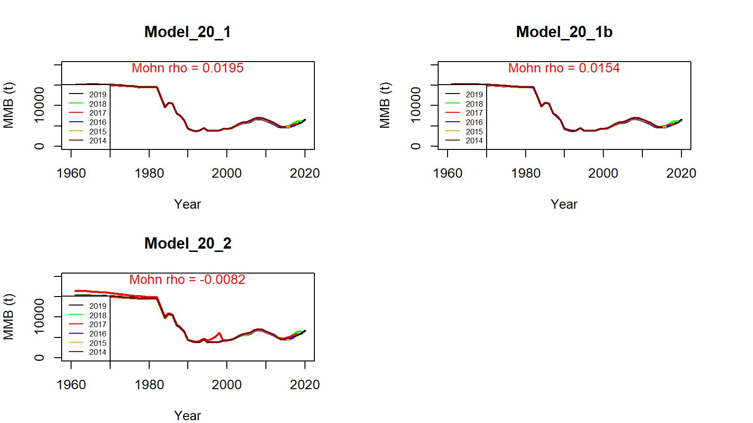
Figure 41. Retrospective fits of MMB by the model following removal of terminal year data under models 20_1, 20_1b, and 20_2 fits for golden king crab in the WAG, 1960/61–2019/20.

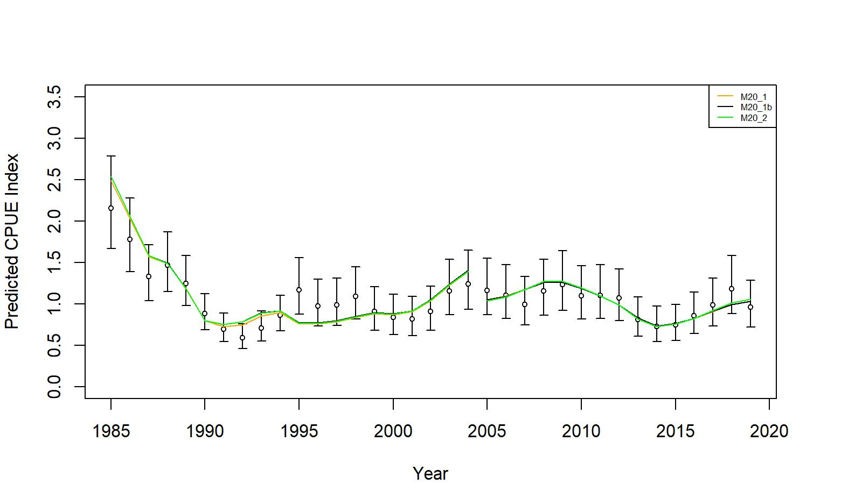
Figure 42. Comparison of input CPUE indices (open circles with +/- 2 SE for model 20_1) with model predicted CPUE indices (colored solid lines) under models 20_1, 20_1b, and 20_2 fits to WAG golden king crab data, 1985/86–2019/20. Model estimated additional standard error was added to each input standard error.

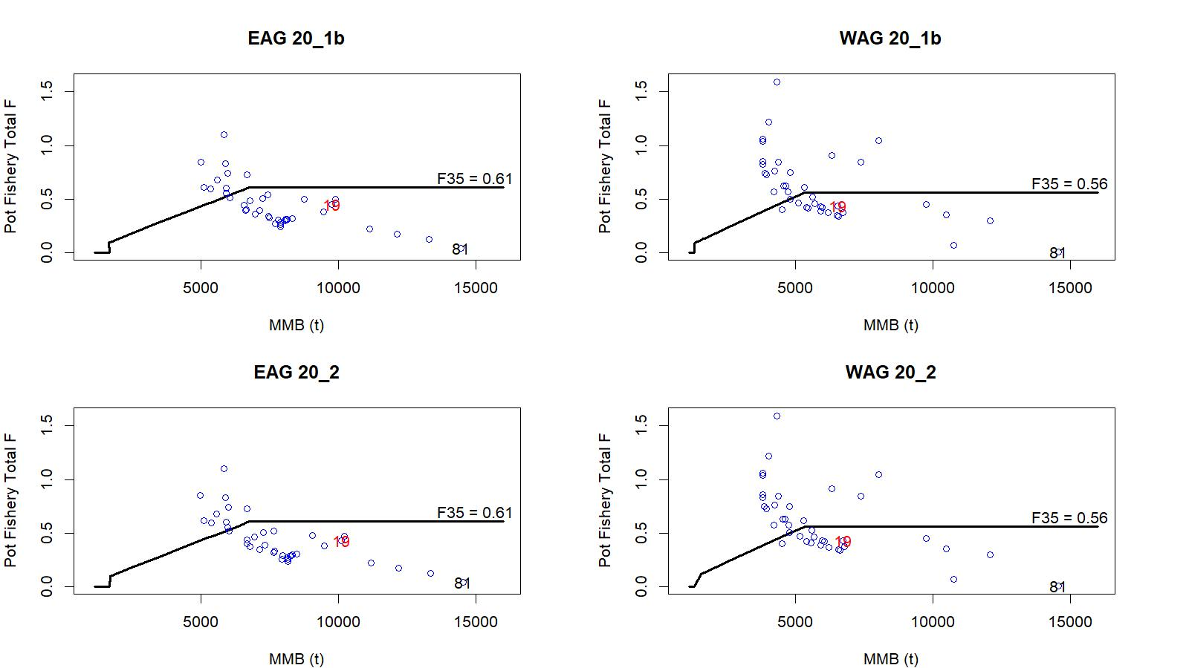

Figure 43. Relationships between full fishing mortalities for the directed pot fishery and mature male biomass during 1981/82–2019/20 under models 20_1b and 20_2 fits to EAG and WAG data.

Appendix A: Integrated model

Aleutian Islands Golden King Crab (Lithodes aequispinus) Stock Assessment Model Development- east of 174° W (EAG) and west of 174° W (WAG) Aleutian Island stocks

Basic population dynamics

The annual [male] abundances by size are modeled using the equation:

$N_{t+1,j}= \sum_{i=1}^{j}{[N_{t,i}e^{-M}}-({\hat{C}}_{t,i}+{\hat{D}}_{t,i}+{\hat{Tr}}_{t,i})e^{\left(y_{t}-1\right)M}]X_{i,j}+R_{t+1,j}$ (A.1)

where is the number of [male] crab in length class i on 1 July (start of fishing year) of year t; , , and ${\hat{T}r}_{t,i}$ are respectively the predicted fishery retained, pot fishery discard dead, and groundfish fishery discard dead catches in length class i during year t; ${\hat{D}}_{t,i}$ is estimated from the intermediate total (${\hat{T}}_{t,i temp}$) catch and the retained (${\hat{C}}_{t,i}$) catch by Equation A.2c. is the probability of length-class i growing into length-class j during the year; y_{t} is elapsed time period from 1 July to the mid –point of fishing period in year t; M is instantaneous rate of natural mortality; and $R_{t+1,j}$ recruitment to length class j in year t+1.

The catches are predicted using the equations

${\hat{T}}_{t,j, temp}= \frac{F_{t}s_{t,j}^{T}}{Z_{t,j}} N_{t,j}e^{-y_{t}M}(1-e^{-Z_{t,j}})$ (A.2a)

${\hat{C}}_{t,j}= \frac{F_{t}s_{t,j}^{T}s_{t,j}^{r}}{Z_{t,j}} N_{t,j}e^{-y_{t}M}(1-e^{-Z_{t,j}})$ (A.2b)

${\hat{D}}_{t,j }= 0.2({\hat{T}}_{t,j, temp}-{\hat{C}}_{t,j})$ (A.2c)

${\hat{Tr}}_{t,j}= 0.65\frac{F_{t}^{Tr}s_{j}^{Tr}}{Z_{t,j}} N_{t,j}e^{-y_{t}M}(1-e^{-Z_{t,j}})$ (A.2d)

${\hat{T}}_{t,j}={\hat{C}}_{t,j}+ {\hat{D}}_{t,j}$ (A.2e)

where is total fishery-related mortality on animals in length-class j during year t:
$Z_{t,j}= F_{t}s_{t,j}^{T}s_{t,j}^{r}+0.2F_{t}s_{t,j}^{T}(1-s_{t,j}^{r})+0.65 F_{t}^{Tr}s_{j}^{Tr}$ (A.3)

is the full selection fishing mortality in the pot fishery, $F_{t}^{Tr}$ is the full selection fishing mortality in the trawl fishery, $s_{t,j}^{T}$ is the total selectivity for animals in length-class j by the pot fishery during year t, $s_{j}^{Tr}$is the selectivity for animals in length-class j by the trawl fishery, $s_{t,j}^{r}$ is the probability of retention for animals in length-class j by the pot fishery during year t. Pot bycatch mortality of 0.2 and groundfish bycatch mortality of 0.65 (average of trawl (0.8) and fish pot (0.5) mortality) were assumed.

Initial abundance
The initial conditions are computed as the equilibrium initial condition using the following relations:

The equilibrium stock abundance is
N = X.S.N + R (A.4)
The equilibrium abundance in 1960, N₁₉₆₀ , is

${\underline{N}}_{1960}= {\left(I-XS\right)}^{-1}\underline{R}$ (A.5)
where X is the growth matrix, S is a matrix with diagonal elements given by , I is the identity matrix, and $\underline{R}$is the product of average recruitment and relative proportion of total recruitment to each size-class.
We used the mean number of recruits from 1987 to 2012 in equation (A.5) to obtain the equilibrium solution under only natural mortality in year 1960, and then projected the equilibrium abundance under natural mortality with recruitment estimated for each year after 1960 up to 1985 with removal of retained catches during 1981/82 to 1984/85.

Growth Matrix
The growth matrix X is modeled as follows:

$X_{i,j}= \left\{\begin{aligned}0 if j<i \\ P_{i,j}+\left(1- m_{i}\right) if j=i \\ P_{i,j} if j>i\end{aligned}\right.$ (A.6)
where:

$P_{i,j}= m_{i}\left\{\begin{aligned}\int_{-∞}^{j_{2}- L_{i}}{N \left(x \right|μ_{i}, σ^{2}) dx if j=i} \\ \int_{j_{1}- L_{i}}^{j_{2}- L_{i}}{N \left(x \right|μ_{i}, σ^{2}) dx} if i<j<n \\ \int_{j_{1}- L_{i}}^{∞}{N \left(x \right|μ_{i}, σ^{2}) dx if i=n}\end{aligned}\right.$,

$N\left(x | μ_{i},σ^{2}\right)=\frac{1}{\sqrt{2πσ^{2}}}e^{-{(\frac{x-μ_{i}}{\sqrt{2}σ})}^{2}}$, and
$μ_{i}$is the mean growth increment for crab in size-class i:
$μ_{i}={}_{1}+{}_{2}*{\overline{L}}_{i}$. (A.7)
${}_{1}$ , ${}_{2}$ , and $σ$are estimable parameters, and j₁ and j₂ are the lower and upper limits of the receiving length-class j (in mm CL), and ${\overline{L}}_{i}$ is the mid-point of the contributing length interval i. The quantity $m_{i}$ is the molt probability for size-class i:

$m_{i}=\frac{1}{1 + e^{c\left({}_{i}-d\right)}}$ (A.8)
where ${}_{i}$ is the mid-length of the i-th length-class, c and d are parameters.

Selectivity and retention
Selectivity and retention are both assumed to be logistic functions of length. Selectivity depends on the fishing period for the pot fishery:

$S_{i}= \frac{1}{1+ e^{\left[-ln⁡(19)\frac{τ_{i}-θ_{50}}{θ_{95}-θ_{50}}\right]}}$ (A.9)

where θ₉₅ and θ₅₀ are the parameters of the selectivity/ retention pattern (Mark Maunder, unpublished generic crab model). In the program, we re-parameterized the denominator (θ₉₅ - θ₅₀) to $log⁡(deltaθ)$ so that the difference is always positive and transformed θ₅₀ to log(θ₅₀) to keep the estimate always positive.

Recruitment
Recruitment to length–class i during year t is modeled as $R_{t,i}=\overline{R}e^{ϵ_{i}}Ω_{i}$ where $Ω_{i}$ is a normalized gamma function
$gamma\left(x | α_{r},β_{r}\right)=\frac{x^{α_{r}-1}e^{\frac{x}{β_{r}}}}{{β_{r}}^{α_{r}}⎾_{(α_{r})}}$ (A.10)

with α_{r} and β_{r} (restricted to the first five length classes).

Parameter estimation
Table A1 lists the parameters of the model indicating which are estimated and which are pre-specified. The objective function includes contributions related to the fit of the model to the available data and penalties (priors on various parameters).

Tables A2 lists parameter values (with the corresponding coefficient of variations in parentheses) used to weight the components of the objective functions for EAG and WAG.

Likelihood components

Catches
The contribution of the catch data (retained, total, and groundfish discarded) to the objective function is given by:
(A.11a)
${LL}_{T}^{catch}= λ_{T}\sum_{t}{\{ln⁡(\sum_{j}{{\hat{T}}_{t,j}w_{j}+c)}}-ln⁡(\sum_{j}{T_{t,j}w_{j}+c)\}^{2}}$ (A.11b)

${LL}_{GD}^{catch}= λ_{GD}\sum_{t}{\{ln⁡(\sum_{j}{{\hat{Tr}}_{t,j}w_{j}+c)}}-ln⁡(\sum_{j}{{Tr}_{t,j}w_{j}+c)\}^{2}}$ (A.11c)

where λ_{r}, λ_{T}, and λ_{GD} are weights assigned to likelihood components for the retained, pot total, and groundfish discard catches; is the average mass of a crab is length-class j; , $T_{t,j}$, and ${Tr}_{t,j}$are, respectively, the observed numbers of crab in size class j for retained, pot total, and groundfish fishery discarded crab during year t, and c is a small constant value. We assumed c = 0.001.

An additional retained catch likelihood (using Equation A.11a without w) for the retained catch in number of crabs during 1981/82 to 1984/85 was also considered in all scenarios.

Catch-rate indices
The catch-rate indices are assumed to be lognormally distributed about the model prediction. Account is taken of variation in addition to that related to sampling variation:

${LL}_{r}^{CPUE}= λ_{r,CPUE}\left\{0.5\sum_{t}{ln⁡\left[2π\left(σ_{r,t}^{2}+ σ_{e}^{2}\right)\right]}+ \sum_{t}{\frac{{\left(ln{(CPUE}_{t}^{r}+c)- \hat{{ln⁡(CPUE}_{t}^{r}+c)}\right)}^{2}}{2\left(σ_{r,t}^{2}+ σ_{e}^{2}\right)}}\right\}$ (A.12)

where is the standardized retain catch-rate index for year t, is standard error of the logarithm of , and $\hat{{CPUE}_{t}^{r}}$ is the model-estimate of :

$\hat{ {CPUE}_{t}^{r}} = q_{k}\sum_{j}{S_{j}^{T}}S_{j}^{r} \left(N_{t,j}-0.5\left[\hat{C_{t,j}}+ \hat{D_{t,j}}+\hat{{Tr}_{t,j}} \right]\right)e^{{-y}_{t}M}$ (A.13)

in which $q_{k}$ is the catchability coefficient during the k-th time period (e.g., pre- and post-rationalization time periods), is the extent of over-dispersion, c is a small constant to prevent zero values (we assumed c = 0.001), and $λ_{r,CPUE}$ is the weight assigned to the catch-rate data. We used the same likelihood formula (A.12) for fish ticket retained catch rate indices.

Following Burnham et al. (1987), we computed the ln(CPUE) variance by:

$σ_{r,t }^{2}=ln⁡(1+{CV}_{r,t}^{2})$ (A.14)

Length-composition data
The length-composition data are included in the likelihood function using the robust normal for proportions likelihood, i.e., generically:
(A.15)
where is the observed proportion of crabs in length-class j in the catch during year t, is the model-estimate corresponding to , i.e.:
${\hat{L}}_{t,j}^{r}= \frac{{\hat{C}}_{t,j}}{\sum_{j}^{n}{{\hat{C}}_{t,j}}}$
${\hat{L}}_{t,j}^{T}= \frac{{\hat{T}}_{t,j}}{\sum_{j}^{n}{{\hat{T}}_{t,j}}}$
${\hat{L}}_{t,j}^{GF}= \frac{{\hat{Tr}}_{t,j}}{\sum_{j}^{n}{{\hat{Tr}}_{t,j}}}$ (A.16)
is the variance of:
(A.17)
and is the effective sample size for year t and n is the number of size classes.

Note: The likelihood calculation for retained length composition starts from length-class 6 (mid length 128 mm CL) because the length-classes 1 to 5 mostly contain zero data.

Tagging data
Let be the number of tagged male crab that were released during year t that were in size-class j when they were released and were recaptured after y years, and be the vector of recaptures by size-class from the males that were released in year t that were in size-class j when they were released and were recaptured after y years. The log-likelihood corresponding to the multinomial distribution for the tagging data is then:

$lnL= λ_{y,tag}\sum_{j}{\sum_{t}{\sum_{y}{\sum_{i}{ρ_{j,t,y,i}ln{\hat{ρ}}_{j,t,y,i}}}}}$ (A18)

where $λ_{y,tag}$ is the weight assigned to the tagging data for recapture year y, is the proportion in size-class i of the recaptures of males that were released during year t that were in size-class j when they were released and were recaptured after y years:
(A19)
where $Z^{(j)}$ is a vector with at element j and 0 otherwise, and S^{T} is the vector of total selectivity for tagged male crab by the pot fishery. This log-likelihood function is predicated on the assumption that all recaptures are in the pot fishery and the reporting rate is independent of the size of crab.

Penalties
Penalties are imposed on the deviations of annual pot fishing mortality about mean pot fishing mortality, annual trawl fishing mortality about mean trawl fishing mortality, recruitment about mean recruitment, and the posfunction (fpen):
(A.20)
(A.21)
(A.22)

$P_{5}= λ_{posfn}*fpen$ (A.23)

Standardized Residual of Length Composition
${Std.Res}_{t,j}= \frac{P_{t,j}-\hat{P_{t,j}}}{\sqrt{2σ_{t,j}^{2}}}$ (A.24)
Output Quantities

Harvest rate

Total pot fishery harvest rate:
$E_{t}=\frac{\sum_{j=1}^{n}{\left({\hat{C}}_{j,t}+ {\hat{D}}_{j,t}\right)}}{\sum_{j=1}^{n}{N_{j,t}}}$ (A.25)

Exploited legal male biomass at the start of year t:
(A.26)
where $w_{j}$ is the weight of an animal in length-class j.

Mature male biomass on 15 February spawning time (NPFMC 2007a, b) in the following year:

${MMB}_{t}= \sum_{j=mature size}^{n}{\{N_{j,t}e^{{-y}^{'}M}-({\hat{C}}_{j,t}}+{\hat{D}}_{j,t}+{\hat{Tr}}_{j,t})e^{\left(y_{t}-y'\right)M}\}w_{j}$ (A.27)

where $y^{'}$is the elapsed time from 1 July to 15 February in the following year.

For estimating the next year limit harvest levels from current year stock abundances, a $F_{OFL}$ value is needed. Current crab management plan specifies five different Tier formulas for different stocks depending on the strength of information available for a stock, for computing $F_{OFL}$ (NPFMC 2007a, b). For the golden king crab, the following Tier 3 formula is applied to compute $F_{OFL}$:

If,
${MMB}_{current}> {MMB}_{35\%}, F_{OFL}= F_{35\%}$

If,
${MMB}_{current}≤ {MMB}_{35\% } and {MMB}_{current} >0.25{MMB}_{35\%}$ ,

$F_{OFL}= F_{35\%} \frac{\left(\frac{{MMB}_{current}}{{MMB}_{35\%}} - α\right)}{\left(1-α\right)}$ (A.28)

If,
${MMB}_{current} ≤0.25{MMB}_{35\%}$ ,

$F_{OFL}=0.$

where α is a parameter, ${MMB}_{current }$is the mature male biomass in the current year and MMB_{35%} is the proxy MMB_{MSY} for Tier 3 stocks. We assumed α = 0.1.
Because projected ${MMB}_{t}$ (i.e., ${MMB}_{current }$) depends on the intervening retained and discard catch (i.e., MMB_{t} is estimated after the fishery), an iterative procedure is applied using Equations A.27 and A.28 with retained and discard catch predicted from Equations A.2b-d. The next year limit harvest catch is estimated using Equations A.2b-d with the estimated $F_{OFL}$ value.

Table A1. Pre-specified and estimated parameters of the population dynamics model
Parameter | Number of parameters
Fishing mortalities:
Pot fishery, | 1981–2019 (estimated)
Mean pot fishery fishing mortality, | 1 (estimated)
Groundfish fishery, | 1989–2019 (the mean F for 1989 to 1994 was used to estimate groundfish discards back to 1981 (estimated)
Mean groundfish fishery fishing mortality, | 1 (estimated)
Selectivity and retention:
Pot fishery total selectivity, $θ_{50}^{T}$ | 2 (1981–2004; 2005+) (estimated)
Pot fishery total selectivity difference, ${deltaθ}^{T}$ | 2 (1981–2004; 2005+) (estimated)
Pot fishery retention, $θ_{50}^{r}$ | 1 (1981+) (estimated)
Pot fishery retention selectivity difference, ${deltaθ}^{r}$ | 1 (1981+) (estimated)
Groundfish fishery selectivity | fixed at 1 for all size-classes
Growth:
Expected growth increment, | 2 (estimated)
Variability in growth increment, $σ$  Molt probability (size transition matrix with tag data), a  Molt probability (size transition matrix with tag data), b | 1 (estimated)  1 (estimated)  1 (estimated)
Natural mortality, M | 1 (pre-specified, 0.21yr⁻¹ )
Recruitment:
Number of recruiting length-classes  Mean recruit length  Distribution to length-class, $β_{r}$  Median recruitment, $\overline{R}$ | 5 (pre-specified)  1 (pre-specified, 110 mmCL)  1 (estimated)  1 (estimated)
Recruitment deviations, | 60 (1961–2020) (estimated)
Fishery catchability, q | 2 (1985–2004; 2005+) (estimated)
Additional CPUE indices standard deviation, $σ_{e}$ | 1 (estimated)
Likelihood weights (coefficient of variation) | Pre-specified, varies by scenario

Table A2. Specifications for the weights with corresponding coefficient of variations* in parentheses for each model for EAG and WAG.
Weight
Weight | Model  20_1 | Model  20_1b | Model  20_2
Catch:
Retained catch for 1981–1984 and/or 1985–2019, λ_{r} | 500 (0.032) | 500 | 500
Total catch for 1990–2019, λ_{T} | Number of sampled pots scaled to a max 250 | Number of sampled pots scaled to a max 250 | Number of sampled pots scaled to a max 250
Groundfish bycatch for 1989 –2019, λ_{GD} | 0.2 (3.344) | 0.2 | 0.2
Catch-rate:
Observer legal size crab catch-rate for 1995–2019, | 1 (0.805) | 1 | 1
Fish ticket retained crab catch-rate for 1985–1998, | 1 (0.805) | 1 | 1
Penalty weights:
Pot fishing mortality dev, | Initially 1000, relaxed to 0.001 at phases ≥ select. phase | Initially 1000, relaxed to 0.001 at phases ≥ select. phase | Initially 1000, relaxed to 0.001 at phases ≥ select. phase
Groundfish fishing mortality dev, | Initially 1000, relaxed to 0.001 at phases ≥ select. phase | Initially 1000, relaxed to 0.001 at phases ≥ select. phase | Initially 1000, relaxed to 0.001 at phases ≥ select. phase
Recruitment, | 2 (0.533) | 2 | 2
Posfunction (to keep abundance estimates always positive), $λ_{posfn}$ | 1000 (0.022) | 1000 | 1000
Tagging likelihood | EAG individual tag returns | EAG tag data | EAG tag data

$* Coefficient of Variation, CV= \sqrt{exp⁡[\frac{1}{2W}]-1}$, w =weight

Appendix B: Catch and CPUE data
The commercial catch and length frequency distribution were estimated from ADF&G landing records and dockside sampling (Bowers et al. 2008, 2011). The annual retained catch, total catch, and groundfish (or trawl) discarded mortality are provided in Tables 1, 2, and 2b for EAG and WAG. The weighted length frequency data were used to distribute the catch into 5-mm size intervals. The length frequency data for a year were weighted by each sampled vessel’s catch as follows. The i-th length-class frequency was estimated as:

$\sum_{j=1}^{k}{C_{j}}\frac{{LF}_{j,i}}{\sum_{i=1}^{n}{{LF}_{j,i}}}$ (B.1)

where k = number of sampled vessels in a year, LF_{j,i} = number of crabs in the i-th length-class in the sample from j-th vessel, n = number of size classes, C_{j} = number of crabs caught by j-th vessel. Then the relative frequency for the year was calculated and applied to the annual retained catch (in number of crabs) to obtain retained catch by length-class.

The annual total catch (in number of crabs) was estimated by the observer nominal (unstandardized) total CPUE considering all vessels multiplied by the total fishing effort (number of pot lifts). The weighted length frequency of the observer samples across the fleet was estimated using Equation B.1. Observer measurement of crab ranged from 20 to 220 mm CL. To restrict the total number of crabs to the model assumed size range (101–185+ mm CL), the proportion of observer total relative length frequency corresponding to this size range was multiplied by the total catch (number of crabs). This total number of crabs was distributed into length-classes using the weighted relative length frequency. Thus, crab sizes < 101 mm CL were excluded from the model. In addition, all crab >185 mm CL were pooled into a plus length class. Note that the total crab catch by size that went into the model did not consider retained and discard components separately. However, once the model estimated the annual total catch, then retained catch was deducted from this total and multiplied by handling mortality [we used a 20% handling mortality (Siddeek et al. 2005) to obtain the directed fishery discarded (dead) catch].

Observer data have been collected since 1988 (Moore et al. 2000; Barnard et al. 2001; Barnard and Burt 2004; Gaeuman 2011), but data were not comprehensive in the initial years, so a shorter time series of data for the period 1990/91–2018/19 was selected for this analysis. During 1990/91–1994/95, observers were only deployed on catcher-processor vessels. During 1995/96–2004/05, observers were deployed on all fishing vessels during fishing activity. Observers have been deployed on all fishing vessels since 2005/06, but catcher-only vessels are only required to carry observers for a minimum of 50% of their fishing activity during a season; catcher-processor vessels are still required to carry observers during all fishing activity. Onboard observers sample seven pots per day (it can be different number of pots per string) and count and measure all crabs caught and categorize catch as females, sublegal males, retained legal males, and non-retained legal males in a sampled pot. Prior to the 2009/10 season, depending on season, area, and type of fishing vessel, observers were also instructed to sample additional pots in which all crab were only counted and categorized as females, sublegal males, retained legal males, and non-retained legal males, but were not measured. Annual mean nominal CPUEs of retained and total crabs were estimated considering all sampled pots within each season (Table 3). The observer CPUE data collection improved over the years and the data since 1995/96 are more reliable. Thus, for model fitting, the observer CPUE time series was restricted to 1995/96–2019/20. The 1990/91–2019/20 observer database consists of 116,508 records and that of 1995/96–2019/20 contains 112,229 records, For CPUE standardization, these data were further reduced by 5% cutoff of Soak time and 1% cutoff of Depth on both ends of the variable range to remove unreliable data or data from dysfunctional pot operations, and restricting to vessels which have made five trips per year for at least three years during 1985/86 –2019/20.

Length-specific CPUE data collected by observers provides information on a wider size range of the stock than did the commercial catch length frequency data obtained from mostly legal-sized landed males.

There were significant changes in fishing practice due to changes in management regulations (e.g., since 1996/97 constant TAC and since 2005/06 crab rationalization), pot configuration (escape web on the pot door increased to 9” since 1999), and improved observer recording in Aleutian Islands golden king crab fisheries since 1998. These changes prompted us to consider two separate observer CPUE time series, 1995/96–2004/05 and 2005/06–2019/20, to estimate CPUE indices for model input.

To include a long time series of CPUE indices for stock abundance contrast, we also considered the 1985/86–1998/99 legal size standardized CPUE as a separate likelihood component in all scenarios. Because of the lack of soak time data before 1990, we estimated the CPUE index considering a limited set of explanatory variables (e.g., vessel, captain, area, month) and fitting the lognormal and negative binomial GLM models to fish ticket data (Tables 4 and 13).

When using CPUE indices in the model fit, we compared the predicted with the observed legal male CPUE in the observer CPUE likelihoods because legal male (retained plus non-retained) data are more reliable than total in the observer samples.

The CPUE standardization followed the GLM fitting procedure (Maunder and Punt 2004; Starr 2012; Siddeek et al. 2018). Following a suggestion made by the CIE reviewers (CIE, June 2018) we reduced the number of gear codes in the database after consulting with the fishing industry (Rip Carlton, Chad Hoefer, and Scott Goodman, personal communication December 2018; Table B1). Following SSC (October 2018) suggestion, we used a hybrid procedure: First, selected a scope of variables set by Akike Information Criterion, AIC (Burnham and Anderson 2002). An increase of more than 2 units in the AIC was used to identify the variable to be included successively (stepAIC program, R Core Team 2019). Then, the model parsimony was improved further by successively removing the term that explained the least proportion of deviance (R2 < 0.01) (stepCPUE R function was used, Siddeek et al. 2018). Feenstra, et al. (unpublished 2019) used a similar hybrid approach.

Table B.1. Updated Gear code for observer data analysis. Only gear code # 5, 6, 7, 8, and 13 were considered following crab industry suggestion. Note: Identical codes were given to those gear codes with similar catchability/selectivity. X stands for the gear codes that were ignored.

Original Gear code | Pot gear description | Mark X against the code that can be ignored | Number Encountered by Observers during 1990-2016 | Updated Gear Code
1 | Dungeness crab pot, small & round | X | 2 | X
2 | Pyramid pot, tunnel openings usually on sides, stackable | X | 2121 | X
3 | Conical pot, opening at top of cone, stackable | X | 2000 | X
4 | 4' X 4' rectangular pot |  | 60 | X
5 | 5' X 5' rectangular pot |  | 18032 | 5
6 | 6' X 6' rectangular pot |  | 17508 | 6
7 | 7' X 7' rectangular pot |  | 23806 | 7
8 | 8' X 8' rectangular pot |  | 1936 | 8
9 | 5 1/2' X 5 1/2' rectangular pot |  | 6934 | 5
10 | 6 1/2' X 6 1/2' rectangular pot |  | 22085 | 6
11 | 7 1/2' X 7 1/2' rectangular pot |  | 387 | 7
12 | Round king crab pot, enlarged version of Dungeness crab pot |  | 8259 | X
13 | 10' X 10' rectangular pot |  | 466 | 13
14 | 9' X 9' rectangular pot | X | 1 | X
15 | 8 1/2' X 8 1/2' rectangular pot | X | 1 | X
16 | 9 1/2' X 9 1/2' rectangular pot | X | Not used | X
17 | 8' X 9' rectangular pot | X | 1 | X
18 | 8' X 10' rectangular pot | X | 1 | X
19 | 9' X 10' rectangular pot |  | Not used | X
20 | 7' X 8' rectangular pot | X | 252 | X
21 | Hair crab pot, longlined and small, stackable |  | Not used | X
22 | snail pot | X | 1 | X
23 | Dome-shaped pot, tunnel opening on top, often longlined in deep-water fisheries | X | 6756 | X
24 | ADF&G shellfish research 7’ X 7’ X34” rectangular pot with 2.75” stretch mesh and no escapement rings or mesh |  | Research pot | X
80 | Historical: Cod pot, any shape pot targeting cod, usually with tunnel fingers | X | 711 | X
81 | Historical: Rectangular pot, unknown size, with escape rings | X | 1123 | X

All scenarios used CPUE indices estimated by the hybrid GLM method. Following January 2019 CPT request, we considered an Year:Area interaction factor as a special case for a CPUE standardization scenario.

Thus we estimated two sets of observer CPUE indices for model input, 20_1 (reduced number of gear codes), and 20_2 (reduced number of gear codes and Year:Area interaction).

Observer CPUE index by GLM:

  - Non-interaction GLM model:

The CPUE standardization followed the GLM fitting procedure (Maunder and Punt 2004; Starr 2012; Siddeek et al. 2016b). We considered the negative binomial GLM on positive and zero catches to select the explanatory variables. The response variable CPUE is the observer sample catch record for a pot haul. The negative binomial model uses the log link function for the GLM fit.

For the non-interaction model, we assumed the null model to be

$\ln\left({CPUE}_{i}\right)={Year}_{y_{i}}$ (B.2)
where Year is a factorial variable.
The maximum set of model terms offered to the stepwise selection procedure was:

${ln⁡(CPUE}_{I}) ={Year}_{y_{i}}+ns\left({Soak}_{si},df\right)+{Month}_{m_{i}}+{Vessel}_{vi}+{Captain}_{ci}+{Area}_{ai}+{Gear}_{gi}+ns\left({Depth}_{di},df\right)$, (B.3)

where Soak is in unit of days and is numeric; Month, Area (Block) code, Vessel code, Captain code, and Gear code are factorial variables; Depth in fathom is a numeric variable; ns=cubic spline, and df = degree of freedom.

We used a log link function and a dispersion parameter (θ) in the GLM fitting process. We used the R² criterion for predictor variable selection (Siddeek et al. 2016b).

The degrees of freedom and dispersion parameters were determined by calculating AICs for a range of values included in the GLM and locating the best values at the minimum AIC (results are available with the first author).

Instead of using the traditional AIC (-2log_likelihood+2p) we used the Consistent Akaike
Information Criteria (CAIC) (Bozdogan 1987) {-2log_likelihood+[ln(n)+1]*p} for variable selection by StepAIC, where n=number of observations and p= number of parameters to be estimated. The number of selected variables were further reduced for parsimony, if feasible, by the R² criterion using the StepCPUE function. i.e., A hybrid selection procedure (Feenstra et al. 2019).

Example R codes used for main effect GLM fitting are as follows:

For EAG 1995_04 CPUE indices:
library(MASS)
library(splines)
Step 1:
glm.object<- glm(Legals~Year,family = negative.binomial(1.38),data=datacore)
epotsampleoutAIC<-stepAIC(glm.object,scope=list(upper= ~(Year+ns(SoakDays,df=4)+Month+Vessel+Captain+Area+Gear+ns(Depth,df=16)),lower=~Year),family=negative.binomial(1.38),direction="forward",trace=9,k=log(nrow(datacore))+1.0)

Step 2:

glm.object<- glm(Legals~Year,family = negative.binomial(1.38),data=datacore)
epotsampleout<-stepCPUE(glm.object,scope=list(upper=~(Year+Gear+Captain+ns(SoakDays,df=4)+
Month+Area),lower=~Year),family=negative.binomial(1.38),direction="forward",trace=9,r2.change=0.01)

The final main effect models for EAG were:

Model 20_1:
Initial selection by stepAIC:
$\ln\left(CPUE\right)= Year+Gear+Captain+ns\left(Soak, 4\right)+Month+Block$
AIC=203808

Final selection by stepCPUE:
$\ln\left(CPUE\right)= Year+Gear+Captain+ns\left(Soak, 4\right)+Month$ (B.4)
for the 1995/96–2004/05 period [θ=1.38, $R^{2}=0.2205$]

Initial selection by stepAIC:
$\ln\left(CPUE\right)= Year+ Captain+Gear+ ns\left(Soak, 16\right)$
AIC=72738

Final selection by stepCPUE:
$\ln\left(CPUE\right)= Year+ Captain+ ns\left(Soak, 16\right)+Gear$ (B.5)
for the 2005/06–2019/20 period [$=2.33, R^{2}=0.1125$].

The final models for WAG were:

Model 20_1:
Initial selection by stepAIC:
$\ln\left(CPUE\right)= Year+Captain+ns\left(Soak, 15\right)+Gear+Area+Month+Vessel$
AIC=191025

Final selection by stepCPUE:
$\ln\left(CPUE\right)= Year+Captain+ns\left(Soak, 15\right)+Gear$ (B.6)
for the 1995/96–2004/05 period [θ=0.97, $R^{2}=0.1684$]

Initial selection by stepAIC:
$\ln\left(CPUE\right)= Year+Gear+Vessel+ Month+ ns\left(Soak, 19\right)$
AIC=110148

Final selection by stepCPUE:
$\ln\left(CPUE\right)= Year+ Gear+ ns\left(Soak, 19\right)$ (B.7)
for the 2005/06–2019/20 period [$=1.13, R^{2}=0.0525, Soak forced in$].

  - Year:Area interaction GLM:

For year and area interaction analysis, we designed the areas in to 1 X 1 nmi grids enmeshed in 10 larger blocks as follows. The number of blocks was restricted to a few to prevent GLM fitting problems.

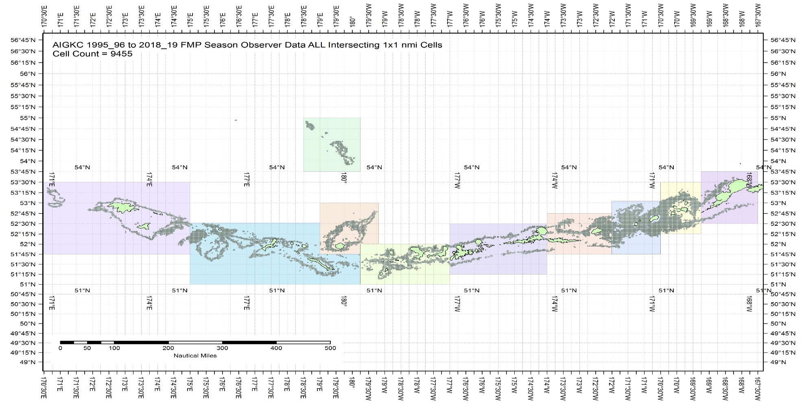

Figure B.1. The 1995/96 to 2019/20 observer pot samples enmeshed in 10 blocks for the Aleutian Islands golden king crab.
The blocks were determined from visually exploring each year’s pot distribution locations (available with the first author). The blocks contain observed patches of crab distribution during this time period.

Table B.1. Number of 1 x 1 nmi grids containing observer sample locations within each block by fishing year for the Aleutian Islands golden king crab, 1995/96–2019/20 data. Blocks 1–4 belong to EAG and 5 – 10 to WAG. Sum of ever fished number of grids for each block is listed at the bottom row.

Year | Block_1 | Block_2 | Block_3 | Block_4 | Block_5 | Block_6 | Block_7 | Block_8 | Block_9 | Block_10
1995 | 125 | 529 | 748 | 379 | 218 | 373 | 112 | 722 | 166 | 122
1996 | 149 | 814 | 761 | 372 | 89 | 473 | 359 | 799 | 200 | 35
1997 | 116 | 530 | 755 | 257 | 202 | 443 | 104 | 568 | 274 | 0
1998 | 78 | 581 | 453 | 236 | 18 | 318 | 157 | 251 | 132 | 0
1999 | 123 | 593 | 454 | 231 | 163 | 476 | 182 | 627 | 193 | 145
2000 | 72 | 540 | 754 | 301 | 187 | 440 | 195 | 555 | 547 | 47
2001 | 123 | 507 | 507 | 329 | 45 | 369 | 288 | 634 | 256 | 9
2002 | 97 | 387 | 584 | 271 | 71 | 341 | 205 | 335 | 242 | 37
2003 | 43 | 492 | 530 | 299 | 111 | 347 | 212 | 465 | 150 | 61
2004 | 81 | 289 | 377 | 216 | 77 | 319 | 150 | 359 | 172 | 116
2005 | 0 | 205 | 221 | 118 | 8 | 220 | 83 | 261 | 54 | 0
2006 | 0 | 154 | 248 | 122 | 15 | 191 | 58 | 220 | 39 | 0
2007 | 0 | 111 | 177 | 110 | 24 | 228 | 78 | 173 | 20 | 0
2008 | 0 | 111 | 203 | 93 | 12 | 181 | 67 | 196 | 0 | 0
2009 | 0 | 59 | 146 | 60 | 6 | 137 | 95 | 220 | 25 | 0
2010 | 0 | 81 | 141 | 85 | 1 | 115 | 73 | 260 | 39 | 0
2011 | 0 | 126 | 117 | 33 | 3 | 83 | 73 | 266 | 9 | 0
2012 | 0 | 146 | 110 | 56 | 7 | 91 | 85 | 312 | 53 | 0
2013 | 2 | 149 | 129 | 51 | 12 | 144 | 105 | 293 | 86 | 0
2014 | 1 | 138 | 96 | 41 | 39 | 120 | 114 | 319 | 37 | 0
2015 | 0 | 135 | 147 | 61 | 46 | 163 | 106 | 280 | 16 | 48
2016 | 0 | 145 | 231 | 63 | 26 | 134 | 89 | 210 | 106 | 0
2017 | 0 | 97 | 170 | 110 | 11 | 87 | 79 | 198 | 118 | 0
2018 | 0 | 91 | 158 | 95 | 7 | 69 | 82 | 204 | 121 | 0
2019 | 1 | 112 | 171 | 101 | 0 | 0 | 89 | 316 | 138 | 0

 | Block_1 | Block_2 | Block_3 | Block_4 | Block_5 | Block_6 | Block_7 | Block_8 | Block_9 | Block_10
1995-2019 - Sum of 1x1 cells ever fished | 375 | 1363 | 1754 | 907 | 452 | 1026 | 777 | 1940 | 998 | 325

We assumed the null model to be

$\ln\left({CPUE}_{i}\right)={Year}_{y_{i}}$:Area_{ai} (B.8)

The maximum set of model terms offered to the stepwise selection procedure was:

${ln⁡(CPUE}_{I}) ={Year}_{y_{i}}:{Area}_{ai}+ns\left({Soak}_{si},df\right)+{Month}_{m_{i}}+{Vessel}_{vi}+{Captain}_{ci}+{Area}_{ai}+{Gear}_{gi}+ns\left({Depth}_{di},df\right)$. (B.9)

Example R codes used for interaction effect GLM fitting are as follows:

For WAG 1995_04 CPUE indices:
library(MASS)
library(splines)
Step 1:
glm.object<- glm(Legals~Year:Area,family = negative.binomial(0.97),data=datacore)
wpotsampleoutAIC<-stepAIC(glm.object,scope=list(upper= ~(Year:Area+ns(SoakDays,df=15)+Month+Vessel+Captain+Area+Gear + ns(Depth,df=18)),lower=~Year:Area),family= negative.binomial(0.97),direction="forward",trace=9,k=log(nrow(datacore))+1.0)

Step 2:

glm.object<- glm(Legals~Year:Area,family = negative.binomial(0.97),data=datacore)
wpotsampleout<-stepCPUE(glm.object,scope=list(upper= ~(Captain+ns(SoakDays,df=15)+Gear+Area+Month+Year:Area),lower= ~Year:Area),family= negative.binomial(0.97),direction="forward",trace=9,r2.change=0.01)

The final interaction effect models for EAG were:

Model 20_2:
Initial selection by stepAIC:
$\ln\left(CPUE\right)= Gear+Captain+ns\left(Soak, 4\right)+Month+Year:Area$
AIC=203851

Final selection by stepCPUE:
$\ln\left(CPUE\right)= Gear+Captain+ns\left(Soak, 4\right)+Year:Area$ (B.10)
for the 1995/96–2004/05 period [θ=1.38, $R^{2}=0.2235$]

Initial selection by stepAIC:
$\ln\left(CPUE\right)= Vessel+Gear+ ns\left(Soak, 16\right)+Year:Area$
AIC=72860

Final selection by stepCPUE:
$\ln\left(CPUE\right)= Vessel+ns\left(Soak, 16\right)+Gear+Year:Area$ (B.11)
for the 2005/06–2019/20 period [$=2.33, R^{2}=0.1238$].

The final interaction effect models for WAG were:

Model 20_2:
Initial selection by stepAIC:
$\ln\left(CPUE\right)= Vessel+ns\left(Soak, 15\right)+Gear+Month+Year:Area$
AIC=191140

Final selection by stepCPUE:
$\ln\left(CPUE\right)= Vessel+ns\left(Soak, 15\right)+Gear+Year:Area$ (B.12)
for the 1995/96–2004/05 period [θ=0.97, $R^{2}=0.1721$]

Initial selection by stepAIC:
$\ln\left(CPUE\right)= Gear+Vessel+Month+ Year:Area+ns(Soak, 19)$
AIC=110438

Final selection by stepCPUE:
$\ln\left(CPUE\right)=Gear+Year:Area+ns(Soak,19)$ (B.13)
for the 2005/06–2019/20 period [$=1.13, R^{2}=0.0708, Soak forced in$].

Steps:
- Block-scale analysis:

The estimate of the CPUE index in each Year-Area (Area=Block) was first obtained:
${CPUE}_{ij}= e^{{YB}_{ij}+ σ_{ij}^{2}/2}$ (B.14)

Where ${CPUE}_{ij}$ is the CPUE index in the ith year and jth block, ${YB}_{ij}$ is the coefficient of the ith year and jth block interaction, and $σ_{ij}$ is the biased correction standard error for expected CPUE value.

The number of 1 x 1 nmi grids in each block can change from year to year; so, we considered using the number of grids ever fished in a block, $N_{everj}$ [this is equivalent to assuming that the grids fished in any year randomly sample the stock in that block (see Campbell, 2004)].

The abundance index for jth block in ith year is

$B_{ij}= N_{{ever}_{j} }{CPUE}_{ij}$ (B.15)

As you noticed in Table B.1 that there are no-observer samplings took place in certain years for a whole block. We filled the $B_{ij}$ index gaps as follows:

Fitted a GLM model $B_{i, j} = A_{i}+ C_{j}$ where $B_{i, j}$is the index of biomass for year i and block j, A_{i} is a year factor, and C_{j} is a block factor, and used this model to predict the biomass index for blocks x years with no (or very limited) data.

Annual biomass index,$B_{i}$ , was estimated as,
$B_{i}= \sum_{j}{B_{ij}}$ (B.16)

The variance of the total biomass index was computed as:

$Var \left(B_{i}\right)= \sum_{j}{{N_{ever, j}}^{2} var({CPUE}_{i, j})}$ (B.17)

where $N_{ever, j}$is the total number of 1x1 cells ever fished in block j, and ${CPUE}_{i, j}$ is the CPUE index for year i and block j.

To compare with other CPUE index estimates (Figures 24 for EAG and 42 for WAG) as well as to input into the assessment model (models 20_2 for EAG and WAG, and 20_2b for EAG), we rescaled the $B_{i}$ indices by the geometric mean of estimated $B_{i}$ values separately for the pre- and post-rationalization periods. The corresponding standard error (~CV) of CPUE_{i} was estimated by

$\sqrt{\frac{Var(B_{i})}{{\left(B_{i}\right)}^{2}}}$ (B.18)

c.Commercial fishery CPUE index by non-interaction model:

We fitted separate lognormal and negative binomial GLM models for fish ticket retained CPUE time series 1985/86 – 1998/99 offering Year, Month, Vessel, Captain, and Area as explanatory variables and applying the hybrid selection method. Reduced area resolution (grouped ADF&G code- AreaGP) was used for model fitting.

The final model under lognormal error structure for EAG was:

Initial selection by stepAIC:
$\ln\left(CPUE\right)= Year + Vessel+Month$
AIC=5,805

Final selection by stepCPUE:
$\ln\left(CPUE\right)= Year + Vessel+Month$ (B.19)
for the 1985/86–1998/99 period [$R^{2}=0.3700 ]$

and that for WAG was:

Initial selection by stepAIC:
$\ln\left(CPUE\right)= Year + Vessel$ + Area
AIC= 11,082

Final selection by stepCPUE
$\ln\left(CPUE\right)= Year +Vessel, R^{2}=0.3679$ (B.20)

The final model under negative binomial error structure for EAG was:

Initial selection by stepAIC:
$\ln\left(CPUE\right)= Year+Vessel+Month$
AIC=16,997

Final selection by stepCPUE:
$\ln\left(CPUE\right)= Year+Vessel+Month$ (B.21)
for the 1985/86–1998/99 period [θ=10.45, $R^{2}=0.3328$]

and that for WAG was:

Initial selection by stepAIC:
$\ln\left(CPUE\right)= Year+Vessel+Area$
AIC=31,701

Final selection by stepCPUE:
$\ln\left(CPUE\right)= Year+Vessel+Area$ (B.22)
for the 1985/86–1998/99 period [θ=6.67, $R^{2}=0.3569$]
Appendix C. Cooperative Survey

1.Survey Method: Brief summary

The ADF&G and industry collaborative pot survey was initiated in 2015 in the EAG and continued since then. The survey was extended to WAG in 2018. A stratified two-stage sampling design has been implemented in a 2 X 2 nm grids within 1000 m depth covering the entire golden king crab fishing area. The 2 x 2nm choice was the best compromise between scale of fishing gear, accuracy of defining habitat, and number of possible stations. There are nearly 1100 grids in the EAG divided into three strata.

Survey occurs during the first month of each fishing season with one to two ADF&G biologists onboard the fishing vessel to collect fishery and biological data. Fishing operation takes place in a randomly selected set of grids with long-line pots. The number of pots per string ranges from 30 to 40, 200 m apart, and a vessel carry on average 35 strings. Pot sizes range from 5.5 x 5.5 ft to 7 x 7 ft with large mesh sizes for retention of legal king crab. A few small mesh size research pots are also deployed for special studies. Fishing operation is not standardized for depth or soak time to allow for normal fishing practices.

There are multiple pots (typically about 5 pots) sampled for each long-line string with approximately 35 crab measurement made per pot. For example, if 100 crabs are caught in a sampled pot, the biologist measures every third crab. The following snapshot of an observation record will provide details of what data are collected.
Work on details size composition plots by year and area are not yet finished to present at this time.

fishery | year | vessel | skipper | string | pot_size | mesh_size | bait | subsample_rate | species_code | sex | size | legal
EAG | 2015 | erla_n | Chad_Hoefer | 1 | 5x5 | king(large) | halibut | 2 | 923 | 1 | 187 | 1

Pot | date_in | time_in | depth_start | start_lat | start_lon | depth_out | end_lat | end_lon | date_out | time_out | comments | soak_time
1 | 8/4/2015 | 17:00 | 132 | 52.74133 | -170.692 | 133 | 52.7515 | -170.675 | 8/17/2015 | 3:00 |  | 12.41667

2. Standardization of cooperative survey CPUE by mixed random effects model:

The unique property of cooperative survey is that multiple pots from multiple strings are sampled. All sample measurements were taken in EAG except for 2018 and 2019, during which measurements were also taken from WAG. The CPT and SSC suggested to use the random effects model to standardize the survey CPUE data.

Data:
There are 27,255 records from five-year (2015–2019) cooperative surveys.

Data preparation for CPUE standardization:
- Created two new columns by concatenating Vessel Code with String ID as well as Pot ID because String ID and Pot ID are not unique numbers to each vessel. The new column names were identified as VesString and VesPot.
For example, a Vessel Code 20556 with a String ID 3 was concatenated to be 205563 in a new column VesString, and a Vessel Code 20556 with a Pot ID 5 was concatenated to be 205565 in a new column VesPot.
- Raised the Catch in each record by the Sample Rate.
- Subset the data by large mesh king crab pot (Mesh ID not equal to 2), legal size (Size > 135 mm CL), and EAG (EAGWAG=1). The female (Sex=2) catch without any male (Sex=1) in a crab pot was set to 0 to account for the possibility of zero catch for expected CPUE determination.
- Further subset the data by 5% to 95% trimmed Soak time and 1% to 99% trimmed Depth. This is to exclude catches from any unusual pot operations.
- Summed up the Catch across sizes for each Pot ID and labelled it as SumCatch. Thus, each Pot ID has a single catch number.

The mixed random effects model considered a random intercept procedure with the following model formulation:

Sum Catch = Y+ns(Soak,df=16)+ns(Depth, df=10)+(1|Vessel/Pot)+(1|Block/String)

We used the “lme4” library in R (version 3.5.1, R Core Team, 2018) with the “glmer()” function to perform the mixed random effects model on the data. The glmer() function allows to use any type of error model (we used the negative binomial model) to fit the data:

library(MASS)
library(splines)
library(Matrix)
library(lme4)
best.lmefit<- glmer(SumCatch~ Year+ns(SoakDays, df=16)+ns(Depth, df=10)+(1|Vessel/VesPot) + )+(1|Block/VesString), family = negative.binomial(2.33),control=glmerControl(optimizer="bobyqa", optCtrl=list(maxfun=100000)), data=eSurvey15_19Subtrim)

where Sum Catch= observed CPUE, best.lmefit = expected CPUE. Year, SoakDays and Depth are fixed effect variables. The fixed effect variables were selected from fit of a fixed effect model on the survey data. The dispersion parameter value for the negative binomial error model and the degrees of freedom for cubic splines were borrowed from the observer final GLM model estimate for EAG for the post rationalization period.

The QQ plot for the fit assured model assumptions were correct (Figure C.1).

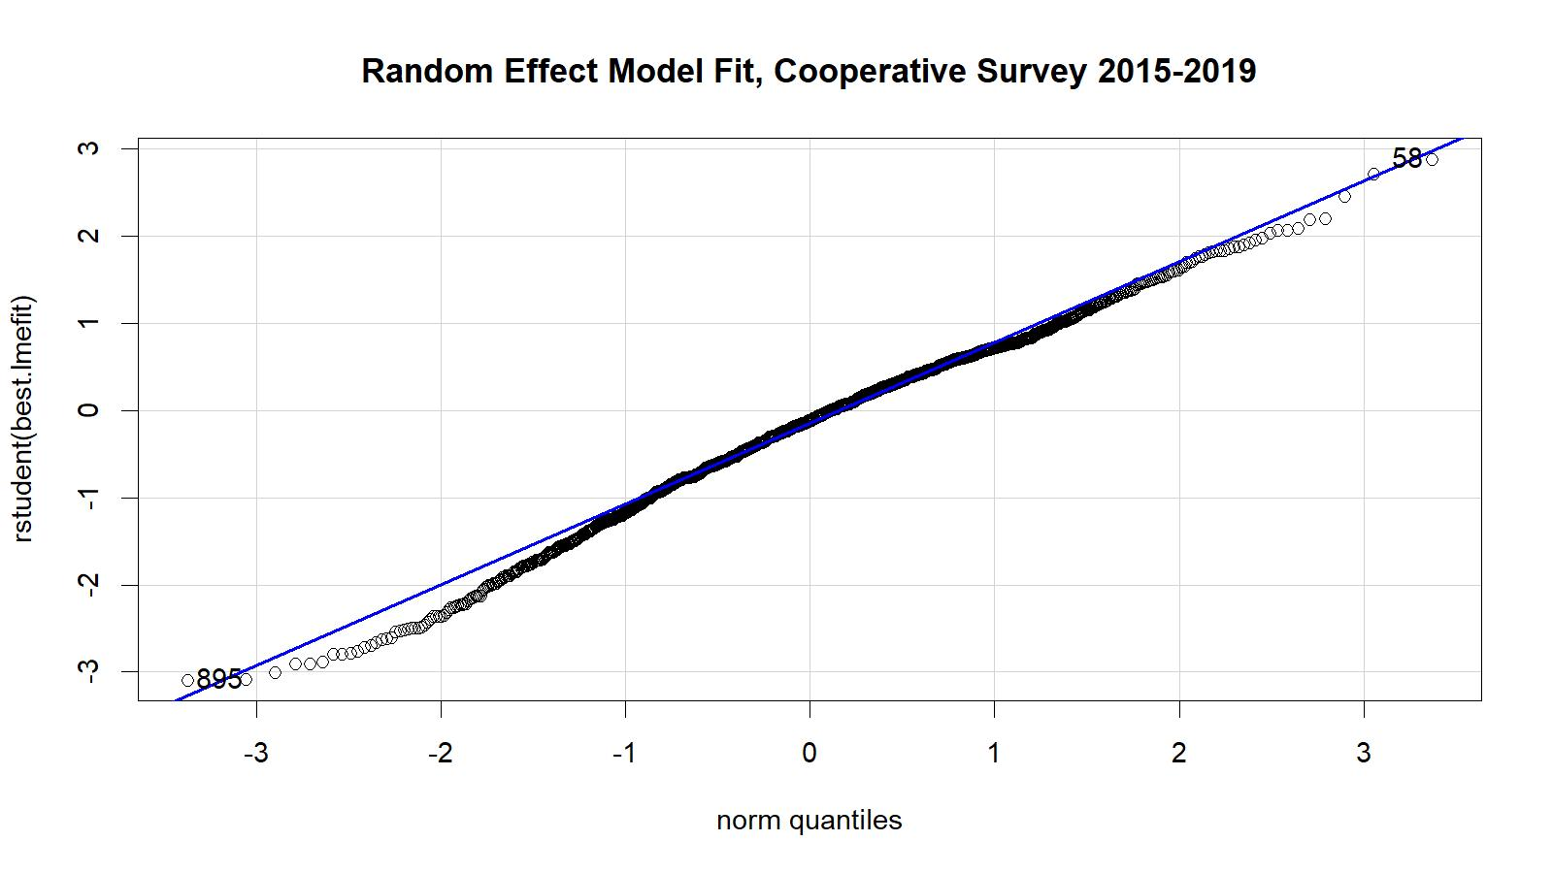

Figure C1. Studentized residual plot for the mixed random effects model fit. The 2015–2019 EAG data were used.

Comparison of standardized CPUE from cooperative survey data (2015-19) for EAG and the corresponding years’ observer CPUE indices indicated similar pattern except for 2019 (Figure C2).
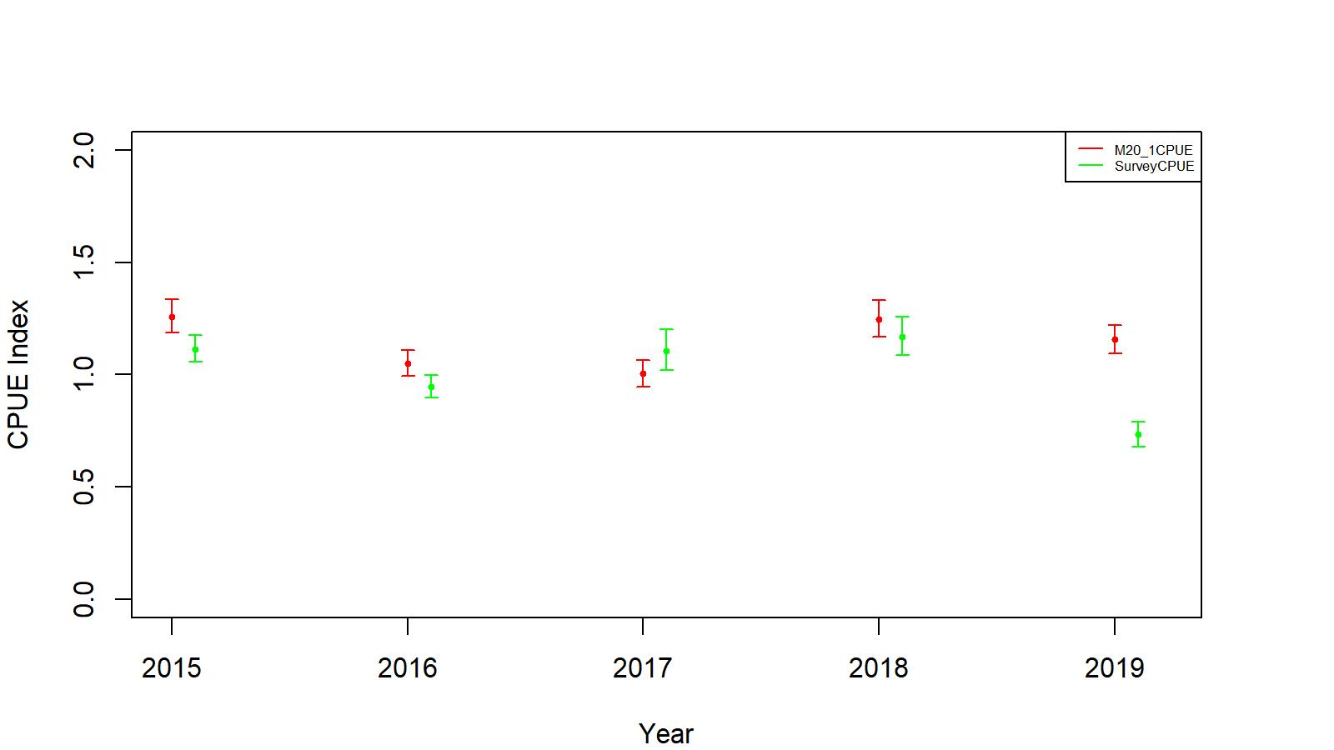
Figure C2. Comparison of cooperative survey CPUE indices (green) and model 20_1 CPUE indices (red). The confidence limits have ±2SE.

We standardized the yearly mean of predicted CPUEs for 2015–2019 by the geometric mean to obtain the CPUE indices for input to the assessment model (20_1c and 20_2b) (Table C.1).

Table C.1. The cooperative survey expected legal size male standardized (by geometric mean) CPUE indices by the mixed random effects model, standard errors (SE), and lower- and upper- 95% confidence limits for assessment model input for EAG, 2015–2019 data.

Year | Predicted CPUE index | SE | Lower Limit | Upper Limit
2015 | 1.1137 | 0.0265 | 1.0562 | 1.1743
2016 | 0.9459 | 0.0266 | 0.8968 | 0.9976
2017 | 1.1075 | 0.0417 | 1.0189 | 1.2038
2018 | 1.1690 | 0.0365 | 1.0868 | 1.2575
2019 | 0.7332 | 0.0382 | 0.6793 | 0.7914

Appendix D: Jittering

Jittering of models 20_1b and 20_2 parameter estimates:
We followed the Stock Synthesis approach to do 100 jitter runs of models 20_1b and 20_2 parameter estimates to use as initial parameter values (as .PIN file in ADMB) to assess model stability and to determine whether a global as opposed to local minima has been reached by the search algorithm:

The Jitter factor of 0.3 was multiplied by a random normal deviation rdev=N(0,1), to a transformed parameter value based upon the predefined parameter:
, (D.1)
with the final jittered initial parameter value back transformed as:
(D.2)
where P_{max} and P_{min} are upper and lower bounds of parameter search space and P_{val} is the estimated parameter value before the jittering.
The jitter results are summarized for scenarios 20_1b in Tables D.1 and D.2; and 20_2 in Tables D.3 and D.4 for EAG and WAG, respectively. Almost all runs converged to the highest log likelihood values. We concluded from jitter results that optimization of 20_1b and 20_2 models achieved global minima.

Table D.1. Results from 100 jitter runs for scenario 20_1b for EAG. Jitter run 0 corresponds to the original optimized estimates.

Jitter Run | Objective Function | Maximum Gradient | B_{35%} (t) | OFL (t) | Current MMB (t)
0 | 12.9831 | 0.003023 | 6,774 | 2,986 | 8,470
1 | 12.9831 | 0.003015 | 6,774 | 2,986 | 8,470
2 | 12.9831 | 0.003412 | 6,774 | 2,986 | 8,470
3 | 12.9831 | 0.003023 | 6,774 | 2,986 | 8,470
4 | 12.9831 | 0.003123 | 6,774 | 2,986 | 8,470
5 | 12.9831 | 0.003023 | 6,774 | 2,986 | 8,470
6 | 12.9831 | 0.003223 | 6,774 | 2,986 | 8,470
7 | 12.9831 | 0.003023 | 6,774 | 2,986 | 8,470
8 | 12.9831 | 0.003213 | 6,774 | 2,986 | 8,470
9 | 12.9831 | 0.003223 | 6,774 | 2,986 | 8,470
10 | 12.9831 | 0.003013 | 6,774 | 2,986 | 8,470
11 | 12.9831 | 0.003123 | 6,774 | 2,986 | 8,470
12 | 12.9831 | 0.003023 | 6,774 | 2,986 | 8,470
13 | 12.9831 | 0.003223 | 6,774 | 2,986 | 8,470
14 | 12.9831 | 0.003323 | 6,774 | 2,986 | 8,470
15 | 12.9831 | 0.003023 | 6,774 | 2,986 | 8,470
16 | 12.9831 | 0.003023 | 6,774 | 2,986 | 8,470
17 | 12.9831 | 0.003023 | 6,774 | 2,986 | 8,470
18 | 12.9831 | 0.003123 | 6,774 | 2,986 | 8,470
19 | 12.9831 | 0.003023 | 6,774 | 2,986 | 8,470
20 | 12.9831 | 0.003023 | 6,774 | 2,986 | 8,470
21 | 12.9831 | 0.003023 | 6,774 | 2,986 | 8,470
22 | 12.9831 | 0.003023 | 6,774 | 2,986 | 8,470
23 | 12.9831 | 0.003023 | 6,774 | 2,986 | 8,470
24 | 12.9831 | 0.003123 | 6,774 | 2,986 | 8,470
25 | 12.9831 | 0.003023 | 6,774 | 2,986 | 8,470
26 | 12.9831 | 0.003023 | 6,774 | 2,986 | 8,470
27 | 12.9831 | 0.003023 | 6,774 | 2,986 | 8,470
28 | 12.9831 | 0.003023 | 6,774 | 2,986 | 8,470
29 | 12.9831 | 0.003023 | 6,774 | 2,986 | 8,470
30 | 12.9831 | 0.003023 | 6,774 | 2,986 | 8,470
31 | 12.9831 | 0.003023 | 6,774 | 2,986 | 8,470
32 | 12.9831 | 0.003023 | 6,774 | 2,986 | 8,470
33 | 12.9831 | 0.002023 | 6,774 | 2,986 | 8,470
34 | 12.9831 | 0.003023 | 6,774 | 2,986 | 8,470
35 | 12.9831 | 0.003023 | 6,774 | 2,986 | 8,470
36 | 12.9831 | 0.003123 | 6,774 | 2,986 | 8,470
37 | 12.9831 | 0.004023 | 6,774 | 2,986 | 8,470
38 | 12.9831 | 0.003023 | 6,774 | 2,986 | 8,470
39 | 12.9831 | 0.003023 | 6,774 | 2,986 | 8,470
40 | 12.9831 | 0.003023 | 6,774 | 2,986 | 8,470
41 | 12.9831 | 0.003023 | 6,774 | 2,986 | 8,470
42 | 12.9831 | 0.003023 | 6,774 | 2,986 | 8,470
43 | 12.9831 | 0.003123 | 6,774 | 2,986 | 8,470
44 | 12.9831 | 0.003023 | 6,774 | 2,986 | 8,470
45 | 12.9831 | 0.003228 | 6,774 | 2,986 | 8,470
46 | 12.9831 | 0.003123 | 6,774 | 2,986 | 8,470
47 | 12.9831 | 0.003023 | 6,774 | 2,986 | 8,470
48 | 12.9831 | 0.003026 | 6,774 | 2,986 | 8,470
49 | 12.9831 | 0.003023 | 6,774 | 2,986 | 8,470
50 | 12.9831 | 0.003023 | 6,774 | 2,986 | 8,470
51 | 12.9831 | 0.003023 | 6,774 | 2,986 | 8,470
52 | 12.9831 | 0.003023 | 6,774 | 2,986 | 8,470
53 | 12.9831 | 0.003023 | 6,774 | 2,986 | 8,470
54 | 12.9831 | 0.003023 | 6,774 | 2,986 | 8,470
55 | 12.9831 | 0.003015 | 6,774 | 2,986 | 8,470
56 | 12.9831 | 0.003023 | 6,774 | 2,986 | 8,470
57 | 12.9831 | 0.003023 | 6,774 | 2,986 | 8,470
58 | 12.9831 | 0.003023 | 6,774 | 2,986 | 8,470
59 | 12.9831 | 0.003023 | 6,774 | 2,986 | 8,470
60 | 12.9831 | 0.003033 | 6,774 | 2,986 | 8,470
61 | 12.9831 | 0.003023 | 6,774 | 2,986 | 8,470
62 | 12.9831 | 0.003123 | 6,774 | 2,986 | 8,470
63 | 12.9831 | 0.003023 | 6,774 | 2,986 | 8,470
64 | 12.9831 | 0.003023 | 6,774 | 2,986 | 8,470
65 | 12.9831 | 0.003123 | 6,774 | 2,986 | 8,470
66 | 12.9831 | 0.003023 | 6,774 | 2,986 | 8,470
67 | 12.9831 | 0.003023 | 6,774 | 2,986 | 8,470
68 | 12.9831 | 0.003123 | 6,774 | 2,986 | 8,470
69 | 12.9831 | 0.003023 | 6,774 | 2,986 | 8,470
70 | 12.9831 | 0.003023 | 6,774 | 2,986 | 8,470
71 | 12.9831 | 0.003023 | 6,774 | 2,986 | 8,470
72 | 12.9831 | 0.003023 | 6,774 | 2,986 | 8,470
73 | 12.9831 | 0.003023 | 6,774 | 2,986 | 8,470
74 | 12.9831 | 0.003023 | 6,774 | 2,986 | 8,470
75 | 12.9831 | 0.003023 | 6,774 | 2,986 | 8,470
76 | 12.9831 | 0.003023 | 6,774 | 2,986 | 8,470
77 | 12.9831 | 0.003023 | 6,774 | 2,986 | 8,470
78 | 12.9831 | 0.003023 | 6,774 | 2,986 | 8,470
79 | 12.9831 | 0.001023 | 6,774 | 2,986 | 8,470
80 | 12.9831 | 0.003023 | 6,774 | 2,986 | 8,470
81 | 12.9831 | 0.003023 | 6,774 | 2,986 | 8,470
82 | 12.9831 | 0.004023 | 6,774 | 2,986 | 8,470
83 | 12.9831 | 0.003023 | 6,774 | 2,986 | 8,470
84 | 12.9831 | 0.003023 | 6,774 | 2,986 | 8,470
85 | 12.9831 | 0.003023 | 6,774 | 2,986 | 8,470
86 | 12.9831 | 0.003023 | 6,774 | 2,986 | 8,470
87 | 12.9831 | 0.003023 | 6,774 | 2,986 | 8,470
88 | 12.9831 | 0.003123 | 6,774 | 2,986 | 8,470
89 | 12.9831 | 0.003023 | 6,774 | 2,986 | 8,470
90 | 12.9831 | 0.003023 | 6,774 | 2,986 | 8,470
91 | 12.9831 | 0.003023 | 6,774 | 2,986 | 8,470
92 | 12.9831 | 0.003023 | 6,774 | 2,986 | 8,470
93 | 12.9831 | 0.003023 | 6,774 | 2,986 | 8,470
94 | 12.9831 | 0.003023 | 6,774 | 2,986 | 8,470
95 | 12.9831 | 0.003023 | 6,774 | 2,986 | 8,470
96 | 12.9831 | 0.003023 | 6,774 | 2,986 | 8,470
97 | 12.9831 | 0.003123 | 6,774 | 2,986 | 8,470
98 | 12.9831 | 0.003023 | 6,774 | 2,986 | 8,470
99 | 12.9831 | 0.003223 | 6,774 | 2,986 | 8,470
100 | 12.9831 | 0.003023 | 6,774 | 2,986 | 8,470

Table D.2 Results from 100 jitter runs for scenario 20_1b for WAG. Jitter run 0 corresponds to the original optimized estimates.

Jitter Run | Objective Function | Maximum Gradient | B_{35%} (t) | OFL (t) | Current MMB (t)
0 | -75.5594 | 0.000060 | 5,319 | 1,807 | 6,290
1 | -70.5593 | 0.000063 | 5,316 | 1,807 | 6,290
2 | -85.5694 | 0.000063 | 5,319 | 1,807 | 6,290
3 | -55.5592 | 0.000063 | 5,418 | 1,807 | 6,291
4 | -75.5597 | 0.000067 | 5,319 | 1,808 | 6,289
5 | -75.5593 | 0.000063 | 5,319 | 1,810 | 6,290
6 | -75.5592 | 0.000063 | 5,313 | 1,807 | 6,291
7 | -75.6594 | 0.000065 | 5,319 | 1,807 | 6,290
8 | -74.5594 | 0.000063 | 5,316 | 1,807 | 6,290
9 | -71.5594 | 0.000063 | 5,319 | 1,807 | 6,290
10 | -85.5594 | 0.000043 | 5,210 | 1,807 | 6,290
11 | -96.5594 | 0.000063 | 5,319 | 1,807 | 6,290
12 | -75.5594 | 0.000063 | 5,319 | 1,807 | 6,290
13 | -75.5594 | 0.000063 | 5,319 | 1,807 | 6,290
14 | -70.5594 | 0.000063 | 5,719 | 1,807 | 6,290
15 | -75.5594 | 0.000063 | 5,316 | 1,807 | 6,290
16 | -55.5594 | 0.000064 | 5,319 | 1,807 | 6,290
17 | -75.5694 | 0.000063 | 5,314 | 1,807 | 6,290
18 | -75.3591 | 0.000065 | 5,319 | 1,815 | 6,290
19 | -75.5594 | 0.000064 | 5,327 | 1,807 | 6,290
20 | -75.5594 | 0.000063 | 5,319 | 1,807 | 6,290
21 | -75.5594 | 0.000065 | 5,319 | 1,807 | 6,290
22 | -75.5594 | 0.000063 | 5,298 | 1,807 | 6,290
23 | -75.5534 | 0.000068 | 5,319 | 1,807 | 6,290
24 | -70.5574 | 0.000063 | 5,313 | 1,807 | 6,290
25 | -75.5594 | 0.000063 | 5,316 | 1,807 | 6,290
26 | -75.3594 | 0.000045 | 5,319 | 1,807 | 6,290
27 | -75.5554 | 0.000063 | 5,319 | 1,810 | 6,290
28 | -75.5534 | 0.000063 | 5,317 | 1,807 | 6,290
29 | -75.5694 | 0.000063 | 5,119 | 1,807 | 6,290
30 | -75.5594 | 0.000063 | 5,315 | 1,808 | 6,290
31 | -75.5594 | 0.000063 | 5,317 | 1,807 | 6,290
32 | -75.5594 | 0.000063 | 5,319 | 1,807 | 6,291
33 | -75.5594 | 0.000063 | 5,319 | 1,807 | 6,290
34 | -75.5594 | 0.000163 | 5,457 | 1,807 | 6,290
35 | -75.5534 | 0.000063 | 5,319 | 1,807 | 6,294
36 | -75.5594 | 0.000043 | 5,319 | 1,807 | 6,290
37 | -75.5593 | 0.000063 | 5,319 | 1,807 | 6,290
38 | -75.5594 | 0.000065 | 5,319 | 1,807 | 6,290
39 | -75.5496 | 0.000063 | 5,319 | 1,807 | 6,290
40 | -75.5394 | 0.000063 | 5,319 | 1,807 | 6,290
41 | -75.5594 | 0.000063 | 5,319 | 1,807 | 6,222
42 | -75.5564 | 0.000163 | 5,319 | 1,807 | 6,290
43 | -65.5597 | 0.000063 | 5,719 | 1,807 | 6,290
44 | -85.5594 | 0.000065 | 5,719 | 1,807 | 6,294
45 | -55.4594 | 0.000063 | 5,619 | 1,807 | 6,290
46 | -75.5594 | 0.000063 | 5,719 | 1,807 | 6,290
47 | -75.5594 | 0.000063 | 5,719 | 1,807 | 6,293
48 | -55.6599 | 0.000063 | 5,319 | 1,807 | 6,290
49 | -75.5594 | 0.000067 | 5,319 | 1,807 | 6,295
50 | -75.5593 | 0.000063 | 5,315 | 1,827 | 6,290
51 | -77.5594 | 0.000163 | 5,319 | 1,807 | 6,290
52 | -75.5594 | 0.000063 | 5,329 | 1,807 | 6,290
53 | -75.5594 | 0.000063 | 5,313 | 1,807 | 6,290
54 | -75.2599 | 0.000063 | 5,319 | 1,807 | 6,290
55 | -75.5594 | 0.000063 | 5,216 | 1,807 | 6,290
56 | -85.5594 | 0.000064 | 5,119 | 1,834 | 6,290
57 | -75.5594 | 0.000067 | 5,319 | 1,806 | 6,290
58 | -95.5594 | 0.000063 | 5,312 | 1,807 | 6,290
59 | -75.5594 | 0.000063 | 5,315 | 1,807 | 6,290
60 | -75.3594 | 0.000063 | 5,359 | 1,804 | 6,290
61 | -75.5594 | 0.000063 | 5,315 | 1,807 | 6,290
62 | -75.5594 | 0.000063 | 5,317 | 1,807 | 6,290
63 | -75.5594 | 0.000063 | 5,318 | 1,807 | 6,290
64 | -75.6594 | 0.000063 | 5,319 | 1,807 | 6,290
65 | -75.4594 | 0.000063 | 5,319 | 1,807 | 6,290
66 | -75.5594 | 0.000063 | 5,319 | 1,803 | 6,201
67 | -75.4594 | 0.000063 | 5,320 | 1,805 | 6,290
68 | -75.5594 | 0.000063 | 5,319 | 1,807 | 6,390
69 | -71.5597 | 0.000063 | 5,319 | 1,807 | 6,290
70 | -75.5594 | 0.000063 | 5,319 | 1,907 | 6,290
71 | -71.5594 | 0.000083 | 5,314 | 1,807 | 6,285
72 | -73.5594 | 0.000063 | 5,315 | 1,807 | 6,290
73 | -76.5591 | 0.000063 | 5,319 | 1,807 | 6,290
74 | -75.5524 | 0.000063 | 5,319 | 1,807 | 6,294
75 | -75.5534 | 0.000063 | 5,313 | 1,807 | 6,290
76 | -75.5592 | 0.000063 | 5,319 | 1,807 | 6,290
77 | -75.5594 | 0.000073 | 5,319 | 1,807 | 6,299
78 | -75.5594 | 0.000063 | 5,323 | 1,812 | 6,290
79 | -75.5594 | 0.000063 | 5,319 | 1,807 | 6,290
80 | -75.6594 | 0.000063 | 5,319 | 1,807 | 6,298
81 | -75.5594 | 0.000066 | 5,314 | 1,807 | 6,290
82 | -75.6594 | 0.000063 | 5,719 | 1,807 | 6,290
83 | -75.5794 | 0.000063 | 5,319 | 1,807 | 6,298
84 | -75.5594 | 0.000063 | 5,317 | 1,814 | 6,290
85 | -75.5594 | 0.000083 | 5,329 | 1,807 | 6,297
86 | -75.5294 | 0.000063 | 5,319 | 1,807 | 6,290
87 | -75.5194 | 0.000063 | 5,318 | 1,815 | 6,296
88 | -75.5194 | 0.000063 | 5,315 | 1,806 | 6,290
89 | -75.5294 | 0.000063 | 5,319 | 1,807 | 6,290
90 | -75.5592 | 0.000063 | 5,339 | 1,678 | 6,294
91 | -75.5597 | 0.000063 | 5,319 | 1,807 | 6,290
92 | -75.1594 | 0.000163 | 5,329 | 1,805 | 6,294
93 | -75.6594 | 0.000063 | 5,339 | 1,807 | 6,290
94 | -75.5594 | 0.000063 | 5,316 | 1,805 | 6,290
95 | -75.5594 | 0.000073 | 5,319 | 1,847 | 6,290
96 | -75.5594 | 0.000063 | 5,319 | 1,807 | 6,295
97 | -75.5594 | 0.000065 | 5,318 | 1,817 | 6,290
98 | -75.1594 | 0.000063 | 5,319 | 1,807 | 6,290
99 | -75.5594 | 0.000061 | 5,319 | 1,807 | 6,291
100 | -75.1594 | 0.000063 | 5,319 | 1,807 | 6,290

Table D.3. Results from 100 jitter runs for scenario 20_2 for EAG. Jitter run 0 corresponds to the original optimized estimates.

Jitter Run | Objective Function | Maximum Gradient | B_{35%} (t) | OFL (t) | Current MMB (t)
0 | 7.7967 | 0.001281 | 6,794 | 3,133 | 8,665
1 | 7.7967 | 0.001281 | 6,794 | 3,133 | 8,665
2 | 7.7967 | 0.001281 | 6,794 | 3,133 | 8,665
3 | 7.7967 | 0.001281 | 6,794 | 3,133 | 8,665
4 | 7.7967 | 0.001281 | 6,794 | 3,133 | 8,665
5 | 7.7967 | 0.001281 | 6,794 | 3,133 | 8,665
6 | 7.7967 | 0.001281 | 6,794 | 3,133 | 8,665
7 | 7.7967 | 0.001281 | 6,794 | 3,133 | 8,665
8 | 7.7967 | 0.001281 | 6,794 | 3,133 | 8,665
9 | 7.7967 | 0.001281 | 6,794 | 3,133 | 8,665
10 | 7.7967 | 0.001281 | 6,794 | 3,133 | 8,665
11 | 7.7967 | 0.001281 | 6,794 | 3,133 | 8,665
12 | 7.7967 | 0.001281 | 6,794 | 3,133 | 8,665
13 | 7.7967 | 0.001281 | 6,794 | 3,133 | 8,665
14 | 7.7967 | 0.001281 | 6,794 | 3,133 | 8,665
15 | 7.7967 | 0.001281 | 6,794 | 3,133 | 8,665
16 | 7.7967 | 0.001281 | 6,794 | 3,133 | 8,665
17 | 7.7967 | 0.001281 | 6,794 | 3,133 | 8,665
18 | 7.7967 | 0.001281 | 6,794 | 3,133 | 8,665
19 | 7.7967 | 0.001281 | 6,794 | 3,133 | 8,665
20 | 7.7967 | 0.001281 | 6,794 | 3,133 | 8,665
21 | 7.7967 | 0.001281 | 6,794 | 3,133 | 8,665
22 | 7.7967 | 0.001281 | 6,794 | 3,133 | 8,665
23 | 7.7967 | 0.001281 | 6,794 | 3,133 | 8,665
24 | 7.7967 | 0.001281 | 6,794 | 3,133 | 8,665
25 | 7.7967 | 0.001281 | 6,794 | 3,133 | 8,665
26 | 7.7967 | 0.001281 | 6,794 | 3,133 | 8,665
27 | 7.7967 | 0.001281 | 6,794 | 3,133 | 8,665
28 | 7.7967 | 0.001281 | 6,794 | 3,133 | 8,665
29 | 7.7967 | 0.001281 | 6,794 | 3,133 | 8,665
30 | 7.7967 | 0.001281 | 6,794 | 3,133 | 8,665
31 | 7.7967 | 0.001281 | 6,794 | 3,133 | 8,665
32 | 7.7967 | 0.001281 | 6,794 | 3,133 | 8,665
33 | 7.7967 | 0.001281 | 6,794 | 3,133 | 8,665
34 | 7.7967 | 0.001281 | 6,794 | 3,133 | 8,665
35 | 7.7967 | 0.001281 | 6,794 | 3,133 | 8,665
36 | 7.7967 | 0.001281 | 6,794 | 3,133 | 8,665
37 | 7.7967 | 0.001281 | 6,794 | 3,133 | 8,665
38 | 7.7967 | 0.001281 | 6,794 | 3,133 | 8,665
39 | 7.7967 | 0.001281 | 6,794 | 3,133 | 8,665
40 | 7.7967 | 0.001281 | 6,794 | 3,133 | 8,665
41 | 7.7967 | 0.001281 | 6,794 | 3,133 | 8,665
42 | 7.7967 | 0.001281 | 6,794 | 3,133 | 8,665
43 | 7.7967 | 0.001281 | 6,794 | 3,133 | 8,665
44 | 7.7967 | 0.001281 | 6,794 | 3,133 | 8,665
45 | 7.7967 | 0.001281 | 6,794 | 3,133 | 8,665
46 | 7.7967 | 0.001281 | 6,794 | 3,133 | 8,665
47 | 7.7967 | 0.001281 | 6,794 | 3,133 | 8,665
48 | 7.7967 | 0.001281 | 6,794 | 3,133 | 8,665
49 | 7.7967 | 0.001281 | 6,794 | 3,133 | 8,665
50 | 7.7967 | 0.001281 | 6,794 | 3,133 | 8,665
51 | 7.7967 | 0.001281 | 6,794 | 3,133 | 8,665
52 | 7.7967 | 0.001281 | 6,794 | 3,133 | 8,665
53 | 7.7967 | 0.001281 | 6,794 | 3,133 | 8,665
54 | 7.7967 | 0.001281 | 6,794 | 3,133 | 8,665
55 | 7.7967 | 0.001281 | 6,794 | 3,133 | 8,665
56 | 7.7967 | 0.001281 | 6,794 | 3,133 | 8,665
57 | 7.7967 | 0.001281 | 6,794 | 3,133 | 8,665
58 | 7.7967 | 0.001281 | 6,794 | 3,133 | 8,665
59 | 7.7967 | 0.001281 | 6,794 | 3,133 | 8,665
60 | 7.7967 | 0.001281 | 6,794 | 3,133 | 8,665
61 | 7.7967 | 0.001281 | 6,794 | 3,133 | 8,665
62 | 7.7967 | 0.001281 | 6,794 | 3,133 | 8,665
63 | 7.7967 | 0.001281 | 6,794 | 3,133 | 8,665
64 | 7.7967 | 0.001281 | 6,794 | 3,133 | 8,665
65 | 7.7967 | 0.001281 | 6,794 | 3,133 | 8,665
66 | 7.7967 | 0.001281 | 6,794 | 3,133 | 8,665
67 | 7.7967 | 0.001281 | 6,794 | 3,133 | 8,665
68 | 7.7967 | 0.001281 | 6,794 | 3,133 | 8,665
69 | 7.7967 | 0.001281 | 6,794 | 3,133 | 8,665
70 | 7.7967 | 0.001281 | 6,794 | 3,133 | 8,665
71 | 7.7967 | 0.001281 | 6,794 | 3,133 | 8,665
72 | 7.7967 | 0.001281 | 6,794 | 3,133 | 8,665
73 | 7.7967 | 0.001281 | 6,794 | 3,133 | 8,665
74 | 7.7967 | 0.001281 | 6,794 | 3,133 | 8,665
75 | 7.7967 | 0.001281 | 6,794 | 3,133 | 8,665
76 | 7.7967 | 0.001281 | 6,794 | 3,133 | 8,665
77 | 7.7967 | 0.001281 | 6,794 | 3,133 | 8,665
78 | 7.7967 | 0.001281 | 6,794 | 3,133 | 8,665
79 | 7.7967 | 0.001281 | 6,794 | 3,133 | 8,665
80 | 7.7967 | 0.001281 | 6,794 | 3,133 | 8,665
81 | 7.7967 | 0.001281 | 6,794 | 3,133 | 8,665
82 | 7.7967 | 0.001281 | 6,794 | 3,133 | 8,665
83 | 7.7967 | 0.001281 | 6,794 | 3,133 | 8,665
84 | 7.7967 | 0.001281 | 6,794 | 3,133 | 8,665
85 | 7.7967 | 0.001281 | 6,794 | 3,133 | 8,665
86 | 7.7967 | 0.001281 | 6,794 | 3,133 | 8,665
87 | 7.7967 | 0.001281 | 6,794 | 3,133 | 8,665
88 | 7.7967 | 0.001281 | 6,794 | 3,133 | 8,665
89 | 7.7967 | 0.001281 | 6,794 | 3,133 | 8,665
90 | 7.7967 | 0.001281 | 6,794 | 3,133 | 8,665
91 | 7.7967 | 0.001281 | 6,794 | 3,133 | 8,665
92 | 7.7967 | 0.001281 | 6,794 | 3,133 | 8,665
93 | 7.7967 | 0.001281 | 6,794 | 3,133 | 8,665
94 | 7.7967 | 0.001281 | 6,794 | 3,133 | 8,665
95 | 7.7967 | 0.001281 | 6,794 | 3,133 | 8,665
96 | 7.7967 | 0.001281 | 6,794 | 3,133 | 8,665
97 | 7.7967 | 0.001281 | 6,794 | 3,133 | 8,665
98 | 7.7967 | 0.001281 | 6,794 | 3,133 | 8,665
99 | 7.7967 | 0.001281 | 6,794 | 3,133 | 8,665
100 | 7.7967 | 0.001281 | 6,794 | 3,133 | 8,665

Table D.4 Results from 100 jitter runs for scenario 20_2 for WAG. Jitter run 0 corresponds to the original optimized estimates.

Jitter Run | Objective Function | Maximum Gradient | B_{35%} (t) | OFL (t) | Current MMB (t)
0 | -75.7768 | 0.000171 | 5,343 | 1,860 | 6,441
1 | -75.7768 | 0.000171 | 5,343 | 1,860 | 6,441
2 | -75.7768 | 0.000161 | 5,343 | 1,860 | 6,451
3 | -75.7768 | 0.000171 | 5,328 | 1,860 | 6,441
4 | -75.7763 | 0.000171 | 5,343 | 1,860 | 6,441
5 | -75.7768 | 0.000271 | 5,343 | 1,860 | 6,441
6 | -75.7768 | 0.000171 | 5,343 | 1,865 | 6,441
7 | -75.7762 | 0.000173 | 5,443 | 1,860 | 6,441
8 | -75.7768 | 0.000171 | 5,343 | 1,860 | 6,441
9 | -75.7768 | 0.000175 | 5,353 | 1,860 | 6,442
10 | -75.7764 | 0.000171 | 5,343 | 1,843 | 6,451
11 | -75.7768 | 0.000171 | 5,343 | 1,860 | 6,441
12 | -75.7765 | 0.000171 | 5,344 | 1,860 | 6,443
13 | -75.7768 | 0.000271 | 5,383 | 1,854 | 6,441
14 | -75.7768 | 0.000171 | 5,345 | 1,860 | 6,445
15 | -75.7768 | 0.000171 | 5,346 | 1,860 | 6,434
16 | -75.7768 | 0.000131 | 5,343 | 1,844 | 6,441
17 | -75.7738 | 0.000171 | 5,343 | 1,860 | 6,441
18 | -75.7768 | 0.000173 | 5,343 | 1,860 | 6,441
19 | -75.7768 | 0.000171 | 5,343 | 1,836 | 6,441
20 | -75.7768 | 0.000174 | 5,343 | 1,862 | 6,441
21 | -75.7768 | 0.000171 | 5,343 | 1,864 | 6,441
22 | -75.7768 | 0.000171 | 5,343 | 1,867 | 6,441
23 | -75.7768 | 0.000172 | 5,445 | 1,858 | 6,443
24 | -75.7768 | 0.000174 | 5,343 | 1,860 | 6,441
25 | -75.7764 | 0.000174 | 5,343 | 1,860 | 6,422
26 | -75.7768 | 0.000171 | 5,343 | 1,860 | 6,441
27 | -75.7768 | 0.000171 | 5,343 | 1,860 | 6,441
28 | -75.7768 | 0.000175 | 5,341 | 1,860 | 6,423
29 | -75.7765 | 0.000176 | 5,327 | 1,860 | 6,441
30 | -75.7768 | 0.000271 | 5,343 | 1,864 | 6,441
31 | -75.7768 | 0.000173 | 5,343 | 1,860 | 6,441
32 | -75.7768 | 0.000171 | 5,332 | 1,856 | 6,439
33 | -75.7468 | 0.000161 | 5,343 | 1,845 | 6,441
34 | -75.7768 | 0.000171 | 5,289 | 1,860 | 6,441
35 | -75.7768 | 0.000173 | 5,343 | 1,860 | 6,441
36 | -75.7768 | 0.000171 | 5,400 | 1,860 | 6,441
37 | -75.7768 | 0.000171 | 5,343 | 1,854 | 6,387
38 | -75.7768 | 0.000171 | 5,345 | 1,860 | 6,441
39 | -75.7768 | 0.000171 | 5,343 | 1,860 | 6,441
40 | -75.7768 | 0.000174 | 5,348 | 1,860 | 6,445
41 | -75.7768 | 0.000141 | 5,343 | 1,860 | 6,441
42 | -75.7768 | 0.000171 | 5,343 | 1,855 | 6,443
43 | -75.7766 | 0.000171 | 5,376 | 1,860 | 6,441
44 | -75.7768 | 0.000171 | 5,343 | 1,860 | 6,442
45 | -75.7768 | 0.000171 | 5,343 | 1,843 | 6,441
46 | -75.7768 | 0.000171 | 5,343 | 1,860 | 6,441
47 | -75.7768 | 0.000151 | 5,343 | 1,860 | 6,455
48 | -75.7768 | 0.000171 | 5,343 | 1,845 | 6,441
49 | -75.7768 | 0.000174 | 5,343 | 1,860 | 6,441
50 | -75.7768 | 0.000171 | 5,354 | 1,860 | 6,441
51 | -75.7768 | 0.000171 | 5,343 | 1,860 | 6,441
52 | -75.7768 | 0.000171 | 5,343 | 1,844 | 6,441
53 | -75.7768 | 0.000171 | 5,343 | 1,860 | 6,456
54 | -75.7768 | 0.000171 | 5,343 | 1,860 | 6,441
55 | -75.7768 | 0.000131 | 5,343 | 1,860 | 6,441
56 | -75.7768 | 0.000172 | 5,343 | 1,860 | 6,447
57 | -75.7768 | 0.000124 | 5,365 | 1,760 | 6,441
58 | -75.7768 | 0.000153 | 5,343 | 1,880 | 6,441
59 | -75.7764 | 0.000155 | 5,343 | 1,861 | 6,444
60 | -75.7768 | 0.000171 | 5,343 | 1,860 | 6,441
61 | -75.7768 | 0.000135 | 5,343 | 1,860 | 6,453
62 | -75.7768 | 0.000171 | 5,343 | 1,864 | 6,441
63 | -75.7768 | 0.000172 | 5,343 | 1,873 | 6,441
64 | -75.7768 | 0.000161 | 5,123 | 1,860 | 6,441
65 | -75.7768 | 0.000154 | 5,343 | 1,860 | 6,441
66 | -75.7567 | 0.000171 | 5,343 | 1,834 | 6,441
67 | -75.7768 | 0.000181 | 5,343 | 1,860 | 6,441
68 | -75.7768 | 0.000151 | 5,343 | 1,860 | 6,467
69 | -75.7769 | 0.000172 | 5,343 | 1,860 | 6,441
70 | -75.7768 | 0.000171 | 5,343 | 1,855 | 6,441
71 | -75.7768 | 0.000172 | 5,343 | 1,860 | 6,441
72 | -75.7568 | 0.000161 | 5,344 | 1,860 | 6,441
73 | -75.7763 | 0.000171 | 5,343 | 1,860 | 6,435
74 | -75.7768 | 0.000173 | 5,343 | 1,858 | 6,441
75 | -75.7768 | 0.000152 | 5,343 | 1,860 | 6,443
76 | -75.7768 | 0.000141 | 5,343 | 1,860 | 6,445
77 | -75.7768 | 0.000174 | 5,343 | 1,855 | 6,444
78 | -75.7768 | 0.000151 | 5,343 | 1,860 | 6,442
79 | -75.7768 | 0.000171 | 5,345 | 1,860 | 6,421
80 | -75.7768 | 0.000174 | 5,343 | 1,860 | 6,444
81 | -75.7768 | 0.000148 | 5,343 | 1,860 | 6,441
82 | -75.7768 | 0.000171 | 5,343 | 1,860 | 6,441
83 | -75.7768 | 0.000134 | 5,343 | 1,854 | 6,444
84 | -75.7768 | 0.000173 | 5,343 | 1,860 | 6,445
85 | -75.7768 | 0.000172 | 5,315 | 1,866 | 6,441
86 | -75.7768 | 0.000171 | 5,343 | 1,860 | 6,411
87 | -75.7768 | 0.000175 | 5,343 | 1,856 | 6,441
88 | -75.7868 | 0.000171 | 5,343 | 1,860 | 6,461
89 | -75.7768 | 0.000171 | 5,343 | 1,860 | 6,441
90 | -75.7765 | 0.000171 | 5,343 | 1,860 | 6,441
91 | -75.7766 | 0.000171 | 5,311 | 1,860 | 6,441
92 | -75.7765 | 0.000171 | 5,343 | 1,860 | 6,431
93 | -75.7778 | 0.000171 | 5,343 | 1,855 | 6,441
94 | -75.7778 | 0.000123 | 5,343 | 1,867 | 6,441
95 | -75.7764 | 0.000171 | 5,343 | 1,860 | 6,441
96 | -75.7768 | 0.000171 | 5,324 | 1,860 | 6,441
97 | -75.7768 | 0.000171 | 5,343 | 1,860 | 6,441
98 | -75.7768 | 0.000148 | 5,343 | 1,860 | 6,431
99 | -75.7768 | 0.000158 | 5,343 | 1,865 | 6,421
100 | -75.7768 | 0.000169 | 5,329 | 1,878 | 6,440

