Alaska Seafood Cooperative’s concerns over data available to consider an “Over 26 inch” halibut bycatch performance standard
Summary: In 2016 and 2017, observers collected comprehensive length data for halibut sorted on deck in the deck sorting EFPs. An unintended consequence of EFP sampling protocols, however, was that observers did not measure individual halibut in the factory (those not removed on deck). Weight of halibut in the factory per haul was estimated through species composition sampling. Deck sorted halibut likely have a different length distribution from halibut recovered in the factory and lengths from deck sorted fish would not be a good representation of the actual length distribution of halibut bycatch.
To assess the availability of length composition data where sampling had access to all halibut in the catch in the non-pollock CP fisheries, AKSC evaluated data from CP vessels outside the EFP and data for EFP vessels in 2016 during months when the EFP was not operating. For the reasons detailed below, we feel these are not good proxies for the overall length distribution of halibut taken in Bering Sea flatfish and the other mainstay target non-pollock target fisheries of the Bering Sea. A valid historical dataset for consideration of an O26 performance standard is therefore lacking. Changes to data observer data collection methods in 2018 should provide one year of data in this regard.
AKSC will not comment on the merits of an O26 performance standard until we have more detail on how it would work. We do want to flag concern if the Council does want to pursue development of an O26 performance standard that the specifics of observer data collections to support such a performance standard be developed in step with consideration of the standard. Also, effects of prioritizing those observer length data collections on other Council management and stock assessment priorities should be taken into account.
Motivation for these comments: Public comment by Alaska Longline Fishermen’s Association in April 2018 requested an alternative for halibut ABM that includes an “Over 26 inch” halibut bycatch performance standard for the non-pollock trawl fisheries. Since little detail was provided on how this new performance standard would work, based on public testimony we interpret ALFA’s construct to be a performance standard triggering a penalty in the following year for any sector/company/vessel that exceeds an O26 standard. Criteria for determining if the standard is exceeded would presumably be based on a proportion or quantity of halibut over 26 inches in length (66 cm) in terms of halibut catch or bycatch mortality.
An “O26” performance standard also came up in the NPFMC deliberations on halibut ABM in April 2018 and the Council’s April 2018 ABM motion directed staff to report on available historical data for evaluation of an O26 performance standard, to look at possible bias in those data, and explore how an O26 performance standard would work.

O26 constructs and data considerations:
To evaluate the adequacy of data to construct an O26 performance standard, it is necessary to make some assumptions about how an O26 standard would work. Based on what was provided in the ALFA letter, the O26 standard would in some manner judge fishery or vessel performance against a standard measured by either: 1) numbers of O26 fish in the catch, 2) weight of O26 catch, 3) weight of O26 mortality, or 4) proportion that is O26 of overall number, weight, weight of mortality. The standard would presumably be set at some target amount or percentage of O26 bycatch (in IPHC Statistical areas 4cde according to the ALFA proposal) per sector/company/vessel. Length data collected by observers would then presumably be used to determine how bycatch data “measured up” to that standard.
To set the standard at the outset, presumably historical length data for halibut caught by each sector would be examined to attempt to evaluate the practicability of the standard. Looking forward, data precision would logically need to be sufficient to determine whether the standard had been met at the level that the standard is to be applied (e.g. vessel, company), particularly where a decision to exact a penalty would be expected to be subject to review/challenge. Even if the standard is applied at a sector level, for sectors with further division of allocations (such as vessel/company level allocations in the Amendment 80 sector), the adequacy of data for imposing any penalty at this disaggregated level should be considered.
Limitations of halibut length data in A80 and other Bering Sea CP fisheries
Prior to the deck sorting exempted fishing permits, observers collected data in the factory below deck to manage the Amendment 80 and trawl limited access (TLA) CP fisheries. Data collections were designed to occur there as fish are moved from stern tanks into the processing area via conveyor belts leading to the flow scale and an observer sampling station and a work table. This sampling location provides access to all of the catch (as nothing could be removed on deck prior to implementing the EFP). The species composition data collected by observers in this location was used, among other management purposes, to estimate halibut catch and mortality. Length data was also collected there by observers, mostly from halibut selected for viability assessments.
Starting with two small pilot projects in 2009 and 2012, AKSC began an effort to determine whether halibut could be removed from the catch on deck to reduce mortality. These initial small studies led to a stepped-up deck sorting effort via exempted fishing permits starting in 2015. With each successive EFP, an increasing share of the flatfish and other non-pollock groundfish catches has occurred on vessels participating in the deck sorting EFPs. Participants in the EFPs now include all vessels in Amendment 80 and CPs and motherships in the TLA and CDQ non-pollock fisheries.
With deck sorting, some of the halibut in a haul are removed from the catch by the crew on deck. These are released after length and viability data are collected by observers. Once released, sorted halibut are obviously not available to observer sampling in the factory.
In designing the data collection procedures of the deck sorting EFPs, emphasis in 2016 and 2017 was placed on observer collections of length and viability data from the halibut sorted on deck. Deck sorting EFPs have in fact utilized a very high sampling rate for halibut length and viability assessments for halibut sorted on deck. Specifically one-in-five (20%) halibut sorted on deck are measured and sampled for viability.
The length data collected on deck, converted to weight using the standard IPHC conversion tables, are then used to extrapolate an estimated weight of halibut sorted on deck per haul. The weight of mortality from halibut that are not sorted out (“factory halibut”) is determined by observer sampling in the factory. The sum of the two is the haul-specific mortality for tows that are deck sorted.
While observer species composition sampling in the factory during 2016-2017 EFPs was used to estimate the total weight of halibut in the factory per haul, an unintended consequence of deck sorting catch accounting protocols in those years was that observers did not collect halibut lengths in the factory on vessels engaged in the EFP. This occurred because the EFPs in 2016 and 2017 used a default mortality rate of 90% applied to the estimated amount of halibut that was not sorted on deck (recovered in the factory). Viability sampling in the factory was not done in the EFPs. Because virtually all of the factory halibut length collections in the past came from viability sampling, the lack of length sampling was an unintended consequence of using a default mortality rate for factory halibut.
Crews did place factory halibut into a tote (referred to in EFP final reports as “industry census”) on all EFP hauls in 2016 and 2017. Observers counted and weighed these halibut (weighed collectively not individually) for each haul. This was done for the EFPs examination of how the observer’s estimate of weight of factory halibut compares to the census weight collected by the crew (reported in AKSC’s final reports for the 2016 and 2017 EFPs). Given the heterogeneity in halibut sizes seen in factory halibut during the one EFP where factory lengths were collected (2015, see Appendix 1 below) AKSC is uncomfortable using an average weight approach (total weight divided by number) from those collections to describe individual fish size for factory halibut. Such an approach would also not provide a length distribution.
Modifications to observer data collection procedures with deck sorting have therefore led to a significant reduction in the total number of halibut measured in the factory relative to what occurred pre-EFP. Essentially, the only length data collections that had sampled all the halibut in the catch (normal observer data collections in the factory) occurred on trips outside of the EFP.
Tables 1 and 2 below provide the annual number of halibut lengths collected on deck and in the factory for Amendment 80 overall and for the TLA CPs that participated in the deck sorting EFP. The number of observer halibut length samples in the factory in these tables was obtained from Sea State via their access to NMFS observer data. Overall, one can see from the tables that the number of halibut lengths done by observers in the factory has decreased steadily over time, even prior to the deck sorting EFPs. The deck sorting EFP further decreased length sampling in the factory for halibut.
In considering the significance of the reduced number of factory lengths and the degree those factory halibut represent the overall halibut catches in the A80 and other CP sectors, it is important to recognize that halibut sorted on deck very likely have a different length distribution from those not sorted on deck. The incentive to remove large fish on deck to realize the greatest halibut savings leads to this different length distribution. Trying to sort every halibut on deck, including all the small ones, can lead to bottlenecks in the factory production because fish cannot be run over the flow scale during deck sorting.
Appendix 1 below compares lengths from deck sorted and factory halibut based on a limited set of data from the 2015 deck sorting EFP. This information is useful for evaluating how the use of deck lengths alone could skew the assessment of the overall length distribution of halibut in the catch.
Attempting to piece together the relevance of available length data for 2016 and 2017 from outside of the EFP (data reflecting access to all of the halibut in the catch) is complex because the set of vessels participating in deck sorting has changed over the course of the different EFPs.
For 2017, there are simply very few observer lengths from sampling in the factory in flatfish and other Bering Sea target fisheries, 2,703 in on Amendment 80 vessels and 81 on TLA CPs respectively. This occurred because the EFP was in place all year and nearly all CPs that fish for flatfish and other Bering Sea non-pollock species were in the EFP for most of the year.
The lower level of participation in the deck sorting EFP in 2016, at first appeared to hold some promise to serve as a source of “unfiltered” halibut length distribution data for that year. But after considering the target fisheries of vessels outside the EFP, AKSC believes lengths from those fisheries would not be a reasonable proxy for vessels participating in the EFP. This is because vessels in the EFP targeted mostly flatfish and those not in the EFP in 2016 generally fished for Atka mackerel or Pacific Ocean Perch in the Aleutian Islands. Aleutian Islands fisheries generally encounter fewer halibut, which are on average larger than halibut encountered in Bering Sea flatfish targets.
Another possible source of length data in 2016 was for vessels that fished for flatfish early in the year, prior to the start of the EFP. In 2016 the deck sorting EFP was issued in May so length data collected by observers in the factory before the EFP had access to all halibut in the catch. Table 1 shows that of the 2.703 factory lengths in 2016, 1,861 of them were taken on EFP boats in 2016. After considering the specifics, however, AKSC believes that the use of pre-May 2016 length data to represent halibut lengths throughout the year is questionable. This is because flatfish target fisheries vary seasonally. Starting at the end of May, flatfish boats typically focus more on deeper water flatfish species and halibut taken as bycatch in deeper water tend to be larger.
Similarly, the TLA CPs that concentrate on non-pollock fishing stayed in the EFP for virtually all their fishing activities in 2016 and 2017. The remaining trawl limited access CPs that fished outside the EFP are actually pollock CPs that typically target yellowfin sole for a few trips in the spring following the pollock A season. The small number of factory halibut lengths in 2017 on TLA CPs in the EFP is shown in Table 2 below.
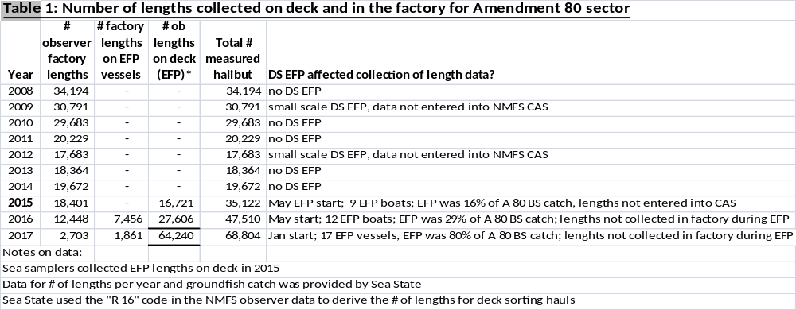
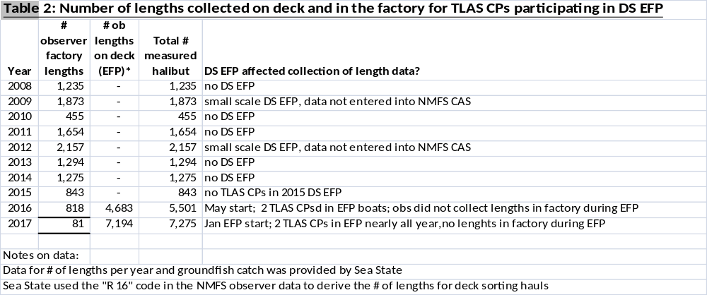
Discussion on the utility of existing data to characterize length distribution of halibut bycatch in A80 and TLA fisheries
Prior to 2016, observers collected length data in the factory and that sampling had access to all the halibut in the catch. For the data prior to 2016, fish selected for length measurement by observers may not always have been selected randomly. In addition, the large changes in the fisheries associated with use of different tools to avoid halibut bycatch make the data pre-2016 unlikely, in our opinion, to be representative of length characteristics of halibut bycatch in more recent years.
In 2016 and 2017, the deck sorting EFP clearly affected the collection of length data in the factory for vessels engaged primarily in flatfish target fisheries, the fisheries where most of the CP halibut bycatch occurs. The absence of factory samples from these fisheries prevents us from characterizing overall halibut length distribution. Some vessels did not participate in the EFP and therefore factory observer length sampling had access to all halibut in the catch; however, for the most part those vessels participated in fisheries with low halibut bycatch and where length distributions differ from the flatfish fisheries.
Starting in January of 2018, NMFS’ FMA modified observer sampling to resume the collection of halibut length and viability in the factory in conjunction with length and viability data collected on deck for vessels in the EFP. Therefore, 2018 should have data collection procedures that allow for a full characterization of length distribution of halibut in the non-pollock CP fisheries and those data should represent all the non-pollock CP fisheries. That said, given the different data collection protocols and sampling rates on deck and in the factory, care will need to be taken in adjusting the deck and factory length distributions for the different data collection protocols in any use of the data to characterize overall length distributions.
AKSC perspective on data requirements for an O26 performance standard looking forward:
Amendment 80 and other non-pollock fisheries are managed under company-specific and individual vessel bycatch limits (e.g. via cooperatives in A80). AKSC does not have a stance on the merits of an O26 performance standard at this time given the lack of details for how such a standard would work. AKSC does want to make clear that if the Council does move forward with consideration of an O26 standard, the data collection practices by observers need to be sufficient to allow the affected fisheries to track their bycatch against the standard. The changes in observer sampling to do this should be considered up front. This includes the detailed methods to collect the data needed for the O26 standard compliance on vessels and the opportunity costs of shifting observer workload away from current duties to collection of halibut data.
Appendix 1: 2015 length data from EFP sea samplers in the context of assessing the utility of available observer length data
To examine the potential for the lack of factory length sampling to affect characterization of overall halibut length distribution in the catch, we examined deck and factory lengths from the 2015 deck sorting EFP. Lengths were collected both on deck and in the factory in the 2015 EFP because, due to the short timeline for formulation of that EFP, observers in 2015 could not be trained ahead of time for EFP data collections. Hence the permit holder (AKSC) was responsible for halibut data collections. To do this, two sea samplers on each EFP were required to collect data on halibut on deck and in the factory. Sea samplers had the same credentials as observers and were hired through the observer providers but worked only for the EFP. EFP vessels in 2015 were also required to have their two regular fishery observers on board during the EFP. Their regular observers collected all (non-halibut) groundfish data needed for management of the fisheries.
In 2015, halibut lengths on deck were collected using the same one-in-five systematic sampling used in the 2016-2017 EFP. The factory crews of EFP vessels were responsible for collecting all halibut that were not sorted on deck in bins in the factory so that EFP sea samplers could measure each fish and record the data. These data collection practices led to a comprehensive dataset including deck and factory lengths used for EFP purposes only and the data were never entered into the NMFS catch accounting system. Because every factory halibut was measured and only one in five fish on deck, the number of lengths in the factory actually exceeded those on deck. Our analysis of these length data did not include any steps to adjust for the different sampling rates.
Figure 1 below shows length distributions of deck sorted halibut and factory halibut for the 2015 EFP. These length distributions are quite different, especially recognizing the different X axis values for the two distributions. The degree of difference between lengths for deck sorted and factory halibut was somewhat surprising to us because, while we would expect them to be different in most fisheries, the 2015 EFP targeted mostly flathead sole. That fishery was selected by participants at the early stage of development of deck sorting because it is believed to have generally larger halibut that are easier to sort and have higher viability rates. The 2015 EFP was conducted by a limited number of vessels, in a limited time window (mostly summer months), with nearly all of the fishing in the target fisheries of flathead sole and arrowtooth flounder.
Figure 1: Length distributions for deck and factory halibut from the 2015 DS EFP
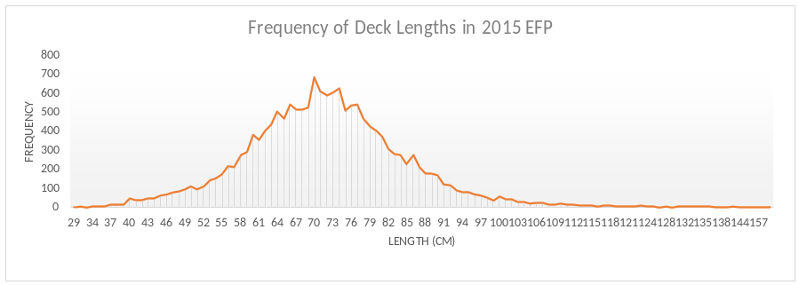
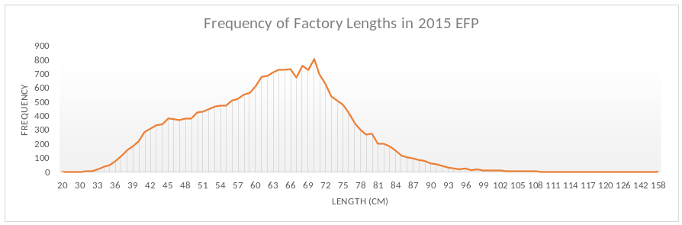
The wider (flatter) distribution of smaller fish lengths in the factory (i.e., the longer tail to the left of the peak) reflects significant numbers of fish smaller than the peak. Also the number of halibut lengths collected in the factory that are greater than the peak is relatively small, as shown by the area under the curve to the right of the peak being much smaller than to the left of the peak. The curve representing the size distribution of deck sorted halibut is more symmetric on both tails of the distribution.
Perhaps somewhat of a surprise to those not familiar with deck sorting is that the factory length distribution does include some very large fish. One might expect that crews would be able to sort all the large fish on deck. This is generally true but very large, lively halibut did occasionally get past the deck crews especially in challenging weather.

