INSERT: INITIAL/PUBLIC/SECRETARIAL REVIEW DRAFT
Environmental Assessment/Regulatory Impact Review
Amendment numbers are only assigned after Council final action.
for Proposed Amendment [XX if known]
to the Fishery Management Plan for INSERT CORRECT
[or if no FMP: for a Proposed Regulatory Amendment]

INSERT TITLE

NPFMC/NMFS Analytical Template, Version 3.0
INSERT DATE May 8, 2019
Grey shaded text is included only in Secretarial Review Draft (SRD).
Lead Agency: National Marine Fisheries Service, Alaska Region
National Oceanic and Atmospheric Administration

Responsible Official: James W. Balsiger, Administrator
Alaska Regional Office, National Marine Fisheries Service

For further information contact: IDENTIFY LEAD ANALYST(S)
For SRD, update contact person to NMFS person
Diana Evans, North Pacific Fishery Management Council
605 W 4th Avenue, Suite 306, Anchorage, AK 99501
(907) 271-2809

Abstract: INSERT SUMMARY OF ACTION (copy from first paragraph of Chapter 1; supplement briefly if necessary).
EXAMPLE: This Environmental Assessment/Regulatory Impact Review analyzes proposed management measures that would apply exclusively to the directed pollock fishery in the Western and Central Gulf of Alaska (GOA). The measures under consideration include setting prohibited species catch limits in the Central and Western GOA for Chinook salmon (Oncorhynchus tshawytscha), which would close the directed pollock fishery in those regulatory areas once attained; full retention of salmon species; and increased observer coverage on vessels under 60 feet length overall. The purpose of this action is to address prohibited species catch of Chinook salmon in the GOA and establish measures that protect against the risk of high Chinook salmon removals in the GOA pollock trawl fisheries in future years.
This Accessibility Statement must be provided in the footer of the Title page or alone on the next page (page 2) if Title page is too lengthy.
USING THE ANALYTICAL TEMPLATE:
The template is not intended to be inflexible and prescriptive, but instead provides you guidance for structuring your analysis. It will need to be appropriately applied to your action. HOWEVER, to eliminate persistent formatting problems, this template should become the master document for beginning all future EAs. This means you should start any new EA using the template, rather than opening an old EA or EIS. Any text that is cut and pasted from older documents should be pasted as “unformatted text,” so that we don’t bring problem coding into the new documents.
List of Acronyms and Abbreviations
REVISE ACCORDINGLY based on what is actually used in document
Acronym or  Abbreviation | Meaning
AAC | Alaska Administrative Code
ABC | acceptable biological catch
ADF&G | Alaska Department of Fish and Game
AFA | American Fisheries Act
AFSC | Alaska Fisheries Science Center
AKFIN | Alaska Fisheries Information Network
BSAI | Bering Sea and Aleutian Islands
CAS | Catch Accounting System
CEQ | Council on Environmental Quality
CFR | Code of Federal Regulations
COAR | Commercial Operators Annual Report
Council | North Pacific Fishery Management Council
CP | catcher/processor
CV | catcher vessel
DPS | distinct population segment
E.O. | Executive Order
EA | Environmental Assessment
EEZ | Exclusive Economic Zone
EFH | essential fish habitat
EIS | Environmental Impact Statement
ESA | Endangered Species Act
ESU | endangered species unit
FMA | Fisheries Monitoring and Analysis
FMP | fishery management plan
FONSI | Finding of No Significant Impact
FR | Federal Register
FRFA | Final Regulatory Flexibility Analysis
ft | foot or feet
GOA | Gulf of Alaska
IRFA | Initial Regulatory Flexibility Analysis
IPA | Incentive Plan Agreement
JAM | jeopardy or adverse modification
lb(s) | pound(s)
LEI | long-term effect index
LLP | license limitation program
LOA | length overall
m | meter or meters
Magnuson-Stevens Act | Magnuson-Stevens Fishery Conservation and Management Act
MMPA | Marine Mammal Protection Act
MSST | minimum stock size threshold
t | tonne, or metric ton
NAICS | North American Industry Classification System
NAO | NOAA Administrative Order
NEPA | National Environmental Policy Act
NMFS | National Marine Fishery Service
NOAA | National Oceanic and Atmospheric Administration
NPFMC | North Pacific Fishery Management Council
NPPSD | North Pacific Pelagic Seabird Database
Observer Program | North Pacific Groundfish and Halibut Observer Program
OMB | Office of Management and Budget
PBR | potential biological removal
PSC | prohibited species catch
PPA | Preliminary preferred alternative
PRA | Paperwork Reduction Act
PSEIS | Programmatic Supplemental Environmental Impact Statement
RFA | Regulatory Flexibility Act
RFFA | reasonably foreseeable future action
RIR | Regulatory Impact Review
RPA | reasonable and prudent alternative
SAFE | Stock Assessment and Fishery Evaluation
SAR | stock assessment report
SBA | Small Business Act
Secretary | Secretary of Commerce
SPLASH | Structure of Populations, Levels of Abundance, and Status of Humpbacks
SRKW | Southern Resident killer whales
TAC | total allowable catch
U.S. | United States
USCG | United States Coast Guard
USFWS | United States Fish and Wildlife Service
VMS | vessel monitoring system

PAGE NUMBERS: Now that so many people are accessing our documents as pdfs on their tablets, it makes things much simpler to have only a single pagination system throughout the document, beginning with the cover sheet as page 1, and no artificial blank pages.
Table of Contents

Executive Summary 7
1 Introduction 9
1.1 Purpose and Need 9
1.2 History of this Action 10
1.3 Description of Management Area 10
2 Description of Alternatives 12
2.1 Alternative 1, No Action 12
2.2 Alternative 2 13
2.3 Alternative 3, etc. 13
2.4 (Preliminary) Preferred Alternative 13
2.5 Comparison of Alternatives 13
2.5.1 Rationale for the Council’s Preferred Alternative 15
2.6 Alternatives Considered but not Analyzed Further 15
3 Environmental Assessment 16
3.1 Methods 17
3.1.1 Documents Incorporated by Reference in this Analysis 17
3.1.2 Resource Components Addressed in the Analysis 18
3.1.3 Methods Used for the Impact Analysis 19
3.1.4 Cumulative Effects Analysis 19
3.2 Target Species 20
3.2.1 Status 20
3.2.2 Effects of the Alternatives 21
3.3 Non-target species 22
3.3.1 Status 22
3.3.2 Effects of the Alternatives 22
3.4 Marine Mammals 23
3.4.1 Status 23
3.4.2 Effects on Marine Mammals 35
3.5 Seabirds 37
3.5.1 Status 37
3.5.2 Effects on Seabirds 39
3.6 Habitat 41
3.6.1 Status 41
3.6.2 Effects of the Alternatives 42
3.7 Ecosystem 42
3.7.1 Status 42
3.7.2 Effects of the Alternatives 43
3.8 NEPA Summary 43
4 Regulatory Impact Review 46
4.1 Statutory Authority 47
4.2 Purpose and Need for Action 47
4.3 Alternatives 47
4.4 Methods Used for the Impact Analysis 48
4.5 Description of Fisheries 48
4.5.1 Harvests (if relevant) 49
4.5.2 Description of Management (if relevant) 49
4.5.3 Harvesting Vessels (if relevant) 49
4.5.4 Processors (if relevant) 49
4.5.5 Communities (if relevant) 49
4.5.6 Target Products (if relevant) 50
4.5.7 Markets (if relevant) 50
4.5.8 Safety Considerations (if relevant) 50
4.5.9 Cost Recovery (if relevant) 50
4.6 Analysis of Impacts: Alternative 1, No Action 50
4.7 Analysis of Impacts: Alternative X 51
4.8 Management and Enforcement Considerations 51
4.8.1 Alternative 1, No Action 52
4.8.2 Alternative X 52
4.9 Affected Small Entities (Regulatory Flexibility Act Considerations) 52
4.10 Summation of the Alternatives with Respect to Net Benefit to the Nation 56
5 Magnuson-Stevens Act and FMP Considerations 57
5.1 Magnuson-Stevens Act National Standards 57
5.2 Section 303(a)(9) Fisheries Impact Statement 58
5.3 Council’s Ecosystem Vision Statement 59
6 Preparers and Persons Consulted 60
7 References 61
7.1 Literature cited 61
7.2 Data Sources 62
Appendix 1 Graphics examples that can help with an analysis 63

List of Tables
- Use of tables:
  - All tables and figures should be captioned using MS Word’s CAPTIONING FUNCTION and should be cross-referenced using the CROSS-REFERENCING FUNCTION (located under the References Tab, and Captions) by the author/analyst. Training will be provided to any who are unfamiliar with this function.
  - All tables must have a header row at the top, including the list of Acronyms and Abbreviations (which is a MS Word table in this template). This is a mandatory 508 Compliance rule.
  - We are experimenting with the best way to include complicated data from Excel in the Word document. Some people copy Excel tables into Word as an image, some copy the data into a Word table. Please don’t link tables in your Word document to the Excel file. THE MOST IMPORTANT THING: staff must send the accompanying Excel file to NMFS along with the Secretarial review draft, so that tables are available to be edited if necessary or adapted in the future. If using data from an Excel file in the document, make sure tables are clearly trackable in the accompanying Excel file (include static copies, not pivot tables).
  - Captions: note, when pasting a table as a picture, the caption should still be generated in Word (i.e., it should not be part of the image). Staff should remember to use short titles in the caption (explanatory language, or identification of source, can be included without caption formatting, so that it is not duplicated in the list of tables). (This may be a topic for a Word training workshop.)
  - Staff should think carefully about whether all tables that are in the document are providing useful information and pare down the number of tables when possible.
Table 1 EXAMPLE from HAPC 2013 action: Summary of alternatives and major impacts. 13
Table 2 Resources potentially affected by the proposed action and alternatives. 18
Table 3 Criteria used to determine significance of effects on target groundfish stocks. 20
Table 4 Criteria used to estimate the significance of impacts on incidental catch of Chinook salmon. 22
Table 5. Marine mammals that are known to occur in the Gulf of Alaska. [Table will be updated each year as annual MM SAR is published] [INCLUDE IF APPROPRIATE –if action occurs in GOA] 26
Table 6. Marine mammals known to occur in the Aleutian Islands subarea. [Table will be updated each year as annual MM SAR is published] [INCLUDE IF APPROPRIATE (action occurs in AI); COMBINE WITH BS IF APPROPRIATE (Action occurs in BS)] 27
Table 7. Marine mammals known to occur in the Bering Sea. [Table will be updated each year as annual MM SAR is published] [INCLUDE IF APPROPRIATE (action occurs in BS): COMBINE WITH AI IF APPROPRIATE (action occurs in the AI)]. 28
EXAMPLE Table 8. Status of pinniped, mustelid, or ursid stocks/DPSs potentially affected by the action. (Source: 2017 Alaska Marine Mammal Stock Assessment Reports unless otherwise noted) [Table will be updated each year as annual MM SAR is published] [UPDATE WITH RELEVANT MAMMALS, USING MOST RECENT SARS] 30
EXAMPLE Table 9 Status of cetacean stocks potentially affected by the action. [Table will be updated each year as annual MM SAR is published] [UPDATE WITH RELEVANT MAMMALS, USING MOST RECENT SARS] 31
Table 10 Criteria for determining significance of impacts to marine mammals. 35
Table 11 Seabird species in Alaska 37
Table 12 Criteria used to determine significance of impacts on seabirds. 39
Table 13 Criteria used to estimate the significance of impacts on essential fish habitat. 41

List of Figures
Figure 1 EXAMPLE Regulatory and reporting areas in the GOA. 11
Figure X-1 Stages of EM development 65
Figure X-2 History of the Council fixed gear EM development 65
Figure X-3 Feedback among the Core BS FEP, individual Action Modules, and the management process 69
Figure X-4 Anticipated flow of information from video review to the Alaska Fisheries Science Center (AFSC) through the catch estimation process in the Alaska Regional Office (AKRO) catch accounting system. 70

Executive Summary
- The Executive Summary should adequately and accurately summarize the analysis, and stress the major conclusions, areas of controversy, and major issues.
- Try to keep Executive Summary to a maximum limit of 5 to 10 pages
INSERT SUMMARY OF ACTION UNDER CONSIDERATION HERE; COPY FROM FIRST PARAGRAPH OF CHAPTER 1
Purpose and Need
COPY OR SUMMARIZE FROM SECTION 1.1
Alternatives
- For the executive summary, the alternatives should be concise, general and easy to understand. The goal is to clearly explain the alternatives.
(Preliminary) Preferred Alternative
COPY OR SUMMARIZE FROM SECTION 2.3
- Secretarial review only, or public review draft if the Council has identified a preliminary preferred alternative (PPA).
Alternatives X through X
COPY THE SHORT VERSION OF ALTERNATIVES FROM CHAPTER 2 — may be the Council’s motion, may be the comparison table — whatever was used in Chapter 2
Environmental Assessment
COPY SUMMARY PARAGRAPHS IF POSSIBLE, OR SUCCINCTLY SYNTHESIZE MAJOR CONCLUSIONS OF IMPACTS FOR EACH MAJOR RESOURCE COMPONENT FROM SECTIONS 3.2.2, Error! Reference source not found., etc.
- Only include sections for major resource components that are potentially impacted by the alternatives.
- The objective is to describe the impacts and how they differentiate among the alternatives, to provide a basis for decision making (see summary table).
Regulatory Impact Review
COPY SUMMARY PARAGRAPHS IF POSSIBLE, OR SUCCINCTLY SYNTHESIZE IMPACTS FOR EACH ALTERNATIVE FROM THE RIR. Include management and enforcement considerations if appropriate.
Comparison of Alternatives for Decision-making
- Where appropriate, copy the decision table from Section 2.5 that identifies the factors that are key to the decision — impacts, costs, and benefits of different alternatives.
- Include, as rows, any decision points that aren’t explicit in the alternatives (e.g., if there are management and enforcement decision points that are relevant).
- Include citations to where things are discussed in the document (especially for the preferred alternative, when applicable).
- Include a summary of the major impacts of Alternative 1, no action.
EXAMPLE Summary of alternatives and major impacts from 2013 analysis of HAPC skate sites.
 | Alternative 1 | Alternative 2 | Alternative 3
 | Status quo. No action. | Identify 6 small area skate egg deposition sites in BS as HAPC | Identify 6 large area skate egg deposition sites in BS as HAPC and prohibit some fishing activity in those areas
Differences in Alternatives
(Sections 2.1 and 2.2)
Area size | None | 81.7 nm² total area; individual sites range from 1.2 - 27.7 nm² | 225.8 nm² total area; individual sites range from 27.4 - 53.3 nm²
Options | None | Request NMFS monitoring of sites (option a)  Consider as a Council research priority (option d) | Prohibit bottom trawl, dredge, dinglebar (option b)  -OR-  Prohibit pelagic trawl, bottom trawl, dredge and dinglebar (option c)
Environmental Impacts
Habitat | No changes. (Section 3.5) | Identification as HAPC highlights importance for consultation on drilling, dredging, laying cables, dumping, and fishing activities. (Section 3.5.1) | Same consultation benefit as Alternative 2 and eliminates habitat disturbance at skate sites. Redistribution of effort insignificant. (Section 3.5.1)
Skate eggs | Unobserved mortality from egg dispersal, directs impacts, and silting, and bycatch mortality. (Section 3.1.1) | Consultations could reduce egg mortality due to activities in the future. (Section 3.1.1) | Same consultation benefit as Alternative 2 and eliminates potential impacts of fishing. (Section 3.1.1)
Skate populations | Stable biomass for stocks in aggregate. (Section 3.1.2) | No immediate impacts. (Section 3.1.2) | Positive effects on biomass with higher egg survival. (Section 3.1.2)
Economic Impacts
Fishing effort | Bering 2 site fished by bottom trawls every year; some years have pelagic trawling in Bering 1 and 2, and Pervenets. (Section 4.6.1) | No changes. (Section 4.7.1) | Effort would be redistributed outside areas. Potential for crowding at Bering 2. (Section 4.7.1)
Gross Revenue at Risk | No changes. (Section 4.6.2) | No changes. (Section 4.7.2) | Average risk of $1.6 million/year for option c, and $0.5 million/yr for option b. (Section 4.7.2)

Introduction
- In first paragraph, WRITE SUMMARY OF THE PROPOSED ACTION and management measures under consideration. This basic summary of the action will be copied throughout the document.
EXAMPLE: This document analyzes proposed management measures that would apply exclusively to the directed pollock fishery in the Central and Western Gulf of Alaska (GOA). The measures under consideration include: setting prohibited species catch (PSC) limits in the Central and Western GOA for Chinook salmon (Oncorhynchus tshawytscha), which would close the directed pollock fishery in those regulatory areas once attained; full retention of salmon species; and increased observer coverage on vessels under 60 feet length overall.
This document is an Environmental Assessment/Regulatory Impact Review (EA/RIR). An EA/RIR provides assessments of the environmental impacts of a proposed action and its reasonable alternatives (the EA), the benefits and costs of the alternatives, the distribution of impacts, and identification of the small entities that may be affected by the alternatives (the RIR). This EA/RIR addresses the statutory requirements of the Magnuson Stevens Fishery Conservation and Management Act, the National Environmental Policy Act, Presidential Executive Order 12866, and some of the requirements of the Regulatory Flexibility Act. An EA/RIR is a standard document produced by the North Pacific Fishery Management Council (Council) and the National Marine Fisheries Service (NMFS) Alaska Region to provide the analytical background for decision-making.
- Where appropriate, include any other relevant statutes that are being specifically addressed in the analysis — e.g., Endangered Species Act (ESA), environmental justice (E.O. 12898), coral reef protection (E.O. 13089), invasive species (E.O. 13112), MPAs (E.O. 13158), tribal consultation (E.O. 13175).

Purpose and Need
- Describe what the purpose of the action is and why it is needed. This write-up may be similar to or expand on the rationale included in the Council’s adopted problem statement/purpose and need statement, if there is one (see below). As appropriate, include reference to statutory authorities that are driving the Council’s attention to this issue, or cite Council objectives from the FMP management policy.
- The impacts analysis should use the P&N to evaluate alts. The P&N may evolve in each draft, as necessary, with changes to the alternatives.
- Alternatives flow directly, as a reasonable range, from the purpose and need. If this is not the case, the P&N or the alternatives need to be revised to ensure this connectivity.
- If appropriate, also include in this section the Council’s written problem statement/purpose and need statement, identifying that it was articulated to initiate the analysis. The Council is not required to provide a written problem statement but should articulate the purpose/need for an action either as formal statement or in the discussion, which can then be written up by staff. While the Council’s adopted problem statement may have originated the action at a given point in time, the purpose and need for the action, as described above, may need to expand on the original problem statement. Note, if the purpose and need description evolves to a point that it is in conflict with the Council’s adopted problem/purpose and need statement, then the Council should revise their problem statement at the next review.
EXAMPLE: The purpose of this action is to address PSC of Chinook salmon in the GOA. Chinook salmon are a prohibited species in the GOA groundfish fisheries, and, as such, must be returned immediately to the sea with a minimum of injury, if caught incidentally in the groundfish fisheries. The Council has determined that levels of Chinook salmon PSC in the pollock trawl fisheries of the GOA, in 2010, were unacceptably high, and has developed this amendment package as a high priority consideration, in order to reduce the risk of high Chinook salmon PSC levels in the future. The directed pollock fishery in the Western and Central GOA is responsible for the majority of Chinook salmon PSC in the GOA groundfish fisheries. As such, the Council has focused this amendment package specifically on management measures for the GOA pollock fisheries in these areas. The Council has purposely identified alternatives that can be implemented within a short timeframe. These alternatives would establish measures that protect against the risk of high Chinook salmon PSC in future years. A subsequent amendment package will evaluate a broader range of alternatives that may offer other solutions to further reduce Chinook salmon PSC.
The Council adopted the following problem statement to originate this action in INSERT DATE.
INSERT COUNCIL PROBLEM STATEMENT VERBATIM FROM COUNCIL MOTION

History of this Action
- As appropriate, provide context for the action (why is it important), and the information necessary to understand the action.
- Include a history of the issue, so that paragraphs can be dropped directly into the background section of the preamble. For some actions that include widely different alternatives, this may need to be revised once the Council has settled on a preferred alternative.
- If appropriate, also include a brief description of the evolution of this action in front of the Council. This could be anything from a paragraph to a couple pages. (If short, this content could also be folded in to the introduction, rather than being a separate section). For example, did it start as a statutory mandate, an agency recommendation, or a Council motion? Has this been an issue of interest to the Council for many years, or is it of recent origination? Have there been multiple discussion papers preparing for this action? If this is final action, when was initial review, and did the Council do anything significant (e.g., restructure the alternatives)? Did the Council once consider this issue more broadly, but over time refine it to the particular proposal currently under review? Is this action a trailing amendment to a previous action, or follow on to an existing program?
- To help with future research and maintaining the admin record, keep track here of meeting dates when this issue was presented to the Council, and previous names for the action, so that the record can be clarified later if needed. For example, the Freezer Longline MLOA Adjustment was previously referred to as the Freezer Longline Vessel Replacement action. Also, highlight any Council committee meetings where the issue was discussed, and recommendations were made (for example, the Fishery Monitoring Advisory Committee, or Salmon Bycatch Workgroup).

Description of Management Area
- Analysis should identify the area that is affected by the proposed action. E.g., is it the whole FMP area, or a particular subset (specific area closures, or management measures affecting a fishery that only operates in a small part of the FMP area).
- Include a map if possible.
Figure 1 EXAMPLE Regulatory and reporting areas in the GOA.
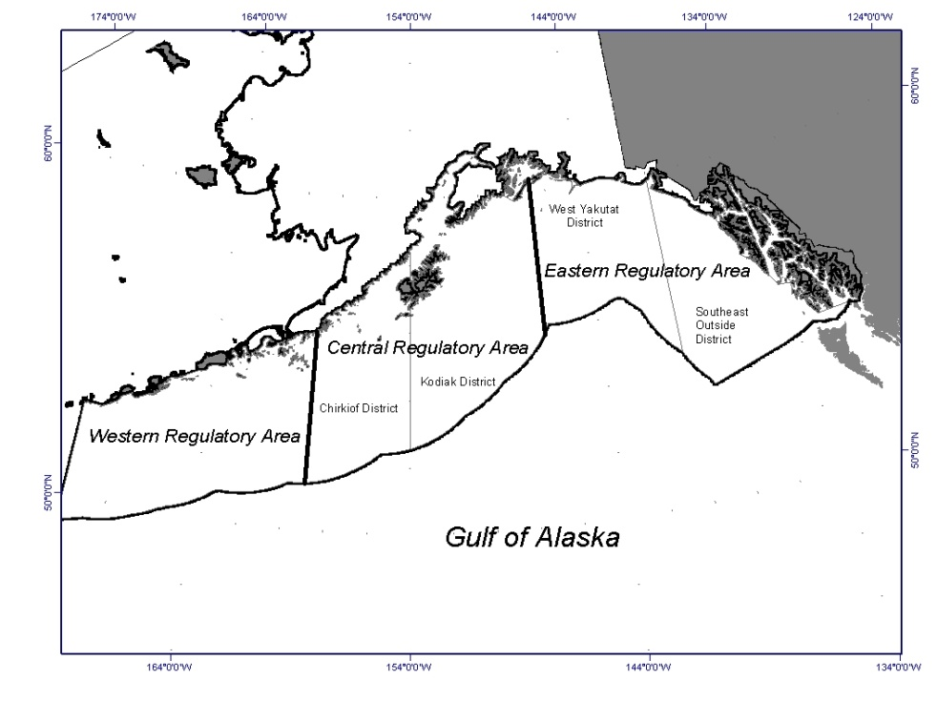
610
620
630
640
650

Description of Alternatives
- The primary focus of this chapter is to 1) describe the alternatives, 2) compare the alternatives, and 3) discuss the alternatives considered and eliminated from detailed study.
- This chapter (here and the sections that follow) should make clear both what the Council motion says (verbatim), and what each alternative means operationally — how to explain that best to the public might vary depending on the nature of the action.
  - If the Council motion on alternatives consists of complicated elements and options, for example for a catch share program, some additional plain language may be needed in introduction, to set the stage for the verbatim motion (e.g., copy language from first paragraph of Chapter 1, identifying the major management measures under consideration).
  - Actual management measures that will be implemented as part of the alternative must also be included in the description of the alternative (e.g., a particular alternative might require special monitoring and enforcement measures at implementation that are not necessarily included in the Council’s alternative language. These should be included in the description of how the alternative will work operationally).
- Remember the linkage with the purpose and need. Reasonable alternatives meet the purpose and need for the action — they solve the problem identified in the purpose and need.
- If appropriate, identify whether and when the Council modified the current alternatives, or whether and when the Council has selected a PPA or preferred alternative. EXAMPLE: In April 2011, the Council identified a preliminary preferred alternative, which was replaced with a preferred alternative recommendation in June 2011.
- If appropriate, and not already specified, include an explanation of whether alternatives/options can be selected in combination. Note that if the Council is adopting a mix and match approach to selecting a preferred alternative, they need to be able to understand the impacts of selecting particular elements and options in combination, and sometimes this may require further analysis.
NEPA requires that an EA analyze a reasonable range of alternatives consistent with the purpose and need for the proposed action. The alternatives in this chapter were designed to accomplish the stated purpose and need for the action. All of the alternatives were designed to insert main big goal of alternatives based on the P&N.
The Council adopted the following alternatives for analysis in Month, Year.
INSERT EITHER the verbatim text from Council motion OR if the motion is complicated, with lots of components and options, a general description of the alternatives.

Alternative 1, No Action
- Provide a description of the situation with no action, as it relates to the proposed management change. For example, if the proposed amendment is proposing to institute restrictions to protect a prohibited species, explain what protections are already in place in the status quo for the species in question.
- The description should include both direct and indirect conditions and cite FMP sections and regs if appropriate (e.g., for a bycatch action, there might be existing spatial restriction measures in place, even if they are not specifically the PSC limits that are the subject of the alternatives).
- Be aware that although the status quo and the No Action alternative are usually the same, this may not always be so. The No Action alternative is usually the baseline.
- Coordinate with NMFS staff re describing the status quo and/or existing FMP language and regs.

Alternative 2
- Separate heading/section for each alternative
- Insert text verbatim from Council motion for this alternative, if appropriate.
- Identify whether each alternative will require an FMP amendment, regulatory amendment, or both. The analyst should review how FMP sections and/or regulations would change with each alternative, and if appropriate, provide a description, or include draft amendment text.
- Provide a description of how the proposed management measure would operate logistically (without preempting the analysis). Use subsections for different alternatives, options, or components, as necessary. For example:
  - If the alternative/option provides a mechanism for achieving a particular end, include a description of the outcome of applying that mechanism. E.g., if implementing a PSC limit based on history in certain fisheries, what are the numerical limits that apply to each fishery under each option.
  - If the alternative/option provides a privilege or restriction to a limited class of participants based on set criteria, identify how many participants would be affected under the proposal.
  - If there are management and regulatory changes needed to implement the alternative, these should be identified too in this section; also, if the FMP needs to be amended for the alternative, staff should be thinking about that too, and discuss to the extent applicable.
  - If there is additional rationale for the particular alternative/option that was discussed by the Council, include in these sections (e.g., require full retention of all salmon, rather than just Chinook, because it can be difficult to identify salmon species unless fish is in hand).
  - Is each alternative/option an FMP amendment, or are some just regulatory amendments?
  - Is there a time constraint on when the management measure could be implemented (e.g., at the start of the calendar year, or not in time for the upcoming harvest specifications process)?
  - Are there legal implications of any of the alternatives (e.g., some are not compliant with current law), or major management constraints to their implementation?

Alternative 3, etc.
- Separate heading/section for each alternative – see above

(Preliminary) Preferred Alternative
- When the Council’s PPA or preferred alternative cannot easily be labeled (i.e., when the Council chooses a slightly modified alternative as PPA or preferred alternative), include preferred alternative as separate section.

Comparison of Alternatives
- Include this section to provide a summary of the main features of the alternatives. To the extent possible, use table or other graphical illustrations.
- Decision table: Where appropriate, add a decision table that identifies the factors that are key to the decision — impacts, costs, and benefits of different alternatives. This may also be copied into the executive summary.
  - Include, as rows, any decision points that aren’t explicit in the alternatives (e.g., if there are management and enforcement decision points that are relevant).
  - Include citations to where things are discussed in the document (especially for the preferred alternative, when applicable).
  - Include the impacts of the No Action alternative.
Table 1 EXAMPLE from HAPC 2013 action: Summary of alternatives and major impacts.
 | Alternative 1 | Alternative 2 | Alternative 3
 | Status quo. No action. | Identify 6 small area skate egg deposition sites in BS as HAPC | Identify 6 large area skate egg deposition sites in BS as HAPC and prohibit some fishing activity in those areas
Differences in Alternatives
(Sections 2.1 and 2.2)
Area size | None | 81.7 nm² total area; individual sites range from 1.2 - 27.7 nm² | 225.8 nm² total area; individual sites range from 27.4 - 53.3 nm²
Options | None | Request NMFS monitoring of sites (option a)  Consider as a Council research priority (option d) | Prohibit bottom trawl, dredge, dinglebar (option b)  -OR-  Prohibit pelagic trawl, bottom trawl, dredge and dinglebar (option c)
Environmental Impacts
Habitat | No changes. (Section 3.5) | Identification as HAPC highlights importance for consultation on drilling, dredging, laying cables, dumping, and fishing activities. (Section 3.5.1) | Same consultation benefit as Alternative 2 and eliminates habitat disturbance at skate sites. Redistribution of effort insignificant. (Section 3.5.1)
Skate eggs | Unobserved mortality from egg dispersal, directs impacts, and silting, and bycatch mortality. (Section 3.1.1) | Consultations could reduce egg mortality due to activities in the future. (Section 3.1.1) | Same consultation benefit as Alternative 2 and eliminates potential impacts of fishing. (Section 3.1.1)
Skate populations | Stable biomass for stocks in aggregate. (Section 3.1.2) | No immediate impacts. (Section 3.1.2) | Positive effects on biomass with higher egg survival. (Section 3.1.2)
Economic Impacts
Fishing effort | Bering 2 site fished by bottom trawls every year; some years have pelagic trawling in Bering 1 and 2, and Pervenets. (Section 4.6.1) | No changes. (Section 4.7.1) | Effort would be redistributed outside areas. Potential for crowding at Bering 2. (Section 4.7.1)
Gross Revenue at Risk | No changes. (Section 4.6.2) | No changes. (Section 4.7.2) | Average risk of $1.6 million/year for option c, and $0.5 million/yr for option b. (Section 4.7.2)

Rationale for the Council’s Preferred Alternative
- Following Council final action, summarize the Council’s record building with respect to the preferred alternative, and why the Council picked the preferred alternative over the others (i.e., discuss both why the Council picked the preferred, and why they did not choose the others). For example, how do the alternatives compare relative to the National Standards, and the key issues identified for decision making? Reference where the impacts are described in sections later in the document.

Alternatives Considered but not Analyzed Further
- Describe any other viable management measures that have been recommended by the public or considered during the Council’s discussion papers or refinement of alternatives. (If none, state that too).
- Focusing on options that might be considered reasonable, given the purpose and need, briefly reference previous documents or Council/AP/SSC/committee/team/tribal consultation discussions where other proposals were advanced, but were not moved forward by the Council, and briefly explain rationale for the choice.
- This section should also explain why alternatives outside either end of the range of alternatives were not considered, if appropriate. For example, if the Council is considering a range of PSC limits, explain why limits higher and lower than the range are not reasonable alternatives, relative to the purpose and need.
- Note, including this section is particularly important to be able to address comments on the analysis post-final action (from public, HQ, lawyers, etc.).

Environmental Assessment
- Structure this chapter around issues pertinent to the proposed action.
- Succinctly describe the resource components to be affected by the alternatives under consideration. Identify and eliminate from further analysis any resource components that are not affected by the proposed action.
- The headings below are a comprehensive list of EA headings. The analyst should put them in the order that makes sense for the analysis, based on the specific nature of the action under consideration. Not all headings or bullets will be relevant for every action — see environmental scan below. This listing is intended only to provide a guideline of sorts, to ensure that all relevant issues are addressed.
- Think about the information and analysis you are going to provide in this chapter. Keep the EA brief and to the point, as per CEQ guidance:
  - Descriptions shall be no longer than is necessary to understand the effects of the alternatives.
  - Data and analyses in a statement shall be commensurate with the importance of the impact, with less important material summarized, consolidated, or simply referenced.
  - Avoid useless bulk in EAs and concentrate effort and attention on important issues.
- For each resource component that the proposed action affects, it is important to include:
  - Background necessary to understand the impacts. Key question: What information is necessary to understand the potential impacts of my action on the resource component?
    - Cite previous analyses and incorporate by reference with a brief summary.
    - Include new information that was not in those other documents and that directly relates to the action, for example, stock status, important management changes.
    - Only if necessary for understanding the impacts, include detailed information, such as specific fishery or life history information.
  - Discussion of direct, indirect, and cumulative impacts. Key questions: What are the potential impacts of my action on this resource component? How do these impacts differ among alternatives?
    - Significance criteria should be identified for each resource component that is analyzed. If significance criteria tables are included, they must be referred to in the analysis, and be applicable to the proposed action.
    - Incorporate cumulative effects into the resource component sections, so that the reader can understand all impacts on that resource component (i.e., no separate cumulative effects section at the end.)
    - If your action has no impacts on a specific resource component, then a separate “cumulative effects” section is not necessary
    - Discuss the reasonably foreseeable future actions (RFFA) that relate to your proposed action. How do you find RFFAs? (1) look at the Harvest Specifications SIR, do any of those RFFAs apply? (2) think about any additional RFFAs applicable to the types of impacts your action has on a resource.
There are four required components for an environmental assessment. The need for the proposal is described in Chapter 1, and the alternatives in Chapter 2. This chapter addresses the probable environmental impacts of the proposed action and alternatives. A list of agencies and persons consulted is included in Chapter 6.
This chapter evaluates the direct, indirect, and cumulative impacts of the alternatives and options on the various resource components. The socio-economic impacts of this action are described in detail in the Regulatory Impact Review (RIR) of this analysis (Chapters 4).
Recent and relevant information, necessary to understand the affected environment for each resource component, is summarized in the relevant section. For each resource component, the analysis identifies the potential impacts of each alternative, and uses criteria to evaluate the significance of these impacts. If significant impacts are likely to occur, preparation of an EIS is required. Although an EA should evaluate economic and socioeconomic impacts that are interrelated with natural and physical environmental effects, economic and social impacts by themselves are not sufficient to require the preparation of an EIS (see 40 CFR 1508.14).
An environmental assessment must consider cumulative effects when determining whether an action significantly affects environmental quality. The Council on Environmental Quality (CEQ) regulations for implementing NEPA define cumulative effects as:
“the impact on the environment, which results from the incremental impact of the action when added to other past, present, and reasonably foreseeable future actions regardless of what agency (Federal or non-Federal) or person undertakes such other actions. Cumulative impacts can result from individually minor but collectively significant actions taking place over a period of time” (40 CFR 1508.7).
The concept behind cumulative effects analysis is to capture the total effects of many actions over time that would be missed if evaluating each action individually. Concurrently, the Council on Environmental Quality (CEQ) guidelines recognize that it is most practical to focus cumulative effects analysis on only those effects that are truly meaningful.

Methods
- Remember that not all of these headings will be relevant for every action. Delete if they are not useful.

Documents Incorporated by Reference in this Analysis
- Check to see whether any of these docs are relevant for this action, and list other relevant docs as appropriate (e.g., EAs for management programs [GOA rockfish, Amd 80, P.cod sector splits]).
- When documents are incorporated by reference, CEQ regs require that the material be cited and its content briefly described. So the relevant information in these documents needs to be summarized to support the environmental analysis.
This EA relies heavily on the information and evaluation contained in previous environmental analyses, and these documents are incorporated by reference. The documents listed below contain information about the fishery management areas, fisheries, marine resources, ecosystem, social, and economic elements of the groundfish fisheries. They also include comprehensive analysis of the effects of the fisheries on the human environment and are referenced in the analysis of impacts throughout this chapter.
Alaska Groundfish Harvest Specifications Final Environmental Impact Statement (NMFS 2007).
This EIS provides decision makers and the public an evaluation of the environmental, social, and economic effects of alternative harvest strategies for the federally managed groundfish fisheries in the GOA and the Bering Sea and Aleutian Islands management areas and is referenced here for an understanding of the groundfish fishery. The EIS examines alternative harvest strategies that comply with Federal regulations, the Fishery Management Plan (FMP) for Groundfish of the GOA, the Fishery Management Plan (FMP) for Groundfish of the BSAI Management Area, and the Magnuson-Stevens Fishery Conservation and Management Act. These strategies are applied using the best available scientific information to derive the total allowable catch (TAC) estimates for the groundfish fisheries. The EIS evaluates the effects of different alternatives on target species, non-specified species, forage species, prohibited species, marine mammals, seabirds, essential fish habitat, ecosystem relationships, and economic aspects of the groundfish fisheries. This document is available from https://alaskafisheries.noaa.gov/fisheries/groundfish-harvest-specs-eis.
Stock Assessment and Fishery Evaluation (SAFE) Report for the Groundfish Resources of the BSAI and/or GOA (NPFMC 20XX).
Annual SAFE reports review recent research and provide estimates of the biomass of each species and other biological parameters. The SAFE report includes the acceptable biological catch (ABC) specifications used by NMFS in the annual harvest specifications. The SAFE report also summarizes available information on the ecosystems and the economic condition of the groundfish fisheries off Alaska. This document is available from http://www.afsc.noaa.gov/refm/stocks/assessments.htm.
Final Programmatic Supplemental Environmental Impact Statement (PSEIS) on the Alaska Groundfish Fisheries (NMFS 2004).
The PSEIS evaluates the Alaska groundfish fisheries management program as a whole and includes analysis of alternative management strategies for the GOA and Bering Sea/Aleutian Islands (BSAI) groundfish fisheries. The EIS is a comprehensive evaluation of the status of the environmental components and the effects of these components on target species, non-specified species, forage species, prohibited species, marine mammals, seabirds, essential fish habitat, ecosystem relationships, and economic aspects of the groundfish fisheries. A Supplemental Information Report (NPFMC and NMFS 2015) was prepared in 2015 which considers new information and affirms that new information does not indicate that there is now a significant impact from the groundfish fisheries where the 2004 PSEIS concluded that the impact was insignificant. The PSEIS document is available from https://alaskafisheries.noaa.gov/node/33552, and the Supplemental Information Report from https://alaskafisheries.noaa.gov/sites/default/files/sir-pseis1115.pdf.

Resource Components Addressed in the Analysis
- Define the resource components that are predicted to be impacted, briefly explain why the other components won’t be impacted, then analyze the impacts on those identified components.
- Environmental scan: if some resource categories can reasonably be justified to be entirely unimpacted by the implementation of the proposed management measures, explain this rationale here in this section, and these categories may be eliminated from the headings that follow. An example, with accompanying table, is provided below.
  - For the rationale, think about the practical effects of the proposed action, and how that will interact with resource categories. For example, think about how the action will affect overall harvest amounts of target species or bycatch, gear types used, spatial effort/location of fishing, timing/seasonality of effort, fishing intensity (CPUE).
EXAMPLE: Table 2 shows the components of the human environment and whether the proposed action and its alternatives have the potential to impact that resource component and thus require further analysis. Extensive environmental analysis on all resource components is not needed in this document because the proposed action is not anticipated to have environmental impacts on all resource components.
SUMMARIZE HOW YOUR ACTION WILL CAUSE IMPACTS AND WHICH RESOURCES COMPONENTS ARE LIKELY IMPACTED
The effects of the alternatives on the resource components would be caused by explain the aspects of the alternative that have the potential to cause impacts EXAMPLE: increased harvest of underutilized groundfish species in the BSAI and GOA, and lengthening of the fishing season. The alternatives have the potential to affect insert specific resource components – MUST match the table- those with a Y EXAMPLE: groundfish, prohibited species, and social and economic components.
IF YOUR ACTION WOULD HAVE NO IMPACTS ON SPECIFIC RESOURCE COMPONENTS
No effects are expected on insert specific resource components – MUST match the table – those with an N EXAMPLE ecosystem component species, marine mammals, seabirds, habitat, and the ecosystem. No effect is presumed for these components because explain reasoning for each excluded component EXAMPLE: current fishing regulations (e.g., season and gear types), harvest limits, or regulations protecting habitat and important breeding areas as described in previous NEPA documents (insert citations) would not be changed by any of the alternatives. No effects are presumed for marine mammals because existing protection measures would not be changed, nor would allowable harvest amounts for important prey species. Moreover, the intensity of trawling would remain unchanged because current regulations define the seasons in which trawl fishing is allowed, methods that may be used, areas in which trawling is allowed, and restrict the maximum amount of trawling to TAC levels. None of the alternatives would change TAC amounts, methods, seasons, or areas closed to trawling. As a result, further analysis is included only for insert resource components to be analyzed EXAMPLE: groundfish, prohibited species, and social and economic components, the only resource components which the proposed action may impact.
Table 2 Resources potentially affected by the proposed action and alternatives.
Potentially affected resource component
Groundfish | Prohibited Species | Ecosystem Component Species | Marine Mammals | Seabirds | Habitat | Ecosystem | Social and  economic
EXAMPLE:  Y | Y | N | N | N | N | N | Y
N = no impact anticipated by each alternative on the component.
Y = an impact is possible if each alternative is implemented.

Methods Used for the Impact Analysis
- This section may not be relevant for all actions, but if appropriate, describe the methods used for the impact analysis. Especially relevant if you are using datasets, models, or analytical methods that are not commonly used in Council analyses.
- If more appropriate, this section can instead be included specifically in the section for each resource component.

Cumulative Effects Analysis
- If there are RFFAs that apply to all resource components, but have not been addressed in SIRs to date, then you can write about those at the end of this section and refer back to this section in the cumulative effects discussions on each resource component.
This EA analyzes the cumulative effects of each alternative and the effects of past, present, and reasonably foreseeable future actions (RFFA). Based on Table 3, the resources with potentially meaningful cumulative effects are specify which resource components – those with a Y. The cumulative effects on the other resources have been analyzed in numerous documents and the impacts of this proposed action and alternatives on those resources is minimal, therefore there is no need to conduct an additional cumulative impacts analysis.
Each section below provides a review of the relevant past, present, and RFFA that may result in cumulative effects on the resource components analyzed in this document. A complete review of the past, present, and RFFAs are described in the prior NEPA documents incorporated by reference and the supplemental information report (SIR) NMFS prepares to annually review of the latest information since the completion of the Alaska Groundfish Harvest Specifications EIS. SIRs have been developed since 2007 and are available on the NMFS Alaska Region website. Each SIR describes changes to the groundfish fisheries and harvest specifications process, new information about environmental components that may be impacted by the groundfish fisheries, and new circumstances, including present and reasonably foreseeable future actions. NMFS reviews the reasonably foreseeable future actions described in the Harvest Specifications EIS each year to determine whether they occurred and, if they did occur, whether they would change the analysis in the Harvest Specifications EIS of the impacts of the harvest strategy on the human environment. In addition, NMFS considered whether other actions not anticipated in the Harvest Specifications EIS occurred that have a bearing on the harvest strategy or its impacts. The SIRs provide the latest review of new information regarding Alaska groundfish fisheries management and the marine environment since the development of the Harvest Specifications EIS and provide cumulative effects information applicable to the alternatives analyzed in this EA.
Actions are understood to be human actions (e.g., a designation of northern right whale critical habitat in the Pacific Ocean), as distinguished from natural events (e.g., an ecological regime shift). CEQ regulations require consideration of actions, whether taken by a government or by private persons, which are reasonably foreseeable. This requirement is interpreted to indicate actions that are more than merely possible or speculative. In addition to these actions, this cumulative effects analysis includes the effects of climate change.
Actions are considered reasonably foreseeable if some concrete step has been taken toward implementation, such as a Council recommendation or NMFS’s publication of a proposed rule. Actions only “under consideration” have not generally been included, because they may change substantially or may not be adopted, and so cannot be reasonably described, predicted, or foreseen. Identification of actions likely to impact a resource component within this action’s area and time frame will allow the public and Council to make a reasoned choice among alternatives.

Target Species

Status
- Key question: What information is necessary to understand the potential impacts of my action on the identified target species?
- Identify, and include sections for, any and all target groundfish species whose fisheries are affected by proposed management measures (e.g., restrictions on the pollock target fishery to address Chinook salmon prohibited species catch).
- Explain and provide recent and relevant information that is necessary for understanding the impacts of the proposed action and its alternatives. Keep the EA brief and to the point (i.e., this is NOT meant to be encyclopedic), as per CEQ guidance (CEQ 1502.15):
  - Descriptions shall be no longer than is necessary to understand the effects of the alts.
  - Data and analyses in a statement shall be commensurate with the importance of the impact, with less important material summarized, consolidated, or simply referenced.
  - Avoid useless bulk in EAs and concentrate effort and attention on important issues.
- E.g., short description of stock status, relevant stock/life history characteristics, catch and catch restrictions (e.g., seasonal/spatial apportionments), referencing SAFE (or previous NEPA analyses) for majority of info.

Effects of the Alternatives
- Key questions: What are the potential impacts of my action on target species? How do these impacts differ among alternatives?
- Describe the anticipated effects, including direction and magnitude, from each alternative on target groundfish.
  - List criteria for significance determination (tweak as appropriate for the action). If you include significance criteria, you must structure your analysis in reference to the criteria.
  - The term “significant” in an EA is understood to be the NEPA definition of “significant”. Please only use this term or its derivatives when discussing significant effects requiring preparation of an EIS. Otherwise, do not use the term unless specifically noting statistical significance (and be sure to use the “statistical” qualifier).
- Analyze, citing other NEPA docs and updating with recent information as appropriate, the effects of status quo (Alt 1) fishing on the target stock.
- State how the alternatives would change fishery interactions with the target stock (e.g., more or less fishing pressure, differences in time/area of fishing, gear type, etc.), and analyze what the biological effects might be on the stock, and whether/how the current stock assessment process might take into account any change.
- Include an analysis of cumulative effects on the resource component.
EXAMPLE CRITERIA: The effects of the GOA pollock fishery on the pollock stock is assessed annually in the GOA SAFE report (Dorn et al. 2010) and was also evaluated in the Alaska Groundfish Fisheries Harvest Specifications EIS (NMFS 2007a). Table 3 describes the criteria used to determine whether the impacts on target fish stocks are likely to be significant. The pollock stock is neither overfished nor subject to overfishing, and in fact biomass levels are projected to increase into 2015. It is estimated that the GOA pollock fishery under the status quo is sustainable for pollock stocks.
Table 3 Criteria used to determine significance of effects on target groundfish stocks.
Effect | Criteria
Effect | Significantly Negative | Insignificant | Significantly Positive | Unknown
Fishing mortality | Changes in fishing mortality are expected to jeopardize the ability of the stock to sustain itself at or above its MSST (minimum stock size threshold) | Changes in fishing mortality are expected to maintain the stock’s ability to sustain itself above MSST | Changes in fishing mortality are expected to enhance the stock’s ability to sustain itself at or above its MSST | Magnitude and/or direction of effects are unknown
Stock Biomass:  potential for increasing and reducing stock size | Reasonably expected to jeopardize the capacity of the stock to yield sustainable biomass on a continuing basis. | Reasonably expected not to jeopardize the capacity of the stock to yield sustainable biomass on a continuing basis. | Action allows the stock to return to its unfished biomass. | Magnitude and/or direction of effects are unknown
Spatial or temporal distribution | Reasonably expected to adversely affect the distribution of harvested stocks either spatially or temporally such that it jeopardizes the ability of the stock to sustain itself. | Unlikely to affect the distribution of harvested stocks either spatially or temporally such that it has an effect on the ability of the stock to sustain itself. | Reasonably expected to positively affect the harvested stocks through spatial or temporal increases in abundance such that it enhances the ability of the stock to sustain itself. | Magnitude and/or direction of effects are unknown

INSERT IMPACT ANALYSIS
Cumulative Effects on Target Species
- list actions that have the potential to result in cumulative impacts when considered with your action/alternatives. Climate change. Any others? Provide the brief discussion of each RFFA. If the RFFA is already described in the SIR, just reference it and explain how that action could have cumulative effects with your action
The following RFFAs are identified as likely to have an impact on insert target species within the action area and timeframe: INSERT.
Based on RFFA discussion, consider whether the following statement is true, and if there is additional justification that it should contain. Considering the direct and indirect impacts of the proposed action when added to the impacts of past and present actions previously analyzed in other documents that are incorporated by reference and the impacts of the reasonably foreseeable future actions listed above, the cumulative impacts of the proposed action are determined to be not significant.

Non-target species

Status
- Identify, and include sections for, other fish or shellfish species that are being affected by proposed management measures. Should address, if appropriate, prohibited species, forage fish, any groundfish species affected incidentally, other ecosystem component species.
- Include recent and relevant information necessary for understanding the impacts of the proposed action and its alternatives. For non-groundfish species (where SAFE can’t be referenced), include appropriate level of background information about status of species, its management, type and level of interaction with target groundfish fishery, substock of species that is being affected by groundfish fisheries (if appropriate), any ESA concerns. Use separate subsections as appropriate. Reference previous NEPA analyses where appropriate.

Effects of the Alternatives
- Key questions: What are the potential impacts of my action on non-target species? How do these impacts differ among alternatives?
- Describe anticipated impacts, including direction and magnitude, of each alternative on the other fish species.
- List criteria for significance determination. If necessary, introduce new significance determination criteria tables, unless they are the same as those already included.
- Analyze effects of Alt 1, No Action (status quo, if same) fishing on the species. Cite other NEPA docs, updated with recent information as appropriate.
- State how the alternatives would change fishery interactions with the species (e.g., more or fewer interactions due to more or less fishing pressure, differences in time/area of fishing, gear type, etc.), and analyze what the biological effects might be on the stock, or on a particular substock if appropriate.
EXAMPLE: Table 4 describes the criteria used to determine whether the impacts on Chinook salmon stocks are likely to be significant.
Table 4 Criteria used to estimate the significance of impacts on incidental catch of Chinook salmon.
No impact | No incidental take of the prohibited species in question.
Adverse impact | There are incidental takes of the prohibited species in question
Beneficial impact | Natural at-sea mortality of the prohibited species in question would be reduced — perhaps by the harvest of a predator or by the harvest of a species that competes for prey.
Significantly adverse impact | An action that diminishes protections afforded to prohibited species in the groundfish fisheries.
Significantly beneficial impact | No benchmarks are available for significantly beneficial impact of the groundfish fishery on the prohibited species, and significantly beneficial impacts are not defined for these species.
Unknown impact | Not applicable

INSERT IMPACT ANALYSIS
Cumulative Effects on Non-Target Species
- list actions that have the potential to result in cumulative impacts when considered with your action/alternatives. Climate change. Any others? Provide the brief discussion of each RFFA. If the RFFA is already described in the SIR, just reference it and explain how that action could have cumulative effects with your action
The following RFFAs are identified as likely to have an impact on insert non-target species within the action area and timeframe: INSERT.
Based on RFFA discussion, consider whether the following statement is true, and if there is additional justification that it should contain. Considering the direct and indirect impacts of the proposed action when added to the impacts of past and present actions previously analyzed in other documents that are incorporated by reference and the impacts of the reasonably foreseeable future actions listed above, the cumulative impacts of the proposed action are determined to be not significant.

Marine Mammals

Status
- Provide a general listing of marine mammals that are present in the affected action area checking the NMFS Alaska Region interactive map at http://alaskafisheries.noaa.gov/mapping/esa/ (see example boilerplate text and tables below).
- Then narrow the list by considering their interactions with the target fishery, to see which ones are likely to be impacted by the action (e.g., Bering Sea polar bears unlikely to be affected by the pollock fishery, through incidental take or effects on prey).
- Briefly summarize the status of marine mammals that may be affected by your action. Can be done effectively in a table, examples provided.
- Provide information on any ESA consultations in progress, or any other recent information that doesn’t fit in the summary table, but may be of relevance
- Key question: What information is necessary to understand the potential impacts of my action on the identified marine mammals?
[BOILERPLATE]Alaska supports one of the richest assemblages of marine mammals in the world. Twenty-two species are present from the order Carnivora, superfamilies Pinnipedia (seals, sea lions, and walrus), Ursoidea (polar bears), and Musteloidea (sea otters), and from the order Artiodactyla, infraorder Cetacea (whales, dolphins, and porpoises). Some marine mammal species are resident in waters off Alaska throughout the year, while others migrate into or out of Alaska fisheries management areas. Marine mammals occur in diverse habitats, including deep oceanic waters, the continental slope, and the continental shelf, including inshore waters. The National Marine Fisheries Service (NMFS) maintains management authority for all marine mammal species in Alaska, while the U.S. Fish and Wildlife Service (USFWS) is the designated management authority for northern polar bears, Pacific walrus, and northern sea otter.
The Marine Mammal Protection Act, the Endangered Species Act, and the Fur Seal Act are the relevant statutes for managing marine mammal interactions with human activities, including commercial fishing operations. The Marine Mammal Protection Act (MMPA) was enacted in 1972 with the ideal of ensuring that marine mammal populations continue to be functioning elements of the ecosystems of which they are a part. The one of the incentives for enacting the MMPA was to reduce take of marine mammals incidental to commercial fishing operations. While marine mammals may be lawfully taken incidentally in the course of commercial fishing operations, the 1994 MMPA Amendments established a requirement for commercial fishing operations to reduce incidental mortalities and serious injuries (M/SI) of marine mammals to insignificant levels approaching a zero rate, commonly referred to as the Zero Mortality Rate Goal (ZMRG). ZMRG is considered to be met for a marine mammal stock when the M/SI level from all commercial fisheries is 10 percent or below the Potential Biological Removal level (PBR) of that marine mammal stock (69 FR 43338, July 20, 2004). Likewise, the Endangered Species Act (ESA) was enacted to provide a means whereby the ecosystems upon which endangered species and threatened species depend may be conserved, to provide a program for the conservation of such endangered species and threatened species, and to take such steps as may be appropriate to achieve such conservation. In practice, the ESA outlines a program to protect endangered species on the brink of extinction and threatened species that are likely to be on the brink of extinction in the near future and pursue their recovery. The ESA also requires designation of any habitat of endangered or threatened species, which is then considered to have physical or biological features essential to the conservation of the species and which may require special management considerations or protection.
Under the MMPA a “population stock” is the fundamental unit of legally-mandated conservation and is defined as “a group of marine mammals of the same species or smaller taxa in a common spatial arrangement, which interbreed when mature.” Stocks are identified in a manner consistent with the management goals of the MMPA which include 1) preventing stocks from diminishing such that they cease to be a significant functioning element in the ecosystem of which they are a part or below their optimum sustainable population keeping the carrying capacity of the habitat in mind; and 2) maintaining the health and stability of the marine ecosystem. Therefore, a stock is also recognized as being a management unit that identifies a demographically isolated biological population. While many types of information can be used to identify stocks of a species, it is recognized that some identified stocks may fall short of that threshold due to a lack of information.
Marine mammal Stock Assessment Reports (SARs) are published annually under the authority of the MMPA for all stocks that occur in state and federal waters of the Alaska region [NMFS 2016]. Individual SARs provide information on each stock’s geographic distribution, population estimates, population trends, and estimates of the potential biological removal (PBR) levels for each stock. The SARs identify sources of human-caused mortality, including serious injury and mortality in commercial fishery operations, by fishery, and whether the stock has met ZMRG for all fisheries. The SARs also include the stock’s ESA listing status and MMPA depleted and strategic designations. Strategic stock SARs are updated annually (Steller sea lions, northern fur seals, bearded seals, ringed seals, Cook Inlet beluga whales, AT1 Transient killer whales, harbor porpoise, sperm whales, humpback whales, fin whales, North Pacific right whales, and bowhead whales). SARs for non-strategic stocks are updated every three years or when significant new information is available.
Under the ESA species, subspecies, and distinct population segments (DPS) are eligible for listing as a threatened or endangered species. The ESA defines a species as ‘‘any subspecies of fish or wildlife or plants, and any DPS of any species of vertebrate fish or wildlife which interbreeds when mature.’’ The joint USFWS /NMFS DPS policy (61 FR 4722; February 7, 1996) establishes two criteria that must be met for a population or group of populations to be considered a DPS: (1) The population segment must be discrete in relation to the remainder of the species (or subspecies) to which it belongs; and (2) the population segment must be significant to the remainder of the species (or subspecies) to which it belongs.
A population segment of a vertebrate species may be considered discrete if it satisfies either one of the following conditions: 1) it is markedly separated from other populations of the same taxon as a consequence of physical, physiological, ecological, or behavioral factors; or 2) it is delimited by international governmental boundaries within which differences in control of exploitation, management of habitat, conservation status, or regulatory mechanisms exist that are significant in light of section 4(a)(1)(D) of the ESA. Significance determinations are made using available scientific evidence of the population’s biological and ecological importance to the taxon to which it belongs. This may include, but is not limited to, one or more of the following: 1) Persistence of the discrete population segment in an ecological setting unusual or unique for the taxon; 2) evidence that loss of the discrete population segment would result in a significant gap in the range of the taxon; 3) evidence that the discrete population segment represents the only surviving natural occurrence of a taxon that may be more abundant elsewhere as an introduced population outside its historic range; or 4) evidence that the discrete population segment differs markedly from other populations of the species in its genetic characteristics. It is important to note that the MMPA stock designations and ESA DPS designations for a given species do not necessarily overlap due to differences in the defining criteria for each.
Marine mammals have been given various levels of protection under the current fishery management plans of the Council, and several species are the subjects of continuing research and monitoring to further define the nature and extent of fishery impacts on them. A number of conservation concerns and/or management determinations may be related to marine mammals and the potential impacts of fishing. For individual species, these concerns or determinations may include—
- Protection under the ESA:
  - listed as endangered or threatened
  - placed on NMFS’ list of “species of concern” or designated as a “candidate species” for ESA listings;
- Protection under the MMPA:
  - designated as depleted or strategic;
  - focus of a Take Reduction Plan;
- Other:
  - declining or depressed populations in a manner of concern to State or Federal agencies;
  - large bycatch or other mortality related to fishing activities; or
  - vulnerability to direct or indirect adverse effects from some fishing activities.
The Alaska Groundfish Fisheries Programmatic Supplemental Environmental Impact Statement (PSEIS) (NMFS 2004) provides descriptions of the range, habitat, and diet for marine mammals found in waters off Alaska. The 2015 PSEIS Supplemental Information Report (NMFS 2015) provides updates on changes to marine mammal stock or species-related management and status, as well as new information regarding impacts on marine mammal stocks and new methods to assess impacts. The information from the PSEIS and the SARs is incorporated by reference.
[UPDATED 11/25/16]Marine mammal stocks, including those currently listed as endangered or threatened under the ESA or depleted or strategic under the MMPA that may be present in the action area are listed in Error! Reference source not found., Error! Reference source not found., and Error! Reference source not found. [EDIT AS APPROPRIATE]. ESA section 7 formal and informal consultations with respect to the actions of the Federal groundfish fisheries have been completed for all of the ESA-listed species, either individually or in groups (NMFS 2010 and NMFS 2014). Of the species listed under the ESA or stocks designated as depleted or strategic under the MMPA and present in the action area, several species may be more vulnerable than others to being adversely affected by commercial groundfish fishing. These include [EDIT LIST AS APPROPRIATE:] Steller sea lions, bearded seals, humpback whales, fin whales, and sperm whales. Stocks designated as depleted or strategic under the MMPA, but not listed as threatened or endangered under the ESA, that may be vulnerable to being adversely affected by commercial groundfish fishing include northern fur seals and harbor porpoise.

Table 5. Marine mammals that are known to occur in the Gulf of Alaska. [Table will be updated each year as annual MM SAR is published] [INCLUDE IF APPROPRIATE –if action occurs in GOA]
Infraorder or Superfamily | Species | MMPA Stock | ESA or MMPA Status | ZMRG Status  (all fisheries)
Pinnipedia | Steller sea lion (Eumatopias jubatus) | Western U.S | Endangered, Depleted, Strategic | Not Met
Pinnipedia | Steller sea lion (Eumatopias jubatus) | Eastern U.S. | Depleted, Strategic † | Not Met
Pinnipedia | Northern fur seal (Callorhinus ursinus) | Eastern Pacific | Depleted, Strategic | Met
Pinnipedia | Harbor seal (Phoca vitulina) | Northern Kodiak | None | Met
Pinnipedia | Harbor seal (Phoca vitulina) | Southern Kodiak | None | Met
Pinnipedia | Harbor seal (Phoca vitulina) | Prince William Sound | None | Met
Pinnipedia | Harbor seal (Phoca vitulina) | Cook Inlet/Shelikof Strait | None | Met
Pinnipedia | Harbor seal (Phoca vitulina) | Glacier Bay/Icy Strait | None | Unknown**
Pinnipedia | Harbor seal (Phoca vitulina) | Lynn Canal/Stephens Passage | None | Unknown**
Pinnipedia | Harbor seal (Phoca vitulina) | Sitka/Chatham Strait | None | Unknown**
Pinnipedia | Harbor seal (Phoca vitulina) | Dixon/Cape Decision | None | Unknown**
Pinnipedia | Harbor seal (Phoca vitulina) | Clarence Strait | None | Met
Pinnipedia | Ribbon seal (Phoca fasciata) | Alaska | None | Met
Pinnipedia | Northern elephant seal (Mirounga angustirostris) | California*** | None | Met
Cetacea | Beluga whale (Delphinapterus leucas) | Cook Inlet (includes Yakutat Bay animals) | Endangered, Depleted, Strategic | Met
Cetacea | Killer whale (Orcinus orca) | Eastern North Pacific Northern Resident | None | Met
Cetacea | Killer whale (Orcinus orca) | Eastern North Pacific Alaska Resident | None | Met
Cetacea | Killer whale (Orcinus orca) | Eastern North Pacific GOA, Aleutian Islands, and Bering Sea Transient | None | Met
Cetacea | Killer whale (Orcinus orca) | AT1 Transient | Depleted, Strategic | Met
Cetacea | Killer whale (Orcinus orca) | West Coast Transient | None | Met
Cetacea | Killer whale (Orcinus orca) | Eastern North Pacific Offshore*** | None | Met
Cetacea | Pacific white-sided dolphin (Lagenorhynchus obliquidens) | North Pacific | None | Unknown*
Cetacea | Harbor porpoise (Phocoena phocoena) | Southeast Alaska | Strategic | Unknown*, **
Cetacea | Harbor porpoise (Phocoena phocoena) | Gulf of Alaska | Strategic | Unknown*, **
Cetacea | Dall’s porpoise (Phocoenoides dalli) | Alaska | None | Unknown**
Cetacea | Sperm whale (Physeter macrocephalus) | North Pacific | Endangered, Depleted, Strategic | Unknown*
Cetacea | Baird’s beaked whale (Berardius bairdii) | Alaska | None | Unknown*
Cetacea | Cuvier’s beaked whale (Ziphius cavirostris) | Alaska | None | Unknown*
Cetacea | Stejneger’s beaked whale (Mesoplodon stejnegeri) | Alaska | None | Unknown*
Cetacea | Gray whale (Eschrichtius robustus) | Eastern North Pacific*** | None | Met
Cetacea | Humpback whale†† (Megaptera novaeangliae) | Western North Pacific‡ | Endangered, Depleted, Strategic | Not Met
Cetacea | Humpback whale†† (Megaptera novaeangliae) | Central North Pacific‡‡ | MexicoDPS: Threatened, Depleted, Strategic‡‡  Hawaii DPS: None | Not Met
Cetacea | Fin whale (Balaenoptera physalus) | Northeast Pacific | Endangered, Depleted, Strategic | Unknown*
Cetacea | Minke whale (Balaenoptera acutorostrata) | Alaska | None | Unknown*
Cetacea | North Pacific right whale (Eubalaena japonica) | Eastern North Pacific | Endangered, Depleted, Strategic | Met
Cetacea | Blue whale (Balaenoptera musculus) | Eastern North Pacific*** | Endangered, Depleted, Strategic | Met
Cetacea | Sei whale (Balaenoptera borealis) | Eastern North Pacific*** | Endangered, Depleted, Strategic | Met
Mustelidae | Northern sea otter (Enhydra lutris) | Southeast Alaska | None | Unknown**
Mustelidae | Northern sea otter (Enhydra lutris) | Southcentral Alaska |  | Unknown**
Sources: Muto et al 2015; List of Fisheries for 2017 (January 12, 2017 82 FR 3655) . UPDATE
*Unknown due to unknown abundance estimate and PBR.
**Unknown due to inadequate observer coverage,
*** This stock is found in the Pacific, rather than in the Alaska, SAR.
† The Steller sea lion EDPS was removed from the ESA list of endangered and threatened wildlife on November 4, 2013.
†† On September 8, 2016, NMFS published a final decision revising the status of humpback whales under the ESA (81 FR 62259), effective October 11, 2016. In the 2016 decision, NMFS recognized the existence of 14 DPSs, classified several as endangered and one as threatened, and determined the remaining DPSs do not warrant protection under the ESA. Three DPSs of humpback whales occur in waters off the coast of Alaska: the Asia/2nd Western North Pacific (WNP) DPS (endangered), the Mexico DPS (threatened), and the Hawaii DPS, which is not protected under the ESA. Whales from these three DPSs overlap to some extent on feeding grounds off Alaska. As of October 2016, the MMPA stock designations of humpback whales found in Alaska have not been updated to reflect the newly-designated DPSs.
‡ Corresponds to the new Asia/ 2nd WDPS (endangered)
‡‡ Includes the new Mexico (threatened) and Hawaii DPSs (not protected under the ESA).

Table 6. Marine mammals known to occur in the Aleutian Islands subarea. [Table will be updated each year as annual MM SAR is published] [INCLUDE IF APPROPRIATE (action occurs in AI); COMBINE WITH BS IF APPROPRIATE (Action occurs in BS)]
Infraorder or Superfamily | Species | MMPA Stock | ESA or MMPA Status | ZMRG Status  (all fisheries)
Pinnipedia | Steller sea lion (Eumatopias jubatus) | Western U.S | Endangered, Depleted, Strategic | Not Met
Pinnipedia | Northern fur seal (Callorhinus ursinus) | Eastern Pacific | Depleted, Strategic | Met
Pinnipedia | Harbor seal (Phoca vitulina) | Aleutian Isalnds | None | Unknown
Pinnipedia | Ribbon seal (Phoca fasciata) | Alaska | None | Met
Pinnipedia | Northern elephant seal (Mirounga angustirostris) | California*** | None | Met
Cetacea | Killer whale (Orcinus orca) | Eastern North Pacific Alaska Resident | None | Met
Cetacea | Killer whale (Orcinus orca) | Eastern North Pacific GOA, Aleutian Islands, and Bering Sea transient | None | Met
Cetacea | Killer whale (Orcinus orca) | Offshore*** | None | Unknown*
Cetacea | Pacific White-sided dolphin (Lagenorhynchus obliquidens) | North Pacific | None | Unknown*
Cetacea | Harbor porpoise (Phocoena phoecena) | Bering Sea | Strategic | Unknown*
Cetacea | Dall’s porpoise (Phocoenoides dalli) | Alaska | None | Unknown
Cetacea | Sperm whale (Physeter macrocephalus) | North Pacific | Endangered, Depleted, Strategic | Unknown
Cetacea | Baird’s beaked whale (Berardius bairdii) | Alaska | None | Unknown*
Cetacea | Cuvier’s beaked whale (Ziphius cavirostris) | Alaska | None | nknown*
Cetacea | Stejneger’s beaked whale (Mesoplodon stejnegeri) | Alaska | None | Unknown*
Cetacea | Gray whale (Eschrichtius robustus) *** | Eastern North Pacific*** | None | Met
Cetacea | Humpback whale (Megaptera novaeangliae) † | Western North Pacific‡ | Endangered, Depleted, Strategic | Not Met
Cetacea | Humpback whale (Megaptera novaeangliae) † | Central North Pacific ‡‡ | Mexico DPS-Threatened, Depleted, Strategic  Hawaii DPS - None | Not Met
Cetacea | Fin whale (Balaenoptera physalus) | Northeast Pacific | Endangered, Depleted, Strategic | Unknown*
Cetacea | Minke whale (Balaenoptera acutorostrata) | Alaska | None | Unknown*
Cetacea | North Pacific right whale (Eubalaena japonica) | Eastern North Pacific | Endangered, Depleted, Strategic | Met
Cetacea | Blue whale (Balaenoptera musculus) | Eastern North Pacific*** | Endangered, Depleted, Strategic | Met
Cetacea | Sei whale (Balaenoptera borealis) | Eastern North Pacific*** | Endangered, Depleted, Strategic | Met
Mustelidae | Northern sea otter (Enhydra lutris) | Southwest Alaska | None | Unknown**
Sources: Muto et al 2015; List of Fisheries for 2017 (January 12, 2017 82 FR 3655) . UPDATE
*Unknown due to unknown abundance estimate and PBR.
** Unknown due to inadequate observer coverage;
*** This stock is found in the Pacific, rather than in the Alaska, SAR.
† On September 8, 2016, NMFS published a final decision revising the status of humpback whales under the ESA (81 FR 62259), effective October 11, 2016. In the 2016 decision, NMFS recognized the existence of 14 DPSs, classified several as endangered and one as threatened, and determined that the remaining DPSs do not warrant protection under the ESA. Three DPSs of humpback whales occur in waters off the coast of Alaska: the Asia/2nd Western North Pacific (WNP) DPS, which is endangered, the Mexico DPS, which is threatened, and the Hawaii DPS, which is not protected under the ESA. Whales from these three DPSs overlap to some extent on feeding grounds off Alaska. As of October 2016, the MMPA stock designations of humpback whales found in Alaska have not been updated to reflect the newly-designated DPSs.
‡ Corresponds to the new Asia/ 2nd WDPS (endangered)
‡‡ Includes the new Mexico (threatened) and Hawaii DPSs (not protected under the ESA).

Table 7. Marine mammals known to occur in the Bering Sea. [Table will be updated each year as annual MM SAR is published] [INCLUDE IF APPROPRIATE (action occurs in BS): COMBINE WITH AI IF APPROPRIATE (action occurs in the AI)].
Infraorder or Superfamily | Species | MMPA Stock | ESA or MMPA Status | ZMRG Status  (all fisheries)
Pinnipedia | Steller sea lion (Eumatopias jubatus) | Western U.S | Endangered, Depleted, Strategic | Not Me
Pinnipedia | Northern fur seal (Callorhinus ursinus) | Eastern Pacific | Depleted, Strategic | Met
Pinnipedia | Harbor seal (Phoca vitulina) | Pribilof Islands | None | Unknown**
Pinnipedia | Harbor seal (Phoca vitulina) | Bristol Bay | None | Unknown**
Pinnipedia | Ribbon seal (Phoca fasciata) | Alaska | None | Met
Pinnipedia | Bearded seal (Erignathus barbatus nauticus) | Alaska | Threatened, depleted, strategic© | Unknown*
Pinnipedia | Spotted seal (Phoca largha) | Alaska | None# | Met
Pinnipedia | Ringed seal (Phoca hispida) | Alaska | None¥ | Unknown*
Pinnipedia | Pacific Walrus (Odobenus rosmarus divergens) | Alaska | Strategic§ | Met
Cetacea | Killer whale (Orcinus orca) | Eastern North Pacific Alaska Resident | None | Met
Cetacea | Killer whale (Orcinus orca) | Eastern North Pacific GOA, Aleutian Islands, and Bering Sea transient | None | Met
Cetacea | Killer whale (Orcinus orca) | Offshore*** | None | Unknown*
Cetacea | Pacific White-sided dolphin (Lagenorhynchus obliquidens) | North Pacific | None | Unknown*
Cetacea | Harbor porpoise (Phocoena phoecena) | Bering Sea | Strategic | Unknown*
Cetacea | Dall’s porpoise (Phocoenoides dalli) | Alaska | None | Unknown*
Cetacea | Beluga whale (Delphinapterus leucas) | Beaufort Sea | None | Met
Cetacea | Beluga whale (Delphinapterus leucas) | Eastern Chukchi Sea | None | Met
Cetacea | Beluga whale (Delphinapterus leucas) | Eastern Bering Sea | None | Unknown*
Cetacea | Beluga whale (Delphinapterus leucas) | Bristol Bay |  | Unknown**
Cetacea | Baird’s beaked whale (Berardius bairdii) | Alaska | None | Unknown*
Cetacea | Stejneger’s beaked whale (Mesoplodon stejnegeri) | Alaska | None | Unknown*
Cetacea | Sperm whale (Physeter macrocephalus) | North Pacific | Endangered, Depleted, Strategic | Unknown*
Cetacea | Bowhead whale (Balaena mysticetus) | Western Arctic (Also known as Bering-Chukchi-Beaufort stock) | Endangered, Depleted, Strategic | Met
Cetacea | Humpback whale (Megaptera novaeangliae) † | Western North Pacific‡ | Endangered, Depleted, Strategic | Not Met
Cetacea | Humpback whale (Megaptera novaeangliae) † | Central North Pacific ‡‡ | Threatened, Depleted, Strategic‡‡ | Not Met
Cetacea | Fin whale (Balaenoptera physalus) | Northeast Pacific | Endangered, Depleted, Strategic | Unknown*
Cetacea | Minke whale (Balaenoptera acutorostrata) | Alaska | None | Unknown*
Cetacea | North Pacific right whale (Eubalaena japonica) | Eastern North Pacific | Endangered, Depleted, Strategic | Met****
Cetacea | Blue whale (Balaenoptera musculus) | Eastern North Pacific*** | Endangered, Depleted, Strategic | Met
Mustelidae | Northern sea otter (Enhydra lutris) | Southwest Alaska | Threatened, Depleted, Strategic | Met
Ursoidea | Polar Bear (Ursus maritimus) | Chukchi/Bering Sea | Threatened, Depleted, Strategic | Met
Sources: Muto et al 2015; List of Fisheries for 2017 (January 12, 2017 82 FR 3655) . UPDATE
* Unknown due to unknown abundance estimate and PBR.
** Unknown due to inadequate observer coverage or unreliable SI/M estimate.
*** This stock is found in the Pacific, rather than in the Alaska, SAR.
**** The PBR for the North Pacific right whale is calculated, but considered unreliable. However, there are no known fishery-related SI/M.
† On September 8, 2016, NMFS published a final decision revising the status of humpback whales under the ESA (81 FR 62259), effective October 11, 2016. In the 2016 decision, NMFS recognized the existence of 14 DPSs, classified several as endangered and one as threatened, and determined that the remaining DPSs do not warrant protection under the ESA. Three DPSs of humpback whales occur in waters off the coast of Alaska: the Asia/2nd Western North Pacific (WNP) DPS, which is endangered, the Mexico DPS, which is threatened, and the Hawaii DPS, which is not protected under the ESA. Whales from these three DPSs overlap to some extent on feeding grounds off Alaska. As of October 2016, the MMPA stock designations of humpback whales found in Alaska have not been updated to reflect the newly-designated DPSs.
‡ Corresponds to the new Asia/ 2nd WDPS (endangered).
‡‡ Includes the new Mexico (threatened) and Hawaii DPSs (not protected under the ESA).
## Spotted seals: Three DPSs are identified, but only the Bering DPS occurs in US waters. Therefore, the Alaska stock identified under the MMPA SAR consists entirely of the Bering DPS.
© Bearded seals: Two DPSs are identified for this subspecies, but only the Beringia DPS occurs in US waters. Therefore, the Alaska stock identified under the MMPA SAR consists entirely of the Beringia DPS. The Beringia DPS was listed as threatened under the ESA in December 2012. In July 2014 the U.S. District Court vacated the listing. In October 2016 the US Court of Apeals for the 9th Circuit reversed the July 2014 decision returning the Beringia DPS to a threatened status under the ESA.
¥ Ringed seals were listed as threatened under the ESA in December 2012. In March 2016 the U.S. District Court vacated the listing. In May 2016 NMFS appealed the March 2016 decision.
§ Walrus – A petition to list walrus under the ESA was determined to be warranted, but precluded by higher priorities (76 FR 7634, February 10, 2011). The USFWS is under court order to make a decision on the listing in 2017.

[UPDATE]The Alaska Groundfish Harvest Specifications EIS provides information on the effects of the groundfish fisheries on marine mammals (NMFS 2007), and has been updated with Supplemental Information Reports (SIRs) (NMFS 2019). These documents are also incorporated by reference. Direct and indirect interactions between marine mammals and groundfish fishing vessels may occur due to overlap in the size and species of groundfish harvested in the fisheries that are also important marine mammal prey, and due to temporal and spatial overlap in marine mammal occurrence and commercial fishing activities. This discussion focuses on those marine mammals that may interact with or be affected by [INSERT FISHERY THAT IS SUBJECT TO THE ACTION IN THE ACTION AREA]. [CITE TABLES IF USING — e.g., Error! Reference source not found.Table 5, Error! Reference source not found.]
[SOMETIMES YOU MAY NEED TO INCLUDE SPECIES THAT ARE NOT IN THE ACTION AREA. FOR EXAMPLE Table 7:]Note that the table also includes Southern Resident killer whales. This stock does not occur in the GOA, but this analysis considers the potential effects of Chinook salmon PSC in the GOA pollock fishery on prey availability for this population of killer whales. The GOA pollock fishery takes Chinook salmon from Pacific Northwest stocks, which are important prey for the Southern Resident killer whales.
EXAMPLE Table 8. Status of pinniped, mustelid, or ursid stocks/DPSs potentially affected by the action. (Source: 2017 Alaska Marine Mammal Stock Assessment Reports unless otherwise noted) [Table will be updated each year as annual MM SAR is published] [UPDATE WITH RELEVANT MAMMALS, USING MOST RECENT SARS]
Marine Mammal Stock/DPS | Population Trends [will be updated with each annual MM SAR] | Distribution in Action Area
Steller sea lion —Western DPS | 2018 update: Overall counts of Steller sea lions in the western DPS in Alaska increased between 2002 and 2018 at lower rates than estimated for 2016 and 2017, especially for pups. This is explained by two factors: (1) the continued declines in the western ALEU and RCAs 4 and 5 (central ALEU); and (2) there were no—or limited—new data collected for the GULF regions in 2018 to update the anomalous stable and lower counts of non-pups and pups (respectively) from 2015 to 2017. General trends in pup and non-pup counts from 2002-2018, east (increasing) and west (generally decreasing) of Samalga Pass in the Aleutian Islands were similar to what has been observed in previous years. Non-pups and pups continued to decline in the western ALEU region. Modeled realized counts (count estimates if all sites had been surveyed) show steep declines until a brief period of stability between 2014 and 2016 (with a slight increase in pup counts). However, both non-pup and pup counts continued to decline between 2016 and 2018. In 2018, virtually none of the eastern and central GULF was surveyed and therefore, the most recent counts conducted in 2017 informed the model. In 2017 anomalous low pup counts were observed in the eastern and central and stable nonpup counts for these regions combined, despite continuous increases observed until 2015. | WDPS inhabits Alaska waters from Prince William Sound westward to the end of the Aleutian Island chain and into Russian waters. EDPS inhabit waters east of Prince William Sound to Dixon Entrance. Occur throughout AK waters, terrestrial haulouts and rookeries on Pribilof Islands, Aleutian Islands, St. Lawrence Island, and off the mainland. Use marine areas for foraging. Critical habitat designated around major rookeries, haulouts, and foraging areas.
Steller sea lion - Eastern DPS | Annual population trends from 1989 to 2015 were modeled using the most recent count data from California, Oregon, British Columbia, and Southeast Alaska. Results indicate the EDPS Eastern stock of Steller sea lions increased at a rate of 4.76% per year during that period. | The EDPS includes animals born east of Cape Suckling, AK (144° W. longitude). These animals range south along the coast into British Columbia and the U.S. west coast from Washington to California.
Northern fur sea l-  Eastern Pacific | Pup production on St. Paul Is. declined 4.84% per year and 1.95% per year on St. George Is. from1998 through 2012. Pup production on Bogoslof Is. increased 9.9% per year from 2005 through 2011. Despite growth on Bogoslof Is., recent pup production estimates indicate the rate of increase may be slowing and declines at the larger Pribilof colony continue to drive the overall stock estimate down. | Fur seals occur throughout Alaska waters, but their main rookeries are located in the Bering Sea on Bogoslof Island and the Pribilof Islands. Approximately 55% of the worldwide abundance of fur seals is found on the Pribilof Islands (NMFS 2007b). Fur seals forage in the pelagic area of the Bering Sea during the summer breeding season, but most leave the Bering Sea in the fall to spend winter and spring in the N. Pacific.
Harbor seal - Aleutian Islands | In the Aleutian Islands, counts declined by 67% between the early 1980s and 1999, with declines of about 86% in the western Aleutians (Small et al. 2008). However, the current (2007-2011) estimate of the population trend in the Aleutian Islands is +75 seals per year, with a probability that the stock is decreasing of 0.36. | In 2010, NMFS and their co-management partners, the Alaska Native Harbor Seal Commission, identified 12 separate stocks of harbor seals based largely on genetic structure. The SARs incorporated this new information by revising the previously recognized three harbor seal stocks in Alaska to twelve. The Aleutian Is. stock is distributed from Unimak to Attu Islands.
Ribbon seal- Alaska | Reliable data on population trends are unavailable. | Widely dispersed throughout the Bering Sea and Aleutian Islands in the summer and fall. Associated with ice in spring and winter and may be associated with ice in summer and fall. Occasional movement into the GOA (Boveng et al. 2008).
Northern sea otters -  SW Alaska | The overall population trend for the southwest Alaska stock is believed to be declining, particularly in the Aleutian Islands. | Coastal waters from Central GOA to W Aleutians within the 40 m depth contour. Critical habitat designated in primarily nearshore waters with few locations into Federal waters in the GOA.
Sources: Muto et al 2015; List of Fisheries for 2017 (82 FR 3655 ) . UPDATE
*NMFS determined that ribbon seals were not to be listed on September 23, 2008. The Center for Biological Diversity and Greenpeace filed suit against NMFS regarding this decision on September 3, 2009.

EXAMPLE Table 9 Status of cetacean stocks potentially affected by the action. [Table will be updated each year as annual MM SAR is published] [UPDATE WITH RELEVANT MAMMALS, USING MOST RECENT SARS]
Cetacean Stock/DPS | Population Trends | Distribution in Action Area
Killer whale –  AT1 transient | This population has been closely documented from 1984- to present. From 1984-1988 22 animals were seen annually. In the two years following the 1989 Exxon Valdez oil spill, only 11 inidividual animals were re-sighted. No recruitment to this population has occurred since 1984. The population has continued to decline with a current estimate of seven individuals. | AT1 killer whales are found only in Prince William Sound and the Kenai fjords area.
Killer whale -  Eastern North Pacific GOA, Aleutian Islands, and Bering Sea transient | Transient killer whales in the northern Gulf of Alaska have had stable numbers from 1984-2012. At present, reliable data on trends in population abundance for the Aleutian Islands and Bering Sea portion of this stock of killer whales are unavailable. | Transient-type killer whales from the GOA, Aleutian Islands, and Bering Sea are considered to be part of a single population. They occur mainly from Prince William Sound through the Aleutian Islands and Bering Sea.
Killer whale - Eastern North Pacific Alaska resident | With the exception of AB pod, which declined drastically after the Exxon Valdez oil spill and has not yet recovered, the component of the Alaska resident stock in the Prince William Sound and Kenai Fjords area increased 3.2% per year from 1990 to 2005. At present, reliable data on trends in population abundance for the entire Alaska resident stock of killer whales are unavailable. | Alaska resident whales are found from southeastern Alaska to the Aleutian Islands and Bering Sea. Intermixing of Alaska residents have been documented among the three areas, at least as far west as the eastern Aleutian Islands.
Dall’s porpoise - Alaska | Reliable data on population trends are unavailable. | One stock of Dall’s porpoise is recognized in Alaskan waters. The only apparent distribution gaps in Alaska waters are upper Cook Inlet and the shallow eastern flats of the Bering Sea. Throughout most of the eastern North Pacific they are present during all months of the year, although there may be seasonal onshore-offshore movements along the west coast of the continental U.S. and winter movements of populations out of areas with ice such as Prince William Sound.
Pacific white-sided dolphin - Alaska | Reliable data on population trends are unavailable. | This stock found throughout the Gulf of Alaska, west to Amchitka in the Aleutian Islands, and is rarely encountered in the southern Bering Sea. It is common both on the high seas and along the continental margins, and animals are known to enter the inshore passes of Alaska.
Harbor porpoise - GOA | Reliable data on population trends are unavailable. | In areas outside of Alaska, studies of harbor porpoise distribution have indicated that stock structure is likely more finely-scaled than is reflected in the Alaska SARs. At this time, no data are available to define stock structure for harbor porpoise on a finer scale in Alaska, but will be updated when such data are available. The GOA stock as currently defined ranges from Cape Suckling to Unimak Pass.
Humpback whale -  Western North Pacific† | The SPLASH abundance estimate for Asia/2nd western N Pacific population represents a 6.7% annual rate of increase over the 1991-1993 abundance estimate (Calambokidis et al. 2008). However, the 1991-1993 estimate was for Ogasawara and Okinawa breeding grounds only, whereas the SPLASH estimate includes the Philippines, so the annual rate of increase is biased high to an unknown degree. | The winter distribution of humpback whales in the Western stock includes several island chains in the western North Pacific, including the Ogasawara Islands, the Okinawa region, and in the Philippines. Humpback whales are reported to also occur in the South China Sea north of the Philippines near Taiwan, and east of Ogasawara in the Marshall and Mariana Islands. Humpback whales are increasingly seen north of the Bering Strait into the northeastern Chukchi Sea, with some indication that more humpback whales are seen on the Russian side north of the Bering Strait. A large area of overlap with the western North Pacific stock in the summer occurs in Southcentral Alaska and along the Aleutian Islands to about Umnak Island, as well as in Southwestern Alaska and Bristol Bay to approximately Cape Newenham.
Humpback whale -  Central North Pacific† | Increasing. The Structure of Populations, Levels of Abundance, and Status of Humpbacks (SPLASH) abundance estimate for the North Pacific represents an annual increase of 4.9% since 1991–1993. SPLASH abundance estimates for Hawaii show annual increases of 5.5% to 6.0% since 1991–1993 (Calambokidis et al. 2008). Reliable trend information for the Mexico DPS, part of which constitutes a part of the Central North Pacific stock, is not available at this time due to variability in the estimates from the early 1990s. A 6.9% increase might be indicated across the entire Mexico DPS. However the Mexico DPS is listed as threatened due to a low abundance estimate and the ongoing threat of entanglement in fishing gear. | The winter distribution of the Central North Pacific stock is primarily in the Hawaiian archipelago and a smaller percentage along the Pacific Mexican coast of mainland Mexico, the Baja Peninsula, and the Revillagigedos Islands. In summer, the majority of whales from the Central North Pacific stock are found in the Aleutian Islands, Bering Sea, Gulf of Alaska, and Southeast Alaska/northern British Columbia. A large area of overlap with the western North Pacific stock in the summer occurs in Southcentral Alaska and along the Aleutian Islands to about Umnak Island, as well as in Southwestern Alaska and Bristol Bay to approximately Cape Newenham.
North Pacific right whale -  Eastern North Pacific | This stock is considered to represent only a small fraction of its pre-commercial whaling abundance and is arguably the most endangered stock of large whales in the world. A reliable estimate of trend in abundance is currently not available. | Before commercial whaling on right whales, concentrations were found in the GOA, eastern Aleutian Islands, south-Central Bering Sea, Sea of Okhotsk, and Sea of Japan (Braham and Rice 1984). During 1965–1999, following large illegal catches by the U.S.S.R., there were only 82 sightings of right whales in the entire eastern North Pacific, with the majority of these occurring in the Bering Sea and adjacent areas of the Aleutian Islands (Brownell et al. 2001). Critical habitat is designated in the southern Bering Sea and near Kodiak Island in the GOA
Fin whale –  Northeast Pacific | Abundance may be increasing but surveys only provide abundance information for portions of the stock in the Central-eastern and southeastern Bering and coastal waters of the Aleutian Islands and the Alaska Peninsula. Much of the North Pacific range has not been surveyed. Estimated rates of increase of fin whales in coastal waters south of the Alaska Peninsula (Kodiak and Shumagin Islands) indicate an annual increase of 4.8 for the period 1987-2003. However, this estimate should be used with caution due to uncertainties in population structure and for the population estimate for 1987 make this estimate, as well as the limited portion of the overall range that it represents. | Found in the Bering Sea, the Chukchi Sea, coastal waters of the Aleutian Islands and the Alaska Peninsula, as well as the Gulf of Alaska. Some fin whales may migrate northward in fall and southward in winter. During winter months, fin whales have been seen over a wide geographic area from 23°N to 60°N, but winter distribution and location of primary wintering areas (if any) are poorly known. Fin whales are known to occur in the central North Pacific and the Aleutian Islands during late summer, fall, and winter, and are regularly seen in summer months in the Gulf of Alaska. Fin whales have been found to be consistently distributed both in an area of high productivity along the edge of the eastern Bering Sea, and in the middle shelf.
Beluga whale –  Cook Inlet | The June 2012 survey resulted in an estimate of 312 whales (CV = 0.13) From 1999 to 2012, the rate of decline was -1.60% (SE = 0. 75%) per year, with a 97% probability that the growth rate is declining. | Occurrence only in Cook Inlet. Depending on season and region, beluga whales may occur in both offshore and coastal waters, with summer concentrations in upper Cook Inlet. Seasonal distribution is affected by ice cover, tidal conditions, prey availability, temperature, and human interaction. During ice-free months, Cook Inlet beluga whales are typically concentrated near river mouths. The winter distribution of this stock is not well known; however, there is evidence that some whales inhabit upper Cook Inlet year-round.
Minke whale –  Alaska | There are no data on trends in Minke whale abundance in Alaska waters. | Common in the Bering and Chukchi Seas and in the inshore waters of the GOA. In the northern part of their range, minke whales are believed to be migratory.
Sperm whale –  North Pacific | Abundance and population trends in Alaska waters are unknown. | The sperm whale is one of the most widely distributed marine mammal species. In the North Pacific, sperm whales are distributed widely, with the northernmost boundary extending from Cape Navarin (62°N) to the Pribilof Islands and may move to higher latitudes in summer and to lower latitudes in winter. Sperm whales are found year-round in the Gulf of Alaska, although they appear to be more common in summer than in winter. Female sperm whales have been found above 50°N, in the western Bering Sea and in the western Aleutian Islands with movements into the Gulf of Alaska and western Aleutians. Males are found in the summer in the Gulf of Alaska, Bering Sea, and waters around the Aleutian Islands. Sperm whales are known to inhabit waters 600 m or more depth.
Sources: Muto et al 2015; List of Fisheries for 2017 (January 12, 2017 82 FR 3655) . UPDATE
† On September 8, 2016, NMFS published a final decision revising the status of humpback whales under the ESA (81 FR 62259), effective October 11, 2016. In the 2016 decision, NMFS recognized the existence of 14 DPSs, classified several as endangered and one as threatened, and determined that the remaining DPSs do not warrant protection under the ESA. Three DPSs of humpback whales occur in waters off the coast of Alaska: the Asia/2nd Western North Pacific (WNP) DPS, which is endangered, the Mexico DPS, which is threatened, and the Hawaii DPS, which is not protected under the ESA. Whales from these three DPSs overlap to some extent on feeding grounds off Alaska. As of October 2016, the MMPA stock designations of humpback whales found in Alaska have not been updated to reflect the newly-designated DPSs.

Example of Background for species potentially affected by the action:
Southern Resident Killer Whale
The Southern Resident killer whale (SRKWs) Distinct Population Segment (DPS) was listed as endangered under the ESA on November 18, 2005 (70 FR 69903) following a 20 percent population decline from 1996 to 2001. The original listing identified three main threats to their survival: 1) scarcity of prey, 2) high levels of contaminants from pollution, and 3) disturbance from vessels and sound. The population declined from historical abundance estimates of 140 to 200 whales in the 1960s and 1970s to 77 whales in 2018. The entire population of SRKWs in 2018 consists of 77 animals in 3 pods, J-pod has 24 whales, K-pod has 18 whales, and L-pod has 35 whales.
A 5-year status review of Southern Resident killer whales was completed in 2016 (NMFS 2016). The status review identifies a number of factors that likely continue to contribute to the decline, including a reduction in availability of preferred prey, small population size, vulnerability to oil spills, and other factors. Although the population of these whales has been studied for more than 40 years, it is not clear which threat is the most important to address in order to ensure recovery. The Recovery Plan (NMFS 2008), therefore, addresses each threat based on the best available science. An active research program is underway at the Northwest Fisheries Science Center (NWFSC) to gather more information about the biology of the whales, habitat use and distribution, how different threats are impacting the whales, and to monitor the population status.
SRKWs range from Haida Gwaii (formerly known as the Queen Charlotte Islands) to Central California. SRKWs forage selectively for Chinook salmon which are relatively large compared with other salmon species, have high lipid content, and are available year-round (Ford and Ellis 2006). In inland waters, the diet of SRKWs consists of 82% Chinook salmon during May through September (Hanson et al. 2010), primarily from the Fraser River, Puget Sound, and other Washington and Oregon stocks. Recent reports of SRKWs in poor body condition (Durban et al. 2009) and studies correlating a reduction in Chinook salmon and decreased survival of SRKWs (Ford et al. 2005) have prompted Washington State officials to conclude that salmon abundance has not been sufficient to support SRKW population growth over the last decade. They have proposed increasing hatchery production of Chinook salmon to supplement natural prey for SRKWs (NMFS, Pers. Comm.) in the next 1-2 years.

Effects on Marine Mammals
- Key questions: What are the potential impacts of my action on specific marine mammal species? How do these impacts differ among alternatives?
- As in sections above, include a discussion of the impact of no action/status quo, referencing existing analyses and updating with recent information as appropriate, using the latest SARs and List of Fisheries information;
- For alternatives, describe changes in fishing practices resulting from proposed measures, and what the effect is likely to be on marine mammals and their habitat. Is it likely that the action alternative will result in an effect different from status quo? Use quantitative data if available, otherwise qualitative assessment of the degree and direction of change.
- Effects discussion should address each type of impact, as appropriate (incidental take and entanglement in marine debris, prey availability, and disturbance of benthic habitat).
  - Incidental take: two important sources of information are the List of Fisheries (the historical occurrence of takes / mortality by fishery) and the SAR which uses more recent data to establish the effect of the incidental takes on the population. Use the LOF first to identify whether the fisheries you are analyzing have had incidental takes and then apply the SAR to get more detail on the level of takes, especially serious injury and mortality, and potential effect.
  - Prey availability: look at the direct harvest of prey that may be important to marine mammals and the potential impact on prey resources, including the impacts to habitat that may support prey
  - Disturbance: You can use the information from the incidental take section to indicate if the amount of disturbance may be affected. If there is likely to be an increase in incidental takes, then you can assume disturbance is also likely to increase. .Acoustic disturbance should also be considered, including increase in vessel traffic or concentration and use of acoustic deterrence devices)

[FOR EXAMPLE] Error! Reference source not found. contains the significance criteria for analyzing the effects of the proposed action on marine mammals. Significantly beneficial impacts are not possible with the management of groundfish fisheries as few, if any beneficial impacts to marine mammals are likely with groundfish harvest. Generally, changes to the fisheries do not benefit marine mammals in relation to incidental take, prey availability, and disturbances; changes increase or decrease potential adverse impacts. The only exception to this may be in instances when marine mammals target prey from fishing gear, as seen with killer whales and sperm whales removing fish from hook-and-line gear or pinnipeds removing fish from nets or troll gear. In this example, the prey availability is enhanced for these animals, because they need less energy for foraging. However, that benefit may be offset by adverse effect from an increased potential for entanglement in the gear or swallowing hooks.
Table 10 Criteria for determining significance of impacts to marine mammals.
 | Incidental take / Entanglement in marine debris | Prey availability | Disturbance
Adverse impact | Mammals are taken incidentally to fishing operations or become entangled in marine debris. | Fisheries reduce the availability of marine mammal prey. | Fishing operations disturb marine mammals.
Beneficial impact | There is no beneficial impact. | Generally, there is no beneficial impacts, with the possible exception for certain net or hook and line fisheries, of increased prey availability from removals from gear. | There is no beneficial impact.
Significantly adverse impact | Incidental take is more than PBR or is considered major in relation to estimated population when PBR is undefined. | Competition for key prey species likely to constrain foraging success of marine mammal species causing population decline. | Disturbance of mammal is such that population is likely to decrease.
Significantly beneficial impact | Not applicable | Not applicable | Not applicable
Unknown impact | Insufficient information available on take rates. | Insufficient information as to what constitutes a key area or important time of year. | Insufficient information as to what constitutes disturbance.

[INSERT IMPACT ANALYSIS – see March 2019 EA/RIR for Proposed Amendment 118 to the BSAI FMP to Allow the Retention of Halibut in Pot Gear in the BSAI as a good example of effects analysis.]
Cumulative Effects on Marine Mammals
- list actions that have the potential to result in cumulative impacts when considered with your action/alternatives, such as climate change, acoustic effects from oil and gas exploration, navy sonar tests, subsistence takes, ship strikes, pollution, etc . Any others? This information can be found in ESA Section 7 consultations on listed species, status reviews, recovery plans. For non-listed species a literature review may be needed or check with Stock Assessment author(s). Provide the brief discussion of each RFFA. If the RFFA is already described in the SIR, just reference it and explain how that action could have cumulative effects with your action
[UPDATE AS APPROPRIATE]The following RFFAs are identified as likely to have an impact target species within the action area and timeframe: [INSERT].
[UPDATE AS APPROPRIATE] Considering the direct and indirect impacts of the proposed action when added to the impacts of past and present actions previously analyzed in other documents that are incorporated by reference and the impacts of the reasonably foreseeable future actions listed above, the cumulative impacts of the proposed action are determined to be [NOT – INSERT AS APPROPRIATE] significant.

Seabirds

Status
- Provide a general listing of seabirds that are present in the affected action area.
- Then narrow the list by considering their interactions with the target fishery, to see which ones are likely to be impacted by the action.
- Briefly summarize the status of seabirds that may be affected by your action. Can be done effectively in a table.
- Identify ESA-listed seabirds occurring in action area, and their interaction with the target groundfish fishery. Reference other documents, as appropriate, for status of ESA consultations, and distribution.
- Key question: What information is necessary to understand the potential impacts of my action on the identified seabirds?
Alaska’s waters support extremely large concentrations of seabirds. Over 80 million seabirds are estimated to occur in Alaska annually, including 40 million to 50 million individuals from the numerous species that breed in Alaska (Table 11; USFWS 2009). An additional 40 million to 50 million individuals do not breed in Alaska but spend part of their life cycle there. These include short-tailed and sooty shearwaters and three albatross species: the black-footed albatross, the Laysan albatross, and the endangered short-tailed albatross (Table 11; USFWS 2009).
As noted in the PSEIS (NMFS 2004), seabird life history includes low reproductive rates, low adult mortality rates, long life span, and delayed sexual maturity. These traits make seabird populations extremely sensitive to changes in adult survival and less sensitive to fluctuations in reproductive effort. The problem with attributing population changes to specific impacts is that, because seabirds are long-lived animals, it may take years or decades before relatively small changes in survival rates result in observable impacts on the breeding population.
Table 11 Seabird species in Alaska
Type | Common name | Status |  | Type | Common name | Status
Albatrosses | Black-footed |  |  | Guillemots | Black
Albatrosses | Short-tailed | Endangered |  | Guillemots | Pigeon
Albatrosses | Laysan |  |  | Eiders | Common
Fulmars | Northern fulmar |  |  | Eiders | King
Shearwaters | Short-tailed |  |  | Eiders | Spectacled | Threatened
Shearwaters | Sooty |  |  | Eiders | Steller’s | Threatened
Storm petrels | Leach’s |  |  | Murrelets | Marbled
Storm petrels | Fork-tailed |  |  | Murrelets | Kittlitz’s
Storm petrels | Pelagic |  |  | Murrelets | Ancient
Storm petrels | Red-faced |  |  | Kittiwakes | Black-legged
Storm petrels | Double-crested |  |  | Kittiwakes | Red-legged
Gulls | Glaucous-winged |  |  | Auklets | Cassin’s
Gulls | Glaucous |  |  | Auklets | Parakeet
Gulls | Herring |  |  | Auklets | Least
Gulls | Mew |  |  | Auklets | Whiskered
Gulls | Bonaparte’s |  |  | Auklets | Crested
Gulls | Slaty-backed |  |  | Terns | Arctic
Murres | Common |  |  | Puffins | Horned
Murres | Thick-billed |  |  | Puffins | Tufted
Jaegers | Long-tailed
Jaegers | Parasitic
Jaegers | Pomarine

More information on seabirds in Alaska’s EEZ may be found in several NMFS, Council, and USFWS documents:
- The URL for the USFWS Migratory Bird Management program is at http://alaska.fws.gov/mbsp/mbm/index.htm.
- Section 3.7 of the PSEIS (NMFS 2004) provides background on seabirds in the action area and their interactions with the fisheries. This may be accessed at https://alaskafisheries.noaa.gov/sites/default/files/pseis0604-chpt_3_7.pdf.
- The annual Ecosystem Status Reports have a chapter on seabird bycatch: https://access.afsc.noaa.gov/reem/ecoweb/index.php.
- The Seabird Fishery Interaction Research webpage of the Alaska Fisheries Science Center: http://www.afsc.noaa.gov/REFM/REEM/Seabirds/Default.php.
- The NMFS Alaska Region’s Seabird Bycatch webpage: https://www.fisheries.noaa.gov/alaska/bycatch/seabird-bycatch-alaska.
- The BSAI and GOA groundfish FMPs each contain an “Appendix I” dealing with marine mammal and seabird populations that interact with the fisheries. The FMPs may be accessed from the Council’s home page at http://www.alaskafisheries.noaa.gov/npfmc/default.htm.
- Washington Sea Grant has several publications on seabird takes, and technologies and practices for reducing them: https://wsg.washington.edu/seabird-bycatch-prevention-in-fisheries/.
- The seabird component of the environment affected by the groundfish FMPs is described in detail in Section 3.7 of the PSEIS (NMFS 2004), and updated in the PSEIS Supplemental Information Report (NPFMC and NMFS 2015).
- Seabirds and fishery impacts are also described in Chapter 9 of the Alaska Groundfish Harvest Specifications EIS (NMFS 2007).
- USFWS. 2015. Biological Opinion for the Effects of the Fishery Management Plans for the Gulf of Alaska and Bering Sea/Aleutian Islands Groundfish Fisheries and the State of Alaska Parallel Groundfish Fisheries. Anchorage, AK: 52 pp. Document available at: https://alaskafisheries.noaa.gov/sites/default/files/analyses/usfws-biop-122315.pdf
- NMFS. 2015. Programmatic Biological Assessment on the Effects of the Fishery Management Plans for the Gulf of Alaska and Bering Sea/Aleutian Islands Groundfish Fisheries and the State of Alaska Parallel Groundfish Fisheries on the Endangered Short-tailed Albatross (Phoebastria albatrus) and the Threatened Alaska-breeding Population of the Steller’s Eider (Polysticta stelleri). Document available at: https://alaskafisheries.noaa.gov/sites/default/files/analyses/seabirdba0815.pdf
- Seabird Bycatch and Mitigation Efforts in Alaska Fisheries Summary Report: 2007 through 2015 (Eich et al. 2016). Document available at: https://repository.library.noaa.gov/view/noaa/12695
- Seabird Bycatch Estimates for Alaska Groundfish Fisheries Annual Report: 2015 (Eich et al. 2017). Document available at: https://repository.library.noaa.gov/view/noaa/16993
- Seabird Bycatch Estimates for Alaska Groundfish Fisheries 2016 through 2017 (Eich et al. 2018). Document available at: https://doi.org/10.25923/vb9g-s503

Effects on Seabirds
- Key questions: What are the potential impacts of my action on specific seabird species? How do these impacts differ among alternatives?
- As in sections above, include a discussion of the impact of no action/status quo, referencing existing analyses and updating with recent information as appropriate;
- For alternatives, describe changes in fishing practices resulting from proposed measures, and what the effect is likely to be on seabirds and their habitat. Is it likely that the action alternative will result in an effect different from status quo? Use quantitative data if available, otherwise qualitative assessment of the degree and direction of change.
- Effects discussion should address each type of impact, as appropriate (incidental take of seabirds, prey availability, and disturbance of benthic habitat).
- Surface feeders, such as albatrosses, fulmars, shearwaters, and gulls, are attracted to fishing vessels’ offal discharge and bait on HAL gear. Nearshore foragers, such as cormorants, terns, guillemots, murrelets, and puffins, are less likely to interact with offshore groundfish and halibut fisheries. Mostly Northern fulmar, shearwaters, gulls, and various alcid species are taken by pot gear.
EXAMPLE: Table 12 explains the criteria used in this analysis to evaluate the significance of the effects of fisheries on seabird populations.

Table 12 Criteria used to determine significance of impacts on seabirds.
 | Incidental take | Prey availability | Benthic habitat
Insignificant | No substantive change in takes of seabirds during the operation of fishing gear. | No substantive change in forage available to seabird populations. | No substantive change in gear impact on benthic habitat used by seabirds for foraging.
Adverse impact | Non-zero take of seabirds by fishing gear. | Reduction in forage fish populations, or the availability of forage fish, to seabird populations. | Gear contact with benthic habitat used by benthic feeding seabirds reduces amount or availability of prey.
Beneficial impact | No beneficial impact can be identified. | Availability of offal from fishing operations or plants may provide additional, readily accessible, sources of food. | No beneficial impact can be identified.
Significantly adverse impact | Trawl and hook-and-line take levels increase substantially from the baseline level, or level of take is likely to have population level impact on species. | Food availability decreased substantially from baseline such that seabird population level survival or reproduction success is likely to decrease. | Impact to benthic habitat decreases seabird prey base substantially from baseline such that seabird population level survival or reproductive success is likely to decrease. (ESA-listed eider impacts may be evaluated at the population level).
Significantly beneficial impact | No threshold can be identified. | Food availability increased substantially from baseline such that seabird population level survival or reproduction success is likely to increase. | No threshold can be identified.
Unknown impacts | Insufficient information available on take rates or population levels. | Insufficient information available on abundance of key prey species or the scope of fishery impacts on prey. | Insufficient information available on the scope or mechanism of benthic habitat impacts on food web.

Short-tailed albatross are listed as endangered under the ESA. The USFWS consulted with NOAA Fisheries Alaska Region under section 7 of the ESA on the effects of the groundfish fisheries on the endangered short-tailed albatross. In its 2015 biological opinion, the USFWS determined the groundfish fisheries off Alaska are likely to adversely affect short-tailed albatross, but they are not likely to jeopardize its continued existence (USFWS 2015). This biological opinion included an incidental take limit of six short-tailed albatross every two years in the groundfish fisheries off Alaska, either by hook-and-line gear or trawl gear.
INSERT IMPACT ANALYSIS
Cumulative Effects on Seabirds
- list actions that have the potential to result in cumulative impacts when considered with your action/alternatives. Climate change. Any others? Provide the brief discussion of each RFFA. If the RFFA is already described in the SIR, just reference it and explain how that action could have cumulative effects with your action
The following RFFAs are identified as likely to have an impact on insert seabird species within the action area and timeframe: INSERT.
Based on RFFA discussion, consider whether the following statement is true, and if there is additional justification that it should contain. Reasonably foreseeable future actions for seabirds include ecosystem-sensitive management; rationalization; traditional management tools; actions by other federal, state, and international agencies; and private actions, as described in Sections 8.4 and 9.3 of the Harvest Specifications EIS (NMFS 2007). Ecosystem-sensitive management, rationalization, and traditional management tools are likely to increase protection to seabirds by considering these species more in management decisions, and by improving the management of fisheries through the restructured Observer Program, catch accounting, seabird avoidance measures, and vessel monitoring systems. Changes in the status of species listed under the ESA, the addition of new listed species or critical habitat, and results of future Section 7 consultations may require modifications to groundfish fishing practices to reduce the impacts of these fisheries on listed species and critical habitat. Additionally, since future TACs will be set with existing or enhanced protection measures, we expect that the effects of the fishery on the harvest of prey species and disturbance will not increase in future years.
Any action by other entities that may impact seabirds will likely be offset by additional protective measures for the federal fisheries to ensure ESA-listed seabirds are not likely to experience jeopardy or adverse modification of critical habitat. Direct mortality by subsistence harvest is likely to continue, but these harvests are tracked and considered in the assessment of seabirds.
Considering the direct and indirect impacts of the proposed action when added to the impacts of past and present actions previously analyzed in other documents that are incorporated by reference and the impacts of the reasonably foreseeable future actions listed above, the cumulative impacts of the proposed action are determined to be not significant.

Habitat

Status
Fishing operations may change the abundance or availability of certain habitat features used by managed fish species to spawn, breed, feed, and grow to maturity. These changes may reduce or alter the abundance, distribution, or productivity of species. The effects of fishing on habitat depend on the intensity of fishing, the distribution of fishing with different gears across habitats, and the sensitivity and recovery rates of specific habitat features.
In 2005, NMFS and the Council completed the EIS for EFH Identification and Conservation in Alaska (NMFS 2005b). The EFH EIS evaluates the long-term effects of fishing on benthic habitat features, as well as the likely consequences of those habitat changes for each managed stock, based on the best available scientific information. The EFH EIS also describes the importance of benthic habitat to different groundfish species and the past and present effects of different types of fishing gear on EFH. Based on the best available scientific information, the EIS analysis concludes that despite persistent disturbance to certain habitats, the effects on EFH are minimal because the analysis finds no indication that continued fishing activities at the current rate and intensity would alter the capacity of EFH to support healthy populations of managed species over the long term. The EIS concludes that no Council managed fishing activities have more than minimal and temporary adverse effects on EFH for any FMP species, which is the regulatory standard requiring action to minimize adverse effects under the Magnuson-Stevens Act (50 CFR 600.815(a)(2)(ii)). Additionally, the analysis indicates that all fishing activities combined have minimal, but not necessarily temporary, effects on EFH.
The Council and NMFS have updated available habitat information, and their understanding of the impacts of fishing on habitat, in periodic 5-year reviews of the EFH components in the Council fishery management plans (NPFMC and NMFS 2010) and (NPFMC and NMFS 2016). These 5-year reviews have not indicated findings different from those in the 2005 EFH EIS with respect to fishing effects on habitat, although new and more recent information has led to the refinement of EFH for a subset of Council-managed species. Update with 2017 EFH review. Maps and descriptions of EFH for groundfish species are available in the applicable fishery management plan.

Effects of the Alternatives
- Key questions: What are the potential impacts of my action on habitat? How do these impacts differ among alternatives?
- As in sections above, include a discussion of impact of no action/status quo, referencing existing analyses and updating with recent information as appropriate; describe changes in fishing practices resulting from proposed measures, and what the effect is likely to be on habitat.
EXAMPLE: Table 13 describes the criteria used to determine whether the impacts on EFH are likely to be significant.
Table 13 Criteria used to estimate the significance of impacts on essential fish habitat.
Significance of Impact | Criteria used to estimate impacts on EFH
No impact | Fishing activity has no impact on EFH.
Adverse impact | Fishing activity causes disruption or damage of EFH.
Beneficial impact | Beneficial impacts of this action cannot be identified.
Significantly adverse impact | Fishery induced disruption or damage of EFH that is more than minimal and not temporary.
Significantly beneficial impact | No threshold can be identified.
Unknown impact | No information is available regarding gear impact on EFH.

INSERT IMPACT ANALYSIS
Cumulative Effects on Habitat
- list actions that have the potential to result in cumulative impacts when considered with your action/alternatives. Climate change. Any others? Provide the brief discussion of each RFFA. If the RFFA is already described in the SIR, just reference it and explain how that action could have cumulative effects with your action
The following RFFAs are identified as likely to have an impact on insert habitat, or EFH of particular species within the action area and timeframe: INSERT.
Based on RFFA discussion, consider whether the following statement is true, and if there is additional justification that it should contain. Considering the direct and indirect impacts of the proposed action when added to the impacts of past and present actions previously analyzed in other documents that are incorporated by reference and the impacts of the reasonably foreseeable future actions listed above, the cumulative impacts of the proposed action are determined to be not significant.

Ecosystem

Status
- Consider whether there is a rationale to exclude this section from detailed analysis, based on the environmental scan described at the beginning of Chapter 3.
- If not, update as appropriate.
Ecosystems consist of communities of organisms interacting with their physical environment. Within marine ecosystems, competition, predation, and environmental disturbance cause natural variation in recruitment, survivorship, and growth of fish stocks. Human activities, including commercial fishing, can also influence the structure and function of marine ecosystems. Fishing may change predator-prey relationships and community structure, introduce foreign species, affect trophic diversity, alter genetic diversity, alter habitat, and damage benthic habitats. ADD ADDITIONAL INFORMATION AS RELEVANT
The TARGET GROUNDFISH FISHERY potentially impacts the BSAI and/or GOA ecosystem by relieving predation pressure on shared prey species (i.e., species that are prey for both target groundfish and other species), reducing prey availability for predators of the target groundfish, altering habitat, imposing PSC and bycatch mortality, or by ghost fishing caused by lost fishing gear. Ecosystem considerations for the groundfish fisheries are summarized annually in the Stock Assessment and Fishery Evaluation report (INSERT MOST RECENT REFERENCE). These considerations are summarized according to the ecosystem effects on the groundfish fisheries, as well as the potential fishery effects on the ecosystem.

Effects of the Alternatives
- As in sections above, include a discussion of impact of no action/status quo, referencing existing analyses and updating as appropriate; describe changes in fishing practices resulting from proposed measures, and what the effect is likely to be on the ecosystem
INSERT IMPACT ANALYSIS
Cumulative Effects on the Ecosystem
- list actions that have the potential to result in cumulative impacts when considered with your action/alternatives. Climate change. Any others? Provide the brief discussion of each RFFA. If the RFFA is already described in the SIR, just reference it and explain how that action could have cumulative effects with your action
The following RFFAs are identified as likely to have an impact on the ecosystem within the action area and timeframe: INSERT.
Based on RFFA discussion, consider whether the following statement is true, and if there is additional justification that it should contain. Considering the direct and indirect impacts of the proposed action when added to the impacts of past and present actions previously analyzed in other documents that are incorporated by reference and the impacts of the reasonably foreseeable future actions listed above, the cumulative impacts of the proposed action are determined to be not significant.

NEPA Summary
- Analyst must ensure that the analysis includes the appropriate CONTENT to be able to respond to each of the 16 questions. This section does not necessarily need to be included directly in the analysis, but it contains the necessary basis for completing the FONSI. The analyst is responsible for drafting responses to the 16 questions before Secretarial Review, and this section can be included in earlier drafts or not at the discretion of the analyst.
- For each question, briefly summarize why the alternatives are not expected to, e.g. under the first question, jeopardize the sustainability of target species, and provide a reference to the section where this is analyzed.
- Generic responses are provided for some questions that are rarely triggered by our actions.
One of the purposes of an environmental assessment is to provide the evidence and analysis necessary to decide whether an agency must prepare an environmental impact statement (EIS). The Finding of No Significant Impact (FONSI) is the decision maker's determination that the action will not result in significant impacts to the human environment, and therefore, further analysis in an EIS is not needed. The Council on Environmental Quality regulations at 40 CFR 1508.27 state that the significance of an action should be analyzed both in terms of “context” and “intensity.” An action must be evaluated at different spatial scales and settings to determine the context of the action. Intensity is evaluated with respect to the nature of impacts and the resources or environmental components affected by the action. These factors form the basis of the analysis presented in this Environmental Assessment/Regulatory Impact Review. The results of that analysis are summarized here for those criteria.
Context: IDENTIFY THE APPROPRIATE SCOPE OF THE ACTION
Intensity: Considerations to determine intensity of the impacts are set forth in 40 CFR 1508.27(b). Each consideration is addressed below in order as it appears in the NMFS Instruction 30-124-1 dated July 22, 2005, Guidelines for Preparation of a FONSI. The sections of the EA that address the considerations are identified.
1) Can the proposed action reasonably be expected to cause both beneficial and adverse impacts that overall may result in a significant effect, even if the effect will be beneficial?
Response: INSERT AND REFERENCE EA or RIR SECTION (EA or RIR Section X)
2) Can the proposed action reasonably be expected to significantly affect public health or safety?
Response: AND REFERENCE EA or RIR SECTION (EA or RIR Section X)
3) Can the proposed action reasonably be expected to result in significant impacts to unique characteristics of the geographic area, such as proximity to historic or cultural resources, park lands, prime farmlands, wetlands, wild and scenic rivers, or ecologically critical areas?
Response: No. This action affects commercial fishing in the offshore waters of the Bering Sea and Aleutian Islands (BSAI), it will not impact any historic or cultural resources, park land, prime farmlands, wetlands, wild and scenic rivers, or ecologically critical areas. SHORT DESCRIPTION OF THIS ACTION Can the proposed action reasonably be expected to result in the introduction or spread of a nonindigenous species?INSERT AND REFERENCE EA or RIR SECTION (EA or RIR Section X)
4) Are the proposed action’s effects on the quality of the human environment likely to be highly controversial?
Response: INSERT AND REFERENCE EA or RIR SECTION (EA or RIR Section X)
5) Are the proposed action’s effects on the human environment likely to be highly uncertain or involve unique or unknown risks?
Response: INSERT AND REFERENCE EA or RIR SECTION (EA or RIR Section X)
6) Can the proposed action reasonably be expected to establish a precedent for future actions with significant effects or represent a decision in principle about a future consideration?
Response: INSERT AND REFERENCE EA or RIR SECTION (EA or RIR Section X)
7) Is the proposed action related to other actions that when considered together will have individually insignificant but cumulatively significant impacts?
Response: INSERT AND REFERENCE EA or RIR SECTION (EA or RIR Section X)
8) Can the proposed action reasonably be expected to adversely affect districts, sites, highways, structures, or objects listed in or eligible for listing in the National Register of Historic Places or may cause loss or destruction of significant scientific, cultural, or historical resources?
Response: INSERT AND REFERENCE EA or RIR SECTION (EA or RIR Section X)
9) Can the proposed action reasonably be expected to have a significant impact on endangered or threatened species, or their critical habitat as defined under the Endangered Species Act of 1973?
Response: INSERT AND REFERENCE EA or RIR SECTION (EA or RIR Section X)
10) Can the proposed action reasonably be expected to threaten a violation of Federal, state, or local law or requirements imposed for environmental protection?Response: INSERT AND REFERENCE EA or RIR SECTION (EA or RIR Section X)
Response: INSERT AND REFERENCE EA or RIR SECTION (EA or RIR Section X)
11) Can the proposed action reasonably be expected to adversely affect stocks of marine mammals as defined in the Marine Mammal Protection Act?
Response: INSERT AND REFERENCE EA or RIR SECTION (EA or RIR Section X)
12) Can the proposed action reasonably be expected to adversely affect managed fish species?
Response: INSERT AND REFERENCE EA or RIR SECTION (EA or RIR Section X)
13) Can the proposed action reasonably be expected to adversely affect essential fish habitat as defined under the Magnuson-Stevens Fishery Conservation and Management Act?
Response: INSERT AND REFERENCE EA or RIR SECTION (EA or RIR Section X)
14) Can the proposed action reasonably be expected to adversely affect vulnerable marine or coastal ecosystems, including but not limited to, deep coral ecosystems?
Response: INSERT AND REFERENCE EA or RIR SECTION (EA or RIR Section X)
15) Can the proposed action reasonably be expected to adversely affect biodiversity or ecosystem functioning (e.g., benthic productivity, predator-prey relationships, etc.)?
Response: INSERT AND REFERENCE EA or RIR SECTION (EA or RIR Section X)
16) Can the proposed action reasonably be expected to result in the introduction or spread of a nonindigenous species?
Response: INSERT AND REFERENCE EA or RIR SECTION (EA or RIR Section X)

Regulatory Impact Review
- The first sentence of the RIR introduction refers to analyzing a proposed regulatory amendment because an RIR is required for revisions to regulations. An RIR is not required if the proposed action only requires amendments to the FMPs, but not to regulations. Analysts may include reference to the FMP amendments or FMP amendment number or otherwise revise the wording of this sentence for clarity and consistency with the remainder of the analysis.
This Regulatory Impact Review (RIR) examines the benefits and costs of a proposed regulatory amendment to INSERT SUMMARY OF ACTION UNDER CONSIDERATION HERE; COPY FROM FIRST PARAGRAPH OF CHAPTER 1 It’s also helpful here to briefly identify the categories of individuals, entities, organizations, or communities that may be affected by the proposed action or alternatives. This list should match the categories identified later in the impact analysis section of the RIR and should match any summary of affected entities that is in the abstract, ES, introduction, or other sections of the EA/RIR. For example, “The proposed action (or alternatives) may affect individuals using observer data, vessel owners and operators, observer providers, observers, and NMFS.” If you’ve identified that some individuals or entities are directly affected and others are indirectly affected, note that distinction as well. Note also if there is a distinction between those directly regulated vs directly affected.
The preparation of an RIR is required under Presidential Executive Order (E.O.) 12866 (58 FR 51735, October 4, 1993). The requirements for all regulatory actions specified in E.O. 12866 are summarized in the following Statement from the E.O.:
In deciding whether and how to regulate, agencies should assess all costs and benefits of available regulatory alternatives, including the alternative of not regulating. Costs and benefits shall be understood to include both quantifiable measures (to the fullest extent that these can be usefully estimated) and qualitative measures of costs and benefits that are difficult to quantify, but nevertheless essential to consider. Further, in choosing among alternative regulatory approaches agencies should select those approaches that maximize net benefits (including potential economic, environmental, public health and safety, and other advantages; distributive impacts; and equity), unless a statute requires another regulatory approach.
E.O. 12866 requires that the Office of Management and Budget review proposed regulatory programs that are considered to be “significant.” A “significant regulatory action” is one that is likely to:
- Have an annual effect on the economy of $100 million or more or adversely affect in a material way the economy, a sector of the economy, productivity, competition, jobs, the environment, public health or safety, or State, local or tribal governments or communities;
- Create a serious inconsistency or otherwise interfere with an action taken or planned by another agency;
- Materially alter the budgetary impact of entitlements, grants, user fees, or loan programs or the rights and obligations of recipients thereof; or
- Raise novel legal or policy issues arising out of legal mandates, the President’s priorities, or the principles set forth in E.O. 12866.

Statutory Authority
Under the Magnuson-Stevens Fishery Conservation and Management Act (Magnuson-Stevens Act) (16 U.S.C. 1801, et seq.), the United States has exclusive fishery management authority over all marine fishery resources found within the exclusive economic zone (EEZ). The management of these marine resources is vested in the Secretary of Commerce (Secretary) and in the regional fishery management councils. In the Alaska Region, the Council has the responsibility for preparing fishery management plans (FMPs) and FMP amendments for the marine fisheries that require conservation and management, and for submitting its recommendations to the Secretary. Upon approval by the Secretary, NMFS is charged with carrying out the Federal mandates of the Department of Commerce with regard to marine and anadromous fish.
The following text should be composed in a single paragraph.
The [insert name of fishery(ies) that are covered by the applicable FMP] fishery in the EEZ off Alaska is managed under the Fishery Management Plan [insert title of FMP or FMPs].
If the alternatives address management of the halibut fisheries off Alaska, also include the following statement. The halibut fishery is managed under regulations promulgated in accordance with the Northern Pacific Halibut Act of 1982.
The proposed action under consideration would amend this FMP and Federal regulations at [insert appropriate reference to the regulations, i.e., 50 CFR 300 Subpart E, 50 CFR 679, 50 CFR 680, etc. Actions taken to amend FMPs or implement regulations governing these fisheries must meet the requirements of applicable Federal laws, regulations, and Executive Orders.
EXAMPLE
The groundfish fisheries in the EEZ off Alaska are managed under the Fishery Management Plan for Groundfish of the Bering Sea and Aleutian Islands Management Area (BSAI FMP) and the Fishery Management Plan for Groundfish of the Gulf of Alaska (GOA FMP). The halibut fishery is managed under regulations promulgated in accordance with the Northern Pacific Halibut Act of 1982. The proposed action under consideration would amend these FMPs and Federal regulations at 50 CFR 300 Subpart E and 50 CFR 679. Actions taken to amend FMPs or implement regulations governing these fisheries must meet the requirements of applicable Federal laws, regulations, and Executive Orders.

Purpose and Need for Action
COPY PURPOSE AND NEED FROM SECTION 1.1
- Ensure that the purpose and need in Chapter 1 articulates the problem necessitating the proposed action, and the management objectives of the action (requirements of EO 12866 and NOAA). If they do not, revise the purpose and need statement in Chapter 1, and then copy here.

Alternatives
COPY THE SHORT VERSION OF ALTERNATIVES FROM SECTION 2 — may be the Council’s motion, may be the comparison table — but use exactly what was used in Chapter 2 so no mismatching

Methods Used for the Impact Analysis
- OPTIONAL SECTION. If appropriate, explain any particular assumptions, analytical approaches, models, or methods that are used to analyze the impacts described in the RIR (could be economic impacts, social impacts, or other types of impacts).
- You could define a set of impact categories in this section, or elsewhere early in the RIR. For example, in the Lead Level 2 Observer RIR, the analyst defined the impact categories as follows.“The impacts of the alternatives are analyzed using five impact categories: observer health and safety, observer data quality, observer availability, cost to the industry, and administrative costs.”
- Note if the EA includes a Methods section (see section 3.1.3 of this template). Consider if it is appropriate to have one Methods section for the entire EA/RIR, one each for the EA and the RIR, or a Methods section in just the EA or RIR, but not necessarily both. Any combination is acceptable as long as you are making a deliberate decision about the organization and content.
- Methods Section vs Data Sources Section - A methods section should contain information that addresses the methods used in the analysis. If you find yourself describing only the sources of data that are used in the RIR in this section, consider not including a Methods section and create a separate “Data Sources” section at the end of the EA/RIR to describe data sources used in the analysis as a whole.
- If you include a true Methods section here or elsewhere in the analysis, you could include a description of the data sources in that Methods section, and you would not need to call it out as a separate section of the EA/RIR (unless that approach fit best in your analysis). If you describe data sources either in the Methods section or in a separate Data Sources section at the end of the analysis, include a short paragraph to describe the data sources you used. See examples for data source descriptions in Section 6 of this template

Description of Fisheries
- Describe the fisheries affected by the proposed action and alternatives. Rename this section or make it a sub-section if you are providing background on more than just the fisheries. Sometimes this section or components of it fit better in a background section for the entire analysis, which may be placed earlier in the document before either the EA or the RIR.
- Consider the relationship between this section (background and description of the fisheries) and the analysis of the Impacts of Alternative 1 (Status Quo). Maybe you are identifying and describing the potentially impacted individuals and entities in this background section, then addressing in the impact sections how each of the alternatives effects these individuals or entities. If so, it helps to maintain parallel construction in each section – discuss the impacts on each category of individual or entity in the same order in which you identified them in the Description of Fisheries or other background section.
- Do not put a lot of background/description in the “Impact of Status Quo” section, rather use this section to address how continuing the status quo may impact the individuals, entities, or communities identified in the Description of Fisheries section, or how a particular issue (i.e. Safety) may be impacted in the future under status quo.
- Do not repeat large sections of background and tables displaying total catch, retained vs discard, etc. in both the EA and RIR. If background or descriptive information is repeated in the EA and RIR, check to ensure consistency of the numbers presented in each section.
- If the fisheries are described earlier in the document, include a reference somewhere early in the RIR to note that additional background information is elsewhere in the document.
- If you include the Description of Fisheries in the RIR, we suggest a separate level 2 heading for each affected fishery, when there are multiples (e.g., 4.5 Description of GOA pollock fishery; 4.6 Description of potentially affected Chinook fisheries)
- The headings below are cited as examples but should be modified and the order prioritized appropriately based on the specific nature of the action under consideration. Not all headings or bullets will be relevant for every action. This is intended only to provide a guideline of sorts, to ensure that all relevant issues are addressed. Some headings will only be appropriate if there are distributional impacts.

Harvests (if relevant)

Catch in Target Fishery
- TACs, historical catch, seasonal patterns, primary and secondary species, differences by regulatory or other special areas, value of fishery

Non-target Catch in Target Fisheries
- Including incidental catch, bycatch, prohibited species catch, etc.
- Catch, catch rates, retained catch, discards, mortality

Description of Management (if relevant)
- Particularly if amendment is dealing with a fishery that is subject to a catch share program, or if it is likely to affect participants of a specific catch share program differently than other harvesters/processors

Harvesting Vessels (if relevant)
- CVs/CPs, vessel length, gear types, crew

Vessel Dependency
- Revenue from affected fishery versus other revenue sources. A good opportunity to identify gross annual receipts, by entity.

Processors (if relevant)
- Landings and processing data, processing workers

Communities (if relevant)
- This section of the template needs to be updated to reflect developing guidance on how to include social impact assessment information in RIRs.
- Recommend including this section even if the alternatives are not likely to impact fishing communities because including this section supports determinations on consistency with NS 8. Include an explanation either here, somewhere in the RIR, or in the NS 8 section, about the proposed action or alternatives impacts to fishing communities.
- The most basic approach in identifying communities that may be impacted is to look at the community listed on vessel owner’s address on an FFP or LLP license, or to identify the communities in which catch from the affected fisheries is landed.

Community Profiles
- Brief summary for key communities, with reference to extensive profiles published elsewhere.
- Include only if you have determined that a particular community may be impacted by the proposed action or alternatives.

Taxes Generated by the Target Fishery
- State of Alaska Fisheries Taxes (Fisheries Business Tax, Fishery Resource Landing Tax, Seafood Marketing Assessment); Municipality Raw Fish Taxes. Taxes are “transfer payments”, not benefits or costs.

Target Products (if relevant)
- Broad information in the Econ SAFE, or specific information available from AKFIN.

Markets (if relevant)
- Some market profile information is included in the Econ SAFE. More general public information should be consulted to, at a minimum, establish the relative proportion of production, by directed fishery, that enters U.S. domestic markets versus exported.

Safety Considerations (if relevant)
- Vessel safety — note, a statement on vessel safety should be included in every analysis, even if it is only a statement that there are no impacts. The Council’s Enforcement Committee has requested this, and it is also an element of the Fishery Impact Statement required in the MSA.
- Safety considerations may be addressed in a background/descriptive section here, or as part of the analysis of the Impacts of Status Quo.
- For future guidance - develop a standard statement for safety issues for either this section or the MSA Considerations section which references the safety description in the programmatic EIS and notes that the Council receives updates on safety in the fisheries off Alaska annually from NIOSH and the Coast Guard.

Cost Recovery (if relevant)
- If the affected fishery or fisheries is covered by a cost recovery program, describe that program here and provide background information on historical recoverable costs in the fishery(ies).
- This will provide background for the analysis of impacts section in which the analyst would address whether any of the alternatives will change the amount of cost recovery fees likely to be paid by the affected individuals or entities.

Analysis of Impacts: Alternative 1, No Action
- E.O. 12866 refers to analyzing the “alternative of not regulating.” For some actions (new programs?) that can be the same as “status quo.” However, for many of our actions, status quo represents a state of regulation that we are proposing to revise. We don’t generally include the alternative of removing regulations all together (i.e., going back to a state of not regulating), because we don’t consider this a reasonable alternative. We also don’t generally explain that explicitly in the RIR and we are not suggesting that we need to do that to comply with E.O. 12866. Just note the requirement of the E.O. in case there may be a reason to expand upon the Council’s or NMFS’s consideration of not regulating.
- Recall that although the status quo and the No Action alternative are usually the same, this may not always be so. The No Action alternative is always to be the baseline.
- What happens if this amendment does not go through (No Action)?
  - If a restriction is being lifted under this amendment, why was it implemented in the first place, and why is it no longer relevant? If a restriction is being imposed, what would happen if it were not implemented?
  - Think about no action/status quo in relation to the categories of impact that are being described under the other alternatives, and with reference to the purpose and need.

Analysis of Impacts: Alternative X
- Separate heading/section for each alternative (e.g. 4.7, 4.8, etc.).
- Where appropriate, organize with subsections, to address the different alternatives, options, or components included in the suite of alternatives.
- Use the purpose and need to identify first order effects.
- Focus is on costs and benefits. As with Section 4.5, bulleted items are cited as examples, but should be modified and the order prioritized appropriately, based on the specific nature of the action under consideration. Not all bullets will be relevant for every action.
- Which user groups are directly impacted by the proposed alternative, and how? Who wins and who loses? Which user groups are indirectly impacted by the proposed alternative, and how? (e.g., removing a restriction on fishermen in one area may allow them to fish in a different area and affect existing practices).
  - Potential user groups: different segments of the regulated sector, participants in different target fisheries, different gear types, different regulatory areas; those with longer or shorter history in the fishery; large vs small vessels; entry to the fishery; crew; processors, processing employees; secondary/support services; taxes; production choices; consumers. Distinguish domestic markets from foreign (concern is net benefits to the Nation).
  - Will the alternatives require that additional information is collected from affected individuals and entities? If so, identify the information collection requirements that may change and included estimated cost information from the PRA analysis. Do not duplicate if these are addressed in the “Management and Enforcement Considerations.”
  - Will the alternatives affect cost recovery fees paid by industry?
  - How are these effects distributed among regions and communities?
  - Analysis of potential social effects — use a checklist to see whether relevant. For example, the Pacific Islands region has developed such a checklist.
- Vessel safety — note, a statement on vessel safety should be included in every analysis, even if it is only a statement that there are no impacts. The Council’s Enforcement Committee has requested this, and it is also an element of the Fishery Impact Statement required in the MSA.

Management and Enforcement Considerations
- Recall that any specific monitoring and enforcement measures that need to be implemented as part of a particular alternative must also be addressed in the description of the alternative in Chapter 2, even if those measures are not specifically called out in the Council’s alternative language (e.g., the Council motion calls for full retention of Chinook salmon, and in order to implement and enforce this alternative, the agency will require full retention of all salmon).
- Content of this section will vary depending on the nature of the action, and the different issues that need to be brought out.
  - Ideally, the section should both describe relevant existing management/enforcement conditions, and how these are affected or compromised under the proposed alternatives and options.
  - Potential management issues could include: observer coverage/sampling procedures, working of the catch accounting system, management of catch share programs, inseason management.
  - Potential enforcement issues could include: monitoring of area closures, gear requirements, safety standards.
- It better serves a cohesive document to have M&E considerations integrated throughout the RIR (e.g., parsed out within Sections 4.5, 4.6, 4.7), as management considerations are often important to other effects. However, it is easier for SF to be able to work on a standalone M&E section, as presented in this template as Section 4.8. Therefore, the exact placement of the M&E discussion within the RIR may vary and occur earlier in the chapter or in this standalone section, depending on the nature of the action. But work with the lead NMFS person to isolate the specific M&E sections in the RIR, so they can coordinate internal NMFS drafting/review.
- NMFS should provide information about implementation, management, and enforcement costs of the proposed action or alternatives. Will the alternatives increase or decrease costs to NMFS for management, enforcement, or administration?
- This is related to the cost recovery fee question in the Impact of the Alternatives section. How much of NMFS’s costs may be recovered through cost recovery vs must be funded by the agency budget.

Alternative 1, No Action

Alternative X

Affected Small Entities (Regulatory Flexibility Act Considerations)
- Note, although some of the small entity threshold information in this guidance is now out of date, useful information on preparing IRFAs, and certification under RFA, is available in L Queirolo’s “Conducting Economic Impact Analyses for NOAA Fisheries Service” (available on the Economic Analysis Guidance shared google folder referenced above at the beginning of the RIR guidance). Other relevant guidance about classifying and identifying small entities is in that section.
- Future guidance will provide additional example language for applying thresholds to additional categories of small entities.
The Regulatory Flexibility Act (RFA), first enacted in 1980 and amended by the Small Business Regulatory Enforcement Fairness Act of 1996 (5 U.S.C. 601-612), is designed to place the burden on the government to review all regulations to ensure that, while accomplishing their intended purposes, they do not unduly inhibit the ability of small entities to compete. The RFA recognizes that the size of a business, unit of government, or nonprofit organization frequently has a bearing on its ability to comply with a Federal regulation. Major goals of the RFA are 1) to increase agency awareness and understanding of the impact of their regulations on small business, 2) to require that agencies communicate and explain their findings to the public, and 3) to encourage agencies to use flexibility and to provide regulatory relief to small entities.
The RFA emphasizes predicting significant adverse economic impacts on small entities as a group distinct from other entities, and on the consideration of alternatives that may minimize adverse economic impacts, while still achieving the stated objective of the action. When an agency publishes a proposed rule, it must either ‘certify’ that the action will not have a significant adverse economic impact on a substantial number of small entities, and support that certification with the ‘factual basis’ upon which the decision is based; or it must prepare and make available for public review an Initial Regulatory Flexibility Analysis (IRFA). Under section 603 of the RFA, an IRFA “shall describe the impact of the proposed rule on small entities.”
Under 5 U.S.C., section 603(b) of the RFA, each IRFA is required to contain:
- A description of the reasons why action by the agency is being considered;
- A succinct statement of the objectives of, and the legal basis for, the proposed rule;
- A description of and, where feasible, an estimate of the number of small entities to which the proposed rule will apply (including a profile of the industry divided into industry segments, if appropriate);
- A description of the projected reporting, record keeping, and other compliance requirements of the proposed rule, including an estimate of the classes of small entities that will be subject to the requirement and the type of professional skills necessary for preparation of the report or record;
- An identification, to the extent practicable, of all relevant Federal rules that may duplicate, overlap, or conflict with the proposed rule;
- A description of any significant alternatives to the proposed rule that accomplish the stated objectives of the proposed action, consistent with applicable statutes, and that would minimize any significant economic impact of the proposed rule on small entities. Consistent with the stated objectives of applicable statutes, the analysis shall discuss significant alternatives, such as:

- The establishment of differing compliance or reporting requirements or timetables that take into account the resources available to small entities;
- The clarification, consolidation, or simplification of compliance and reporting requirements under the rule for such small entities;
- The use of performance rather than design standards;
- An exemption from coverage of the rule, or any part thereof, for such small entities.
When an agency publishes a final rule, it must prepare a Final Regulatory Flexibility Analysis, unless, based on public comment, it chooses to certify the action.
As of January 2017, NMFS Alaska Region prepares the IRFA for a proposed action in the Classification section of the proposed rule. Therefore, the preparation of a complete IRFA is not necessary for Council final action on this issue. This section of the RIR provides information about the small entities that may be directly regulatory by the alternatives and the general nature of those effects. This information is useful for the Council to consider in selecting among the alternatives analyzed in this EA/RIR and for NMFS to use to prepare the IRFA for the proposed rule, should the Council recommend implementation of one of the action alternatives. Specifically, this section provides a description and estimate of the number of small entities that may be directly regulated by the action alternatives, noting if the categories or numbers of directly regulated small entities differs among the action alternatives. This section also identifies the general nature of the potential economic impacts on directly regulated small entities, specifically addressing whether the impacts may be adverse or beneficial. The exact nature of the costs and benefits of each of the alternatives is addressed in the impact analysis sections of the RIR and is not repeated in this section, unless the costs and benefits described elsewhere in the RIR differs between small and large entities.
Include here a general statement of the categories of entities that are directly regulated by the alternatives, identifying if different alternatives affect different categories of directly regulated entities. Then, proceed to identify the number of small entities in each of those categories by explaining and applying the appropriate criteria for identifying the number of small entities.
EXAMPLE The alternatives would directly regulate observers and owners and operators of the following vessels: 1) freezer longline vessels that participate in the BSAI hook-and-line Pacific cod fishery; and 2) pot CPs, trawl CPs, nontrawl CPs, and motherships when groundfish CDQ fishing. Observer providers are impacted by the availability of LL2 observers, but the preferred alternative would not modify regulations that directly apply to observer provider firms. Observers are individuals so they do not meet the SBA definition of a small entity. Therefore, neither observer providers nor observers are considered directly regulated entities in the IRFA prepared for this action.
Next, describe the appropriate thresholds to apply to estimate the number of small entities, using any of the following text that is applicable to the proposed action and alternatives.
The RFA recognizes and defines three kinds of small entities: 1) small businesses, 2) small non-profit organizations, and 3) small government jurisdictions.
Small businesses. Section 601(3) of the RFA defines a ‘small business’ as having the same meaning as ‘small business concern’, which is defined under section 3 of the Small Business Act (SBA). ‘Small business’ or ‘small business concern’ includes any firm that is independently owned and operated and not dominant in its field of operation. The SBA has further defined a “small business concern” as one “organized for profit, with a place of business located in the United States, and which operates primarily within the United States or which makes a significant contribution to the U.S. economy through payment of taxes or use of American products, materials or labor…A small business concern may be in the legal form of an individual proprietorship, partnership, limited liability company, corporation, joint venture, association, trust or cooperative, except that where the firm is a joint venture there can be no more than 49 percent participation by foreign business entities in the joint venture.”
The thresholds applied to determine if an entity or group of entities is a small business under the RFA depend on the industry classification for the entity or entities. Businesses classified as primarily engaged in commercial fishing are considered small entities if they have combined annual gross receipts not in excess of $11.0 million for all affiliated operations worldwide (81 FR 4469; January 26, 2016). Businesses classified as primarily engaged in fish processing are considered small entities if they employ 750 or fewer persons on a full-time, part-time, temporary, or other basis, at all affiliated operations worldwide. [Include the next statement if the alternatives would directly regulated CPs.] Since at least 1993, NMFS has considered CPs to be predominantly engaged in fish harvesting rather than fish processing. Under this classification, the threshold of $11.0 million in annual gross receipts is appropriate.
[Include some or all of this information if you are applying a threshold to a group of affiliated entities.] The SBA has established “principles of affiliation” to determine whether a business concern is “independently owned and operated.” In general, business concerns are affiliates of each other when one concern controls or has the power to control the other, or a third party controls or has the power to control both. The SBA considers factors such as ownership, management, previous relationships with or ties to another concern, and contractual relationships, in determining whether affiliation exists. Individuals or firms that have identical or substantially identical business or economic interests, such as family members, persons with common investments, or firms that are economically dependent through contractual or other relationships, are treated as one party with such interests aggregated when measuring the size of the concern in question.
The SBA counts the receipts or employees of the concern whose size is at issue and those of all its domestic and foreign affiliates, regardless of whether the affiliates are organized for profit, in determining the concern’s size. However, business concerns owned and controlled by Indian Tribes, Alaska Regional or Village Corporations organized pursuant to the Alaska Native Claims Settlement Act (43 U.S.C. 1601), Native Hawaiian Organizations, or Community Development Corporations authorized by 42 U.S.C. 9805 are not considered affiliates of such entities, or with other concerns owned by these entities solely because of their common ownership.
Affiliation may be based on stock ownership when 1) a person is an affiliate of a concern if the person owns or controls, or has the power to control 50 percent or more of its voting stock, or a block of stock which affords control because it is large compared to other outstanding blocks of stock; or 2) if two or more persons each owns, controls or has the power to control less than 50 percent of the voting stock of a concern, with minority holdings that are equal or approximately equal in size, but the aggregate of these minority holdings is large as compared with any other stock holding, each such person is presumed to be an affiliate of the concern.
Affiliation may be based on common management or joint venture arrangements. Affiliation arises where one or more officers, directors, or general partners, controls the board of directors and/or the management of another concern. Parties to a joint venture also may be affiliates. A contractor and subcontractor are treated as joint venturers if the ostensible subcontractor will perform primary and vital requirements of a contract or if the prime contractor is unusually reliant upon the ostensible subcontractor. All requirements of the contract are considered in reviewing such relationship, including contract management, technical responsibilities, and the percentage of subcontracted work.
NMFS considers members of fishing cooperatives affiliated for purposes of applying thresholds for identifying small entities. In making this determination, NMFS considered SBA’s “principles of affiliation” at 13 CFR 121.103. Specifically, in § 121.103(f), SBA refers to “[A]ffiliation based on identity of interest,” which states “[A]ffiliation may arise among two or more persons with an identity of interest. Individuals or firms that have identical or substantially identical business or economic interests (such as family members, individuals or firms with common investments, or firms that are economically dependent through contractual or other relationships) may be treated as one party with such interests aggregated.” If business entities are affiliated, then the threshold for identifying small entities is applied to the group of affiliated entities rather than on an individual entity basis.
Small organizations. The RFA defines “small organizations” as any not-for-profit enterprise that is independently owned and operated, and is not dominant in its field.
Small governmental jurisdictions. The RFA defines “small governmental jurisdictions” as governments of cities, counties, towns, townships, villages, school districts, or special districts with populations of fewer than 50,000.
Next, apply the appropriate thresholds and provide the description and estimate of the number of small entities that may be directly regulated by the alternatives.
It would be very helpful if analysts could include a general summary statement about the ways in which the directly regulated small entities may be impacted.

Summation of the Alternatives with Respect to Net Benefit to the Nation
- Provide a descriptive, qualitative summary of the likely net benefits and net costs of each alternative, compared to the No Action baseline, with a summary of the net National benefit attributable to each. Objectively characterize the comparative strengths and weaknesses of the competing alternatives in achieving the objectives of the action.
- Note, further information on preparing the RIR analysis, and summarizing the net National benefit, is also available in Lew Queirolo’s “Conducting Economic Impact Analyses for NOAA Fisheries Service” document.

Magnuson-Stevens Act and FMP Considerations
- This chapter is not necessary for halibut fishery management actions, which are not under the authority of the MSA or an FMP.

Magnuson-Stevens Act National Standards
- This section is OPTIONAL FOR INITIAL REVIEW, BUT goal should be to include it, with caveat that things may change as alternatives/analysis evolves; it is more critical that this be included for public review/Council final action. After final action, for the Secretarial Review Draft, ensure that this section is consistent with the Council’s discussion of rationale for the preferred alternative.
- Staff should consult with NOAA GC when developing this section – ask if you have questions, and at a minimum, share a review draft w GC before it is published.
- The National Standard guidelines, at 50 CFR 600, provide guidance on how to analyze actions relative to each national standard. This section should compare how successfully each alternative achieves/complies with the respective National Standard, as interpreted through the National Standard Guidelines.
- The goal is to provide some relative comparison of how each alternative performs relative to each National Standard and distinguish the varying degrees of success that we expect the different alternatives to achieve. Justification should be longer than 1-2 sentences and should not just repeat the National Standard language or make conclusory determinations. The rationale must make a connection between the facts found (citing specific sections of the analysis) and the decision made (the Council’s preferred alternative).
- If you are changing a part of a larger program, and the larger program has provisions to address each national standard, then briefly explain that and explain that your new action makes no change to that provision.
Below are the 10 National Standards as contained in the Magnuson-Stevens Fishery Conservation and Management Act (Magnuson-Stevens Act), and a brief discussion of how each alternative is consistent with the National Standards, where applicable. In recommending a preferred alternative, the Council must consider how to balance the national standards.
National Standard 1 — Conservation and management measures shall prevent overfishing while achieving, on a continuing basis, the optimum yield from each fishery for the United States fishing industry.
National Standard 2 — Conservation and management measures shall be based upon the best scientific information available.
National Standard 3 — To the extent practicable, an individual stock of fish shall be managed as a unit throughout its range, and interrelated stocks of fish shall be managed as a unit or in close coordination.
National Standard 4 — Conservation and management measures shall not discriminate between residents of different states. If it becomes necessary to allocate or assign fishing privileges among various United States fishermen, such allocation shall be; (A) fair and equitable to all such fishermen, (B) reasonably calculated to promote conservation, and (C) carried out in such a manner that no particular individual, corporation, or other entity acquires an excessive share of such privileges.
National Standard 5 — Conservation and management measures shall, where practicable, consider efficiency in the utilization of fishery resources, except that no such measure shall have economic allocation as its sole purpose.
National Standard 6 — Conservation and management measures shall take into account and allow for variations among, and contingencies in, fisheries, fishery resources, and catches.
National Standard 7 — Conservation and management measures shall, where practicable, minimize costs and avoid unnecessary duplication.
National Standard 8 — Conservation and management measures shall, consistent with the conservation requirements of this Act (including the prevention of overfishing and rebuilding of overfished stocks), take into account the importance of fishery resources to fishing communities by utilizing economic and social data that meet the requirements of National Standard 2, in order to (A) provide for the sustained participation of such communities, and (B) to the extent practicable, minimize adverse economic impacts on such communities.
National Standard 9 — Conservation and management measures shall, to the extent practicable, (A) minimize bycatch, and (B) to the extent bycatch cannot be avoided, minimize the mortality of such bycatch.
National Standard 10 — Conservation and management measures shall, to the extent practicable, promote the safety of human life at sea.

Section 303(a)(9) Fisheries Impact Statement
- This section is only required for FMP and FMP amendments.
Section 303(a)(9) of the Magnuson-Stevens Act requires that a fishery impact statement be prepared for each FMP or FMP amendment. A fishery impact statement is required to assess, specify, and analyze the likely effects, if any, including the cumulative conservation, economic, and social impacts, of the conservation and management measures on, and possible mitigation measures for (a) participants in the fisheries and fishing communities affected by the plan amendment; (b) participants in the fisheries conducted in adjacent areas under the authority of another Council; and (c) the safety of human life at sea, including whether and to what extent such measures may affect the safety of participants in the fishery.
The EA/RIR prepared for this plan amendment constitutes the fishery impact statement. The likely effects of the proposed action are analyzed and described throughout the EA/RIR. The effects on participants in the fisheries and fishing communities are analyzed in the RIR chapter of the analysis (Chapters 4). Add more specific discussion or references if appropriate. The effects of the proposed action on safety of human life at sea are evaluated in Section 4.8, and above under National Standard 10, in Section 5.1 or reference appropriate section. Based on the information reported in this section, there is no need to update the Fishery Impact Statement included in the FMP. CHECK IF TRUE; IF NOT, CHANGE APPROPRIATELY
The proposed action affects the groundfish fisheries in the EEZ off Alaska, which are under the jurisdiction of the North Pacific Fishery Management Council. Impacts on participants in fisheries conducted in adjacent areas under the jurisdiction of other Councils are not anticipated as a result of this action.

Council’s Ecosystem Vision Statement
- Insert a short statement at the end of this section describing how the proposed action and alternatives are consistent with the Council’s ecosystem vision statement.
In February 2014, the Council adopted, as Council policy, the following:
Ecosystem Approach for the North Pacific Fishery Management Council
Value Statement
The Gulf of Alaska, Bering Sea, and Aleutian Islands are some of the most biologically productive and unique marine ecosystems in the world, supporting globally significant populations of marine mammals, seabirds, fish, and shellfish. This region produces over half the nation’s seafood and supports robust fishing communities, recreational fisheries, and a subsistence way of life. The Arctic ecosystem is a dynamic environment that is experiencing an unprecedented rate of loss of sea ice and other effects of climate change, resulting in elevated levels of risk and uncertainty. The North Pacific Fishery Management Council has an important stewardship responsibility for these resources, their productivity, and their sustainability for future generations.
Vision Statement
The Council envisions sustainable fisheries that provide benefits for harvesters, processors, recreational and subsistence users, and fishing communities, which (1) are maintained by healthy, productive, biodiverse, resilient marine ecosystems that support a range of services; (2) support robust populations of marine species at all trophic levels, including marine mammals and seabirds; and (3) are managed using a precautionary, transparent, and inclusive process that allows for analyses of tradeoffs, accounts for changing conditions, and mitigates threats.
Implementation Strategy
The Council intends that fishery management explicitly take into account environmental variability and uncertainty, changes and trends in climate and oceanographic conditions, fluctuations in productivity for managed species and associated ecosystem components, such as habitats and non-managed species, and relationships between marine species. Implementation will be responsive to changes in the ecosystem and our understanding of those dynamics, incorporate the best available science (including local and traditional knowledge), and engage scientists, managers, and the public.
The vision statement shall be given effect through all of the Council’s work, including long-term planning initiatives, fishery management actions, and science planning to support ecosystem-based fishery management.
In considering this action, the Council is being consistent with its ecosystem approach policy. INSERT JUSTIFICATION HERE.
EXAMPLE: In considering this action, the Council is being consistent with its ecosystem approach policy. This action expands the tools available for appropriate and conservative monitoring of fishing activities, especially species caught incidentally and discarded at sea. This is directly supportive of the Council’s intention to provide best data possible for scientists, managers, and the public in order to ensure sustainable fisheries for managed species and their effects on associated ecosystem components.

Preparers and Persons Consulted
Preparers
- Include name and agency
- Preparers and contributors can also be combined, depending on nature of action and size of cast, but separation can be useful to distinguish the primary authors.
INSERT HERE
Contributors
INSERT HERE
Persons (and Agencies) Consulted
- For most Council actions, there will only be persons consulted, not agencies
INSERT HERE

References

Literature cited
- Include all refs cited in document here.
- Before finalizing the secretarial review draft, make sure that refs are checked, and check that this section only includes those refs that are actually cited in the document
- Consistent format should be used within documents, and eventually across documents (Harvard style has been proposed — stay tuned). EndNote is available to NMFS and Council staff to create in-text citations and the list of references.
COMMON REFERENCES:
M.M. Muto, V. T. Helker, R. P. Angliss, B. A. Allen, P. L. Boveng, J. M. Breiwick, M. F. Cameron, P. J. Clapham, S. P. Dahle,M. E. Dahlheim, B. S. Fadely, M. C. Ferguson, L. W. Fritz, R. C. Hobbs, Y. V. Ivashchenko, A. S. Kennedy, J. M. London, S. A. Mizroch,R. R. Ream, E. L. Richmond, K. E. W. Shelden, R. G. Towell,P. R. Wade, J. M. Waite, and A. N. Zerbini. 2018. Alaska marine mammal stock assessments, 2017. U.S. Dep. Commer., NOAA Tech. Memo. NMFS-AFSC-378, 382 p. URL: http://www.afsc.noaa.gov/Publications/AFSC-TM/NOAA-TM-AFSC-378.pdf This reference will change annually.
National Marine Fisheries Service (NMFS). 2004. Programmatic Supplemental Environmental Impact Statement for the Alaska Groundfish Fisheries Implemented Under the Authority of the Fishery Management Plans for the Groundfish Fishery of the Gulf of Alaska and the Groundfish of the Bering Sea and Aleutian Islands Area. NMFS Alaska Region, P.O. Box 21668, Juneau, AK 99802-1668. June 2004. Available at: https://alaskafisheries.noaa.gov/fisheries/groundfish-seis
NMFS. 2007. Environmental impact statement for the Alaska groundfish harvest specifications. January 2007. National Marine Fisheries Service, Alaska Region, P.O. Box 21668, Juneau, Alaska 99802-1668. Available: http://www.alaskafisheries.noaa.gov/index/analyses/analyses.asp.
NMFS. 2010. Endangered Species Act - Section 7 Consultation Biological Opinion: Authorization of groundfish fisheries under the Fishery Management Plan for groundfish of the Bering Sea and Aleutian Islands management area; Authorization of groundfish fisheries under the Fishery Management Plan for Groundfish of the Gulf of Alaska; State of Alaska parallel groundfish fisheries. NOAA/NMFS, Juneau Alaska.
NMFS. 2016. Southern Resident Killer Whale (Orcinus orca) 5-Year Review: Summary and Evaluation. Seattle, WA.
NMFS. 2019. Alaska Groundfish Harvest Specifications Final Environmental Impact Statement Supplemental Information Report. Dept. of Commerce, Juneau, Alaska, November. URL: https://alaskafisheries.noaa.gov/sites/default/files/sir-pseis0219.pdf. This reference will change annually.
NPFMC (North Pacific Fishery Management Council). 20xx - update. Stock Assessment and Fishery Evaluation Report for the Groundfish Resources of the Bering Sea/Aleutian Islands Regions. North Pacific Fishery Management Council. Anchorage, Alaska. Available at: http://www.npfmc.org/safe-stock-assessment-and-fishery-evaluation-reports/.
NPFMC and NMFS. 2010. Essential Fish Habitat (EFH) 5-year Review for 2010: Summary Report, Final. April 2010. Available at: http://www.fakr.noaa.gov/habitat/efh/review.htm.
NPFMC and NMFS. 2015. Alaska Groundfish Fisheries Programmatic Supplemental Environmental Impact Statement Supplemental Information Report, Final. November 2015. Available at: https://alaskafisheries.noaa.gov/sites/default/files/sir-pseis1115.pdf.
NPFMC and NMFS. 2016. 2016 Review of Essential Fish Habitat (EFH) in the North Pacific Fishery Management Council’s Fishery Management Plans: Summary Report, Final. October 2016. Available at: https://npfmc.legistar.com/View.ashx?M=F&ID=4695297&GUID=70949C7D-81C4-40B2-9115-B32A6C78CE37.

Data Sources
- OPTIONAL SECTION – use if you’d like to include more detailed information about the data sources used in the analysis than can be explained in the notes to each table or figure.
- If you choose to include a “Data Sources” section, consider applying io the analysis as a whole, specifically which data sources would benefit from additional explanation. Don’t include information about some of the major data sources without including the same information about other major data sources. In other words, make a considered and deliberate decision about whether this information is needed and why.
ONLY INCLUDE DESCRIPTION OF THOSE DATA SETS YOU ARE USING
Catch Accounting System UPDATE
This analysis was prepared using data from the NMFS catch accounting system, which is the best available data to estimate total catch in the groundfish fisheries off Alaska. Total catch estimates are generated from information provided through a variety of required industry reports of harvest and at-sea discard, and data collected through an extensive fishery observer program. In 2003, NMFS changed the methodologies used to determine catch estimates from the NMFS blend database (1995 through 2002) to the catch accounting system (2003 through present).
The catch accounting system was implemented to better meet the increasing information needs of fisheries scientists and managers. Currently, the catch accounting system relies on data derived from a mixture of production and observer reports as the basis of the total catch estimates. The 2003 modifications in catch estimation included providing more frequent data summaries at finer spatial and fleet resolution, and the increased use of observer data. Redesigned observer program data collections were implemented in 2008 and include recording sample-specific information in lieu of pooled information, increased use of systematic sampling over simple random and opportunistic sampling, and decreased reliance on observer computations. As a result of these modifications, NMFS is unable to recreate blend database estimates for total catch and retained catch after 2002. Therefore, NMFS is not able to reliably compare historical data from the blend database to the current catch accounting system.
Others? Observer Data, COAR, AKFIN comprehensive, etc.

Appendix 1 Graphics examples that can help with an analysis
Contents:
Tagging/linking to specific section numbers in the Executive Summary 63
Tables that employ color or spacing for emphasis 64
Smart art tables 65
Figures that include multiple info types within the same space 68
Figures that show complex relationships - created in powerpoint 69
Smart art figures 70
Combining tables and figures to present the same information two ways 72

Tagging/linking to specific section numbers in the Executive Summary
Executive Summary
This document analyzes a proposed management change to …
What is electronic monitoring? 🔍 For more info, see Section X
In broad terms, electronic monitoring is the use of technology to collect data...
Purpose and Need 🔍 For more info, see Section XX
In February 2016, the Council adopted the following statement of purpose and need: …
Alternatives 🔍 For more info, see Section XXX
In February 2016, the Council adopted three alternatives and Option B to be analyzed as part of the Council’s EM Integration analysis. Option A was added for analysis at initial review in October 2016. The Council identified Alternative 2 and Option A as the Preferred Alternative in December 2016.

Tables that employ color or spacing for emphasis
The analysis breaks out different components that have been identified within the EM program:
1. EM Deployment Design | Goal: Use best available information to design the EM deployment methods, including the EM selection pool, which meet policy and data collection goals.
2. Participation | Goal: A pool of EM participants that are capable and committed to making EM work on their boats.
3. Equipment and installation | Goal: Appropriate EM equipment (wiring/sensors, cameras, monitors, hard drives) gets properly installed on each vessel, at the right port, and in a timely fashion, with the least interruption to the fishing plan.
4. Operation | Goal: Each vessel operator maintains a functioning EM system throughout the fishing trip and there is a good process for maintaining quality control and addressing equipment failures.

Figure ES-5 Stages of EM development, and anticipated stage of Alaska fixed gear EM development in 2018
 |  | Fisheries |  | Technology
Proof of Concept | - <40 ft hook-and-line catcher vessels |  | - Automatic species identification through video review
Pilot Program |  |  | - Stereo cameras  - E-logbooks
Operational Testing |  |  | - Logbooks with EM audit (Alt 3)
Pre-Implementation | - Pot catcher vessels |  | - Standard cameras for pot
Mature | - >40 ft hook-and-line catcher vessels |  | - Standard cameras for hook-and-line
Table ES-3 Unit cost estimates for the 2016 hook-and-line EM program, under three different assumptions of the EM costs that might be paid from the observer fee

Figure X-1 Stages of EM development
Programmatic Development | EM Program Stage | Logistical Development
- Scale - A few volunteer boats  - Data use - Demonstration  - Management pathway - undetermined  - Costs - unknown  - Typical timeline - 1-2 years | Proof of Concept  Goal: Adaptive development of new technologies | - EM Hardware - Custom construction  - Vessel responsibilities - Limited/informal  - Review software - Under development  - EM Acceptance - Unknown  - Data review protocols - Under development
- Scale - a few volunteer boats  - Data Use - Program design  - Management pathway - Initial management objectives defined  - Costs - Gathering cost data  - Typical timeline - 1-2 years | Pilot Program  Goal: Standardized testing | - EM Hardware - System Components defined  - Vessel Responsibilities - preliminary responsibilities defined  - EM Acceptance - initially positive  - Review software - Standardized and ready for initial testing  - Data review protocols - Preliminarily defined
- Scale - A diverse portion of the fleet  - Data Use - Fishery demographics used to enhance program design  - Management pathway - Management objectives approved by Council  - Costs - initially promising, now independently evaluated  - Typical timeline - 1-2 years | Operational Testing  Goal: Independent evaluation under operational conditions | - EM Hardware - Commercially available  - Vessel Responsibilities - Preliminary Vessel Monitoring Plan (VMP) process  - EM Acceptance - Mixed  - Review software - Independent evaluation under operational conditions  - Data review protocols - Defined

Smart art tables
Figure X-2 History of the Council fixed gear EM development
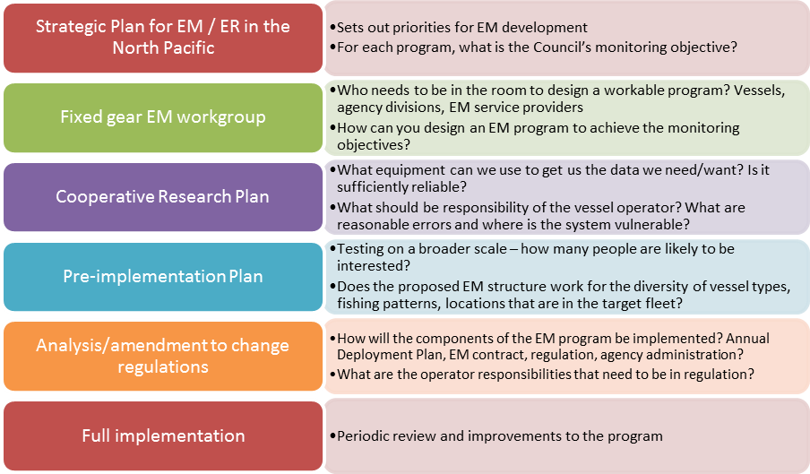

1. EM Deployment Design | Goal: Use best available information to design the EM deployment methods, including the EM selection pool, which meet policy and data collection goals.
- Use the ADP process to define the
  - EM deployment methods and coverage rates
  - Allocate budget between EM coverage and observer coverage
2. Participation | Goal: A pool of EM participants that are capable and committed to making EM work on their boats.
- Opt-in process - NMFS to notify the universe of vessel owners defined by the selection pool and provide the opportunity for eligible vessels to opt-in.
3. Equipment and installation | Goal: Appropriate EM equipment (wiring/sensors, cameras, monitors, hard drives) gets properly installed on each vessel, at the right port, and in a timely fashion, with the least interruption to the fishing plan.
- NMFS contracts with service provider to provide and install equipment on each vessel
  - Specifications/performance standards for equipment would be in the contract (few, if any, regulations would be needed to specify equipment)
  - Contractor works with a vessel operator to write a VMP, which can be amended between trips

Figure ES-3 Preliminary assessment of EM components, organized by implementation vehicle
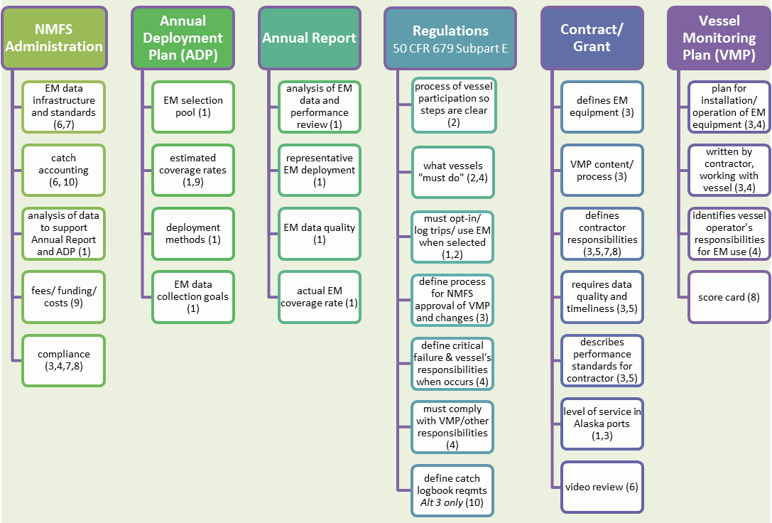

Figure X-X Examples of periodic or annual EM review metrics for EM components

Figures that include multiple info types within the same space
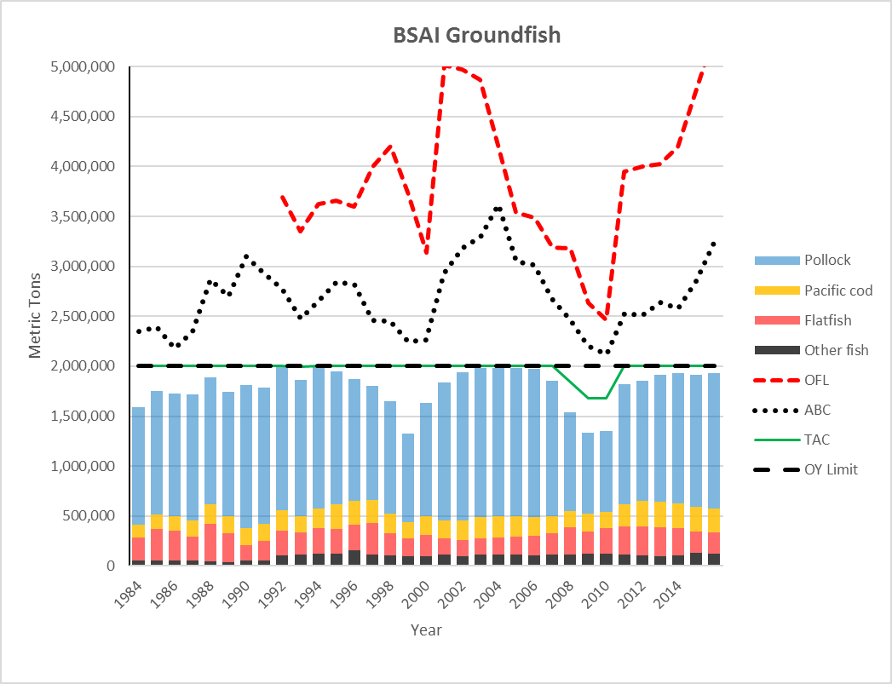
Figure ES-6 Count of longline and pot vessels fishing in 2015, by gear type, target fishery, and size category
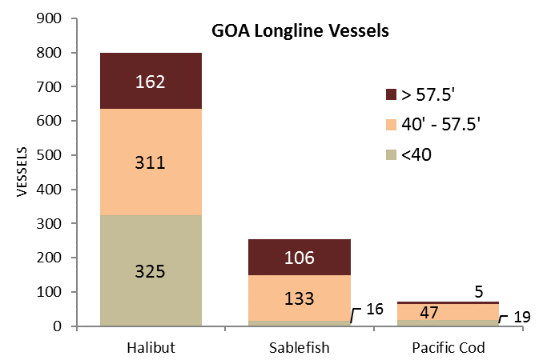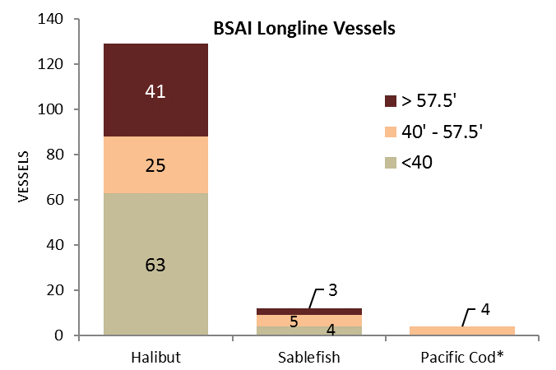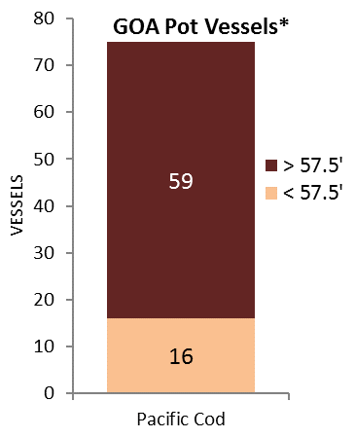
Source: Catch Accounting System, provided by NMFS AKRO.
* Vessel size categories <40 ft and 40-57.5ft LOA have been combined, and pot vessels in the BSAI are not shown, in order to preserve confidentiality.

Figures that show complex relationships - created in powerpoint
Figure ES-1 Flow diagram of Amendment 113 adjustment
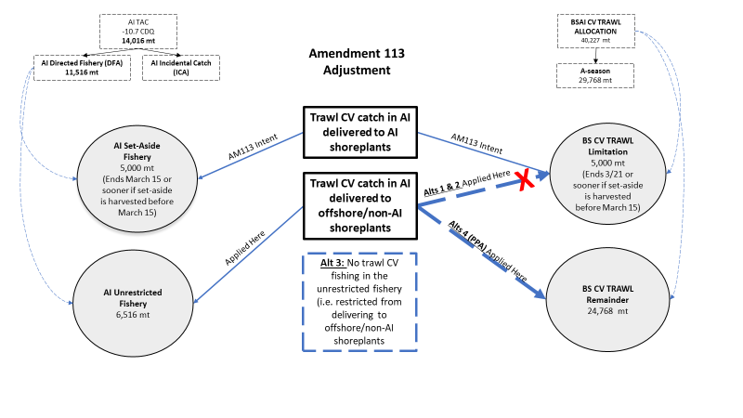
Figure X-3 Feedback among the Core BS FEP, individual Action Modules, and the management process
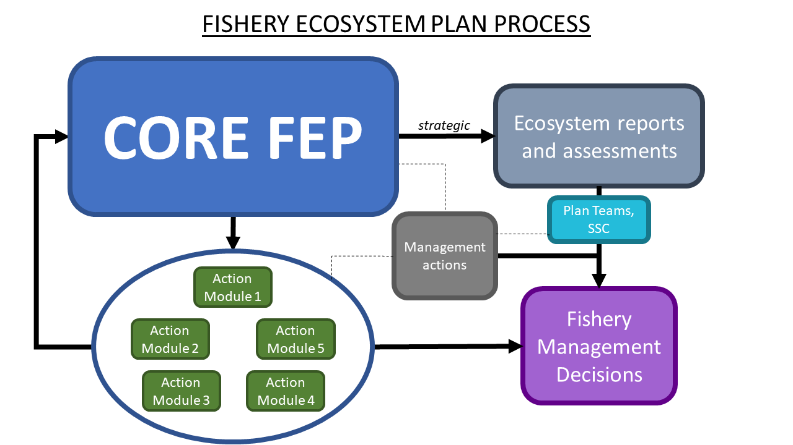

Smart art figures
Figure ES-4 Annual EM cycle
The Draft ADP will identify selection pools, deployment, and draft coverage rates for EM as well as human observer pool participants, on an annual basis.

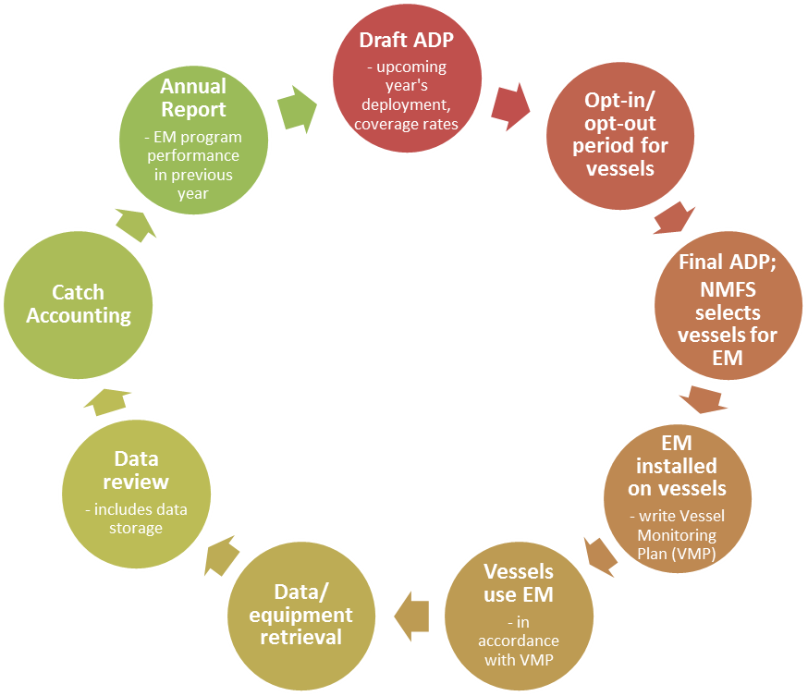
Once the draft ADP is released, vessels wanting to participate in the EM selection pool(s) will have a time period to opt-in* or opt-out for the whole of the upcoming year.

Once the ADP has been finalized, NMFS will select vessels to carry EM for all or part of the year, depending on the deployment model selected in the ADP.

*Once a vessel has initially opted-in, it remains in the EM selection pool for all future years, until either the vessel opts out, or the EM selection pool is changed (through the ADP) such that the vessel is no longer eligible. Vessels will opt-in or opt-our through the existing Observer Declare and Deploy System (ODDS).
After each year, the Annual Report will evaluate the performance of the EM deployment model as part of its overall review of the partial coverage program. This information will be used to improve EM deployment in future ADPs.

Once a vessel has been selected, the contracted EM service provider ensures that the EM system is correctly installed, and creates a VMP (submitted to NMFS for approval) detailing the operator’s responsibilities for the EM system.

The reviewed data will be uploaded to the Observer database and made available to the Catch Accounting System for inseason fishery monitoring.

Vessels proceed with their fishing activity, following the guidelines of the VMP.

Data will be sent for review, and archived as appropriate.

Data and/or equipment will be retrieved as necessary at the conclusion of a vessel’s fishing activity or selection period.

Figure X-4 Anticipated flow of information from video review to the Alaska Fisheries Science Center (AFSC) through the catch estimation process in the Alaska Regional Office (AKRO) catch accounting system.
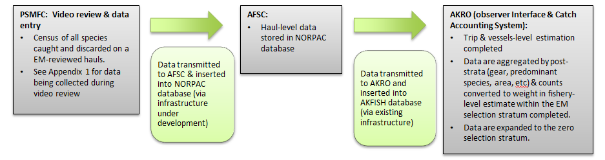
Figure ES-2 Action Module cycle
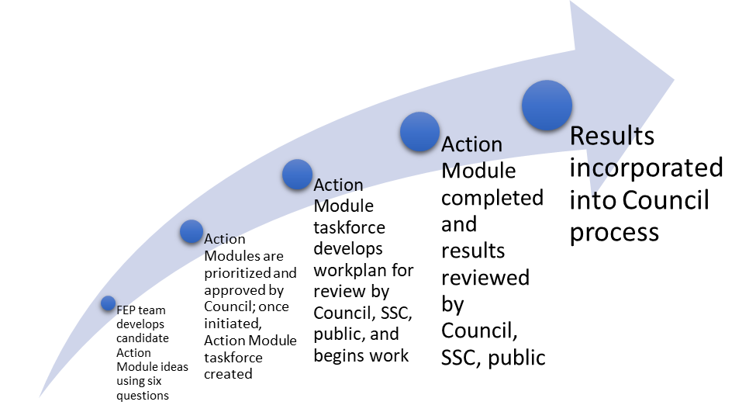
Figure X-X How different Action Module outcomes may be used in fishery management.
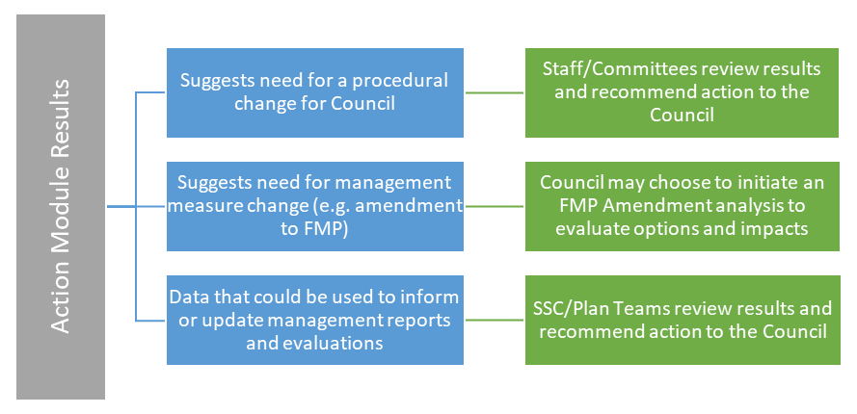
Figure X-X Council process and opportunities for public input (including LK and TK)
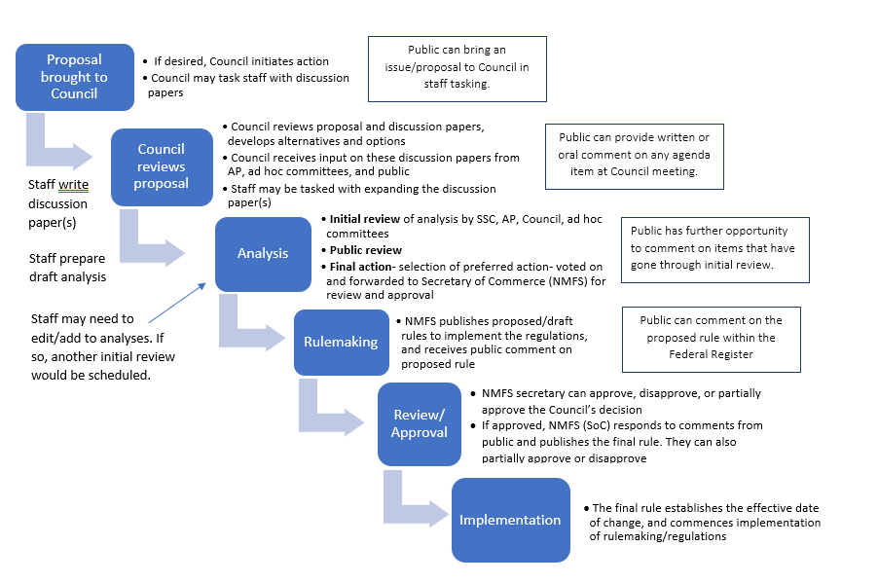

Combining tables and figures to present the same information two ways

Except when their retention is authorized by other applicable law for biological sampling or for programs such as the Prohibited Species Donation Program.
Megan Mackey Personal Communication with Teresa Mongillo (NMFS) 2/28/2018
If the RIR is a stand-alone document because the action qualifies for a CE, add this footnote: "Analysts have consulted with NMFS Alaska Region and preliminarily determined that none of the alternatives have the potential to have an effect individually or cumulatively on the human environment. This determination is subject to further review and public comment. If this determination is confirmed when a proposed rule is prepared, the proposed action will be categorically excluded from the need to prepare an Environmental Assessment."

