Chum management measures considered in 2012
Prior to the development of Amendment 91, the Council had been considering management measures for both chum and Chinook simultaneously. At the time Amendment 84 was approved as an interim measure to the closure of the existing Salmon Savings Areas (based on historical bycatch locations) but information from the portion of the fleet that was not closed to the SSAs was indicating that bycatch rates for both species were higher outside of the closures than inside. Amendment 84 provided an exemption to the SSAs for portions of the fleet that participated in a mandatory rolling hot spot program to mitigate bycatch levels while new management measures were developed. The Council began work on a comprehensive bycatch management package for both chum and Chinook which considered both updated closure areas as well as a range of overall PSC limits by sector, season and species. Following the 2007 spike in Chinook bycatch and continued concerns about the status of western Alaska Chinook stocks, the Council bifurcated the analysis with the indication that management measures for Chinook were the priority action item. Final action on Amendment 91 occurred in 2009 with implementation at the start of the 2011 A season.

Once Amendment 91 was completed the Council restarted development of chum bycatch management measures. After an iterative approach to developing alternatives, an analysis was presented in December 2012 (NPFMC Chum PSC analysis). This analysis evaluated the impacts of a suite of alternative measures to manage chum bycatch in the EBS pollock fishery including a range of PSC limits as well as time area closures. The Council’s problem statement for this analysis was as follows:

Magnuson-Stevens Act National Standards direct management Councils to balance achieving optimum yield with bycatch reduction as well as to minimize adverse impacts on fishery dependent communities. Non-Chinook salmon (primarily made up of chum salmon) prohibited species bycatch (PSC) in the Bering Sea pollock trawl fishery is of concern because chum salmon are an important stock for subsistence and commercial fisheries in Alaska. There is currently no limitation on the amount of non-Chinook PSC that can be taken in the directed pollock trawl fisheries in the Bering Sea. The potential for high levels of chum salmon bycatch as well as long-term impacts of more moderate bycatch levels on conservation and abundance, may have adverse impacts in fishery dependent communities.

Non-Chinook salmon PSC is managed under chum salmon savings areas and the voluntary Rolling Hotspot System (RHS). Hard caps, area closures and perhaps and enhanced RHS may be needed to ensure that non-Chinook PSC is limited and remains at a level that will minimize adverse impacts on fishery dependent communities. The Council should structure non-Chinook PSC management measures to provide incentive for the pollock trawl fleet to improve performance in avoiding non-Chinook salmon while achieving optimum yield from the directed fishery and objectives of the Amendment 91 Chinook salmon PSC management program. Non-Chinook salmon PSC reduction measures should focus, to the extent possible, on reducing impacts to Alaska chum salmon as a top priority.

Three alternatives (in addition to status quo) were considered at that time each with multiple options and sub-options.
Alternative 1: Status Quo (No Action)
Alternative 2: Hard cap
Alternative 3: Triggered closure with inter-cooperative exemption
Alternative 4: Triggered closure with inter-cooperative exemption and options for non-exempt closures
The proposed action alternatives are further explained below.

Alternative 2: Hard Cap
Alternative 2 considered establishing separate chum salmon PSC limits for the pollock fishery in the B season, with accounting towards the cap beginning on June 10. Under this alternative, when the PSC limit is reached, all directed fishing for pollock must cease for either the remainder of the year (Option 1a) or until August 1 (Option 1b). Only those chum salmon caught by vessels participating in the directed pollock fishery would accrue towards the cap. When the cap is reached, directed fishing for pollock would be prohibited during the applicable time frame. Alternative 2 contains components, and options for each component, to determine (1) the total hard cap amount and time frame over which the cap is applied, (2) whether and how to allocate the cap to sectors, (3) whether and how salmon bycatch allocations can be transferred among sectors, and (4) whether and how the cap is allocated to and transferred among catcher vessel (CV) cooperatives. The existing Chum Salmon Savings Area and associated trigger cap would be removed from regulation.

Component 1 – Component 1 would establish the annual PSC limit, based on a range of optional caps,
with 10.7% allocated to the CDQ pollock fishery. There are two options considered to establish the hard
cap. These options differ by whether the cap is established for the entire B season (Option 1a) or for June and July only (Option 1b). There are 6 options for caps under Option 1a, and 6 options for caps under
Option 1b, of which three options encompassing the entire range were selected for analysis.

Component 2 – Component 2 would allow hard caps to be apportioned as sector-level caps for the three
non-CDQ sectors: the inshore CV sector, the mothership sector, and the offshore CP sector. A fishery
level cap would be managed by NMFS with inseason actions to close the fishery once the cap was
reached. The CDQ fishery caps would be allocated and managed at the CDQ group level, as occurs under
status quo. The hard caps could be apportioned to sectors as sector level caps based on the percentages in
the table below. Non-CDQ sector level caps would be managed by NMFS with inseason actions to close the fishery once the cap was reached. The inshore CV sector level cap could be allocated to cooperatives and the inshore CV limited access fishery. The cooperative transferable allocation amounts would be based on the proportion of pollock allocations received by the cooperatives.

Component 3 – Component 3 would provide sectors more opportunity to fully harvest their pollock
allocations, by authorizing the ability to transfer sector allocations and/or rollover unused salmon bycatch.
Options include: no transfers or rollovers, NMFS-approved transfers between sectors, and allowance for
NMFS to roll-over unused bycatch allocation to sectors that are still fishing. A suboption for sector
transfers would limit transfers to the 50%-90% of the salmon that is available to the transferring entity at
the time of transfer.

Component 4 – Component 4 would allow allocation at the co-op level for the inshore sector, and apply
transfer rules at the co-op level for the inshore sector. Sub-options can limit transfers to 50%-90% of
salmon that is available to the transferring entity at the time of transfer. An additional option would allow
NMFS to rollover unused bycatch allocation to inshore cooperatives that are still fishing.
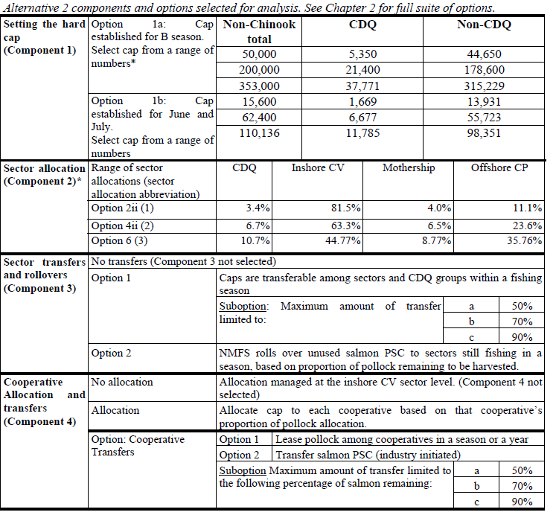

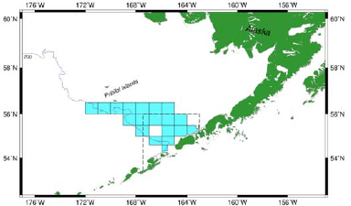
Alternative 3: Triggered Closure with Inter-cooperative Exemption
Alternative 3 would have created new boundaries for the Chum Salmon Savings Area. The existing Chum Salmon Savings Area and associated trigger cap would have been removed from regulation. The new boundaries considered encompass the area of the Bering Sea where historically 80% of non-Chinook prohibited species catch occurred from 2003-2011 (see adjacent figure). The trigger caps that would close this area are described below. The area closure would apply to pollock vessels that are not in a RHS system when total non-Chinook salmon PSC from all vessels (those in a RHS system and those not in a RHS system) reaches the trigger cap level. The trigger cap would be allocated between the CDQ and non-CDQ pollock fisheries, as currently done under status quo.

There is only one component for this alternative. Component 1 of this alternative sets the trigger PSC cap level for this large-scale closure. PSC from all vessels will accrue towards the cap level selected. However, if the cap level is reached, the triggered closure would not apply to participants in the RHS program.

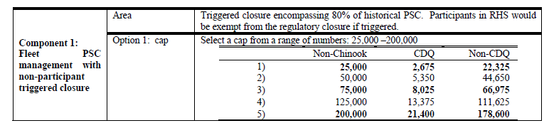
As part of Alternative 3, industry proposed a new RHS that makes a number of modifications to the
existing program in response to requests by the Council. The new proposal achieves several changes that
are likely to be improvements that help meet the Council’s goals of both Western Alaska chum and
Chinook PSC reduction. These changes include an ability to incorporate new genetic information, a
management change whereby closures operate at vessel- or platform-level rather than coop-level, and
suspension of the chum closure program when Chinook PSC rates are higher. Other measures in the
program will facilitate more efficient pollock harvest, which in some years is likely to reduce fishing in
October, thus likely reducing Chinook PSC. These measures include a floor on the base rate so that
closures are not unnecessarily implemented when they are not expected to be effective, and a change of
the start-time of closures from 6pm to 10pm.
Alternative 4: Triggered Closure with Inter-cooperative Exemption and Options for Non-exempt Closures
As with Alternative 3, Alternative 4 would have create new boundaries for the Chum Salmon Savings Area. The existing Chum Salmon Savings Area and associated trigger cap would have been removed from regulation. The new boundaries in this alternative would have encompassed the area of the Bering Sea where historically 80% of non-Chinook prohibited species catch occurred from 2003-2011. The trigger caps that would close this area are described below, with accounting against the closure to being on June 10. The area closure would apply to pollock vessels that are not in a RHS system when total non-Chinook salmon PSC from all vessels (those in a RHS system and those not in a RHS system) reaches the trigger cap level. The trigger cap would be allocated between the CDQ and non-CDQ pollock fisheries, as currently done under status quo. The revised RHS program proposed under Alternative 3 would also apply under this alternative.

There are 6 components of Alternative 4. Component 1 of this alternative sets the trigger PSC cap level
for this large-scale closure. PSC from all vessels will accrue towards the cap level selected (ranging from
25,000 to 200,000), with accounting towards the cap beginning on June 10. However, if the cap level is
reached, the triggered closure would not apply to participants in the RHS program. Under Component 2
however, in addition to the large closure for non-participants, a select triggered area closure would apply
to RHS participants. Four options of triggered closure areas and time frames are provided under Component 2. Note that the closure areas are larger under Option 1 because they are based on areas that
incorporate a higher proportion of the historical chum salmon bycatch than in Option 2.

Option 1: A trigger closure would be established that encompasses 80% of historical non-Chinook salmon PSC estimates.
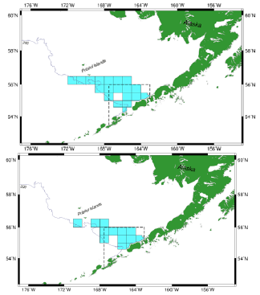
Sub-option 1a) The trigger closure would apply for the B season. The adjacent figure shows the areas closed under this sub-option.

Sub-option 1b) The trigger closure would apply for the months of June-July only. The adjacent figure shows the areas closed under this sub-option.

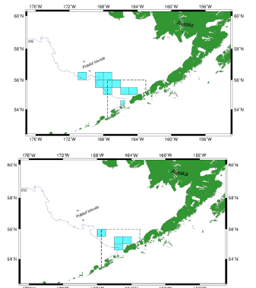
Option 2: A trigger closure encompassing 60% of historical non-Chinook salmon PSC estimates.

Sub-option 2a) Trigger closure would only apply for B-season. The adjacent figure shows the areas closed under this sub-option.

Sub-option 2b) Trigger closure would apply for the June-July. The adjacent figure shows the areas closed under this sub-option.

Component 3 then sets the trigger PSC cap level for the area selected under Component 2. Component 4
would allocate the trigger cap to at the sector level. Component 5 sets the sector-level rollover and
transferability provisions. Component 6 would allocate the trigger cap for the inshore sector at the
cooperative level. A summary of the components analyzed for Alternative 4 are listed in the table below.
Finally, an option to this alternative as a whole includes the ability to specify just the goals and objectives
of the revised RHS in regulation rather than specifying all provisions of the program in regulation as is done under the status quo.
