Consideration of the Charter Halibut Management Timeline
Staff Memo October 2023

The timeline for the charter halibut management process that is used to set charter halibut management measures was developed and defined in the creation of the Catch Sharing Plan. This process is intended to allow annual adjustments to the management measures to ensure the charter sector remains at or below its allocation given the best information available for predicting charter harvest for the following year, without inseason adjustments. This is a collaborative process which involves input from stakeholders, ADF&G, the Council, NMFS and the IPHC (Figure 1). However, the timeline in place generates a bottleneck for affected stakeholders and decision-makers in December each year, providing ADF&G staff only a brief window to finalize the analysis, and subsequently a short opportunity for Charter Halibut Management Committee members to discuss management measures with other stakeholders prior to providing recommendations to the AP and Council. Staff were asked to consider the challenges with the timeline and discuss possible solutions. This memo was prepared to address this request.
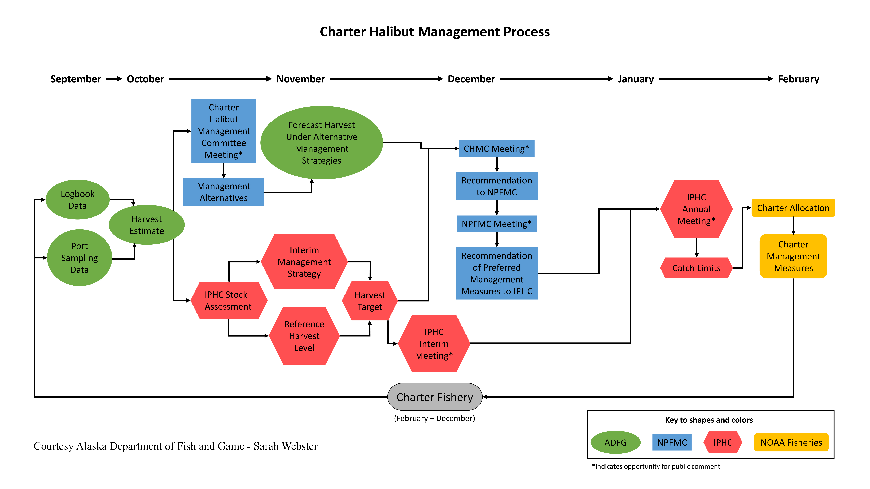
Figure 1 Diagram of the annual charter halibut management process
The bottleneck in the current decision-making process is primarily due to the Nov/ Dec pinch between the Interim IPHC meeting, which provides reference points for completion of the ADF&G analysis, and availability of the analysis with enough time to socialize the results with affected charter halibut stakeholder and solicit feedback on proposed management measures prior to the Charter Halibut Management Meeting. Scheduling of the Charter Halibut Management Meeting has been constrained by a desire to provide recommendations in time for consideration by the Council’s Advisory Panel (AP), which must occur prior to the Council’s consideration of charter management measures.

For instance, the timelines below demonstrate the schedules for the last 3 years:
2020 (virtual) – 5 days between analysis and Committee meeting
Sun | Mon | Tues | Wed | Thur | Fri | Sat
Nov 15 | 16 | 17 | 18 Interim IPHC mtg | 19 Interim IPHC mtg | 20 | 21
22 | 23 | 24 | 25 ADF&G analysis available | 26 | 27 | 28
29 | 30 AP mtg  Committee mtg (1 pm – 5pm) | Dec 1 AP mtg | 2 AP mtg – charter measures | 3 AP mtg  Council mtg | 4 AP mtg  Council mtg- charter measures | 5 AP mtg
6 | 7 Council mtg | 8 Council mtg | 9 Council mtg | 10 Council mtg | 11 Council mtg | 12 Council mtg

2021 (virtual) – 4 days between analysis and Committee meeting
Sun | Mon | Tues | Wed | Thur | Fri | Sat
 | Nov 29 | 30 Interim IPHC mtg | Dec 1 Interim IPHC mtg | 2 AP mtg  ADF&G analysis available | 3 AP mtg | 4
5 | 6 AP mtg Committee mtg (8am- 4pm) | 7 AP mtg – charter measures | 8 AP mtg  Council mtg | 9 AP mtg  Council mtg | 10  Council mtg | 11
12 | 13 Council mtg | 14 Council mtg | 15 Council mtg | 16 Council mtg | 17 | 18

2022 – 5 days between tables and Committee meeting
Sun | Mon | Tues | Wed | Thur | Fri | Sat
 |  | Nov 29 | 30 Interim IPHC mtg | Dec 1 Interim IPHC mtg | 2 Tables from ADF&G analysis available | 3
4 | 5 ADF&G analysis available | 6 AP mtg | 7 AP mtg  Committee mtg (8am- 1pm) | 8 AP mtg  Council mtg | 9 AP mtg – charter measures  Council mtg | 10  Council mtg
11 Council mtg | 12 Council mtg | 13 Council mtg | 14 Council mtg | 15 | 16 | 17

The Council and Charter Halibut Management Committee are interested in options that would extend the opportunity for charter stakeholders to review the ADF&G analysis prior to Committee recommendations. Whether a few days extension would suffice or whether the Council/ Committee’s desire would be for a process that provides substantially more review time will dictate the changes that might be considered. Staff considered several types of options, which are not mutually exclusive from each other (i.e., choosing more than one could address the timing issues even better). Most would not require any formal or regulatory change and could be implemented as soon as this December 2023 meeting. Option 5 would require regulatory change.
Staff note that the Council does not have influence of the IPHC’s meeting schedule and pushing the Council December meeting dates back is not viable option due to the holiday season. In addition, electronic logbooks will be mandatory for Area 3A in 2025. This means Area 3A data should be available earlier for ADF&G analysts. This may not address the bottleneck between the interim IPHC and Committee meetings, but paired with some other options that are explored by staff this could influence the timeline for stakeholder input as well.
Options considered by staff:
- Established (but malleable) hierarchy of management measures for each area and less management measure options for analysis.
- The Committee members could work with affected stakeholders to define a more standardized (but still changeable) system of management measures to implement. This may take pressure off of soliciting public input during the bottleneck period in between analysis and Committee meeting.
- This would be on the Committee members to execute.
- It seems like we’re pretty close to this; usually the chosen measures are not too different than what has occurred previously.
- This could streamline the analysis. If taken along with another option (e.g., Option 4), it could get the analysis out quite a bit earlier.
- Limit the annual process for the AP.
- Currently the Committee must meet before the end of the AP so the AP can hear the presentations and provide recommendations. But the AP does not have to weigh in on annual charter management measures.
- Could also consider providing an informational report to the AP (possibly in staff tasking) if that was desired.
- This would only provide a few more days for stakeholders.
- Two-part Committee meeting.
- Split the meeting up. Staff presentations could be virtual earlier in the week, and recommendations could be an evening session later in the week. Possibly recommendations could be a quick 1-2 hr meeting.
- Would only provide a few extra days.
- Release the analysis prior to the Interim IPHC meeting, but with only last year as a reference point.
- The primary information incorporated into the analysis from the Interim IPHC meeting includes reference points that anchor the analysis around possible allocations that could result from the TCEY. The analysis uses this information to demonstrate management measures throughout that are predicted to achieve the appropriate yield given the reference levels. However, even at this stage the IPHC is not locked into any of these reference levels. The analysis could be released using the previous years’ TCEY as a reference level.
- This could potentially give stakeholders a lot longer (1 week +) to review the analysis.
- If desired, staff could provide an additional memo when the reference points are available that highlights which measures could be used.
- Would this be helpful or confusing to stakeholders?
- One-year lag in management measures or setting measures for two years at a time.
- These options would both require regulatory action and coordination with other regulatory bodies (ADF&G and the IPHC).
- They would both restructure the management measure process and decrease the precision in estimates.
For this upcoming year, the Interim IPHC meeting is scheduled for Nov 30 – Dec 1. The Dec Council meeting begins with the SSC on Dec 4. This could create an even tighter pinch that last year.
2023
Sun | Mon | Tues | Wed | Thur | Fri | Sat
 |  |  | Nov 29 | 30 Interim IPHC mtg | Dec 1 Interim IPHC mtg | 2
3 | 4 | 5 AP mtg | 6 AP mtg  Proposed timing for Committee mtg (evening) | 7 AP mtg  Council mtg | 8 AP mtg  Council mtg | 9  Council mtg
10 Council mtg | 11 Council mtg | 12 | 13 | 14 | 15 | 16

Prepared by Sarah Marrinan, with review from Brianna Bowman (ADF&G), Sarah Webster (ADF&G), and Kurt Iverson (NMFS)

