Aleutian Islands Golden King Crab Model Discussions and Scenarios for May 2019Assessment

Draft report for the January 2019 Crab Plan Team Meeting

Prepared by:

M.S.M. Siddeek^{1,} J. Zheng¹, C. Siddon¹, B. Daly², and M.J. Westphal³,
¹Alaska Department of Fish and Game, Division of Commercial Fisheries, P.O. Box 115526, Juneau, Alaska 99811
²Alaska Department of Fish and Game, Division of Commercial Fisheries, 351 Research Ct., Kodiak, Alaska 99615

³Alaska Department of Fish and Game, Division of Commercial Fisheries, PO Box 920587, Dutch Harbor, Alaska 99692Preamble

Preamble
In this report, we provide a set of model scenarios that could be selected for May 2019 assessment and OFL and ABC determination for the Aleutian Islands golden king crab. The scenarios were based on re-evaluation of observer database and CPUE standardization method. These follow some of the recommendations made by the May 2018 CPT, June 2018 SSC, and June 2018 CIE review reports. We compared parameter estimates and reference points results between the three proposed model scenarios 18_0, 18_1, and 18_1a. Following May 2018 CPT recommendation, the OFL and ABC projections for the 2019/20 fishery were made considering three year mean of retained and groundfish bycatch to fill the gap for the 2018/19 completed fishery data. There were minor differences in the estimated parameters and reference point results among the three scenarios. We suggest either 18_1 or 18_1a model for the May2019 OFL and ABC estimation.

Please note that this document does not follow the standard CPT stock assessment format. For detailed accounts of the Aleutian Islands golden king crab model formulation, fisheries, and biology, we direct you to the stock assessment report presented at the May 2018 CPT and June 2018 SSC meetings (Siddeek et al. 2018).

Executive Summary

Stock
Golden king crab, Lithodes aequispinus, Aleutian Islands, east of 174° W longitude (EAG) and west of 174° W longitude (WAG).

Catches
The Aleutian Islands golden king crab commercial fishery has been prosecuted since 1981/82 and opened every year since then. Retained catch peaked in 1986/87 at 2,686 t (5.922,425 lb) and 3,999 t (8,816,319 lb), respectively, for EAG and WAG, but the retained catch dropped sharply from 1989/90 to 1990/91. The fishery has been managed separately east (EAG) and west (WAG) of 174° W longitude since 1996/97 and Guideline Harvest Levels (GHLs) of 1,452 t (3,200,000 lb) for EAG and 1,225 t (2,700,000 lb) for WAG were introduced into management for the first time in 1996/97. The GHL was subsequently reduced to 1,361 t (3,000,000 lb beginning in 1998/99 for EAG. The reduced GHLs remained at 1,361 t (3,000,000 lb) for EAG and 1,225 t (2,700,000 lb) for WAG through 2007/08, but were increased to 1,429 t (3,150,000 lb) for EAG and 1,294 t (2,835,000 lb) for WAG beginning with the 2008/09 fishing season following an Alaska Board of Fisheries (BOF) decision. The acronym changed from GHL to TAC (Total Allowable Catch) since crab rationalization in 2005/06. The TACs were further increased by another BOF decision to 1,501 t (3,310,000 lb) for EAG and 1,352 t (2,980,000 lb) for WAG beginning with the 2012/13 fishing season.

Catches have been steady since the introduction of GHL/TAC and the fishery has harvested close to TAC levels since 1996/97. These TAC levels were below the ABCs determined under Tier 5 criteria (considering 1991–1995 mean catch for the whole Aleutian Islands region, 3,145 t (6,933,822 lb), as the limit catch) under the most recent crab management plan. The below par fishery performance in WAG in recent years lead to reduction in TAC to 1,014 t (2,235,000 lb), which reflected a 25% reduction on the TAC for WAG, while the TAC for EAG was kept at the same level, 1,501 t (3,310,000 lb) for the 2015/16 through 2017/18 fishing seasons. Following the BOF recommendation in March 2018 to change the TAC based on stock status and fishery performance, the TACs were increased to 1,134 t (2,500,000 lb) for WAG and 1,749 t (3,856,000lb) for EAG beginning with the 2018/19 fishing season. In addition to the retained catch that is allotted as TAC, there was retained catch in a cost-recovery fishery towards a $300,000 goal in 2013/14 and 2014/15, and towards a $500,000 goal in 2015/16 and 2016/17.

Catch per pot lift (CPUE) of retained legal males decreased from the 1980s into the mid-1990s, but increased steadily after 1994/95 and increased markedly at the initiation of the Crab Rationalization program in 2005/06. Although CPUE for the two areas showed similar trends through 2010/11, during 2011/12–2014/1 5 CPUE trends have diverged (increasing EAG and decreasing WAG). Total retained catch in 2017/18 was 2,585 t (5,699,152 lb): 1,571 t (3,464,429 lb) from the EAG fishery, which included cost-recovery catch, 1,014 t (2,234,723 lb) from the WAG fishery. Discarded (non-retained) catch occurs mainly during the directed fishery. Although low levels of discarded catch can occur during other crab fisheries, there have been no such fisheries prosecuted since 2004/05, except as surveys for red king crab conducted under a commissioner’s permit (and there were none caught during the cooperative red king crab survey performed by industry and ADF&G in the Adak area in September 2015 (Hilsinger et al. 2016). Estimates of the bycatch mortality during crab fisheries decreased during 1995/96–2005/06, both in absolute value and relative to the retained catch weight and stabilized during 2005/06–2014/15. Total estimated bycatch mortality during crab fisheries in 2017/18 was 219 t (483,000 lb) for EAG and 126 t (278,000 lb) for WAG. Discarded catch also occurs during fixed-gear and trawl groundfish fisheries, but is small relative to that during the directed fishery and the groundfish fisheries are a minor contributor to total fishery mortality. Estimated bycatch mortality during groundfish fisheries in 2017/18 was 10 t (22,000 lb) for EAG and 2 t (4,000 lb) for WAG. A cooperative golden king crab survey was performed by the Aleutian Islands King Crab Foundation (an industry group) and ADF&G during the EAG fishery in August 2016, by vessels that were simultaneously fishing. During the survey work, adjustments were made to a portion of the gear so escape mechanisms were no longer functional. However, for the purpose of catch accounting for 2017/18, it was assumed that bycatch mortality that occurred during the survey was accounted for by reported discards for the 2017/18 EAG fishery. The cooperative survey was also conducted in August 2018 during the 2018/19 EAG fishery.

Stock biomass
Estimated mature male biomass (MMB) for EAG under all scenarios decreased from high levels during the 1990s, then systematically increased during the 2000s and 2010s. Estimated MMB for WAG decreased during the late 1980s and 1990s, systematically increased during the 2000s, and decreased for several years since 2009. The low levels of MMB for EAG were observed in 1995–1997 and in 1990s for WAG. Slightly increasing trends in MMB were observed since 2014 in both regions. Stock trends reflected the fishery standardized CPUE trends in both regions.

Recruitment
The numbers of recruits to the model size groups under all scenarios have fluctuated in both EAG and WAG. For EAG, the model recruitment was high in 2014 and 2015, and highest in 2015; and lowest in 1986. An increasing trend in recruitment was observed since the early-1990s in EAG. The model recruitment for WAG was high during 1984 to 1986 and highest in 1985; and lowest in 1991. A redusing trend in recruitment was observed since the early-1990s in WAG.

Management performance
The model was accepted at the September 2016 CPT and October 2016 SSC meetings for OFL determination for the 2017/18 fishery cycle. In addition, the CPT in January 2017 and SSC in February 2017 recommended using the Tier 3 method to compute OFL and ABC. The assessment model was first used for setting OFL and ABC for the 2017/18 fishing season. This was followed for the second season in 2018/19. The CPT in May 2017 and SSC in June 2017 accepted author’s recommendation of using scenario 9 (i.e., model using the knife edge maturity to determine MMB) for OFL and ABC calculation. During the May 2017 meeting, the CPT noted that a single OFL and ABC are defined for Aleutian Islands golden king crab (AIGKC). However, separate models are available by area. Hence, following previous presentations, OFLs and ABCs by area were added to calculate OFL and ABC for the entire stock.

Among the three common scenarios for EAG and WAG, we recommend two scenarios [18_1 (re-evaluation of observer CPUE indices after reducing the number of gear codes) and 18_1a (same as scenario 18_1, but crab fishery bycatch mortality rate scaled by the annual bycatch amount)]. Scenario 18_0 is the base scenario with the knife edge male maturity at 111 mm CL, an M of 0.21yr⁻¹ and the addition of 2017/18 data. Scenarios 18_1 and 18_1a are modifications from the base scenario.

Status and catch specifications (1000 t) of Aleutian Islands golden king crab
Year | MSST | Biomass (MMB) | TAC | Retained Catch | Total Catchª | OFL | ABC^{b}
2015/16 | N/A | N/A | 2.853 | 2.729 | 3.076 | 5.69 | 4.26
2016/17 | N/A | N/A | 2.515 | 2.593 | 2.947 | 5.69 | 4.26
2017/18 | 6.044 | 14.205 | 2.515 | 2.585 | 2.942 | 6.048 | 4.536
2018/19^{c} | 6.046 | 17.952 | 2.883 |  |  | 5.514 | 4.136
2019//20^{d} | 5.976 | 16.095 |  |  |  | 5.159 | 3.948.
2019/20e | 5.990 | 16.000 |  |  |  | 5.086 | 3.892
2019/20^{f} | 5.713 | 15.465 |  |  |  | 4.869 | 3.726
- Total retained catch plus estimated bycatch mortality of discarded bycatch during crab fisheries and groundfish fisheries.
- 25% buffer was applied to total catch OFL to determine ABC.
- 17_0 2018/19 accepted scenario with Francis method of re-weighting
- 18_0 base scenario with Francis method of re-weighting
- 18_1 scenario 18_0 modified with number of gear code reduced for observer CPUE standardization
- 18_1a scenario 18_1 with pot fishery bycatch mortality rate scaled by annual pot fishery bycatch

Status and catch specifications (million lb) of Aleutian Islands golden king crab
Year | MSST | Biomass (MMB) | TAC | Retained Catch | Total Catchª | OFL | ABC^{b}
2015/16 | N/A | N/A | 6.290 | 6.016 | 6.782 | 12.53 | 9.40
2016/17 | N/A | N/A | 5.545 | 5.716 | 6.497 | 12.53 | 9.40
2017/18 | 13.325 | 31.315 | 5.545 | 5.699 | 6.487 | 13.333 | 10.000
2018/19^{c} | 13.329 | 39.577 | 6.356 |  |  | 12.157 | 9.118
2019//20^{d} | 13.174 | 35.483 |  |  |  | 11.606 | 8.704
2019/20e | 13.204 | 35.274 |  |  |  | 11.440 | 8.580
2019/20^{f} | 12.594 | 34.096 |  |  |  | 10.977 | 8.215
- Total retained catch plus estimated bycatch mortality of discarded bycatch during crab fisheries and groundfish fisheries.
- 25% buffer was applied to total catch OFL to determine ABC.
- 17_0 2018/19 accepted scenario with Francis method of re-weighting
- 18_0 base scenario with Francis method of re-weighting
- 18_1 scenario 18_0 modified with number of gear code reduced for observer CPUE standardization
- 18_1a scenario 18_1 with pot fishery bycatch mortality rate scaled by annual pot fishery bycatch

Basis for the OFL
The length-based model developed for the Tier 3 analysis estimated MMB on February 15 each year for the period 1986 through 2018 (2018/19 data was the recent three-year mean retained catch and groundfish bycatch) and projected to February 15, 2019 for OFL and ABC determination for the 2019/20 season. The Tier 3 approach uses a constant annual natural mortality (M) and the mean number of recruits for the period 1987 – 2012 for OFL and ABC calculation. An M of 0.21 yr⁻¹ derived from the combined data was used.

We provide the OFL and ABC estimates for EAG, WAG, and the two regions pooled together (i.e., for the entire Aleutian Islands, AI) for three scenarios 18_0, 18_1, 18_1a in the following six tables. We treat scenario 18_0 as the base scenario for EAG and WAG.

EAG (Tier 3):
Biomass, total OFL, and ABC for the next fishing season in millions of pounds. Current MMB = MMB on 15 Feb. 2018. The OFL and ABC for 2019/20 were projected considering recent three-year mean retained catch and groundfish bycatch for the incomplete 2018/19 fishing season.
Scenario | Tier | MMB_{35%} | Current MMB | MMB/  MMB_{35%} | F_{OFL} | Recruitment Years to define MMB_{35%} | F_{35%} | OFL | ABC  (P*=0.49) | ABC  (0.75*OFL)
EAG18_0 | 3a | 14.982 | 23.682 | 1.58 | 0.644 | 1987–2012 | 0.644 | 8.141 | 7.978 | 6.106
EAG18_1 | 3a | 14.958 | 23.327 | 1.56 | 0.644 | 1987–2012 | 0.644 | 7.928 | 7.770 | 5.946
EAG18_1a | 3a | 14.285 | 22.538 | 1.58 | 0.644 | 1987–2012 | 0.644 | 7.617 | 7.465 | 5.713

Biomass in 1000 t; total OFL and ABC for the next fishing season in t.
Scenario | Tier | MMB_{35%} | Current MMB | MMB/  MMB_{35%} | F_{OFL} | Recruitment Years to Define MMB_{35%} | F_{35%} | OFL | ABC  (P*=0.49) | ABC  (0.75*OFL)
EAG18_0 | 3a | 6.796 | 10.742 | 1.58 | 0.644 | 1987–2012 | 0.644 | 3,692.810 | 3,618.954 | 2,769.608
EAG18_1 | 3a | 6.785 | 10.581 | 1.56 | 0.644 | 1987–2012 | 0.644 | 3,596.260 | 3,524.335 | 2,697.195
EAG18_1a | 3a | 6.479 | 10.223 | 1.58 | 0.644 | 1987–2012 | 0.644 | 3,455.010 | 3,385.910 | 2,591.258

WAG (Tier 3):
Biomass, total OFL, and ABC for the next fishing season in millions of pounds. Current MMB= MMB on 15 Feb. 2018. The OFL and ABC for 2019/20 were projected considering recent three-year mean retained catch and groundfish bycatch for the incomplete 2018/19 fishing season.
Scenario | Tier | MMB_{35%} | Current MMB | MMB/  MMB_{35%} | F_{OFL} | Recruitment Years to Define MMB_{35%} | F_{35%} | OFL | ABC  (P*=0.49) | ABC  (0.75*OFL)
WAG18_0 | 3a | 11.365 | 11.801 | 1.04 | 0.596 | 1987–2012 | 0.596 | 3.465 | 3.395 | 2.598
WAG18_1 | 3a | 11.451 | 11.947 | 1.04 | 0.596 | 1987–2012 | 0.596 | 3.512 | 3.442 | 2.634
WAG18_1a | 3a | 10.903 | 11.558 | 1.06 | 0.596 | 1987–2012 | 0.596 | 3.360 | 3.269 | 2.502

Biomass in 1000 t; total OFL and ABC for the next fishing season in t.
Scenario | Tier | MMB_{35%} | Current MMB | MMB / MMB_{35%} | F_{OFL} | Recruitment Years to Define MMB_{35%} | F_{35%} | OFL | ABC  (P*=0.49) | ABC  (0.75*OFL)
WAG18_0 | 3a | 5.155 | 5.353 | 1.04 | 0.596 | 1987–2012 | 0.596 | 1,571.490 | 1,540.060 | 1,178.618
WAG18_1 | 3a | 5.194 | 5.419 | 1.04 | 0.596 | 1987–2012 | 0.596 | 1,593.020 | 1,561.160 | 1,194.765
WAG18_1a | 3a | 4.946 | 5.242 | 1.06 | 0.596 | 1987–2012 | 0.596 | 1,513.280 | 1,483.014 | 1,134.960

Aleutian Islands (AI)
Total OFL and ABC for the next fishing season in millions of pounds.
Scenario | OFL | ABC | ABC
Scenario | OFL | (P*=0.49) | (0.75*OFL)
18_0 | 11.606 | 11.373 | 8.704
18_1 | 11.440 | 11.212 | 8.580
18_1a | 10.977 | 10.734 | 8.215
Aleutian Islands (AI)
Total OFL and ABC for the next fishing season in t.
Scenario | OFL | ABC | ABC
Scenario | OFL | (P*=0.49) | (0.75*OFL)
18_0 | 5,264.30 | 5,159.01 | 3,948.23
18_1 | 5,189.28 | 5,085.50 | 3,891.96
18_1a | 4,968.29 | 4,868.92 | 3,726.22

Input Data

Summary of Major Changes

Changes to input data

Retained catch (1981/82–2017/18), total catch (1990/91–2017/18), and groundfish bycatch (1989/90–20167/18) biomass and size compositions.

Observer pot sample legal size crab CPUE data were standardized by the generalized linear model (GLM) with the negative binomial link function, separately for 1995/96–2004/05 and 2005/06–20167/18 periods.

Fish ticket retained CPUE were standardized by the GLM with the lognormal link function for the 1985/86–1998/98 period.

Proposed model scenarios are defined in Table A.

.

Table A. Model Scenarios

The listed scenarios were common to both EAG and WAG. Following CPT and SSC suggestion, model scenario codes were identified as follows. e.g., 18_0: 2017 accepted model with data extended to 2017/18 completed fishery. 18_1: the 18_0 model with observer data modified for CPUE standardization, and 18_1a: model with pot bycatch mortality rate scaled by the amount of bycatch. Changes are marked by light gray.

Scenario | Size-composition weighting | Catchability and logistic total selectivity sets | Maturity | CPUE data type | Initial Abundance, Treatment of M and Tier 3 MMB_{MSY} reference points | Natural mortality (M yr⁻¹)
18_0 | Stage-1: Number of days/trips  Stage-2: Francis method | 2 | Knife-edge  111 mmCL | Observer from 1995/96–2017/18 & Fish Ticket from 1985/86–1998/99 | Initial abundance by equilibrium condition; estimated common M using the combined EAG and WAG | 0.21
18_1 | Stage-1: Number of days/trips  Stage-2: Francis method | 2 | Knife-edge  111 mmCL | Observer from 1995/96–2017/18; Number of gear codes were reduced for CPUE standardization & Fish Ticket from 1985/86–1998/99 | Initial abundance by equilibrium condition; estimated common M using the combined EAG and WAG | 0.21
18_1a | Stage-1: Number of days/trips  Stage-2: Francis method | 2 | Knife-edge  111 mmCL | Observer from 1995/96–2017/18; Number of gear codes were reduced for CPUE standardization & Fish Ticket from 1985/86–1998/99 | Initial abundance by equilibrium condition; estimated common M using the combined EAG and WAG.  Pot bycatch mortality scaled by the amount of bycatch. | 0.21

Response to May 2018 CPT comments:

Comment 1: Base OFL and ABC recommendations on a model projection for the coming fishing year that includes total catch for the concluded fishing year.

Response:
Because at the time of May 2019 CPT meeting the 2018/19 completed fishery data are not going to be ready, we projected the next year OFL and ABC considering a total catch composed of recent three-year mean retained catch, model predicted pot fishery bycatch, and recent three-year mean groundfish bycatch. The OFLs and ABCs listed in the executive summary are based on this procedure.

Comment 2: Reanalyze chela measurement data for AIGKC using new analytical techniques developed for snow crab and Tanner crab.

Response:
We are currently collecting more chela measurement data from the Observer, dockside retained catch, and independent survey (in EAG) sampling. The first set of extended data will not be available for completing the revised analysis for the May 2019 CPT meeting. However, we will complete the re-analysis for May 2020 presentation.

We are also collecting additional length-weight data during the 2018/19 fishing season from the independent survey sampling which covers all sizes and both regions. These data will enable us to update the length-weight relationship separately for EAG and WAG. We will complete this analysis for the May 2020 CPT.

Comment 3: Work on appropriate statistical models for analysis of ADF&G cooperative pot survey that reflect the nested sampling design of vessels, strings within vessel, and pots within strings and consider the use of random effects as appropriate.

Response:
We have completed for seasons’ (2015/16, 2016/17, 2017/18, and 2018/19) independent survey sampling in the EAG region. Still the data series is not long enough to provide meaningful results. As per your guidelines, we will follow the random effect approach and present the results at the 2020 CPT meeting.

Comment 4: Continue work on the VAST spatial modeling approach. This work can be given lower priority until approaches using VAST for CPUE data are better established and suitable model diagnostics become available.
Response:
We temporarily stopped using VAST to Aleutian Islands golden king crab CPUE index analysis because of the islands’ edge effects that are not addressed by the current version of VAST. Furthermore, CPT plans to discuss the suitability of VAST for crab abundance index estimation.

Comment 5: Continue exploration of year-area interactions using appropriate analytical methods, and develop area weights using fishing footprint calculations.

Response:
With the modification of observer database [following CIE review suggestion, fishery industry input, and SSC comment (below)] we re-analyzed the CPUE index. The Year:Area interaction was not selected by the hybrid stepwise selection procedure (see Appendix B). We suspect with the detail area locations (Lat and Long), there is a possibility of severe collinearity between Area and Year. We are investigating this further. For the current stock assessment, we considered the main effect final model.
.
Comment 6: . A standard set of plots should be prepared to summarize the B0 calculations for each model-based crab assessment, including AIGKC. Plot 1 should compare dynamic B0 and the estimated time series of mature male biomass. Plot 2 should plot the B0 depletion ratio, MMB/B0. Plot 3 should plot the estimated recruitment time series. These plots should be collated, and used to develop recommendations on the use of B0 in Bering Sea crab assessments at the September 2018 CPT meeting for subsequent SSC review. This should be flagged as a general recommendation applicable to all assessed stocks.

Response:
Done. See Figures 17 (EAG) and 18 (WAG).

Response to June 2018 SSC comments:

Comment 1: The SSC reminds all stock assessment authors to implement the guidelines for model numbering for consistency and easier version tracking over time. The authors should use their best estimate of catch for current and future years to get the best estimate of projected ABC/OFLs. The groundfish stock assessment authors have adopted methods to do this, such as using the 3-year average ratio of catch/TAC.
Response:
We followed CPT suggested model numbering.
We used the three-year mean retained and groundfish bycatch to project the OFL/ABC for the next year when the current year fishery data are not available.
Comment 2: There is continued high uncertainty about maturity. Using knife-edge maturity, as currently implemented, was an interim fix due to problems with estimating maturity at size. We support and encourage efforts to obtain additional chela measurements to improve the parameterization of maturity in the model as a probabilistic function of size (e.g., logistic).

Response:
Please read our response to CPT comment#2. We will be developing a logistic curve with the additional data and analysis.

Comment 3: We encourage the co-operative survey to be continued and endorse further work to include this independent survey into the model. The SSC specifically endorses the CPT recommendation to use nested random effects for strings within vessels and for pots within strings in a mixed-effects model.
The SSC also requests the authors to include a brief description of the cooperative survey in the document, including the area sampled, size composition, and a summary of trends in CPUE.

Response:
Please read CPT comment#3. We will provide a description of the survey.
Comment 4: The use of the VAST model as a geostatistical modeling approach for smoothing CPUE data is still relatively new and is particularly challenging in the Aleutians because of the many islands and associated edge effects. We agree with the CPT that the VAST model will require more analyses, which are ongoing, before it can be adopted for AIGKC. One specific suggestion to consider is using a smoother in the analysis that is designed to better deal with edge effects such as a “soap film” smoother. The VAST model is relatively untested for dealing with fishery-dependent data, and the areas used to extrapolate spatial temporal effects need to be chosen carefully.

Response:
Please read our response to CPT comment#4.

Comment 5: The CPT noted that the year effect is not appropriate as an abundance index in the presence of interactions and recommended use of the “fishing footprint” as a measure of area, then use of area weights to compute the annual abundance index. The SSC supports this recommendation but notes that, like the VAST analyses, the ‘fishing footprint’ needs to be clearly defined and a rationale for how it is quantified needs to be developed before further pursuing year-area interactions in the model.
Response:
Please read our response to CPT comment 5.

Comment 6: In terms of model selection, all models except one use a somewhat arbitrary R² criterion for model selection. The SSC is unclear on the rationale for this choice of model selection criterion and why it was considered better than the AIC. The SSC encourages the authors to consider AIC or other information-theoretic approaches (e.g., BIC) if any non-independence in the fishery CPUE data can be addressed appropriately through a geostatistical approach and/or the use of random effects.

Response:
In this report we are followed a hybrid approach: 1. Select a set of independent variables by the stepwise selection using the consistence AIC procedure and 2. Carryout further reduction (if feasible) for model parsimony using another step wise selection procedure with a R² criterion. This way we can address over parametrization of the final GLM model by the AIC method (please see Appendix B). .

Response to some of the June 2018 CIE comments:

We have not completely addressed all the comments made by the reviewers. We addressed some in this report.
- Comment by Yong Chen:
Short Term:

Comment A.1: New scenarios should be run in parallel to the old one.
Response:
Time trends in CPUE indices, fishing mortality, and mature male and legal male biomasses are shown in parallel to the May 2017 and in some cases September 2017 estimates.

Comment A.2: Retrospective analysis should be done for all scenarios.
Response:
Will do with the May 2019 final assessment.

Comment A.3: VAST type analysis should be carried out for index estimation to capture autocorrelation over space and time
Response:
Currently discussed by the CPT. We will follow their decision.

Comment A.4: Jittering should be done to evaluate the sensitivity of model convergence.
Response:
Previously done. Will do with the May 2019 final assessment as well.

Long-term:

Comment A.5: Constant discard mortality over time and space may not be biologically realistic.

Response:
We re-scaled the pot fishery bycatch mortality rate by the amount of annual bycatch in scenario 18_1a. We will re-scale the groundfish by catch mortality rate by the amount of annual catch in the next assessment.

Comment A.6: Survey for AIGKC should be extended to WAG and more information on small crabs

Response:
That is in our future plan.

- Comments by John Neilson:

Comment B.1: Bycatch mortality may vary over season.

Response:
Yes, we re-scaled the pot fishery bycatch mortality rate in one scenario 18_1a.

Comment B.2: Past models’ projections should have been compared with the currents estimates and trends of MMB.

Response:
Yes, we did in this report

Comment B.3: However, there are so many degrees of freedom associated with Gear in the CPUE standardization. Consulting with fishing industry could help obtain realistic and sensible ways of combining gear types that have essentially similar selectivity.

Response:

We reduced the number of gear codes in scenarios 18_1 and 18_1a with the industry consultation.

Comment B.3: The CPUE standardization attempts to deal with the issue of reduction in number of vessels by considering vessels stayed in the fishery for a long time period.

Response:
Agree.

Comment B.4: The fishery independent survey is not truly independent index because the survey does not standardize for soak time and depth. But useful for the model and sampling young crabs. The industry survey offers the best hope to avoid problems with the changes in the area fished or number of vessels over time. Can test the gear power as well. The coverage should also expand to WAG.

Response:
Agree. We are planning to extend the fishery independent survey to WAG.

Comment B.4: Estimate maturity outside the model.

Response:
We did.

- Comments by Rauf Kalida:

Comment C.1: Breakpoint analysis is a good approach. Spatial and temporal changes in maturity should also be investigated to improve maturity breakpoint.
Response:
With the additional data currently being collected we will investigate spatial and temporal changes in maturity.

Several other recommendations, such as tagging experiments with DST and PIT tags, larval distribution study, crab ageing, have been made in the CIE report, which will be addressed in the future.

Introduction

There is no direct evidence of separate golden king crab (Lithodes aequispinus) stocks in the Aleutian Islands; however, an ongoing genetic study will shed more light on stock structure. CPUE trends suggest different factors may influence stock productivity in EAG and WAG. There is a paucity of information on golden king crab life history characteristics due in part to the deep depth distribution (~200–1000 m) and the asynchronous nature of life history events (Otto and Cummiskey 1985; Somerton and Otto 1986). Molt increment for legal-size males in the EAG was estimated at 14.4 mm carapace length (CL) (Watson et al. 2002).

Since 1996, the Alaska Department of Fish and Game (ADF&G) has divided management of the Aleutian Islands golden king crab fishery at 174° W longitudes (ADF&G 2002). Hereafter, the stock segment east of 174°W longitude is referred to as EAG and the stock segment west of 174° W longitude is referred to as WAG. The stocks in the two areas were managed with a constant annual guideline harvest level or total allowable (retained) catch. Additional management measures include a male-only fishery and a minimum legal size limit (152.4 mm CW, or approximately 136 mm CL), which is at least one annual molt increment larger than the 50% maturity length of 120.8 mm CL for males estimated by Otto and Cummiskey (1985). We re-evaluated the male maturity sizes using ADF&G 1991 pot survey sample measurements of carapace length and chela height for EAG and National Marine Fisheries Service (NMFS) 1984 measurements for WAG. In the base model scenarios, a knife-edge 50% maturity length of 111 mm CL was used for categorizing immature and mature crab. The length-weight relationship of $W=aL^{b}$ , where a= 3.725*10⁻⁴, b = 3.0896, was used for biomass calculation from number of crabs by length.

Figures 1 and 2 provide the historical time series of catches and CPUE for EAG and WAG, respectively. Increases in CPUE were observed during the late 1990s through the early 2000s, and with the implementation of crab rationalization in 2005. Declining CPUE trends were observed since 2015 in EAG and since 2012 in WAG.

Analytic Approach

The underlying population dynamics model is male-only and length-based (Siddeek et al. 2018). This model combines commercial retained catch, total catch, groundfish (trawl and pot) fishery discarded catch, standardized observer legal size catch-per-unit-effort (CPUE) and commercial fishery CPUE indices, fishery retained catch size composition, total catch size composition, and tag recaptures by release-recapture length to estimate stock assessment parameters. The tagging data were used to calculate the size transition matrix.

We fitted the observer and commercial fishery CPUE indices with GLM estimated standard errors and an additional constant variance. The additional constant variance was estimated by the model fit. There were significant changes in fishing practice due to changes in management regulations (e.g., constant TAC since 1996/97 and crab rationalization since 2005/06), pot configuration (escape web on the pot door increased to 9-inch since 1999), and improved observer coverage in Aleutian Islands golden king crab fisheries since 1998. These changes prompted us to consider two sets of catchability and total selectivity parameters with only one set of retention parameters for the periods 1985/86–2004/05 and 2005/06–2017/18.

We used standardized CPUE indices (Appendix B) and catch and size composition information to determine the stock abundance trends in both regions. We assumed that the observer and fish ticket CPUE indices are linearly related to exploitable abundance. We kept M constant at 0.21 yr⁻¹. We assumed directed pot fishery discard mortality proportion at 0.20 yr-1 overall groundfish fishery mortality proportion at 0.65 yr⁻¹ [mean of groundfish pot fishery mortality (0.5 yr⁻¹) and groundfish trawl fishery mortality (0.8 yr⁻¹)], groundfish fishery selectivity at full selection for all length classes (i.e., selectivity = 1.0). We considered a re-scaled pot fishery bycatch mortality rate in scenario 18_1a. The re-scaling follows the following formula:
${Byc_M}_{t}= \frac{0.2×{Byc}_{t}}{maxByc}$ (1)

Where Byc_M_{t} = bycatch mortality rate in year t; Byc_{t} = pot fishery bycatch in tones in year t; and maxByc = maximum bycatch during 1991-2017. A maximum bycatch mortality rate of 0.2 was applied to years prior to 1991.

Any discard of legal size males in the directed pot fishery was not considered in this analysis.

We considered number of fishing days as the initial input effective sample sizes (i.e., stage-1) for retained and total size compositions and number of trips for groundfish discard catch size composition without enforcing any upper limit. We did not fit the groundfish size composition following a CPT suggestion in all model scenarios. We estimated the stage-2 effective sample sizes iteratively from stage-1 input effective sample sizes by the Francis (2011) method for all scenarios.

Results

Model equations and weights for different data sets were provided in Appendix A ( Siddeek et al. 2018) for EAG and WAG. These weights (with the corresponding coefficient of variations) adequately fitted various data under integrated model setting. The retained and total length compositions were fitted by the robust multinomial likelihood function. All scenarios considered molt probability parameters in addition to the linear growth increment and normal growth variability parameters to determine the size transition matrix.

Tables of input values and parameter estimates

- Time series of retained and total catch and groundfish fishery discard mortality are summarized in Tables 1, 2, and 2a for EAG and WAG. The estimation methods are described in Appendix B.
- Time series of pot fishery and observer nominal retained and total CPUE, annual pot fishing effort, observer sample size, estimated observer CPUE indices are listed in Table 3 for EAG and WAG. The estimated commercial fishery CPUE indices are provided in Table 3 for EAG and WAG. The CPUE index estimation methods, fits, and diagnostic plots are described in Appendix B.
- The fishery retained catch CPUE indices and CVs for EAG and WAG are provided in Table 4.
- The parameter estimates with coefficient of variation for three scenarios are summarized respectively in Tables 5 and 6 for EAG and WAG. We have also provided the boundaries for parameter searches in those tables, and the estimates were within the bounds. However, for some non-equilibrium initialization scenarios, initial total abundance parameter estimate hit the lower bound.
- The mature male and legal male abundance time series for scenarios 18_0, 18_1, and 18_1a are provided in Tables 7-9 for EAG and 10-12 for WAG, respectively..
- The recruitment estimates for those three scenarios are summarized in the above same tables.
- The likelihood component values and the total likelihood values for the three scenarios are summarized in Table 13 for EAG and Table 14 for WAG.

Graphs of estimates

- We compare the input CPUE indices among the May 2017, September 2017, 18_0, 18_1, and 18_1a models in Figure 3 for EAG and Figure 4 for WAG.
- We provide the fitted vs. input CPUE indices for scenarios 18_0, 18_1, and 18_1a in Figure 5 for EAG and Figure 6 for WAG.
- We provide the pre- and post-rationalization periods’ total and retained selectivity curves in Figure 7 for EAG and Figure 8 and for WAG for the three scenarios.
- We show the recruitment trends for the three scenarios in Figure 9 for EAG and Figure 10 for WAG. The recruitment pulse in the recent year peaked in EAG.
- We provide the fits to retained catch, total catch, and groundfish discarded catch by the three scenarios in Figure 11 for EAG and Figure 12 for WAG. The retained and groundfish bycatch fits are adequate, but the total catch fits showed some discrepancy.
- We provide the pot fishery total fishing mortality plots for the three scenarios in Figure 13 for EAG and Figure 14 for WAG. We also provide the May 2017 F trend for comparison.
- We provide the MMB trends for the three scenarios in Figure 15 for EAG and WAG. We also provide the May 2017 and September 2017 MMB trends for comparison.
- We provide the LMB trends for the three scenarios in Figure 16 for EAG and WAG. We also provide the May 2017 and September 2017 LMB trends for comparison.
- We provide the B0 vs MMB, Recruit, and MMB/B0 ratio trends in Figure 17 for EAG and Figure 18 for WAG.
- We illustrate the standardized residual plots as bubble plots of size composition over time for retained catch (Figure 19 for EAG and 21 for WAG) and for total catch (Figure 20 for EAG and 22 for WAG) for the three scenarios. The retained catch bubble plots appear random for the selected scenarios.

Specification of the Tier level

The OFL and ABC for Aleutian Islands golden king crab stocks are determined under Tier 3 level. The calculation procedures are described below:

Calculation of the OFL

Tier 3 Approach

The critical assumptions for reference point estimation are:

Natural mortality is constant over all size groups.
Growth transition matrix estimated using tagging data is time invariant.
The catchability parameter estimate for the 2005/06–2017/18 period is used.
Total fishery selectivity and retention curves are length dependent and the 2005/06–2017/18 period selectivity estimates are used.
Groundfish bycatch fishery selectivity is kept constant at 1.0 for all length groups.
Model estimated molt probability is not time dependent, but is length dependent.
For the equilibrium initialization scenarios, model estimated recruits (in millions of crab) are averaged for the time period 1987–2012.
Model estimated groundfish bycatch mortality values are averaged for the period 2008 to 2017 (10 years).

Method:

We simulated the population abundance starting from the model estimated final year stock abundance by length-class and parameter values; projecting the abundance with a fishing mortality (F) and a constant natural mortality (M) values; and adding a constant number of annual recruits. Once the stock dynamics were stabilized (we used the 99th year estimates) for an F, we calculated the MMB/R for that F. We computed the relative MMB/R in percentage, ${\left(\frac{MMB}{R}\right)}_{x\%}$ (where x% = $\frac{\frac{{MMB}_{F}}{R}}{\frac{{MMB}_{0}}{R}} ×100$ and ${MMB}_{0}/R$ is the virgin MMB/R) for different F values.
F_{35%} is the F value that produces the MMB/R value equal to 35% of ${MMB}_{0}/R$.

MMB_{35%} is estimated using the following formula:

${MMB}_{35\%}={\left(\frac{MMB}{R}\right)}_{35\%}×\overline{R}$ , where $\overline{R}$ is the mean number of model estimated recruits for a selected time period.

$F_{OFL}$ is determined using the following set of equations (2):

If,
${MMB}_{current}> {MMB}_{35\%}, F_{OFL}= F_{35\%}$

If,
${MMB}_{current}≪ {MMB}_{35\% } and {MMB}_{current} >0.25{MMB}_{35\%}$ ,

$F_{OFL}= F_{35\%} \frac{\left(\frac{{MMB}_{current}}{{MMB}_{35\%}}- α\right)}{\left(1-α\right)}$ (2)

If,
${MMB}_{current} ≤0.25{MMB}_{35\%}$ , $F_{OFL}=0.$

where α is set to 0.1, ${MMB}_{current }$is the mature male biomass in the current year and MMB_{35%} is the proxy MMB_{MSY} for Tier 3 stocks.

Because projected ${MMB}_{t}$ (i.e., ${MMB}_{current }$) depends on the intervening retained and discarded (dead) catch (i.e., MMB_{t} is estimated after the fishery), an iterative procedure is applied (see Appendix A in Siddeek et al. 2018).

Calculation of the ABC

Specification of the probability distribution of the total catch OFL:

We estimated the cumulative probability distribution of OFL assuming a log normal distribution of OFL. We calculated the OFL at the 0.5 probability and the maximum ABC at the 0.49 probability and considered an additional buffer by setting ABC =0.75*OFL.

The OFL and ABC estimates for the three scenarios under Tier 3 are summarized in the Executive summary tables, separately for EAG and WAG, and the area combined.

B0 Estimation:

For proper B0 analysis, a stock-recruitment relationship and impacts of environmental factors on recruitment are needed. We did not establish a stock-recruitment relationship for Aleutian Islands golden king crab. Furthermore, the impacts of environmental factors on recruitment have not been studied in the Aleutian Islands areas. Therefore, we approached the B0 analysis in a simple way. We computed the time series of B0 values using the same recruitment time series estimated by the base scenarios 18_0, 18_1, and 18_1a fits and setting all directed and bycatch fishing mortality to zero. Figures 17 and 18 compare the time series of estimated B0 and MMB with fishing, recruits, and MMB ratio (MMB/B0) for scenarios 18_0, 18_1, and 18_1a separately for EAG and WAG, respectively. The fishery has a great impact on the biomass dynamics with MMB dropping precipitously with the onset of significant fishery removals in 1981.

Acknowledgments

We thank Ethan Nichols,Robert Foy, Vicki Vanek, Leland Hulbert, and Andrew Nault for preparing/providing various fisheries and biological data and plots for this assessment; We appreciate the technical and editorial help at various time from Andre Punt, Martin Dorn, William Stockhausen, Sherri Dressel, Hamazaki Hamachan, William Bechtol, CPT and SSC members, industry personnel, and industry consultants.

Literature Cited

ADF&G (Alaska Department of Fish and Game). 2002. Annual management report for the shellfish fisheries of the Westward Region, 2001. Alaska Department of Fish and Game, Division of Commercial Fisheries, Regional Information Report 4K02–54, Kodiak, Alaska.
Barnard, D.R., and R. Burt. 2004. Summary of the 2002 mandatory shellfish observer program database for the general and CDQ fisheries. Alaska Department of Fish and Game, Division of Commercial Fisheries, Regional Information Report 4K04–27, Kodiak, Alaska.
Barnard, D.R., R. Burt, and H. Moore. 2001. Summary of the 2000 mandatory shellfish observer program database for the open access fisheries. Alaska Department of Fish and Game, Division of Commercial Fisheries, Regional Information Report 4K01–39, Kodiak, Alaska.
Bowers, F.R., M. Schwenzfeier, S. Coleman, B.J. Failor-Rounds, K. Milani, K. Herring, M. Salmon, and M. Albert. 2008. Annual management report for the commercial and subsistence shellfish fisheries of the Aleutian Islands, Bering Sea, and the Westward Region’s shellfish observer program, 2006/07. Alaska Department of Fish and Game, Divisions of Sport Fish and Commercial Fisheries, Fishery Management Report No. 08-02, Anchorage, Alaska.
Bowers, F.R., M. Schwenzfeier, K. Herring, M. Salmon, J. Shaishnikoff, H. Fitch, J. Alas, and B. Baechler. 2011. Annual management report for the commercial and subsistence shellfish fisheries of the Aleutian Islands, Bering Sea, and the Westward Region’s shellfish observer program, 2009/10. Alaska Department of Fish and Game, Divisions of Sport Fish and Commercial Fisheries, Fishery Management Report No. 11-05, Anchorage, Alaska.
Burnham, K.P., D.R. Anderson, G.C. White, C. Brownie, and K.H. Pollock. 1987. Design and analysis methods for fish survival experiments based on release-recapture. American Fisheries Society, Monograph 5, 437p.
Feenstra, J., A. Linnane, M. Haddon, and A. Punt. (unpublished, 2019). Impacts on CPUE from vessel fleet composition changes in an Australian lobster (Jasus edwardsii) fishery. New Zealand Journal of Marine and Freshwater Research.
Fox, J., and S. Weisberg. 2011. An R Companion to Applied Regression. Second edition. Sage Publications, Inc. 449 p.
Francis, R.I.C.C. 2011. Data weighting in statistical fisheries stock assessment models. Can. J. Fish. Aquat. Sci. 68: 1124–1138.
Gaeuman, W.B. 2011. Summary of the 2009/10 mandatory crab observer program database for the BSAI commercial crab fisheries. Fishery Data Series No. 11-04. Alaska Department of Fish and Game, Kodiak.
Hilsinger, J., C. Siddon and L. Hulbert. 2016. Cooperative red king crab survey in the Adak area, 2015. Anchorage., Alaska Department of Fish and Game, Fishery Data Series No. 16-18.
Maunder, M.N., and A.E. Punt. 2004. Standardizing catch and effort data: a review of recent approaches. Fisheries Research, 70: 141-159.
McAllister, M.K., and J.N. Ianelli. 1997. Bayesian stock assessment using catch-age data and the sampling/importance resampling algorithm. Can. J. Fish. Aquat. Sci. 54: 284–300.
Moore, H., L.C. Byrne, and M.C. Schwenzfeier. 2000. Summary of the 1999 mandatory shellfish observer program database for the open access fisheries. Alaska Department of Fish and Game, Division of Commercial Fisheries, Regional Information Report 4K00–50, Kodiak, Alaska.
North Pacific Fishery Management Council (NPFMC). 2007. Initial Review Draft: Environmental Assessment for proposed Amendment 24 to the Fishery Management Plan for Bering Sea and Aleutian Islands King and Tanner Crabs to Revise Overfishing Definitions. 17 January 2007. North Pacific Fishery Management Council, Anchorage.
Otto, R.S., and P.A. Cummiskey. 1985. Observations on the reproductive biology of golden king crab (Lithodes aequispina) in the Bering Sea and Aleutian Islands. Pages 123-135 In: Proceedings of the International King Crab Symposium. Alaska Sea Grant College Program, AK-SG-85-12, Fairbanks, Alaska.
Punt, A.E. 2017. Some insights into data weighting in integrated stock assessments. Fisheries Research, 192: 52-65.
R Core Team. 2018. R: A language and environment for statistical computing. R Foundation for Statistical Computing, Vienna, Austria. URL http://www.R-project.org/.
Siddeek, M.S.M., D.R. Barnard, L.J. Watson, and R.K. Gish. 2005. A modified catch-length analysis model for golden king crab (Lithodes aequispinus) stock assessment in the eastern Aleutian Islands. Pages 783-805 in Fisheries assessment and management in data limited situations, Alaska Sea Grant College Program, AK-SG-05-02, Fairbanks, Alaska.
Siddeek, M.S.M., Jie Zheng, and Doug Pengilly 2016. Standardizing CPUE from the Aleutian Islands golden king crab observer data. In: T.J. Quinn II, J.L. Armstrong, M.R. Baker, J. Heifetz, and D. Witherell (eds.), Assessing and Managing Data-Limited Fish Stocks. Alaska Sea Grant, University of Alaska Fairbanks, Alaska, USA, pp. 97-116.
Siddeek, M.S.M., J. Zheng, C. Siddon, B. Daly, J. Runnebaum, and M.J. Westphal. 2018. Aleutian Islands Golden King Crab Model-Based Stock Assessment. 2018CRABSAFE report. North Pacific Fishery Management Council, Anchorage, Alaska.
Somerton, D.A., and R.S. Otto. 1986. Distribution and reproductive biology of the golden king crab, Lithodes aequispina, in the Eastern Bering Sea. Fishery Bulletin. 81(3): 571-584.
Starr, P.J. 2012. Standardized CPUE analysis exploration: using the rock lobster voluntary logbook and observer catch sampling programmes. New Zealand Fisheries Assessment Report 2012/34, 75 p.
Watson, L.J., D. Pengilly, and S.F. Blau. 2002. Growth and molting of golden king crabs (Lithodes aequispinus) in the eastern Aleutian Islands, Alaska. Pages 169-187 in Crabs in cold water regions: biology, management, and economics, Alaska Sea Grant College Program, AK-SG-02-01, Fairbanks, Alaska.

Table 1. Commercial fishery history for the Aleutian Islands golden king crab fishery1981/82–2017/18: number of vessels, guideline harvest level (GHL; established in lb, converted to t) for 1996/97–2004/05, total allowable catch (TAC; established in lb, converted to t) for 2005/06–2017/18, weight of retained catch (Harvest; t), number of retained crab, pot lifts, fishery catch per unit effort (CPUE; retained crab per pot lift), and average weight (kg) of landed crab. The values are separated by EAG and WAG beginning 1996/97.
Crab Fishing Season | Vessels |  | GHL/TAC |  | Harvestª |  | Crab^{b} |  | Pot Lifts |  | CPUE^{b} |  | Average Weight^{c}
1981/82 | 14–20 |  | – |  | 599 |  | 240,458 |  | 27,533 |  | 9 |  | 2.5^{d}
1982/83 | 99–148 |  | – |  | 4,169 |  | 1,737,109 |  | 179,472 |  | 10 |  | 2.4^{d}
1983/84 | 157–204 |  | – |  | 4,508 |  | 1,773,262 |  | 256,393 |  | 7 |  | 2.5^{d}
1984/85 | 38–51 |  | – |  | 2,132 |  | 971,274 |  | 88,821 |  | 11 |  | 2.2e
1985/86 | 53 |  | – |  | 5,776 |  | 2,816,313 |  | 236,601 |  | 12 |  | 2.1^{f}
1986/87 | 64 |  | – |  | 6,685 |  | 3,345,680 |  | 433,870 |  | 8 |  | 2.0^{f}
1987/88 | 66 |  | – |  | 4,199 |  | 2,177,229 |  | 307,130 |  | 7 |  | 1.9^{f}
1988/89 | 76 |  | – |  | 4,820 |  | 2,488,433 |  | 321,927 |  | 8 |  | 1.9^{f}
1989/90 | 68 |  | – |  | 5,453 |  | 2,902,913 |  | 357,803 |  | 8 |  | 1.9^{f}
1990/91 | 24 |  | – |  | 3,153 |  | 1,707,618 |  | 215,840 |  | 8 |  | 1.9^{f}
1991/92 | 20 |  | – |  | 3,494 |  | 1,847,398 |  | 234,857 |  | 8 |  | 1.9^{f}
1992/93 | 22 |  | – |  | 2,854 |  | 1,528,328 |  | 203,221 |  | 8 |  | 1.9^{f}
1993/94 | 21 |  | – |  | 2,518 |  | 1,397,530 |  | 234,654 |  | 6 |  | 1.8^{f}
1994/95 | 35 |  | – |  | 3,687 |  | 1,924,271 |  | 386,593 |  | 5 |  | 1.9^{f}
Crab Fishing Season | Vessels |  | GHL/TAC |  | Harvestª |  | Crab^{b} |  | Pot Lifts |  | CPUE^{b} |  | Average Weight^{c}
1995/96 | 28 |  | – |  | 3,157 |  | 1,582,333 |  | 293,021 |  | 5 |  | 2.0^{f}
 | EAG | WAG | EAG | WAG | EAG | WAG | EAG | WAG | EAG | WAG | EAG | WAG | EAG | WAG
1996/97 | 14 | 13 | 1,452 | 1,225 | 1,493 | 1,145 | 731,909 | 602,968 | 113,460 | 99,267 | 7 | 6 | 2.04^{f} | 1.91^{f}
1997/98 | 13 | 9 | 1,452 | 1,225 | 1,588 | 1,109 | 780,610 | 569,550 | 106,403 | 86,811 | 7 | 7 | 2.04^{f} | 1.95^{f}
1998/99 | 14 | 3 | 1,361 | 1,225 | 1,473 | 768 | 740,011 | 410,018 | 83,378 | 35,975 | 9 | 11 | 2.00^{f} | 1.86^{f}
1999/00 | 15 | 15 | 1,361 | 1,225 | 1,392 | 1,256 | 709,332 | 676,558 | 79,129 | 107,040 | 9 | 6 | 1.95^{f} | 1.86^{f}
2000/01 | 15 | 12 | 1,361 | 1,225 | 1,422 | 1,308 | 704,702 | 705,613 | 71,551 | 101,239 | 10 | 7 | 2.00^{f} | 1.86^{f}
2001/02 | 19 | 9 | 1,361 | 1,225 | 1,442 | 1,243 | 730,030 | 686,738 | 62,639 | 105,512 | 12 | 7 | 2.00^{f} | 1.81^{f}
2002/03 | 19 | 6 | 1,361 | 1,225 | 1,280 | 1,198 | 643,886 | 664,823 | 52,042 | 78,979 | 12 | 8 | 2.00^{f} | 1.81^{f}
2003/04 | 18 | 6 | 1,361 | 1,225 | 1,350 | 1,220 | 643,074 | 676,633 | 58,883 | 66,236 | 11 | 10 | 2.09^{f} | 1.81^{f}
2004/05 | 19 | 6 | 1,361 | 1,225 | 1,309 | 1,219 | 637,536 | 685,465 | 34,848 | 56,846 | 18 | 12 | 2.04^{f} | 1.77^{f}
2005/06 | 7 | 3 | 1,361 | 1,225 | 1,300 | 1,204 | 623,971 | 639,368 | 24,569 | 30,116 | 25 | 21 | 2.09^{f} | 1.91^{f}
2006/07 | 6 | 4 | 1,361 | 1,225 | 1,357 | 1,030 | 650,587 | 527,734 | 26,195 | 26,870 | 25 | 20 | 2.09^{f} | 1.95^{f}
2007/08 | 4 | 3 | 1,361 | 1,225 | 1,356 | 1,142 | 633,253 | 600,595 | 22,653 | 29,950 | 28 | 20 | 2.13^{f} | 1.91^{f}
2008/09 | 3 | 3 | 1,361 | 1,286 | 1,426 | 1,150 | 666,946 | 587,661 | 24,466 | 26,200 | 27 | 22 | 2.13^{f} | 1.95^{f}
2009/10 | 3 | 3 | 1,429 | 1,286 | 1,429 | 1,253 | 679,886 | 628,332 | 29,298 | 26,489 | 26 | 24 | 2.09^{f} | 2.00^{f}
2010/11 | 3 | 3 | 1,429 | 1,286 | 1,428 | 1,279 | 670,983 | 626,246 | 25,851 | 29,994 | 26 | 21 | 2.13^{f} | 2.04^{f}
Crab Fishing Season | Vessels |  | GHL/TAC |  | Harvestª |  | Crab^{b} |  | Pot Lifts |  | CPUE^{b} |  | Average Weight^{c}
 | EAG | WAG | EAG | WAG | EAG | WAG | EAG | WAG | EAG | WAG | EAG | WAG | EAG | WAG
2011/12 | 3 | 3 | 1,429 | 1,286 | 1,429 | 1,276 | 668,828 | 616,118 | 17,915 | 26,326 | 37 | 23 | 2.13^{f} | 2.09^{f}
2012/13 | 3 | 3 | 1,501 | 1,352 | 1,504 | 1,339 | 687,666 | 672,916 | 20,827 | 32,716 | 33 | 21 | 2.18^{f} | 2.00^{f}
2013/14 | 3 | 3 | 1,501 | 1,352 | 1,546 | 1,347 | 720,220 | 686,883 | 21,388 | 41,835 | 34 | 16 | 2.13^{f} | 1.95^{f}
2014/15 | 3 | 2 | 1,501 | 1,352 | 1,554 | 1,217 | 719,064 | 635,312 | 17,002 | 41,548 | 42 | 15 | 2.18^{f} | 1.91^{f}
2015/16 | 3 | 2 | 1,501 | 1,352 | 1,590 | 1,139 | 763,604 | 615,355 | 19,376 | 41,108 | 39 | 15 | 2.09^{f} | 1.85^{f}
2016/17 | 3 | 3 | 1,501 | 1,014 | 1,578 | 1,015 | 793,983 | 543,796 | 24,470 | 38,118 | 32 | 14 | 1.99^{f} | 1.87^{f}
2017/18 | 3 | 3 | 1,501 | 1,014 | 1,571 | 1,014 | 802,610 | 519,051 | 25,516 | 30,885 | 31 | 17 | 1.96^{f} | 1.95^{f}

Note:
- Includes deadloss.
- Number of crab per pot lift.
- Average weight of landed crab, including deadloss.
- Managed with 6.5" carapace width (CW) minimum size limit.
- Managed with 6.5" CW minimum size limit west of 171° W longitude and 6.0" minimum size limit east of 171° W longitude.
- Managed with 6.0" minimum size limit.
Catch and effort data include cost recovery fishery.

Table 2. Annual weight of total fishery mortality to Aleutian Islands golden king crab, 1981/82 – 2017/18, partitioned by source of mortality: retained catch, bycatch mortality during crab fisheries, and bycatch mortality during groundfish fisheries. For bycatch in the federal groundfish fisheries, historical data (1991–2008) are not available for areas east and west of 174W, and are listed for federal groundfish reporting areas 541, 542, and 543 combined. The 2009– present data are available by separate EAG and WAG fisheries and are listed as such. A mortality rate of 20% was applied for crab fisheries bycatch, and a mortality rate of 50% for groundfish pot fisheries and 80% for the trawl fisheries were applied.
 |  |  | Bycatch Mortality by Fishery Type (t)
 | Retained Catch (t) |  | Crab |  | Groundfish |  | Total Fishery Mortality (t)
Season | EAG | WAG | EAG | WAG | EAG | WAG | EAG | WAG | Entire AI
1981/82 | 490 | 95 |  |  |  |  |  |  | 585
1982/83 | 1,260 | 2,655 |  |  |  |  |  |  | 3,914
1983/84 | 1,554 | 2,991 |  |  |  |  |  |  | 4,545
1984/85 | 1,839 | 424 |  |  |  |  |  |  | 2,263
1985/86 | 2,677 | 1,996 |  |  |  |  |  |  | 4,673
1986/87 | 2,798 | 4,200 |  |  |  |  |  |  | 6,998
1987/88 | 1,882 | 2,496 |  |  |  |  |  |  | 4,379
1988/89 | 2,382 | 2,441 |  |  |  |  |  |  | 4,823
1989/90 | 2,738 | 3,028 |  |  |  |  |  |  | 5,766
1990/91 | 1,623 | 1,621 |  |  |  |  |  |  | 3,244
1991/92 | 2,035 | 1,397 | 515 | 344 | 0 |  |  |  | 4,291
1992/93 | 2,112 | 1,025 | 1,206 | 373 | 0 |  |  |  | 4,716
1993/94 | 1,439 | 686 | 383 | 258 | 4 |  |  |  | 2,770
1994/95 | 2,044 | 1,540 | 687 | 823 | 1 |  |  |  | 5,095
1995/96 | 2,259 | 1,203 | 725 | 530 | 2 |  |  |  | 4,719
1996/97 | 1,738 | 1,259 | 485 | 439 | 5 |  |  |  | 3,926
1997/98 | 1,588 | 1,083 | 441 | 343 | 1 |  |  |  | 3,455
1998/99 | 1,473 | 955 | 434 | 285 | 1 |  |  |  | 3,149
1999/00 | 1,392 | 1,222 | 313 | 385 | 3 |  |  |  | 3,316
2000/01 | 1,422 | 1,342 | 82 | 437 | 2 |  |  |  | 3,285
2001/02 | 1,442 | 1,243 | 74 | 387 | 0 |  |  |  | 3,146
2002/03 | 1,280 | 1,198 | 52 | 303 | 18 |  |  |  | 2,850
2003/04 | 1,350 | 1,220 | 53 | 148 | 20 |  |  |  | 2,792
2004/05 | 1,309 | 1,219 | 41 | 143 | 1 |  |  |  | 2,715
2005/06 | 1,300 | 1,204 | 22 | 73 | 2 |  |  |  | 2,601
2006/07 | 1,357 | 1,022 | 28 | 81 | 18 |  |  |  | 2,506
2007/08 | 1,356 | 1,142 | 24 | 114 | 59 |  |  |  | 2,695
2008/09 | 1,426 | 1,150 | 61 | 102 | 33 |  |  |  | 2,772
2009/10 | 1,429 | 1,253 | 111 | 108 | 18 | 5 | 1,558 | 1,366 | 2,923
2010/11 | 1,428 | 1,279 | 123 | 124 | 49 | 3 | 1,600 | 1,407 | 3,006
2011/12 | 1,429 | 1,276 | 106 | 117 | 25 | 4 | 1,560 | 1,398 | 2,957
2012/13 | 1,504 | 1,339 | 118 | 145 | 9 | 6 | 1,631 | 1,491 | 3,122
2013/14 | 1,546 | 1,347 | 113 | 174 | 5 | 7 | 1,665 | 1,528 | 3,192
2014/15 | 1,554 | 1,217 | 127 | 175 | 9 | 5 | 1,691 | 1,397 | 3,088
2015/16 | 1,590 | 1,139 | 165 | 157 | 23 | 2 | 1,778 | 1,298 | 3,076
2016/17 | 1,578 | 1,015 | 203 | 145 | 3 | 3 | 1,785 | 1,163 | 2,947
2017/18 | 1,571 | 1,014 | 219 | 126 | 10 | 2 | 1,801 | 1,142 | 2,942
Table 2a. Time series of estimated total male catch (weight of crabs on the deck without applying any handling mortality) for the EAG and WAG golden king crab stocks (1990/91–2017/18). The crab weights are for the size range ≥ 101mm CL and Length-Weight formula was used to predict weight at the mid-point of each size bin. NA: no observer sampling to compute catch.
Year | Total Catch Biomass (t)  EAG | Total Catch Biomass (t)  WAG
1990/91 | 1,881 | 3,684
1991/92 | 5,899 | 2,565
1992/93 | 5,580 | 1,517
1993/94 | NA | 2,814
1994/95 | 2,266 | 4,942
1995/96 | 3,734 | 2,128
1996/97 | 2,059 | 1,763
1997/98 | 2,548 | 1,793
1998/99 | 2,797 | 1,085
1999/00 | 2,280 | 2,087
2000/01 | 2,555 | 2,228
2001/02 | 2,097 | 2,133
2002/03 | 1,800 | 1,889
2003/04 | 1,816 | 1,855
2004/05 | 1,619 | 1,874
2005/06 | 1,717 | 1,786
2006/07 | 1,615 | 1,542
2007/08 | 1,791 | 1,602
2008/09 | 1,790 | 1,721
2009/10 | 1,750 | 1,667
2010/11 | 1,735 | 1,580
2011/12 | 1,748 | 1,506
2012/13 | 1,919 | 1,812
2013/14 | 1,818 | 1,895
2014/15 | 1,939 | 1,583
2015/16 | 2,099 | 1,548
2016/17 | 2,218 | 1,545
2017/18 | 2,035 | 1,155

Table 3. Time series of nominal annual pot fishery retained, observer retained, and observer total catch-per-unit-effort (CPUE, number of crabs per pot lift), total pot fishing effort (number of pot lifts), observer sample size (number of sampled pots), and GLM estimated observer CPUE Index for the EAG and WAG golden king crab stocks, 1985/86–2017/18. Observer retained CPUE includes retained and non-retained legal size crabs.
Year | Pot Fishery Nominal Retained CPUE |  | Obs. Nominal Retained CPUE |  | Obs. Nominal Total CPUE |  | Pot Fishery Effort (no.pot lifts) |  |  | Obs. Sample Size (no.pot lifts) |  | Obs. CPUE Index
Year | EAG | WAG | EAG | WAG | EAG | WAG | EAG | WAG |  | EAG | WAG | EAG | WAG
1985/86 | 11.90 | 11.90 |  |  |  |  | 117,718 |  | 118,563
1986/87 | 8.42 | 7.32 |  |  |  |  | 155,240 |  | 277,780
1987/88 | 7.03 | 7.15 |  |  |  |  | 146,501 |  | 160,229
1988/89 | 7.52 | 7.93 |  |  |  |  | 155,518 |  | 166,409
1989/90 | 8.49 | 7.83 |  |  |  |  | 155,262 |  | 202,541
1990/91 | 8.90 | 7.00 | 6.84 | 8.00 | 33.60 | 27.04 | 106,281 |  | 108,533 | 138 | 340
1991/92 | 8.20 | 7.40 | 8.11 | 6.83 | 24.69 | 17.01 | 133,428 |  | 101,429 | 377 | 857
1992/93 | 8.40 | 5.90 | 10.42 | 6.35 | 38.46 | 16.64 | 133,778 |  | 69,443 | 199 | 690
1993/94 | 7.80 | 4.40 | 5.07 | 6.51 | 20.81 | 17.14 | 106,890 |  | 127,764 | 31 | 174
1994/95 | 5.90 | 4.10 | 2.54 | 6.71 | 12.91 | 19.25 | 191,455 |  | 195,138 | 127 | 1,270
1995/96 | 5.90 | 4.70 | 5.03 | 4.96 | 16.94 | 14.26 | 177,773 |  | 115,248 | 6,388 | 5,598 | 0.78 | 1.16
1996/97 | 6.50 | 6.10 | 5.11 | 5.43 | 13.65 | 13.56 | 113,460 |  | 99,267 | 8,360 | 7,194 | 0.82 | 0.98
1997/98 | 7.30 | 6.60 | 7.11 | 6.53 | 18.15 | 15.03 | 106,403 |  | 86,811 | 4,670 | 3,985 | 0.81 | 0.98
1998/99 | 8.90 | 11.40 | 9.10 | 9.41 | 25.76 | 23.05 | 83,378 |  | 35,975 | 3,616 | 1,876 | 0.96 | 1.09
1999/00 | 9.00 | 6.30 | 9.21 | 5.92 | 20.70 | 14.47 | 79,129 |  | 107,040 | 3,851 | 4,523 | 0.90 | 0.90
2000/01 | 9.90 | 7.00 | 9.90 | 6.39 | 25.35 | 16.63 | 71,551 |  | 101,239 | 5,043 | 4,740 | 0.89 | 0.84
2001/02 | 11.70 | 6.50 | 11.19 | 5.99 | 22.59 | 14.64 | 62,639 |  | 105,512 | 4,626 | 4,454 | 1.15 | 0.82
2002/03 | 12.40 | 8.40 | 11.94 | 7.47 | 22.54 | 17.37 | 52,042 |  | 78,979 | 3,980 | 2,509 | 1.21 | 0.91
2003/04 | 10.90 | 10.20 | 11.03 | 9.28 | 19.46 | 18.15 | 58,883 |  | 66,236 | 3,960 | 3,334 | 1.09 | 1.16
2004/05 | 18.30 | 12.10 | 17.71 | 11.13 | 28.47 | 22.43 | 34,848 |  | 56,846 | 2,206 | 2,619 | 1.68 | 1.25
2005/06 | 25.40 | 21.20 | 29.44 | 23.89 | 38.47 | 36.23 | 24,569 |  | 30,116 | 1,193 | 1,365 | 1.01 | 1.19
2006/07 | 24.80 | 19.60 | 25.21 | 24.01 | 33.52 | 33.47 | 26,195 |  | 26,870 | 1,098 | 1,183 | 0.82 | 1.15
2007/08 | 28.00 | 20.00 | 31.09 | 21.07 | 40.37 | 32.48 | 22,653 |  | 29,950 | 998 | 1,082 | 0.93 | 1.02
2008/09 | 27.30 | 22.40 | 29.92 | 24.54 | 38.36 | 38.12 | 24,466 |  | 26,200 | 613 | 979 | 0.91 | 1.17
2009/10 | 25.90 | 23.70 | 26.64 | 26.54 | 35.89 | 34.07 | 26,298 |  | 26,489 | 408 | 892 | 0.75 | 1.25
2010/11 | 26.00 | 20.90 | 26.05 | 22.35 | 36.76 | 29.05 | 25,851 |  | 29,994 | 436 | 867 | 0.77 | 1.08
2011/12 | 37.30 | 23.40 | 38.79 | 23.76 | 51.69 | 31.09 | 17,915 |  | 26,326 | 361 | 837 | 1.10 | 1.11
2012/13 | 33.02 | 20.57 | 38.00 | 22.81 | 47.74 | 30.73 | 20,827 |  | 32,716 | 438 | 1,109 | 1.07 | 1.08
2013/14 | 33.67 | 16.42 | 35.83 | 16.93 | 46.16 | 24.95 | 21,388 |  | 41,835 | 499 | 1,223 | 1.05 | 0.82
2014/15 | 42.29 | 15.29 | 46.96 | 15.28 | 60.00 | 22.67 | 17,002 |  | 41,548 | 376 | 1,137 | 1.36 | 0.73
2015/16 | 39.41 | 14.97 | 43.17 | 15.75 | 58.81 | 22.13 | 19,376 |  | 41,108 | 478 | 1,296 | 1.28 | 0.75
2016/17 | 32.45 | 14.29 | 37.04 | 16.74 | 52.78 | 24.25 | 24,470 |  | 38,118 | 617 | 1,060 | 1.08 | 0.86
2017/18 | 31.46 | 16.81 | 36.33 | 19.30 | 54.62 | 25.54 | 25,516 |  | 30,885 | 585 | 760 | 1.04 | 0.98

Table 4. Time series of GLM estimated CPUE indices and coefficient of variations (CV) for the fish ticket based retained catch-per-pot lift for the EAG and WAG golden king crab stock. The GLM was fitted to the 1985/86 to 1998/99 time series of data.
Year | EAG  CPUE Index | CV | WAG  CPUE Index | CV
1985/86 | 1.63 | 0.05 | 1.87 | 0.03
1986/87 | 1.20 | 0.05 | 1.68 | 0.03
1987/88 | 0.93 | 0.06 | 1.26 | 0.04
1988/89 | 1.02 | 0.05 | 1.37 | 0.03
1989/90 | 1.05 | 0.04 | 1.10 | 0.03
1990/91 | 0.85 | 0.06 | 0.84 | 0.04
1991/92 | 0.87 | 0.06 | 0.73 | 0.06
1992/93 | 0.94 | 0.06 | 0.70 | 0.06
1993/94 | 0.89 | 0.06 | 0.67 | 0.08
1994/95 | 0.80 | 0.06 | 0.84 | 0.05
1995/96 | 0.77 | 0.07 | 0.87 | 0.05
1996/97 | 0.82 | 0.07 | 0.85 | 0.04
1997/98 | 1.19 | 0.05 | 0.84 | 0.04
1998/99 | 1.39 | 0.05 | 1.12 | 0.03

Table 5. Parameter estimates and coefficient of variations (CV) with the 2017 MMB (MMB on 15 Feb 2018) for scenarios 18_0, 18_1, and 18_1a for the golden king crab data from the EAG, 1985/86–2017/18. Recruitment and fishing mortality deviations and initial size frequency determination parameters were omitted from this list.

 | Scenario 18_0 |  | Scenario 18_1 |  | Scenario 18_1a
Parameter | Estimate | CV | Estimate | CV | Estimate | CV | Limits
log_ω1 ( growth incr. intercept) | 2.54 | 0.01 | 2.54 | 0.01 | 2.54 | 0.01 | 1.0, 4.5
ω2 ( growth incr. slope) | -8.20 | 0.21 | -8.20 | 0.21 | -8.27 | 0.21 | -12.0,-5.0
log_a (molt prob. slope) | -2.50 | 0.022 | -2.50 | 0.02 | -2.49 | 0.02 | -4.61,-1.39
log_b (molt prob. L50) | 4.95 | 0.001 | 4.95 | 0.001 | 4.95 | 0.001 | 3.869,5.05
σ (growth variability std) | 3.68 | 0.03 | 3.68 | 0.03 | 3.68 | 0.03 | 0.1,12.0
log_total sel deltaθ, 1985-04 | 3.38 | 0.02 | 3.38 | 0.02 | 3.38 | 0.02 | 0.,4.4
log_ total sel deltaθ, 2005-17 | 2.98 | 0.03 | 2.98 | 0.03 | 2.98 | 0.03 | 0.,4.4
log_ ret. sel deltaθ, 1985-17 | 1.86 | 0.02 | 1.85 | 0.02 | 1.85 | 0.02 | 0.,4.4
log_tot sel θ₅₀, 1985-04 | 4.83 | 0.003 | 4.83 | 0.003 | 4.83 | 0.003 | 4.0,5.0
log_tot sel θ₅₀, 2005-17 | 4.92 | 0.002 | 4.92 | 0.002 | 4.92 | 0.002 | 4.0,5.0
log_ret. sel θ₅₀, 1985-17 | 4.91 | 0.0003 | 4.91 | 0.0003 | 4.91 | 0.0003 | 4.0,5.0
log_β_{r} (rec.distribution par.) | -1.07 | 0.18 | -1.07 | 0.18 | -1.06 | 0.19 | -12.0, 12.0
logq2 (catchability 1985-04) | -0.58 | 0.13 | -0.58 | 0.13 | -0.58 | 0.12 | -9.0, 2.25
logq3 (catchability 2005-17) | -0.90 | 0.13 | -0.88 | 0.14 | -0.87 | 0.14 | -9.0, 2.25
log_mean_rec (mean rec.) | 0.87 | 0.05 | 0.86 | 0.05 | 0.83 | 0.05 | 0.01, 5.0
log_mean_Fpot (Pot fishery F) | -1.04 | 0.07 | -1.03 | 0.07 | -1.02 | 0.07 | -15.0, -0.01
log_mean_Fground (GF byc. F) | -9.24 | 0.09 | -9.23 | 0.09 | -9.20 | 0.09 | -15.0, -1.6
$σ_{e}^{2}$ (observer CPUE additional var) | 0.02 | 0.37 | 0.02 | 0.38 | 0.02 | 0.38 | 0.0, 0.15
$σ_{e}^{2}$ (fishery CPUE additional var) | 0.05 | 0.43 | 0.05 | 0.43 | 0.05 | 0.43 | 0.0,1.0
2017 MMB | 12,599 | 0.17 | 12,340 | 0.17 | 12,081 | 0.17

Table 6. Parameter estimates and coefficient of variations (CV) with the 2017 MMB (MMB on 15 Feb 2018) for scenarios 18_0, 18_1, and 18_1a for the golden king crab data from the WAG, 1985/86–2017/18. Recruitment and fishing mortality deviations and initial size frequency determination parameters were omitted from this list.

 | Scenario 18_0 |  | Scenario 18_1 |  | Scenario 18_1a
Parameter | Estimate | CV | Estimate | CV | Estimate | CV | Limits
log_ω1 ( growth incr. intercept) | 2.54 | 0.01 | 2.54 | 0.01 | 2.54 | 0.01 | 1.0, 4.5
ω2 ( growth incr. slope) | -7.76 | 0.22 | -7.75 | 0.22 | -7.84 | 0.22 | -12.0,-5.0
log_a (molt prob. slope) | -2.62 | 0.03 | -2.62 | 0.026 | -2.62 | 0.03 | -4.61,-1.39
log_b (molt prob. L50) | 4.95 | 0.001 | 4.95 | 0.001 | 4.95 | 0.001 | 3.869,5.05
σ (growth variability std) | 3.69 | 0.03 | 3.69 | 0.03 | 3.69 | 0.03 | 0.1,12.0
log_total sel deltaθ, 1985-04 | 3.41 | 0.01 | 3.41 | 0.01 | 3.41 | 0.01 | 0.,4.4
log_ total sel deltaθ, 2005-17 | 2.89 | 0.02 | 2.89 | 0.02 | 2.89 | 0.02 | 0.,4.4
log_ ret. sel deltaθ, 1985-17 | 1.78 | 0.02 | 1.78 | 0.02 | 1.78 | 0.02 | 0.,4.4
log_tot sel θ₅₀, 1985-04 | 4.87 | 0.002 | 4.87 | 0.002 | 4.86 | 0.002 | 4.0,5.0
log_tot sel θ₅₀, 2005-17 | 4.90 | 0.002 | 4.90 | 0.002 | 4.90 | 0.002 | 4.0,5.0
log_ret. sel θ₅₀, 1985-17 | 4.92 | 0.0002 | 4.92 | 0.0002 | 4.92 | 0.0002 | 4.0,5.0
log_β_{r} (rec.distribution par.) | -1.02 | 0.16 | -1.02 | 0.16 | -1.01 | 0.17 | -12.0, 12.0
logq2 (catchability 1985-04) | -0.04 | 1.74 | -0.04 | 1.75 | -0.04 | 1.59 | -9.0, 2.25
logq3 (catchability 2005-17) | -0.38 | 0.24 | -0.39 | 0.23 | -0.38 | 0.23 | -9.0, 2.25
log_mean_rec (mean rec.) | 0.71 | 0.06 | 0.71 | 0.06 | 0.68 | 0.06 | 0.01, 5.0
log_mean_Fpot (Pot fishery F) | -0.70 | 0.09 | -0.70 | 0.09 | -0.70 | 0.09 | -15.0, -0.01
log_mean_Fground (GF byc. F) | -8.36 | 0.10 | -8.36 | 0.10 | -8.32 | 0.10 | -15.0, -1.6
$σ_{e}^{2}$ (observer CPUE additional var) | 0.02 | 0.36 | 0.02 | 0.36 | 0.02 | 0.36 | 0.0, 0.15
$σ_{e}^{2}$ (fishery CPUE additional var) | 0.03 | 0.61 | 0.03 | 0.60 | 0.03 | 0.60 | 0.0,1.0
2017 MMB | 5,658 | 0.15 | 5,721 | 0.15 | 5,604 | 0.15

Table 7. Annual abundance estimates of model recruits (millions of crabs), legal male biomass (t) with coefficient of variations (CV), and mature male biomass (t) with CV for scenarios 18_0 for golden king crab in the EAG. Legal male biomass was estimated on July 1 (start of fishing year) of fishing year y. Mature male biomass for fishing year y was estimated on February 15 of year y+1, after the year y fishery total catch removal. Recruits estimates for 1961 to 2018 are restricted to 1985–2018. Equilibrium MMBeq and MMB_{35%} are also listed.

Year | Recruits to the Model ( ≥ 101 mm CL) | Mature Male Biomass ( ≥ 111 mm CL) | CV | Legal Size Male Biomass ( ≥ 136 mm CL) | CV
MMBeq =19,517
MMB_{35%}=6,796
1985 | 1.68 | 9,546 | 0.04 | 9,620 | 0.05
1986 | 1.00 | 7,299 | 0.04 | 8,151 | 0.04
1987 | 4.18 | 6,684 | 0.05 | 6,360 | 0.04
1988 | 3.64 | 6,730 | 0.05 | 5,287 | 0.05
1989 | 2.06 | 5,912 | 0.06 | 4,728 | 0.07
1990 | 2.96 | 6,029 | 0.05 | 4,278 | 0.07
1991 | 3.47 | 6,131 | 0.04 | 4,576 | 0.06
1992 | 2.25 | 6,054 | 0.04 | 4,432 | 0.05
1993 | 2.14 | 6,184 | 0.03 | 4,467 | 0.05
1994 | 2.45 | 5,706 | 0.04 | 4,878 | 0.04
1995 | 2.30 | 5,132 | 0.04 | 4,427 | 0.04
1996 | 2.25 | 5,247 | 0.04 | 3,835 | 0.04
1997 | 3.03 | 5,523 | 0.05 | 3,974 | 0.04
1998 | 2.78 | 6,112 | 0.05 | 4,089 | 0.05
1999 | 2.94 | 6,800 | 0.05 | 4,530 | 0.05
2000 | 2.74 | 7,430 | 0.06 | 5,190 | 0.06
2001 | 2.08 | 7,789 | 0.06 | 5,823 | 0.06
2002 | 2.62 | 8,083 | 0.06 | 6,368 | 0.06
2003 | 2.21 | 8,361 | 0.07 | 6,714 | 0.07
2004 | 1.91 | 8,394 | 0.07 | 6,973 | 0.07
2005 | 2.88 | 8,436 | 0.07 | 7,145 | 0.07
2006 | 2.21 | 8,655 | 0.07 | 7,045 | 0.08
2007 | 2.13 | 8,643 | 0.08 | 7,171 | 0.08
2008 | 3.36 | 8,820 | 0.08 | 7,299 | 0.08
2009 | 2.25 | 9,231 | 0.07 | 7,249 | 0.08
2010 | 2.07 | 9,204 | 0.07 | 7,591 | 0.08
2011 | 2.60 | 9,131 | 0.08 | 7,828 | 0.08
2012 | 2.42 | 9,151 | 0.08 | 7,745 | 0.08
2013 | 2.08 | 8,989 | 0.09 | 7,679 | 0.08
2014 | 4.07 | 9,199 | 0.10 | 7,610 | 0.09
2015 | 5.23 | 10,500 | 0.12 | 7,461 | 0.10
2016 | 3.77 | 11,969 | 0.15 | 7,978 | 0.12
2017 | 2.61 | 12,599 | 0.17 | 9,345 | 0.14
2018 | 2.38

Table 8. Annual abundance estimates of model recruits (millions of crabs), legal male biomass (t) with coefficient of variations (CV), and mature male biomass (t) with CV for scenarios 18_1 for golden king crab in the EAG. Legal male biomass was estimated on July 1 (start of fishing year) of fishing year y. Mature male biomass for fishing year y was estimated on February 15 of year y+1, after the year y fishery total catch removal. Recruits estimates for 1961 to 2018 are restricted to 1985–2018. Equilibrium MMBeq and MMB_{35%} are also listed.

Year | Recruits to the Model ( ≥ 101 mm CL) | Mature Male Biomass ( ≥ 111 mm CL) | CV | Legal Size Male Biomass ( ≥ 136 mm CL) | CV
MMBeq =19,445
MMB_{35%}=6,785
1985 | 1.68 | 9,536 | 0.04 | 9,605 | 0.06
1986 | 1.00 | 7,291 | 0.04 | 8,141 | 0.04
1987 | 4.17 | 6,676 | 0.05 | 6,354 | 0.04
1988 | 3.65 | 6,722 | 0.05 | 5,281 | 0.05
1989 | 2.06 | 5,906 | 0.06 | 4,721 | 0.07
1990 | 2.97 | 6,023 | 0.05 | 4,272 | 0.07
1991 | 3.47 | 6,128 | 0.04 | 4,571 | 0.06
1992 | 2.25 | 6,054 | 0.04 | 4,429 | 0.05
1993 | 2.14 | 6,189 | 0.03 | 4,466 | 0.05
1994 | 2.45 | 5,713 | 0.04 | 4,881 | 0.04
1995 | 2.30 | 5,136 | 0.04 | 4,434 | 0.04
1996 | 2.24 | 5,244 | 0.04 | 3,842 | 0.04
1997 | 3.02 | 5,509 | 0.05 | 3,975 | 0.04
1998 | 2.77 | 6,087 | 0.05 | 4,082 | 0.05
1999 | 2.92 | 6,762 | 0.05 | 4,514 | 0.05
2000 | 2.72 | 7,379 | 0.06 | 5,162 | 0.06
2001 | 2.06 | 7,722 | 0.06 | 5,784 | 0.06
2002 | 2.59 | 7,999 | 0.06 | 6,315 | 0.06
2003 | 2.20 | 8,265 | 0.07 | 6,646 | 0.07
2004 | 1.90 | 8,297 | 0.07 | 6,890 | 0.07
2005 | 2.86 | 8,337 | 0.07 | 7,055 | 0.07
2006 | 2.20 | 8,554 | 0.08 | 6,957 | 0.08
2007 | 2.12 | 8,546 | 0.08 | 7,081 | 0.08
2008 | 3.34 | 8,723 | 0.08 | 7,210 | 0.08
2009 | 2.24 | 9,131 | 0.07 | 7,163 | 0.08
2010 | 2.07 | 9,105 | 0.07 | 7,503 | 0.08
2011 | 2.58 | 9,036 | 0.08 | 7,738 | 0.08
2012 | 2.38 | 9,046 | 0.08 | 7,659 | 0.08
2013 | 2.06 | 8,869 | 0.09 | 7,593 | 0.08
2014 | 4.01 | 9,055 | 0.10 | 7,510 | 0.09
2015 | 5.13 | 10,306 | 0.12 | 7,345 | 0.10
2016 | 3.73 | 11,724 | 0.15 | 7,831 | 0.12
2017 | 2.60 | 12,340 | 0.17 | 9,145 | 0.15
2018 | 2.37

Table 9. Annual abundance estimates of model recruits (millions of crabs), legal male biomass (t) with coefficient of variations (CV), and mature male biomass (t) with CV for scenarios 18_1a for golden king crab in the EAG. Legal male biomass was estimated on July 1 (start of fishing year) of fishing year y. Mature male biomass for fishing year y was estimated on February 15 of year y+1, after the year y fishery total catch removal. Recruits estimates for 1961 to 2018 are restricted to 1985–2018. Equilibrium MMBeq and MMB_{35%} are also listed.

Year | Recruits to the Model ( ≥ 101 mm CL) | Mature Male Biomass ( ≥ 111 mm CL) | CV | Legal Size Male Biomass ( ≥ 136 mm CL) | CV
MMBeq =18,616
MMB_{35%}=6,479
1985 | 1.68 | 9,498 | 0.04 | 9,548 | 0.06
1986 | 0.98 | 7,260 | 0.04 | 8,114 | 0.04
1987 | 4.13 | 6,633 | 0.05 | 6,343 | 0.04
1988 | 3.69 | 6,667 | 0.05 | 5,267 | 0.05
1989 | 2.00 | 5,840 | 0.06 | 4,695 | 0.07
1990 | 2.82 | 5,895 | 0.05 | 4,246 | 0.07
1991 | 3.35 | 6,069 | 0.04 | 4,515 | 0.06
1992 | 2.11 | 5,916 | 0.04 | 4,415 | 0.05
1993 | 2.00 | 6,076 | 0.03 | 4,413 | 0.05
1994 | 2.28 | 5,599 | 0.04 | 4,836 | 0.04
1995 | 2.12 | 5,015 | 0.04 | 4,391 | 0.04
1996 | 2.06 | 5,121 | 0.04 | 3,795 | 0.04
1997 | 2.79 | 5,378 | 0.05 | 3,927 | 0.05
1998 | 2.56 | 5,937 | 0.05 | 4,034 | 0.05
1999 | 2.70 | 6,598 | 0.06 | 4,456 | 0.05
2000 | 2.53 | 7,220 | 0.06 | 5,093 | 0.06
2001 | 1.92 | 7,578 | 0.06 | 5,715 | 0.06
2002 | 2.43 | 7,855 | 0.07 | 6,247 | 0.06
2003 | 2.08 | 8,118 | 0.07 | 6,575 | 0.07
2004 | 1.81 | 8,161 | 0.07 | 6,813 | 0.07
2005 | 2.80 | 8,193 | 0.07 | 6,977 | 0.07
2006 | 2.13 | 8,413 | 0.08 | 6,866 | 0.08
2007 | 2.05 | 8,408 | 0.08 | 6,992 | 0.08
2008 | 3.25 | 8,581 | 0.08 | 7,125 | 0.08
2009 | 2.18 | 8,984 | 0.07 | 7,079 | 0.08
2010 | 2.01 | 8,966 | 0.07 | 7,417 | 0.08
2011 | 2.50 | 8,898 | 0.08 | 7,653 | 0.08
2012 | 2.31 | 8,903 | 0.08 | 7,575 | 0.08
2013 | 1.99 | 8,724 | 0.09 | 7,507 | 0.08
2014 | 3.86 | 8,892 | 0.10 | 7,422 | 0.09
2015 | 4.94 | 10,093 | 0.12 | 7,253 | 0.10
2016 | 3.61 | 11,474 | 0.15 | 7,720 | 0.12
2017 | 2.52 | 12,081 | 0.17 | 9,005 | 0.15
2018 | 2.29

Table 10. Annual abundance estimates of model recruits (millions of crabs), legal male biomass (t) with coefficient of variations (CV), and mature male biomass (t) with CV for scenarios 18_0 for golden king crab in the WAG. Legal male biomass was estimated on July 1 (start of fishing year) of fishing year y. Mature male biomass for fishing year y was estimated on February 15 of year y+1, after the year y fishery total catch removal. Recruits estimates for 1961 to 2018 are restricted to 1985–2018. Equilibrium MMBeq and MMB_{35%} are also listed.

Year | Recruits to the Model ( ≥ 101 mm CL) | Mature Male Biomass ( ≥ 111 mm CL) | CV | Legal Size Male Biomass ( ≥ 136 mm CL) | CV
MMBeq =14,994
MMB_{35%}=5,155
1985 | 3.76 | 10,631 | 0.05 | 8,752 | 0.11
1986 | 3.42 | 8,163 | 0.05 | 8,349 | 0.08
1987 | 2.68 | 7,495 | 0.04 | 5,945 | 0.06
1988 | 1.87 | 6,412 | 0.04 | 5,533 | 0.05
1989 | 2.57 | 4,433 | 0.04 | 4,873 | 0.04
1990 | 1.93 | 4,157 | 0.05 | 3,067 | 0.06
1991 | 1.56 | 3,908 | 0.05 | 2,826 | 0.05
1992 | 2.05 | 4,028 | 0.04 | 2,782 | 0.05
1993 | 1.60 | 4,609 | 0.03 | 2,914 | 0.05
1994 | 1.96 | 3,920 | 0.03 | 3,483 | 0.03
1995 | 1.89 | 3,923 | 0.04 | 2,820 | 0.04
1996 | 1.71 | 3,932 | 0.04 | 2,772 | 0.04
1997 | 1.86 | 3,996 | 0.04 | 2,817 | 0.04
1998 | 1.89 | 4,313 | 0.04 | 2,894 | 0.04
1999 | 2.23 | 4,344 | 0.04 | 3,168 | 0.04
2000 | 2.48 | 4,497 | 0.04 | 3,105 | 0.04
2001 | 2.51 | 4,922 | 0.05 | 3,109 | 0.04
2002 | 2.47 | 5,454 | 0.05 | 3,426 | 0.05
2003 | 1.75 | 5,759 | 0.05 | 3,922 | 0.05
2004 | 2.27 | 5,852 | 0.06 | 4,390 | 0.06
2005 | 2.31 | 6,141 | 0.06 | 4,561 | 0.06
2006 | 2.44 | 6,666 | 0.06 | 4,729 | 0.06
2007 | 1.72 | 6,848 | 0.05 | 5,168 | 0.06
2008 | 1.49 | 6,656 | 0.05 | 5,464 | 0.06
2009 | 1.92 | 6,282 | 0.05 | 5,519 | 0.05
2010 | 1.62 | 6,016 | 0.05 | 5,170 | 0.05
2011 | 1.17 | 5,533 | 0.05 | 4,881 | 0.05
2012 | 1.88 | 4,958 | 0.05 | 4,561 | 0.05
2013 | 2.39 | 4,801 | 0.06 | 3,970 | 0.05
2014 | 1.87 | 5,015 | 0.07 | 3,533 | 0.06
2015 | 2.08 | 5,213 | 0.09 | 3,671 | 0.07
2016 | 1.77 | 5,463 | 0.11 | 3,917 | 0.09
2017 | 1.98 | 5,658 | 0.15 | 4,214 | 0.11
2018 | 2.04

Table 11. Annual abundance estimates of model recruits (millions of crabs), legal male biomass (t) with coefficient of variations (CV), and mature male biomass (t) with CV for scenarios 18_1 for golden king crab in the WAG. Legal male biomass was estimated on July 1 (start of fishing year) of fishing year y. Mature male biomass for fishing year y was estimated on February 15 of year y+1, after the year y fishery total catch removal. Recruits estimates for 1961 to 2018 are restricted to 1985–2018. Equilibrium MMBeq and MMB_{35%} are also listed.

Year | Recruits to the Model ( ≥ 101 mm CL) | Mature Male Biomass ( ≥ 111 mm CL) | CV | Legal Size Male Biomass ( ≥ 136 mm CL) | CV
MMBeq =15,010
MMB_{35%}=5,194
1985 | 3.75 | 10,641 | 0.05 | 8,767 | 0.11
1986 | 3.42 | 8,167 | 0.05 | 8,361 | 0.08
1987 | 2.68 | 7,499 | 0.04 | 5,950 | 0.06
1988 | 1.87 | 6,414 | 0.04 | 5,535 | 0.05
1989 | 2.57 | 4,435 | 0.04 | 4,874 | 0.04
1990 | 1.93 | 4,159 | 0.05 | 3,067 | 0.06
1991 | 1.56 | 3,911 | 0.05 | 2,826 | 0.05
1992 | 2.05 | 4,030 | 0.04 | 2,782 | 0.05
1993 | 1.59 | 4,608 | 0.03 | 2,915 | 0.05
1994 | 1.96 | 3,916 | 0.03 | 3,482 | 0.03
1995 | 1.89 | 3,917 | 0.04 | 2,817 | 0.04
1996 | 1.71 | 3,927 | 0.04 | 2,765 | 0.04
1997 | 1.85 | 3,993 | 0.04 | 2,811 | 0.04
1998 | 1.89 | 4,308 | 0.04 | 2,890 | 0.04
1999 | 2.23 | 4,338 | 0.04 | 3,163 | 0.04
2000 | 2.50 | 4,499 | 0.04 | 3,099 | 0.04
2001 | 2.54 | 4,939 | 0.05 | 3,105 | 0.04
2002 | 2.48 | 5,485 | 0.05 | 3,430 | 0.05
2003 | 1.75 | 5,795 | 0.05 | 3,942 | 0.05
2004 | 2.27 | 5,886 | 0.06 | 4,419 | 0.05
2005 | 2.31 | 6,170 | 0.06 | 4,593 | 0.06
2006 | 2.46 | 6,699 | 0.06 | 4,757 | 0.06
2007 | 1.72 | 6,888 | 0.05 | 5,193 | 0.06
2008 | 1.49 | 6,693 | 0.05 | 5,495 | 0.06
2009 | 1.92 | 6,314 | 0.05 | 5,553 | 0.05
2010 | 1.62 | 6,042 | 0.05 | 5,201 | 0.05
2011 | 1.17 | 5,555 | 0.05 | 4,907 | 0.05
2012 | 1.89 | 4,979 | 0.05 | 4,581 | 0.05
2013 | 2.40 | 4,823 | 0.06 | 3,987 | 0.05
2014 | 1.89 | 5,044 | 0.07 | 3,550 | 0.06
2015 | 2.10 | 5,258 | 0.09 | 3,690 | 0.07
2016 | 1.78 | 5,521 | 0.12 | 3,946 | 0.09
2017 | 1.99 | 5,721 | 0.15 | 4,258 | 0.11
2018 | 2.04

Table 12. Annual abundance estimates of model recruits (millions of crabs), legal male biomass (t) with coefficient of variations (CV), and mature male biomass (t) with CV for scenarios 18_1a for golden king crab in the WAG. Legal male biomass was estimated on July 1 (start of fishing year) of fishing year y. Mature male biomass for fishing year y was estimated on February 15 of year y+1, after the year y fishery total catch removal. Recruits estimates for 1961 to 2018 are restricted to 1985–2018. Equilibrium MMBeq and MMB_{35%} are also listed.

Year | Recruits to the Model ( ≥ 101 mm CL) | Mature Male Biomass ( ≥ 111 mm CL) | CV | Legal Size Male Biomass ( ≥ 136 mm CL) | CV
MMBeq =14,296
MMB_{35%}=4,946
1985 | 3.76 | 10,598 | 0.05 | 8,739 | 0.11
1986 | 3.41 | 8,130 | 0.05 | 8,350 | 0.08
1987 | 2.70 | 7,461 | 0.04 | 5,950 | 0.06
1988 | 1.86 | 6,381 | 0.04 | 5,533 | 0.05
1989 | 2.49 | 4,380 | 0.05 | 4,872 | 0.04
1990 | 1.79 | 4,033 | 0.05 | 3,057 | 0.06
1991 | 1.45 | 3,834 | 0.05 | 2,779 | 0.05
1992 | 1.95 | 3,972 | 0.04 | 2,760 | 0.05
1993 | 1.57 | 4,569 | 0.03 | 2,906 | 0.05
1994 | 1.85 | 3,838 | 0.03 | 3,479 | 0.03
1995 | 1.76 | 3,821 | 0.04 | 2,793 | 0.04
1996 | 1.59 | 3,826 | 0.04 | 2,733 | 0.04
1997 | 1.72 | 3,896 | 0.04 | 2,773 | 0.04
1998 | 1.76 | 4,203 | 0.04 | 2,855 | 0.04
1999 | 2.07 | 4,226 | 0.04 | 3,125 | 0.04
2000 | 2.31 | 4,368 | 0.04 | 3,058 | 0.04
2001 | 2.35 | 4,787 | 0.05 | 3,056 | 0.04
2002 | 2.30 | 5,319 | 0.05 | 3,369 | 0.05
2003 | 1.63 | 5,647 | 0.05 | 3,868 | 0.05
2004 | 2.14 | 5,756 | 0.06 | 4,348 | 0.05
2005 | 2.24 | 6,038 | 0.06 | 4,531 | 0.06
2006 | 2.36 | 6,566 | 0.06 | 4,692 | 0.06
2007 | 1.66 | 6,759 | 0.05 | 5,126 | 0.06
2008 | 1.43 | 6,575 | 0.05 | 5,430 | 0.06
2009 | 1.84 | 6,203 | 0.05 | 5,490 | 0.05
2010 | 1.55 | 5,929 | 0.05 | 5,142 | 0.05
2011 | 1.11 | 5,448 | 0.05 | 4,849 | 0.05
2012 | 1.79 | 4,873 | 0.05 | 4,525 | 0.05
2013 | 2.28 | 4,704 | 0.06 | 3,935 | 0.05
2014 | 1.81 | 4,919 | 0.07 | 3,498 | 0.06
2015 | 2.01 | 5,138 | 0.09 | 3,634 | 0.07
2016 | 1.71 | 5,403 | 0.12 | 3,891 | 0.09
2017 | 1.91 | 5,605 | 0.15 | 4,202 | 0.11
2018 | 1.97

Table 13. Negative log-likelihood values of the fits for scenarios (Sc) 18_0, 18_1, and 18_1a for golden king crab in the EAG. Likelihood components with zero entry in the entire rows are omitted. RetdcatchB= retained catch biomass.

Likelihood Component / scenarios | Sc 18_0 | Sc 18_1 | Sc 18_1a
Number of free parameters | 143 | 143 | 143
Retlencomp | -1215.57 | -1215.25 | -1216.82
Totallencomp | -1308.53 | -1307.53 | -1306.00
Observer cpue | -11.22 | -10.72 | -10.73
RetdcatchB | 7.38 | 7.30 | 7.27
TotalcatchB | 22.23 | 22.18 | 22.01
GdiscdcatchB | 0.00 | 0.00 | 0.00
Rec_dev | 7.32 | 7.21 | 7.01
Pot F_dev | 0.01 | 0.01 | 0.01
Gbyc_F_dev | 0.03 | 0.03 | 0.03
Tag | 2692.26 | 2692.31 | 2692.78
Fishery CPUE | -0.546 | -0.594 | -0.572
81_84RetCatch | 0.007 | 0.007 | 0.006
Total | 193.36 | 194.96 | 195.00

Table 14. Negative log-likelihood values of the fits for scenarios (Sc) 18_0, 18_1, and 18_1a for golden king crab in the WAG. Likelihood components with zero entry in the entire rows are omitted. RetdcatchB= retained catch biomass.

Likelihood Component / scenarios | Sc 18_0 | Sc 18_1 | Sc 18_1a
Number of free parameters | 143 | 143 | 143
Retlencomp | -1179.17 | -1180.18 | -1183.30
Totallencomp | -1452.28 | -1452.55 | -1452.91
Observer cpue | -13.39 | -12.73 | -12.94
RetdcatchB | 4.87 | 4.95 | 4.89
TotalcatchB | 44.74 | 44.81 | 44.36
GdiscdcatchB | 0.00 | 0.00 | 0.00
Rec_dev | 4.49 | 4.50 | 4.92
Pot F_dev | 0.03 | 0.03 | 0.03
Gbyc_F_dev | 0.04 | 0.04 | 0.04
Tag | 2694.09 | 2694.08 | 2694.68
Fishery CPUE | -4.962 | -4.915 | -4.499
81_84RetCatch | 0.002 | 0.038 | 0.038
Total | 98.46 | 98.03 | 95.27
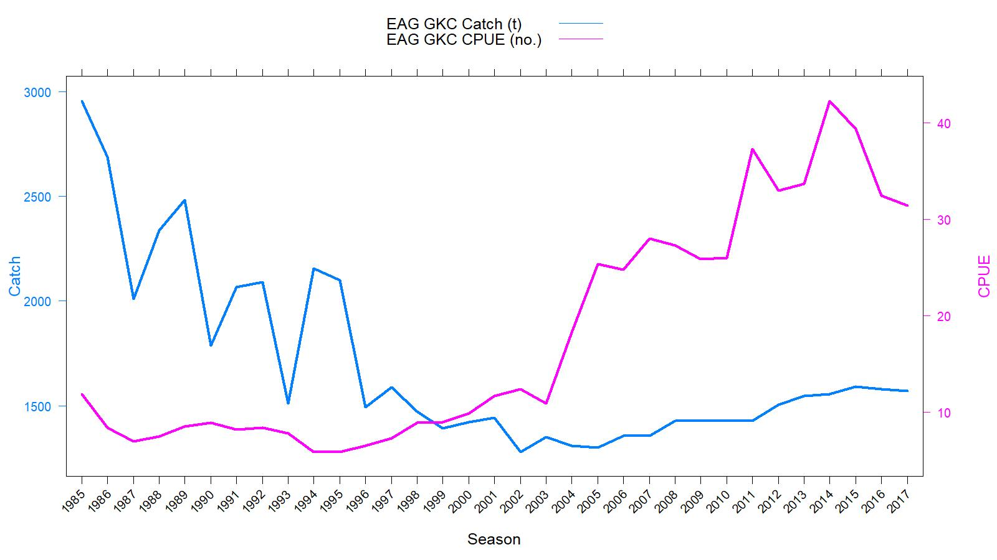
Figure 1. Historical commercial harvest (from fish tickets; metric tons) and catch-per-unit effort (CPUE, number of crabs per pot lift) of golden king crab in the EAG, 1985/86–2017/18 fisheries (note: 1985 refers to the 1985/86 fishing year).

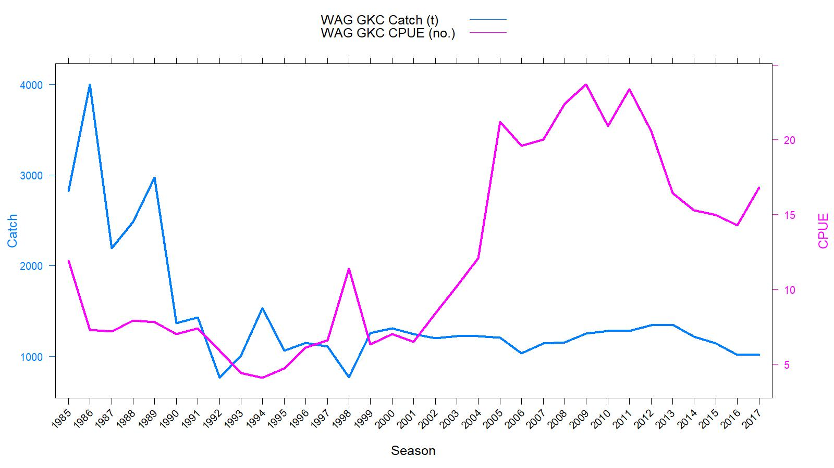
Figure 2. Historical commercial harvest (from fish tickets; metric tons) and catch-per-unit effort (CPUE, number of crabs per pot lift) of golden king crab in the WAG, 1985/86–2017/18 fisheries (note: 1985 refers to the 1985/86 fishing year).

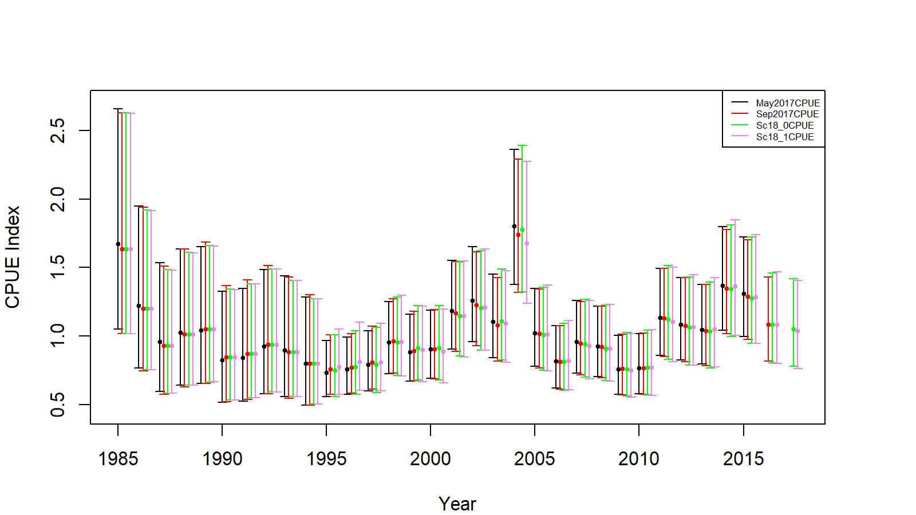

Figure 3. Comparison of input CPUE indices for accepted scenario in May 2017 (ADF&G area codes grouped into 10 groups, up to 2015/16 data), in September 2017 (ADF&G area codes not grouped, up to 2016/17 data), Sc18_0 (Lat and Long position of observed pot, up to 2017/18 data), and Sc18_1 ( Lat and Long position of observed pot, reduced number of gear codes, up to 2017/18 data) for EAG golden king crab. Model estimated additional standard error was added to each input standard error for 2-standard error confidence interval determination.

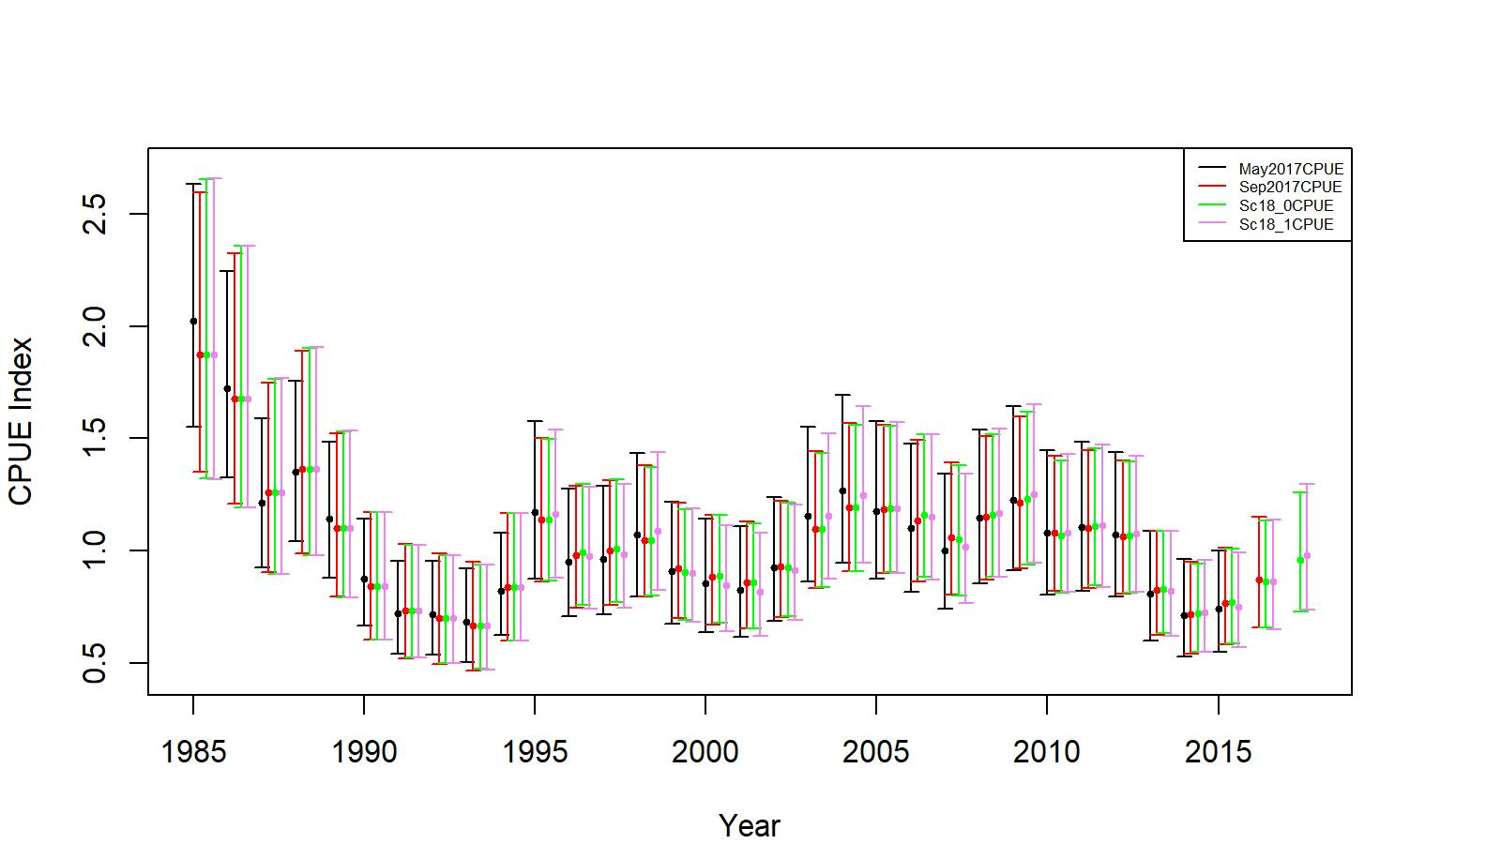
Figure 4. Comparison of input CPUE indices for accepted scenario in May 2017 (ADF&G area codes grouped into 10 groups, up to 2015/16 data), in September 2017 (ADF&G area codes not grouped, up to 2016/17 data), Sc18_0 (Lat and Long position of observed pot, up to 2017/18 data), and Sc18_1 ( Lat and Long position of observed pot, reduced number of gear codes, up to 2017/18 data) for WAG golden king crab. Model estimated additional standard error was added to each input standard error for 2-standard error confidence interval determination.

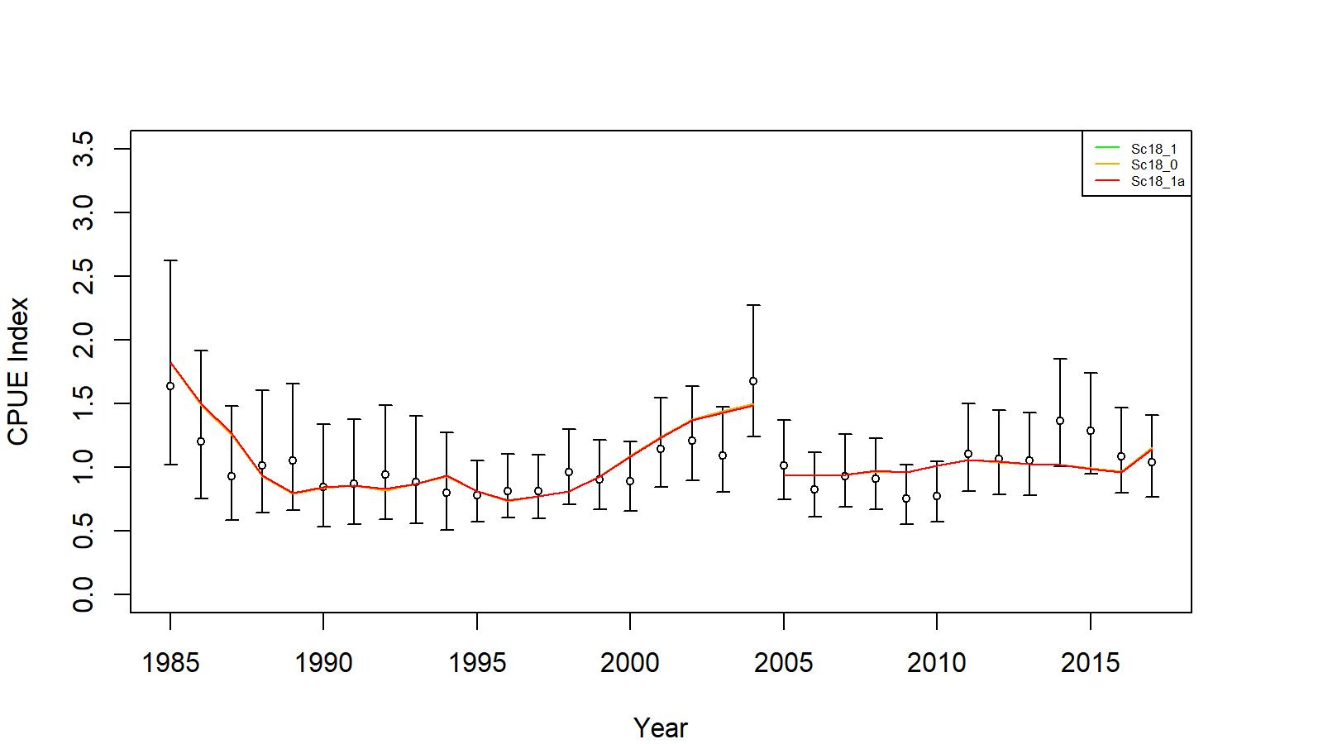

Figure 5. Comparison of input CPUE indices (open circles with +/- 2 SE) with predicted CPUE indices (colored solid lines) for model scenarios Sc18_0, Sc18_1, and Sc 18_1a for EAG golden king crab data, 1985/86–2017/18. Model estimated additional standard error was added to each input standard error.

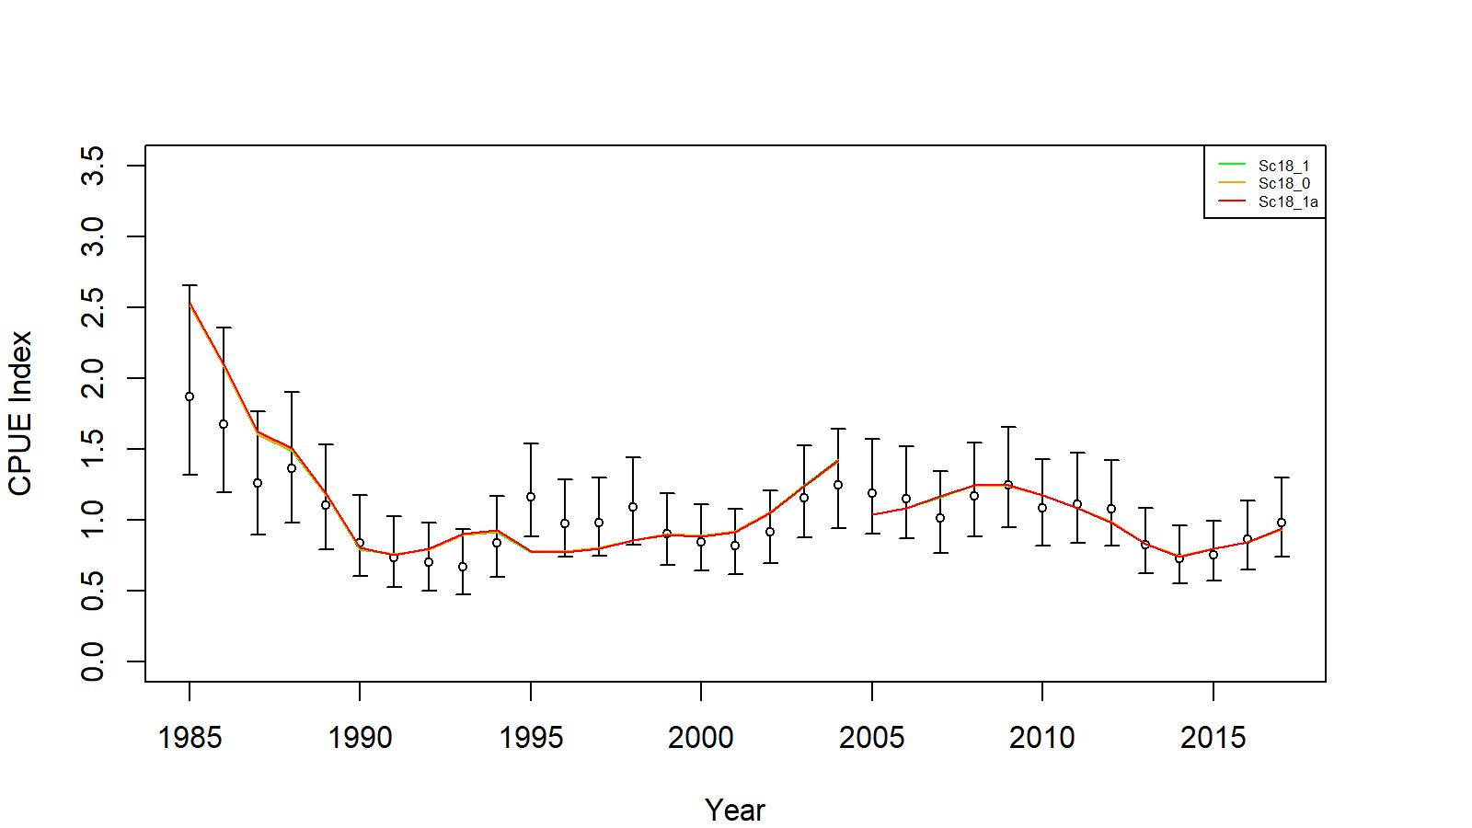
Figure 6. Comparison of input CPUE indices (open circles with +/- 2 SE) with predicted CPUE indices (colored solid lines) for model scenarios Sc18_0, Sc18_1, and Sc 18_1a for WAG golden king crab data, 1985/86–2017/18. Model estimated additional standard error was added to each input standard error.

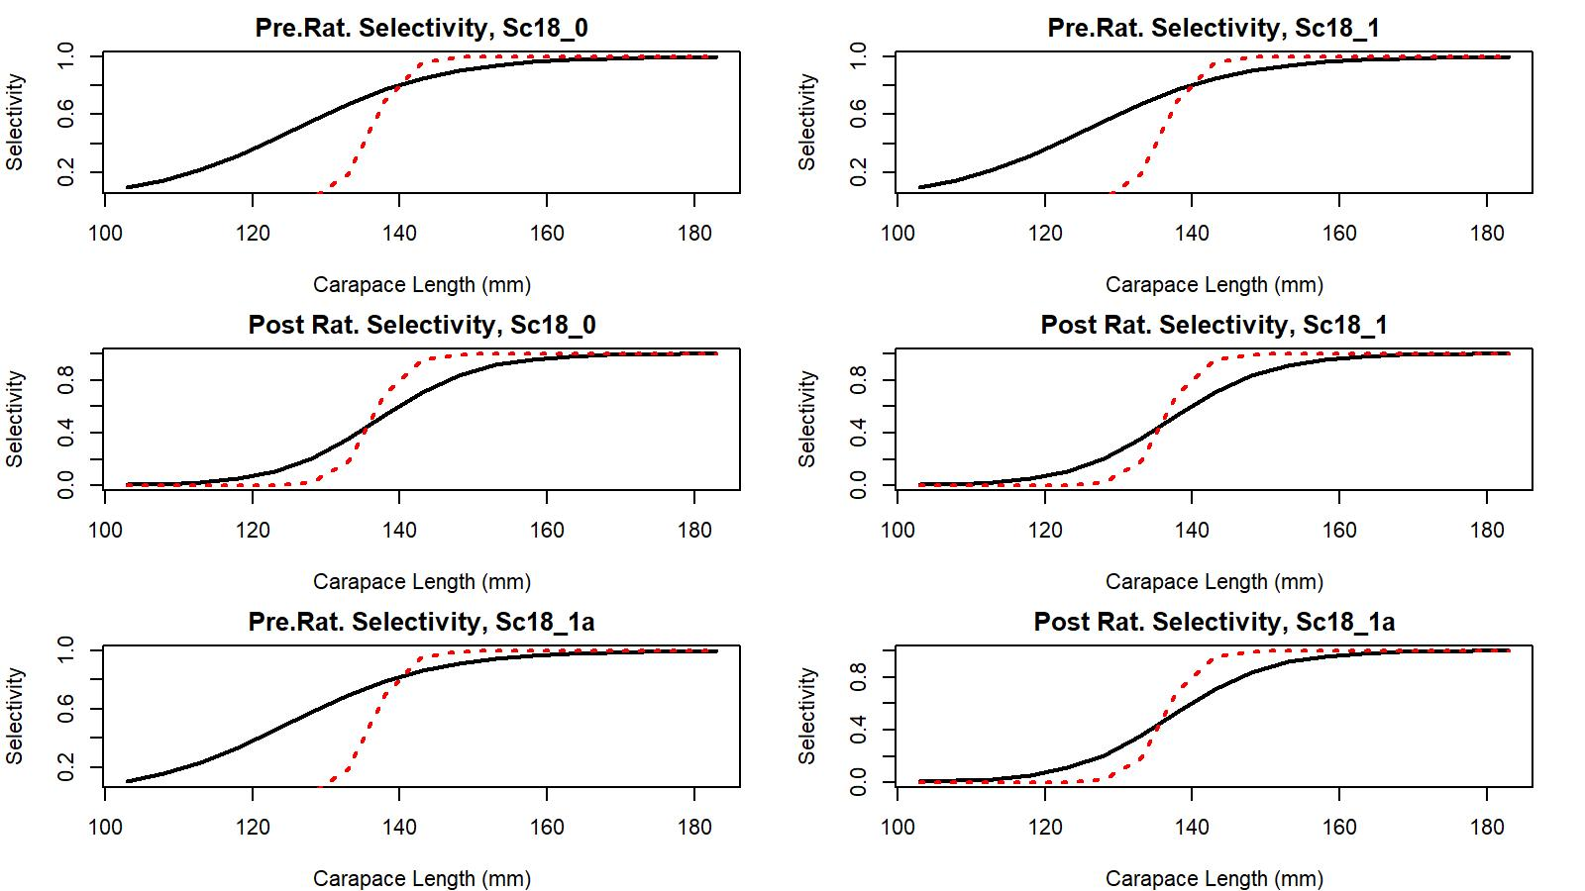

Figure 7. Estimated total (black solid line) and retained selectivity (red dotted line) for pre- and post- rationalization periods under scenarios Sc18_0), 18_1, and 18_1a fit of golden king crab data in the EAG, 1985/86 to 2017/18.

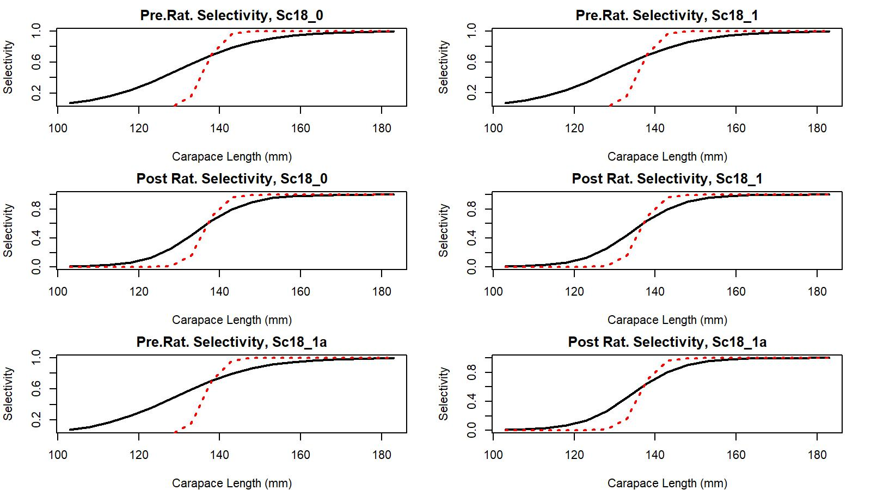

Figure 8. Estimated total (black solid line) and retained selectivity (red dotted line) for pre- and post- rationalization periods under scenarios Sc18_0), 18_1, and 18_1a fit of golden king crab data in the WAG, 1985/86 to 2017/18.

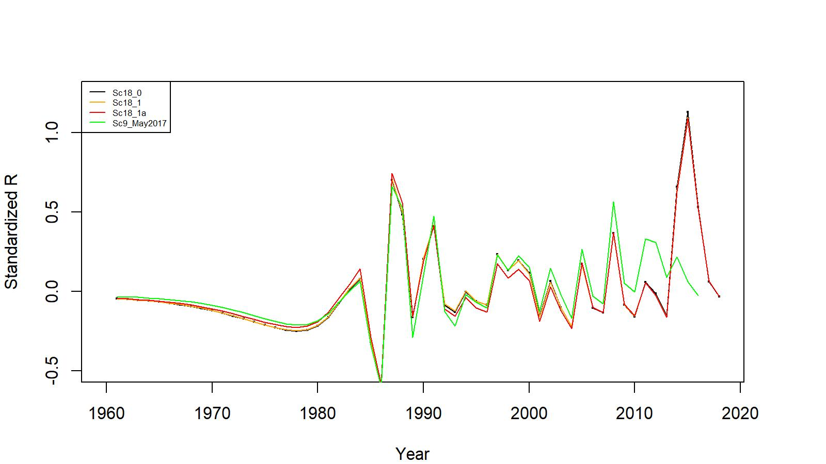
Figure 9. Estimated number of male recruits (crab size ≥ 101 mm CL) to the assessment model for scenarios 18_0, 18_1, and 18_1a fits for EAG golden king crab data, 1961–2018. The numbers of recruits are centralized using (R-mean R)/mean R for comparing different scenarios’ results. Scenario 9 model estimated recruits in May 2017 are also shown for comparison.

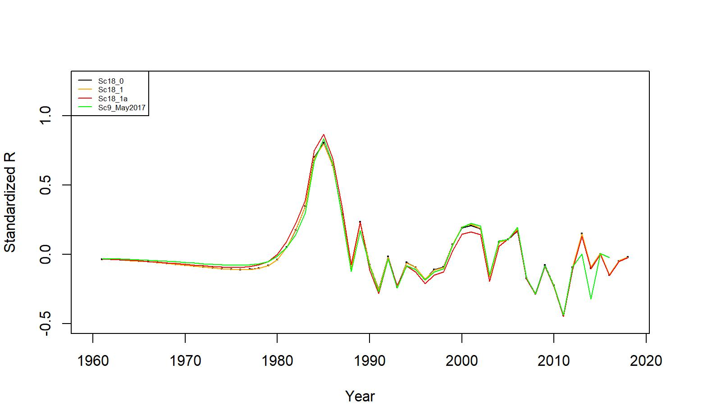
Figure 10. Estimated number of male recruits (crab size ≥ 101 mm CL) to the assessment model for scenarios 18_0, 18_1, and 18_1a fits for WAG golden king crab data, 1961–2018. The numbers of recruits are centralized using (R-mean R)/mean R for comparing different scenarios’ results. Scenario 9 model estimated recruits in May 2017 are also shown for comparison.

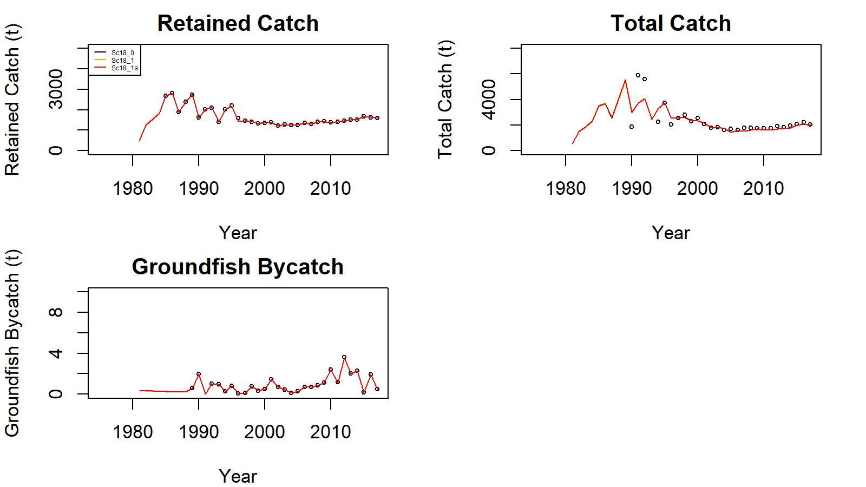
Figure 11. Observed (open circle) vs. predicted (solid line) retained catch (top left in each scenario set), total catch (top right in each scenario set), and groundfish bycatch (bottom left in each scenario set) of golden king crab for scenarios 18_0, 18_1, and 18_1a fits in EAG, 1981–2017.

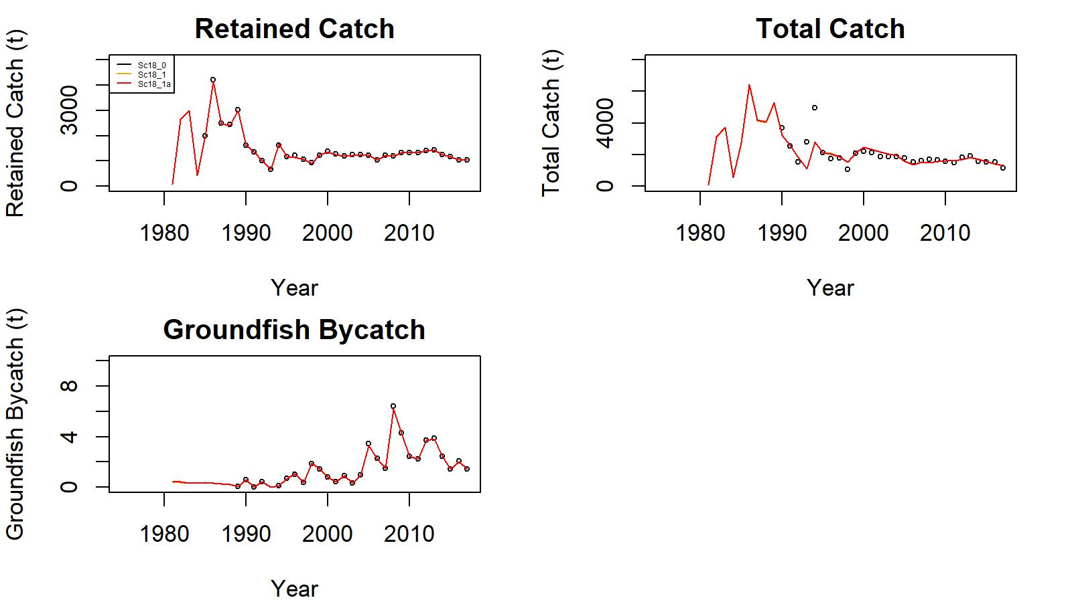
Figure 12. Observed (open circle) vs. predicted (solid line) retained catch (top left in each scenario set), total catch (top right in each scenario set), and groundfish bycatch (bottom left in each scenario set) of golden king crab for scenarios 18_0, 18_1, and 18_1a fits in WAG, 1981–2017.

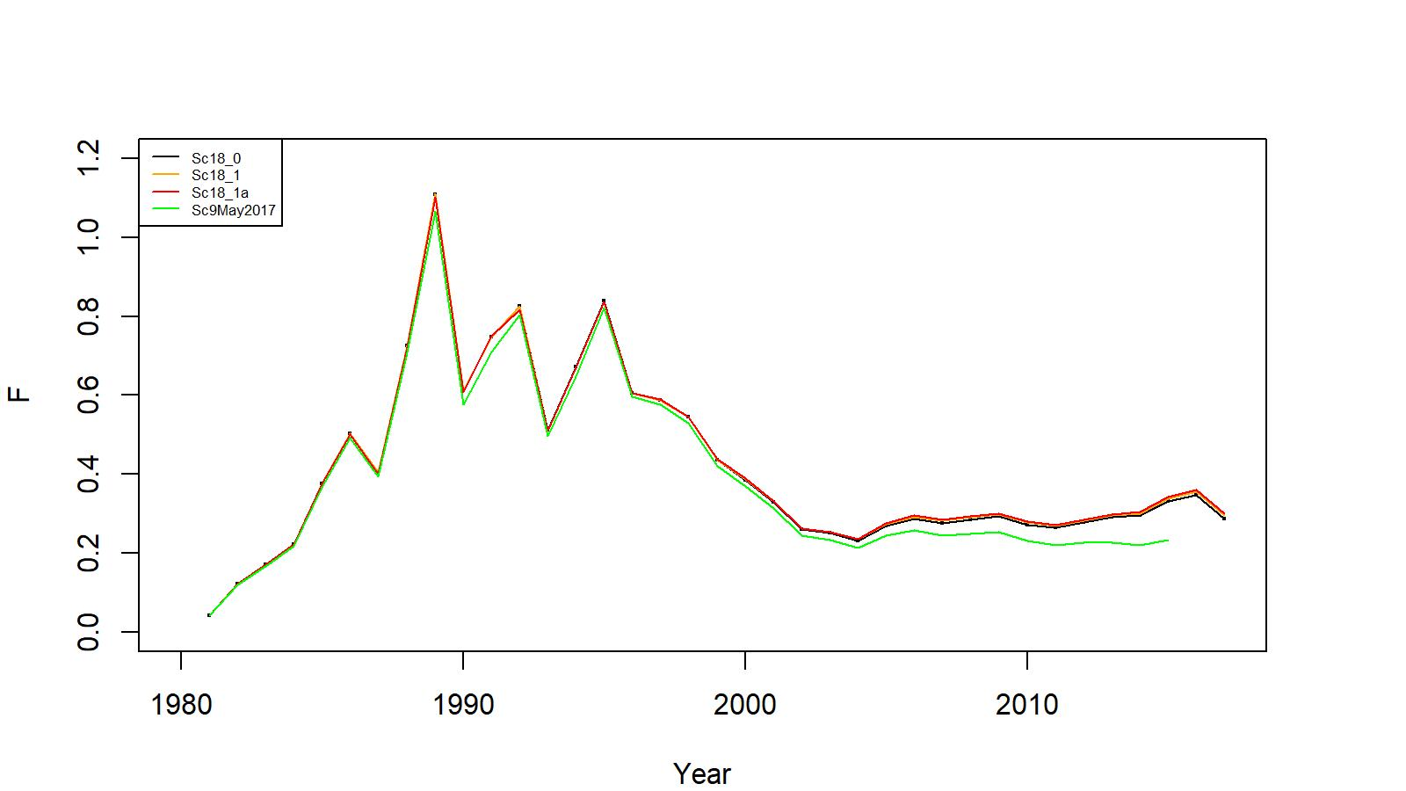
Figure 13. Estimated pot fishery total fishing mortality (F) for scenarios 18_0, 18_1, and 18_1a fits for EAG golden king crab data, 1981–2017. Scenario 9 model estimated F in May 2017 are also shown for comparison.

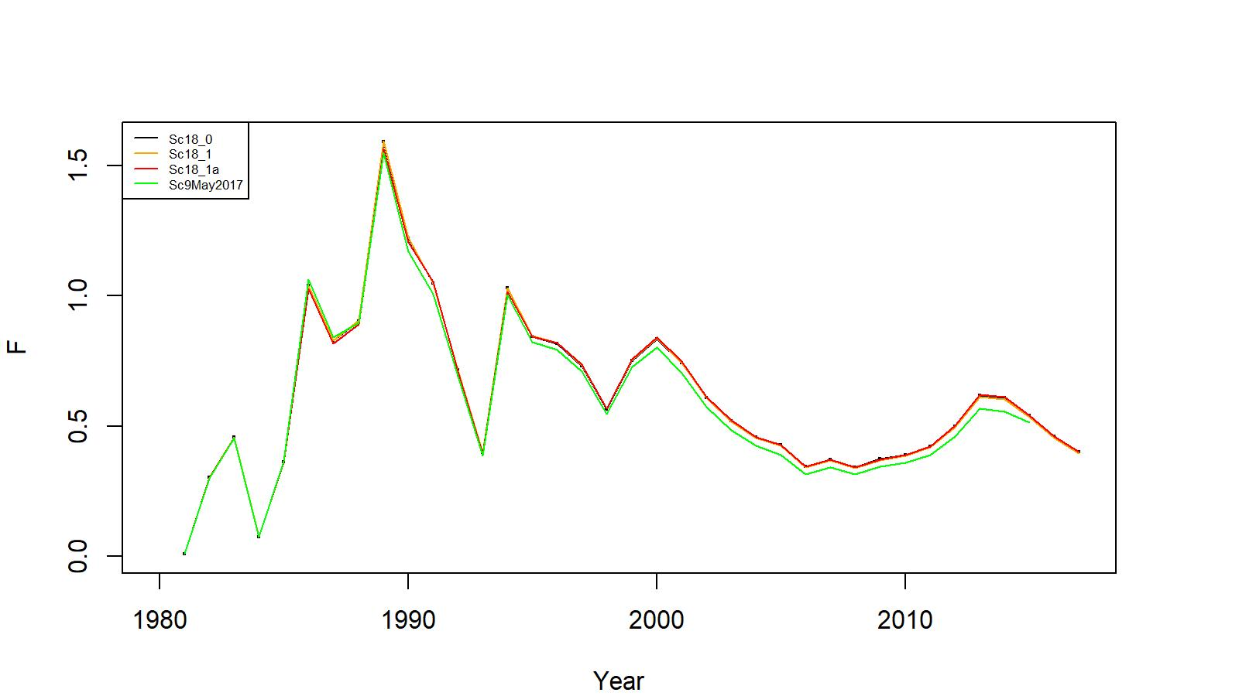
Figure 14. Estimated pot fishery total fishing mortality (F) for scenarios 18_0, 18_1, and 18_1a fits for WAG golden king crab data, 1981–2017. Scenario 9 model estimated F in May 2017 are also shown for comparison.

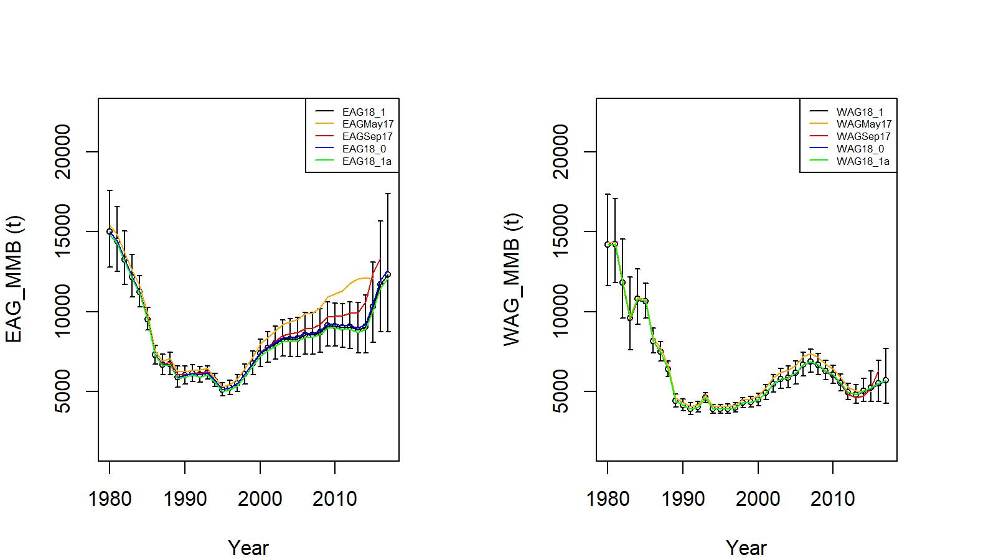
Figure 15. Trends in golden king crab mature male biomass for scenarios Sc9 of May 2017, Sc17AD17 of September 2017, 18_0, 18_1, and 18_1a fits for EAG (left) and WAG (right) golden king crab data, 1980/81–2017/18. Scenario 18_1 estimate have two standard errors confidence limits. The results for May 2017 and September 2017 fits are given for comparisons.

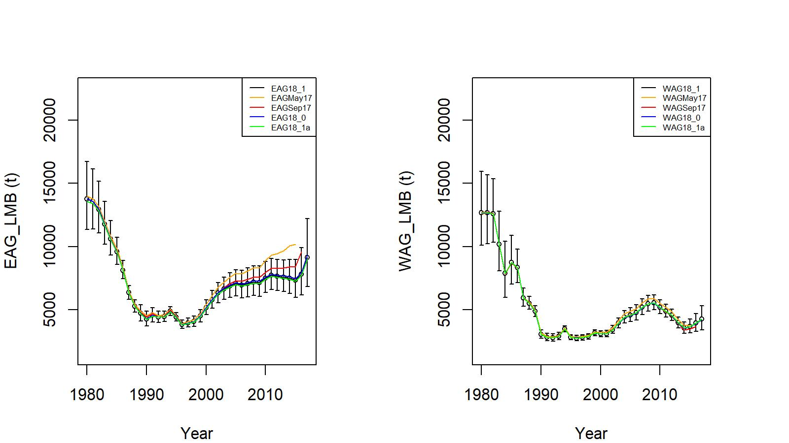
Figure 16. Trends in golden king crab legal male biomass for scenarios Sc9 of May 2017, Sc17AD17 of September 2017, 18_0, 18_1, and 18_1a fits for EAG (left) and WAG (right) golden king crab data, 1980/81–2017/18. Scenario 18_1 estimates have two standard errors confidence limits. The results for May 2017 and September 2017 fits are given for comparisons.
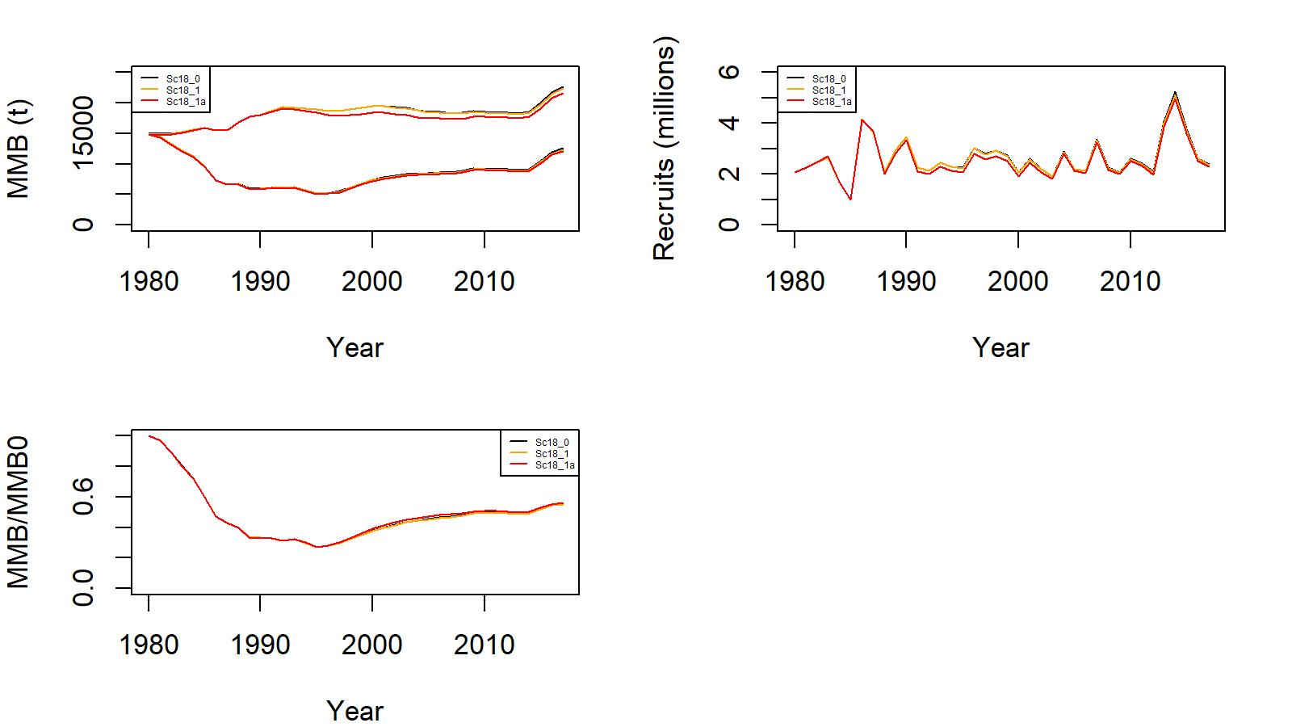

Figure 17. Estimated B0 (t) vs. MMB (t) (top left), trends in recruitment (top right), and MMB/B0 ratio (bottom left) from 1980 to 2017 for scenarios 18_0 (black), 18_1 (orange), and 18_1a (red) for EAG golden king crab data. (Note: 2017 MMB= MMB estimated on 15 February 2018).

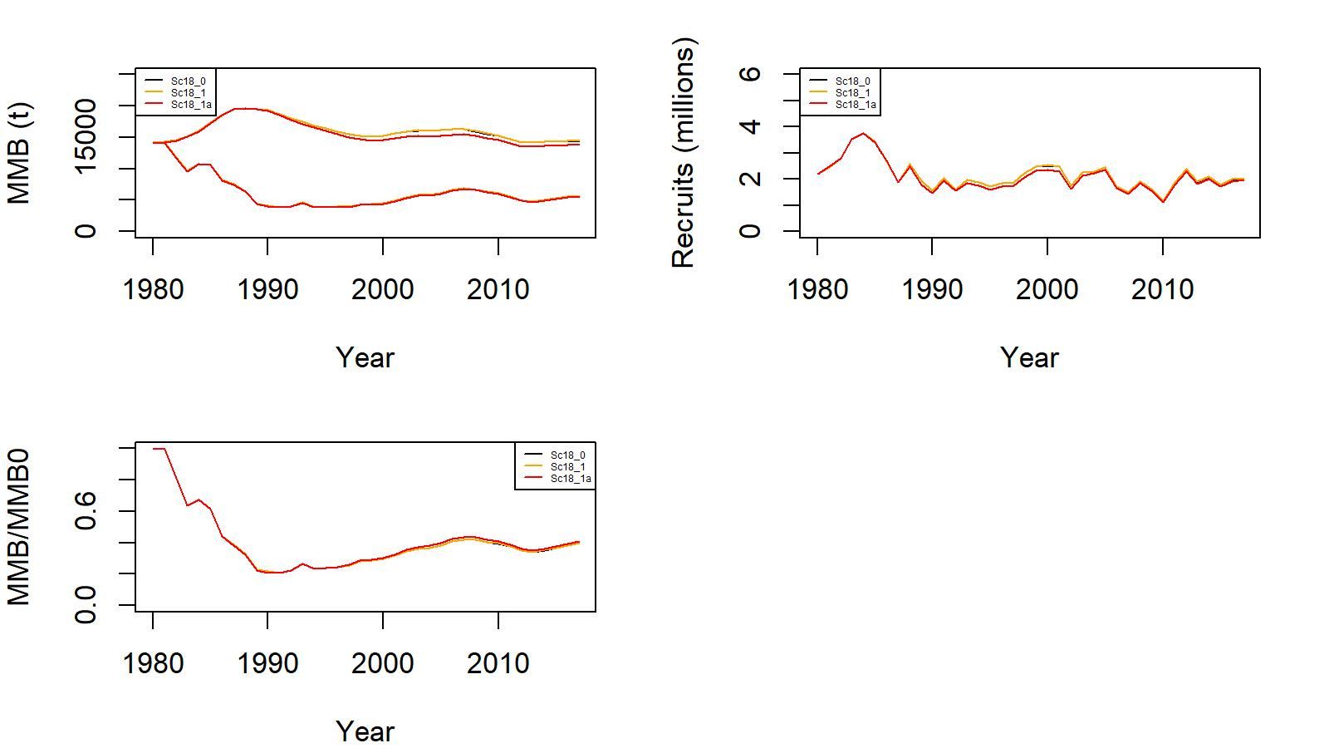
Figure 18. Estimated B0 (t) vs. MMB (t) (top left), trends in recruitment (top right), and MMB/B0 ratio (bottom left) from 1980 to 2017 for scenarios 18_0 (black), 18_1 (orange), and 18_1a (red) for WAG golden king crab data. (Note: 2017 MMB= MMB estimated on 15 February 2018).

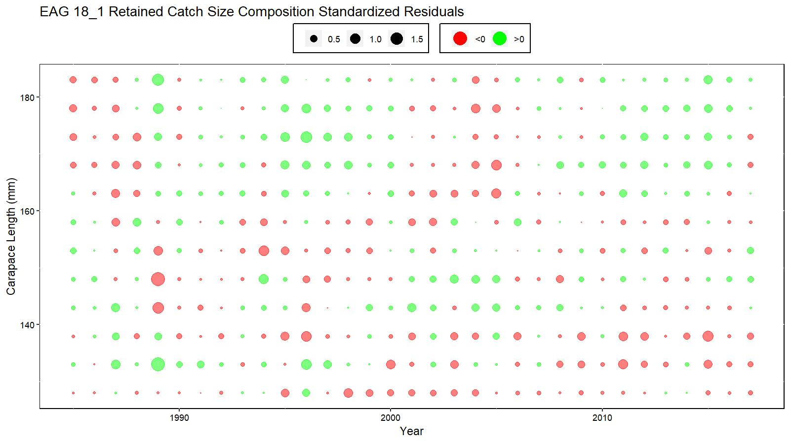
Figure 19. Bubble plot of scenario 18_1 retained catch length composition residual for EAG.

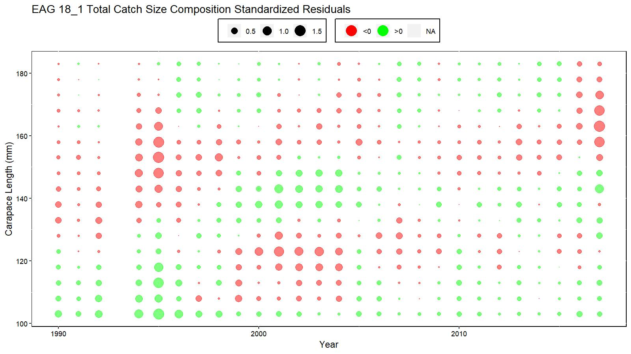
Figure 20. Bubble plot of scenario 18_1 total catch length composition residual for EAG.

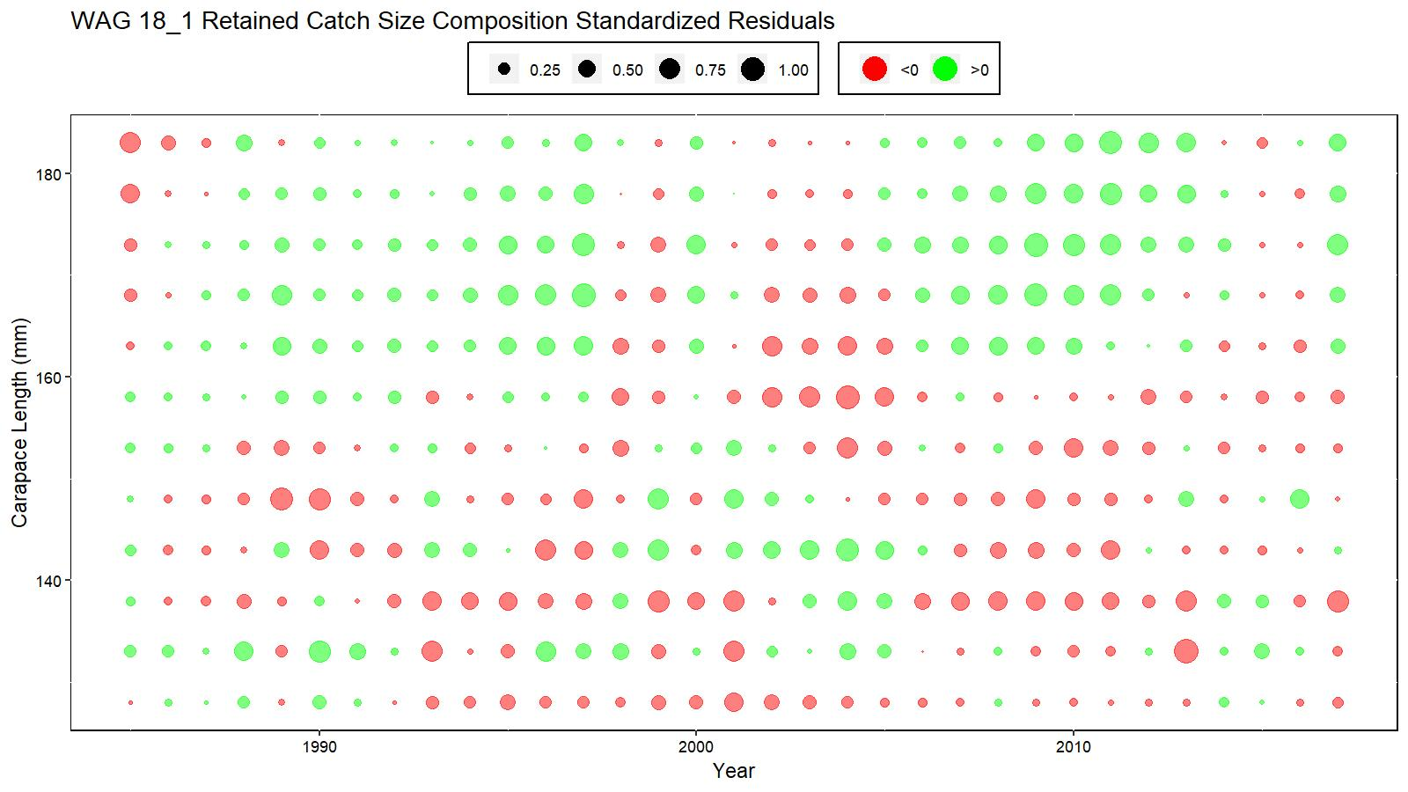
Figure 21. Bubble plot of scenario 18_1 retained catch length composition residuals for WAG.

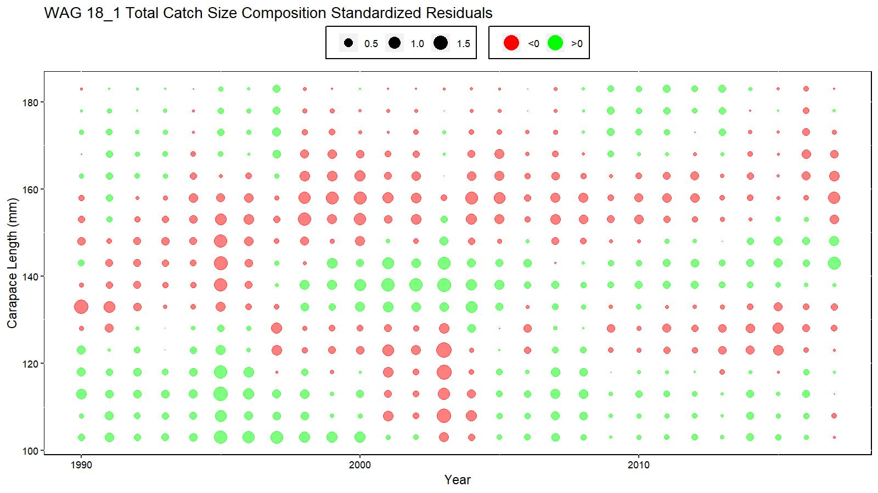
Figure 22. Bubble plot of scenario 18_1 total catch length composition residuals for WAG.

Appendix A: Model formulas listed as Appendix A in Siddeek et al. (2018).

Appendix B: Catch and CPUE data

The commercial catch and length frequency distribution were estimated from ADF&G landing records and dockside sampling (Bowers et al. 2008, 2011). The annual retained catch, total catch, and groundfish (or trawl) discarded mortality are provided in Tables 1, 2, and 2b for EAG and WAG. The weighted length frequency data were used to distribute the catch into 5-mm size intervals. The length frequency data for a year were weighted by each sampled vessel’s catch as follows. The i-th length-class frequency was estimated as:

$\sum_{j=1}^{k}{C_{j}}\frac{{LF}_{j,i}}{\sum_{i=1}^{n}{{LF}_{j,i}}}$ (B.1)

where k = number of sampled vessels in a year, LF_{j,i} = number of crabs in the i-th length-class in the sample from j-th vessel, n = number of size classes, C_{j} = number of crabs caught by j-th vessel. Then the relative frequency for the year was calculated and applied to the annual retained catch (in number of crabs) to obtain retained catch by length-class.

The annual total catch (in number of crabs) was estimated by the observer nominal (unstandardized) total CPUE considering all vessels multiplied by the total fishing effort (number of pot lifts). The weighted length frequency of the observer samples across the fleet was estimated using Equation B.1. Observer measurement of crab ranged from 20 to 220 mm CL. To restrict the total number of crabs to the model assumed size range (101–185+ mm CL), the proportion of observer total relative length frequency corresponding to this size range was multiplied by the total catch (number of crabs). This total number of crabs was distributed into length-classes using the weighted relative length frequency. Thus, crab sizes < 101 mm CL were excluded from the model. In addition, all crab >185 mm CL were pooled into a plus length class. Note that the total crab catch by size that went into the model did not consider retained and discard components separately. However, once the model estimated the annual total catch, then retained catch was deducted from this total and multiplied by handling mortality [we used a 20% handling mortality (Siddeek et al. 2005) to obtain the directed fishery discarded (dead) catch].

Observer data have been collected since 1988 (Moore et al. 2000; Barnard et al. 2001; Barnard and Burt 2004; Gaeuman 2011), but data were not comprehensive in the initial years, so a shorter time series of data for the period 1990/91–2016/17 was selected for this analysis. During 1990/91–1994/95, observers were only deployed on catcher-processor vessels. During 1995/96–2004/05, observers were deployed on all fishing vessels during fishing activity. Observers have been deployed on all fishing vessels since 2005/06, but catcher-only vessels are only required to carry observers for a minimum of 50% of their fishing activity during a season; catcher-processor vessels are still required to carry observers during all fishing activity. Onboard observers sample seven pots per day (it can be different number of pots per string) and count and measure all crabs caught and categorize catch as females, sublegal males, retained legal males, and non-retained legal males in a sampled pot. Prior to the 2009/10 season, depending on season, area, and type of fishing vessel, observers were also instructed to sample additional pots in which all crab were only counted and categorized as females, sublegal males, retained legal males, and non-retained legal males, but were not measured. Annual mean nominal CPUEs of retained and total crabs were estimated considering all sampled pots within each season (Table 3). The observer CPUE data collection improved over the years and the data since 1995/96 are more reliable. Thus, for model fitting, the observer CPUE time series was restricted to 1995/96–2017/18. For CPUE standardization, these data were further reduced by 5% cutoff of Soak time and 1% cutoff of Depth on both ends of the variable range to remove unreliable data or data from dysfunctional pot operations, and restricting to vessels which have made five trips per year for at least three years during 1985/86 –2017/18.

Length-specific CPUE data collected by observers provides information on a wider size range of the stock than did the commercial catch length frequency data obtained from mostly legal-sized landed males.

There were significant changes in fishing practice due to changes in management regulations (e.g., since 1996/97 constant TAC and since 2005/06 crab rationalization), pot configuration (escape web on the pot door increased to 9” since 1999), and improved observer recording in Aleutian Islands golden king crab fisheries since 1998. These changes prompted us to consider two separate observer CPUE time series, 1995/96–2004/05 and 2005/06–2017/18, to estimate CPUE indices for model input.

To include a long time series of CPUE indices for stock abundance contrast, we also considered the 1985/86–1998/99 legal size standardized CPUE as a separate likelihood component in all scenarios. Because of the lack of soak time data previous to 1990, we estimated the CPUE index considering a limited set of explanatory variables (e.g., vessel, captain, area, month) and fitting the lognormal GLM to fish ticket data (Table 4).

When using CPUE indices in the model fit, we compared the predicted with the observed legal male CPUE in the observer CPUE likelihoods because legal male (retained plus non-retained) data are more reliable than total in the observer samples.

Observer CPUE index by GLM:
The CPUE standardization followed the GLM fitting procedure (Maunder and Punt 2004; Starr 2012; Siddeek et al. 2018). Following a suggestion made by the CIE reviewers (CIE, June 2018) we reduced the number of gear codes in the database after consulting with the fishing industry (Rip Carlton, Chad Hoefer, and Scott Goodman, personal communication December 2018; Table B1). Following SSC (October 2018) suggestion, we used a hybrid procedure: First, selected a scope variables set by Akike Information Criterion, AIC (Burnham and Anderson, 2002). An increase of more than 2 units in the AIC was used to identify the variable to be included successively (stepAIC program, R Core Team, 2018). Then, the model parsimony was improved further by successively removing the term that explained the least proportion of deviance (R² < 0.01) (stepCPUE R function was used, Siddeek et al. 2018). Feenstra, et al. (unpublished, 2019) used a similar hybrid approach.

Table B.1. Updated Gear code for observer data analysis. Only gear code # 5, 6, 7, 8, and 13 were considered following crab industry suggestion. Note: Identical codes were given to those gear codes with similar catchability/selectivity. X stands for the gear codes that were ignored.

Original Gear code | Pot gear description | Mark X against the code that can be ignored | Number Encountered by Observers during 1990-2016 | Updated Gear Code
1 | Dungeness crab pot, small & round | X | 2 | X
2 | Pyramid pot, tunnel openings usually on sides, stackable | X | 2121 | X
3 | Conical pot, opening at top of cone, stackable | X | 2000 | X
4 | 4' X 4' rectangular pot |  | 60 | X
5 | 5' X 5' rectangular pot |  | 18032 | 5
6 | 6' X 6' rectangular pot |  | 17508 | 6
7 | 7' X 7' rectangular pot |  | 23806 | 7
8 | 8' X 8' rectangular pot |  | 1936 | 8
9 | 5 1/2' X 5 1/2' rectangular pot |  | 6934 | 5
10 | 6 1/2' X 6 1/2' rectangular pot |  | 22085 | 6
11 | 7 1/2' X 7 1/2' rectangular pot |  | 387 | 7
12 | Round king crab pot, enlarged version of Dungeness crab pot |  | 8259 | X
13 | 10' X 10' rectangular pot |  | 466 | 13
14 | 9' X 9' rectangular pot | X | 1 | X
15 | 8 1/2' X 8 1/2' rectangular pot | X | 1 | X
16 | 9 1/2' X 9 1/2' rectangular pot | X | Not used | X
17 | 8' X 9' rectangular pot | X | 1 | X
18 | 8' X 10' rectangular pot | X | 1 | X
19 | 9' X 10' rectangular pot |  | Not used | X
20 | 7' X 8' rectangular pot | X | 252 | X
21 | Hair crab pot, longlined and small, stackable |  | Not used | X
22 | snail pot | X | 1 | X
23 | Dome-shaped pot, tunnel opening on top, often longlined in deep-water fisheries | X | 6756 | X
24 | ADF&G shellfish research 7’ X 7’ X34” rectangular pot with 2.75” stretch mesh and no escapement rings or mesh |  | Research pot | X
80 | Historical: Cod pot, any shape pot targeting cod, usually with tunnel fingers | X | 711 | X
81 | Historical: Rectangular pot, unknown size, with escape rings | X | 1123 | X

We investigated the “design matrix” of the full model variables (Equation B.2) to check for severe collinearity by computing bivariate correlation of independent variables. Severe collinearity was identified arbitrarily when |r| > 0.6. We provide the correlation matrix for the pre-rationalized period data set in Table B2 for EAG and Table B3 for WAG. The results for the post rationalization period data sets were similar and are available with the first author.
${Year}_{y_{i}}+ns\left({Soak}_{si},df\right)+{Month}_{m_{i}}+{Vessel}_{vi}+{Captain}_{ci}+{Area}_{ai}+{Gear}_{gi}+ns\left({Depth}_{di},df\right)+ns({VesSoak}_{vsi},df)$ , (B.2)

Table B2. A part of the bivariate correlation matrix of the design matrix relating Year factor with other independent variables for pre-rationalization period observer data in EAG. The EastVesSoak variable has very high collinearity (yellow highlighted) with the Year.
 | 1995 | 1996 | 1997 | 1998 | 1999 | 2000 | 2001 | 2002 | 2003 | 2004
1995 | 1 | -0.14 | -0.12 | -0.11 | -0.11 | -0.13 | -0.12 | -0.11 | -0.11 | -0.08
1996 | -0.14 | 1 | -0.14 | -0.13 | -0.13 | -0.16 | -0.14 | -0.13 | -0.13 | -0.09
1997 | -0.12 | -0.14 | 1 | -0.11 | -0.11 | -0.13 | -0.11 | -0.1 | -0.11 | -0.08
1998 | -0.11 | -0.13 | -0.11 | 1 | -0.1 | -0.12 | -0.11 | -0.1 | -0.1 | -0.07
1999 | -0.11 | -0.13 | -0.11 | -0.1 | 1 | -0.13 | -0.11 | -0.1 | -0.1 | -0.07
2000 | -0.13 | -0.16 | -0.13 | -0.12 | -0.13 | 1 | -0.13 | -0.12 | -0.12 | -0.09
2001 | -0.12 | -0.14 | -0.11 | -0.11 | -0.11 | -0.13 | 1 | -0.1 | -0.11 | -0.08
2002 | -0.11 | -0.13 | -0.1 | -0.1 | -0.1 | -0.12 | -0.1 | 1 | -0.1 | -0.07
2003 | -0.11 | -0.13 | -0.11 | -0.1 | -0.1 | -0.12 | -0.11 | -0.1 | 1 | -0.07
2004 | -0.08 | -0.09 | -0.08 | -0.07 | -0.07 | -0.09 | -0.08 | -0.07 | -0.07 | 1
ns(SoakDays, df = 4)1 | -0.09 | -0.09 | 0.01 | -0.02 | -0.03 | -0.01 | 0.08 | 0.05 | 0.1 | 0.02
ns(SoakDays, df = 4)2 | 0.1 | 0.01 | 0.02 | -0.04 | -0.03 | 0 | 0.06 | -0.02 | -0.05 | -0.07
ns(SoakDays, df = 4)3 | -0.12 | 0 | -0.01 | -0.01 | 0.05 | 0.05 | -0.06 | 0.03 | 0.01 | 0.07
ns(SoakDays, df = 4)4 | 0.1 | 0.09 | 0.05 | 0 | -0.03 | 0 | -0.02 | -0.07 | -0.07 | -0.1
Month | -0.46 | 0.19 | 0.26 | 0.16 | 0.14 | -0.01 | -0.06 | -0.08 | -0.07 | -0.11
Vessel | 0.1 | 0.04 | 0.04 | -0.05 | -0.07 | -0.03 | -0.01 | 0.01 | -0.05 | 0
Captain | -0.01 | -0.01 | 0.01 | 0 | -0.02 | -0.02 | -0.09 | 0.04 | 0.05 | 0.09
StatArea | 0.16 | -0.01 | 0.02 | -0.06 | -0.15 | -0.01 | 0.02 | -0.01 | 0.03 | 0.02
Gear | 0.25 | 0.28 | 0.02 | 0.05 | -0.09 | -0.1 | -0.12 | -0.12 | -0.15 | -0.09
ns(Depth, df = 2)1 | 0.02 | 0.02 | 0.03 | -0.04 | 0.01 | 0 | -0.03 | -0.02 | 0 | 0.01
ns(Depth, df = 2)2 | 0.01 | -0.02 | 0.01 | -0.03 | -0.05 | 0.04 | 0.03 | -0.01 | 0.01 | 0
ns(EastVesSoak, df = 9)1 | -0.14 | -0.17 | 0.97 | -0.13 | 0.12 | -0.15 | -0.14 | -0.13 | -0.13 | -0.09
ns(EastVesSoak, df = 9)2 | -0.21 | -0.25 | 0.31 | -0.19 | -0.2 | 0.77 | -0.2 | -0.19 | -0.19 | 0.38
ns(EastVesSoak, df = 9)3 | -0.2 | -0.24 | -0.2 | -0.19 | -0.19 | 0.66 | -0.2 | -0.18 | 0.33 | 0.53
ns(EastVesSoak, df = 9)4 | -0.12 | -0.05 | -0.12 | -0.11 | -0.12 | -0.14 | -0.12 | -0.11 | 1 | -0.08
ns(EastVesSoak, df = 9)5 | -0.21 | 0.83 | -0.21 | -0.2 | -0.2 | -0.24 | -0.21 | 0.4 | 0.05 | -0.14
ns(EastVesSoak, df = 9)6 | -0.21 | 0.14 | -0.21 | -0.2 | -0.2 | -0.24 | 0.76 | 0.48 | -0.2 | -0.14
ns(EastVesSoak, df = 9)7 | -0.39 | 0.01 | -0.06 | 0.01 | -0.49 | 0.01 | 0.85 | 0.02 | 0.01 | 0.01
ns(EastVesSoak, df = 9)8 | 0.55 | -0.26 | -0.07 | -0.2 | 0.74 | -0.24 | 0.04 | -0.19 | -0.2 | -0.14
ns(EastVesSoak, df = 9)9 | 0.95 | -0.07 | -0.11 | -0.06 | -0.4 | -0.07 | -0.11 | -0.06 | -0.06 | -0.04

Table B2. A part of the bivariate correlation matrix of the design matrix relating Year factor with other independent variables for post-rationalization period observer data in WAG. The WestVesSoak variable has very high collinearity (yellow highlighted) with the Year.

 | 1995 | 1996 | 1997 | 1998 | 1999 | 2000 | 2001 | 2002 | 2003 | 2004
1995 | 1 | -0.14 | -0.11 | -0.07 | -0.11 | -0.11 | -0.1 | -0.08 | -0.1 | -0.09
1996 | -0.14 | 1 | -0.16 | -0.11 | -0.17 | -0.17 | -0.16 | -0.13 | -0.15 | -0.14
1997 | -0.11 | -0.16 | 1 | -0.08 | -0.13 | -0.12 | -0.12 | -0.1 | -0.11 | -0.1
1998 | -0.07 | -0.11 | -0.08 | 1 | -0.09 | -0.08 | -0.08 | -0.07 | -0.08 | -0.07
1999 | -0.11 | -0.17 | -0.13 | -0.09 | 1 | -0.13 | -0.12 | -0.1 | -0.12 | -0.11
2000 | -0.11 | -0.17 | -0.12 | -0.08 | -0.13 | 1 | -0.12 | -0.1 | -0.11 | -0.1
2001 | -0.1 | -0.16 | -0.12 | -0.08 | -0.12 | -0.12 | 1 | -0.09 | -0.11 | -0.1
2002 | -0.08 | -0.13 | -0.1 | -0.07 | -0.1 | -0.1 | -0.09 | 1 | -0.09 | -0.08
2003 | -0.1 | -0.15 | -0.11 | -0.08 | -0.12 | -0.11 | -0.11 | -0.09 | 1 | -0.09
2004 | -0.09 | -0.14 | -0.1 | -0.07 | -0.11 | -0.1 | -0.1 | -0.08 | -0.09 | 1
ns(SoakDays, df = 8)1 | 0.1 | 0.2 | 0.06 | 0.01 | -0.02 | -0.02 | -0.09 | -0.04 | -0.14 | -0.12
ns(SoakDays, df = 8)2 | -0.02 | 0.04 | 0.12 | 0.13 | 0.04 | -0.01 | -0.05 | -0.06 | -0.11 | -0.1
ns(SoakDays, df = 8)3 | -0.09 | -0.06 | -0.01 | 0.1 | 0.06 | 0.03 | 0.04 | -0.01 | -0.04 | 0
ns(SoakDays, df = 8)4 | -0.12 | -0.13 | -0.11 | -0.03 | -0.02 | 0 | 0.16 | 0.1 | 0.11 | 0.1
ns(SoakDays, df = 8)5 | -0.12 | -0.18 | -0.1 | -0.04 | -0.04 | -0.01 | 0.04 | 0.09 | 0.25 | 0.19
ns(SoakDays, df = 8)6 | -0.12 | -0.11 | -0.03 | -0.01 | -0.03 | 0 | 0.07 | 0.04 | 0.11 | 0.13
ns(SoakDays, df = 8)7 | 0.2 | 0.12 | 0.01 | -0.07 | -0.04 | 0.02 | -0.06 | -0.05 | -0.11 | -0.08
ns(SoakDays, df = 8)8 | -0.16 | -0.08 | -0.03 | 0.02 | 0 | 0 | 0.09 | 0.04 | 0.1 | 0.06
Month | -0.05 | -0.09 | -0.04 | -0.02 | -0.13 | -0.04 | -0.02 | 0.03 | 0.16 | 0.27
Vessel | -0.07 | -0.16 | -0.12 | -0.04 | -0.01 | 0.12 | 0.11 | 0.01 | 0.14 | 0.07
Captain | 0.13 | -0.05 | 0.02 | 0 | 0.18 | -0.12 | 0.1 | -0.07 | -0.08 | -0.12
StatArea | -0.07 | 0.03 | -0.02 | -0.01 | 0 | 0.01 | 0.05 | 0.03 | 0 | -0.02
Gear | 0.22 | 0.22 | -0.06 | -0.01 | -0.01 | -0.1 | -0.05 | -0.09 | -0.09 | -0.1
ns(Depth, df = 10)1 | -0.03 | -0.02 | -0.02 | -0.02 | -0.02 | -0.01 | 0.01 | 0.04 | 0.03 | 0.05
ns(Depth, df = 10)2 | -0.03 | -0.02 | -0.03 | -0.01 | -0.02 | -0.01 | 0.01 | 0.05 | 0.02 | 0.06
ns(Depth, df = 10)3 | 0.01 | -0.01 | -0.01 | 0 | -0.01 | 0 | -0.01 | 0.04 | -0.01 | 0.02
ns(Depth, df = 10)4 | 0.03 | 0 | 0.01 | 0.01 | -0.01 | -0.01 | -0.02 | 0.02 | -0.02 | 0.01
ns(Depth, df = 10)5 | 0.01 | 0 | 0.01 | 0.01 | 0 | -0.01 | -0.01 | -0.01 | 0 | 0.01
ns(Depth, df = 10)6 | 0 | -0.01 | 0.01 | -0.01 | 0 | 0.01 | 0.02 | -0.03 | 0 | 0.01
ns(Depth, df = 10)7 | 0 | 0 | 0.01 | 0.01 | 0.01 | 0.03 | 0.01 | -0.04 | 0 | -0.03
ns(Depth, df = 10)8 | -0.01 | 0 | 0 | 0.01 | 0.01 | 0.03 | -0.01 | -0.03 | 0.02 | -0.03
ns(Depth, df = 10)9 | 0 | 0.04 | 0.02 | 0.01 | 0.01 | 0 | 0.01 | -0.02 | -0.02 | -0.07
ns(Depth, df = 10)10 | -0.03 | -0.02 | -0.01 | 0 | 0.02 | 0.03 | -0.02 | 0 | 0.01 | 0
ns(WestVesSoak, df = 7)1 | -0.21 | -0.32 | 0.59 | -0.17 | -0.26 | -0.25 | -0.09 | 0.05 | 0.67 | 0.08
ns(WestVesSoak, df = 7)2 | -0.1 | -0.26 | -0.15 | -0.13 | -0.2 | 0.25 | 0.92 | -0.15 | -0.03 | -0.16
ns(WestVesSoak, df = 7)3 | 0.33 | -0.28 | -0.21 | -0.14 | -0.22 | 0.81 | 0.25 | -0.17 | -0.19 | -0.18
ns(WestVesSoak, df = 7)4 | 0.96 | -0.1 | -0.16 | -0.11 | -0.17 | 0.17 | -0.15 | -0.12 | -0.14 | -0.13
ns(WestVesSoak, df = 7)5 | 0.01 | 0.96 | -0.23 | -0.04 | -0.23 | -0.06 | -0.05 | -0.26 | -0.15 | -0.27
ns(WestVesSoak, df = 7)6 | -0.34 | 0.19 | 0.2 | -0.3 | 0.17 | -0.44 | -0.42 | 0.45 | -0.01 | 0.47
ns(WestVesSoak, df = 7)7 | -0.01 | -0.23 | -0.19 | 0 | 0.95 | 0 | 0 | -0.24 | -0.11 | -0.25

Thus “EastVesSoak” and “WestVesSoak” were removed from the suite of scope variables. Note that this has no effect either in the previous or current CPUE standardization because these variables were never selected by the stepwise variable selection procedure.

The Year:Area interaction term was not selected by the step selection procedure. We suspect that with the detail Lat and Long configuration of observations high collinearity of Year and Area interaction terms prevent selection of Year:Area interaction

We considered the negative binomial GLM on positive and zero catches to select the explanatory variables. The response variable CPUE is the observer sample catch record for a pot haul. The negative binomial model uses the log link function for the GLM fit. Therefore, we assumed the null model to be

$\ln\left({CPUE}_{i}\right)={Year}_{y_{i}}$ (B.3)
where Year is a factorial variable.
The maximum set of model terms offered to the stepwise selection procedure was:

${ln⁡(CPUE}_{I}) ={Year}_{y_{i}}+ns\left({Soak}_{si},df\right)+{Month}_{m_{i}}+{Vessel}_{vi}+{Captain}_{ci}+{Area}_{ai}+{Gear}_{gi}+ns\left({Depth}_{di},df\right)$ , (B.4)

where Soak is in unit of days and is numeric; Month, Area code, Vessel code, Captain code, and Gear code are factorial variables; Depth in fathom is a numeric variable; ns=cubic spline, and df = degree of freedom.

Instead of using the traditional AIC (-2log_likelihood+2p) we used the Consistent Akaike
Information Criteria (CAIC) {-2log_likelihood+[ln(n)+1]p} for variable selection by StepAIC, where n=number of observations and p= number of parameters to be estimated. The number of selected variables were further reduced for parsimony, if feasible, by the R² criterion using the StepCPUE function.

The final models for EAG were:

Initial selection by stepAIC:
$\ln\left(CPUE\right)= Year+Gear+Captain+ns\left(Soak, 4\right)+Month+Area+Vessel$

Final selection by stepCPUE:
$\ln\left(CPUE\right)= Year+Captain+Gear+ns\left(Soak, 4\right)+Area$ (B.5)
for the 1995/96–2004/05 period [θ=1.34, $R^{2}=0.2202$]

Initial selection by stepAIC:
$\ln\left(CPUE\right)= Year+ Captain+Gear+ ns\left(Soak, 12\right)$

Final selection by stepCPUE:
$\ln\left(CPUE\right)= Year+ Captain+Gear+ ns\left(Soak, 12\right)$ (B.6)
for the 2005/06–2017/18 period ($=2.31, R^{2}=0.1118$).

The final models for WAG were:

Initial selection by stepAIC:
$\ln\left(CPUE\right)= Year + Captain+ ns\left(Soak,8\right)+Gear+Month+Vessel+ns\left(Depth, 10\right)$

Final selection by stepCPUE:
$\ln\left(CPUE\right)= Year + Captain+ ns\left(Soak,8\right)+Gear$ (B.7) for the 1995/96–2004/05 period (θ=0.97, $R^{2}=0.1678)$

Initial selection by stepAIC:
$\ln\left(CPUE\right)= Year + Gear+ns\left(Depth,2\right)+Vessel+Month$

Final selection by stepCPUE:
$\ln\left(CPUE\right)= Year + Gear+ns\left(Soak,5\right)$ (B.8)
for the 2005/06–2017/18 period [θ=1.13, $R^{2}=0.0504 with ns(Soak, 5) forced in]$

Area factor was selected by GLM for the 1995/96–2004/05 period for EAG (B.5). Soak factor was selected by GLM for all models except the 2005/06–2017/18 period for WAG (B.8). However, as per CPT recommendation, we forced in the soak factor in B.8.

Figures B.1 and B.2 depict the trends in nominal and standardized CPUE indices for the two CPUE time series for EAG and WAG, respectively.

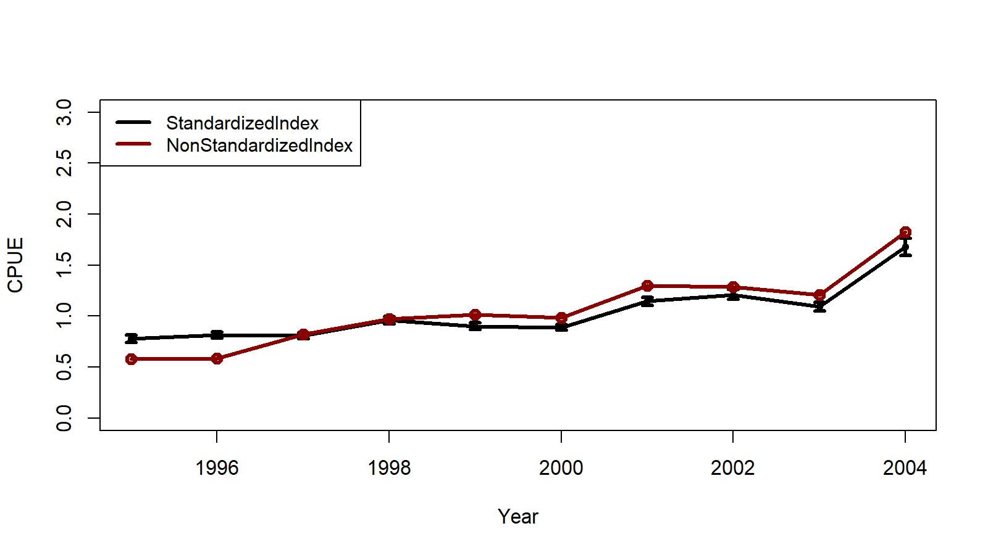
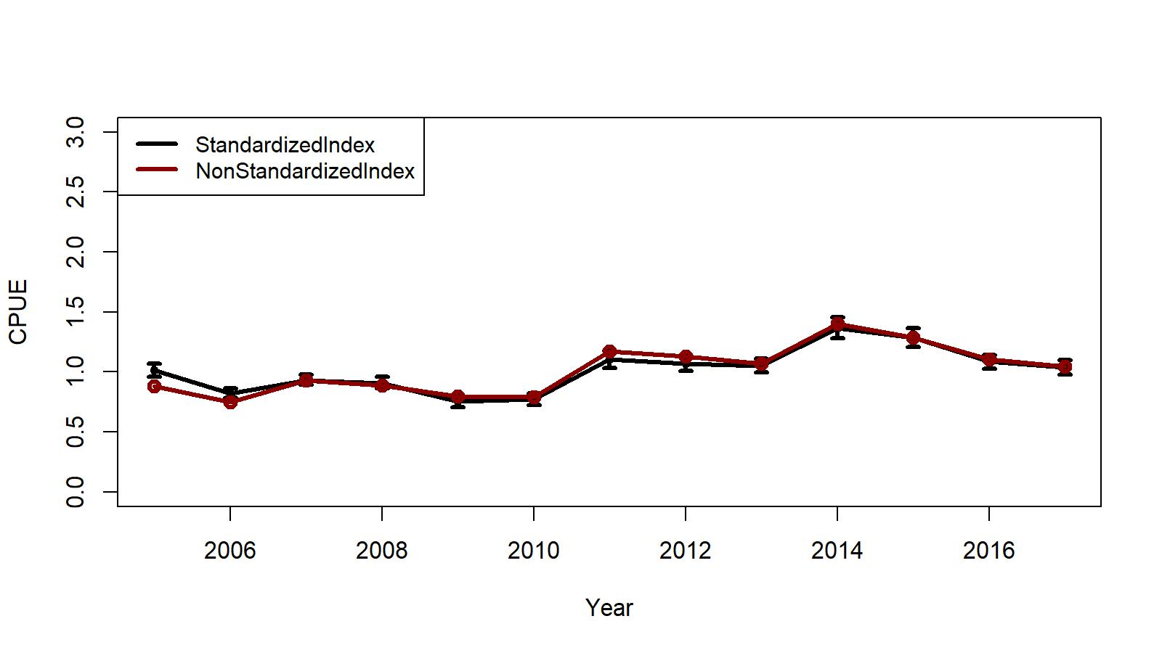
Figure B.1. Trends in non-standardized [arithmetic (nominal)] and standardized (negative binomial GLM) CPUE indices with +/- 2 SE for Aleutian Islands golden king crab from EAG (east of 174 ° W longitude). Top panel: 1995/96–2004/05 observer data and bottom panel: 2005/06–2017/18 observer data. Standardized indices: black line and non-standardized indices: red line.

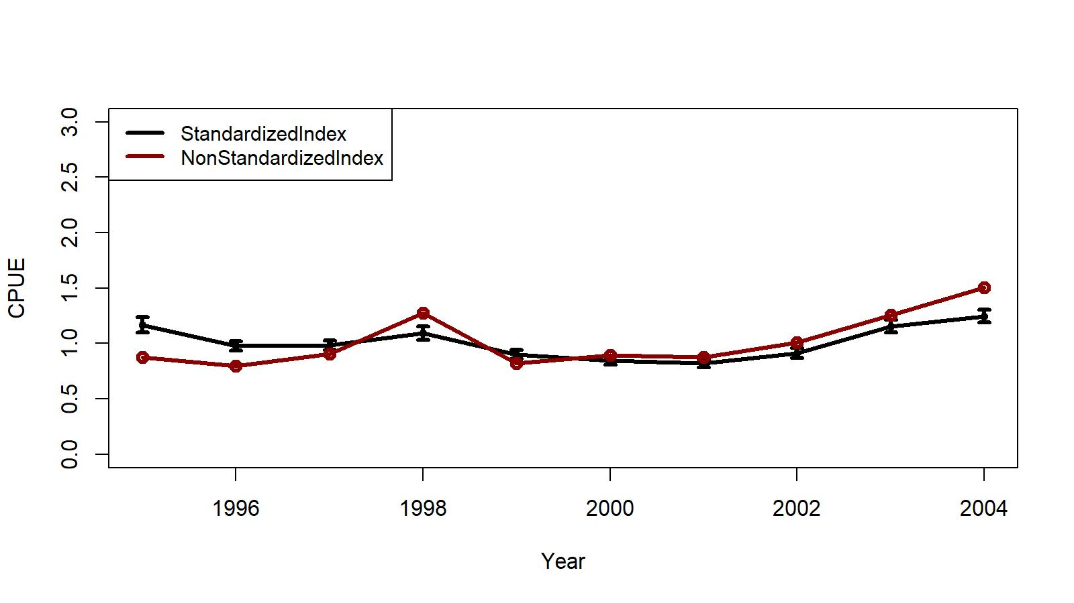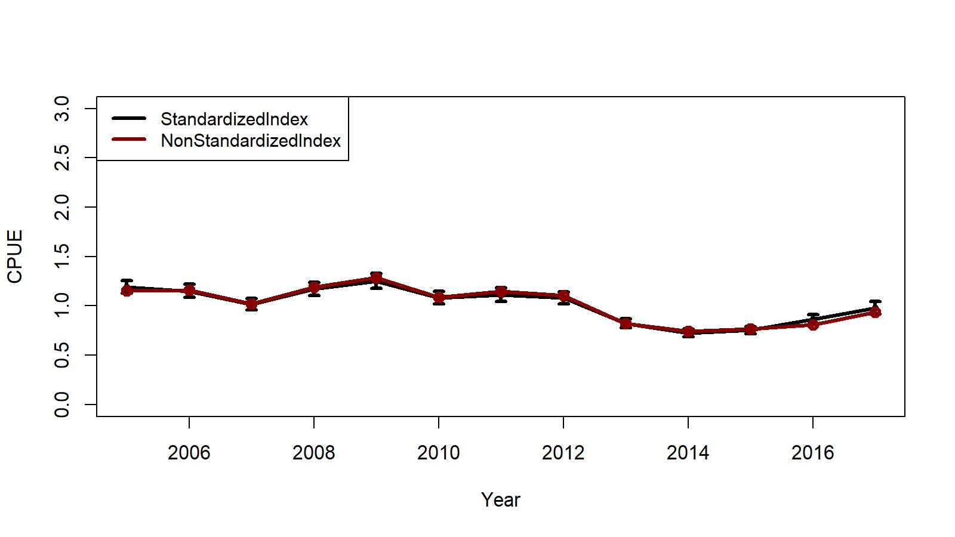

Figure B.2. Trends in non-standardized [arithmetic (nominal)] and standardized (negative binomial GLM) CPUE indices with +/- 2 SE for Aleutian Islands golden king crab from WAG (west of 174 ° W longitude). Top panel: 1995/96–2004/05 observer data and bottom panel: 2005/06–2017/18 observer data. Standardized indices: black line and non-standardized indices: red line.

Figures B.3 and B.4 show studentized residual diagnostic plots for the GLM fits for EAG and WAG, respectively.

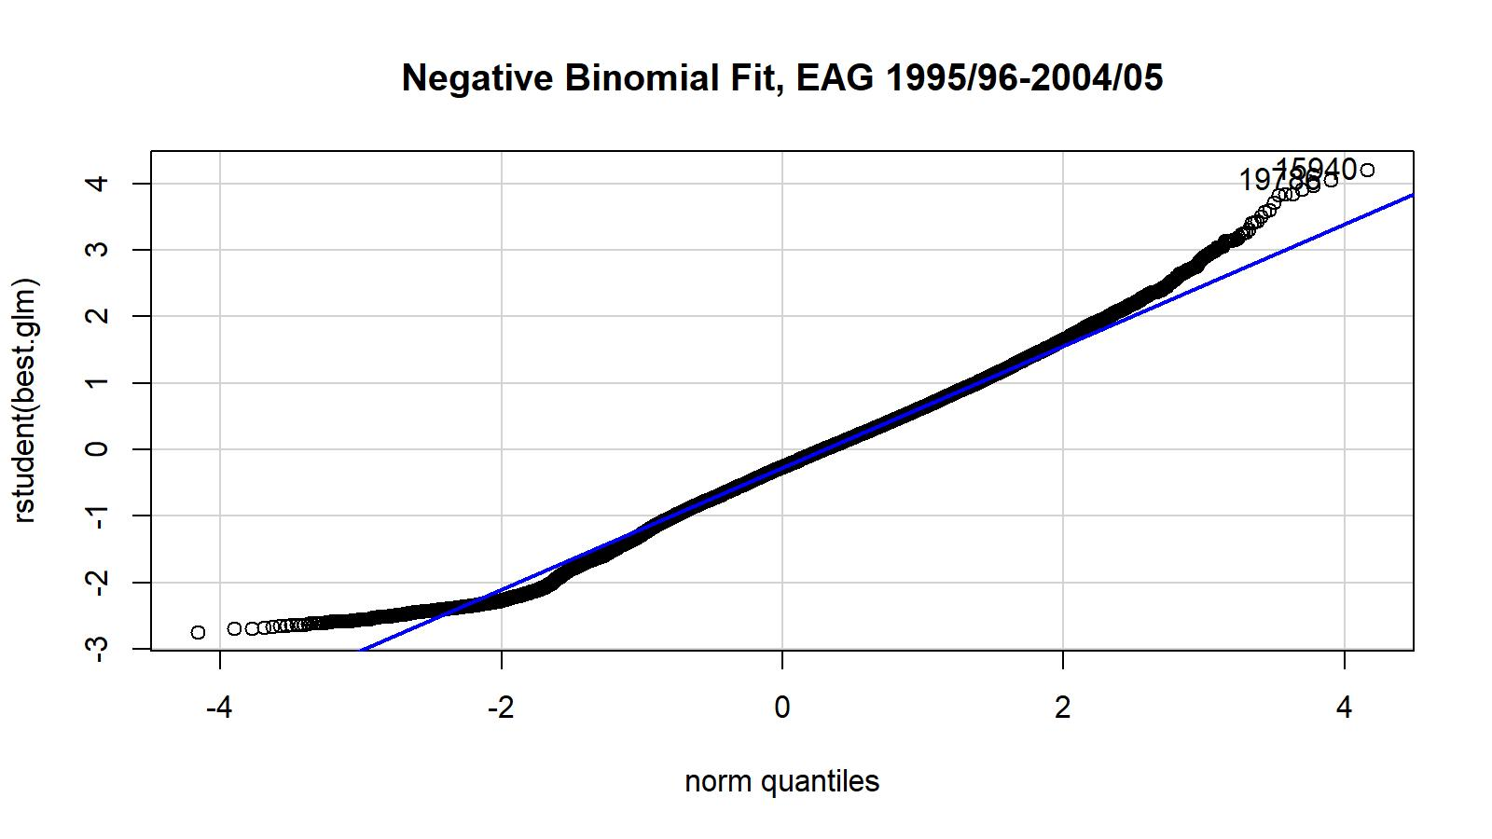
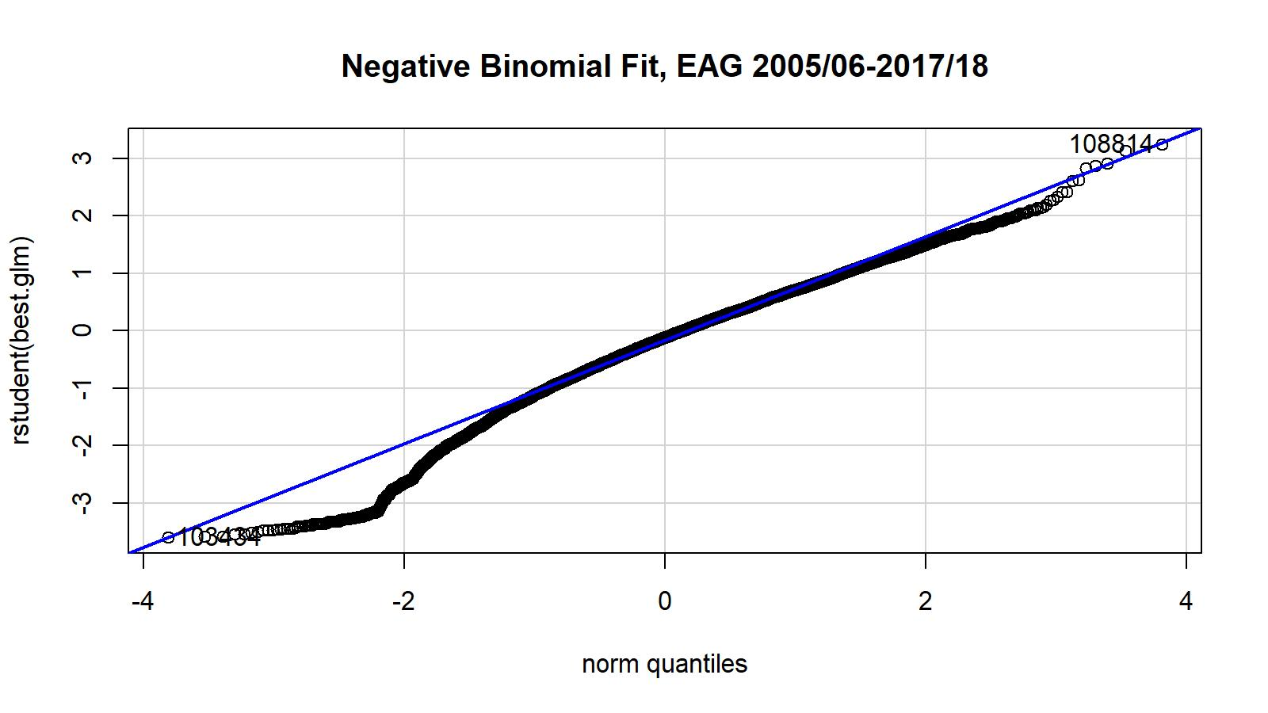

Figure B.3. Studentized residual plots for negative binomial GLM fit for EAG golden king crab observer legal size male crab CPUE data. Top panel is for 1995/96–2004/05 data and the bottom panel is for 2005/06–2017/18 data.

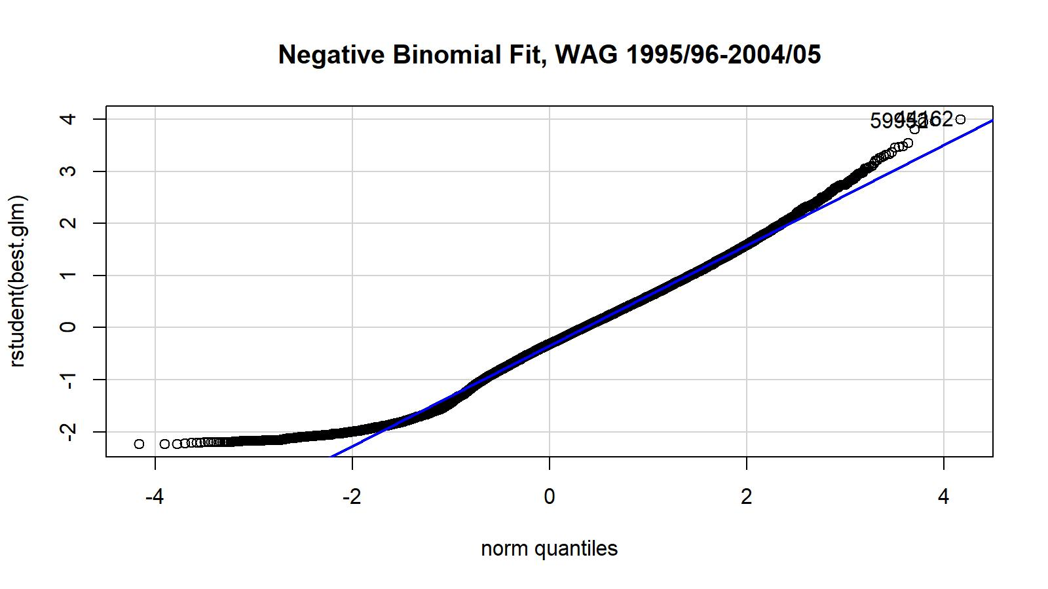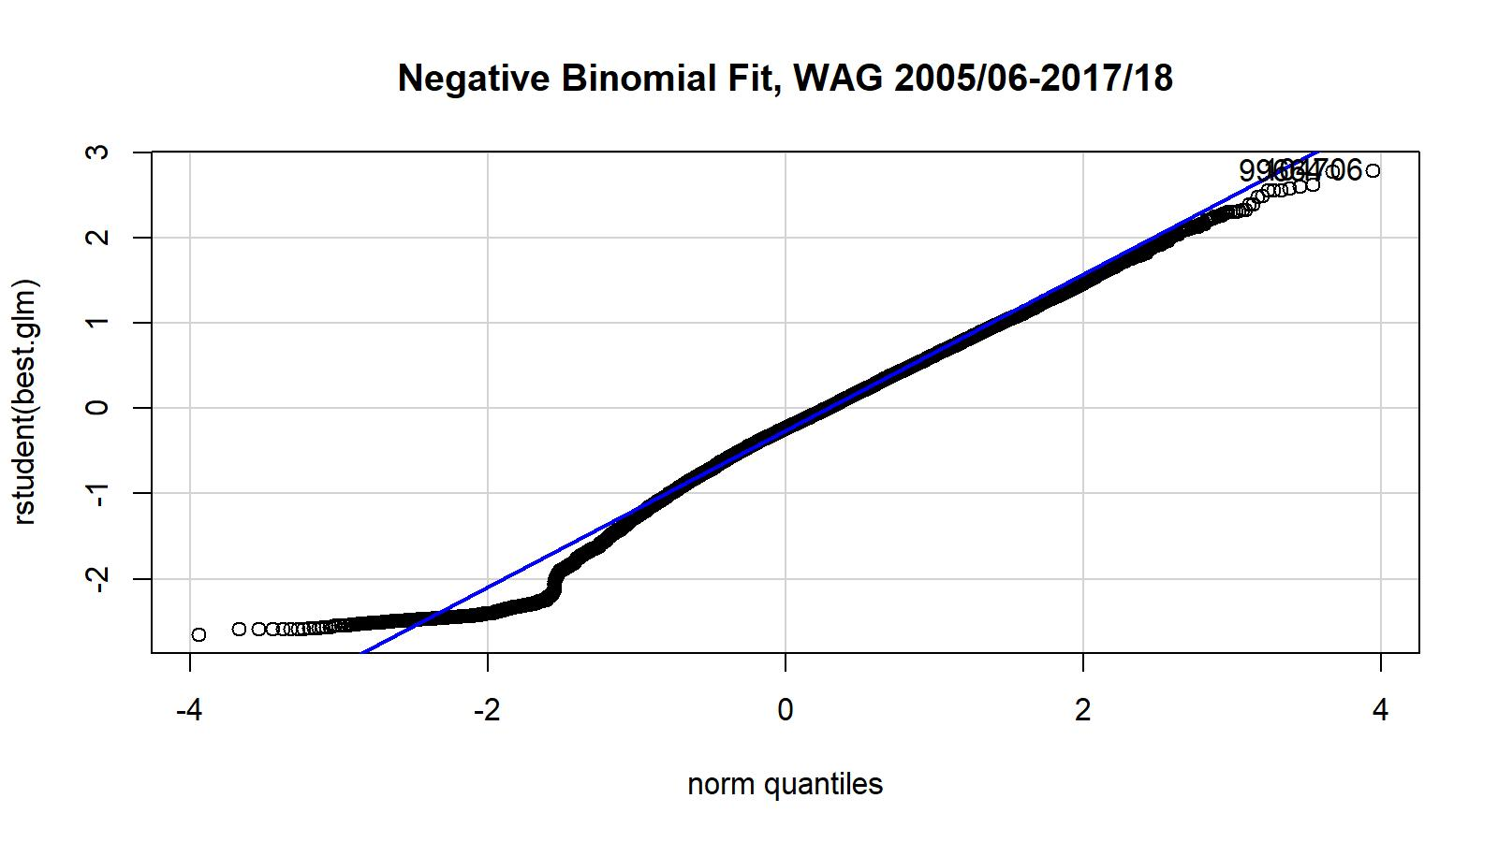
Figure B.4. Studentized residual plots for negative binomial GLM fit for WAG golden king crab observer legal size male crab CPUE data. Top panel is for 1995/96–2004/05 data and the bottom panel is for 2005/06–2016/17 data.

A number of diagnostic CDI plots are made for the fits for the two periods and area,, but not included for brevity. They are available with the first author.

Fish Ticket CPUE index:

We also fitted the lognormal GLM for fish ticket retained CPUE time series 1985/86 – 1998/99 offering Year, Month, Vessel, Captain, and Area as explanatory variables and applying the hybrid selection method. Fine area resolution (ADF&G code) was used for model fitting. The final model for EAG was:

Initial selection by stepAIC:
$\ln\left(CPUE\right)= Year + Vessel+Month$

Final selection by stepCPUE:
$\ln\left(CPUE\right)= Year + Vessel+Month$ (B.9)
for the 1985/86–1998/99 period [$R^{2}=0.3700 ]$

and that for WAG was:

Initial selection by stepAIC:
$\ln\left(CPUE\right)= Year + Vessel$

Final selection by stepCPUE
$\ln\left(CPUE\right)= Year +Vessel, R^{2}=0.3679$ (B.10)

The R² for the fish ticket data fits are much higher compared to that for observer data fits. Furthermore, both models selected the area factor.

Figures B.9 and B.10 depict the trends in nominal and standardized CPUE indices for the fish ticket CPUE time series for EAG and WAG, respectively.

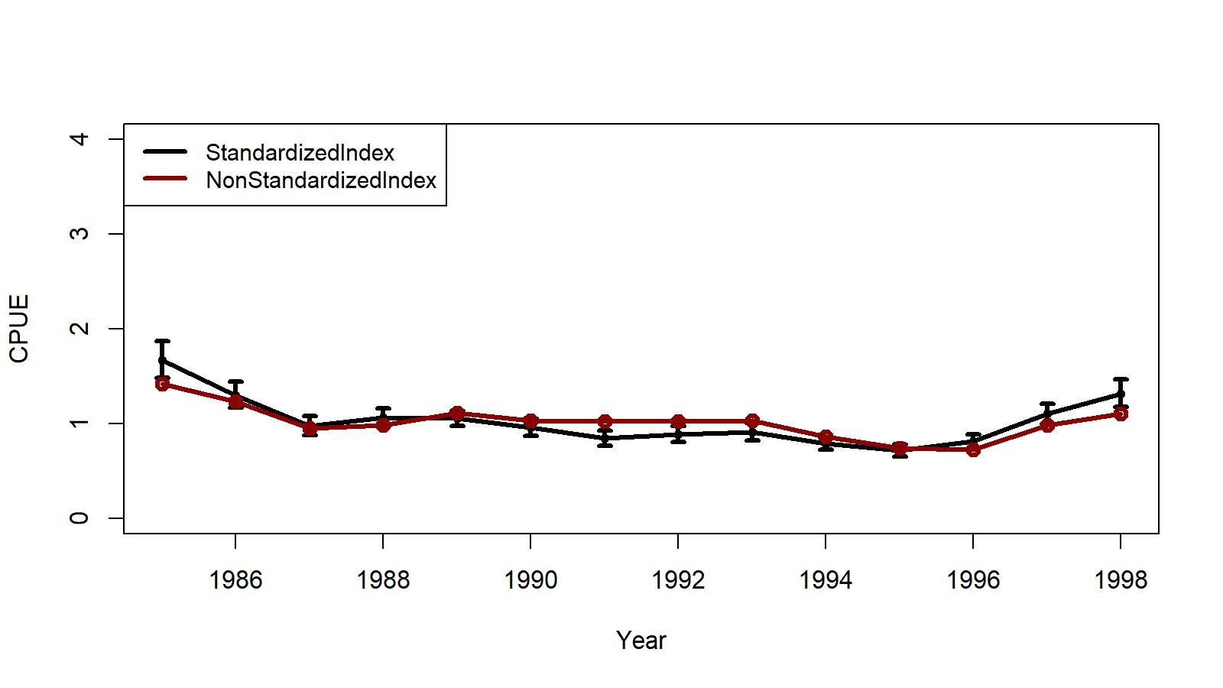
Figure B.9. Trends in non-standardized [arithmetic (nominal)] and standardized (lognormal GLM) CPUE indices with +/- 2 SE for Aleutian Islands golden king crab from EAG (east of 174 ° W longitude). The 1985/86–1998/99 fish ticket data set was used. Standardized indices: black line and non-standardized indices: red line.

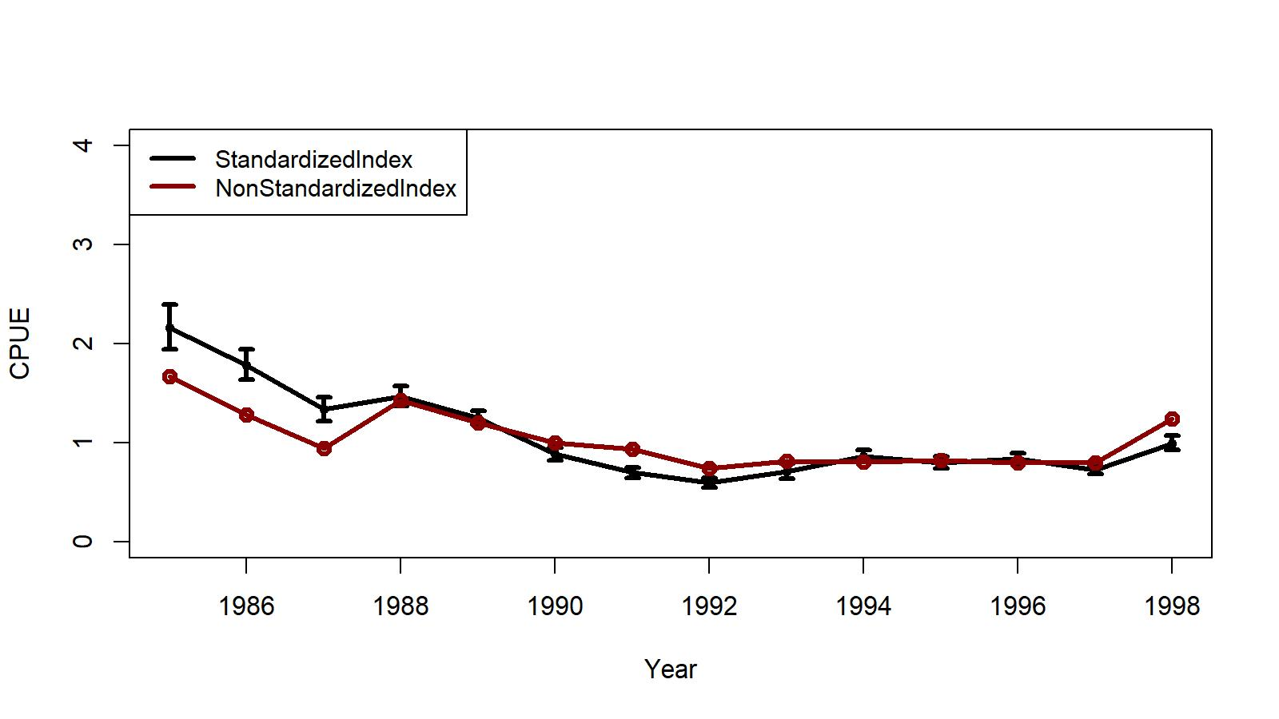
Figure B.10. Trends in non-standardized [arithmetic (nominal)] and standardized (lognormal GLM) CPUE indices with +/- 2 SE for Aleutian Islands golden king crab from WAG (east of 174 ° W longitude). The 1985/86–1998/99 fish ticket data set was used. Standardized indices: black line and non-standardized indices: red line.

Figures B.11 shows the QQ plots for the fits for EAG and WAG, respectively. The QQ plots support reasonable fits to EAG and WAG data by GLM using the lognormal error distribution.

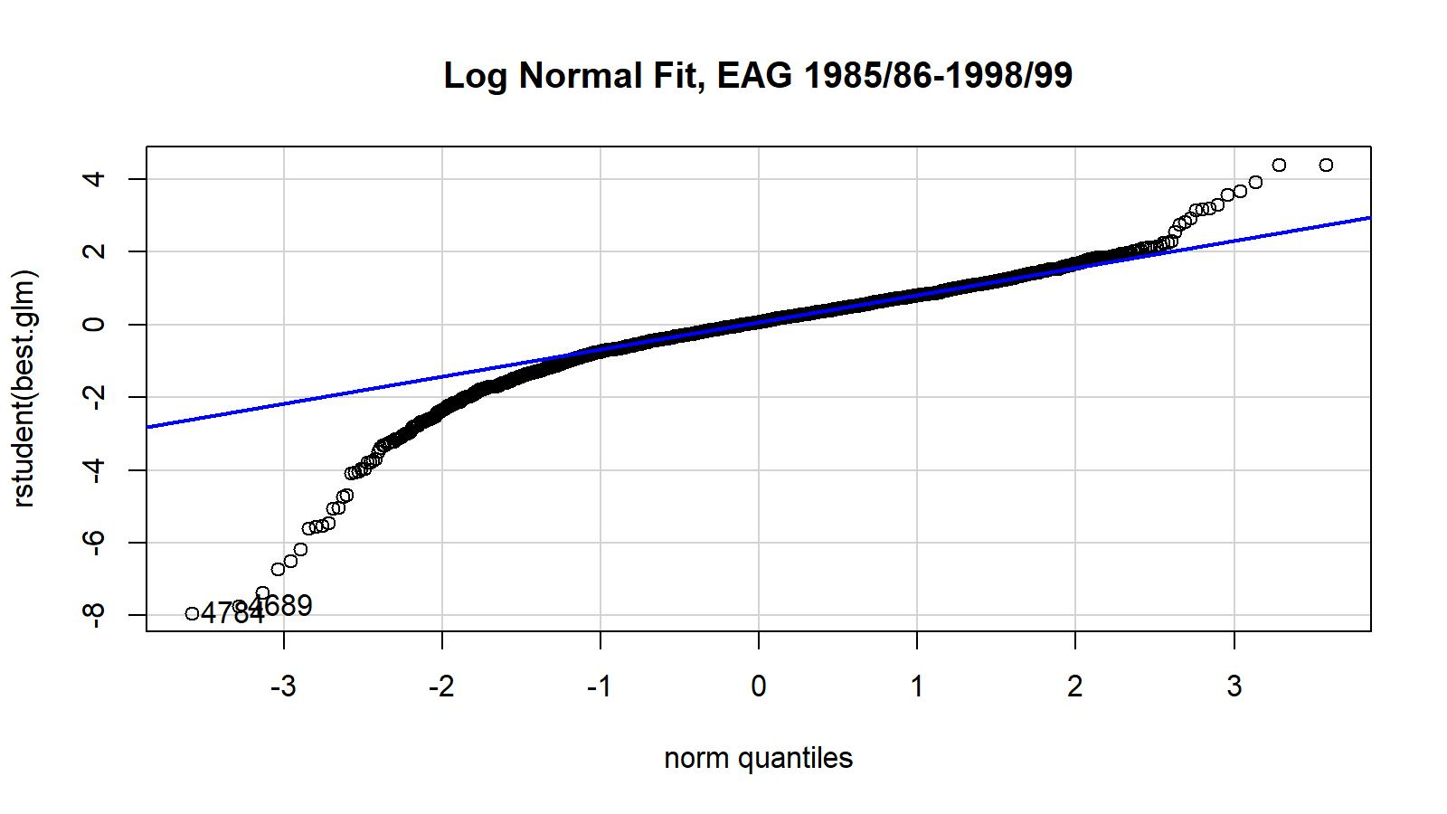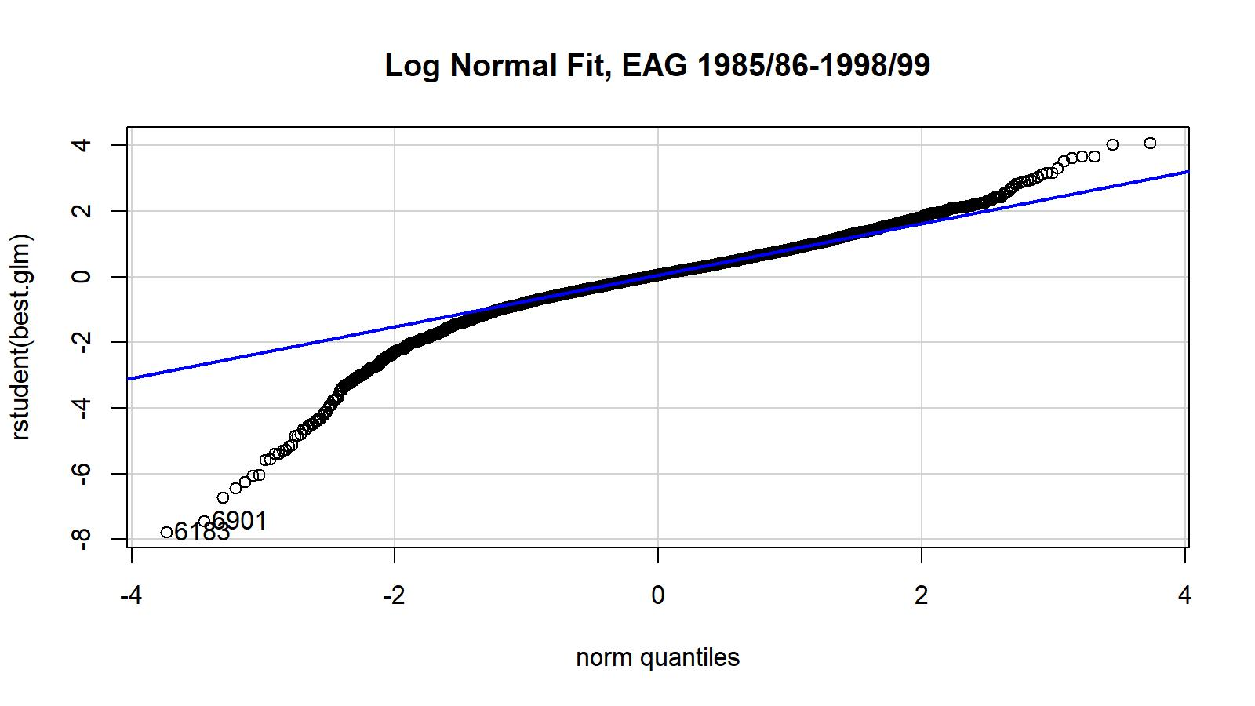
Figure B.11. Studentized residual plots for lognormal GLM fit for EAG (top) and WAG (bottom) golden king crab fish ticket CPUE data. The 1985/86–1998/99 fish ticket data set was used.

