From the AP Handbook April 2021 (posted online)
5.5 Overview of the Council’s Decision-making Process
The procedure for changing Federal fishing regulations follows a standardized process, set forth by a combination of laws, regulations, operational guidelines, policies, as well as adjustments and adaptations developed by the Council to increase efficiency, provide public participation, and produce quality outcomes. As shown in Figure 1, and discussed below, there are several key steps in the process. The AP plays a very important role in the development of fishery regulations.
The process follows several distinct steps, as detailed below.
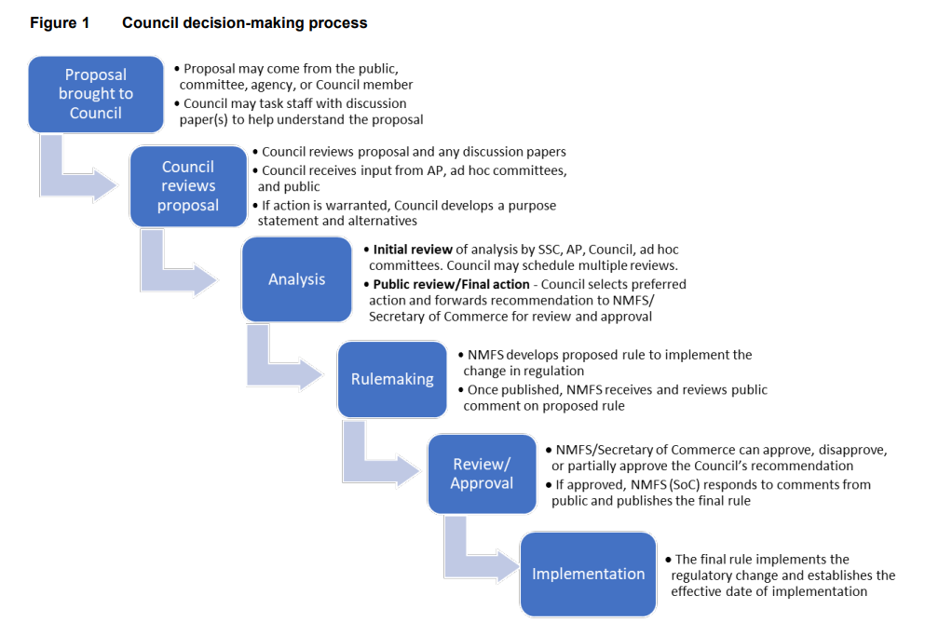
Proposal for Change
Concerns and proposals for change are brought to the Council’s attention by the public through the AP, SSC or other committee, or directly to the AP or Council via written or oral public comment during the ‘Staff Tasking’ agenda item at each Council meeting. For example, at the AP meeting during discussion of an agenda item, testimony or deliberations may reveal a related issue that the AP feels should also be addressed, and the AP may recommend initiating an analysis or discussion paper to explore the issue. Additionally, new issues on unrelated matters frequently come up during the staff tasking agenda item, and the AP may recommend some level of analysis of these issues with a discussion paper or analysis. It is helpful to the Council if the AP provides rationale for recommending new scientific issues to be addressed.
Discussion Paper
A discussion paper is frequently prepared by staff as a first step to flesh out the scope of the problem identified, and discuss issues that may be of concern in the development of alternatives. For very complex issues, several discussion papers may be necessary to explore the full scope of an issue before reasonable alternatives can be developed. For relatively simple changes, where the problem and alternatives are selfevident, a discussion paper may not be necessary, and the issue can go straight to analysis, even without developing a problem statement and range of alternatives. The AP (and other committees if appropriate) provides recommendations to the council at this stage as to whether the issue should proceed further in the process, an expanded discussion paper is needed, or the issue is ready for analysis (and recommend alternatives to be evaluated).
When the AP is reviewing a discussion paper, there are several actions the AP can take. The AP can recommend: 1) no further action be taken, 2) another discussion paper for more information or related issues, or 3) initiation of a full analysis, including AP-recommended draft alternatives and purpose and need statement. While the AP has not often drafted a full purpose and need statement (in part due to the challenges and pitfalls associated with group editing), it could do so, or simply provide recommendations to the Council about what should be included in the problem statement or in the purpose and needs section of an analysis.
Initial Review of Analysis
Normally, the Council adopts a problem statement (or thoroughly describes the problem) and identifies alternatives to be considered, and then staff prepares a draft analysis that integrates analytical requirements of applicable laws and executive orders. The analysis is released for review about 2-3 weeks before the meeting. The analysis is reviewed by the SSC for scientific merit, and by the AP to make recommendations regarding any missing information and the suite of alternatives and options evaluated. If the SSC has deemed the analysis inadequate and not ready for public review, or if the Council determines that additional alternatives or other substantial changes to the analysis are required, another initial review may be scheduled before the issue is scheduled for final action. If the analysis is to be released, the Council may designate a preliminary preferred alternative to focus public comments on their indicated course of action. At the Initial Review stage, the AP can recommend: 1) no further action be taken on this issue; 2) additional alternatives or options be added, modified, or dropped from analysis (and why); 3) changes to the problem statement or other revisions or information that would assist in future decision-making; 4) another initial review if a substantial amount of information or new alternatives; or 5) the Council move forward and release the document for final review. At this stage, the AP may also recommend a preliminary preferred alternative.
Final (‘Public’) Review of Analysis
After initial review, staff revises the analysis based on SSC, AP, and Council comments, and the analysis is posted on the Council website about 3-4 weeks before the meeting. When an issue is scheduled for Final Action, the AP can recommend: 1) no further action be taken on this issue; 2) an additional public review draft be reviewed before final action is taken (in cases when the AP find that critical additional information may be needed and/or new information indicates that additional alternatives should be analyzed); or 3) a preferred alternative. The Council makes a final decision by roll call vote on the motion.
Rulemaking
The NMFS regional office prepares draft regulations based on Council action, and, once cleared by the region and OMB, a proposed rule is published in the Federal Register. The public is provided time to comment on the proposed rule. After the comment period closes, NMFS regional staff summarize comments, and may make adjustments to the rule based on these comments. These comment summaries, the revised rule, and final approval decision are published in the Federal Register, and the action is implemented.

