Appendix D. Recruitment Breakpoint Analysis

Introduction
In 2018 SMBKC was declared overfished and a rebuilding plan was put into motion. On examination, it was clear that recruitment for SMBKC has been consistently lower in recent years. Thus, the crab Plan Team requested that the authors conduct a recruitment breakpoint analysis similar to that conducted for Bristol Bay red king crab in 2017 (Zheng et al. 2017) and eastern Bering Sea Tanner crab in 2013 (Stockhausen 2013). The R code based on these studies was adapted for this study (Jie Zheng, Buck Stockhausen pers. Comm.). The goal of this analysis was to objectively identify a change in stock productivity based on the recruitment time series. This could then be used to develop alternative rebuilding scenarios and also provide alternative B_{MSY} proxies. Results from assessment model 3 from 2018 (Ianelli and Zheng 2018) were used for this analysis.

Methods
The methods were the same as used for BBKRC (Zheng et al. 2017) which followed Punt et al. (2014) and Stockhausen (2013). Stock productivity is represented by ln(R/MMB), where R is recruitment and MMB is mature male biomass, with recruitment lagging to the brood year of mature biomass. Let y_{t} = ln(R/MMB) as estimated directly from the stock assessment model and fit externally to stock-recruitment relationships (with predictions as ŷ_{t} ). For the Ricker stock-recruitment models,
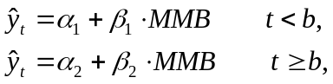 (1)
where α₁ and β₁ are the Ricker stock-recruit function parameters for the early period before the potential breakpoint in year b and α₂ and β₂ are the parameters for the period after the breakpoint in year b. For Beverton-Holt stock-recruitment models,
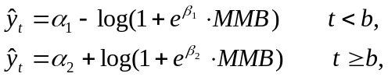 (2)
where α₁ and β₁ are the Beverton-Holt stock-recruit function log-transformed parameters for the early period before the potential breakpoint in year b and α₂ and β₂ are the log-transformed parameters for the period after the breakpoint in year b.
A maximum likelihood approach was used to estimate stock-recruitment model and error parameters. Because y_{t} is measured with error, the negative log-likelihood function is
(3)
where Ω contains observation and process error as
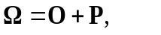 (4)
where O is the observation error covariance matrix estimated from the stock assessment model and P is the process error matrix and is assumed to reflect a first-order autoregressive process to have σ² on the diagonal and σ² ρ^{|t-j|} on the off-diagonal elements. σ² represents process error variance and ρ represents the degree of autocorrelation.
For each candidate breakpoint year b, the negative log likelihood value of equation (3) was minimized with respect to the six model parameters: α₁, β₁, α₂, β₂, ln(σ) and tan(ρ). The minimum time span considered as a potential regime was 5 years. Each brood year from 1983 to 2005 was evaluated as a potential breakpoint b using time series of ln(R/MMB) and MMB for brood years 1978-2010. A model with no breakpoint was also evaluated. Models with different breakpoints were then ranked using AICc (AIC corrected for small sample size; Burnham and Anderson 2004),
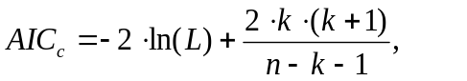 (5)
where k is the number of parameters and n is the number of observations. Using AICc, the model with the smallest AICc is regarded as the “best” model among the set of models evaluated. Different models can be compared in terms of θ_{m}, the relative probability (odds) that the model with the minimum AICc score is a better model than model m, where
(6)

Results
Results are summarized in Tables D1-D4 and Figures D1-D6. Both Ricker and Beverton-Holt (B-H) models resulted in the same breakpoint brood year of 1989, which corresponded to recruitment year of 1996. The model without a breakpoint (i.e., a single period) was about 26 times less probable than the 1989 breakpoint model for the Ricker stock-recruitment relationship and 4 times less probable than the Beverton-Holt, which suggested a possible change in stock productivity from the early high period to the recent low period. Alternative breakpoint brood years of 1984-1988 for the Ricker model and of 1990 for Beverton-Holt model were also reasonably reported with relative odds less than 10.
Both Ricker and Beverton-Holt stock-recruitment models fitted the data poorly. Additionally, the fit to the breakpoint group with fewer data points was extremely poor for both models, especially the Ricker model. For example, the Ricker model with a breakpoint year of 1983 (Figure D1) fits the larger data group well (black line) but the fit to the smaller data group (red line) is poor, with an estimated intercept (α₁) that appears to be lower than the expected fit. This was the case for all breakpoint years with the data group (pre or post breakpoint) that had fewer data points. A sensitivity analysis was performed to determine the source of this lack of fit for both the Ricker and B-H models. For the Ricker model a breakpoint analysis that produced two independent regression (where the covariance matrix and ρ were set to 0) produced model fits that fit both data groups well, additionally this analysis produced the same breakpoint year of 1989, but suggested that 1990 was also a possibility. The poor model fit is primarily due to covariance and estimation of ρ in the analysis. The same analysis with the B-H model was performed but only the Ricker results are presented here for simplicity (Figures D8-D10).
Sensitivity analyses suggest that error within the model, specifically autocorrelation (ρ), produce poor fits to the stock-recruit relationships when the sample size for the data set is low. However, the resulting breakpoint year is still the same, suggesting strong evidence for a brood year breakpoint in 1989. The only other likely breakpoint year is 1990, with relative odds < 2 compared to 1989. These breakpoint brood years would produce breaks in recruitment in either 1996 or 1997.

Discussion
A recruitment breakpoint analysis was conducted on St Matthews blue king crab by Punt et al. (2014) with data from 1978 to 2010 to estimate a breakpoint brood year of 1993, corresponding to recruitment year of 1998, but this model used a 5-year lag and incorporated smaller size classes (20 - 90mm) than the current assessment model. The projections for recruitment from the Punt et al. (2014) model are substantially higher in the late 2000s than the current assessment model, which would greatly influence the breakpoint analysis results. The different time series of data may also explain the differences; however, both suggest a break in recruitment in the mid to late 1990s.
Time series of estimated mature male biomass during 1978-2017 (the entire time series) has been used to compute a B_{MSY} proxy. Using the 2018 assessment model the B_{MSY} proxy for 2018 is 3,478 t. The B_{MSY} proxy for the recent recruitment period (based on the break point analysis; 1996-2017) using the same model is 2,030 t (Table D5). The is approximately a 42% reduction (Figure D7). If the estimated breakpoint year is used to set the new recruitment time series, the estimated B_{MSY} proxy will be correspondingly lower than the current estimated value.

References
Burnham, K.P., and D.R. Anderson. 2004. Multimodal inference: understanding AIC and BIC in model selection. Sociological Methods & Research 33:261–304.
Punt, A.E., C.S. Szuwalski, and W. Stockhausen. 2014. An evaluation of stock-recruitment proxies and environmental change points for implementing the US Sustainable Fisheries Act. Fisheries Research 157:28-40.
Stockhausen, W.T. 2013 Recruitment Analysis for Stock Status Determination and Harvest Recommendations. Appendix to: 2013 Stock Assessment and Fishery Evaluation Report for the Tanner Crab Fisheries in the Bering Sea and Aleutian Islands Regions. In: Stock Assessment and Fishery Evaluation Report for the King and Tanner Crab Fisheries of the Bering Sea and Aleutian Islands Regions. North Pacific Fishery Management Council, Anchorage. pp.450-478.

Table D1. Results of the breakpoint analysis, with AICc and the relative probability (odds) against the Ricker stock-recruitment model being correct by breakpoint year. The model with no breakpoint is listed first in the table. The “best” model is shaded. Years are brood year.
Year | AICc | Odds
NA | 1.474 | 26.124
1983 | -0.187 | 11.384
1984 | -1.498 | 5.913
1985 | -0.975 | 7.679
1986 | -1.449 | 6.059
1987 | -1.141 | 7.066
1988 | -1.784 | 5.124
1989 | -5.052 | 1.000
1990 | 0.141 | 13.413
1991 | 2.586 | 45.564
1992 | 4.658 | 128.335
1993 | 4.621 | 125.992
1994 | 2.479 | 43.172
1995 | 5.339 | 180.461
1996 | 5.266 | 173.990
1997 | 4.137 | 98.931
1998 | 4.950 | 148.548
1999 | 7.258 | 471.115
2000 | 7.234 | 465.383
2001 | 5.509 | 196.408
2002 | 6.186 | 275.605
2003 | 4.537 | 120.830
2004 | 2.989 | 55.723
2005 | 6.716 | 359.120

Table D2. Parameter estimates and standard deviations for the Ricker stock-recruitment model with no breakpoint (first row) and the single breakpoint models (by year of breakpoint). The “best” model is shaded. Years are brood year.

Year | α₁ | std.dev. | α₂ | std.dev. | β₁ | std.dev. | β₂ | std.dev. | ln(σ) | std.dev. | tan(ρ) | std.dev.
 |  |  | 5.488 | 0.624 |  |  | 0.155 | 0.068 | -0.099 | 0.373 | 6.493 | 5.311
1983 | 4.456 | 1.224 | 6.770 | 1.096 | 0.062 | 0.078 | 0.546 | 0.127 | 0.180 | 0.610 | 22.813 | 29.838
1984 | 4.834 | 0.989 | 6.862 | 0.970 | 0.080 | 0.058 | 0.632 | 0.138 | 0.064 | 0.570 | 20.324 | 24.984
1985 | 5.199 | 0.845 | 6.764 | 0.859 | 0.100 | 0.054 | 0.634 | 0.142 | -0.044 | 0.523 | 15.556 | 17.804
1986 | 5.510 | 0.743 | 6.615 | 0.764 | 0.104 | 0.055 | 0.617 | 0.149 | -0.166 | 0.474 | 11.401 | 12.175
1987 | 5.193 | 0.856 | 6.794 | 0.883 | 0.101 | 0.054 | 0.645 | 0.145 | -0.031 | 0.530 | 15.858 | 18.137
1988 | 5.356 | 0.779 | 6.667 | 0.814 | 0.103 | 0.053 | 0.621 | 0.147 | -0.131 | 0.520 | 13.543 | 15.341
1989 | 5.819 | 0.625 | 6.080 | 0.698 | 0.098 | 0.052 | 0.475 | 0.183 | -0.521 | 0.495 | 6.231 | 7.556
1990 | 5.818 | 0.874 | 5.790 | 1.116 | 0.101 | 0.058 | 0.358 | 0.292 | -0.594 | 0.654 | 3.776 | 7.050
1991 | 5.918 | 0.703 | 5.606 | 0.820 | 0.124 | 0.064 | 0.294 | 0.194 | -0.581 | 0.433 | 2.791 | 3.540
1992 | 5.270 | 1.008 | 6.317 | 1.232 | 0.134 | 0.062 | 0.439 | 0.262 | -0.031 | 0.696 | 10.149 | 15.757
1993 | 5.288 | 1.009 | 6.262 | 1.282 | 0.137 | 0.063 | 0.424 | 0.275 | -0.040 | 0.691 | 9.514 | 15.029
1994 | 5.632 | 0.812 | 5.994 | 1.089 | 0.138 | 0.066 | 0.420 | 0.245 | -0.289 | 0.512 | 5.086 | 6.549
1995 | 4.886 | 1.189 | 6.705 | 1.340 | 0.136 | 0.063 | 0.500 | 0.227 | 0.255 | 0.621 | 17.185 | 22.680
1996 | 4.949 | 1.110 | 6.683 | 1.273 | 0.136 | 0.063 | 0.513 | 0.236 | 0.208 | 0.597 | 15.375 | 20.228
1997 | 4.720 | 1.295 | 6.554 | 1.437 | 0.135 | 0.061 | 0.381 | 0.252 | 0.367 | 0.600 | 22.852 | 29.149
1998 | 4.997 | 1.047 | 5.658 | 1.435 | 0.141 | 0.062 | 0.068 | 0.427 | 0.201 | 0.551 | 15.742 | 19.015
1999 | 5.533 | 0.687 | 5.493 | 1.665 | 0.156 | 0.069 | 0.179 | 0.798 | -0.129 | 0.438 | 6.011 | 6.144
2000 | 5.443 | 0.719 | 5.636 | 1.740 | 0.155 | 0.069 | 0.198 | 0.805 | -0.067 | 0.472 | 6.998 | 7.404
2001 | 5.717 | 0.537 | 4.613 | 1.775 | 0.156 | 0.066 | -0.078 | 0.803 | -0.261 | 0.334 | 4.720 | 3.589
2002 | 5.657 | 0.553 | 4.553 | 1.799 | 0.156 | 0.066 | -0.142 | 0.800 | -0.239 | 0.366 | 5.149 | 4.225
2003 | 5.767 | 0.492 | 4.785 | 1.705 | 0.159 | 0.063 | 0.062 | 0.779 | -0.343 | 0.323 | 4.474 | 3.254
2004 | 5.814 | 0.468 | 4.685 | 1.664 | 0.160 | 0.062 | 0.099 | 0.758 | -0.384 | 0.301 | 4.213 | 2.864
2005 | 5.607 | 0.555 | 5.195 | 1.790 | 0.155 | 0.067 | 0.141 | 0.826 | -0.227 | 0.378 | 5.190 | 4.365

Table D3. Results of the breakpoint analysis, with AICc and the relative probability (odds) against the Beverton-Holt stock-recruitment model being correct by breakpoint year. The model with no breakpoint is listed first in the table. The “best” model is shaded. Years are brood year.

Year | AICc | Odds
NA | -1.533 | 4.232
1983 | 4.103 | 70.852
1984 | 3.986 | 66.809
1985 | 4.005 | 67.459
1986 | 2.860 | 38.062
1987 | 3.925 | 64.830
1988 | 2.563 | 32.810
1989 | -4.418 | 1.000
1990 | -0.741 | 6.288
1991 | 0.740 | 13.187
1992 | 2.859 | 38.028
1993 | 2.630 | 33.923
1994 | 0.854 | 13.956
1995 | 4.237 | 75.741
1996 | 4.267 | 76.888
1997 | 1.905 | 23.605
1998 | 2.075 | 25.703
1999 | 3.956 | 65.817
2000 | 4.112 | 71.165
2001 | 2.937 | 39.540
2002 | 3.116 | 43.263
2003 | 0.877 | 14.121
2004 | -0.855 | 5.939
2005 | 3.579 | 54.527

Table D4. Parameter estimates and standard deviations for the Beverton-Holt stock-recruitment model with no breakpoint (first row) and the single breakpoint models (by year of breakpoint). The “best” model is shaded. Years are brood year.

Year | α₁ | std.dev. | α₂ | std.dev. | β₁ | std.dev. | β₂ | std.dev. | ln(σ) | std.dev. | tan(ρ) | std.dev.
 |  |  | 11.908 | 34.104 |  |  | 5.800 | 34.131 | -0.009 | 0.437 | 9.869 | 9.284
1983 | 11.694 | NA | 12.970 | 47.627 | 5.444 | NA | 6.914 | 47.639 | -0.064 | 0.440 | 8.852 | 8.394
1984 | 5.572 | 2.004 | 16.904 | 327.946 | -0.995 | 2.787 | 10.826 | 327.948 | -0.048 | 0.461 | 9.257 | 9.254
1985 | 6.345 | 3.335 | 13.895 | 71.302 | -0.097 | 4.202 | 7.862 | 71.309 | -0.040 | 0.568 | 9.453 | 11.707
1986 | 7.533 | NA | 13.399 | 63.519 | 0.973 | NA | 7.500 | 63.531 | -0.261 | 0.335 | 6.145 | 5.013
1987 | 5.981 | 1.683 | 16.024 | 219.692 | -0.666 | 2.487 | 10.011 | 219.695 | -0.134 | 0.472 | 7.647 | 7.894
1988 | 6.262 | 1.538 | 13.277 | 68.643 | -0.711 | 2.287 | 7.383 | 68.656 | -0.350 | 0.425 | 5.155 | 5.008
1989 | 7.068 | 1.875 | 11.864 | 69.327 | -0.295 | 2.416 | 6.194 | 69.377 | -0.751 | 0.300 | 2.896 | 2.154
1990 | 12.339 | NA | 11.704 | NA | 5.363 | NA | 5.993 | NA | -0.722 | 0.336 | 2.646 | 2.383
1991 | 12.304 | 38.041 | 11.711 | NA | 5.419 | 38.076 | 5.985 | NA | -0.653 | 0.356 | 2.588 | 2.578
1992 | 12.200 | 33.709 | 11.752 | NA | 5.608 | 33.730 | 5.917 | NA | -0.420 | 0.496 | 4.429 | 5.120
1993 | 12.881 | 44.794 | 11.465 | NA | 6.344 | 44.807 | 5.636 | NA | -0.369 | 0.430 | 4.791 | 4.774
1994 | 13.348 | 51.252 | 11.695 | 233.066 | 6.642 | 51.264 | 6.049 | 233.257 | -0.446 | 0.310 | 3.715 | 2.753
1995 | 11.988 | 36.396 | 11.863 | 111.774 | 5.817 | 36.408 | 5.805 | 111.874 | -0.058 | 0.518 | 8.939 | 9.881
1996 | 11.966 | 37.397 | 11.882 | 93.181 | 5.842 | 37.411 | 5.790 | 93.266 | -0.020 | 0.527 | 9.588 | 11.563
1997 | 13.744 | 105.672 | 7.696 | 5.406 | 8.060 | 105.672 | 1.102 | 5.906 | 0.337 | 0.621 | 24.517 | 32.501
1998 | 12.980 | 58.869 | 5.748 | 1.618 | 7.151 | 58.870 | -2.250 | 6.036 | 0.229 | 0.584 | 19.852 | 25.260
1999 | 13.405 | 47.136 | 11.393 | NA | 7.144 | 47.143 | 5.452 | NA | -0.137 | 0.447 | 7.230 | 7.396
2000 | 14.297 | 98.747 | 5.732 | 1.989 | 8.272 | 98.752 | -1.652 | 6.425 | 0.074 | 0.552 | 12.085 | 14.354
2001 | 12.041 | 31.917 | 11.731 | NA | 5.698 | 31.953 | 5.946 | NA | -0.230 | 0.398 | 6.243 | 5.598
2002 | 13.694 | 52.456 | 5.888 | NA | 7.486 | 52.464 | -0.604 | NA | -0.162 | 0.425 | 7.790 | 7.064
2003 | 13.209 | 40.983 | 11.292 | NA | 6.789 | 40.995 | 5.706 | NA | -0.349 | 0.371 | 5.920 | 4.824
2004 | 13.213 | 39.232 | 11.330 | NA | 6.749 | 39.244 | 5.911 | NA | -0.392 | 0.349 | 5.678 | 4.409
2005 | 14.402 | 93.698 | 10.309 | NA | 8.150 | 93.706 | 4.447 | NA | -0.158 | 0.432 | 7.808 | 7.191

Table D5. Estimates of B_{MSY} proxy using the entire time series and model suggested breakpoint years for recruitment.

Year | Basis for B_{MSY} | B_{MSY} proxy | MSST | Biomass (MMB_{mating}) | B/B_{MSY}
2018/19 | 1978-2017 | 3.48 | 1.74 | 1.09 | 0.31
2018/19 | 1996-2017 | 2.03 | 1.015 | 1.08 | 0.53

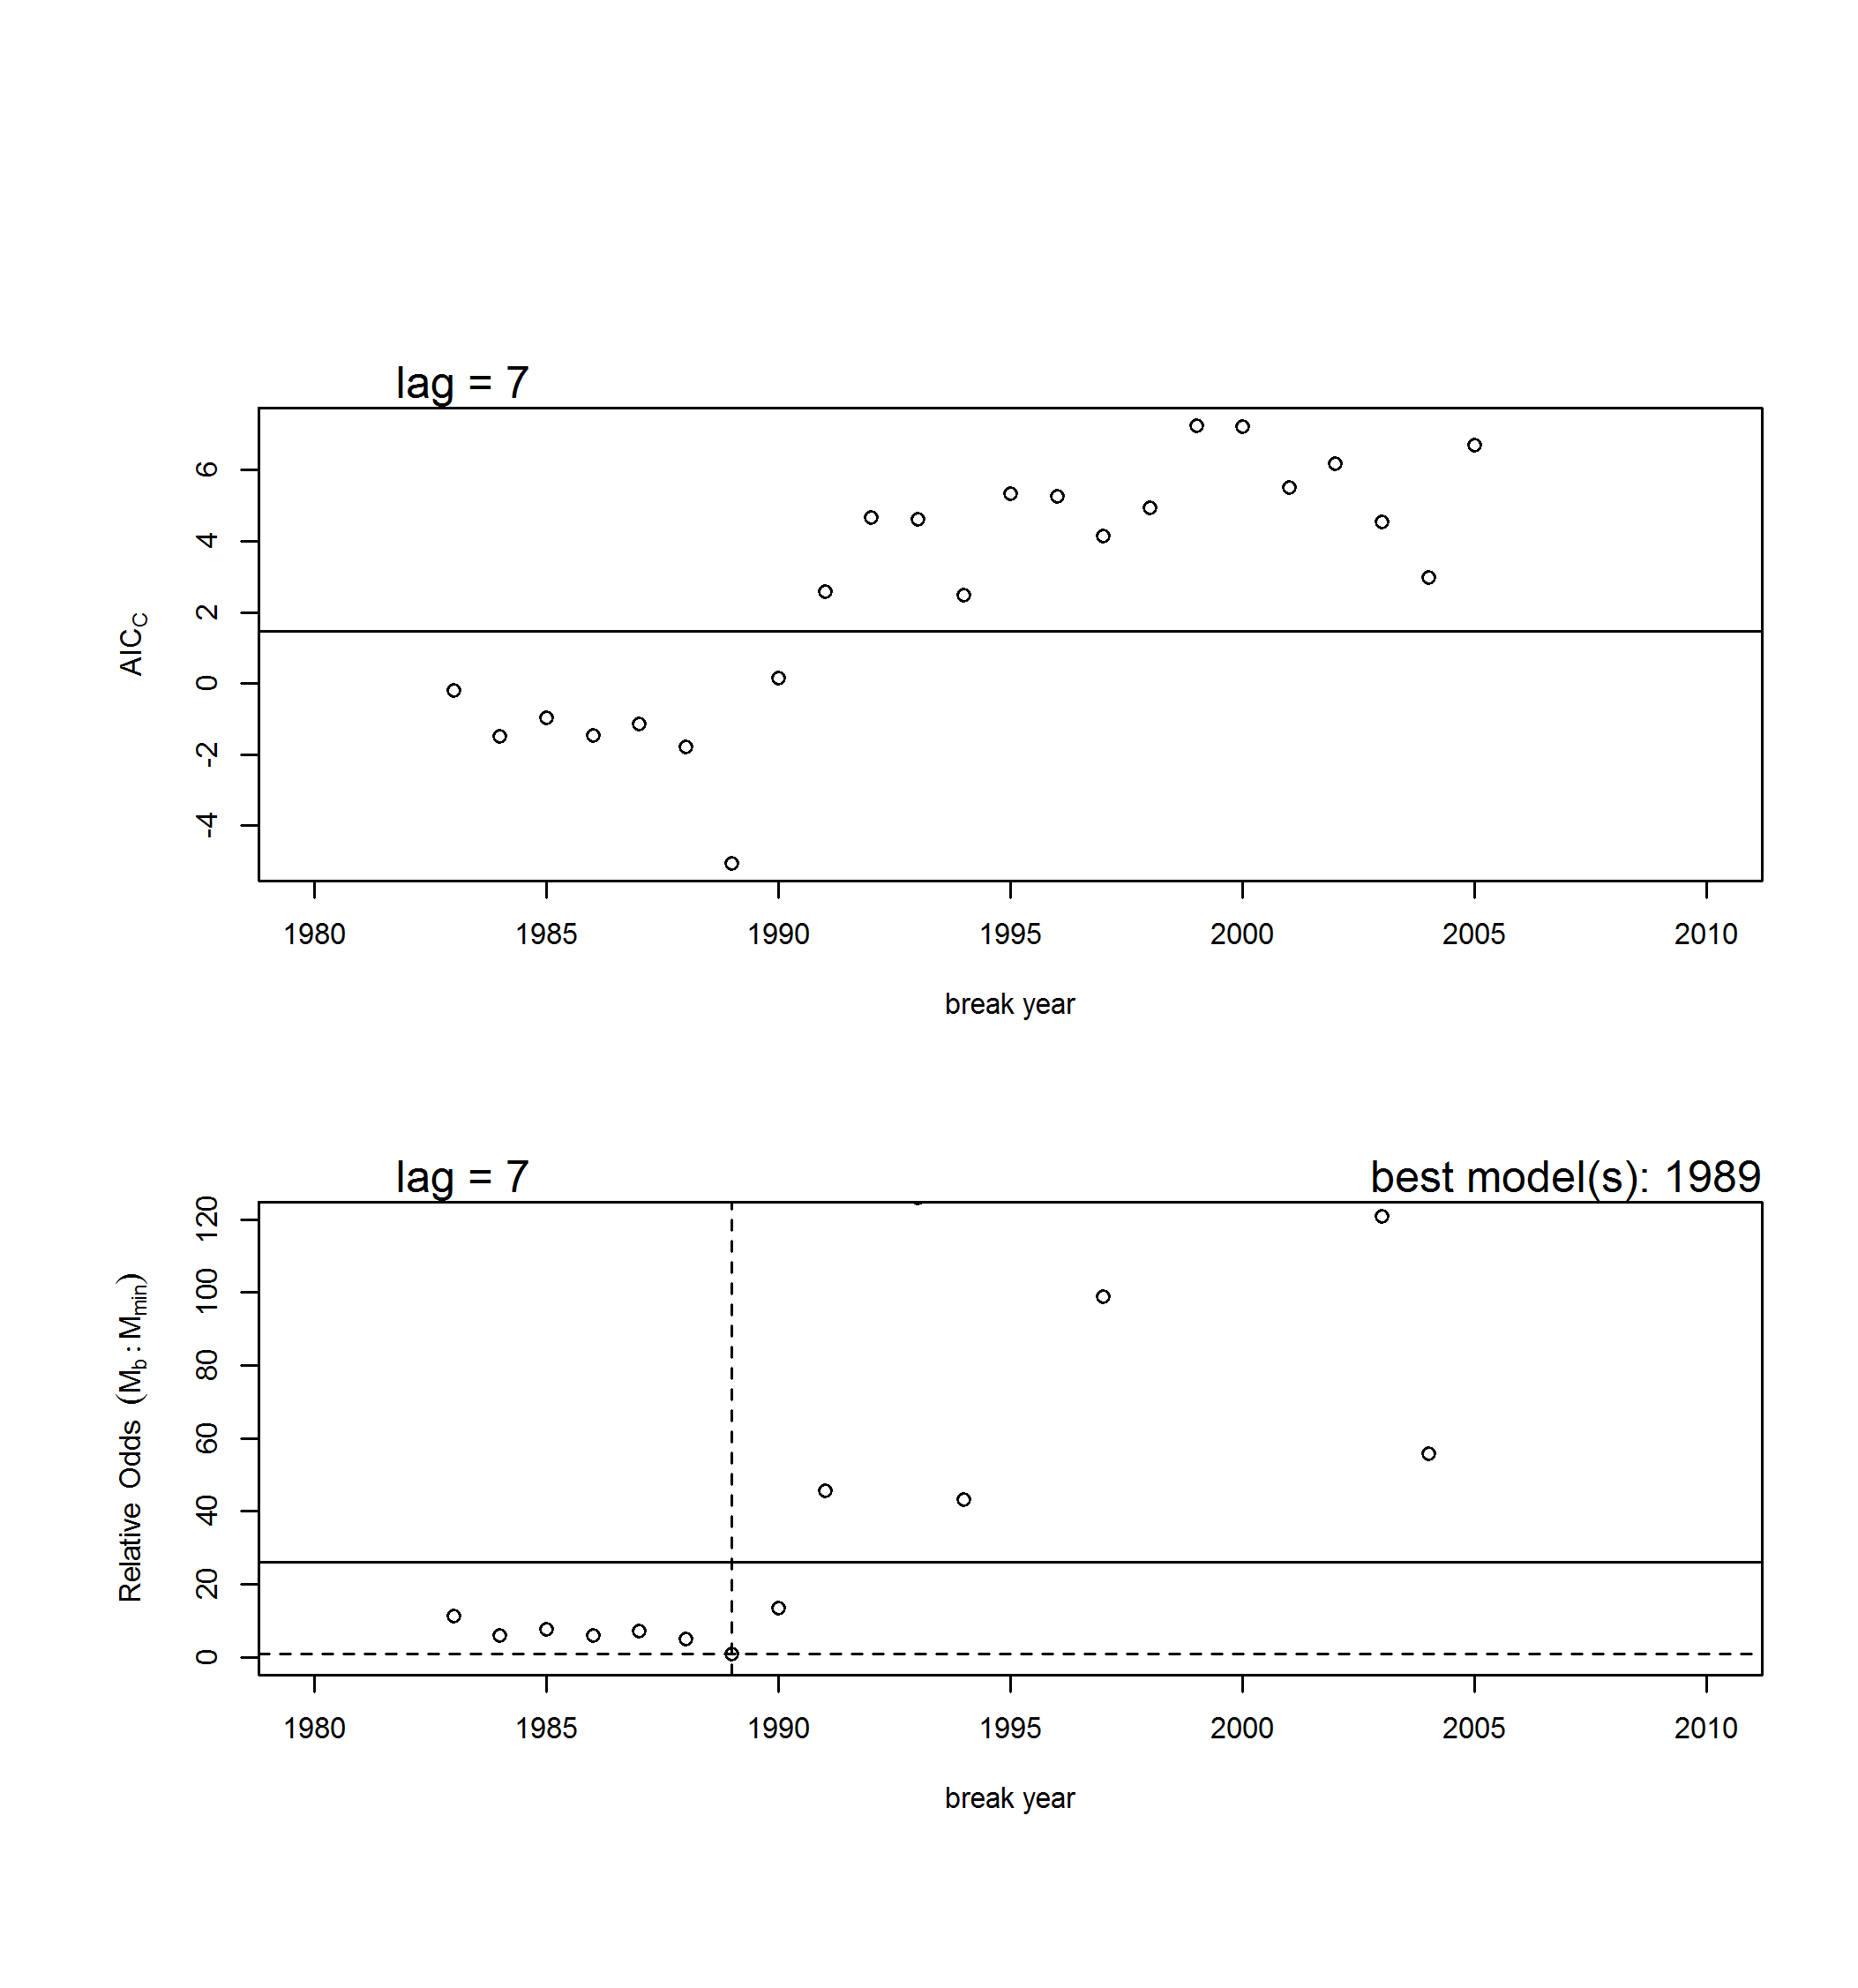

Figure D1. Results from the Ricker stock-recruit breakpoint analysis. Upper graph: AICc vs. year of breakpoint for the 1-breakpoint models (circles) and AICc for the model with no breakpoint (horizontal line). Lower graph: probabilistic odds for all 1-breakpoint models (circles) and the no breakpoint model (horizontal solid line) relative to the model with the smallest AICc score. The dashed lines indicate the value for the model with the lowest AICc score (breakpoint in 1989). Not shown are 1-breakpoint models with high odds (>120) of being incorrect.

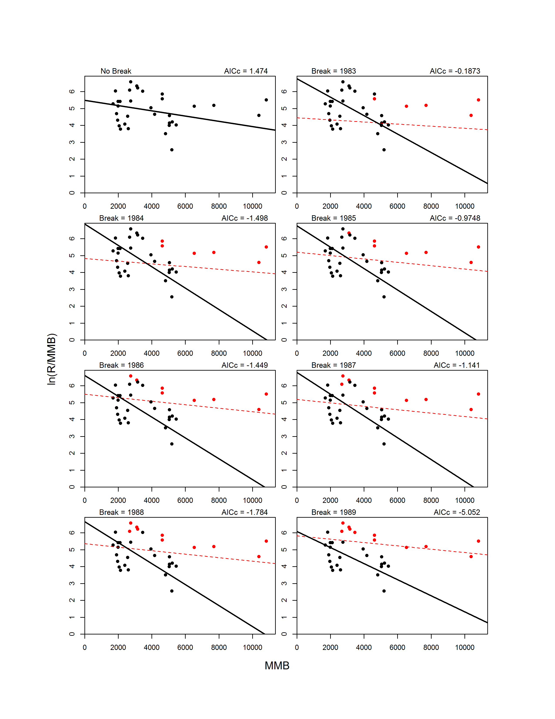
Figure D2. Fits for Ricker models with no breakpoint (upper left graph) and with 1-breakpoint for break years 1978-2005. For 1-breakpoint models, the pre-break data (circles) and model fit (line) are shown in red, whereas the post-break data and fit are shown in black.
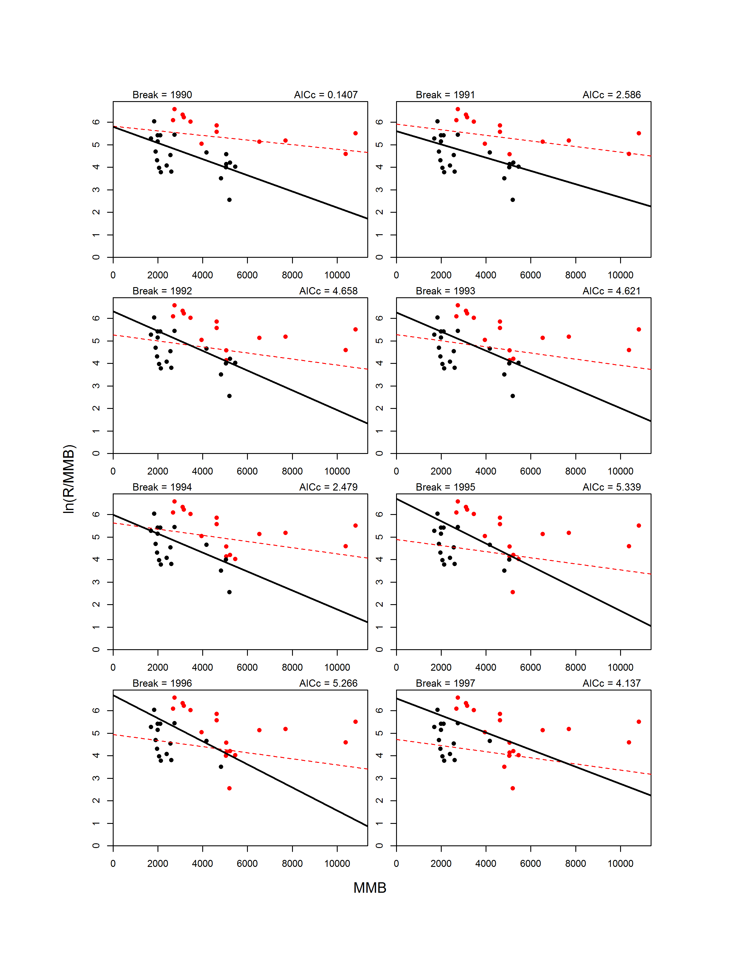
Figure D2. Continued.
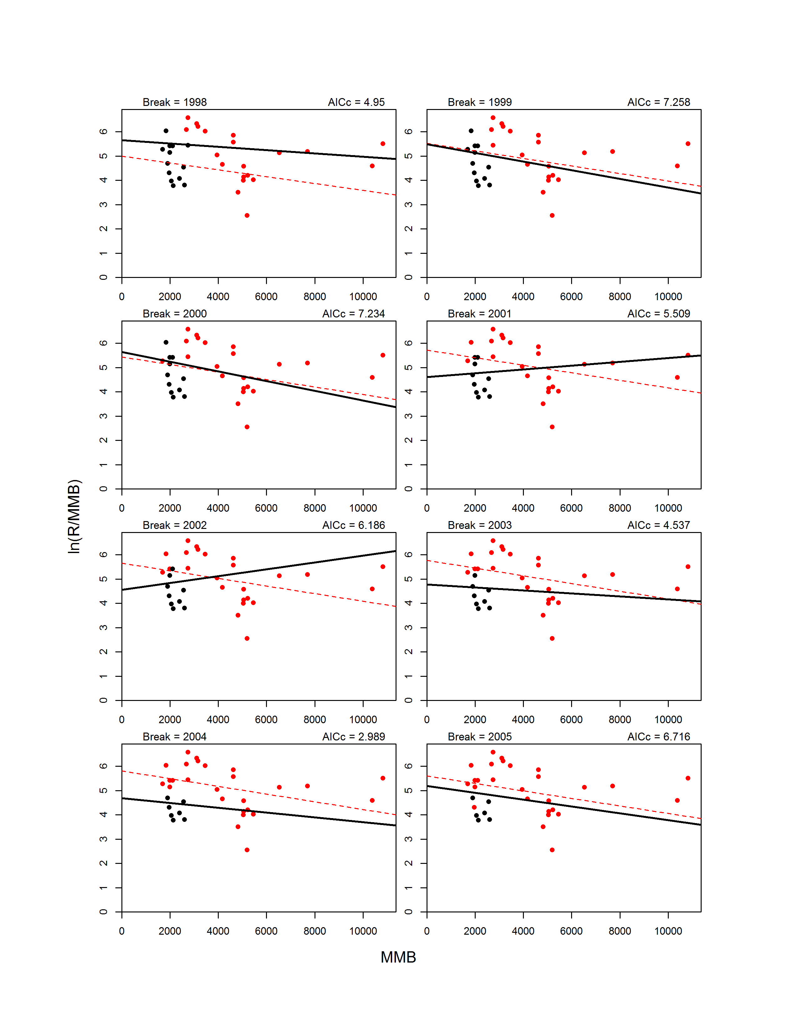
Figure D2. Continue.

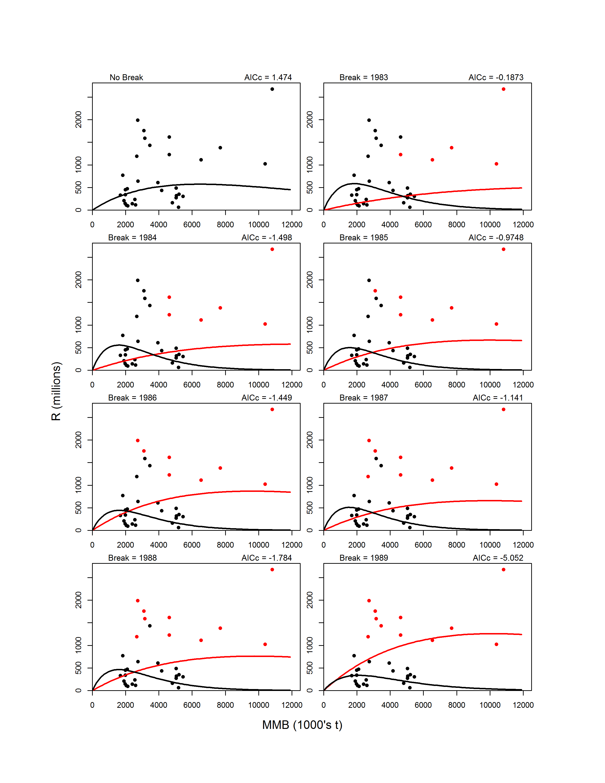
Figure D3. Fits on the arithmetic scale for Ricker models with no breakpoint (upper left graph) and with 1-breakpoint for break years 1978-2005. For 1-breakpoint models, the pre-break data (circles) and model fit (line) are shown in red, whereas the post-break data and fit are shown in black.

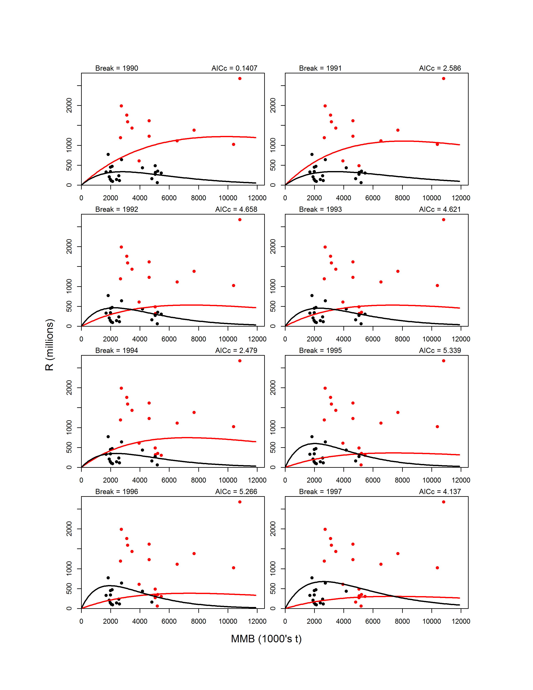
Figure D3. Continued.

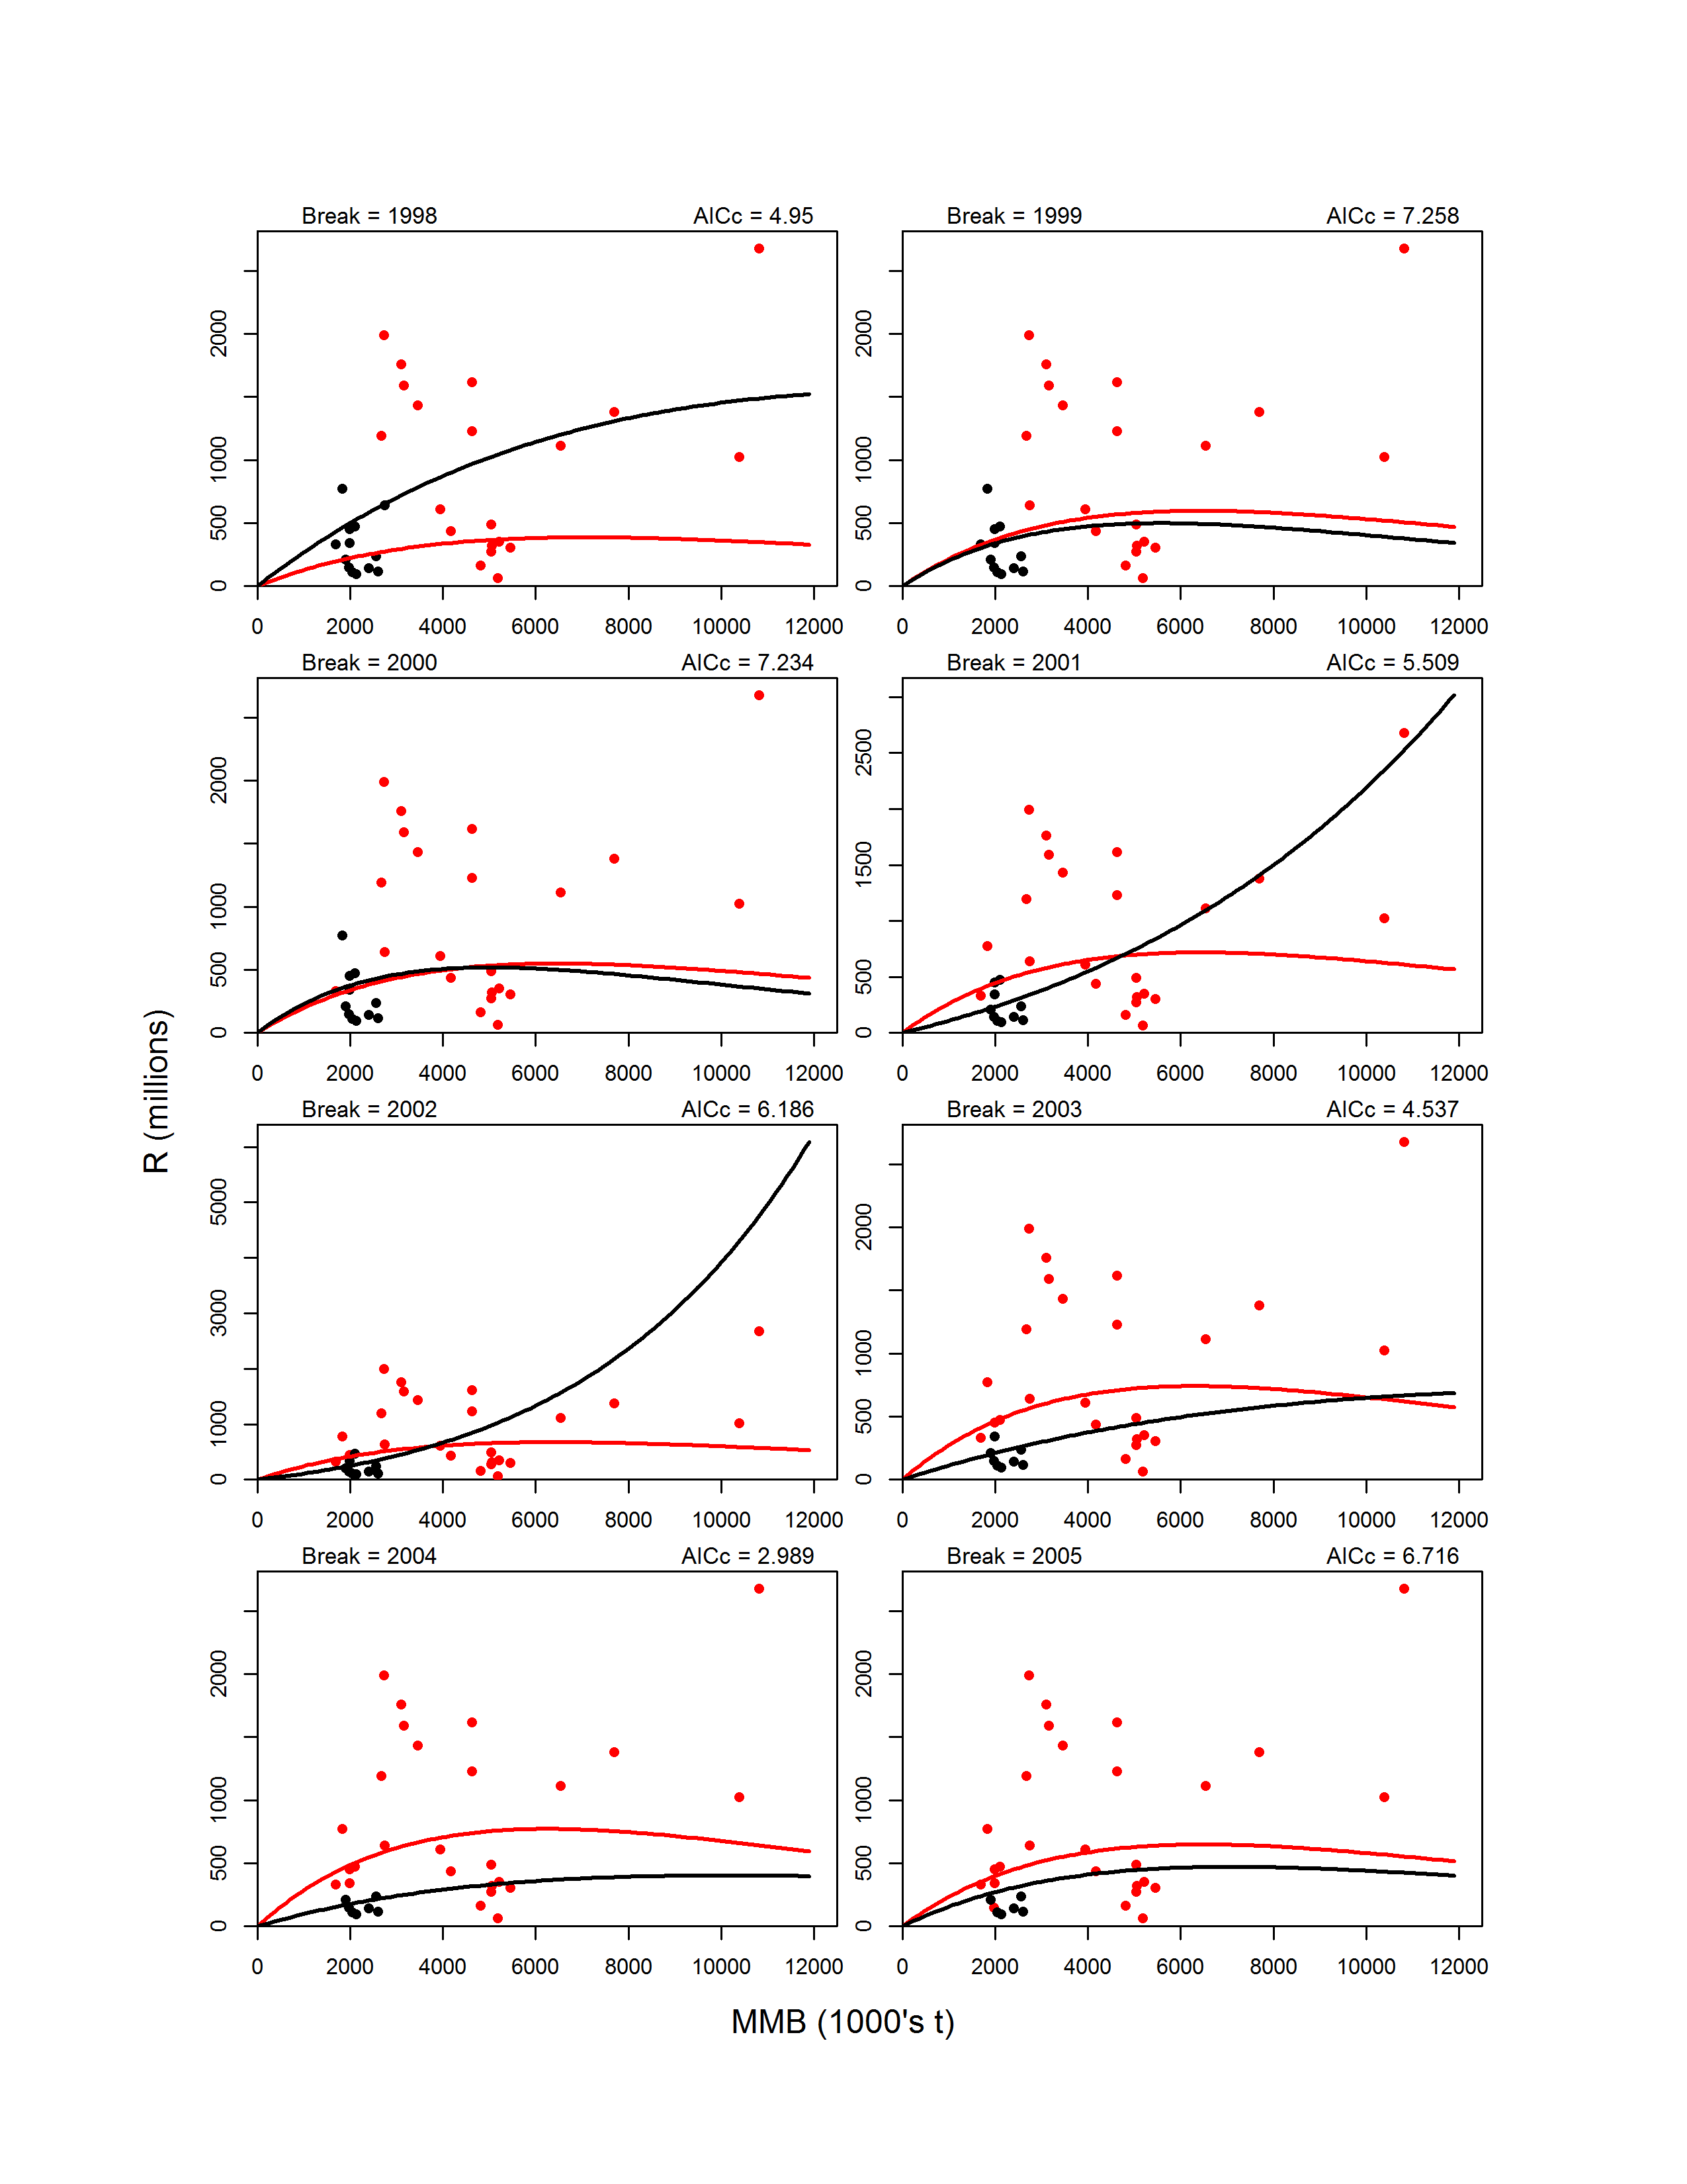
Figure D3. Contiued.
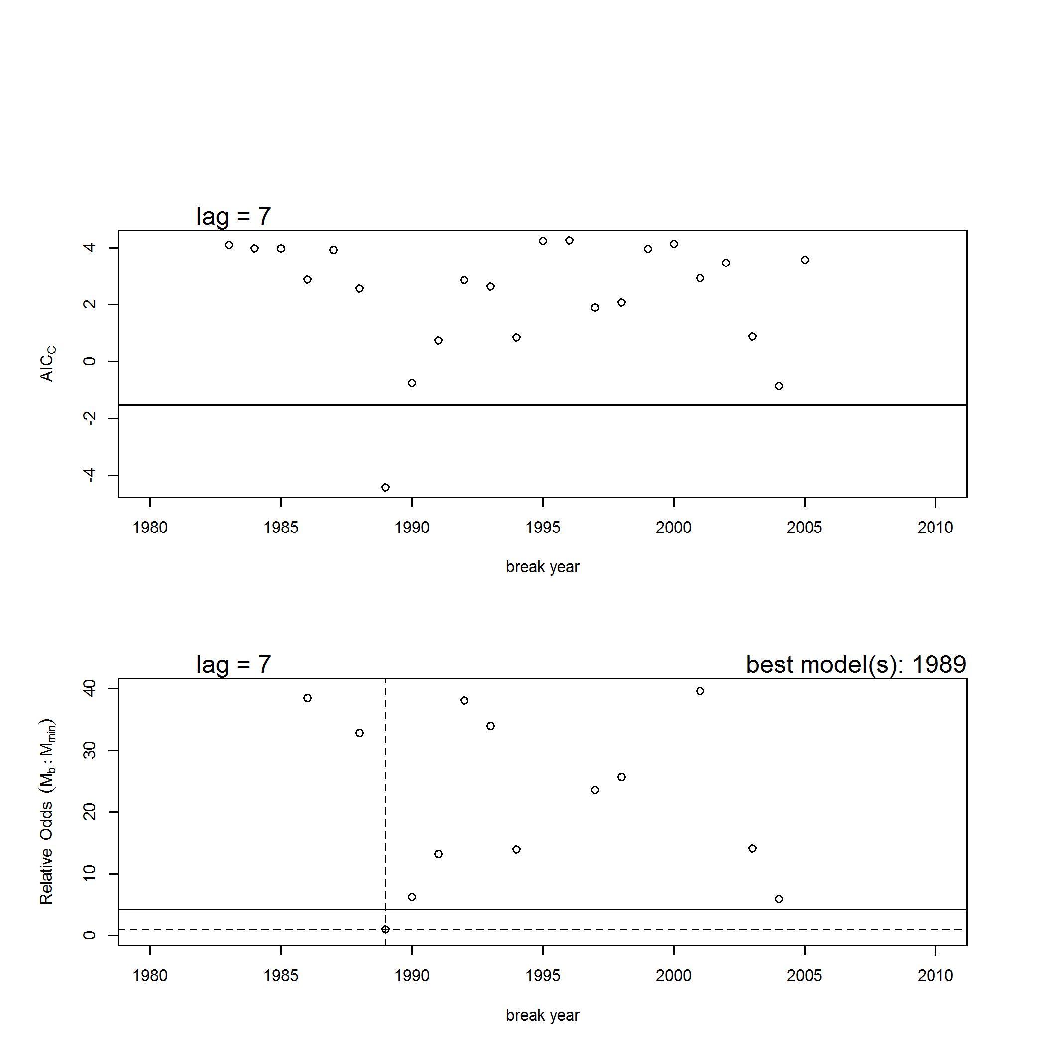

Figure D4. Results from the B-H stock-recruit breakpoint analysis. Upper graph: AICc vs. year of breakpoint for the 1-breakpoint models (circles) and AICc for the model with no breakpoint (horizontal line). Lower graph: probabilistic odds for all 1-breakpoint models (circles) and the no breakpoint model (horizontal solid line) relative to the model with the smallest AICc score. The dashed lines indicate the value for the model with the lowest AICc score (breakpoint in 1989). Not shown are 1-breakpoint models with high odds (>40) of being incorrect.

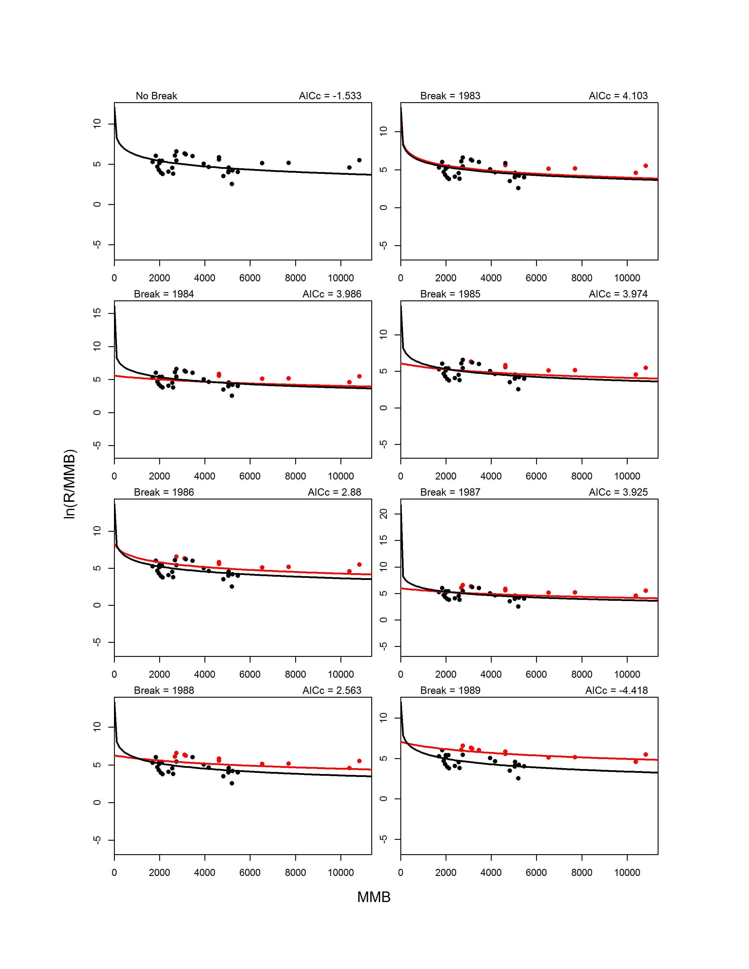
Figure D5. Fits for B-H models with no breakpoint (upper left graph) and with 1-breakpoint for break years 1978-2005. For 1-breakpoint models, the pre-break data (circles) and model fit (line) are shown in red, whereas the post-break data and fit are shown in black.
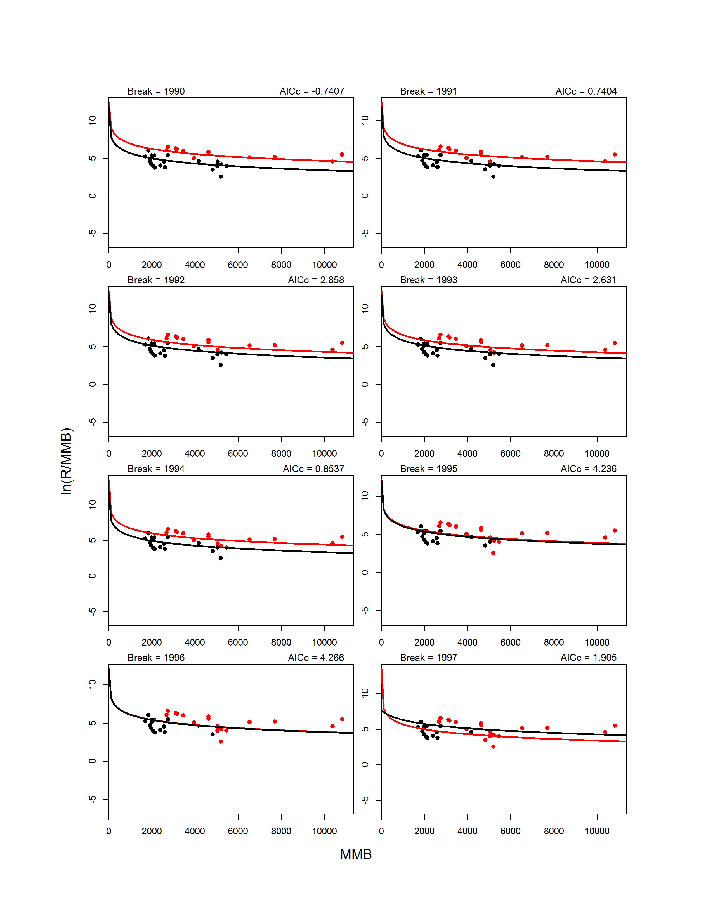
Figure D5. Continued.
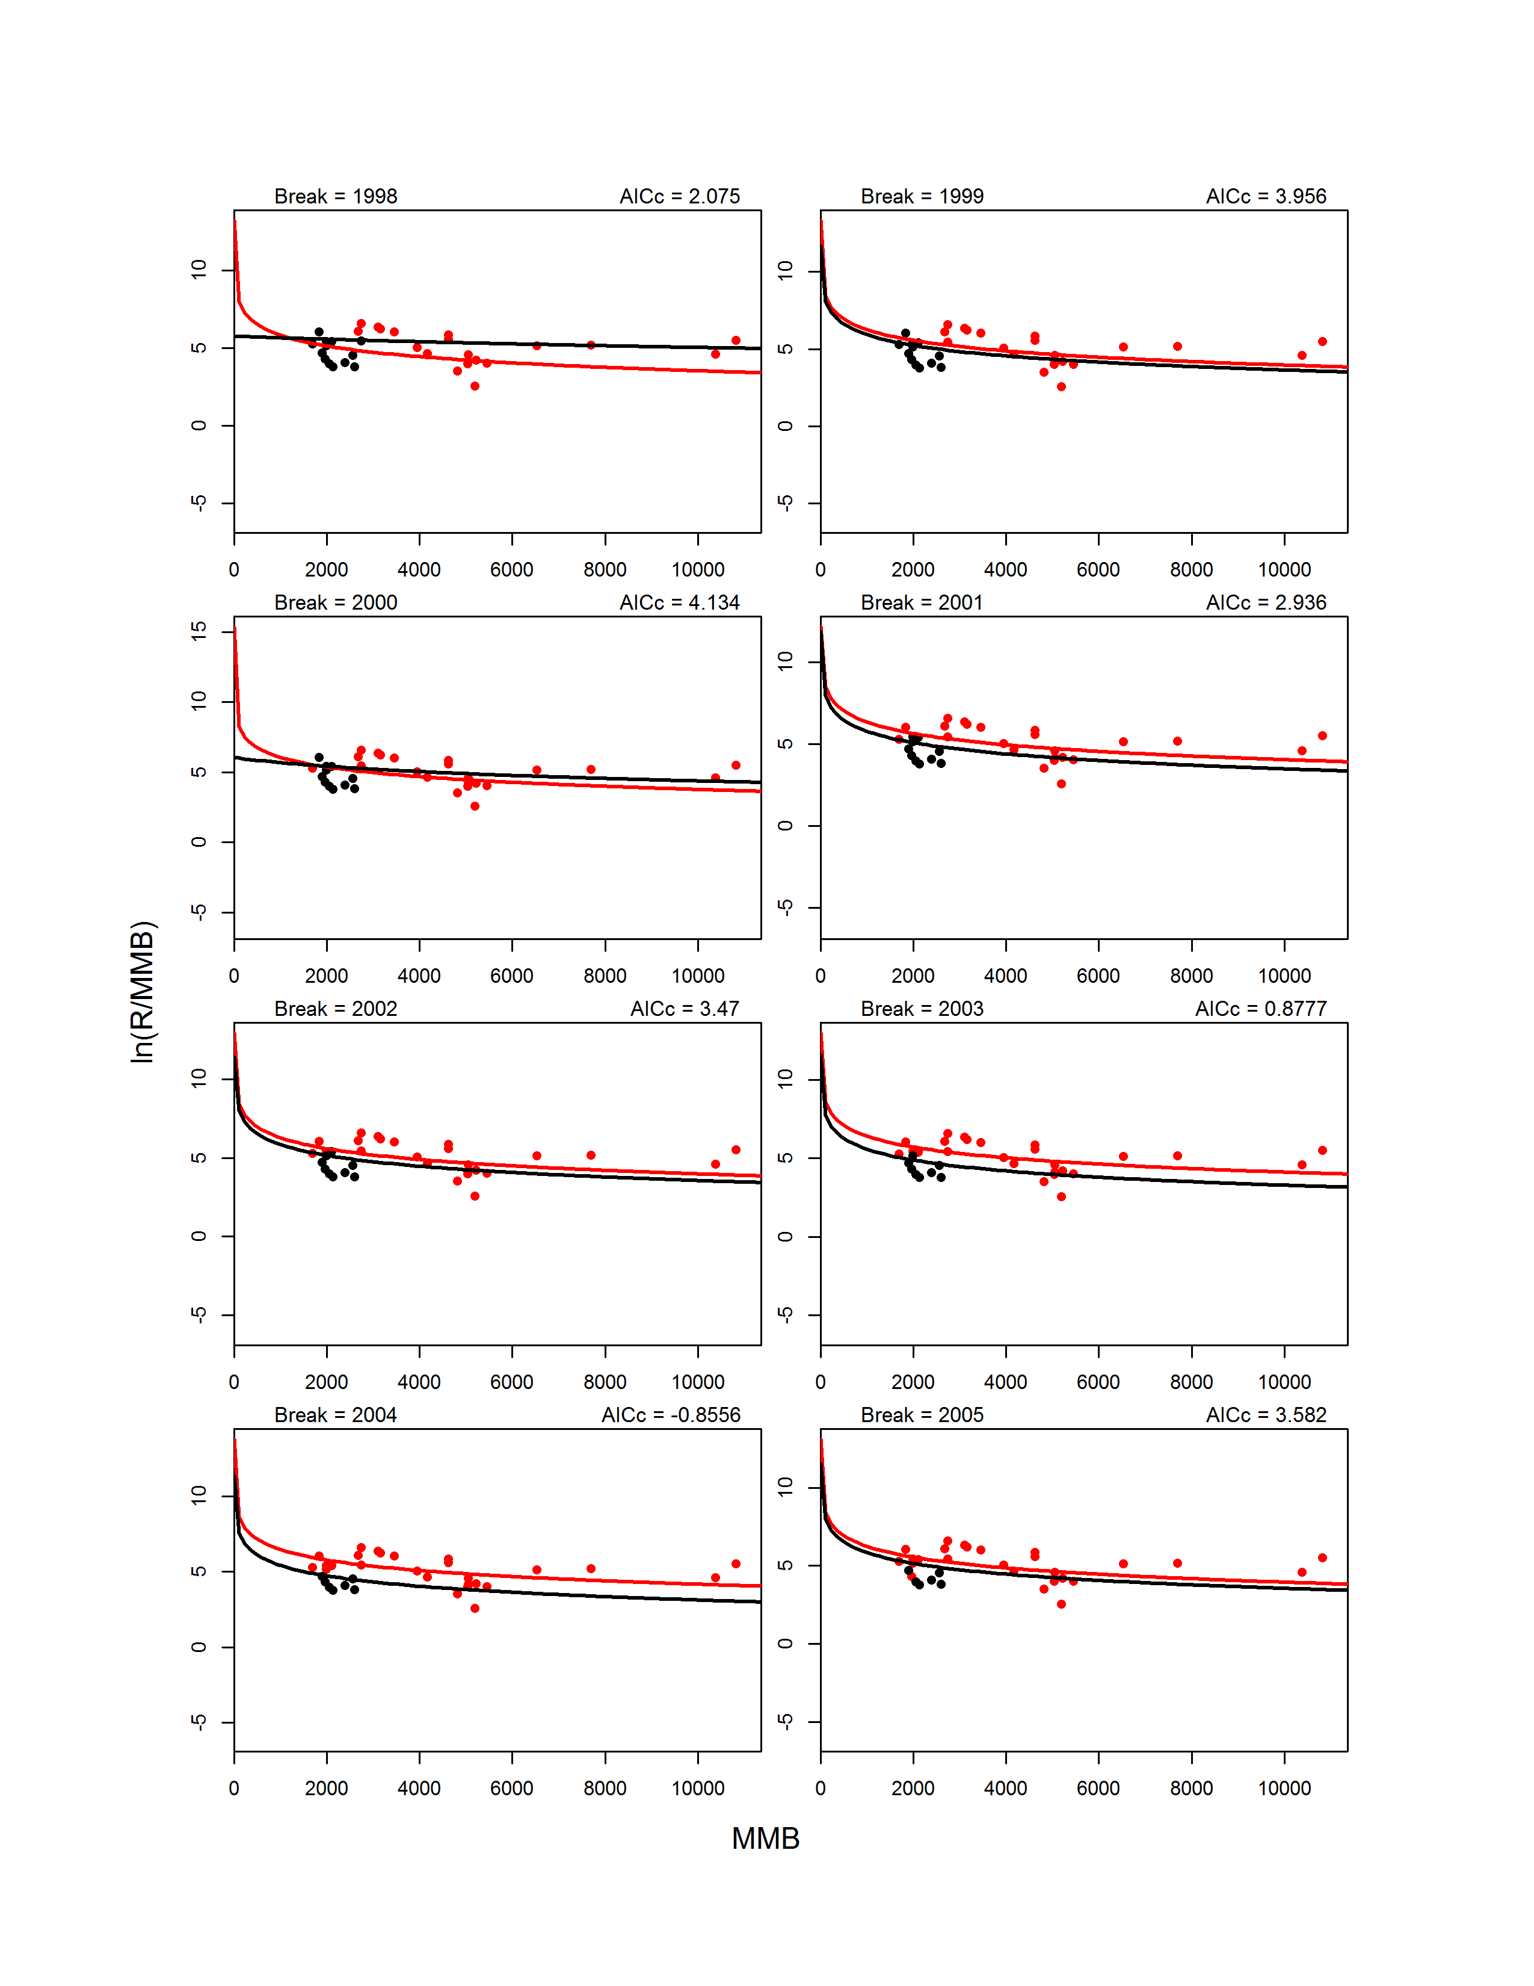
Figure D5. Continued.
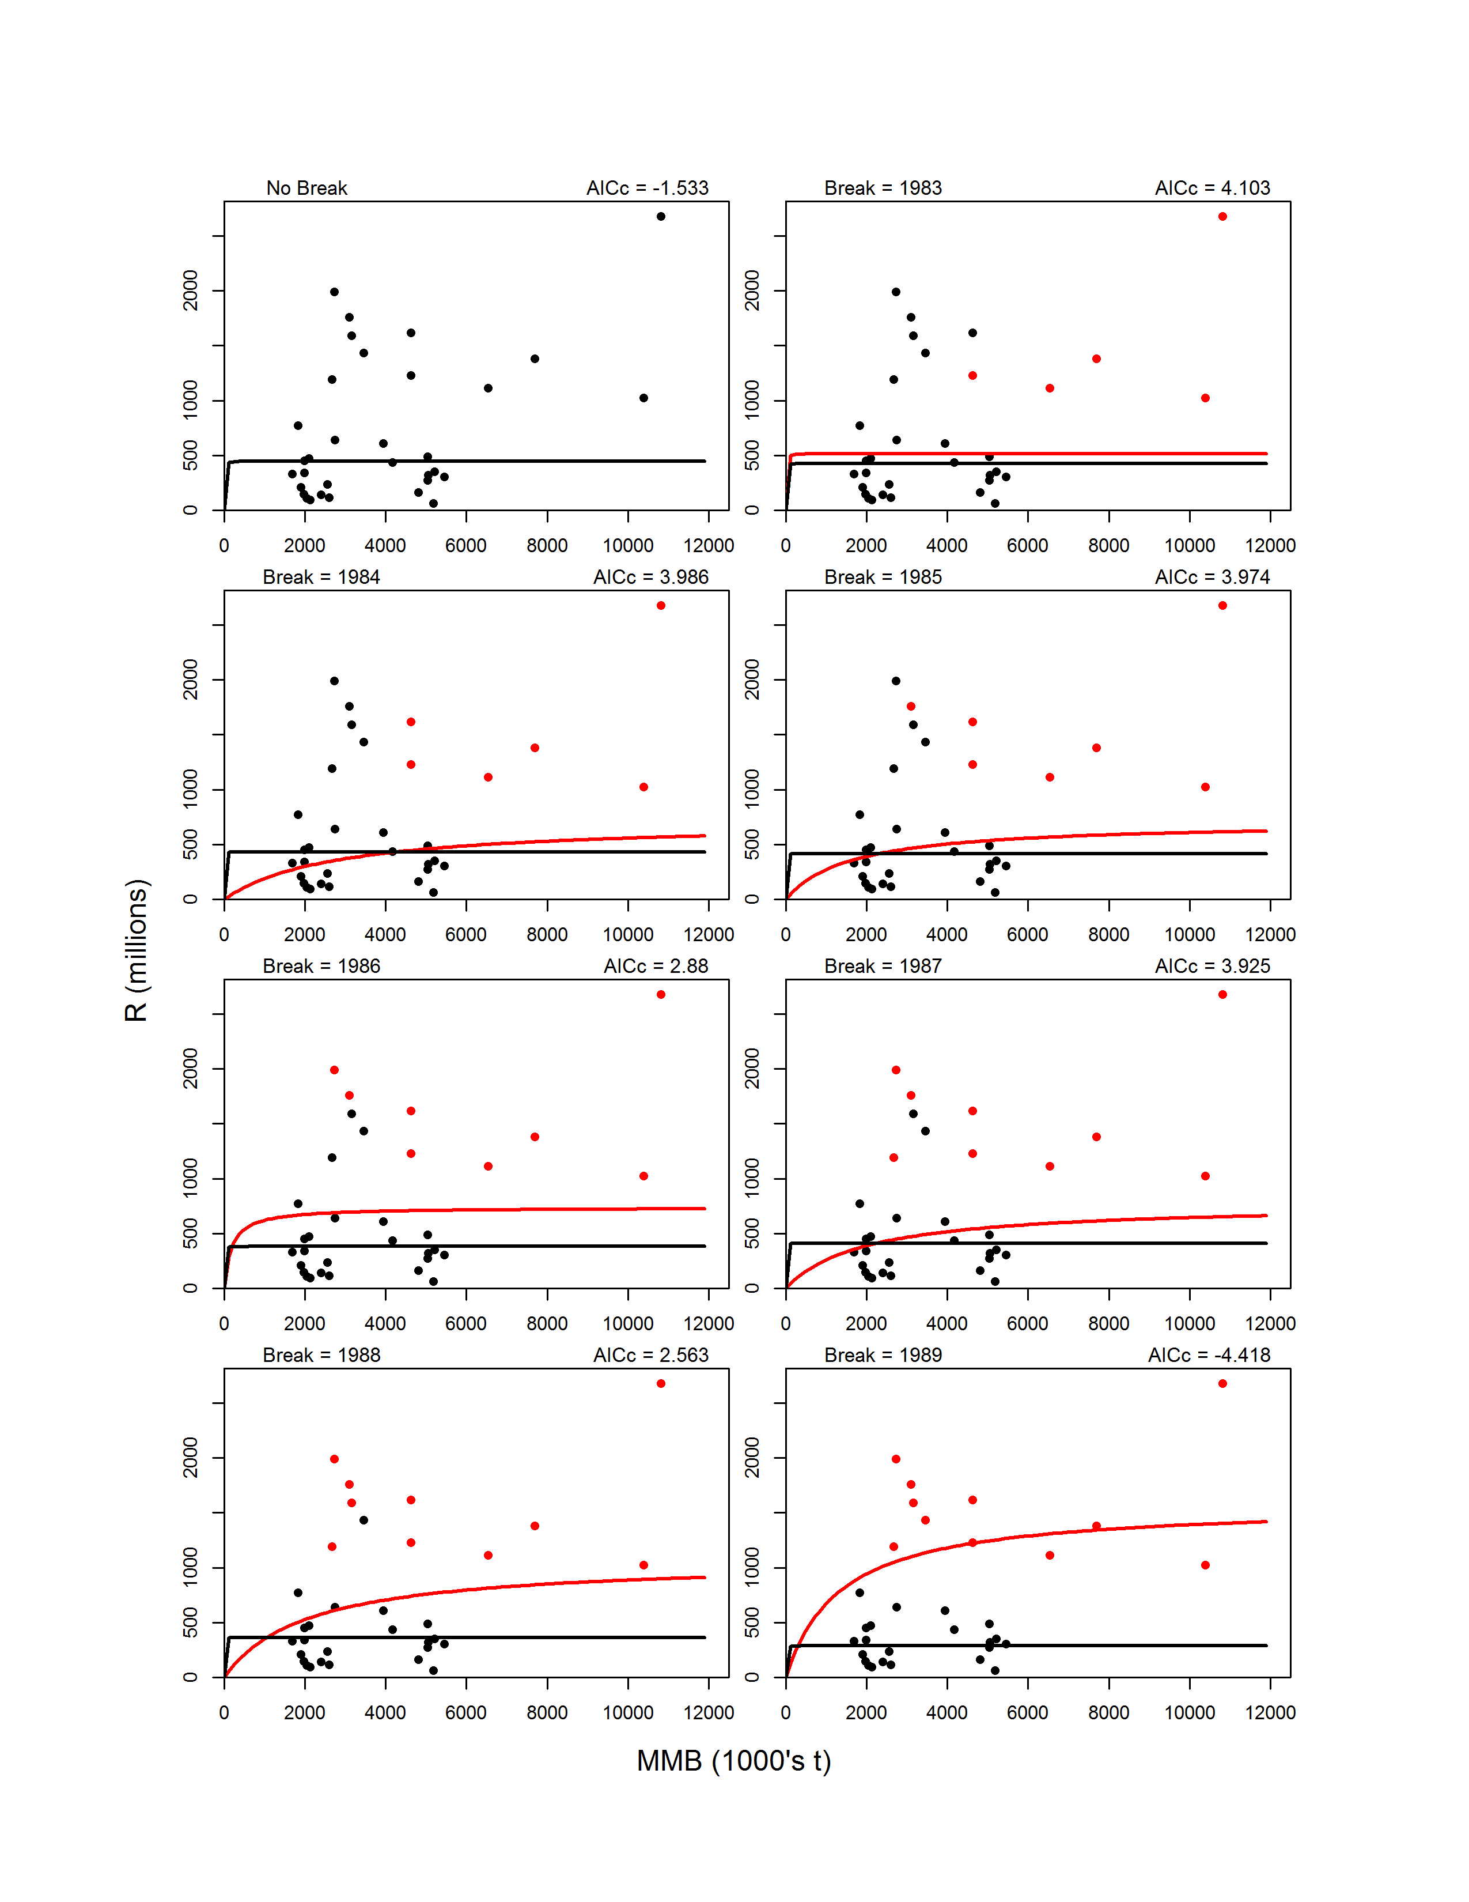 Figure D6. Fits on the arithmetic scale for B-H models with no breakpoint (upper left graph) and with 1-breakpoint for break years 1978-2005. For 1-breakpoint models, the pre-break data (circles) and model fit (line) are shown in red, whereas the post-break data and fit are shown in black.
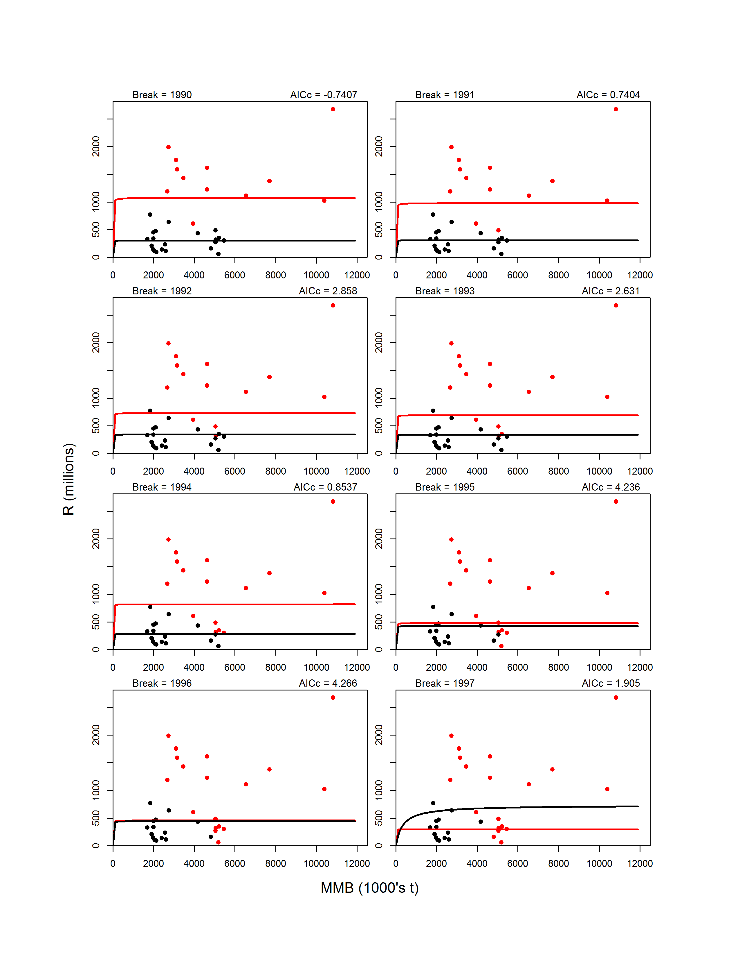
Figure D6. Continued.
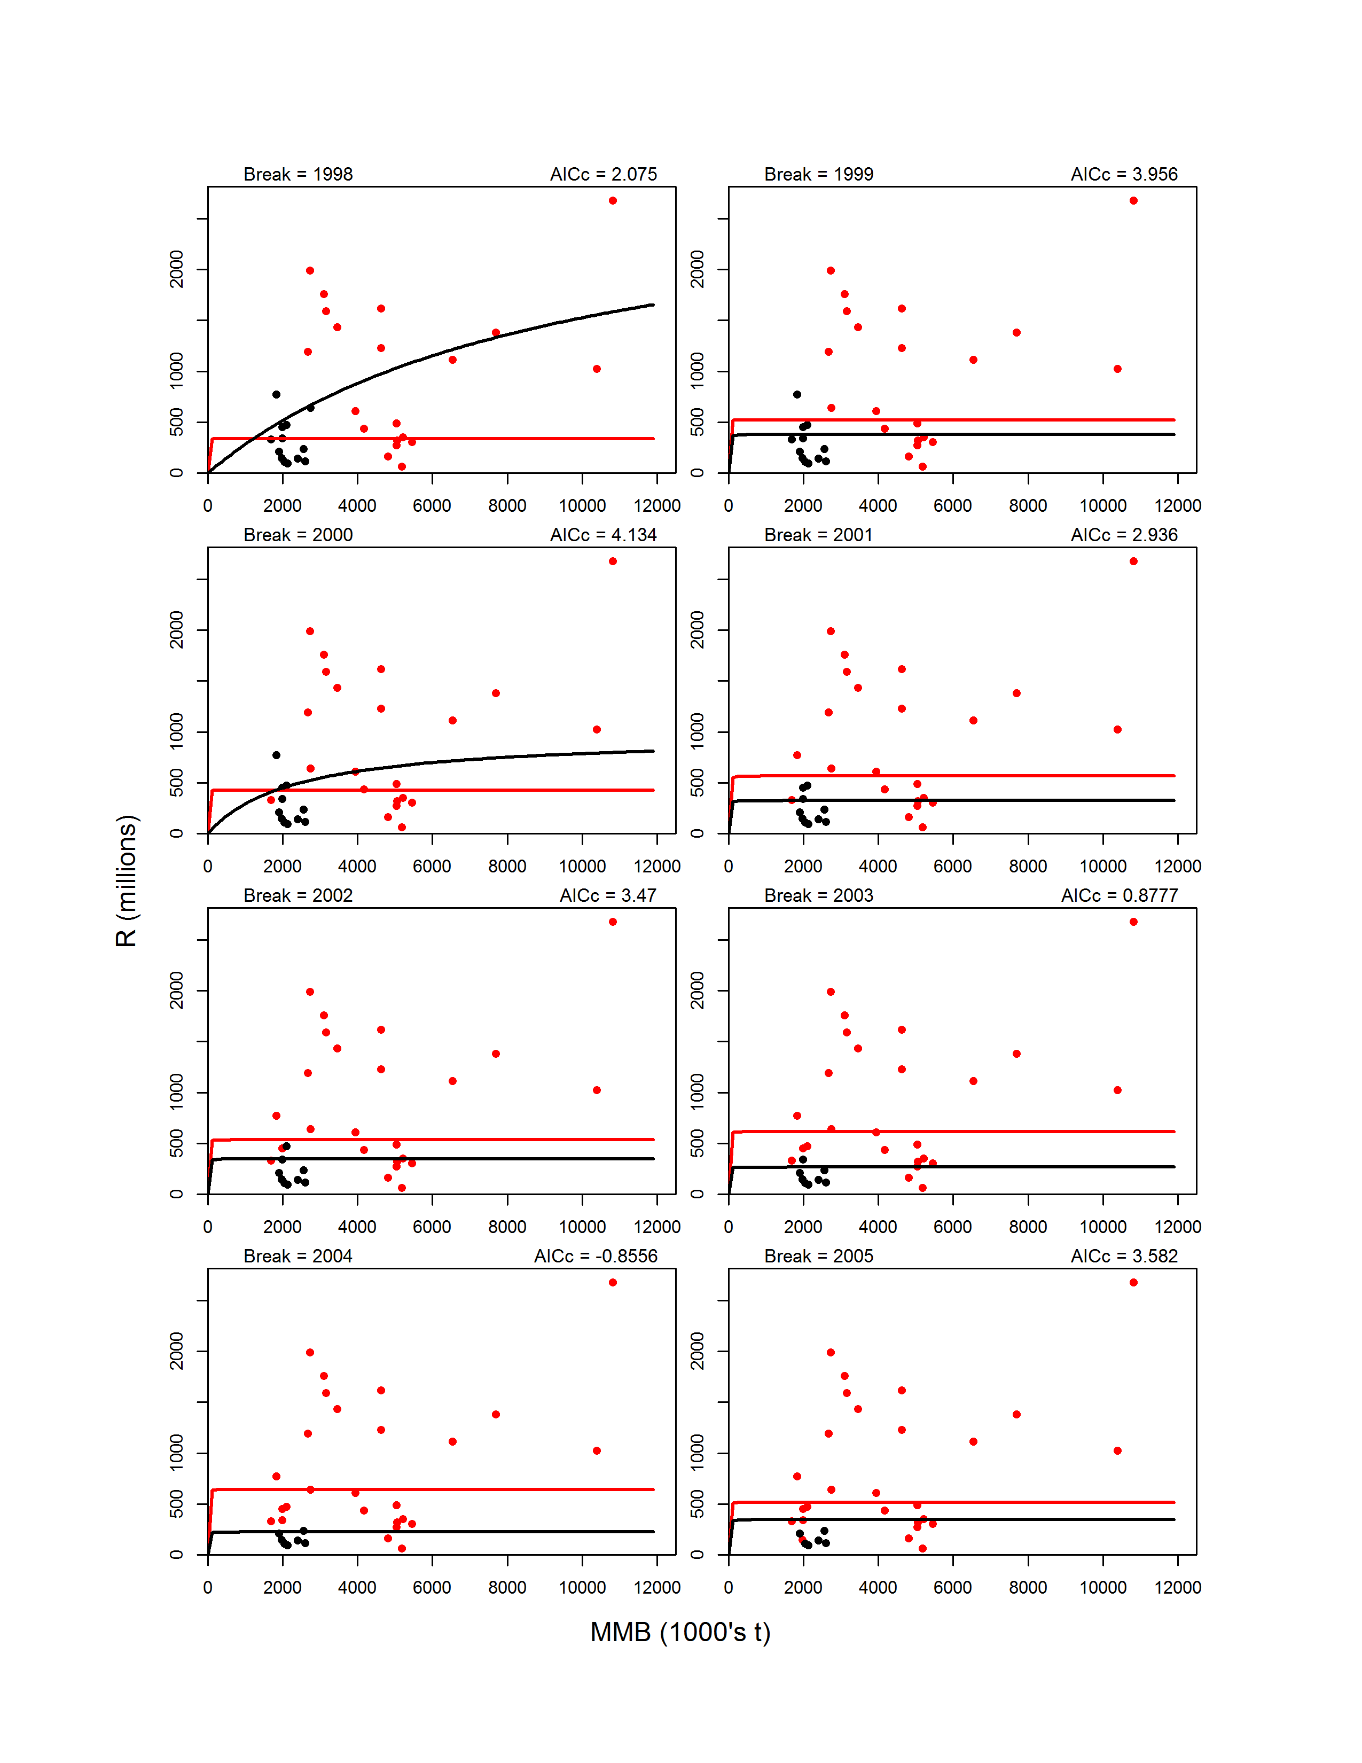
Figure D6. Continued.
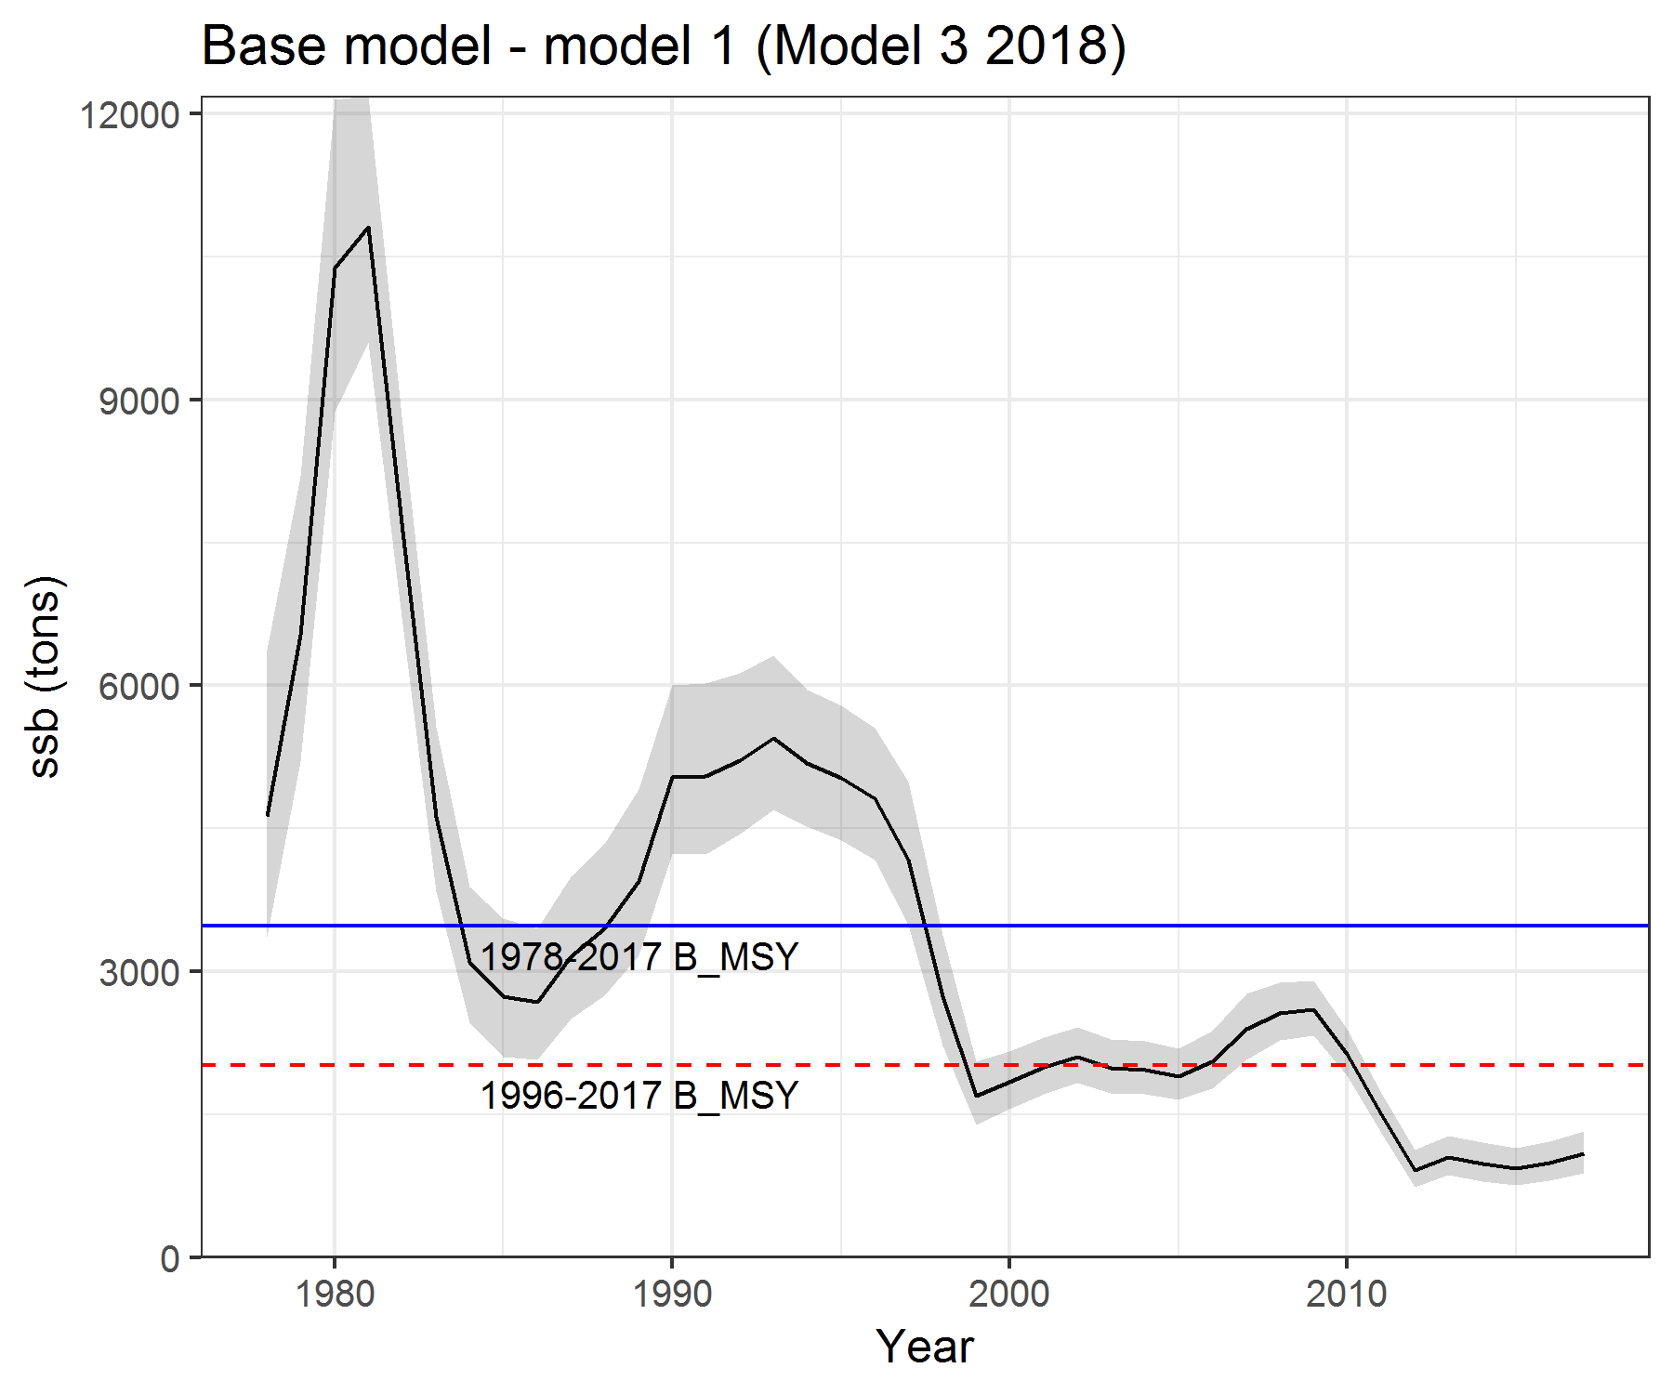
Figure D7. Computed B_{MSY} proxy (average mature male biomass) for the corresponding year ranges based on the 2018 assessment model with GMACS code updates.

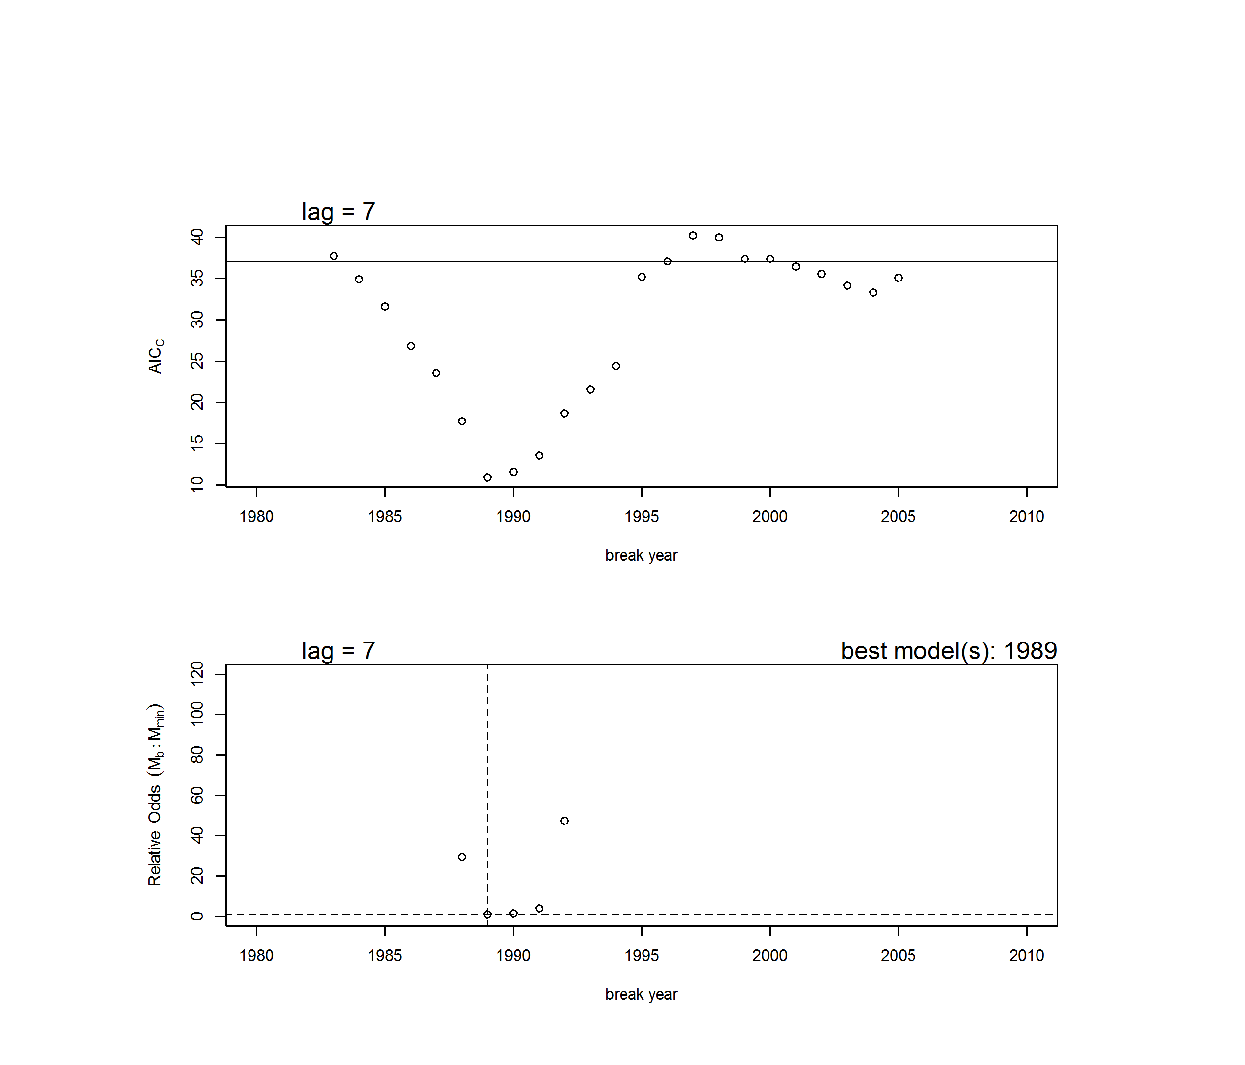
Figure D8. Results from the sensitivity analysis for Ricker stock-recruit breakpoint analysis. Upper graph: AICc vs. year of breakpoint for the 1-breakpoint models (circles) and AICc for the model with no breakpoint (horizontal line). Lower graph: probabilistic odds for all 1-breakpoint models (circles) and the no breakpoint model (horizontal solid line) relative to the model with the smallest AICc score. The dashed lines indicate the value for the model with the lowest AICc score (breakpoint in 1989). Not shown are 1-breakpoint models with high odds (>120) of being incorrect.

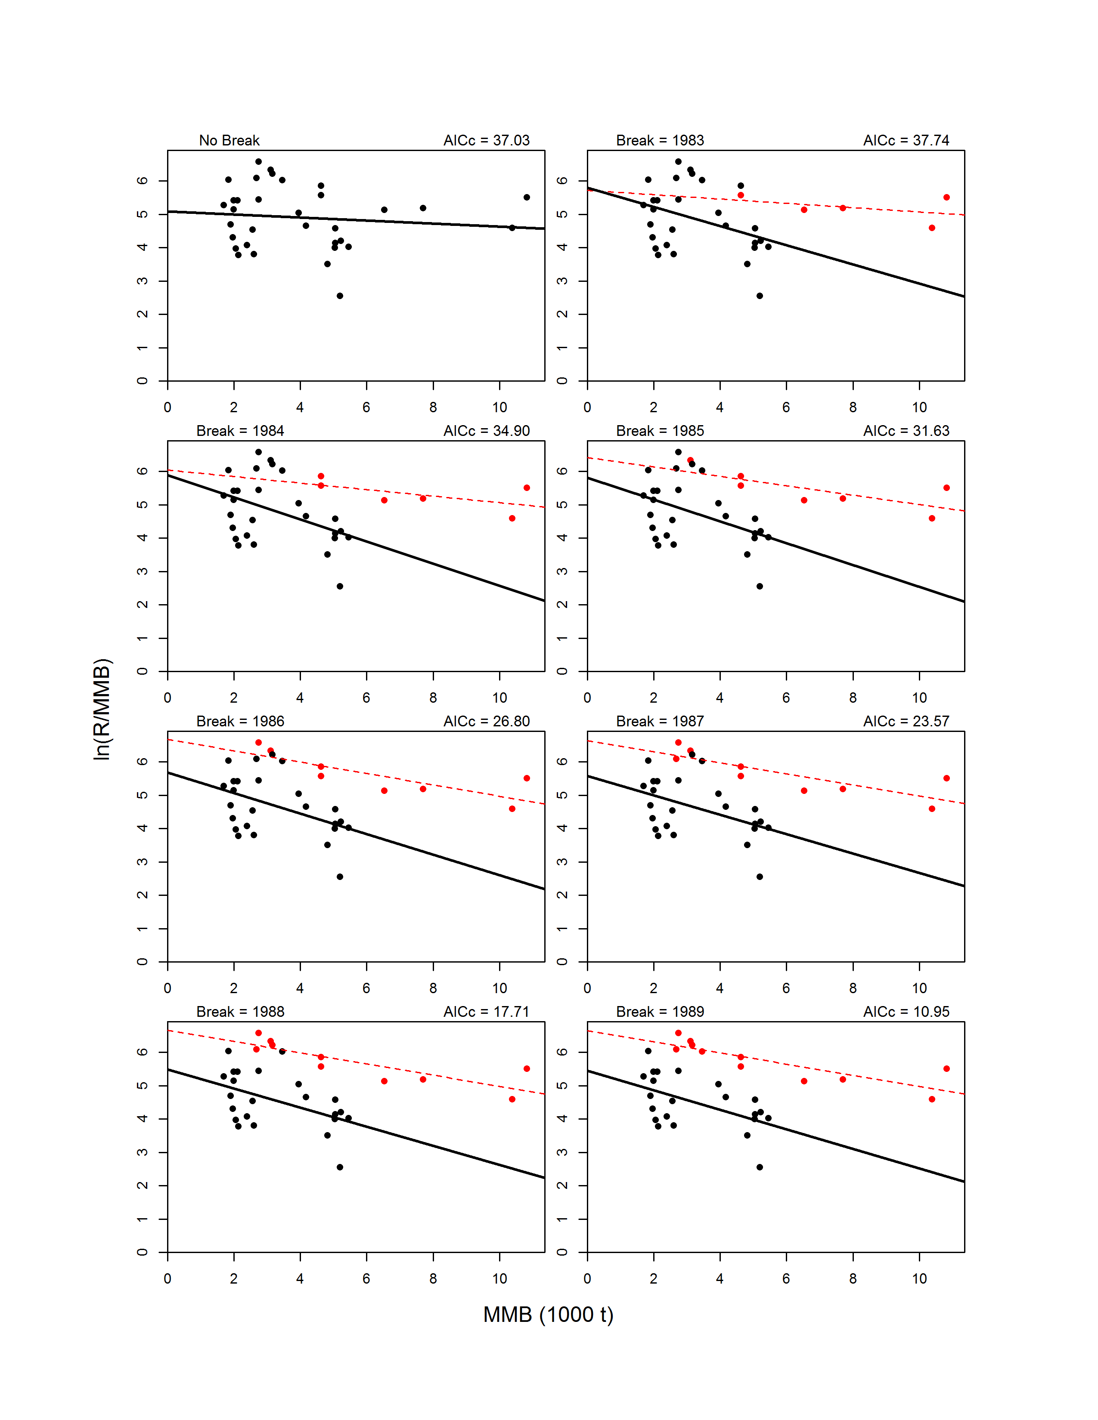
Figure D9. Fits for the sensitivity analysis using the Ricker models with no breakpoint (upper left graph) and with 1-breakpoint for break years 1978-2005. For 1-breakpoint models, the pre-break data (circles) and model fit (line) are shown in red, whereas the post-break data and fit are shown in black.
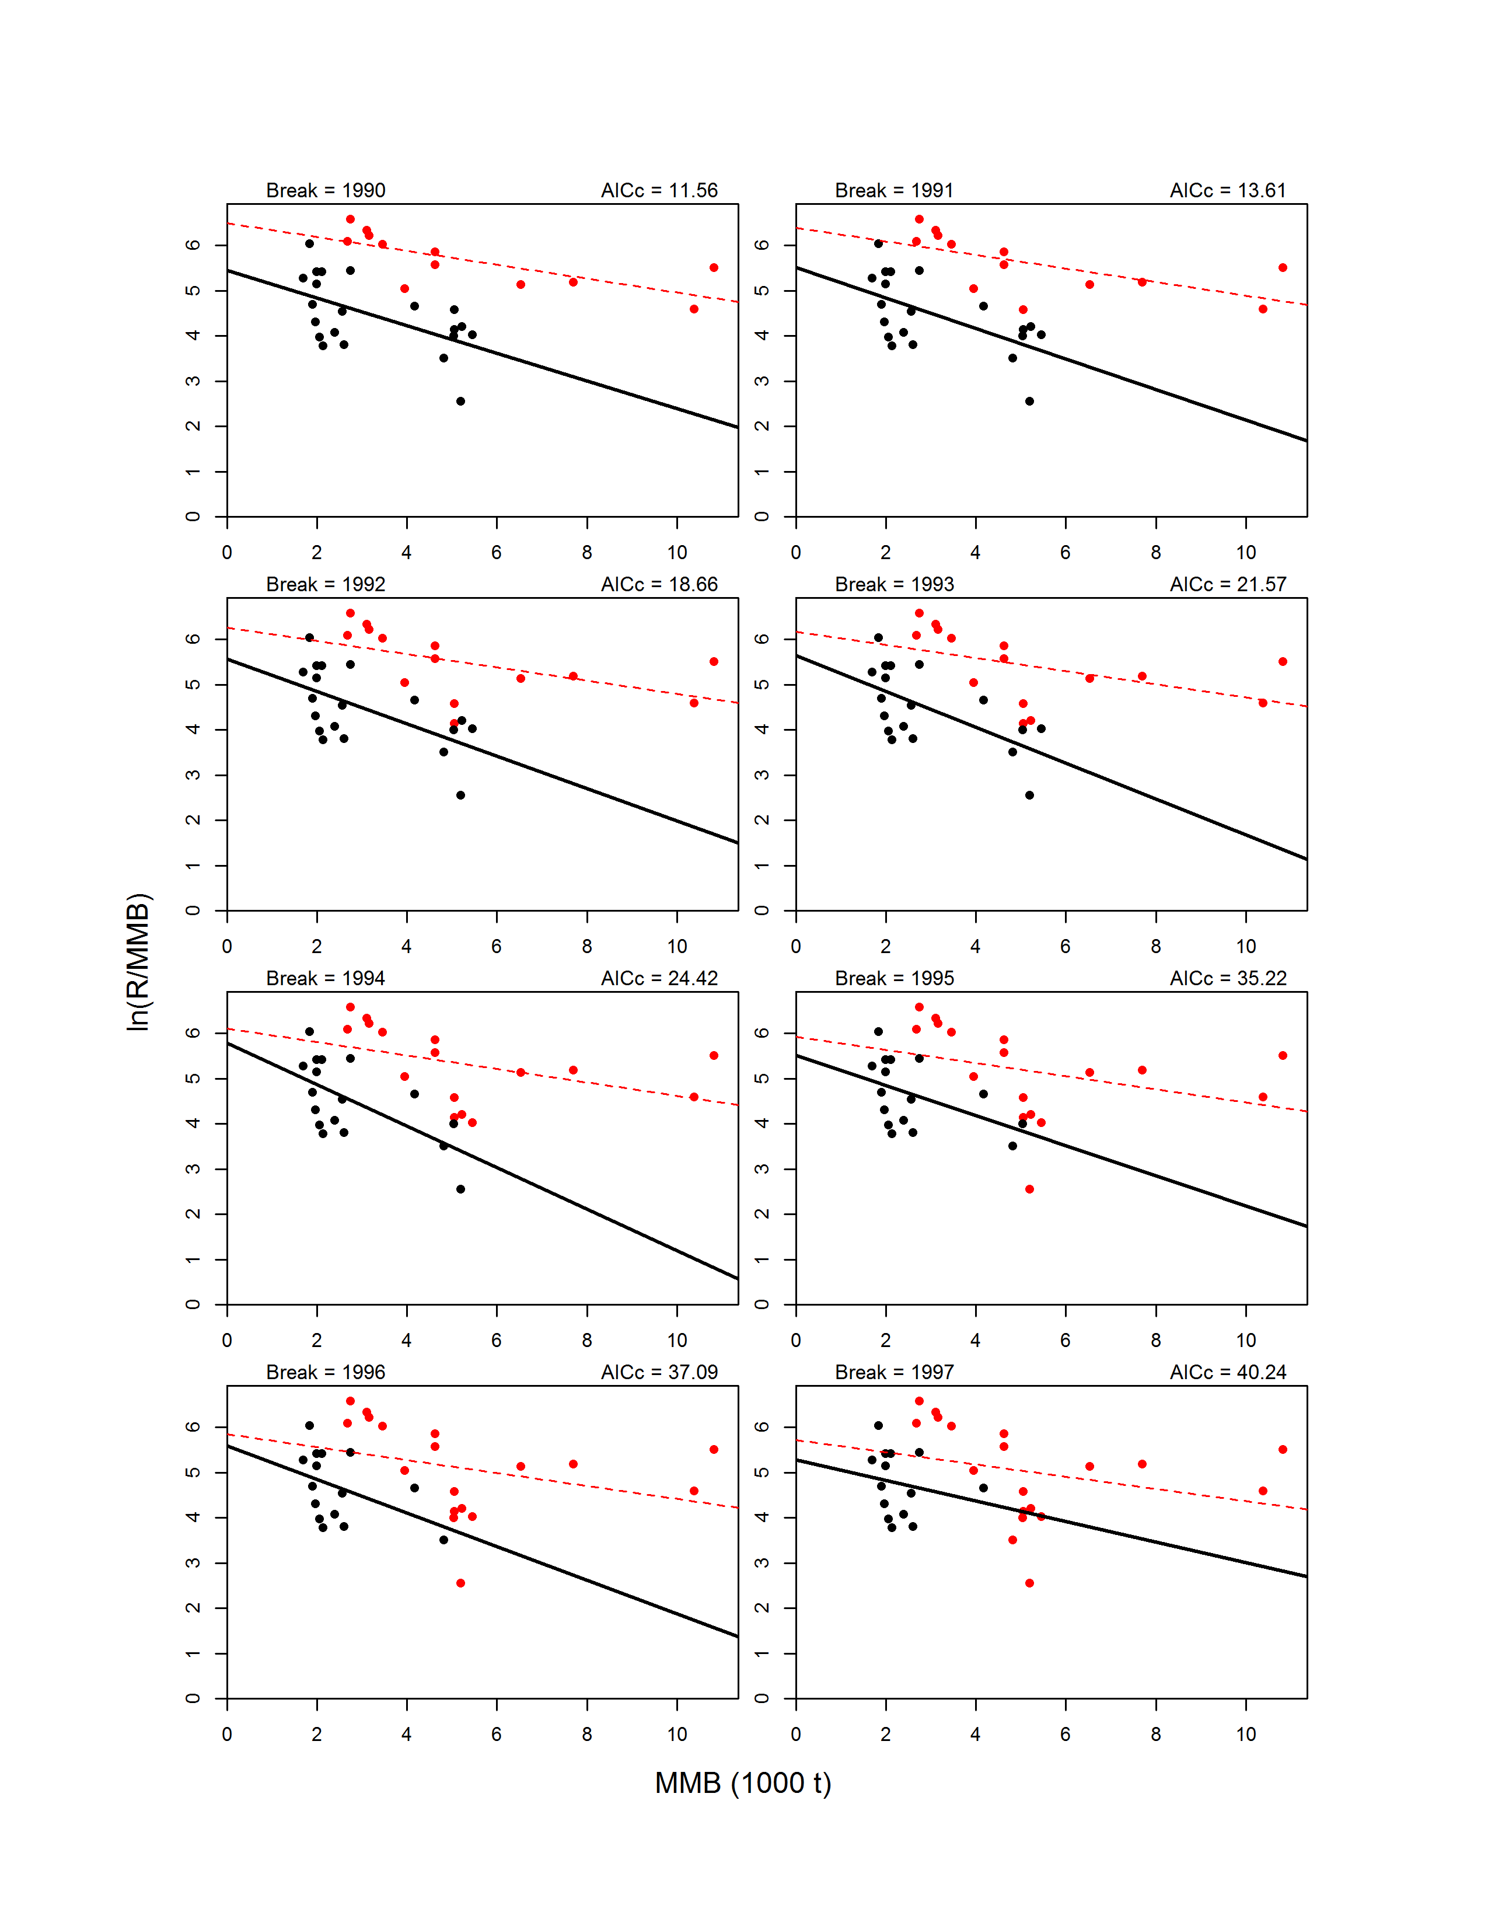
Figure D9. Continued.
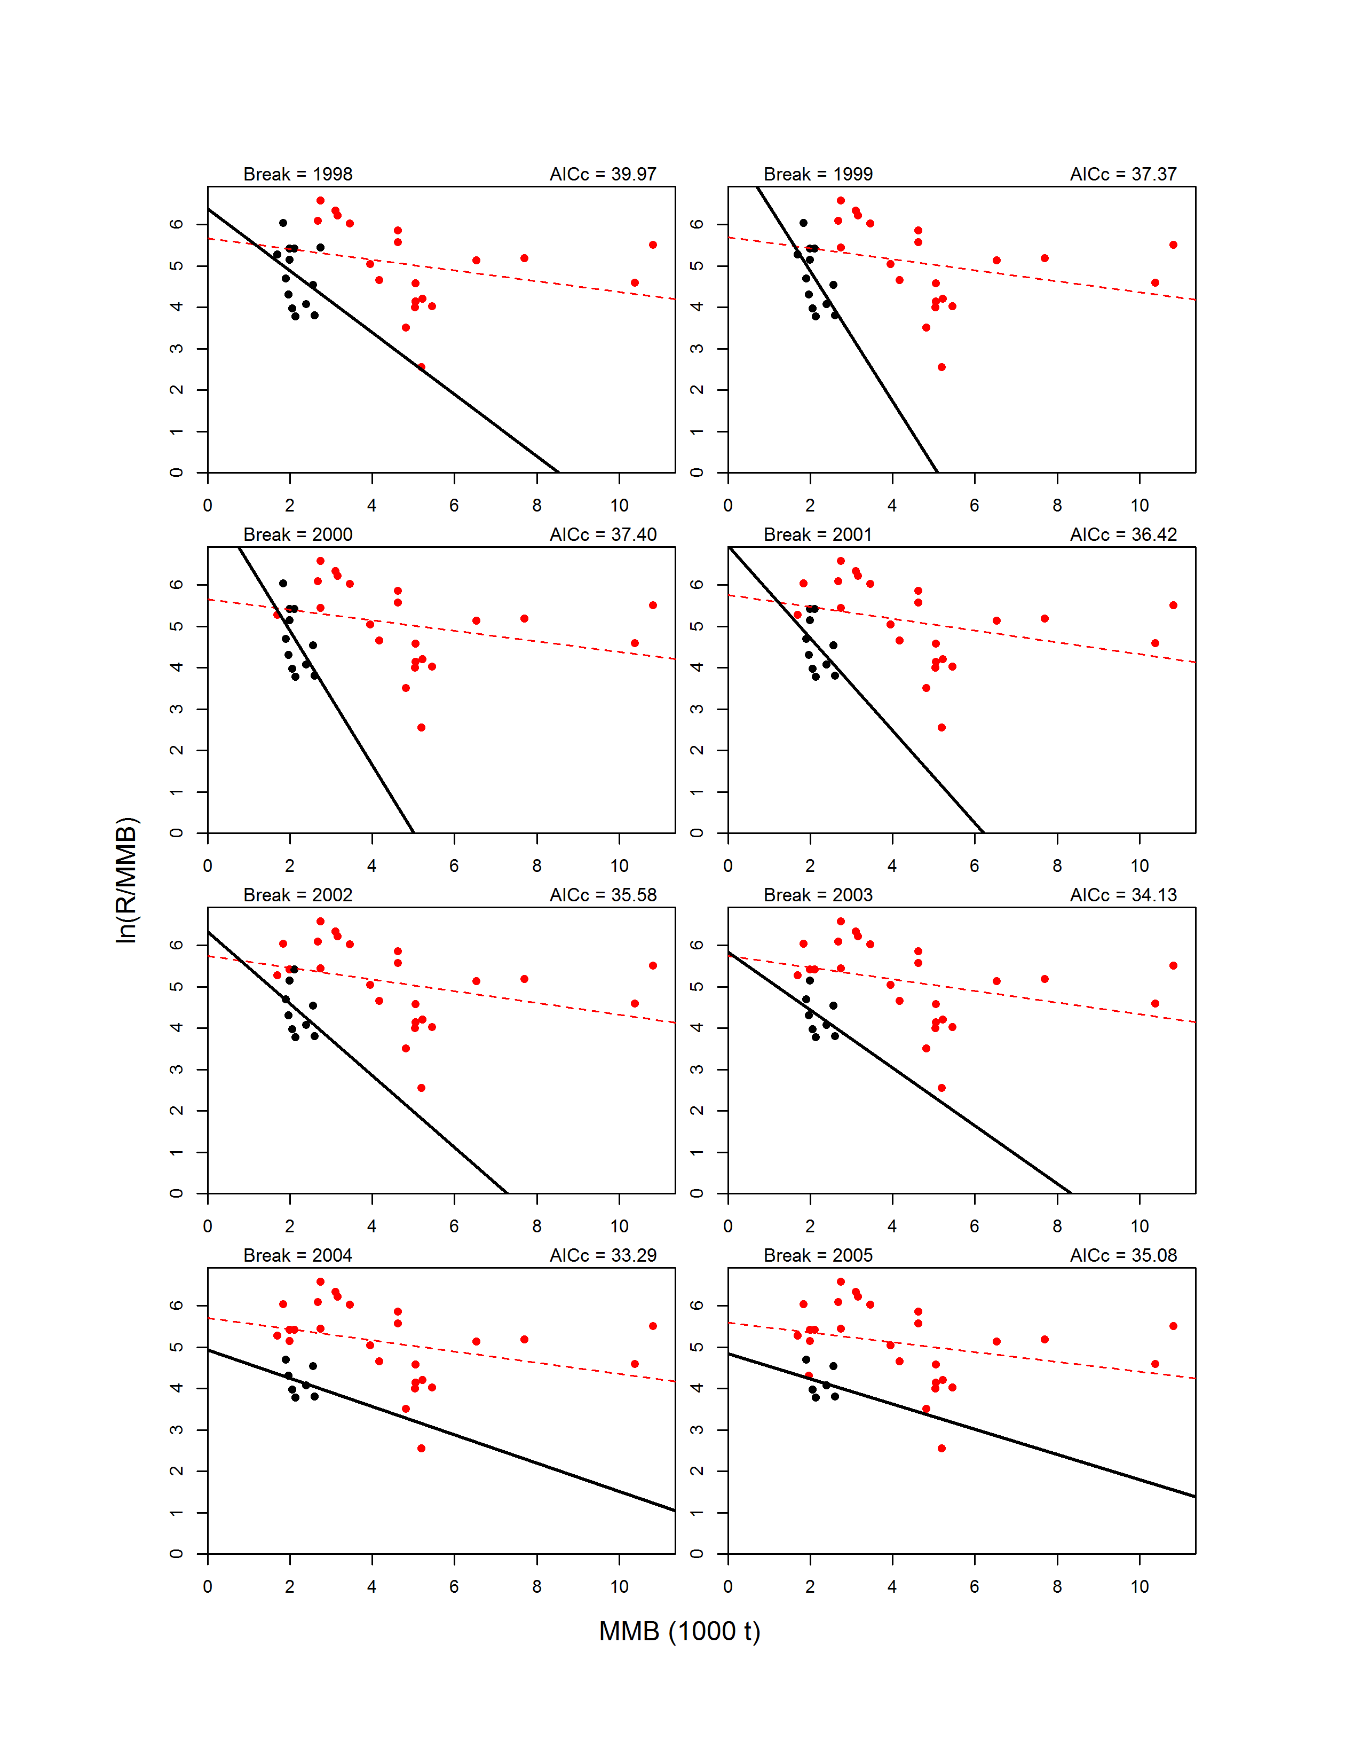
Figure D9. Continued.
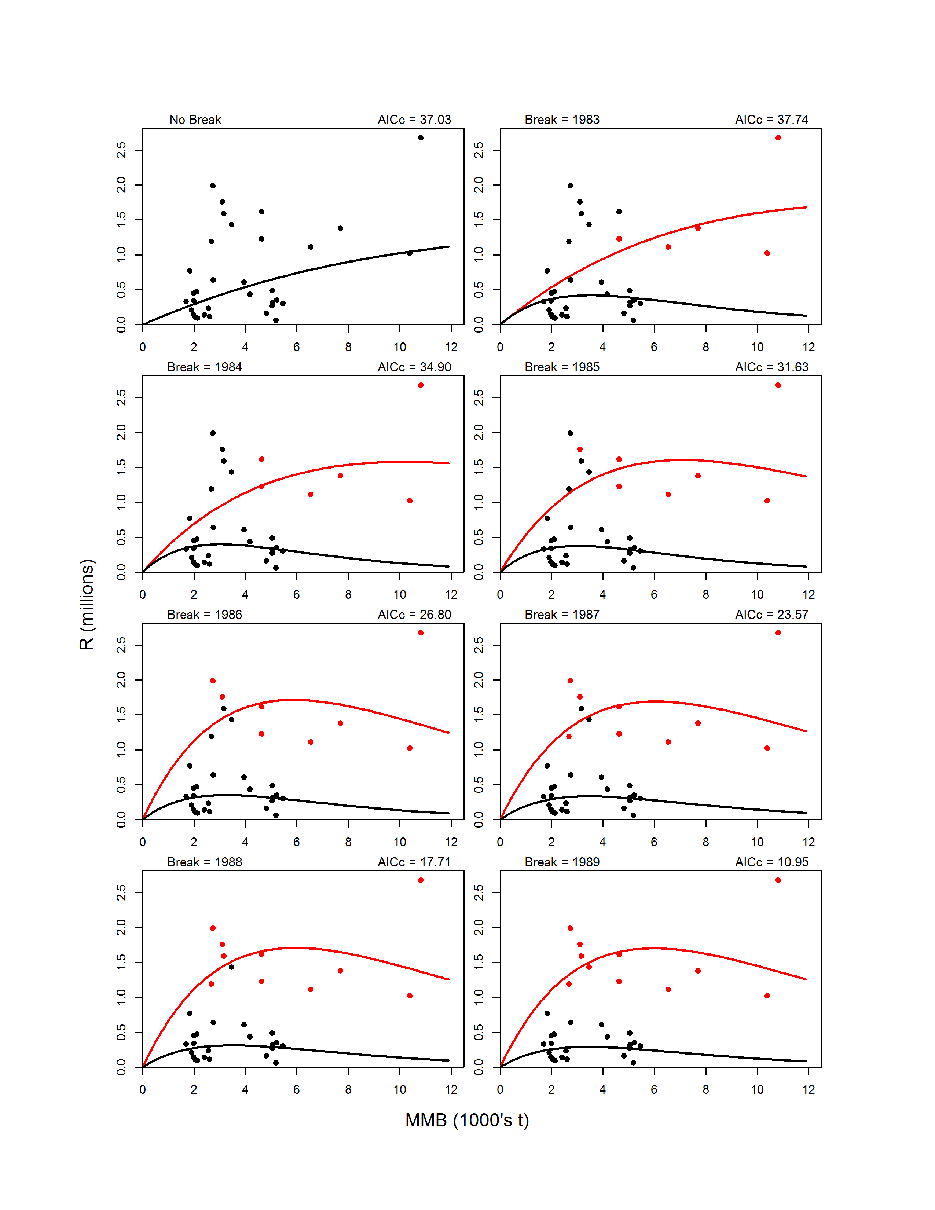
Figure D10. Fits on the arithmetic scale for the sensitivity analysis using the Ricker models with no breakpoint (upper left graph) and with 1-breakpoint for break years 1978-2005. For 1-breakpoint models, the pre-break data (circles) and model fit (line) are shown in red, whereas the post-break data and fit are shown in black.
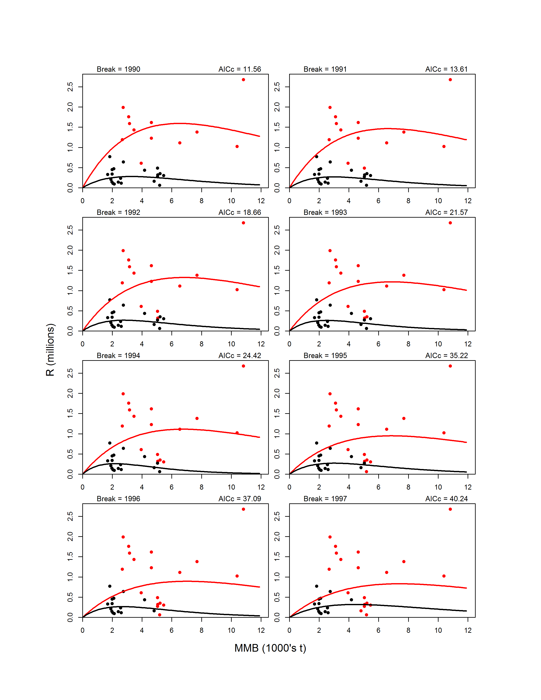
Figure D10. Continued.
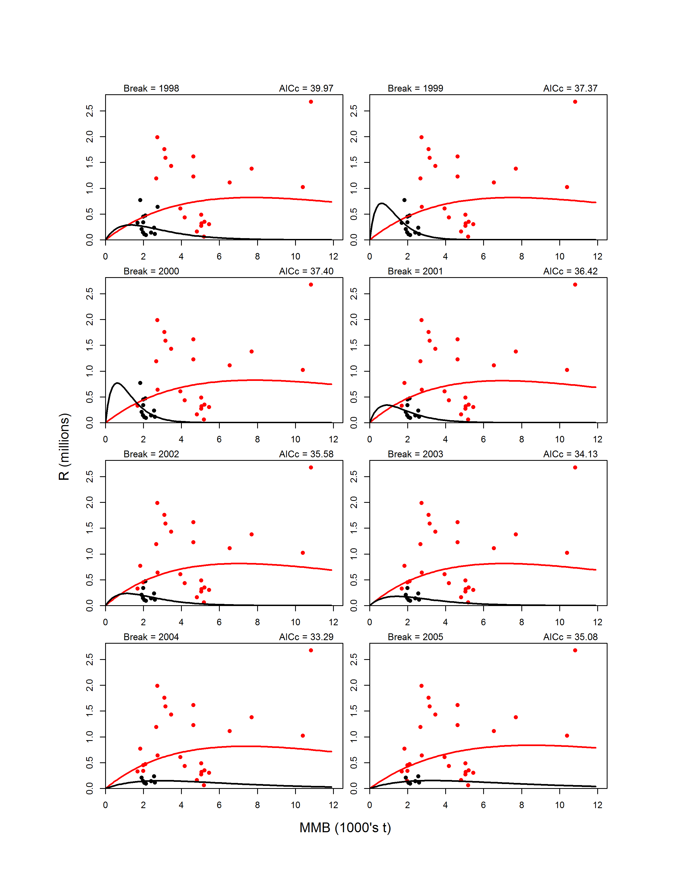
Figure D10. Continued.

