Appendix E. Ecosystem and Socioeconomic Profile of the Saint Matthew Blue King Crab stock in the Bering Sea

Erin Fedewa, Brian Garber-Yonts, Kalei Shotwell and Katie Palof
September 2019

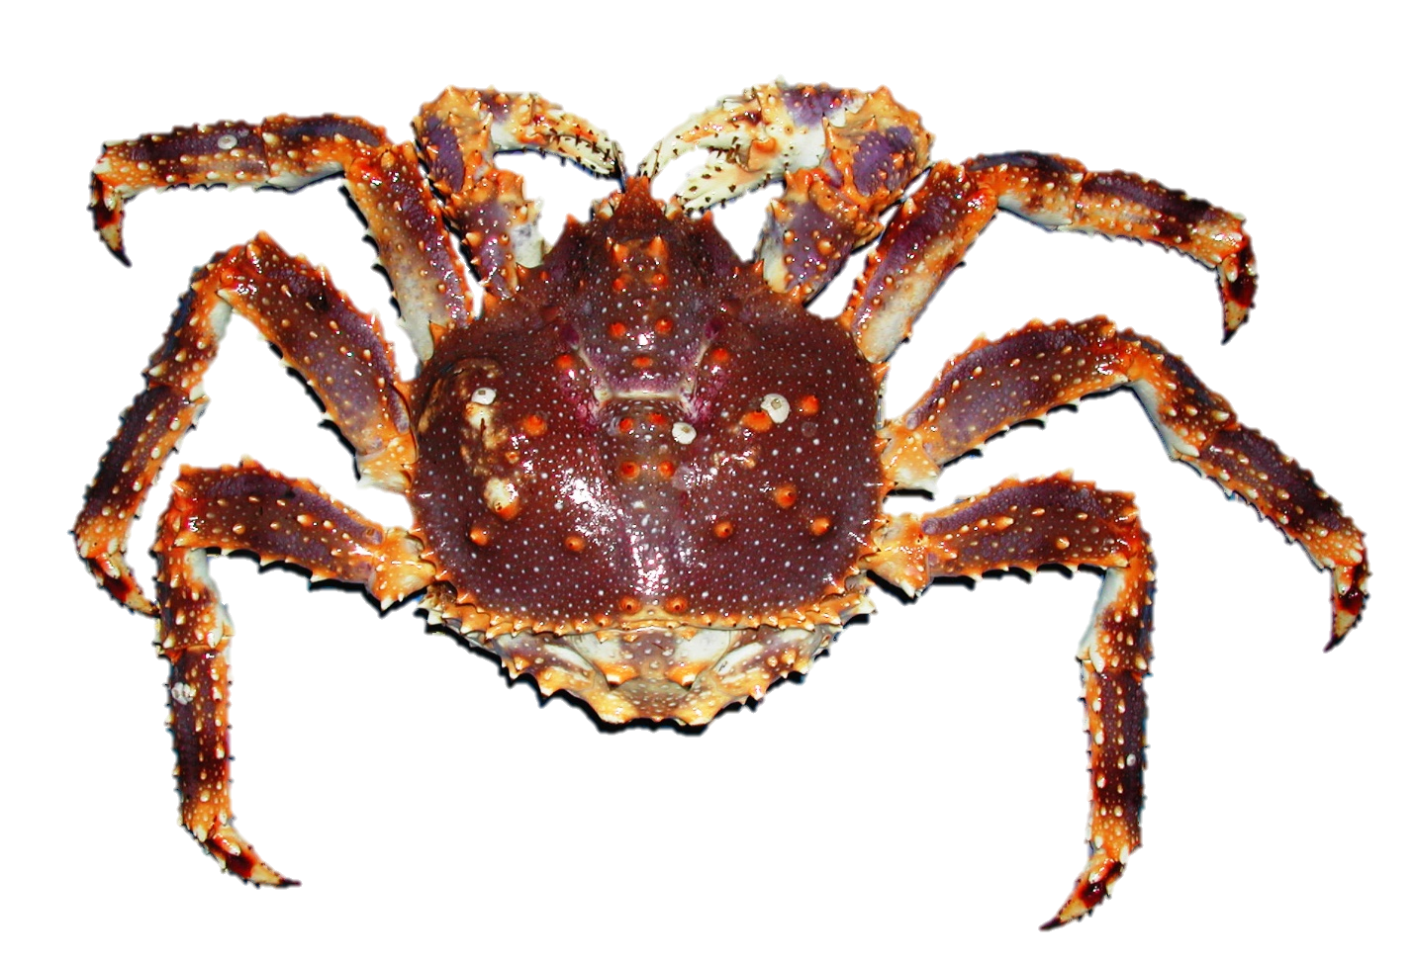

Executive Summary
National initiative and NPFMC recommendations suggest a high priority for conducting an ecosystem and socioeconomic profile (ESP) for the Saint Matthew blue king crab (SMBKC) stock. Scores for stock assessment prioritization, habitat prioritization, climate vulnerability assessment, and data classification analysis were moderate to high. The SMBKC ESP follows the new standardized framework for evaluating ecosystem and socioeconomic considerations for SMBKC and may be considered a proving ground for potential operational use in the main stock assessment.
We use information from a variety of data streams available for the SMBKC stock in the Bering Sea and present results of applying the ESP process through a metric and subsequent indicator assessment. Analysis of the ecosystem and socioeconomic metrics for SMBKC by life history stage along with information from the literature identified a suite of indicators for testing and continued monitoring within the ESP. Results of the metric and indicator assessment are summarized below as ecosystem and socioeconomic considerations that can be used for evaluating concerns in the main stock assessment.

Ecosystem Considerations
- Despite repeated fishery closures, SMBKC mature male biomass and recruitment estimates remain below-average following a 1989 regime shift in the Bering Sea, suggesting that environmental factors may be impeding recruitment success and stock recovery.
- Highly specific thermal optimums and habitat requirements of SMBKC likely limit mobility in response to warmer than average bottom temperatures and shifting predator distributions in the Bering Sea.
- Large catches of Pacific cod in the St. Matthew Island management boundary in 2016 preceded declines in BKC recruitment and the overfished declaration in 2018.
- Trend modeling for ecosystem indicators revealed poor conditions for SMBKC in recent years, attributed to above average bottom temperatures, a reduction in the cold pool extent, and an increase in mean benthic predator biomass in the St. Matthew Island management boundary.

Socioeconomic Considerations
- Vessel engagement in the SMBKC fishery as measured by annual counts of active vessels during years that the fishery has opened, has declined relative to the pre-rationalization period reflecting consolidation of the crab fleet following rationalization.
- In the most recent open seasons, the active fleet has been reduced to 3-4 vessels, with TAC utilization also declining to 26% during the 2015/16 season.
- Ex-vessel revenue share and the Local Quotient for Saint Paul both reached high values during 2010, concurrent with a peak in ex-vessel price; large declines in both metrics over the subsequent open seasons, despite relatively high ex-vessel prices during the next four open SMBKC seasons indicate that both vessels and processors active during those years have shifted into other fisheries.

Introduction
Ecosystem-based science is becoming a component of effective marine conservation and resource management; however, the gap remains between conducting ecosystem research and integrating with the stock assessment. A consistent approach has been lacking for deciding when and how to incorporate ecosystem and socioeconomic information into a stock assessment and how to test the reliability of this information for identifying future change. A new standardized framework termed the ecosystem and socioeconomic profile (ESP) has recently been developed to serve as a proving ground for testing ecosystem and socioeconomic linkages within the stock assessment process (Shotwell et al., In Review). The ESP uses data collected from a large variety of national initiatives, literature, process studies, and laboratory analyses in a four-step process to generate a set of standardized products that culminate in a focused, succinct, and meaningful communication of potential drivers on a given stock. The ESP process and products are supported in several strategic documents (Sigler et al., 2017; Dorn et al., 2018; Lynch et al., 2018) and recommended by the North Pacific Fishery Management Council’s (NPFMC) groundfish and crab Plan Teams and the Scientific and Statistical Committee (SSC).
This ESP for Bering Sea Saint Matthew blue king crab (hereafter referred to as SMBKC) follows a template for ESPs (Shotwell et al., In Review) and replaces the previous ecosystem considerations chapter in the 2011 Bering Sea and Aleutian Islands Crab SAFE document and the stock-specific report cards produced in recent years. The four-step ESP process begins with an evaluation of the stock assessment classification results (Lynch et al., 2018) to assess the priority for conducting an ESP and the target ecosystem linkage level. Once it is established to conduct an ESP, the second step is a metric assessment. Metrics are quantitative stock-specific measures that identify vulnerability or resilience of the stock with respect to biological or socioeconomic processes. Where possible, evaluating these metrics by life history stage can highlight potential bottlenecks and lead to a mechanistic understanding of ecosystem or socioeconomic pressures on the stock. The third step is an indicator assessment where a time-series suite is created that represent the critical processes identified by the metric assessment. These indicators must be useful for stock assessment in that they are regularly updated, reliable, consistent, and long-term. The indicator suite is then monitored in a series of statistical tests that gradually increase in complexity depending on the data availability of the stock. The final step of the ESP is to report potential ecosystem and socioeconomic recommendations, data gaps, caveats, and future research priorities.

Justification
The national initiative prioritization scores for SMBKC are overall moderate to high primarily because the distribution of this stock depends greatly on habitat, there was increasing model development for this stock, and there is potential vulnerability to impacts of future ocean acidification. Also in 2018 the stock was declared overfished, warranting the Crab Plan Team to request an evaluation of ecosystem factors to inform the stock rebuilding plan. Current data availability as well as target data availability for five attributes of stock assessment model input data (i.e. catch, size composition, abundance, life history and ecosystem linkage) were classified for the SMBKC stock in order to identify data gaps and assess the priority for conducting an ESP. SMBKC is currently managed as a Tier 4 crab stock and as such, the new data classification scores characterize the stock as data-limited with insufficient life history, natural mortality and recruitment data. Both current and target data availability attribute levels for the SMBKC stock size composition attribute were classified as a 3, which adequately supports a size-structured stock assessment. However, catch, abundance, life history and ecosystem linkage attributes were highlighted as having gaps between current and target data availability. Research priorities for data classification include improvements in survey extent/design to better understand the spatial extent of the stock, increases in stock specific growth and other life history information, and understanding mechanisms for detecting productivity regimes in the population. These initiative scores and data classification levels suggest a high priority for conducting an ESP for SMBKC.

Data
Initially, information on SMBKC was gathered through a variety of national initiatives that were conducted by AFSC personnel. These include (but are not limited to) stock assessment prioritization, habitat assessment prioritization, climate vulnerability analysis, and stock assessment categorization. A form was submitted to stock assessment authors to gather results from all the initiatives in one location. The form data serves as the initial starting point for developing the ESP metrics for groundfish and crab stocks in the BSAI and GOA fishery management plans (FMP).
Data used to generate metrics and indicators for the SMBKC ESP were collected from surveys, regional reports, laboratory studies and the literature (Table 1). Information for the first year of life was collected primarily from laboratory studies completed at the Kodiak Fisheries Research Center (Long and Daly, 2017), Hatfield Marine Science Center (Stoner et al., 2013) and the Alutiiq Pride Shellfish Hatchery (Herter et al., 2011). Data for late-juvenile through adult BKC stages were derived from the annual NOAA eastern Bering Sea bottom trawl survey and the triannual Alaska Department of Fish and Game St. Matthew Pot Survey. The NOAA bottom trawl survey has been collected annually since 1975 and uses a standardized 376 station grid from Bristol Bay to northwest of St. Matthew Island. Data collected on the survey provides fishery-independent estimates of groundfish and crab abundances and biological data (Zacher et al., 2019). Due to the rocky substrate preferences of BKC, much of the habitat utilized by the SMBKC stock is untrawlable and biomass estimates are underrepresented using NOAA standardized survey gear. As a result, Alaska Department of Fish and Game has conducted the St. Matthew Pot Survey triannually since 1995. In addition to reporting spatial trends in CPUE, the pot survey provides biological data from areas not surveyed by the NOAA trawl survey and is better suited to sample nearshore areas where mature female BKC are concentrated (Watson, 2004; Pengilly and Vanek, 2014).
Information on BKC habitat use was derived from essential fish habitat (EFH) model output and maps (Laman et al., 2017) as well as a recent data rescue effort to recover historic cruise data across all life history stages of the Pribilof Islands BKC stock (Armstrong et al., 2015). Data from the NOAA Resource Ecology and Ecosystem Modeling (REEM) food habits database were used to determine species compositions of benthic predators on commercial crab species. The Food Habits database consists of diet data collected from major groundfish species during the annual NOAA eastern Bering Sea bottom trawl survey.
Data used to generate socioeconomic metrics and indicators are derived from fishery-dependent sources, including commercial landings data for SMBKC collected in ADFG fish tickets (sourced from AKFIN), and effort statistics reported in the most recent ADFG Annual Management Report for BSAI shellfish fisheries estimated from ADF&G Crab Observer program data (Leon et al. 2017).

Metrics Assessment

National Metrics
The national initiative form data were summarized into a metric panel (Figure 1) that acts as a first pass ecosystem and socioeconomic synthesis. Metrics range from estimated values to qualitative scores of population dynamics, life history, or economic data for a given stock (see Shotwell et al., In Review for more details). To simplify interpretation, the metrics are rescaled by using a percentile rank for SMBKC relative to all other stocks in the groundfish and crab FMP’s. Additionally, some metrics are reversed so that all metrics can be compared on a low to high scale between all stocks in the FMP. These adjustments allow for initial identification of vulnerable (percentile rank value is high) and resilient (percentile rank value is low) traits for SMBKC. Data quality estimates are also provided from the lead stock assessment author (0 or green shaded means no data to support answer, 4 or purple shaded means complete data), and if there are no data available for a particular metric then an “NA” will appear in the panel. The metric panel gives context for how SMBKC relate to other groundfish and crab stocks and highlights the potential vulnerabilities and data gaps for the stock. The 80th and 90th percentile rank areas are provided to highlight metrics that cross into these zones indicating a high level of vulnerability for SMBKC (Figure 1, yellow and red shaded area).
For SMBKC ecosystem metrics, latitude range, depth range, adult mobility, ocean acidification sensitivity and predator stressors fell within the 90th percentile rank of vulnerability, suggesting that BKC are habitat specialists and highly sensitive to changes in resource availability and habitat requirements. Additionally, predation pressure is very high during early life history stages and BKC are particularly vulnerable to predators after molting. Recruitment variability, temperature range, fecundity, habitat specificity, habitat dependence index and habitat vulnerability index fell within the 80th percentile rank when compared to other stocks in the groundfish and crab FMP’s. SMBKC were also relatively resilient for breeding strategy index, hatch size and ecosystem value top-down and bottom-up. These initial results suggest that stage-based information regarding the implications of high predation, climate change, and habitat quality would be both valuable for the stock and would assist with subsequent indicator development. For the three applicable socioeconomic metrics, values indicated medium to low vulnerability.
SMBKC had numerous data gaps for ecosystem metrics, including growth rate, length at 50% maturity, maximum length, spawning duration, dispersal ELH, prey specificity and mean trophic level. The data quality was rated as medium to complete for all metrics with data available except for natural mortality, recruitment variability and ecosystem value top-down. The numerous data gaps highlight the need for additional studies to contribute to a better understanding of BKC life history processes.

Ecosystem Processes

Data evaluated over ontogenetic shifts (e.g., egg, larvae, juvenile, adult) may be helpful for identifying specific bottlenecks in productivity and relevant indicators for monitoring. However, BKC early life history processes are not well understood and data has been provided primarily from laboratory studies (e.g. Stoner et al., 2013, Long and Daly, 2017). As a first attempt to synthesize distribution, habitat usage and phenology of BKC across all life stages, we created a baseline life history conceptual model which is detailed in Figure 2. In the conceptual model figure, abiotic and biotic processes were identified by each life stage from the lead author and relevant papers. The main categories of the primary ecosystem processes influencing BKC life stages were identified as water temperature, larval transport and retention, habitat suitability and impact of predation. Details on why these processes were highlighted in the conceptual model and the potential relationship between these processes and the different life stages are described below.

BKC larval development consists of four zoeal stages and one glaucothoe stage, after which larvae metamorphose and settle as stage C1 benthic juveniles (Persselin, 2006). Cultivation experiments reported a 91.7% survival rate of BKC larvae from hatching to C1 stage at 6°C with increased mortality at rearing temperatures greater than 9°C (Stevens et al., 2005; Stevens et al., 2008a). While BKC larvae exhibit an upper thermal tolerance in captivity, cooler water temperatures could, in turn, slow development rates and increase mortality due to both increased larval transport and larval stage duration (Loher, 2014). Dispersal pathways of SMBKC larvae are currently unknown but advection and dispersal rates may be a significant driver of recruitment dynamics, as observed in other EBS crab stocks (Rosenkranz et al., 1998; Richar et al., 2015; Daly et al., 2018). Transport to favorable settlement grounds in the nearshore waters of St. Matthew Island is most likely dependent on high localized retention rates of BKC larvae although studies are needed to identify relationships between oceanographic conditions, larval transport and recruitment success.

During the early juvenile stages, successful settlement requires shallow, nearshore waters (<50m) and hard substrate such as shell hash, gravel or rock due to the reliance of BKC on crypsis to evade predation (Armstrong et al., 1985; Daly and Long, 2014). Survival in juvenile BKC is linked to mollusk shell abundance, including mussels (Modiolus modiolus), scallops (Chlamys sp.), rock oysters (Pododesmus macrochisma), and hairy tritons (Fusitriton oregonensis) (Chilton et al., 2011; Palacios and Armstrong, 1985). Unlike RKC, juvenile BKC lack a heavy covering of carapace spines and do not form pods to offer protection from predation, emphasizing the role of habitat complexity in BKC survival (Stevens, 2014). In addition, juvenile BKC molt several times a year during early benthic instar stages and are especially vulnerable to predation while soft. Pacific cod have been shown to predate heavily on soft-shell female red king crab (Livingston, 1989) and are likely also a key predator on juvenile BKC. Early juvenile BKC appear to have a broad range of temperature tolerance, indicated by relatively high survival over the range of temperatures tested (1.5 to 12 °C) in a laboratory experiment (Stoner et al., 2013). This is likely advantageous during the juvenile stage when BKC utilize relatively shallow habitats more prone to temperature fluctuations.
Late juvenile and adult BKC are less reliant on habitat with complex substrate, however a suite of habitat variables can be used to predict SMBKC distribution and identify vulnerabilities associated with suitable habitat characteristics. EFH models suggest that the probability of mature BKC abundance is highest over coarser sediments and lower maximum tidal currents (Laman et al., 2017). Temperature and depth likely also represent vulnerabilities given that mature female BKC migrate to relatively shallow, nearshore waters south of St. Matthew Island during the spring and summer months when bottom temperatures reach their maximum (Pengilly and Vanek, 2014). BKC exhibit reduced growth rates at 12°C and above, with feeding ration increasing with temperature up to 6°C (Long and Daly, 2017). In addition to temperature effects on BKC physiology, laboratory studies have demonstrated temperature-mediated shifts in hatch timing and embryo development (Stevens et al., 2008b). The biannual molt and reproductive strategy characteristic of BKC in contrast to most other Paralithodes spp. suggests that energetic restrictions imposed by temperature or prey conditions may be a limitation in reproductive dynamics (Webb, 2014; Jensen et al., 1985). However, adult BKC are generalists and as such, it is hypothesized that benthic prey abundances may not play an important role in life history processes.

Socioeconomic Processes

As discussed in more historical detail in Leon et al. (2017), the commercial SMBKC fishery began in 1977, with 10 vessels harvesting 1.2 million pounds (including deadloss), increasing to 22 vessels in 1978, harvesting 2.0 million pounds, and declining over the next two years to 2 active vessels in 1980. Over the next three years, the fishery increased from 31 active vessels in 1981 harvesting 4.6 million pounds to 164 vessels landing 9.5 million pounds in 1983, the largest annual catch volume in the fishery to-date and the first year of management under a declared GHL, which began at 8 million pounds. In subsequent seasons through 1997, the GHL varied from 0.5 million to 5.0 million pounds, with an active fleet varying between 31 and 174 vessels and total landings varying between 1.0 million pounds in 1986 (exceeding the preseason declared GHL range of 0.2 – 0.5 million by 100%) to 4.6 million pounds in 1997. With the initial year of the CDQ program in 1998, the fishery opened with a GHL of 5.0 million pounds, with 1.0 million pounds allocated as CDQ quota in addition to 4.0 million pounds in the general allocation fishery; the latter was prosecuted by 131 active vessels harvesting 2.9 million pounds before the fishery was closed inseason, however, only one active vessel harvested CDQ and total 1998 catch cannot be reported due to confidentiality of the CDQ catch.
The stock declined following the 1998 season, being declared overfished by NMFS in 1999 based on the results of the summer trawl survey, and the fishery was closed from the 1999 to 2008/09 seasons, with a rebuilding plan being implemented beginning in 2000. The fishery reopened for the 2009/10 season under the CR program and TAC management (both of which began in 2005 for the 2005/06 crab season), with a combined TAC of 1.67 million pounds (90% issued as IFQ allocation and 10% as CDQ), and with 7 active vessels harvesting 0.46 million pounds (39% of the TAC). The fishery remained open over the next three seasons, increasing to 2.4 million pounds TAC in 2011/12, with 18 active vessels harvesting 1.9 million pounds (80% of the TAC), and 1.63 million pounds TAC in 2012/13, with 17 active vessels harvesting 1.62 million pounds, approaching full utilization of the TAC for the first time under the CR program. Due to low abundance in the 2013 survey, the fishery was closed for 2013/14, and opened for the next two seasons with substantially reduced TACs relative to previous open seasons, at 0.66 million pounds in 2014/15 and 0.41 million pounds in 2015/16, and the number of active vessels during the two most recent seasons reduced to 4 and 3 vessels, respectively, with a catch of 0.11 million pounds in 2015/16 and utilization of the available catch limit declining to 26%, the lowest level in the fishery to-date. The fishery has been closed during each of the last three crab seasons, beginning in 2016/17.
Over the 1977 to 1998 period, the SMBKC fishery was prosecuted during open seasons that varied in length and timing, with the earliest opening on June 7 in 1977, growing later over subsequent seasons to August 1 in 1982, September 1 in 1985, and September 16 in 1991, and September 15 from 1993 through 1998. Prior to 1982, SMBKC openings ranged from approximately 5 to 9 weeks, with the latest closing on September 3 after 19 days in both 1978 and 1980. Over subsequent years prior to 2005, openings in the fishery were limited to shorter spans of 1 to 11 days, with the latest closing in 1998 on September 26. With the implementation of the CR program, the regulatory season for SMBKC was shifted to October 15 through February 1, with active fishing typically during years when the fishery opened occurring within a period of 4-5 weeks beginning October 15, with final landings for the respective seasons occurring during early- to mid-November. Over the more recent history of the SMBKC fishery, active vessels have prosecuted the SMBKC fishery in the period preceding active fishing in the other rationalized crab fisheries (most commonly the Bristol Bay RKC and Bering Sea snow crab fisheries, with some vessels also fishing in the Bering Sea Tanner crab fisheries ) and groundfish, with SMBKC contributing a component to associated vessels’ fishing portfolio, and comprising a small to moderate proportion of total annual ex-vessel revenue for most vessels active in SMBKC during a given year.

Indicators Assessment

Indicator Suite
We first provide information on how we selected the indicators for this third step of the ESP process and then provide results on the indicators analysis.

Ecosystem Indicators

Very few studies have linked environmental or ecosystem conditions to recruitment of Bering Sea crab stocks, owing primarily to the highly variable nature of crab recruitment. Zheng and Kruse (2000) noted that strong year classes of red and blue king crab stocks in the early 1970’s corresponded with low temperatures. However, recruitment trends are not consistently explained by temperatures or decadal-scale environmental variability (Zheng and Kruse, 2006). Furthermore, groundfish predation has been hypothesized as a mechanism driving recruitment variability. SMBKC recruitment was positively correlated with Pacific cod biomass, opposite of the hypothesized directionality of predation effects on recruitment (Zheng and Kruse, 2006). The lack of general or biologically meaningful relationships supporting recruitment hypotheses for SMBKC in these studies may be attributed to analyses using basin-scale indicators that are not relevant to the small spatial scale of the SMBKC management area.
When selecting a suite of indicators for the SMBKC ESP, efforts were instead focused on developing spatially explicit indicators bounded by the SMBKC management area. These indicators are described below.
Bottom temperature and cold pool indicators representing environmental conditions during the summer survey period are likely drivers of juvenile and adult BKC distribution, timing of the reproductive cycle and larval transport. BKC females move inshore in late spring to hatch eggs, molt and mate (Armstrong et al., 1981). These inshore movements may be triggered by warming bottom temperatures, suggesting that cold years in the Bering Sea have the potential to delay mating migrations, embryo development and hatching as demonstrated in laboratory studies (Stevens et al., 2008b). Temperature-mediated shifts in hatch timing could subsequently result in BKC larvae mismatches with prey resources, or increase the probability of advection away from favorable nursery grounds. Laboratory studies have also shown that temperature is a direct driver of growth, molt duration and feeding ration (Long et al., 2017: Stoner et al., 2013).

An indicator representing the cold pool extent ( <2°C) is not only important in driving BKC distributions, but also in driving distributions of major predators of BKC. Pacific cod and several flatfish species typically avoid temperatures less than 1° C (Kotwicki and Lauth, 2013), suggesting that years with a large cold pool extent around St. Matthew Island may offer BKC a refuge from predation.

A SMBKC pre-recruit biomass index effectively tracks the number of males that will likely enter the fishery the following year. Small catches of these sub-legal BKC are often a reliable indicator of impending declines in mature male biomass and may be useful as an early indicator of stock recovery for the SMBKC rebuilding plan. Likewise, a male bycatch indicator tracks mortality in trawl and fixed gear fisheries and fluctuations in bycatch rates may necessitate different regulations on groundfish fisheries or area closures to limit BKC mortality due to bycatch.

Estimates of benthic predator biomass (i.e. Pacific cod, sablefish, Pacific halibut, skates, sculpin, octopus and assorted flatfish) and invertebrate biomass (i.e. brittle stars, sea stars, sea cucumber, bivalves, non-commercial crab species, shrimp and polychaetes) provide information on the relative fluctuations of these foraging guilds (BSAI ESR, 2018). Increases in benthic predator biomass may represent increased mortality events due to predation on BKC. Although no studies on BKC diet and foraging ecology exist to date, species included in the invert biomass indicator are important prey sources for other EBS commercial crab species, and therefore likely prey of BKC as well. Increases in invert biomass may suggest optimal foraging conditions for BKC. It is, however, important to note that bottom trawl survey methods result in very low catchability of polychaetes, which are recognized as an important prey source for EBS crab species. Furthermore, increases in highly mobile benthic foragers such as hermit crabs and sea stars may, instead, suggest increased competition for benthic resources. A better understanding of benthic production and foraging ecology in the Bering Sea, and specifically, the St. Matthew Island region, is necessary to refine foraging guild indicators and their impacts on SMBKC.

Socioeconomic Indicators
Indicators reported for applicable socioeconomic metrics are derived from fishery-dependent sources that represent full enumeration of commercial landings captured in ADFG fish tickets, and ADFG and NMFS observer program data that support reliable estimates of fishing effort in the SMBKC fishery and bycatch in groundfish fisheries, respectively. Due to the intermittent opening of the targeted SMBKC fishery over the last 20 years, however, substantial gaps in the time-series for most socioeconomic indicators indicate zero (0) values when no fishery occurred, and the small number of vessels or processors participating in the fishery during some recent openings prevents reporting the value of some indicators for those years to protect confidentiality of associated landings and/or catch and effort data. The socioeconomic indicators reported below were selected in part on the basis of maximal length of time-series available¹, however, discontinuities in some data series due to changes in data collection methods limit reporting of indicator values to 1991 and later. Also, because the most recent fishery-dependent data sources are typically available for the prior year or lagged by up to three years (as of the September-November assessment cycle for most Alaska-region FMP crab and groundfish stocks), socioeconomic indicators are limited to providing retrospective information. Although relative to other crab and groundfish stocks, SMBKC is not data-poor with regard to most socioeconomic dimensions relevant to the fishery, the time-series gaps in socioeconomic indicators reported below may limit the ability to identify trends or movements in the indicators contemporaneous with reported ecosystem indicators and other factors considered in the SMBKC assessment. Combined with other functional limitations, this may substantially diminish the utility of these or other potential socioeconomic indicators for many of the purposes envisioned for the ESP.
The socioeconomic indicators reported below can be grouped into two broad, interrelated categories: 1) those addressing dimensions of commercial value, constituent demand and community dependence, and 2) indicators related to the relative quantity and efficiency of fishing effort. The latter set of indicators are reported in the assessment and are included in Figure 4 to support visual comparison of the relative values and trends in the respective sets of indicators.
Commercial value and constituent demand indicators
Ex-vessel price per pound, 1991-2015 ($2018)
Ex-vessel prices are revenue per pound of retained SMBKC catch, delivered live and sold to processors. Ex-vessel prices, combined with vessel operating costs and other factors, determine the economic return to vessels per unit of catch and, considering the availability and expected returns from alternative fishing targets, are a direct driver of the level and intensity of fishing effort.
SMB exvessel revenue share (% of total exvessel revenue)
This indicator represents the proportion of total annual ex-vessel revenue from all crab and groundfish landings for vessels active in the SMBKC fishery during a given calendar year that is produced from the SMBKC fishery. The reported values are calculated as the vessel-level mean SMBKC revenue share over the set of vessels active in the fishery for the year. Revenue share provides an indicator of the relative income dependence of participating vessels on the SMBKC fishery, where changes in the fishery that reduce the returns from fishing (e.g., reductions in TAC and/or ex-vessel price) are offset by income produced from alternative fishing targets.
Processors active in fishery
The number of processors (buyers) of SMBKC landings during the year; this provides an indicator of the density of the market for SMBKC landings.
Local Quotient of SMB landed catch in Saint Paul
St Paul represents the principal port of landing for the SMBKC fishery during the post-rationalization period, representing from 78% to 100% of all purchased landings in the fishery. The local quotient (LQ) represents the share of community landings attributed to SMBKC in relation to revenue from all other species landed in the community during years when the fishery was opened.
____________________________
¹As one of the eight FMP crab stocks included in the Crab Rationalization Program, substantial additional data are available for the SMBKC fishery that are collected by NMFS in several mandatory reporting data collections that were initiated in 2005 to monitor the performance and effects of the management program, including the ownership of CR crab harvesting and processing quota share (QS) and the quantity and value of QS transfers between buyers and sellers, and vessel and plant operating cost, quota lease activity and value, and employment data reported by crab fishing and processing sector participants in the Crab Economic Data Report (EDR) program. Although these and other CR program-specific data collections provide substantial additional data to support a variety of socioeconomic indicators of potential utility for the purpose of the ESP (many of which are reported in BSAI Crab Economic Status Reports produced annually by AFSC (Garber-Yonts and Lee, 2019), the associated data series are only available beginning 2005 or more recent, and are largely subject to the same intermittency as other fishery-dependent data available for the SMBKC fishery.
TAC Utilization (%)
The percentage of the available catch allocation (GHL or TAC) that was harvested by participating vessels (including catch discarded as deadloss at the landing). Underutilization of the available TAC indicates a low value of expected returns from fishing SMBKC relative to alternative fishing targets, or idling the vessel.

Fishing effort
Vessels active in fishery
Total Potlifts
CPUE (no. of crabs per potlift - mean)
SMBKC male bycatch biomass (1000t)

Indicator Monitoring Analysis

The suite of indicators for SMBKC is monitored using a series of statistical tests that gradually increase in complexity depending on the stability of the indicator for monitoring the ecosystem or socioeconomic process and the data availability for the stock (Shotwell et al., In Review). At this time, we only report the results of the first stage indicator testing procedure for SMBKC. The first stage is a simple assessment of the trend and variance of the most recent year and a traffic-light evaluation of the most current year of data when available (Table x). The traffic-light ranking of the current year is based on the 20th and 80th percentiles of the time series and the color of blue, yellow, or red related to being below, within, or above the two percentiles (Caddy et al., 2015). 2019 data was not yet available for many of the indicators and therefore 2018 data represent the current year for traffic-light ranking.
Ecosystem indicator trends suggest poor environmental conditions during the past 5 years for the SMBKC stock. Summer bottom water temperatures in the St. Matthew management area were at an all-time high in 2018 while the cold pool did not extend into the management area. Similar conditions were observed during 2019 summer survey operations. SMBKC pre-recruit biomass has also been on a steady decline since the mid-1990’s and the 2017 recruitment estimate is the third lowest in the 41 year time-series, following the lowest previously observed in 2016. Results of a recent breakpoint analysis suggest a SMBKC recruitment regime shift around 1996, corresponding with a 1989 brood year (Palof et al., 2019). Interestingly, there is empirical evidence for a 1989 regime shift in the North Pacific which was attributed to declines in Bering Sea groundfish recruitment and overall decreases in marine productivity (Hare and Mantua, 2000). Synchronous declines in time-lagged SMBKC recruitment suggest that ELH stages of BKC may have been negatively affected by these basin-scale ecological changes. Furthermore, warmer than average bottom temperatures in the St. Matthew Island management area in recent years correspond with low recruitment, suggesting that temperature may have an indirect effect on BKC early life history processes and survival to recruitment.
Benthic predator biomass was at an all-time high in 2016, attributed to high catches of Pacific cod surrounding St. Matthew Island. Likewise, in 2016 benthic invert biomass was up from previous years, characterized by high catches of several sea star species (Ctenodiscus crispatus, Gorgonocephalus eucnemis and Leptasterias polaris) as well as Hyas coarctatus and Pagarus trigonocheirus. 2016 biomass increases in highly mobile decapods and echinoderms may suggest increased competition for food resources available for juvenile and adult BKC. Both benthic predator and benthic invert biomasses have since declined, although remain above-average.
As a full suite of indicators is developed in the coming years, bayesian adaptive sampling (BAS) will be used for the second stage modeling application to quantify the association between hypothesized predictors and SMBKC along with the strength of support for each hypothesis.

Recommendations
In initial projections for the SMBKC rebuilding plan, recruitment appears to drive recovery time of the stock so we emphasize a concerted focus on developing a better understanding of early life history processes and the continued development of indicators relevant to larval and juvenile SMBKC. Developing an EFH habitat indicator for SMBKC should also be prioritized, as metric assessment results highlighted several vulnerabilities related to habitat. These updated indicators may then be used in second and third stage testing and modeling.
With these future priorities in mind, we provide the following set of considerations:

Ecosystem Considerations
- Despite repeated fishery closures, SMBKC mature male biomass and recruitment estimates remain below-average following a 1989 regime shift in the Bering Sea, suggesting that environmental factors may be impeding recruitment success and stock recovery.
- Highly specific thermal optimums and habitat requirements of SMBKC likely limit mobility in response to warmer than average bottom temperatures and shifting predator distributions in the Bering Sea.
- Large catches of Pacific cod in the St. Matthew Island management boundary in 2016 preceded declines in BKC mature male biomass, recruitment, and the overfished declaration in 2018.
- Trend modeling for SMBKC ecosystem indicators revealed poor conditions for SMBKC in recent years attributed to above average bottom temperatures, a reduction in the cold pool extent, and an increase in mean benthic predator biomass in the St. Matthew management boundary.

Socioeconomic Considerations
- Vessel engagement in the SMBKC fishery as measured by annual counts of active vessels during years that the fishery has opened, has declined relative to the pre-rationalization period reflecting consolidation of the crab fleet following rationalization.
- In the most recent open seasons, the active fleet has been reduced to 3-4 vessels, with TAC utilization also declining to 26% during the 2015/16 season.
- Ex-vessel revenue share and the Local Quotient for Saint Paul both reached high values during 2010, concurrent with a peak in ex-vessel price; large declines in both metrics over the subsequent open seasons, despite relatively high ex-vessel prices during the next four open SMBKC seasons indicate that both vessels and processors active during those years have shifted into other fisheries.

Data Gaps and Future Research Priorities
Additional data on BKC life history characteristics (i.e. growth-per-molt data and molting probabilities) as well as estimates for natural mortality would aide in a better understanding of stage-specific vulnerabilities. In addition, process-based studies are necessary in order to identify links between larval survival, recruitment and environmental factors. Examining larval drift patterns and spatial distributions of mature BKC around St. Matthew Island in relation to habitat characteristics will help to inform essential fish habitat models and the development of a larval retention indicator. Furthermore, additional groundfish stomach data outside of the summer survey time series would help to refine our understanding of predation pressure across life history stages of SMBKC. Likewise, spring bottom temperatures prior to the summer bottom trawl survey may help to understand SMBKC distribution in relation to survey catchability.
As noted above, in most socioeconomic dimensions, SMBKC fishery is relatively data rich in many respects. In the context of the ESP, however, the intermittent nature of the fishery and reliance on fishery-dependent socioeconomic data limits the available socioeconomic information to years when the fishery has opened. This complicates the depiction and/or interpretation of long-term averages for most socioeconomic indicators and suggests the need for development of indicators that are informative of social and economic factors relevant to the purposes of the ESP, but function on a continuous basis, including during years when the fishery is closed. Potential examples include estimation of current value of PSMFC QS assets, calculation of revenue share metrics for SMBKC processors and vessels identified with the SMBKC fishery on the basis of more continuous association than participation in the fishery during a particular year. Substantial improvements over the indicators reported above are feasible, however, are largely dependent on further development of clear objectives for the inclusion of social and economic indicators within the ESP framework.

Acknowledgements
We would like to thank all the crab stock assessment authors for their timely response to requests and questions regarding their data, report summaries, and manuscripts. We also thank all attendees and presenters at the AFSC sponsored ESP Data workshop (May, 2019) for their valuable insight on the development of the SMBKC ESP and their collective efforts in summarizing data sources and time series for future indicator development. Lastly, we thank the Crab Plan Team for supporting the development of this report and future reports.

Literature Cited
Armstrong, D., Incze, L., Wencker, D., and Armstrong, J. 1981. Distribution and abundance of decapod crustacean larvae in the southeastern Bering Sea with emphasis on commercial species.: 53. 479-878 pp.
Armstrong, D. A., Armstrong, J. L., Palacios, R., Williams, G., Jensen, G. C., and Pearson, W. 1985. Early life history of juvenile blue king crab, Paralithodes platypus, around the Pribilof Islands. In Proceedings of the International King Crab Symposium, pp. 211-229. Ed. by S. K. Davis, F. Gaffney, J. McCrary, A. J. Paul, and R. S. Otto. Alaska Sea Grant College Program, University of Alaska Fairbanks, Anchorage, AK.
Armstrong, D.A., W.C. Long, J. Armstrong, P.S. McDonald. 2015. Blue king crab, habitat, and the ecosystem: Data rescue from the 1980s. NPRB Project 1321 Final Report. North Pacific Research Board.
Caddy, J.F. 2015. The traffic light procedure for decision making: its rapid extension from fisheries to other sectors of the economy. Glob. J. of Sci. Front. Res: 1 Mar. Sci. 15(1), 30 pp.
Chilton, E., Swiney, K., Urban, D.J., and Munk E.J. 2011. Ecosystem considerations for Bering Sea and Aleutian Islands king and tanner crab species In Stock Assessment and Fishery Evaluation Report for the King and Tanner Crab Fisheries of the Bering Sea and Aleutian Islands Regions. North Pacific Fishery Management Council, 605 W 4th Ave, Suite 306 Anchorage, AK 99501.
Daly, B., and Long, W. C. 2014. Intra-guild predation among early benthic phase red and blue king crabs: Evidence for a habitat-mediated competitive advantage. Journal of Experimental Marine Biology and Ecology, 451: 98-104.
Daly, B., A.J. Hermann, C. Parada, S. Hinckley, T.H. Loher, and D.A. Armstrong. 2018. Impacts of climate change on red king crab larval advection in Bristol Bay: implications for recruitment variability. NPRB Project 1402 Final Report. North Pacific Research Board.
Dorn, M. W., C. J. Cunningham, M. T. Dalton, B. S. Fadely, B. L. Gerke, A. B. Hollowed, K. K.
Garber-Yonts, B., and J. Lee. 2019. Stock Assessment and Fishery Evaluation Report for King and Tanner Crab Fisheries of the Bering Sea and Aleutian Islands Regions: Economic Status of the BSAI Crab Fisheries, 2018. NPFMC, April, 2019. 178 p. https://www.fisheries.noaa.gov/webdam/download/91792918.
Hare, S.R. and M.J. Mantua. 2000. Empirical evidence for North Pacific regime shifts in 1977 and 1989. Progress in Oceanography, 47: 103-145.
Herter, H., Daly, B., Swingle, J. S., and Lean, C. 2011. Morphometrics, fecundity, and hatch timing of blue king crabs (Paralithodes platypus) from the Bering Strait, Alaska, USA. Journal of Crustacean Biology, 31: 304-312.
Holsman, J. H. Moss, O. A. Ormseth, W. A. Palsson, P. A. Ressler, L. A. Rogers, M. A. Sigler, P. J. Stabeno, and M. Szymkowiak. 2018. A climate science regional action plan for the Gulf of Alaska. U.S. Dep. Commer., NOAA Tech. Memo. NMFS-AFSC-376, 58 p.
Jensen, G. C., Armstrong, D. A., and Williams, G. 1985. Reproductive biology of blue king crab, Paralithodes platypus, in the Pribilof Islands In Proceedings of the International King Crab Symposium, 5th edn, pp. 109-121. Ed. by S. K. Davis, F. Gaffney, J. McCrary, A. J. Paul, and R. S. Otto. Alaska Sea Grant College Program, University of Alaska Fairbanks, Anchorage, AK.
Kotwicki, S., and Lauth, R. R. 2013. Detecting temporal trends and environmentally-driven changes in the spatial distribution of bottom fishes and crabs on the eastern Bering Sea shelf. Deep-Sea Research Part Ii-Topical Studies in Oceanography, 94: 231-243.
Laman, E. A., C. N. Rooper, S. C. Rooney, K. A. Turner, D. W. Cooper, and M. Zimmermann. 2017. Model-based Essentail Fish Habitat Definitions for Bering Sea Groundfish Species. U.S. Dep. Commer., NOAA Tech Memo. doi:10.7289/V5/TM-AFSC-357
Leon, J. M., J. Shaishnikoff, E. Nichols, and M. Westphal. 2017. Annual management report for shellfish fisheries of the Bering Sea–Aleutian Islands Management Area, 2015/16. Alaska Department of Fish and Game, Fishery Management Report No. 17-10, Anchorage. 188 p.
Livingston, P. 1989. Interannual trends in Pacific cod, Gadus macrocephalus, predation on three commercially important crab species in the eastern Bering Sea. Fishery Bulletin, 87: 807-827.

Loher, T. 2014. Modeling Larval Advection and Spatial Population Structure in King Crabs: Interactions among Life-History Requirements, Extrinsic Forcing, and Source-Sink Dynamics, In King Crabs of the World : Biology and Fisheries Management. Ed. by B. G. Stevens. CRC Press LLC.
Long, W. C., and Daly, B. 2017. Upper thermal tolerance in red and blue king crab: sublethal and lethal effects. Marine Biology, 164: 162.

Lynch, P. D., R. D. Methot, and J. S. Link (eds.). 2018. Implementing a Next Generation Stock Assessment Enterprise. An Update to the NOAA Fisheries Stock Assessment Improvement Plan. U.S. Dep. Commer., NOAA Tech. Memo. NMFS-F/SPO-183, 127 p. doi: 10.7755/TMSPO.183
Palacios, R., and Armstrong, D. 1985. Community analysis applied to characterization of blue king crab habitat around the Pribilof Islands. In Proceedings of the International King Crab Symposium, pp. 193-209. Ed. by B. Melteff. University of Alaska Sea Grant Program, Anchorage, AK, USA.

Pengilly, D., and Vanek, V. 2014. Results of the 2013 triennial St. Matthew Island blue king crab pot survey. ICES Document 14-35: No. 14-35. 81 pp.

Palof, K., Zheng, J., Ianelli, J. 2019. St. Matthew Island Blue King Crab Stock Assessment In Stock Assessment and Fishery Evaluation Report for the King and Tanner Crab Fisheries of the Bering Sea and Aleutian Islands Regions. North Pacific Fishery Management Council, 605 W 4th Ave, Suite 306 Anchorage, AK 99501.
Persselin, S. 2006. Cultivation of king crab larvae at the Kodiak Fisheries Research Center, Kodiak, Alaska. In Alaska Crab Stock Enhancement and Rehabilitation: Workshop Proceedings, pp. 9-13. Ed. by B. Stevens. Alaska Sea Grant College Program AKSG-06-04.
Richar, J. I., Kruse, G. H., Curchitser, E., and Hermann, A. J. 2015. Patterns in connectivity and retention of simulated Tanner crab (Chionoecetes bairdi) larvae in the eastern Bering Sea. Progress in Oceanography, 138: 475-485.
Rosenkranz, G., Tyler, A., Kruse, G., and Niebauer, H. 1998. Relationship between wind and year class strength of Tanner crabs in the southeastern Bering Sea. Alaska Fishery Research Bulletin, 5: 18- 24.
Siddon, E., and S., Zador. 2018. Ecosystem Status Report 2018: Status of the Bering Sea marine ecosystem. In Stock Assessment and Fishery Evaluation Report, North Pacific Fishery Management Council, 605 W 4th Ave, Suite 306, Anchorage, AK 99501. 215 p.
Sigler, M. F., M. P. Eagleton, T. E. Helser, J. V. Olson, J. L. Pirtle, C. N. Rooper, S. C. Simpson, and R.P. Stone. 2017. Alaska Essential Fish Habitat Research Plan: A Research Plan for the National Marine Fisheries Service’s Alaska Fisheries Science Center and Alaska Regional Office. AFSC Processed Rep. 2015-05, 22 p. Alaska Fish. Sci. Cent., NOAA, Natl. Mar. Fish. Serv., 7600 Sand Point Way NE, Seattle WA 98115.
Stevens, B. G., Persselin, S., and Matweyou, J. 2008a. Survival of blue king crab Paralithodes platypus Brandt, 1850, larvae in cultivation: effects of diet, temperature and rearing density. Aquaculture Research: 390-397.
Stevens, B. G., Persselin, S. L., and Matweyou, J. A. 2005. Cultivation of blue king crab larvae, Paralithodes platypus: effects of diet, temperature, and density. In Larvi '05 - Fish & Shellfish Larviculture Symposium, pp. 485-488. Ed. by C. I. Hendry, G. Van Stappen, M. Wille, and P. Sorgeloos. European Aquaculture Society, Gent, Belgium.
Stevens, B. G., Swiney, K. M., and Buck, L. 2008b. Thermal effects on embryonic development and hatching for blue king crab Paralithodes platypus (Brandt, 1850) held in the laboratory, and a method for predicting dates of hatching. Journal of Shellfish Research, 27: 1255-1263.
Stevens, B.G. 2014. Biology and Ecology of Juvenile King Crabs, In King Crabs of the World: Biology and Fisheries Management. Ed. by B. G. Stevens. CRC Press LLC.
Stoner, A. W., Copeman, L. A., and Ottmar, M. L. 2013. Molting, growth, and energetics of newly-settled blue king crab: Effects of temperature and comparisons with red king crab. Journal of Experimental Marine Biology and Ecology, 442: 10-21.
Watson, L. J. 2004. Project operational plan for the 2004 Triennial St. Matthew Island blue king crab survey. ICES Document 4K04-26. 55 pp.
Webb, J. 2014. Reproductive Ecology of Commercially Important Lithodid Crabs, In King Crabs of the World: Biology and Fisheries Management. Ed. by B. G. Stevens. CRC Press LLC.
Zacher, L.S., Richar J.I., and Foy R.J. 2019. The 2019 Eastern Bering Sea Continental Shelf Trawl Survey: Results for Commercial Crab Species. U.S. Dep. Commer., NOAA Tech Memo.
Zheng, J., and Kruse, G. 2000. Recruitment patterns of Alaskan crabs in relation to decadal shifts in climate and physical oceanography. ICES Journal of Marine Science, 57: 438.
Zheng, J., and Kruse, G. H. 2006. Recruitment variation of eastern Bering Sea crabs: Climate-forcing or top-down effects? Progress in Oceanography, 68: 184-204.

Table 1. List of data sources used in the SMBKC ESP evaluation. Please see the SMBKC SAFE document (Palof et al., 2019), the NOAA EBS Trawl Survey: Results for Commercial Crab Species Technical Memo (Zacher et al., 2019) and the SAFE Economic Status Report (Garber-Yonts and Lee, 2019) for more details

Title |  | Description | Years | Extent
Ecosystem | RACE EBS Bottom Trawl Survey | Bottom trawl survey of groundfish and crab on standardized 376-station grid using an 83-112 Eastern otter trawl | 1975-2019 | EBS annual
Ecosystem | REEM Food Habits Database | Diet data collected from key groundfish species on the EBS bottom trawl survey | 1987-2018 | EBS annual
Ecosystem | ADF&G St. Matthew Island Pot Survey | Pot survey for blue king crab in the standard EBS bottom trawl survey area offshore and the nearshore area south and west of St. Matthew Island | 1995-2018 | St. Matthew Island Management Area, triannual
Ecosystem | Essential Fish Habitat Models | Habitat suitability MaxEnt models for describing essential fish habitat of groundfish and crab in Alaska, EFH 2017 Update | 1970-2016 | Alaska
Ecosystem | Historic Pribilof Island BKC Cruise Data | Data from zooplankton tows, beam trawl and rock dredge samples and side scan sonar to examine BKC processes across life history stages | 1983-1984 | Pribilof Islands, EBS
Socioeconomic | ADF&G fish ticket database | Volume, value, and port of landing for Alaska crab and groundfish commercial landings; data processed and provided by Alaska Fisheries Information Network | 1992-2018 | Alaska
Socioeconomic | ADF&G Crab Observer program data | SMBKC catch and effort data (number of active vessels, total pots lifted, and CPUE), sourced from ADF&G Annual Fishery Management Report | 1980-2017 | Alaska

Table 2. First stage ecosystem indicator analysis for SMBKC including indicator title and short description. The recent five-year trend (up, down, or stable) and recent five-year mean (greater than (+), less than (-) or within 1 standard deviation (∙) of long-term mean) are provided following the ESR methods. Fill is based on 2018 conditions for SMBKC relative to the 20th and 80th percentiles of the time series (yellow = average, blue = good, red = poor, no fill = no current year data). NA = data gap.
Title | Description | Trend | Mean
Summer Bottom Temperature | Average bottom temperature (ºC) over all hauls within the SMBKC management boundary of the RACE Bering Sea shelf bottom trawl survey | Up | ∙
Proportion Cold Pool | Proportion of RACE Bering Sea shelf bottom trawl survey stations within the SMBKC management boundary less than 2°C | Down | -
SMBKC Pre-recruit Biomass | Model estimates for SMBKC recruitment. Includes male crab (105-119 mm CL) that will likely enter the fishery the following year. | Stable | ∙
Benthic Predator Biomass | Combined biomass (1,000t) of benthic predators within the SMBKC management boundary on the RACE Bering Sea shelf bottom trawl survey | Stable | +
Benthic Invert Biomass | Combined biomass (1,000t) of benthic invertebrates within the SMBKC management boundary on the RACE Bering Sea shelf bottom trawl survey | Stable | +

Table 3. First stage socioeconomic indicator analysis for SMBKC including indicator title and short description. The recent five-year trend (up, down, or stable) and recent five-year mean (greater than (+), less than (-) or within 1 standard deviation (∙) of long-term mean) are provided following the ESR methods. Fill is based on current year conditions for SMBKC relative to the 20th and 80th percentiles of the time series (yellow = average, blue = good, red = poor, no fill = no current year data). NA = data gap.
Title | Description | Trend | Mean
Vessels active in fishery | Annual count of crab vessels that delivered commercial landings of SMBKC to processors² | Stable | -
TAC Utilization | Percentage of the annual SMBKC TAC (GHL prior to 2005) that was harvested by active vessels, including deadloss discarded at landing. | Down | ∙
Total Potlifts | Fishing effort, as measured by estimated number of crab pots lifted by vessels during the SMBKC fishery | Down | ∙
CPUE | Fishing effort efficiency, as measured by estimated mean number of retained SMBKC per potlift | Down | ∙
Ex-vessel price per pound | Commercial value per unit (pound) of SMBKC landings (as adjusted by CFEC to account for post-season adjustments to ex-vessel settlements), measured as weighted average value over all ex-vessel sales reported. | Down | ∙
SMBKC ex-vessel revenue share | SMBKC ex-vessel revenue share as percentage of total calendar year ex-vessel revenue from all commercial landings in Alaska fisheries, mean value over all vessels active in SMBKC during the respective year. | Down | ∙
Processors active in fishery | Total number of crab processors that purchased landings of SMBKC from delivering vessels during the calendar year. | Down | ∙
Local Quotient of SMBKC landed catch in St. Paul | Ex-vessel value share of SMBKC landings to communities on St. Paul Island, as percentage of total value of commercial landings to St. Paul processors from all commercial Alaska fisheries, aggregate percentage over all landings during the respective year. | Down | ∙
SMBKC Male Bycatch in Groundfish Fishery | Incidental bycatch biomass estimates of male SMBKC (tons) in trawl and fixed gear fisheries | Stable | ∙

___________________________
²Includes crab catcher/processors that harvested and processed SMBKC catch on-board.

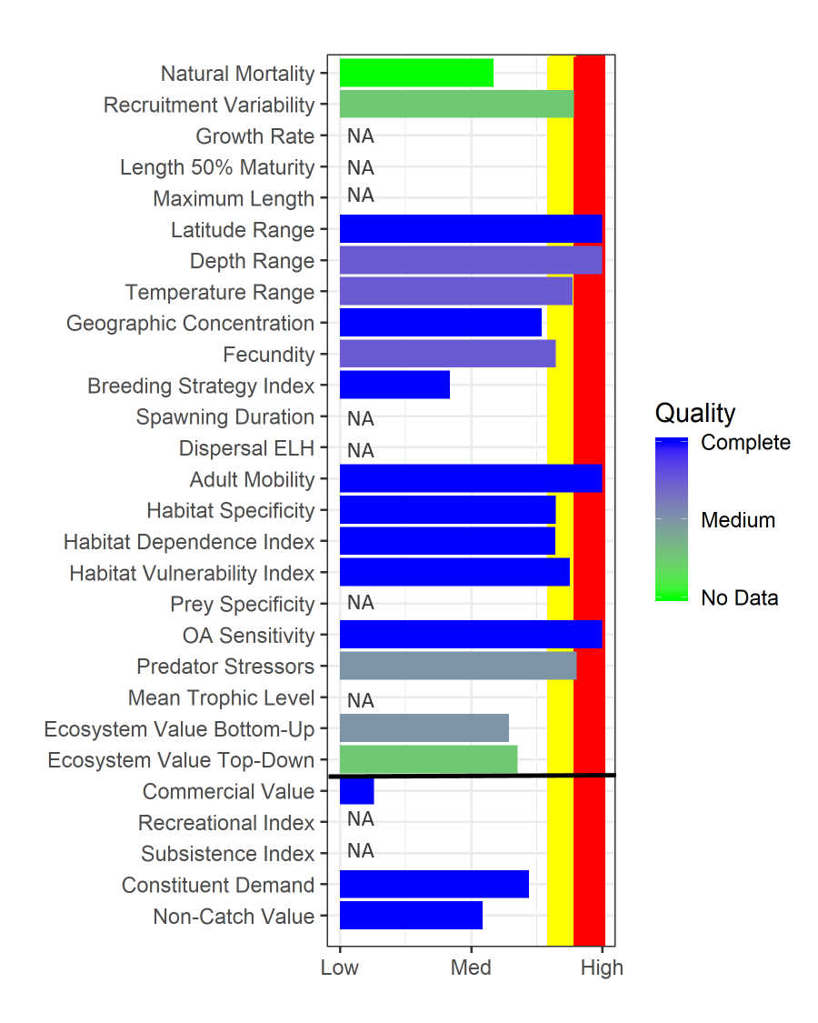
Figure 1. Baseline metrics for SMBKC graded as percentile rank over all groundfish and crab stocks in the FMP. Red bar indicates 90th percentile, yellow bar indicates 80th percentile. Higher rank values indicate a vulnerability and color of the horizontal bar describes data quality of the metric (see Shotwell et al., In Review, for more details on the metric definitions). Ecosystem indicators above and socioeconomic indicators below the horizontal black line.

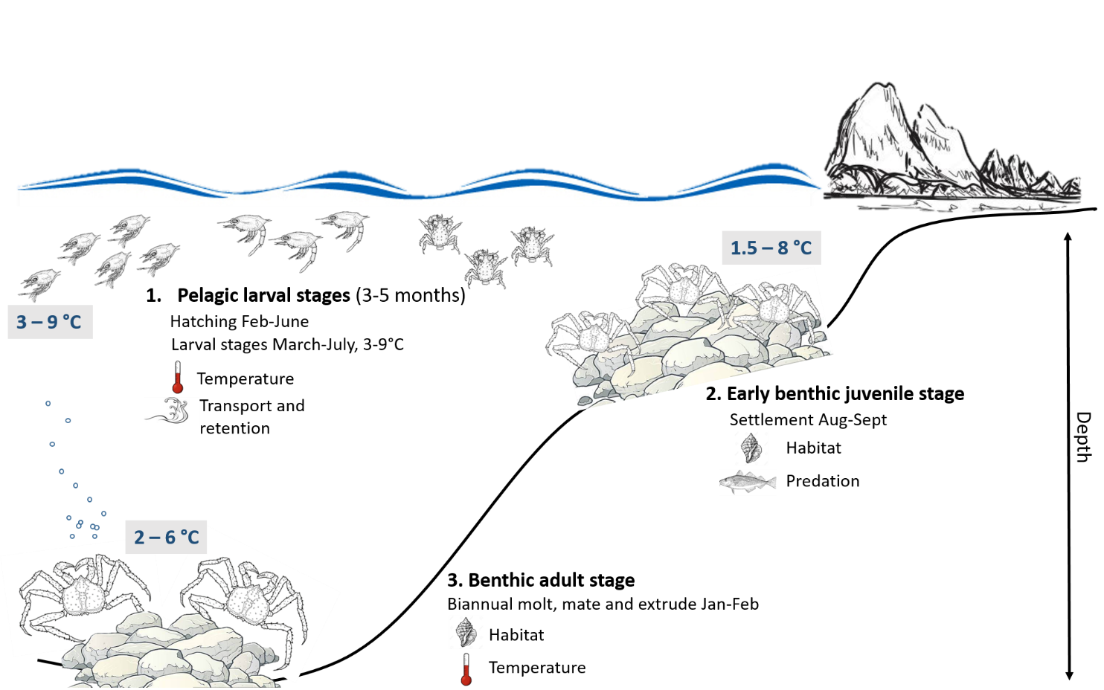

Figure 2. Conceptual diagram of phenological information by life history stage for SMBKC and processes likely affecting survival in each stage. Thermal requirements by life history stage were determined from BKC laboratory studies (Stoner et al., 2013, Stevens et al., 2008a, Stevens et al., 2008b).

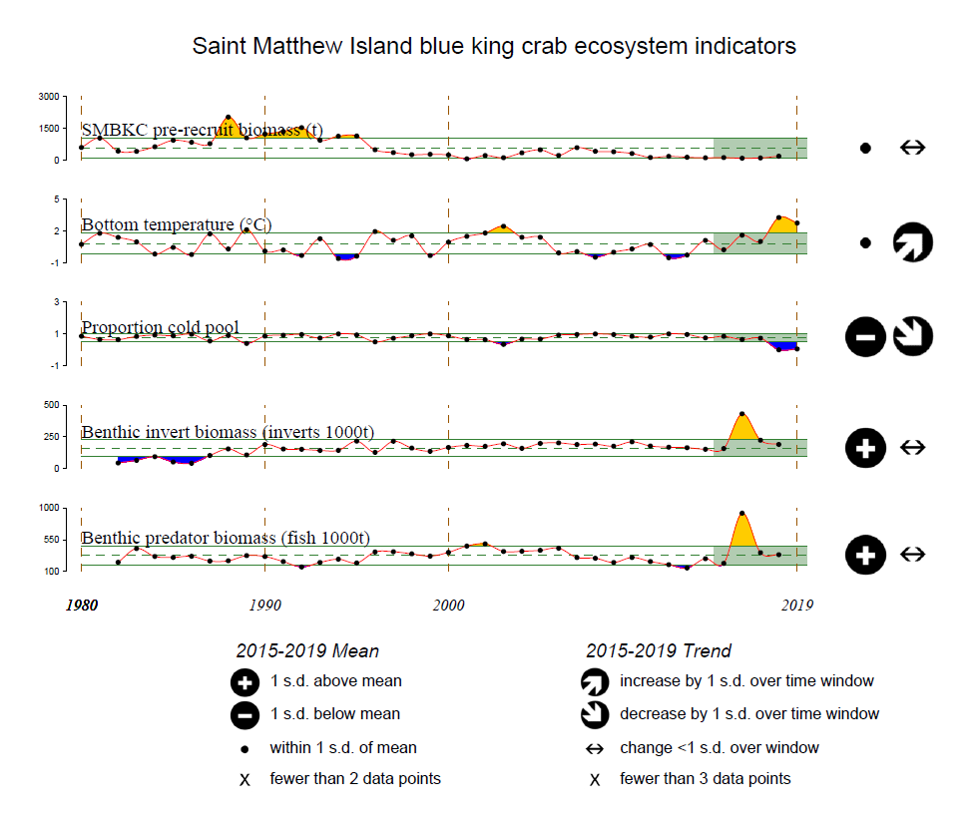

Figure 3. Selected ecosystem indicators for SMBKC with time series ranging from 1980 – 2019. Upper and lower solid green horizontal lines are 90th and 10th percentiles of time series. Dotted green horizontal line is mean of time series. Light green shaded area represents most recent five years for mean and trend analysis.

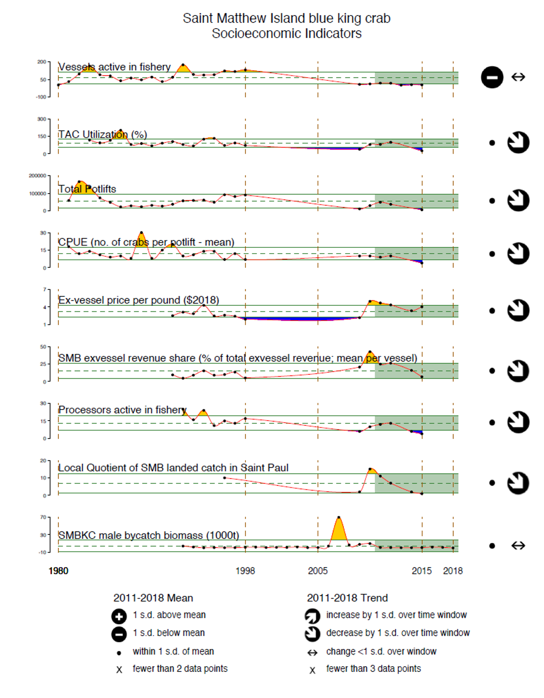
Figure 4. Selected socioeconomic indicators for SMBKC with time series ranging from 1980 – 2019. Upper and lower solid green horizontal lines are 90th and 10th percentiles of time series. Dotted green horizontal line is the mean of time series. For mean and trend analysis, the light green shaded area represents the most recent eight year period, which includes the most recent five year period (2011-2015) of open fisheries in more than two successive years.

