BRISTOL BAY RED KING CRAB STOCK ASSESSMENT IN SPRING 2020

J. Zheng and M.S.M. Siddeek
Alaska Department of Fish and Game
Division of Commercial Fisheries
P.O. Box 115526
Juneau, AK 99811-5526, USA
Phone: (907) 465-6102
Fax: (907) 465-2604
Email: jie.zheng@alaska.gov

Executive Summary

- Stock: Red king crab (RKC), Paralithodes camtschaticus, in Bristol Bay, Alaska.
- Catches: The domestic RKC fishery began to expand in the late 1960s and peaked in 1980 with a catch of 129.95 million lbs (58,943 t). The catch declined dramatically in the early 1980s and remained at low levels during the last three decades. Catches during recent years until 2010/11 were among the high catches in last 15 years. The retained catch in 2018/19 was approximately 4.5 million lbs (2,027 t), below the catch in 2017/18 (6.8 million lbs, 3,094 t). The catch reduction was due to reduction in total allowable catch. The magnitude of bycatch from groundfish trawl and fixed gear fisheries has been stable and small relative to stock abundance during the last 10 years.
- Stock biomass: Estimated mature biomass increased dramatically in the mid-1970s and decreased precipitously in the early 1980s. Estimated mature crab abundance had increased during 1985-2009 with mature females being about three times more abundant in 2009 than in 1985 and mature males being about two times more abundant in 2009 than in 1985. Estimated mature abundance has steadily declined since 2009.
- Recruitment: Estimated recruitment was high during 1970s and early 1980s and has generally been low since 1985 (1979-year class). During 1984-2019, only in 1984, 1986, 1995, 1999, 2002 and 2005 were estimated recruitments above the historical average for 1976-2019. Estimated recruitment was extremely low during the last 12 years.
- Management performance:

Status and catch specifications (1,000 t) (model 19.0): (not updated)
Year | MSST |  | Biomass (MMB) | TAC | Retained Catch | Total Catch | OFL | ABC
2015/16 |  | 12.89^{A} | 27.68^{A} | 4.52 | 4.61 | 5.30 | 6.73 | 6.06
2016/17 |  | 12.53^{B} | 25.81^{B} | 3.84 | 3.92 | 4.37 | 6.64 | 5.97
2017/18 |  | 12.74^{C} | 24.86^{C} | 2.99 | 3.09 | 3.60 | 5.60 | 5.04
2018/19 |  | 10.62^{D} | 16.92D | 1.95 | 2.03 | 2.65 | 5.34 | 4.27
2019/20 |  |  | 15.96^{D} |  |  |  | 3.40 | 2.72

The stock was above MSST in 2018/19 and hence was not overfished. Overfishing did not occur.

Status and catch specifications (million lbs):
Year | MSST |  | Biomass (MMB) | TAC | Retained Catch | Total Catch | OFL | ABC
2015/16 |  | 28.4^{A} | 61.0^{A} | 9.97 | 10.17 | 11.69 | 14.84 | 13.36
2016/17 |  | 27.6^{B} | 56.9^{B} | 8.47 | 8.65 | 9.63 | 14.63 | 13.17
2017/18 |  | 28.1^{C} | 54.8^{C} | 6.60 | 6.82 | 7.93 | 12.35 | 11.11
2018/19 |  | 23.4^{D} | 37.3^{D} | 4.31 | 4.31 | 5.85 | 11.76 | 9.41
2019/20 |  |  | 35.2^{D} |  |  |  | 7.5 | 6.00

Notes:
A – Calculated from the assessment reviewed by the Crab Plan Team in September 2016
B – Calculated from the assessment reviewed by the Crab Plan Team in September 2017
C – Calculated from the assessment reviewed by the Crab Plan Team in September 2018
D – Calculated from the assessment reviewed by the Crab Plan Team in September 2019

6. Basis for the OFL: Values in 1,000 t (model 19.0): (Not updated)

Year | Tier |  | B_{MSY} | Current  MMB | B/B_{MSY} (MMB) | F_{OFL} |  | Years to define B_{MSY} | Natural  Mortality
2015/16 |  | 3b | 26.1 | 24.7 | 0.95 | 0.27 | 1984-2015 |  |  | 0.18
2016/17 |  | 3b | 25.8 | 24.0 | 0.93 | 0.27 | 1984-2016 |  |  | 0.18
2017/18 |  | 3b | 25.1 | 21.3 | 0.85 | 0.24 | 1984-2017 |  |  | 0.18
2018/19 |  | 3b | 25.5 | 20.8 | 0.82 | 0.25 | 1984-2017 |  |  | 0.18
2019/20 |  | 3b | 21.2 | 16.0 | 0.75 | 0.22 | 1984-2018 |  |  | 0.18

Basis for the OFL: Values in million lbs:

Year | Tier |  | B_{MSY} | Current  MMB | B/B_{MSY} (MMB) | F_{OFL} |  | Years to define B_{MSY} | Natural  Mortality
2015/16 |  | 3b | 57.5 | 54.4 | 0.95 | 0.27 | 1984-2015 |  |  | 0.18
2016/17 |  | 3b | 56.8 | 52.9 | 0.93 | 0.27 | 1984-2016 |  |  | 0.18
2017/18 |  | 3b | 55.2 | 47.0 | 0.85 | 0.24 | 1984-2017 |  |  | 0.18
2018/19 |  | 3b | 56.2 | 45.9 | 0.82 | 0.25 | 1984-2017 |  |  | 0.18
2019/20 |  | 3b | 46.8 | 35.2 | 0.75 | 0.22 | 1984-2018 |  |  | 0.18

A. Summary of Major Changes

1. Changes to management of the fishery: None.
2. Changes to the input data:
- Updated NMFS trawl survey data through 2019.
- Updated the directed pot fishery catch and bycatch data through 2018 (i.e., completed 2018/19 fishery).
- Updated groundfish fisheries bycatch data during 1991-2018.
- Added VAST-estimated NMFS survey biomass and CV (provided by NMFS).
3. Changes to the assessment methodology:
a. Estimated recruitment in the terminal year is not used for estimating B_{35%}. That is, the mean recruitment from 1984-2018 is used for estimating B_{35%}.
b. For the directed pot fishery, the model fits total observer male biomass and length compositions, instead of discarded male biomass and length compositions. Observers have not separated retained and discarded legal males in the directed pot fishery starting in 2018.
c. The analyses of terminal years of recruitment is updated.
d. Eight models are compared in this report (See Section E.3.a for details):
19.0a: the model 19.0 in September 2019 except with mean recruitment sex ratio during the reference period to estimate B_{35%}. This model replaces the bad choice of the previous GMACS version with the sex ratio only in the terminal year.
19.1: the same as model 19.0a except for a constant M of 0.18 for males and an estimated constant multiplier being used to multiply male M to estimate M for females in the model.
19.2: the same as model 19.1 except for a constant M being estimated for both males and females during 1980-1984 and a constant M of 0.18 for both males and females during the other years.
19.3: the same as model 19.2 except for a constant M being estimated for males during 1980-1984, a constant M of 0.18 for males during the other years, and an estimated constant multiplier being used to multiply male M to estimate M for females. That is, M for females is relative to M for males each year.
19.4: the same as model 19.3 except for males and females to have the same selectivity curve for each survey.
19.4a: the same as model 19.4 except for VAST-estimated NMFS survey trawl biomass and CV are used.
19.4b: the same as model 19.4a except for an additional CV is estimated for NMFS trawl survey biomass.
19.5: the same as model 19.4 except for males and females to have different NMFS trawl survey catchabilities.

4. Changes to assessment results:
The population biomass estimates in 2019 are lower than those in 2018. Among the eight models, model estimated relative NMFS survey biomasses and mature biomasses are very similar except for model 19.1. A constant M of 0.18 for model 19.1 generally results in lower biomass estimates during the 1970s and early 1980s, higher biomass estimates during the mid 1980s, and very poor fits to the survey data. Estimated results are extremely similar for models 19.4, 19.4a and 19.5 except for higher biomass estimates for model 19.4a during recent years, indicating that separating NMFS survey catchabilities for sex has only very small impacts on the results. Higher biomass estimates during recent years for models 19.4a and 19.4b than models 19.4 and 19.5 are resulted from higher survey biomass estimates in 2018 and 2019 by VAST. Estimating additional NMFS survey CV for model 19.4b results in further poor fits to NMFS survey biomass and higher biomass estimates during recent years. Differences of biomass estimates between models 19.0a, 19.1 and 19.2 and models 19.3, 19.4, 19.4a, 19.4b and 19.5 can largely be explained by different structures of M. Equal survey selectivity for both males and females reduces six number of parameters and also reduces confounding of parameter estimates of M, recruits by sex and fishing mortalities. All eight models fit the catch and bycatch biomasses extremely well except for the model 19.2 fit to the retained and total male catches. Among the eight models, models 19.1 and 19.2 have poor fits to the data and thus are eliminated for consideration of model choice. Models 19.4, 19.4a and 19.5 have relatively a fewer number of parameters and fit the data very well, thus being our preferred models for overfishing definition determination. Among the above three models, model 19.4a does not fit the survey biomass as well as the other two models in the last two years due to higher VAST estimates, and model 19.5 fits the data very slightly less than model 19.4; therefore, model 19.4 is preferred. The CPT adopted GMACS for overfishing definition determination for September 2019.
Like the results of model 19.0 in September 2019, the terminal year recruitment analysis with model 19.4 also suggests the estimated recruitment in the last year should not be used for estimating B35%.

B. Responses to SSC and CPT Comments
1. Responses to the most recent two sets of SSC and CPT comments on assessments in general:

Response to SSC Comments (from October 2019):

“The SSC reminds authors to use the model numbering protocols that allows the SSC to understand the year in which a particular version of the model was first introduced. Also, when reporting bycatch in tables in each SAFE chapter, the SSC requests authors to be clear whether they report bycatch or bycatch mortality (DMRs have been applied). Further, when reporting bycatch mortality, it would be helpful to report the DMR values used.”

Response: We have followed these recommendations.

“The SSC requests that the CPT consider developing a standard approach for projecting the upcoming year’s biomass that does not include removing the entire OFL for stocks where recent mortality has been substantially below the OFL. This may appreciably change the projected biomass levels for stocks such as Tanner crab, where actual catch mortality has been less than 10% of the OFL.”

Response: Agree to this request and will follow the standard approach developed by the CPT.

2. Responses to the most recent two sets of SSC and CPT comments specific to this assessment:

Response to CPT Comments (from May 2019):

“Explain why the likelihoods for size-compositions differ given the fits are very similar.”

Response in September 2019: four reasons: (1) GMACS does not include the constant term whereas we had a constant term in the robust normal for proportion likelihoods, (2) for sex combined normalized length compositions, the effective sample sizes were doubled for GMACS (GMACS adds them together), (3) for sex combined normalized length compositions, the robust constant for variance estimation is 1/36 for both males and females with GMACS, while our past assessment program in May 2019 or earlier used 1/20 for males and 1/16 for females, and (4) although it is an extremely small value, our past program did not compute likelihood for the first several length groups for retained catch due to zero proportions while GMACS computes it.

We made all length composition likelihoods comparable in this report: models 18.0d and 18.0e drop the constant term; for sex combined normalized length compositions, effective sample sizes in data file are reduced to half for GMACS and the robust constant 1/36 is used for all models; and for retained length compositions, all groups are used to compute likelihood for models 18.0d and 18.0e.

Also, NMFS survey biomass likelihood was not comparable in the report in May 2019 between models 18.0e and 19.0. GMACS had an extra term, 0.5σ, in the likelihood function and a constant term. We deleted the extra term from GMACS and added the constant term to models 18.0d and 18.0e. Now the likelihood function values for both NMFS and BSFRF survey biomass are comparable among the three models in this report.

“Document how the two models penalize parameter values, in particular, differences in the sex ratio of recruits from 1:1, and explore whether the difference in results is due to difference in this penalty.”

Response in September 2019: model 18.0e doesn’t have priors on parameters except NMFS survey catchability. Most of penalties of model 18.0e are on recruitment: sex ratio of recruits from 1:1 and recruitment variation over time. Model 18.0e also has a very small penalty on bycatch fishing mortality deviations to make sure that they make sense, and this small penalty generally does not affect the results. Model 19.0 has the same prior on NMFS survey catchability and tried to have the same penalties as model 18.0e on recruitment. However, model 19.0 has further penalty on recruitment, such as sigmaR. Besides sigmaR, model 19.0 has many prior-densities and a penalty on natural mortality (M) deviations. Based on penalty values in negative likelihood components, prior-densities have the highest value, recruitment has the second, and M deviations have the third. Since prior-densities in GMACS are mostly constants, we examined penalties from sigmaR, recruitment sex ratio, and M deviations on the results of model 19.0.

At first, sigmaR seems to have a huge impact (it was the case in May 2019); however, we found out that the impacts were caused by the interaction of female fishing mortality offset values in the groundfish bycatch. Therefore, we set the offsets for the groundfish bycatch female mortality to be zero for model 19.0, consistent with model 18.0e, the impacts by sigmaR on results are very small. See the following table for sigmaR (the default sigmaR is 0.9):

GMACS' sensitivity on sigmaR:
SigmaR | 0.5 | 0.7 | 0.88 | 1 | 1.2
Neg. log likelihood | -23550.3 | -23549.9 | -23548.6 | -23547.5 | -23545.5
B_{35%}(t) | 21389.8 | 21535.1 | 21662.2 | 21724.9 | 21786.8
F_{35%} | 0.299 | 0.299 | 0.299 | 0.299 | 0.299
MMB₂₀₁₉(t) | 15978.2 | 16043.7 | 16090.7 | 16115.5 | 16148.4
OFL₂₀₁₉(t) | 3386.9 | 3390.2 | 3389.2 | 3389.4 | 3394.2
ABC₂₀₁₉(t) | 2709.5 | 2712.2 | 2711.4 | 2711.6 | 2715.4
F_{ofl2019} | 0.215 | 0.214 | 0.214 | 0.213 | 0.213
Q | 0.925 | 0.924 | 0.925 | 0.925 | 0.925

Surprisingly, the weighting factor (emphasis factor/prior) for recruitment ratios does not have large impacts on the results for model 19.0 (the default factor is 10):

GMACS' sensitivity on mean R sex ratio:
W.factor | 1 | 5 | 10 | 20 | 50
Neg. log likelihood | -23551.2 | -23550.8 | -23550.3 | -23549.5 | -23547.6
B_{35%}(t) | 21751.2 | 21518.4 | 21247.2 | 20759.3 | 19601.0
F35% | 0.299 | 0.299 | 0.299 | 0.299 | 0.299
MMB₂₀₁₉(t) | 16015.4 | 15988.1 | 15956.6 | 15895.4 | 15741.6
OFL₂₀₁₉(t) | 3336.8 | 3367.3 | 3403.4 | 3469.8 | 3636.2
ABC₂₀₁₉(t) | 2669.4 | 2693.8 | 2722.7 | 2775.8 | 2908.9
F_{ofl2019} | 0.211 | 0.214 | 0.216 | 0.221 | 0.234
Q | 0.925 | 0.925 | 0.925 | 0.924 | 0.924

Finally, the penalty on M deviations has some impacts on the results for model 19.0, but the impacts are not very large (the default factor is 1.0):

GMACS' sensitivity on M penalty:
W. factor | 0.1 | 0.5 | 1.0 | 2.0 | 5.0
Neg. log likelihood | -23598.2 | -23576.6 | -23550.3 | -23500.2 | -23365.1
B_{35%}(t) | 21793.0 | 21531.3 | 21247.2 | 20698.5 | 19462.7
F_{35%} | 0.298 | 0.299 | 0.299 | 0.300 | 0.303
MMB₂₀₁₉(t) | 16133.4 | 16051.6 | 15956.6 | 15675.0 | 15147.8
OFL₂₀₁₉(t) | 3374.3 | 3389.4 | 3403.4 | 3384.4 | 3410.6
ABC₂₀₁₉(t) | 2699.5 | 2711.5 | 2722.7 | 2707.5 | 2728.5
F_{ofl2019} | 0.212 | 0.214 | 0.216 | 0.219 | 0.228
Q | 0.925 | 0.925 | 0.925 | 0.928 | 0.922

“Check whether GMACS is fitting to length-composition for males and females combined rather than by sex, and ensure that observed and predicted length-compositions are correctly plotted.”

Response in September 2019: GMACS has options whether to fit length-composition for males and females combined, or by sex. It is the GMACS output that causes confusion. GMACS normalizes all length composition output by sex even fitting to length-composition for males and females combined in the program. We changed GMACS output to match what are fitted in the program, and all plots are correct.

“Further examine the difference in OFL values from the two models, in particular check the inputs into the OFL calculation such as mean recruitment corresponding to MSY.”

Response in September 2019: we compared mean recruitment, B_{35%}, and OFL between GMACS and model 18.0e for a lot of runs. The mean male recruitment (50% of total recruitment) for model 18.0e and GMACS (19.0) are 8.63 and 7.80 million, so GMACS has a lower B_{35%} as it should be.

“Explain why the number of estimated parameters in GMACS differs from 18.0e (some of the additional parameters are the fully selected fishing mortalities due to bycatch in the Tanner crab fishery).”

Response in September 2019: the extra number of estimated parameters for GMACS is 38 from the fully selected fishing mortalities due to bycatch in the Tanner crab fishery (deriving from fishing effort and model 18.0e does not count them as parameters), 3 for survey selectivity (model 18.0e uses three parameters for two sets of male and female logistic selectivity curves due to assuming the smallest length group has the same selectivity value for both sexes), and 2 for mean fishing mortality and female offset for Tanner crab fishery bycatch (model 18.0e estimates Tanner crab fishing mortalities without mean F and female offset).

“Report fits to biomass indices (NMFS and BSFRF) and residuals by sex rather than aggregated over sex because that is how the data are included in the model likelihood.”

Response: done.

“Include the fits by GMACS and 18.0e on the same plot to ease comparisons.”

Response: done.

“Evaluate whether the two models have converged using a jitter analysis.”

Response in September 2019: we did jitter analysis for model 18.0d and 18.0e. We tried to do the same for model 19.0; however, our approach (doing in R) does not work for GMACS (when taking in initial values from a parameter file, GMACS tried to estimate M, which should be fixed to 0.18). It may need to change initial parameter values from the control file for GMACS, and we have not figured out how to automate it. We tried many runs with GMACS, which seems quite robust.

“Apply the CPT-approved naming conventions for the model scenarios.”

Response: hopefully we got it right this time.

Response to CPT Comments (from September 2019):

“Explore the cause of the residual pattern for female fits for the largest size class in the bottom trawl survey.”

Response: The patterns could be due to changes in maturities-at-size, growths and natural mortalities. The patterns have been improved in many models in May 2020.

“Provide a plot of the empirical BSFRF vs. NMFS selectivity values.”

Response: we plot NMFS/(NMFS+BSFRF) in Figure 7.

“Consider a scenario with different catchabilities for males and females in the NMFS survey to address the discrepancies in the respective selectivity curves.”

Response: we added model 19.5 with different catchabilities for males and females in the NMFS survey.

“Investigate the discrepancies in historical assessment, e.g., by retrospective plots, and estimation of Mohn’s rho.”

Response: These have been plotted in Figures 27-29 in our SAFE report since September 2019.

Response to SSC Comments specific to this assessment (from June 2019):

“The authors identified seven areas for which the GMACS scenario needs some improvement or additional examination on the bottom of page 4 and top of page 5 of the assessment report. One of these issues includes an unbelievably high estimate of fishing mortality in 1981. The SSC supports the authors’ intentions to investigate these issues for the September assessment. Additionally, the SSC supports the CPT’s recommendations to the authors to provide additional diagnostics to facilitate comparisons among the base model with better bycatch data and GMACS model so that outcomes can be better understood. It is important to understand what drives differences among these models, and such an evaluation is critical before GMACS can be accepted. Finally, the SSC reiterates its request that model names should follow approved conventions.”

Response in September 2019: we tried to understand GMACS as much as we could. The GMACS results in May 2019 and earlier were impacted by one parameter that seems not important at all. It is the offset female mortality for the trawl bycatch, that is, estimating separate mean fishing mortalities for male and female trawl bycatch. Due to unusual conditions for BBRKC in the early 1980s, this parameter causes confoundings among other parameters, especially estimated high natural mortality in the early 1980s. After fixing this parameter to be 0 (no difference between male and female mean trawl bycatch fishing mortalities; the same approach as models 18.0d and 18.0e), GMACS results are better understood than before. Besides the GMACS penalty and prior-densities, we believe that the assumption of equal survey selectivity value for the smallest length group for both sexes and different treatments of the relationship between NMFS and BSFRF surveys can explain the differences in results between models 18.0e and 19.0. The difference of estimated NMFS survey selectivity values for small length groups are quite larger for these two models (Figure 8a (18.0e) and Figure 8a (19.0) due to this survey selectivity assumption. More options are needed for different treatments of the relationship between NMFS and BSFRF surveys in GMACS; current options are unlikely to work for other stocks: snow and Tanner crabs.

The extremely high estimated fishing mortality in 1981 is a concern for all models. It is caused by a huge decrease of crab abundance. We watched this parameter all the time to make sure it does not cause any convergence problem.

Model names have been changed in this report. We also changed word “scenarios” to “models”.

Response to SSC Comments specific to this assessment (from October 2019):

“The SSC recommends evaluating the use of one selectivity curve for both sexes, since the selectivity is length based and the gear is the same. If the authors believe that one sex is less available to the survey, please provide evidence. If evidence exists, consider using two catchabilities (as recommended by the CPT) with one selectivity curve.”

Response: This is a very good suggestion. New models 19.4, 19.4a, 19.4b and 19.5 have the same selectivity curve for both sexes. In model 19.5, different survey catchabilities are used for each sex.

“The SSC requests that these large differences in length predictions between the models be investigated, given what appear to be similar selectivities.”

Response: GMACS has been improved since September 2019, including rewriting selectivity function codes, and six out of the current eight models have reasonable fits to these large female length compositions. Models 19.1 and 19.2 do not fit well primarily due to M assumptions.

“The SSC recommends that details on the reference point calculations should be investigated and reported on for the next assessment. The SSC also requests that the addition of new data be consistently evaluated by comparing the results from the preceding year to the same model with the addition of new data. Note, these models will retain the same model number (e.g., Model 19.0 with 2019 data and Model 19.0 with 2020 data).”

Response: We found out the problem of the previous GMACS version using the sex ratio of recruitment in the terminal year only for B_{35%} computation. The current version of GMACS uses average of sex ratios of recruitment during the reference period to estimate B_{35%}, which results in a much more stable sex ratio for the reference point calculation. In September 2020, we will compare a model with 2019 and 2020 data.

C. Introduction

1. Species
Red king crab (RKC), Paralithodes camtschaticus, in Bristol Bay, Alaska.

2. General distribution
Red king crab inhabit intertidal waters to depths >200 m of the North Pacific Ocean from British Columbia, Canada, to the Bering Sea, and south to Hokkaido, Japan, and are found in several areas of the Aleutian Islands, eastern Bering Sea, and the Gulf of Alaska.

3. Stock Structure
The State of Alaska divides the Aleutian Islands and eastern Bering Sea into three management registration areas to manage RKC fisheries: Aleutian Islands, Bristol Bay, and Bering Sea (Alaska Department of Fish and Game (ADF&G) 2012). The Bristol Bay area includes all waters north of the latitude of Cape Sarichef (54°36' N lat.), east of 168°00' W long., and south of the latitude of Cape Newenham (58°39' N lat.) and the fishery for RKC in this area is managed separately from fisheries for RKC outside of this area; i.e., the red king crab in the Bristol Bay area are assumed to be a separate stock from red king crab outside of this area. This report summarizes the stock assessment results for the Bristol Bay RKC stock.

4. Life History
Red king crab have a complex life history. Fecundity is a function of female size, ranging from several tens of thousands to a few hundreds of thousands (Haynes 1968; Swiney et al. 2012). The eggs are extruded by females, fertilized in the spring, and held by females for about 11 months (Powell and Nickerson 1965). Fertilized eggs are hatched in the spring, most during April-June (Weber 1967). Primiparous females are bred a few weeks earlier in the season than multiparous females.
Larval duration and juvenile crab growth depend on temperature (Stevens 1990; Stevens and Swiney 2007). Male and female RKC mature at 5–12 years old, depending on stock and temperature (Stevens 1990; Loher et al. 2001) and may live >20 years (Matsuura and Takeshita 1990). Males and females attain a maximum size of 227 and 195 mm carapace length (CL), respectively (Powell and Nickerson 1965). Female maturity is evaluated by the size at which females are observed to carry egg clutches. Male maturity can be defined by multiple criteria including spermataphore production and size, chelae vs. carapace allometry, and participation in mating in situ (reviewed by Webb 2014). For management purposes, females >89 mm CL and males >119 mm CL are assumed to be mature for Bristol Bay RKC. Juvenile RKC molt multiple times per year until age 3 or 4; thereafter, molting continues annually in females for life and in males until maturity. Male molting frequency declines after attaining functional maturity.

5. Fishery
The RKC stock in Bristol Bay, Alaska, supports one of the most valuable fisheries in the United States. A review of the history of the Bristol Bay RKC fishery is provided in Fitch et al. (2012) and Otto (1989). The Japanese fleet started the fishery in the early 1930s, stopped fishing from 1940 to 1952, and resumed the fishery from 1953 until 1974. The Russian fleet fished for RKC from 1959 to 1971. The Japanese fleet employed primarily tanglenets with a very small proportion of catch from trawls and pots. The Russian fleet used only tanglenets. United States trawlers started fishing Bristol Bay RKC in 1947, but the effort and catch declined in the 1950s. The domestic RKC fishery began to expand in the late 1960s and peaked in 1980 with a catch of 129.95 million lbs (58,943 t), worth an estimated $115.3 million ex-vessel value. The catch declined dramatically in the early 1980s and has remained at low levels during the last two decades (Tables 1a and 1b). After the early 1980s stock collapse, the Bristol Bay RKC fishery took place during a short period in the fall (usually lasting about a week) with the catch quota based on the stock assessment conducted the previous summer (Zheng and Kruse 2002). Beginning with the 2005/2006 season, new regulations associated with fishery rationalization resulted in an increase in the duration of the fishing season (October 15 to January 15). With the implementation of crab rationalization, historical guideline harvest levels (GHL) were changed to a total allowable catch (TAC). Before rationalization, the implementation errors were quite high for some years and total actual catch from 1980 to 2007 was about 6% less than the sum of GHL/TAC over that period.

6. Fisheries Management
King and Tanner crab stocks in the Bering Sea and Aleutian Islands are managed by the State of Alaska through a federal king and Tanner crab fishery management plan (FMP). Under the FMP, management measures are divided into three categories: (1) fixed in the FMP, (2) frameworked in the FMP, and (3) discretion of the State of Alaska. The State of Alaska is responsible for determining and establishing the GHL/TAC under the framework in the FMP.
Harvest strategies for the Bristol Bay RKC fishery have changed over time. Two major management objectives for the fishery are to maintain a healthy stock that ensures reproductive viability and to provide for sustained levels of harvest over the long term (ADF&G 2012). In attempting to meet these objectives, the GHL/TAC is coupled with size-sex-season restrictions. Only males ≥6.5-in carapace width (equivalent to 135-mm carapace length, CL) may be harvested and no fishing is allowed during molting and mating periods (ADF&G 2012). Specification of TAC is based on a harvest rate strategy. Before 1990, harvest rates on legal males were based on population size, abundance of prerecruits to the fishery, and postrecruit abundance, and rates varied from less than 20% to 60% (Schmidt and Pengilly 1990). In 1990, the harvest strategy was modified, and a 20% mature male harvest rate was applied to the abundance of mature-sized (≥120-mm CL) males with a maximum 60% harvest rate cap of legal (≥135-mm CL) males (Pengilly and Schmidt 1995). In addition, a minimum threshold of 8.4 million mature-sized females (≥90-mm CL) was added to existing management measures to avoid recruitment overfishing (Pengilly and Schmidt 1995). Based on a new assessment model and research findings (Zheng et al. 1995a, 1995b, 1997a, 1997b), the Alaska Board of Fisheries adopted a new harvest strategy in 1996. That strategy had two mature male harvest rates: 10% when effective spawning biomass (ESB) is between 14.5 and 55.0 million lbs and 15% when ESB is at or above 55.0 million lbs (Zheng et al. 1996). The maximum harvest rate cap of legal males was changed from 60% to 50%. A threshold of 14.5 million lbs of ESB was also added. In 1997, a minimum threshold of 4.0 million lbs was established as the minimum GHL for opening the fishery and maintaining fishery manageability when the stock abundance is low. The Board modified the current harvest strategy in 2003 by adding a mature harvest rate of 12.5% when the ESB is between 34.75 and 55.0 million lbs and in 2012 eliminated the minimum GHL threshold. The current harvest strategy is illustrated in Figure 1.

D. Data

1. Summary of New Information
a. Updated NMFS trawl survey data through 2019.
b. Updated the directed pot fishery catch and bycatch data through 2018 (2018/19 completed fishery).
c. Updated groundfish fisheries bycatch data during 1991-2018.
d. Added VAST-estimated NMFS survey biomass and CV (provided by NMFS).

Data types and ranges are illustrated in Figure 2.

2. Catch Data
Data on landings of Bristol Bay RKC by length and year and catch per unit effort from 1960 to 1973 were obtained from annual reports of the International North Pacific Fisheries Commission (Hoopes et al. 1972; Jackson 1974; Phinney 1975) and from ADF&G from 1974 to 2017. Bycatch data are available starting from 1990 and were obtained from the ADF&G observer database and reports (Gaeuman 2013). Sample sizes for catch by length and shell condition are summarized in Table 2. Relatively large samples were taken from the retained catch each year. Sample sizes for trawl bycatch were the annual sums of length frequency samples in the National Marine Fisheries Service (NMFS) database.

(i). Catch Biomass
Retained catch and estimated bycatch biomasses are summarized in Table 1a and illustrated in Figure 3. Retained catch and estimated bycatch from the directed fishery include the general, open-access fishery (prior to rationalization), or the individual fishery quota (IFQ) fishery (after rationalization), as well as the Community Development Quota (CDQ) fishery and the ADF&G cost-recovery harvest. Starting in 1973, the fishery generally occurred during the late summer and fall. Before 1973, a small portion of retained catch in some years was caught from April to June. Because most crab bycatch from the groundfish trawl fisheries occurred during the spring, the years in Table 1a are one year less than those from the NMFS trawl bycatch database to approximate the annual bycatch for reporting years defined as July 1 to June 30; e.g., year 2002 in Table 1a for trawl bycatch corresponds to what is reported for year 2003 in the NMFS database. Bycatch data for the cost-recovery fishery before 2006 were not available. In this report, pot fisheries include both the directed fishery and RKC bycatch in the Tanner crab pot fishery and trawl fisheries and fixed gear fisheries are groundfish fisheries.

(ii). Catch Size Composition
Retained catch by length and shell condition and bycatch by length, shell condition, and sex were obtained for stock assessments. From 1960 to 1966, only retained catch length compositions from the Japanese fishery were available. Retained catches from the Russian and U.S. fisheries were assumed to have the same length compositions as the Japanese fishery during this period. From 1967 to 1969, the length compositions from the Russian fishery were assumed to be the same as those from the Japanese and U.S. fisheries. After 1969, foreign catch declined sharply and only length compositions from the U.S. fishery were used to distribute catch by length.

(iii). Catch per Unit Effort
Catch per unit effort (CPUE) is defined as the number of retained crab per tan (a unit fishing effort for tanglenets) for the Japanese and Russian tanglenet fisheries and the number of retained crab per potlift for the U.S. fishery (Table 1b). Soak time, while an important factor influencing CPUE, is difficult to standardize. Furthermore, complete historical soak time data from the U.S. fishery are not available. Based on the approach of Balsiger (1974), all fishing effort from Japan, Russia, and U.S. were standardized to the Japanese tanglenet from 1960 to 1971, and the CPUE was standardized as crab per tan. Except for the peak-to-crash years of the late 1970s and early 1980s, the correspondence between U.S. fishery CPUE and area-swept survey abundance is poor (Figure 4). Due to the difficulty in estimating commercial fishing catchability and crab availability to the NMFS annual trawl survey data, commercial CPUE data were not used in the model.

3. NMFS Survey Data
The NMFS has conducted annual trawl surveys of the eastern Bering Sea since 1968. Two vessels, each towing an eastern otter trawl with an 83 ft headrope and a 112 ft footrope, conducted this multispecies, crab-groundfish survey during the summer. Stations were sampled in the center of a systematic 20 X 20 nm grid overlaid in an area of ≈140,000 nm². Since 1972, the trawl survey has covered the full stock distribution except in nearshore waters. The survey in Bristol Bay occurs primarily during late May and June. Tow-by-tow trawl survey data for Bristol Bay RKC during 1975-2017 were provided by NMFS.
Abundance estimates by sex, carapace length, and shell condition were derived from survey data using an area-swept approach (Figures 5a and 5b). Until the late 1980s, NMFS used a post-stratification approach, but subsequently treated Bristol Bay as a single stratum; the estimates shown for Bristol Bay in Figures 4, 5a and 5b were made without post-stratification. If multiple tows were made for a single station in a given year, the average of the abundances from all tows within that station was used as the estimate of abundance for that station. The new time series since 2015 discards all “hot spot” tows. We used the new area-swept estimates provided by NMFS in 2019. VAST estimated biomasses are compared to area-swept biomasses in Figure 6.
In addition to standard surveys, NMFS also conducted some surveys after the standard surveys to better assess mature female abundance. In addition to the standard surveys conducted in early June (late May to early June in 1999 and 2000), a portion of the distribution of Bristol Bay RKC was re-surveyed in 1999, 2000, 2006-2012, and 2017. Resurveys performed in late July, about six weeks after the standard survey, included 31 stations (1999), 23 stations (2000), 31 stations (2006, 1 bad tow and 30 valid tows), 32 stations (2007-2009), 23 stations (2010), and 20 stations (2011 and 2012) with high female densities. The resurveys were necessary because a high proportion of mature females had not yet molted or mated when sampled by the standard survey. Differences in area-swept estimates of abundance between the standard surveys and resurveys of these same stations are attributed to survey measurement errors or to seasonal changes in distribution between survey and resurvey. More large females were observed in the resurveys than during the standard surveys in 1999 and 2000 because most mature females had not molted prior to the standard surveys. As in 2006, area-swept estimates of males >89 mm CL, mature males, and legal males within the 32 resurvey stations in 2007 were not significantly different (P=0.74, 0.74 and 0.95; paired t-test of sample means) between the standard survey and resurvey tows. However, similar to 2006, area-swept estimates of mature females within the 32 resurvey stations in 2007 were significantly different (P=0.03; paired t-test) between the standard survey and resurvey tows. Resurvey stations were close to shore during 2010-2012, and mature and legal male abundance estimates were lower for the re-tow than the standard survey. Following the CPT recommendation, we used the standard survey data for male abundance estimates and only the resurvey data, plus the standard survey data outside the resurveyed stations, to assess female abundances during these resurvey years.

4. Bering Sea Fisheries Research Foundation Survey Data
The BSFRF conducted trawl surveys for Bristol Bay RKC in 2007 and 2008 with a small-mesh trawl net and 5-minute tows. The surveys occurred at similar times as the NMFS standard surveys and covered about 97% of the Bristol Bay survey area. Few Bristol Bay RKC were found outside the BSFRF survey area. Because of the small mesh size, the BSFRF surveys were expected to catch more RKC within the swept area. Crab abundances of different size groups were estimated by the kriging method. Mature male abundances were estimated to be 22.331 in 2007 and 19.747 million in 2008 with respective CVs of 0.0634 and 0.0765. BSFRF also conducted a side-by-side survey concurrent with the NMFS trawl survey during 2013-2016 in Bristol Bay. In May 2017, survey biomass and size composition estimates from 2016 BSFRF side-by-side trawl survey data were updated. Proportions of NMFS survey abundances of total NMFS and BSFRF side-by-side trawl surveys are illustrated in Figure 7.

E. Analytic Approach

1. History of Modeling Approaches
To reduce annual measurement errors associated with abundance estimates derived from the area-swept method, ADF&G developed a length-based analysis (LBA) in 1994 that incorporates multiple years of data and multiple data sources in the estimation procedure (Zheng et al. 1995a). Annual abundance estimates of the Bristol Bay RKC stock from the LBA have been used to manage the directed crab fishery and to set crab bycatch limits in the groundfish fisheries since 1995 (Figure 1). An alternative LBA (research model) was developed in 2004 to include small size crab for federal overfishing limits. Given that the crab abundance declined sharply during the early 1980s, the LBA estimated natural mortality for different periods of years, whereas the research model estimated additional mortality beyond a base constant natural mortality during 1976-1993. In this report, we present only the research model that was fit to the data from 1975 to 2019.

2. Model Description
The original LBA model was described in detail by Zheng et al. (1995a, 1995b) and Zheng and Kruse (2002). The model combines multiple sources of survey, catch, and bycatch data using a maximum likelihood approach to estimate abundance, recruitment, selectivities, catches, and bycatch of the commercial pot fisheries and groundfish trawl fisheries. A full model description is provided in Appendix A.
a-f. See Appendix A.
- Critical assumptions of the model:
- The base natural mortality is constant at 0.18yr⁻¹ over sex, shell condition and length and was estimated assuming a maximum age of 25 and applying the 1% rule (Zheng 2005).
- Survey and fisheries selectivities are a function of length and were constant over shell condition. Selectivities may also or may not be a function of sex except for groundfish fisheries bycatch selectivities, which are the same for both sexes. Two different NMFS survey selectivities were estimated: (1) 1975-1981 and (2) 1982-2019, based on modifications to the trawl gear used in the assessment survey.
- Growth is a function of length and is assumed to not change over time for males. For females, growth-per-molt increments as a function of length are estimated for three periods (1975-1982, 1983-1993, and 1994-2019) based on sizes at maturity. Once mature, female red king crab grow with a much smaller growth increment per molt.
- Molting probabilities are an inverse logistic function of length for males. Females molt annually.
- Annual fishing seasons for the directed fishery are short.
- The prior of NMFS survey catchability (Q) is estimated to be 0.896 with a standard deviation of 0.025 for some models, based on a trawl experiment by Weinberg et al. (2004); Q is assumed to be constant over time and is estimated in the model. The BSFRF survey catchability is assumed to be 1.0.
- Males mature at sizes ≥120 mm CL. For convenience, female abundance is summarized at sizes ≥90 mm CL as an index of mature females.
- Measurement errors are assumed to be normally distributed for length compositions and are log-normally distributed for biomasses.
- Changes to the above since previous assessment: see Section A.3. Changes to the assessment methodology.
- Outline of methods used to validate the code used to implement the model and whether the code is available: The code is available with the first author.

3. Model Selection and Evaluation
a. Alternative model configurations (models):
19.0a: the model 19.0 in September 2019 except with mean recruitment sex ratio during the reference period to estimate B_{35%}.
Basic features of this model include:
(1) Base M = 0.18yr⁻¹, with an additional mortality level during 1980-1984 for males and two additional mortality levels (one for 1980-1984 and the other for 1976-1979 and 1985-1993) for females. Additional mortalities are estimated in the model.
(2) Including BSFRF survey data during 2007-2008 and 2013-2016.
(3) Estimating a constant NMFS survey catchability over time in the model and assuming BSFRF survey catchability to be 1.0.
(4) Assuming the BSFRF survey selectivities as the availabilities of the NMFS trawl survey because the BSFRF survey gear has very small mesh sizes and touches sea bottom very well. This implies that there are crab in nearshore area not available to trawl survey gears.
(5) Two levels of molting probabilities for males: one before 1980 and one after 1979, based on survey shell condition data. Each level has two parameters.
(6) Estimating effective sample size from observed sample sizes. Stage-1 effective sample sizes are estimated as min[0.25*n, N] for trawl surveys and min(0.05*n, N) for catch and bycatch, where n is the sum of observed sample sizes for two sexes, and N is the maximum sample size (200 for trawl surveys, 100 for males from the pot fishery and 50 for females from pot fishery and both males and females from the groundfish fisheries). There is justification for enforcing a maximum limit to effective sample sizes because the number of length measurements is large (Fournier et al. 1998).
(7) Standard survey data for males and NMFS survey re-tow data (during cold years) for females.
(8) Estimating initial year length compositions.
(9) Using the total observer male biomass and total observer male length composition data in the directed pot fishery to replace discarded male biomass and discarded male length composition data.
(10) Using total male selectivity and retained proportions in the directed pot fishery to replace retained selectivity and discarded male selectivity, and due to high grading problems in some years since rationalization, estimating two logistic curves for retained proportions: one before rationalization (before 2005) and another after 2004.
(11) Equal annual effective sample sizes of male and female length compositions.
19.1: the same as model 19.0a except for a constant M of 0.18 for males and an estimated constant multiplier being used to multiply male M to estimate M for females in the model.
19.2: the same as model 19.1 except for a constant M being estimated for both males and females during 1980-1984 and a constant M of 0.18 for both males and females during the other years.
19.3: the same as model 19.2 except for a constant M being estimated for males during 1980-1984, a constant M of 0.18 for males during the other years, and an estimated constant multiplier being used to multiply male M to estimate M for females. That is, M for females is relative to M for males each year.
19.4: the same as model 19.3 except for males and females to have the same selectivity curve for each survey.
19.4a: the same as model 19.4 except for VAST-estimated NMFS survey trawl biomass and CV are used.
19.4b: the same as model 19.4a except for an additional CV is estimated for NMFS trawl survey biomass.
19.5: the same as model 19.4 except for males and females to have different NMFS trawl survey catchabilities.
- Progression of results: See the new results at the beginning of the report.
- Evidence of search for balance between realistic and simpler models: NA.
- Convergence status/criteria: ADMB default convergence criteria.
- Sample sizes for length composition data: observed sample sizes are summarized in Table 2.
- Credible parameter estimates: All estimated parameters seem to be credible.
- Model selection criteria: The likelihood values are used to select among alternatives that could be legitimately compared by that criterion.
- Residual analysis: Residual plots are illustrated in various figures.
- Model evaluation is provided under Results, below.
- Jittering: The Stock Synthesis Approach is used to perform jittering to find the optimum:
The Jitter factor of 0.1 is multiplied by a random normal deviation rdev=N(0,1), to a transformed parameter value based upon the predefined parameter:
, (6)
with the final jittered starting parameter value back-transformed as:
(7)
where P_{max} and P_{min} are upper and lower bounds of parameters and P_{val} is the estimated parameter value before the jittering. Jittering results are not updated in this report.

4. Results
- Effective sample sizes and weighting factors.
i. CVs are assumed to be 0.03 for retained catch biomass, 0.04 for total male biomass, 0.07 for pot bycatch biomasses, 0.10 for groundfish bycatch biomasses, and 0.23 for recruitment sex ratio. Models also use sigmaR for recruitment variation and have a penalty M variation and many prior-densities.
ii. Initial trawl survey catchability (Q) is estimated to be 0.896 with a standard deviation of 0.025 (CV about 0.03) based on the double-bag experiment results (Weinberg et al. 2004). These values are used as a prior for estimating Q in all models.

- Tables of estimates.
- Negative log-likelihood values and parameter estimates are summarized in Tables 4 and 5 for some models.
- Abundance and biomass time series are provided in Table 6 for models 19.0a, 19.4 and 19.4a.
- Recruitment time series for models 19.0a, 19.4, and 19.4a are provided in Table 6.
- Time series of catch biomass is provided in Table 1.
Length-specific fishing mortality is equal to selectivity-at-length times the full fishing mortality. Estimated full pot fishing mortalities for females and full fishing mortalities for groundfish fisheries bycatch are very low due to low bycatch as well as handling mortality rates less than 1.0. Estimated recruits varied greatly among years (Table 6). Estimated selectivities for female pot bycatch are close to 1.0 for all mature females, and the estimated full fishing mortalities for female pot bycatch are lower than for male retained catch and bycatch (Table 5).
- Graphs of estimates.
  - Estimated selectivities and molting probabilities by length are provided in Figures 8 and 9 for models 19.0a, 19.4, and 19.4a.
One of the most important results is estimated trawl survey selectivity (Figure 8). Survey selectivity affects not only the fitting of the data but also the absolute abundance estimates. Estimated survey selectivities in Figure 8 are generally smaller than the capture probabilities in Figure A1 because survey selectivities include capture probabilities and crab availability. The NMFS survey catchability is estimated to be 0.896 from the trawl experiment. The reliability of estimated survey selectivities will greatly affect the application of the model to fisheries management. Under- or over-estimates of survey selectivities will cause a systematic upward or downward bias of abundance estimates. Information about crab availability to the survey area at survey times will help estimate the survey selectivities.
For all models, estimated molting probabilities during 1975-2019 (Figure 9) are generally lower than those estimated from the 1954-1961 and 1966-1969 tagging data (Balsiger 1974). Lower molting probabilities mean more oldshell crab, possibly due to changes in molting probabilities over time or shell aging errors. Overestimates or underestimates of oldshell crab will result in lower or higher estimates of male molting probabilities.
  - Estimated total survey biomass and mature male and female abundances are plotted in Figure 10. Absolute mature male biomasses are illustrated in Figure 11.
The population biomass estimates in 2019 are lower than those in 2018. Estimated population biomass increased dramatically in the mid-1970s then decreased precipitously in the early 1980s. Estimated biomass had increased during 1985-2009, declined since 2009, and then have steadily declined since the late 2000s (Figures 10 and 11). Absolute mature male biomasses for all models have a similar trend over time (Figure 11). Among the eight models, model estimated relative NMFS survey biomasses and mature biomasses are very similar except for model 19.1. A constant M of 0.18 for model 19.1 generally results in lower biomass estimates during the 1970s and early 1980s, higher biomass estimates during the mid 1980s, and very poor fits to the survey data. Estimated results are extremely similar for models 19.4, 19.4a and 19.5 except for higher biomass estimates for model 19.4a during recent years, indicating that separating NMFS survey catchabilities for sex has only very small impacts on the results. Higher biomass estimates during recent years for models 19.4a and 19.4b than models 19.4 and 19.5 are resulted from higher survey biomass estimates in 2018 and 2019 by VAST. Estimating additional NMFS survey CV for model 19.4b results in further poor fits to NMFS survey biomass and higher biomass estimates during recent years. Differences of biomass estimates between models 19.0a, 19.1 and 19.2 and models 19.3, 19.4, 19.4a, 19.4b and 19.5 can largely be explained by different structures of M. Equal survey selectivity for both males and females reduces six number of parameters and also reduces confounding of parameter estimates of M, recruits by sex and fishing mortalities. All eight models fit the catch and bycatch biomass extremely well except for the model 19.2 fit to the retained and total male catches.
The fit to BSFRF survey data and estimated survey selectivities are illustrated in Figures 10c-e.
The recruitment breakpoint analysis done in May 2019 (Appendix B) has similar results to the analysis done in May 2017, estimating 1984 as the breakpoint brood year, or 1990 recruitment year with a Beverton-Holt model, and 1986 as the breakpoint brood year, or 1992 recruitment year with a Ricker model. No recruitment breakpoint is seen in brook year of 2006. Terminal year recruitment analysis suggests the estimated recruitment in the last terminal year should not be used for estimating B_{35%}.
  - Estimated recruitment time series are plotted in Figure 12 for models 19.0a and 19.4. Recruitment is estimated at the end of year in GMACS and is moved up one year for the beginning of next year.
  - Estimated fishing mortality rates are plotted against mature male biomass in Figure 13 for models 19.0a, 19.4, and 19.4a.
The average of estimated male recruits from 1984 to 2018 (Figure 12) and mature male biomass per recruit are used to estimate B_{35%}. Alternative periods of 1976-present and 1976-1983 are compared in our report. The full fishing mortalities for the directed pot fishery at the time of fishing are plotted against mature male biomass on Feb. 15 (Figure 13). Estimated fishing mortalities in most years before the current harvest strategy was adopted in 1996 were above F_{35%} (Figure 13). Under the current harvest strategy, estimated fishing mortalities were at or above the F_{35%} limits in 1998-1999, 2005, and 2007-2010 for models 19.0a and 19.4a, and in 1998-1999, 2005, 2007-2010, 2015, and 2017 for model 19.4, but below the F_{35%} limits in the other post-1995 years.
For model 19.0a, estimated full pot fishing mortalities ranged from 0.00 to 2.90 during 1975-2018. Estimated values were greater than 0.40 during 1975-1976, 1978-1982, 1984-1987, 1990-1991, 1993, 1998 and 2007-2008 (Table 5, Figure 13). For model 19.4, estimated full pot fishing mortalities ranged from 0.00 to 2.29 during 1975-2018, with estimated values over 0.40 in the same years as model 19.0a (Figure 13). Estimated fishing mortalities for pot female and groundfish fisheries bycatches are generally less than 0.07.
  - Estimated mature male biomass and recruitment are plotted to illustrate their relationships with model 19.4 (Figure 14a). Annual stock productivities are illustrated in Figure 14b.
Stock productivity (recruitment/mature male biomass) is generally lower during the last 20 years (Figure 14b).
Egg clutch data collected during summer surveys may provide information about mature female reproductive conditions. Although egg clutch data are subject to rating errors as well as sampling errors, data trends over time may be useful. Proportions of empty clutches for newshell mature females >89 mm CL are high in some years before 1990 but have been low since 1990 (Figure 15). The highest proportion of empty clutches (0.2) was in 1986, and primarily involved soft shell females (shell condition 1). Clutch fullness fluctuated annually around average levels during two periods: before 1991 and after 1990 (Figure 15). The average clutch fullness is similar for these two periods (Figure 15). Egg clutch fullness during the last three years is relatively low.
- Graphic evaluation of the fit to the data.
  - Observed vs. estimated catches are plotted in Figure 16.
  - Model fits to total survey biomass are shown in Figure 10 with a standardized residual plot in Figure 17.
  - Model fits to catch and survey proportions by length are illustrated in Figures 18-24 and residual bubble plots are shown in Figures 25-26.
Except for models 19.1 and 19.2, the other six models fit the fishery biomass data well and the survey biomass reasonably well (Figures 10 and 16). Because the model estimates annual fishing mortality for directed pot male catch, pot female bycatch, trawl and fixed gear bycatch, the deviations of observed and predicted (estimated) fishery biomass are mainly due to size composition differences.
The models also fit the length composition data well except for models 19.1 and 19.2 (Figures 18-24). Modal progressions are tracked well in the trawl survey data, particularly beginning in mid-1990s (Figures 18 and 19). Cohorts first seen in the trawl survey data in 1975, 1986, 1990, 1995, 1999, 2002 and 2005 can be tracked over time. Some cohorts can be tracked over time in the pot bycatch as well (Figure 21), but the bycatch data did not track the cohorts as well as the survey data. Groundfish bycatch data provide little information to track modal progression (Figures 23 and 24).
Standardized residuals of survey biomasses and proportions of length are plotted to examine their patterns. Residuals were calculated as observed minus predicted and standardized by the estimated standard deviation. Standardized residuals of survey biomasses did not show any consistent patterns for models 19.0a, 19.4 and 19.4a (Figure 17). Residuals of proportions of survey males and females appear to be random over length and year for models 19.0a, 19.4, and 19.4a (Figures 25 and 26).
- Retrospective and historic analyses.
Two kinds of retrospective analyses were conducted for this report: (1) the 2019 model (model 19.4) hindcast results and (2) historical results. The 2019 model results are based on sequentially excluding one-year of data to evaluate the current model performance with fewer data. The historical results are the trajectories of biomass and abundance from previous assessments that capture both new data and changes in methodology over time. Treating the 2019 estimates as the baseline values, we can evaluate how well the model had done in the past.
  - Retrospective analysis (retrospective bias in base model or models).
The performance of the 2019 model includes sequentially excluding one-year of data. Model 19.4 produced some upward biases during 2009-2018 with higher terminal year estimates of mature male biomass in 2009-2010 and 2014-2017 (Figures 27-28). Higher than expected BSFRF survey biomass during 2007-2008 and 2013-2016 and NMFS survey biomass in 2014 likely caused these biases. Also, much lower than expected NMFS survey biomass during 2018-2019 results in lower biomass estimates in 2019. The biases for total abundance are much smaller than mature male biomass.
  - Historic analysis (plot of actual estimates from current and previous assessments).
The model first fit the data from 1985 to 2004 in the terminal year of 2004. Thus, sequentially incrementing the terminal year provided 16 historical assessments for comparison with the 2019 assessment model results (Figure 29). The main differences of the 2004 model were weighting factors and effective sample sizes for the likelihood functions. In 2004, the weighting factors were 1,000 for survey biomass, 2,000 for retained catch biomass and 200 for bycatch biomasses. The effective sample sizes were set to be 200 for all proportion data but weighting factors of 5, 2, and 1 were also respectively applied to retained catch proportions, survey proportions and bycatch proportions. Estimates of time series of abundance in 2004 were generally higher than those estimated after 2004 (Figure 29).
In 2005, to improve the fit for retained catch data, the weight for retained catch biomass was increased to 3,000 and the weight for retained catch proportions was increased to 6. All other weights were not changed. In 2006, all weights were re-configured. No weights were used for proportion data, and instead, effective sample sizes were set to 500 for retained catch, 200 for survey data, and 100 for bycatch data. Weights for biomasses were changed to 800 for retained catch, 300 for survey and 50 for bycatch. The weights in 2007 were the same as 2006. Generally, estimates of time series of abundance in 2005 were slightly lower than in 2006 and 2007, and there were few differences between estimates in 2006 and 2007 (Figure 29).
In 2008, estimated coefficients of variation for survey biomass were used to compute likelihood values as suggested by the CPT in 2007. Thus, weights were re-configured to: 500 for retained catch biomass, 50 for survey biomass, and 20 for bycatch biomasses. Effective sample size was lowered to 400 for the retained catch data. These changes were necessary for the estimation to converge and for a relatively good balanced fit to both biomasses and proportion data. Also, sizes at 50% selectivities for all fisheries data were allowed to change annually, subject to a random walk pattern, for all assessments before 2008. The 2008 model does not allow annual changes in any fishery selectivities. Except for higher estimates of abundance during the late 1980s and early 1990s, estimates of time series of abundance in 2008 were generally close to those in 2006 and 2007 (Figure 29).
During 2009-2013, the model was extended to the data through 1968. No weighting factors were used for the NMFS survey biomass during 2009-2013 assessments. Since 2013, the model has fitted the data only back to 1975 for consistence of trawl survey data. Two levels of molting probabilities over time were used, shell conditions for males were combined, and length composition data of the BSFRF survey were used as well. In 2014 and 2015, the trawl survey time series were re-estimated and a trawl survey catchability was estimated for some models.
Model 19.4 with GMACS was used for 2019. Among many differences from previous models, one main difference is the same trawl survey selectivity by sex for model 19.4. All previous models used different trawl survey selectivities by sex. Model 19.4 results in relatively low abundance estimates in recent years.
Overall, both historical results (historic analysis) and the 2019 model results (retrospective analysis) performed reasonably well. No great overestimates or underestimates occurred as was observed in assessments for Pacific halibut (Hippoglossus stenolepis) (Parma 1993) and some eastern Bering Sea groundfish stocks (Zheng and Kruse 2002; Ianelli et al. 2003). Since the most recent model was not used to set TAC or overfishing limits until 2009, historical implications for management from the stock assessment errors cannot be evaluated at the current time. However, management implications of the ADF&G stock assessment model were evaluated by Zheng and Kruse (2002).
Ratios of estimated retrospective recruitments to terminal estimates in 2019 as a function of number of years estimated in the model show converging to 1.0 as the number of years increase (Figure 28). Standard deviations of the ratios drop sharply from one year estimated in the model to two years (Figure 28), showing great uncertainty of recruitment estimates for terminal years. Based on these results, we suggest not using recruitment estimates in a terminal year for overfishing/overfished determination.
- Uncertainty and sensitivity analyses
  - Estimated standard deviations of parameters are summarized in Table 5 for models 19.0a, 19.4, and 19.4a. Estimated standard deviations of mature male biomass are listed in Table 6.
  - Probabilities for NMFS trawl survey catchability Q were illustrated in Figure 30 for model 19.4 using the mcmc approach; estimated Qs are less than 1.0. Probabilities for mature male biomass and OFL in 2019 were illustrated in Figure 31 for model 19.4 using the mcmc approach. The confidence intervals are quite narrow.
  - Sensitivity analysis for handling mortality rate was reported in the SAFE report in May 2010. The baseline handling mortality rate for the directed pot fishery was set at 0.2. A 50% reduction and 100% increase respectively resulted in 0.1 and 0.4 as alternatives. Overall, a higher handling mortality rate resulted in slightly higher estimates of mature abundance, and a lower rate resulted in a minor reduction of estimated mature abundance. Differences of estimated legal abundance and mature male biomass were small among these handling mortality rates.
  - Sensitivity of weights. Sensitivity of weights was examined in the SAFE report in May 2010. Weights to biomasses (trawl survey biomass, retained catch biomass, and bycatch biomasses) were reduced to 50% or increased to 200% to examine their sensitivity to abundance estimates. Weights to the penalty terms (recruitment variation and sex ratio) were also reduced or increased. Overall, estimated biomasses were very close under different weights except during the mid-1970s. The variation of estimated biomasses in the mid-1970s was mainly caused by the changes in estimates of additional mortalities in the early 1980s.
- Comparison of alternative models
These comparisons, based on the data through 2010, were reported in the SAFE report in May 2011. Estimating length proportions in the initial year (scenario 1a) results in a better fit of survey length compositions at an expense of 36 more parameters than model 1. Abundance and biomass estimates with model 1a are similar between models. Using only standard survey data (scenario 1b) results in a poorer fit of survey length compositions and biomass than scenarios using both standard and re-tow data (scenarios 1, 1a, and 1c) and has the lowest likelihood value. Although the likelihood value is higher for using both standard survey and re-tow data for males (scenario 1) than using only standard survey for males (scenario 1c), estimated abundances and biomasses are almost identical. The higher likelihood value for scenario 1 over scenario 1c is due to trawl bycatch length compositions.

In this report (May 2020), eight models are compared. The population biomass estimates in 2019 are lower than those in 2018. Absolute mature male biomasses for all models have a similar trend over time (Figure 11). Among the eight models, model estimated relative NMFS survey biomasses and mature biomasses are very similar except for model 19.1. A constant M of 0.18 for model 19.1 generally results in lower biomass estimates during the 1970s and early 1980s, higher biomass estimates during the mid 1980s, and very poor fits to the survey data. Estimated results are extremely similar for models 19.4, 19.4a and 19.5 except for higher biomass estimates for model 19.4a during recent years, indicating that separating NMFS survey catchabilities for sex has only very small impacts on the results. Higher biomass estimates during recent years for models 19.4a and 19.4b than models 19.4 and 19.5 are resulted from higher survey biomass estimates in 2018 and 2019 by VAST. Estimating additional NMFS survey CV for model 19.4b results in further poor fits to NMFS survey biomass and higher biomass estimates during recent years. Differences of biomass estimates between models 19.0a, 19.1 and 19.2 and models 19.3, 19.4, 19.4a, 19.4b and 19.5 can largely be explained by different structures of M. Equal survey selectivity for both males and females reduces six number of parameters and also reduces confounding of parameter estimates of M, recruits by sex and fishing mortalities. All eight models fit the catch and bycatch biomass extremely well except for the model 19.2 fit to the retained and total male catches.

For negative likelihood value comparisons (Table 4b), model 19.1 has the far lowest likelihood value than the other models. Model 19.2 also has a low likelihood value. The likelihood values for models 19.4a and 19.4b are not comparable to the other models, and models 19.4 and 19.5 resulted in the highest likelihood values among the other six models. Model 19.4 fits the NMFS trawl survey data slightly better than model 19.5, and the opposite is true for the BSFRF survey data between these two models, but the differences are extremely small.

Among the eight models, models 19.1 and 19.2 have poor fits to the data and thus are eliminated for consideration of model choice. Models 19.4, 19.4a and 19.5 have relatively a fewer number of parameters and fit the data very well, thus being our preferred models for overfishing definition determination. Among the above three models, model 19.4a does not fit the survey biomass as well as the other two models during the last two years due to higher VAST estimates, and model 19.5 fits the data slightly poorer than model 19.4; therefore, model 19.4 is preferred. The CPT adopted GMACS for overfishing definition determination for September 2019.

F. Calculation of the OFL and ABC

- Bristol Bay RKC is currently placed in Tier 3b (NPFMC 2007).
- For Tier 3 stocks, estimated biological reference points include B_{35%} and F_{35%}. Estimated model parameters are used to conduct mature male biomass-per-recruit analysis.
- Specification of the OFL:
The Tier 3 control rule formula is as follows:
a)
b) (8)
c) directed fishery and
Where
B = a measure of the productive capacity of the stock such as spawning biomass or fertilized egg production. A proxy of B is MMB estimated at the time of primiparous female mating (February 15).
F* = F_{35%}, a proxy of F_{MSY}, which is a full selection instantaneous F that will produce MSY at the MSY producing biomass,
B* = B_{35%}, a proxy of B_{MSY}, which is the value of biomass at the MSY producing level,
β = a parameter with restriction that . A default value of 0.25 is used.
α = a parameter with restriction that . A default value of 0.1 is used.
Because trawl bycatch fishing mortality is not related to pot fishing mortality, average trawl bycatch fishing mortality during 2014 to 2018 is used for the per recruit analysis as well as for projections in the next section. Pot female bycatch fishing mortality is set equal to pot male fishing mortality times 0.02, an intermediate level during 1990-2018. Some discards of legal males occurred since the Individual Fishery Quota (IFQ) fishery started in 2005, but the discard rates were much lower during 2007-2013 than in 2005 after the fishing industry minimized discards of legal males. However, due to high proportions of large oldshell males, the discard rate increased greatly in 2014. The current models estimate two levels of retained proportions before 2005 and after 2004. The retained proportions after 2004 and total male selectivities are used to represent current trends for per recruit analysis and projections. Average molting probabilities during 2014-2018 are used for per recruit analysis and projections. For the models in 2019, the averages are the same since they are constant over time during at least last 14 years.
Average recruitments during three periods are used to estimate B_{35%:} 1976-2018, 1984-2018, and 1991-2018 (Figure 12). Estimated B_{35%} is compared with historical mature male biomass in Figure 13a. We recommend using the average recruitment during 1984-2018, corresponding to the 1976/77 regime shift. Note that recruitment period 1984-present has been used since 2011 to set the overfishing limits. Several factors support our recommendation. First, estimated recruitment was lower after 1983 than before 1984, which corresponded to brood years 1978 and later, after the 1976/77 regime shift. Second, high recruitments during the late 1960s and 1970s generally occurred when the spawning stock was primarily located in the southern Bristol Bay, whereas the current spawning stock is mainly in the middle of Bristol Bay. The current flows favor larvae hatched in the southern Bristol Bay (see the section on Ecosystem Considerations for SAFE reports in 2008 and 2009). Finally, stock productivity (recruitment/mature male biomass) was higher before the 1976/1977 regime shift.
The control rule is used for stock status determination. If total catch exceeds OFL estimated at B, then “overfishing” occurs. If B equals or declines below 0.5 B_{MSY} (i.e., MSST), the stock is “overfished.” If B/B_{MSY} or B/B_{MSY}-proxy equals or declines below β, then the stock productivity is severely depleted, and the fishery is closed.
The estimated probability distribution of MMB in 2019 is illustrated in Figure 30. Based on SSC suggestions in 2011, ABC = 0.9*OFL and in October 2018, ABC = 0.8*OFL. The CPT also recommended ABC = 0.8*OFL in May 2018, which is used to estimate ABC in this report.
Status and catch specifications (1,000 t) (model 19.0): (not updated)
Year | MSST |  | Biomass (MMB) | TAC | Retained Catch | Total Catch | OFL | ABC
2015/16 |  | 12.89^{A} | 27.68^{A} | 4.52 | 4.61 | 5.30 | 6.73 | 6.06
2016/17 |  | 12.53^{B} | 25.81^{B} | 3.84 | 3.92 | 4.37 | 6.64 | 5.97
2017/18 |  | 12.74^{C} | 24.86^{C} | 2.99 | 3.09 | 3.60 | 5.60 | 5.04
2018/19 |  | 10.62^{D} | 16.92D | 1.95 | 2.03 | 2.65 | 5.34 | 4.27
2019/20 |  |  | 15.96^{D} |  |  |  | 3.40 | 2.72

The stock was above MSST in 2018/19 and hence was not overfished. Overfishing did not occur.

Status and catch specifications (million lbs):
Year | MSST |  | Biomass (MMB) | TAC | Retained Catch | Total Catch | OFL | ABC
2015/16 |  | 28.4^{A} | 61.0^{A} | 9.97 | 10.17 | 11.69 | 14.84 | 13.36
2016/17 |  | 27.6^{B} | 56.9^{B} | 8.47 | 8.65 | 9.63 | 14.63 | 13.17
2017/18 |  | 28.1^{C} | 54.8^{C} | 6.60 | 6.82 | 7.93 | 12.35 | 11.11
2018/19 |  | 23.4^{D} | 37.3^{D} | 4.31 | 4.31 | 5.85 | 11.76 | 9.41
2019/20 |  |  | 35.2^{D} |  |  |  | 7.5 | 6.00

Notes:
A – Calculated from the assessment reviewed by the Crab Plan Team in September 2016
B – Calculated from the assessment reviewed by the Crab Plan Team in September 2017
C – Calculated from the assessment reviewed by the Crab Plan Team in September 2018
D – Calculated from the assessment reviewed by the Crab Plan Team in September 2019

6. Basis for the OFL: Values in 1,000 t (model 19.0):

Year | Tier |  | B_{MSY} | Current  MMB | B/B_{MSY} (MMB) | F_{OFL} |  | Years to define B_{MSY} | Natural  Mortality
2015/16 |  | 3b | 26.1 | 24.7 | 0.95 | 0.27 | 1984-2015 |  |  | 0.18
2016/17 |  | 3b | 25.8 | 24.0 | 0.93 | 0.27 | 1984-2016 |  |  | 0.18
2017/18 |  | 3b | 25.1 | 21.3 | 0.85 | 0.24 | 1984-2017 |  |  | 0.18
2018/19 |  | 3b | 25.5 | 20.8 | 0.82 | 0.25 | 1984-2017 |  |  | 0.18
2019/20 |  | 3b | 21.2 | 16.0 | 0.75 | 0.22 | 1984-2018 |  |  | 0.18

Basis for the OFL: Values in million lbs:

Year | Tier |  | B_{MSY} | Current  MMB | B/B_{MSY} (MMB) | F_{OFL} |  | Years to define B_{MSY} | Natural  Mortality
2015/16 |  | 3b | 57.5 | 54.4 | 0.95 | 0.27 | 1984-2015 |  |  | 0.18
2016/17 |  | 3b | 56.8 | 52.9 | 0.93 | 0.27 | 1984-2016 |  |  | 0.18
2017/18 |  | 3b | 55.2 | 47.0 | 0.85 | 0.24 | 1984-2017 |  |  | 0.18
2018/19 |  | 3b | 56.2 | 45.9 | 0.82 | 0.25 | 1984-2017 |  |  | 0.18
2019/20 |  | 3b | 46.8 | 35.2 | 0.75 | 0.22 | 1984-2018 |  |  | 0.18

- Based on the B_{35%} estimated from the average male recruitment during 1984-2018, the biological reference points and OFL are illustrated in Table 4.

5. Based on the CPT/SSC recommendation of 20% buffer rule in May 2018, ABC = 0.8*OFL (Table 4).

G. Rebuilding Analyses
NA.

H. Data Gaps and Research Priorities
1. The following data gaps exist for this stock:
- Information about changes in natural mortality in the early 1980s;
- Un-observed trawl bycatch in the early 1980s;
- Natural mortality;
- Crab availability to the trawl surveys;
- Juvenile crab abundance;
- Female growth per molt as a function of size and maturity;
- Changes in male molting probability over time.
2. Research priorities:
  - Estimating natural mortality;
  - Estimating crab availability to the trawl surveys;
  - Surveying juvenile crab abundance in nearshore;
  - Studying environmental factors that affect the survival rates from larvae to recruitment.

I. Projections and Future Outlook
1. Projections
Future population projections primarily depend on future recruitment, but crab recruitment is difficult to predict. Therefore, annual recruitment for the projections is a random selection from estimated recruitments during 1984-2019. Besides recruitment, the other major uncertainty for the projections is estimated abundance in 2019. The 2019 abundance is randomly selected from the estimated normal distribution of the assessment model output for each replicate. Three models of fishing mortality for the directed pot fishery are used in the projections:
- No directed fishery. This was used as a base projection.
- F_{40%}. This fishing mortality creates a buffer between the limits and target levels.
- F_{35%}. This is the maximum fishing mortality allowed under the current overfishing definitions.
Each model is replicated 1,000 times and projections made over 10 years beginning in 2019 (Table 7).
As expected, projected mature male biomasses are much higher without the directed fishing mortality than under the other models. At the end of 10 years, projected mature male biomass is above B_{35%} for all models (Table 7; Figure 32). Projected retained catch for the F_{35%} model is higher than those for the F_{40%} model (Table 7, Figure 33). Due to the poor recruitment in recent years, the projected biomass and retained catch are expected to decline during the next few years.

2. Near Future Outlook
The near future outlook for the Bristol Bay RKC stock is a declining trend. The three recent above-average year classes (hatching years 1990, 1994, and 1997) had entered the legal population by 2006 (Figure 34). Most individuals from the 1997-year class will continue to gain weight to offset loss of the legal biomass to fishing and natural mortalities. The above-average year class (hatching year 2000) with lengths centered around 87.5 mm CL for both males and females in 2006 and with lengths centered around 112.5-117.5 mm CL for males and around 107.5 mm CL for females in 2008 has largely entered the mature male population in 2009 and the legal population by 2014 (Figure 34). No strong cohorts have been observed in the survey data after this cohort through 2010 (Figure 34). There was a huge tow of juvenile crab of size 45-55 mm in 2011, but these juveniles were not tracked during 2012-2019 surveys. This single tow is unlikely to be an indicator for a strong cohort. The high survey abundance of large males and mature females in 2014 cannot be explained by the survey data during the previous years and were also inconsistent with the 2016-2019 survey results (Figure 34). Due to lack of recruitment, mature and legal crab should continue to decline next year. Current crab abundance is still low relative to the late 1970s, and without favorable environmental conditions, recovery to the high levels of the late 1970s is unlikely.

J. Acknowledgements
Drs. Andre Punt, James Ianelli and D’Arcy Webber applied BBRKC data to GMACS for stock assessments and our GMACS model mainly comes from their work. We thank the Crab Plan Team and Katie Palof for reviewing the earlier draft of this manuscript.

K. Literature Cited
Alaska Department of Fish and Game (ADF&G). 2012. Commercial king and Tanner crab fishing regulations, 2012-2013. Alaska Department of Fish and Game, Division of Commercial Fisheries, Juneau. 170 pp.
Balsiger, J.W. 1974. A computer simulation model for the eastern Bering Sea king crab. Ph.D. dissertation, Univ. Washington, Seattle, WA. 198 pp.
Fitch, H., M. Deiman, J. Shaishnikoff, and K. Herring. 2012. Annual management report for the commercial shellfish fisheries of the Bering Sea, 2010/11. In Fitch, H. M. Schwenzfeier, B. Baechler, T. Hartill, M. Salmon, M. Deiman, E. Evans, E. Henry, L. Wald, J. Shaishnikoff, K. Herring, and J. Wilson. 2012. Annual management report for the commercial and subsistence fisheries of the Aleutian Islands, Bering Sea and the Westward Region’s shellfish observer program, 2010/11. Alaska Department of Fish and Game, Fishery Management report No. 12-22, Anchorage.
Fournier, D.A., J. Hampton, and J.R. Sibert. 1998. MULTIFAN-CL: a length-based, age-structured model for fisheries stock assessment, with application to South Pacific albacore, Thunnus alalunga. Can.J.Fish.Aquat. Sci., 55:2105-2116.
Fournier, D.A., H.J. Skaug, J. Ancheta, J. Ianelli, A. Magnusson, M.N. Maunder, A. Nielsen, and J. Sibert. 2012. AD Model Builder: using automatic differentiation for statistical inference of highly parameterized complex nonlinear models. Optim. Methods Softw. 27:233-249.
Gaeuman, W.G. 2013. Summary of the 2012/13 mandatory crab observer program database for the Bering Sea/Aleutian Islands commercial crab fisheries. Alaska Department of Fish and Game, Fishery Data Series No. 13-54, Anchorage.
Gray, G.W. 1963. Growth of mature female king crab Paralithodes camtschaticus (Tilesius). Alaska Dept. Fish and Game, Inf. Leafl. 26. 4 pp.
Griffin, K. L., M. F. Eaton, and R. S. Otto. 1983. An observer program to gather in-season and post-season on-the-grounds red king crab catch data in the southeastern Bering Sea. Contract 82-2, North Pacific Fishery Management Council, Anchorage, 39 pp.
Haynes, E.B. 1968. Relation of fecundity and egg length to carapace length in the king crab, Paralithodes camtschaticus. Proc. Nat. Shellfish Assoc. 58: 60-62.
Hoopes, D.T., J.F. Karinen, and M. J. Pelto. 1972. King and Tanner crab research. Int. North Pac. Fish. Comm. Annu. Rep. 1970:110-120.
Ianelli, J.N., S. Barbeaux, G. Walters, and N. Williamson. 2003. Eastern Bering Sea walleye Pollock stock assessment. Pages 39-126 in Stock assessment and fishery evaluation report for the groundfish resources of the Bering Sea/Aleutian Islands regions. North Pacific Fishery Management Council, Anchorage.
Jackson, P.B. 1974. King and Tanner crab fishery of the United States in the Eastern Bering Sea, 1972. Int. North Pac. Fish. Comm. Annu. Rep. 1972:90-102.
Loher, T., D.A. Armstrong, and B.G. Stevens. 2001. Growth of juvenile red king crab (Paralithodes camtschaticus) in Bristol Bay (Alaska) elucidated from field sampling and analysis of trawl-survey data. Fish. Bull. 99:572-587.
Matsuura, S., and K. Takeshita. 1990. Longevity of red king crab, Paralithodes camtschaticus, revealed by long-term rearing study. Pages 247-266 in Proceedings of the International Symposium on King and Tanner Crabs. University Alaska Fairbanks, Alaska Sea Grant College Program Report 90-04, Fairbanks. 633 pp.
McCaughran, D.A., and G.C. Powell. 1977. Growth model for Alaskan king crab (Paralithodes camtschaticus). J. Fish. Res. Board Can. 34:989-995.
North Pacific Fishery Management Council (NPFMC). 2007. Environmental assessment for proposed amendment 24 to the fishery management plan for Bering Sea and Aleutian Islands king and Tanner crabs to revise overfishing definitions. A review draft.
Otto, R.S. 1989. An overview of eastern Bering Sea king and Tanner crab fisheries. Pages 9–26 in Proceedings of the International Symposium on King and Tanner Crabs, Alaska Sea Grant Collecge Program Report No. 90-04.
Parma, A.M. 1993. Retrospective catch-at-age analysis of Pacific halibut: implications on assessment of harvesting policies. Pages 247-266 in G. Kruse, D.M. Eggers, R.J. Marasco, C. Pautzke, and T.J. Quinn II (eds.). Proceedings of the international symposium on management strategies for exploited fish populations. University of Alaska Fairbanks, Alaska Sea Grant Rep. 90-04.
Paul, J.M., and A.J. Paul. 1990. Breeding success of sublegal size male red king crab Paralithodes camtschaticus (Tilesius, 1815) (Decapopa, Lithodidae). J. Shellfish Res. 9:29-32.
Paul, J.M., A.J. Paul, R.S. Otto, and R.A. MacIntosh. 1991. Spermatophore presence in relation to carapace length for eastern Bering Sea blue king crab (Paralithodes platypus, Brandt, 1850) and red king crab (P. camtschaticus, Tilesius, 1815). Journal of Shellfish research, Vol. 10, No. 1, 157-163.
Pengilly, D., S.F. Blau, and J.E. Blackburn. 2002. Size at maturity of Kodiak area female red king crab. Pages 213-224 in A.J. Paul, E.G. Dawe, R. Elner, G.S. Jamieson, G.H. Kruse, R.S. Otto, B. Sainte-Marie, T.C. Shirley, and D. Woodby (eds.). Crabs in Cold Water Regions: Biology, Management, and Economics. University of Alaska Sea Grant, AK-SG-02-01, Fairbanks.
Pengilly, D., and D. Schmidt. 1995. Harvest strategy for Kodiak and Bristol Bay red king crab and St. Matthew Island and Pribilof Islands blue king crab. Alaska Dep. Fish and Game, Comm. Fish. Manage. and Dev. Div., Special Publication 7. Juneau, AK. 10 pp.
Phinney, D.E. 1975. United States fishery for king and Tanner crabs in the eastern Bering Sea, 1973. Int. North Pac. Fish. Comm. Annu. Rep. 1973: 98-109.
Powell, G.C. 1967. Growth of king crabs in the vicinity of Kodiak, Alaska. Alaska Dept. Fish and Game, Inf. Leafl. 92. 106 pp.
Powell, G. C., and R.B. Nickerson. 1965. Aggregations among juvenile king crab (Paralithodes camtschaticus, Tilesius) Kodiak, Alaska. Animal Behavior 13: 374–380.
Schmidt, D., and D. Pengilly. 1990. Alternative red king crab fishery management practices: modeling the effects of varying size-sex restrictions and harvest rates, p.551-566. In Proc. Int. Symp. King and Tanner Crabs, Alaska Sea Grant Rep. 90-04.
Sparks, A.K., and J.F. Morado. 1985. A preliminary report on diseases of Alaska king crabs, p.333-340. In Proc. Int. Symp. King and Tanner Crabs, Alaska Sea Grant Rep. 85-12.
Stevens, B.G. 1990. Temperature-dependent growth of juvenile red king crab (Paralithodes camtschaticus), and its effects on size-at-age and subsequent recruitment in the eastern Bering Sea. Can. J. Fish. Aquat. Sci. 47: 1307-1317.
Stevens, B.G., and K. Swiney. 2007. Hatch timing, incubation period, and reproductive cycle for primiparous and multiparous red king crab, Paralithodes camtschaticus. J. Crust. Bio. 27(1): 37-48.
Swiney, K. M., W.C. Long, G.L. Eckert, and G.H. Kruse. 2012. Red king crab, Paralithodes camtschaticus, size-fecundity relationship, and interannual and seasonal variability in fecundity. Journal of Shellfish Research, 31:4, 925-933.
Webb. J. 2014. Reproductive ecology of commercially important Lithodid crabs. Pages 285-314 In B.G. Stevens (ed.): King Crabs of the World: Biology and Fisheries Management. CRC Press, Taylor & Francis Group, New York.
Weber, D.D. 1967. Growth of the immature king crab Paralithodes camtschaticus (Tilesius). Int. North Pac. Fish. Comm. Bull. 21:21-53.
Weber, D.D., and T. Miyahara. 1962. Growth of the adult male king crab, Paralithodes camtschaticus (Tilesius). Fish. Bull. U.S. 62:53-75.
Weinberg, K.L., R.S. Otto, and D.A. Somerton. 2004. Capture probability of a survey trawl for red king crab (Paralithodes camtschaticus). Fish. Bull. 102:740-749.
Zheng, J. 2005. A review of natural mortality estimation for crab stocks: data-limited for every stock? Pages 595-612 in G.H. Kruse, V.F. Gallucci, D.E. Hay, R.I. Perry, R.M. Peterman, T.C. Shirley, P.D. Spencer, B. Wilson, and D. Woodby (eds.). Fisheries Assessment and Management in Data-limited Situation. Alaska Sea Grant College Program, AK-SG-05-02, Fairbanks.
Zheng, J., and G.H. Kruse. 2002. Retrospective length-based analysis of Bristol Bay red king crabs: model evaluation and management implications. Pages 475-494 in A.J. Paul, E.G. Dawe, R. Elner, G.S. Jamieson, G.H. Kruse, R.S. Otto, B. Sainte-Marie, T.C. Shirley, and D. Woodby (eds.). Crabs in Cold Water Regions: Biology, Management, and Economics. University of Alaska Sea Grant, AK-SG-02-01, Fairbanks.
Zheng, J., M.C. Murphy, and G.H. Kruse. 1995a. A length-based population model and stock-recruitment relationships for red king crab, Paralithodes camtschaticus, in Bristol Bay, Alaska. Can. J. Fish. Aquat. Sci. 52:1229-1246.
Zheng, J., M.C. Murphy, and G.H. Kruse. 1995b. Updated length-based population model and stock-recruitment relationships for red king crab, Paralithodes camtschaticus, in Bristol Bay, Alaska. Alaska Fish. Res. Bull. 2:114-124.
Zheng, J., M.C. Murphy, and G.H. Kruse. 1996. Overview of population estimation methods and recommended harvest strategy for red king crabs in Bristol Bay. Alaska Department of Fish and Game, Reg. Inf. Rep. 5J96-04, Juneau, Alaska. 37 pp.
Zheng, J., M.C. Murphy, and G.H. Kruse. 1997a. Analysis of the harvest strategies for red king crab, Paralithodes camtschaticus, in Bristol Bay, Alaska. Can. J. Fish. Aquat. Sci. 54:1121-1134.
Zheng, J., M.C. Murphy, and G.H. Kruse. 1997b. Alternative rebuilding strategies for the red king crab Paralithodes camtschaticus fishery in Bristol Bay, Alaska. J. Shellfish Res. 16:205-217.
Table 1a. Bristol Bay red king crab annual catch and bycatch mortality biomass (t) from July 1 to June 30. A handling mortality rate of 20% for the directed pot, 25% for the Tanner fishery, 80% for trawl, and 50% or fixed gear was assumed to estimate bycatch mortality biomass.

Year | Retained Catch |  |  |  | Pot Bycatch |  | Trawl Bycat. | Fixed Bycat. | Tanner Fishery  Bycat. | Total Catch
Year | U.S. | Cost-Recovery | Foreign | Total | Males | Females
1953 | 1331.3 |  | 4705.6 | 6036.9 |  |  |  |  |  | 6036.9
1954 | 1149.9 |  | 3720.4 | 4870.2 |  |  |  |  |  | 4870.2
1955 | 1029.2 |  | 3712.7 | 4741.9 |  |  |  |  |  | 4741.9
1956 | 973.4 |  | 3572.9 | 4546.4 |  |  |  |  |  | 4546.4
1957 | 339.7 |  | 3718.1 | 4057.8 |  |  |  |  |  | 4057.8
1958 | 3.2 |  | 3541.6 | 3544.8 |  |  |  |  |  | 3544.8
1959 | 0.0 |  | 6062.3 | 6062.3 |  |  |  |  |  | 6062.3
1960 | 272.2 |  | 12200.7 | 12472.9 |  |  |  |  |  | 12472.9
1961 | 193.7 |  | 20226.6 | 20420.3 |  |  |  |  |  | 20420.3
1962 | 30.8 |  | 24618.7 | 24649.6 |  |  |  |  |  | 24649.6
1963 | 296.2 |  | 24930.8 | 25227.0 |  |  |  |  |  | 25227.0
1964 | 373.3 |  | 26385.5 | 26758.8 |  |  |  |  |  | 26758.8
1965 | 648.2 |  | 18730.6 | 19378.8 |  |  |  |  |  | 19378.8
1966 | 452.2 |  | 19212.4 | 19664.6 |  |  |  |  |  | 19664.6
1967 | 1407.0 |  | 15257.0 | 16664.1 |  |  |  |  |  | 16664.1
1968 | 3939.9 |  | 12459.7 | 16399.6 |  |  |  |  |  | 16399.6
1969 | 4718.7 |  | 6524.0 | 11242.7 |  |  |  |  |  | 11242.7
1970 | 3882.3 |  | 5889.4 | 9771.7 |  |  |  |  |  | 9771.7
1971 | 5872.2 |  | 2782.3 | 8654.5 |  |  |  |  |  | 8654.5
1972 | 9863.4 |  | 2141.0 | 12004.3 |  |  |  |  |  | 12004.3
1973 | 12207.8 |  | 103.4 | 12311.2 |  |  |  |  |  | 12311.2
1974 | 19171.7 |  | 215.9 | 19387.6 |  |  |  |  |  | 19387.6
1975 | 23281.2 |  | 0 | 23281.2 |  |  |  |  |  | 23281.2
1976 | 28993.6 |  | 0 | 28993.6 |  |  | 682.8 |  |  | 29676.4
1977 | 31736.9 |  | 0 | 31736.9 |  |  | 1249.9 |  |  | 32986.8
1978 | 39743.0 |  | 0 | 39743.0 |  |  | 1320.6 |  |  | 41063.6
1979 | 48910.0 |  | 0 | 48910.0 |  |  | 1331.9 |  |  | 50241.9
1980 | 58943.6 |  | 0 | 58943.6 |  |  | 1036.5 |  |  | 59980.1
1981 | 15236.8 |  | 0 | 15236.8 |  |  | 219.4 |  |  | 15456.2
1982 | 1361.3 |  | 0 | 1361.3 |  |  | 574.9 |  |  | 1936.2
1983 | 0.0 |  | 0 | 0.0 |  |  | 420.4 |  |  | 420.4
1984 | 1897.1 |  | 0 | 1897.1 |  |  | 1094.0 |  |  | 2991.1
1985 | 1893.8 |  | 0 | 1893.8 |  |  | 390.1 |  |  | 2283.8
1986 | 5168.2 |  | 0 | 5168.2 |  |  | 200.6 |  |  | 5368.8
1987 | 5574.2 |  | 0 | 5574.2 |  |  | 186.4 |  |  | 5760.7
1988 | 3351.1 |  | 0 | 3351.1 |  |  | 598.4 |  |  | 3949.4
1989 | 4656.0 |  | 0 | 4656.0 |  |  | 175.2 |  |  | 4831.2
1990 | 9236.2 | 36.6 | 0 | 9272.8 | 526.9 | 648.0 | 259.9 |  |  | 10707.6
1991 | 7791.8 | 93.4 | 0 | 7885.1 | 407.8 | 47.3 | 349.4 |  | 1401.8 | 10091.5
1992 | 3648.2 | 33.6 | 0 | 3681.8 | 552.0 | 400.2 | 293.5 |  | 244.4 | 5172.0
1993 | 6635.4 | 24.1 | 0 | 6659.6 | 763.2 | 634.9 | 401.4 |  | 54.6 | 8513.6
1994 | 0.0 | 42.3 | 0 | 42.3 | 3.8 | 1.9 | 87.3 |  | 10.8 | 146.2
1995 | 0.0 | 36.4 | 0 | 36.4 | 3.3 | 1.6 | 82.1 |  | 0.0 | 123.3
1996 | 3812.7 | 49.0 | 0 | 3861.7 | 164.6 | 1.0 | 90.8 | 41.4 | 0.0 | 4159.6
1997 | 3971.9 | 70.2 | 0 | 4042.1 | 244.7 | 37.0 | 57.5 | 22.5 | 0.0 | 4403.7
1998 | 6693.8 | 85.4 | 0 | 6779.2 | 959.7 | 579.4 | 186.1 | 18.5 | 0.0 | 8522.8
1999 | 5293.5 | 84.3 | 0 | 5377.9 | 314.2 | 5.6 | 150.5 | 50.1 | 0.0 | 5898.3
2000 | 3698.8 | 39.1 | 0 | 3737.9 | 360.8 | 166.7 | 81.7 | 4.7 | 0.0 | 4351.9
2001 | 3811.5 | 54.6 | 0 | 3866.2 | 417.9 | 122.3 | 192.8 | 35.3 | 0.0 | 4634.4
2002 | 4340.9 | 43.6 | 0 | 4384.5 | 442.7 | 9.2 | 151.2 | 29.2 | 0.0 | 5016.8
2003 | 7120.0 | 15.3 | 0 | 7135.3 | 918.9 | 360.9 | 136.9 | 12.7 | 0.0 | 8564.7
2004 | 6915.2 | 91.4 | 0 | 7006.7 | 345.5 | 174.6 | 173.5 | 15.2 | 0.0 | 7715.5
2005 | 8305.0 | 94.7 | 0 | 8399.7 | 1359.5 | 410.3 | 124.7 | 19.9 | 0.0 | 10314.1
2006 | 7005.3 | 137.9 | 0 | 7143.2 | 563.8 | 37.5 | 151.7 | 19.6 | 3.8 | 7919.6
2007 | 9237.9 | 66.1 | 0 | 9303.9 | 1001.3 | 163.3 | 154.1 | 32.3 | 1.8 | 10656.8
2008 | 9216.1 | 0.0 | 0 | 9216.1 | 1165.5 | 146.9 | 136.6 | 15.6 | 4.0 | 10684.6
2009 | 7226.9 | 45.5 | 0 | 7272.5 | 888.1 | 93.7 | 95.1 | 5.8 | 1.6 | 8356.9
2010 | 6728.5 | 33.0 | 0 | 6761.5 | 797.5 | 121.8 | 83.3 | 2.4 | 0.0 | 7766.5
2011 | 3553.3 | 53.8 | 0 | 3607.1 | 395.0 | 24.7 | 56.3 | 10.9 | 0.0 | 4093.9
2012 | 3560.6 | 61.1 | 0 | 3621.7 | 205.2 | 12.0 | 34.2 | 18.4 | 0.0 | 3891.5
2013 | 3901.1 | 89.9 | 0 | 3991.0 | 310.6 | 102.9 | 67.1 | 55.5 | 28.5 | 4555.5
2014 | 4530.0 | 8.6 | 0 | 4538.6 | 584.7 | 72.4 | 34.2 | 118.8 | 42.0 | 5390.8
2015 | 4522.3 | 91.4 | 0 | 4613.7 | 266.1 | 216.3 | 45.4 | 77.4 | 84.2 | 5303.1
2016 | 3840.4 | 83.4 | 0 | 3923.9 | 237.4 | 105.4 | 71.1 | 29.3 | 0.0 | 4367.1
2017 | 2994.1 | 99.6 | 0 | 3093.7 | 225.2 | 53.3 | 96.1 | 11.0 | 0.0 | 3598.7
2018 | 1954.1 | 72.4 | 0 | 2026.5 | 279.6 | 114.8 | 84.3 | 148.1 | 0.0 | 2653.3

Table 1b. Annual retained catch (millions of crab) and catch per unit effort of the Bristol Bay red king crab fishery.

Year | Japanese Tanglenet |  | Russian Tanglenet |  | U.S. Pot |  | Standardized Crab/tan
Year | Catch | Crab/tan | Catch | Crab/tan | Catch | Crab/Potlift | Standardized Crab/tan
1960 | 1.949 | 15.2 | 1.995 | 10.4 | 0.088 |  | 15.8
1961 | 3.031 | 11.8 | 3.441 | 8.9 | 0.062 |  | 12.9
1962 | 4.951 | 11.3 | 3.019 | 7.2 | 0.010 |  | 11.3
1963 | 5.476 | 8.5 | 3.019 | 5.6 | 0.101 |  | 8.6
1964 | 5.895 | 9.2 | 2.800 | 4.6 | 0.123 |  | 8.5
1965 | 4.216 | 9.3 | 2.226 | 3.6 | 0.223 |  | 7.7
1966 | 4.206 | 9.4 | 2.560 | 4.1 | 0.140 | 52 | 8.1
1967 | 3.764 | 8.3 | 1.592 | 2.4 | 0.397 | 37 | 6.3
1968 | 3.853 | 7.5 | 0.549 | 2.3 | 1.278 | 27 | 7.8
1969 | 2.073 | 7.2 | 0.369 | 1.5 | 1.749 | 18 | 5.6
1970 | 2.080 | 7.3 | 0.320 | 1.4 | 1.683 | 17 | 5.6
1971 | 0.886 | 6.7 | 0.265 | 1.3 | 2.405 | 20 | 5.8
1972 | 0.874 | 6.7 |  |  | 3.994 | 19
1973 | 0.228 |  |  |  | 4.826 | 25
1974 | 0.476 |  |  |  | 7.710 | 36
1975 |  |  |  |  | 8.745 | 43
1976 |  |  |  |  | 10.603 | 33
1977 |  |  |  |  | 11.733 | 26
1978 |  |  |  |  | 14.746 | 36
1979 |  |  |  |  | 16.809 | 53
1980 |  |  |  |  | 20.845 | 37
1981 |  |  |  |  | 5.308 | 10
1982 |  |  |  |  | 0.541 | 4
1983 |  |  |  |  | 0.000
1984 |  |  |  |  | 0.794 | 7
1985 |  |  |  |  | 0.796 | 9
1986 |  |  |  |  | 2.100 | 12
1987 |  |  |  |  | 2.122 | 10
1988 |  |  |  |  | 1.236 | 8
1989 |  |  |  |  | 1.685 | 8
1990 |  |  |  |  | 3.130 | 12
1991 |  |  |  |  | 2.661 | 12
1992 |  |  |  |  | 1.208 | 6
1993 |  |  |  |  | 2.270 | 9
1994 |  |  |  |  | 0.015
1995 |  |  |  |  | 0.014
1996 |  |  |  |  | 1.264 | 16
1997 |  |  |  |  | 1.338 | 15
1998 |  |  |  |  | 2.238 | 15
1999 |  |  |  |  | 1.923 | 12
2000 |  |  |  |  | 1.272 | 12
2001 |  |  |  |  | 1.287 | 19
2002 |  |  |  |  | 1.484 | 20
2003 |  |  |  |  | 2.510 | 18
2004 |  |  |  |  | 2.272 | 23
2005 |  |  |  |  | 2.763 | 30
2006 |  |  |  |  | 2.477 | 31
2007 |  |  |  |  | 3.154 | 28
2008 |  |  |  |  | 3.064 | 22
2009 |  |  |  |  | 2.553 | 21
2010 |  |  |  |  | 2.410 | 18
2011 |  |  |  |  | 1.298 | 28
2012 |  |  |  |  | 1.176 | 30
2013 |  |  |  |  | 1.272 | 27
2014 |  |  |  |  | 1.501 | 26
2015 |  |  |  |  | 1.527 | 31
2016 |  |  |  |  | 1.281 | 38
2017 |  |  |  |  | 0.997 | 20
2018 |  |  |  |  | 0.630 | 20
Table 2. Annual sample sizes (>64 mm CL) in numbers of crab for trawl surveys, retained catch, directed pot, Tanner crab, trawl and fixed gear fishery bycatches of Bristol Bay red king crab.

Year | Trawl Survey |  | Retained Catch | Pot Total |  | Pot Bycatch | Trawl & Fixed Gear Bycatch |  | Tanner Fishery Bycatch
Year | Males | Females | Retained Catch | Males | Females |  | Males | Females | Males | Females
1975 | 2,815 | 2,042 | 29,570
1976 | 2,699 | 1,466 | 26,450 |  |  |  | 676 | 2,327
1977 | 2,734 | 2,424 | 32,596 |  |  |  | 689 | 14,014
1978 | 2,735 | 2,793 | 27,529 |  |  |  | 1,456 | 8,983
1979 | 1,158 | 1,456 | 27,900 |  |  |  | 2,821 | 7,228
1980 | 1,917 | 1,301 | 34,747 |  |  |  | 39,689 | 47,463
1981 | 591 | 664 | 18,029 |  |  |  | 49,634 | 42,172
1982 | 1,911 | 1,948 | 11,466 |  |  |  | 47,229 | 84,240
1983 | 1,343 | 733 | 0 |  |  |  | 104,910 | 204,464
1984 | 1,209 | 778 | 4,404 |  |  |  | 147,134 | 357,981
1985 | 790 | 414 | 4,582 |  |  |  | 30,693 | 169,767
1986 | 959 | 341 | 5,773 |  |  |  | 1,199 | 927
1987 | 1,123 | 1,011 | 4,230 |  |  |  | 723 | 275
1988 | 708 | 478 | 9,833 |  |  |  | 437 | 194
1989 | 764 | 403 | 32,858 |  |  |  | 3,140 | 1,566
1990 | 729 | 535 | 7,218 | 2,571 | 1,416 |  | 756 | 375
1991 | 1,180 | 490 | 36,820 | 5,024 | 366 |  | 236 | 90 | 885 | 2,198
1992 | 509 | 357 | 23,552 | 4,769 | 3,238 |  | 212 | 228 | 280 | 685
1993 | 725 | 576 | 32,777 | 10,334 | 6,187 |  |  |  | 232 | 265
1994 | 416 | 239 | 0 | 0 | 0 |  | 327 | 245
1995 | 685 | 407 | 0 | 0 | 0 |  | 120 | 40
1996 | 755 | 753 | 8,896 | 1,778 | 11 |  | 1,035 | 971
1997 | 1,280 | 702 | 15,747 | 11,089 | 939 |  | 1,200 | 445
1998 | 1,067 | 1,123 | 16,131 | 31,432 | 10,236 |  | 1,623 | 913
1999 | 765 | 618 | 17,666 | 13,519 | 57 |  | 2,025 | 843
2000 | 734 | 730 | 14,091 | 32,711 | 8,470 |  | 957 | 661
2001 | 599 | 736 | 12,854 | 26,460 | 5,474 |  | 3,444 | 2,406
2002 | 972 | 826 | 15,932 | 32,612 | 714 |  | 3,262 | 1,435
2003 | 1,360 | 1,250 | 16,212 | 45,583 | 12,971 |  | 1,518 | 1,008
2004 | 1,852 | 1,271 | 20,038 | 38,782 | 6,667 |  | 1,656 | 1,508
2005 | 1,198 | 1,563 | 21,938 | 94,794 | 26,824 |  | 1,814 | 1,871
2006 | 1,178 | 1,432 | 18,027 | 66,529 | 3,646 |  | 1,461 | 1,979
2007 | 1,228 | 1,305 | 22,387 | 111,575 | 12,457 |  | 1,018 | 1,099
2008 | 1,228 | 1,183 | 14,567 | 90,331 | 8,737 |  | 1,794 | 979
2009 | 837 | 941 | 16,708 | 92,616 | 6,050 |  | 1,443 | 853
2010 | 708 | 1,004 | 20,137 | 66,659 | 6,862 |  | 624 | 843
2011 | 531 | 912 | 10,706 | 40,226 | 1,752 |  | 566 | 1,071
2012 | 585 | 707 | 8,956 | 20,161 | 562 |  | 1,508 | 1,752
2013 | 647 | 569 | 10,197 | 30,261 | 6,070 |  | 4,809 | 4,198 | 218 | 596
2014 | 1,107 | 1,257 | 9,618 | 28,540 | 1,953 |  | 1,975 | 2,584 | 256 | 381
2015 | 615 | 681 | 11,746 | 22,022 | 5,927 |  | 1,154 | 3,734 | 726 | 2163
2016 | 378 | 812 | 10,811 | 26,510 | 4,315 |  | 1,946 | 3,020
2017 | 385 | 508 | 9,867 | 27,219 | 3,834 |  | 1,031 | 1,168
2018 | 285 | 359 | 7,626 | 22,480 | 7,386 |  | 2,820 | 3,470
2019 | 273 | 299
Table 3(18.0d) (not updated). Summary of jittering results for model 18.0d. Run 80 is used for initial conditions. Runs with “NA” did not converge. The jittering factor is 0.1. Biomass and OFL are in t. The R scripts (100 runs each time) were run twice for total 200 runs; about 100 runs converged. This table has the second 100 runs.

Table 3(18.0e) (not updated). Summary of jittering results for model 18.0e. Run 62 is used for initial conditions. Runs with “NA” did not converge. The jittering factor is 0.1. Biomass and OFL are in t. The R scripts (100 runs each time) were run twice for total 200 runs; about 100 runs converged. This table has the second 100 runs.

Run | Neg.log.liklihood | Max gradient | B_{35%} | B₂₀₁₉ | OFL₂₀₁₉

Table 4a. Number of parameters for the model (Models 19.0a, 19.1, 19.2, 19.3, 19.4, 19.4a, 19.4b, and 19.5.

Parameter counts 19.0a 19.1 19.2 19.3 19.4 19.4a 19.4b 19.5
Fixed growth parameters 9 9 9 9 9 9 9 9
Fixed recruitment parameters 2 2 2 2 2 2 2 2
Fixed length-weight relationship parameters 6 6 6 6 6 6 6 6
Fixed mortality parameters 4 4 4 4 4 4 4 4
Fixed survey catchability parameter 1 1 1 1 1 1 1 1
Fixed high grading parameters 0 0 0 0 0 0 0 0
Total number of fixed parameters 22 22 22 22 22 22 22 22

Free survey catchability parameter 1 1 1 1 1 1 1 2
Free growth parameters 6 6 6 6 6 6 6 6
Initial abundance (1975) 1 1 1 1 1 1 1 1
Recruitment-distribution parameters 2 2 2 2 2 2 2 2
Mean recruitment parameters 1 1 1 1 1 1 1 1
Male recruitment deviations 44 44 44 44 44 44 44 44
Female recruitment deviations 44 44 44 44 44 44 44 44
Natural mortality parameters 3 1 1 2 2 2 2 2
Mean & offset fishing mortality parameters 6 6 6 6 6 6 6 6
Pot male fishing mortality deviations 44 44 44 44 44 44 44 44
Bycatch mortality from the Tanner crab fishery 50 50 50 50 50 50 50 50
Pot female bycatch fishing mortality deviations 29 29 29 29 29 29 29 29
Trawl bycatch fishing mortality deviations 43 43 43 43 43 43 43 43
Fixed gear bycatch fishing mortality deviations 23 23 23 23 23 23 23 23
Initial (1975) length compositions 35 35 35 35 35 35 35 35
Survey extra CV 1 1 1 1 1 1 2 1
Free selectivity parameters 28 28 28 28 22 22 22 22

Total number of free parameters 361 359 359 360 354 354 355 355
Total number of fixed and free parameters 383 381 381 382 376 376 377 377

Table 4b. Negative log likelihood components for Models 19.0a, 19.1, 19.2, 19.3, 19.4, 19.4a, 19.4b, and 19.5, and some management quantities. Highlighted cells in yellow color are not comparable among models due to different CV values.

Models
 | 19.0a | 19.1 | 19.2 | 19.3 | 19.4 | 19.4a | 19.4b | 19.5
Pot-ret-catch | -61.80 | -60.40 | -54.70 | -59.11 | -59.29 | -58.23 | -58.67 | -59.08
Pot-totM-catch | 22.88 | 22.21 | 31.35 | 25.44 | 25.05 | 25.60 | 26.00 | 25.45
Pot-F-discC | -50.49 | -50.41 | -50.30 | -50.47 | -50.46 | -50.46 | -50.46 | -50.47
Trawl-discC | -59.58 | -59.38 | -59.59 | -59.59 | -59.59 | -59.59 | -59.59 | -59.59
Tanner-M-discC | -43.54 | -43.54 | -43.54 | -43.54 | -43.54 | -43.54 | -43.54 | -43.54
Tanner-F-discC | -43.54 | -43.39 | -43.31 | -43.49 | -43.49 | -43.49 | -43.49 | -43.49
Fixed-discC | -31.88 | -31.88 | -31.88 | -31.88 | -31.88 | -31.88 | -31.88 | -31.88
Traw-suv-bio | -21.95 | 70.95 | -22.84 | -35.26 | -35.10 | -0.64 | -62.94 | -34.92
BSFRF-sur-bio | -7.20 | -4.13 | -7.15 | -5.38 | -5.11 | -6.02 | -6.14 | -5.61
Pot-ret-comp | -3551.18 | -3560.27 | -3560.18 | -3556.47 | -3556.67 | -3557.13 | -3558.24 | -3556.37
Pot-totM-comp | -2066.52 | -2064.21 | -2066.02 | -2070.72 | -2071.54 | -2069.88 | -2072.27 | -2071.17
Pot-discF-comp | -1304.72 | -1285.24 | -1297.54 | -1297.79 | -1297.75 | -1296.43 | -1296.95 | -1297.80
Trawl-disc-comp | -5443.50 | -5302.70 | -5438.28 | -5458.78 | -5460.75 | -5465.15 | -5465.34 | -5461.62
TC-disc-comp | -779.92 | -782.87 | -779.50 | -789.67 | -789.20 | -788.75 | -791.13 | -788.84
Fixed-disc-comp | -3049.66 | -3053.52 | -3049.43 | -3054.79 | -3053.78 | -3052.85 | -3054.27 | -3053.76
Trawl-sur-comp | -6730.43 | -6390.62 | -6645.58 | -6722.56 | -6715.94 | -6710.67 | -6709.79 | -6714.48
BSFRF-sur-comp | -844.77 | -851.56 | -845.17 | -852.43 | -847.08 | -847.04 | -846.54 | -847.18
Recruit-dev | 61.31 | 52.39 | 90.61 | 66.72 | 67.11 | 68.03 | 65.74 | 67.18
Recruit-sex-R | 72.68 | 72.81 | 76.03 | 72.00 | 71.82 | 71.79 | 71.81 | 71.82
Log_fdev=0 | 0.00 | 0.30 | 0.00 | 0.00 | 0.00 | 0.00 | 0.00 | 0.00
M-deviation | 51.97 | 0.00 | 48.96 | 44.23 | 44.05 | 44.72 | 44.56 | 44.07
Sex-specific-R | 0.86 | 0.08 | 1.94 | 0.06 | 0.00 | 0.00 | 0.00 | 0.00
Ini-size-struct. | 29.84 | 22.02 | 29.76 | 31.28 | 30.09 | 30.70 | 31.55 | 29.93
PriorDensity | 257.60 | 323.55 | 255.75 | 294.94 | 264.91 | 260.83 | 262.28 | 261.30
Tot-likelihood | -23593.5 | -23019.8 | -23460.6 | -23597.2 | -23618.1 | -23580.1 | -23649.3 | -23620.0
Tot-parameter | 361 | 359 | 359 | 360 | 354 | 354 | 355 | 355
MMB35% | 25435.66 | 22293.53 | 23494.32 | 25705.71 | 25210.01 | 25236.52 | 25645.78 | 25448.81
MMB-terminal | 16268.65 | 11550.28 | 15987.88 | 14757.65 | 14699.96 | 16408.79 | 17734.05 | 15187.85
F35% | 0.297 | 0.291 | 0.295 | 0.292 | 0.292 | 0.292 | 0.291 | 0.292
Fofl | 0.178 | 0.135 | 0.190 | 0.154 | 0.157 | 0.178 | 0.192 | 0.161
OFL | 2755.60 | 1515.81 | 2935.65 | 2155.37 | 2178.49 | 2787.02 | 3187.24 | 2319.32
ABC | 2204.48 | 1212.65 | 2348.52 | 1724.30 | 1742.79 | 2229.62 | 2549.79 | 1855.46
Q-1982-now | 0.930 | 0.972 | 0.915 | 0.950 | 0.951 | 0.936 | 0.920 | 0.92/0.94

Table 5(19.0a). Summary of estimated model parameter values and standard deviations for model 19.0a for Bristol Bay red king crab.

index | name | value | std.dev | index | name | value | std.dev
1 | theta[4] | 19.8900 | 0.0545 | 47 | log_slx_pars[2] | 2.2068 | 0.0604
2 | theta[5] | 16.2220 | 0.1436 | 48 | log_slx_pars[3] | 4.4334 | 0.0160
3 | theta[7] | 0.6020 | 0.1079 | 49 | log_slx_pars[4] | 1.4081 | 0.2364
4 | theta[9] | -0.5463 | 0.2556 | 50 | log_slx_pars[5] | 5.1541 | 0.0585
5 | theta[13] | 0.9769 | 0.3271 | 51 | log_slx_pars[6] | 2.8573 | 0.0459
6 | theta[14] | 0.5145 | 0.3818 | 52 | log_slx_pars[7] | 4.7305 | 0.1941
7 | theta[15] | 0.6812 | 0.3008 | 53 | log_slx_pars[8] | 2.7028 | 0.7518
8 | theta[16] | 0.5424 | 0.2870 | 54 | log_slx_pars[9] | 4.5094 | 0.0194
9 | theta[17] | 0.3954 | 0.2857 | 55 | log_slx_pars[10] | 0.9593 | 0.4109
10 | theta[18] | 0.3894 | 0.2736 | 56 | log_slx_pars[11] | 4.8411 | 0.0379
11 | theta[19] | 0.2498 | 0.2804 | 57 | log_slx_pars[12] | 2.4827 | 0.1038
12 | theta[20] | 0.3079 | 0.2709 | 58 | log_slx_pars[13] | 4.1094 | 0.2159
13 | theta[21] | 0.3588 | 0.2668 | 59 | log_slx_pars[14] | 1.9301 | 0.8750
14 | theta[22] | 0.1647 | 0.2884 | 60 | log_slx_pars[15] | 4.1980 | 0.1597
15 | theta[23] | 0.1783 | 0.2840 | 61 | log_slx_pars[16] | 3.1420 | 0.3282
16 | theta[24] | 0.0689 | 0.2967 | 62 | log_slx_pars[17] | 4.2622 | 0.0796
17 | theta[25] | 0.1384 | 0.2781 | 63 | log_slx_pars[18] | 2.2808 | 0.2707
18 | theta[26] | 0.0407 | 0.2199 | 64 | log_slx_pars[19] | 4.1370 | 0.4350
19 | theta[27] | -0.1829 | 0.2135 | 65 | log_slx_pars[20] | 0.0004 | 0.7446
20 | theta[28] | -0.3498 | 0.2157 | 66 | log_slx_pars[21] | 4.3308 | 0.0399
21 | theta[29] | -0.6832 | 0.2305 | 67 | log_slx_pars[22] | 2.2568 | 0.1373
22 | theta[30] | -1.1309 | 0.2518 | 68 | log_slx_pars[23] | 4.4410 | 0.0121
23 | theta[31] | -1.1608 | 0.2539 | 69 | log_slx_pars[24] | 2.3250 | 0.0838
24 | theta[52] | 0.4142 | 0.9003 | 70 | log_slx_pars[25] | 4.9221 | 0.0017
25 | theta[53] | 1.7545 | 0.5053 | 71 | log_slx_pars[26] | 0.6962 | 0.0661
26 | theta[54] | 1.7269 | 0.4179 | 72 | log_slx_pars[27] | 4.9282 | 0.0022
27 | theta[55] | 1.3671 | 0.3612 | 73 | log_slx_pars[28] | 0.6783 | 0.1275
28 | theta[56] | 1.1394 | 0.3191 | 74 | log_fbar[1] | -1.5193 | 0.0443
29 | theta[57] | 0.6002 | 0.3438 | 75 | log_fbar[2] | -4.3122 | 0.0792
30 | theta[58] | 0.2360 | 0.3640 | 76 | log_fbar[3] | -5.4151 | 0.2171
31 | theta[59] | 0.0090 | 0.3666 | 77 | log_fbar[4] | -6.6385 | 0.1069
32 | theta[60] | -0.1679 | 0.3540 | 78 | log_fdev[1] | 0.6111 | 0.1227
33 | theta[61] | -0.5005 | 0.3737 | 79 | log_fdev[1] | 0.6220 | 0.0902
34 | theta[62] | -0.8869 | 0.3855 | 80 | log_fdev[1] | 0.5762 | 0.0720
35 | theta[63] | -1.1444 | 0.3905 | 81 | log_fdev[1] | 0.7350 | 0.0603
36 | theta[64] | -1.3782 | 0.3892 | 82 | log_fdev[1] | 1.0151 | 0.0557
37 | theta[65] | -1.7566 | 0.3777 | 83 | log_fdev[1] | 1.9673 | 0.0658
38 | theta[66] | -1.8681 | 0.3736 | 84 | log_fdev[1] | 2.5825 | 0.1970
39 | theta[67] | -1.8075 | 0.3524 | 85 | log_fdev[1] | 0.9386 | 0.2359
40 | Grwth[21] | 0.9975 | 0.1952 | 86 | log_fdev[1] | -8.9368 | 0.1346
41 | Grwth[42] | 1.4987 | 0.1306 | 87 | log_fdev[1] | 0.9389 | 0.1038
42 | Grwth[85] | 139.8600 | 1.6637 | 88 | log_fdev[1] | 0.9560 | 0.0976
43 | Grwth[86] | 0.0623 | 0.0094 | 89 | log_fdev[1] | 1.1919 | 0.0778
44 | Grwth[87] | 139.3300 | 0.6684 | 90 | log_fdev[1] | 0.7553 | 0.0674
45 | Grwth[88] | 0.0758 | 0.0042 | 91 | log_fdev[1] | -0.1562 | 0.0555
46 | log_slx_pars[1] | 4.7502 | 0.0090 | 92 | log_fdev[1] | -0.0183 | 0.0501
93 | log_fdev[1] | 0.6473 | 0.0421 | 143 | log_fdev[2] | -1.1666 | 0.1041
94 | log_fdev[1] | 0.6613 | 0.0446 | 144 | log_fdev[2] | 0.1505 | 0.1044
95 | log_fdev[1] | 0.1413 | 0.0484 | 145 | log_fdev[2] | -0.1452 | 0.1040
96 | log_fdev[1] | 0.8166 | 0.0521 | 146 | log_fdev[2] | -0.9235 | 0.1033
97 | log_fdev[1] | -4.3137 | 0.0498 | 147 | log_fdev[2] | -0.1705 | 0.1032
98 | log_fdev[1] | -4.6984 | 0.0436 | 148 | log_fdev[2] | -0.4818 | 0.1029
99 | log_fdev[1] | -0.2052 | 0.0425 | 149 | log_fdev[2] | -0.5852 | 0.1027
100 | log_fdev[1] | -0.1351 | 0.0433 | 150 | log_fdev[2] | -0.3656 | 0.1026
101 | log_fdev[1] | 0.8307 | 0.0460 | 151 | log_fdev[2] | -0.6630 | 0.1025
102 | log_fdev[1] | 0.4267 | 0.0448 | 152 | log_fdev[2] | -0.5143 | 0.1022
103 | log_fdev[1] | -0.1717 | 0.0436 | 153 | log_fdev[2] | -0.4651 | 0.1023
104 | log_fdev[1] | -0.2598 | 0.0432 | 154 | log_fdev[2] | -0.5305 | 0.1026
105 | log_fdev[1] | -0.1530 | 0.0421 | 155 | log_fdev[2] | -0.9195 | 0.1029
106 | log_fdev[1] | 0.3068 | 0.0409 | 156 | log_fdev[2] | -1.0982 | 0.1032
107 | log_fdev[1] | 0.2579 | 0.0410 | 157 | log_fdev[2] | -1.5734 | 0.1033
108 | log_fdev[1] | 0.5270 | 0.0415 | 158 | log_fdev[2] | -2.1095 | 0.1037
109 | log_fdev[1] | 0.2565 | 0.0408 | 159 | log_fdev[2] | -1.4242 | 0.1042
110 | log_fdev[1] | 0.6087 | 0.0409 | 160 | log_fdev[2] | -2.0438 | 0.1051
111 | log_fdev[1] | 0.7546 | 0.0428 | 161 | log_fdev[2] | -1.7050 | 0.1066
112 | log_fdev[1] | 0.5364 | 0.0440 | 162 | log_fdev[2] | -1.1971 | 0.1088
113 | log_fdev[1] | 0.3799 | 0.0445 | 163 | log_fdev[2] | -0.8369 | 0.1114
114 | log_fdev[1] | -0.2597 | 0.0446 | 164 | log_fdev[2] | -0.9202 | 0.1137
115 | log_fdev[1] | -0.3394 | 0.0448 | 165 | log_fdev[3] | -0.0389 | 0.0685
116 | log_fdev[1] | -0.1817 | 0.0460 | 166 | log_fdev[3] | -0.0389 | 0.0685
117 | log_fdev[1] | 0.1255 | 0.0490 | 167 | log_fdev[3] | 1.7534 | 0.0685
118 | log_fdev[1] | 0.1318 | 0.0543 | 168 | log_fdev[3] | 1.4486 | 0.0685
119 | log_fdev[1] | 0.0504 | 0.0618 | 169 | log_fdev[3] | 1.6752 | 0.0685
120 | log_fdev[1] | -0.1154 | 0.0703 | 170 | log_fdev[3] | 2.5537 | 0.0685
121 | log_fdev[1] | -0.4048 | 0.0777 | 171 | log_fdev[3] | 1.4425 | 0.0685
122 | log_fdev[2] | 0.1080 | 0.1241 | 172 | log_fdev[3] | 1.6004 | 0.0685
123 | log_fdev[2] | 0.5997 | 0.1153 | 173 | log_fdev[3] | -0.2471 | 0.0685
124 | log_fdev[2] | 0.6432 | 0.1104 | 174 | log_fdev[3] | 0.9281 | 0.0685
125 | log_fdev[2] | 0.7961 | 0.1099 | 175 | log_fdev[3] | 0.4544 | 0.0685
126 | log_fdev[2] | 1.6043 | 0.1176 | 176 | log_fdev[3] | 0.9396 | 0.0685
127 | log_fdev[2] | 1.3785 | 0.1498 | 177 | log_fdev[3] | 1.6528 | 0.0685
128 | log_fdev[2] | 2.6055 | 0.1479 | 178 | log_fdev[3] | 1.6604 | 0.0685
129 | log_fdev[2] | 2.2278 | 0.1247 | 179 | log_fdev[3] | 3.0291 | 0.0725
130 | log_fdev[2] | 3.3378 | 0.1187 | 180 | log_fdev[3] | 1.1067 | 0.0737
131 | log_fdev[2] | 2.0784 | 0.1144 | 181 | log_fdev[3] | 0.4148 | 0.0911
132 | log_fdev[2] | 1.0249 | 0.1130 | 182 | log_fdev[3] | -2.9935 | 0.0685
133 | log_fdev[2] | 0.5884 | 0.1099 | 183 | log_fdev[3] | -3.9509 | 0.0685
134 | log_fdev[2] | 1.3935 | 0.1053 | 184 | log_fdev[3] | -3.7277 | 0.0685
135 | log_fdev[2] | -0.0188 | 0.1043 | 185 | log_fdev[3] | -3.7277 | 0.0685
136 | log_fdev[2] | 0.4504 | 0.1044 | 186 | log_fdev[3] | -4.6440 | 0.0685
137 | log_fdev[2] | 0.8879 | 0.1057 | 187 | log_fdev[3] | -1.1624 | 0.0728
138 | log_fdev[2] | 0.7407 | 0.1059 | 188 | log_fdev[3] | -0.2809 | 0.0741
139 | log_fdev[2] | 1.2482 | 0.1085 | 189 | log_fdev[3] | 0.1525 | 0.0812
140 | log_fdev[2] | -0.5055 | 0.1055 | 190 | log_fdev[4] | 0.8614 | 0.1050
141 | log_fdev[2] | -0.7897 | 0.1040 | 191 | log_fdev[4] | 0.2145 | 0.1027
142 | log_fdev[2] | -0.7106 | 0.1043 | 192 | log_fdev[4] | 0.0266 | 0.1028
193 | log_fdev[4] | 0.9173 | 0.1019 | 243 | log_fdov[1] | 0.8585 | 0.0927
194 | log_fdev[4] | -1.5457 | 0.1009 | 244 | log_fdov[3] | 0.0003 | 0.0967
195 | log_fdev[4] | 0.3940 | 0.1006 | 245 | log_fdov[3] | 0.0001 | 0.0967
196 | log_fdev[4] | 0.1273 | 0.1001 | 246 | log_fdov[3] | 0.0003 | 0.0967
197 | log_fdev[4] | -0.7212 | 0.0999 | 247 | log_fdov[3] | 0.0008 | 0.0967
198 | log_fdev[4] | -0.5592 | 0.0997 | 248 | log_fdov[3] | 0.0008 | 0.0967
199 | log_fdev[4] | -0.2941 | 0.0995 | 249 | log_fdov[3] | -0.0015 | 0.0966
200 | log_fdev[4] | -0.3626 | 0.0992 | 250 | log_fdov[3] | -0.0002 | 0.0967
201 | log_fdev[4] | 0.1631 | 0.0993 | 251 | log_fdov[3] | -0.0001 | 0.0967
202 | log_fdev[4] | -0.5576 | 0.1000 | 252 | log_fdov[3] | 0.0000 | 0.0967
203 | log_fdev[4] | -1.5856 | 0.1001 | 253 | log_fdov[3] | 0.0001 | 0.0967
204 | log_fdev[4] | -2.5015 | 0.0996 | 254 | log_fdov[3] | -0.0002 | 0.0966
205 | log_fdev[4] | -1.0118 | 0.0992 | 255 | log_fdov[3] | 0.0000 | 0.0967
206 | log_fdev[4] | -0.4850 | 0.0994 | 256 | log_fdov[3] | -0.0011 | 0.0966
207 | log_fdev[4] | 0.6326 | 0.0997 | 257 | log_fdov[3] | 0.0004 | 0.0967
208 | log_fdev[4] | 1.4376 | 0.1003 | 258 | log_fdov[3] | 0.6147 | 0.0997
209 | log_fdev[4] | 1.0643 | 0.1012 | 259 | log_fdov[3] | 0.9123 | 0.0983
210 | log_fdev[4] | 0.1577 | 0.1025 | 260 | log_fdov[3] | -0.2261 | 0.1120
211 | log_fdev[4] | 1.7228 | 0.1042 | 261 | log_fdov[3] | 0.0000 | 0.0967
212 | log_fdev[4] | 1.9051 | 0.1058 | 262 | log_fdov[3] | 0.0000 | 0.0967
213 | log_foff[1] | -2.8977 | 0.0381 | 263 | log_fdov[3] | 0.0000 | 0.0967
214 | log_foff[3] | 0.4546 | 0.2042 | 264 | log_fdov[3] | 0.0000 | 0.0967
215 | log_fdov[1] | 2.1254 | 0.0844 | 265 | log_fdov[3] | 0.0000 | 0.0967
216 | log_fdov[1] | -0.5034 | 0.0842 | 266 | log_fdov[3] | -0.1393 | 0.0979
217 | log_fdov[1] | 2.2321 | 0.0851 | 267 | log_fdov[3] | -0.8781 | 0.0982
218 | log_fdov[1] | 2.1707 | 0.0872 | 268 | log_fdov[3] | -0.2835 | 0.1017
219 | log_fdov[1] | -0.0445 | 0.0873 | 269 | rec_dev_est | 1.2585 | 0.2654
220 | log_fdov[1] | 0.1169 | 0.0846 | 270 | rec_dev_est | 0.7986 | 0.3063
221 | log_fdov[1] | -3.5187 | 0.0848 | 271 | rec_dev_est | 1.1033 | 0.2587
222 | log_fdov[1] | -0.1947 | 0.0815 | 272 | rec_dev_est | 1.6691 | 0.2207
223 | log_fdov[1] | 1.5921 | 0.0820 | 273 | rec_dev_est | 1.8158 | 0.2343
224 | log_fdov[1] | -2.6533 | 0.0811 | 274 | rec_dev_est | 1.0763 | 0.2614
225 | log_fdov[1] | 1.2422 | 0.0805 | 275 | rec_dev_est | 2.1217 | 0.1723
226 | log_fdov[1] | 0.9487 | 0.0803 | 276 | rec_dev_est | 1.3717 | 0.1804
227 | log_fdov[1] | -1.8153 | 0.0797 | 277 | rec_dev_est | 1.2070 | 0.1696
228 | log_fdov[1] | 1.2362 | 0.0802 | 278 | rec_dev_est | -0.6200 | 0.2442
229 | log_fdov[1] | 0.4509 | 0.0795 | 279 | rec_dev_est | 0.5270 | 0.1690
230 | log_fdov[1] | 1.0075 | 0.0797 | 280 | rec_dev_est | -0.6545 | 0.2475
231 | log_fdov[1] | -1.2148 | 0.0788 | 281 | rec_dev_est | -1.0609 | 0.3037
232 | log_fdov[1] | -0.1682 | 0.0788 | 282 | rec_dev_est | -1.1669 | 0.2388
233 | log_fdov[1] | -0.4301 | 0.0795 | 283 | rec_dev_est | 0.0710 | 0.1702
234 | log_fdov[1] | -0.6393 | 0.0798 | 284 | rec_dev_est | -0.6907 | 0.1972
235 | log_fdov[1] | -0.1924 | 0.0798 | 285 | rec_dev_est | -2.0541 | 0.3392
236 | log_fdov[1] | -1.1680 | 0.0789 | 286 | rec_dev_est | -1.0726 | 0.2007
237 | log_fdov[1] | -1.8298 | 0.0788 | 287 | rec_dev_est | -2.1673 | 0.3724
238 | log_fdov[1] | 0.1836 | 0.0792 | 288 | rec_dev_est | 0.7992 | 0.1502
239 | log_fdov[1] | -0.4255 | 0.0802 | 289 | rec_dev_est | -1.0675 | 0.2422
240 | log_fdov[1] | 0.7335 | 0.0821 | 290 | rec_dev_est | -1.7119 | 0.3117
241 | log_fdov[1] | 0.1744 | 0.0851 | 291 | rec_dev_est | -0.6579 | 0.1945
242 | log_fdov[1] | -0.2753 | 0.0889 | 292 | rec_dev_est | 0.2364 | 0.1607
293 | rec_dev_est | -0.6558 | 0.2166 | 336 | logit_rec_prop_est | 0.3155 | 0.1501
294 | rec_dev_est | -0.6062 | 0.2288 | 337 | logit_rec_prop_est | 0.6128 | 0.3665
295 | rec_dev_est | 0.6572 | 0.1598 | 338 | logit_rec_prop_est | -0.4500 | 0.3602
296 | rec_dev_est | -0.7817 | 0.2666 | 339 | logit_rec_prop_est | -0.0313 | 0.1316
297 | rec_dev_est | -0.7562 | 0.2525 | 340 | logit_rec_prop_est | -0.2684 | 0.4433
298 | rec_dev_est | 0.5588 | 0.1596 | 341 | logit_rec_prop_est | 0.3420 | 0.4356
299 | rec_dev_est | -0.2546 | 0.1893 | 342 | logit_rec_prop_est | -0.1848 | 0.1354
300 | rec_dev_est | -0.5524 | 0.1917 | 343 | logit_rec_prop_est | 0.3666 | 0.2732
301 | rec_dev_est | -1.1656 | 0.2425 | 344 | logit_rec_prop_est | 0.3965 | 0.2779
302 | rec_dev_est | -1.0004 | 0.2345 | 345 | logit_rec_prop_est | 0.0291 | 0.3863
303 | rec_dev_est | -0.0446 | 0.1758 | 346 | logit_rec_prop_est | -0.1134 | 0.3632
304 | rec_dev_est | -0.5208 | 0.2036 | 347 | logit_rec_prop_est | -0.5474 | 0.1923
305 | rec_dev_est | -1.0000 | 0.2250 | 348 | logit_rec_prop_est | -0.0111 | 0.2863
306 | rec_dev_est | -1.2896 | 0.2218 | 349 | logit_rec_prop_est | -0.1686 | 0.3375
307 | rec_dev_est | -1.8978 | 0.2862 | 350 | logit_rec_prop_est | 0.3673 | 0.3499
308 | rec_dev_est | -1.3636 | 0.2232 | 351 | logit_rec_prop_est | 0.0081 | 0.4787
309 | rec_dev_est | -0.9126 | 0.2029 | 352 | logit_rec_prop_est | 0.2227 | 0.3392
310 | rec_dev_est | -1.7328 | 0.3192 | 353 | logit_rec_prop_est | 0.2426 | 0.2816
311 | rec_dev_est | -1.3072 | 0.3138 | 354 | logit_rec_prop_est | 0.5607 | 0.5659
312 | rec_dev_est | -1.5709 | 0.4298 | 355 | logit_rec_prop_est | 0.3843 | 0.5150
313 | logit_rec_prop_est | -0.7097 | 0.3782 | 356 | logit_rec_prop_est | -0.0960 | 0.7140
314 | logit_rec_prop_est | -1.1350 | 0.4901 | 357 | m_dev_est[1] | 1.4160 | 0.0486
315 | logit_rec_prop_est | -0.7208 | 0.3638 | 358 | m_dev_est[3] | 0.5632 | 0.0385
316 | logit_rec_prop_est | -1.0124 | 0.2746 | 359 | m_dev_est[4] | 1.8773 | 0.0353
317 | logit_rec_prop_est | -0.5832 | 0.2769 | 360 | survey_q[1] | 0.9304 | 0.0248
318 | logit_rec_prop_est | -0.6196 | 0.3477 | 361 | log_add_cv[2] | -1.2327 | 0.3093
319 | logit_rec_prop_est | 0.1177 | 0.1577 | 362 | sd_rbar | 15589000 | 438800
320 | logit_rec_prop_est | -0.0419 | 0.2092 | 363 | sd_ssbF0 | 72673.00 | 1970.40
321 | logit_rec_prop_est | -0.5661 | 0.1765 | 364 | sd_Bmsy | 25436.00 | 689.63
322 | logit_rec_prop_est | -0.0120 | 0.3904 | 365 | sd_depl | 0.6396 | 0.0390
323 | logit_rec_prop_est | -0.7869 | 0.1762 | 366 | sd_fmsy | 0.2965 | 0.0048
324 | logit_rec_prop_est | -0.1939 | 0.3855 | 367 | sd_fmsy | 0.0039 | 0.0004
325 | logit_rec_prop_est | -0.4344 | 0.4821 | 368 | sd_fmsy | 0.0017 | 0.0003
326 | logit_rec_prop_est | 0.8504 | 0.4887 | 369 | sd_fmsy | 0.0054 | 0.0006
327 | logit_rec_prop_est | -0.3735 | 0.1711 | 370 | sd_fmsy | 0.0000 | 0.0000
328 | logit_rec_prop_est | 0.4249 | 0.3037 | 371 | sd_fmsy | 0.0000 | 0.0000
329 | logit_rec_prop_est | 0.4198 | 0.6186 | 372 | sd_fofl | 0.1778 | 0.0134
330 | logit_rec_prop_est | 0.2873 | 0.2875 | 373 | sd_fofl | 0.0039 | 0.0004
331 | logit_rec_prop_est | -0.4894 | 0.6224 | 374 | sd_fofl | 0.0017 | 0.0003
332 | logit_rec_prop_est | 0.1664 | 0.0818 | 375 | sd_fofl | 0.0054 | 0.0006
333 | logit_rec_prop_est | 1.9584 | 0.6301 | 376 | sd_fofl | 0.0000 | 0.0000
334 | logit_rec_prop_est | 0.7747 | 0.5801 | 377 | sd_fofl | 0.0000 | 0.0000
335 | logit_rec_prop_est | 0.7020 | 0.3024 | 378 | sd_ofl | 2755.60 | 390.96

Table 5(19.4). Summary of estimated model parameter values and standard deviations for model 19.4 for Bristol Bay red king crab.

index | name | value | std.dev | index |  | name | value | std.dev
1 | theta[2] | 0.2585 | 0.0149 | 47 |  | log_slx_pars[1] | 4.7466 | 0.0086
2 | theta[4] | 19.8350 | 0.0497 | 48 |  | log_slx_pars[2] | 2.1975 | 0.0595
3 | theta[5] | 16.2840 | 0.1431 | 49 |  | log_slx_pars[3] | 4.4888 | 0.0300
4 | theta[7] | 0.6167 | 0.1161 | 50 |  | log_slx_pars[4] | 1.9700 | 0.2211
5 | theta[9] | -0.4513 | 0.2407 | 51 |  | log_slx_pars[5] | 5.1279 | 0.0502
6 | theta[13] | 0.9696 | 0.4267 | 52 |  | log_slx_pars[6] | 2.8310 | 0.0445
7 | theta[14] | 0.6736 | 0.4710 | 53 |  | log_slx_pars[7] | 4.6380 | 0.0663
8 | theta[15] | 0.8516 | 0.3366 | 54 |  | log_slx_pars[8] | 2.1875 | 0.6116
9 | theta[16] | 0.6803 | 0.3094 | 55 |  | log_slx_pars[9] | 4.5110 | 0.0172
10 | theta[17] | 0.5073 | 0.2977 | 56 |  | log_slx_pars[10] | 0.9157 | 0.4229
11 | theta[18] | 0.4655 | 0.2788 | 57 |  | log_slx_pars[11] | 4.7996 | 0.0255
12 | theta[19] | 0.3104 | 0.2808 | 58 |  | log_slx_pars[12] | 2.3386 | 0.0916
13 | theta[20] | 0.3424 | 0.2694 | 59 |  | log_slx_pars[13] | 4.1565 | 0.1362
14 | theta[21] | 0.3728 | 0.2648 | 60 |  | log_slx_pars[14] | 2.2445 | 0.3198
15 | theta[22] | 0.1700 | 0.2851 | 61 |  | log_slx_pars[15] | 3.7086 | 0.7313
16 | theta[23] | 0.1764 | 0.2796 | 62 |  | log_slx_pars[16] | 3.2959 | 0.4518
17 | theta[24] | 0.0652 | 0.2912 | 63 |  | log_slx_pars[17] | 4.4206 | 0.0309
18 | theta[25] | 0.1318 | 0.2739 | 64 |  | log_slx_pars[18] | 2.4253 | 0.0736
19 | theta[26] | 0.0372 | 0.2175 | 65 |  | log_slx_pars[19] | 4.9217 | 0.0016
20 | theta[27] | -0.1716 | 0.2103 | 66 |  | log_slx_pars[20] | 0.6880 | 0.0652
21 | theta[28] | -0.3353 | 0.2127 | 67 |  | log_slx_pars[21] | 4.9279 | 0.0022
22 | theta[29] | -0.6671 | 0.2278 | 68 |  | log_slx_pars[22] | 0.6739 | 0.1304
23 | theta[30] | -1.1135 | 0.2496 | 69 |  | log_fbar[1] | -1.5072 | 0.0421
24 | theta[31] | -1.1375 | 0.2510 | 70 |  | log_fbar[2] | -4.3045 | 0.0780
25 | theta[52] | 1.2200 | 0.7795 | 71 |  | log_fbar[3] | -5.4743 | 0.0999
26 | theta[53] | 1.4795 | 0.4800 | 72 |  | log_fbar[4] | -6.6610 | 0.0825
27 | theta[54] | 1.3875 | 0.3709 | 73 |  | log_fdev[1] | 0.6219 | 0.1193
28 | theta[55] | 1.1456 | 0.3382 | 74 |  | log_fdev[1] | 0.6304 | 0.0882
29 | theta[56] | 1.0687 | 0.2937 | 75 |  | log_fdev[1] | 0.5773 | 0.0716
30 | theta[57] | 0.6051 | 0.3134 | 76 |  | log_fdev[1] | 0.7017 | 0.0601
31 | theta[58] | 0.2142 | 0.3488 | 77 |  | log_fdev[1] | 0.9345 | 0.0549
32 | theta[59] | -0.0299 | 0.3589 | 78 |  | log_fdev[1] | 1.8233 | 0.0613
33 | theta[60] | -0.2218 | 0.3525 | 79 |  | log_fdev[1] | 2.3344 | 0.1369
34 | theta[61] | -0.5569 | 0.3725 | 80 |  | log_fdev[1] | 0.7001 | 0.1700
35 | theta[62] | -0.9434 | 0.3843 | 81 |  | log_fdev[1] | -9.0115 | 0.1088
36 | theta[63] | -1.2017 | 0.3893 | 82 |  | log_fdev[1] | 1.0115 | 0.0994
37 | theta[64] | -1.4303 | 0.3881 | 83 |  | log_fdev[1] | 1.0927 | 0.0894
38 | theta[65] | -1.7997 | 0.3764 | 84 |  | log_fdev[1] | 1.2862 | 0.0748
39 | theta[66] | -1.9040 | 0.3727 | 85 |  | log_fdev[1] | 0.8375 | 0.0659
40 | theta[67] | -1.8454 | 0.3528 | 86 |  | log_fdev[1] | -0.0927 | 0.0544
41 | Grwth[21] | 0.9766 | 0.1975 | 87 |  | log_fdev[1] | 0.0275 | 0.0489
42 | Grwth[42] | 1.4133 | 0.1214 | 88 |  | log_fdev[1] | 0.6707 | 0.0405
43 | Grwth[85] | 140.680 | 1.6402 | 89 |  | log_fdev[1] | 0.6765 | 0.0434
44 | Grwth[86] | 0.0595 | 0.0091 | 90 |  | log_fdev[1] | 0.1521 | 0.0477
45 | Grwth[87] | 139.990 | 0.6400 | 91 |  | log_fdev[1] | 0.8215 | 0.0517
46 | Grwth[88] | 0.0718 | 0.0037 | 92 |  | log_fdev[1] | -4.3239 | 0.0491
93 | log_fdev[1] | -4.7220 | 0.0424 | 143 |  | log_fdev[2] | -0.5238 | 0.1027
94 | log_fdev[1] | -0.2354 | 0.0412 | 144 |  | log_fdev[2] | -0.6193 | 0.1025
95 | log_fdev[1] | -0.1726 | 0.0419 | 145 |  | log_fdev[2] | -0.3896 | 0.1025
96 | log_fdev[1] | 0.7918 | 0.0451 | 146 |  | log_fdev[2] | -0.6724 | 0.1024
97 | log_fdev[1] | 0.3816 | 0.0436 | 147 |  | log_fdev[2] | -0.5102 | 0.1021
98 | log_fdev[1] | -0.2158 | 0.0422 | 148 |  | log_fdev[2] | -0.4414 | 0.1022
99 | log_fdev[1] | -0.2996 | 0.0417 | 149 |  | log_fdev[2] | -0.4820 | 0.1025
100 | log_fdev[1] | -0.1902 | 0.0405 | 150 |  | log_fdev[2] | -0.8525 | 0.1028
101 | log_fdev[1] | 0.2741 | 0.0392 | 151 |  | log_fdev[2] | -1.0172 | 0.1030
102 | log_fdev[1] | 0.2307 | 0.0393 | 152 |  | log_fdev[2] | -1.4858 | 0.1031
103 | log_fdev[1] | 0.5083 | 0.0397 | 153 |  | log_fdev[2] | -2.0124 | 0.1035
104 | log_fdev[1] | 0.2468 | 0.0389 | 154 |  | log_fdev[2] | -1.3118 | 0.1042
105 | log_fdev[1] | 0.6118 | 0.0390 | 155 |  | log_fdev[2] | -1.9094 | 0.1053
106 | log_fdev[1] | 0.7742 | 0.0411 | 156 |  | log_fdev[2] | -1.5468 | 0.1072
107 | log_fdev[1] | 0.5685 | 0.0422 | 157 |  | log_fdev[2] | -1.0139 | 0.1100
108 | log_fdev[1] | 0.4188 | 0.0426 | 158 |  | log_fdev[2] | -0.6299 | 0.1136
109 | log_fdev[1] | -0.2208 | 0.0424 | 159 |  | log_fdev[2] | -0.6954 | 0.1169
110 | log_fdev[1] | -0.3001 | 0.0425 | 160 |  | log_fdev[3] | -0.0389 | 0.0685
111 | log_fdev[1] | -0.1363 | 0.0437 | 161 |  | log_fdev[3] | -0.0388 | 0.0685
112 | log_fdev[1] | 0.1801 | 0.0466 | 162 |  | log_fdev[3] | 1.7536 | 0.0685
113 | log_fdev[1] | 0.2012 | 0.0521 | 163 |  | log_fdev[3] | 1.4488 | 0.0685
114 | log_fdev[1] | 0.1360 | 0.0602 | 164 |  | log_fdev[3] | 1.6753 | 0.0685
115 | log_fdev[1] | -0.0124 | 0.0698 | 165 |  | log_fdev[3] | 2.5537 | 0.0685
116 | log_fdev[1] | -0.2901 | 0.0785 | 166 |  | log_fdev[3] | 1.4426 | 0.0685
117 | log_fdev[2] | 0.1174 | 0.1237 | 167 |  | log_fdev[3] | 1.6003 | 0.0685
118 | log_fdev[2] | 0.5859 | 0.1151 | 168 |  | log_fdev[3] | -0.2471 | 0.0685
119 | log_fdev[2] | 0.5906 | 0.1103 | 169 |  | log_fdev[3] | 0.9278 | 0.0685
120 | log_fdev[2] | 0.6832 | 0.1094 | 170 |  | log_fdev[3] | 0.4542 | 0.0685
121 | log_fdev[2] | 1.4081 | 0.1135 | 171 |  | log_fdev[3] | 0.9392 | 0.0685
122 | log_fdev[2] | 1.1304 | 0.1308 | 172 |  | log_fdev[3] | 1.6522 | 0.0685
123 | log_fdev[2] | 2.4026 | 0.1275 | 173 |  | log_fdev[3] | 1.6600 | 0.0685
124 | log_fdev[2] | 2.1301 | 0.1154 | 174 |  | log_fdev[3] | 3.0150 | 0.0726
125 | log_fdev[2] | 3.3552 | 0.1144 | 175 |  | log_fdev[3] | 1.0644 | 0.0736
126 | log_fdev[2] | 2.1584 | 0.1119 | 176 |  | log_fdev[3] | 0.3401 | 0.0801
127 | log_fdev[2] | 1.1000 | 0.1119 | 177 |  | log_fdev[3] | -2.9934 | 0.0685
128 | log_fdev[2] | 0.6523 | 0.1095 | 178 |  | log_fdev[3] | -3.9508 | 0.0685
129 | log_fdev[2] | 1.4335 | 0.1050 | 179 |  | log_fdev[3] | -3.7276 | 0.0685
130 | log_fdev[2] | 0.0049 | 0.1040 | 180 |  | log_fdev[3] | -3.7276 | 0.0685
131 | log_fdev[2] | 0.4546 | 0.1042 | 181 |  | log_fdev[3] | -4.6439 | 0.0685
132 | log_fdev[2] | 0.8674 | 0.1054 | 182 |  | log_fdev[3] | -1.1356 | 0.0706
133 | log_fdev[2] | 0.6969 | 0.1055 | 183 |  | log_fdev[3] | -0.2401 | 0.0730
134 | log_fdev[2] | 1.1714 | 0.1078 | 184 |  | log_fdev[3] | 0.2167 | 0.0782
135 | log_fdev[2] | -0.5863 | 0.1048 | 185 |  | log_fdev[4] | 0.7393 | 0.1035
136 | log_fdev[2] | -0.8633 | 0.1035 | 186 |  | log_fdev[4] | 0.0889 | 0.1020
137 | log_fdev[2] | -0.7859 | 0.1037 | 187 |  | log_fdev[4] | -0.1179 | 0.1024
138 | log_fdev[2] | -1.2413 | 0.1036 | 188 |  | log_fdev[4] | 0.7894 | 0.1016
139 | log_fdev[2] | 0.0732 | 0.1040 | 189 |  | log_fdev[4] | -1.6477 | 0.1010
140 | log_fdev[2] | -0.2174 | 0.1038 | 190 |  | log_fdev[4] | 0.3051 | 0.1006
141 | log_fdev[2] | -0.9863 | 0.1031 | 191 |  | log_fdev[4] | 0.0466 | 0.1001
142 | log_fdev[2] | -0.2219 | 0.1030 | 192 |  | log_fdev[4] | -0.7894 | 0.1001
193 | log_fdev[4] | -0.6174 | 0.0998 | 243 |  | log_fdov[3] | 0.0005 | 0.0967
194 | log_fdev[4] | -0.3465 | 0.0996 | 244 |  | log_fdov[3] | -0.0016 | 0.0966
195 | log_fdev[4] | -0.3992 | 0.0993 | 245 |  | log_fdov[3] | -0.0007 | 0.0967
196 | log_fdev[4] | 0.1419 | 0.0993 | 246 |  | log_fdov[3] | -0.0003 | 0.0967
197 | log_fdev[4] | -0.5677 | 0.0998 | 247 |  | log_fdov[3] | -0.0004 | 0.0967
198 | log_fdev[4] | -1.5792 | 0.0997 | 248 |  | log_fdov[3] | 0.0002 | 0.0967
199 | log_fdev[4] | -2.4729 | 0.0994 | 249 |  | log_fdov[3] | 0.0003 | 0.0967
200 | log_fdev[4] | -0.9616 | 0.0992 | 250 |  | log_fdov[3] | 0.0015 | 0.0967
201 | log_fdev[4] | -0.4149 | 0.0994 | 251 |  | log_fdov[3] | 0.0027 | 0.0967
202 | log_fdev[4] | 0.7192 | 0.0996 | 252 |  | log_fdov[3] | 0.0038 | 0.0967
203 | log_fdev[4] | 1.5442 | 0.1003 | 253 |  | log_fdov[3] | 0.4912 | 0.0991
204 | log_fdev[4] | 1.1968 | 0.1015 | 254 |  | log_fdov[3] | 0.7391 | 0.0981
205 | log_fdev[4] | 0.3187 | 0.1033 | 255 |  | log_fdov[3] | -0.4589 | 0.1027
206 | log_fdev[4] | 1.9112 | 0.1056 | 256 |  | log_fdov[3] | -0.0005 | 0.0967
207 | log_fdev[4] | 2.1130 | 0.1077 | 257 |  | log_fdov[3] | -0.0005 | 0.0967
208 | log_foff[1] | -2.8789 | 0.0528 | 258 |  | log_fdov[3] | -0.0005 | 0.0967
209 | log_foff[3] | 0.5067 | 0.0944 | 259 |  | log_fdov[3] | -0.0005 | 0.0967
210 | log_fdov[1] | 2.0606 | 0.0838 | 260 |  | log_fdov[3] | -0.0005 | 0.0967
211 | log_fdov[1] | -0.6063 | 0.0832 | 261 |  | log_fdov[3] | 0.0221 | 0.0967
212 | log_fdov[1] | 2.0711 | 0.0848 | 262 |  | log_fdov[3] | -0.7020 | 0.0975
213 | log_fdov[1] | 1.9054 | 0.0858 | 263 |  | log_fdov[3] | -0.0948 | 0.1002
214 | log_fdov[1] | -0.3433 | 0.0844 | 264 |  | rec_dev_est | 1.0580 | 0.2663
215 | log_fdov[1] | -0.1268 | 0.0826 | 265 |  | rec_dev_est | 0.6367 | 0.2859
216 | log_fdov[1] | -3.6381 | 0.0838 | 266 |  | rec_dev_est | 1.0769 | 0.2373
217 | log_fdov[1] | -0.2901 | 0.0854 | 267 |  | rec_dev_est | 1.6398 | 0.2075
218 | log_fdov[1] | 1.4869 | 0.0826 | 268 |  | rec_dev_est | 1.9237 | 0.2155
219 | log_fdov[1] | -2.7271 | 0.0812 | 269 |  | rec_dev_est | 1.1614 | 0.2506
220 | log_fdov[1] | 1.2136 | 0.0804 | 270 |  | rec_dev_est | 2.3283 | 0.1688
221 | log_fdov[1] | 0.9373 | 0.0804 | 271 |  | rec_dev_est | 1.3650 | 0.1822
222 | log_fdov[1] | -1.8130 | 0.0797 | 272 |  | rec_dev_est | 0.9852 | 0.1698
223 | log_fdov[1] | 1.2645 | 0.0808 | 273 |  | rec_dev_est | -0.8182 | 0.2445
224 | log_fdov[1] | 0.4789 | 0.0809 | 274 |  | rec_dev_est | 0.2555 | 0.1658
225 | log_fdov[1] | 1.0197 | 0.0794 | 275 |  | rec_dev_est | -0.8743 | 0.2355
226 | log_fdov[1] | -1.1705 | 0.0790 | 276 |  | rec_dev_est | -1.3211 | 0.2687
227 | log_fdov[1] | -0.1192 | 0.0791 | 277 |  | rec_dev_est | -1.1072 | 0.2299
228 | log_fdov[1] | -0.3857 | 0.0794 | 278 |  | rec_dev_est | -0.1120 | 0.1744
229 | log_fdov[1] | -0.5866 | 0.0800 | 279 |  | rec_dev_est | -0.6237 | 0.1937
230 | log_fdov[1] | -0.1229 | 0.0807 | 280 |  | rec_dev_est | -2.0010 | 0.3436
231 | log_fdov[1] | -1.0633 | 0.0793 | 281 |  | rec_dev_est | -1.0468 | 0.2054
232 | log_fdov[1] | -1.7040 | 0.0787 | 282 |  | rec_dev_est | -2.1424 | 0.4089
233 | log_fdov[1] | 0.3186 | 0.0791 | 283 |  | rec_dev_est | 0.9331 | 0.1507
234 | log_fdov[1] | -0.2795 | 0.0805 | 284 |  | rec_dev_est | -1.0319 | 0.2572
235 | log_fdov[1] | 0.8893 | 0.0830 | 285 |  | rec_dev_est | -1.5832 | 0.3120
236 | log_fdov[1] | 0.3469 | 0.0865 | 286 |  | rec_dev_est | -0.6315 | 0.1992
237 | log_fdov[1] | -0.0858 | 0.0902 | 287 |  | rec_dev_est | 0.3338 | 0.1597
238 | log_fdov[1] | 1.0661 | 0.0942 | 288 |  | rec_dev_est | -0.5816 | 0.2169
239 | log_fdov[3] | -0.0002 | 0.0967 | 289 |  | rec_dev_est | -0.5541 | 0.2330
240 | log_fdov[3] | -0.0004 | 0.0967 | 290 |  | rec_dev_est | 0.7741 | 0.1586
241 | log_fdov[3] | 0.0001 | 0.0967 | 291 |  | rec_dev_est | -0.7023 | 0.2638
242 | log_fdov[3] | 0.0005 | 0.0967 | 292 |  | rec_dev_est | -0.6588 | 0.2485
293 | rec_dev_est | 0.5722 | 0.1602 | 336 |  | logit_rec_prop_est | -0.0844 | 0.3960
294 | rec_dev_est | -0.1599 | 0.1842 | 337 |  | logit_rec_prop_est | -0.4188 | 0.1375
295 | rec_dev_est | -0.5480 | 0.1910 | 338 |  | logit_rec_prop_est | -0.0537 | 0.2344
296 | rec_dev_est | -1.1046 | 0.2330 | 339 |  | logit_rec_prop_est | 0.2906 | 0.2664
297 | rec_dev_est | -1.0006 | 0.2348 | 340 |  | logit_rec_prop_est | -0.2122 | 0.3571
298 | rec_dev_est | 0.0130 | 0.1743 | 341 |  | logit_rec_prop_est | -0.3662 | 0.3553
299 | rec_dev_est | -0.5425 | 0.2172 | 342 |  | logit_rec_prop_est | -0.8148 | 0.1834
300 | rec_dev_est | -0.9708 | 0.2197 | 343 |  | logit_rec_prop_est | -0.2622 | 0.3030
301 | rec_dev_est | -1.3577 | 0.2208 | 344 |  | logit_rec_prop_est | -0.4423 | 0.3163
302 | rec_dev_est | -1.8851 | 0.2691 | 345 |  | logit_rec_prop_est | 0.1741 | 0.3386
303 | rec_dev_est | -1.4531 | 0.2228 | 346 |  | logit_rec_prop_est | -0.0823 | 0.4363
304 | rec_dev_est | -0.9549 | 0.1960 | 347 |  | logit_rec_prop_est | -0.0427 | 0.3237
305 | rec_dev_est | -1.7836 | 0.3001 | 348 |  | logit_rec_prop_est | 0.1746 | 0.2523
306 | rec_dev_est | -1.4326 | 0.3006 | 349 |  | logit_rec_prop_est | 0.4364 | 0.5227
307 | rec_dev_est | -1.7802 | 0.4270 | 350 |  | logit_rec_prop_est | 0.3748 | 0.4948
308 | logit_rec_prop_est | -0.1283 | 0.4166 | 351 |  | logit_rec_prop_est | 0.1625 | 0.7144
309 | logit_rec_prop_est | -0.6976 | 0.4876 | 352 |  | m_dev_est[1] | 1.6028 | 0.0295
310 | logit_rec_prop_est | -0.1847 | 0.3448 | 353 |  | survey_q[1] | 0.9514 | 0.0255
311 | logit_rec_prop_est | -0.4219 | 0.2564 | 354 |  | log_add_cv[2] | -0.9945 | 0.2897
312 | logit_rec_prop_est | 0.1054 | 0.2492 | 355 |  | sd_rbar | 16261000 | 446830
313 | logit_rec_prop_est | 0.2492 | 0.3195 | 356 |  | sd_ssbF0 | 72029.0 | 1814.3
314 | logit_rec_prop_est | 0.3750 | 0.1446 | 357 |  | sd_Bmsy | 25210.0 | 635.0
315 | logit_rec_prop_est | 0.4290 | 0.2305 | 358 |  | sd_depl | 0.5831 | 0.0372
316 | logit_rec_prop_est | -0.0418 | 0.1756 | 359 |  | sd_fmsy | 0.2917 | 0.0044
317 | logit_rec_prop_est | 0.3740 | 0.4255 | 360 |  | sd_fmsy | 0.0047 | 0.0005
318 | logit_rec_prop_est | -0.4243 | 0.1612 | 361 |  | sd_fmsy | 0.0017 | 0.0002
319 | logit_rec_prop_est | 0.2420 | 0.3904 | 362 |  | sd_fmsy | 0.0062 | 0.0006
320 | logit_rec_prop_est | -0.0461 | 0.4406 | 363 |  | sd_fmsy | 0.0000 | 0.0000
321 | logit_rec_prop_est | 0.5011 | 0.4033 | 364 |  | sd_fmsy | 0.0000 | 0.0000
322 | logit_rec_prop_est | -0.1715 | 0.1825 | 365 |  | sd_fofl | 0.1566 | 0.0127
323 | logit_rec_prop_est | 0.2259 | 0.2728 | 366 |  | sd_fofl | 0.0047 | 0.0005
324 | logit_rec_prop_est | 0.5436 | 0.6569 | 367 |  | sd_fofl | 0.0017 | 0.0002
325 | logit_rec_prop_est | 0.1132 | 0.2913 | 368 |  | sd_fofl | 0.0062 | 0.0006
326 | logit_rec_prop_est | -0.4900 | 0.6570 | 369 |  | sd_fofl | 0.0000 | 0.0000
327 | logit_rec_prop_est | -0.2315 | 0.0831 | 370 |  | sd_fofl | 0.0000 | 0.0000
328 | logit_rec_prop_est | 1.2668 | 0.6025 | 371 |  | sd_ofl | 2178.50 | 323.100
329 | logit_rec_prop_est | 0.4693 | 0.5766
330 | logit_rec_prop_est | 0.4724 | 0.3071
331 | logit_rec_prop_est | -0.0612 | 0.1420
332 | logit_rec_prop_est | 0.1948 | 0.3336
333 | logit_rec_prop_est | -0.5614 | 0.3622
334 | logit_rec_prop_est | -0.4503 | 0.1278
335 | logit_rec_prop_est | -0.4846 | 0.4300

Table 5(19.4a). Summary of estimated model parameter values and standard deviations for model 19.4a for Bristol Bay red king crab.

index | name | value | std.dev | index |  | name | value | std.dev
1 | theta[2] | 0.2469 | 0.0145 | 47 |  | log_slx_pars[1] | 4.7460 | 0.0083
2 | theta[4] | 19.8230 | 0.0469 | 48 |  | log_slx_pars[2] | 2.1880 | 0.0591
3 | theta[5] | 16.3070 | 0.1427 | 49 |  | log_slx_pars[3] | 4.5068 | 0.0290
4 | theta[7] | 0.6412 | 0.1188 | 50 |  | log_slx_pars[4] | 2.0756 | 0.1797
5 | theta[9] | -0.4783 | 0.2336 | 51 |  | log_slx_pars[5] | 5.1073 | 0.0447
6 | theta[13] | 0.9752 | 0.4420 | 52 |  | log_slx_pars[6] | 2.8148 | 0.0443
7 | theta[14] | 0.7037 | 0.4847 | 53 |  | log_slx_pars[7] | 4.6602 | 0.0977
8 | theta[15] | 0.8920 | 0.3432 | 54 |  | log_slx_pars[8] | 2.3412 | 0.7044
9 | theta[16] | 0.7201 | 0.3135 | 55 |  | log_slx_pars[9] | 4.5111 | 0.0172
10 | theta[17] | 0.5430 | 0.2990 | 56 |  | log_slx_pars[10] | 0.9001 | 0.4220
11 | theta[18] | 0.4939 | 0.2778 | 57 |  | log_slx_pars[11] | 4.7978 | 0.0237
12 | theta[19] | 0.3316 | 0.2785 | 58 |  | log_slx_pars[12] | 2.3244 | 0.0879
13 | theta[20] | 0.3537 | 0.2667 | 59 |  | log_slx_pars[13] | 4.0798 | 0.1701
14 | theta[21] | 0.3771 | 0.2607 | 60 |  | log_slx_pars[14] | 2.1530 | 0.4559
15 | theta[22] | 0.1707 | 0.2795 | 61 |  | log_slx_pars[15] | 3.7351 | 257.1700
16 | theta[23] | 0.1750 | 0.2732 | 62 |  | log_slx_pars[16] | 0.3047 | 425.9900
17 | theta[24] | 0.0638 | 0.2839 | 63 |  | log_slx_pars[17] | 4.4683 | 0.0099
18 | theta[25] | 0.1253 | 0.2680 | 64 |  | log_slx_pars[18] | 2.4624 | 0.0541
19 | theta[26] | 0.0336 | 0.2144 | 65 |  | log_slx_pars[19] | 4.9215 | 0.0016
20 | theta[27] | -0.1655 | 0.2072 | 66 |  | log_slx_pars[20] | 0.6829 | 0.0652
21 | theta[28] | -0.3292 | 0.2096 | 67 |  | log_slx_pars[21] | 4.9280 | 0.0023
22 | theta[29] | -0.6594 | 0.2248 | 68 |  | log_slx_pars[22] | 0.6746 | 0.1316
23 | theta[30] | -1.1043 | 0.2472 | 69 |  | log_fbar[1] | -1.5262 | 0.0394
24 | theta[31] | -1.1257 | 0.2483 | 70 |  | log_fbar[2] | -4.3356 | 0.0750
25 | theta[52] | 1.1689 | 0.8155 | 71 |  | log_fbar[3] | -5.4791 | 0.1351
26 | theta[53] | 1.4722 | 0.4964 | 72 |  | log_fbar[4] | -6.6844 | 0.0753
27 | theta[54] | 1.3988 | 0.3867 | 73 |  | log_fdev[1] | 0.6510 | 0.1118
28 | theta[55] | 1.1612 | 0.3533 | 74 |  | log_fdev[1] | 0.6627 | 0.0820
29 | theta[56] | 1.0801 | 0.3048 | 75 |  | log_fdev[1] | 0.6096 | 0.0668
30 | theta[57] | 0.6006 | 0.3251 | 76 |  | log_fdev[1] | 0.7243 | 0.0566
31 | theta[58] | 0.1954 | 0.3576 | 77 |  | log_fdev[1] | 0.9431 | 0.0522
32 | theta[59] | -0.0481 | 0.3615 | 78 |  | log_fdev[1] | 1.8158 | 0.0589
33 | theta[60] | -0.2372 | 0.3514 | 79 |  | log_fdev[1] | 2.3323 | 0.1350
34 | theta[61] | -0.5781 | 0.3698 | 80 |  | log_fdev[1] | 0.6920 | 0.1652
35 | theta[62] | -0.9636 | 0.3806 | 81 |  | log_fdev[1] | -9.0198 | 0.1036
36 | theta[63] | -1.2245 | 0.3854 | 82 |  | log_fdev[1] | 1.0098 | 0.0949
37 | theta[64] | -1.4524 | 0.3842 | 83 |  | log_fdev[1] | 1.0925 | 0.0861
38 | theta[65] | -1.8255 | 0.3733 | 84 |  | log_fdev[1] | 1.2901 | 0.0718
39 | theta[66] | -1.9277 | 0.3696 | 85 |  | log_fdev[1] | 0.8555 | 0.0630
40 | theta[67] | -1.8718 | 0.3493 | 86 |  | log_fdev[1] | -0.0664 | 0.0521
41 | Grwth[21] | 0.9914 | 0.1982 | 87 |  | log_fdev[1] | 0.0577 | 0.0472
42 | Grwth[42] | 1.3578 | 0.1201 | 88 |  | log_fdev[1] | 0.7007 | 0.0389
43 | Grwth[85] | 140.980 | 1.5408 | 89 |  | log_fdev[1] | 0.7087 | 0.0414
44 | Grwth[86] | 0.0587 | 0.0088 | 90 |  | log_fdev[1] | 0.1866 | 0.0449
45 | Grwth[87] | 140.190 | 0.5791 | 91 |  | log_fdev[1] | 0.8576 | 0.0483
46 | Grwth[88] | 0.0707 | 0.0035 | 92 |  | log_fdev[1] | -4.2882 | 0.0460
93 | log_fdev[1] | -4.6889 | 0.0404 | 143 |  | log_fdev[2] | -0.5023 | 0.1023
94 | log_fdev[1] | -0.2038 | 0.0395 | 144 |  | log_fdev[2] | -0.6016 | 0.1021
95 | log_fdev[1] | -0.1404 | 0.0400 | 145 |  | log_fdev[2] | -0.3757 | 0.1021
96 | log_fdev[1] | 0.8211 | 0.0428 | 146 |  | log_fdev[2] | -0.6638 | 0.1020
97 | log_fdev[1] | 0.4067 | 0.0416 | 147 |  | log_fdev[2] | -0.5079 | 0.1018
98 | log_fdev[1] | -0.1933 | 0.0405 | 148 |  | log_fdev[2] | -0.4448 | 0.1019
99 | log_fdev[1] | -0.2788 | 0.0402 | 149 |  | log_fdev[2] | -0.4929 | 0.1022
100 | log_fdev[1] | -0.1714 | 0.0391 | 150 |  | log_fdev[2] | -0.8721 | 0.1023
101 | log_fdev[1] | 0.2896 | 0.0381 | 151 |  | log_fdev[2] | -1.0450 | 0.1025
102 | log_fdev[1] | 0.2436 | 0.0384 | 152 |  | log_fdev[2] | -1.5187 | 0.1024
103 | log_fdev[1] | 0.5181 | 0.0389 | 153 |  | log_fdev[2] | -2.0506 | 0.1027
104 | log_fdev[1] | 0.2512 | 0.0381 | 154 |  | log_fdev[2] | -1.3583 | 0.1030
105 | log_fdev[1] | 0.6124 | 0.0383 | 155 |  | log_fdev[2] | -1.9691 | 0.1035
106 | log_fdev[1] | 0.7695 | 0.0404 | 156 |  | log_fdev[2] | -1.6219 | 0.1045
107 | log_fdev[1] | 0.5552 | 0.0413 | 157 |  | log_fdev[2] | -1.1045 | 0.1061
108 | log_fdev[1] | 0.3969 | 0.0413 | 158 |  | log_fdev[2] | -0.7343 | 0.1081
109 | log_fdev[1] | -0.2502 | 0.0408 | 159 |  | log_fdev[2] | -0.8103 | 0.1098
110 | log_fdev[1] | -0.3359 | 0.0403 | 160 |  | log_fdev[3] | -0.0388 | 0.0685
111 | log_fdev[1] | -0.1804 | 0.0407 | 161 |  | log_fdev[3] | -0.0387 | 0.0685
112 | log_fdev[1] | 0.1240 | 0.0422 | 162 |  | log_fdev[3] | 1.7538 | 0.0685
113 | log_fdev[1] | 0.1286 | 0.0454 | 163 |  | log_fdev[3] | 1.4489 | 0.0685
114 | log_fdev[1] | 0.0447 | 0.0502 | 164 |  | log_fdev[3] | 1.6751 | 0.0685
115 | log_fdev[1] | -0.1214 | 0.0560 | 165 |  | log_fdev[3] | 2.5533 | 0.0685
116 | log_fdev[1] | -0.4126 | 0.0611 | 166 |  | log_fdev[3] | 1.4426 | 0.0685
117 | log_fdev[2] | 0.1401 | 0.1193 | 167 |  | log_fdev[3] | 1.6005 | 0.0685
118 | log_fdev[2] | 0.6063 | 0.1119 | 168 |  | log_fdev[3] | -0.2470 | 0.0685
119 | log_fdev[2] | 0.6039 | 0.1079 | 169 |  | log_fdev[3] | 0.9279 | 0.0685
120 | log_fdev[2] | 0.6848 | 0.1071 | 170 |  | log_fdev[3] | 0.4542 | 0.0685
121 | log_fdev[2] | 1.3946 | 0.1108 | 171 |  | log_fdev[3] | 0.9391 | 0.0685
122 | log_fdev[2] | 1.1168 | 0.1284 | 172 |  | log_fdev[3] | 1.6519 | 0.0685
123 | log_fdev[2] | 2.3850 | 0.1249 | 173 |  | log_fdev[3] | 1.6597 | 0.0685
124 | log_fdev[2] | 2.1176 | 0.1137 | 174 |  | log_fdev[3] | 3.0610 | 0.0708
125 | log_fdev[2] | 3.3585 | 0.1134 | 175 |  | log_fdev[3] | 1.1186 | 0.0724
126 | log_fdev[2] | 2.1681 | 0.1109 | 176 |  | log_fdev[3] | 0.4026 | 0.0838
127 | log_fdev[2] | 1.1109 | 0.1106 | 177 |  | log_fdev[3] | -2.9933 | 0.0685
128 | log_fdev[2] | 0.6713 | 0.1081 | 178 |  | log_fdev[3] | -3.9507 | 0.0685
129 | log_fdev[2] | 1.4577 | 0.1041 | 179 |  | log_fdev[3] | -3.7276 | 0.0685
130 | log_fdev[2] | 0.0353 | 0.1033 | 180 |  | log_fdev[3] | -3.7276 | 0.0685
131 | log_fdev[2] | 0.4904 | 0.1034 | 181 |  | log_fdev[3] | -4.6439 | 0.0685
132 | log_fdev[2] | 0.9096 | 0.1046 | 182 |  | log_fdev[3] | -1.1725 | 0.0701
133 | log_fdev[2] | 0.7420 | 0.1045 | 183 |  | log_fdev[3] | -0.2932 | 0.0718
134 | log_fdev[2] | 1.2222 | 0.1063 | 184 |  | log_fdev[3] | 0.1441 | 0.0770
135 | log_fdev[2] | -0.5417 | 0.1039 | 185 |  | log_fdev[4] | 0.7952 | 0.1023
136 | log_fdev[2] | -0.8230 | 0.1029 | 186 |  | log_fdev[4] | 0.1425 | 0.1010
137 | log_fdev[2] | -0.7443 | 0.1032 | 187 |  | log_fdev[4] | -0.0681 | 0.1016
138 | log_fdev[2] | -1.1995 | 0.1030 | 188 |  | log_fdev[4] | 0.8339 | 0.1008
139 | log_fdev[2] | 0.1117 | 0.1032 | 189 |  | log_fdev[4] | -1.6064 | 0.1003
140 | log_fdev[2] | -0.1869 | 0.1031 | 190 |  | log_fdev[4] | 0.3432 | 0.1000
141 | log_fdev[2] | -0.9598 | 0.1026 | 191 |  | log_fdev[4] | 0.0804 | 0.0997
142 | log_fdev[2] | -0.1976 | 0.1026 | 192 |  | log_fdev[4] | -0.7589 | 0.0997
193 | log_fdev[4] | -0.5908 | 0.0995 | 243 |  | log_fdov[3] | 0.0005 | 0.0967
194 | log_fdev[4] | -0.3253 | 0.0994 | 244 |  | log_fdov[3] | -0.0025 | 0.0966
195 | log_fdev[4] | -0.3827 | 0.0992 | 245 |  | log_fdov[3] | -0.0011 | 0.0967
196 | log_fdev[4] | 0.1538 | 0.0992 | 246 |  | log_fdov[3] | -0.0003 | 0.0967
197 | log_fdev[4] | -0.5621 | 0.0997 | 247 |  | log_fdov[3] | -0.0005 | 0.0967
198 | log_fdev[4] | -1.5811 | 0.0996 | 248 |  | log_fdov[3] | 0.0003 | 0.0967
199 | log_fdev[4] | -2.4830 | 0.0993 | 249 |  | log_fdov[3] | 0.0004 | 0.0967
200 | log_fdev[4] | -0.9783 | 0.0991 | 250 |  | log_fdov[3] | 0.0018 | 0.0967
201 | log_fdev[4] | -0.4385 | 0.0992 | 251 |  | log_fdov[3] | 0.0031 | 0.0967
202 | log_fdev[4] | 0.6865 | 0.0993 | 252 |  | log_fdov[3] | 0.0042 | 0.0967
203 | log_fdev[4] | 1.4997 | 0.0997 | 253 |  | log_fdov[3] | 0.5215 | 0.0987
204 | log_fdev[4] | 1.1393 | 0.1005 | 254 |  | log_fdov[3] | 0.7614 | 0.0978
205 | log_fdev[4] | 0.2483 | 0.1015 | 255 |  | log_fdov[3] | -0.4476 | 0.1063
206 | log_fdev[4] | 1.8297 | 0.1030 | 256 |  | log_fdov[3] | -0.0006 | 0.0967
207 | log_fdev[4] | 2.0229 | 0.1042 | 257 |  | log_fdov[3] | -0.0006 | 0.0967
208 | log_foff[1] | -2.8113 | 0.0528 | 258 |  | log_fdov[3] | -0.0006 | 0.0967
209 | log_foff[3] | 0.5327 | 0.1284 | 259 |  | log_fdov[3] | -0.0006 | 0.0967
210 | log_fdov[1] | 2.1078 | 0.0834 | 260 |  | log_fdov[3] | -0.0006 | 0.0967
211 | log_fdov[1] | -0.5646 | 0.0825 | 261 |  | log_fdov[3] | -0.0086 | 0.0967
212 | log_fdov[1] | 2.1137 | 0.0839 | 262 |  | log_fdov[3] | -0.7246 | 0.0974
213 | log_fdov[1] | 1.9410 | 0.0850 | 263 |  | log_fdov[3] | -0.1056 | 0.1004
214 | log_fdov[1] | -0.3159 | 0.0836 | 264 |  | rec_dev_est | 1.0750 | 0.2584
215 | log_fdov[1] | -0.1065 | 0.0818 | 265 |  | rec_dev_est | 0.6249 | 0.2883
216 | log_fdov[1] | -3.6048 | 0.0820 | 266 |  | rec_dev_est | 1.1076 | 0.2304
217 | log_fdov[1] | -0.2618 | 0.0840 | 267 |  | rec_dev_est | 1.6996 | 0.1995
218 | log_fdov[1] | 1.5023 | 0.0824 | 268 |  | rec_dev_est | 2.0320 | 0.2053
219 | log_fdov[1] | -2.7204 | 0.0807 | 269 |  | rec_dev_est | 1.2496 | 0.2395
220 | log_fdov[1] | 1.2187 | 0.0800 | 270 |  | rec_dev_est | 2.3603 | 0.1663
221 | log_fdov[1] | 0.9384 | 0.0800 | 271 |  | rec_dev_est | 1.2936 | 0.1828
222 | log_fdov[1] | -1.8185 | 0.0793 | 272 |  | rec_dev_est | 0.9118 | 0.1695
223 | log_fdov[1] | 1.2626 | 0.0800 | 273 |  | rec_dev_est | -0.8984 | 0.2431
224 | log_fdov[1] | 0.4729 | 0.0804 | 274 |  | rec_dev_est | 0.1523 | 0.1656
225 | log_fdov[1] | 1.0036 | 0.0791 | 275 |  | rec_dev_est | -0.9154 | 0.2278
226 | log_fdov[1] | -1.1868 | 0.0786 | 276 |  | rec_dev_est | -1.3975 | 0.2648
227 | log_fdov[1] | -0.1386 | 0.0788 | 277 |  | rec_dev_est | -1.1431 | 0.2216
228 | log_fdov[1] | -0.4114 | 0.0792 | 278 |  | rec_dev_est | -0.2004 | 0.1685
229 | log_fdov[1] | -0.6162 | 0.0796 | 279 |  | rec_dev_est | -0.6774 | 0.1879
230 | log_fdov[1] | -0.1550 | 0.0802 | 280 |  | rec_dev_est | -2.0383 | 0.3325
231 | log_fdov[1] | -1.0930 | 0.0791 | 281 |  | rec_dev_est | -1.1036 | 0.2020
232 | log_fdov[1] | -1.7328 | 0.0785 | 282 |  | rec_dev_est | -2.1988 | 0.3927
233 | log_fdov[1] | 0.2890 | 0.0788 | 283 |  | rec_dev_est | 0.8630 | 0.1495
234 | log_fdov[1] | -0.3080 | 0.0799 | 284 |  | rec_dev_est | -1.0002 | 0.2468
235 | log_fdov[1] | 0.8666 | 0.0818 | 285 |  | rec_dev_est | -1.6314 | 0.3105
236 | log_fdov[1] | 0.3335 | 0.0844 | 286 |  | rec_dev_est | -0.6660 | 0.1968
237 | log_fdov[1] | -0.0885 | 0.0867 | 287 |  | rec_dev_est | 0.2930 | 0.1588
238 | log_fdov[1] | 1.0694 | 0.0891 | 288 |  | rec_dev_est | -0.6003 | 0.2130
239 | log_fdov[3] | -0.0002 | 0.0967 | 289 |  | rec_dev_est | -0.6047 | 0.2318
240 | log_fdov[3] | -0.0004 | 0.0967 | 290 |  | rec_dev_est | 0.7498 | 0.1576
241 | log_fdov[3] | 0.0004 | 0.0967 | 291 |  | rec_dev_est | -0.7298 | 0.2617
242 | log_fdov[3] | 0.0008 | 0.0967 | 292 |  | rec_dev_est | -0.6596 | 0.2436
293 | rec_dev_est | 0.5513 | 0.1595 | 336 |  | logit_rec_prop_est | -0.1176 | 0.3849
294 | rec_dev_est | -0.1497 | 0.1832 | 337 |  | logit_rec_prop_est | -0.3982 | 0.1381
295 | rec_dev_est | -0.5147 | 0.1897 | 338 |  | logit_rec_prop_est | -0.0600 | 0.2318
296 | rec_dev_est | -1.0554 | 0.2307 | 339 |  | logit_rec_prop_est | 0.2590 | 0.2617
297 | rec_dev_est | -0.9732 | 0.2324 | 340 |  | logit_rec_prop_est | -0.2412 | 0.3545
298 | rec_dev_est | 0.0448 | 0.1731 | 341 |  | logit_rec_prop_est | -0.3876 | 0.3542
299 | rec_dev_est | -0.4989 | 0.2121 | 342 |  | logit_rec_prop_est | -0.8118 | 0.1827
300 | rec_dev_est | -0.8959 | 0.2149 | 343 |  | logit_rec_prop_est | -0.2282 | 0.2952
301 | rec_dev_est | -1.2751 | 0.2175 | 344 |  | logit_rec_prop_est | -0.4772 | 0.3102
302 | rec_dev_est | -1.8058 | 0.2666 | 345 |  | logit_rec_prop_est | 0.1418 | 0.3294
303 | rec_dev_est | -1.3876 | 0.2222 | 346 |  | logit_rec_prop_est | -0.1152 | 0.4331
304 | rec_dev_est | -0.8909 | 0.1938 | 347 |  | logit_rec_prop_est | -0.0898 | 0.3266
305 | rec_dev_est | -1.7336 | 0.3004 | 348 |  | logit_rec_prop_est | 0.1389 | 0.2541
306 | rec_dev_est | -1.3626 | 0.2983 | 349 |  | logit_rec_prop_est | 0.3231 | 0.5123
307 | rec_dev_est | -1.7244 | 0.4223 | 350 |  | logit_rec_prop_est | 0.2926 | 0.4875
308 | logit_rec_prop_est | -0.1544 | 0.3998 | 351 |  | logit_rec_prop_est | -0.0473 | 0.6977
309 | logit_rec_prop_est | -0.7362 | 0.5090 | 352 |  | m_dev_est[1] | 1.6289 | 0.0255
310 | logit_rec_prop_est | -0.1622 | 0.3402 | 353 |  | survey_q[1] | 0.9358 | 0.0246
311 | logit_rec_prop_est | -0.4073 | 0.2528 | 354 |  | log_add_cv[2] | -1.0924 | 0.2916
312 | logit_rec_prop_est | 0.0768 | 0.2389 | 355 |  | sd_rbar | 16186000 | 402350
313 | logit_rec_prop_est | 0.1936 | 0.3084 | 356 |  | sd_ssbF0 | 72104.00 | 1689.80
314 | logit_rec_prop_est | 0.3905 | 0.1417 | 357 |  | sd_Bmsy | 25237.00 | 591.44
315 | logit_rec_prop_est | 0.5774 | 0.2501 | 358 |  | sd_depl | 0.6502 | 0.0312
316 | logit_rec_prop_est | 0.0870 | 0.1793 | 359 |  | sd_fmsy | 0.2915 | 0.0042
317 | logit_rec_prop_est | 0.4245 | 0.4236 | 360 |  | sd_fmsy | 0.0042 | 0.0004
318 | logit_rec_prop_est | -0.2866 | 0.1619 | 361 |  | sd_fmsy | 0.0016 | 0.0002
319 | logit_rec_prop_est | 0.3096 | 0.3768 | 362 |  | sd_fmsy | 0.0057 | 0.0005
320 | logit_rec_prop_est | 0.0253 | 0.4370 | 363 |  | sd_fmsy | 0.0000 | 0.0000
321 | logit_rec_prop_est | 0.4944 | 0.3718 | 364 |  | sd_fmsy | 0.0000 | 0.0000
322 | logit_rec_prop_est | -0.0678 | 0.1714 | 365 |  | sd_fofl | 0.1782 | 0.0107
323 | logit_rec_prop_est | 0.2674 | 0.2543 | 366 |  | sd_fofl | 0.0042 | 0.0004
324 | logit_rec_prop_est | 0.4877 | 0.6118 | 367 |  | sd_fofl | 0.0016 | 0.0002
325 | logit_rec_prop_est | 0.2055 | 0.2886 | 368 |  | sd_fofl | 0.0057 | 0.0005
326 | logit_rec_prop_est | -0.5892 | 0.6358 | 369 |  | sd_fofl | 0.0000 | 0.0000
327 | logit_rec_prop_est | -0.1590 | 0.0827 | 370 |  | sd_fofl | 0.0000 | 0.0000
328 | logit_rec_prop_est | 1.1890 | 0.5352 | 371 |  | sd_ofl | 2787.00 | 309.81
329 | logit_rec_prop_est | 0.4292 | 0.5580
330 | logit_rec_prop_est | 0.4908 | 0.2999
331 | logit_rec_prop_est | -0.0231 | 0.1407
332 | logit_rec_prop_est | 0.2281 | 0.3245
333 | logit_rec_prop_est | -0.5623 | 0.3660
334 | logit_rec_prop_est | -0.4116 | 0.1252
335 | logit_rec_prop_est | -0.4985 | 0.4321

Table 6(19.0a). Annual abundance estimates (million crab), mature male biomass (MMB, 1000 t), and total survey biomass (1000 t) for red king crab in Bristol Bay estimated by length-based analysis (model 19.0a) from 1975-2019. Mature male biomass for year t is on Feb. 15, year t+1. Size measurements are mm carapace length.

Year (t) | Males |  |  |  | Females | Total Recruits | Total Survey Biomass
Year (t) | Mature (>119 mm) | Legal  (>134mm) | MMB (>119 mm) | SD MMB | Mature (>89 mm) | Total Recruits | Model Est. (>64 mm) | Area-Swept (>64 mm)
1975 | 60.393 | 31.488 | 93.627 | 9.416 | 59.442 |  | 248.375 | 202.731
1976 | 69.101 | 38.235 | 107.507 | 8.475 | 101.939 | 78.102 | 289.881 | 331.868
1977 | 73.599 | 42.959 | 116.037 | 7.018 | 127.923 | 49.309 | 300.915 | 375.661
1978 | 76.584 | 45.878 | 116.918 | 5.373 | 122.686 | 66.870 | 291.702 | 349.545
1979 | 65.906 | 45.034 | 92.479 | 4.005 | 110.437 | 117.755 | 268.215 | 167.627
1980 | 46.545 | 34.381 | 25.758 | 1.738 | 106.871 | 136.358 | 239.497 | 249.322
1981 | 13.326 | 7.387 | 5.127 | 1.119 | 48.551 | 65.092 | 96.674 | 132.669
1982 | 5.873 | 1.822 | 5.809 | 0.952 | 22.560 | 185.159 | 57.118 | 143.740
1983 | 5.828 | 2.043 | 7.486 | 0.701 | 14.217 | 87.457 | 51.967 | 49.320
1984 | 6.073 | 2.431 | 5.750 | 0.536 | 13.711 | 74.178 | 49.575 | 155.312
1985 | 8.111 | 2.122 | 10.801 | 0.799 | 10.971 | 11.935 | 37.644 | 34.535
1986 | 12.983 | 5.020 | 16.650 | 1.156 | 15.828 | 37.580 | 48.704 | 48.158
1987 | 15.247 | 7.187 | 22.178 | 1.340 | 19.338 | 11.530 | 54.705 | 70.263
1988 | 15.186 | 8.980 | 26.726 | 1.374 | 23.737 | 7.680 | 57.336 | 55.372
1989 | 16.160 | 10.187 | 29.327 | 1.300 | 21.350 | 6.908 | 58.473 | 55.941
1990 | 15.541 | 10.779 | 25.238 | 1.208 | 17.611 | 23.820 | 57.062 | 60.321
1991 | 11.978 | 8.932 | 19.403 | 1.129 | 15.829 | 11.121 | 50.841 | 85.055
1992 | 9.575 | 6.721 | 17.990 | 1.082 | 16.177 | 2.845 | 44.874 | 37.687
1993 | 10.577 | 6.325 | 16.171 | 1.123 | 13.616 | 7.591 | 42.787 | 53.703
1994 | 10.227 | 5.998 | 21.615 | 1.195 | 10.613 | 2.540 | 36.957 | 32.335
1995 | 10.582 | 7.724 | 24.346 | 1.175 | 10.566 | 49.337 | 42.824 | 38.396
1996 | 10.617 | 8.262 | 22.274 | 1.115 | 15.159 | 7.629 | 52.052 | 44.649
1997 | 9.866 | 7.327 | 20.530 | 1.086 | 22.610 | 4.005 | 58.130 | 85.277
1998 | 15.467 | 7.168 | 23.396 | 1.301 | 20.807 | 11.491 | 62.474 | 85.176
1999 | 16.673 | 9.147 | 27.488 | 1.482 | 18.418 | 28.103 | 61.585 | 65.604
2000 | 14.442 | 10.207 | 27.902 | 1.493 | 19.930 | 11.516 | 63.967 | 68.102
2001 | 14.191 | 9.898 | 28.299 | 1.468 | 22.752 | 12.101 | 68.147 | 53.188
2002 | 16.956 | 10.067 | 32.269 | 1.491 | 23.062 | 42.805 | 73.664 | 69.786
2003 | 17.992 | 11.635 | 32.120 | 1.474 | 27.913 | 10.153 | 80.406 | 116.794
2004 | 16.319 | 11.351 | 29.905 | 1.408 | 34.060 | 10.415 | 82.692 | 131.910
2005 | 18.517 | 10.689 | 31.050 | 1.399 | 32.988 | 38.794 | 85.017 | 107.341
2006 | 17.770 | 11.451 | 31.872 | 1.385 | 34.548 | 17.199 | 86.858 | 95.676
2007 | 16.183 | 11.342 | 27.239 | 1.321 | 39.780 | 12.770 | 90.398 | 104.841
2008 | 16.998 | 9.832 | 26.740 | 1.388 | 38.488 | 6.916 | 88.734 | 114.430
2009 | 17.263 | 10.067 | 28.516 | 1.496 | 35.433 | 8.159 | 84.478 | 91.673
2010 | 16.190 | 10.582 | 28.222 | 1.514 | 32.302 | 21.220 | 80.924 | 81.642
2011 | 13.862 | 10.143 | 28.035 | 1.474 | 32.187 | 13.180 | 78.039 | 67.053
2012 | 12.539 | 9.619 | 26.625 | 1.415 | 34.441 | 8.162 | 77.878 | 61.248
2013 | 12.640 | 8.929 | 25.994 | 1.400 | 33.400 | 6.109 | 76.571 | 62.410
2014 | 12.807 | 8.789 | 24.781 | 1.423 | 30.664 | 3.326 | 73.117 | 114.103
2015 | 11.610 | 8.407 | 22.653 | 1.452 | 27.234 | 5.674 | 67.267 | 64.240
2016 | 10.077 | 7.599 | 20.307 | 1.479 | 24.014 | 8.908 | 61.199 | 61.231
2017 | 8.464 | 6.692 | 17.905 | 1.475 | 22.096 | 3.922 | 56.186 | 52.922
2018 | 7.569 | 5.781 | 16.662 | 1.474 | 20.527 | 6.003 | 52.174 | 28.932
2019 | 7.793 | 5.417 | 16.269 | 1.187 | 18.441 | 4.612 | 49.215 | 28.744

Table 6(19.4). Annual abundance estimates (million crab), mature male biomass (MMB, 1000 t), and total survey biomass (1000 t) for red king crab in Bristol Bay estimated by length-based analysis (model 19.4) from 1975-2019. Mature male biomass for year t is on Feb. 15, year t+1. Size measurements are mm carapace length.

Year (t) | Males |  |  |  | Females | Total Recruits | Total Survey Biomass
Year (t) | Mature (>119 mm) | Legal  (>134mm) | MMB (>119 mm) | SD MMB | Mature (>89 mm) | Total Recruits | Model Est. (>64 mm) | Area-Swept (>64 mm)
1975 | 58.417 | 30.663 | 90.061 | 8.322 | 55.623 |  | 238.886 | 202.731
1976 | 67.306 | 37.258 | 104.087 | 7.704 | 84.290 | 67.986 | 277.777 | 331.868
1977 | 73.876 | 42.262 | 115.620 | 6.686 | 112.650 | 44.611 | 298.941 | 375.661
1978 | 78.945 | 46.669 | 120.855 | 5.372 | 117.198 | 69.284 | 301.326 | 349.545
1979 | 69.625 | 47.260 | 100.153 | 3.969 | 112.570 | 121.646 | 290.224 | 167.627
1980 | 51.752 | 37.737 | 30.010 | 1.751 | 114.882 | 161.586 | 276.426 | 249.322
1981 | 15.018 | 8.064 | 6.672 | 1.058 | 50.785 | 75.395 | 111.680 | 132.669
1982 | 6.979 | 2.207 | 6.718 | 0.808 | 22.819 | 242.161 | 67.731 | 143.740
1983 | 6.408 | 2.219 | 7.638 | 0.604 | 14.807 | 92.420 | 59.038 | 49.320
1984 | 6.245 | 2.357 | 5.331 | 0.419 | 14.335 | 63.215 | 51.012 | 155.312
1985 | 7.505 | 1.894 | 9.645 | 0.618 | 9.802 | 10.414 | 34.710 | 34.535
1986 | 12.069 | 4.615 | 14.923 | 0.921 | 13.753 | 30.471 | 45.287 | 48.158
1987 | 14.267 | 6.613 | 20.184 | 1.102 | 17.130 | 9.845 | 51.088 | 70.263
1988 | 14.337 | 8.363 | 24.823 | 1.163 | 21.591 | 6.298 | 54.507 | 55.372
1989 | 15.568 | 9.638 | 27.802 | 1.124 | 20.388 | 7.800 | 57.186 | 55.941
1990 | 15.168 | 10.401 | 24.227 | 1.064 | 18.094 | 21.101 | 57.197 | 60.321
1991 | 11.716 | 8.709 | 18.726 | 1.007 | 17.437 | 12.649 | 52.123 | 85.055
1992 | 9.372 | 6.564 | 17.482 | 0.965 | 18.667 | 3.191 | 47.499 | 37.687
1993 | 10.440 | 6.217 | 15.844 | 1.009 | 17.349 | 8.286 | 46.849 | 53.703
1994 | 10.220 | 5.968 | 21.534 | 1.088 | 14.823 | 2.770 | 42.038 | 32.335
1995 | 10.701 | 7.799 | 24.571 | 1.082 | 13.771 | 60.001 | 47.896 | 38.396
1996 | 10.791 | 8.411 | 22.689 | 1.031 | 19.645 | 8.410 | 57.176 | 44.649
1997 | 10.054 | 7.507 | 21.035 | 1.017 | 28.857 | 4.846 | 63.347 | 85.277
1998 | 15.708 | 7.366 | 23.966 | 1.221 | 25.458 | 12.552 | 67.338 | 85.176
1999 | 16.830 | 9.449 | 28.039 | 1.387 | 21.641 | 32.953 | 65.797 | 65.604
2000 | 14.559 | 10.474 | 28.451 | 1.396 | 23.048 | 13.193 | 67.600 | 68.102
2001 | 14.349 | 10.107 | 28.898 | 1.372 | 26.237 | 13.561 | 71.371 | 53.188
2002 | 17.084 | 10.283 | 32.819 | 1.399 | 25.739 | 51.181 | 76.614 | 69.786
2003 | 18.006 | 11.863 | 32.472 | 1.385 | 31.331 | 11.694 | 82.938 | 116.794
2004 | 16.283 | 11.497 | 30.119 | 1.325 | 38.551 | 12.213 | 84.660 | 131.910
2005 | 18.256 | 10.758 | 30.835 | 1.303 | 36.034 | 41.824 | 86.056 | 107.341
2006 | 17.366 | 11.399 | 31.325 | 1.286 | 36.945 | 20.113 | 86.592 | 95.676
2007 | 15.701 | 11.172 | 26.428 | 1.214 | 41.575 | 13.645 | 88.899 | 104.841
2008 | 16.304 | 9.549 | 25.474 | 1.253 | 39.227 | 7.820 | 85.951 | 114.430
2009 | 16.427 | 9.660 | 26.886 | 1.333 | 34.663 | 8.678 | 80.463 | 91.673
2010 | 15.432 | 10.083 | 26.580 | 1.325 | 30.503 | 23.910 | 75.906 | 81.642
2011 | 13.204 | 9.659 | 26.501 | 1.266 | 30.140 | 13.720 | 72.025 | 67.053
2012 | 11.875 | 9.161 | 25.078 | 1.190 | 32.248 | 8.940 | 70.963 | 61.248
2013 | 11.903 | 8.451 | 24.306 | 1.140 | 30.521 | 6.071 | 68.789 | 62.410
2014 | 11.937 | 8.266 | 22.845 | 1.108 | 27.162 | 3.583 | 64.567 | 114.103
2015 | 10.677 | 7.799 | 20.531 | 1.080 | 23.167 | 5.519 | 58.092 | 64.240
2016 | 9.142 | 6.928 | 18.098 | 1.059 | 19.662 | 9.084 | 51.571 | 61.231
2017 | 7.611 | 6.004 | 15.749 | 1.027 | 17.634 | 3.966 | 46.300 | 52.922
2018 | 6.721 | 5.123 | 14.502 | 1.009 | 15.966 | 5.633 | 42.251 | 28.932
2019 | 6.996 | 4.766 | 14.700 | 0.941 | 13.853 | 3.979 | 39.359 | 28.744

Table 6(19.4a). Annual abundance estimates (million crab), mature male biomass (MMB, 1000 t), and total survey biomass (1000 t) for red king crab in Bristol Bay estimated by length-based analysis (model 19.4a) from 1975-2019. Mature male biomass for year t is on Feb. 15, year t+1. Size measurements are mm carapace length.

Year (t) | Males |  |  |  | Females | Total Recruits | Total Survey Biomass
Year (t) | Mature (>119 mm) | Legal  (>134mm) | MMB (>119 mm) | SD MMB | Mature (>89 mm) | Total Recruits | Model Est. (>64 mm) | Area-Swept (>64 mm)
1975 | 57.490 | 30.283 | 88.418 | 8.797 | 53.854 | 0.000 | 223.983 | 205.357
1976 | 66.361 | 36.728 | 102.255 | 8.151 | 82.723 | 70.802 | 261.668 | 309.360
1977 | 73.521 | 41.748 | 114.556 | 7.079 | 111.402 | 45.141 | 283.981 | 371.316
1978 | 79.003 | 46.551 | 120.711 | 5.661 | 116.870 | 73.150 | 288.840 | 323.371
1979 | 69.858 | 47.432 | 100.841 | 4.187 | 113.291 | 132.229 | 280.344 | 151.339
1980 | 52.191 | 38.106 | 30.550 | 1.835 | 117.273 | 184.360 | 270.074 | 212.427
1981 | 15.300 | 8.131 | 6.859 | 1.116 | 52.230 | 84.311 | 109.300 | 129.932
1982 | 7.275 | 2.266 | 6.950 | 0.884 | 23.805 | 256.020 | 70.813 | 122.280
1983 | 6.664 | 2.291 | 7.842 | 0.663 | 15.373 | 88.105 | 60.204 | 46.889
1984 | 6.420 | 2.408 | 5.440 | 0.460 | 14.132 | 60.142 | 50.678 | 73.257
1985 | 7.491 | 1.919 | 9.659 | 0.672 | 8.979 | 9.840 | 33.620 | 36.397
1986 | 11.920 | 4.630 | 14.786 | 0.999 | 12.439 | 28.142 | 43.713 | 32.682
1987 | 14.048 | 6.568 | 19.881 | 1.198 | 15.392 | 9.674 | 49.027 | 61.440
1988 | 14.086 | 8.258 | 24.393 | 1.262 | 19.374 | 5.974 | 52.198 | 51.621
1989 | 15.333 | 9.491 | 27.347 | 1.226 | 18.396 | 7.704 | 54.820 | 50.764
1990 | 14.989 | 10.260 | 23.846 | 1.161 | 16.451 | 19.778 | 54.815 | 51.960
1991 | 11.566 | 8.598 | 18.377 | 1.092 | 15.900 | 12.275 | 49.724 | 54.095
1992 | 9.230 | 6.460 | 17.146 | 1.049 | 17.001 | 3.148 | 45.169 | 37.548
1993 | 10.288 | 6.119 | 15.502 | 1.094 | 15.904 | 8.015 | 44.650 | 52.629
1994 | 10.040 | 5.868 | 21.145 | 1.189 | 13.637 | 2.681 | 39.983 | 34.061
1995 | 10.512 | 7.682 | 24.154 | 1.182 | 12.754 | 57.275 | 45.762 | 33.615
1996 | 10.624 | 8.283 | 22.300 | 1.122 | 18.264 | 8.888 | 54.671 | 43.915
1997 | 9.935 | 7.389 | 20.715 | 1.105 | 27.019 | 4.728 | 60.955 | 75.947
1998 | 15.572 | 7.286 | 23.662 | 1.330 | 24.005 | 12.415 | 65.249 | 83.380
1999 | 16.734 | 9.384 | 27.810 | 1.515 | 20.531 | 32.391 | 63.902 | 62.208
2000 | 14.474 | 10.434 | 28.271 | 1.520 | 22.054 | 13.258 | 65.754 | 71.070
2001 | 14.280 | 10.064 | 28.757 | 1.491 | 25.314 | 13.201 | 69.707 | 52.505
2002 | 17.050 | 10.258 | 32.747 | 1.519 | 24.961 | 51.150 | 75.171 | 68.978
2003 | 18.016 | 11.873 | 32.504 | 1.500 | 30.598 | 11.648 | 81.552 | 100.890
2004 | 16.324 | 11.537 | 30.233 | 1.432 | 37.972 | 12.495 | 83.669 | 101.063
2005 | 18.413 | 10.828 | 31.155 | 1.415 | 35.695 | 41.939 | 85.485 | 101.111
2006 | 17.551 | 11.553 | 31.765 | 1.392 | 36.841 | 20.806 | 86.300 | 95.942
2007 | 15.894 | 11.347 | 26.920 | 1.317 | 41.728 | 14.443 | 89.067 | 101.781
2008 | 16.576 | 9.737 | 26.104 | 1.373 | 39.707 | 8.411 | 86.713 | 96.348
2009 | 16.805 | 9.911 | 27.747 | 1.477 | 35.425 | 9.131 | 81.767 | 70.927
2010 | 15.913 | 10.420 | 27.694 | 1.496 | 31.439 | 25.273 | 77.683 | 82.084
2011 | 13.738 | 10.070 | 27.800 | 1.450 | 31.330 | 14.674 | 74.225 | 71.292
2012 | 12.435 | 9.609 | 26.496 | 1.389 | 33.798 | 9.866 | 73.656 | 64.801
2013 | 12.566 | 8.926 | 25.933 | 1.371 | 32.191 | 6.752 | 71.985 | 64.529
2014 | 12.748 | 8.823 | 24.773 | 1.398 | 28.923 | 3.971 | 68.165 | 127.927
2015 | 11.555 | 8.460 | 22.672 | 1.437 | 24.854 | 6.033 | 61.952 | 72.984
2016 | 10.035 | 7.641 | 20.356 | 1.486 | 21.242 | 9.914 | 55.565 | 65.624
2017 | 8.475 | 6.732 | 18.022 | 1.508 | 19.193 | 4.269 | 50.335 | 55.556
2018 | 7.556 | 5.832 | 16.748 | 1.526 | 17.509 | 6.186 | 46.301 | 32.337
2019 | 7.849 | 5.458 | 16.409 | 1.107 | 15.311 | 4.308 | 43.343 | 32.400

Table 7(18.0e) (not updated). Comparison of projected mature male biomass (1000 t) on Feb. 15, retained catch (1000 t), their 95% limits, and mean fishing mortality with no directed fishery, F_{40%}, and F_{35%} harvest strategy with F_{35%} constraint during 2018-2027. Parameter estimates with model 18.0e are used for the projection.

No Directed Fishery
Year | MMB | 95% LCI | 95% UCI | Catch | 95% LCI | 95% UCI
2019 | 20.911 | 17.712 | 23.932 | 0.000 | 0.000 | 0.000
2020 | 22.863 | 19.365 | 26.166 | 0.000 | 0.000 | 0.000
2021 | 24.595 | 20.832 | 28.149 | 0.000 | 0.000 | 0.000
2022 | 26.250 | 22.328 | 30.138 | 0.000 | 0.000 | 0.000
2023 | 29.361 | 23.989 | 39.509 | 0.000 | 0.000 | 0.000
2024 | 33.884 | 25.578 | 52.244 | 0.000 | 0.000 | 0.000
2025 | 38.730 | 27.121 | 61.231 | 0.000 | 0.000 | 0.000
2026 | 43.296 | 28.544 | 70.041 | 0.000 | 0.000 | 0.000
2027 | 47.428 | 30.699 | 77.976 | 0.000 | 0.000 | 0.000
2028 | 51.265 | 32.069 | 84.474 | 0.000 | 0.000 | 0.000

F_{40%}
2019 | 18.287 | 15.823 | 20.552 | 2.678 | 1.928 | 3.448
2020 | 17.992 | 15.792 | 19.981 | 2.518 | 1.883 | 3.148
2021 | 17.796 | 15.769 | 19.612 | 2.445 | 1.876 | 2.998
2022 | 17.785 | 15.891 | 19.590 | 2.417 | 1.898 | 2.941
2023 | 19.193 | 16.083 | 27.580 | 2.607 | 1.959 | 3.699
2024 | 21.686 | 16.276 | 36.240 | 3.046 | 2.010 | 5.078
2025 | 24.081 | 16.406 | 40.001 | 3.650 | 2.046 | 6.730
2026 | 25.897 | 16.834 | 44.376 | 4.212 | 2.152 | 7.530
2027 | 27.174 | 17.548 | 46.821 | 4.647 | 2.290 | 8.384
2028 | 28.209 | 17.872 | 48.426 | 4.952 | 2.402 | 8.975

F_{35%}
2019 | 17.798 | 15.458 | 19.941 | 3.175 | 2.300 | 4.070
2020 | 17.212 | 15.187 | 19.033 | 2.852 | 2.156 | 3.536
2021 | 16.841 | 15.007 | 18.477 | 2.689 | 2.089 | 3.267
2022 | 16.726 | 15.016 | 18.330 | 2.612 | 2.076 | 3.152
2023 | 18.024 | 15.125 | 25.831 | 2.807 | 2.113 | 4.147
2024 | 20.330 | 15.235 | 34.276 | 3.312 | 2.149 | 5.751
2025 | 22.455 | 15.322 | 37.051 | 3.998 | 2.169 | 7.621
2026 | 23.969 | 15.740 | 40.553 | 4.606 | 2.275 | 8.397
2027 | 24.961 | 16.363 | 43.313 | 5.047 | 2.409 | 9.320
2028 | 25.750 | 16.680 | 44.114 | 5.338 | 2.534 | 9.887

Figure 1. Current harvest rate strategy (line) for the Bristol Bay red king crab fishery and annual prohibited species catch (PSC) limits (numbers of crab) of Bristol Bay red king crab in the groundfish fisheries in zone 1 in the eastern Bering Sea. Harvest rates are based on current-year estimates of effective spawning biomass (ESB), whereas PSC limits apply to previous-year ESB.

0
14.5
55.0
Effective Spawning Biomass (million lbs)
0.1
0.15
Mature Harvest Rate
Threshold: 8.4 millions of females >89 mm CL

PSC =
32,000 crab
PSC =
97,000 crab
PSC =
197,000 crab

Figure 2. Data types and ranges used for the stock assessment.
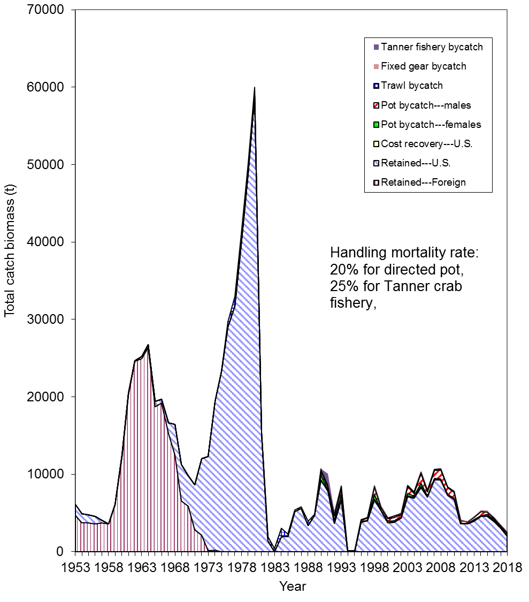
Figure 3. Retained catch biomass and bycatch mortality biomass (t) for Bristol Bay red king crab from 1953 to 2018. Handling mortality rates were assumed to be 0.2 for the directed pot fishery, 0.25 for the Tanner crab fishery, 0.8 for the trawl fisheries, and 50% for the fixed gear fisheries.
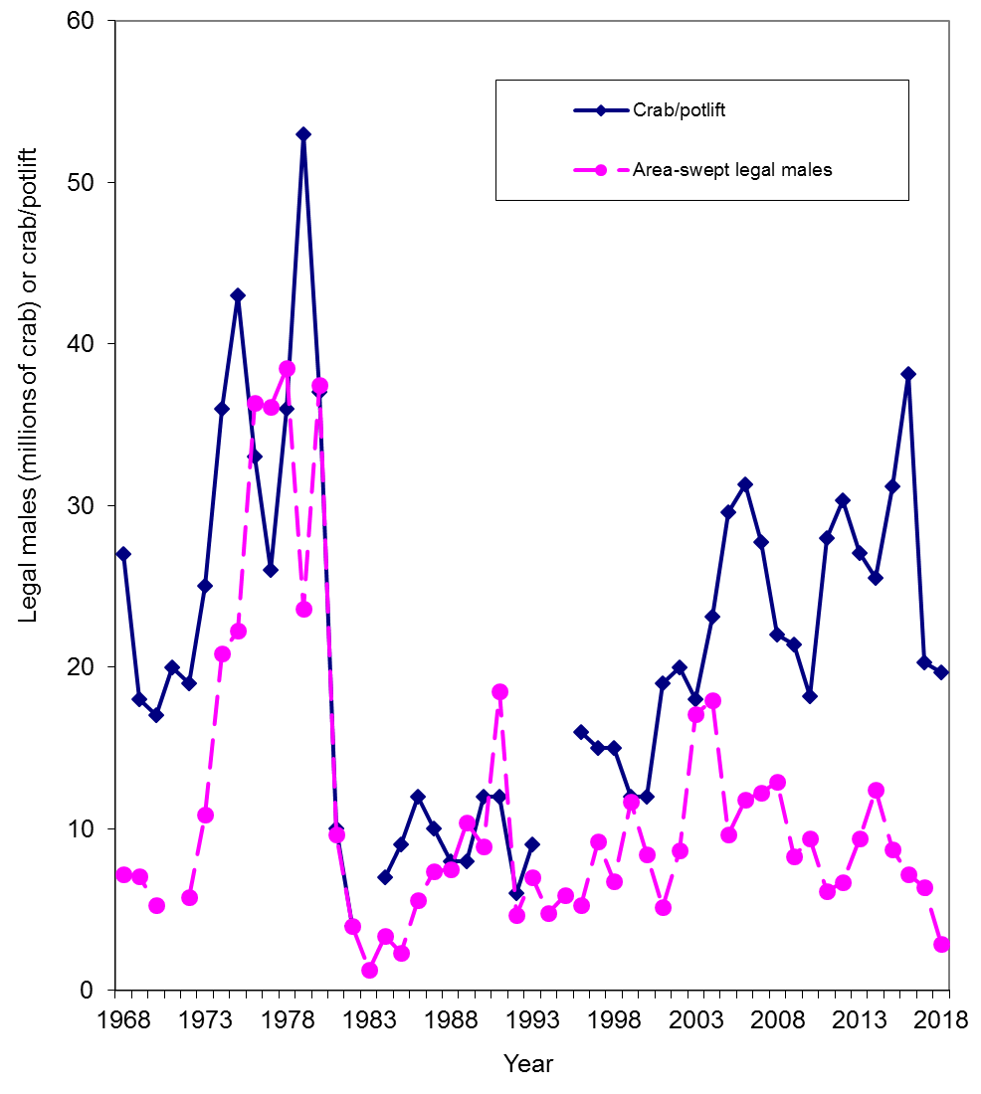
Figure 4. Comparison of survey legal male abundances and catches per unit effort for Bristol Bay red king crab from 1968 to 2018.

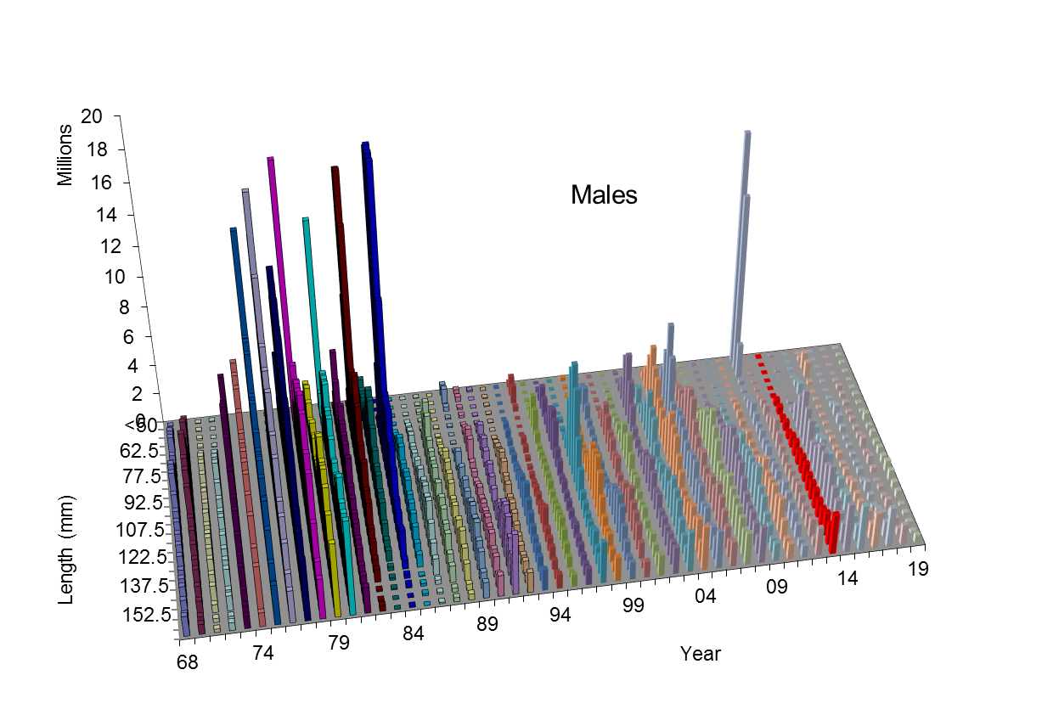
Figure 5a. Survey abundances by 5-mm carapace length bin for male Bristol Bay red king crab from 1968 to 2019.
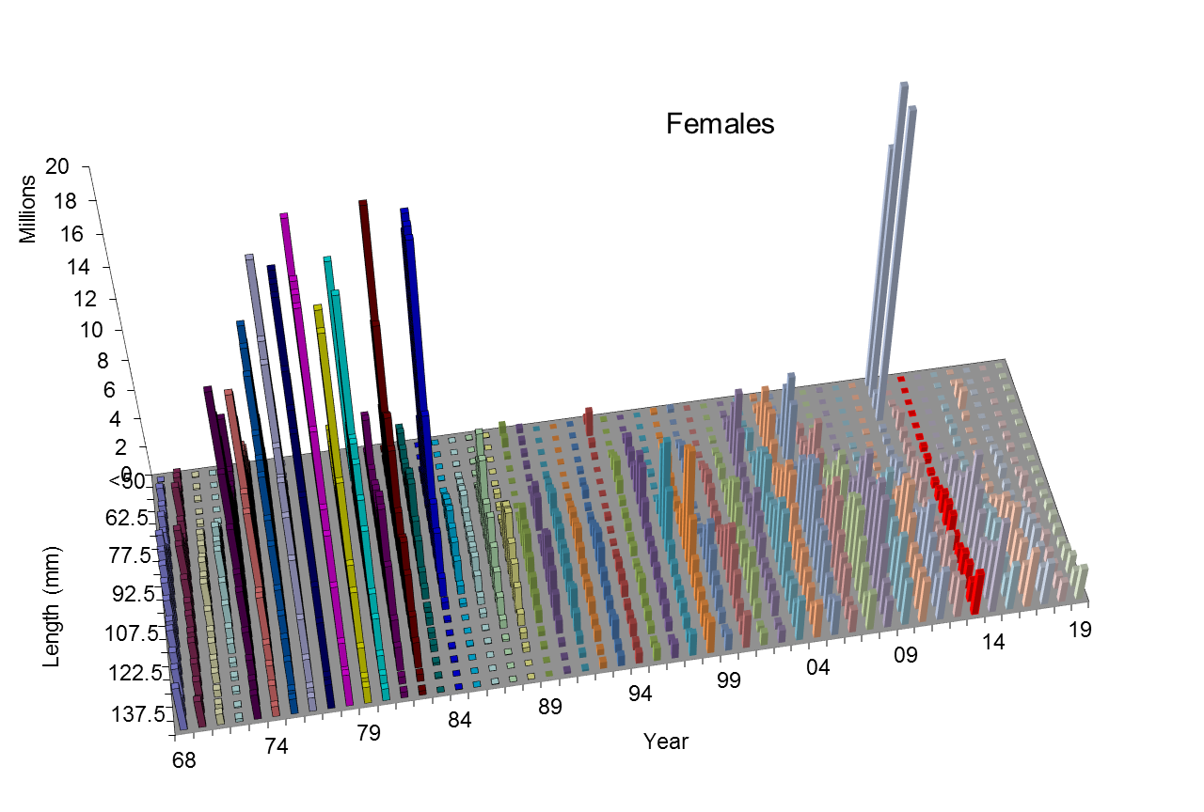
Figure 5b. Survey abundances by 5 mm carapace length bin for female Bristol Bay red king crab from 1968 to 2019.
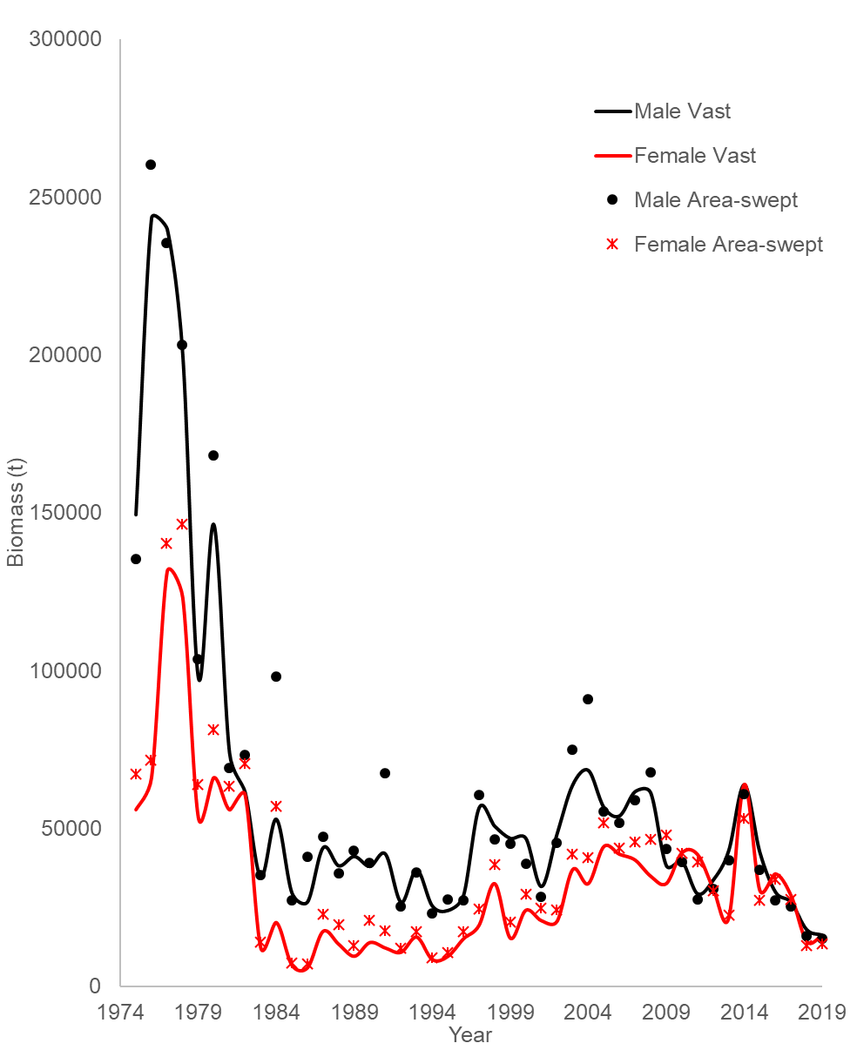

Figure 6. Comparison of area-swept and VAST-estimated survey biomasses for Bristol Bay red king crab from 1975 to 2019.
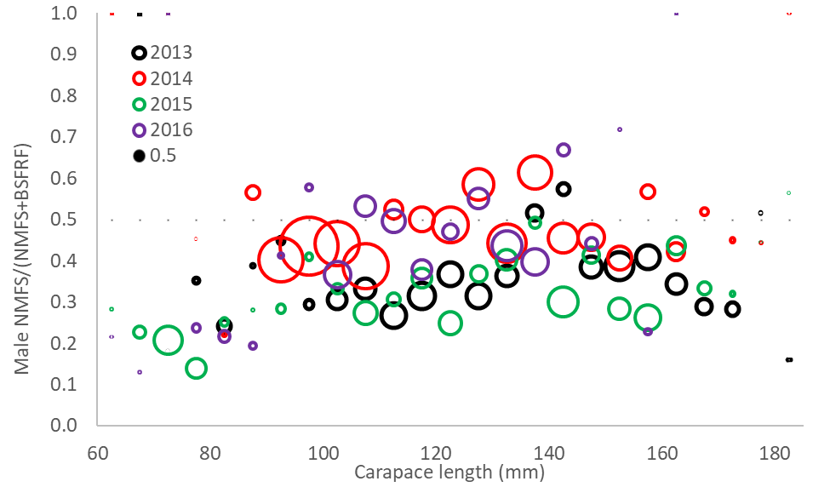
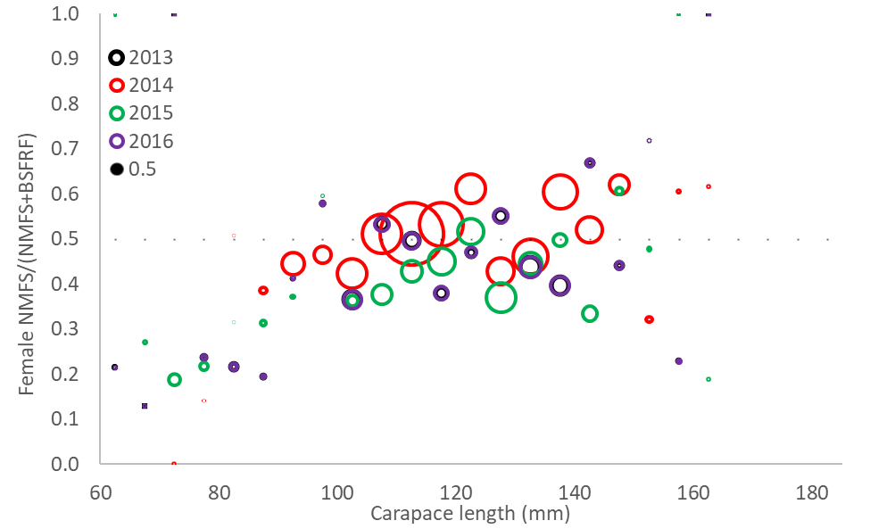
Figure 7. Comparison of NMFS survey abundance proportions of total NMFS and BSFRF side-by-side trawl surveys during 2013-2016 for Bristol Bay red king crab. Sizes of circles are proportional to total abundances.
Figure 8a(19.0a). Estimated NMFS trawl survey selectivities under model 19.0a. Pot, Tanner crab, fixed gear and trawl handling mortality rates were assumed to be 0.2, 0.25, 0.5 and 0.8, respectively.

Figure 8a(19.4). Estimated NMFS trawl survey selectivities under model 19.0a. Pot, Tanner crab, fixed gear and trawl handling mortality rates were assumed to be 0.2, 0.25, 0.5 and 0.8, respectively.

Figure 8a(19.4a). Estimated NMFS trawl survey selectivities under model 19.0a. Pot, Tanner crab, fixed gear and trawl handling mortality rates were assumed to be 0.2, 0.25, 0.5 and 0.8, respectively.

Figure 8c(19.0a). Estimated total pot fishery selectivities and retained proportions and groundfish fisheries bycatch selectivities under model 19.0a. Pot, Tanner crab, fixed gear and trawl handling mortality rates were assumed to be 0.2, 0.25, 0.5 and 0.8, respectively.

Figure 8c(19.4). Estimated total pot fishery selectivities and retained proportions and groundfish fisheries bycatch selectivities under model 19.4. Pot, Tanner crab, fixed gear and trawl handling mortality rates were assumed to be 0.2, 0.25, 0.5 and 0.8, respectively.

Figure 8c(19.4a). Estimated total pot fishery selectivities and retained proportions and groundfish fisheries bycatch selectivities under model 19.4a. Pot, Tanner crab, fixed gear and trawl handling mortality rates were assumed to be 0.2, 0.25, 0.5 and 0.8, respectively.

Figure 9(19.0a). Comparison of estimated probabilities of molting of male red king crab in Bristol Bay for different periods with model 19.0a. Molting probabilities for periods 1954-1961 and 1966-1969 were estimated by Balsiger (1974) from tagging data. Molting probabilities for 1975-2019 were estimated with a length-based model.
Figure 9(19.4). Comparison of estimated probabilities of molting of male red king crab in Bristol Bay for different periods with model 19.4. Molting probabilities for periods 1954-1961 and 1966-1969 were estimated by Balsiger (1974) from tagging data. Molting probabilities for 1975-2019 were estimated with a length-based model.
Figure 10a. Comparisons of area-swept estimates of total NMFS survey biomass and model prediction for model estimates in 2019 under models 19.0a, 19.1, 19.2, 19.3, 19.4, 19.4a, 19.4b, and 19.5. Pot, Tanner crab, fixed gear and trawl handling mortality rates were assumed to be 0.2, 0.25, 0.5 and 0.8, respectively. The error bars are plus and minus 2 standard deviations of model 19.4.
Figure 10b. Comparisons of survey biomass estimates by sex (upper plot for males and lower plot for females) by the BSFRF survey and the model for model estimates in 2019 (models 19.0a, 19.1, 19.2, 19.3, 19.4, 19.4a, 19.4b, and 19.5). The error bars are plus and minus 2 standard deviations of model 19.4.
Figure 10c. Comparisons of estimated BSFRF survey selectivities with models 19.0a, 19.4, and 19.4a. The catchability is assumed to be 1.0.

Figure 10d(19.0a, 19.1, 19.4 & 19.4a). Comparisons of length compositions by the BSFRF survey and the model estimates during 2007-2008 and 2013-2016 with four models.

Figure 11. Estimated absolute mature male biomasses during 1975-2019 for models 19.0a, 19.1, 19.2, 19.3, 19.4, 19.4a, 19.4b, and 19.5.

Figure 12(19.0a & 19.4). Estimated recruitment time series during 1976-2019 with models 19.0a and 19.4. Mean male recruits during 1984-2018 was used to estimate B_{35%}.

Figure 13a(19.0a). Relationships between full fishing mortalities for the directed pot fishery and mature male biomass on Feb. 15 during 1975-2019 under model 19.0a. Average of recruitment from 1984 to 2018 was used to estimate B_{MSY}. Pot, Tanner crab, fixed gear, and trawl handling mortality rates were assumed to be 0.2, 0.25, 0.5, and 0.8, respectively.

Figure 13a(19.4). Relationships between full fishing mortalities for the directed pot fishery and mature male biomass on Feb. 15 during 1975-2019 under model 19.4. Average of recruitment from 1984 to 2018 was used to estimate B_{MSY}. Pot, Tanner crab, fixed gear, and trawl handling mortality rates were assumed to be 0.2, 0.25, 0.5, and 0.8, respectively.

Figure 13a(19.4a). Relationships between full fishing mortalities for the directed pot fishery and mature male biomass on Feb. 15 during 1975-2019 under model 19.4a. Average of recruitment from 1984 to 2017 was used to estimate B_{MSY}. Pot, Tanner crab, fixed gear, and trawl handling mortality rates were assumed to be 0.2, 0.25, 0.5, and 0.8, respectively.
Figure 13b. Comparison of estimated natural mortality and directed pot fishing mortality for models models 19.0a and 19.4. Pot, Tanner crab, fixed gear, and trawl handling mortality rates were assumed to be 0.2, 0.25, 0.5, and 0.8, respectively.

Figure 14a. Relationships between mature male biomass on Feb. 15 and total recruits at age 5 (i.e., 6-year time lag) for Bristol Bay red king crab with pot handling mortality rate of 0.2 under model 19.4. Numerical labels are years of mating, and the vertical dotted line is the estimated B_{35%} based on the mean recruitment level during 1984 to 2018.
Figure 14b. Relationships between log recruitment per mature male biomass and mature male biomass on Feb. 15 for Bristol Bay red king crab with pot handling mortality rate of 0.2 under model 19.4. Numerical labels are years of mating, and the line is the regression line for data of 1978-2013.
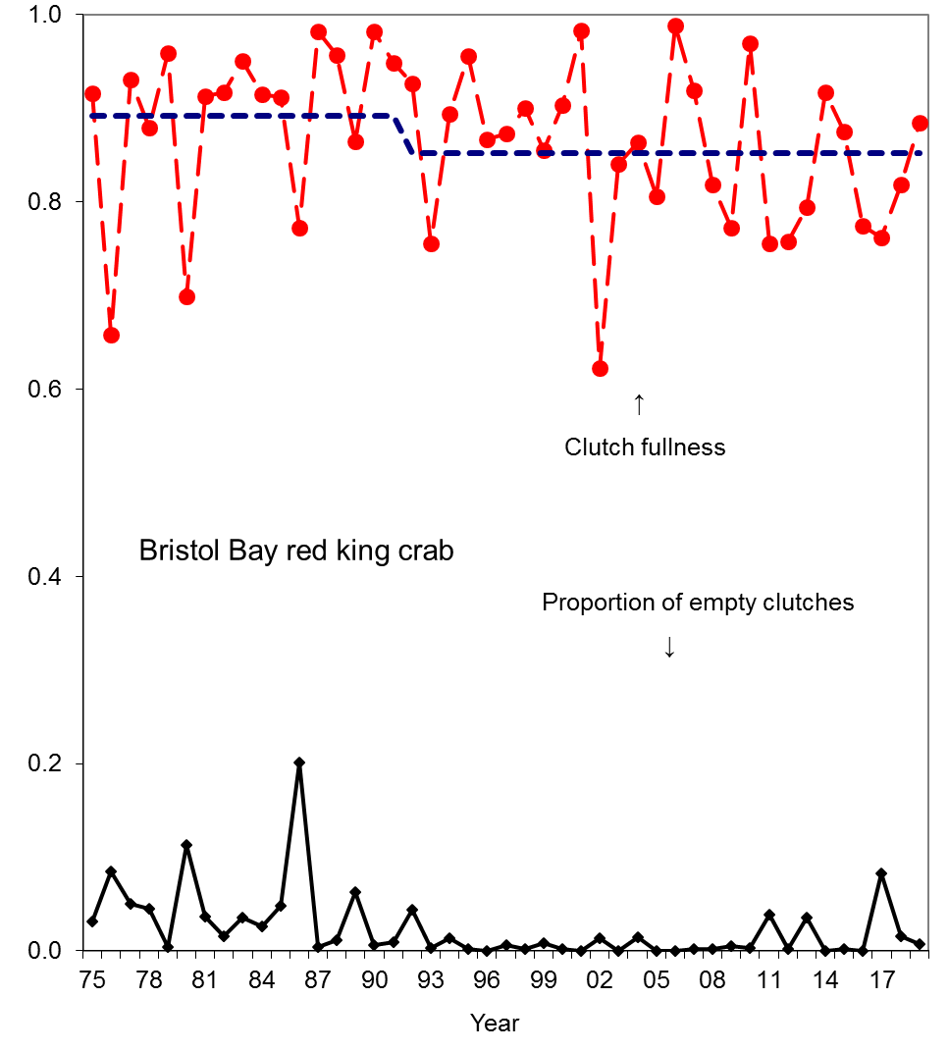

Figure 15. Average clutch fullness and proportion of empty clutches of newshell (shell conditions 1 and 2) mature female crab >89 mm CL from 1975 to 2019 from survey data. Oldshell females were excluded. The blue dashed line is the mean clutch fullness during two periods before 1992 and after 1991.

Figure 16a. Observed and predicted RKC catch mortality biomass under models 19.0a, 19.4, and 19.4a. Mortality biomass is equal to caught biomass times a handling mortality rate.
Figure 16b. Observed and predicted RKC bycatch mortality biomass from groundfish fisheries and the Tanner crab fishery under models 19.0a, 19.4, and 19.4a. Mortality biomass is equal to caught biomass times a handling mortality rate. Pot, Tanner crab, fixed gear, and trawl handling mortality rates were assumed to be 0.2, 0.25, 0.5, and 0.8, respectively. Trawl bycatch biomass was 0 before 1976.
Figure 17(19.0a). Standardized residuals of NMFS survey biomass under model 19.0a. Pot, Tanner crab, fixed gear, and trawl handling mortality rates were assumed to be 0.2, 0.25, 0.5, and 0.8, respectively.
Figure 17(19.4). Standardized residuals of NMFS survey biomass under model 19.4. Pot, Tanner crab, fixed gear, and trawl handling mortality rates were assumed to be 0.2, 0.25, 0.5, and 0.8, respectively.
Figure 17(19.4a). Standardized residuals of NMFS survey biomass under model 19.4a. Pot, Tanner crab, fixed gear, and trawl handling mortality rates were assumed to be 0.2, 0.25, 0.5, and 0.8, respectively.
Figure 18(19.0a, 19.1, 19.4 & 19.4a). Comparison of area-swept and model estimated NMFS survey length frequencies of Bristol Bay male red king crab by year under four model.
Figure 19(19.0a, 19.1, 19.4 & 19.4a). Comparison of area-swept and model estimated NMFS survey length frequencies of Bristol Bay female red king crab by year under four models.
Figure 20(19.0a, 19.1, 19.4 & 19.4a). Comparison of observed and model estimated retained length frequencies of Bristol Bay male red king crab by year in the directed pot fishery under four models.
Figure 21(19.0a, 19.1, 19.4 & 19.4a). Comparison of observer and model estimated total observer length frequencies of Bristol Bay male red king crab by year in the directed pot fishery under four models.
Figure 22(19.0a, 19.1, 19.4 & 19.4a). Comparison of observer and model estimated discarded length frequencies of Bristol Bay female red king crab by year in the directed pot fishery under four models.
Figure 23(19.0a, 19.1, 19.4 & 19.4a). Comparison of observer and model estimated discarded length frequencies of Bristol Bay male red king crab by year in the groundfish trawl fisheries under four models.
Figure 23(19.0a, 19.1, 19.4 & 19.4a). Comparison of observer and model estimated discarded length frequencies of Bristol Bay female red king crab by year in the groundfish trawl fisheries under four models.
Figure 24(19.0a, 19.1, 19.4 & 19.4a). Comparison of observer and model estimated discarded length frequencies of Bristol Bay male red king crab by year in the groundfish fixed gear fisheries under four models.
Figure 24(19.0a, 19.1, 19.4 & 19.4a). Comparison of observer and model estimated discarded length frequencies of Bristol Bay female red king crab by year in the groundfish fixed gear fisheries under four models.
Figure 24(19.0a, 19.1, 19.4 & 19.4a). Comparison of observer and model estimated discarded length frequencies of Bristol Bay red king crab by year in the Tanner crab fishery under four models.
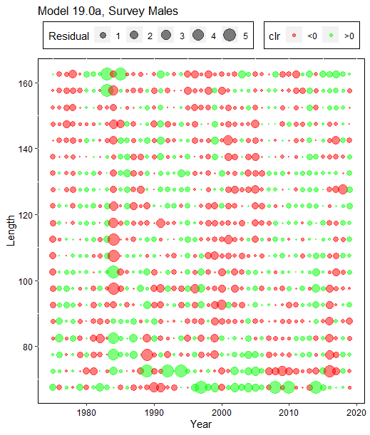
Figure 25(19.0a). Residuals of proportions of NMFS survey male red king crab by year and carapace length (mm) under model 19.0a. Green circles are positive residuals, and red circles are negative residuals. Pot, Tanner crab, fixed gear, and trawl handling mortality rates were assumed to be 0.2, 0.25, 0.5, and 0.8, respectively.
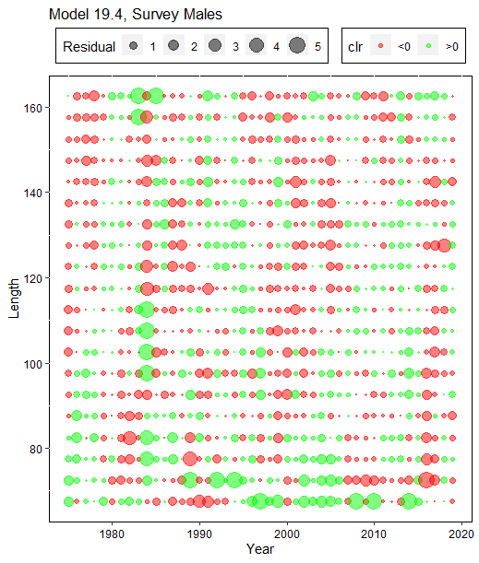
Figure 25(19.4). Residuals of proportions of NMFS survey male red king crab by year and carapace length (mm) under model 19.4. Green circles are positive residuals, and red circles are negative residuals. Pot, Tanner crab, fixed gear, and trawl handling mortality rates were assumed to be 0.2, 0.25, 0.5, and 0.8, respectively.
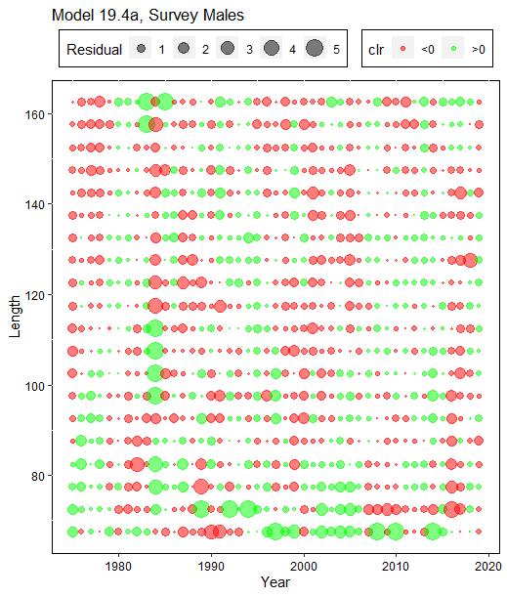
Figure 25(19.4a). Residuals of proportions of NMFS survey male red king crab by year and carapace length (mm) under model 19.4a. Green circles are positive residuals, and red circles are negative residuals. Pot, Tanner crab, fixed gear, and trawl handling mortality rates were assumed to be 0.2, 0.25, 0.5, and 0.8, respectively.
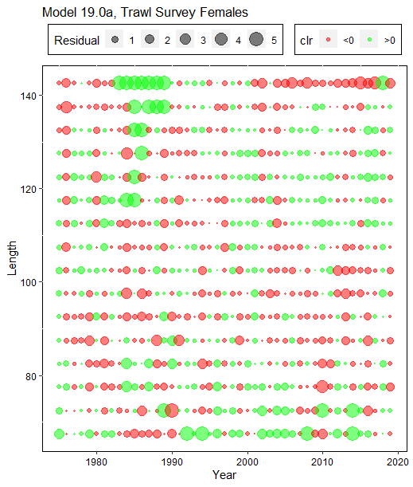
Figure 26(19.0a). Residuals of proportions of NMFS survey female red king crab by year and carapace length (mm) under model 19.0a. Green circles are positive residuals, and red circles are negative residuals. Pot, Tanner crab, fixed gear, and trawl handling mortality rates were assumed to be 0.2, 0.25, 0.5, and 0.8, respectively.
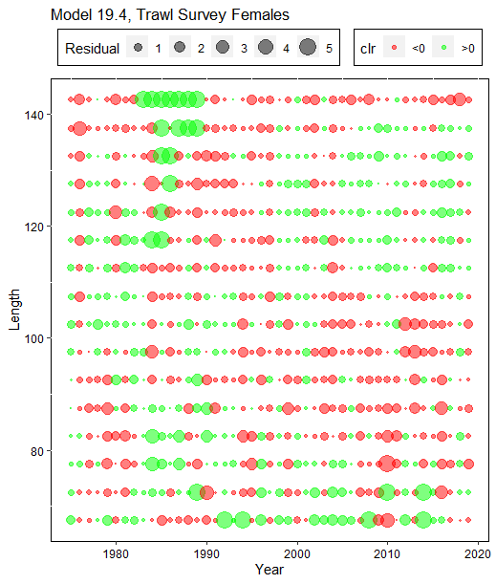
Figure 26(19.4). Residuals of proportions of NMFS survey female red king crab by year and carapace length (mm) under model 19.4. Green circles are positive residuals, and red circles are negative residuals. Pot, Tanner crab, fixed gear, and trawl handling mortality rates were assumed to be 0.2, 0.25, 0.5, and 0.8, respectively.
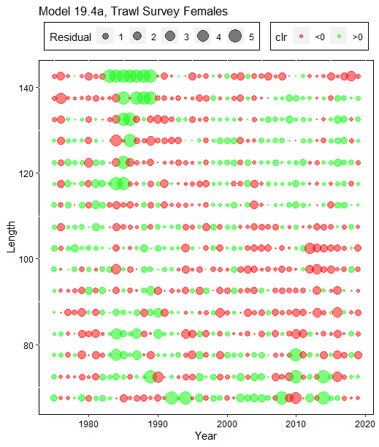
Figure 26(19.4a). Residuals of proportions of NMFS survey female red king crab by year and carapace length (mm) under model 19.4a. Green circles are positive residuals, and red circles are negative residuals. Pot, Tanner crab, fixed gear, and trawl handling mortality rates were assumed to be 0.2, 0.25, 0.5, and 0.8, respectively.
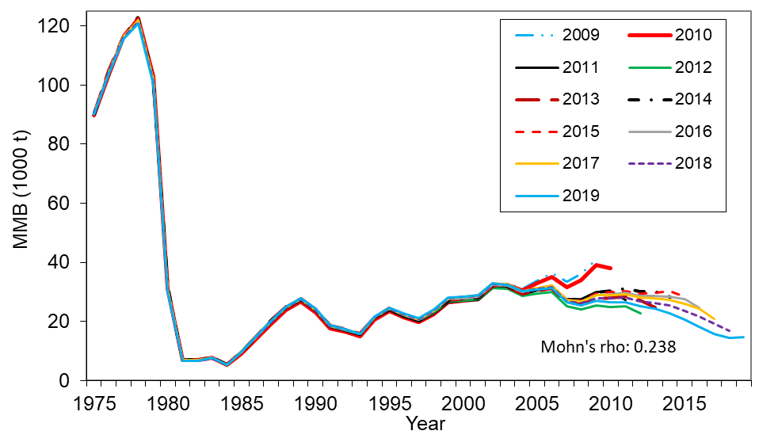
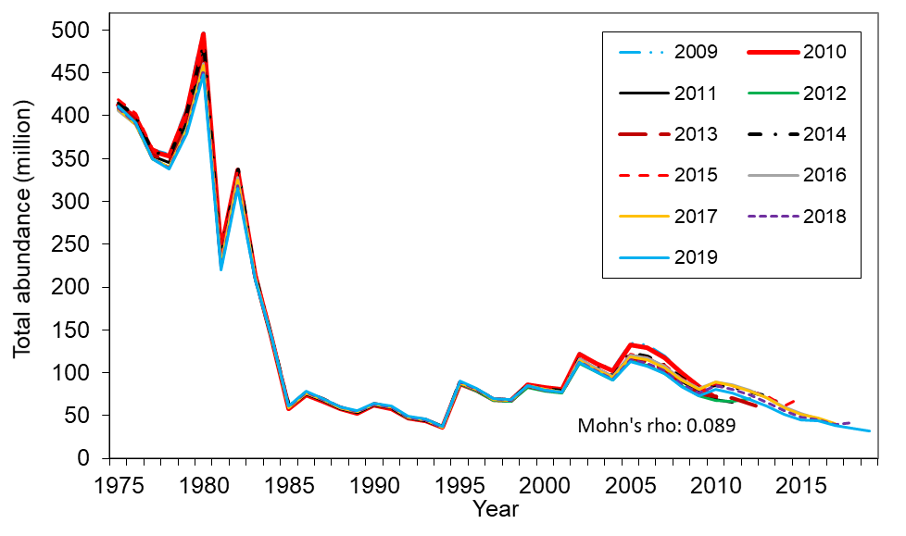
Figure 27. Comparison of hindcast estimates of mature male biomass on Feb. 15 (top) and total abundance (bottom) of Bristol Bay red king crab from 1975 to 2019 made with terminal years 2009-2019 with model 19.4. These are results of the 2019 model. Legend shows the terminal year. Pot, Tanner crab, fixed gear, and trawl handling mortality rates were assumed to be 0.2, 0.25, 0.5, and 0.8, respectively.
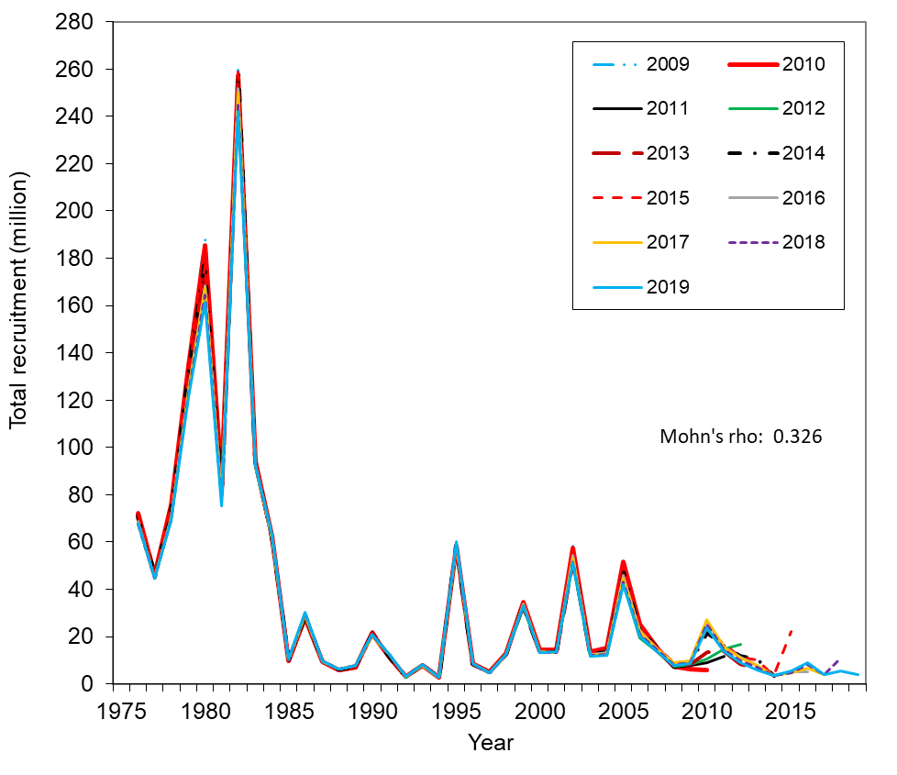

Figure 28a. Comparison of hindcast estimates of total recruitment for model 19.4 of Bristol Bay red king crab from 1976 to 2019 made with terminal years 2009-2019. These are results of the 2019 model. Legend shows the terminal year. Pot, Tanner crab, fixed gear, and trawl handling mortality rates were assumed to be 0.2, 0.25, 0.5, and 0.8, respectively.

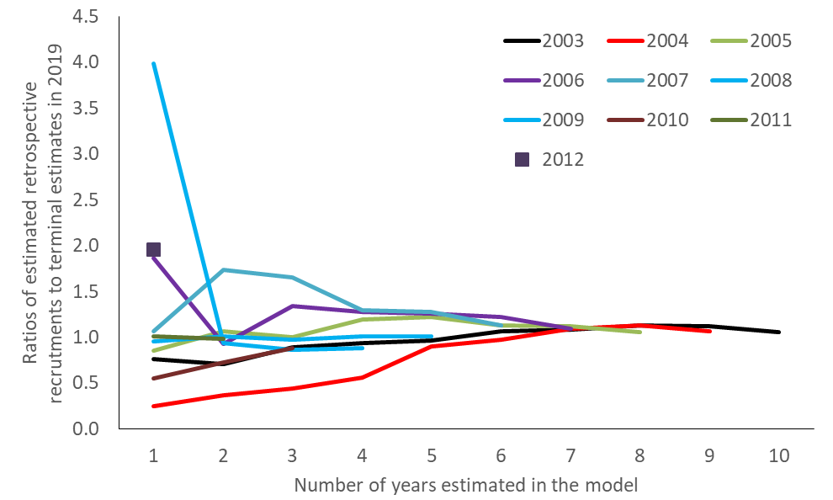
Figure 28b. Evaluation of Bristol Bay red king crab retrospective errors on recruitment estimates as a function of the number of years in the model for model 19.4.

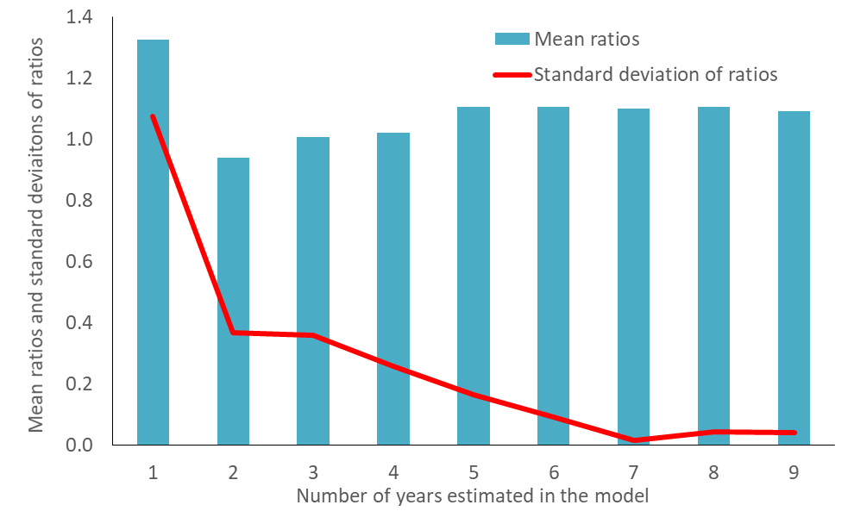
Figure 28c. Mean ratios of retrospective estimates of recruitments to those estimated in the most recent year (2019) and standard deviations of the ratios as a function of the number of years in the model for model 19.4.
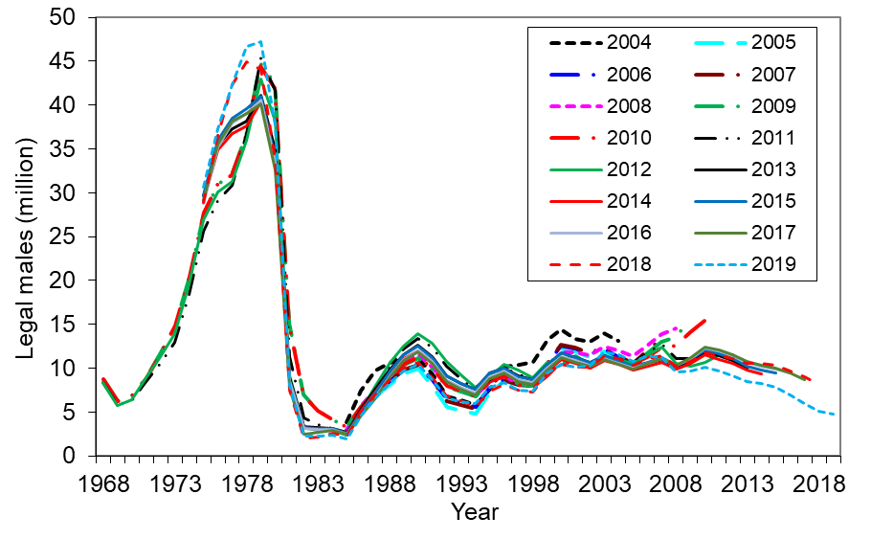
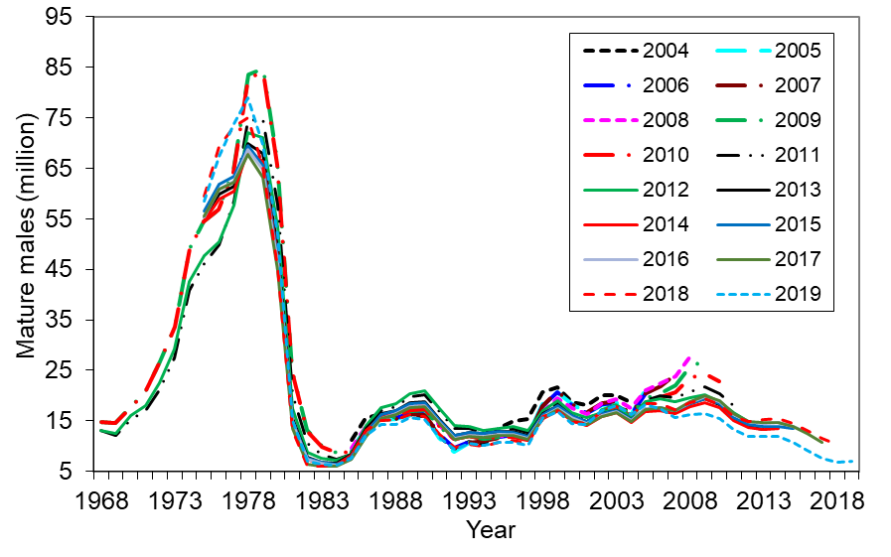
Figure 29. Comparison of estimates of legal male abundance (top) and mature males (bottom) of Bristol Bay red king crab from 1968 to 2019 made with terminal years 2004-2019 with the base models. Model 19.4 is used for 2019. These are results of historical assessments. Legend shows the year in which the assessment was conducted. Pot, Tanner crab, fixed gear, and trawl handling mortality rates were assumed to be 0.2, 0.25, 0.5, and 0.8, respectively.
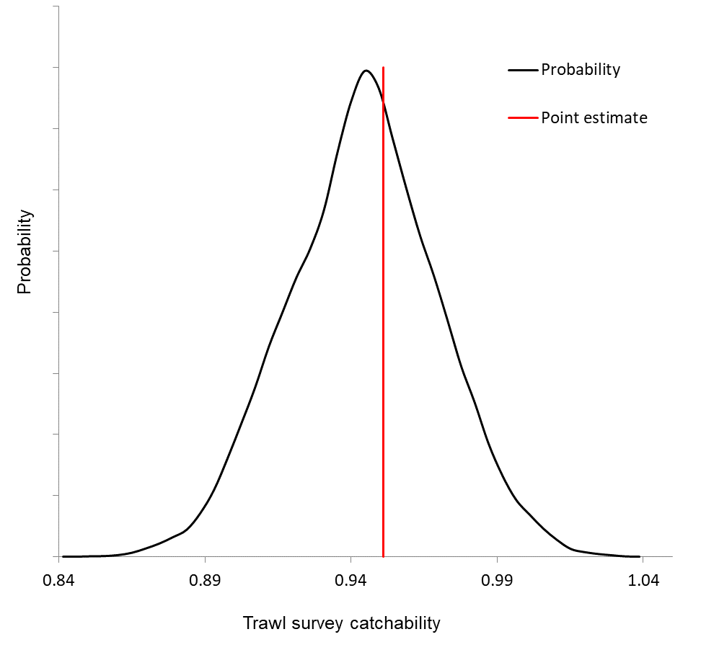

Figure 30. Probability distributions of estimated trawl survey catchability (Q) under model 19.4 with the mcmc approach. Pot, Tanner crab, fixed gear, and trawl handling mortality rates were assumed to be 0.2, 0.25, 0.5, and 0.8, respectively.

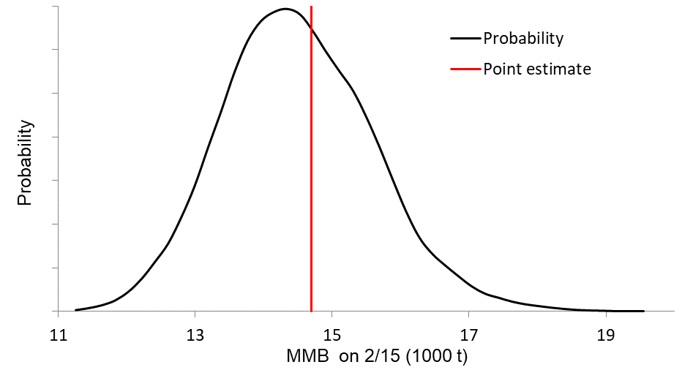
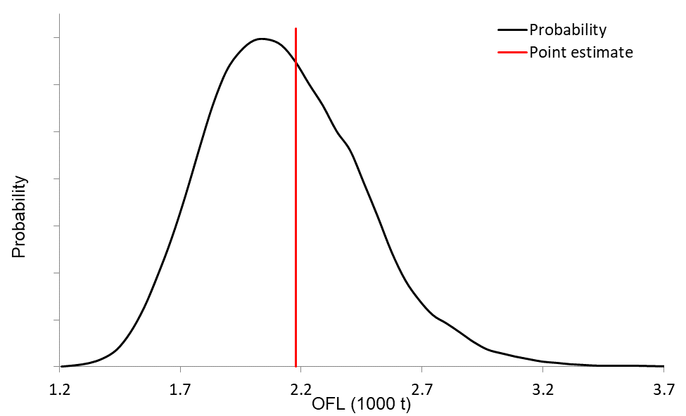

Figure 31. Probability distributions of estimated mature male biomass on Feb. 15, 2019 (upper panel) and probability distributions of the 2019 estimated OFL (lower panel) under model 19.4 with the mcmc approach. Pot, Tanner crab, fixed gear, and trawl handling mortality rates were assumed to be 0.2, 0.25, 0.5, and 0.8, respectively.
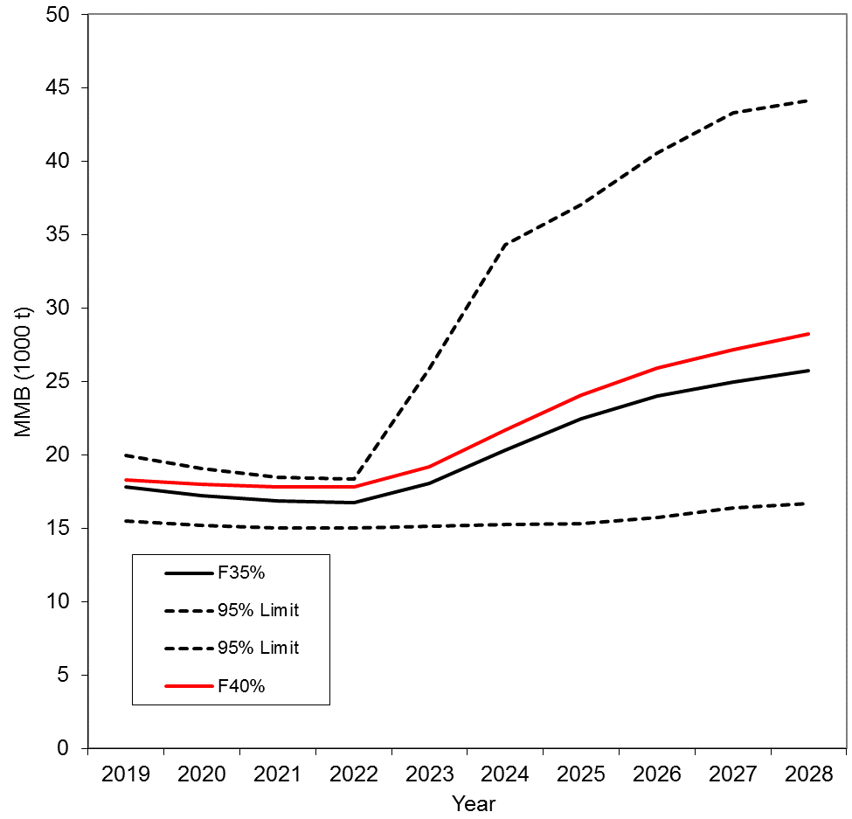

Figure 32. Projected mature male biomass on Feb. 15 with F_{40%} and F_{35%} harvest strategy during 2019-2029. Input parameter estimates are based on model 18.0e. Pot, Tanner crab, fixed gear, and trawl handling mortality rates were assumed to be 0.2, 0.25, 0.5, and 0.8, respectively, and the confidence limits are for the F_{35%} harvest strategy. (Not updated)

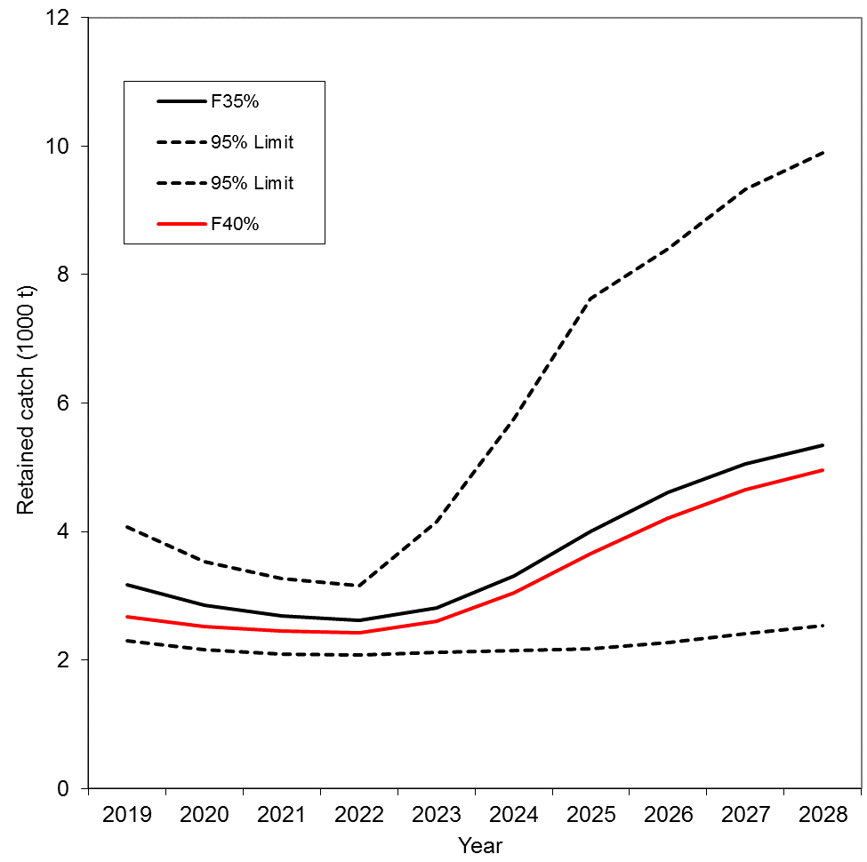

Figure 33. Projected retained catch biomass with F_{40%} and F_{35%} harvest strategy during 2019-2128. Input parameter estimates are based on model 18.0e. Pot, Tanner crab, fixed gear, and trawl handling mortality rates were assumed to be 0.2, 0.25, 0.5, and 0.8, respectively, and the confidence limits are for the F_{35%} harvest strategy. (Not updated)

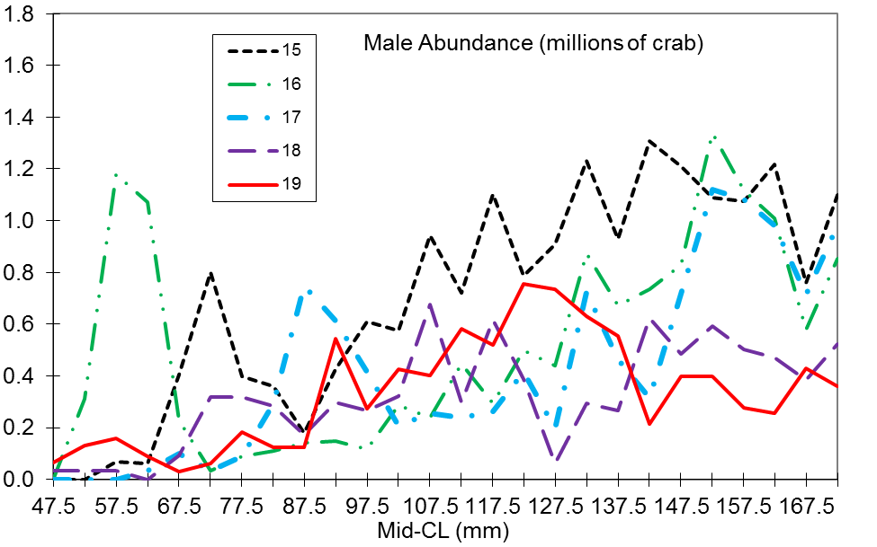
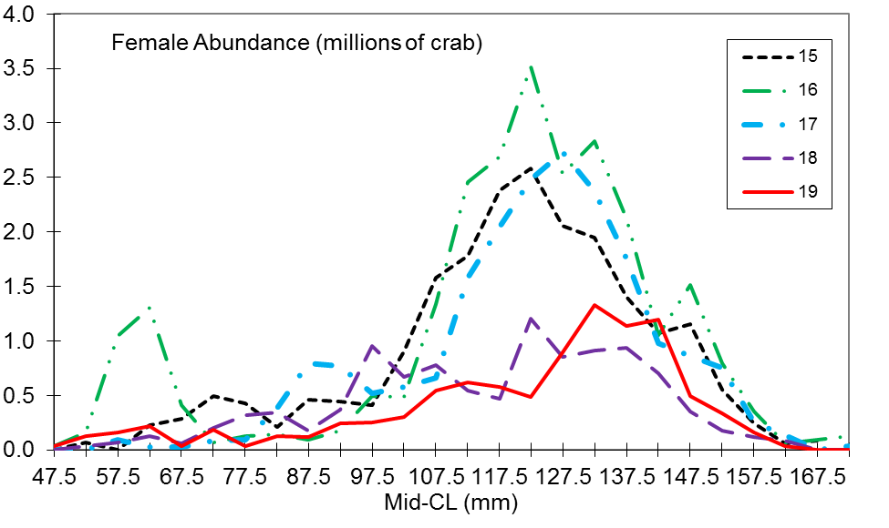
Figure 34. Length frequency distributions of male (top panel) and female (bottom panel) red king crab in Bristol Bay from NMFS trawl surveys during 2015-2019. For purposes of these graphs, abundance estimates are based on area-swept methods.

Appendix A. Description of GMACS with Bristol Bay Red King Crab Options (mainly from the GMACS document)

A. Model Description
a. Population model
The basic dynamics account for growth, mortality, maturity state and shell condition (although most of the equations below do not explicitly refer to maturity state and shell condition). For the case in which shell condition is not distinguished:
(A.1)
where is the number of animals by size-class of gender g at the start of season t of year y, is a matrix with diagonals given by vector of molting probabilities for animals of gender g at the start of season t of year y, is a matrix with diagonals given by the vector of probabilities of surviving for animals of gender g during time-step t of year y (which may be of zero duration):
(A.2)
is the size-transition matrix (probability of growing from one size-class to each of the other size-classes or remains in the same size class) for animals of gender g during season t of year y, is the recruitment (by size-class) to gear g during season t of year y (which will be zero except for one season – the recruitment season), and is the total mortality for animals of gender g in size-class l during season t of year y. Note that mortality is continuous across a time-step.
The initial conditions for the model (i.e., the numbers-at-size at the start of the first year, y₁) is specified with an overall total recruitment multiplied by offsets for each size-class, i.e.:
(A.3)
The minimum carapace length for both males and females is set at 65 mm, and crab abundance is modeled with a length-class interval of 5 mm. The last length class includes all crab ≥160-mm CL for males and ≥140-mm CL for females. Thus, length classes/groups are 20 for males and 16 for females.
b. Recruitment
Recruitment occurs once during each year. Recruitment by sex and size-class is the product of total recruitment, the split of the total recruitment to sex and the assignment of sex-specific recruitment to size-classes, i.e.:
(A.4)
where is median recruitment, determines the sex ratio of recruitment during year y, and is the proportion of the recruitment (by gender and year) that recruits to size-class l:
(A.5)
where and are the parameters that define a gamma function for the distribution of recruits to size-class. Equation A.5 can be restricted to a subset of size-classes, in which case the results from Equation A.5 are normalized to sum to 1 over the selected size-classes.
c. Total mortality / probability of encountering the gear
Total mortality is the sum of fishing mortality and natural mortality, i.e.:
(A.6)
where is the proportion of natural mortality that occurs during season t for year y, is the rate of natural mortality for year y for animals of gender g (applies to animals for which ), is the relative natural mortality for size-class l , is the (capture) selectivity for animals of gender g in size-class l by fleet f during season t of year y, is the probability of retention for animals of gender g in size-class l by fleet f during season t of year y, is the mortality rate for discards of gender g in size-class l by fleet f during season t of year y, and is the fully-selected fishing mortality for animals of gender g by fleet f during season t of year y.
The probability of encountering the gear (occurs instantaneously) is given by:
(A.7)
Note that Equation A.7 is computed under the premise that fishing is instantaneous and hence that there is no natural mortality during season t of year y.
The logarithms of the fully-selected fishing mortalities by season are modelled as:
(A.8)
(A.9)
where is the reference fully-selected fishing mortality rate for fleet f, is the offset between female and male fully-selected fishing mortality for fleet f, and are the annual deviation of fully-selected fishing mortality for fleet f (by gender).
Natural mortality can depend on time with blocked natural mortality (individual parameters). This option estimates natural mortality as parameters by block, i.e.:
(A.10)
where is the rate of natural mortality for gender g for the first year of the model, and is the annual change in natural mortality and changes in blocks of years.
It is possible to ‘mirror’ the values for the parameters (between genders and between blocks), which allows male and female natural mortality to be the same, and for natural mortality to be the same for discontinuous blocks (based on Equation A.10). It is also possible to estimate a ratio of natural mortality between genders. The deviations in natural mortality can also be penalized to avoid unrealistic changes in natural mortality to fit ‘quirks’ in the data.
d. Landings, discards, total catch
The model keeps track of (and can be fitted to) landings, discards, total catch by fleet in season with continuous mortality:
Landed catch |  | (A.11)
Discards |  | (A.12)
Total catch |  | (A.13)

Landings, discards, and total catches by fleet can be aggregated over gender (e.g., when fitting to removals reported as gender-combined). Equations A.11-13 are extended naturally for the case in which the population is represented by shell condition and/or maturity status (given the assumption that fishing mortality, retention and discard mortality depend on gender and time, but not on shell condition nor maturity status).
Landings, discards, and total catches by fleet can be reported in numbers (Equations A.11–13) or in terms of weight. For example, the landings, discards, and total catches by fleet, season, year, and gender for the total (over size-class) removals are computed as:
; ; (A.14)
where , , and are respectively the landings, discards, and total catches in weight by fleet, season, year, and gender for the total (over size-class) removals, and is the weight of an animal of gender g in size-class l during year y.
e. Selectivity / retention
Selectivity (the probability of encountering the gear) and retention (the probability of being landed given being captured) are logistic function:
$S_{l}=1-(1+\exp{(}({\bar{L}}_{l}-S_{50})/σ^{S}))^{-1}$ (A.15)
where is the size corresponding to 50% selectivity, is the “standard deviation” of the selectivity curve, and is the midpoint of size-class l.
It is possible to assume that selectivity for one fleet is the product of two of the selectivity patterns. This option is used to model cases in which one survey (NMFS trawl survey) is located within the footprint of another survey (BSFRF trawl survey).
The options to model retention are the same as those for selectivity, except that it is possible to estimate an asymptotic parameter, which allows discard of animals that would be “fully retained” according to the standard options for (capture) selectivity.
Selectivity and retention can be defined for blocks of contiguous years. Two blocks are used for NMFS survey selectivity (before 1982 and after 1981) due to gear modifications and two blocks are used for the directed pot fishery retention (before 2005 and after 2004) due to the fishery rationalization.
f. Growth
Growth is a key component of any size-structured model. It is modelled in terms of molt probability and the size-transition matrix (the probability of growing from each size-class to each of the other size-classes, constrained to be zero for sizes less than the current size). Note that the size-transition matrix has entries on its diagonal, which represent animals that molt but do not change size-classes.
(1) Molt probability
There are two options for modelling the probability of molting as a function of size, :
- Constant probability (1 for females)
- Logistic probability (for males), i.e.:
(A.16)
where is the size at which the probability of molting is 0.5, and is the “standard deviation” of the molt probability function.
Molt probability is specified by gender and can change in blocks (one block before 1981 and one block after 1980 for males).
(2) Size-transition
The proportion of animals in size-class j that grow to be in size-class i () can be pre-specified as gamma-distributed size-increments:
(A.17)
where is the ‘expected’ growth increment for an animal in size-class i (a linear function of the mid-point of size-class i), determines the variation in growth among individuals, and and are respectively the lower and upper bounds of size-class j.
The size-transition matrix is specified by gender and can change in blocks (one block for males and three blocks for females (1975-1982, 1983-1993, and 1994-present based on changes in sizes at maturity).
B. Outputs, Projections and OFL Calculation
a. Core model outputs
The core model outputs are the N-matrix, the matrix of fully-selected fishing mortalities, the time-series of spawning stock biomass, mature male biomass (SSB), the values for the model parameters, and the predictions related to the observations. The spawning stock biomass (and hence mature male biomass) is defined according to:
(A.18)
where is the relative contribution of gender g to spawning biomass (; corresponds to spawning stock biomass equating to mature male biomass), and t* is the season in which spawning takes place (spawning occurs at the start of the season).
Definition of model outputs:
- Biomass: two population biomass measurements are used in this report: total survey biomass (crab >64 mm CL) and mature male biomass (males >119 mm CL). Mating time is assumed to Feb. 15.
- Recruitment: new entry of number of males in the 1st seven length classes (65- 99 mm CL) and new entry of number of females in the 1st five length classes (65-89 mm CL).
- Fishing mortality: full-selected instantaneous annual fishing mortality rate at the time of fishery.
b. Biological reference points
The key biological reference points are the proxy for F_{MSY}, the proxy for B_{MSY} and the Overfishing Level (OFL).
(1) The proxy for F_{MSY}
The specification for the proxy for F_{MSY} depends on the tier in which the stock is placed. BBRKC belongs to Tier 3, and the proxy for F_{MSY} is F_{35%}, the value of a multiplier on the fully-selected fishing mortality rates for directed fisheries in the final year of the assessment such that spawning biomass-per-recruit is 35% of the unfished level. The fully-selected fishing mortality rates for non-directed fisheries are set to recent averages (recent 5 years for BBRKC). The unfished spawning biomass-per-recruit, , is calculated by projecting the population model forward where fishing mortality is zero for all fleets, and recruitment is constant (and ideally equal to 1). F_{35%} is then computed (using Newtons’ method) such that:
(A.19)
where is the vector of recent average fully-selected fishing mortalities, and is a vector with 1 for the non-directed fisheries and a calculated constant for the directed fisheries.
(2) The proxy for B_{MSY}
The specification for the proxy for B_{MSY} depends on the tier in which the stock is placed. For stocks in Tier 4, the proxy for B_{MSY} is the average spawning stock biomass over a pre-specified number of years. For Tier 3, the proxy for B_{MSY} is multiplied by the mean recruitment over a pre-specified number of years.
(3) Calculating the OFL
The OFL is the total catch (in weight) encountered by the gear that dies either due to being landed or due to being discarded when fully-selected fishing mortality is computed using the OFL control rule. The total catch

(A.20)
where y₂ is the final year of the assessment, is the multiplier on average fully-selected fishing mortality for fleet f (1 for non-directed fisheries and a value computed from the OFL control rule for the directed fisheries), is recent average fully-selected fishing mortality for fleet f and gender g during season t, and is the total mortality on animals of gender g in size-class l during season t of year y₂+1:
(A.21)
The values for entries of the vector for the directed fisheries are determined using the OFL control rule:
- If the projected spawning stock biomass in year y₂+1 when exceeds the proxy for B_{MSY}, then .
- If the projected spawning stock biomass in year y₂+1 when is less than 25% of the proxy for B_{MSY}, then .
- If the projected spawning stock biomass in year y₂+1, when lies between less than 25% and 100% of the proxy for B_{MSY}, then is tuned according to
$α^{*,f}=α^{f}(SSB_{y_{2}}^{*}/B_{MSY}-0.1)/0.9$ until convergence.
c. Projections
The specifications for the projections relate to:
- The duration of the projection.
- Whether the fully-selected fishing mortalities for the non-directed fisheries are set to zero or to recent averages by fleet.
- The way in which future recruitment is generated. The options available are:
  - Select a recruitment from a set of historical recruitments at random.
  - Generate a future recruitment from a Ricker stock-recruitment relationship, i.e.:
; (A.22)
where a* is the time-lag between spawning and entering the first size-class in the model, SSB₀ is unfished spawning stock biomass, h is the steepness of the stock-recruitment relationship, is the variation in recruitment about the stock-recruitment relationship.
  - Generate a future recruitment from a Beverton-Holt stock-recruitment relationship, i.e.:
(A.23)
where R₀ is unfished recruitment (i.e.. ).
- The control rule used to set fully-selected fishing mortality for the directed fisheries. The options are available
  - Pre-specified values for fully-selected fishing mortality for each fishery.
  - Pre-specified values subject to the dead catch not exceeding that corresponding to the OFL.
  - Pre-specified values subject to the dead catch not exceeding that corresponding to the OFL and the landed catch not exceeding that corresponding to the State of Alaska harvest control rule.

The value for the steepness of the stock-recruitment relationship is computed such that the maximum sustainable yield occurs at F_{35%}, i.e.:
(A.24)
where is the equilibrium landed catch when the population model is projected forward deterministically under one of the two stock-recruitment relationships.

C. Parameter Estimation
a. Estimating Bycatch Fishing Mortalities for Years without Observer Data
Observer data are not available for the directed pot fishery before 1990 and the Tanner crab fishery before 1991. There are also extremely low observed bycatches in the Tanner crab fishery in 1994 and during 2006-2009. Bycatch fishing mortalities for male and females during 1975-1989 in the directed pot fishery were estimated as
(A.25)
where r^{s} is the mean ratio of estimated bycatch discard fishing mortalities to the estimated directed pot fishing mortalities during 1990-2004 for sex s. Directed pot fishing practice has changed after 2004 due to fishery rationalization.
We used pot fishing effort (potlifts) east of 163º W in the Tanner crab fishery to estimate red king crab bycatch discard fishing mortalities in that fishery when observer data are not available (1975-1990, 1994, 2006-2009):
(A.26)
where a^{s} is the mean ratio of estimated Tanner crab fishery bycatch fishing mortalities to fishing efforts during 1991-1993 for sex s, and E_{t} is Tanner crab fishery fishing efforts east of 163º W in year t. Due to fishery rationalization after 2004, we used the data only during 1991-1993 to estimate the ratio.
b. Likelihood Components
A maximum likelihood approach was used to estimate parameters. For length compositions (p_{l,t,s,sh}), the likelihood functions are :
$\begin{aligned}Rf= \prod_{l=1}^{L}{\prod_{t=1}^{T}{\coprod_{s=1}^{2}{\prod_{sh=1}^{2}{\frac{\left\{exp\left[-\frac{{\left(p_{l, t, s, sh }- {\hat{p}}_{l, t, s, sh}\right)}^{2}}{2σ_{l,t,s,sh}^{2}}\right]+0.01\right\}}{\sqrt{2πσ_{l,t,s,sh}^{2}}}}}}} \\ σ_{l,t,s,sh}^{2}= \frac{\left[p_{l, t, s, sh} \left(1-p_{l, t, s, sh} \right)+ \frac{0.1}{L}\right]}{n_{t}}\end{aligned}$ (A.27)
where L is the number of length groups, T the number of years, and n_{t} the effective sample size in year t, which was estimated for trawl survey, pot retained catch, total directed pot male catch, directed pot female discard, groundfish trawl discard, groundfish fixed gear discard, and Tanner crab fishery discard length composition data. $p_{l, t, s, sh}$ is the observed proportion of crab in length-class l, year t, sex s and shell condition sh, and ${\hat{p}}_{l, t, s, sh}$is the model-estimate corresponding to $p_{l, t, s, sh}$.
The weighted negative log likelihood functions are:
$\begin{aligned}Length compositions: -\sum{ln⁡({Rf}_{i}}) \\ Catch and bycatch biomasses: \sum{\left[ln{\left(\frac{C_{t}}{{\hat{C}}_{t}}\right)}^{2}/(2\ln\left({cv}_{t}^{2}+1\right))\right]} \\ NMFS survey biomass: \sum{\left[ln{\left(ln\left({{CV}_{t}}^{2} +1\right)\right)}^{0.5}+ \frac{ln{\left(\frac{B_{t}}{{\hat{B}}_{t}}\right)}^{2}}{\left(2ln\left({{CV}_{t}}^{2}+1\right)\right)}\right]} \\ BSFRF survey biomass: \sum{\left[ln{\left(ln\left({{CV}_{t}}^{2} {+AV}^{2}+1\right)\right)}^{0.5}+ \frac{ln{\left(\frac{B_{t}}{{\hat{B}}_{t}}\right)}^{2}}{\left(2ln\left({{CV}_{t}}^{2}+{AV}^{2}+1\right)\right)} \right]} \\ R variation: λ_{R }\sum{\left[ln{\left(\frac{R_{t}}{\overline{R}}\right)}^{2}\right]} \\ R sex ratio: λ_{s }\sum{\left[ln{\left(\frac{{\overline{R}}_{M}}{{\overline{R}}_{F}}\right)}^{2}\right]} \\ Groundfish bycatch fishing mortalities: λ_{t }\sum{\left[ln{\left(\frac{F_{t, gf}}{\overline{{\overline{F}}_{gf}}}\right)}^{2}\right]} \\ Pot female bycatch fishing mortalities: { λ}_{p }\sum{\left[ln{\left(\frac{F_{t, f}}{\overline{{\overline{F}}_{f}}}\right)}^{2}\right]} \\ Trawl survey catchability: \frac{{\left(Q- \hat{Q}\right)}^{2}}{2σ^{2}}\end{aligned}$ (A.28)
where R_{t} is the recruitment in year t, the mean recruitment, ${\overline{R}}_{M}$ the mean male recruitment, ${\overline{R}}_{F}$ the mean female recruitment, AV is additional CV and estimated in the model, ${\overline{F}}_{gf}$ the mean groundfish bycatch fishing mortality (this is separated into trawl and fixed gear fishery bycatch), ${\overline{F}}_{f}$ the mean pot female bycatch fishing mortality, Q summer trawl survey catchability, and σ the estimated standard deviation of Q (all models).
Weights λ_{j} are assumed to be 2 for recruitment variation, 10 for recruitment sex ratio, 0.2 for pot female bycatch fishing mortality, and 0.1 for trawl bycatch fishing mortality. These λ_{j} values correspond to CV values of 0.53, 0.23, 3.34, and 12.14, respectively.

c. Population State in Year 1.
The total abundance and proportions for the first year are estimated in the model.

d. Parameter estimation framework:
- Parameters estimated independently
Basic natural mortality, length-weight relationships, and mean growth increments per molt were estimated independently outside of the model. Mean length of recruits to the model depends on growth and was assumed to be 72.5 for both males and females. Handling mortality rates were set to 0.2 for the directed pot fishery, 0.25 for the Tanner crab fishery, 0.5 for the groundfish fixed gear fishery, and 0.8 for the groundfish trawl fishery.

i. Natural Mortality
Based on an assumed maximum age of 25 years and the 1% rule (Zheng 2005), basic M was estimated to be 0.18 for both males and females. Natural mortality in a given year, M_{t}, equals to M +Mm_{t} (for males) or M + Mf_{t} (females). Different model scenarios estimate Mm_{t} and Mf_{t} differently.

ii. Length-weight Relationship
Length-weight relationships for males and females were as follows:
Immature Females: W = 0.000408 L^{3.127956}
Ovigerous Females: W = 0.003593 L^{2.666076} (A.29)
Males: W = 0.0004031 L^{3.141334}
where W is weight in grams, and L CL in mm.
iii. Growth Increment per Molt
A variety of data are available to estimate male mean growth increment per molt for Bristol Bay RKC. Tagging studies were conducted during the 1950s, 1960s and 1990s, and mean growth increment per molt data from these tagging studies in the 1950s and 1960s were analyzed by Weber and Miyahara (1962) and Balsiger (1974). Modal analyses were conducted for the data during 1957-1961 and the 1990s (Weber 1967; Loher et al. 2001). Mean growth increment per molt may be a function of body size and shell condition and vary over time (Balsiger 1974; McCaughran and Powell 1977); however, for simplicity, mean growth increment per molt was assumed to be only a function of body size in the models. Tagging data were used to estimate mean growth increment per molt as a function of pre-molt length for males (Figure A2). The results from modal analyses of 1957-1961 and the 1990s were used to estimate mean growth increment per molt for immature females during 1975-1993 and 1994-2019, respectively, and the data presented in Gray (1963) were used to estimate those for mature females for model scenarios (Figure A2). To make a smooth transition of growth increment per molt from immature to mature females, weighted growth increment averages of 70% and 30% at 92.5 mm CL pre-molt length and 90% and 10% at 97.5 mm CL were used, respectively, for mature and immature females during 1983-1993. These percentages are roughly close to the composition of maturity. During 1975-1982, females matured at a smaller size, so the growth increment per molt as a function of length was shifted to smaller increments. Likewise, during 1994-2019, females matured at a slightly higher size, so the growth increment per molt was shifted to high increments for immature crab (Figure A2). Once mature, the growth increment per molt for male crab decreases slightly and annual molting probability decreases, whereas the growth increment for female crab decreases dramatically but annual molting probability remains constant at 1.0 (Powell 1967).
iv. Sizes at Maturity for Females
The NMFS collected female reproductive condition data during the summer trawl surveys. Mature females are separated from immature females by a presence of egg clutches or egg cases. Proportions of mature females at 5-mm length intervals were summarized and a logistic curve was fitted to the data each year to estimate sizes at 50% maturity. Sizes at 50% maturity are illustrated in Figure A3 with mean values for three different periods (1975-82, 1983-93, and 1994-2019).
v. Sizes at Maturity for Males
Although size at sexual maturity for Bristol Bay red king crab males has been estimated (Paul et al. 1991), there are no data for estimating size of functional maturity collected in the natural environment. Sizes at functional maturity for Bristol Bay male RKC have been assumed to be 120 mm CL (Schmidt and Pengilly 1990). This is based on mating pair data collected off Kodiak Island (Figure A4). Sizes at maturity for Bristol Bay female RKC are about 90 mm CL, about 15 mm CL less than Kodiak female RKC (Pengilly et al. 2002). The size ratio of mature males to females is 1.3333 at sizes at maturity for Bristol Bay RKC, and since mature males grow at much larger increments than mature females, the mean size ratio of mature males to females is most likely larger than this ratio. Size ratios of the large majority of Kodiak mating pairs were less than 1.3333, and in some bays, only a small proportion of mating pairs had size ratios above 1.3333 (Figure A4).
In the laboratory, male RKC as small as 80 mm CL from Kodiak and Southeast Alaska can successfully mate with females (Paul and Paul 1990). But few males less than 100 mm CL were observed to mate with females in the wild. Based on the size ratios of males to females in the Kodiak mating pair data, setting 120 mm CL as a minimum size of functional maturity for Bristol Bay male RKC is proper in terms of managing the fishery.
vi. Potential Reasons for High Mortality during the Early 1980s
Bristol Bay red king crab abundance had declined sharply during the early 1980s. Many factors have been speculated for this decline: (i) completely wiped out by fishing: the directed pot fishery, the other directed pot fishery (Tanner crab fishery), and bottom trawling; and (ii) high fishing and natural mortality. With the survey abundance, harvest rates in 1980 and 1981 were among the highest, thus the directed fishing definitely had a big impact on the stock decline, especially legal and mature males. However, for the sharp decline during 1980-1984 for males, 3 out of 5 years had low mature harvest rates. During the 1981-1984 decline for females, 3 out of 4 years had low mature harvest rates. Also pot catchability for females and immature males are generally much lower than for legal males, so the directed pot fishing alone cannot explain the sharp decline for all segments of the stock during the early 1980s.
Red king crab bycatch in the eastern Bering Sea Tanner crab fishery is another potential factor (Griffin et al. 1983). The main overlap between Tanner crab and Bristol Bay red king crab is east of 163º W. No absolute red king crab bycatch estimates are available until 1991. So there are insufficient data to fully evaluate the impact. Retained catch and potlifts from the eastern Bering Sea Tanner crab fishery are illustrated in Figure A5. The observed red king crab bycatch in the Tanner crab fishery during 1991-1993 and total potlifts east of 163º W during 1968 to 2005 were used to estimate the bycatch mortality in the current model. Because winter sea surface temperatures and air temperatures were warmer (which means a lower handling mortality rate) and there were fewer potlifts during the early 1980s than during the early 1990s, bycatch in the Tanner crab fishery is unlikely to have been a main factor for the sharp decline of Bristol Bay red king crab.
Several factors may have caused increases in natural mortality. Crab diseases in the early 1980s were documented by Sparks and Morado (1985), but inadequate data were collected to examine their effects on the stock. Stevens (1990) speculated that senescence may be a factor because many crab in the early 1980s were very old due to low temperatures in the 1960s and early 1970s. The biomass of the main crab predator, Pacific cod, increased about 10 times during the late 1970s and early 1980s. Yellowfin sole biomass also increased substantially during this period. Predation is primarily on juvenile and molting/softshell crab. But we lack stomach samples in shallow waters (juvenile habitat) and during the period when red king crab molt. Also cannibalism occurs during molting periods for red king crab. High crab abundance in the late 1970s and early 1980s may have increased the occurrence of cannibalism.
Overall, the likely causes for the sharp decline in the early 1980s are combinations of the above factors, such as pot fisheries on legal males, bycatch, and predation on females and juvenile and sublegal males, senescence for older crab, and disease for all crab. In our model, we estimated one mortality parameter for males and another for females during 1980-1984. We also estimated a mortality parameter for females during 1976-1979 and 1985-1993. These three mortality parameters are additional to the basic natural mortality of 0.18yr⁻¹, all directed fishing mortality, and non-directed fishing mortality. These three mortality parameters could be attributed to natural mortality as well as undocumented non-directed fishing mortality. The model fit the data much better with these three parameters than without them.
- Parameters estimated conditionally
The following model parameters were estimated for male and female crab: total recruits for each year (year class strength R_{t} for t = 1976 to 2019), total abundance in the first year (1975), growth parameter β, and recruitment parameter β_{r} for males and females separately. Molting probability parameters β and L₅₀ were also estimated for male crab. Estimated parameters also include different sets of β and L₅₀ for total selectivity and retained proportions, β and L₅₀ for pot-discarded female selectivity, β and L₅₀ for pot-discarded male and female selectivities from the eastern Bering Sea Tanner crab fishery, β and L₅₀ for groundfish trawl and fixed gear discarded selectivities, and different sets of β and L₅₀ for NMFS trawl survey male and female selectivities separately. The NMFS survey catchabilities Q for some models were also estimated. Different sets of β and L₅₀ for selectivity parameters were estimated for the survey data from the Bering Fisheries Research Foundation. Annual fishing mortalities were also estimated for the directed pot fishery for males (1975-2018), pot-discarded females from the directed fishery (1990-2018), pot-discarded males and females from the eastern Bering Sea Tanner crab fishery (1991-93, 2013-15), groundfish trawl discarded males and females (1976-2019), and groundfish fixed gear discarded males and females (1996-2018). Three additional mortality parameters for Mm_{t} and Mf_{t} were also estimated for some model scenarios. Some estimated parameters were constrained in the model. For example, male and female recruitment estimates were forced to be close to each other for a given year.

Figure A1. Estimated capture probabilities for NMFS Bristol Bay red king crab trawl surveys by Weinberg et al. (2004) and the Bering Sea Fisheries Research Foundation surveys.

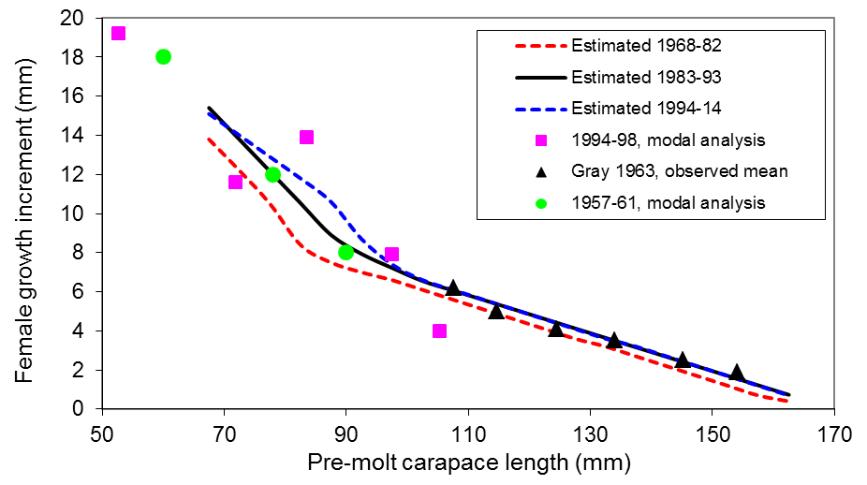Figure A2. Mean growth increments per molt for Bristol Bay red king crab. Note: “tagging”---based on tagging data; “mode”---based on modal analysis. The female growth increments per molt are for different model scenarios.
Figure A3. Estimated sizes at 50% maturity for Bristol Bay female red king crab from 1975 to 2008. Averages for three periods (1975-82, 1983-93, and 1994-08) are plotted with a line.

Figure A4. Histograms of carapace lengths (CL) and CL ratios of males to females for male shell ages ≤13 months of red king crab males in grasping pairs; Powell’s Kodiak data. Upper plot: all locations and years pooled; middle plot: location 11; lower plot: locations 4 and 13. Sizes at maturity for Kodiak red king crab are about 15 mm larger than those for Bristol Bay red king crab. (Doug Pengilly, ADF&G, pers. comm.).
Figure A5. Retained catch and potlifts for total eastern Bering Sea Tanner crab fishery (upper plot) and the Tanner crab fishery east of 163º W (bottom).

Appendix B. Recruitment Breakpoint Analysis in May 2019

Introduction
SSC asked authors to conduct a recruitment breakpoint analysis similar to that conducted for eastern Bering Sea Tanner crab in 2013 (Stockhausen 2013). We obtained the R codes from Dr. William (Buck) Stockhausen of NMFS and slightly modified them to conduct the analysis for Bristol Bay red king crab for better understanding the temporal change of stock productivity and the recruitment time series used for overfishing/overfished definitions. Results from assessment model model 18.0a are used for this analysis. We are very grateful for the help of Dr. Stockhausen for this analysis.

Methods
The methods are the same as Punt et al. (2014) and Stockhausen (2013). Stock productivity is represented by ln(R/MMB), where R is recruitment and MMB is mature male biomass, with recruitment lagging to the brood year of mature biomass. Let y_{t} = ln(R/MMB) and y_{t} can be estimated directly from the stock assessment model as observed values or from a stock-recruitment model as ŷ_{t}. For Ricker stock-recruitment models,

(B.1)
where α₁ and β₁ are the Ricker stock-recruit function parameters for the early time period before the potential breakpoint in year b and α₂ and β₂ are the parameters for the time period after the breakpoint in year b. For Beverton-Holt stock-recruitment models,

(B.2)
where α₁ and β₁ are the Beverton-Holt stock-recruit function log-transformed parameters for the early time period before the potential breakpoint in year b and α₂ and β₂ are the log-transformed parameters for the time period after the breakpoint in year b.
A maximum likelihood approach is used to estimate stock-recruitment model and error parameters. Because y_{t} is measured with error, the negative log-likelihood function is

(B.3)
where Ω contains observation and process error as

(B.4)
where O is the observation error covariance matrix estimated from the stock assessment model and P is the process error matrix and is assumed to reflect a first-order autoregressive process to have σ² on the diagonal and σ² ρ^{|t-j|} on the off-diagonal elements. σ² represents process error variance and ρ represents the degree of autocorrelation.
For each candidate breakpoint year b, the negative log likelihood value of equation (B.3) is minimized with respect to the six model parameters: α₁, β₁, α₂, β₂, ln(σ) and tan(ρ). The minimum time span considered as a potential regime is 5 years. Each brood year from 1980 to 2007 is evaluated as a potential breakpoint b using time series of ln(R/MMB) and MMB for brood years 1975-2012. A model with no breakpoint is also evaluated. Models with different breakpoints are then ranked using AICc (AIC corrected for small sample size; Burnham and Anderson 2004),
(B.5)
where k is the number of parameters and n is the number of observations. Using AICc, the model with the smallest AICc is regarded as the “best” model among the set of models evaluated. Different models can be compared in terms of θ_{m}, the relative probability (odds) that the model with the minimum AICc score is a better model than model m, where
(B.6)

Results
Results are summarized in Tables B1-B4 and Figures B1-B6. Discarding the implausible breakpoint year of 1980 for the Ricker model due to implausible stock-recruitment model parameters, the Ricker model has a breakpoint of brood year of 1986 (recruitment year of 1992), and the Beverton-Holt model results in the same breakpoint brood year of 1984, which corresponds to recruitment year of 1990. The model with no breakpoint (i.e., a single time period) is about 18 times less probable than the 1984 breakpoint model for Beverton-Holt stock-recruitment models and about 17 times less probable for Ricker stock-recruitment relationships, which may suggest a possible change in stock productivity from the early high period to the recent low period. Alternative breakpoint brood years of 1980-1986 for both Ricker and Beverton-Holt models are also reasonably reported. Both Ricker and Beverton-Holt stock-recruitment models fit the data poorly.

Discussion
A recruitment breakpoint analysis was conducted on Bristol Bay red king crab by Punt et al. (2014) with data from 1968 to 2010 to estimate a breakpoint brood year of 1984, corresponding to recruitment year of 1990, which is the same as our estimate with the Beverton-Holt model. Our data start in 1975 and have only two brood-year data points before the regime shift of 1976/77 and thus we cannot detect any stock productivity changes due to the 1976/77 regime shift because of lack of data. Without the early data, the fits of stock-recruitment models to the data are also more poorly.
Time series of estimated recruitment during 1984-present have been used to compute Bmsy proxy. The mean recruitment with model 18.0e during 1984-present is 17.70 million of crab, compared to the mean recruitment of 16.21 million of crab during 1990-present, about 8.4% reduction (Figure 12(18.0a). If the estimated breakpoint year is used to set the new recruitment time series, estimated Bmsy proxy will be correspondingly lower than the current estimated value.

References
Burnham, K.P., and D.R. Anderson. 2004. Multimodal inference: understanding AIC and BIC in model selection. Sociological Methods & Research 33:261–304.
Punt, A.E., C.S. Szuwalski, and W. Stockhausen. 2014. An evaluation of stock-recruitment proxies and environmental change points for implementing the US Sustainable Fisheries Act. Fisheries Research 157:28-40.
Stockhausen, W.T. 2013 Recruitment Analysis for Stock Status Determination and Harvest Recommendations. Appendix to: 2013 Stock Asssessment and Fishery Evaluation Report for the Tanner Crab Fisheries in the Bering Sea and Aleutian Islands Regions. In: Stock Assessment and Fishery Evaluation Report for the King and Tanner Crab Fisheries of the Bering Sea and Aleutian Islands Regions. North Pacific Fishery Management Council, Anchorage. pp.450-478.

Table B1. Results of the breakpoint analysis, with AICc and the relative probability (odds) against the Ricker stock-recruitment model being correct by breakpoint year. The model with no breakpoint is listed first in the table. The “best” model is shaded with a plausible stock-recruitment model. Years are brood year.

Year | AICc | Odds
NA | 30.9238 | 22.6194
1980 | 24.6862 | 1.0000
1981 | 26.0669 | 1.9944
1982 | 26.1803 | 2.1107
1983 | 26.1267 | 2.0549
1984 | 26.1003 | 2.0280
1985 | 25.6051 | 1.5832
1986 | 25.3132 | 1.3682
1987 | 28.6416 | 7.2259
1988 | 29.9626 | 13.9875
1989 | 32.4417 | 48.3160
1990 | 29.2430 | 9.7607
1991 | 31.1066 | 24.7833
1992 | 31.1349 | 25.1368
1993 | 30.8432 | 21.7255
1994 | 31.8353 | 35.6785
1995 | 32.0101 | 38.9364
1996 | 32.2674 | 44.2836
1997 | 30.7012 | 20.2369
1998 | 31.6248 | 32.1144
1999 | 32.0321 | 39.3669
2000 | 29.4065 | 10.5927
2001 | 28.6866 | 7.3904
2002 | 29.3953 | 10.5332
2003 | 30.9657 | 23.0977
2004 | 31.5810 | 31.4179
2005 | 30.1676 | 15.4974
2006 | 29.9998 | 14.2502
2007 | 31.0384 | 23.9530

Table B2. Parameter estimates and standard deviations for the Ricker stock-recruitment model with no breakpoint (first row) and the single breakpoint models (by year of breakpoint). The “best” model is shaded. Years are brood year.

Year α₁ std.dev. α₂ std.dev. β₁ std.dev. β₂ std.dev. ln(σ) std.dev. tan(ρ) std.dev.
 |  |  | -0.319 | 0.260 |  |  | 0.006 | 0.006 | -0.224 | 0.127 | 0.367 | 0.304
1980 | -4.927 | 3.085 | 0.825 | 0.358 | -0.043 | 0.030 | 0.057 | 0.014 | -0.406 | 0.123 | -0.021 | 0.282
1981 | 0.215 | 0.869 | 0.789 | 0.353 | 0.007 | 0.009 | 0.056 | 0.014 | -0.388 | 0.124 | -0.082 | 0.279
1982 | 0.527 | 0.563 | 0.734 | 0.394 | 0.010 | 0.007 | 0.054 | 0.016 | -0.387 | 0.124 | -0.056 | 0.275
1983 | 0.406 | 0.440 | 0.818 | 0.436 | 0.009 | 0.006 | 0.057 | 0.017 | -0.388 | 0.124 | -0.066 | 0.271
1984 | 0.397 | 0.376 | 0.858 | 0.498 | 0.009 | 0.005 | 0.059 | 0.019 | -0.389 | 0.124 | -0.060 | 0.271
1985 | 0.623 | 0.333 | 0.336 | 0.608 | 0.011 | 0.005 | 0.040 | 0.023 | -0.395 | 0.124 | -0.059 | 0.273
1986 | 0.581 | 0.307 | 0.087 | 0.728 | 0.011 | 0.005 | 0.031 | 0.027 | -0.398 | 0.124 | -0.047 | 0.277
1987 | 0.337 | 0.300 | 0.555 | 0.820 | 0.009 | 0.005 | 0.047 | 0.030 | -0.354 | 0.124 | -0.043 | 0.270
1988 | 0.223 | 0.308 | 0.645 | 0.912 | 0.008 | 0.005 | 0.050 | 0.033 | -0.335 | 0.123 | 0.058 | 0.271
1989 | 0.057 | 0.302 | 0.727 | 0.929 | 0.007 | 0.005 | 0.052 | 0.034 | -0.302 | 0.123 | 0.037 | 0.274
1990 | 0.172 | 0.309 | 0.809 | 0.949 | 0.008 | 0.005 | 0.057 | 0.035 | -0.347 | 0.125 | 0.169 | 0.282
1991 | 0.036 | 0.298 | 0.946 | 0.971 | 0.007 | 0.005 | 0.061 | 0.035 | -0.320 | 0.125 | 0.152 | 0.274
1992 | -0.083 | 0.288 | 1.514 | 1.041 | 0.006 | 0.005 | 0.080 | 0.037 | -0.320 | 0.125 | 0.159 | 0.276
1993 | -0.097 | 0.275 | 1.800 | 1.140 | 0.006 | 0.005 | 0.089 | 0.041 | -0.325 | 0.125 | 0.149 | 0.274
1994 | -0.002 | 0.275 | 0.929 | 1.586 | 0.007 | 0.005 | 0.060 | 0.055 | -0.309 | 0.124 | 0.156 | 0.286
1995 | -0.046 | 0.261 | 1.410 | 1.784 | 0.006 | 0.005 | 0.076 | 0.061 | -0.308 | 0.124 | 0.129 | 0.273
1996 | -0.080 | 0.253 | 1.675 | 1.881 | 0.006 | 0.005 | 0.084 | 0.064 | -0.305 | 0.124 | 0.116 | 0.272
1997 | 0.009 | 0.256 | -0.664 | 2.251 | 0.007 | 0.005 | 0.008 | 0.076 | -0.324 | 0.125 | 0.182 | 0.287
1998 | -0.048 | 0.241 | -0.088 | 3.178 | 0.006 | 0.005 | 0.027 | 0.106 | -0.315 | 0.124 | 0.114 | 0.271
1999 | -0.079 | 0.233 | -0.453 | 4.442 | 0.006 | 0.005 | 0.015 | 0.146 | -0.309 | 0.124 | 0.078 | 0.276
2000 | -0.047 | 0.219 | -1.902 | 4.333 | 0.006 | 0.004 | -0.029 | 0.142 | -0.350 | 0.125 | 0.049 | 0.275
2001 | -0.060 | 0.206 | -2.645 | 4.313 | 0.006 | 0.004 | -0.052 | 0.141 | -0.360 | 0.125 | -0.016 | 0.277
2002 | -0.086 | 0.211 | -2.603 | 4.317 | 0.006 | 0.004 | -0.050 | 0.141 | -0.348 | 0.124 | 0.023 | 0.271
2003 | -0.126 | 0.215 | -4.313 | 5.199 | 0.006 | 0.005 | -0.108 | 0.172 | -0.325 | 0.124 | 0.038 | 0.273
2004 | -0.150 | 0.215 | -5.235 | 6.326 | 0.006 | 0.005 | -0.139 | 0.211 | -0.315 | 0.123 | 0.039 | 0.276
2005 | -0.142 | 0.211 | -4.701 | 6.169 | 0.006 | 0.005 | -0.118 | 0.206 | -0.336 | 0.124 | 0.056 | 0.274
2006 | -0.155 | 0.209 | -3.551 | 6.362 | 0.006 | 0.005 | -0.077 | 0.213 | -0.337 | 0.124 | 0.051 | 0.272
2007 | -0.181 | 0.210 | -3.992 | 9.066 | 0.006 | 0.005 | -0.093 | 0.308 | -0.322 | 0.123 | 0.059 | 0.277

Table B3. Results of the breakpoint analysis, with AICc and the relative probability (odds) against the Beverton-Holt stock-recruitment model being correct by breakpoint year. The model with no breakpoint is listed first in the table. The “best” model is shaded. Years are brood year.

Year | AICc | Odds
NA | 29.7727 | 18.4149
1980 | 25.7843 | 2.5066
1981 | 24.5863 | 1.3770
1982 | 24.5910 | 1.3803
1983 | 24.1006 | 1.0801
1984 | 23.9464 | 1.0000
1985 | 24.8023 | 1.5341
1986 | 24.7628 | 1.5041
1987 | 27.9016 | 7.2254
1988 | 29.2177 | 13.9523
1989 | 31.7329 | 49.0694
1990 | 28.6093 | 10.2928
1991 | 30.6450 | 28.4827
1992 | 31.5624 | 45.0590
1993 | 31.6181 | 46.3324
1994 | 31.3514 | 40.5480
1995 | 31.7759 | 50.1358
1996 | 32.1970 | 61.8866
1997 | 30.0083 | 20.7162
1998 | 31.0013 | 34.0360
1999 | 31.4110 | 41.7743
2000 | 28.8322 | 11.5062
2001 | 28.1772 | 8.2927
2002 | 28.8375 | 11.5366
2003 | 30.5744 | 27.4948
2004 | 31.1698 | 37.0289
2005 | 29.6270 | 17.1211
2006 | 29.2277 | 14.0223
2007 | 30.1635 | 22.3878

Table B4. Parameter estimates and standard deviations for the Beverton-Holt stock-recruitment model with no breakpoint (first row) and the single breakpoint models (by year of breakpoint). The “best” model is shaded. Years are brood year.

Year α₁ std.dev. α₂ std.dev. β₁ std.dev. β₂ std.dev. ln(σ) std.dev. tan(ρ) std.dev.
 |  |  | 0.224 | 0.851 |  |  | -3.290 | 1.684 | -0.236 | 0.129 | 0.403 | 0.324
1980 | -0.556 | 0.310 | 2.686 | 3.333 | -10.91 | 35.202 | 0.094 | 3.500 | -0.388 | 0.125 | -0.146 | 0.282
1981 | 0.672 | 1.635 | 2.762 | 3.782 | -3.736 | 2.500 | 0.203 | 3.952 | -0.409 | 0.124 | -0.052 | 0.296
1982 | 0.799 | 0.787 | 2.882 | 4.945 | -3.551 | 1.225 | 0.326 | 5.129 | -0.409 | 0.124 | -0.045 | 0.282
1983 | 0.538 | 0.526 | 8.307 | 57.004 | -3.945 | 0.992 | 5.768 | 57.013 | -0.416 | 0.124 | -0.068 | 0.275
1984 | 0.501 | 0.436 | 9.152 | 68.364 | -4.003 | 0.889 | 6.604 | 68.368 | -0.418 | 0.124 | -0.064 | 0.273
1985 | 0.776 | 0.421 | 2.594 | 11.533 | -3.580 | 0.785 | 0.026 | 11.994 | -0.406 | 0.124 | -0.051 | 0.275
1986 | 0.727 | 0.393 | 0.795 | 2.881 | -3.643 | 0.777 | -1.978 | 3.689 | -0.405 | 0.124 | -0.041 | 0.278
1987 | 0.482 | 0.385 | 8.354 | 122.464 | -3.906 | 0.876 | 5.793 | 122.479 | -0.364 | 0.124 | -0.035 | 0.273
1988 | 0.394 | 0.421 | 8.228 | 111.591 | -3.939 | 0.996 | 5.652 | 111.606 | -0.344 | 0.123 | 0.079 | 0.274
1989 | 0.249 | 0.434 | 7.025 | 61.785 | -4.023 | 1.107 | 4.410 | 61.814 | -0.312 | 0.123 | 0.060 | 0.278
1990 | 0.370 | 0.452 | 7.051 | 52.894 | -3.911 | 1.065 | 4.513 | 52.916 | -0.354 | 0.125 | 0.187 | 0.288
1991 | 0.237 | 0.452 | 7.762 | 72.745 | -4.018 | 1.157 | 5.185 | 72.760 | -0.326 | 0.125 | 0.164 | 0.279
1992 | 0.084 | 0.433 | 7.678 | 54.671 | -4.237 | 1.267 | 5.051 | 54.684 | -0.311 | 0.124 | 0.178 | 0.279
1993 | 0.058 | 0.419 | 7.628 | 51.998 | -4.281 | 1.277 | 4.996 | 52.011 | -0.310 | 0.124 | 0.180 | 0.280
1994 | 0.206 | 0.450 | 5.852 | 54.545 | -4.008 | 1.204 | 3.282 | 54.618 | -0.313 | 0.125 | 0.199 | 0.288
1995 | 0.145 | 0.426 | 6.347 | 56.553 | -4.097 | 1.219 | 3.763 | 56.599 | -0.309 | 0.124 | 0.165 | 0.280
1996 | 0.100 | 0.411 | 6.545 | 58.063 | -4.156 | 1.234 | 3.954 | 58.102 | -0.304 | 0.124 | 0.132 | 0.280
1997 | 0.212 | 0.430 | -0.690 | 2.493 | -4.005 | 1.178 | -4.849 | 13.254 | -0.333 | 0.126 | 0.196 | 0.296
1998 | 0.130 | 0.391 | 0.233 | 9.064 | -4.143 | 1.176 | -2.668 | 13.428 | -0.324 | 0.125 | 0.119 | 0.276
1999 | 0.094 | 0.380 | -0.473 | 6.417 | -4.193 | 1.186 | -4.029 | 18.286 | -0.318 | 0.124 | 0.081 | 0.281
2000 | 0.113 | 0.352 | -1.011 | 0.284 | -4.231 | 1.113 | -9.764 | 109.299 | -0.358 | 0.125 | 0.065 | 0.272
2001 | 0.098 | 0.336 | -1.063 | 0.260 | -4.258 | 1.083 | -9.645 | 77.507 | -0.368 | 0.125 | 0.012 | 0.272
2002 | 0.088 | 0.356 | -1.074 | 0.349 | -4.211 | 1.121 | -8.571 | 46.119 | -0.357 | 0.125 | 0.041 | 0.272
2003 | 0.087 | 0.401 | -1.046 | 0.280 | -4.085 | 1.186 | -9.606 | 63.896 | -0.331 | 0.124 | 0.073 | 0.275
2004 | 0.086 | 0.425 | -1.051 | 0.334 | -4.022 | 1.217 | -8.858 | 47.684 | -0.321 | 0.124 | 0.082 | 0.278
2005 | 0.089 | 0.411 | -1.171 | 0.310 | -4.033 | 1.179 | -9.685 | 77.778 | -0.344 | 0.124 | 0.081 | 0.277
2006 | 0.080 | 0.407 | -1.248 | 0.398 | -4.032 | 1.168 | -8.833 | 63.349 | -0.349 | 0.124 | 0.056 | 0.277
2007 | 0.082 | 0.440 | -1.261 | 0.596 | -3.954 | 1.211 | -8.167 | 60.765 | -0.336 | 0.124 | 0.075 | 0.281

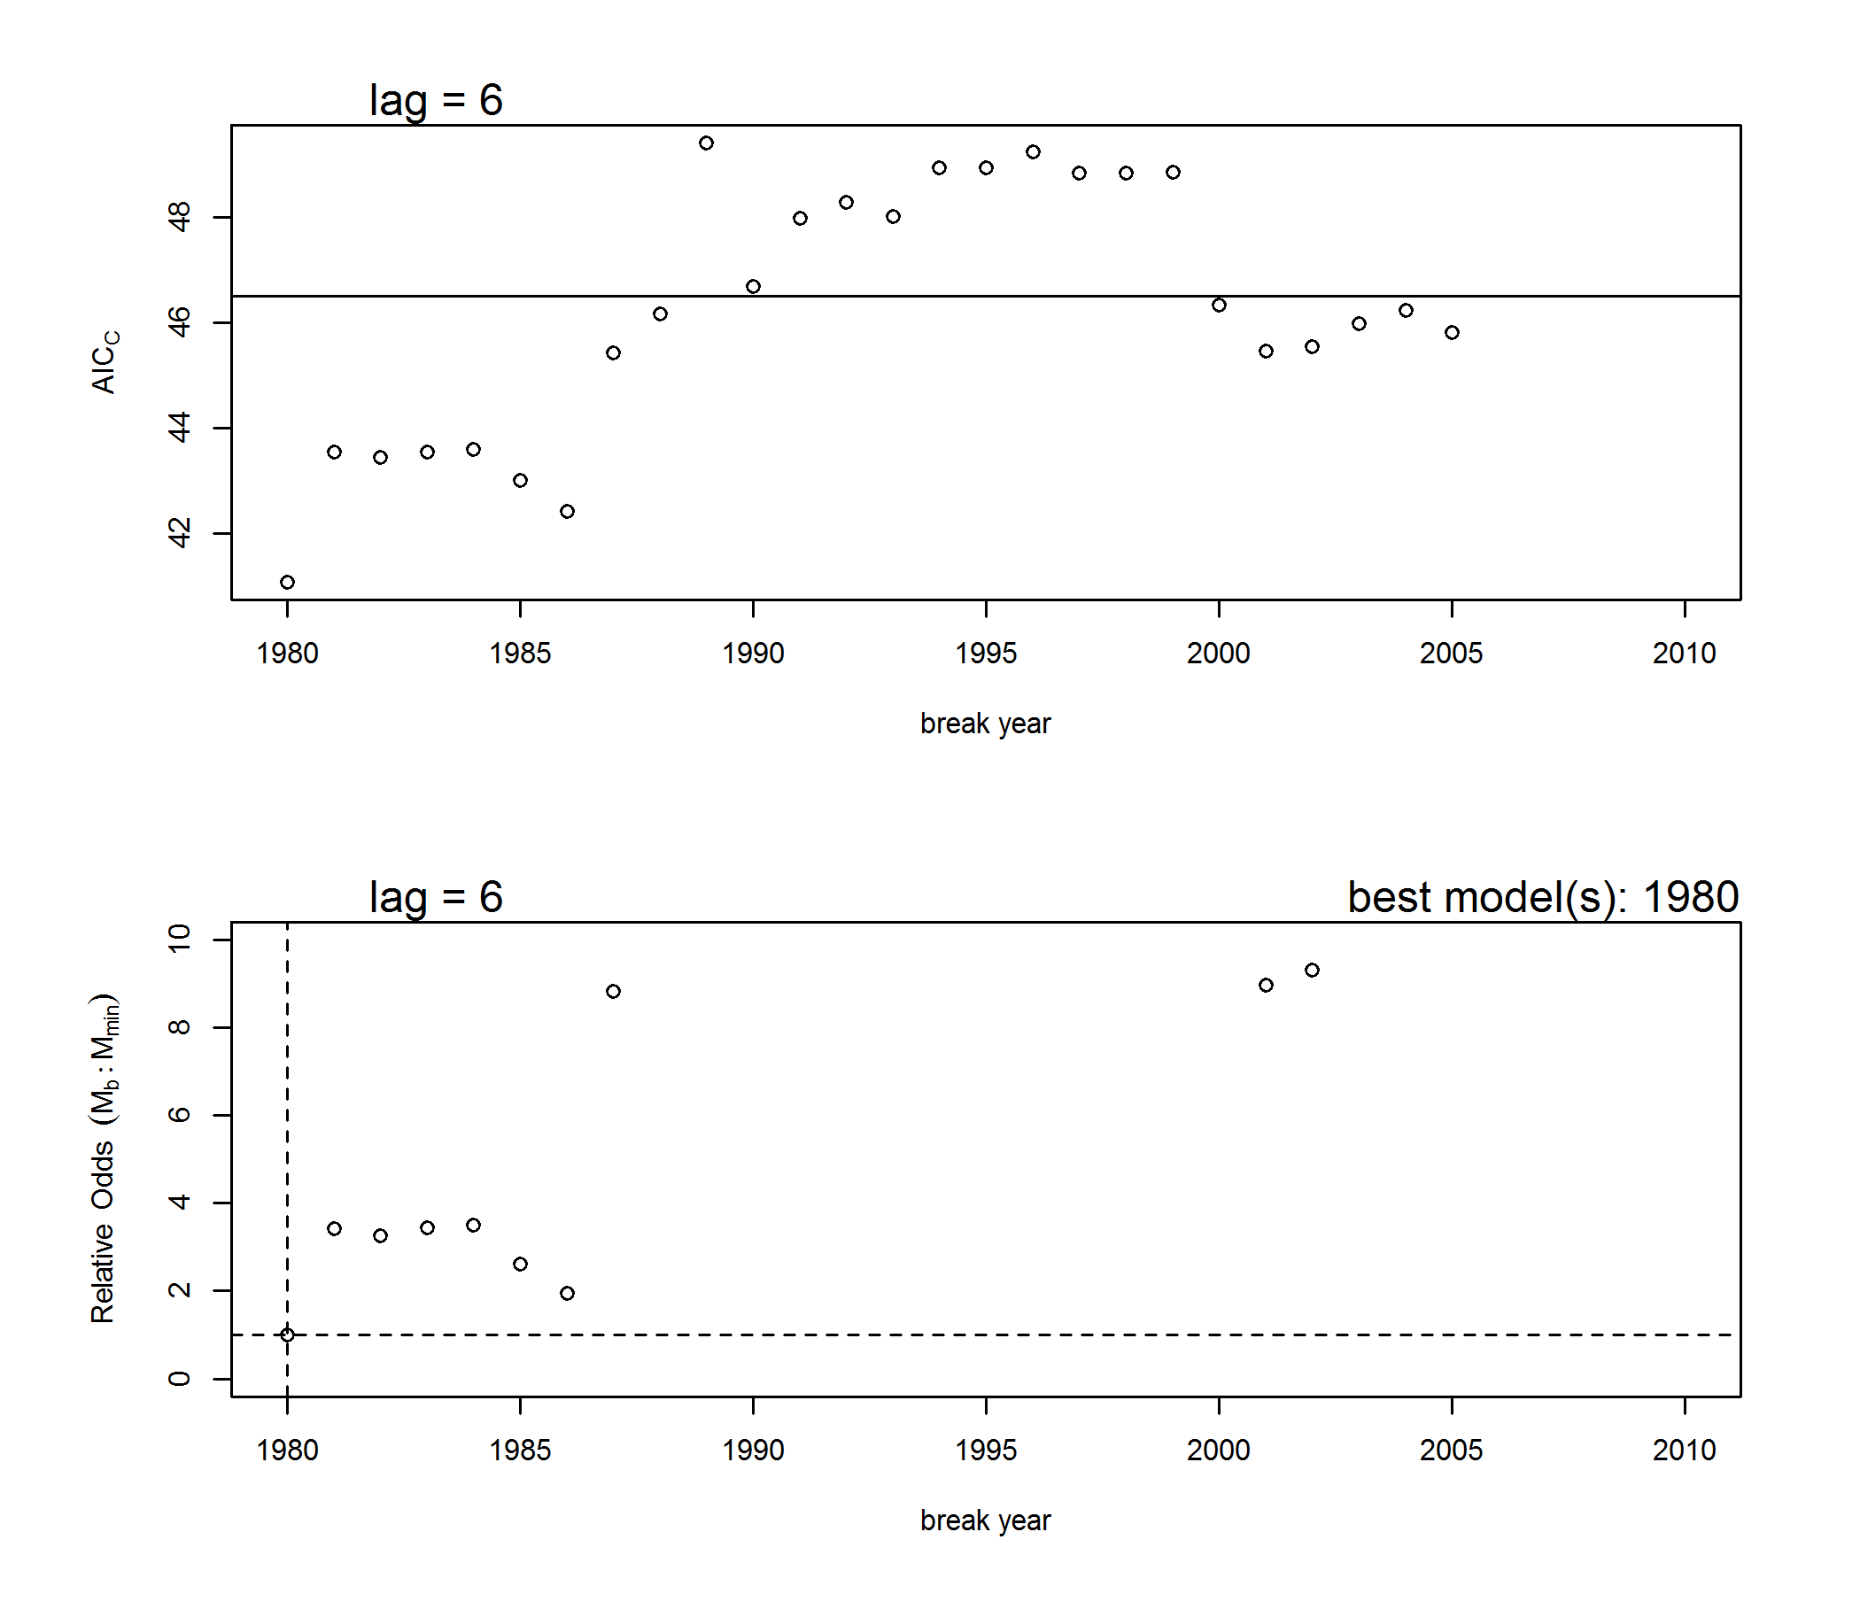

Figure B1. Results from the Ricker stock-recruit breakpoint analysis. Upper graph: AICc vs. year of breakpoint for the 1-breakpoint models (circles) and AICc for the model with no breakpoint (horizontal line). Lower graph: probabilistic odds for all 1-breakpoint models (circles) and the no breakpoint model (horizontal solid line) relative to the model with the smallest AICc score. The dashed lines indicate the value for the model with the lowest AICc score. Not shown are 1-breakpoint models with high odds (>10) of being incorrect.

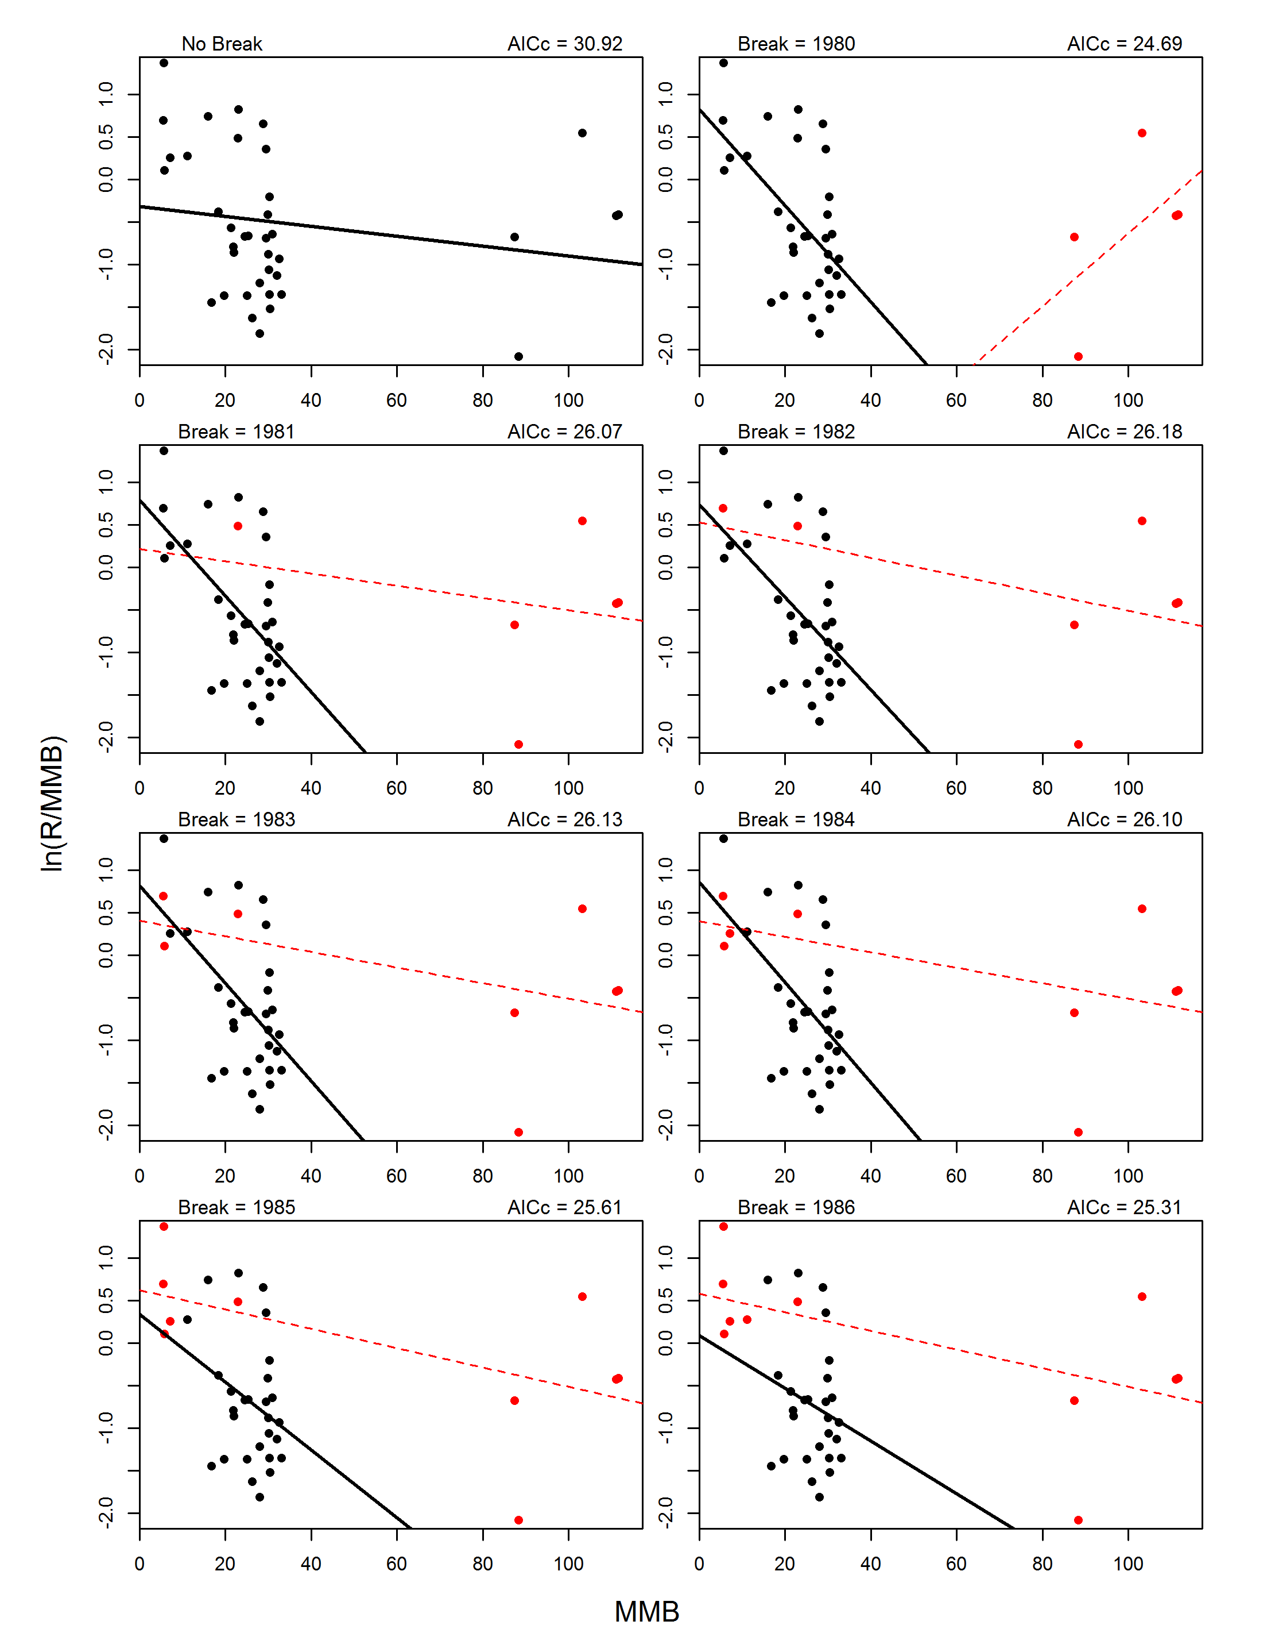
Figure B2. Fits for Ricker models with no breakpoint (upper left graph) and with 1-breakpoint for break years 1975-2007. For 1-breakpoint models, the pre-break data (circles) and model fit (line) are shown in red, whereas the post-break data and fit are shown in black.
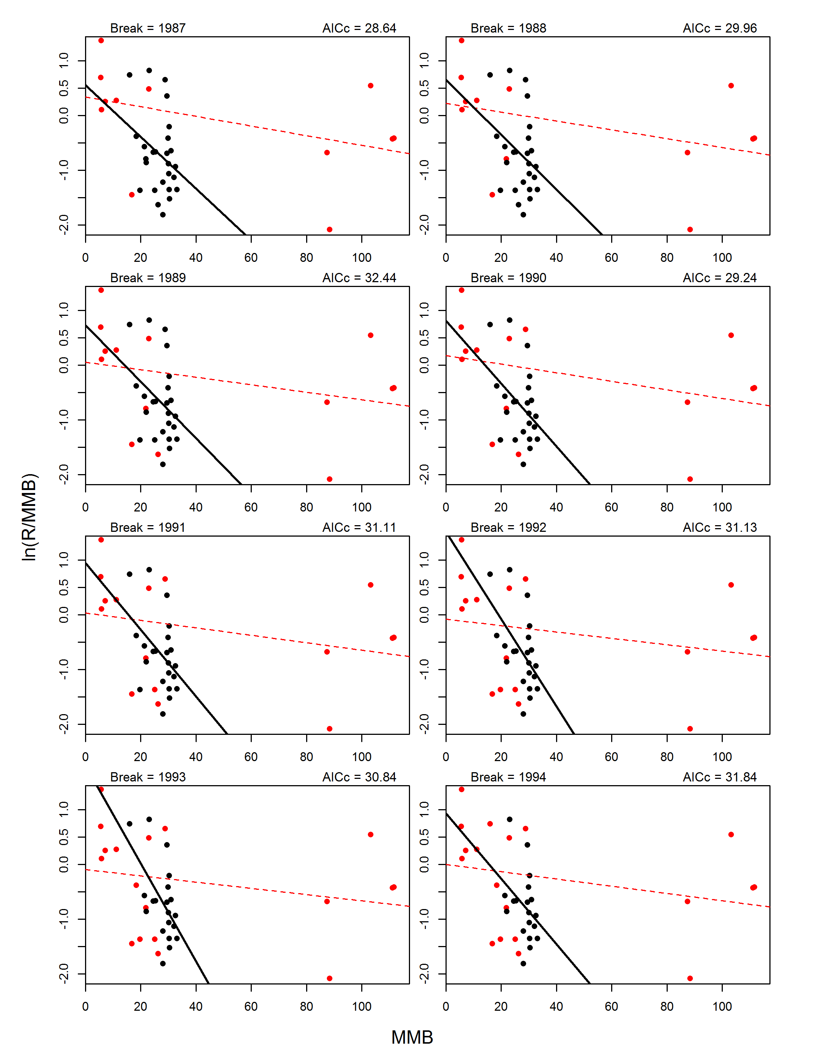
Figure B2. Continue.

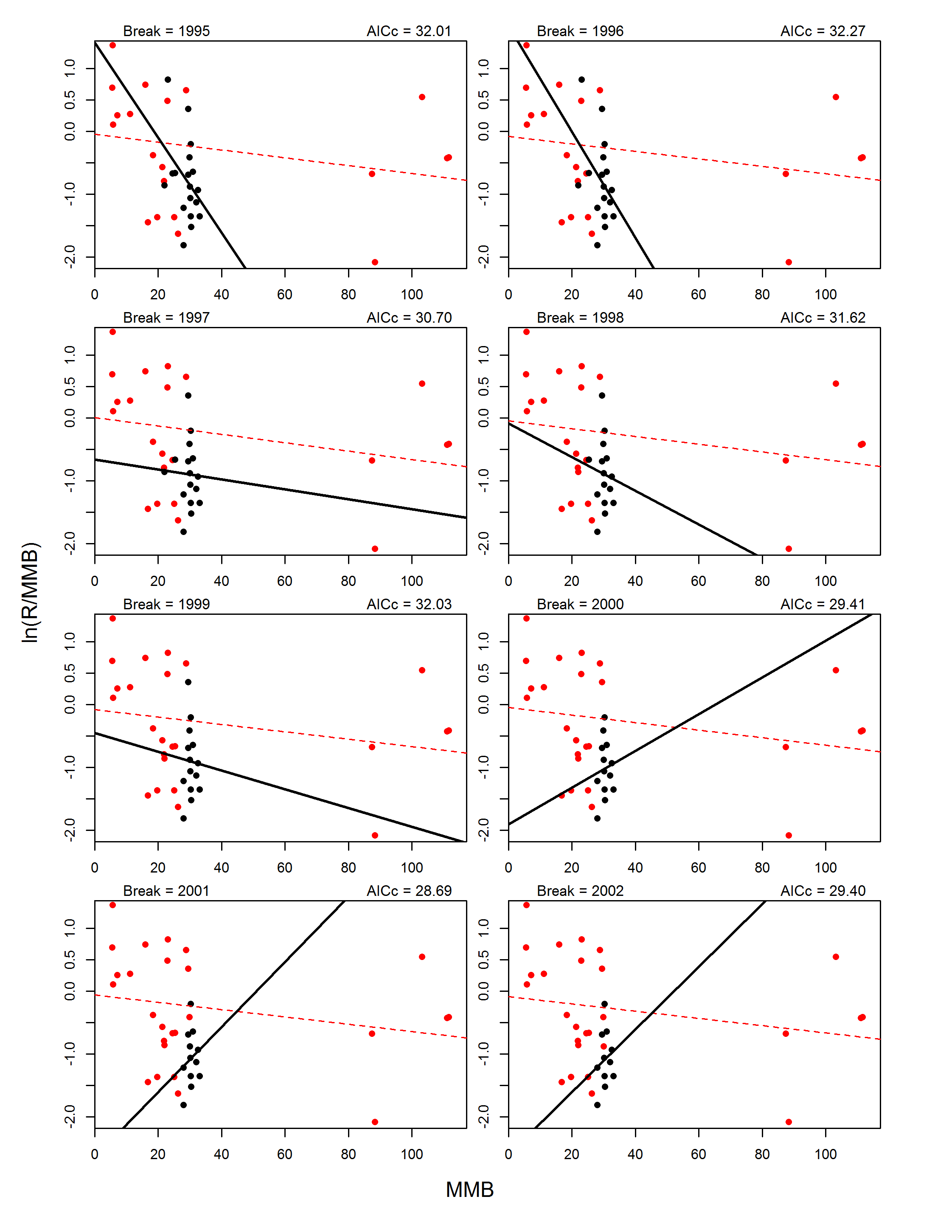
Figure B2. Continue.

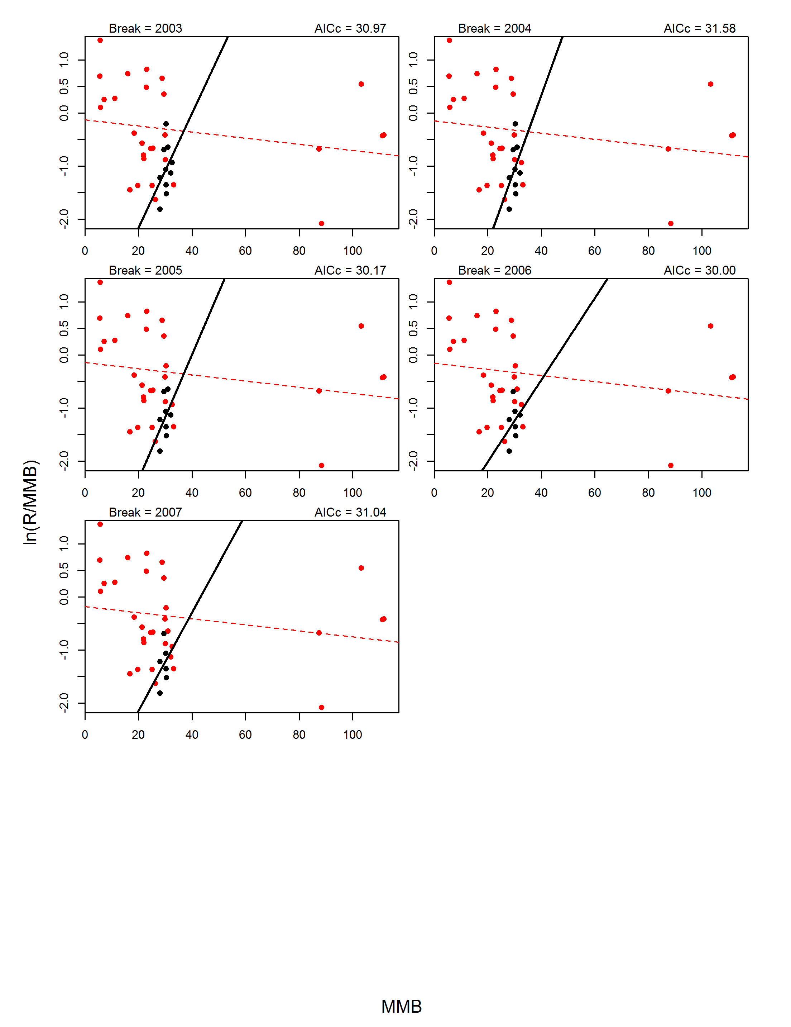
Figure B2. Continue.

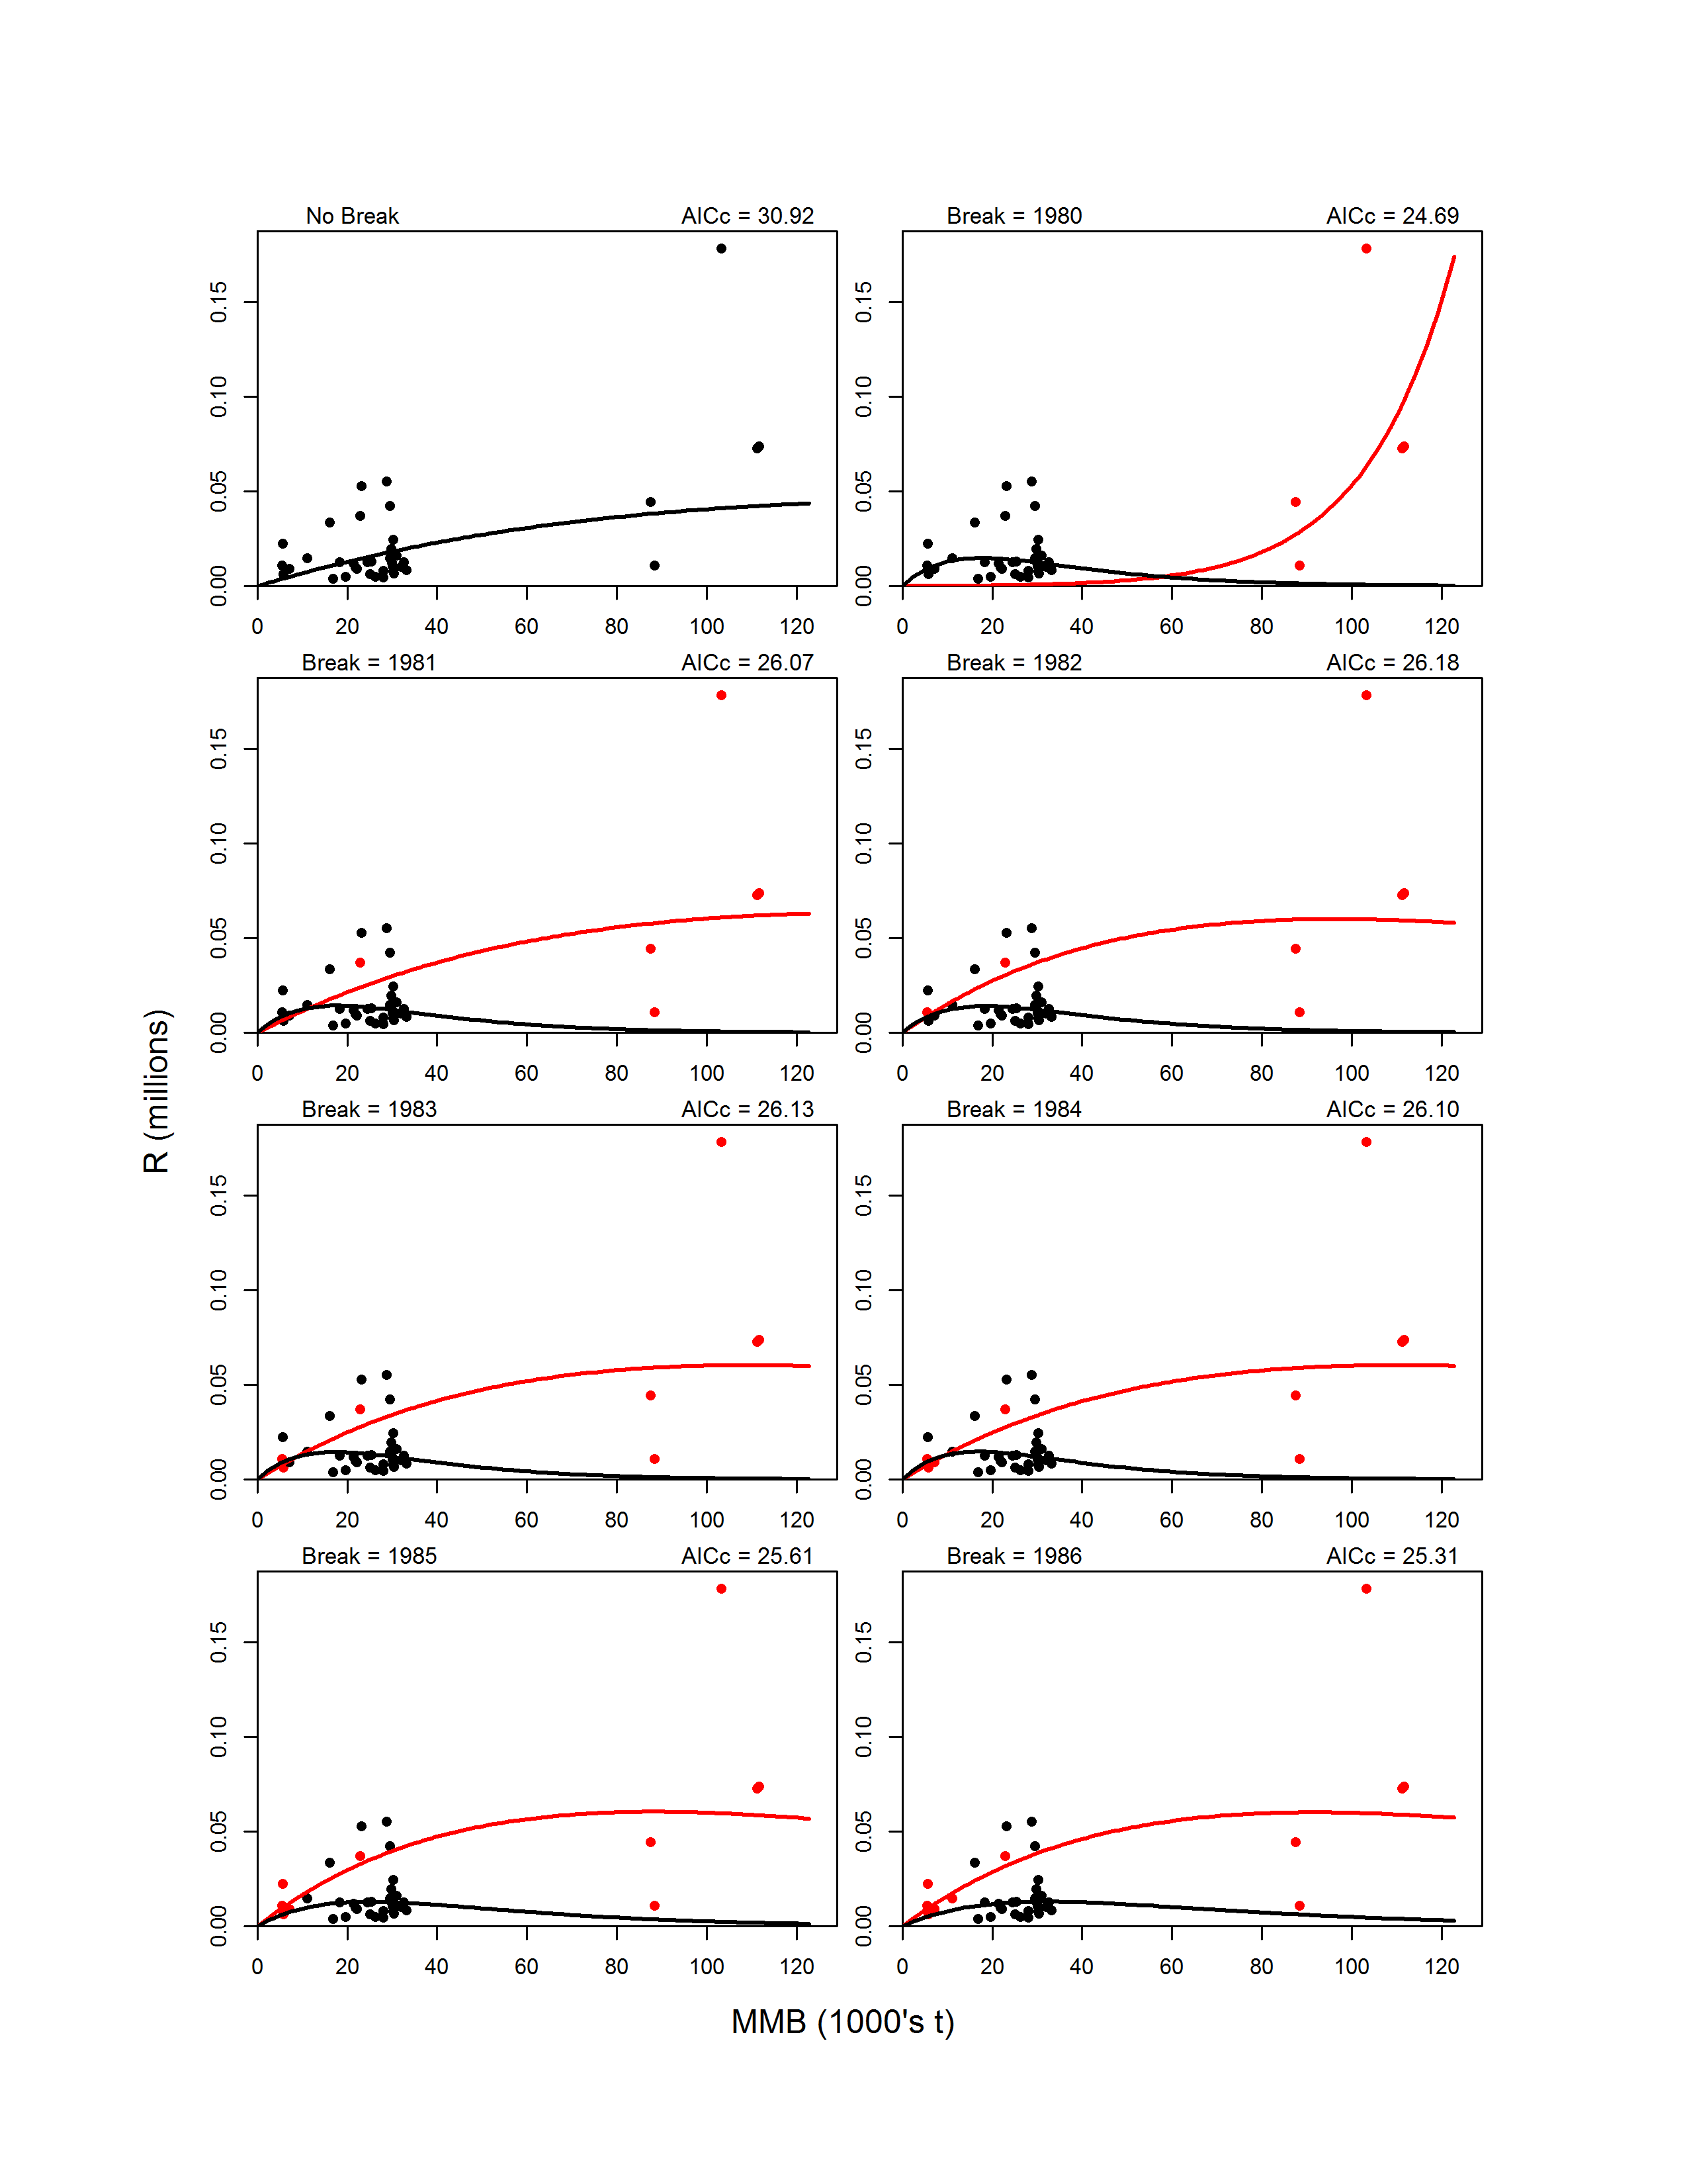
Figure B3. Fits on the arithmetic scale for Ricker models with no breakpoint (upper left graph) and with 1-breakpoint for break years 1975-2007. For 1-breakpoint models, the pre-break data (circles) and model fit (line) are shown in red, whereas the post-break data and fit are shown in black.
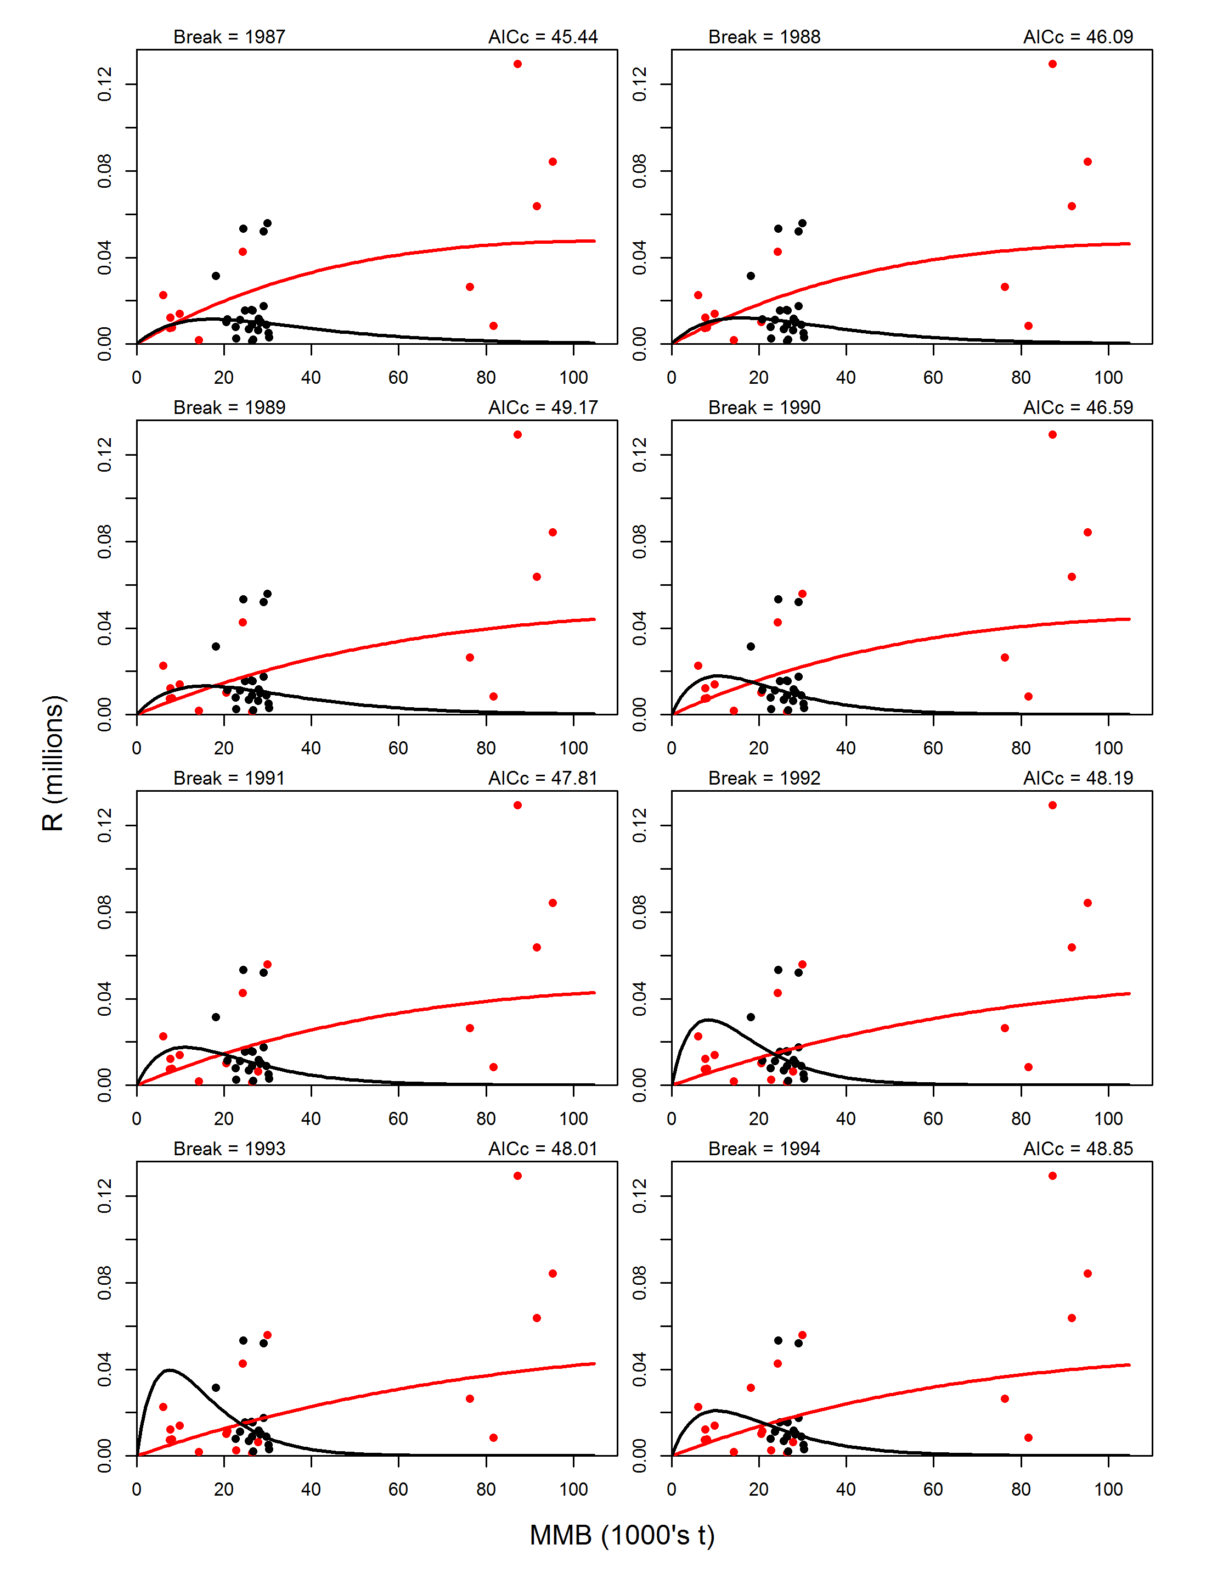
Figure B3. Continue.

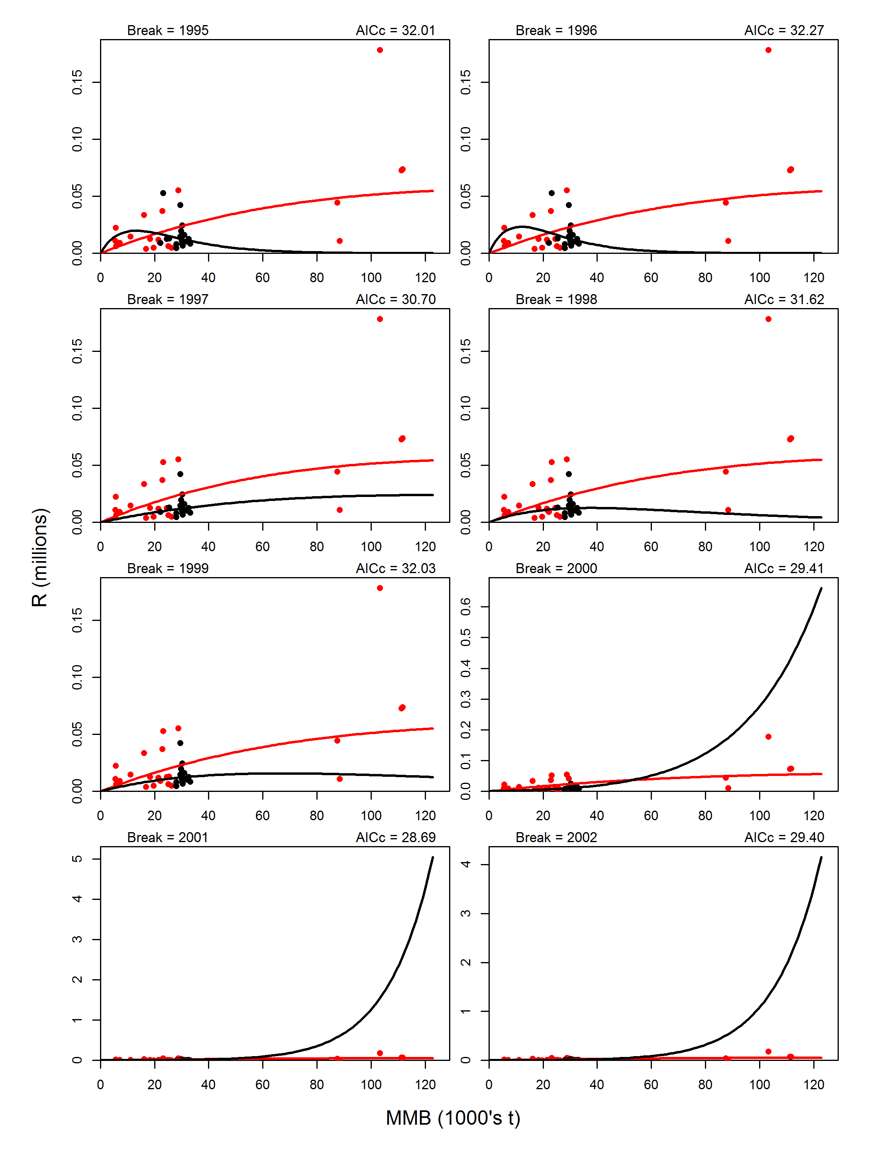
Figure B3. Continue.

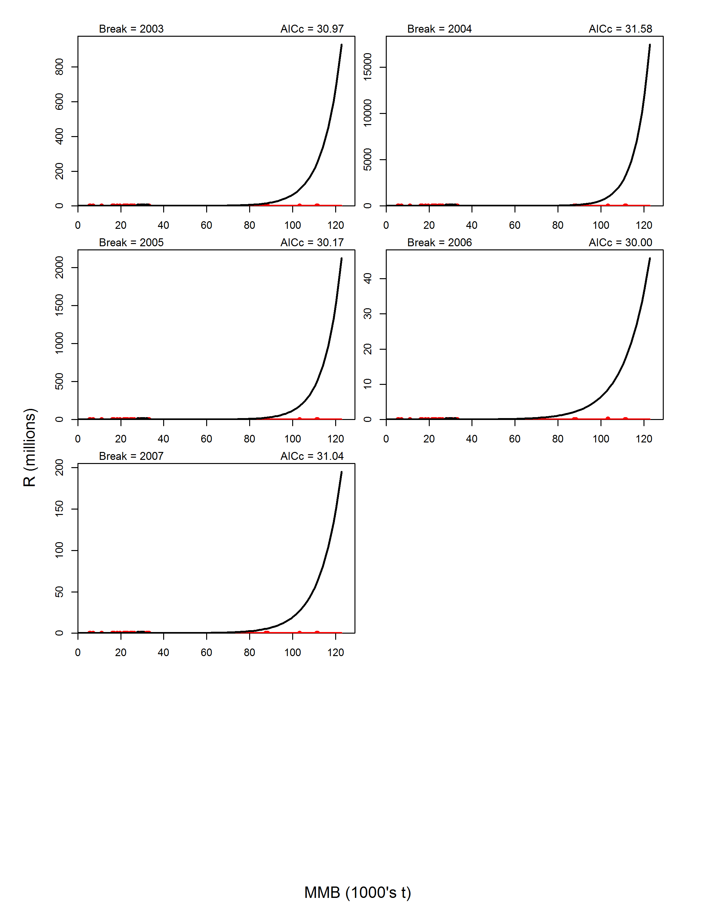
Figure B3. Continue.

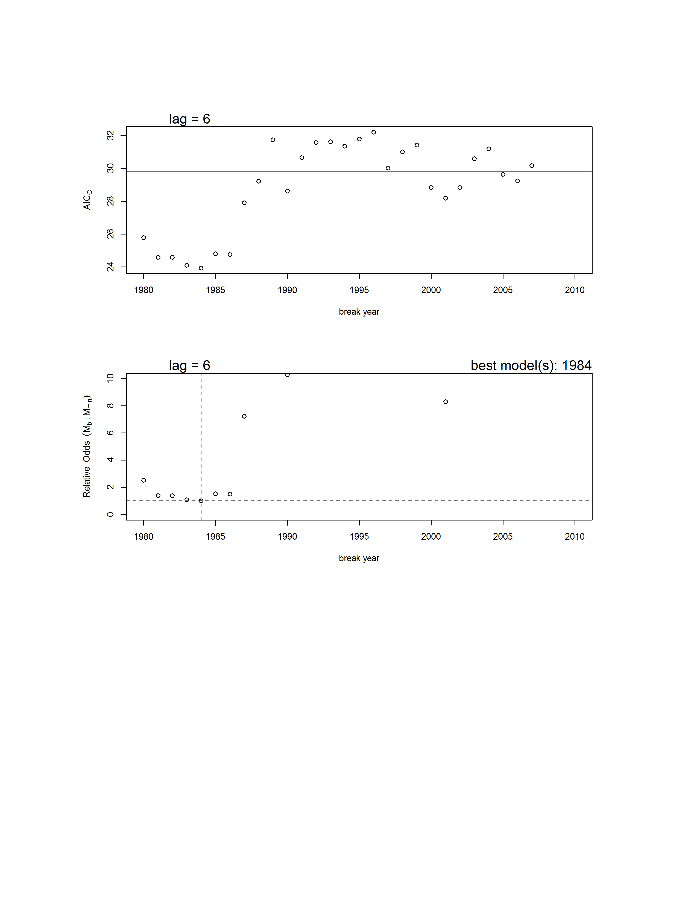

Figure B4. Results from the B-H stock-recruit breakpoint analysis. Upper graph: AICc vs. year of breakpoint for the 1-breakpoint models (circles) and AICc for the model with no breakpoint (horizontal line). Lower graph: probabilistic odds for all 1-breakpoint models (circles) and the no breakpoint model (horizontal solid line) relative to the model with the smallest AICc score. The dashed lines indicate the value for the model with the lowest AICc score (breakpoint in 1984). Not shown are 1-breakpoint models with high odds (>10) of being incorrect.

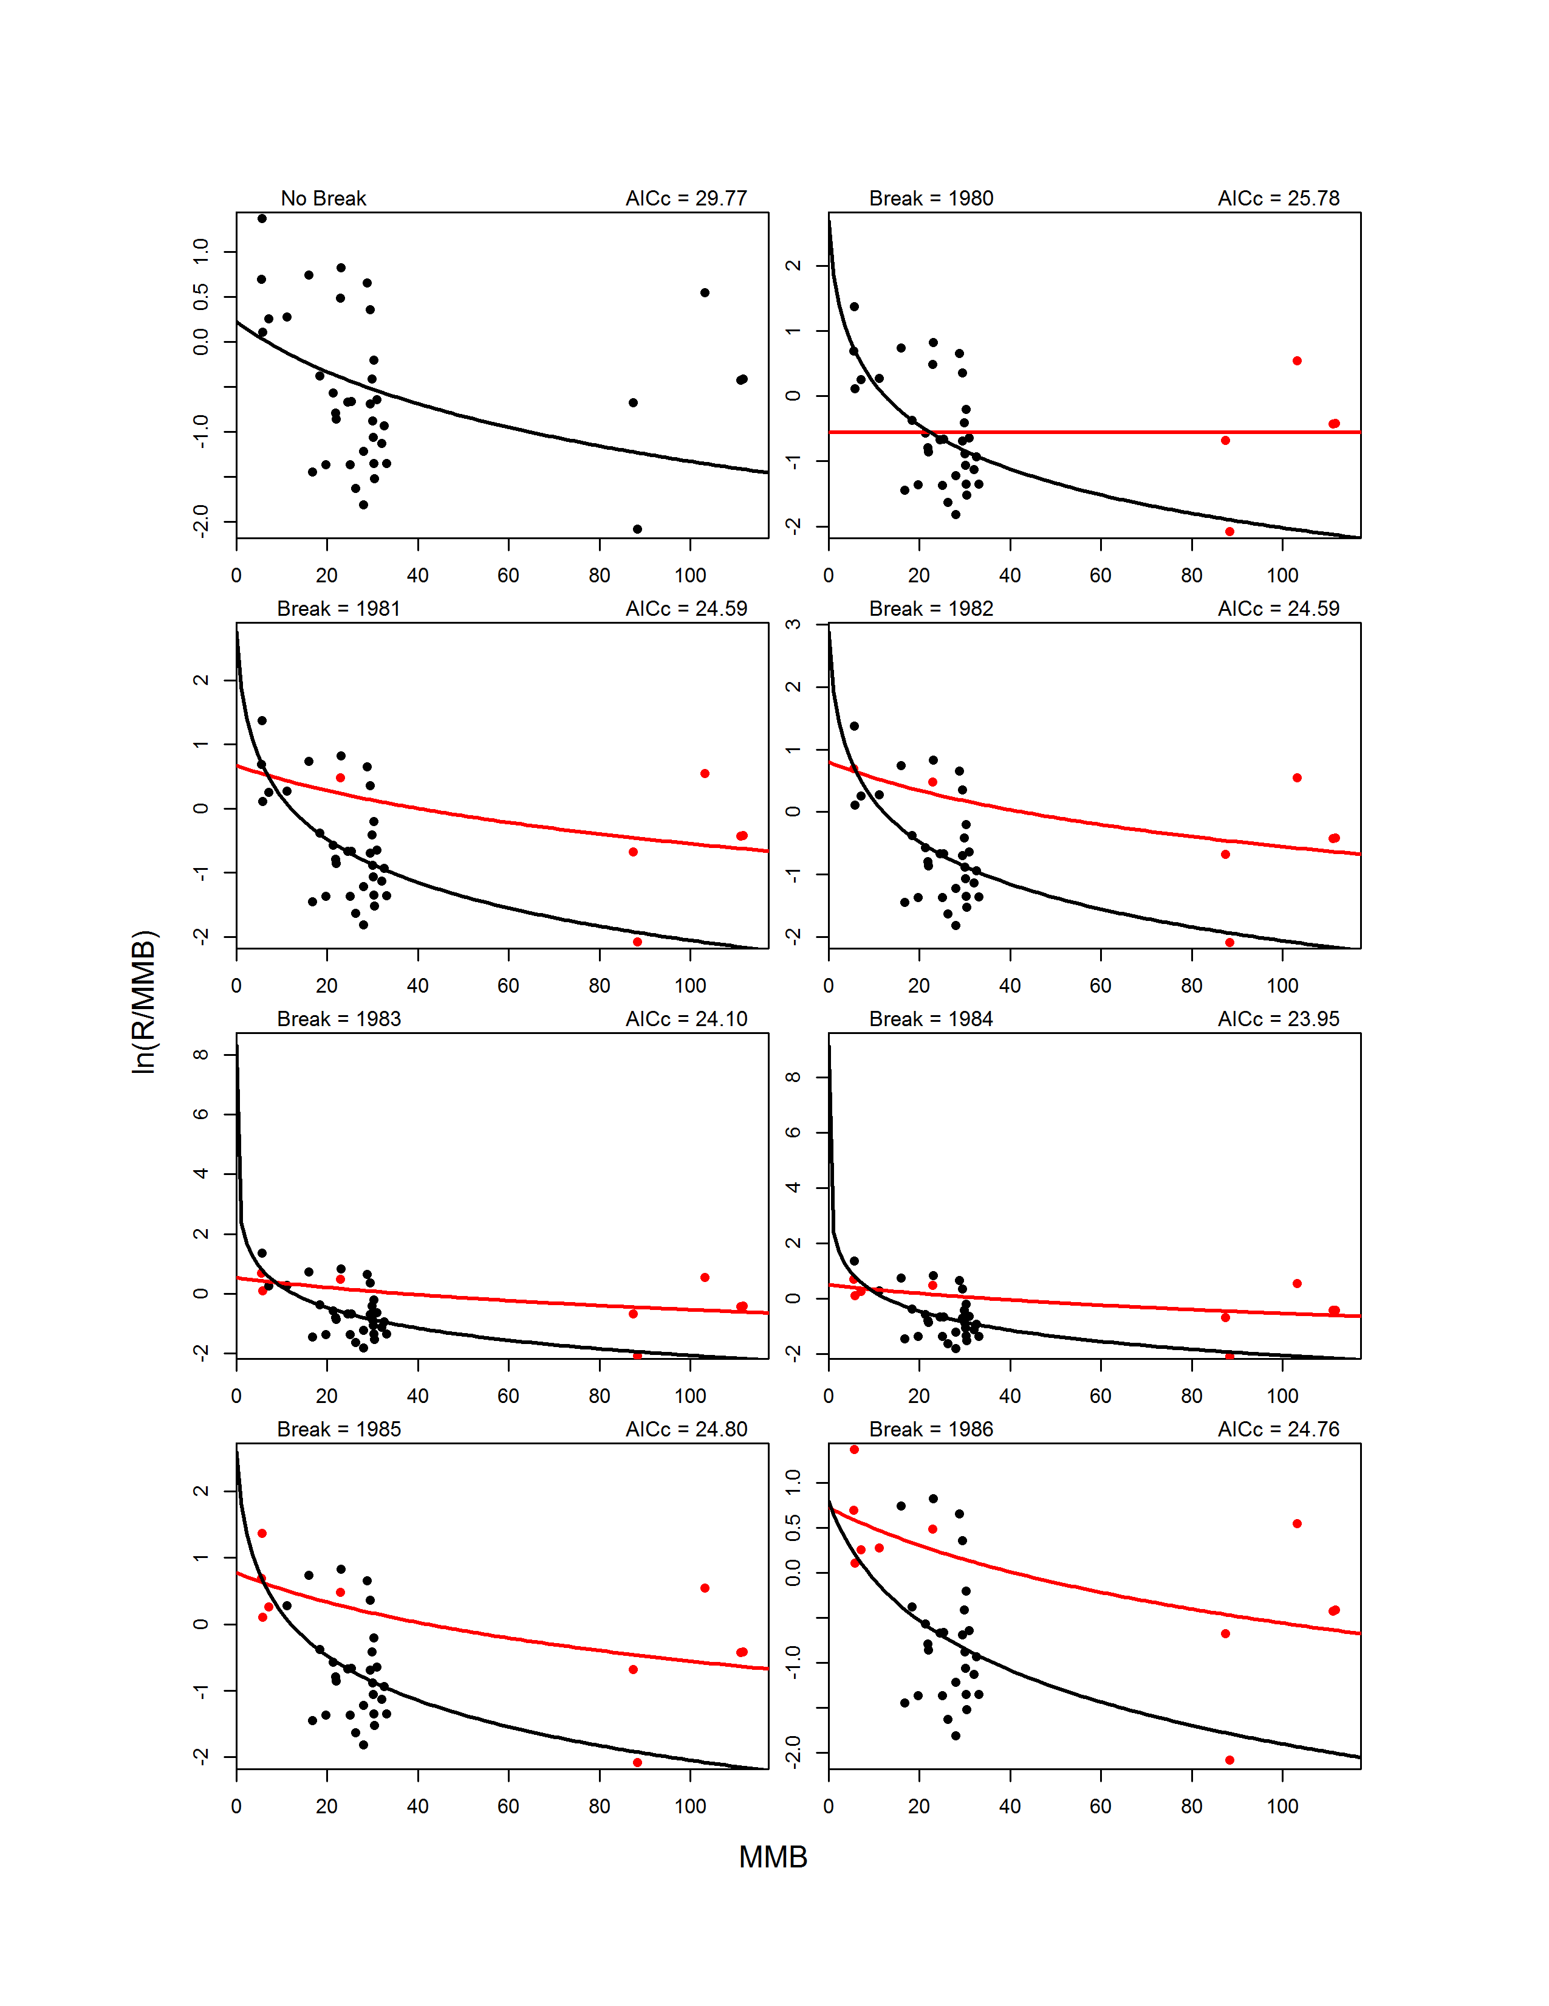
Figure B5. Fits for B-H models with no breakpoint (upper left graph) and with 1-breakpoint for break years 1975-2007. For 1-breakpoint models, the pre-break data (circles) and model fit (line) are shown in red, whereas the post-break data and fit are shown in black.
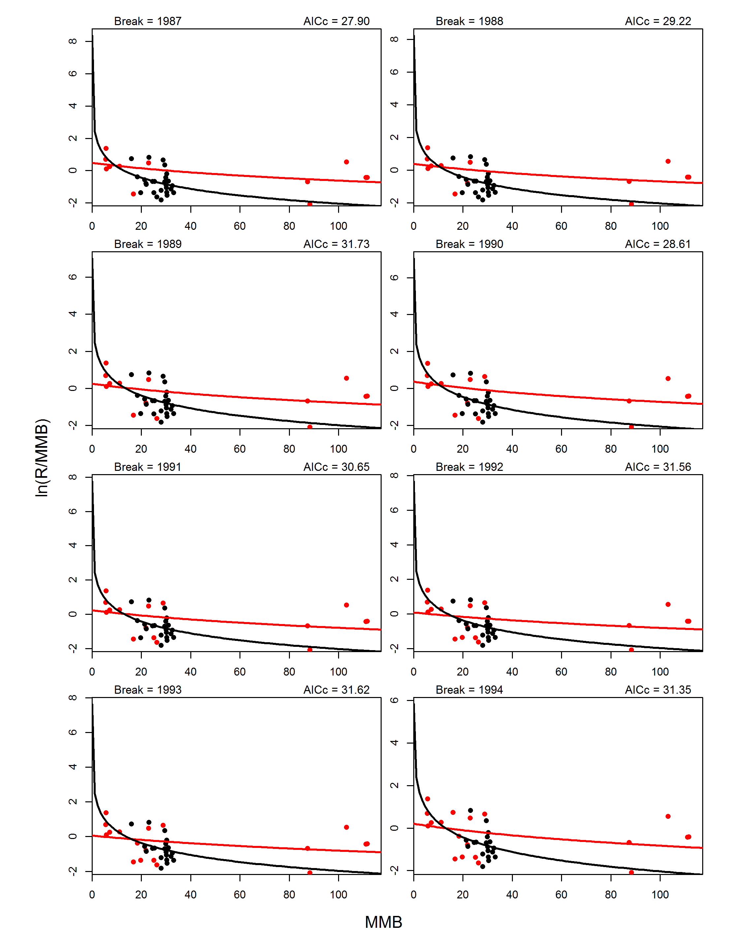
Figure B5. Continue.

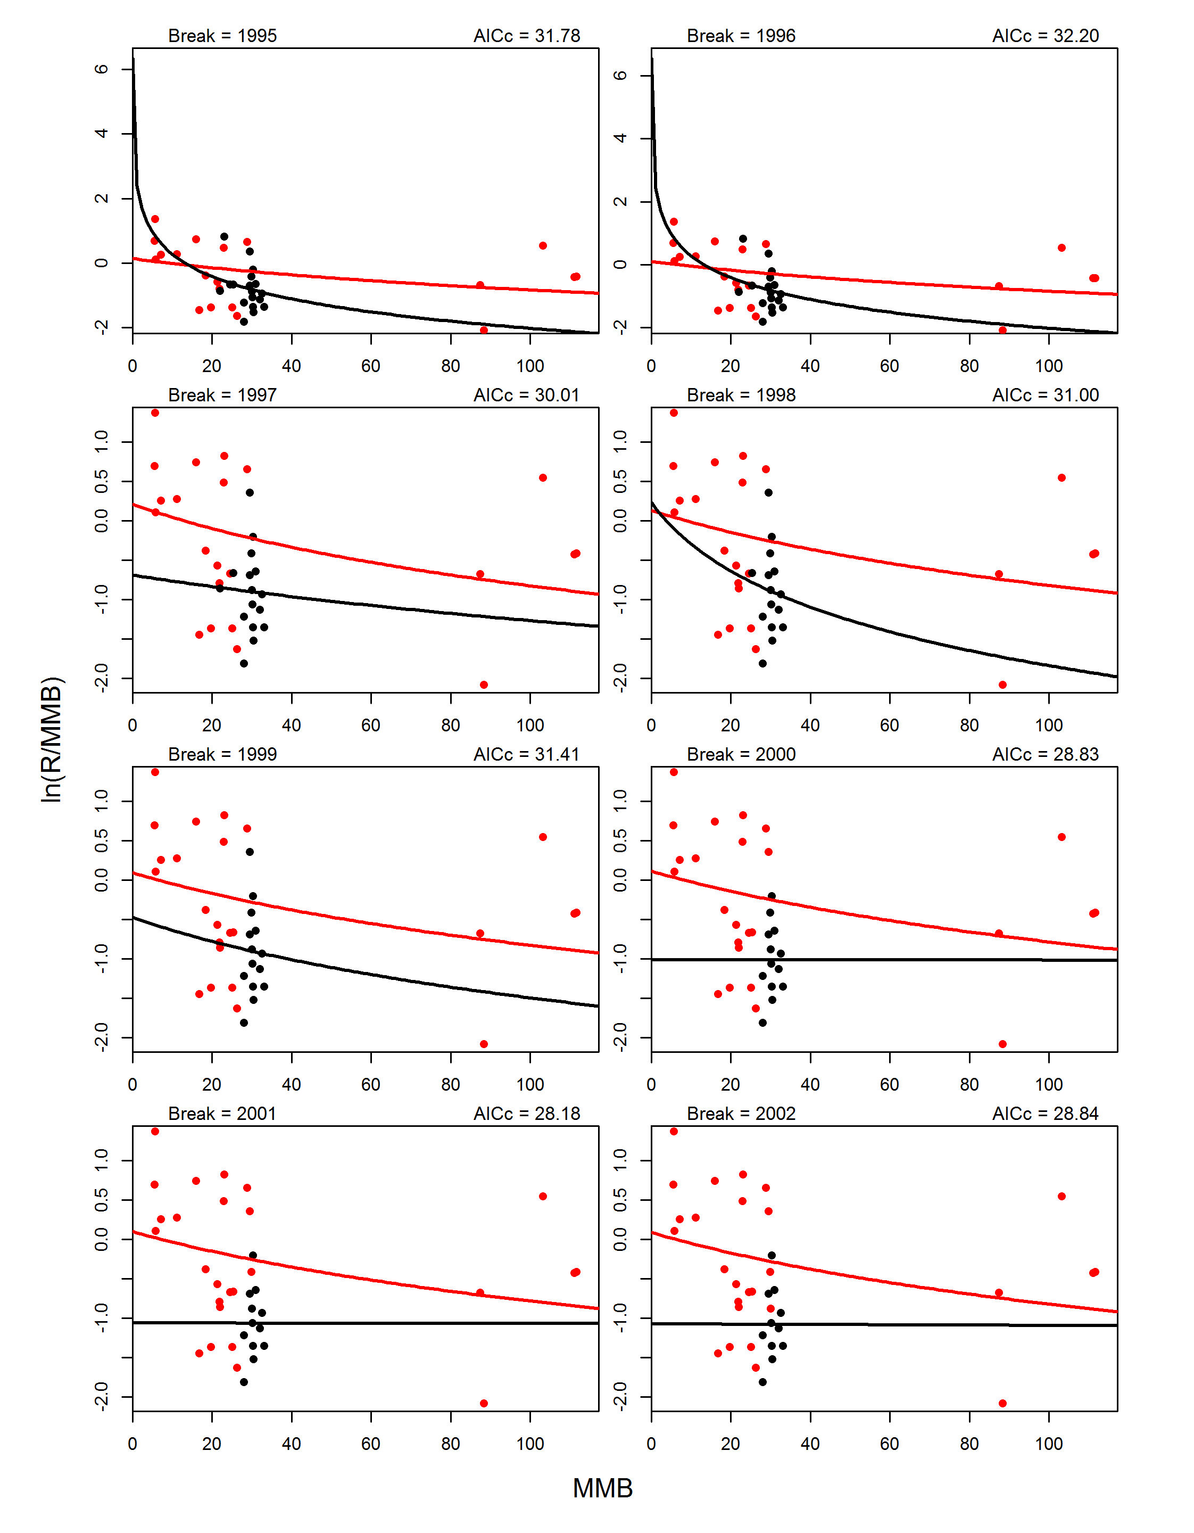
Figure B5. Continue.
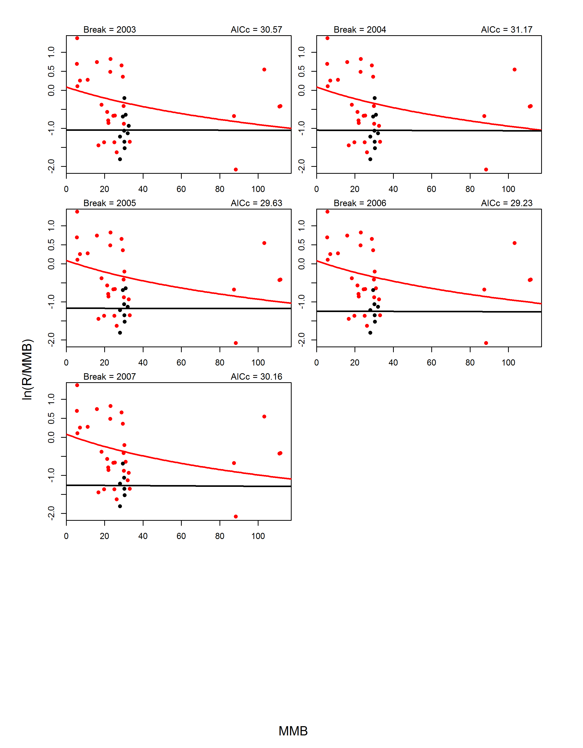
Figure B5. Continue.
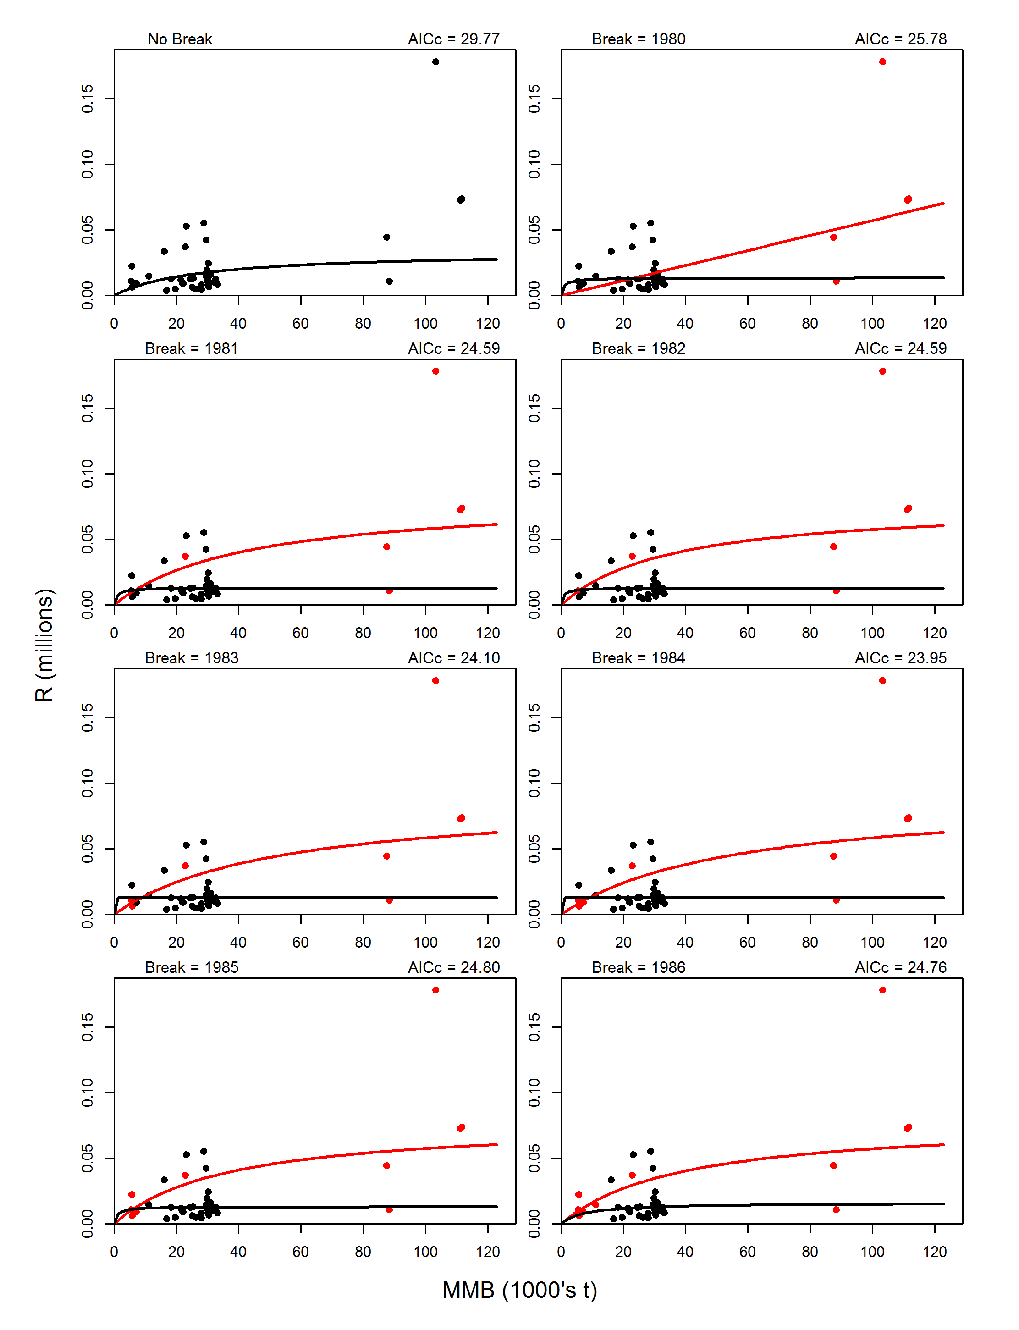
Figure B6. Fits on the arithmetic scale for B-H models with no breakpoint (upper left graph) and with 1-breakpoint for break years 1975-2007. For 1-breakpoint models, the pre-break data (circles) and model fit (line) are shown in red, whereas the post-break data and fit are shown in black.
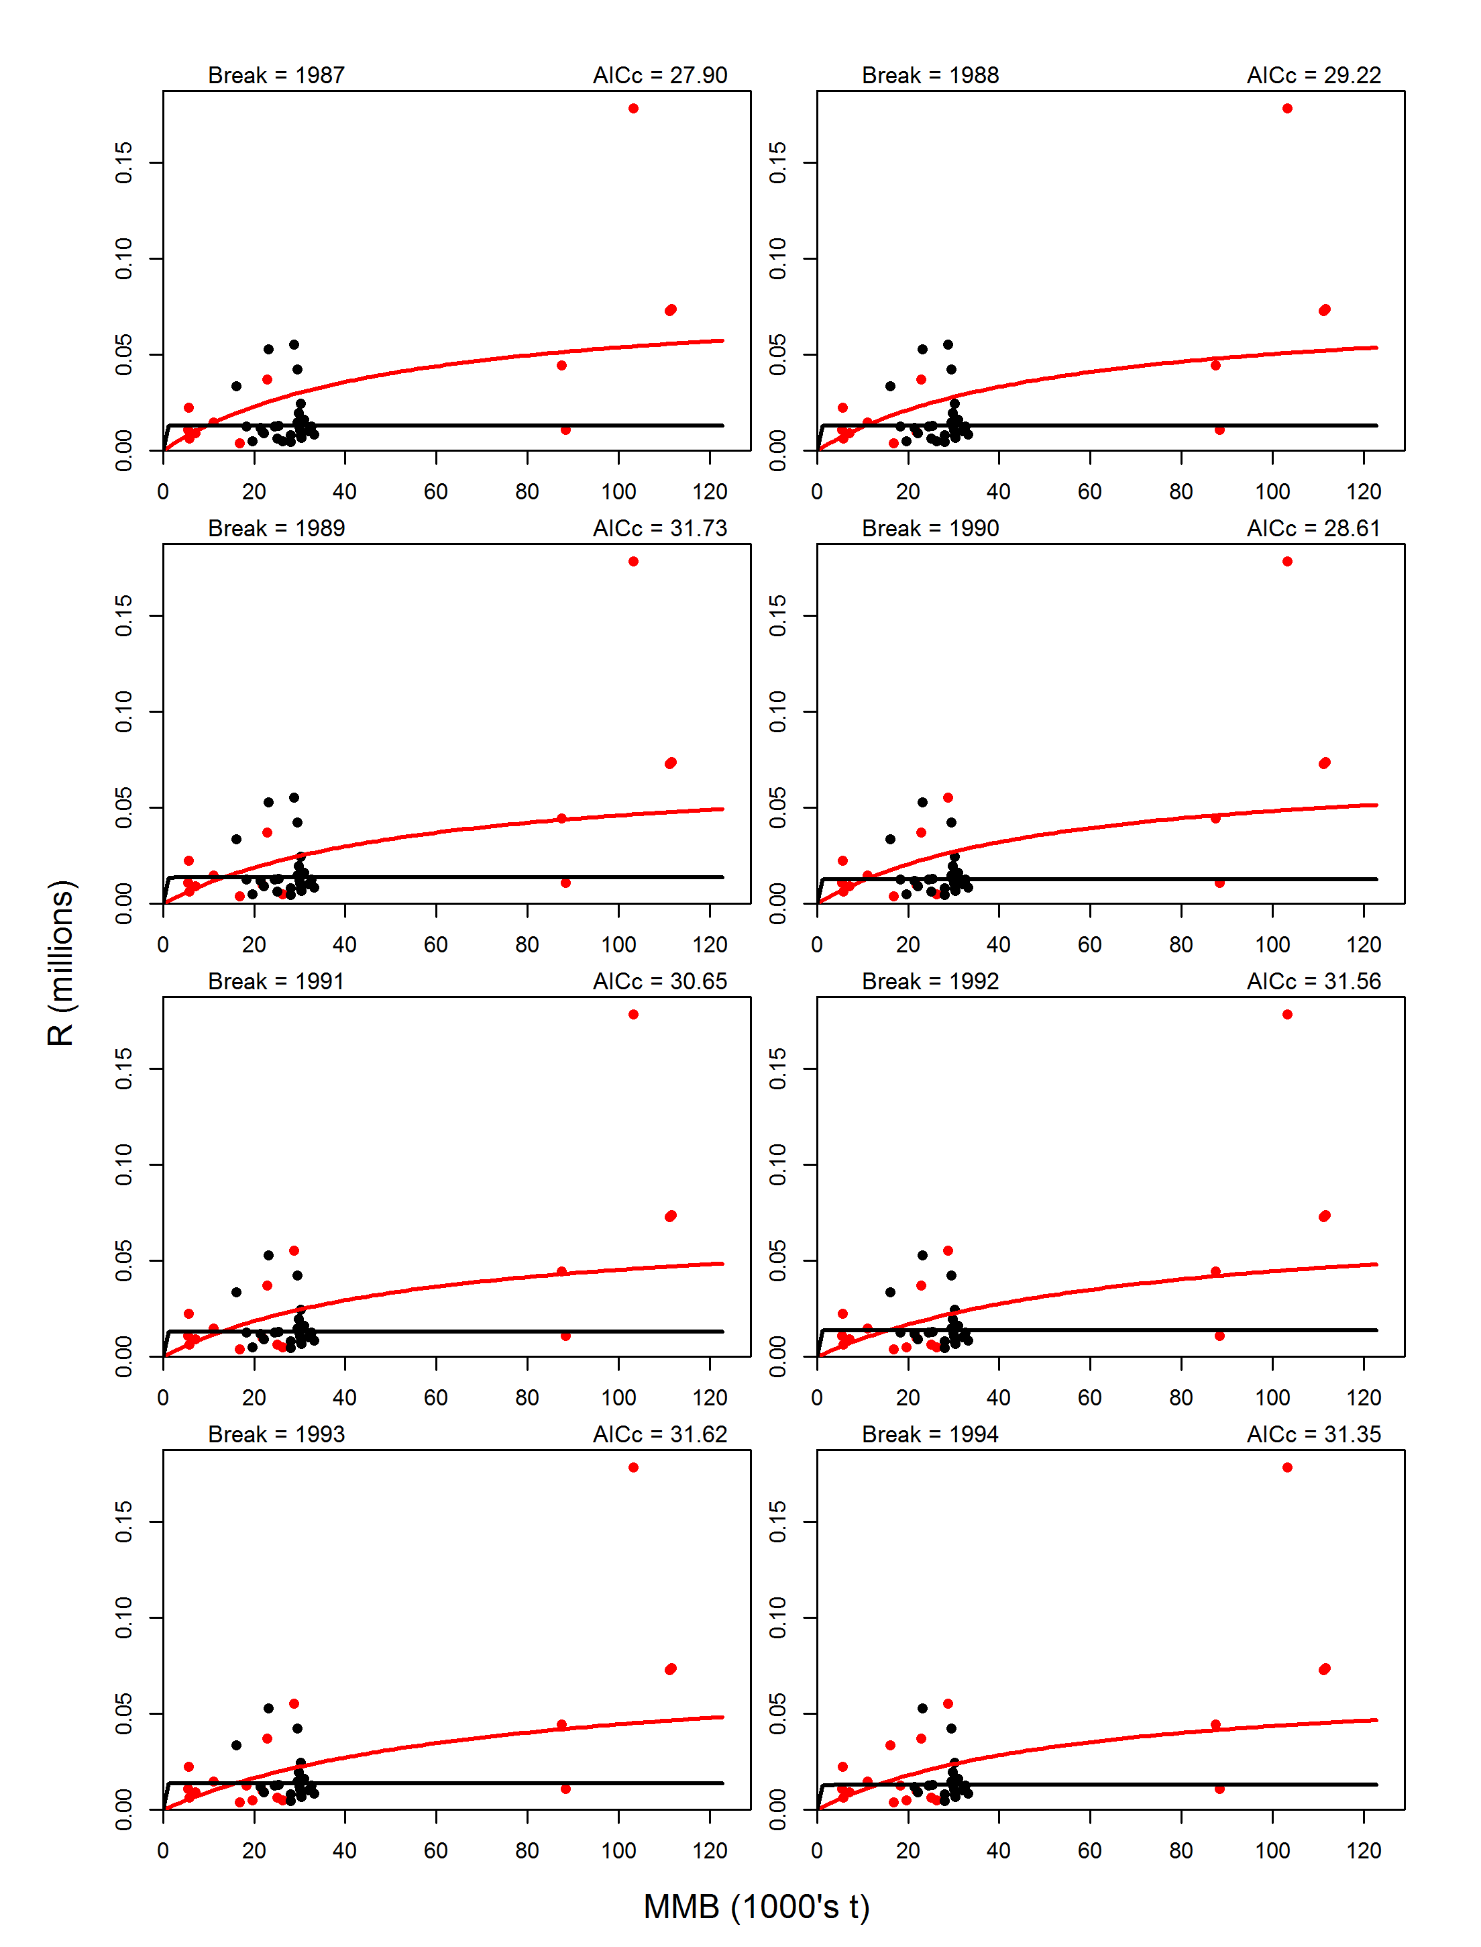
Figure B6. Continue.

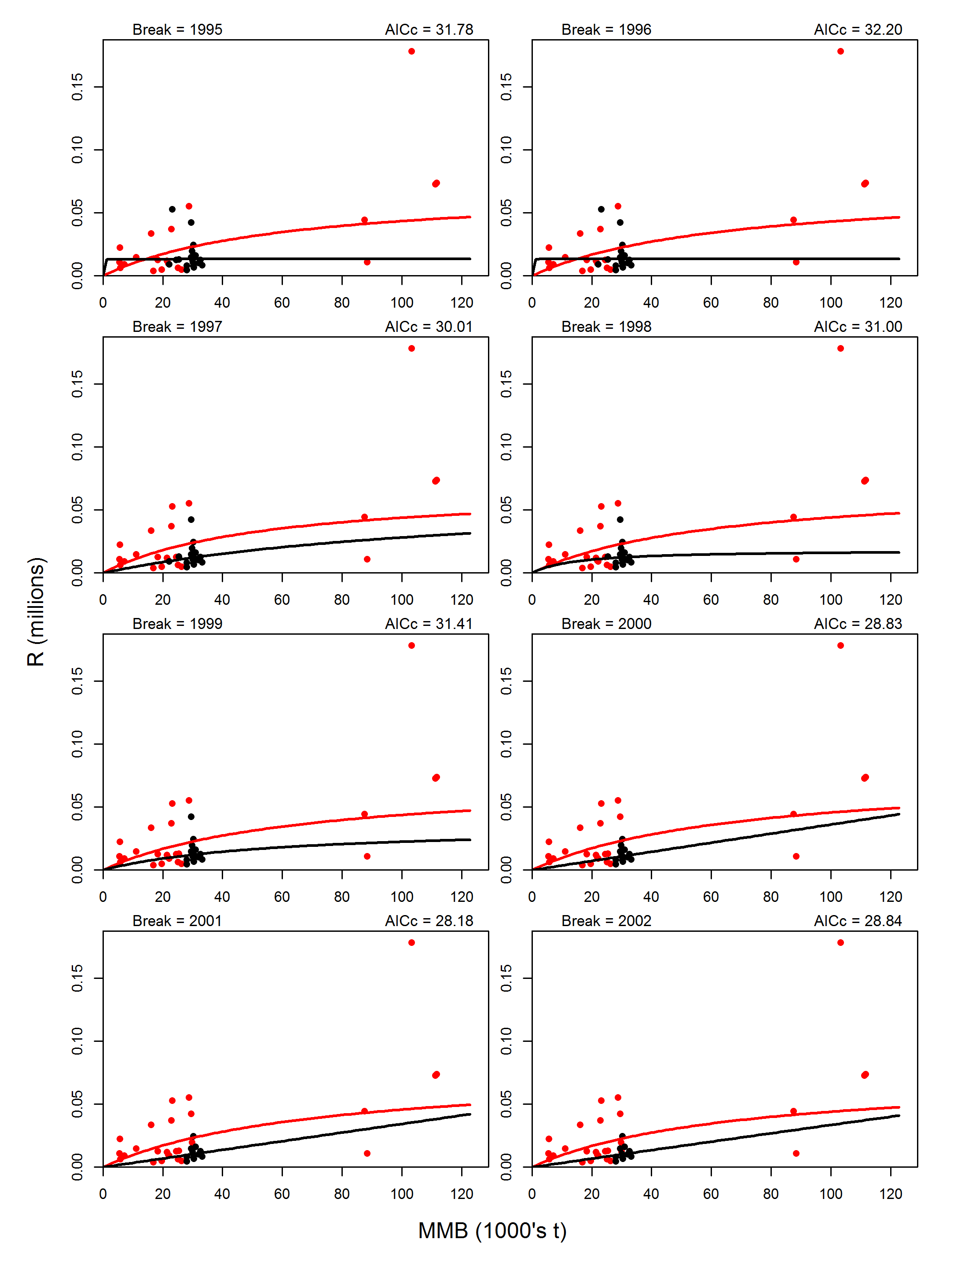
Figure B6. Continue.

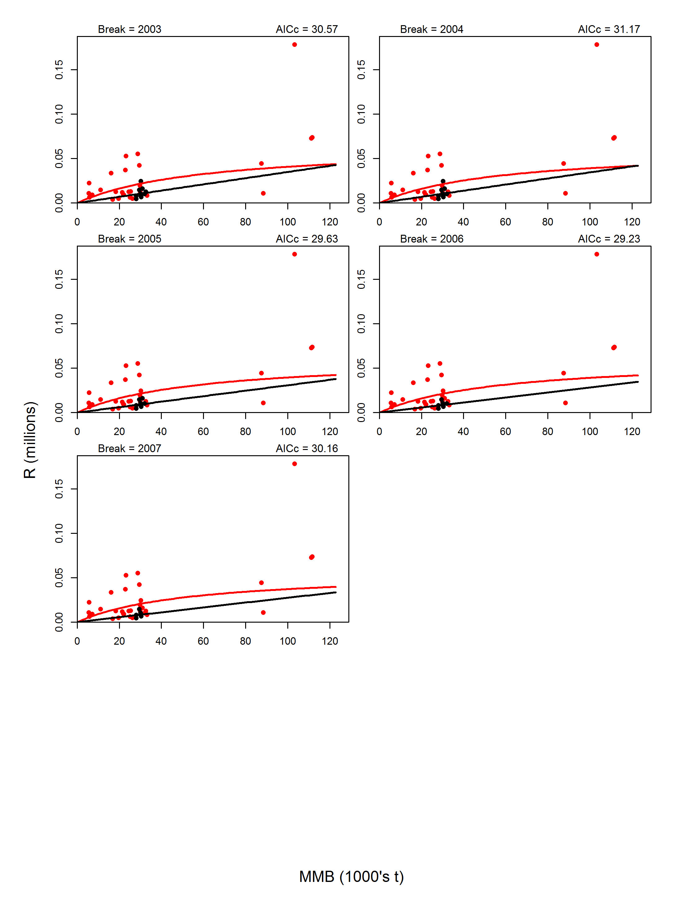
Figure B6. Continue.

Appendix C. Simple B0 Analysis

Ideally, a stock-recruitment relationship and impacts of environmental factors on recruitment are developed before doing B0 analysis. For Bristol Bay red king crab, there is hardly any relationship between estimated recruits and MMB (Figure 14a). The impacts of environmental factors on recruitment have not been quantified. We simply computed B0 values over time using the same recruitment time series estimated from the assessment model through setting all directed and bycatch fishing mortality to be zero. Figure C1 shows the time series of estimated B0, MMB with fishing, and ratios of MMB to B0 for model 18.0e. As expected, estimated B0 values change greatly over time.

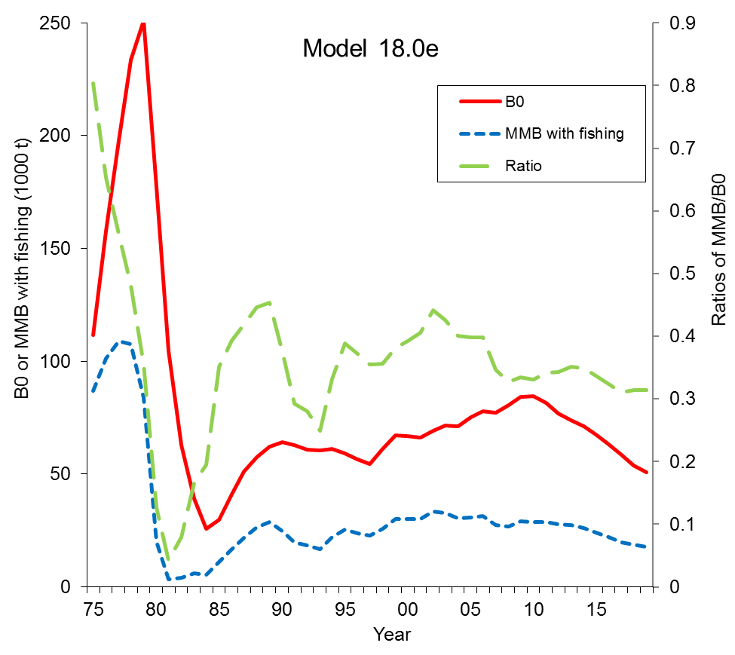
Figure C1. Estimated B0, MMB with fishing, and ratios of MMB/B0 from 1975 to 2019 for model 18.0e for Bristol Bay red king crab.
Appendix D. Control File for Model 19.4

## ————————————————————————————————————————— ##
## LEADING PARAMETER CONTROLS ##
## Controls for leading parameter vector (theta) ##
## LEGEND ##
## prior: 0 = uniform, 1 = normal, 2 = lognormal, 3 = beta, 4 = gamma ##
## ————————————————————————————————————————— ##
## ntheta
91
## ————————————————————————————————————————— ##
## ival lb ub phz prior p1 p2 # parameter ##
## ————————————————————————————————————————— ##
0.18 0.15 0.2 -4 2 0.18 0.04 # M
# 0.18 0.15 0.4 4 2 0.18 0.03 # M
0.0 -0.4 0.4 4 1 0.0 0.03 # M
16.5 -10 18 -2 0 -10.0 20.0 # logR0
19.5 -10 25 3 0 10.0 25.0 # logRini, to estimate if NOT initialized at unfished (n68)
16.5 -10 25 1 0 10.0 20.0 #1 # logRbar, to estimate if NOT initialized at unfished #1
72.5 55 100 -4 1 72.5 7.25 # recruitment expected value (males or combined)
0.726149 0.32 1.64 3 0 0.1 5.0 # recruitment scale (variance component) (males or combined)
0.00 -5 5 -4 0 0.0 20.00 # recruitment expected value (females)
0.00 -1.69 0.40 3 0 0.0 20.0 # recruitment scale (variance component) (females)
-0.10536 -10 0.75 -4 0 -10.0 0.75 # ln(sigma_R)
#-0.10 -5 5.0 4 0 -10.0 10.0 # ln(sigma_R)
0.75 0.20 1.00 -2 3 3.0 2.00 # steepness
0.01 0.00 1.00 -3 3 1.01 1.01 # recruitment autocorrelation
# 0.00 -10 4 2 0 10.0 20.00 # Deviation for size-class 1 (normalization class)
1.107962885630 -10 4 9 0 10.0 20.00 # Deviation for size-class 2
0.563229168219 -10 4 9 0 10.0 20.00 # Deviation for size-class 3
0.681928313426 -10 4 9 0 10.0 20.00 # Deviation for size-class 4
0.491057364532 -10 4 9 0 10.0 20.00 # Deviation for size-class 5
0.407911777560 -10 4 9 0 10.0 20.00 # Deviation for size-class 6
0.436516142684 -10 4 9 0 10.0 20.00 # Deviation for size-class 7
0.40612675395550 -10 4 9 0 10.0 20.00 # Deviation for size-class 8
0.436145974880 -10 4 9 0 10.0 20.00 # Deviation for size-class 9
0.40494522852708 -10 4 9 0 10.0 20.00 # Deviation for size-class 10
0.30401970466854 -10 4 9 0 10.0 20.00 # Deviation for size-class 11
0.2973752673022 -10 4 9 0 10.0 20.00 # Deviation for size-class 12
0.1746800712364 -10 4 9 0 10.0 20.00 # Deviation for size-class 13
0.0845298456942 -10 4 9 0 10.0 20.00 # Deviation for size-class 14
0.0107462399193 -10 4 9 0 10.0 20.00 # Deviation for size-class 15
-0.190468322904 -10 4 9 0 10.0 20.00 # Deviation for size-class 16
-0.376312503735 -10 4 9 0 10.0 20.00 # Deviation for size-class 17
-0.699162895473 -10 4 9 0 10.0 20.00 # Deviation for size-class 18
-1.15881771530 -10 4 9 0 10.0 20.00 # Deviation for size-class 19
-1.17311583316 -10 4 9 0 10.0 20.00 # Deviation for size-class 20
-100.00 -101 5 -2 0 10.0 20.00 # Deviation for size-class 1
-100.00 -101 5 -2 0 10.0 20.00 # Deviation for size-class 2
-100.00 -101 5 -2 0 10.0 20.00 # Deviation for size-class 3
-100.00 -101 5 -2 0 10.0 20.00 # Deviation for size-class 4
-100.00 -101 5 -2 0 10.0 20.00 # Deviation for size-class 5
-100.00 -101 5 -2 0 10.0 20.00 # Deviation for size-class 6
-100.00 -101 5 -2 0 10.0 20.00 # Deviation for size-class 7
-100.00 -101 5 -2 0 10.0 20.00 # Deviation for size-class 8
-100.00 -101 5 -2 0 10.0 20.00 # Deviation for size-class 9
-100.00 -101 5 -2 0 10.0 20.00 # Deviation for size-class 10
-100.00 -101 5 -2 0 10.0 20.00 # Deviation for size-class 11
-100.00 -101 5 -2 0 10.0 20.00 # Deviation for size-class 12
-100.00 -101 5 -2 0 10.0 20.00 # Deviation for size-class 13
-100.00 -101 5 -2 0 10.0 20.00 # Deviation for size-class 14
-100.00 -101 5 -2 0 10.0 20.00 # Deviation for size-class 15
-100.00 -101 5 -2 0 10.0 20.00 # Deviation for size-class 16
-100.00 -101 5 -2 0 10.0 20.00 # Deviation for size-class 17
-100.00 -101 5 -2 0 10.0 20.00 # Deviation for size-class 18
-100.00 -101 5 -2 0 10.0 20.00 # Deviation for size-class 19
-100.00 -101 5 -2 0 10.0 20.00 # Deviation for size-class 20
0.425704202053 -10 4 9 0 10.0 20.00 # Deviation for size-class 1
2.268408592660 -10 4 9 0 10.0 20.00 # Deviation for size-class 2
1.810451373080 -10 4 9 0 10.0 20.00 # Deviation for size-class 3
1.37035725111 -10 4 9 0 10.0 20.00 # Deviation for size-class 4
1.158258087990 -10 4 9 0 10.0 20.00 # Deviation for size-class 5
0.596196784439 -10 4 9 0 10.0 20.00 # Deviation for size-class 6
0.225756761257 -10 4 9 0 10.0 20.00 # Deviation for size-class 7
-0.0247857565368 -10 4 9 0 10.0 20.00 # Deviation for size-class 8
-0.214045895269 -10 4 9 0 10.0 20.00 # Deviation for size-class 9
-0.560539577780 -10 4 9 0 10.0 20.00 # Deviation for size-class 10
-0.974218300021 -10 4 9 0 10.0 20.00 # Deviation for size-class 11
-1.24580072031 -10 4 9 0 10.0 20.00 # Deviation for size-class 12
-1.49292897450 -10 4 9 0 10.0 20.00 # Deviation for size-class 13
-1.94135821253 -10 4 9 0 10.0 20.00 # Deviation for size-class 14
-2.05101560679 -10 4 9 0 10.0 20.00 # Deviation for size-class 15
-1.94956606430 -10 4 9 0 10.0 20.00 # Deviation for size-class 16
-100.00 -101 5 -2 0 10.0 20.00 # Deviation for size-class 17
-100.00 -101 5 -2 0 10.0 20.00 # Deviation for size-class 18
-100.00 -101 5 -2 0 10.0 20.00 # Deviation for size-class 19
-100.00 -101 5 -2 0 10.0 20.00 # Deviation for size-class 20
-100.00 -101 5 -2 0 10.0 20.00 # Deviation for size-class 1
-100.00 -101 5 -2 0 10.0 20.00 # Deviation for size-class 2
-100.00 -101 5 -2 0 10.0 20.00 # Deviation for size-class 3
-100.00 -101 5 -2 0 10.0 20.00 # Deviation for size-class 4
-100.00 -101 5 -2 0 10.0 20.00 # Deviation for size-class 5
-100.00 -101 5 -2 0 10.0 20.00 # Deviation for size-class 6
-100.00 -101 5 -2 0 10.0 20.00 # Deviation for size-class 7
-100.00 -101 5 -2 0 10.0 20.00 # Deviation for size-class 8
-100.00 -101 5 -2 0 10.0 20.00 # Deviation for size-class 9
-100.00 -101 5 -2 0 10.0 20.00 # Deviation for size-class 10
-100.00 -101 5 -2 0 10.0 20.00 # Deviation for size-class 11
-100.00 -101 5 -2 0 10.0 20.00 # Deviation for size-class 12
-100.00 -101 5 -2 0 10.0 20.00 # Deviation for size-class 13
-100.00 -101 5 -2 0 10.0 20.00 # Deviation for size-class 14
-100.00 -101 5 -2 0 10.0 20.00 # Deviation for size-class 15
-100.00 -101 5 -2 0 10.0 20.00 # Deviation for size-class 16
-100.00 -101 5 -2 0 10.0 20.00 # Deviation for size-class 17
-100.00 -101 5 -2 0 10.0 20.00 # Deviation for size-class 18
-100.00 -101 5 -2 0 10.0 20.00 # Deviation for size-class 19
-100.00 -101 5 -2 0 10.0 20.00 # Deviation for size-class 20

# weight-at-length input method (1 = allometry [w_l = a*l^b], 2 = vector by sex)
2
## Males
0.000224781 0.000281351 0.000346923 0.000422209 0.000507927 0.000604802 0.000713564 0.00083495 0.0009697 0.00111856 0.00128229 0.00146163 0.00165736 0.00187023 0.00210101 0.00235048 0.00261942 0.00290861 0.00321882 0.0039059
## Females
0.0002151 0.00026898 0.00033137 0.00040294 0.00048437 0.00062711 0.0007216 0.00082452 0.00093615 0.00105678 0.00118669 0.00132613 0.00147539 0.00163473 0.00180441 0.00218315 0.00218315 0.00218315 0.00218315 0.0021831
# Proportion mature by sex
0 0 0 0 0 0 0 0 0 0 0 1 1 1 1 1 1 1 1 1
0 0 0 0 0 1 1 1 1 1 1 1 1 1 1 1 1 1 1 1
# Proportion legal by sex
0 0 0 0 0 0 0 0 0 0 0 1 1 1 1 1 1 1 1 1
0 0 0 0 0 0 0 0 0 0 0 0 0 0 0 0 0 0 0 0

## ————————————————————————————————————————— ##

## ————————————————————————————————————————— ##
## GROWTH PARAMETER CONTROLS ##
## Two lines for each parameter if split sex, one line if not ##
## ————————————————————————————————————————— ##
# Use growth transition matrix option (1=read in growth-increment matrix; 2=read in size-transition; 3=gamma distribution for size-increment; 4=gamma distribution for size after increment)
3
# growth increment model (1=alpha/beta; 2=estimated by size-class;3=pre-specified/emprical)
3
# molt probability function (0=pre-specified; 1=flat;2=declining logistic)
2
# Maximum size-class for recruitment(males then females)
7 5
## number of size-increment periods
1 3
## Year(s) size-incremnt period changes (blank if no changes)
1983 1994
## number of molt periods
2 2
## Year(s) molt period changes (blank if no changes)
1980 1980
## Beta parameters are relative (1=Yes;0=no)
1

## —————————————————————————————————————————— ##
## ival lb ub phz prior p1 p2 # parameter ##
## —————————————————————————————————————————— ##
16.5 0 20 -33 0 0 999 # Males
16.5 0 20 -33 0 0 999 # Males
16.4 0 20 -33 0 0 999 # Males
16.3 0 20 -33 0 0 999 # Males
16.3 0 20 -33 0 0 999 # Males
16.2 0 20 -33 0 0 999 # Males
16.2 0 20 -33 0 0 999 # Males
16.1 0 20 -33 0 0 999 # Males
16.1 0 20 -33 0 0 999 # Males
16 0 20 -33 0 0 999 # Males
16 0 20 -33 0 0 999 # Males
15.9 0 20 -33 0 0 999 # Males
15.8 0 20 -33 0 0 999 # Males
15.8 0 20 -33 0 0 999 # Males
15.7 0 20 -33 0 0 999 # Males
15.7 0 20 -33 0 0 999 # Males
15.6 0 20 -33 0 0 999 # Males
15.6 0 20 -33 0 0 999 # Males
15.5 0 20 -33 0 0 999 # Males
15.5 0 20 -33 0 0 999 # Males
#1.38403 0.5 3.7 7 0 0 999 # Males (beta)
1.0 0.5 3.0 6 0 0 999 # Males (beta)
13.8 0 20 -33 0 0 999 # Females
12.2 0 20 -33 0 0 999 # Females
10.5 0 20 -33 0 0 999 # Females
8.4 0 20 -33 0 0 999 # Females
7.5 0 20 -33 0 0 999 # Females
7 0 20 -33 0 0 999 # Females
6.6 0 20 -33 0 0 999 # Females
6.1 0 20 -33 0 0 999 # Females
5.6 0 20 -33 0 0 999 # Females
5.1 0 20 -33 0 0 999 # Females
4.6 0 20 -33 0 0 999 # Females
4.1 0 20 -33 0 0 999 # Females
3.6 0 20 -33 0 0 999 # Females
3.2 0 20 -33 0 0 999 # Females
2.7 0 20 -33 0 0 999 # Females
2.2 0 20 -33 0 0 999 # Females
1.7 0 20 -33 0 0 999 # Females
1.2 0 20 -33 0 0 999 # Females
0.7 0 20 -33 0 0 999 # Females
0.4 0 20 -33 0 0 999 # Females
#1.38403 0.5 3.0 7 0 0 999 # Females (beta)
1.5 0.5 3.0 6 0 0 999 # Females (beta)
15.4 0 20 -33 0 0 999 # Females
13.8 0 20 -33 0 0 999 # Females
12.2 0 20 -33 0 0 999 # Females
10.5 0 20 -33 0 0 999 # Females
8.9 0 20 -33 0 0 999 # Females
7.9 0 20 -33 0 0 999 # Females
7.2 0 20 -33 0 0 999 # Females
6.6 0 20 -33 0 0 999 # Females
6.1 0 20 -33 0 0 999 # Females
5.6 0 20 -33 0 0 999 # Females
5.1 0 20 -33 0 0 999 # Females
4.6 0 20 -33 0 0 999 # Females
4.1 0 20 -33 0 0 999 # Females
3.6 0 20 -33 0 0 999 # Females
3.2 0 20 -33 0 0 999 # Females
2.7 0 20 -33 0 0 999 # Females
2.2 0 20 -33 0 0 999 # Females
1.7 0 20 -33 0 0 999 # Females
1.2 0 20 -33 0 0 999 # Females
0.7 0 20 -33 0 0 999 # Females
0.0 -1.0 1.0 -7 0 0 999 # Females (beta)
#1.38403 0.5 3.7 -7 0 0 999 # Females (beta)
15.1 0 20 -33 0 0 999 # Females
14 0 20 -33 0 0 999 # Females
12.9 0 20 -33 0 0 999 # Females
11.8 0 20 -33 0 0 999 # Females
10.6 0 20 -33 0 0 999 # Females
8.7 0 20 -33 0 0 999 # Females
7.4 0 20 -33 0 0 999 # Females
6.6 0 20 -33 0 0 999 # Females
6.1 0 20 -33 0 0 999 # Females
5.6 0 20 -33 0 0 999 # Females
5.1 0 20 -33 0 0 999 # Females
4.6 0 20 -33 0 0 999 # Females
4.1 0 20 -33 0 0 999 # Females
3.6 0 20 -33 0 0 999 # Females
3.2 0 20 -33 0 0 999 # Females
2.7 0 20 -33 0 0 999 # Females
2.2 0 20 -33 0 0 999 # Females
1.7 0 20 -33 0 0 999 # Females
1.2 0 20 -33 0 0 999 # Females
0.7 0 20 -33 0 0 999 # Females
0.0 -1.0 1.0 -7 0 0 999 # Females (beta)
#1.38403 0.5 3.7 -7 0 0 999 # Females (beta)
## —————————————————————————————————————————— ##

## —————————————————————————————————————————— ##
## MOLTING PROBABILITY CONTROLS ##
## Two lines for each parameter if split sex, one line if not ##
## —————————————————————————————————————————— ##
## ival lb ub phz prior p1 p2 # parameter ##
## —————————————————————————————————————————— ##
## males and combined
145.0386 100. 500.0 3 0 0.0 999.0 # molt_mu males
0.053036 0.02 2.0 3 0 0.0 999.0 # molt_cv males
145.0386 100. 500.0 3 0 0.0 999.0 # molt_mu males
0.053036 0.02 2.0 3 0 0.0 999.0 # molt_cv males
## females
300.0000 5. 500.0 -4 0 0.0 999.0 # molt_mu females (molt every year)
0.01 0.001 9.0 -4 0 0.0 999.0 # molt_cv females (molt every year)
300.0000 5. 500.0 -4 0 0.0 999.0 # molt_mu females (molt every year)
0.01 0.001 9.0 -4 0 0.0 999.0 # molt_cv females (molt every year)
## —————————————————————————————————————————— ##

# The custom growth-increment matrix

# custom molt probability matrix

## —————————————————————————————————————————— ##
## SELECTIVITY CONTROLS ##
## Selectivity P(capture of all sizes). Each gear must have a selectivity and a ##
## retention selectivity. If a uniform prior is selected for a parameter then the ##
## lb and ub are used (p1 and p2 are ignored) ##
## LEGEND ##
## sel type: 0 = parametric, 1 = coefficients (NIY), 2 = logistic, 3 = logistic95, ##
## 4 = double normal (NIY) ##
## gear index: use +ve for selectivity, -ve for retention ##
## sex dep: 0 for sex-independent, 1 for sex-dependent ##
## —————————————————————————————————————————— ##
## Gear-1 Gear-2 Gear-3 Gear-4 Gear-5 Gear-6
## PotFshry TrawlByc TCFshry FixedGr NMFS BSFRF
1 1 1 1 2 1 # selectivity periods
1 0 1 0 0 0 # sex specific selectivity
2 2 2 2 2 2 # male selectivity type
2 2 2 2 2 2 # female selectivity type
0 0 0 0 6 0 #6 # within another gear
0 0 0 0 0 0 #-NEW: extra parameters for each pattern by fleet, males
0 0 0 0 0 0 #-NEW: extra parameters for each pattern by fleet, females
## Gear-1 Gear-2 Gear-3 Gear-4 Gear-5 Gear-6
2 1 1 1 1 1 # retention periods
1 0 0 0 0 0 # sex specific retention
2 6 6 6 6 6 # male retention type
6 6 6 6 6 6 # female retention type
1 0 0 0 0 0 # male retention flag (0 = no, 1 = yes)
0 0 0 0 0 0 # female retention flag (0 = no, 1 = yes)
0 0 0 0 0 0 #-NEW: extra parameters for each pattern by fleet, males
0 0 0 0 0 0 #-NEW: extra parameters for each pattern by fleet, females

## —————————————————————————————————————————— ##
## gear par sel start end ##
## index index par sex ival lb ub prior p1 p2 phz period period ##
## —————————————————————————————————————————— ##
# Gear-1
1 1 1 1 125.0000 5 190 0 1 999 4 1975 2018 #4
1 2 2 1 8.0 0.1 20 0 1 999 4 1975 2018 #4
1 3 1 2 84.00 5 150 0 1 999 4 1975 2018
1 4 2 2 4.0000 0.1 20 0 1 999 4 1975 2018
# Gear-2
2 5 1 0 165.0 5 190 0 1 999 4 1975 2018
2 6 2 0 15.0000 0.1 25 0 1 999 4 1975 2018
# Gear-3-
3 7 1 1 115.0 5 190 0 1 999 4 1975 2018
3 8 2 1 15.0 0.1 25 0 1 999 4 1975 2018
3 9 1 2 95.0 5 190 0 1 999 4 1975 2018 # dummy
3 10 2 2 2.5 0.1 25 0 1 999 4 1975 2018
# Gear-4
4 11 1 0 115.0 5 190 0 1 999 4 1975 2018 # dummy
4 12 2 0 9.0 0.1 25 0 1 999 4 1975 2018
# Gear-5
5 13 1 0 75.0 30 190 0 1 999 5 1975 1981 #5
5 14 2 0 6.0 1 50 0 1 999 5 1975 1981 #5
5 15 1 0 75.0 30 190 0 1 999 5 1982 2019 #5
5 16 2 0 7.0 1 50 0 1 999 5 1982 2019 #5
# Gear-6
6 17 1 0 80.0 1 180 0 1 999 5 1975 2019 # 5
6 18 2 0 9.0 1 50 0 1 999 5 1975 2019 # 5
## —————————————————————————————————————————— ##
## Retained ##
## gear par sel start end ##
## index index par sex ival lb ub prior p1 p2 phz period period ##
## —————————————————————————————————————————— ##
# Gear-1
-1 19 1 1 135 1 999 0 1 999 4 1975 2004
-1 20 2 1 2.0 1 20 0 1 999 4 1975 2004
-1 21 1 1 140 1 999 0 1 999 4 2005 2018
-1 22 2 1 2.5 1 20 0 1 999 4 2005 2018
-1 23 1 2 591 1 999 0 1 999 -3 1975 2004
-1 24 1 2 591 1 999 0 1 999 -3 2005 2018
# Gear-2
-2 25 1 0 595 1 999 0 1 999 -3 1975 2018
# Gear-3
-3 26 1 0 595 1 999 0 1 999 -3 1975 2018 #Dummy
# Gear-4
-4 27 1 0 595 1 999 0 1 999 -3 1975 2018
# Gear-5
-5 28 1 0 590 1 999 0 1 999 -3 1975 2019
# Gear-6
-6 29 1 0 580 1 999 0 1 999 -3 1975 2019
## —————————————————————————————————————————— ##

# Number of asyptotic parameters
1
# Fleet Sex Year ival lb ub phz
1 1 1975 0.000001 0 1 -3
# 1 1 2006 0.044000 0 1 -3
# 1 1 2007 0.019700 0 1 -3
# 1 1 2008 0.019875 0 1 -3
# 1 1 2009 0.032750 0 1 -3
# 1 1 2010 0.015320 0 1 -3
# 1 1 2011 0.011250 0 1 -3
# 1 1 2012 0.024045 0 1 -3
# 1 1 2013 0.063200 0 1 -3
# 1 1 2014 0.160500 0 1 -3
# 1 1 2015 0.070950 0 1 -3
# 1 1 2016 0.082600 0 1 -3

## —————————————————————————————————————————— ##
## PRIORS FOR CATCHABILITY ##
## If a uniform prior is selected for a parameter then the lb and ub are used (p1 ##
## and p2 are ignored). ival must be > 0 ##
## LEGEND ##
## prior: 0 = uniform, 1 = normal, 2 = lognormal, 3 = beta, 4 = gamma ##
## —————————————————————————————————————————— ##
## ival lb ub phz prior p1 p2 Analytic? LAMBDA Emphasis
0.896 0 2 6 1 0.896 0.03 0 1 1
1.0 0 5 -6 0 0.001 5.00 0 1 1 # BSFRF
## —————————————————————————————————————————— ##

## —————————————————————————————————————————— ##
## ADDITIONAL CV FOR SURVEYS/INDICES ##
## If a uniform prior is selected for a parameter then the lb and ub are used (p1 ##
## and p2 are ignored). ival must be > 0 ##
## LEGEND ##
## prior type: 0 = uniform, 1 = normal, 2 = lognormal, 3 = beta, 4 = gamma ##
## —————————————————————————————————————————— ##
## ival lb ub phz prior p1 p2
0.0001 0.00001 10.0 -4 4 1.0 100 # NMFS
0.25 0.00001 10.0 9 0 0.001 1.00 # BSFRF
## —————————————————————————————————————————— ##

## —————————————————————————————————————————— ##
## PENALTIES FOR AVERAGE FISHING MORTALITY RATE FOR EACH GEAR
## —————————————————————————————————————————— ##
## Mean_F Female Offset STD_PHZ1 STD_PHZ2 PHZ_M PHZ_F Bounds
0.22313 0.0505 0.5 45.50 1 1 -12 4 -10 2.95 -10 10 # Pot
0.0183156 1.0 0.5 45.50 1 -1 -12 4 -10 10 -10 10 # Trawl
0.011109 1.0 0.5 45.50 1 1 -12 4 -10 10 -10 10 # Tanner (-1 -5)
0.011109 1.0 0.5 45.50 1 -1 -12 4 -10 10 -10 10 # Fixed
0.00 0.0 2.00 20.00 -1 -1 -12 4 -10 10 -10 10 # NMFS trawl survey (0 catch)
0.00 0.0 2.00 20.00 -1 -1 -12 4 -10 10 -10 10 # BSFRF (0)
## —————————————————————————————————————————— ##

## —————————————————————————————————————————— ##
## OPTIONS FOR SIZE COMPOSTION DATA ##
## One column for each data matrix ##
## LEGEND ##
## Likelihood: 1 = Multinomial with estimated/fixed sample size ##
## 2 = Robust approximation to multinomial ##
## 3 = logistic normal (NIY) ##
## 4 = multivariate-t (NIY) ##
## 5 = Dirichlet ##
## AUTO TAIL COMPRESSION ##
## pmin is the cumulative proportion used in tail compression ##
## —————————————————————————————————————————— ##
# Pot Trawl Tanner Fixed NMFS BSFRF
2 2 2 2 2 2 2 2 2 2 2 2 2 # Type of likelihood
0 0 0 0 0 0 0 0 0 0 0 0 0 # Auto tail compression (pmin)
1 1 1 1 1 1 1 1 1 1 1 1 1 # Initial value for effective sample size multiplier
-4 -4 -4 -4 -4 -4 -4 -4 -4 -4 -4 -4 -4 # Phz for estimating effective sample size (if appl.)
1 2 3 4 4 5 5 6 6 7 7 8 8 # Composition aggregator
1 1 1 1 1 1 1 1 1 1 1 1 1 # LAMBDA
1 1 1 1 1 1 1 1 1 1 1 1 1 # Emphasis AEP
## —————————————————————————————————————————— ##

## —————————————————————————————————————————— ##
## TIME VARYING NATURAL MORTALIIY RATES ##
## LEGEND ##
## Type: 0 = constant natural mortality ##
## 1 = Random walk (deviates constrained by variance in M) ##
## 2 = Cubic Spline (deviates constrained by nodes & node-placement) ##
## 3 = Blocked changes (deviates constrained by variance at specific knots) ##
## 4 = Time blocks ##
## —————————————————————————————————————————— ##
## Type
6
## M is relative (YES=1; NO=0)
1
## Phase of estimation
3
## STDEV in m_dev for Random walk
0.25
## Number of nodes for cubic spline or number of step-changes for option 3
2
2
## Year position of the knots (vector must be equal to the number of nodes)
1980 1985
1980 1985
# number of breakpoints in M by size
0
## Specific initial values for the natural mortality devs (0-no, 1=yes)
1
## —————————————————————————————————————————— ##
## ival lb ub phz extra prior p1 p2 # parameter ##
## —————————————————————————————————————————— ##
1.5342575 0 2 8 0
0.000000 -2 2 -99 0
# 0.22 0 2 8 0
1.780586 0 2 -8 -1
# 9.262792 0 2 -8 -3
0.000000 -2 2 -99 0
## —————————————————————————————————————————— ##

## —————————————————————————————————————————— ##
## OTHER CONTROLS
## —————————————————————————————————————————— ##
1975 # First rec_dev
2018 # last rec_dev
2 # Estimated rec_dev phase
2 # Estimated sex_ratio
0.5 # initial sex-ratio
-3 # Estimated rec_ini phase
1 # VERBOSE FLAG (0 = off, 1 = on, 2 = objective func; 3 diagnostics)
3 # Initial conditions (0 = Unfished, 1 = Steady-state fished, 2 = Free parameters, 3 = Free parameters (revised))
1 # Lambda (proportion of mature male biomass for SPR reference points).
0 # Stock-Recruit-Relationship (0 = none, 1 = Beverton-Holt)
10 # Maximum phase (stop the estimation after this phase).
-1 # Maximum number of function calls

## —————————————————————————————————————————— ##
## EMPHASIS FACTORS (CATCH)
## —————————————————————————————————————————— ##
#Ret_male Disc_male Disc_female Disc_trawl Disc_Tanner_male Disc_Tanner_female Disc_fixed
1 1 1 1 1 1 1
# 500 100 100 50 100 100 50

## —————————————————————————————————————————— ##
## EMPHASIS FACTORS (Priors)
## —————————————————————————————————————————— ##
# Log_fdevs meanF Mdevs Rec_devs Initial_devs Fst_dif_dev Mean_sex-Ratio
10000 0 1.0 2 0 0 10 #(10000)

## EOF
9999

