Bering Sea Fishery Ecosystem Plan:

Action Module to evaluate short- to long-term effects of climate change on fish, fisheries, and the Bering Sea Ecosystem, and develop management considerations
Feb 2020 DRAFT Action Module Workplan
Contents
Module Goal 2
Introduction 2
Action Module Objectives 4
Action Module Objectives 5
Action Module Results/Products 7
Examples 8
Short-term (1-3 years) 8
Medium-term (5-10 years) 8
Long-term (> 10 years) 8
How it will be implemented in the Council process 9
Planning and Logistics 10
How Action Module will interface with existing work 10
Action Module Taskforce 10
Deliverables and tracking progress 11
Milestones 11
Requests for Council feedback: 12
References 12
Appendix 1. Action Module Scoping Summary from Core BS FEP 15
Appendix 2: Membership of Climate Change Taskforce 18

Module Goal
The goal of the climate change module is to facilitate equitable climate change adaptation pathways, transparent communication, and broad engagement to support short- and long-term resilience for the coupled social-ecological system of the Bering Sea (see geographic description in the FEP). This module will support the North Pacific Fishery Management Council’s capacity to i) evaluate management tools to develop incremental (normative) adaptation measures to preserve livelihoods, economies, health and wellbeing across fisheries and dependent coastal communities,ii) enable transformative adaptation needed to ensure the productivity and sustainability of the coupled social-ecological Bering Sea system, and iii) encourage transparent, effective, and dynamic communication and engagement of communities, fishers, managers and other stakeholders and the Council. To achieve this, the climate change module will be used to synthesize current knowledge regarding climate change effects on the Bering Sea ecosystem, identify potential climate-resilient management measures that can improve adaptive capacity and avoid maladaptation (Fig. 1), evaluate the risks, timescales, and probability of success of potential climate-resilient management policies under future scenarios of change; and provide short-, medium-, and long-term recommendations for actions that could be considered and initiated by the Council to help advance the goals and minimize the risks identified.
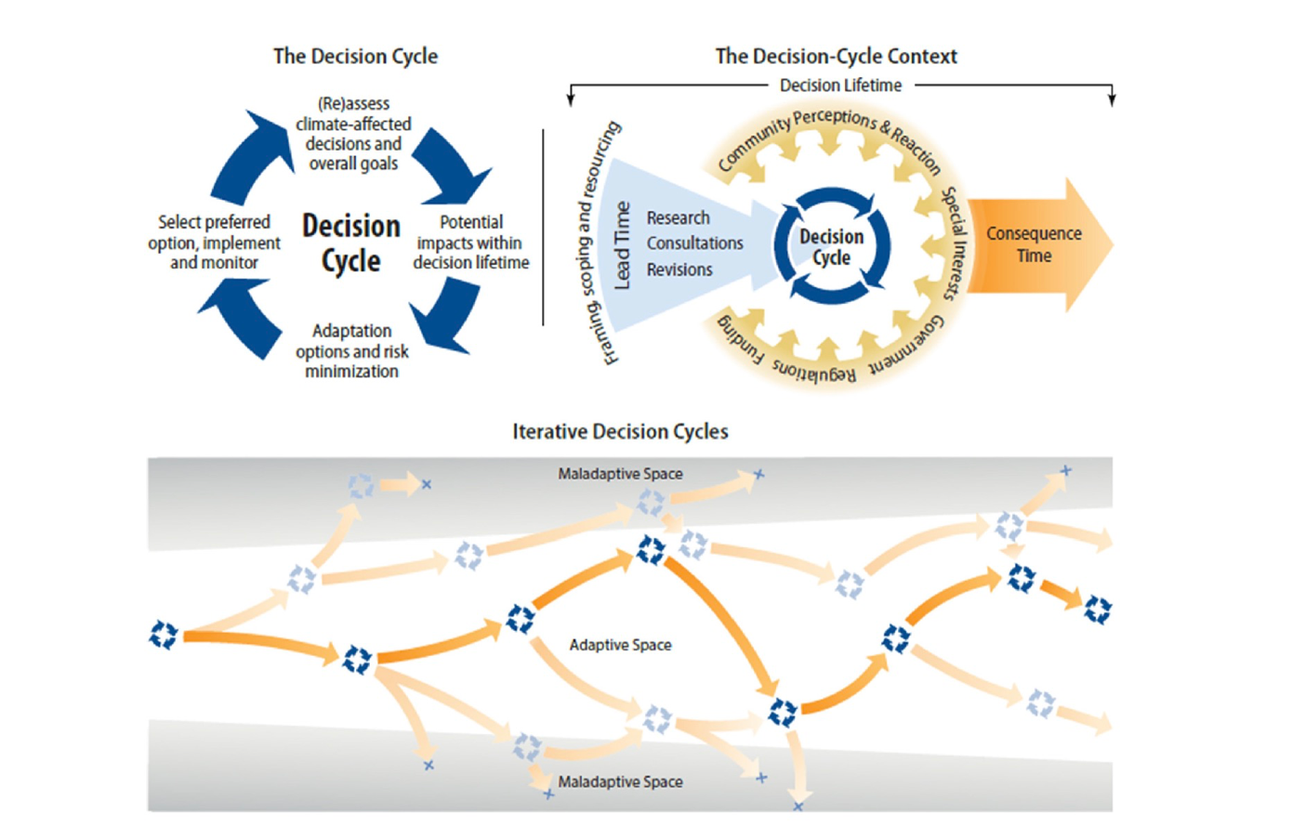
Figure 1 Climate adaptation pathways. From Wise et al. 2014.

Introduction
Coastal communities in the Bering Sea have coevolved with the marine ecosystem for thousands of years and subsistence fisheries and harvest have long been critical for the collective wellbeing and stability of Alaskan communities. Subsistence and commercial fisheries in the Bering Sea also support economic vitality, social prosperity, and food security both within and outside of Alaska (Dumas, 1984, Meredith et al., 2019, Fall et al., 2013; Haynie and Huntington, 2016; Raymond-Yakoubian et al., 2017). For thousands of years this region has had a historically strong connection between the marine system and coastal communities as well as supporting present day regional food security and well being. Bering Sea fisheries are also important for national and global nutrition and food security; one out of every two fish captured annually in the US comes from Alaska, and regional fisheries support a >$5 billion 2018 USD fishing industry, nearly half of which is Bering Sea groundfish harvest. Groundfish fisheries in the Bering Sea have a 30+ year history of proactive science-based adaptive management that is able to adjust to highly productive yet variable ecosystem dynamics. Yet, Bering Sea fisheries are driven by ecological processes and climate conditions that are increasingly extreme and difficult to anticipate (e.g., 2016 and 2018 marine heatwaves and associated negative impacts to seabirds, marine mammals, coastal communities and commercially important groundfish fisheries). The frequency and intensity of marine heatwaves and extreme events in the Bering Sea are projected to increase in coming decades, and conditions are expected to shift markedly over the next 20-50 years (Figure 2). Specifically, marine heatwaves may become more commonplace and severe, winter and summer water temperatures are anticipated to increase, and the duration and frequency of productive “cold” multi-year stanzas are projected to decline (Oliver et al. 2019).
Climate change is very likely to continue to cause changes in distribution, survival, growth, timing, behavior, fisheries catchability, and strength of species interactions. Some of these changes may occur gradually, whereas other species may exhibit sudden threshold-like changes in abundance and distribution in response to changing climate conditions (i.e., as conditions cross ecological “tipping-points”). A recent example is the change in distribution and abundance of multiple groundfish species in the Bering Sea.
Subsistence and commercial fisheries are essential to coastal communities well-being and food security, and as a major contributor to national capture fisheries. In addition, Bering Sea fisheries will be an essential contributor to sustainable and affordable nutrition for the future global population of 9 billion people (2050 UN estimate). Productive future Bering Sea fisheries and harvest will require efficient and sustainable approaches and implementation of cutting edge, “climate-ready” fisheries management tools and policies. Some of these tools may already be in-hand in the context of ecosystem-based management tools (Karp et al. 2019; Holsman et al. 2019) and should be preserved going forward. Others, especially long-term and fixed management policies (e.g., protected areas, annual biomass caps, minimal biomass thresholds), which by design are intended to provide stability and remain stationary even when conditions are variable, may be vulnerable to the one-way trajectory of changing conditions and might require modification or periodic revaluation. To improve fisheries management in the face of climate change, a portfolio management approach that is robust to climatic uncertainty should be developed.

Adaptation:
The IPCC defines adaptation as “the process of adjustment to actual or expected climate change and its effects.” (IPCC 2014, p. 5) This IPCC definition is included here as a starting point, and the CCTF intends to work to create our own definition collaboratively with stakeholders to best suit our purposes in the continued development of this workplan and work products from this module.
Adaptation to support climate resilient social-ecological systems in the Bering Sea includes ecosystem-based management policies that embrace uncertainty, adjust at a rate that is consistent with observed changes (e.g., allows communities and fisheries to adapt in a proactive rather than a solely reactive manner), are inclusive of broad knowledge sources and information that may change and evolve over time, and consider both direct and indirect impacts and interactions with other species, sectors, and stakeholders and the environment. Adaptation can include reactive responses as well as proactive anticipatory planning and prevention. Adaptation is separate from, but can be synergistic with, mitigation measures (which are actions at global or regional scales that aim to reduce or recapture atmospheric CO₂). Climate adaptation is a multi-step and iterative process that includes evaluation of key risks and needs, assessment of available potential tools and approaches, understanding of institutional capacity and feasibility for adaptation planning and implementation (and evolving limits and constraints to adaptation), and interactive inclusive discussions regarding, realized costs, tradeoffs, and benefits of adaptation measures (Meredith et al. 2019).
This module will seek to provide the Council pathways to identify and implement management measures that provide for fisheries adaptation to future climate conditions and to ensure that diverse perspectives are considered when assessing risks, impacts and tradeoffs. The latter relies on both understanding of biological trajectories of change as well as understanding and considering social, cultural, and economic implications and scope for adaptation in the intricately coupled social-ecological Bering Sea ecosystem. Co-production of knowledge is essential for identifying, understanding and promoting pathways of adaptation in both fisheries and fishing communities. Some social and ecological changes could help promote adaptation, but others might intensify negative impacts of climate-driven change. Thus, climate-related advice to managers must include coupled climate-biological-social-economic evaluations in order to inform management actions that effectively address climate-driven impacts, utilize novel opportunities, and identify and promote equitable adaptive pathways. Of particular interest to the Council might be the future performance of existing management approaches and ecosystem-based management measures, such as protected or conservation areas, alternative time-space closures, catch share programs, bycatch reduction incentives, sector/gear specific fishing areas, minimum biomass thresholds that address target and non-target species and upper/lower trophic levels, and aggregate total harvest limits.

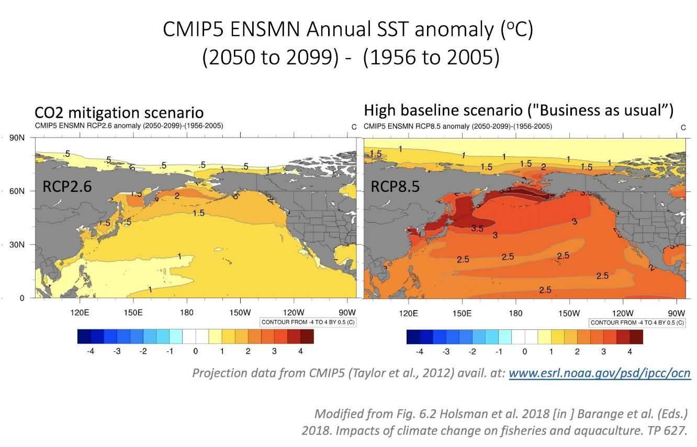
Figure 2 Projected end of century changes in sea surface temperature (SST) anomalies relative to historical SST under global carbon mitigation (left) and unmitigated (right) future scenarios. Based on Coupled Model Intercomparison Project (CMIP) 5 ensemble scenarios.

Action Module Objectives
Overview:
The Bering Sea climate change taskforce is comprised of a diversity of knowledge holders from agency, university, industry, and independent researchers; coastal communities; and non-governmental organizations. Under this module, the taskforce will coordinate to provide a synthesis of anticipated short to long-term climate change impacts on Bering Sea ecosystem, including fish, protected species, fisheries, and coastal communities, and an evaluation and recommendation for management actions. The taskforce will assemble information from recent ongoing and completed efforts, present synthesized results to the Council and other stakeholders for feedback, and work with the Council and stakeholders to develop climate resilient management tools and policies and a plan for their implementation and evaluation.
The end product is a synthesis and proposed Climate resilient fisheries report (e.g., “Bering Sea Fisheries and Climate Change Assessment Report”). The report will specify short-, medium-, and long-term management actions to build climate resilience in regional fisheries and fishing communities. The report will identify knowledge gaps, information requirements, and technological needs that should be addressed in order to promote resilience and adaptation to climate-induced changes (Figure 3). These strategic policies could be implemented as needed between module cycles (see sections 4 and 5 for more detail) and would aim to use long-term management scenario analyses to inform short-term climate-specific decisions during relevant management cycles (e.g., annual groundfish assessment cycle, updates to essential fish habitat designations, updates to marine mammal assessments and species biological opinions). Particular emphasis would be focused on developing tools for the purposes of testing and exploring alternative policy options including: in-season management tools, adaptive management experiments (e.g., temperature-dependent shifts in spatial distribution), and fixed management measures (e.g., long-term ecosystem biomass caps, closure areas, and/or minimal biomass threshold reference points).
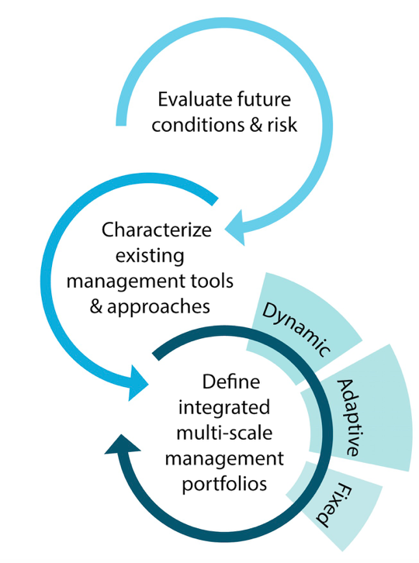
Figure 3 Iterative climate-resilient fisheries management approach. Modified from Holsman et al. 2019.

Action Module Objectives
The primary goal of this climate module is to provide information, pathways, and tools that can be used to ensure equitable climate resilience in the region’s fishery management. Specifically, the module will leverage ongoing, proposed, and completed projects at State and Federal government entities (e.g., AFSC, PMEL), academic institutions, non-governmental organizations, Alaska Native Tribes and Organizations, industry, communities and other stakeholders to address the following objectives:
- Operationalize the delivery of climate change information to the Council to support adaptation through ecosystem based fisheries management, including evaluations of risk and tradeoffs among alternative policies. Such decision making tools may range from simple conceptual models to complex tools that integrate the most recent Intergovernmental Panel on Climate Change projections of carbon mitigation scenarios..
- Coordinate researchers and knowledge holders to synthesize and communicate policy relevant information resulting from a diversity of ongoing and completed climate change experiences, knowledge, and research including, but not limited to:
  - Synthesized current and projected climate change impacts on the coupled social-ecological Bering Sea system through review of diverse sources of knowledge, context and impacts of change and evaluation of future impacts and risks.
  - Indigenous and Traditional Knowledge of climate impacts, adaptation responses, and risks, including direct and cascading impacts of change and response on social and ecological processes and connections.
  - Local knowledge, experience, and testimonials of climate change impacts and adaptation measures
  - Rapid Climate Vulnerability Assessments, which use expert knowledge to identify species and communities vulnerable to climate change and prioritize research needs.
  - Project changes in species productivity, distributions, and phenology which includes projected changes in habitat under future climate scenarios in order to estimate potential shifts in BSAI FMP species distributions and potential fishing grounds (sensu Predicting changes in habitat for groundfishes under future climate scenarios using spatial distribution modeling).
  - Performance, validation, and operationalized delivery of weekly forecasts (up to 9 months from present day) of Bering Sea conditions, fish productivity and distribution, ecosystem condition, and fisheries relevant metrics (e.g., recruitment, predation, growth, energetics) specifically aimed at informing the annual groundfish assessment cycle (sensu The Bering Seasons Project).
- Evaluate the scope of impacts on focal species and communities identified in step (2) with participation from Indigenous, traditional and local knowledge holders, researchers, and other regional and topical experts
- Support proactive climate planning and response through identification and strategic re-evaluation of emergent issues, recent findings, data gaps and research priorities, management strategies, and potential management actions (recommendations only that would be considered through the Council process). Additionally, the CCTF will work with the LKTK module, FEP Team (and/or Council committees, Plan Teams and working groups) to iteratively (annual basis) identify and assess the performance of potential short-term, medium and long-term management actions for climate adaptation (i.e., derive alternative strategies for MSEs).
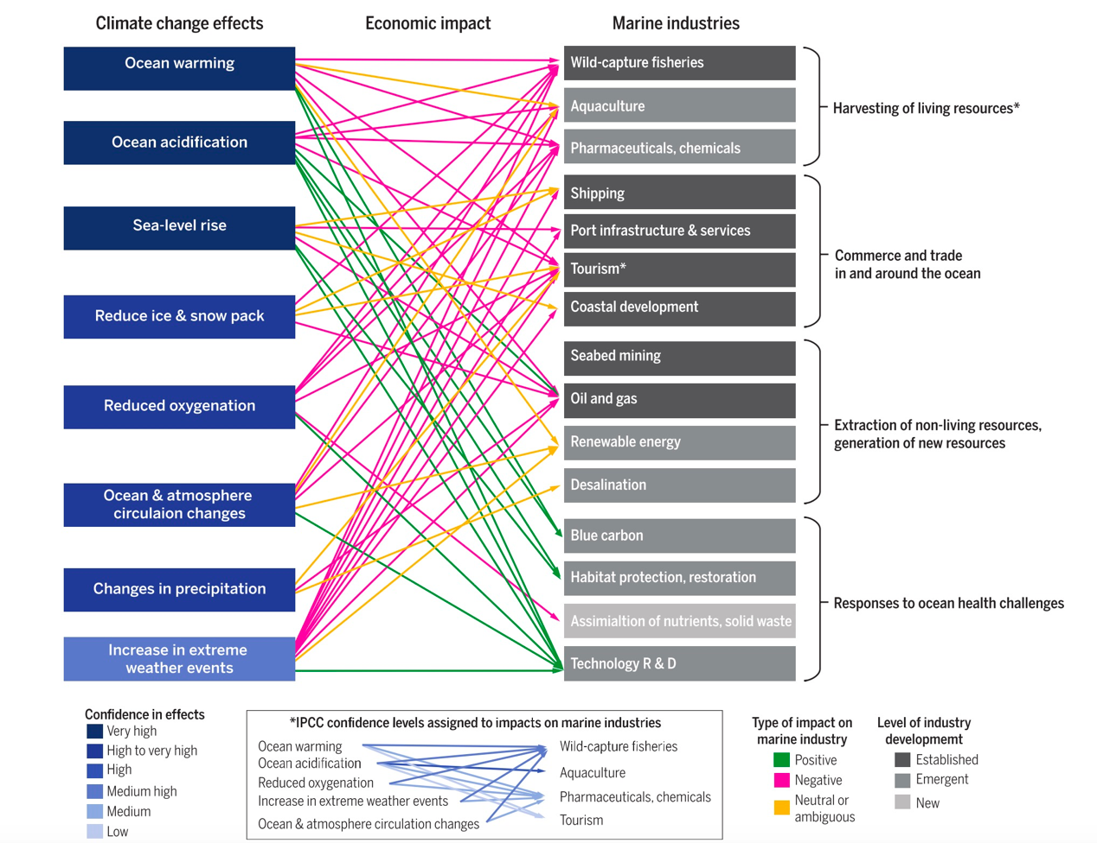
Figure 4 Climate change impacts on marine systems. From Alisson and Bassett 2015.

Action Module Results/Products
This module will result in a synthesis report and framework for recommended short-, medium-, and long-term actions and evaluations that could be implemented by the Council. In this way, the results of this module will help the Council track climate impacts on the Bering Sea ecosystem and ensure that fisheries managers in the region have the right tools to adapt to rapid shifts in species distributions or abundances under future conditions. New tools and pathways can be implemented to ensure that fisheries management best complies with the Magnuson-Stevens Act, including the National Standards, Fishery Management Plan objectives, and other statutory obligations, and that the Council has a more complete understanding impacts to communities as conditions change. Initial studies suggest that the outcome of potential climate change impacts on fish and fisheries in the Bering Sea largely depends on harvest strategies in the region. Climate change represents additional sources of uncertainty in the system that need to be accounted for in trade-off analyses and future policies. Fortunately, completed and ongoing studies continue to advance regional understanding of potential climate change impacts to fish and fisheries.
Short-term “climate-ready” management actions can be co-developed and implemented relatively quickly (e.g. 1-3 year time frame), thus climate change management strategy evaluations would be focused on testing their performance under a wide range of potential future climate conditions. In contrast, modification of medium- and long-term management measures require more specific characterizations of risks and uncertainty around future trajectories (i.e., long-term change as well as the frequency, intensity and recovery from extreme events) mandating thorough interdisciplinary scientific evaluation as well as consistent and regular stakeholder and Council review and feedback. Thus, evaluations under a co-production approach should be initiated early on and should continue until performance under various policies options are fully evaluated.

Examples

Short-term (1-3 years)
- Preservation of existing climate-resilient fisheries management approaches that are flexible enough to adjust to shifts in species distributions and abundances (e.g., annually updated % biomass-based F rates, tier 1-3 biological reference points, sloping control rules).
- Development and evaluation of frequency of stock assessments (e.g., are assessments conducted on a 2-or 3-year cycle more likely to “get it wrong” under climate change than annual assessments?).
- Development and performance of climate-enhanced single- and multi-species reference points (e.g., climate-specific F_{ABC} from ecologically-enhanced assessment models).
- Evaluation of social (non-economic), economic and biological impacts of changes in the timing of seasonal openings/closures and TAC decisions (i.e., to compensate for shifts under climate change).
- Regular incorporation of diverse sources of knowledge and perspectives regarding climate change and fisheries (e.g. observations and experiences, impacts, suggested management measures, evaluation of existing management measures, etc.), particularly in line with evolving Council processes regarding community outreach and engagement, and the incorporation of LK, TK, information about subsistence, economic and non-economic social science data.

Medium-term (5-10 years)
- Evaluation, scoping, and market development for new or increasing populations of fish species.
- Development of climate-specific biomass targets for fishery rebuilding plans under future trajectories (i.e., when declines are also due to climate change).
- Strategic planning and development of mechanisms to allow for sustainable, intentional (e.g. gradual rather than abrupt) fishery closures for populations projected to decline under future conditions.
- Gear modifications, technological development and management improvements to decrease bycatch rates for new or expanded “choke” species under climate change.
- Evaluation of management measures to improve climate-resilience specific to the different types of fishery allocation schemes (IFQ, catch shares, cooperatives, etc.) utilized in the Bering Sea.
- Evaluation of potential management measures to improve the efficacy of protected marine mammal species critical habitat, conservation plans or conservation area designations in light of anticipated fishery distributional shifts, vessel traffic changes and warming climate scenarios.
- Evaluation of potential important areas and adaptive management tools for existing/new marine protected areas and habitat protections.

Long-term (> 10 years)
- Periodic evaluation of long-term management measures to ensure continued conservative performance (e.g, implementing adaptive and responsive closures or MPA boundary adjustments to encompass expanded or retracted distributions, changes in monitoring, or changes in total yield cap to reflect potential reductions in groundfish biomass).
- Adjusting (increasing or decreasing) the lower limits of sloping control rules and or minimum biomass thresholds to reflect sudden shifts in abundances of non-target forage or target species.

How it will be implemented in the Council process
We aim to complement existing delivery of ecosystem-based management to the Council process through organizing and synthesizing the breadth of climate information, a subset of which is currently communicated through various channels to the Council. This module will also standardize the method of communicating actionable climate information to the Council through the development of a framework for climate-resilient management. This includes 1) systematic review of new and emergent climate change information, both immediate and long-term in scope (most long-term information is currently not included in ESRs and other reports), 2) synthesis and evaluation of key issues, emergent trends, and potential red flags relevant to the Council, 3) coordination and iterative review with the LK TK Subsistence taskforce and FEP Team to support the plurality of perspectives needed for evaluation of risk and tradeoffs, and 4) recommendations of climate-resilient management actions to enable adaptation to climate-driven change (this particular point would be in the form of recommendations that can be considered by the Council through the Council process). A proposed approach is outlined in the figure below. As much as possible we will work with existing teams and products (such as the Ecosystem Status Report teams) to minimize the amount of reporting and review and avoid duplication of existing efforts.
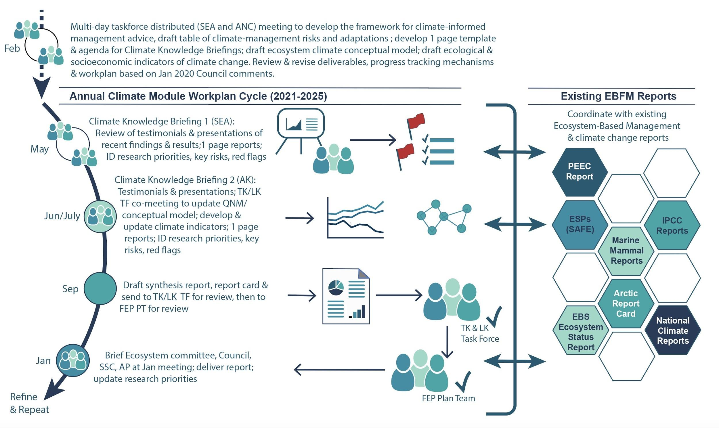

We propose the following approach: In late Feb of 2020 we will hold a distributed spin up meeting with two meeting locations connected through Webex video conferencing (ANC and SEA). This meeting will focus on development of materials that will be used in the annual workplan cycle (e.g., forms for contributors, draft conceptual models, an outline of the proposed EBS Climate Change and Fisheries Report, or a new forward-looking chapter or appendix to the EBS Ecosystem Status Report). This meeting will be conducted in coordination with ESR authors, FEP Team leads, and LK TK Subsistence taskforce members.

Following this spin up we propose the following annual cycle to summarize and deliver actionable climate-information and advice relevant to fisheries management in the EBS. First, two 1 day “Climate Knowledge Briefings”, aimed to include Indigenous, traditional, and local knowledge regarding climate change from communities in Alaska as well as academic and agency research regarding climate change and fisheries. Speakers will be asked to provide information according to a template in order to standardize information for the EBS Climate Change and Fisheries Report. This will aid in synthesis and summary of findings, which will be included as a short report card and executive summary (similar in structure to the Ecosystem Status Report). In addition, and with input and coordination with the LK/TK Subsistence Taskforce, the Climate Change Taskforce will identify emergent issues, red flags, research priorities and knowledge gaps, and key risks. If warranted, the Taskforce may also make recommendations for management or action that could be considered by the Council through the Council process.

Planning and Logistics

How Action Module will interface with existing work
The Alaska Integrated Ecosystem Assessment program, the Bering Sea Regional Action Plan teams, and multiple ongoing projects at AFSC and through various academic and independent research efforts are already providing the logistical and analytical support to meet objectives 1 and 2 of the module, as well as providing the modeling platforms for objectives 3. Under the Regional Action Plan, the IEA, the ACLIM: Alaska Climate Integrated Modeling project, and the related habitat projection project (third bullet above), climate assessment teams are working closely together with each other and with Pacific Marine Environment Lab researchers to expand the suite of downscaled climate projections coupled to climate-enhanced bioeconomic assessment, ecosystem and fish habitat models, as well as MSE sub-modules for some of the ecosystem and assessment models. Thus the expert teams, analytical capacity, and climate scenarios are already available for some species. The rapid climate assessment conducted during 2016 provides a framework for quickly and efficiently identifying additional species that may be impacted. Similarly, the other projects maintain the operational readiness of AFSC to evaluate climate impacts on Bering Sea species and additional ecosystem models or species additions to existing models could be readily implemented for future evaluations.
Interdisciplinary teams like those already assembled for ongoing projects will be needed to conduct the full 3-5 year MSE evaluations, but personnel needs will depend greatly on the number and complexity of MSE scenarios and the number of new species evaluations.

Action Module Taskforce
- Scope: The CCTF will be responsible for synthesizing vulnerability and climate-resilience information from MSEs and action module-related projects. Main challenges will include highlighting key findings to the public and Council and identifying areas for future research and conservation actions.
- A diverse taskforce with interdisciplinary expertise will help the taskforce crosscut issues that relate to science, policy and socio-economics.
- Two co-chairs should be appointed to lead the taskforce.
- The climate action module would benefit from crosswalking with other FEP action modules, including the LK/TK Subsistence module taskforce.
- The climate change action module taskforce should include AFSC researchers as well as those with expertise outside of the AFSC, including representation from traditional knowledge holders, indigenous organizations, and NGOs, in order to synthesize diverse climate knowledge and research.
- Proposed frequency of meetings: one in person (Spring), one by teleconference (Fall), Council meetings, and check-ins as needed.

Deliverables and tracking progress
- A framework for exploring a range of EBS management actions across a range of climate scenarios(e.g., periodic review of existing and alternative management strategies/policies).
- Synthesis report of climate change impacts and adaptive strategies of interest and within the purview of the Council; authored by the climate module taskforce, contributing authors, and collaborators.
- Communication and engagement plan (in collaboration with LK TK Subsistence Taskforce)
- Periodic update of recommendations of Council’s climate-specific research priorities (with Council cycle)
Each year we will:
- Review climate change hot-topics/ red flags/ considerations for the coming year (e.g. via the ESR or other recommended document)
- Table of potential short-, medium-, long-term adaptive measures and new climate tools
- Table of climate risks/ unknowns, data and information needs
- Conceptual model of climate-social-ecological linkages (including direct and indirect connections)
- Recommendations for potential management action(s) to be considered in the Council process

Milestones
May 2019 FEP team meets to discuss draft work plan
June 2019 Council approves draft work plan
June-August 2019 Formation of Action Module taskforce
January 2020 Taskforce initial Webex meeting, draft work plan revisions; Report progress to Ecosystem Committee/SSC/Council
Feb 26-28, 2020 (tent) ~3 day meeting ANC/SEA dual locations/web coordinated taskforce meeting to develop framework, begin to draft list of short-medium and long-term projects and scenarios to explore; draft table of climate-management risks and adaptations by species or focal components; develop one-page template and tasking for climate knowledge briefing reports; agenda for proposed Climate Knowledge Briefing 1 meeting in May and Climate Knowledge Briefing 2 workshop with LK TK taskforce; draft ecosystem climate conceptual model; draft ecological and socioeconomic indicators of climate change. Review and revise deliverables and progress tracking mechanisms. Revise workplan based on Jan 2020 Council comments.
March 2002 Report progress to FEP (FEP meets Mar 3-5, 2020) team including performance metrics.
March/April 2020 Report progress to Ecosystem Committee/SSC/Council
________________________
May 18 & 19, 2020 (tent) Climate Knowledge Briefing 1 meeting in SEA (possible dual locations web coordinated TBD) in coordination with PEEC meeting (May 19-20). Highlight red flags, upcoming issues, new tools and products, emergent management actions/ recommendations. Outline report assign writing tasks, and deadlines for contributions to the synthesis [potentially add Climate section to PEEC report].
Summer 2020 TBD Climate Knowledge Briefing 2 workshop with LK TK taskforce (ideally Bering Sea village). Derive communication and engagement plan in conjunction with LK TK TF. Additional issues TBD.
June-September 2020 Continued taskforce work - continued development and update of climate indicators; draft synthesis report and climate report card
June 2020 Write report. 1-2 hr Telecon check-in June [date TBD].
June- July 2020 LK/TK Taskforce and FEP review of Climate Synthesis report.
September 2020 Present Synthesis report to Plan Team
December 2020 Report progress to Ecosystem Committee/SSC/Council potentially in conjunction with ESR
April 2021 Case study/red flags presentations to Council; progress report on updated tools and adaptation measures.
2021-2025 Repeat and refine May 2020 - April 2021work products

Requests for Council feedback:
- What is the best method for delivery of Climate Synthesis report? Part of ESR, along with ESR but separate?
- Endorse the CCTF direction; are we on the right track?
- “Research priorities” and “Management recommendations” language and intent?

References
Allison, E and HR Bassett. (2015). Climate change in the oceans: Human impacts and responses, Science 350 (6262), 778-782.
Dumas, 1984. Prehistory of the Bering Sea Region. In: Damas (Editor), Handbook of North American Indians. Smithsonian Institute, Washington DC, pp. 94-105.
Fall et al. 2013. Continuity and change in subsistence harvests in five Bering Sea communities: Akutan, Emmonak, Savoonga, St. Paul and Togiak. Deep-Sea Research Part II, 94: 274-291.
Haynie and Huntington 2016. Strong connections, loose coupling: the influence of the Bering Sea ecosystem on commercial fisheries and subsistence harvests in Alaska. Ecology and Society, 21(4).
Holsman, KK, EL Hazen, A Haynie, S Gourguet, A Hollowed, S Bograd, JF Samhouri, K Aydin. Toward climate-resiliency in fisheries management. ICES. 10.1093/icesjms/fsz031
Karp, M ,JO Peterson, PD Lynch, RB Griffis, C Adams, B Arnold, L Barnett, Y deReynier, J DiCosimo, K Fenske, S Gaichas, A Hollowed, K Holsman, + 13. Accounting for Shifting Distributions and Changing Productivity in the Development of Scientific Advice for Fishery Management. ICES Journal of Marine Sciencefsz048, https://doi.org/10.1093/icesjms/fsz048
Raymond-Yakoubian, et al. 2017. The incorporation of traditional knowledge into Alaska federal fisheries management. Marine Policy, 78: 132-142.
Sigler, M, Hollowed, A, Holsman, KK,+9 (2016). Alaska Regional Action Plan for Southeastern Bering Sea Climate Science. NOAA Technical Memo NMFS-AFSC-336 doi:10.7289/V5/TM-AFSC-336.
Meredith et al. 2019. Polar Regions. In: Portner, Roberts, Masson-Delmotte, Zhai, Tignor, Poloczanska, Mintenbeck, Nicolai, Okem, Petzold, Rama and Weyer (Editors), IPCC Special Report on the Ocean and Cryosphere in a Changing Climate.
Wise et al. 2014. Reconceptualising adaptation to climate change as part of pathways of change and response. Global Environmental Change 28: 325–336.

Appendix 1. Action Module Scoping Summary from Core BS FEP
1. Synopsis  including how it will be accomplished | The goal of this climate project is to evaluate the vulnerability of key species, fisheries and communities to climate change and to strengthen resilience in regional fisheries management. Methods will leverage ongoing projects at AFSC and partner organizations. The Action Module will address the following objectives: (1) coordinate to synthesize results of various ongoing and completed climate change research projects; (2) evaluate the scope of impacts on priority species identified in initial studies; and (3) strategically reevaluate management strategies every ~5 years; (4) include synthesis to evaluate climate-resilient management tools. The climate change Action Module taskforce will work with the Council to iteratively identify and assess the performance of potential short-term, medium and long-term management actions for climate adaptation (i.e., derive alternative strategies for MSEs).
2. Purpose  relationship to the BS FEP’s strategic objectives | This Action Module is specifically responsive to Process Objective 13, to establish a process for addressing change under novel or intensified stressors, as well as the implementation strategy of the Council’s ecosystem policy vision statement. While the Action Module leverages ongoing AFSC research projects on climate change, including it in the BS FEP provides a direct link for the Council to be involved in prioritizing Action Module research that addresses questions most relevant to Council fishery management. This is in keeping with the BS FEP’s purpose to facilitate dialogue between managers, co-managers, scientists, and diverse stakeholders. This Action Module will provide a five to seven-year climate context within which to interpret and respond to annual signals and will establish a more formal process for considering those variables. This is responsive to the BS FEP purpose to build resiliency into the Council’s management strategies, and to enhance the capacity for adaptive EBFM approaches in the context of shifting climate conditions.
3. How it will inform the Council process | Climate-ready fisheries management will help continue the legacy of sustainable fisheries management in the region, including management to promote a productive marine ecosystem and healthy vibrant marine fisheries. Results will inform short, medium, and long-term “climate ready” tactical and strategic management measures.
4. How it will be integrated in the Council process | Short-term “climate-ready” management actions can be developed and implemented relatively quickly, thus climate change management strategy evaluations would be focused on testing their performance under the full scope of potential future conditions. In contrast, modification of medium- and long-term management measures require more specific characterization of risk and uncertainty around future trajectories, with thorough scientific evaluation as well as stakeholder and Council review and feedback. This information can provide a frame of reference for setting harvest recommendations and implementing other management actions. Alternatively, climate-specific biomass reference limits (e.g., temperature-specific F_{ABC}) are derived using projections of environmentally enhanced single- or multi-species assessment models and can be used to set harvest rates that account for future climate variability. If management strategy evaluations as part of objective (3) determine the performance of these reference points is acceptable or preferable, they could be used to set harvest recommendations (or alternatively, could be presented along with status-quo assessment values) and to inform conservation measures.
5. Estimate of time and staff resources | Multiple ongoing projects at AFSC are already providing the logistical and analytical support to meet the first two parts of the Action Module, as well as provide the modeling platforms for part 3. Interdisciplinary teams like those already assembled for ongoing projects will be needed to conduct the full 5- to 7-year MSE evaluations, but personnel needs will depend greatly on the number and complexity of MSE scenarios and the number of new species evaluations.
6. Plan for public involvement | For this Action Module, the Council may solicit public input, to identify priorities for MSE evaluations. The climate change module taskforce would ideally include broad expertise across diverse knowledge holders (e.g., traditional knowledge holders). Stakeholders will also be involved through the Council process and iterative dialogue with module taskforce members.

Appendix 2: Membership of Climate Change Taskforce
Lauren Divine (Aleut Community of Saint Paul Island)
Scott Goodman (Natural Resources Consultants/Bering Sea Fisheries Research Foundation) Kirstin Holsman co-Chair (AFSC-Seattle)
Steve Martell (SeaState)
Joe Krieger (NMFS-Regional Office)
Brenden Raymond-Yakoubian (Sandhill.Culture.Craft)
Mike LeVine (Ocean Conservancy)
Jeremy Sterling (AFSC Marine Mammal Lab)
Diana Stram co-Chair (NPFMC)

Initial draft prepared by Kirstin Holsman, AFSC, with input from the Bering Sea Fishery Ecosystem Plan Team and public participating in the May 2019 BS FEP Team meeting. Draft revisions by members of the Climate Change Taskforce (CCTF) were incorporated during the Taskforce meeting on January 21, 2020. See appended list of taskforce members

