**Appendix A: Integrated model**

Aleutian Islands Golden King Crab (*Lithodes aequispinus*) Stock Assessment Model Development- east of 174° W (EAG) and west of 174° W (WAG) Aleutian Island stocks

*Basic population dynamics*

The annual [male] abundances by size are modeled using the equation:

(A.1)

where is the number of [male] crab in length class *i* on 1 July (start of fishing year) of year *t*; are respectively the predicted fishery retained, pot fishery discard dead, and groundfish fishery discard dead catches in length class *i* during year *t*; is estimated from the intermediate total *(*) catch and the retained () catch by Equation A.2c. is the probability of length-class *i* growing into length-class *j* during the year; *yt* is elapsed time period from 1 July to the midpoint of fishing period in year *t*; *M* is instantaneous rate of natural mortality; and recruitment to length class *j* in year *t+1*.

The catches are predicted using the equations

(A.2a)

(A.2b)

(A.2c)

(A.2d)

(A.2e)

where is total fishery-related mortality on animals in length-class *j* during year *t*:

(A.3)

is the full selection fishing mortality in the pot fishery, is the full selection fishing mortality in the trawl fishery, is the total selectivity for animals in length-class *j* by the pot fishery during year *t*, is the selectivity for animals in length-class *j* by the trawl fishery, is the probability of retention for animals in length-class *j* by the pot fishery during year *t*. Pot bycatch mortality of 0.2 and groundfish bycatch mortality of 0.65 (average of trawl [0.8] and groundfish pot [0.5] mortality) were assumed.

**Initial abundance**

The initial conditions are computed as the equilibrium initial condition using the following relations:

The equilibrium stock abundance is

*N = X.S.N + R* (A.4)  
  
The equilibrium abundance in 1960, *N1960*, is

(A.5)

where *X* is the growth matrix, *S* is a matrix with diagonal elements given by , *I* is the identity matrix, and is the product of average recruitment and relative proportion of total recruitment to each size-class.

We used the mean number of recruits from 1987 to 2012 in equation (A.5) to obtain the equilibrium solution under only natural mortality in year 1960, and then projected the equilibrium abundance under natural mortality with recruitment estimated for each year after 1960 up to 1985 with removal of retained catches during 1981/82–1984/85.

**Growth Matrix**

The growth matrix *X* is modeled as follows:

(A.6)

where:

,

*, an*d

is the mean growth increment for crab in size-class *i*:

. (A.7)

, , and are estimable parameters, j*1* and *j2*are the lower and upper limits of the receiving length-class *j* (in mm CL), and is the mid-point of the contributing length interval *i.* The quantity is the molt probability for size-class *i*:

(A.8)

where is the mid-length of the *i*-th length-class, *c* and *d* are parameters.

**Selectivity and retention**

Selectivity and retention are both assumed to be logistic functions of length. Selectivity depends on the fishing period for the directed pot fishery:

(A.9)

where *θ95* and *θ50* are the parameters of the selectivity/ retention pattern (Mark Maunder, unpublished generic crab model). In our program, we re-parameterized the denominator (θ95 - θ50) to so that the difference is always positive and transformed *θ50* to *log(θ50)* to keep the estimate always positive.

**Recruitment**

Recruitment to length–class i during year *t* is modeled as where is a normalized gamma function

(A.10)

with *αr* and *βr* (restricted to the first five length classes).

**Parameter estimation**

Table A1 lists the parameters of the model indicating which are estimated and which are pre-specified. The objective function includes contributions related to the fit of the model to the available data and penalties (priors on various parameters).

Tables A2 lists parameter values (with the corresponding coefficient of variations in parentheses) used to weight the components of the objective functions for EAG and WAG.

**Likelihood components**

*Catches*

The contribution of the catch data (retained, total, and groundfish discarded) to the objective function is given by:

 (A.11a)

(A.11b)

(A.11c)

where *λr*, *λT*, and *λGD* are weights assigned to likelihood components for the retained, pot total, and groundfish discard catches; is the average mass of a crab is length-class *j*; , , and are, respectively, the observed numbers of crab in size class *j* for retained, pot total, and groundfish fishery discarded crab during year *t*, and *c* is a small constant value. We assumed *c* = 0.001.

An additional retained catch likelihood (using Equation A.11a without *w*) for the retained catch in number of crabs during 1981/82–1984/85 was also considered in all scenarios.

*Catch-rate indices*

The catch-rate indices are assumed to be lognormally distributed about the model prediction. Account is taken of variation in addition to that related to sampling variation:

(A.12)

where is the standardized retain catch-rate index for year *t*, is standard error of the logarithm of ,and is the model-estimate of :

(A.13)

in which is the catchability coefficient during the *k*-th period (e.g., pre- and post-rationalization time periods), is the extent of over-dispersion, *c* is a small constant to prevent zero values (we assumed *c* = 0.001), and is the weight assigned to the catch-rate data. We used the same likelihood formula (A.12) for fish ticket and cooperative survey retained catch rate indices. However, for cooperative survey catch rate prediction we used a different catchability parameter.

Following Burnham *et al.* (1987), we computed the ln(CPUE) variance by:

(A.14)

*Length-composition data*

The length-composition data are included in the likelihood function using the robust normal for proportions likelihood, i.e., generically:

 (A.15)

where is the observed proportion of crabs in length-class j in the catch during year t, is the model-estimate corresponding to , i.e.:

(A.16)

is the variance of :

 (A.17)

and is the effective sample size for year *t* and *n* is the number of size classes.

Note: The likelihood calculation for retained length composition starts from length-class 6 (mid length 128 mm CL) because the length-classes 1 to 5 mostly contain zero data.

*Tagging data*

Let be the number of tagged male crab that were released during year *t* that were in size-class *j* when they were released and were recaptured after *y* years, and be the vector of recaptures by size-class from the males that were released in year *t* that were in size-class *j* when they were released and were recaptured after *y* years. The log-likelihood corresponding to the multinomial distribution for the tagging data is then:

(A18)

where is the weight assigned to the tagging data for recapture year *y*, is the proportion in size-class *i* of the recaptures of males that were released during year *t* that were in size-class *j* when they were released and were recaptured after *y* years:

** (A19)

where is a vector with at element *j* and 0 otherwise, and *ST* is the vector of total selectivity for tagged male crab by the pot fishery. This log-likelihood function is predicated on the assumption that all recaptures are in the pot fishery and the reporting rate is independent of the size of crab.

*Penalties*

Penalties are imposed on the deviations of annual pot fishing mortality about mean pot fishing mortality, annual trawl fishing mortality about mean trawl fishing mortality, recruitment about mean recruitment, and the posfunction (fpen):

 (A.20)

 (A.21)

 (A.22)

(A.23)

*Standardized Residual of Length Composition*

(A.24)

*Output Quantities*

*Harvest rate*

Total pot fishery harvest rate:

(A.25)

*Exploited legal male biomass at the start of year t:*

 (A.26)

where is the weight of an animal in length-class *j*.

*Mature male biomass on 15 February spawning time (NPFMC 2007a, b) in the following year:*

(A.27)

where is the elapsed time from 1 July to 15 February in the following year.

For estimating the next year limit harvest levels from current year stock abundances, an value is needed. The current crab management plan specifies five different Tier formulas for different stocks depending on the strength of information available for a stock, for computing (NPFMC 2007a, b). For the golden king crab, the following Tier 3 formula is applied to compute :

If,

If,

*,*

(A.28)

If,

*,*

where

*β* = a parameter with a restriction that . A default value of 0.25 is used,

*α* = a parameter with a restriction that . A default value of 0.1 is used,

= the mature male biomass in the current year, and

*MMB35%* = a proxy *MMBMSY* for Tier 3 stocks.

Because projected (i.e., ) depends on the intervening retained and discard catch (i.e., MMBt is estimated after the fishery), an iterative procedure is applied using Equations A.27 and A.28 with retained and discard catch predicted from Equations A.2b-d. The next year limit harvest catch is estimated using Equations A.2b-d with the estimated value.

Table A1. Pre-specified and estimated parameters of the population dynamics model

|  |  |
| --- | --- |
| Parameter | Number of parameters |
| *Fishing mortalities:* |  |
| Pot fishery, | 1981–2020 (estimated) |
| Mean pot fishery fishing mortality, | 1 (estimated) |
| Groundfish fishery, | 1989–2020 (the mean F for 1989 to 1994 was used to estimate groundfish discards back to 1981 (estimated) |
| Mean groundfish fishery fishing mortality, | 1 (estimated) |
| *Selectivity and retention:* |  |
| Pot fishery total selectivity, | 2 (1981–2004; 2005+) (estimated) |
| Pot fishery total selectivity difference, | 2 (1981–2004; 2005+) (estimated) |
| Pot fishery retention, | 1 (1981+) (estimated) |
| Pot fishery retention selectivity difference, | 1 (1981+) (estimated) |
| Groundfish fishery selectivity | fixed at 1 for all size-classes |
| *Growth:* |  |
| Expected growth increment, | 2 (estimated) |
| Variability in growth increment,  Molt probability (size transition matrix with tag data), a  Molt probability (size transition matrix with tag data), b | 1 (estimated)  1 (estimated)  1 (estimated) |
| Natural mortality, *M* | 1 (pre-specified, 0.21yr-1 ) |
| *Recruitment:* |  |
| Number of recruiting length-classes  Mean recruit length  Distribution to length-class,  Median recruitment, | 5 (pre-specified)  1 (pre-specified, 110 mm CL)  1 (estimated)  1 (estimated) |
| Recruitment deviations, | 61 (1961–2021) (estimated) |
|  |  |
| Fishery catchability, q | 2 (1985–2004; 2005+) (estimated) |
| Additional CPUE indices standard deviation, | 1 (estimated) |
| Likelihood weights (coefficient of variation) | Pre-specified, varies by scenario |

Table A2. Specifications for the weights with corresponding coefficient of variations* in parentheses for each model for EAG and WAG.

|  |  |
| --- | --- |
| Weight | Models  19.1, 21.1a, 21.1b, and 21.1c |
| *Catch:* |  |
| Retained catch for 1981–1984 and/or 1985–2020, *λr* | 500 (0.032) |
| Total catch for 1990–2020, *λT* | Number of sampled pots scaled to a max 250 |
| Groundfish bycatch for 1989 –2020, *λGD* | 0.2 (3.344) |
| *Catch-rate:* |  |
| Observer legal size crab catch-rate for 1995–2020, | 1 (0.805) |
| Fish ticket retained crab catch-rate for 1985–1998, | 1 (0.805) |
| *Penalty weights:* |  |
| Pot fishing mortality dev, | Initially 1000, relaxed to 0.001 at phases ≥ select. phase |
| Groundfish fishing mortality dev, | Initially 1000, relaxed to 0.001 at phases ≥ select. phase |
| Recruitment, | 2 (0.533) |
| Posfunction (to keep abundance estimates always positive), | 1000 (0.022) |
| Tagging likelihood | EAG individual tag returns |

, w =weight

**Appendix B: *Catch and CPUE data***

The commercial catch and length frequency distribution were estimated from ADF&G landing records and dockside sampling (Bowers *et al.* 2008, 2011). The annual retained catch, total catch, and groundfish (or trawl) discarded mortality are provided in Tables 1, 2, and 2b for EAG and WAG. The weighted length frequency data were used to distribute the catch into 5-mm size intervals. The length frequency data for a year were weighted by each sampled vessel’s catch as follows. The *i*-th length-class frequency was estimated as:

(B.1)

where *k* = number of sampled vessels in a year, *LFj,i* = number of crabs in the *i*-th length-class in the sample from *j*-th vessel, *n* = number of size classes, *Cj*= number of crabs caught by *j*-th vessel. Then the relative frequency for the year was calculated and applied to the annual retained catch (in number of crabs) to obtain retained catch by length-class.

The annual total catch (in number of crabs) was estimated by the observer nominal (unstandardized) total CPUE considering all vessels multiplied by the total fishing effort (number of pot lifts). The weighted length frequency of the observer samples across the fleet was estimated using Equation B.1. Observer measurement of crab ranged from 20 to 220 mm CL. To restrict the total number of crabs to the model assumed size range (101–185+ mm CL), the proportion of observer total relative length frequency corresponding to this size range was multiplied by the total catch (number of crabs). This total number of crabs was distributed into length-classes using the weighted relative length frequency. Thus, crab sizes < 101 mm CL were excluded from the model. In addition, all crab >185 mm CL were pooled into a plus length class. Note that the total crab catches by size that went into the model did not consider retained and discard components separately. However, once the model estimated the annual total catch, then retained catch was deducted from this total and multiplied by handling mortality [we used a 20% handling mortality (Siddeek *et al.* 2005) to obtain the directed fishery discarded (dead) catch].

Observer data have been collected since 1988 (Moore *et al.* 2000; Barnard *et al.* 2001; Barnard and Burt 2004; Gaeuman 2011), but data were not comprehensive in the initial years, so a shorter time series of data for the period 1990/91–2020/21 was selected for this analysis. During 1990/91–1994/95, observers were only deployed on catcher-processor vessels. During 1995/96–2004/05, observers were deployed on all fishing vessels during fishing activity. Observers have been deployed on all fishing vessels since 2005/06, but catcher-only vessels are only required to carry observers for a minimum of 50% of their fishing activity during a season; catcher-processor vessels are still required to carry observers during all fishing activity. Onboard observers sample seven pots per day (may be different numbers of pots per string) and count and measure all crabs caught and categorize catch as females, sublegal males, retained legal males, and non-retained legal males in a sampled pot. Prior to the 2009/10 season, depending on season, area, and type of fishing vessel, observers were also instructed to sample additional pots in which all crab were only counted and categorized as females, sublegal males, retained legal males, and non-retained legal males, but were not measured. Annual mean nominal CPUEs of retained and total crabs were estimated considering all sampled pots within each season (Table 3). The observer CPUE data collection improved over the years and the data since 1995/96 are more reliable. Thus, for model fitting, the observer CPUE time series was restricted to 1995/96–2020/21. The 1990/91–2020/21 observer database consists of 118,025 records and that of 1995/96–2020/21 contains 113,746 records, For CPUE standardization, these data were further reduced by 5% cutoff of Soak time and 1% cutoff of Depth on both ends of the variable range to remove unreliable data or data from dysfunctional pot operations and restricting to vessels which have made five trips per year for at least three years during 1985/86 –2020/21.

We detected some computational errors in raw size frequency summary data preparation (observer and fish ticket sampling) for 2016–2019 and rectified errors in relative retained and total size frequency computations in the current analysis. The correction of errors did not affect retained catch crab distribution by size bins but caused minor changes to allocation of total catch crab into size bins.

Length-specific CPUE data collected by observers provides information on a wider size range of the stock than did the commercial catch length frequency data obtained from mostly legal-sized landed males.

There were significant changes in fishing practice due to changes in management regulations (e.g., since 1996/97 constant TAC and since 2005/06 crab rationalization), pot configuration (escape web on the pot door increased to 9” since 1999), and improved observer recording in Aleutian Islands golden king crab fisheries since 1998. These changes prompted us to consider two separate observer CPUE time series, 1995/96–2004/05 and 2005/06–2020/21, to estimate CPUE indices for model input.

To include a long time series of CPUE indices for stock abundance contrast, we also considered the 1985/86–1998/99 legal size standardized CPUE as a separate likelihood component in all scenarios. Because of the lack of soak time data before 1990, we estimated the CPUE index considering a limited set of explanatory variables (e.g., vessel, captain, area, month) and fitting the negative binomial GLM model to fish ticket data (Tables 4 and 14).

When using CPUE indices in the model fit, we compared the predicted with the observed legal male CPUE in the observer CPUE likelihoods because legal male (retained plus non-retained) data are more reliable than total in the observer samples.

The CPUE standardization followed the GLM fitting procedure (Maunder and Punt 2004; Starr 2012; Siddeek *et al*. 2018). Following a suggestion from the CIE reviewers in June 2018 we reduced the number of gear codes in the database after consulting with the fishing industry (Rip Carlton, Chad Hoefer, and Scott Goodman, personal communication December 2018; Table B1). Following an SSC suggestion in October 2018, we used a hybrid procedure: First, we selected a scope of variables set by Akike Information Criterion, AIC (Burnham and Anderson 2002). An increase of more than 2 units in the AIC was used to identify the variable to be included successively (stepAIC program, R Core Team 2020). Then, the model parsimony was improved further by successively removing the term that explained the least proportion of deviance (R2 < 0.01) (stepCPUE R function was used, Siddeek *et al*. 2018). Feenstra, *et al*. (2019) used a similar hybrid approach.

Table B.1. Updated gear codes for observer data analysis. Only gear code # 5, 6, 7, 8, and 13 were considered following crab industry suggestion. Note: Identical codes were given to those gear codes with similar catchability/selectivity. X indicates gear codes that were ignored.

|  |  |  |  |  |
| --- | --- | --- | --- | --- |
| **Original Gear code** | **Pot gear description** | **Mark X against the code that can be ignored** | **Number encountered by observers during 1990**–**2016** | **Updated gear code** |
| 1 | Dungeness crab pot, small & round | X | 2 | X |
| 2 | Pyramid pot, tunnel openings usually on sides, stackable | X | 2121 | X |
| 3 | Conical pot, opening at top of cone, stackable | X | 2000 | X |
| 4 | 4' X 4' rectangular pot |  | 60 | X |
| 5 | 5' X 5' rectangular pot |  | 18032 | 5 |
| 6 | 6' X 6' rectangular pot |  | 17508 | 6 |
| 7 | 7' X 7' rectangular pot |  | 23806 | 7 |
| 8 | 8' X 8' rectangular pot |  | 1936 | 8 |
| 9 | 5 1/2' X 5 1/2' rectangular pot |  | 6934 | 5 |
| 10 | 6 1/2' X 6 1/2' rectangular pot |  | 22085 | 6 |
| 11 | 7 1/2' X 7 1/2' rectangular pot |  | 387 | 7 |
| 12 | Round king crab pot, enlarged version of Dungeness crab pot |  | 8259 | X |
| 13 | 10' X 10' rectangular pot |  | 466 | 13 |
| 14 | 9' X 9' rectangular pot | X | 1 | X |
| 15 | 8 1/2' X 8 1/2' rectangular pot | X | 1 | X |
| 16 | 9 1/2' X 9 1/2' rectangular pot | X | Not used | X |
| 17 | 8' X 9' rectangular pot | X | 1 | X |
| 18 | 8' X 10' rectangular pot | X | 1 | X |
| 19 | 9' X 10' rectangular pot |  | Not used | X |
| 20 | 7' X 8' rectangular pot | X | 252 | X |
| 21 | Hair crab pot, longlined and small, stackable |  | Not used | X |
| 22 | snail pot | X | 1 | X |
| 23 | Dome-shaped pot, tunnel opening on top, often longlined in deep-water fisheries | X | 6756 | X |
| 24 | ADF&G shellfish research 7’ X 7’ X34” rectangular pot with 2.75” stretch mesh and no escapement rings or mesh |  | Research pot | X |
| 80 | Historical: Cod pot, any shape pot targeting cod, usually with tunnel fingers | X | 711 | X |
| 81 | Historical: Rectangular pot, unknown size, with escape rings | X | 1123 | X |

All scenarios used CPUE indices estimated by the hybrid GLM method. Following a January 2019 CPT request, we considered a Year:Area interaction factor as a special case for a CPUE standardization scenario.

Thus we estimated two sets of observer CPUE indices for model input, 19.1 (reduced number of gear codes), and 21.1c (reduced number of gear codes and Year:Area interaction).

*Observer CPUE index by GLM*

* 1. *Non-interaction GLM model*

The CPUE standardization followed the GLM fitting procedure (Maunder and Punt 2004; Starr 2012; Siddeek *et al*. 2016b). We considered the negative binomial GLM on positive and zero catches to select the explanatory variables. The response variable CPUE is the observer sample catch record for a pot haul. The negative binomial model uses the log link function for the GLM fit.

For the non-interaction model, we assumed the null model to be:

(B.2)

where Year is a factorial variable.

The maximum set of model terms offered to the stepwise selection procedure was:

, (B.3)

where Soak is in unit of days and is numeric; Month, Area (Block) code, Vessel code, Captain code, and Gear code are factorial variables; Depth in fathom is a numeric variable; ns=cubic spline, and df = degree of freedom.

We used a log link function and a dispersion parameter (θ) in the GLM fitting process. We used the R2 criterion for predictor variable selection (Siddeek *et al*. 2016b).

We calculated appropriate degrees of freedom and dispersion parameters by calculating AICs for a range of values and locating the best values at the minimum AIC (Figures B1 and B.2, respectively).

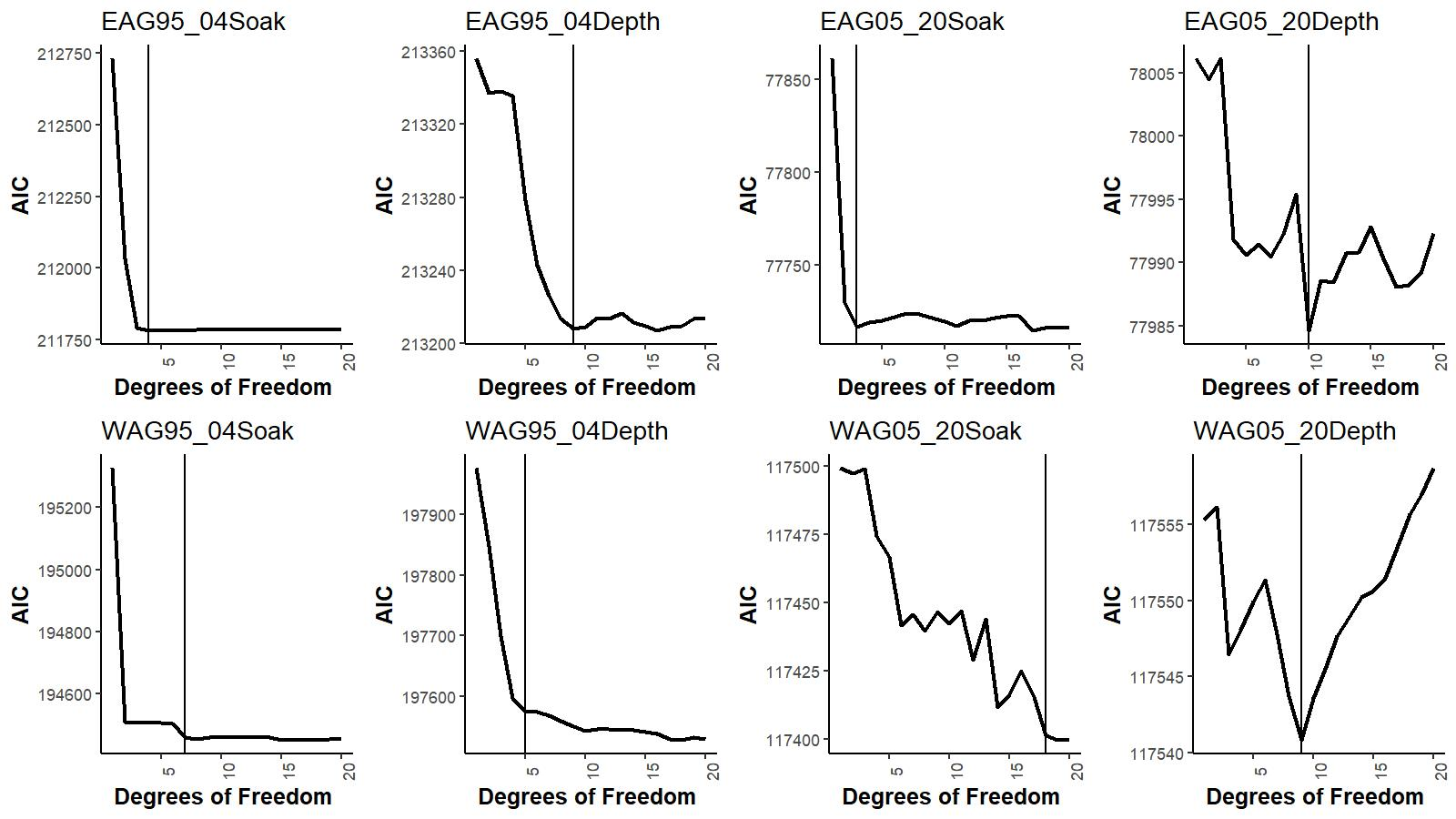

Figure B.1. AIC vs degrees of freedom for soak time and depth during pre- and post-rationalization periods for EAG (top) and WAG (bottom). Vertical lines identify the optimum degrees of freedom values chosen for CPUE standardization.

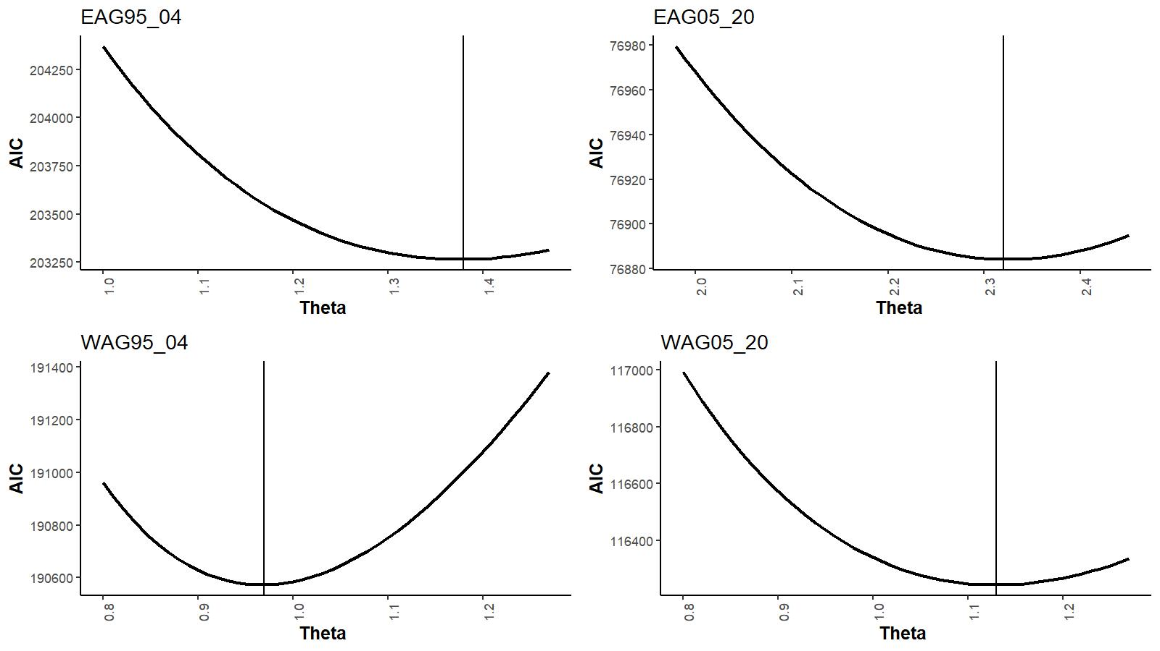

Figure B.2. AIC vs theta (dispersion parameter) during pre- and post-rationalization periods for EAG (top) and WAG (bottom). Vertical lines identify the optimum theta values chosen for CPUE standardization.

Instead of using the traditional AIC (-2log_likelihood+2p) we used the Consistent Akaike

Information Criteria (CAIC) (Bozdogan 1987) {-2log_likelihood+[ln(n)+1]*p} for variable selection by StepAIC, where n=number of observations and p= number of parameters to be estimated. The number of selected variables were further reduced for parsimony, if feasible, by the R2 criterion using the StepCPUE function. i.e., a hybrid selection procedure (Feenstra *et al.* 2019).

Example R codes used for main effect GLM fitting are as follows:

For EAG 1995_04 CPUE indices:

*library(MASS)*

*library(splines)*

Step 1:

*glm.object<- glm(Legals~Year,family = negative.binomial(1.38),data=datacore)*

*epotsampleoutAIC<-stepAIC(glm.object,scope=list(upper= ~(Year+ns(SoakDays,df=4)+Month+Vessel+Captain+Area+Gear+ns(Depth,df=9)),lower=~Year),family=negative.binomial(1.38),direction="forward",trace=9,k=log(nrow(datacore))+1.0)*

Step 2:

*glm.object<- glm(Legals~Year,family = negative.binomial(1.38),data=datacore)*

*epotsampleout<-stepCPUE(glm.object,scope=list(upper=~(Year+Gear+Captain+ns(SoakDays,df=4)+*

*Month+Area),lower=~Year),family=negative.binomial(1.38),direction="forward",trace=9,r2.change=0.01)*

The final main effect models for EAG were:

Model 19.1:

Initial selection by stepAIC:

AIC=203,808

Final selection by stepCPUE:

(B.4)

for the 1995/96–2004/05 period [θ=1.38, ]

Initial selection by stepAIC:

AIC=77,173

Final selection by stepCPUE:

(B.5)

for the 2005/06–2020/21 period [].

The final models for WAG were:

Model 19.1:

Initial selection by stepAIC:

AIC=190,897

Final selection by stepCPUE:

(B.6)

for the 1995/96–2004/05 period [θ=0.97, ]

Initial selection by stepAIC:

AIC=116,552

Final selection by stepCPUE:

(B.7)

for the 2005/06–2020/21 period [].

* 1. *Year:Area interaction GLM:*

For year and area interaction analysis, we designed the areas in to 1 nmi x 1nmi grids enmeshed in 10 larger blocks as follows. The number of blocks was restricted to a few to prevent GLM fitting problems (Figure B.3 and Table B.2).

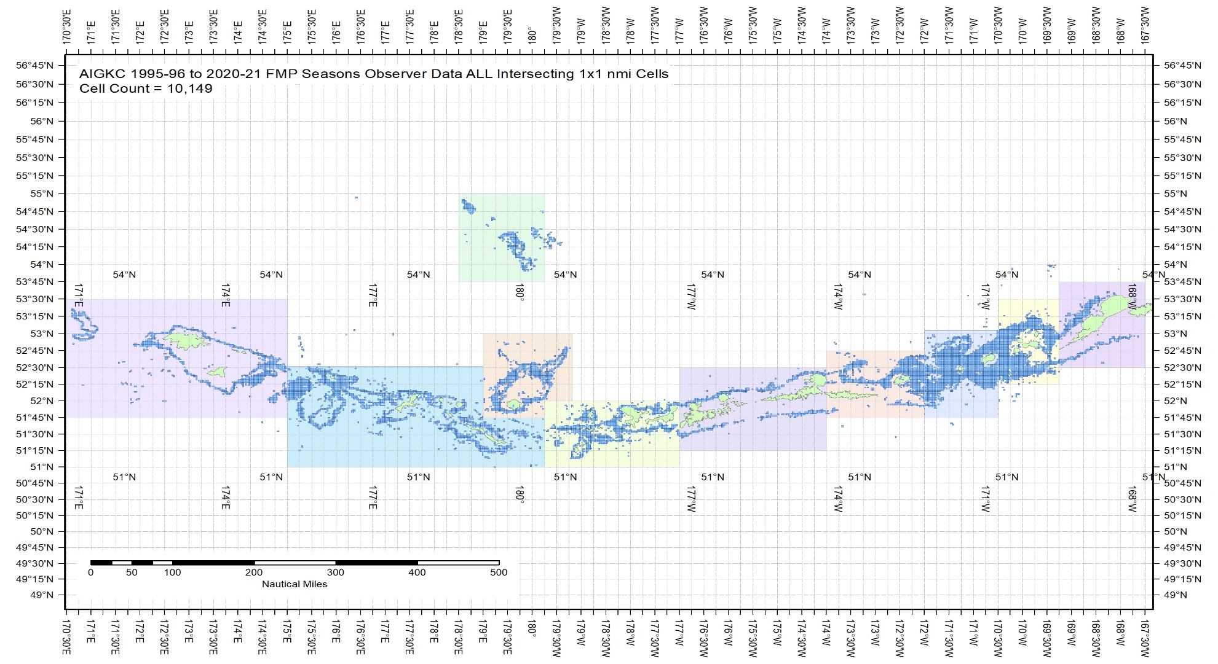

Figure B.3. The 1995/96–2020/21 observer pot samples enmeshed in 10 blocks for the Aleutian Islands golden king crab.

The blocks were determined from visually exploring each year’s pot distribution locations (available with the first author). The blocks contain observed patches of crab distribution during this period.

Table B.2. Number of 1 nmi x 1 nmi grids containing observer sample locations within each block by fishing year for the Aleutian Islands golden king crab, 1995/96–2020/21 data. Blocks 1–4 belong to EAG and 5–10 to WAG. Sum of ever fished number of grids for each block is listed at the bottom row.

|  |  |  |  |  |  |  |  |  |  |  |
| --- | --- | --- | --- | --- | --- | --- | --- | --- | --- | --- |
| **FMP Season** | **Block_1** | **Block_2** | **Block_3** | **Block_4** | **Block_5** | **Block_6** | **Block_7** | **Block_8** | **Block_9** | **Block_10** |
| 1995 | 125 | 529 | 748 | 379 | 218 | 373 | 112 | 722 | 166 | 122 |
| 1996 | 149 | 814 | 761 | 372 | 89 | 473 | 359 | 799 | 200 | 35 |
| 1997 | 116 | 530 | 755 | 257 | 202 | 443 | 104 | 568 | 274 | 0 |
| 1998 | 78 | 581 | 453 | 236 | 18 | 318 | 157 | 251 | 132 | 0 |
| 1999 | 123 | 593 | 454 | 231 | 163 | 476 | 182 | 627 | 193 | 145 |
| 2000 | 72 | 540 | 754 | 301 | 187 | 440 | 195 | 555 | 547 | 47 |
| 2001 | 123 | 507 | 507 | 329 | 45 | 369 | 288 | 634 | 256 | 9 |
| 2002 | 97 | 387 | 584 | 271 | 71 | 341 | 205 | 335 | 242 | 37 |
| 2003 | 43 | 492 | 530 | 299 | 111 | 347 | 212 | 465 | 150 | 61 |
| 2004 | 81 | 289 | 377 | 216 | 77 | 319 | 150 | 359 | 172 | 116 |
| 2005 | 0 | 205 | 221 | 118 | 8 | 220 | 83 | 261 | 54 | 0 |
| 2006 | 0 | 154 | 248 | 122 | 15 | 191 | 58 | 220 | 39 | 0 |
| 2007 | 0 | 111 | 177 | 110 | 24 | 228 | 78 | 173 | 20 | 0 |
| 2008 | 0 | 111 | 203 | 93 | 12 | 181 | 67 | 196 | 0 | 0 |
| 2009 | 0 | 59 | 146 | 60 | 6 | 137 | 95 | 220 | 25 | 0 |
| 2010 | 0 | 81 | 141 | 85 | 1 | 115 | 73 | 260 | 39 | 0 |
| 2011 | 0 | 126 | 117 | 33 | 3 | 83 | 73 | 266 | 9 | 0 |
| 2012 | 0 | 146 | 110 | 56 | 7 | 91 | 85 | 312 | 53 | 0 |
| 2013 | 2 | 149 | 129 | 51 | 12 | 144 | 105 | 293 | 86 | 0 |
| 2014 | 1 | 138 | 96 | 41 | 39 | 120 | 114 | 319 | 37 | 0 |
| 2015 | 0 | 135 | 147 | 61 | 46 | 163 | 106 | 280 | 16 | 48 |
| 2016 | 0 | 145 | 231 | 63 | 26 | 134 | 89 | 210 | 106 | 0 |
| 2017 | 0 | 97 | 170 | 110 | 11 | 87 | 79 | 198 | 118 | 0 |
| 2018 | 0 | 91 | 158 | 95 | 7 | 69 | 82 | 204 | 121 | 0 |
| 2019 | 1 | 112 | 171 | 101 | 0 | 0 | 89 | 316 | 138 | 0 |
| 2020 | 4 | 109 | 193 | 95 | 0 | 0 | 76 | 287 | 91 | 36 |
| **Ever Fished:** |  |  |  |  |  |  |  |  |  |  |
| **AIGKC All Seasons** | **Block_1** | **Block_2** | **Block_3** | **Block_4** | **Block_5** | **Block_6** | **Block_7** | **Block_8** | **Block_9** | **Block_10** |
| 1995–2020 - Sum of 1x1 cells | 381 | 1402 | 1792 | 917 | 459 | 1028 | 796 | 2012 | 1021 | 334 |

We assumed the null model to be

:Areaai (B.8)

The maximum set of model terms offered to the stepwise selection procedure was:

. (B.9)

Example R codes used for interaction effect GLM fitting are as follows:

For WAG 1995_04 CPUE indices:

*library(MASS)*

*library(splines)*

Step 1:

glm.object<- glm(Legals~Year:Area,family = negative.binomial(0.97),data=datacore)

wpotsampleoutAIC<-stepAIC(glm.object,scope=list(upper= ~(Year:Area+ns(SoakDays,df=7)+Month+Vessel+Captain+Area+Gear + ns(Depth,df=5)),lower=~Year:Area),family= negative.binomial(0.97),direction="forward",trace=9,k=log(nrow(datacore))+1.0)

Step 2:

glm.object<- glm(Legals~Year:Area,family = negative.binomial(0.97),data=datacore)

wpotsampleout<-stepCPUE(glm.object,scope=list(upper= ~(Captain+ns(SoakDays,df=7)+Gear+Area+Month+Year:Area),lower= ~Year:Area),family= negative.binomial(0.97),direction="forward",trace=9,r2.change=0.01)

The final interaction effect models for EAG were:

Model 21.1c:

Initial selection by stepAIC:

AIC=203,851

Final selection by stepCPUE:

(B.10)

for the 1995/96–2004/05 period [θ=1.38, ]

Initial selection by stepAIC:

AIC=72,343

Final selection by stepCPUE:

(B.11)

for the 2005/06–2020/21 period [].

The final interaction effect models for WAG were:

Model 21.1c:

Initial selection by stepAIC:

AIC=191,018

Final selection by stepCPUE:

(B.12)

for the 1995/96–2004/05 period [θ=0.97, ]

Initial selection by stepAIC:

AIC=116,859

Final selection by stepCPUE:

(B.13)

for the 2005/06–2020/21 period [].

Steps:

1. *Block-scale analysis*:

The bias corrected estimate of CPUE index for each Year-Area (Area=Block) interaction was first obtained as:

(B.14)

where is the CPUE index in the ith year and jth block, is the coefficient of the *i*th year and *j*th block interaction, and is the biased correction standard error for expected CPUE value.

The number of 1 nmi x 1 nmi grids in each block can change from year to year; so, we considered using the number of grids **ever fished** in a block, [this is equivalent to assuming that the grids fished in any year randomly sample the stock in that block (Campbell, 2004)].

The abundance index for *j*th block in *i*th year is

(B.15)

Notice in Table B.2 that no or very few observer samplings occurred in certain years for a whole block. We filled the index gaps resulting from Year:Area CPUE standardization model fit as follows:

fitted by GLM [i.e., fitting a log-linear model, ], (B.16)

where is the available index of biomass for year i and block *j*, *Ai* is a year factor, and *Cj* is a block factor, and used this model to predict the unavailable biomass index for blocks x years with no (or very limited) data.

An example set of R codes used to predict the missing biomass index is as follows:

**library(MASS)**

To fit the log-linear model (Equation B.16):

**glm.fit<- glm(log(Bij)~Yeari + Blockj, data=Bindex)**

where the data frame “Bindex” contains available Bij,Yeari, and Blockj column values.

To predict the missing biomass index Y:

**Y<- predict.glm (glm.fit, BindexFillpredict, se.fit=TRUE)**

where the new data frame “BindexFillpredict” contains Yeari and Blockj column values for which Bij indices are needed and contains an empty Bij column for fill in.

By setting se.fit=TRUE, the standard errors, , of predictions are also estimated.

Bias correction was made to each predicted biomass index by

where is the standard error of predicted value, which is on the scale of the linear predictor (i.e., log transformed Bij). The standard error for each year and area combination is estimated as follows.

If we denote the covariance matrix of the fitted “glm.fit” as *Σ* and write the coefficients for linear combination of a set of predictors in a vector form as *C*, then the standard error of prediction for that combination is , where is the transpose of vector .

Annual biomass index, , was estimated as,

(B.17)

The variance of the total biomass index was computed as:

(B.18)

where is the total number of 1mni x 1 mni cells ever fished in block *j*, and is the CPUE index for year *i* and block *j*.

To compare with other CPUE index estimates (Figures 24 for EAG and 41 for WAG) as well as to use in the assessment model 21.1c, we rescaled the indices by the geometric mean of estimated values (Equation B.17) separately for the pre- and post-rationalization periods. The corresponding standard error (~CV) of *Bi* was estimated by

(B.19)

The rescaled biomass indices with standard errors are listed in Table B.3 for EAG and Table B.4 for WAG.

Table B.3. Steps to estimate biomass-based abundance indices with standard errors for 1995/96–2020/21 in EAG. GMScaled B_index and B_Index SE were used as CPUE index and its standard error.

|  |  |  |  |  |  |
| --- | --- | --- | --- | --- | --- |
| Year | B_Index | GMScaled B_Index | Var(B_index) | Var(B_Index)/(B_Index)2 | B_Index SE |
| 1995 | 1646.045 | 0.772 | 31119.811 | 0.011 | 0.107 |
| 1996 | 1664.192 | 0.781 | 30961.039 | 0.011 | 0.106 |
| 1997 | 1657.073 | 0.777 | 26973.953 | 0.010 | 0.099 |
| 1998 | 1983.401 | 0.930 | 28416.977 | 0.007 | 0.085 |
| 1999 | 1889.406 | 0.886 | 26998.598 | 0.008 | 0.087 |
| 2000 | 1829.271 | 0.858 | 48321.122 | 0.014 | 0.120 |
| 2001 | 2644.434 | 1.240 | 159513.439 | 0.023 | 0.151 |
| 2002 | 2685.133 | 1.260 | 33738.827 | 0.005 | 0.068 |
| 2003 | 2403.298 | 1.127 | 33864.001 | 0.006 | 0.077 |
| 2004 | 3651.543 | 1.713 | 114213.956 | 0.009 | 0.093 |
| 2005 | 11479.919 | 1.051 | 2445608.389 | 0.019 | 0.136 |
| 2006 | 8686.932 | 0.796 | 2442560.854 | 0.032 | 0.180 |
| 2007 | 9615.569 | 0.881 | 2441515.275 | 0.026 | 0.163 |
| 2008 | 9592.846 | 0.879 | 2445626.553 | 0.027 | 0.163 |
| 2009 | 8430.385 | 0.772 | 2454692.100 | 0.035 | 0.186 |
| 2010 | 8569.358 | 0.785 | 2452577.255 | 0.033 | 0.183 |
| 2011 | 11695.405 | 1.071 | 2455608.856 | 0.018 | 0.134 |
| 2012 | 11150.360 | 1.021 | 2451865.327 | 0.020 | 0.140 |
| 2013 | 11544.882 | 1.057 | 2516532.727 | 0.019 | 0.137 |
| 2014 | 14396.446 | 1.319 | 2451276.698 | 0.012 | 0.109 |
| 2015 | 13446.866 | 1.232 | 2445059.570 | 0.014 | 0.116 |
| 2016 | 11681.802 | 1.070 | 2443192.818 | 0.018 | 0.134 |
| 2017 | 10484.499 | 0.960 | 2447524.594 | 0.022 | 0.149 |
| 2018 | 12931.639 | 1.184 | 2447048.616 | 0.015 | 0.121 |
| 2019 | 12126.070 | 1.111 | 2569011.349 | 0.017 | 0.132 |
| 2020 | 10966.012 | 1.004 | 2507915.925 | 0.021 | 0.144 |

Table B.4. Steps to estimate biomass-based abundance indices with standard errors for 1995/96–2020/21 in WAG. GMScaled B_index and B_Index SE were used as CPUE index and its standard error.

|  |  |  |  |  |  |
| --- | --- | --- | --- | --- | --- |
| Year | B_Index | GMScaled B_Index | Var(B_index) | Var(B_Index)/(B_Index)2 | B_Index SE |
| 1995 | 4171.339 | 1.133 | 108954.723 | 0.006 | 0.079 |
| 1996 | 3700.400 | 1.005 | 59000.363 | 0.004 | 0.066 |
| 1997 | 3793.778 | 1.030 | 62175.636 | 0.004 | 0.066 |
| 1998 | 3890.218 | 1.056 | 83518.738 | 0.006 | 0.074 |
| 1999 | 3419.423 | 0.928 | 56573.751 | 0.005 | 0.070 |
| 2000 | 3235.253 | 0.878 | 57888.952 | 0.006 | 0.074 |
| 2001 | 2947.962 | 0.800 | 130461.360 | 0.015 | 0.123 |
| 2002 | 3411.078 | 0.926 | 62878.499 | 0.005 | 0.074 |
| 2003 | 4145.339 | 1.126 | 56898.996 | 0.003 | 0.058 |
| 2004 | 4371.503 | 1.187 | 63567.812 | 0.003 | 0.058 |
| 2005 | 12519.564 | 1.069 | 336101.196 | 0.002 | 0.046 |
| 2006 | 12648.627 | 1.080 | 262528.825 | 0.002 | 0.041 |
| 2007 | 12145.212 | 1.037 | 276246.442 | 0.002 | 0.043 |
| 2008 | 13834.526 | 1.182 | 294798.093 | 0.002 | 0.039 |
| 2009 | 18360.125 | 1.568 | 423396.136 | 0.001 | 0.035 |
| 2010 | 12742.844 | 1.088 | 271918.180 | 0.002 | 0.041 |
| 2011 | 12819.358 | 1.095 | 325347.368 | 0.002 | 0.044 |
| 2012 | 12472.968 | 1.065 | 247042.061 | 0.002 | 0.040 |
| 2013 | 8698.067 | 0.743 | 308718.510 | 0.004 | 0.064 |
| 2014 | 8667.031 | 0.740 | 250151.136 | 0.003 | 0.058 |
| 2015 | 8566.046 | 0.732 | 262916.058 | 0.004 | 0.060 |
| 2016 | 10509.029 | 0.898 | 247759.318 | 0.002 | 0.047 |
| 2017 | 12543.516 | 1.071 | 258282.878 | 0.002 | 0.041 |
| 2018 | 15738.039 | 1.344 | 298711.438 | 0.001 | 0.035 |
| 2019 | 10006.568 | 0.855 | 292689.921 | 0.003 | 0.054 |
| 2020 | 9330.912 | 0.797 | 300658.131 | 0.003 | 0.059 |

*c. Commercial fishery CPUE index by non-interaction model*

We fitted the negative binomial GLM model for fish ticket retained CPUE time series 1985/86 – 1998/99 offering Year, Month, Vessel, Captain, and Area as explanatory variables and applying the hybrid selection method. Reduced area resolution (grouped ADF&G codes to AreaGP) was used for model fitting.

The final model for EAG was:

Initial selection by stepAIC:

AIC=16,996

Final selection by stepCPUE:

(B.20)

for the 1985/86–1998/99 period [θ=10.40, ]

and that for WAG was:

Initial selection by stepAIC:

AIC=31,701

Final selection by stepCPUE:

(B.21)

for the 1985/86–1998/99 period [θ=6.67, ]

**Appendix C. Cooperative Survey**

1. *Summary of the survey method*

The ADF&G and industry collaborative pot survey was initiated in 2015 in the EAG and has continued since then. The survey was extended to WAG in 2018. A stratified two-stage sampling design has been implemented in a 2 nmi x 2 nmi grids within 1000 m depth covering the entire golden king crab fishing area. The 2 nmi x 2 nmi choice was the best compromise between scale of fishing gear, accuracy of defining habitat, and number of possible stations (Figure C1).

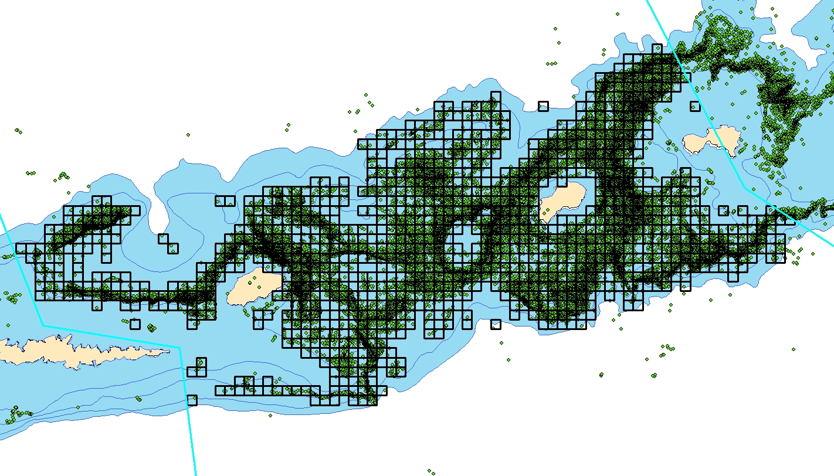

Figure C.1. Survey design: 2 nmi x 2 nmi grids overlaid on observer pot sample locations (green squares) in EAG.

There are nearly 1100 grids in the EAG divided into three equal size strata for selecting random pot sampling locations (Figures C.2 and C.3).

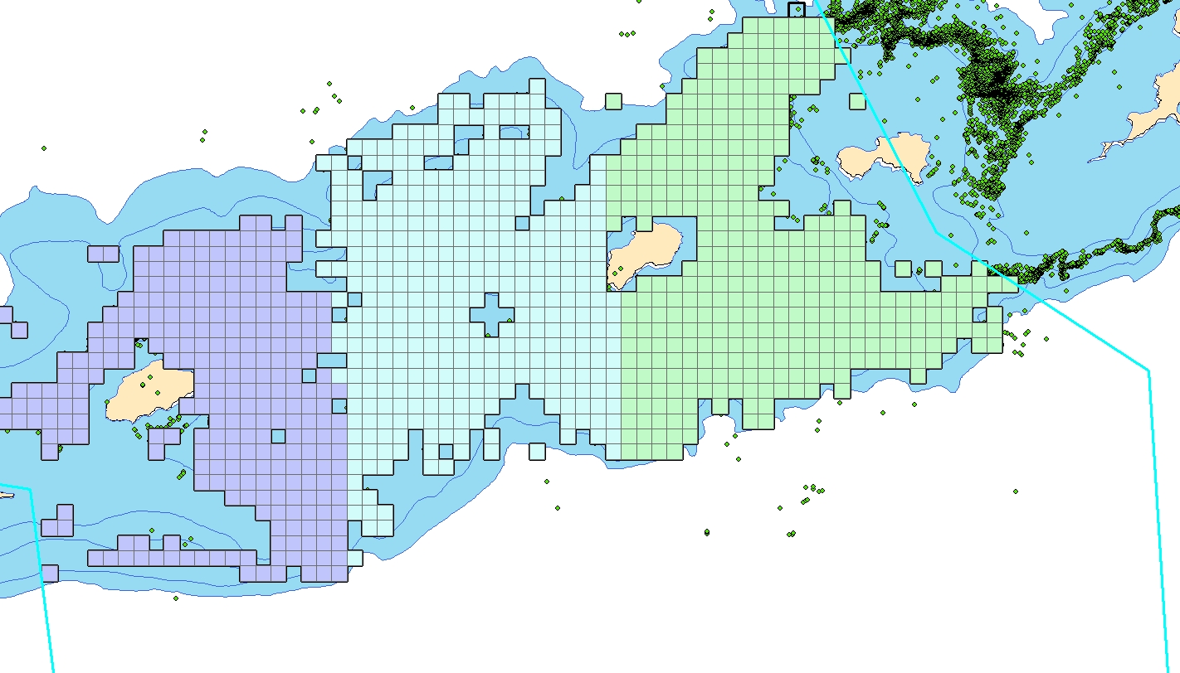

Figure C.2. Survey design: 2 nmi x 2 nmi grids stratified by three equal sizes for selecting random pot sampling locations in EAG.

Figure C.3. Random sample of 22 cells selected in each of three sub strata in EAG during the 2019 fishery.

Surveys occur during the first month of each fishing season with one to two ADF&G biologists onboard the fishing vessel to collect fishery and biological data. Fishing operation takes place in a randomly selected set of grids in each stratum with long-line pots. The number of pots per string ranges from 30 to 40, 200 m apart, and a vessel carries on average 35 strings. Pot sizes range from 5.5 ft x 5.5 ft to 7 ft x 7 ft with large mesh sizes for retention of legal-sized king crab. A few small mesh size research pots are also deployed for special studies. Fishing operation is not standardized for depth or soak time to allow normal fishing practices.

There are multiple pots (typically about 5 pots) sampled for each long-line string with approximately 35 crab measurement made per pot. For example, if 100 crabs are caught in a sampled pot, the biologist measures every third crab. The following snapshot of an observation record provides an example of what stock assessment data are collected.

|  |  |  |  |  |  |  |  |  |  |  |  |  |
| --- | --- | --- | --- | --- | --- | --- | --- | --- | --- | --- | --- | --- |
| fishery | year | vessel | skipper | String# | pot_size | mesh_size | bait | subsample_rate | species_code | sex | size | legal |
| EAG | 2015 | 20556 | Chad_Hoefer | 1 | 5x5 | king(large) | halibut | 2 | 923 | 1 | 187 | 1 |

|  |  |  |  |  |  |  |  |  |  |  |  |  |
| --- | --- | --- | --- | --- | --- | --- | --- | --- | --- | --- | --- | --- |
| Pot# | date_in | time_in | depth_start | start_lat | start_lon | depth_out | end_lat | end_lon | date_out | time_out | comments | soak_time |
| 1 | 8/4/2015 | 17:00 | 132 | 52.74133 | -170.692 | 133 | 52.7515 | -170.675 | 8/17/2015 | 3:00 |  | 12.41667 |

*2. Standardization of cooperative survey CPUE*

*Data*

A unique property of the cooperative survey is that multiple pots from multiple strings are sampled. All sample measurements were taken in EAG except for 2018/19, during which measurements were also taken from WAG. There was no survey during 2020/21 due to COVID related restriction.

There are 27,255 records from five years (2015–2019) of surveys. After cleaning up for missing entries, the number of records reduced to 27,122 golden king crab.

*Method*

Data preparation for CPUE standardization:

1. Created two new columns by concatenating Vessel Code with String# as well as with String# and Pot# because String# and Pot# are not unique numbers to each vessel. The new column names were identified as VesString and VesStingPot.

For example, a Vessel Code 20556 with a String# 3 was concatenated to be 205563 in a new column VesString, and a Vessel Code 20556 with a String#17 and a Pot# 5 was concatenated to be 20556175 in a new column VesStringPot.

1. Raised the Catch in each record by the Sample Rate.
2. Subset the data by large mesh king crab pot [Mesh ID not equal to 2 (i.e., small mesh pot)], legal size (> 135 mm CL), and EAG (EAGWAG=1). The female (Sex=2) and unclassified catch without any male crab (Sex=1) in a crab pot was set to 0 to account for the possibility of zero catch for expected male CPUE determination.
3. Further subset the data by 5% to 95%, trimmed Soak time, and 1% to 99% trimmed Depth. This is to exclude catches from any unusual pot operations.
4. Summed up the catch across sizes for each Pot# and labelled it as SumCatch. Thus, each Pot# has a single catch number.

The sampling design (sampling crab from a pot within a string within a vessel) begged for application of a mixed effects model to analyze data, which was recommended by the CPT. However, we explored different model structures before finalizing on a model: a fixed effect model and two versions of a random effects model. The dispersion parameter value for the negative binomial error model and the degrees of freedom for cubic splines for soak time and depth were borrowed from the observer final GLM model estimates for EAG for the post rationalization period, 2005–2020.

*Results*

1. Fixed effect model:

Sum Catch = Y, family= negative binomial (θ=2.32)

The maximum set of model terms offered to the stepwise selection procedure was:

Sum Catch= Y+ns(Soak,df=3)+VesselStringPot+Captain+Block+ns(Depth, df=10), family= negative binomial (θ=2.32).

Final model:

Sum Catch= Y + VesselStringPot + ns(Depth, df=10) + Block + ns(Soak, df=3) (C.1)

R2 = 0.6088 (Soak forced in).

1. Random intercept model (model 1):

Sum Catch = Y + ns(Depth, df=10) +ns(Soak, df=3) + (1|Vessel/VesStringPot)+(1|Block/VesselString) family= negative binomial (θ=2.32). (C.2)

We selected relevant fixed effect components from the final fixed effect model for the random intercept models 1 and 2. We used the “lme4” library in R (R Core Team, 2020) with the “glmer()” function for model fitting. The glmer() function allows use of any type of error model to fit the data. The random intercept model 1 resulted in a singular fit (i.e., Vessel and VesStringPot:Vessel group variances were (very close to) zero):

Table C.1. Random intercept model 1 output.

Groups Name Variance Std.Dev.

VesStringPot:Vessel (Intercept) 0.00000 0.00000

VesString:Block (Intercept) 0.35685 0.59737

Block (Intercept) 0.00059 0.02439

Vessel (Intercept) 0.00000 0.00000

1. Therefore, we used the following simpler form of the random intercept model (model 2):

Sum Catch = Y + ns(Depth, df=10) + ns(Soak, df=3) + (1|Block/VesselString) (C.3)

family= negative binomial (θ=2.32).

The random intercept model 2 converged with the following output:

Table C.2. Random intercept model 2 parameter estimates.

Random Effects:

Groups Name Variance Std.Dev.

VesString:Block (Intercept) 0.3569 0.5974

Block (Intercept) 0.0006 0.0244

Fixed Effects:

Estimate Std. Error z_value Pr(|z|)

Intercept 3.0426 0.2776 10.959 0.0000

Year2016 -0.2952 0.1005 -2.937 0.0033

Year2017 -0.0621 0.1107 -0.561 0.5748

Year2018 0.0963 0.1060 0.909 0.3634

Year2019 -0.3591 0.1052 -3.415 0.0006

ns(Depth, DF=10)1 0.6944 0.2399 2.895 0.0038

ns(Depth, DF=10)2 0.3130 0.3152 0.993 0.3206

ns(Depth, DF=10)3 0.0967 0.2740 0.353 0.7241

ns(Depth, DF=10)4 0.4526 0.3268 1.385 0.1661

ns(Depth, DF=10)5 0.0541 0.3188 0.170 0.8653

ns(Depth, DF=10)6 0.0146 0.3219 0.045 0.9639

ns(Depth, DF=10)7 0.7676 0.3270 2.348 0.0189

ns(Depth, DF=10)8 -0.0894 0.2574 -0.347 0.7285

ns(Depth, DF=10)9 0.3136 0.6123 0.512 0.6085

ns(Depth, DF=10)10 0.9769 0.2983 3.275 0.0011

ns(Soak, DF=3)1 0.2857 0.1638 1.744 0.0811

ns(Soak, DF=3)2 0.3628 0.4337 0.836 0.4029

ns(Soak, DF=3)3 0.7725 0.2448 3.156 0.0016

Inadequate time series (2015–2019) with fewer random effect levels (only three levels for Vessel and, somewhat better, four levels for Block) prevented us from exploring expanded model structures, such as a random intercept with random slope model. Categorical variable levels above 5 is recommended to be ideal for determining variances of the distribution of random effect factors (Gelman and Hill 2007). Comparison of the random intercept model 2 (C.3) with that of the fixed effects model (C.1) by the Hausman’s (1978) model selection test resulted in rejecting the null hypothesis that random effect model is consistent with the data (Chi Square = 1124.4, df = 18, p < 2.2e-16). However, because of limiting factors discussed above that could spoil any statistical test, we based our selection of random effects model 2 on the sampling design (i.e., multi-level sampling) implemented in data collection.

There is a plan to continue the cooperative survey in 2021/22, which will increase the time series of data to 6 years. Note that we do not have a flexibility to increase the number of Vessel levels from three but do have flexibility to increase the number of Block levels from four. Therefore, we intend to increase the number of Block levels by defining smaller areas in EAG for the next round of analysis.

*Diagnostic test*

The QQ plot for the fit assured that model 2 assumptions were correct (Figure C.4).

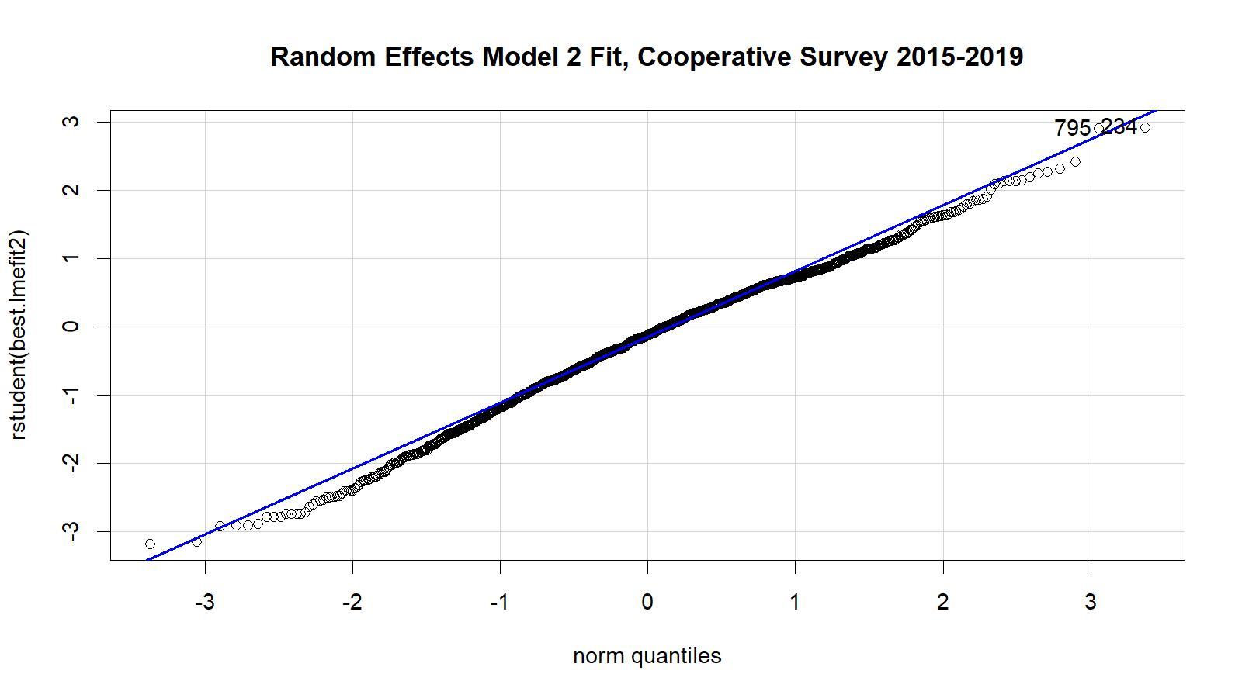

Figure C.4. Studentized residual plot for the mixed random effects model fit using the 2015–2019 EAG data.

Comparison of standardized CPUE from cooperative survey data (2015–19) for EAG and the corresponding years’ observer CPUE indices indicated a similar pattern except for 2019 (Figure C.5).

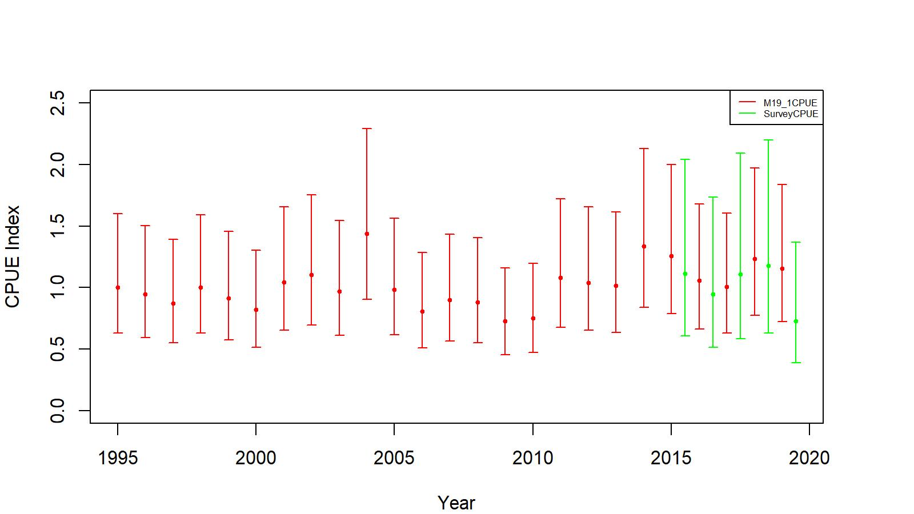

Figure C.5. Comparison of cooperative survey random effects model 2 CPUE indices (green) and observer non interaction factor model CPUE indices (red, 19.1) for EAG. The confidence limits are determined with ±2SE. Model estimated additional standard error was added to SE.

We standardized the yearly mean of predicted survey CPUEs for 2015–2019 by the geometric mean to obtain the CPUE indices for input to the assessment model (Table C.3).

Table C.3. The cooperative survey predicted legal male standardized (by geometric mean) CPUE indices by the mixed random effects model 2, standard errors (SE), and lower- and upper- 95% confidence limits with added model estimated additional standard error for EAG, 2015–2019 data.

|  |  |  |  |  |  |
| --- | --- | --- | --- | --- | --- |
| Year | Predicted CPUE index | SE | Lower Limit | Upper Limit | Sample size |
| 2015 | 1.11164 | 0.02666 | 0.60593 | 2.03943 | 335 |
| 2016 | 0.94664 | 0.02656 | 0.51610 | 1.73636 | 304 |
| 2017 | 1.10698 | 0.04148 | 0.58576 | 2.09200 | 206 |
| 2018 | 1.17588 | 0.03565 | 0.62952 | 2.19642 | 199 |
| 2019 | 0.73004 | 0.03749 | 0.38940 | 1.36867 | 289 |

We added a likelihood function with the 2015–2019 survey indices using Equations A.12 and A.13 to the likelihoods of observer indices (1995–2014) and fishery indices (1985–1998) and formulated a new model 21.1d. We maintained the same post-rationalization fishery catchability, total and retained selectivity for fitting survey indices. The reference points estimates were like those of 21.1a but a little lower.

**EAG (Tier 3):**

Biomass, total OFL, and ABC for the next fishing season in millions of pounds. Current MMB = MMB on 15 Feb. 2022

|  |  |  |  |  |  |  |  |  |  |  |
| --- | --- | --- | --- | --- | --- | --- | --- | --- | --- | --- |
| Model | Tier | *MMB35%* | Current MMB | MMB/  *MMB35%* | *FOFL* | Recruitment Years to define *MMB35%* | *F35%* | OFL | ABC  (P*=0.49) | ABC  (0.75*OFL) |
| EAG21.1d | 3a | 14.686 | 17.823 | 1.21 | 0.62 | 1987–2017 | 0.62 | 5.822 | 5.791 | 4.367 |

Biomass in 1000 t; total OFL and ABC for the next fishing season in t.

|  |  |  |  |  |  |  |  |  |  |  |
| --- | --- | --- | --- | --- | --- | --- | --- | --- | --- | --- |
| Model | Tier | *MMB35%* | *Current MMB* | *MMB/*  *MMB35%* | *FOFL* | *Recruitment Years to Define MMB35%* | *F35%* | *OFL* | *ABC*  *(P*=0.49)* | *ABC*  *(0.75*OFL)* |
| EAG21.1d | 3a | 6661.73 | 8084.57 | 1.21 | 0.62 | 1987–2017 | 0.62 | 2,641.064 | 2,626.844 | 1,980.798 |

Figure C.6 provides the long-term trends in MMB by model 21.1d with the state quo knife-edge maturity size of 111 mm CL.

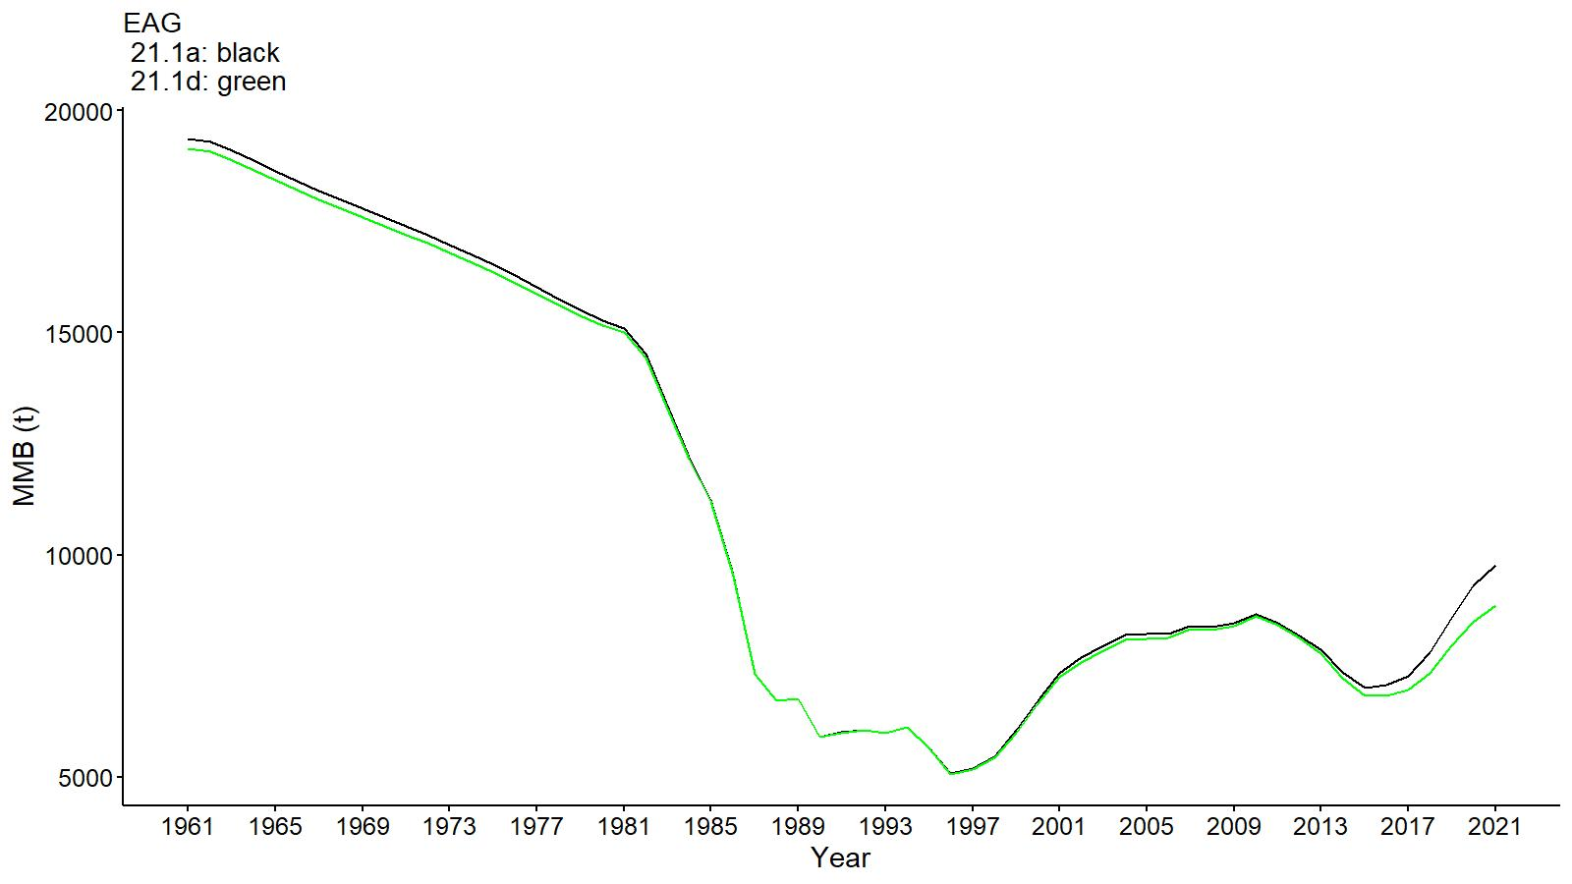

Figure C.6. Comparison of trends in golden king crab mature male biomass between models 21.1a and 21.1d for EAG, 1961–2021. Year 2021 refers to 2020/21 fishing season.

**Appendix D: Male Maturity**

*Introduction*

Sexual maturity is associated with alterations in both external morphology and internal physiology, on which bases different types of maturity can be defined: physiological, morphometric, and functional maturity. Although functional maturity is the true way of determining maturity, it requires elaborate lab or field experiments. Hence, crab researchers often adapt an indirect detection technique via morphometric measurement for maturity determination. Chelae allometry has been used to determine morphometric male size-at-maturity among several king crab (*Lithodidae*) stocks. Male golden king crab provides a better discrimination of chelae height against size at onset of maturity than other king crab stocks (Somerton and Otto 1986). Table D.1 lists the literature reported estimates of size-at-maturity of male golden king crab (*Lithodes aequispins*) stocks in Alaska. Breakpoint analysis has been used to estimate maturity in majority of cases.

Table D.1. Review of estimates of male size-at-maturity of golden (*Lithodes aequispins*) king crabs by regions in Alaska. Numbers in parentheses are standard errors (SE).

|  |  |  |  |  |  |
| --- | --- | --- | --- | --- | --- |
| **Species** | **Sex** | **Size-at-Maturity (mm CL)** | **Method** | **Area** | **Sources** |
| *Lithodes aequispins* | Male | 114 (11.4) | Breakpoint analysis on log(chela height) vs. log(carapace length) | British Columbia, Canada | Jewett *et al*. 1985 |
|  |  | 92 (2.4)  107 (4.6)  130 (4.0) | Breakpoint analysis on log(chela height) vs. log(carapace length) | St. Matthew Is. District  Pribilof Is District  Eastern Aleutian Is | Somerton and Otto 1986 |
|  |  | 117.9 to 158.0 | Breakpoint analysis on log(chela height) vs. log(carapace length) | Various water inlets in southeast Alaska | Olson 2016 |
|  |  | 108.6 (2.6)  120.8 (2.9) | Breakpoint analysis on log(chela height) vs. log(carapace length) | Bowers Ridge  Seguam Pass | Otto and Cummiskey 1985 |
|  |  | 110 | Minimum size of successful mating (lab observation) | Prince William Sound | Paul and Paul 2001 |
|  |  |  |  |  |  |

*Method*

We used the carapace length (mm CL) and chela height (up to one-tenth of a mm CH) data collected by the observer, retained catch, and cooperative surveys sampling during the 2018/19, 2019/20, and 2020/21 fishing seasons for male maturity investigation. We determined bend points and corresponding two segmented lines for different groups of data outside the assessment model using the ‘segmented regression’ package available in R version 3.6.3 (R Core Team 2020).

First, we fitted a linear regression model to the data pair using the R package as follows:

(D.1)

where and are regression parameters

The procedure of ‘segmented regression’ uses maximum likelihood to fit a somewhat different parameterization of the linear model. It can be approximated as

(D.2)

where is a regression parameter and c is the break-point, and is a dummy variable. When *CL* < *c*, the model reduces to,

(D.3)

###### The *γ* term is a measure of the distance between the end of the first segment and the beginning of the next. The model converges when *γ*is minimized, thus this method constrains the segments to be (nearly) continuous.

We further refined the estimates by bootstrapping each data set (ln (CH/CL), CL pairs) 1000 times and applying ‘segmented regression’ to each bootstrapped sample. We used the bootstrap median bend point, intercept, and slope estimates to establish the two segmented lines (i.e., left hand line 1 was for immature and right-hand line 2 was for mature crab).

Finally, we categorized the observed ln (CH/CL) vs CL pair in to mature (code 1) if the ln (CH/CL) value was on or above line 2 or immature (code 0) if this value was below line 2 for a given CL. Then we fitted the following logistic model by GLM to the response variable (mature 1, immature 0, converted to mature proportion *P*) vs. the independent variable (CL) to obtain a maturity curve.

(D.4)

where *P* is the proportion mature, *α* and *β* are intercept and slope parameters of the maturity curve, and CL is carapace length.

*Data*

We used the following data sets (Table D.2) for current maturity analysis. We restricted the size range to 85.0 mm CL to 142.0 mm CL (a plausible morphometric male maturity size range for golden king crab in the Bering Sea and Aleutian Islands (i.e., 92.0 mm CL – 3SE to 130 mm CL+3SE, Table D.1) for ‘segmented regression’ fit and maturity determination from segmented line 2 for subsequent logistic model fit.

Table D.2. Golden king crab male carapace length and chela height data collected during 2018/19 – 2020/21 fishing seasons in the Aleutian Islands.

|  |  |  |  |  |
| --- | --- | --- | --- | --- |
| Measurement type | Source and season of data collection | Group | | |
|  |  | Aleutian Islands (AI) 2018/19– 2020/21 | EAG 2018/19– 2019/20 | WAG 2018/19– 2020/21 |
|  | Co-operative survey (2018/19, 2019/20) |  |  |  |
|  | Observer sampling (2018/19, 2019/20) |  |  |  |
|  | Retained catch sampling (2018/19, 2019/20) |  |  |  |
|  | Special sampling WAG (2020/21) |  |  |  |
| Carapace length and chela height records (all sizes) |  | 10760 | 5433 | 5327 |
| Carapace length and chela height records (85 mm CL–142 mm CL) |  | 4025 | 1901 | 2124 |

*Results*

The median breakpoint ranged from 117.800 to 119.984 mm CL for the three 2018– 2020 data sets (AI, EAG, and WAG). These values are one to two 5 mm CL bins higher than the WAG 1984 and EAG 1991 estimates considered previously (Table D.3). The focus of the current analysis is to establish separate maturity curves for AI, EAG, and WAG for MMB determination. Table D.4 lists the logistic maturity curve parameter estimates for AI, EAG, and WAG. The estimates for the three data sets are highly significant. We considered three options for MMB estimation: 111 mm CL (status quo knife edge maturity), 116 mm CL (a cautionary choice based on the current determination of 50% maturity length by the logistic model for AI), and the AI logistic maturity curve common to both EAG and WAG.

Figures D.1, D.2, and D.3 show the fitted segmented regression lines overlayed on observed log (CH/CL) vs CL data for AI, EAG, and WAG, respectively. Figures D.4, D.5, and D.6 show the fitted logistic curves overlayed on observed maturity proportion vs CL for AI, EAG, and WAG, respectively. The observed mature (1) and immature (0) counts at each 2 mm CL interval were used to calculate the observed mature proportion by size. The observed maturity data were hard cutoff to be immature below 85 mm CL and mature above 142 mm CL (i.e., outside the data range considered for segmented regression fitting) for logistic model fitting. Although arbitrary, but reasonable, data massaging occurred before logistic model fitting. We considered that the fitted logistic curve (with highly significant parameter estimates) was appropriate for MMB determination.

Table D.3. Segment regression fit to 2018–2020 log (CH/CL) vs. CL data pairs and median estimates from 1000 bootstrap samples including breakpoints for EAG, WAG, and combined (AI) data sets. The data sets were truncated to 85.0–142.0 mm CL range for segmented regression fits. We also provide re-estimated parameters for the 1991 EAG and 1984 WAG data with the same size restriction for comparison. Intercept of line 2 was determined for each data set by solving the two lines at the bend point.

|  |  |  |  |  |  |  |  |
| --- | --- | --- | --- | --- | --- | --- | --- |
|  | Estimate | SE | t-value | Pr(>|t|) | Breakpoint (mm CL) | SE | Remarks |
| AI 2018–20: |  |  |  |  |  |  | Fit to original data, 85.0– 142.0 mm CL range |
| Intercept line 1 | -1.76273 | 0.04974 | -35.43610 | 0.00000 | 118.900 | 1.760 |  |
| Slope line 1 | 0.00183 | 0.00046 | 3.96526 | 0.00007 |  |  |  |
| Slope to add | 0.00465 | 0.00053 | 8.70356 | 0.00000 |  |  |  |
| Slope line 2 | 0.00648 |  |  |  |  |  |  |
|  |  |  |  |  |  |  |  |
| Intercept line 1 | -1.78187 | 0.00185 |  |  | 119.984 | 0.104 | Bootstrap median estimates |
| Slope line 1 | 0.00200 | 0.00002 |  |  |  |  |  |
| Slope line 2 | 0.00663 | 0.00002 |  |  |  |  |  |
|  |  |  |  |  |  |  |  |
| EAG 2018–20: |  |  |  |  |  |  | Fit to original data, 85.0– 142.0 mm CL range |
| Intercept line 1 | -1.74671 | 0.15258 | -11.44750 | 0.00000 | 112.574 | 4.125 |  |
| Slope line 1 | 0.00146 | 0.00149 | 0.98016 | 0.32713 |  |  |  |
| Slope to add | 0.00515 | 0.00154 | 3.35423 | 0.00081 |  |  |  |
| Slope line 2 | 0.00661 |  |  |  |  |  |  |
|  |  |  |  |  |  |  |  |
| Intercept line 1 | -1.81430 | 0.01115 |  |  | 117.800 | 0.317 | Bootstrap median estimates |
| Slope line 1 | 0.00216 | 0.00012 |  |  |  |  |  |
| Slope line 2 | 0.00698 | 0.00230 |  |  |  |  |  |
|  |  |  |  |  |  |  |  |
| WAG 2018–20: |  |  |  |  |  |  | Fit to original data, 85.0– 142.0 mm CL range |
| Intercept line 1 | -1.73808 | 0.05330 | -32.60763 | 0.00000 | 119.330 | 2.115 |  |
| Slope line 1 | 0.00164 | 0.00049 | 3.33148 | 0.00088 |  |  |  |
| Slope to add | 0.00440 | 0.00061 | 7.19722 | 0.00000 |  |  |  |
| Slope line 2 | 0.00604 |  |  |  |  |  |  |
|  |  |  |  |  |  |  |  |
| Intercept line 1 | -1.74555 | 0.00188 |  |  | 119.603 | 0.124 | Bootstrap median estimates |
| Slope line 1 | 0.00171 | 0.00002 |  |  |  |  |  |
| Slope line 2 | 0.00620 | 0.00005 |  |  |  |  |  |
|  |  |  |  |  |  |  |  |
| EAG 1991: |  |  |  |  |  |  | Fit to 85.0–142.0 mm CL range |
| Intercept line 1 | -1.60166 | 0.02286 | -70.04911 | 0.00000 | 107.000 | 1.915 | Estimates from 2457 measurements |
| Slope line 1 | 0.00070 | 0.00026 | 2.71486 | 0.00668 |  |  |  |
| Slope to add | 0.00424 | 0.00029 | 14.45235 | 0.00000 |  |  |  |
| Slope line 2 | 0.00494 |  |  |  |  |  |  |
|  |  |  |  |  |  |  |  |
| WAG 1984: |  |  |  |  |  |  | Fit to 85.0–142.0 mm CL range |
| Intercept line 1 | -1.67570 | 0.09222 | -18.17129 | 0.00000 | 105.824 | 4.650 | Estimates from 341 measurements |
| Slope line 1 | 0.00126 | 0.00097 | 1.29613 | 0.19582 |  |  |  |
| Slope to add | 0.00332 | 0.00106 | 3.12254 | 0.00195 |  |  |  |
| Slope line 2 | 0.00458 |  |  |  |  |  |  |

Table D.4. Logistic fit to 2018–2020 maturity data for AI, EAG, and WAG.

|  |  |  |  |  |  |  |
| --- | --- | --- | --- | --- | --- | --- |
|  | Estimate | SE | z-value | Pr(>|z|) | L50 (mm CL) | Remarks |
| AI 2018–20: |  |  |  |  |  | Logistic model fit to 52.6–198.7 mm CL range, 10760 measurements |
|  | -7.68092 | 0.29230 | -26.28000 | 0.00000 | 116.879 |  |
|  | 0.06572 | 0.00209 | 31.43000 | 0.00000 |  |  |
| EAG 2018–20: |  |  |  |  |  | Logistic model fit to 57.6–197.3 mm CL range, 5433 measurements |
| Intercept (α) | -13.45746 | 0.63635 | -21.15000 | 0.00000 | 126.403 |  |
| Slope (β) | 0.10647 | 0.00453 | 23.49000 | 0.00000 |  |  |
|  |  |  |  |  |  |  |
| WAG 2018–20: |  |  |  |  | 110.363 | Logistic model fit to 52.6–198.7 mm CL range, 5327 measurements |
| Intercept (α) | -5.64641 | 0.32860 | -17.18000 | 0.00000 |  |  |
| Slope (β) | 0.05116 | 0.00237 | 21.59000 | 0.00000 |  |  |

Figures D.1, D.2 and D.3 provide the segment regression lines fitted to the log (CH/CL) vs. CL data pairs and D.4, D.5, and D.6 depict the logistic curves fitted to mature proportion vs. CL data pairs for 2018–2020 in AI, EAG, and WAG, respectively:

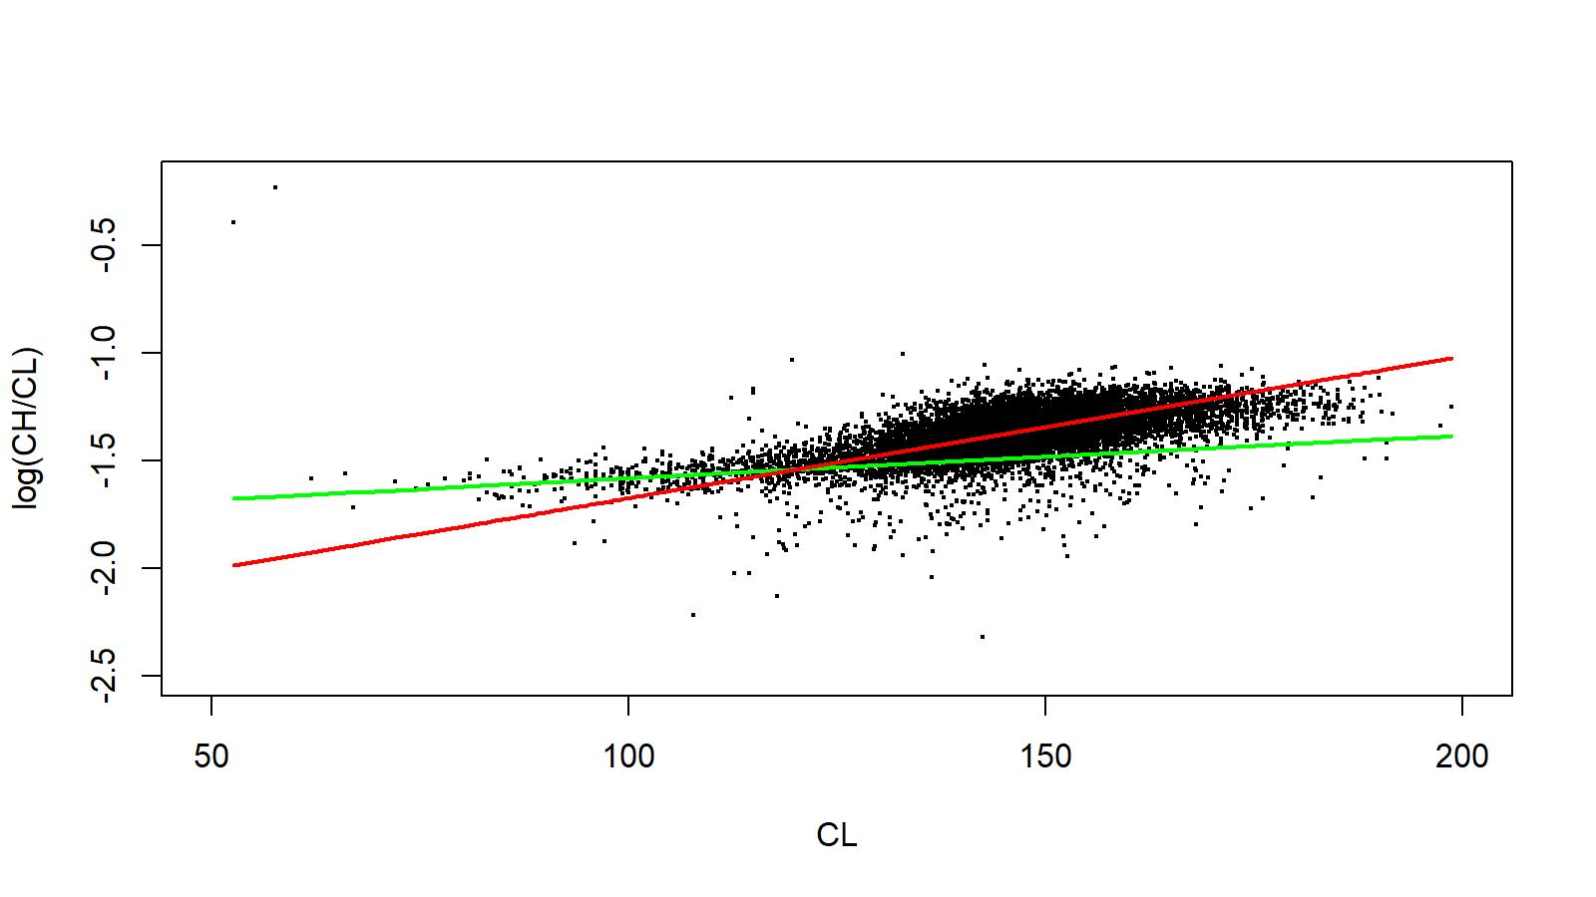

Figure D.1. Segmented linear regression fit to log(CH/CL) vs. CL data of male golden king crab for 2018–2020 in AI.

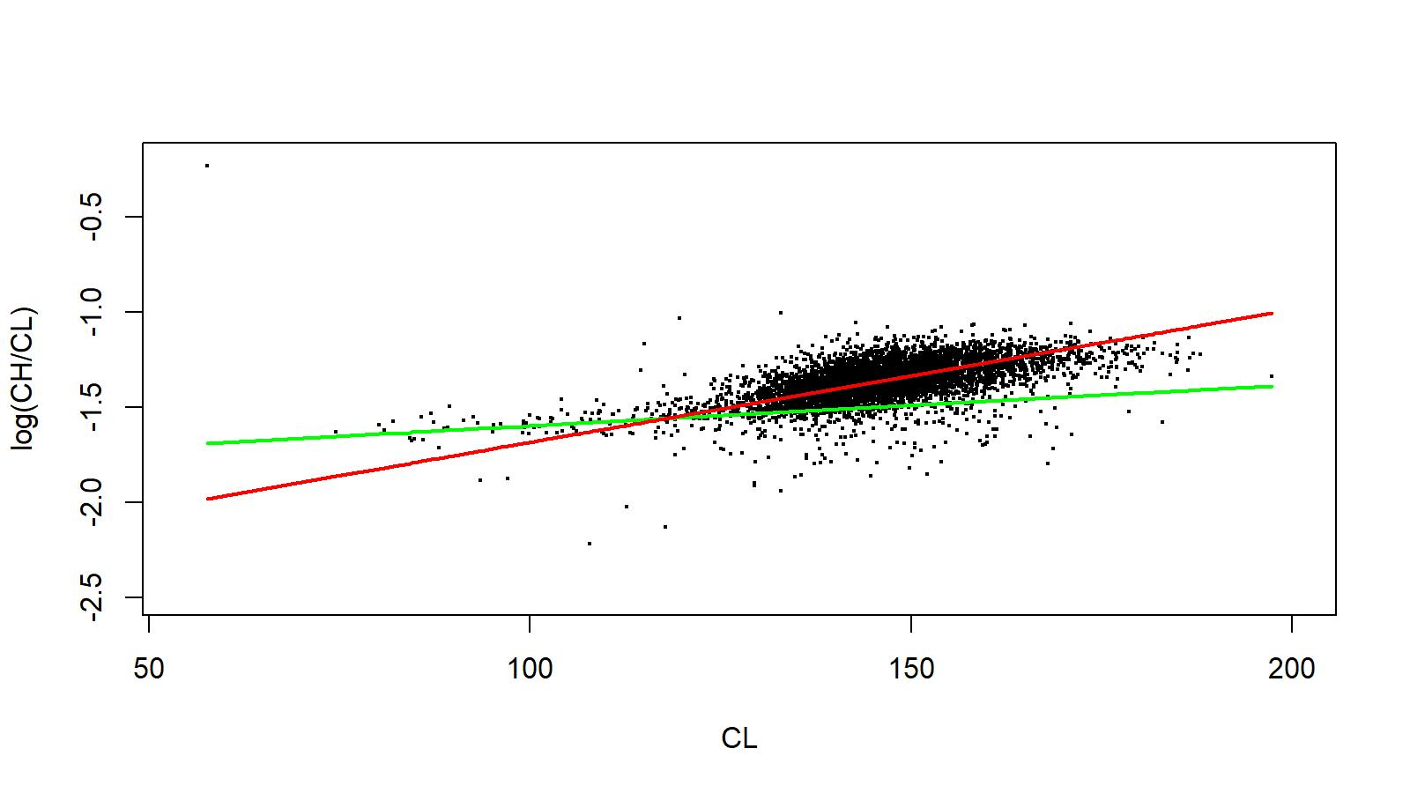

Figure D.2. Segmented linear regression fit to log(CH/CL) vs. CL data of male golden king crab for 2018–2020 in EAG.

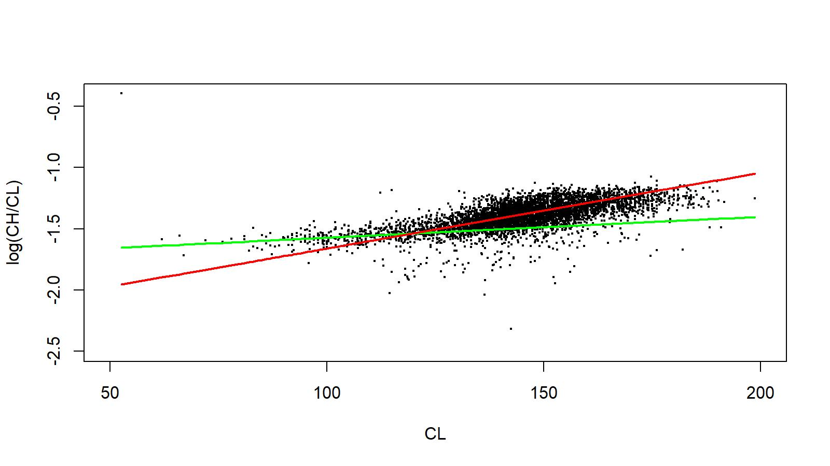

Figure D.3. Segmented linear regression fit to log(CH/CL) vs. CL data of male golden king crab for 2018–2020 in WAG.

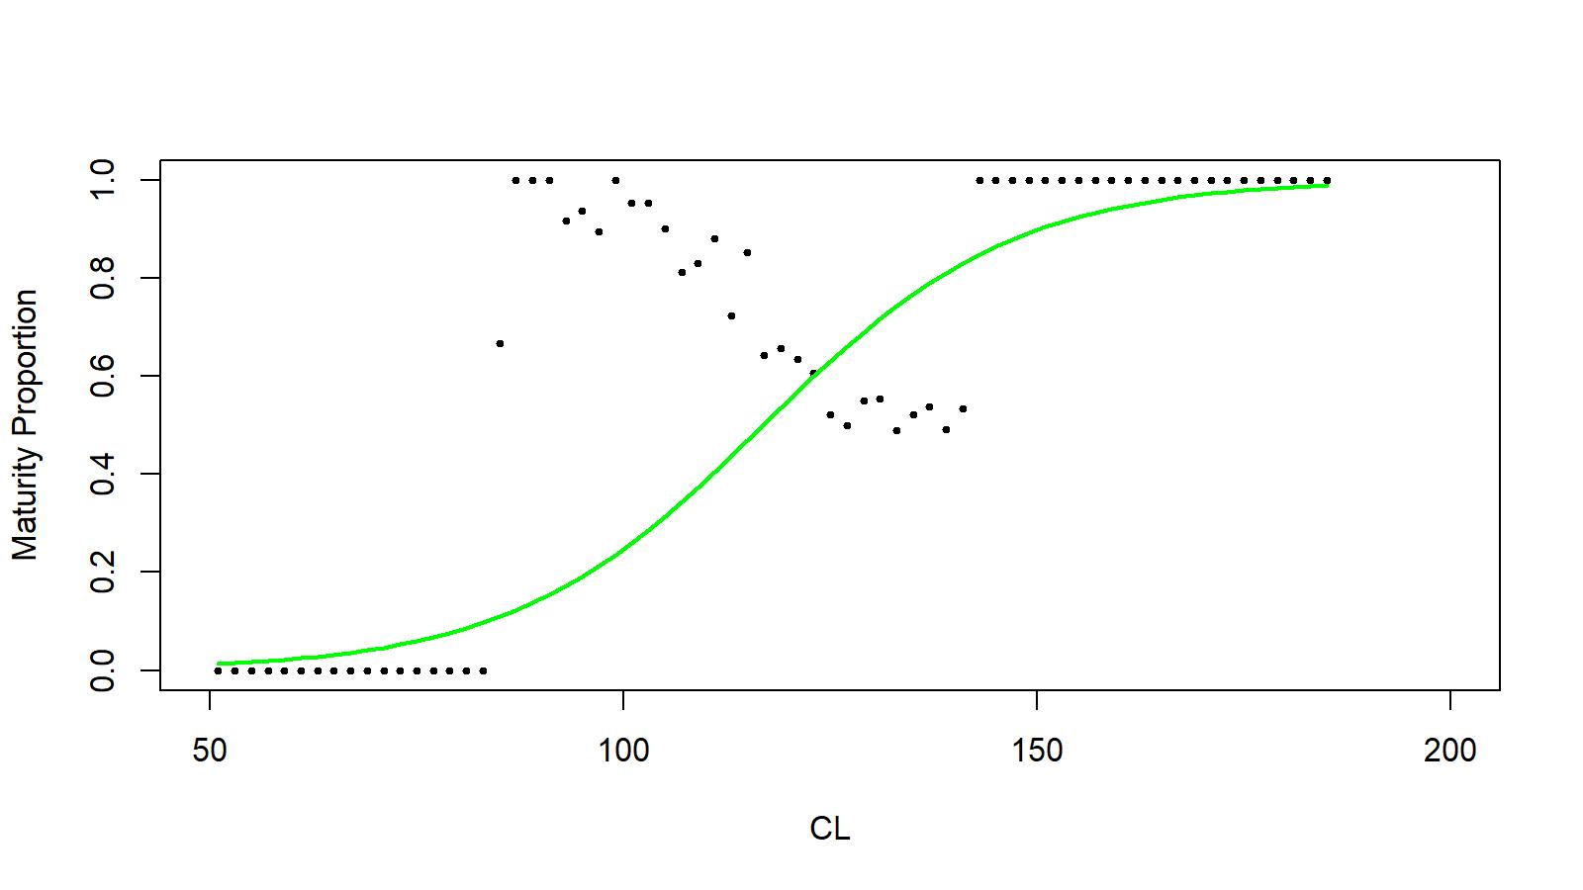

Figure D.4. Logistic fit to mature proportion of male golden king crab for 2018–2020 in AI.

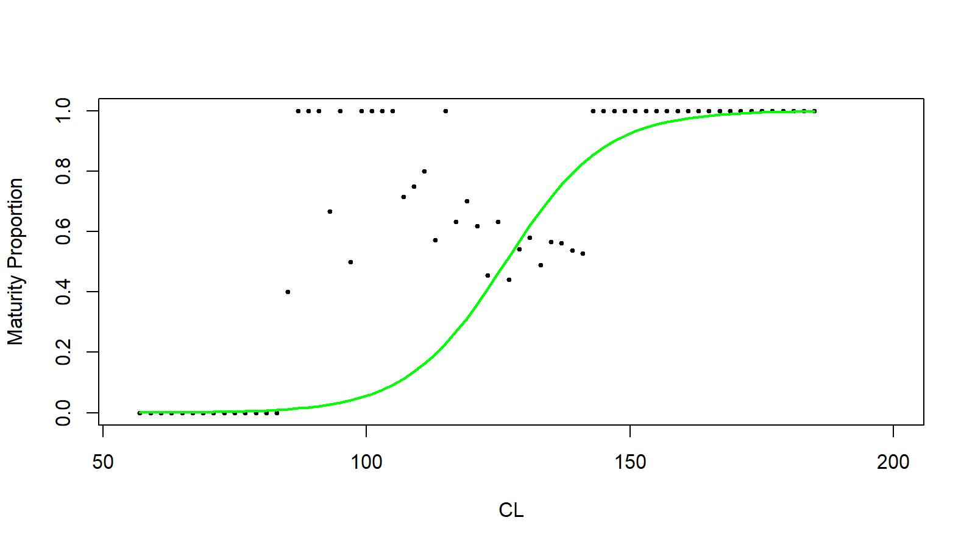

Figure D.5. Logistic fit to mature proportion of male golden king crab for 2018–2020 in EAG.

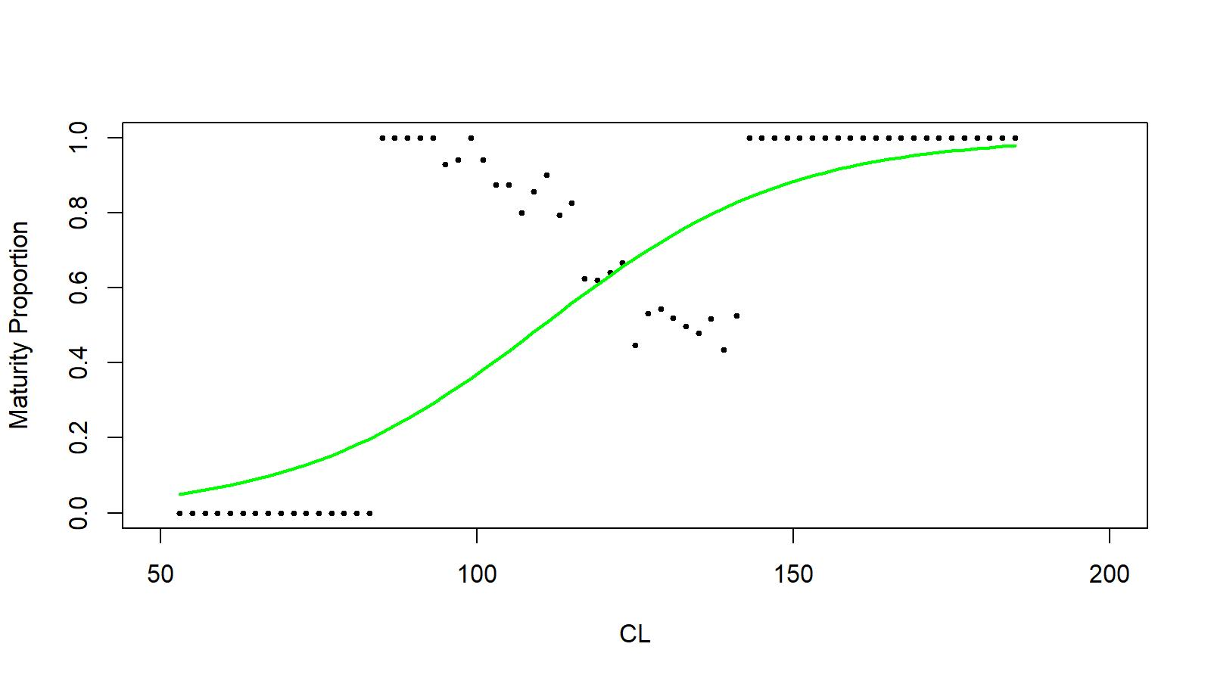

Figure D.6. Logistic fit to mature proportion of male golden king crab for 2018–2020 in WAG.

*Implication on mature male biomass estimation:*

Figure D.7 provides the long-term trends in MMB by models 21.1a, 21.1b, and 21.1c with varying maturity assumptions: status quo knife-edge maturity size of 111 mm CL (...1a, …1b, …1c), higher maturity size of 116 mm CL (…1a1, …1b1, …1c1), and logistic maturity curve (...1a2, …1b2, …1c2). Changes from status quo maturity assumption generally result in lower MMB values.

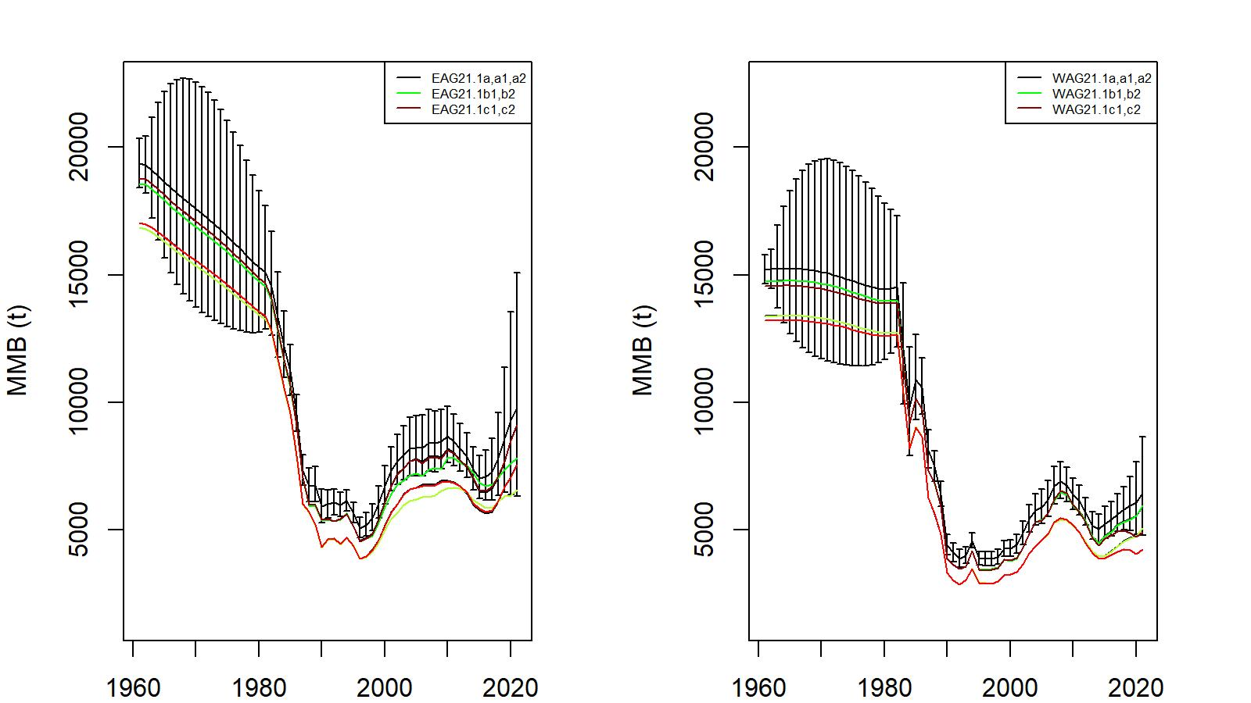

Figure D.7. Trends in golden king crab mature male biomass for models 21.1a, 21.1a1, 21.1a2, 21.1b1, 21.1b2, 21.1c1, and 21.1c2 fits to EAG (left) and WAG (right) data, 1961–2021. Model 21.1a estimate has two standard error confidence limits. Year 2021 refers to 2020/21 fishing season.

**Appendix E: Jittering**

*Jittering of model 19.1 parameter estimates*

We followed the Stock Synthesis approach to do 100 jitter runs of model 19.1parameter estimates to use as initial parameter values (as .PIN file in ADMB) to assess model stability and to determine whether a global, as opposed to local, minima has been reached by the search algorithm:

Following CPT suggestion, we increased the jittering to 50% from previously used 30%. A *Jitter* factor of 0.5 was multiplied by a random normal deviation *rdev=N*(0,1) to create a transformed parameter value based upon the predefined parameter:

, (E.1)

with the final jittered initial parameter value back transformed as:

 (E.2)

where *Pmax* and *Pmin* are upper and lower bounds of parameter search space and *Pval* is the estimated parameter value before the jittering.

The jitter results are summarized for scenario 19.1 in Tables E.1 and E.2 for EAG and WAG, respectively. All runs converged to the highest log likelihood values except for nonconvergent runs. We concluded from jitter results that optimization of 19.1 model achieved global minima for both EAG and WAG.

Table E.1. Results from 100 jitter runs for scenario 19.1 for EAG. Jitter run 0 corresponds to the original optimized estimates. NA: model did not converge for run#3.

|  |  |  |  |  |  |
| --- | --- | --- | --- | --- | --- |
| Jitter Run | Objective Function | Maximum Gradient | B35% (t) | OFL (t) | Current  MMB (t) |
| **0** | **-94.08746** | **0.000155** | **6,696** | **2,935** | **8,722** |
| 1 | -94.08746 | 0.000155 | 6,696 | 2,935 | 8,722 |
| 2 | -94.08746 | 0.000155 | 6,696 | 2,935 | 8,722 |
| 3 | NA | NA | NA | NA | NA |
| 4 | -94.08746 | 0.000066 | 6,696 | 2,935 | 8,722 |
| 5 | -94.08746 | 0.000015 | 6,696 | 2,935 | 8,722 |
| 6 | -94.08746 | 0.000022 | 6,696 | 2,935 | 8,722 |
| 7 | -94.08746 | 0.000370 | 6,696 | 2,935 | 8,722 |
| 8 | -94.08746 | 0.000181 | 6,696 | 2,935 | 8,722 |
| 9 | -94.08746 | 0.000131 | 6,696 | 2,935 | 8,722 |
| 10 | -94.08746 | 0.000160 | 6,696 | 2,935 | 8,722 |
| 11 | -94.08746 | 0.000050 | 6,696 | 2,935 | 8,722 |
| 12 | -94.08746 | 0.000105 | 6,696 | 2,935 | 8,722 |
| 13 | -94.08746 | 0.000152 | 6,696 | 2,935 | 8,722 |
| 14 | -94.08746 | 0.000075 | 6,696 | 2,935 | 8,722 |
| 15 | -94.08746 | 0.000166 | 6,696 | 2,935 | 8,722 |
| 16 | -94.08746 | 0.000060 | 6,696 | 2,935 | 8,722 |
| 17 | -94.08746 | 0.000024 | 6,696 | 2,935 | 8,722 |
| 18 | -94.08746 | 0.000153 | 6,696 | 2,935 | 8,722 |
| 19 | -94.08746 | 0.000202 | 6,696 | 2,935 | 8,722 |
| 20 | -94.08746 | 0.000020 | 6,696 | 2,935 | 8,722 |
| 21 | -94.08746 | 0.000078 | 6,696 | 2,935 | 8,722 |
| 22 | -94.08746 | 0.001453 | 6,696 | 2,935 | 8,722 |
| 23 | -94.08746 | 0.000478 | 6,696 | 2,935 | 8,722 |
| 24 | -94.08746 | 0.000241 | 6,696 | 2,935 | 8,722 |
| 25 | -94.08746 | 0.000309 | 6,696 | 2,935 | 8,722 |
| 26 | -94.08746 | 0.000128 | 6,696 | 2,935 | 8,722 |
| 27 | -94.08746 | 0.000054 | 6,696 | 2,935 | 8,722 |
| 28 | -94.08746 | 0.000259 | 6,696 | 2,935 | 8,722 |
| 29 | -94.08746 | 0.000169 | 6,696 | 2,935 | 8,722 |
| 30 | -94.08746 | 0.000145 | 6,696 | 2,935 | 8,722 |
| 31 | -94.08746 | 0.000079 | 6,696 | 2,935 | 8,722 |
| 32 | -94.08746 | 0.000033 | 6,696 | 2,935 | 8,722 |
| 33 | -94.08746 | 0.001445 | 6,696 | 2,935 | 8,722 |
| 34 | -94.08746 | 0.000158 | 6,696 | 2,935 | 8,722 |
| 35 | -94.08746 | 0.000159 | 6,696 | 2,935 | 8,722 |
| 36 | -94.08746 | 0.000389 | 6,696 | 2,935 | 8,722 |
| 37 | -94.08746 | 0.000111 | 6,696 | 2,935 | 8,722 |
| 38 | -94.08746 | 0.000243 | 6,696 | 2,935 | 8,722 |
| 39 | -94.08746 | 0.000041 | 6,696 | 2,935 | 8,722 |
| 40 | -94.08746 | 0.000098 | 6,696 | 2,935 | 8,722 |
| 41 | -94.08746 | 0.000045 | 6,696 | 2,935 | 8,722 |
| 42 | -94.08746 | 0.000689 | 6,696 | 2,935 | 8,722 |
| 43 | -94.08746 | 0.000013 | 6,696 | 2,935 | 8,722 |
| 44 | -94.08746 | 0.000250 | 6,696 | 2,935 | 8,722 |
| 45 | -94.08746 | 0.000222 | 6,696 | 2,935 | 8,722 |
| 46 | -94.08746 | 0.000114 | 6,696 | 2,935 | 8,722 |
| 47 | -94.08746 | 0.000306 | 6,696 | 2,935 | 8,722 |
| 48 | -94.08746 | 0.000029 | 6,696 | 2,935 | 8,722 |
| 49 | -94.08746 | 0.000175 | 6,696 | 2,935 | 8,722 |
| 50 | -94.08746 | 0.000231 | 6,696 | 2,935 | 8,722 |
| 51 | -94.08746 | 0.000163 | 6,696 | 2,935 | 8,722 |
| 52 | -94.08746 | 0.000145 | 6,696 | 2,935 | 8,722 |
| 53 | -94.08746 | 0.000192 | 6,696 | 2,935 | 8,722 |
| 54 | -94.08746 | 0.000051 | 6,696 | 2,935 | 8,722 |
| 55 | -94.08746 | 0.000281 | 6,696 | 2,935 | 8,722 |
| 56 | -94.08746 | 0.000124 | 6,696 | 2,935 | 8,722 |
| 57 | -94.08746 | 0.000162 | 6,696 | 2,935 | 8,722 |
| 58 | -94.08746 | 0.000141 | 6,696 | 2,935 | 8,722 |
| 59 | -94.08746 | 0.000254 | 6,696 | 2,935 | 8,722 |
| 60 | -94.08746 | 0.000045 | 6,696 | 2,935 | 8,722 |
| 61 | -94.08746 | 0.000005 | 6,696 | 2,935 | 8,722 |
| 62 | -94.08746 | 0.000354 | 6,696 | 2,935 | 8,722 |
| 63 | -94.08746 | 0.000068 | 6,696 | 2,935 | 8,722 |
| 64 | -94.08746 | 0.000124 | 6,696 | 2,935 | 8,722 |
| 65 | -94.08746 | 0.000057 | 6,696 | 2,935 | 8,722 |
| 66 | -94.08746 | 0.000015 | 6,696 | 2,935 | 8,722 |
| 67 | -94.08746 | 0.000088 | 6,696 | 2,935 | 8,722 |
| 68 | -94.08746 | 0.000195 | 6,696 | 2,935 | 8,722 |
| 69 | -94.08746 | 0.000204 | 6,696 | 2,935 | 8,722 |
| 70 | -94.08746 | 0.000623 | 6,696 | 2,935 | 8,722 |
| 71 | -94.08746 | 0.000090 | 6,696 | 2,935 | 8,722 |
| 72 | -94.08746 | 0.000083 | 6,696 | 2,935 | 8,722 |
| 73 | -94.08746 | 0.000031 | 6,696 | 2,935 | 8,722 |
| 74 | -94.08746 | 0.000336 | 6,696 | 2,935 | 8,722 |
| 75 | -94.08746 | 0.000113 | 6,696 | 2,935 | 8,722 |
| 76 | -94.08746 | 0.000029 | 6,696 | 2,935 | 8,722 |
| 77 | -94.08746 | 0.000065 | 6,696 | 2,935 | 8,722 |
| 78 | -94.08746 | 0.000238 | 6,696 | 2,935 | 8,722 |
| 79 | -94.08746 | 0.000034 | 6,696 | 2,935 | 8,722 |
| 80 | -94.08746 | 0.000134 | 6,696 | 2,935 | 8,722 |
| 81 | -94.08746 | 0.000152 | 6,696 | 2,935 | 8,722 |
| 82 | -94.08746 | 0.000230 | 6,696 | 2,935 | 8,722 |
| 83 | -94.08746 | 0.000141 | 6,696 | 2,935 | 8,722 |
| 84 | -94.08746 | 0.000142 | 6,696 | 2,935 | 8,722 |
| 85 | -94.08746 | 0.000147 | 6,696 | 2,935 | 8,722 |
| 86 | -94.08746 | 0.000151 | 6,696 | 2,935 | 8,722 |
| 87 | -94.08746 | 0.000146 | 6,696 | 2,935 | 8,722 |
| 88 | -94.08746 | 0.000093 | 6,696 | 2,935 | 8,722 |
| 89 | -94.08746 | 0.000118 | 6,696 | 2,935 | 8,722 |
| 90 | -94.08746 | 0.000073 | 6,696 | 2,935 | 8,722 |
| 91 | -94.08746 | 0.000041 | 6,696 | 2,935 | 8,722 |
| 92 | -94.08746 | 0.000050 | 6,696 | 2,935 | 8,722 |
| 93 | -94.08746 | 0.000034 | 6,696 | 2,935 | 8,722 |
| 94 | -94.08746 | 0.000038 | 6,696 | 2,935 | 8,722 |
| 95 | -94.08746 | 0.000108 | 6,696 | 2,935 | 8,722 |
| 96 | -94.08746 | 0.000006 | 6,696 | 2,935 | 8,722 |
| 97 | -94.08746 | 0.000079 | 6,696 | 2,935 | 8,722 |
| 98 | -94.08746 | 0.000236 | 6,696 | 2,935 | 8,722 |
| 99 | -94.08746 | 0.000039 | 6,696 | 2,935 | 8,722 |
| 100 | -94.08746 | 0.000179 | 6,696 | 2,935 | 8,722 |

Table E.2 Results from 100 jitter runs for scenario 19.1 for WAG. Jitter run 0 corresponds to the original optimized estimates. NA: model did not converge for runs #9 and 30.

|  |  |  |  |  |  |
| --- | --- | --- | --- | --- | --- |
| Jitter Run | Objective Function | Maximum Gradient | B35% (t) | OFL (t) | Current  MMB (t) |
| **0** | **-177.0032** | **0.000280** | **5,300** | **1,884** | **6,099** |
| **1** | -177.0032 | 0.000280 | 5,300 | 1,884 | 6,099 |
| 2 | -177.0032 | 0.000280 | 5,300 | 1,884 | 6,099 |
| 3 | -177.0032 | 0.000280 | 5,300 | 1,884 | 6,099 |
| 4 | -177.0032 | 0.000280 | 5,300 | 1,884 | 6,099 |
| 5 | -177.0032 | 0.000280 | 5,300 | 1,884 | 6,099 |
| 6 | -177.0032 | 0.000280 | 5,810 | 1,964 | 6,334 |
| 7 | -177.0032 | 0.000280 | 5,300 | 1,884 | 6,099 |
| 8 | -177.0032 | 0.000280 | 5,300 | 1,884 | 6,099 |
| 9 | NA | NA | NA | NA | NA |
| 10 | -177.0032 | 0.000280 | 5,300 | 1,884 | 6,099 |
| 11 | -177.0032 | 0.000280 | 5,300 | 1,884 | 6,099 |
| 12 | -177.0032 | 0.000280 | 5,300 | 1,884 | 6,099 |
| 13 | -177.0032 | 0.000280 | 5,300 | 1,884 | 6,099 |
| 14 | -177.0032 | 0.000280 | 5,300 | 1,884 | 6,099 |
| 15 | -177.0032 | 0.000280 | 5,872 | 1,962 | 6,378 |
| 16 | -177.0032 | 0.000280 | 5,300 | 1,884 | 6,099 |
| 17 | -177.0032 | 0.000280 | 5,300 | 1,884 | 6,099 |
| 18 | -177.0032 | 0.000280 | 5,300 | 1,884 | 6,099 |
| 19 | -177.0032 | 0.000280 | 5,300 | 1,884 | 6,099 |
| 20 | -177.0032 | 0.000280 | 5,300 | 1,884 | 6,099 |
| 21 | -177.0032 | 0.000280 | 5,300 | 1,884 | 6,099 |
| 22 | -177.0032 | 0.000280 | 5,300 | 1,884 | 6,099 |
| 23 | -177.0032 | 0.000280 | 5,300 | 1,884 | 6,099 |
| 24 | -177.0032 | 0.000280 | 5,300 | 1,884 | 6,099 |
| 25 | -177.0032 | 0.000280 | 5,300 | 1,884 | 6,099 |
| 26 | -177.0032 | 0.000280 | 5,300 | 1,884 | 6,099 |
| 27 | -177.0032 | 0.000280 | 5,300 | 1,884 | 6,099 |
| 28 | -177.0032 | 0.000280 | 5,300 | 1,884 | 6,099 |
| 29 | -177.0032 | 0.000280 | 5,300 | 1,884 | 6,099 |
| 30 | NA | NA | NA | NA | NA |
| 31 | -177.0032 | 0.000280 | 5,300 | 1,884 | 6,099 |
| 32 | -177.0032 | 0.000280 | 5,300 | 1,884 | 6,099 |
| 33 | -177.0032 | 0.000280 | 5,300 | 1,884 | 6,099 |
| 34 | -177.0032 | 0.000280 | 5,300 | 1,884 | 6,099 |
| 35 | -177.0032 | 0.000280 | 5,300 | 1,884 | 6,099 |
| 36 | -177.0032 | 0.000280 | 5,872 | 1,962 | 6,378 |
| 37 | -177.0032 | 0.000280 | 5,300 | 1,884 | 6,099 |
| 38 | -177.0032 | 0.000280 | 5,300 | 1,884 | 6,099 |
| 39 | -177.0032 | 0.000280 | 5,300 | 1,884 | 6,099 |
| 40 | -177.0032 | 0.000280 | 5,300 | 1,884 | 6,099 |
| 41 | -177.0032 | 0.000280 | 5,300 | 1,884 | 6,099 |
| 42 | -177.0032 | 0.000280 | 5,300 | 1,884 | 6,099 |
| 43 | -177.0032 | 0.000280 | 5,300 | 1,884 | 6,099 |
| 44 | -177.0032 | 0.000280 | 5,300 | 1,884 | 6,099 |
| 45 | -177.0032 | 0.000280 | 5,300 | 1,884 | 6,099 |
| 46 | -177.0032 | 0.000280 | 5,300 | 1,884 | 6,099 |
| 47 | -177.0032 | 0.000280 | 5,782 | 1,960 | 6,331 |
| 48 | -177.0032 | 0.000280 | 5,300 | 1,884 | 6,099 |
| 49 | -177.0032 | 0.000280 | 5,300 | 1,884 | 6,099 |
| 50 | -177.0032 | 0.000280 | 5,300 | 1,884 | 6,099 |
| 51 | -177.0032 | 0.000280 | 5,300 | 1,884 | 6,099 |
| 52 | -177.0032 | 0.000280 | 5,300 | 1,884 | 6,099 |
| 53 | -177.0032 | 0.000280 | 5,300 | 1,884 | 6,099 |
| 54 | -177.0032 | 0.000280 | 5,810 | 1,964 | 6,334 |
| 55 | -177.0032 | 0.000280 | 5,300 | 1,884 | 6,099 |
| 56 | -177.0032 | 0.000280 | 5,300 | 1,884 | 6,099 |
| 57 | -177.0032 | 0.000280 | 5,300 | 1,884 | 6,099 |
| 58 | -177.0032 | 0.000280 | 5,300 | 1,884 | 6,099 |
| 59 | -177.0032 | 0.000280 | 5,300 | 1,884 | 6,099 |
| 60 | -177.0032 | 0.000280 | 5,300 | 1,884 | 6,099 |
| 61 | -177.0032 | 0.000280 | 5,300 | 1,884 | 6,099 |
| 62 | -177.0032 | 0.000280 | 5,300 | 1,884 | 6,099 |
| 63 | -177.0032 | 0.000280 | 5,300 | 1,884 | 6,099 |
| 64 | -177.0032 | 0.000280 | 5,300 | 1,884 | 6,099 |
| 65 | -177.0032 | 0.000280 | 5,300 | 1,884 | 6,099 |
| 66 | -177.0032 | 0.000280 | 5,300 | 1,884 | 6,099 |
| 67 | -177.0032 | 0.000280 | 5,300 | 1,884 | 6,099 |
| 68 | -177.0032 | 0.000280 | 5,300 | 1,884 | 6,099 |
| 69 | -177.0032 | 0.000280 | 5,782 | 1,960 | 6,331 |
| 70 | -177.0032 | 0.000280 | 5,300 | 1,884 | 6,099 |
| 71 | -177.0032 | 0.000280 | 5,872 | 1,962 | 6,378 |
| 72 | -177.0032 | 0.000280 | 5,300 | 1,884 | 6,099 |
| 73 | -177.0032 | 0.000280 | 5,300 | 1,884 | 6,099 |
| 74 | -177.0032 | 0.000280 | 5,300 | 1,884 | 6,099 |
| 75 | -177.0032 | 0.000280 | 5,901 | 1,958 | 6,338 |
| 76 | -177.0032 | 0.000280 | 5,300 | 1,884 | 6,099 |
| 77 | -177.0032 | 0.000280 | 5,300 | 1,884 | 6,099 |
| 78 | -177.0032 | 0.000280 | 5,872 | 1,962 | 6,378 |
| 79 | -177.0032 | 0.000280 | 5,872 | 1,962 | 6,378 |
| 80 | -177.0032 | 0.000280 | 5,300 | 1,884 | 6,099 |
| 81 | -177.0032 | 0.000280 | 5,300 | 1,884 | 6,099 |
| 82 | -177.0032 | 0.000280 | 5,300 | 1,884 | 6,099 |
| 83 | -177.0032 | 0.000280 | 5,300 | 1,884 | 6,099 |
| 84 | -177.0032 | 0.000280 | 5,300 | 1,884 | 6,099 |
| 85 | -177.0032 | 0.000280 | 5,872 | 1,962 | 6,378 |
| 86 | -177.0032 | 0.000280 | 5,300 | 1,884 | 6,099 |
| 87 | -177.0032 | 0.000280 | 5,300 | 1,884 | 6,099 |
| 88 | -177.0032 | 0.000280 | 5,300 | 1,884 | 6,099 |
| 89 | -177.0032 | 0.000280 | 5,300 | 1,884 | 6,099 |
| 90 | -177.0032 | 0.000280 | 5,300 | 1,884 | 6,099 |
| 91 | -177.0032 | 0.000280 | 5,300 | 1,884 | 6,099 |
| 92 | -177.0032 | 0.000280 | 5,300 | 1,884 | 6,099 |
| 93 | -177.0032 | 0.000280 | 5,300 | 1,884 | 6,099 |
| 94 | -177.0032 | 0.000280 | 5,782 | 1,960 | 6,331 |
| 95 | -177.0032 | 0.000280 | 5,300 | 1,884 | 6,099 |
| 96 | -177.0032 | 0.000280 | 5,300 | 1,884 | 6,099 |
| 97 | -177.0032 | 0.000280 | 5,300 | 1,884 | 6,099 |
| 98 | -177.0032 | 0.000280 | 5,300 | 1,884 | 6,099 |
| 99 | -177.0032 | 0.000280 | 5,300 | 1,884 | 6,099 |
| 100 | -177.0032 | 0.000280 | 5,872 | 1,962 | 6,378 |

**Appendix F**: Progress in Gmacs

*Introduction*

Implementation of Aleutian Islands golden king crab stock assessment in gmacs started in 2020 and the effort is continuing.

*Method*

As a first step, we tried to compare EAG19.1 assessment results with that of gmacs. Estimated parameters from a modified EAG19.1 model (known as modifiedEAG19.1) that was reparametrized for gmacs computational formulas were input to gmacs ctl file. Parallel EAG19.1 data and projection files were also created for gmacs runs (gmacsEAG19.1CatchNo.ctl, gmacsEAG19.1CatchNo.dat, and gmacsEAG19.1CatchNo.prj). We compared time series of abundance composition (N- matrix), retained catch composition, and CPUE indices among originalEAG19.1, modifiedEAG19.1, and gmacsEAG19.1 for two options: (1) fixed parameters of modifiedEAG19.1 for gmacs run (run#10) and (2) free parameters of modifiedEAG19.1 for gmacs run (run#9).

*Results*

The gmacs ctl, dat, and prj files for EAG19.1 are provided in Tables F.1, F.2, and F.3, respectively. The abundance and retained catch compositions compare well among the three versions of EAG19.1 (originalEAG19.1, modifiedEAG19.1, and gmacsEAG19.1) in Figures F1, and F.2). The CPUE trends also compare well among the three versions (Figure F.3).

We found some differences in likelihood and reference points estimates between the original EAG19.1 model and its gmacs version. We will address those discrepancies before going into gmacs full implementation.

Table F1. gmacsEAG19.1.ctl file.

|  |  |  |  |  |  |  |  |  |  |  |  |  |  |
| --- | --- | --- | --- | --- | --- | --- | --- | --- | --- | --- | --- | --- | --- |
| # | EAG19_1 |  |  |  |  |  |  |  |  |  |  |  |  |
| # |  |  |  |  |  |  |  |  |  |  |  |  |  |
| # | Controls | for | leading | parameter | vector | theta |  |  |  |  |  |  |  |
| # |  |  |  |  |  |  |  |  |  |  |  |  |  |
| # | ntheta |  |  |  |  |  |  |  |  |  |  |  |  |
|  | 9 |  |  |  |  |  |  |  |  |  |  |  |  |
| # |  |  |  |  |  |  |  |  |  |  |  |  |  |
| # | ival | lb | ub | phz | prior | p1 | p2 | parameter | | |  |  |  |
| # |  |  |  |  |  |  |  |  |  |  |  |  |  |
|  | 0.21 | 0.01 | 1 | -3 | 2 | 0.18 | 0.04 | M |  |  |  |  |  |
|  | 7.704441838 | -10 | 20 | -1 | 0 | -10 | 20 | R0 |  |  |  |  |  |
|  | 12 | -10 | 20 | -3 | 0 | -10 | 20 | Rini |  |  |  |  |  |
|  | 8 | -10 | 20 | -1 | 0 | -10 | 20 | Rbar |  |  |  |  |  |
|  | 110 | 103 | 165 | -2 | 1 | 72.5 | 7.25 | R expected | | |  |  |  |
|  | 0.375940107 | 0.001 | 5.65 | -3 | 0 | 0.1 | 5 | R scale | |  |  |  |  |
|  | -0.05129329 | -10 | 0.75 | -1 | 0 | -10 | 0.75 | SigmaR | |  |  |  |  |
|  | 0.73 | 0.2 | 1 | -2 | 3 | 3 | 2 | steepness | |  |  |  |  |
|  | 0.001 | 0 | 1 | -3 | 3 | 1.01 | 1.01 | autocorrelation | | | |  |  |
| # |  |  |  |  |  |  |  |  |  |  |  |  |  |
| # | weight-at-length | |  |  |  |  |  |  |  |  |  |  |  |
| 1 |  |  |  |  |  |  |  |  |  |  |  |  |  |
| #a, | in | kg |  |  |  |  |  |  |  |  |  |  |  |
|  | 1.10E-07 |  |  |  |  |  |  |  |  |  |  |  |  |
| #b |  |  |  |  |  |  |  |  |  |  |  |  |  |
|  | 3.335923 |  |  |  |  |  |  |  |  |  |  |  |  |
| # | Male | weight-at-length | |  |  |  |  |  |  |  |  |  |  |
| # |  |  |  |  |  |  |  |  |  |  |  |  |  |
| # | Proportion | mature | by | sex, | males |  |  |  |  |  |  |  |  |
|  | 0 0 1 1 1 1 1 1 1 1 1 1 1 1 1 1 1 | | |  |  |  |  |  |  |  |  |  |  |
| # | Proportion | legal | by | sex, | males |  |  |  |  |  |  |  |  |
|  | 0 0 0 0 0 0 0 1 1 1 1 1 1 1 1 1 1 | | |  |  |  |  |  |  |  |  |  |  |
| # |  |  |  |  |  |  |  |  |  |  |  |  |  |
| ## | GROWTH | PARAM | CONTROLS | ## |  |  |  |  |  |  |  |  |  |
| ## | Two | lines | for | each | parameter | |  |  |  |  |  |  |  |
| # |  |  |  |  |  |  |  |  |  |  |  |  |  |
| # | option | 8 | is | normal | distributed | |  |  |  |  |  |  |  |
| 8 |  |  |  |  |  |  |  |  |  |  |  |  |  |
| # | growth increment | | model |  |  |  |  |  |  |  |  |  |  |
| 1 |  |  |  |  |  |  |  |  |  |  |  |  |  |
| # | molt probability | function |  |  |  |  |  |  |  |  |  |  |  |
| 2 |  |  |  |  |  |  |  |  |  |  |  |  |  |
| # | maximum | size-class | |  |  |  |  |  |  |  |  |  |  |
|  |  |  |  |  |  |  |  |  |  |  |  |  |  |
| # | Maximum | size-class | | recruitment | |  |  |  |  |  |  |  |  |
| 5 |  |  |  |  |  |  |  |  |  |  |  |  |  |
| ## | number | of | size-increment | periods |  |  |  |  |  |  |  |  |  |
| 1 |  |  |  |  |  |  |  |  |  |  |  |  |  |
| ## | Year(s) | size-increment | period | changes |  |  |  |  |  |  |  |  |  |
|  |  |  |  |  |  |  |  |  |  |  |  |  |  |
| ## | number | of | molt | periods |  |  |  |  |  |  |  |  |  |
| 1 |  |  |  |  |  |  |  |  |  |  |  |  |  |
| ## | Year(s) | molt | period | changes |  |  |  |  |  |  |  |  |  |
|  |  |  |  |  |  |  |  |  |  |  |  |  |  |
| ## | Beta | parameters | |  |  |  |  |  |  |  |  |  |  |
| 1 |  |  |  |  |  |  |  |  |  |  |  |  |  |
|  |  |  |  |  |  |  |  |  |  |  |  |  |  |
| # |  | Growth | parameters | |  |  |  |  |  |  |  |  |  |
| # |  |  |  |  |  |  |  |  |  |  |  |  |  |
| # | ival | lb | ub | phz | prior | p1 | p2 | parameter | | |  |  |  |
| # |  |  |  |  |  |  |  |  |  |  |  |  |  |
|  | 22.456186 | 10 | 50 | -3 | 0 | 0 | 20 | alpha, | |  |  |  |  |
|  | 0.069134986 | -0.4 | 20 | -3 | 0 | 0 | 10 | beta, | |  |  |  |  |
|  | 3.65852444 | 0.01 | 5 | -3 | 0 | 0 | 3 | growth | scale | |  |  |  |
|  | 141.1264139 | 65 | 165 | -2 | 0 | 0 | 999 | moult | mu |  |  |  |  |
|  | 0.08898126 | -0.1 | 2 | -2 | 0 | 0 | 2 | moult | cv |  |  |  |  |
| # |  |  |  |  |  |  |  |  |  |  |  |  |  |
| # | The | custom | growth-increment | | matrix |  |  |  |  |  |  |  |  |
|  |  |  |  |  |  |  |  |  |  |  |  |  |  |
| # | custom | molt | probability | matrix |  |  |  |  |  |  |  |  |  |
|  |  |  |  |  |  |  |  |  |  |  |  |  |  |
| # |  |  |  |  |  |  |  |  |  |  |  |  |  |
| ## | SELECTIVITY | CONTROLS | |  |  |  |  |  |  |  |  |  |  |
| # |  |  |  |  |  |  |  |  |  |  |  |  |  |
| ## | ivector | for | number | of | year | blocks | or | nodes | |  |  |  |  |
| ## | Gear-1 | Gear-2 |  |  |  |  |  |  |  |  |  |  |  |
| ## | PotFishery | Trawl | Byc |  |  |  |  |  |  |  |  |  |  |
|  | 2 | 1 | # | selectivity | periods | |  |  |  |  |  |  |  |
|  | 0 | 0 | # | male | only | fishery, | |  |  |  |  |  |  |
|  | 2 | 5 | # | male | selectivity | type |  |  |  |  |  |  |  |
|  | 0 | 0 | # | within | another | gear |  |  |  |  |  |  |  |
|  | 0 | 0 | # | extra |  |  |  |  |  |  |  |  |  |
| ## | Gear-1 | Gear-2 |  |  |  |  |  |  |  |  |  |  |  |
|  | 1 | 1 | # | retention | periods | |  |  |  |  |  |  |  |
|  | 0 | 0 | # | male | only | fishery, | |  |  |  |  |  |  |
|  | 2 | 6 | # | male | retention | type |  |  |  |  |  |  |  |
|  | 1 | 0 | # | male | retention | |  |  |  |  |  |  |  |
|  | 0 | 0 | # | extra |  |  |  |  |  |  |  |  |  |
| ## |  |  |  |  |  |  |  |  |  |  |  |  |  |
| ## | Selectivity | P(capture | of | all | sizes) |  |  |  |  |  |  |  |  |
| # |  |  |  |  |  |  |  |  |  |  |  |  |  |
| ## | gear | par | sel | phz | start | end |  |  |  |  |  |  |  |
| # | index | index | par | sex | ival | lb | ub | prior | p1 | p2 | mirror | period | |
| # |  |  |  |  |  |  |  |  |  |  |  |  |  |
| ## | Gear-1 |  |  |  |  |  |  |  |  |  |  |  |  |
|  | 1 | 1 | 1 | 0 | 125.5 | 105 | 180 | 0 | 100 | 190 | -3 | 1960 | 2004 |
|  | 1 | 2 | 2 | 0 | 10.35 | 0.01 | 20 | 0 | 0.1 | 50 | -3 | 1960 | 2004 |
|  | 1 | 3 | 1 | 0 | 137.1 | 105 | 180 | 0 | 100 | 190 | -3 | 2005 | 2019 |
|  | 1 | 4 | 2 | 0 | 6.556 | 0.01 | 20 | 0 | 0.1 | 50 | -3 | 2005 | 2019 |
| # | Gear-2 |  |  |  |  |  |  |  |  |  |  |  |  |
|  | 2 | 5 | 1 | 0 | 1 | 0.99 | 1.02 | 0 | 10 | 200 | -3 | 1960 | 2019 |
| # |  |  |  |  |  |  |  |  |  |  |  |  |  |
| ## | Retained |  |  |  |  |  |  |  |  |  |  |  |  |
| ## | gear | par | sel | phz | start | end |  |  |  |  |  |  |  |
| # | index | index | par | sex | ival | lb | ub | prior | p1 | p2 | mirror | period | |
| # | Gear-1 |  |  |  |  |  |  |  |  |  |  |  |  |
|  | -1 | 6 | 1 | 0 | 136.3 | 105 | 180 | 0 | 100 | 190 | -3 | 1960 | 2019 |
|  | -1 | 7 | 2 | 0 | 2.161 | 1E-04 | 20 | 0 | 0.1 | 50 | -3 | 1960 | 2019 |
|  |  |  |  |  |  |  |  |  |  |  |  |  |  |
| # | Gear-2 |  |  |  |  |  |  |  |  |  |  |  |  |
|  | -2 | 8 | 1 | 0 | 1 | 0.99 | 1.01 | 0 | 10 | 200 | -3 | 1960 | 2019 |
|  |  |  |  |  |  |  |  |  |  |  |  |  |  |
|  |  |  |  |  |  |  |  |  |  |  |  |  |  |
| # | Number | of | asyptotic | parameters | |  |  |  |  |  |  |  |  |
| 1 |  |  |  |  |  |  |  |  |  |  |  |  |  |
| # | Fleet | Sex | Year | ival | lb | ub | phz |  |  |  |  |  |  |
|  | 1 | 1 | 1960 | 1E-06 | 0 | 1 | -3 |  |  |  |  |  |  |
| # |  |  |  |  |  |  |  |  |  |  |  |  |  |
| ## | PRIORS | FOR | CATCHABILITY | |  |  |  |  |  |  |  |  |  |
| # |  |  |  |  |  |  |  |  |  |  |  |  |  |
| ## | SURVEYS/INDICES | ONLY |  |  |  |  |  |  |  |  |  |  |  |
| ## | observer | and | fishery | CPUE |  |  |  |  |  |  |  |  |  |
| ## | ival | lb | ub | phz | prior | p1 | p2 | Analytic? | LAMBDA | Emphasis | | |  |
|  | 0.000585278 | 1E-07 | 0.01 | 1 | 0 | 0.1 | 1 | 0 | 1 | 1 |  |  |  |
|  | 0.000483222 | 1E-07 | 0.01 | 1 | 0 | 0.1 | 1 | 0 | 1 | 1 |  |  |  |
| # |  |  |  |  |  |  |  |  |  |  |  |  |  |
| ## | ADDITIONAL | CV | FOR | SURVEYS/INDICES | | |  |  |  |  |  |  |  |
| # |  |  |  |  |  |  |  |  |  |  |  |  |  |
| ## | ival | lb | ub | phz | prior | p1 | p2 |  |  |  |  |  |  |
|  | 0.000235 | 1E-07 | 0.01 | -1 | 4 | 0.5 | 100 | Fish cticket | CPUE | additional | var |  |  |
|  | 0.000189 | 1E-07 | 0.01 | -1 | 4 | 0.5 | 100 | obs | CPUE | additional | var |  |  |
| ## |  |  |  |  |  |  |  |  |  |  |  |  |  |
| ##PENALTIES | | FOR | AVERAGE | FISHING | MORTALITY | RATE | FOR | EACH | GEAR | |  |  |  |
| # |  |  |  |  |  |  |  |  |  |  |  |  |  |
| ## | Trap | Trawl |  |  |  |  |  |  |  |  |  |  |  |
| ## | Mean_F | Fema-Offset | STD_PHZ1 | STD_PHZ2 | PHZ_M | PHZ_F | Lb | Ub | Lb | Ub | Lb | Ub |  |
|  | 0.388745475 | 0 | 3 | 15 | -1 | -1 | -12 | 4 | -10 | 10 | -10 | 10 |  |
|  | 0.000109758 | 0 | 4 | 15 | -1 | -1 | -12 | 4 | -10 | 10 | -10 | 10 |  |
|  |  |  |  |  |  |  |  |  |  |  |  |  |  |
|  |  |  |  |  |  |  |  |  |  |  |  |  |  |
| ## | OPTIONS | FOR | SIZE | COMPOSTION | DATA | ## |  |  |  |  |  |  |  |
| # | ret | tot |  |  |  |  |  |  |  |  |  |  |  |
| # |  |  |  |  |  |  |  |  |  |  |  |  |  |
|  | 2 | 2 | Type | of | likelihood | |  |  |  |  |  |  |  |
|  | 0 | 0 | Auto | tail | compression | |  |  |  |  |  |  |  |
|  | 1 | 1 | effective | sample | size | multiplier | |  |  |  |  |  |  |
|  | -4 | -4 | Phz | for | estimating | effective | sample | size |  |  |  |  |  |
|  | 1 | 2 | Composition | | aggregator | |  |  |  |  |  |  |  |
|  | 1 | 1 | LAMBDA |  |  |  |  |  |  |  |  |  |  |
|  | 1 | 1 | Emphasis | | Dritchlet | |  |  |  |  |  |  |  |
| # |  |  |  |  |  |  |  |  |  |  |  |  |  |
|  |  |  |  |  |  |  |  |  |  |  |  |  |  |
| ## | TIME | VARYING | NATURAL | MORTALIIY | RATES |  |  |  |  |  |  |  |  |
| # |  |  |  |  |  |  |  |  |  |  |  |  |  |
|  | 0 | # | M | type |  |  |  |  |  |  |  |  |  |
| ## | M | is | relative | (YES=1; | NO=0) |  |  |  |  |  |  |  |  |
|  |  |  |  |  |  |  |  |  |  |  |  |  |  |
| ## | Phase | of | estimation | |  |  |  |  |  |  |  |  |  |
| 3 |  |  |  |  |  |  |  |  |  |  |  |  |  |
| ## | STDEV | in | m_dev | for | Random | walk |  |  |  |  |  |  |  |
| 0.25 |  |  |  |  |  |  |  |  |  |  |  |  |  |
| ## | Number | of | nodes | for | cubic | spline |  |  |  |  |  |  |  |
| 1 |  |  |  |  |  |  |  |  |  |  |  |  |  |
|  |  |  |  |  |  |  |  |  |  |  |  |  |  |
| ## | Year | position | of | the | knots |  |  |  |  |  |  |  |  |
| 1960 |  |  |  |  |  |  |  |  |  |  |  |  |  |
| ## | number | of | breakpoints | in | M | by | size |  |  |  |  |  |  |
| 0 |  |  |  |  |  |  |  |  |  |  |  |  |  |
| # | line | groups | for | breakpoint | |  |  |  |  |  |  |  |  |
| 8 |  |  |  |  |  |  |  |  |  |  |  |  |  |
| ## | Specific | initial | values | for | the | natural | mortality | devs |  |  |  |  |  |
|  |  |  |  |  |  |  |  |  |  |  |  |  |  |
| ## | ival | lb | ub | phz | extra |  |  |  |  |  |  |  |  |
| ## | 3 | 0.5 | 5 | 4 | 0 |  |  |  |  |  |  |  |  |
|  |  |  |  |  |  |  |  |  |  |  |  |  |  |
| # |  |  |  |  |  |  |  |  |  |  |  |  |  |
| ## | OTHER | CONTROLS | |  |  |  |  |  |  |  |  |  |  |
| # |  |  |  |  |  |  |  |  |  |  |  |  |  |
| # |  |  |  |  |  |  |  |  |  |  |  |  |  |
| 1960 | # | #start | rec_dev |  |  |  |  |  |  |  |  |  |  |
| 2019 | # | #last | rec_dev |  |  |  |  |  |  |  |  |  |  |
|  | -1 | Estimated | rec_dev | phase |  |  |  |  |  |  |  |  |  |
|  | -2 | Estimated | sex-ratio | phase |  |  |  |  |  |  |  |  |  |
|  | 0.5 | Expected | sex-ratio |  |  |  |  |  |  |  |  |  |  |
|  | -3 | Estimated | rec_ini | phase |  |  |  |  |  |  |  |  |  |
|  | 1 | VERBOSE | |  |  |  |  |  |  |  |  |  |  |
|  | 0 | Initial | conditions | |  |  |  |  |  |  |  |  |  |
|  | 1 | Lambda |  |  |  |  |  |  |  |  |  |  |  |
|  | 0 | Stock-Recruit-Relationship | | |  |  |  |  |  |  |  |  |  |
|  | 10 | Maximum | | phase |  |  |  |  |  |  |  |  |  |
|  | -1 |  |  |  |  |  |  |  |  |  |  |  |  |
| ## | EMPHASIS | FACTORS | (CATCH) |  |  |  |  |  |  |  |  |  |  |
| #ret_male | tot_male | Groundfish | |  |  |  |  |  |  |  |  |  |  |
|  | 4 | 2 | 1 |  |  |  |  |  |  |  |  |  |  |
| ## | EMPHASIS | FACTORS | (Priors) |  |  |  |  |  |  |  |  |  |  |
| ## |  |  |  |  |  |  |  |  |  |  |  |  |  |
| # | Log_fdevs | meanF | Mdevs | Rec_devs | Initial_devs | Fst_dif_dev | Mean_sex-Ratio | | |  |  |  |  |
|  | 10000 | 0 | 1 | 2 | 0 | 0 | 1 |  |  |  |  |  |  |
|  |  |  |  |  |  |  |  |  |  |  |  |  |  |
| ## | EOF |  |  |  |  |  |  |  |  |  |  |  |  |
| 9999 |  |  |  |  |  |  |  |  |  |  |  |  |  |

Table F2. gmacs EAG19.1. dat file.

|  |  |  |  |  |  |  |  |  |  |  |  |  |  |  |  |  |  |
| --- | --- | --- | --- | --- | --- | --- | --- | --- | --- | --- | --- | --- | --- | --- | --- | --- | --- |
| # | EAG19.1 |  |  |  |  |  |  |  |  |  |  |  |  |  |  |  |  |
| # | Gmacs | Main | Data | File |  |  |  |  |  |  |  |  |  |  |  |  |  |
| # | GEAR_ | INDEX | DESCRIPTION | | |  |  |  |  |  |  |  |  |  |  |  |  |
| # | 1 | : | Pot | fishery | Retained | catch |  |  |  |  |  |  |  |  |  |  |  |
| # | 2 | : | Pot | fishery | total | catch |  |  |  |  |  |  |  |  |  |  |  |
| # | 3 | : | Trawl | bycatch | |  |  |  |  |  |  |  |  |  |  |  |  |
| # | 4 | : | Observer | CPUE |  |  |  |  |  |  |  |  |  |  |  |  |  |
| # | 5 | : | Fishery | CPUE |  |  |  |  |  |  |  |  |  |  |  |  |  |
|  |  |  |  |  |  |  |  |  |  |  |  |  |  |  |  |  |  |
| # | Fisheries: | 1 | Pot | Fishery, | 2 | Pot | Total |  |  |  |  |  |  |  |  |  |  |
| # | Cooperative | Survey: | |  |  |  |  |  |  |  |  |  |  |  |  |  |  |
| # |  |  |  |  |  |  |  |  |  |  |  |  |  |  |  |  |  |
| 1960 | # | start | year) |  |  |  |  |  |  |  |  |  |  |  |  |  |  |
| 2019 | # | terminal | year |  |  |  |  |  |  |  |  |  |  |  |  |  |  |
| #2020 | # | Projection | year |  |  |  |  |  |  |  |  |  |  |  |  |  |  |
| 6 | # | Number | of | seasons: | |  |  |  |  |  |  |  |  |  |  |  |  |
| 2 | # | Number | of | distinct | data | groups |  |  |  |  |  |  |  |  |  |  |  |
| 1 | # | Number | of | sexes |  |  |  |  |  |  |  |  |  |  |  |  |  |
| 1 | # | Number | of | shell | condition | types |  |  |  |  |  |  |  |  |  |  |  |
| 1 | # | Number | of | maturity | types |  |  |  |  |  |  |  |  |  |  |  |  |
| 17 | # | Number | of | size-classes | |  |  |  |  |  |  |  |  |  |  |  |  |
| 6 | # | Season | when | recruitment | occurs |  |  |  |  |  |  |  |  |  |  |  |  |
| 6 | # | Season | when | molting | and | growth | occur |  |  |  |  |  |  |  |  |  |  |
| 5 | # | Season | to | calculate | MMB |  |  |  |  |  |  |  |  |  |  |  |  |
| 1 | # | Season | for | N | output |  |  |  |  |  |  |  |  |  |  |  |  |
| # | maximum | size-class | |  |  |  |  |  |  |  |  |  |  |  |  |  |  |
| 17 |  |  |  |  |  |  |  |  |  |  |  |  |  |  |  |  |  |
| # | size_breaks | |  |  |  |  |  |  |  |  |  |  |  |  |  |  |  |
| 100.5 | 105.5 | 110.5 | 115.5 | 120.5 | 125.5 | 130.5 | 135.5 | 140.5 | 145.5 | 150.5 | 155.5 | 160.5 |  |  |  |  |  |
| 165.5 | 170.5 | 175.5 | 180.5 | 185.5 |  |  |  |  |  |  |  |  |  |  |  |  |  |
| # | Natural | mortality | per | season |  |  |  |  |  |  |  |  |  |  |  |  |  |
| 2 |  |  |  |  |  |  |  |  |  |  |  |  |  |  |  |  |  |
| # | Proportion | of | the | total | natural | mortality |  |  |  |  |  |  |  |  |  |  |  |
| # | 1 | Start | biological | year | (Jul | 1) | instantaneous | N | estimation | |  |  |  |  |  |  |  |
| # | 2 | to | mid | fishing | time |  |  |  |  |  |  |  |  |  |  |  |  |
| # | 3 | instantanous | C | removal | |  |  |  |  |  |  |  |  |  |  |  |  |
| # | 4 | to | spawning | time |  |  |  |  |  |  |  |  |  |  |  |  |  |
| # | 5 | instantaneous | byc | removal | and | estimate | MMB |  |  |  |  |  |  |  |  |  |  |
| # | 6 | Rest | of | the | period | of | non | fishing |  |  |  |  |  |  |  |  |  |
|  |  | from | Feb | 15 | to | June | 30 |  |  |  |  |  |  |  |  |  |  |
| #Ins | N | Jul1-MidFish | Inst | C | Jul1-15Feb | Ins |  |  |  |  |  |  |  |  |  |  |  |
| 0 | 0.16667 | 0 | 0.463 | 0 | 0.3699 | #1960 |  |  |  |  |  |  |  |  |  |  |  |
| 0 | 0.16667 | 0 | 0.463 | 0 | 0.3699 | #1961 |  |  |  |  |  |  |  |  |  |  |  |
| 0 | 0.16667 | 0 | 0.463 | 0 | 0.3699 | #1962 |  |  |  |  |  |  |  |  |  |  |  |
| 0 | 0.16667 | 0 | 0.463 | 0 | 0.3699 | #1963 |  |  |  |  |  |  |  |  |  |  |  |
| 0 | 0.16667 | 0 | 0.463 | 0 | 0.3699 | #1964 |  |  |  |  |  |  |  |  |  |  |  |
| 0 | 0.16667 | 0 | 0.463 | 0 | 0.3699 | #1965 |  |  |  |  |  |  |  |  |  |  |  |
| 0 | 0.16667 | 0 | 0.463 | 0 | 0.3699 | #1966 |  |  |  |  |  |  |  |  |  |  |  |
| 0 | 0.16667 | 0 | 0.463 | 0 | 0.3699 | #1967 |  |  |  |  |  |  |  |  |  |  |  |
| 0 | 0.16667 | 0 | 0.463 | 0 | 0.3699 | #1968 |  |  |  |  |  |  |  |  |  |  |  |
| 0 | 0.16667 | 0 | 0.463 | 0 | 0.3699 | #1969 |  |  |  |  |  |  |  |  |  |  |  |
| 0 | 0.16667 | 0 | 0.463 | 0 | 0.3699 | #1970 |  |  |  |  |  |  |  |  |  |  |  |
| 0 | 0.16667 | 0 | 0.463 | 0 | 0.3699 | #1971 |  |  |  |  |  |  |  |  |  |  |  |
| 0 | 0.16667 | 0 | 0.463 | 0 | 0.3699 | #1972 |  |  |  |  |  |  |  |  |  |  |  |
| 0 | 0.16667 | 0 | 0.463 | 0 | 0.3699 | #1973 |  |  |  |  |  |  |  |  |  |  |  |
| 0 | 0.16667 | 0 | 0.463 | 0 | 0.3699 | #1974 |  |  |  |  |  |  |  |  |  |  |  |
| 0 | 0.16667 | 0 | 0.463 | 0 | 0.3699 | #1975 |  |  |  |  |  |  |  |  |  |  |  |
| 0 | 0.16667 | 0 | 0.463 | 0 | 0.3699 | #1976 |  |  |  |  |  |  |  |  |  |  |  |
| 0 | 0.16667 | 0 | 0.463 | 0 | 0.3699 | #1977 |  |  |  |  |  |  |  |  |  |  |  |
| 0 | 0.16667 | 0 | 0.463 | 0 | 0.3699 | #1978 |  |  |  |  |  |  |  |  |  |  |  |
| 0 | 0.16667 | 0 | 0.463 | 0 | 0.3699 | #1979 |  |  |  |  |  |  |  |  |  |  |  |
| 0 | 0.16667 | 0 | 0.463 | 0 | 0.3699 | #1980 |  |  |  |  |  |  |  |  |  |  |  |
| 0 | 0.43973 | 0 | 0.19 | 0 | 0.3699 | #1981 |  |  |  |  |  |  |  |  |  |  |  |
| 0 | 0.48082 | 0 | 0.149 | 0 | 0.3699 | #1982 |  |  |  |  |  |  |  |  |  |  |  |
| 0 | 0.48082 | 0 | 0.149 | 0 | 0.3699 | #1983 |  |  |  |  |  |  |  |  |  |  |  |
| 0 | 0.3137 | 0 | 0.316 | 0 | 0.3699 | #1984 |  |  |  |  |  |  |  |  |  |  |  |
| 0 | 0.16575 | 0 | 0.464 | 0 | 0.3699 | #1985 |  |  |  |  |  |  |  |  |  |  |  |
| 0 | 0.24932 | 0 | 0.381 | 0 | 0.3699 | #1986 |  |  |  |  |  |  |  |  |  |  |  |
| 0 | 0.08493 | 0 | 0.545 | 0 | 0.3699 | #1987 |  |  |  |  |  |  |  |  |  |  |  |
| 0 | 0.29726 | 0 | 0.333 | 0 | 0.3699 | #1988 |  |  |  |  |  |  |  |  |  |  |  |
| 0 | 0.31233 | 0 | 0.318 | 0 | 0.3699 | #1989 |  |  |  |  |  |  |  |  |  |  |  |
| 0 | 0.26301 | 0 | 0.367 | 0 | 0.3699 | #1990 |  |  |  |  |  |  |  |  |  |  |  |
| 0 | 0.27123 | 0 | 0.359 | 0 | 0.3699 | #1991 |  |  |  |  |  |  |  |  |  |  |  |
| 0 | 0.27397 | 0 | 0.356 | 0 | 0.3699 | #1992 |  |  |  |  |  |  |  |  |  |  |  |
| 0 | 0.46027 | 0 | 0.17 | 0 | 0.3699 | #1993 |  |  |  |  |  |  |  |  |  |  |  |
| 0 | 0.24795 | 0 | 0.382 | 0 | 0.3699 | #1994 |  |  |  |  |  |  |  |  |  |  |  |
| 0 | 0.22192 | 0 | 0.408 | 0 | 0.3699 | #1995 |  |  |  |  |  |  |  |  |  |  |  |
| 0 | 0.3274 | 0 | 0.303 | 0 | 0.3699 | #1996 |  |  |  |  |  |  |  |  |  |  |  |
| 0 | 0.28493 | 0 | 0.345 | 0 | 0.3699 | #1997 |  |  |  |  |  |  |  |  |  |  |  |
| 0 | 0.26301 | 0 | 0.367 | 0 | 0.3699 | #1998 |  |  |  |  |  |  |  |  |  |  |  |
| 0 | 0.24521 | 0 | 0.385 | 0 | 0.3699 | #1999 |  |  |  |  |  |  |  |  |  |  |  |
| 0 | 0.17808 | 0 | 0.452 | 0 | 0.3699 | #2000 |  |  |  |  |  |  |  |  |  |  |  |
| 0 | 0.1589 | 0 | 0.471 | 0 | 0.3699 | #2001 |  |  |  |  |  |  |  |  |  |  |  |
| 0 | 0.15479 | 0 | 0.475 | 0 | 0.3699 | #2002 |  |  |  |  |  |  |  |  |  |  |  |
| 0 | 0.15616 | 0 | 0.474 | 0 | 0.3699 | #2003 |  |  |  |  |  |  |  |  |  |  |  |
| 0 | 0.14247 | 0 | 0.488 | 0 | 0.3699 | #2004 |  |  |  |  |  |  |  |  |  |  |  |
| 0 | 0.43288 | 0 | 0.197 | 0 | 0.3699 | #2005 |  |  |  |  |  |  |  |  |  |  |  |
| 0 | 0.33151 | 0 | 0.299 | 0 | 0.3699 | #2006 |  |  |  |  |  |  |  |  |  |  |  |
| 0 | 0.36849 | 0 | 0.262 | 0 | 0.3699 | #2007 |  |  |  |  |  |  |  |  |  |  |  |
| 0 | 0.30274 | 0 | 0.327 | 0 | 0.3699 | #2008 |  |  |  |  |  |  |  |  |  |  |  |
| 0 | 0.3274 | 0 | 0.303 | 0 | 0.3699 | #2009 |  |  |  |  |  |  |  |  |  |  |  |
| 0 | 0.29315 | 0 | 0.337 | 0 | 0.3699 | #2010 |  |  |  |  |  |  |  |  |  |  |  |
| 0 | 0.26301 | 0 | 0.367 | 0 | 0.3699 | #2011 |  |  |  |  |  |  |  |  |  |  |  |
| 0 | 0.27534 | 0 | 0.355 | 0 | 0.3699 | #2012 |  |  |  |  |  |  |  |  |  |  |  |
| 0 | 0.2726 | 0 | 0.358 | 0 | 0.3699 | #2013 |  |  |  |  |  |  |  |  |  |  |  |
| 0 | 0.24795 | 0 | 0.382 | 0 | 0.3699 | #2014 |  |  |  |  |  |  |  |  |  |  |  |
| 0 | 0.22877 | 0 | 0.401 | 0 | 0.3699 | #2015 |  |  |  |  |  |  |  |  |  |  |  |
| 0 | 0.42055 | 0 | 0.21 | 0 | 0.3699 | #2016 |  |  |  |  |  |  |  |  |  |  |  |
| 0 | 0.40959 | 0 | 0.221 | 0 | 0.3699 | #2017 |  |  |  |  |  |  |  |  |  |  |  |
| 0 | 0.34932 | 0 | 0.281 | 0 | 0.3699 | #2018 |  |  |  |  |  |  |  |  |  |  |  |
| 0 | 0.3274 | 0 | 0.303 | 0 | 0.3699 | #2019 |  |  |  |  |  |  |  |  |  |  |  |
| # |  |  |  |  |  |  |  |  |  |  |  |  |  |  |  |  |  |
| # | Fishing | fleet | names |  |  |  |  |  |  |  |  |  |  |  |  |  |  |
| Pot_Fishery | Trawl_Bycatch | |  |  |  |  |  |  |  |  |  |  |  |  |  |  |  |
| # | Survey | names |  |  |  |  |  |  |  |  |  |  |  |  |  |  |  |
|  |  |  |  |  |  |  |  |  |  |  |  |  |  |  |  |  |  |
| # | Are | the | seasons | discrete-instantaneous | | |  |  |  |  |  |  |  |  |  |  |  |
| 1 | 1 | 1 | 1 | 1 | 1 |  |  |  |  |  |  |  |  |  |  |  |  |
| # | Number | of | catch | data | frames |  |  |  |  |  |  |  |  |  |  |  |  |
| 3 |  |  |  |  |  |  |  |  |  |  |  |  |  |  |  |  |  |
| # | Number | of | rows | in | each | data | frame |  |  |  |  |  |  |  |  |  |  |
| # | 1993 | total | catch | is | missing, |  |  |  |  |  |  |  |  |  |  |  |  |
| # | retained | catch | 1981/82-2019/20 | | |  |  |  |  |  |  |  |  |  |  |  |  |
| 39 | 29 | 31 |  |  |  |  |  |  |  |  |  |  |  |  |  |  |  |
| ## | CATCH | DATA | in | t |  |  |  |  |  |  |  |  |  |  |  |  |  |
| ## | Type | of | catch: | 1 | = | retained, | 2 | = | discard, | 0= | total |  |  |  |  |  |  |
| ## | Units | of | catch: | 1 | = | biomass, | 2 | = | numbers |  |  |  |  |  |  |  |  |
| # | Mult: | 1= | use | data | as | thy | are, | 2 | = | multiply | |  |  |  |  |  |  |
|  |  |  |  |  |  |  |  |  |  |  |  |  |  |  |  |  |  |
| ## | Retained | Catch | (in | 1000 | crab) |  |  |  |  |  |  |  |  |  |  |  |  |
| #year | seas | fleet | sex | obs | cv | type | units | mult | effort | discard_mortality | | |  |  |  |  |  |
| 1981 | 3 | 1 | 1 | 204 | 0.032 | 1 | 2 | 1 | 0 | 0.2 |  |  |  |  |  |  |  |
| 1982 | 3 | 1 | 1 | 529.8 | 0.032 | 1 | 2 | 1 | 0 | 0.2 |  |  |  |  |  |  |  |
| 1983 | 3 | 1 | 1 | 662.3 | 0.032 | 1 | 2 | 1 | 0 | 0.2 |  |  |  |  |  |  |  |
| 1984 | 3 | 1 | 1 | 801.1 | 0.032 | 1 | 2 | 1 | 0 | 0.2 |  |  |  |  |  |  |  |
| 1985 | 3 | 1 | 1 | 1251 | 0.032 | 1 | 2 | 1 | 0 | 0.2 |  |  |  |  |  |  |  |
| 1986 | 3 | 1 | 1 | 1375 | 0.032 | 1 | 2 | 1 | 0 | 0.2 |  |  |  |  |  |  |  |
| 1987 | 3 | 1 | 1 | 968.6 | 0.032 | 1 | 2 | 1 | 0 | 0.2 |  |  |  |  |  |  |  |
| 1988 | 3 | 1 | 1 | 1156 | 0.032 | 1 | 2 | 1 | 0 | 0.2 |  |  |  |  |  |  |  |
| 1989 | 3 | 1 | 1 | 1420 | 0.032 | 1 | 2 | 1 | 0 | 0.2 |  |  |  |  |  |  |  |
| 1990 | 3 | 1 | 1 | 892.7 | 0.032 | 1 | 2 | 1 | 0 | 0.2 |  |  |  |  |  |  |  |
| 1991 | 3 | 1 | 1 | 1083 | 0.032 | 1 | 2 | 1 | 0 | 0.2 |  |  |  |  |  |  |  |
| 1992 | 3 | 1 | 1 | 1127 | 0.032 | 1 | 2 | 1 | 0 | 0.2 |  |  |  |  |  |  |  |
| 1993 | 3 | 1 | 1 | 767.9 | 0.032 | 1 | 2 | 1 | 0 | 0.2 |  |  |  |  |  |  |  |
| 1994 | 3 | 1 | 1 | 1087 | 0.032 | 1 | 2 | 1 | 0 | 0.2 |  |  |  |  |  |  |  |
| 1995 | 3 | 1 | 1 | 1150 | 0.032 | 1 | 2 | 1 | 0 | 0.2 |  |  |  |  |  |  |  |
| 1996 | 3 | 1 | 1 | 848 | 0.032 | 1 | 2 | 1 | 0 | 0.2 |  |  |  |  |  |  |  |
| 1997 | 3 | 1 | 1 | 780.6 | 0.032 | 1 | 2 | 1 | 0 | 0.2 |  |  |  |  |  |  |  |
| 1998 | 3 | 1 | 1 | 740 | 0.032 | 1 | 2 | 1 | 0 | 0.2 |  |  |  |  |  |  |  |
| 1999 | 3 | 1 | 1 | 709.3 | 0.032 | 1 | 2 | 1 | 0 | 0.2 |  |  |  |  |  |  |  |
| 2000 | 3 | 1 | 1 | 704.7 | 0.032 | 1 | 2 | 1 | 0 | 0.2 |  |  |  |  |  |  |  |
| 2001 | 3 | 1 | 1 | 730 | 0.032 | 1 | 2 | 1 | 0 | 0.2 |  |  |  |  |  |  |  |
| 2002 | 3 | 1 | 1 | 643.9 | 0.032 | 1 | 2 | 1 | 0 | 0.2 |  |  |  |  |  |  |  |
| 2003 | 3 | 1 | 1 | 643.1 | 0.032 | 1 | 2 | 1 | 0 | 0.2 |  |  |  |  |  |  |  |
| 2004 | 3 | 1 | 1 | 637.5 | 0.032 | 1 | 2 | 1 | 0 | 0.2 |  |  |  |  |  |  |  |
| 2005 | 3 | 1 | 1 | 624 | 0.032 | 1 | 2 | 1 | 0 | 0.2 |  |  |  |  |  |  |  |
| 2006 | 3 | 1 | 1 | 650.6 | 0.032 | 1 | 2 | 1 | 0 | 0.2 |  |  |  |  |  |  |  |
| 2007 | 3 | 1 | 1 | 633.3 | 0.032 | 1 | 2 | 1 | 0 | 0.2 |  |  |  |  |  |  |  |
| 2008 | 3 | 1 | 1 | 666.9 | 0.032 | 1 | 2 | 1 | 0 | 0.2 |  |  |  |  |  |  |  |
| 2009 | 3 | 1 | 1 | 679.9 | 0.032 | 1 | 2 | 1 | 0 | 0.2 |  |  |  |  |  |  |  |
| 2010 | 3 | 1 | 1 | 671 | 0.032 | 1 | 2 | 1 | 0 | 0.2 |  |  |  |  |  |  |  |
| 2011 | 3 | 1 | 1 | 668.8 | 0.032 | 1 | 2 | 1 | 0 | 0.2 |  |  |  |  |  |  |  |
| 2012 | 3 | 1 | 1 | 687.7 | 0.032 | 1 | 2 | 1 | 0 | 0.2 |  |  |  |  |  |  |  |
| 2013 | 3 | 1 | 1 | 720.2 | 0.032 | 1 | 2 | 1 | 0 | 0.2 |  |  |  |  |  |  |  |
| 2014 | 3 | 1 | 1 | 719.1 | 0.032 | 1 | 2 | 1 | 0 | 0.2 |  |  |  |  |  |  |  |
| 2015 | 3 | 1 | 1 | 763.6 | 0.032 | 1 | 2 | 1 | 0 | 0.2 |  |  |  |  |  |  |  |
| 2016 | 3 | 1 | 1 | 794 | 0.032 | 1 | 2 | 1 | 0 | 0.2 |  |  |  |  |  |  |  |
| 2017 | 3 | 1 | 1 | 802.6 | 0.032 | 1 | 2 | 1 | 0 | 0.2 |  |  |  |  |  |  |  |
| 2018 | 3 | 1 | 1 | 940.3 | 0.032 | 1 | 2 | 1 | 0 | 0.2 |  |  |  |  |  |  |  |
| 2019 | 3 | 1 | 1 | 1057 | 0.032 | 1 | 2 | 1 | 0 | 0.2 |  |  |  |  |  |  |  |
|  |  |  |  |  |  |  |  |  |  |  |  |  |  |  |  |  |  |
| ## | Total | Catch | (in | 1000 | crab, | no | mortality | applied) | |  |  |  |  |  |  |  |  |
| #year | seas | fleet | sex | obs | cv | type | units | mult | effort | discard_mortality | | |  |  |  |  |  |
| 1990 | 3 | 1 | 1 | 1149 | 0.045 | 0 | 2 | 1 | 0 | 0.2 |  |  |  |  |  |  |  |
| 1991 | 3 | 1 | 1 | 4385 | 0.045 | 0 | 2 | 1 | 0 | 0.2 |  |  |  |  |  |  |  |
| 1992 | 3 | 1 | 1 | 4332 | 0.045 | 0 | 2 | 1 | 0 | 0.2 |  |  |  |  |  |  |  |
| 1994 | 3 | 1 | 1 | 1713 | 0.045 | 0 | 2 | 1 | 0 | 0.2 |  |  |  |  |  |  |  |
| 1995 | 3 | 1 | 1 | 2743 | 0.045 | 0 | 2 | 1 | 0 | 0.2 |  |  |  |  |  |  |  |
| 1996 | 3 | 1 | 1 | 1452 | 0.045 | 0 | 2 | 1 | 0 | 0.2 |  |  |  |  |  |  |  |
| 1997 | 3 | 1 | 1 | 1788 | 0.045 | 0 | 2 | 1 | 0 | 0.2 |  |  |  |  |  |  |  |
| 1998 | 3 | 1 | 1 | 2012 | 0.045 | 0 | 2 | 1 | 0 | 0.2 |  |  |  |  |  |  |  |
| 1999 | 3 | 1 | 1 | 1556 | 0.045 | 0 | 2 | 1 | 0 | 0.2 |  |  |  |  |  |  |  |
| 2000 | 3 | 1 | 1 | 1707 | 0.045 | 0 | 2 | 1 | 0 | 0.2 |  |  |  |  |  |  |  |
| 2001 | 3 | 1 | 1 | 1353 | 0.045 | 0 | 2 | 1 | 0 | 0.2 |  |  |  |  |  |  |  |
| 2002 | 3 | 1 | 1 | 1120 | 0.045 | 0 | 2 | 1 | 0 | 0.2 |  |  |  |  |  |  |  |
| 2003 | 3 | 1 | 1 | 1111 | 0.045 | 0 | 2 | 1 | 0 | 0.2 |  |  |  |  |  |  |  |
| 2004 | 3 | 1 | 1 | 965.4 | 0.045 | 0 | 2 | 1 | 0 | 0.2 |  |  |  |  |  |  |  |
| 2005 | 3 | 1 | 1 | 929.3 | 0.045 | 0 | 2 | 1 | 0 | 0.2 |  |  |  |  |  |  |  |
| 2006 | 3 | 1 | 1 | 857.3 | 0.045 | 0 | 2 | 1 | 0 | 0.2 |  |  |  |  |  |  |  |
| 2007 | 3 | 1 | 1 | 911.3 | 0.045 | 0 | 2 | 1 | 0 | 0.2 |  |  |  |  |  |  |  |
| 2008 | 3 | 1 | 1 | 931 | 0.045 | 0 | 2 | 1 | 0 | 0.2 |  |  |  |  |  |  |  |
| 2009 | 3 | 1 | 1 | 936.7 | 0.045 | 0 | 2 | 1 | 0 | 0.2 |  |  |  |  |  |  |  |
| 2010 | 3 | 1 | 1 | 944.2 | 0.045 | 0 | 2 | 1 | 0 | 0.2 |  |  |  |  |  |  |  |
| 2011 | 3 | 1 | 1 | 927 | 0.045 | 0 | 2 | 1 | 0 | 0.2 |  |  |  |  |  |  |  |
| 2012 | 3 | 1 | 1 | 986.8 | 0.045 | 0 | 2 | 1 | 0 | 0.2 |  |  |  |  |  |  |  |
| 2013 | 3 | 1 | 1 | 978.6 | 0.045 | 0 | 2 | 1 | 0 | 0.2 |  |  |  |  |  |  |  |
| 2014 | 3 | 1 | 1 | 1013 | 0.045 | 0 | 2 | 1 | 0 | 0.2 |  |  |  |  |  |  |  |
| 2015 | 3 | 1 | 1 | 1129 | 0.045 | 0 | 2 | 1 | 0 | 0.2 |  |  |  |  |  |  |  |
| 2016 | 3 | 1 | 1 | 1284 | 0.045 | 0 | 2 | 1 | 0 | 0.2 |  |  |  |  |  |  |  |
| 2017 | 3 | 1 | 1 | 1239 | 0.045 | 0 | 2 | 1 | 0 | 0.2 |  |  |  |  |  |  |  |
| 2018 | 3 | 1 | 1 | 1599 | 0.045 | 0 | 2 | 1 | 0 | 0.2 |  |  |  |  |  |  |  |
| 2019 | 3 | 1 | 1 | 1778 | 0.045 | 0 | 2 | 1 | 0 | 0.2 |  |  |  |  |  |  |  |
|  |  |  |  |  |  |  |  |  |  |  |  |  |  |  |  |  |  |
| ## | Trawl | fishery | discards | (in | 1000 | crab, | handling | mortality | rate | applied) | |  |  |  |  |  |  |
| #year | seas | fleet | sex | obs | cv | type | units | mult | effort | discard_mortality | | |  |  |  |  |  |
| 1989 | 5 | 2 | 1 | 0.388 | 1.58 | 2 | 2 | 1 | 0 | 1 |  |  |  |  |  |  |  |
| 1990 | 5 | 2 | 1 | 1.19 | 1.58 | 2 | 2 | 1 | 0 | 1 |  |  |  |  |  |  |  |
| 1991 | 5 | 2 | 1 | 0 | 1.58 | 2 | 2 | 1 | 0 | 1 |  |  |  |  |  |  |  |
| 1992 | 5 | 2 | 1 | 0.779 | 1.58 | 2 | 2 | 1 | 0 | 1 |  |  |  |  |  |  |  |
| 1993 | 5 | 2 | 1 | 0.719 | 1.58 | 2 | 2 | 1 | 0 | 1 |  |  |  |  |  |  |  |
| 1994 | 5 | 2 | 1 | 0.311 | 1.58 | 2 | 2 | 1 | 0 | 1 |  |  |  |  |  |  |  |
| 1995 | 5 | 2 | 1 | 0.569 | 1.58 | 2 | 2 | 1 | 0 | 1 |  |  |  |  |  |  |  |
| 1996 | 5 | 2 | 1 | 0.046 | 1.58 | 2 | 2 | 1 | 0 | 1 |  |  |  |  |  |  |  |
| 1997 | 5 | 2 | 1 | 0.076 | 1.58 | 2 | 2 | 1 | 0 | 1 |  |  |  |  |  |  |  |
| 1998 | 5 | 2 | 1 | 0.587 | 1.58 | 2 | 2 | 1 | 0 | 1 |  |  |  |  |  |  |  |
| 1999 | 5 | 2 | 1 | 0.284 | 1.58 | 2 | 2 | 1 | 0 | 1 |  |  |  |  |  |  |  |
| 2000 | 5 | 2 | 1 | 0.387 | 1.58 | 2 | 2 | 1 | 0 | 1 |  |  |  |  |  |  |  |
| 2001 | 5 | 2 | 1 | 0.934 | 1.58 | 2 | 2 | 1 | 0 | 1 |  |  |  |  |  |  |  |
| 2002 | 5 | 2 | 1 | 0.707 | 1.58 | 2 | 2 | 1 | 0 | 1 |  |  |  |  |  |  |  |
| 2003 | 5 | 2 | 1 | 0.392 | 1.58 | 2 | 2 | 1 | 0 | 1 |  |  |  |  |  |  |  |
| 2004 | 5 | 2 | 1 | 0.059 | 1.58 | 2 | 2 | 1 | 0 | 1 |  |  |  |  |  |  |  |
| 2005 | 5 | 2 | 1 | 0.252 | 1.58 | 2 | 2 | 1 | 0 | 1 |  |  |  |  |  |  |  |
| 2006 | 5 | 2 | 1 | 0.679 | 1.58 | 2 | 2 | 1 | 0 | 1 |  |  |  |  |  |  |  |
| 2007 | 5 | 2 | 1 | 0.697 | 1.58 | 2 | 2 | 1 | 0 | 1 |  |  |  |  |  |  |  |
| 2008 | 5 | 2 | 1 | 0.808 | 1.58 | 2 | 2 | 1 | 0 | 1 |  |  |  |  |  |  |  |
| 2009 | 5 | 2 | 1 | 0.718 | 1.58 | 2 | 2 | 1 | 0 | 1 |  |  |  |  |  |  |  |
| 2010 | 5 | 2 | 1 | 2.415 | 1.58 | 2 | 2 | 1 | 0 | 1 |  |  |  |  |  |  |  |
| 2011 | 5 | 2 | 1 | 1.208 | 1.58 | 2 | 2 | 1 | 0 | 1 |  |  |  |  |  |  |  |
| 2012 | 5 | 2 | 1 | 2.058 | 1.58 | 2 | 2 | 1 | 0 | 1 |  |  |  |  |  |  |  |
| 2013 | 5 | 2 | 1 | 0.894 | 1.58 | 2 | 2 | 1 | 0 | 1 |  |  |  |  |  |  |  |
| 2014 | 5 | 2 | 1 | 1.327 | 1.58 | 2 | 2 | 1 | 0 | 1 |  |  |  |  |  |  |  |
| 2015 | 5 | 2 | 1 | 0.303 | 1.58 | 2 | 2 | 1 | 0 | 1 |  |  |  |  |  |  |  |
| 2016 | 5 | 2 | 1 | 0.717 | 1.58 | 2 | 2 | 1 | 0 | 1 |  |  |  |  |  |  |  |
| 2017 | 5 | 2 | 1 | 0.538 | 1.58 | 2 | 2 | 1 | 0 | 1 |  |  |  |  |  |  |  |
| 2018 | 5 | 2 | 1 | 0.495 | 1.58 | 2 | 2 | 1 | 0 | 1 |  |  |  |  |  |  |  |
| 2019 | 5 | 2 | 1 | 1.468 | 1.58 | 2 | 2 | 1 | 0 | 1 |  |  |  |  |  |  |  |
|  |  |  |  |  |  |  |  |  |  |  |  |  |  |  |  |  |  |
| ## | RELATIVE | ABUNDANCE | DATA |  |  |  |  |  |  |  |  |  |  |  |  |  |  |
| ## | Units | of | abundance: | 1 | = | biomass, | 2 | = | numbers |  |  |  |  |  |  |  |  |
| ## | Number | of | relative | abundance | indicies |  |  |  |  |  |  |  |  |  |  |  |  |
| ## | sex:1=male;2=female; | 0=both | |  |  |  |  |  |  |  |  |  |  |  |  |  |  |
| ## | maturity: | 1=immature;2=mature;0 | = | both) |  |  |  |  |  |  |  |  |  |  |  |  |  |
|  |  |  |  |  |  |  |  |  |  |  |  |  |  |  |  |  |  |
| # | Fishery | CPUE | index, | Observer | CPUE | index2 |  |  |  |  |  |  |  |  |  |  |  |
| 2 |  |  |  |  |  |  |  |  |  |  |  |  |  |  |  |  |  |
| # | Index | Type | (1=Selecivity; | 2=retention) | |  |  |  |  |  |  |  |  |  |  |  |  |
| # | AEPAEP |  |  |  |  |  |  |  |  |  |  |  |  |  |  |  |  |
| 2 | 2 |  |  |  |  |  |  |  |  |  |  |  |  |  |  |  |  |
| ## | Number | of | rows | in | each | index |  |  |  |  |  |  |  |  |  |  |  |
| 39 |  |  |  |  |  |  |  |  |  |  |  |  |  |  |  |  |  |
| # | Fishery | CPUE | index | NB | error | in | GLM | fits | Obs &FishTicket | |  |  |  |  |  |  |  |
| #Index | Year | Seas | fleet | Sex | maturity | index | cv | abundance | unit | timing |  |  |  |  |  |  |  |
|  | 1 | 1985 | 3 | 1 | 1 | 0 | 1.6287 | 0.051 | 2 | 0.5 |  |  |  |  |  |  |  |
|  | 1 | 1986 | 3 | 1 | 1 | 0 | 1.2289 | 0.047 | 2 | 0.5 |  |  |  |  |  |  |  |
|  | 1 | 1987 | 3 | 1 | 1 | 0 | 0.9552 | 0.049 | 2 | 0.5 |  |  |  |  |  |  |  |
|  | 1 | 1988 | 3 | 1 | 1 | 0 | 1.0358 | 0.041 | 2 | 0.5 |  |  |  |  |  |  |  |
|  | 1 | 1989 | 3 | 1 | 1 | 0 | 1.0765 | 0.034 | 2 | 0.5 |  |  |  |  |  |  |  |
|  | 1 | 1990 | 3 | 1 | 1 | 0 | 0.9868 | 0.045 | 2 | 0.5 |  |  |  |  |  |  |  |
|  | 1 | 1991 | 3 | 1 | 1 | 0 | 0.9046 | 0.043 | 2 | 0.5 |  |  |  |  |  |  |  |
|  | 1 | 1992 | 3 | 1 | 1 | 0 | 0.9172 | 0.043 | 2 | 0.5 |  |  |  |  |  |  |  |
|  | 1 | 1993 | 3 | 1 | 1 | 0 | 0.9145 | 0.049 | 2 | 0.5 |  |  |  |  |  |  |  |
|  | 1 | 1994 | 3 | 1 | 1 | 0 | 0.8086 | 0.042 | 2 | 0.5 |  |  |  |  |  |  |  |
|  | 1 | 1995 | 3 | 1 | 1 | 0 | 0.7798 | 0.043 | 2 | 0.5 |  |  |  |  |  |  |  |
|  | 1 | 1996 | 3 | 1 | 1 | 0 | 0.7791 | 0.044 | 2 | 0.5 |  |  |  |  |  |  |  |
|  | 1 | 1997 | 3 | 1 | 1 | 0 | 1.0505 | 0.045 | 2 | 0.5 |  |  |  |  |  |  |  |
|  | 1 | 1998 | 3 | 1 | 1 | 0 | 1.2141 | 0.051 | 2 | 0.5 |  |  |  |  |  |  |  |
|  |  |  |  |  |  |  |  |  |  |  |  |  |  |  |  |  |  |
| # | Observer | CPUE | index |  |  |  |  |  |  |  |  |  |  |  |  |  |  |
|  | 1 | 1995 | 3 | 1 | 1 | 0 | 1.0034 | 0.032 | 2 | 0.5 |  |  |  |  |  |  |  |
|  | 1 | 1996 | 3 | 1 | 1 | 0 | 0.9444 | 0.021 | 2 | 0.5 |  |  |  |  |  |  |  |
|  | 1 | 1997 | 3 | 1 | 1 | 0 | 0.8742 | 0.021 | 2 | 0.5 |  |  |  |  |  |  |  |
|  | 1 | 1998 | 3 | 1 | 1 | 0 | 1.0004 | 0.019 | 2 | 0.5 |  |  |  |  |  |  |  |
|  | 1 | 1999 | 3 | 1 | 1 | 0 | 0.9154 | 0.018 | 2 | 0.5 |  |  |  |  |  |  |  |
|  | 1 | 2000 | 3 | 1 | 1 | 0 | 0.8196 | 0.016 | 2 | 0.5 |  |  |  |  |  |  |  |
|  | 1 | 2001 | 3 | 1 | 1 | 0 | 1.0429 | 0.018 | 2 | 0.5 |  |  |  |  |  |  |  |
|  | 1 | 2002 | 3 | 1 | 1 | 0 | 1.1029 | 0.021 | 2 | 0.5 |  |  |  |  |  |  |  |
|  | 1 | 2003 | 3 | 1 | 1 | 0 | 0.9714 | 0.019 | 2 | 0.5 |  |  |  |  |  |  |  |
|  | 1 | 2004 | 3 | 1 | 1 | 0 | 1.4394 | 0.027 | 2 | 0.5 |  |  |  |  |  |  |  |
|  | 2 | 2005 | 3 | 1 | 1 | 0 | 0.9829 | 0.026 | 2 | 0.5 |  |  |  |  |  |  |  |
|  | 2 | 2006 | 3 | 1 | 1 | 0 | 0.8087 | 0.023 | 2 | 0.5 |  |  |  |  |  |  |  |
|  | 2 | 2007 | 3 | 1 | 1 | 0 | 0.9017 | 0.022 | 2 | 0.5 |  |  |  |  |  |  |  |
|  | 2 | 2008 | 3 | 1 | 1 | 0 | 0.8819 | 0.026 | 2 | 0.5 |  |  |  |  |  |  |  |
|  | 2 | 2009 | 3 | 1 | 1 | 0 | 0.7266 | 0.031 | 2 | 0.5 |  |  |  |  |  |  |  |
|  | 2 | 2010 | 3 | 1 | 1 | 0 | 0.7518 | 0.031 | 2 | 0.5 |  |  |  |  |  |  |  |
|  | 2 | 2011 | 3 | 1 | 1 | 0 | 1.0808 | 0.033 | 2 | 0.5 |  |  |  |  |  |  |  |
|  | 2 | 2012 | 3 | 1 | 1 | 0 | 1.0407 | 0.03 | 2 | 0.5 |  |  |  |  |  |  |  |
|  | 2 | 2013 | 3 | 1 | 1 | 0 | 1.0141 | 0.028 | 2 | 0.5 |  |  |  |  |  |  |  |
|  | 2 | 2014 | 3 | 1 | 1 | 0 | 1.3351 | 0.032 | 2 | 0.5 |  |  |  |  |  |  |  |
|  | 2 | 2015 | 3 | 1 | 1 | 0 | 1.2551 | 0.029 | 2 | 0.5 |  |  |  |  |  |  |  |
|  | 2 | 2016 | 3 | 1 | 1 | 0 | 1.056 | 0.027 | 2 | 0.5 |  |  |  |  |  |  |  |
|  | 2 | 2017 | 3 | 1 | 1 | 0 | 1.0065 | 0.03 | 2 | 0.5 |  |  |  |  |  |  |  |
|  | 2 | 2018 | 3 | 1 | 1 | 0 | 1.2361 | 0.032 | 2 | 0.5 |  |  |  |  |  |  |  |
|  | 2 | 2019 | 3 | 1 | 1 | 0 | 1.1534 | 0.027 | 2 | 0.5 |  |  |  |  |  |  |  |
|  |  |  |  |  |  |  |  |  |  |  |  |  |  |  |  |  |  |
| ## | Number | of | length | frequency | matrices | |  |  |  |  |  |  |  |  |  |  |  |
| #3 |  |  |  |  |  |  |  |  |  |  |  |  |  |  |  |  |  |
| 2 |  |  |  |  |  |  |  |  |  |  |  |  |  |  |  |  |  |
| ## | Number | of | rows | in | each | matrix |  |  |  |  |  |  |  |  |  |  |  |
| 35 | 29 |  |  |  |  |  |  |  |  |  |  |  |  |  |  |  |  |
| #30 |  |  |  |  |  |  |  |  |  |  |  |  |  |  |  |  |  |
| ## | Number | of | bins | in | each | matrix | (columns | of | size | data) |  |  |  |  |  |  |  |
| 17 | 17 |  |  |  |  |  |  |  |  |  |  |  |  |  |  |  |  |
| #17 |  |  |  |  |  |  |  |  |  |  |  |  |  |  |  |  |  |
| ## | SIZE | COMPOSITION | DATA | FOR | ALL | FLEETS |  |  |  |  |  |  |  |  |  |  |  |
| ## | SIZE | COMP | LEGEND | |  |  |  |  |  |  |  |  |  |  |  |  |  |
| ## | Sex: | 1 | = | male, | 2 | = | female, | 0 | = | sexes | combined | |  |  |  |  |  |
| ## | Type | of | composition: | 1 | = | retained, | 2 | = | discard, | 0 | = | total |  |  |  |  |  |
| ## | Maturity | state: | 1 | = | immature, | 2 | = | mature, | 0 | = | both | states |  |  |  |  |  |
| ## | Shell | condition: | 0 | = | both | shell | types | combined | |  |  |  |  |  |  |  |  |
| ## | Type | 1 | effective | sample: | Nsamp |  |  |  |  |  |  |  |  |  |  |  |  |
| ## | Retain | catch | size | comp |  |  |  |  |  |  |  |  |  |  |  |  |  |
|  |  |  |  |  |  |  |  |  |  |  |  |  |  |  |  |  |  |
| ##Year, | Seas, | Fleet, | Sex, | Type, | Shell, | Maturity, | Nsamp, | DataVec | |  |  |  |  |  |  |  |  |
|  | 1985 | 3 | 1 | 1 | 1 | 0 | 0 | 47 | 0 | 0 | 0 | 0 | 0 | 0.002 | 0.0347 | 0.1037 | 0.15892 |
|  | 1986 | 3 | 1 | 1 | 1 | 0 | 0 | 9 | 0 | 0 | 0 | 0 | 0 | 0.001 | 0.0304 | 0.1431 | 0.18313 |
|  | 1987 | 3 | 1 | 1 | 1 | 0 | 0 | 50 | 0 | 0 | 0.004 | 0 | 0.00055 | 0.003 | 0.0705 | 0.163 | 0.24088 |
|  | 1988 | 3 | 1 | 1 | 1 | 0 | 0 | 291 | 0 | 0 | 0 | 0 | 0.00025 | 0.005 | 0.0438 | 0.1216 | 0.17348 |
|  | 1989 | 3 | 1 | 1 | 1 | 0 | 0 | 655 | 0 | 0 | 0 | 0.000 | 0.00019 | 0.008 | 0.1085 | 0.2347 | 0.19164 |
|  | 1990 | 3 | 1 | 1 | 1 | 0 | 0 | 135 | 0 | 0.000 | 0.000 | 0 | 0.00034 | 0.006 | 0.0799 | 0.226 | 0.26032 |
|  | 1991 | 3 | 1 | 1 | 1 | 0 | 0 | 116 | 0 | 0 | 0 | 0 | 0.00029 | 0.006 | 0.0746 | 0.2017 | 0.23332 |
|  | 1992 | 3 | 1 | 1 | 1 | 0 | 0 | 41 | 0 | 0 | 0.000 | 0.000 | 0.00045 | 0.005 | 0.075 | 0.1884 | 0.24028 |
|  | 1993 | 3 | 1 | 1 | 1 | 0 | 0 | 281 | 0 | 0 | 0 | 0 | 0.00127 | 0.006 | 0.0578 | 0.2277 | 0.26315 |
|  | 1994 | 3 | 1 | 1 | 1 | 0 | 0 | 264 | 0 | 0 | 0 | 0 | 0 | 0.005 | 0.0565 | 0.1872 | 0.25314 |
|  | 1995 | 3 | 1 | 1 | 1 | 0 | 0 | 727 | 0 | 0 | 0.000 | 0 | 0.00013 | 0.003 | 0.0532 | 0.1743 | 0.23717 |
|  | 1996 | 3 | 1 | 1 | 1 | 0 | 0 | 452 | 0 | 0.001 | 0 | 0.003 | 0.00446 | 0.011 | 0.076 | 0.1768 | 0.21982 |
|  | 1997 | 3 | 1 | 1 | 1 | 0 | 0 | 445 | 0 | 0 | 0 | 0 | 0.00055 | 0.006 | 0.067 | 0.1959 | 0.24137 |
|  | 1998 | 3 | 1 | 1 | 1 | 0 | 0 | 447 | 0 | 0 | 0 | 0 | 0.00015 | 0.002 | 0.058 | 0.1954 | 0.23751 |
|  | 1999 | 3 | 1 | 1 | 1 | 0 | 0 | 383 | 0 | 0 | 0 | 0 | 0 | 0.003 | 0.057 | 0.2098 | 0.25617 |
|  | 2000 | 3 | 1 | 1 | 1 | 0 | 0 | 360 | 0 | 0 | 0 | 0 | 0 | 0.002 | 0.0382 | 0.1872 | 0.24352 |
|  | 2001 | 3 | 1 | 1 | 1 | 0 | 0 | 403 | 0 | 0.000 | 0 | 0 | 0 | 0.002 | 0.0434 | 0.1664 | 0.25442 |
|  | 2002 | 3 | 1 | 1 | 1 | 0 | 0 | 336 | 0.0004 | 0 | 0 | 0 | 0 | 0.001 | 0.0427 | 0.1738 | 0.23197 |
|  | 2003 | 3 | 1 | 1 | 1 | 0 | 0 | 335 | 0 | 0 | 0 | 0 | 0.0001 | 0.001 | 0.0254 | 0.129 | 0.19866 |
|  | 2004 | 3 | 1 | 1 | 1 | 0 | 0 | 231 | 0 | 0 | 0 | 0 | 0 | 0.000 | 0.0367 | 0.1279 | 0.21585 |
|  | 2005 | 3 | 1 | 1 | 1 | 0 | 0 | 220 | 0 | 0 | 0 | 0 | 0 | 0.001 | 0.0188 | 0.1183 | 0.19959 |
|  | 2006 | 3 | 1 | 1 | 1 | 0 | 0 | 193 | 0 | 0 | 0 | 0 | 0 | 0.000 | 0.0161 | 0.0847 | 0.17979 |
|  | 2007 | 3 | 1 | 1 | 1 | 0 | 0 | 165 | 0.0003 | 0 | 0 | 0 | 0.00062 | 0 | 0.024 | 0.1151 | 0.18815 |
|  | 2008 | 3 | 1 | 1 | 1 | 0 | 0 | 163 | 0 | 0 | 0 | 0 | 0 | 0.001 | 0.0129 | 0.1046 | 0.20128 |
|  | 2009 | 3 | 1 | 1 | 1 | 0 | 0 | 141 | 0 | 0 | 0 | 0 | 0 | 0 | 0.013 | 0.0856 | 0.17812 |
|  | 2010 | 3 | 1 | 1 | 1 | 0 | 0 | 151 | 0 | 0 | 0 | 0 | 0 | 0.000 | 0.0191 | 0.1242 | 0.19022 |
|  | 2011 | 3 | 1 | 1 | 1 | 0 | 0 | 132 | 0 | 0 | 0 | 0 | 0 | 0.000 | 0.0066 | 0.0804 | 0.16915 |
|  | 2012 | 3 | 1 | 1 | 1 | 0 | 0 | 155 | 0 | 0 | 0 | 0 | 0 | 0.001 | 0.0117 | 0.0809 | 0.16751 |
|  | 2013 | 3 | 1 | 1 | 1 | 0 | 0 | 160 | 0 | 0 | 0 | 0 | 0 | 0.002 | 0.0155 | 0.1041 | 0.16673 |
|  | 2014 | 3 | 1 | 1 | 1 | 0 | 0 | 139 | 0 | 0 | 0 | 0 | 0 | 0.001 | 0.0221 | 0.0915 | 0.17156 |
|  | 2015 | 3 | 1 | 1 | 1 | 0 | 0 | 157 | 0 | 0 | 0 | 0 | 0 | 0.000 | 0.0114 | 0.0722 | 0.16984 |
|  | 2016 | 3 | 1 | 1 | 1 | 0 | 0 | 184 | 0 | 0 | 0 | 0 | 0 | 0.002 | 0.0237 | 0.131 | 0.1874 |
|  | 2017 | 3 | 1 | 1 | 1 | 0 | 0 | 176 | 0 | 0 | 0 | 0.000 | 0 | 0.000 | 0.0234 | 0.1332 | 0.21842 |
|  | 2018 | 3 | 1 | 1 | 1 | 0 | 0 | 180 | 0 | 0 | 0 | 0.001 | 0 | 0.000 | 0.0274 | 0.1308 | 0.24813 |
|  | 2019 | 3 | 1 | 1 | 1 | 0 | 0 | 177 | 0 | 0 | 0 | 0 | 0 | 0.001 | 0.0316 | 0.15 | 0.25013 |
|  |  |  |  |  |  |  |  |  |  |  |  |  |  |  |  |  |  |
| ## | Total | catch | size | comp |  |  |  |  |  |  |  |  |  |  |  |  |  |
| ##Year, | Seas, | Fleet, | Sex, | Type, | Shell, | Maturity, | Nsamp, | DataVec | |  |  |  |  |  |  |  |  |
|  | 1990 | 3 | 1 | 1 | 0 | 0 | 0 | 13 | 0.0942 | 0.086 | 0.084 | 0.093 | 0.12217 | 0.11 | 0.1022 | 0.0942 | 0.08206 |
|  | 1991 | 3 | 1 | 1 | 0 | 0 | 0 | 28 | 0.0462 | 0.064 | 0.078 | 0.084 | 0.10383 | 0.117 | 0.1228 | 0.1157 | 0.09851 |
|  | 1992 | 3 | 1 | 1 | 0 | 0 | 0 | 24 | 0.0703 | 0.085 | 0.084 | 0.108 | 0.11602 | 0.101 | 0.0966 | 0.0893 | 0.08007 |
|  | 1994 | 3 | 1 | 1 | 0 | 0 | 0 | 20 | 0.1205 | 0.111 | 0.092 | 0.089 | 0.10685 | 0.123 | 0.1069 | 0.0784 | 0.07461 |
|  | 1995 | 3 | 1 | 1 | 0 | 0 | 0 | 649 | 0.0365 | 0.049 | 0.069 | 0.088 | 0.10852 | 0.128 | 0.1369 | 0.118 | 0.09638 |
|  | 1996 | 3 | 1 | 1 | 0 | 0 | 0 | 296 | 0.033 | 0.045 | 0.061 | 0.08 | 0.1005 | 0.123 | 0.1317 | 0.1204 | 0.10017 |
|  | 1997 | 3 | 1 | 1 | 0 | 0 | 0 | 413 | 0.0327 | 0.042 | 0.059 | 0.077 | 0.09885 | 0.121 | 0.1326 | 0.1243 | 0.10594 |
|  | 1998 | 3 | 1 | 1 | 0 | 0 | 0 | 333 | 0.0296 | 0.042 | 0.061 | 0.084 | 0.1087 | 0.129 | 0.137 | 0.1258 | 0.10199 |
|  | 1999 | 3 | 1 | 1 | 0 | 0 | 0 | 352 | 0.0242 | 0.032 | 0.043 | 0.064 | 0.09039 | 0.121 | 0.1443 | 0.1403 | 0.12154 |
|  | 2000 | 3 | 1 | 1 | 0 | 0 | 0 | 287 | 0.0222 | 0.032 | 0.045 | 0.063 | 0.07697 | 0.111 | 0.1374 | 0.1491 | 0.12608 |
|  | 2001 | 3 | 1 | 1 | 0 | 0 | 0 | 296 | 0.0175 | 0.024 | 0.034 | 0.047 | 0.06295 | 0.092 | 0.1408 | 0.1587 | 0.15243 |
|  | 2002 | 3 | 1 | 1 | 0 | 0 | 0 | 254 | 0.0204 | 0.026 | 0.032 | 0.039 | 0.05208 | 0.084 | 0.1168 | 0.1484 | 0.15045 |
|  | 2003 | 3 | 1 | 1 | 0 | 0 | 0 | 242 | 0.0147 | 0.024 | 0.029 | 0.04 | 0.05596 | 0.09 | 0.1122 | 0.1369 | 0.14177 |
|  | 2004 | 3 | 1 | 1 | 0 | 0 | 0 | 174 | 0.0127 | 0.017 | 0.024 | 0.033 | 0.055 | 0.08 | 0.1059 | 0.1395 | 0.14766 |
|  | 2005 | 3 | 1 | 1 | 0 | 0 | 0 | 135 | 0.0066 | 0.009 | 0.01 | 0.016 | 0.02939 | 0.042 | 0.0802 | 0.1354 | 0.15647 |
|  | 2006 | 3 | 1 | 1 | 0 | 0 | 0 | 83 | 0.005 | 0.009 | 0.011 | 0.014 | 0.02415 | 0.038 | 0.0863 | 0.1164 | 0.15873 |
|  | 2007 | 3 | 1 | 1 | 0 | 0 | 0 | 78 | 0.0028 | 0.004 | 0.005 | 0.008 | 0.01826 | 0.033 | 0.0718 | 0.1247 | 0.15006 |
|  | 2008 | 3 | 1 | 1 | 0 | 0 | 0 | 66 | 0.0039 | 0.005 | 0.008 | 0.012 | 0.02182 | 0.042 | 0.0791 | 0.1246 | 0.15279 |
|  | 2009 | 3 | 1 | 1 | 0 | 0 | 0 | 55 | 0.004 | 0.005 | 0.009 | 0.015 | 0.02396 | 0.048 | 0.0913 | 0.1409 | 0.15474 |
|  | 2010 | 3 | 1 | 1 | 0 | 0 | 0 | 63 | 0.0074 | 0.009 | 0.014 | 0.02 | 0.03743 | 0.057 | 0.092 | 0.1346 | 0.14592 |
|  | 2011 | 3 | 1 | 1 | 0 | 0 | 0 | 62 | 0.0049 | 0.007 | 0.01 | 0.014 | 0.02171 | 0.039 | 0.0838 | 0.1446 | 0.15686 |
|  | 2012 | 3 | 1 | 1 | 0 | 0 | 0 | 57 | 0.0023 | 0.005 | 0.007 | 0.007 | 0.01942 | 0.037 | 0.0794 | 0.1246 | 0.1552 |
|  | 2013 | 3 | 1 | 1 | 0 | 0 | 0 | 71 | 0.0038 | 0.007 | 0.01 | 0.016 | 0.0268 | 0.051 | 0.0957 | 0.1418 | 0.15559 |
|  | 2014 | 3 | 1 | 1 | 0 | 0 | 0 | 57 | 0.0042 | 0.006 | 0.01 | 0.016 | 0.02694 | 0.047 | 0.0893 | 0.1203 | 0.14879 |
|  | 2015 | 3 | 1 | 1 | 0 | 0 | 0 | 73 | 0.0053 | 0.009 | 0.014 | 0.022 | 0.03282 | 0.054 | 0.0892 | 0.1307 | 0.15083 |
|  | 2016 | 3 | 1 | 1 | 0 | 0 | 0 | 90 | 0.0087 | 0.008 | 0.014 | 0.019 | 0.04065 | 0.066 | 0.1286 | 0.1513 | 0.15302 |
|  | 2017 | 3 | 1 | 1 | 0 | 0 | 0 | 77 | 0.0058 | 0.007 | 0.013 | 0.02 | 0.03253 | 0.085 | 0.1351 | 0.1505 | 0.22632 |
|  | 2018 | 3 | 1 | 1 | 0 | 0 | 0 | 136 | 0.0038 | 0.006 | 0.01 | 0.017 | 0.04301 | 0.08 | 0.1398 | 0.1463 | 0.23076 |
|  | 2019 | 3 | 1 | 1 | 0 | 0 | 0 | 86 | 0.0007 | 0.002 | 0.005 | 0.009 | 0.02372 | 0.079 | 0.1179 | 0.17 | 0.25789 |
| # |  |  |  |  |  |  |  |  |  |  |  |  |  |  |  |  |  |
| ## | Trawl | byc | size | comp |  |  |  |  |  |  |  |  |  |  |  |  |  |
| ##Year, | Seas, | Fleet, | Sex, | Type, | Shell, | Maturity, | Nsamp, | DataVec | |  |  |  |  |  |  |  |  |
| #1989 | 5 | 2 | 1 | 2 | 0 | 0 | 4 | 0 | 0.0545 | 0.127 | 0.091 | 0.073 | 0.09091 | 0.127 | 0.0545 | 0.1091 | 0.07273 |
| #1990 | 5 | 2 | 1 | 2 | 0 | 0 | 6 | 0.074 | 0.0465 | 0.039 | 0.066 | 0.078 | 0.03876 | 0.101 | 0.0814 | 0.062 | 0.10853 |
| #1992 | 5 | 2 | 1 | 2 | 0 | 0 | 1 | 0 | 0.1667 | 0 | 0.167 | 0.167 | 0.16667 | 0 | 0.1667 | 0 | 0 |
| #1993 | 5 | 2 | 1 | 2 | 0 | 0 | 1 | 0 | 0 | 0.25 | 0 | 0.25 | 0 | 0 | 0.25 | 0 | 0.25 |
| #1994 | 5 | 2 | 1 | 2 | 0 | 0 | 2 | 0.167 | 0.2407 | 0.185 | 0.167 | 0.074 | 0.03704 | 0.019 | 0.0556 | 0.0185 | 0 |
| #1995 | 5 | 2 | 1 | 2 | 0 | 0 | 2 | 0.037 | 0.037 | 0.037 | 0.148 | 0.111 | 0.11111 | 0.185 | 0.0741 | 0.037 | 0.11111 |
| #1996 | 5 | 2 | 1 | 2 | 0 | 0 | 2 | 0 | 0 | 1 | 0 | 0 | 0 | 0 | 0 | 0 | 0 |
| #1997 | 5 | 2 | 1 | 2 | 0 | 0 | 4 | 0.096 | 0.0769 | 0.058 | 0.135 | 0.115 | 0.13462 | 0.115 | 0.0769 | 0.0192 | 0.07692 |
| #1998 | 5 | 2 | 1 | 2 | 0 | 0 | 7 | 0.088 | 0.0949 | 0.066 | 0.08 | 0.153 | 0.12409 | 0.058 | 0.0876 | 0.0657 | 0.07299 |
| #1999 | 5 | 2 | 1 | 2 | 0 | 0 | 7 | 0.152 | 0.1714 | 0.057 | 0.086 | 0.076 | 0.08571 | 0.029 | 0.1238 | 0.019 | 0.0381 |
| #2000 | 5 | 2 | 1 | 2 | 0 | 0 | 8 | 0.197 | 0.171 | 0.068 | 0.063 | 0.063 | 0.05386 | 0.063 | 0.0796 | 0.0562 | 0.04684 |
| #2001 | 5 | 2 | 1 | 2 | 0 | 0 | 6 | 0.076 | 0.0714 | 0.107 | 0.103 | 0.083 | 0.05804 | 0.06 | 0.0491 | 0.0513 | 0.05134 |
| #2002 | 5 | 2 | 1 | 2 | 0 | 0 | 7 | 0.225 | 0.2143 | 0.132 | 0.093 | 0.126 | 0.03297 | 0.055 | 0.044 | 0.0385 | 0.00549 |
| #2003 | 5 | 2 | 1 | 2 | 0 | 0 | 8 | 0.301 | 0.1399 | 0.07 | 0.091 | 0.063 | 0.05594 | 0.056 | 0.0629 | 0.014 | 0.04895 |
| #2004 | 5 | 2 | 1 | 2 | 0 | 0 | 5 | 0.095 | 0.0476 | 0.048 | 0.048 | 0.048 | 0 | 0 | 0 | 0.0476 | 0.14286 |
| #2005 | 5 | 2 | 1 | 2 | 0 | 0 | 6 | 0.268 | 0.1959 | 0.082 | 0.082 | 0.052 | 0.05155 | 0.021 | 0.0309 | 0.0515 | 0.03093 |
| #2006 | 5 | 2 | 1 | 2 | 0 | 0 | 7 | 0.269 | 0.1346 | 0.115 | 0.096 | 0.067 | 0.06731 | 0.058 | 0.0865 | 0.0192 | 0.02885 |
| #2007 | 5 | 2 | 1 | 2 | 0 | 0 | 8 | 0.257 | 0.2163 | 0.122 | 0.073 | 0.082 | 0.07755 | 0.037 | 0.0327 | 0.0286 | 0.02041 |
| #2008 | 5 | 2 | 1 | 2 | 0 | 0 | 7 | 0.229 | 0.2048 | 0.117 | 0.083 | 0.052 | 0.05714 | 0.052 | 0.0452 | 0.0405 | 0.03571 |
| #2009 | 5 | 2 | 1 | 2 | 0 | 0 | 8 | 0.174 | 0.0413 | 0.025 | 0.058 | 0.107 | 0.05785 | 0.058 | 0.0331 | 0.0661 | 0.05785 |
| #2010 | 5 | 2 | 1 | 2 | 0 | 0 | 12 | 0.184 | 0.2175 | 0.154 | 0.103 | 0.091 | 0.06647 | 0.063 | 0.0393 | 0.006 | 0.02115 |
| #2011 | 5 | 2 | 1 | 2 | 0 | 0 | 6 | 0.324 | 0.1639 | 0.172 | 0.107 | 0.049 | 0.05328 | 0.02 | 0.0164 | 0.0123 | 0.01639 |
| #2012 | 5 | 2 | 1 | 2 | 0 | 0 | 9 | 0.063 | 0.0833 | 0.083 | 0.083 | 0.042 | 0.02083 | 0.021 | 0.125 | 0.0625 | 0.10417 |
| #2013 | 5 | 2 | 1 | 2 | 0 | 0 | 8 | 0 | 0 | 0 | 0 | 0.059 | 0 | 0.059 | 0.1176 | 0 | 0.05882 |
| #2014 | 5 | 2 | 1 | 2 | 0 | 0 | 8 | 0.063 | 0 | 0.031 | 0.125 | 0.094 | 0.09375 | 0.063 | 0.125 | 0 | 0.0625 |
| #2015 | 5 | 2 | 1 | 2 | 0 | 0 | 5 | 0.116 | 0.1053 | 0.116 | 0.116 | 0.137 | 0.12632 | 0.105 | 0.0316 | 0.0737 | 0.02105 |
| #2016 | 5 | 2 | 1 | 2 | 0 | 0 | 6 | 0.039 | 0.0789 | 0.118 | 0.118 | 0.158 | 0.14474 | 0.066 | 0.0658 | 0.0789 | 0.02632 |
| #2017 | 5 | 2 | 1 | 2 | 0 | 0 | 6 | 0.304 | 0.1957 | 0.098 | 0.054 | 0.043 | 0.03261 | 0.043 | 0.0652 | 0.0435 | 0.03261 |
| #2018 | 5 | 2 | 1 | 2 | 0 | 0 | 4 | 0.286 | 0.119 | 0.119 | 0.048 | 0.071 | 0.09524 | 0.048 | 0.0238 | 0.0952 | 0.02381 |
| #2019 | 5 | 2 | 1 | 2 | 0 | 0 | 4 | 0.158 | 0.1228 | 0.175 | 0.07 | 0.088 | 0.05263 | 0.105 | 0.0351 | 0.0351 | 0.05263 |
| # |  |  |  |  |  |  |  |  |  |  |  |  |  |  |  |  |  |
|  |  |  |  |  |  |  |  |  |  |  |  |  |  |  |  |  |  |
| ## | Growth | data | (increment) | |  |  |  |  |  |  |  |  |  |  |  |  |  |
| # | Type | of | growth | increment | |  |  |  |  |  |  |  |  |  |  |  |  |
| 0 |  |  |  |  |  |  |  |  |  |  |  |  |  |  |  |  |  |
| # | nobs_growth | |  |  |  |  |  |  |  |  |  |  |  |  |  |  |  |
| 0 |  |  |  |  |  |  |  |  |  |  |  |  |  |  |  |  |  |
| # | Class-at-release; | Sex; | Class-at-recapture; | Years-at-liberty; | number | transition | matrix; |  |  |  |  |  |  |  |  |  |  |
|  | RecaptureFleet | Recapture | Year |  |  |  |  |  |  |  |  |  |  |  |  |  |  |
| #not considered | |  |  |  |  |  |  |  |  |  |  |  |  |  |  |  |  |
| ## | eof |  |  |  |  |  |  |  |  |  |  |  |  |  |  |  |  |
| 9999 |  |  |  |  |  |  |  |  |  |  |  |  |  |  |  |  |  |

Table F3. gmacs EAG19.1. prj file.

|  |  |  |  |  |  |  |  |  |  |  |  |
| --- | --- | --- | --- | --- | --- | --- | --- | --- | --- | --- | --- |
|  | 0 |  | Do | not | compute | MSY | (1=Yes) |  |  |  |  |
|  | 1 | 1 | if | future | F | is | to | be | fixed |  |  |
|  | 1987 | 2017 | for | Rbar |  | calc, |  |  |  |  |  |
|  | 1985 | 2019 | First | and | last | year | for | average | sex | ratio |  |
|  | 2010 | 2019 | First | and | last | year | for | average | F | for | discards |
|  |  |  |  |  |  |  |  |  |  |  |  |
| # | OFL | specifications |  |  |  |  |  |  |  |  |  |
|  | 0.35 | Target | SPR | ratio | for | Bmsy | proxy. |  |  |  |  |
|  | 3 | Tier |  |  |  |  |  |  |  |  |  |
|  | 0.1 | Alpha |  |  |  |  |  |  |  |  |  |
|  | 0.25 | Beta |  |  |  |  |  |  |  |  |  |
|  | 1 | Gamma |  |  |  |  |  |  |  |  |  |
|  | 0.75 | ABC-OFL | buffer |  |  |  |  |  |  |  |  |
|  | 0 | Produce | a | yield | curve or not |  |  |  |  |  |  |
|  |  |  |  |  |  |  |  |  |  |  |  |
| # | Projection | material |  |  |  |  |  |  |  |  |  |
|  | 2020 | # | Last | year | of | projection | from | the | terminal | year |  |
|  | 1 | # | Number | of | strategies |  |  |  |  |  |  |
|  | 0 | 0.7 | Range | of | F | values |  |  |  |  |  |
|  | 1 | mortality | for | non-directed |  |  |  |  |  |  |  |
|  | 2 | Mcmc | replicates | per | draw |  |  |  |  |  |  |
|  | -3423.8 | Fixed | BMSY | (negative | number | for | replicate-specific) | |  |  |  |
|  |  |  |  |  |  |  |  |  |  |  |  |
|  | 1 | Stock-recruitment | | option | (1=Mean | Rec;2=Ricker;3=BH;4=Mean | and | CV) |  |  |  |
|  | 8 | age-at-recruitment | |  |  |  |  |  |  |  |  |
| # |  |  |  |  |  |  |  |  |  |  |  |
|  | 1960 | 2019 | First | and | last | years | for | generating | future | recruitment |  |
|  | 2294 | Mean | recruitment | for | projections |  |  |  |  |  |  |
|  | 0.6 | SigmaR | only | used | if | Stock_recruitment | option | 2 |  |  |  |
|  | 0.2 | ProwR |  |  |  |  |  |  |  |  |  |
|  | -999 | first | rec_dev, | set | to | -999 | to | generate | it |  |  |
|  |  |  |  |  |  |  |  |  |  |  |  |
| # | State | strategy |  |  |  |  |  |  |  |  |  |
|  | 0 | Apply | strategies | [OFL, | ABC] | (1=yes;0=no) |  |  |  |  |  |
|  | 0.00135303 | # | Mean | weight | (mature | in | t) |  |  |  |  |
|  | 0.00196451 | # | Mean | weight | (legal | in | t) |  |  |  |  |
|  |  |  |  |  |  |  |  |  |  |  |  |
| # | Stop | after | XX | mcdraws |  |  |  |  |  |  |  |
|  | 10000 |  |  |  |  |  |  |  |  |  |  |
|  |  |  |  |  |  |  |  |  |  |  |  |
| ## | eof |  |  |  |  |  |  |  |  |  |  |
| 9999 |  |  |  |  |  |  |  |  |  |  |  |

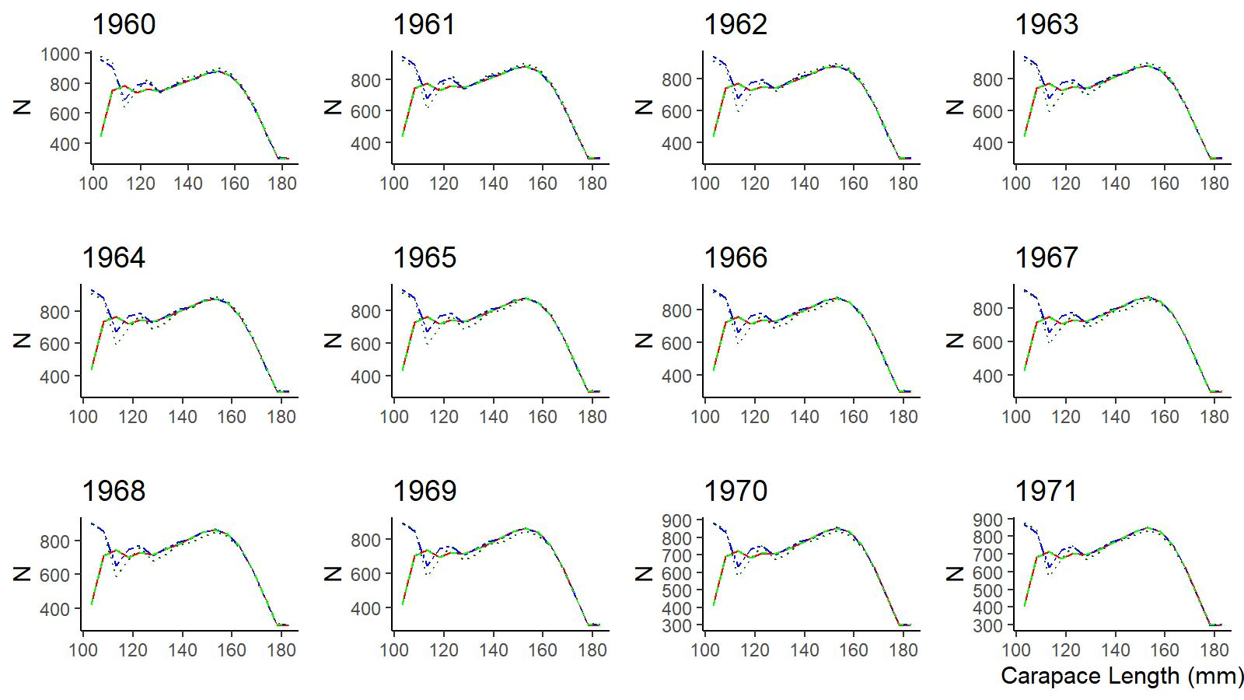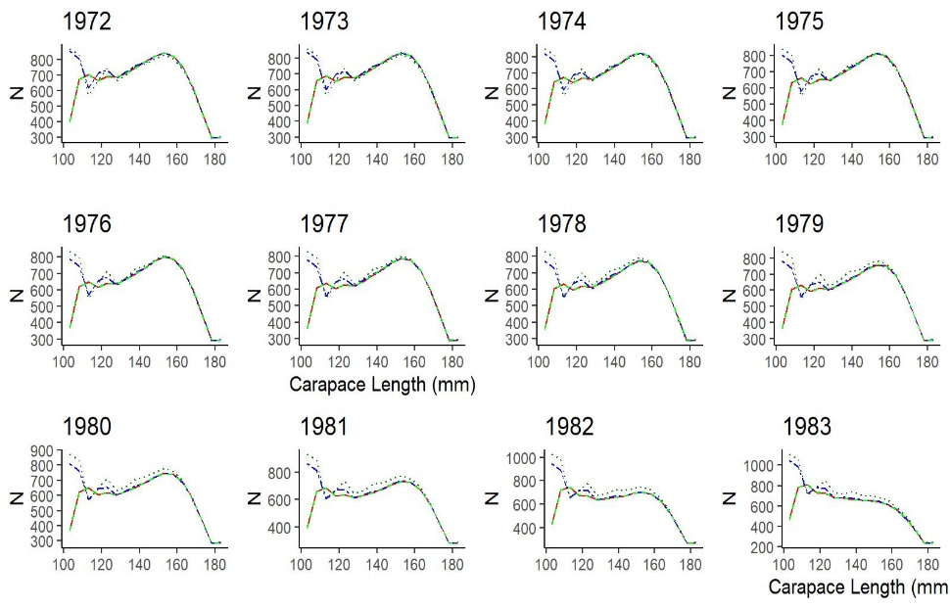

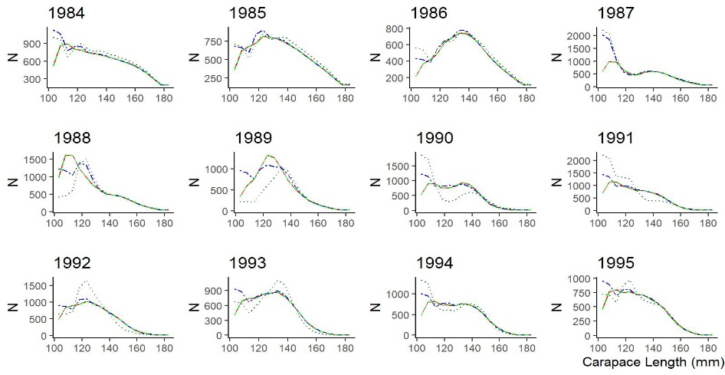 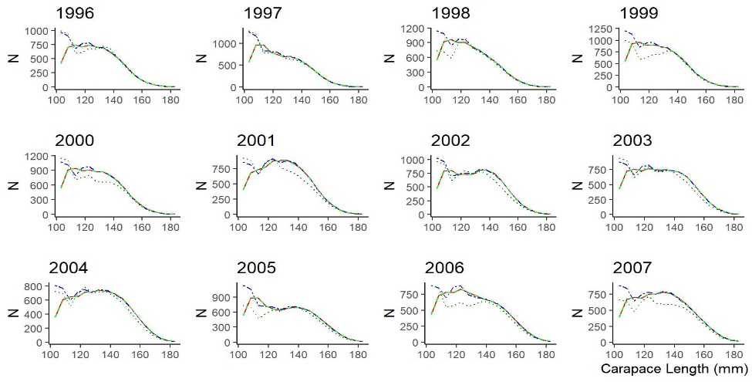

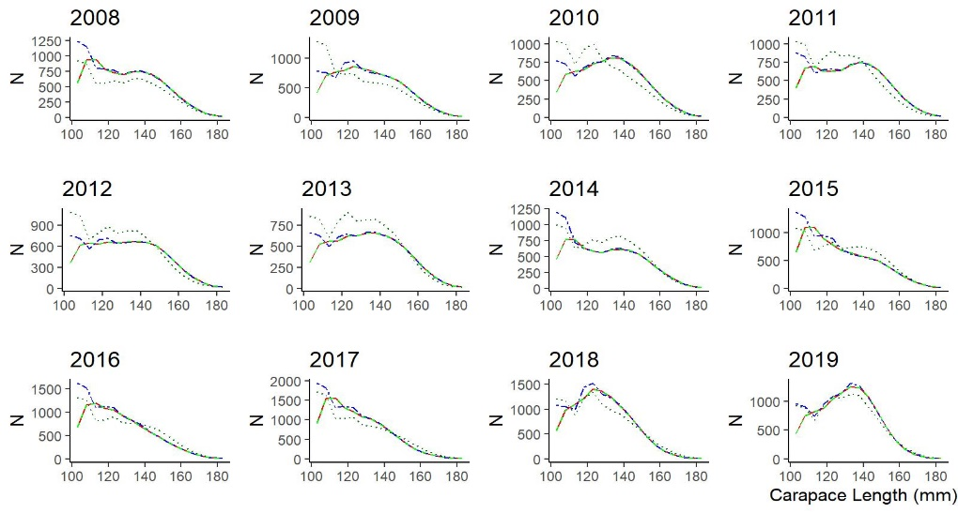

Figure F1. Comparison of time series of abundance by size (N-matrix) of EAG golden king crab, 1960–2019 [blue: OrignalEAG19.1; red: ModifiedEAG19.1; dark green: gmacs run#9 (free parameters); green: gmacs run#10(fixed parameters)]

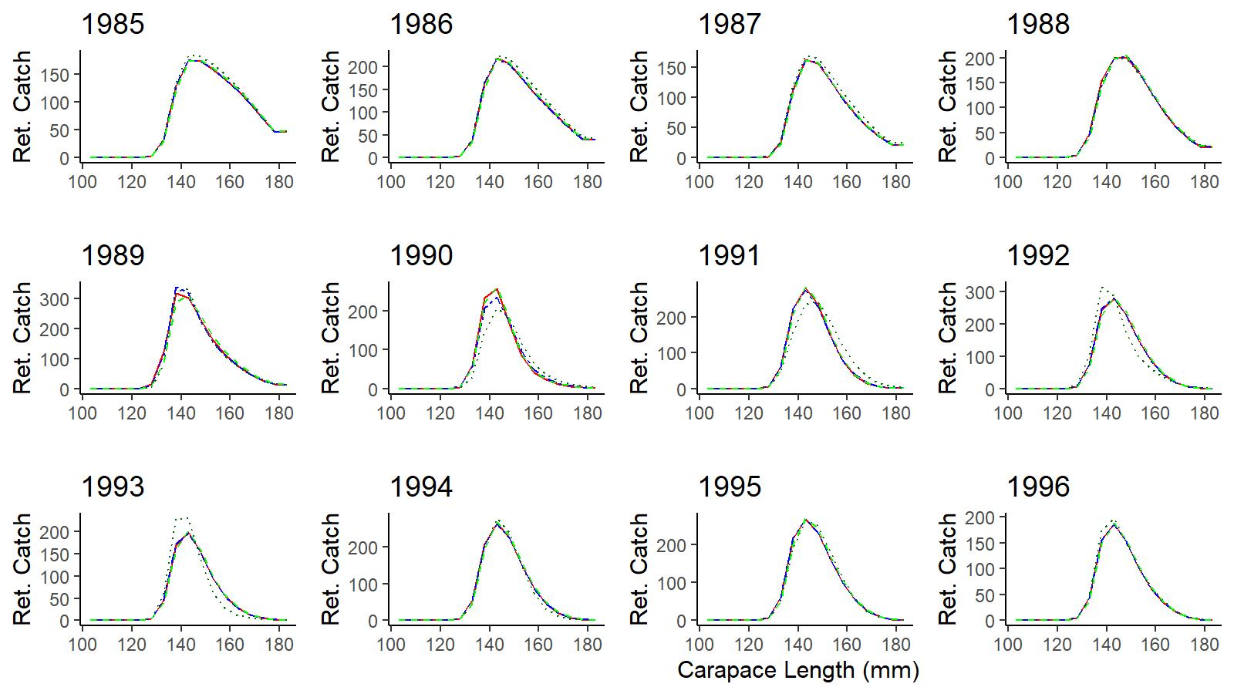 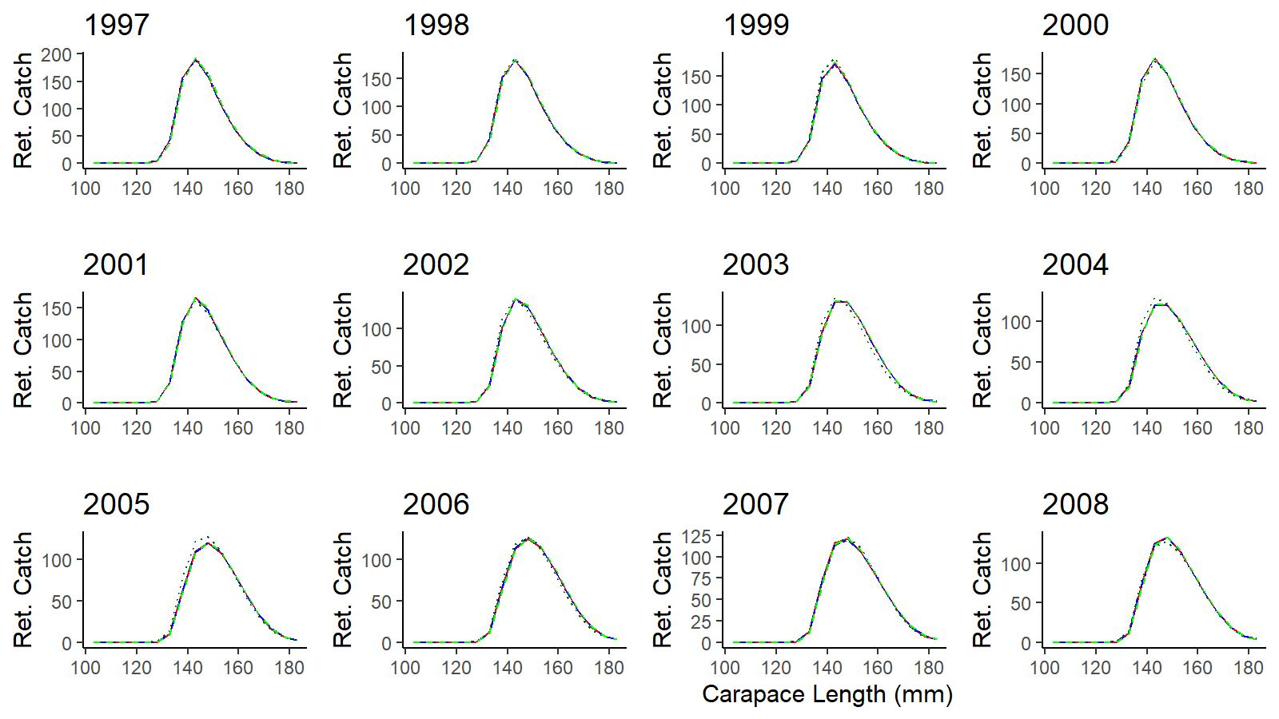

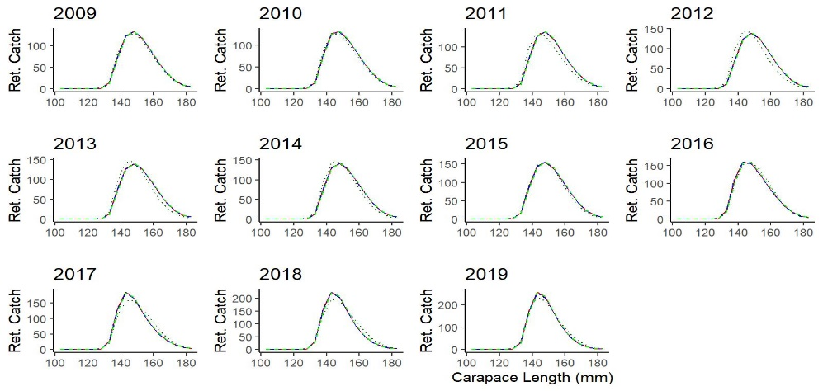

Figure F2. Comparison of time series of retained catch by size of EAG golden king crab, 1985–2019 (blue: OrignalEAG19.1; red: ModifiedEAG19.1; dark green: gmacs run#9; green: gmacs run#10)

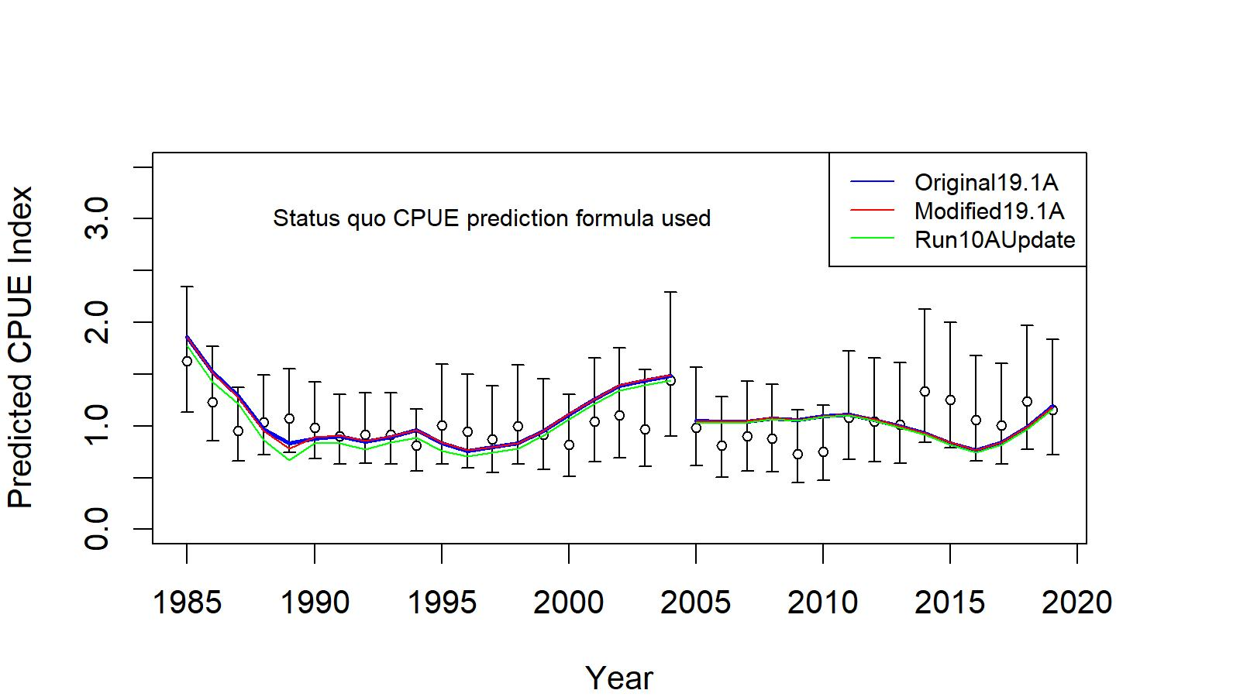

Figure F3. Comparison of time series of CPUE indices for EAG golden king crab, 1995–2019 (blue: OrignalEAG19.1A; red: ModifiedEAG19.1A; green: gmacs run#10AUpdate). For this comparison, the gmacs base model was slightly modified (update) to instantaneously remove catches at the middle of the fishing period.